NATIONAL CENTER FOR EDUCATION STATISTICS NATIONAL ASSESSMENT OF EDUCATIONAL PROGRESS

National Assessment of Educational Progress (NAEP)
2022

Appendix J-S

2022 Spanish Questionnaires

OMB# 1850-0928 v.25

September 2021

Appendix J-S provides updated Spanish student, teacher, and school survey questionnaires to be used in NAEP 2022. The change tables indicate any revisions that have been made to the previous versions of the SQs. Please note, the student change tables compare the 2022 items to the 2019 versions of the items. No changes to the student items have been made since OMB# 1850-0928 v.22.
Table of Contents
Student Login Screen 5
Appendix J-1a-s-BL: Summary of Changes Operational Grade 4 CORE 7
Appendix J-1a-s-BL: Operational Grade 4 CORE 12
Appendix J-1b-s-PR: Summary of Changes Operational Grade 4 CORE 16
Appendix J-1b-s-PR: Operational Grade 4 CORE 21
Appendix J-1c-s-BL: Summary of Changes Operational Grade 8 CORE 25
Appendix J-1c-s-BL: Operational Grade 8 CORE 31
Appendix J-1d-s-PR: Summary of Changes Operational Grade 8 CORE 37
Appendix J-1d-s-PR: Operational Grade 8 CORE 43
Appendix J-1e-s-BL: Summary of Changes Operational Grade 4 Mathematics 49
Appendix J-1e-s-BL: Operational Grade 4 Mathematics 54
Appendix J-1f-s-PR: Summary of Changes Operational Grade 4 Mathematics 58
Appendix J-1f-s-PR: Operational Grade 4 Mathematics 63
Appendix J-1g-s-BL: Summary of Changes Operational Grade 8 Mathematics 67
Appendix J-1g-s-BL: Operational Grade 8 Mathematics 75
Appendix J-1h-s-PR: Summary of Changes Operational Grade 8 Mathematics 80
Appendix J-1h-s-PR: Operational Grade 8 Mathematics 88
Appendix J-1i-s-BL: Summary of Changes Operational Grade 4 Reading 93
Appendix J-1i-s-BL: Operational Grade 4 Reading 98
Appendix J-1j-s-BL: Summary of Changes Operational Grade 8 Reading 102
Appendix J-1j-s-BL: Operational Grade 8 Reading 108
Appendix J-1k-s-BL: Operational Grade 8 Civics 113
Appendix J-1l-s-BL: Operational Grade 8 US History 120
Appendix J-1m-s-BL: Summary of Operational Grade 4 Debrief 126
Appendix J-1m-s-BL: Operational Grade 4 Debrief 127
Appendix J-1n-s-PR: Summary of Operational Grade 4 Debrief 128
Appendix J-1n-s-PR: Operational Grade 4 Debrief 129
Appendix J-1o-s-BL: Summary of Operational Grade 8 Debrief 130
Appendix J-1o-s-BL: Operational Grade 8 Debrief 131
Appendix J-1p-s-PR: Summary of Operational Grade 8 Debrief 132
Appendix J-1p-s-PR: Operational Grade 8 Debrief 133
Appendix J-1q-s-BL: Operational Grade 4 COVID-19 (ELA) 134
Appendix J-1r-s-BL: Operational Grade 8 COVID-19 (ELA) 137
Appendix J-1s-s-BL: Operational Grade 4 COVID-19 (Math) 141
Appendix J-1t-s-PR: Operational Grade 4 COVID-19 (Math) 144
Appendix J-1u-s-BL: Operational Grade 8 COVID-19 (Math) 147
Appendix J-1v-s-PR: Operational Grade 8 COVID-19 (Math) 151
Appendix J-1w-s-BL: Operational Grade 8 COVID-19 (Civics) 155
Appendix J-1x-s-BL: Operational Grade 8 COVID-19 (U.S. History) 159
Sample Teacher Login Screen 163
Sample Teacher Questionnaire Booklet Cover 164
Appendix J-2-s: Spanish Translations of Teacher Questionnaires 165
Appendix J-2a-s-PR: Summary of Changes Operational Grade 4 CORE 166
Appendix J-2a-s-PR: Operational Grade 4 CORE 173
Appendix J-2b-s-PR: Summary of Changes Operational Grade 8 CORE 180
Appendix J-2b-s-PR: Operational Grade 8 CORE 187
Appendix J-2c-s-PR: Summary of Changes Operational Grade 4 Mathematics 195
Appendix J-2c-s-PR: Operational Grade 4 Mathematics 200
Appendix J-2d-s-PR: Summary of Changes Operational Grade 8 Mathematics 207
Appendix J-2d-s-PR: Operational Grade 8 Mathematics 214
Appendix J-2e-s-PR: Summary of Operational Grade 4 COVID-19 220
Appendix J-2f-s-PR: Operational Grade 4 COVID-19 225
Appendix J-2g-s-PR: Summary of Operational Grade 8 COVID-19 230
Appendix J-2h-s-PR: Operational Grade 8 COVID-19 235
Sample School Administrator Login Screen 240
Sample School Questionnaire Booklet Covers 241
Appendix J-3-s: Spanish Translations of School Questionnaires 242
Appendix J-3a-s-PR: Summary of Changes Operational Grade 4 CORE 243
Appendix J-3a-s-PR: Operational Grade 4 CORE 253
Appendix J-3b-s-PR: Summary of Changes Operational Grade 8 CORE 264
Appendix J-3b-s-PR: Operational Grade 8 CORE 274
Appendix J-3c-s-PR: Summary of Changes Operational Grade 4 Mathematics 285
Appendix J-3c-s-PR: Operational Grade 4 Mathematics 288
Appendix J-3d-s-PR: Summary of Changes Operational Grade 8 Mathematics 291
Appendix J-3d-s-PR: Operational Grade 8 Mathematics 294
Appendix J-3e-s-PR: Summary of Operational Grade 4 COVID-19 298
Appendix J-3f-s-PR: Operational Grade 4 COVID-19 307
Appendix J-3g-s-PR: Summary of Operational Grade 8 COVID-19 316
Appendix J-3h-s-PR: Operational Grade 8 COVID-19 325

Student Login Screen

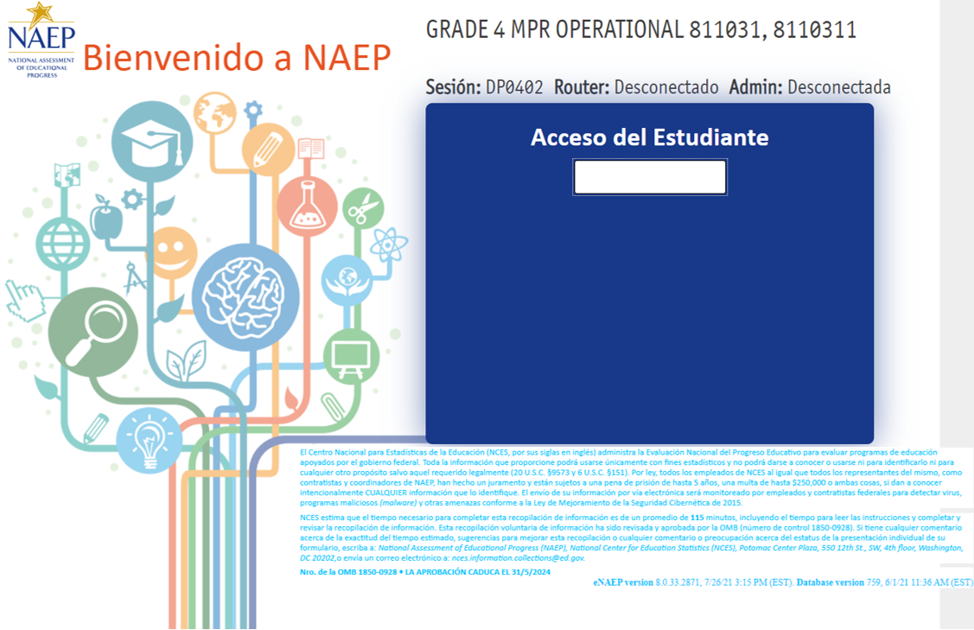

Appendix J-1-s: Spanish Translations of Student Questionnaires

Appendix J-1a-s-BL: Summary of Changes Operational Grade 4 CORE
2022 Operational Grade 4 Core Student – Bilingual
Previous item | 2022 item | D/A/R/NC+ | Rationale
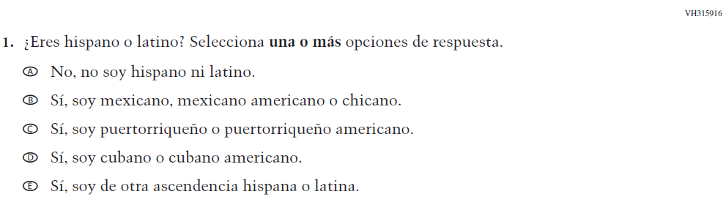  (2019 Operational Grade 4 Student Core - Bilingual) | Issue: Race/Ethnicity | NC | N/A
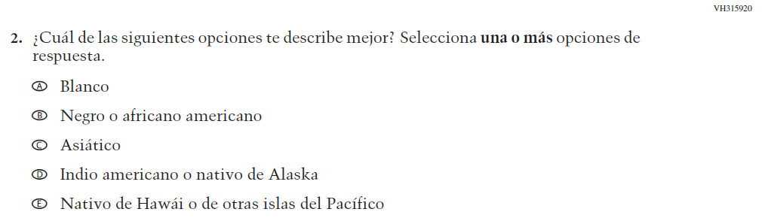  (2019 Operational Grade 4 Student Core - Bilingual) | Issue: Race/Ethnicity | NC | N/A
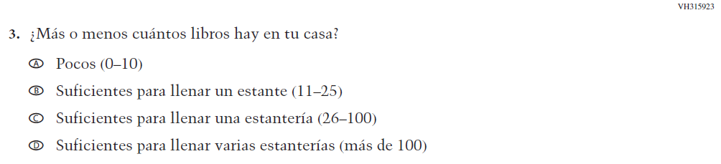  (2019 Operational Grade 4 Student Core - Bilingual) | Issue: Socioeconomic Status | NC | N/A

2022 Operational Grade 4 Core Student – Bilingual
Previous item | 2022 item | D/A/R/NC+ | Rationale
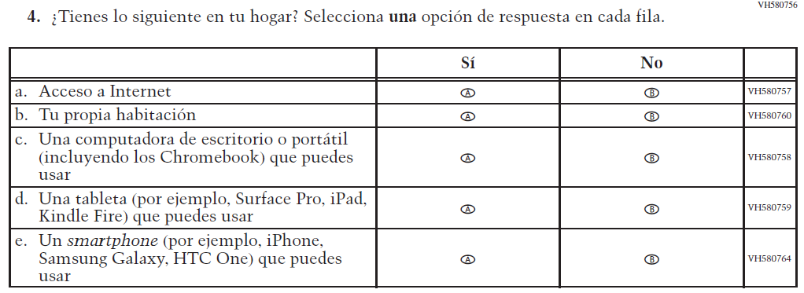  (2019 Operational Grade 4 Student Core - Bilingual) | 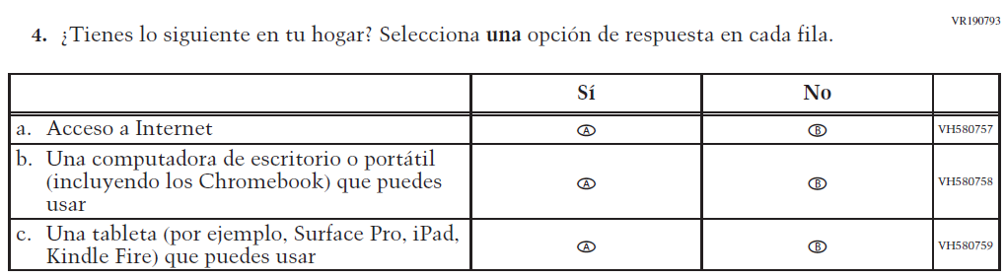  Issue: Socioeconomic Status | R | To keep student burden low, sub-items b and e were dropped.
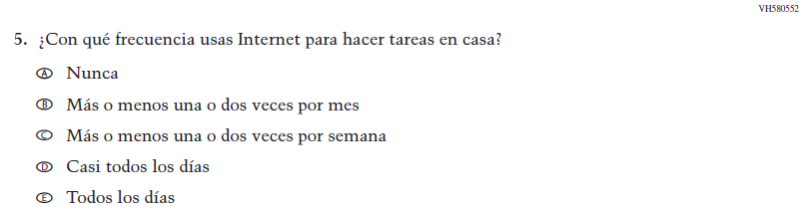  (2019 Operational Grade 4 Student Core - Bilingual) | N/A | D | To keep student burden low, this item was dropped.
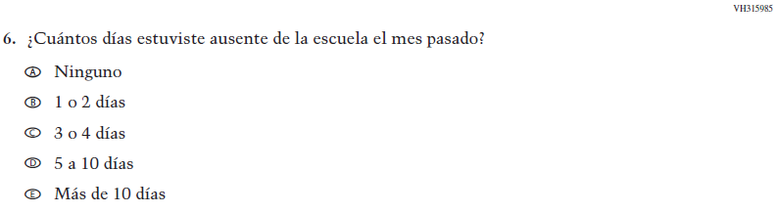  (2019 Operational Grade 4 Student Core - Bilingual) | 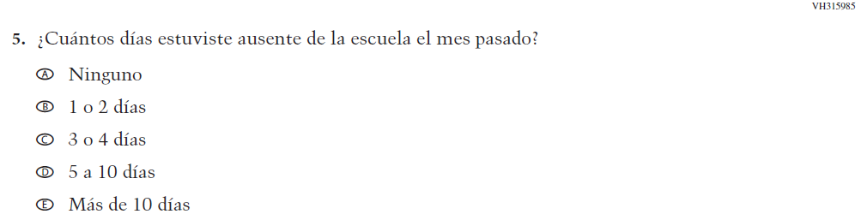  Issue: School Climate | NC | N/A

2022 Operational Grade 4 Core Student – Bilingual
Previous item | 2022 item | D/A/R/NC+ | Rationale
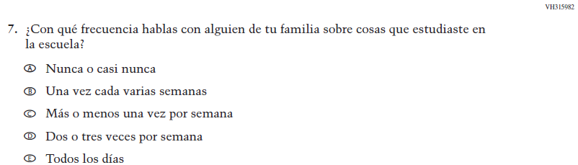  (2019 Operational Grade 4 Student Core - Bilingual) | N/A | D | To keep student burden low, this item was dropped.
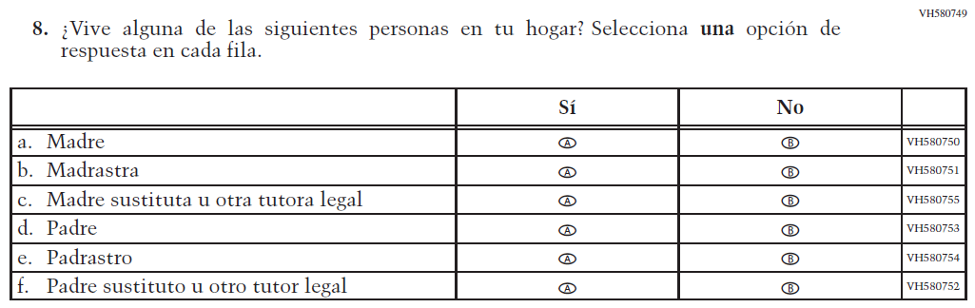  (2019 Operational Grade 4 Student Core - Bilingual) | 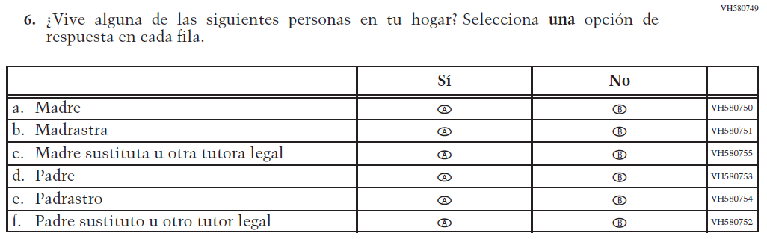  Issue: Socioeconomic Status | NC | N/A
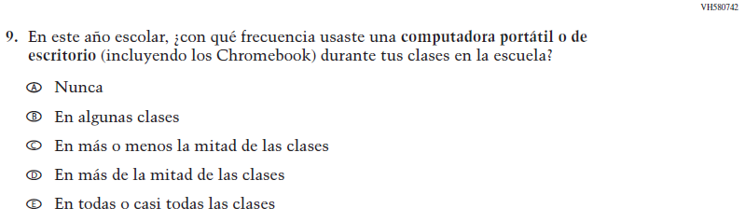  (2019 Operational Grade 4 Student Core - Bilingual) | 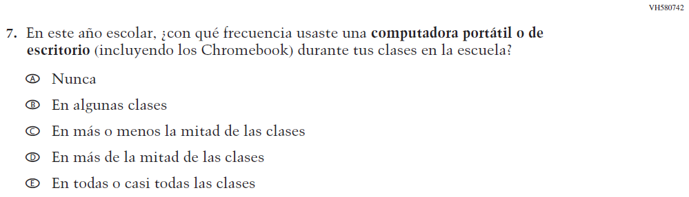  Issue: Technology Use | NC | N/A

2022 Operational Grade 4 Core Student – Bilingual
Previous item | 2022 item | D/A/R/NC+ | Rationale
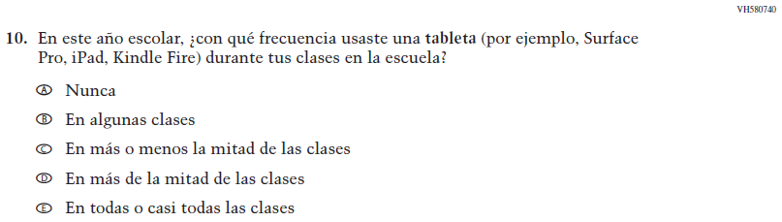  (2019 Operational Grade 4 Student Core - Bilingual) | N/A | D | To keep student burden low, this item was dropped.
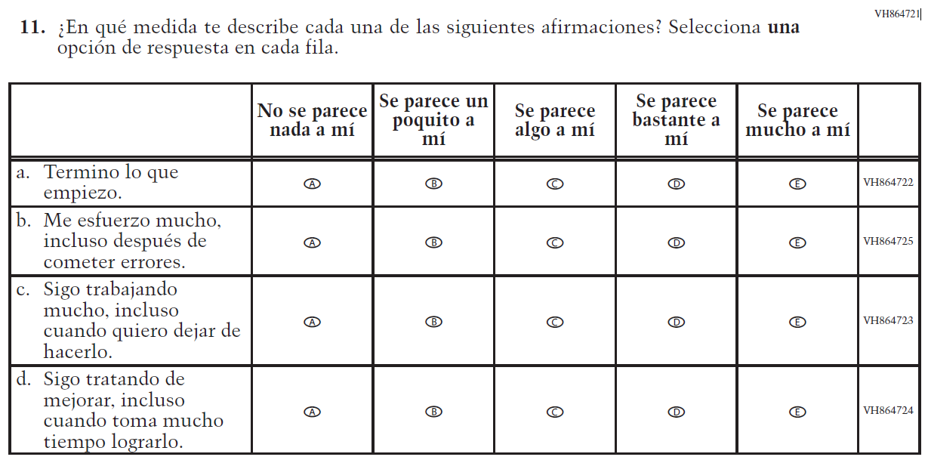  (2019 Operational Grade 4 Student Core - Bilingual) | N/A | D | To keep student burden low, this item was dropped.
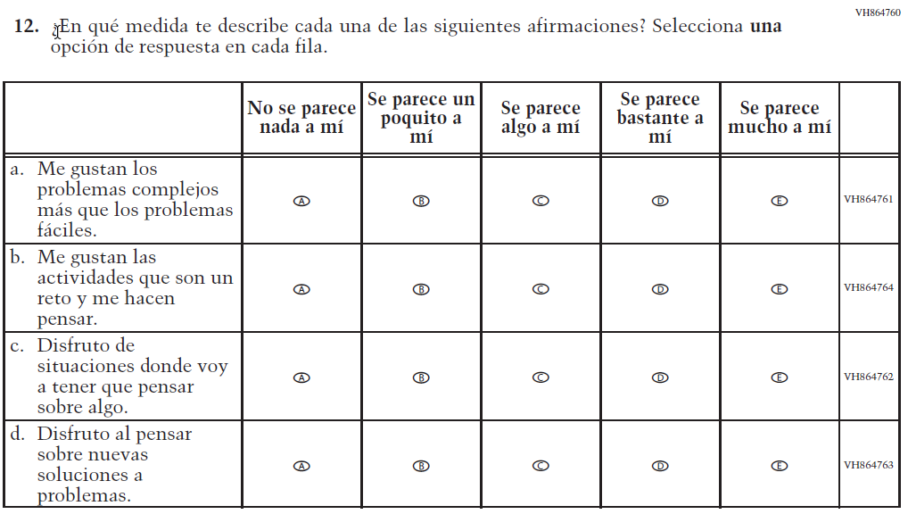  (2019 Operational Grade 4 Student Core - Bilingual) | 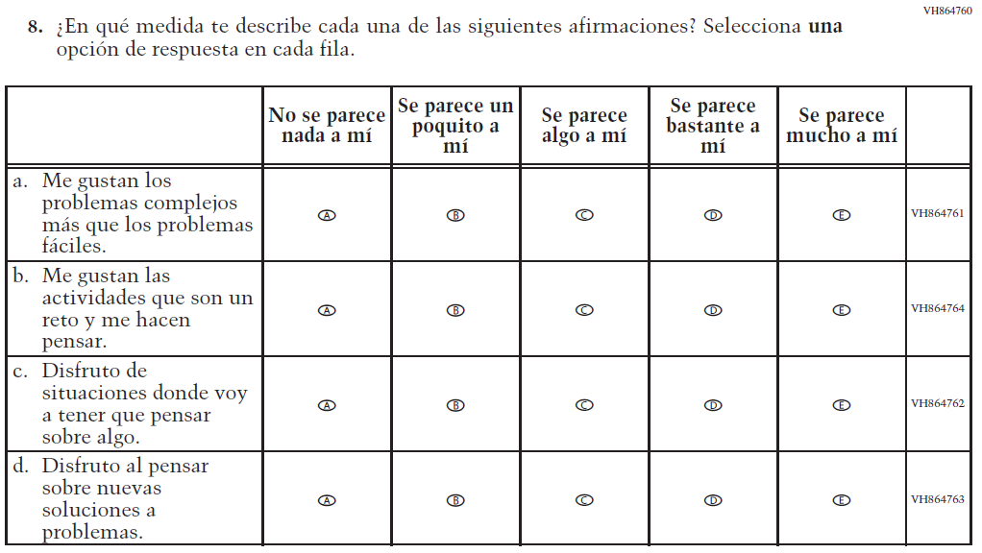  Issue: Desire for Learning | NC | N/A
2022 Operational Grade 4 Core Student – Bilingual
Previous item | 2022 item | D/A/R/NC+ | Rationale
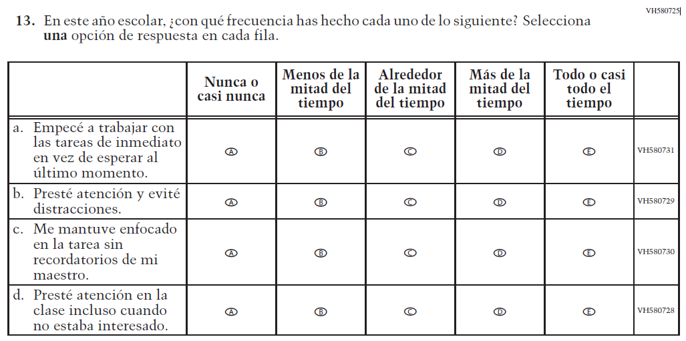  (2019 Operational Grade 4 Student Core - Bilingual) | 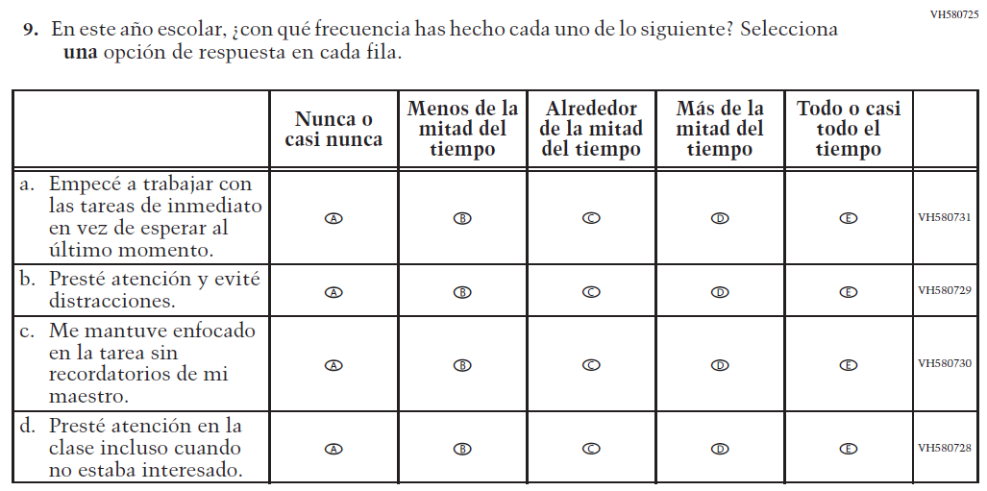  Issue: Grit | NC | N/A
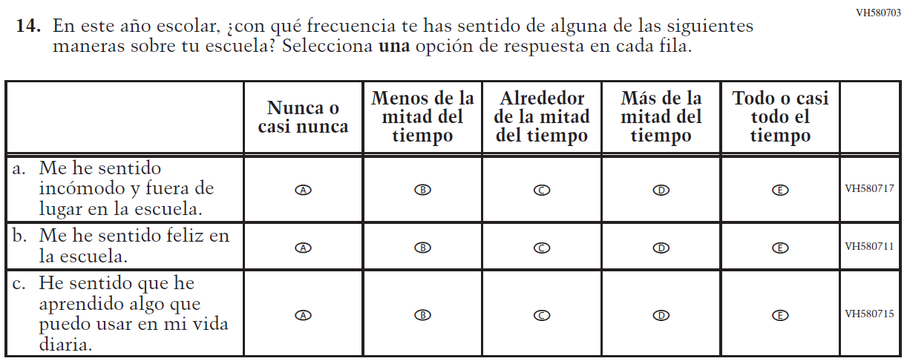  (2019 Operational Grade 4 Student Core - Bilingual) | N/A | D | To keep student burden low, this item was dropped.

Appendix J-1a-s-BL: Operational Grade 4 CORE
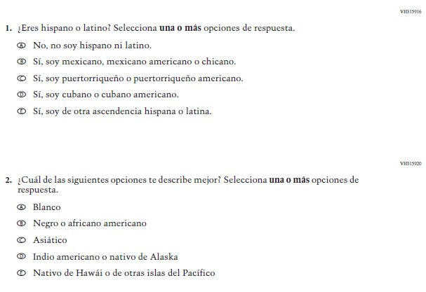
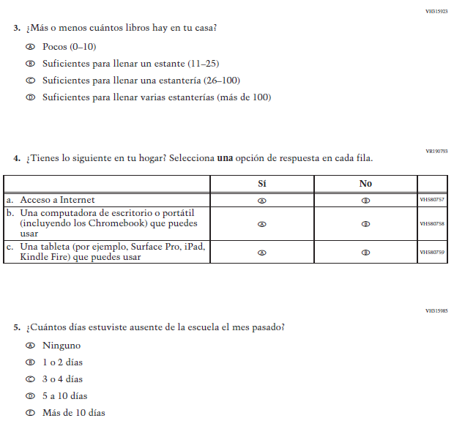
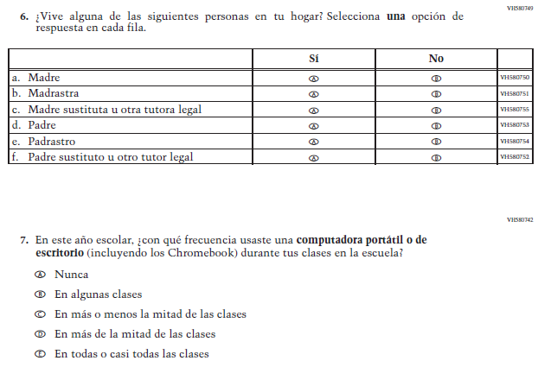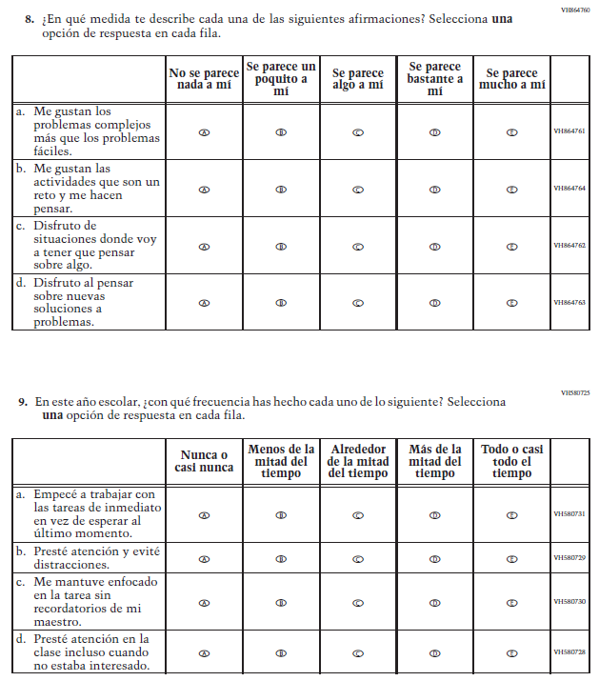

Appendix J-1b-s-PR: Summary of Changes Operational Grade 4 CORE
2022 Operational Grade 4 Core Student – Puerto Rico

Previous item | 2022 item | D/A/ R/NC+ | Rationale
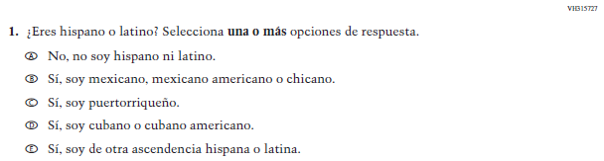  (2019 Operational Grade 4 Student Core – Puerto Rico) | 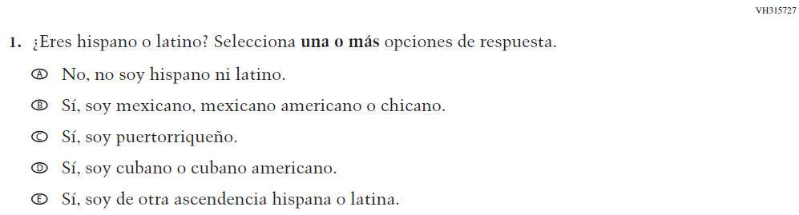  Issue: Race/Ethnicity | NC | N/A
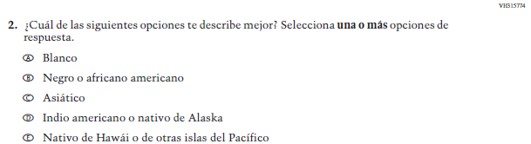  (2019 Operational Grade 4 Student Core – Puerto Rico) | 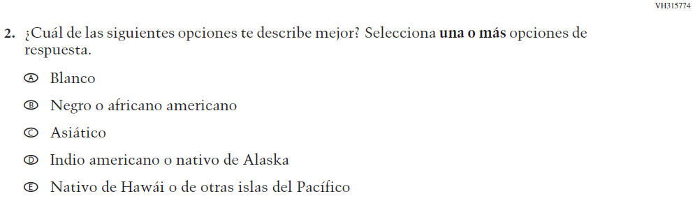  Issue: Race/Ethnicity | NC | N/A
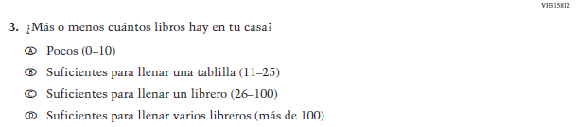  (2019 Operational Grade 4 Student Core – Puerto Rico) | 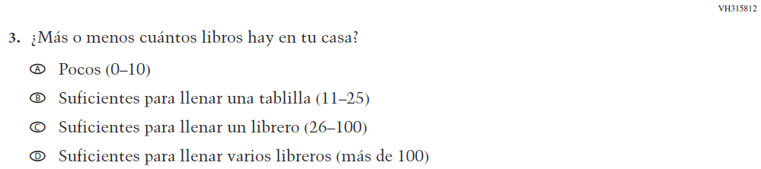  Issue: Socioeconomic Status | NC | N/A
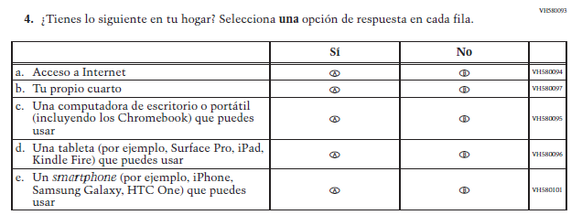  (2019 Operational Grade 4 Student Core – Puerto Rico) | 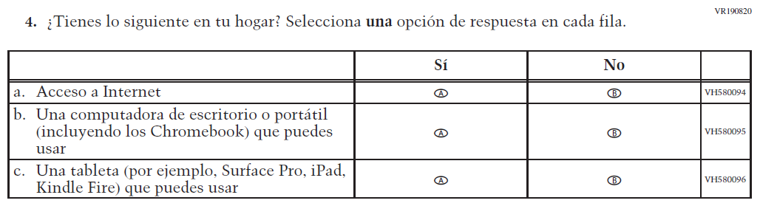  Issue: Socioeconomic Status | R | To keep student burden low, sub-items b and e were dropped.
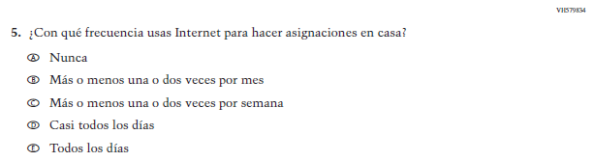  (2019 Operational Grade 4 Student Core – Puerto Rico) | N/A | D | To keep student burden low, this item was dropped.
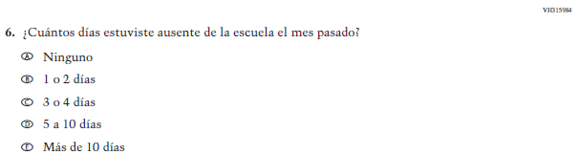  (2019 Operational Grade 4 Student Core – Puerto Rico) | 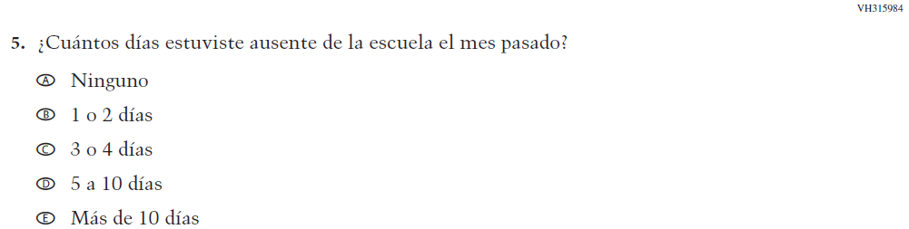  Issue: School Climate | NC | N/A

2022 Operational Grade 4 Core Student – Puerto Rico

Previous item | 2022 item | D/A/ R/NC+ | Rationale
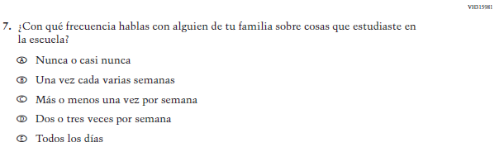  (2019 Operational Grade 4 Student Core – Puerto Rico) | N/A | D | To keep student burden low, this item was dropped.
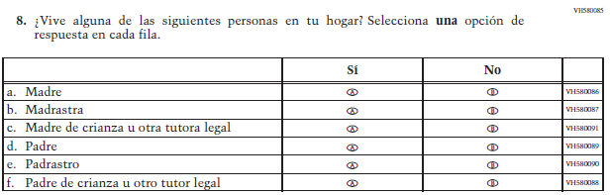  (2019 Operational Grade 4 Student Core – Puerto Rico) | 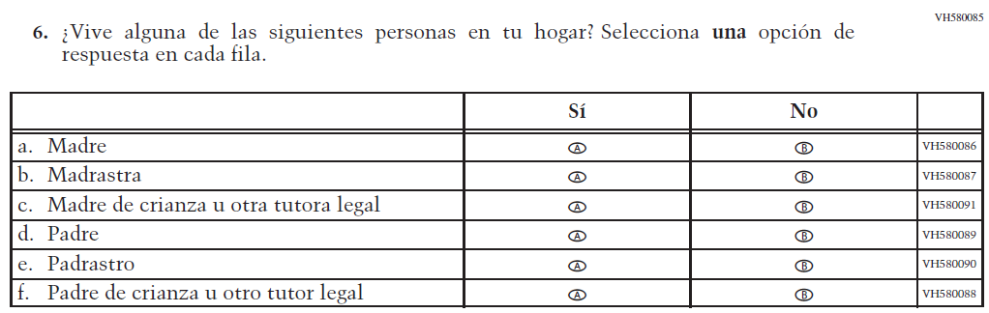  Issue: Socioeconomic Status | NC | N/A
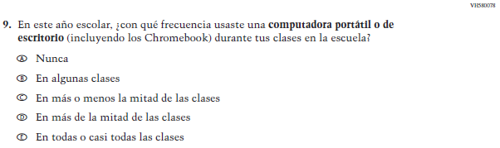  (2019 Operational Grade 4 Student Core – Puerto Rico) | 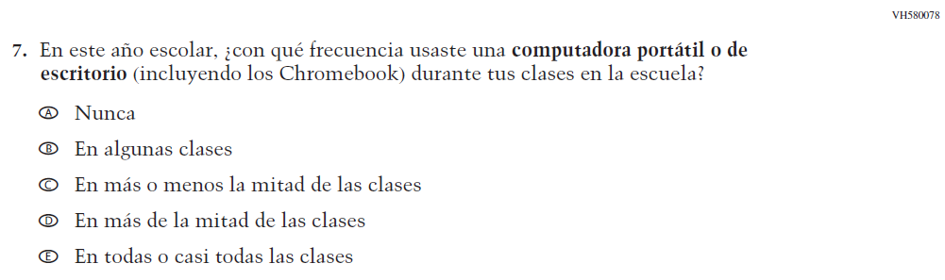  Issue: Technology Use | NC | N/A
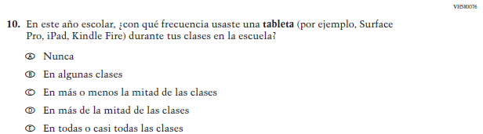  (2019 Operational Grade 4 Student Core – Puerto Rico) | N/A | D | To keep student burden low, this item was dropped.

2022 Operational Grade 4 Core Student – Puerto Rico

Previous item | 2022 item | D/A/ R/NC+ | Rationale
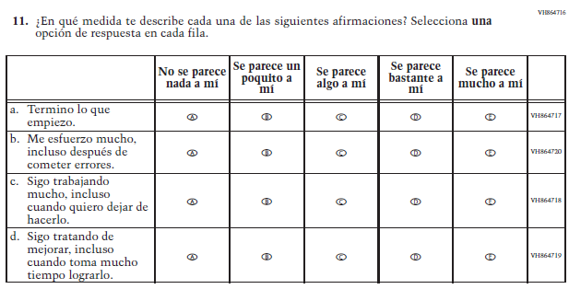  (2019 Operational Grade 4 Student Core – Puerto Rico) | N/A | D | To keep student burden low, this item was dropped.
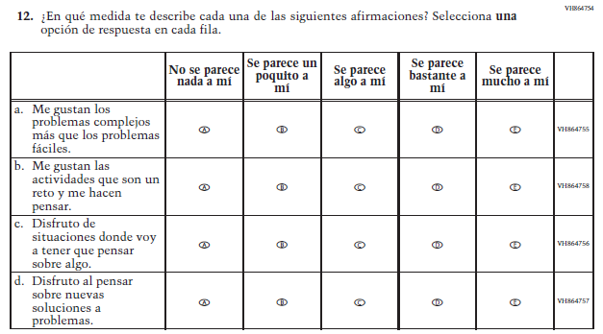  (2019 Operational Grade 4 Student Core – Puerto Rico) | 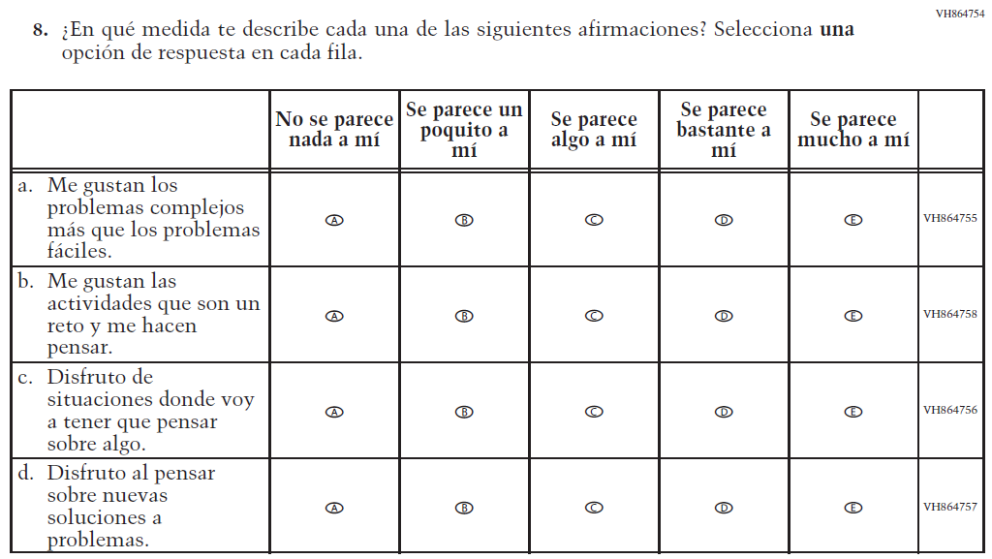  Issue: Desire for Learning | NC | N/A

2022 Operational Grade 4 Core Student – Puerto Rico

Previous item | 2022 item | D/A/ R/NC+ | Rationale
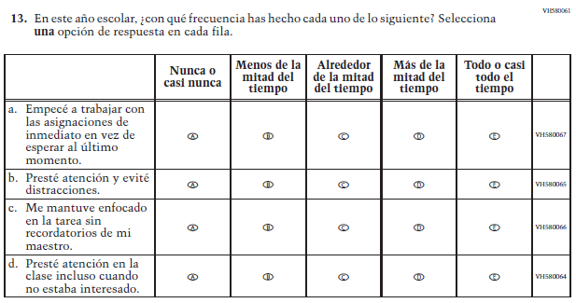  (2019 Operational Grade 4 Student Core – Puerto Rico) | 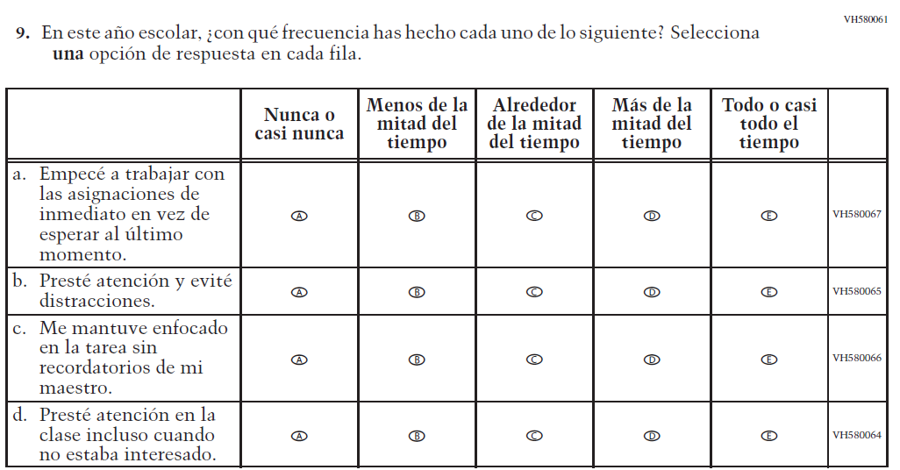  Issue: Grit | NC | N/A
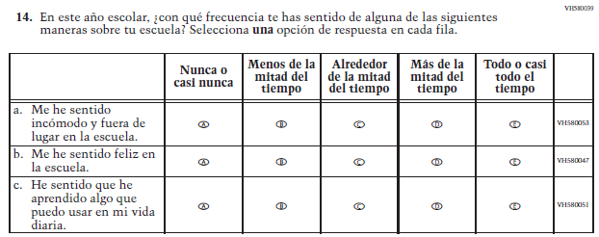  (2019 Operational Grade 4 Student Core – Puerto Rico) | N/A | D | To keep student burden low, this item was dropped.

Appendix J-1b-s-PR: Operational Grade 4 CORE
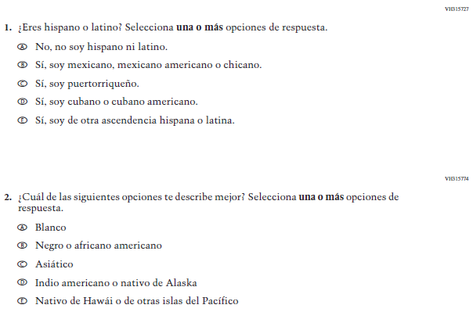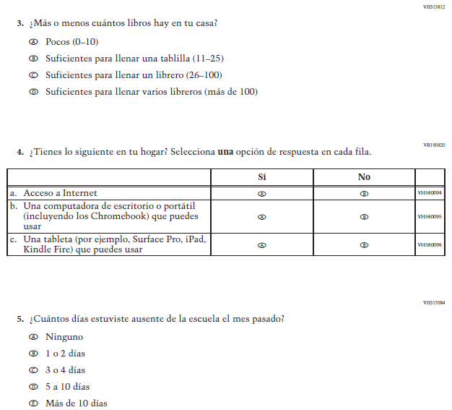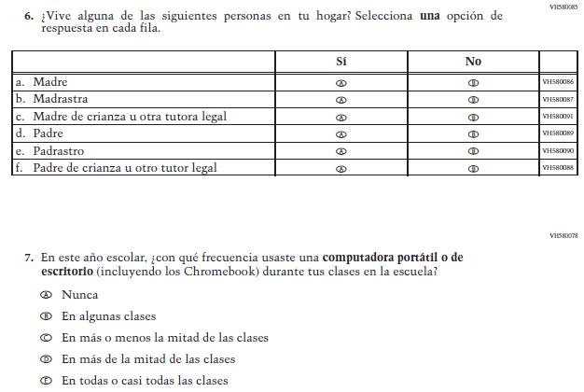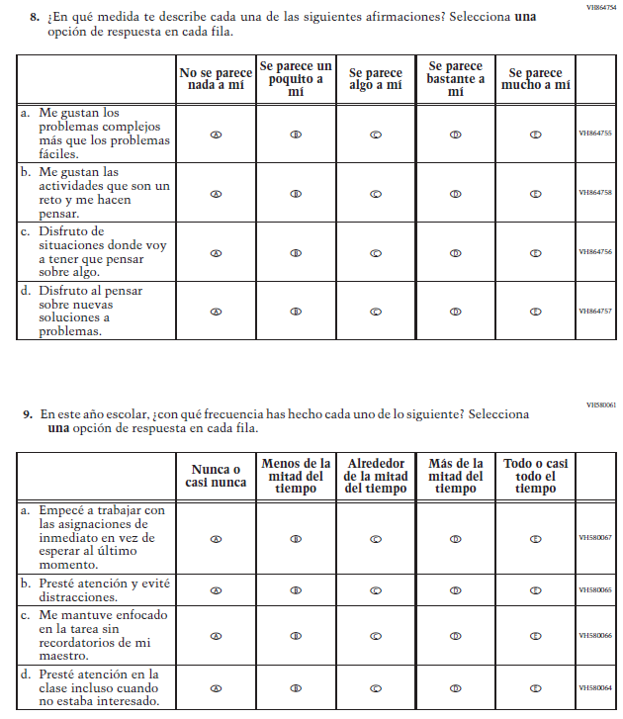

Appendix J-1c-s-BL: Summary of Changes Operational Grade 8 CORE
2022 Operational Grade 8 Core Student – Bilingual
Previous item | 2022 item | D/A/R/NC+ | Rationale
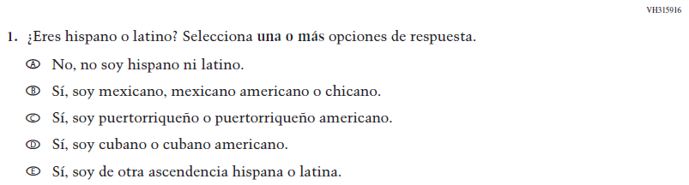  (2019 Operational Grade 8 Student Core - Bilingual) | Issue: Race/Ethnicity | NC | N/A
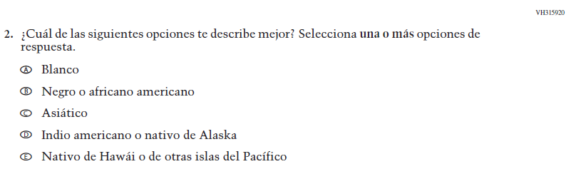  (2019 Operational Grade 8 Student Core - Bilingual) | Issue: Race/Ethnicity | NC | N/A
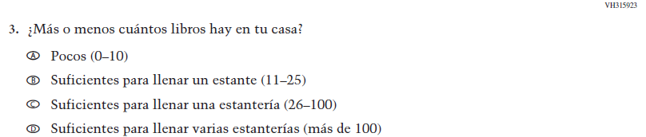  (2019 Operational Grade 8 Student Core - Bilingual) | Issue: Socioeconomic Status | NC | N/A

2022 Operational Grade 8 Core Student – Bilingual
Previous item | 2022 item | D/A/R/NC+ | Rationale
(2019 Operational Grade 8 Student Core - Bilingual) | 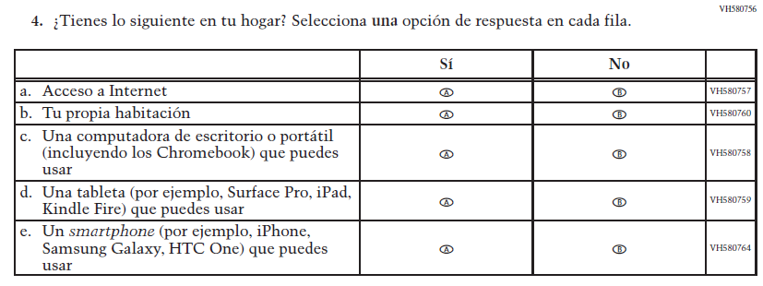  Issue: Socioeconomic Status | NC | N/A
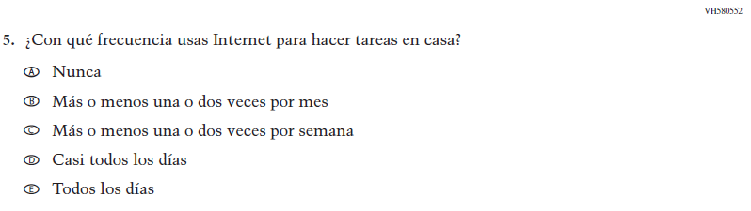  (2019 Operational Grade 8 Student Core - Bilingual) | Issue: Technology Use | NC | N/A
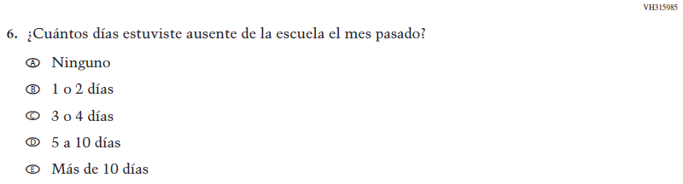  (2019 Operational Grade 8 Student Core - Bilingual) | Issue: School Climate | NC | N/A

2022 Operational Grade 8 Core Student – Bilingual
Previous item | 2022 item | D/A/R/NC+ | Rationale
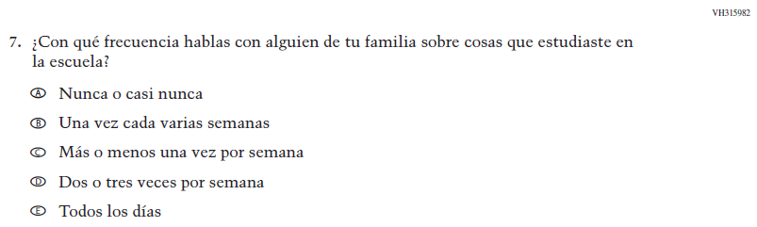  (2019 Operational Grade 8 Student Core - Bilingual) | Issue: Socioeconomic Status | NC | N/A
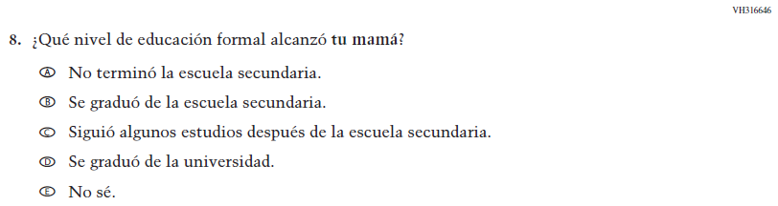  (2019 Operational Grade 8 Student Core - Bilingual) | Issue: Socioeconomic Status | NC | N/A
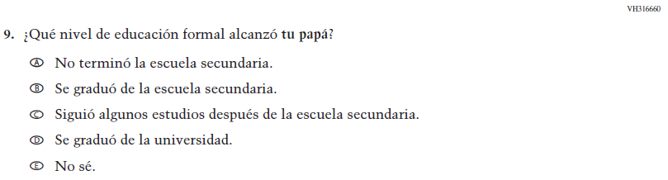  (2019 Operational Grade 8 Student Core - Bilingual) | Issue: Socioeconomic Status | NC | N/A

2022 Operational Grade 8 Core Student – Bilingual
Previous item | 2022 item | D/A/R/NC+ | Rationale
(2019 Operational Grade 8 Student Core - Bilingual) | Issue: Socioeconomic Status | NC | N/A
(2019 Operational Grade 8 Student Core - Bilingual) | Issue: Socioeconomic Status | NC | N/A
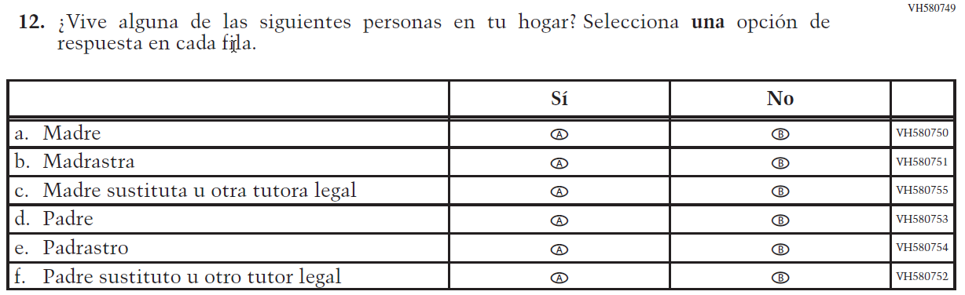  (2019 Operational Grade 8 Student Core - Bilingual) | 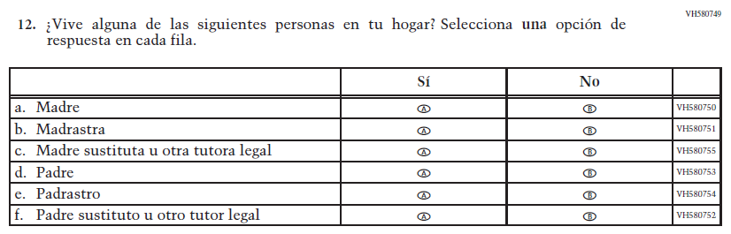  Issue: Socioeconomic Status | NC | N/A

2022 Operational Grade 8 Core Student – Bilingual
Previous item | 2022 item | D/A/R/NC+ | Rationale
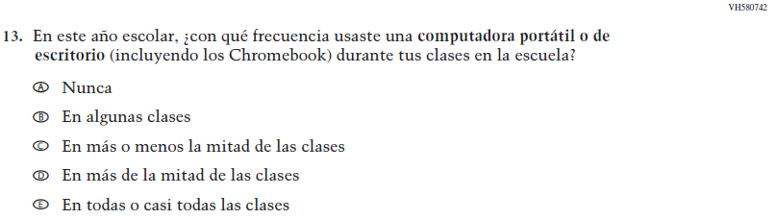  (2019 Operational Grade 8 Student Core - Bilingual) | Issue: Technology Use | NC | N/A
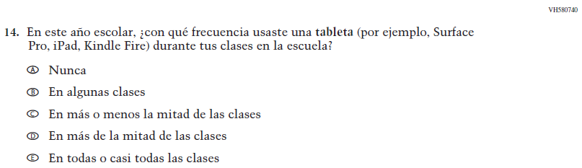  (2019 Operational Grade 8 Student Core - Bilingual) | Issue: Technology Use | NC | N/A
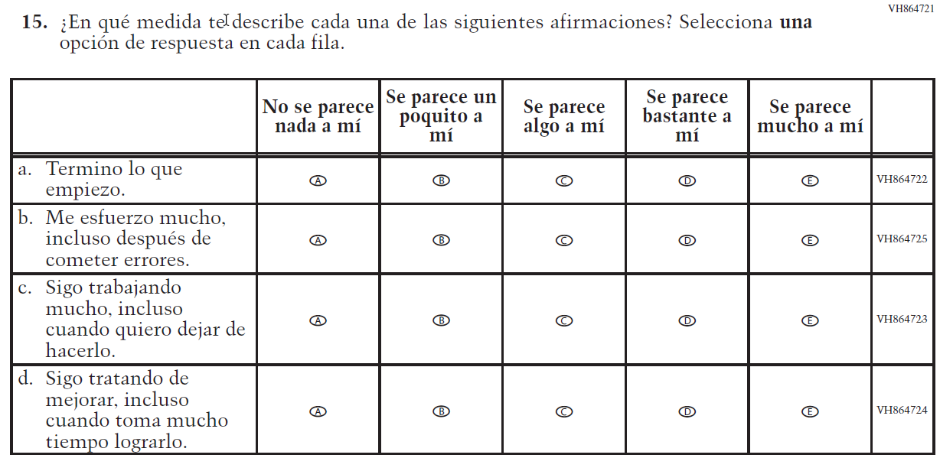  (2019 Operational Grade 8 Student Core - Bilingual) | 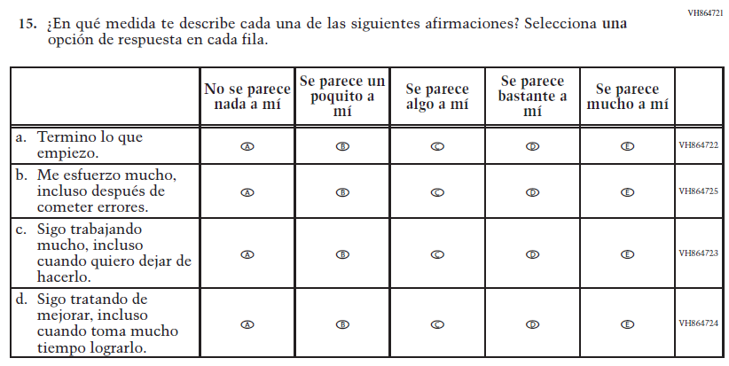  Issue: Grit | NC | N/A

2022 Operational Grade 8 Core Student – Bilingual
Previous item | 2022 item | D/A/R/NC+ | Rationale
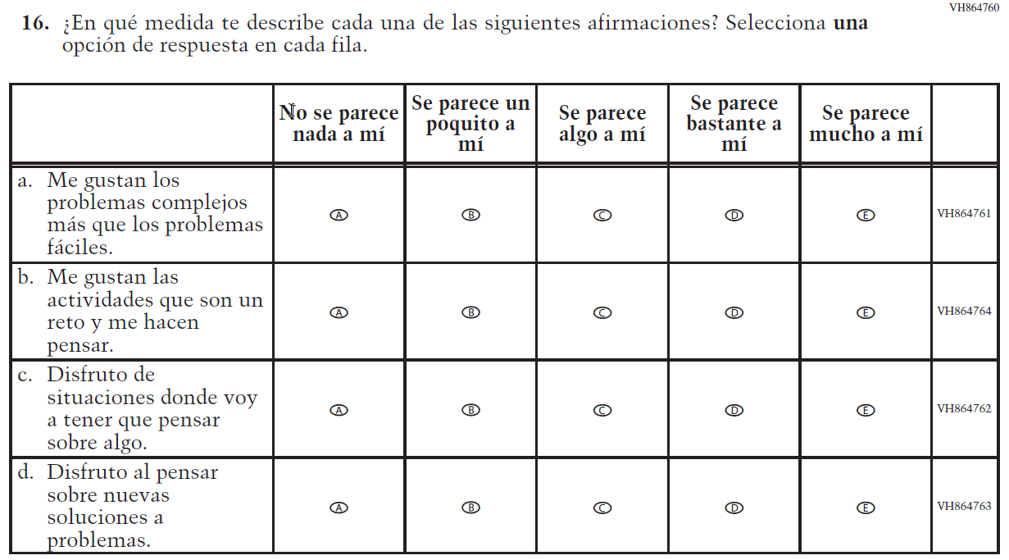  (2019 Operational Grade 8 Student Core - Bilingual) | 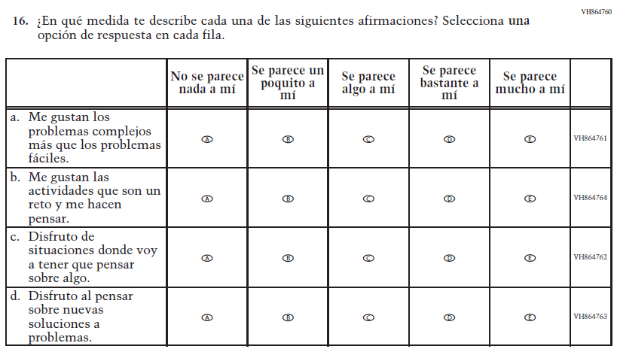  Issue: Desire for Learning | NC | N/A
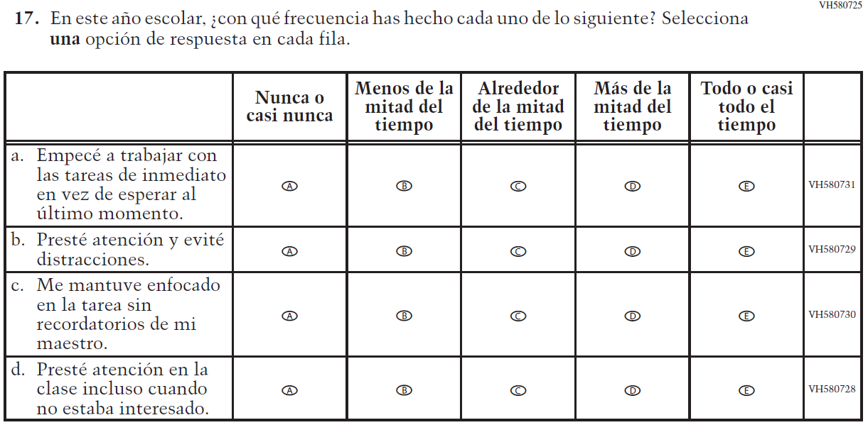  (2019 Operational Grade 8 Student Core - Bilingual) | Issue: Grit | NC | N/A

2022 Operational Grade 8 Core Student – Bilingual
Previous item | 2022 item | D/A/R/NC+ | Rationale
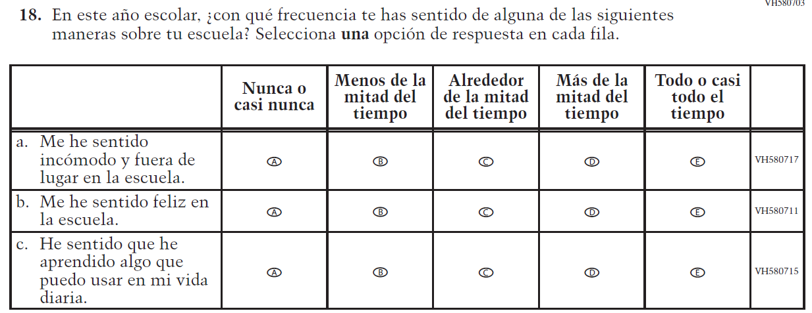  (2019 Operational Grade 8 Student Core - Bilingual) | N/A | D | To keep student burden low, this item was dropped.
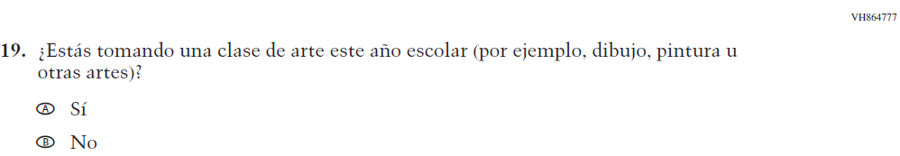  (2019 Operational Grade 8 Student Core - Bilingual) | 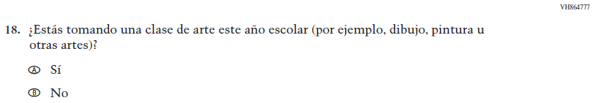  Issue: Educational Experiences | NC | N/A

Appendix J-1c-s-BL: Operational Grade 8 CORE
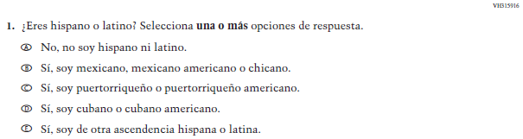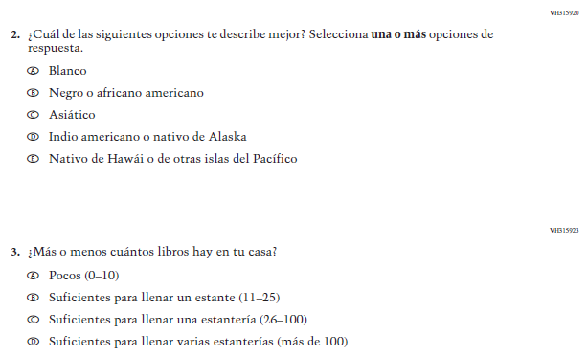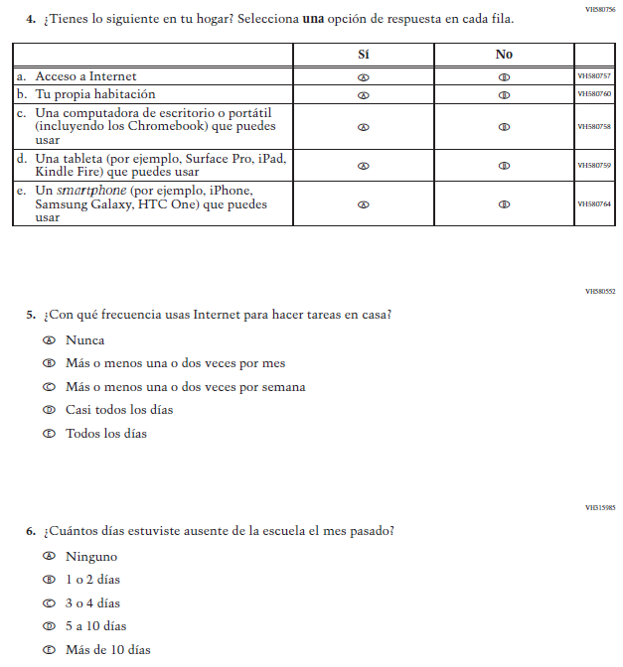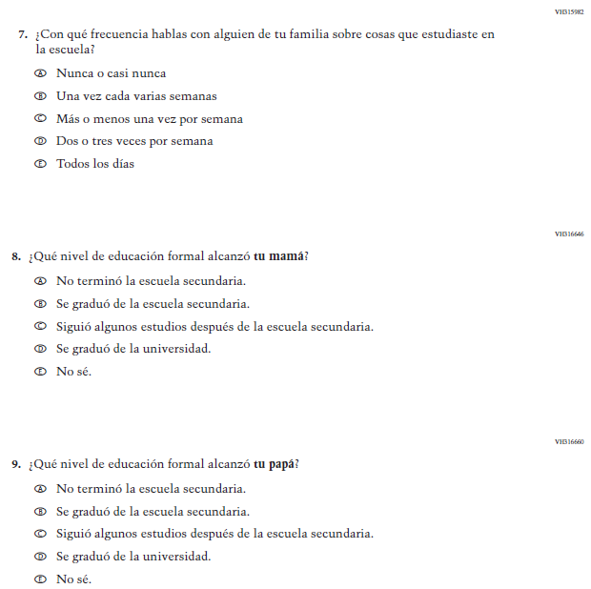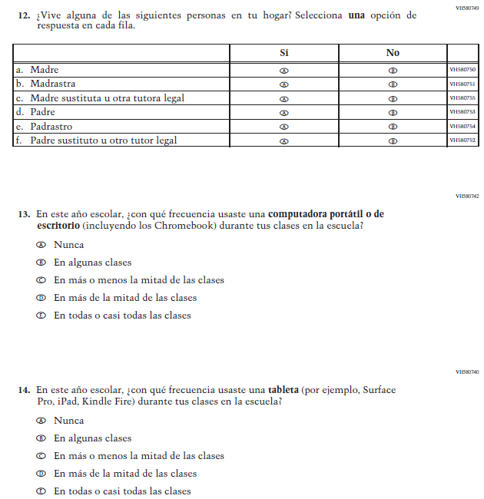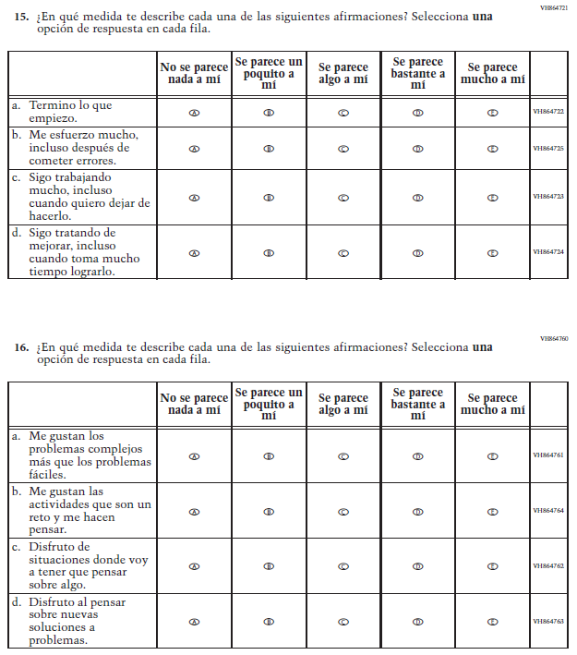

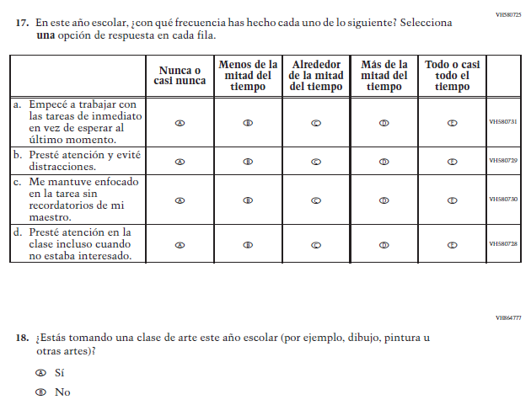

Appendix J-1d-s-PR: Summary of Changes Operational Grade 8 CORE
2022 Operational Grade 8 Core Student – Puerto Rico

Previous item | 2022 item | D/A/ R/NC+ | Rationale
(2019 Operational Grade 8 Student Core – Puerto Rico) | 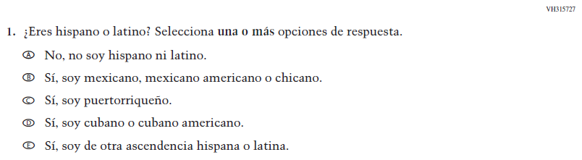  Issue: Race/Ethnicity | NC | N/A
(2019 Operational Grade 8 Student Core – Puerto Rico) | 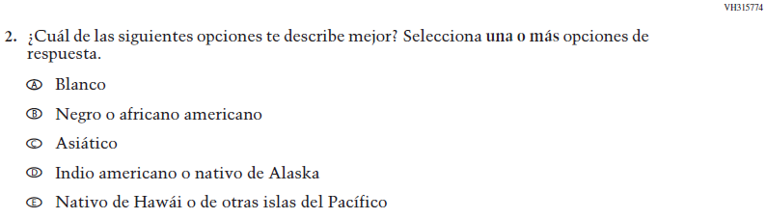  Issue: Race/Ethnicity | NC | N/A
(2019 Operational Grade 8 Student Core – Puerto Rico) | 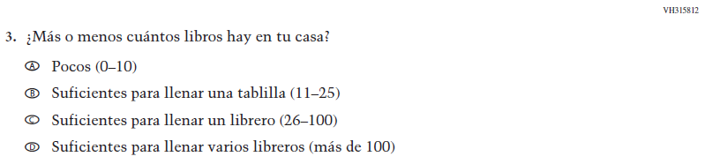  Issue: Socioeconomic Status | NC | N/A
(2019 Operational Grade 8 Student Core – Puerto Rico) | Issue: Socioeconomic Status | NC | N/A
(2019 Operational Grade 8 Student Core – Puerto Rico) | Issue: Technology Use | NC | N/A
(2019 Operational Grade 8 Student Core – Puerto Rico) | Issue: School Climate | NC | N/A
(2019 Operational Grade 8 Student Core – Puerto Rico) | Issue: Socioeconomic Status | NC | N/A
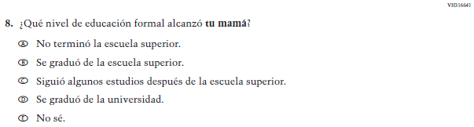  (2019 Operational Grade 8 Student Core – Puerto Rico) | Issue: Socioeconomic Status | NC | N/A

2022 Operational Grade 8 Core Student – Puerto Rico

Previous item | 2022 item | D/A/ R/NC+ | Rationale
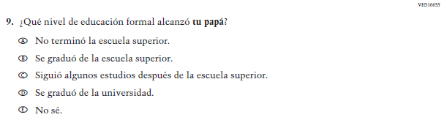  (2019 Operational Grade 8 Student Core – Puerto Rico) | Issue: Socioeconomic Status | NC | N/A
(2019 Operational Grade 8 Student Core – Puerto Rico) | Issue: Socioeconomic Status | NC | N/A
(2019 Operational Grade 8 Student Core – Puerto Rico) | Issue: Socioeconomic Status | NC | N/A
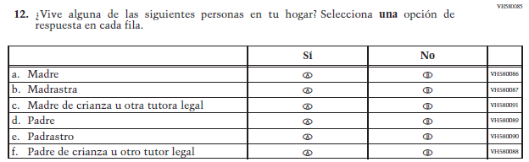  (2019 Operational Grade 8 Student Core – Puerto Rico) | Issue: Socioeconomic Status | NC | N/A

2022 Operational Grade 8 Core Student – Puerto Rico

Previous item | 2022 item | D/A/ R/NC+ | Rationale
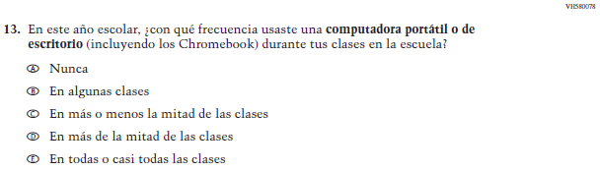  (2019 Operational Grade 8 Student Core – Puerto Rico) | Issue: Technology Use | NC | N/A
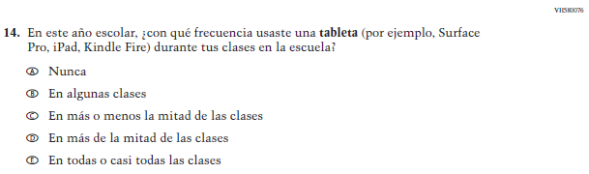  (2019 Operational Grade 8 Student Core – Puerto Rico) | Issue: Technology Use | NC | N/A
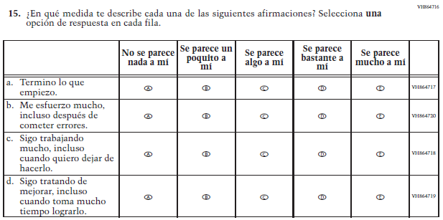  (2019 Operational Grade 8 Student Core – Puerto Rico) | Issue: Grit | NC | N/A

2022 Operational Grade 8 Core Student – Puerto Rico

Previous item | 2022 item | D/A/ R/NC+ | Rationale
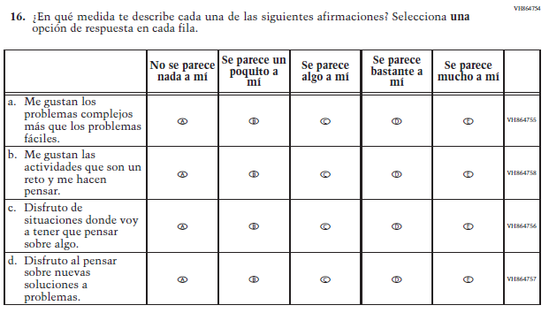  (2019 Operational Grade 8 Student Core – Puerto Rico) | Issue: Desire for Learning | NC | N/A
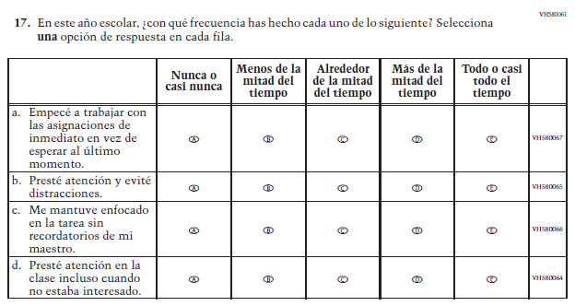  (2019 Operational Grade 8 Student Core – Puerto Rico) | Issue: Grit | NC | N/A

2022 Operational Grade 8 Core Student – Puerto Rico

Previous item | 2022 item | D/A/ R/NC+ | Rationale
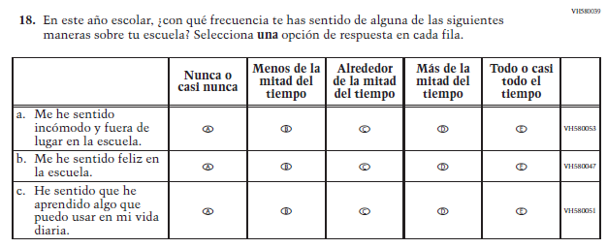  (2019 Operational Grade 8 Student Core – Puerto Rico) | N/A | D | To keep student burden low, this item was dropped.
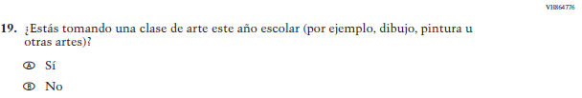  (2019 Operational Grade 8 Student Core – Puerto Rico) | 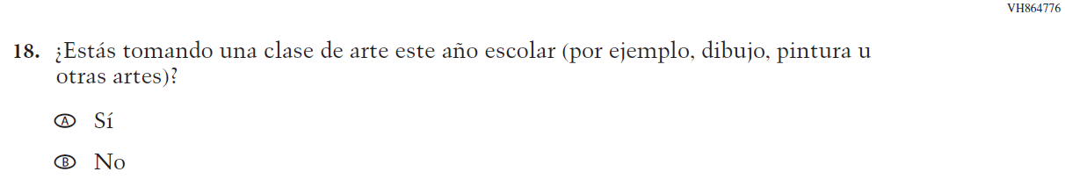  Issue: Educational Experiences | NC | N/A

Appendix J-1d-s-PR: Operational Grade 8 CORE
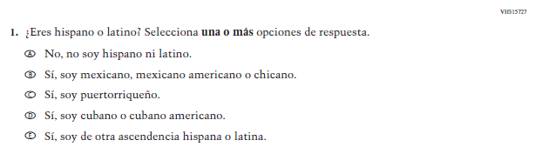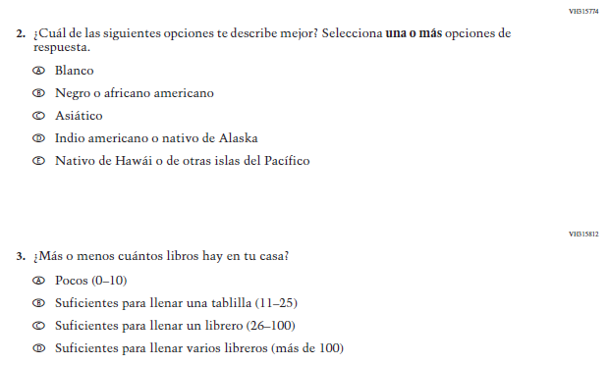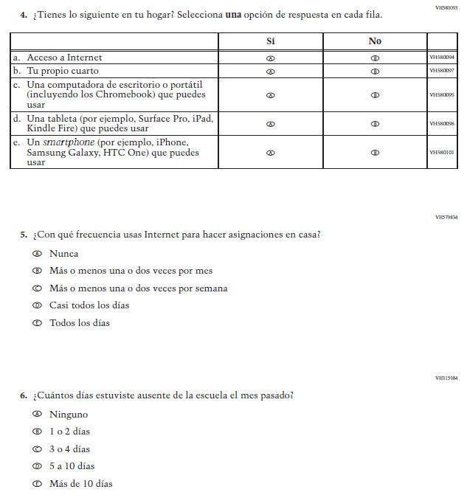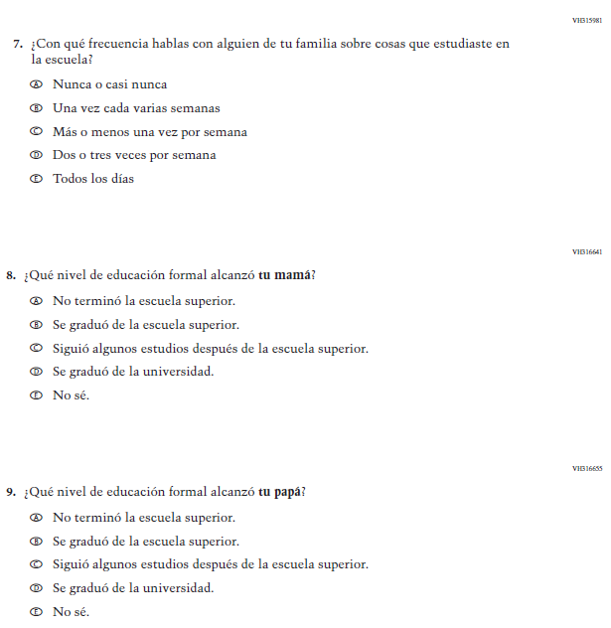
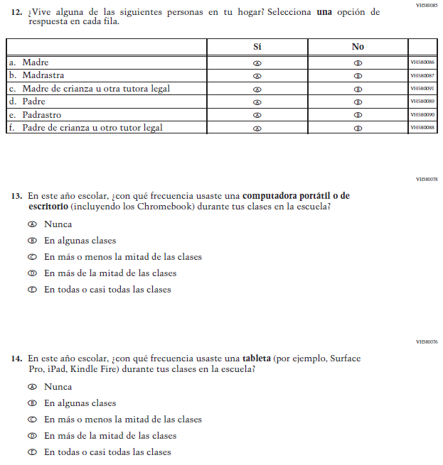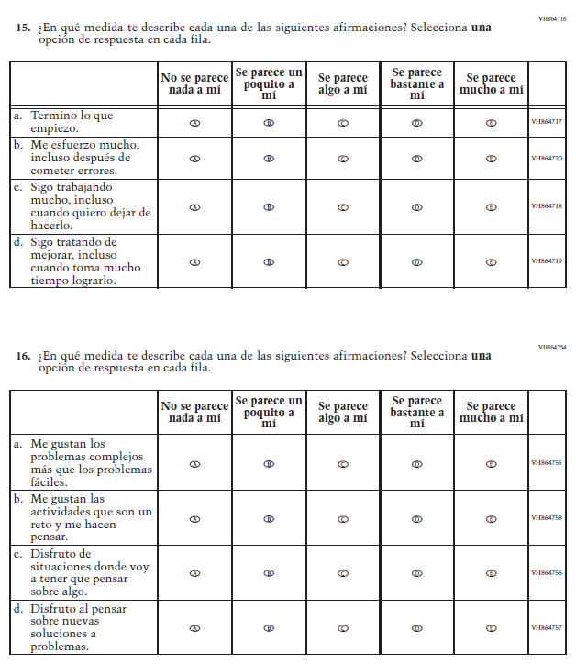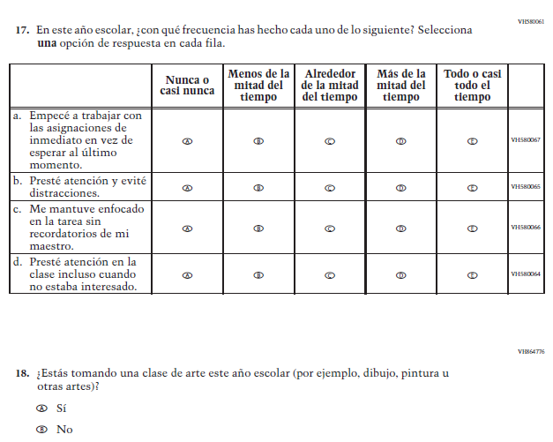

Appendix J-1e-s-BL: Summary of Changes Operational Grade 4 Mathematics
2022 Operational Grade 4 Mathematics Student – Bilingual
Previous item | 2022 item | D/A/R/NC+ | Rationale
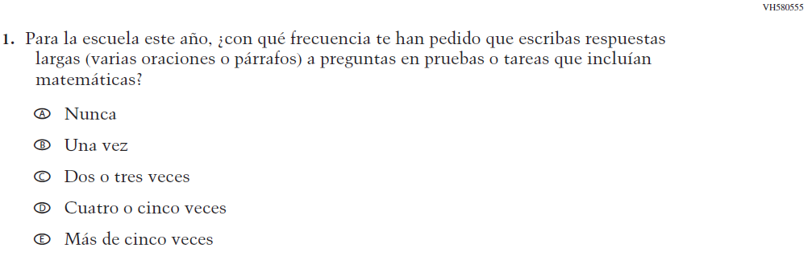  (2019 Operational Grade 4 Student Mathematics - Bilingual) | Issue: Organization of Instruction | NC | N/A
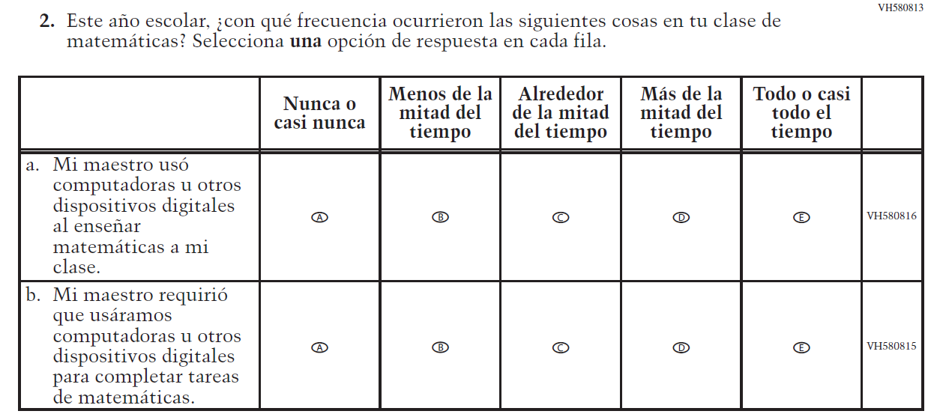  (2019 Operational Grade 4 Student Mathematics - Bilingual) | Issue: Resources for Learning and Instruction | NC | N/A

2022 Operational Grade 4 Mathematics Student – Bilingual
Previous item | 2022 item | D/A/R/NC+ | Rationale
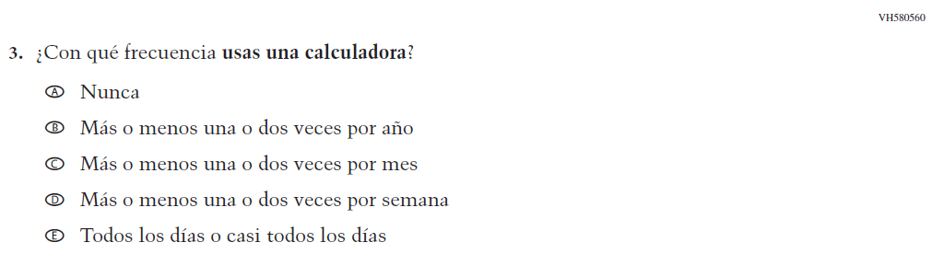  (2019 Operational Grade 4 Student Mathematics - Bilingual) | Issue: Resources for Learning and Instruction | NC | N/A
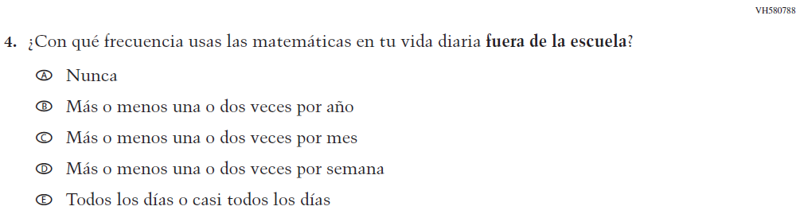  (2019 Operational Grade 4 Student Mathematics - Bilingual) | Issue: Resources for Learning and Instruction | NC | N/A
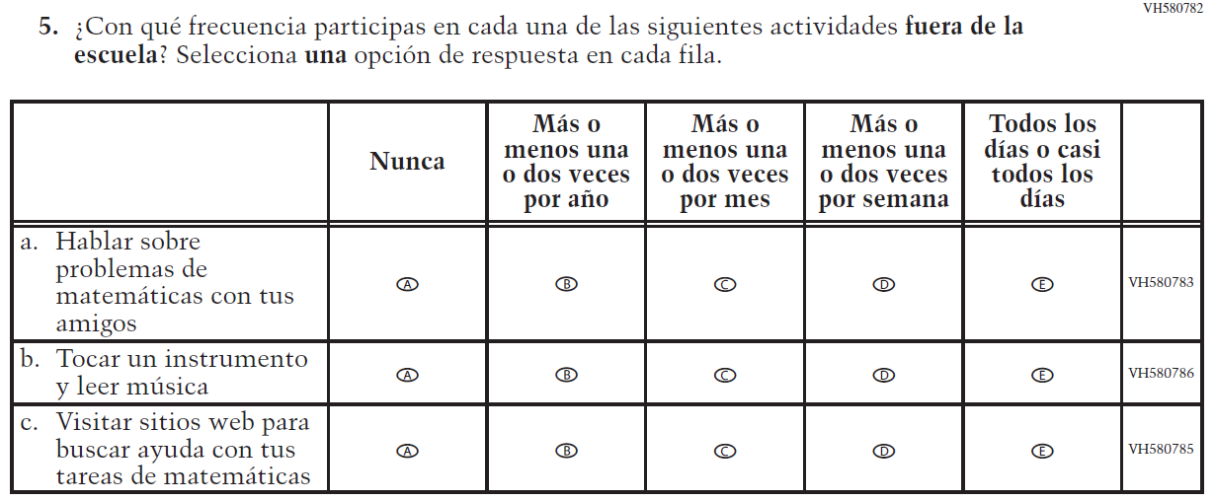  (2019 Operational Grade 4 Student Mathematics - Bilingual) | Issue: Resources for Learning and Instruction | NC | N/A

2022 Operational Grade 4 Mathematics Student – Bilingual
Previous item | 2022 item | D/A/R/NC+ | Rationale
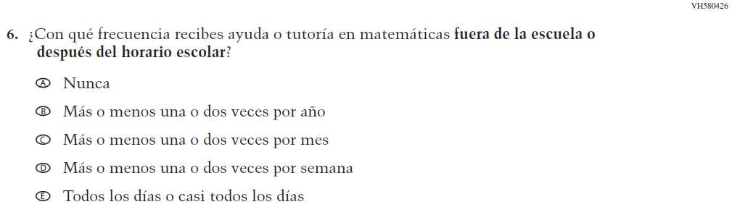  (2019 Operational Grade 4 Student Mathematics - Bilingual) | Issue: Resources for Learning and Instruction | NC | N/A
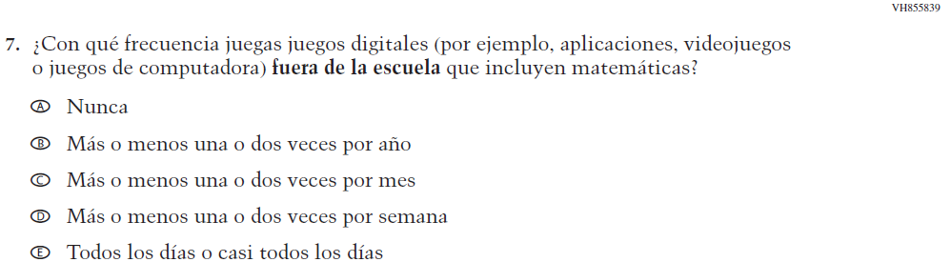  (2019 Operational Grade 4 Student Mathematics - Bilingual) | Issue: Resources for Learning and Instruction | NC | N/A
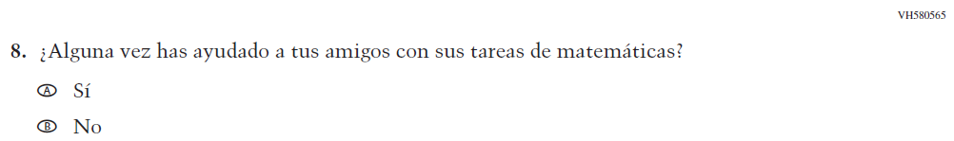  (2019 Operational Grade 4 Student Mathematics - Bilingual) | N/A | D | To keep student burden low, this item was dropped.
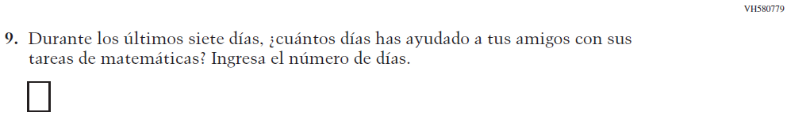  (2019 Operational Grade 4 Student Mathematics - Bilingual) | N/A | D | To keep student burden low, this item was dropped.

2022 Operational Grade 4 Mathematics Student – Bilingual
Previous item | 2022 item | D/A/R/NC+ | Rationale
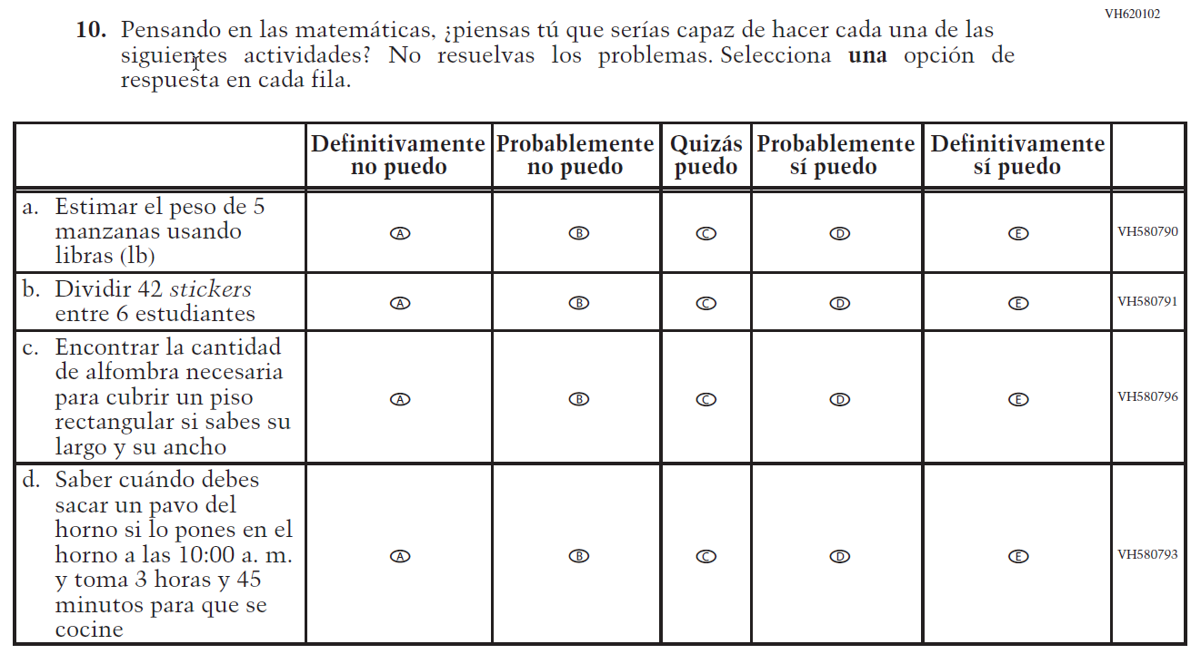  (2019 Operational Grade 4 Student Mathematics - Bilingual) | 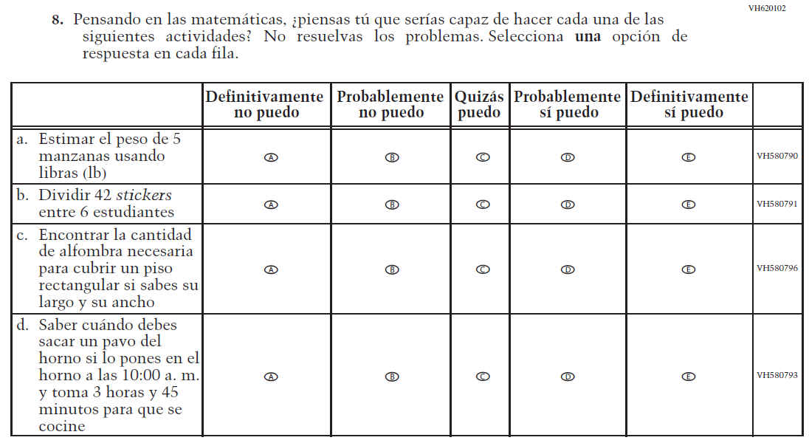  Issue: Student Factors | NC | N/A
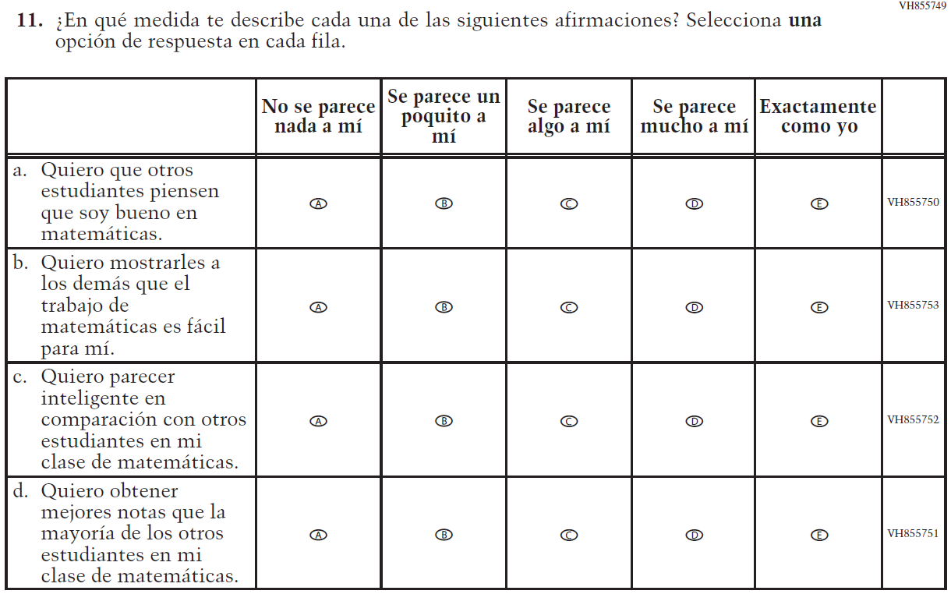  (2019 Operational Grade 4 Student Mathematics - Bilingual) | N/A | D | To keep student burden low, this item was dropped.

2022 Operational Grade 4 Mathematics Student – Bilingual
Previous item | 2022 item | D/A/R/NC+ | Rationale
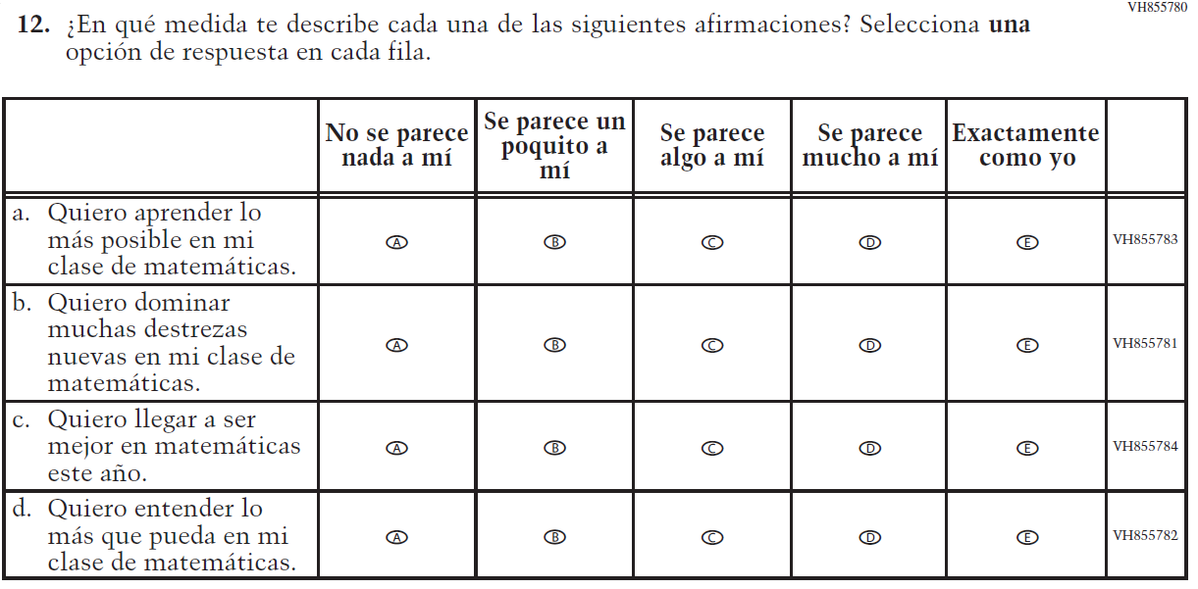  (2019 Operational Grade 4 Student Mathematics - Bilingual) | 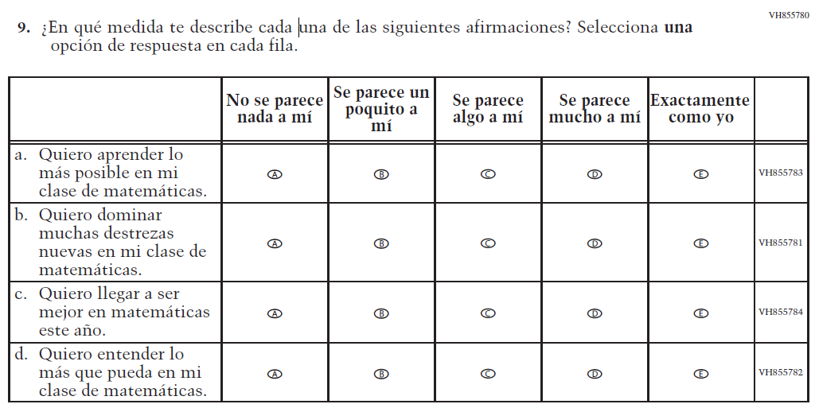  Issue: Student Factors | NC | N/A
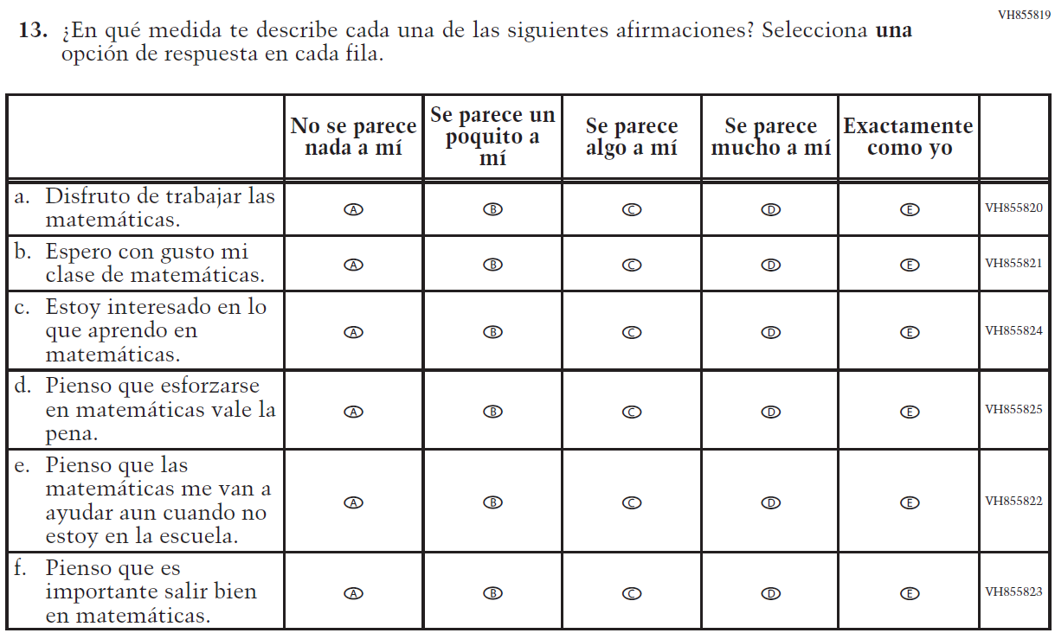  (2019 Operational Grade 4 Student Mathematics - Bilingual) | 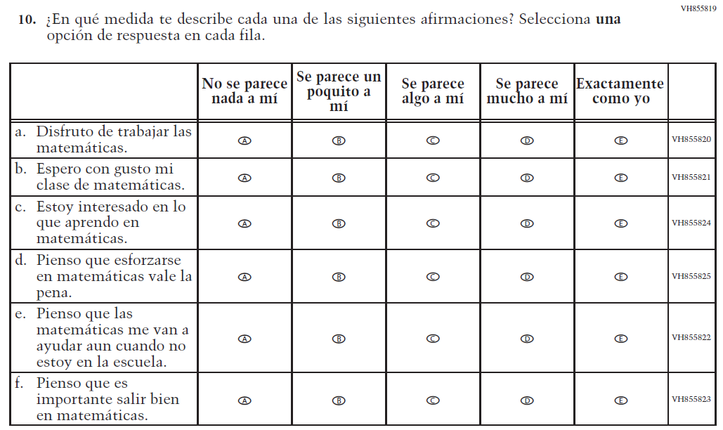  Issue: Student Factors | NC | N/A

Appendix J-1e-s-BL: Operational Grade 4 Mathematics
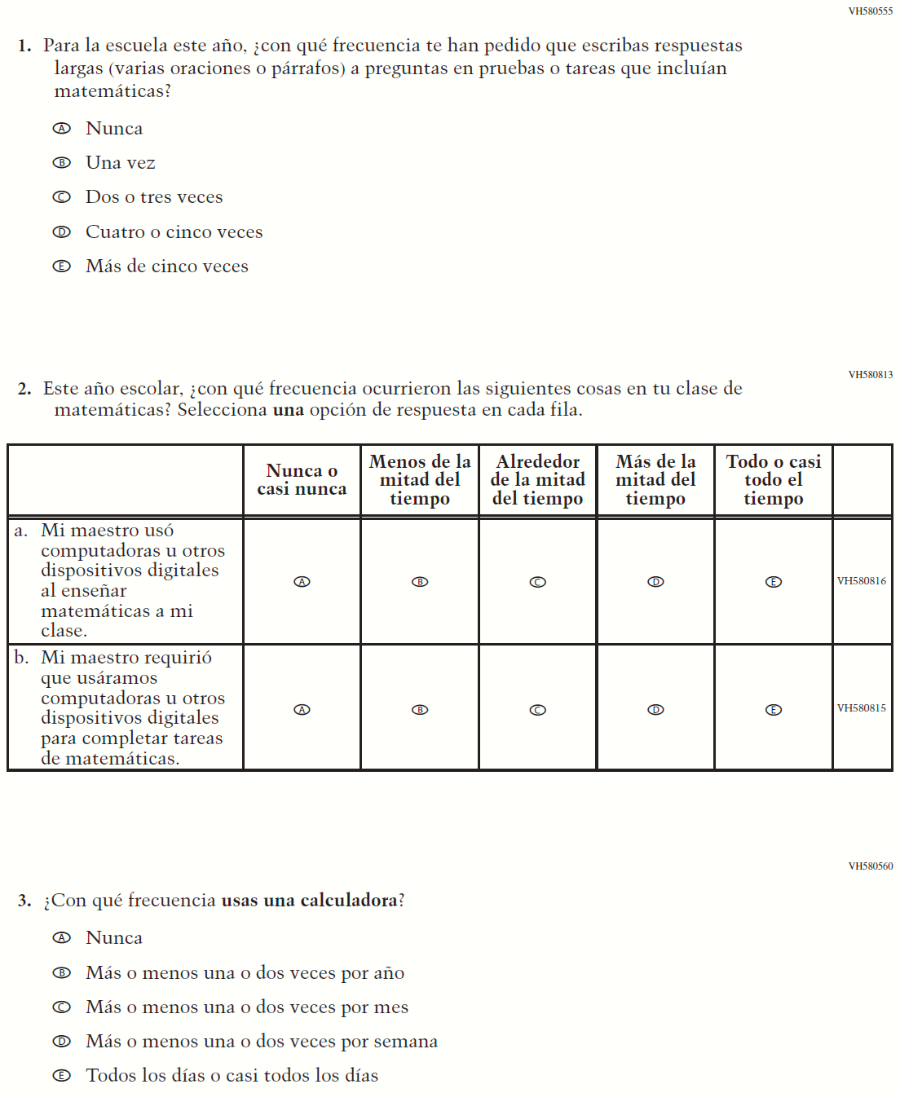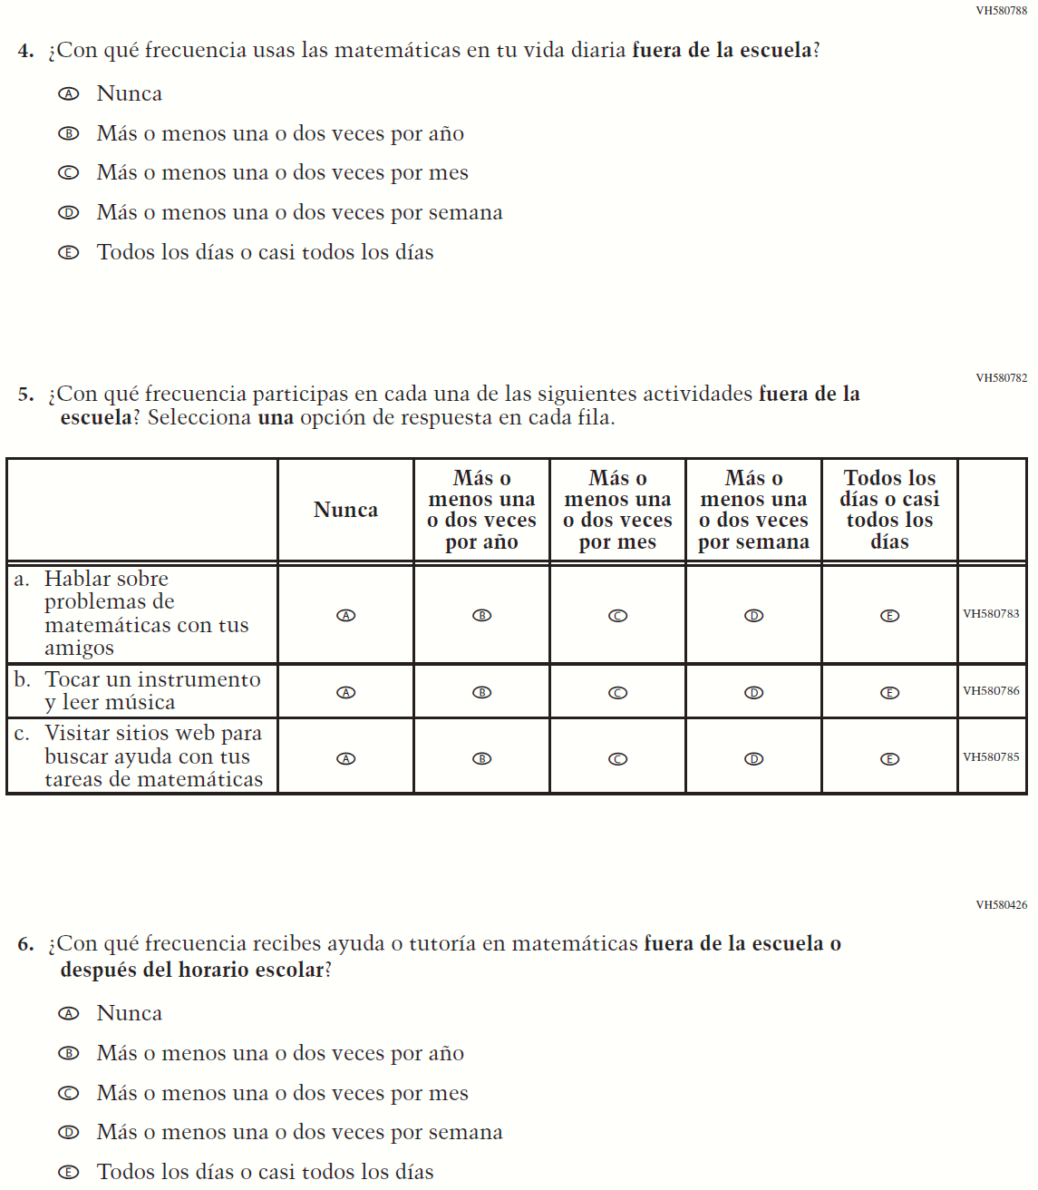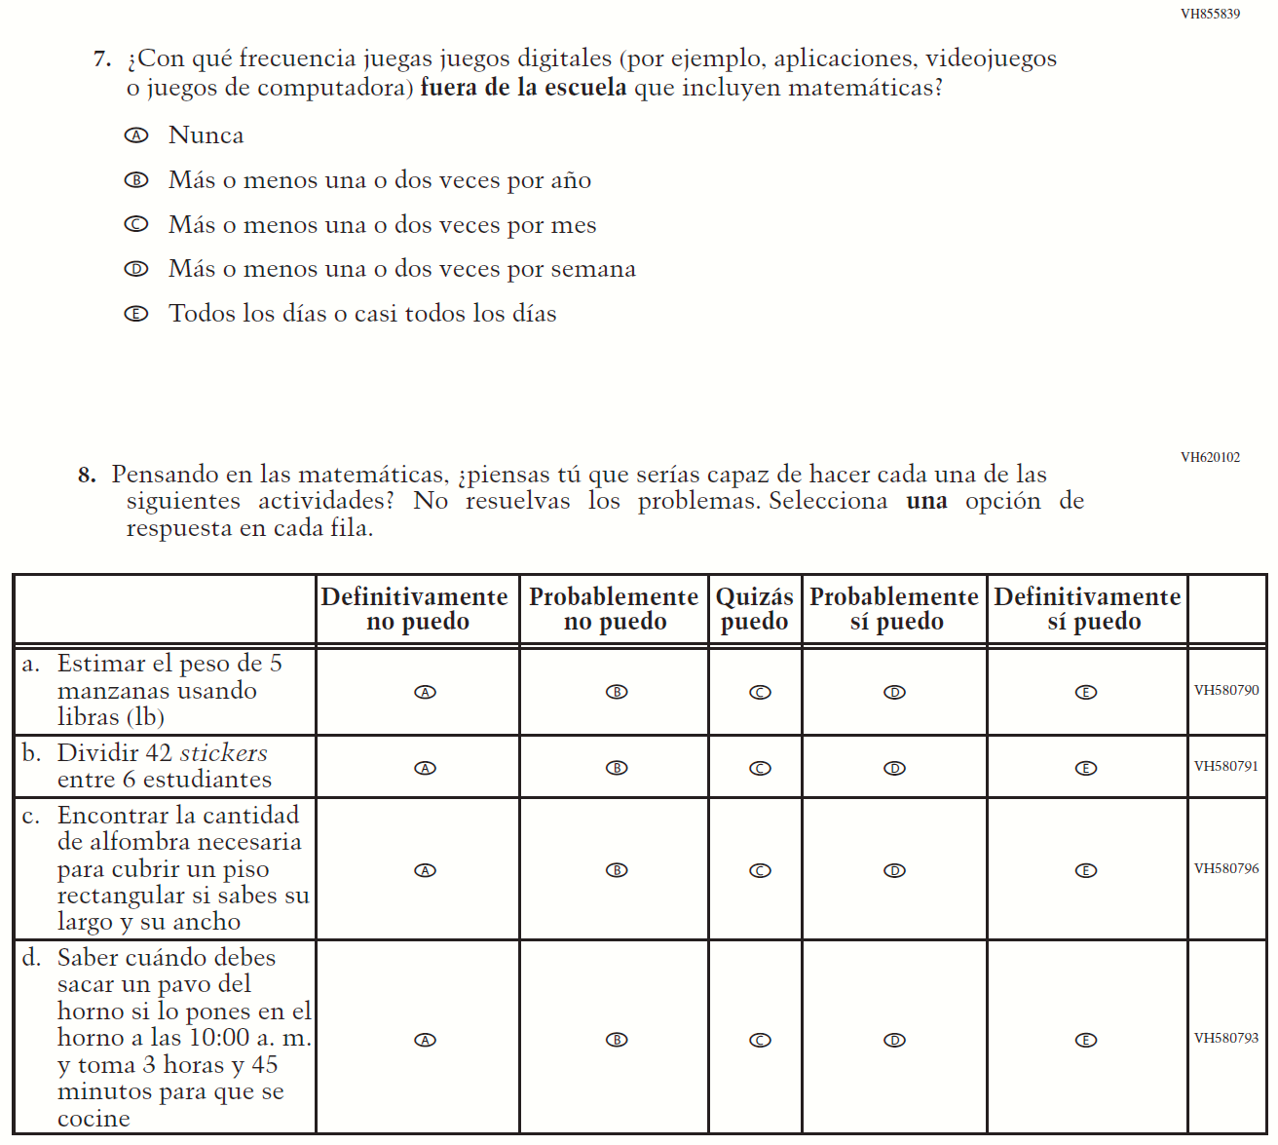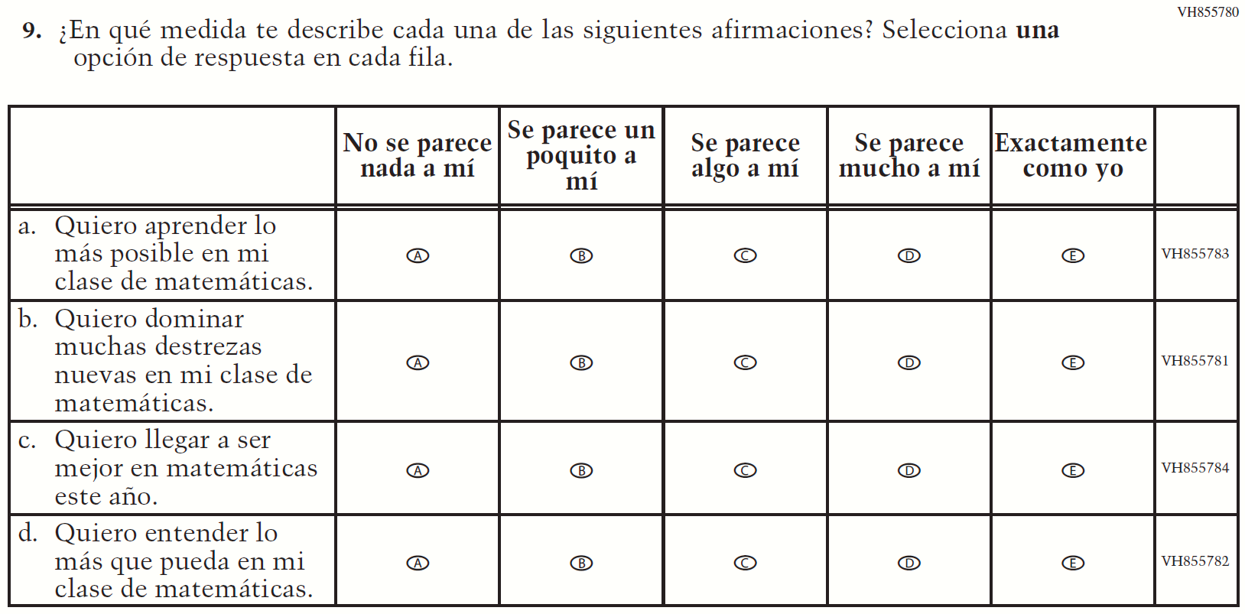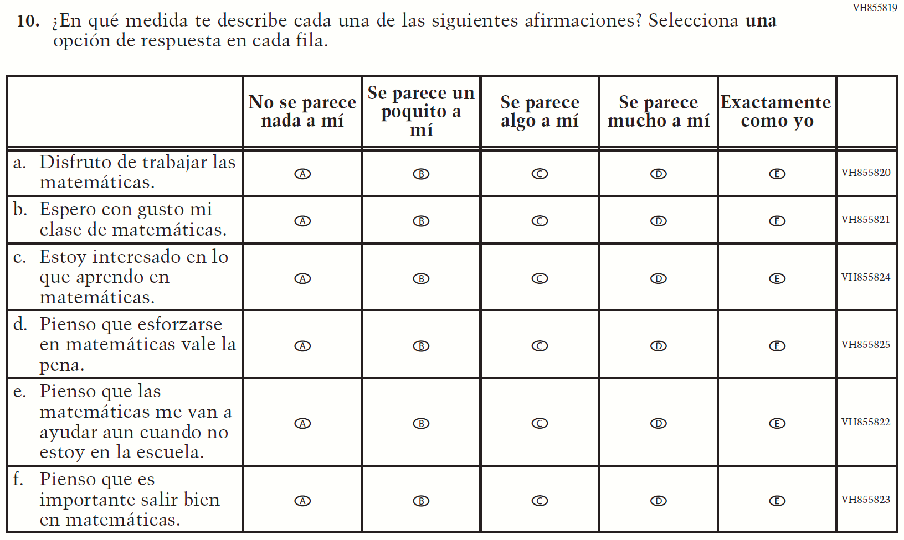

Appendix J-1f-s-PR: Summary of Changes Operational Grade 4 Mathematics
2022 Operational Grade 4 Mathematics Student – Puerto Rico

Previous item | 2022 item | D/A/ R/NC+ | Rationale
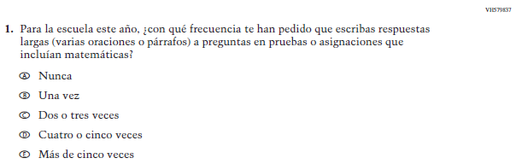  (2019 Operational Grade 4 Student Mathematics – Puerto Rico) | Issue: Organization of Instruction | NC | N/A
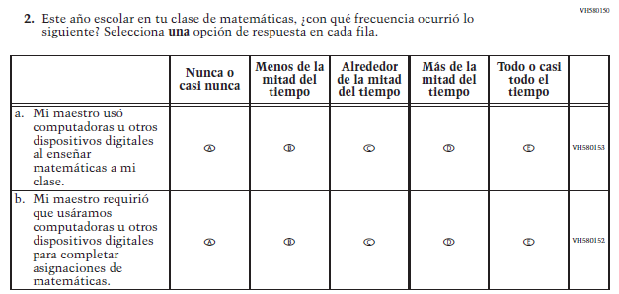  (2019 Operational Grade 4 Student Mathematics – Puerto Rico) | Issue: Resources for Learning and Instruction | NC | N/A
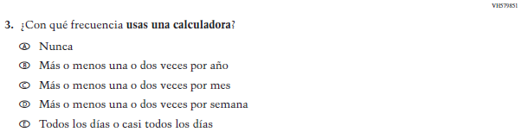  (2019 Operational Grade 4 Student Mathematics – Puerto Rico) | Issue: Resources for Learning and Instruction | NC | N/A
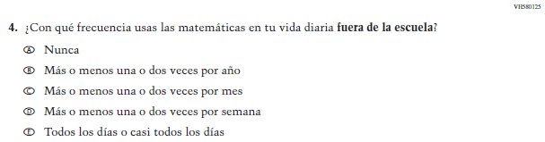  (2019 Operational Grade 4 Student Mathematics – Puerto Rico) | Issue: Resources for Learning and Instruction | NC | N/A
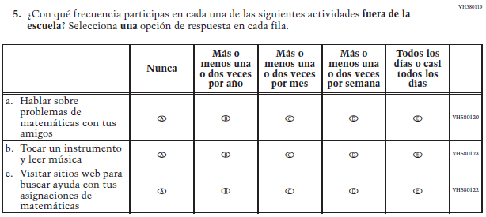  (2019 Operational Grade 4 Student Mathematics – Puerto Rico) | Issue: Resources for Learning and Instruction | NC | N/A
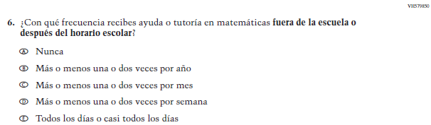  (2019 Operational Grade 4 Student Mathematics – Puerto Rico) | Issue: Resources for Learning and Instruction | NC | N/A

2022 Operational Grade 4 Mathematics Student – Puerto Rico

Previous item | 2022 item | D/A/ R/NC+ | Rationale
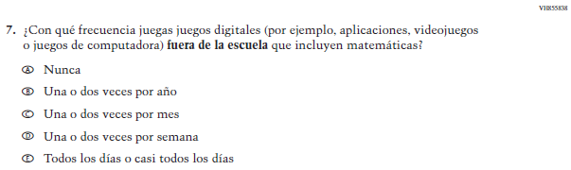  (2019 Operational Grade 4 Student Mathematics – Puerto Rico) | Issue: Resources for Learning and Instruction | NC | N/A
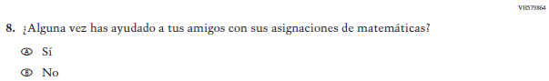  (2019 Operational Grade 4 Student Mathematics – Puerto Rico) | N/A | D | To keep student burden low, this item was dropped.
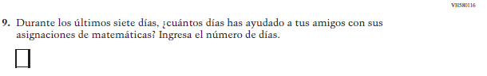  (2019 Operational Grade 4 Student Mathematics – Puerto Rico) | N/A | D | To keep student burden low, this item was dropped.
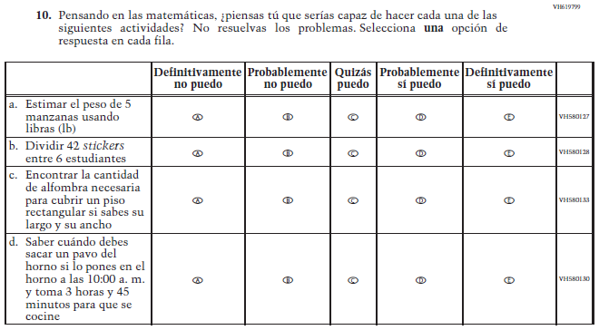  (2019 Operational Grade 4 Student Mathematics – Puerto Rico) | 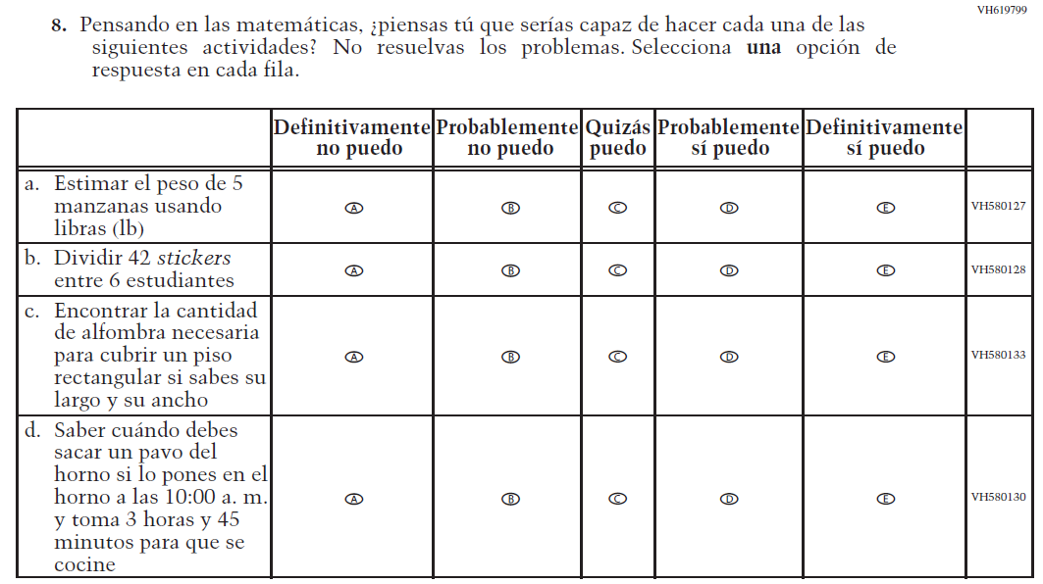  Issue: Student Factors | NC | N/A

2022 Operational Grade 4 Mathematics Student – Puerto Rico

Previous item | 2022 item | D/A/ R/NC+ | Rationale
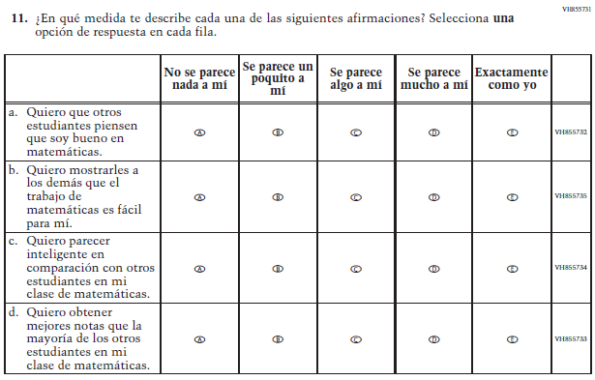  (2019 Operational Grade 4 Student Mathematics – Puerto Rico) | N/A | D | To keep student burden low, this item was dropped.
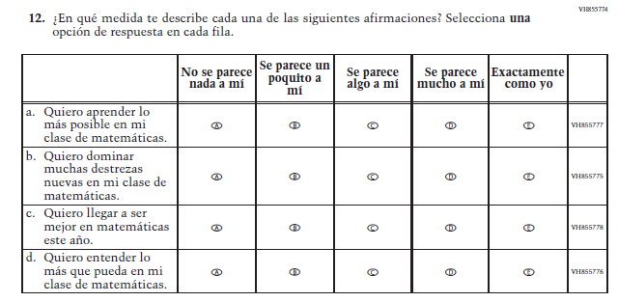  (2019 Operational Grade 4 Student Mathematics – Puerto Rico) | 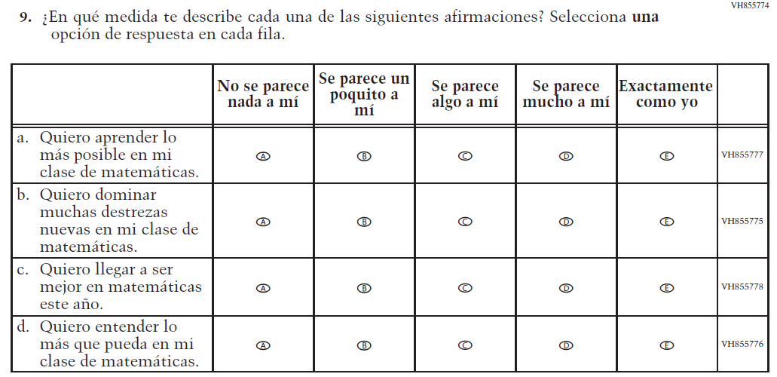  Issue: Student Factors | NC | N/A

2022 Operational Grade 4 Mathematics Student – Puerto Rico

Previous item | 2022 item | D/A/ R/NC+ | Rationale
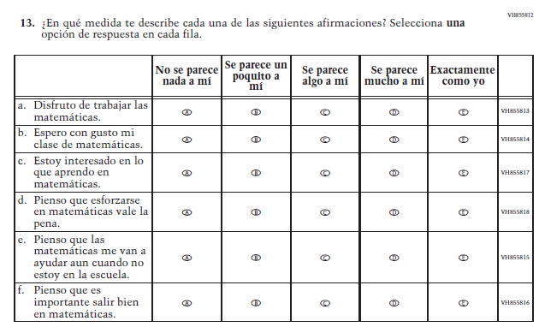  (2019 Operational Grade 4 Student Mathematics – Puerto Rico) | 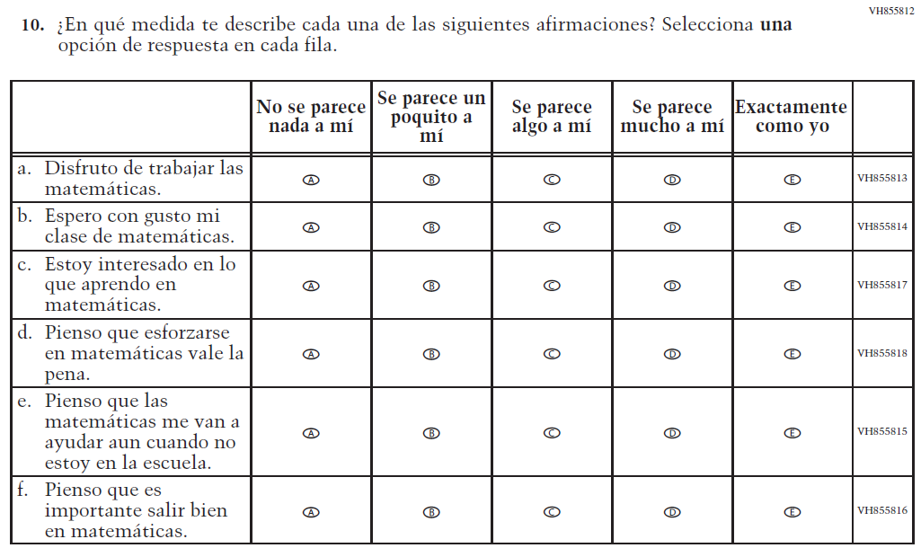  Issue: Student Factors | NC | N/A

Appendix J-1f-s-PR: Operational Grade 4 Mathematics
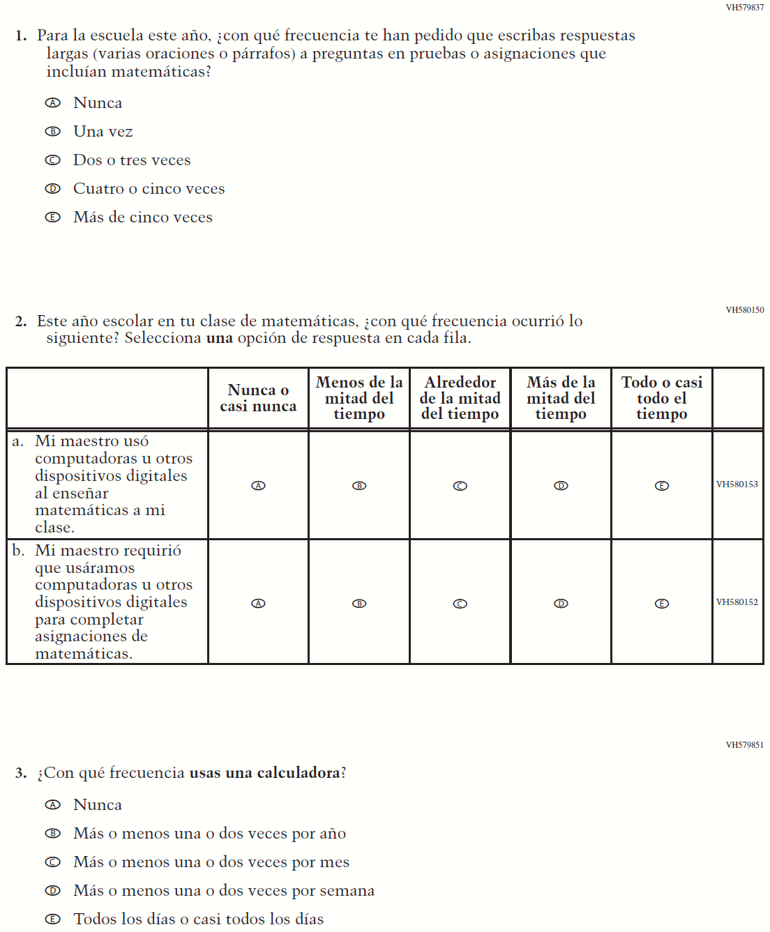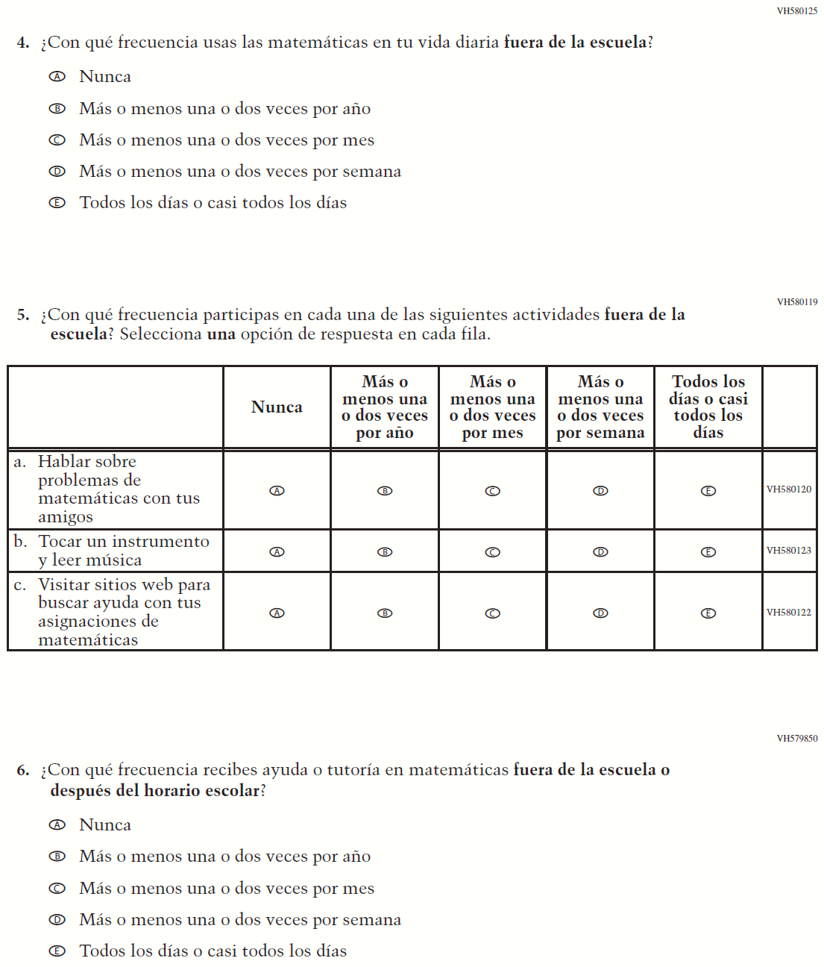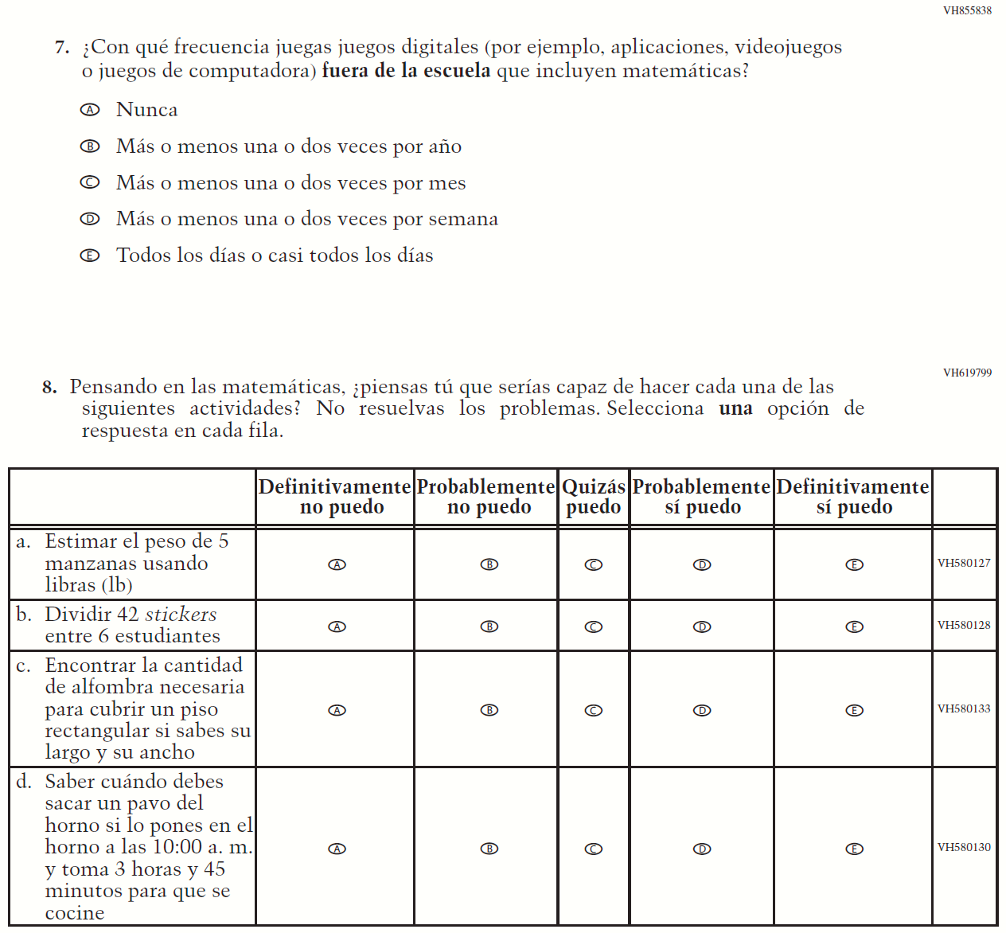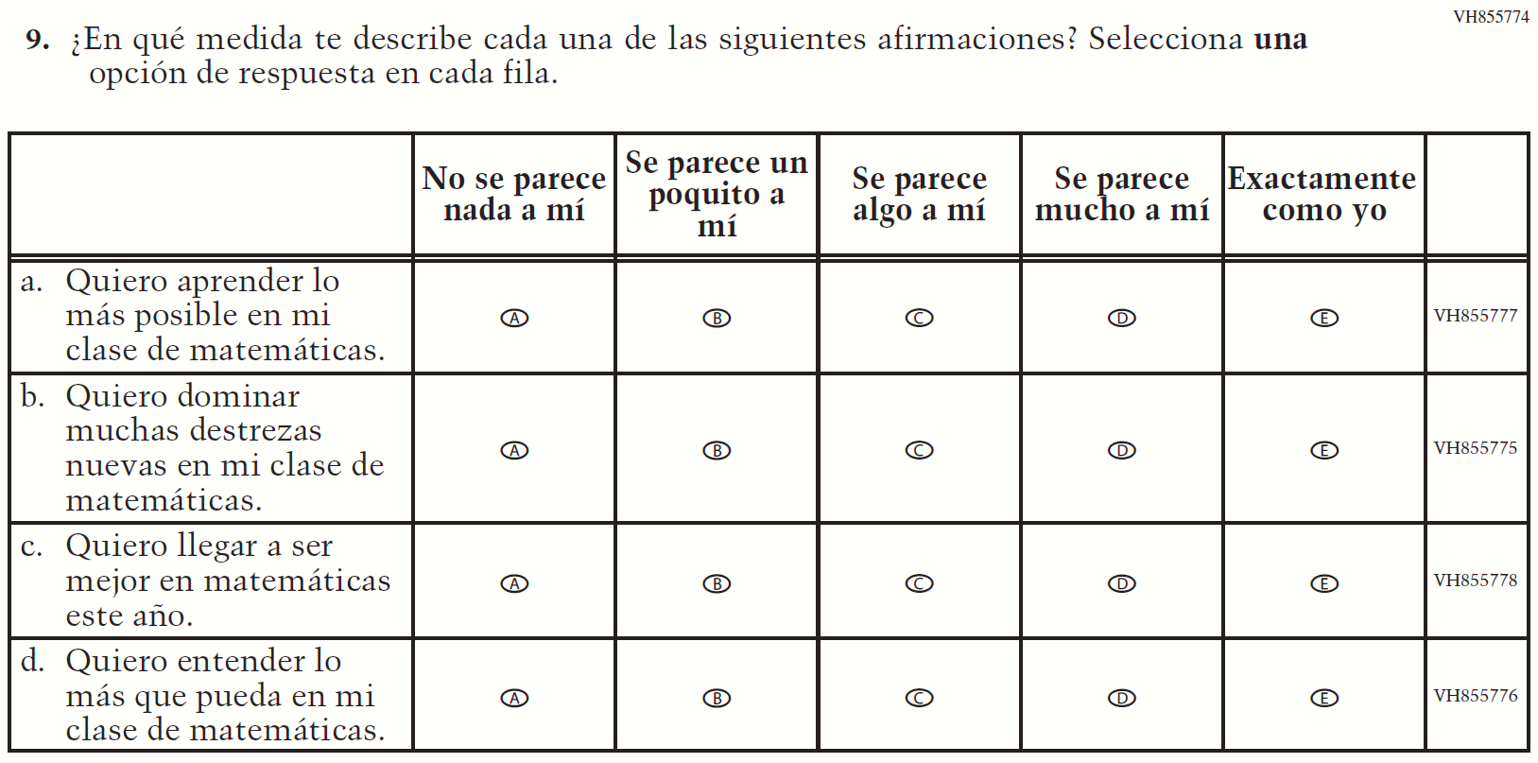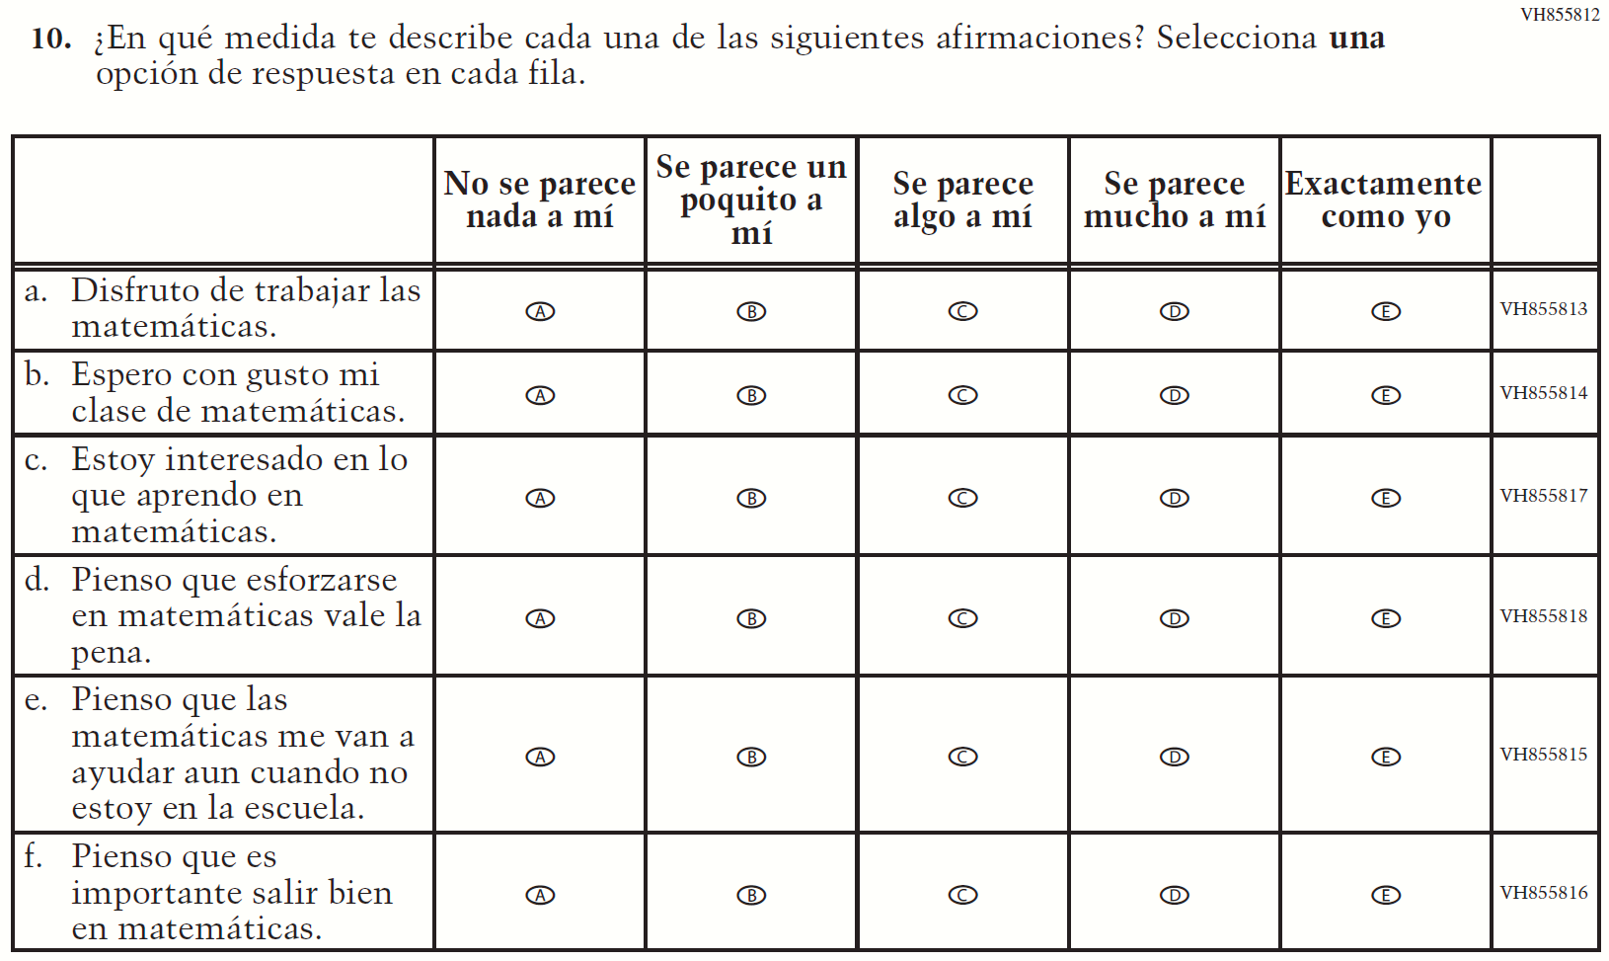

Appendix J-1g-s-BL: Summary of Changes Operational Grade 8 Mathematics
2022 Operational Grade 8 Mathematics Student – Bilingual
Previous item | 2022 item | D/A/R/NC+ | Rationale
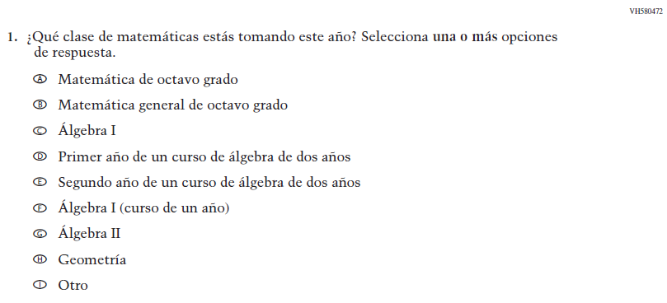  (2019 Operational Grade 8 Student Mathematics - Bilingual) | Issue: Organization of Instruction | NC | N/A
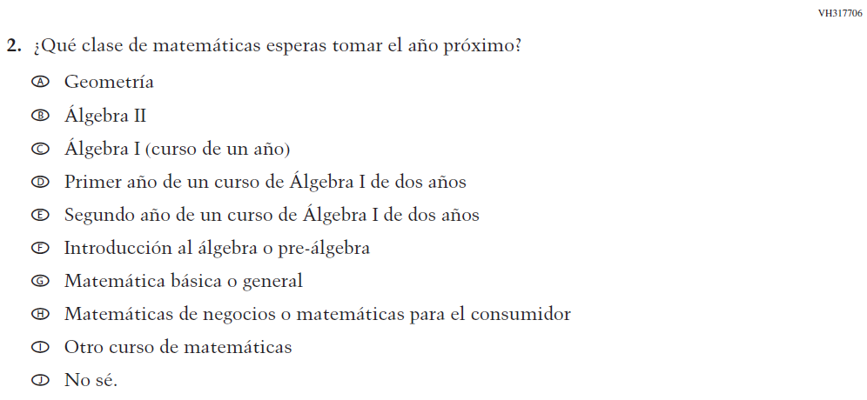  (2019 Operational Grade 8 Student Mathematics - Bilingual) | 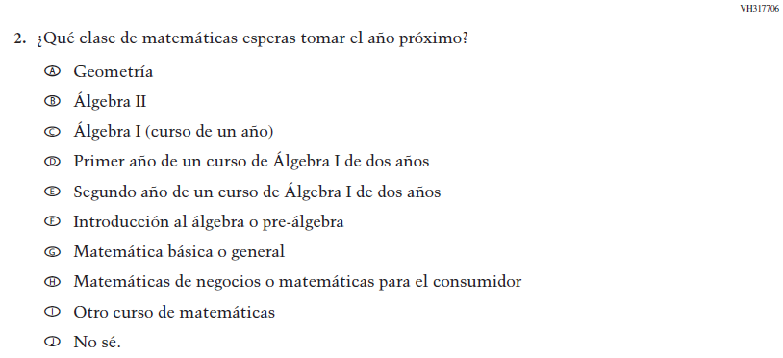  Issue: Organization of Instruction | NC | N/A

2022 Operational Grade 8 Mathematics Student – Bilingual
Previous item | 2022 item | D/A/R/NC+ | Rationale
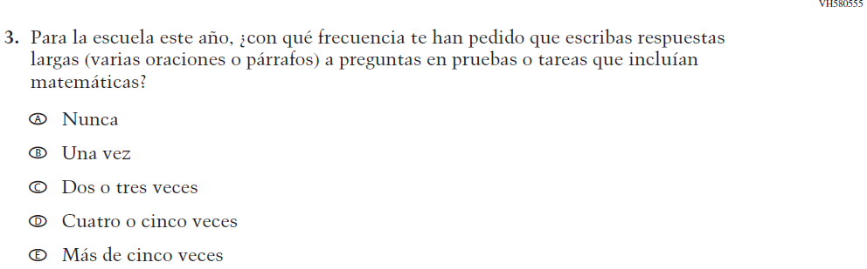  (2019 Operational Grade 8 Student Mathematics - Bilingual) | Issue: Organization of Instruction | NC | N/A
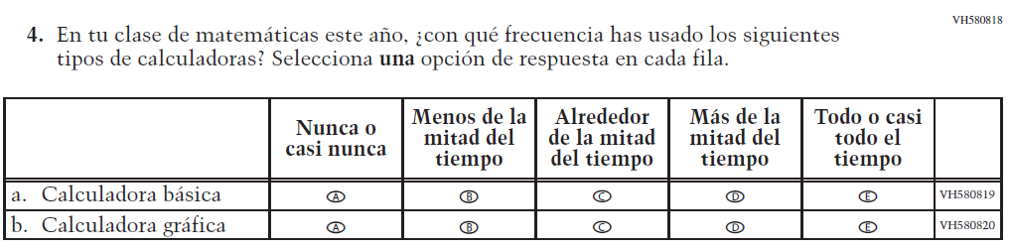  (2019 Operational Grade 8 Student Mathematics - Bilingual) | 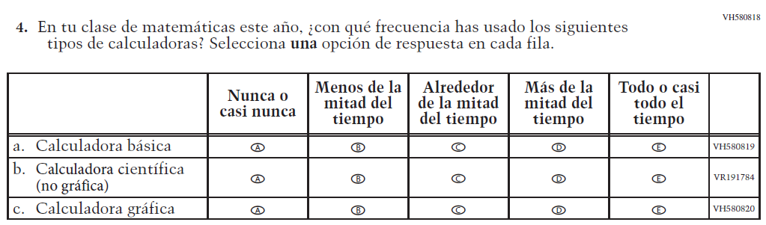  Issue: Resources for Learning and Instruction | A: sub-item “b”  NC for SL and sub-items “a” and “c” | The “Scientific (not graphing) calculator” sub-item was dropped previously due to an oversight and is being reinstated to capture calculator features in mathematics as students progress from K to 12.

2022 Operational Grade 8 Mathematics Student – Bilingual
Previous item | 2022 item | D/A/R/NC+ | Rationale
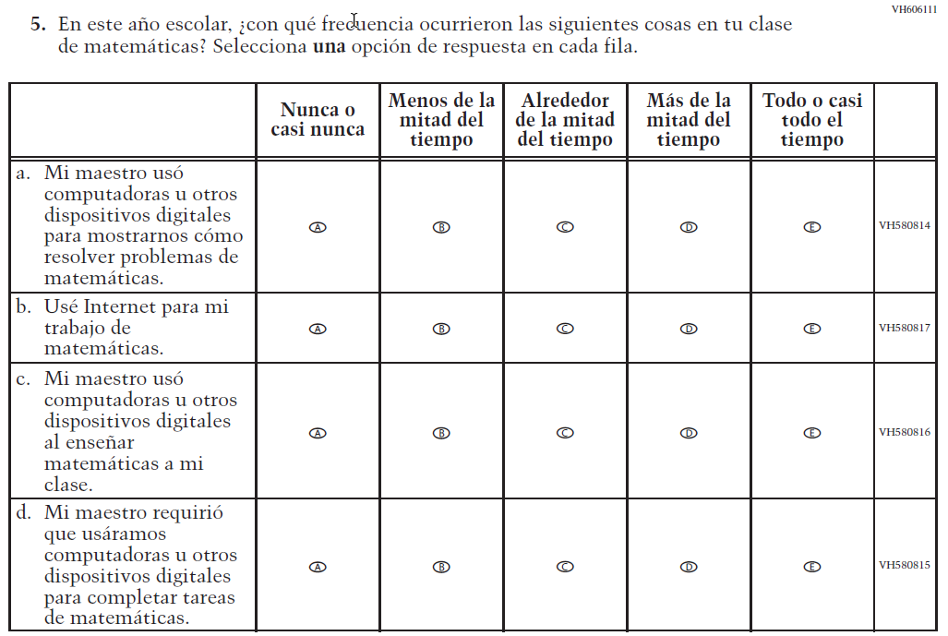  (2019 Operational Grade 8 Student Mathematics - Bilingual) | 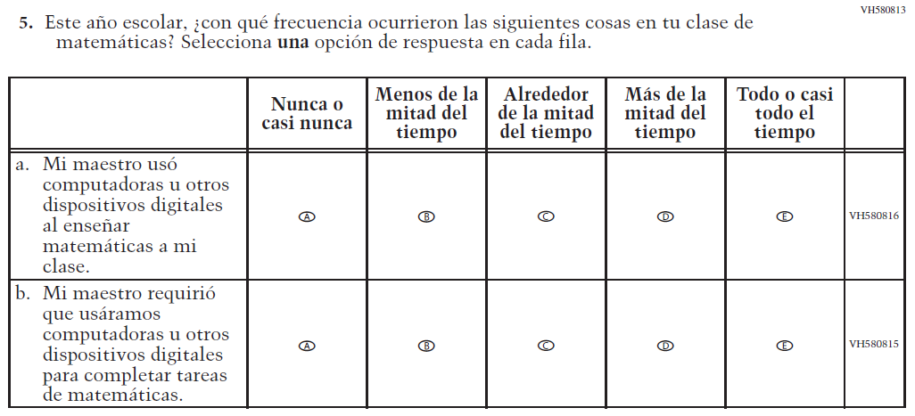  Issue: Resources for Learning and Instruction | R | To keep student burden low, sub-items a and b were dropped.
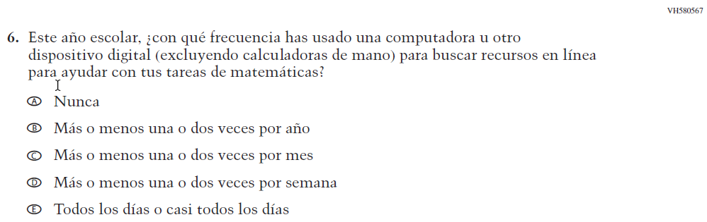  (2019 Operational Grade 8 Student Mathematics - Bilingual) | N/A | D | To keep student burden low, this item was dropped.

2022 Operational Grade 8 Mathematics Student – Bilingual
Previous item | 2022 item | D/A/R/NC+ | Rationale
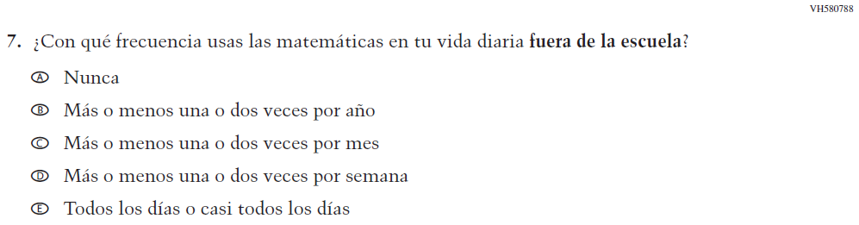  (2019 Operational Grade 8 Student Mathematics - Bilingual) | 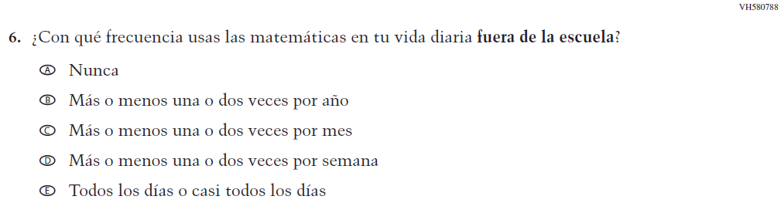  Issue: Resources for Learning and Instruction | NC | N/A
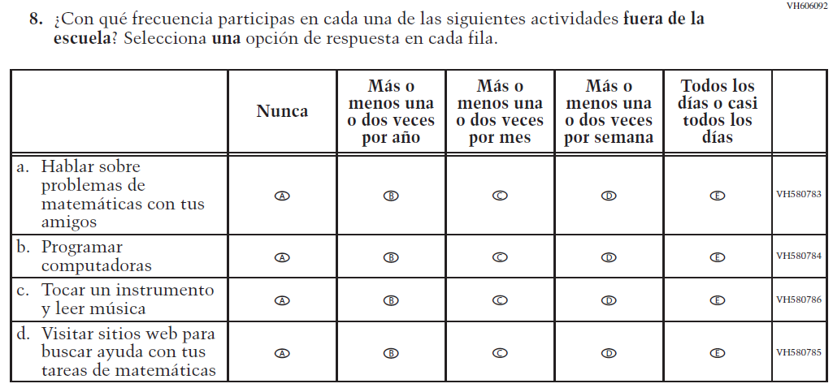  (2019 Operational Grade 8 Student Mathematics - Bilingual) | 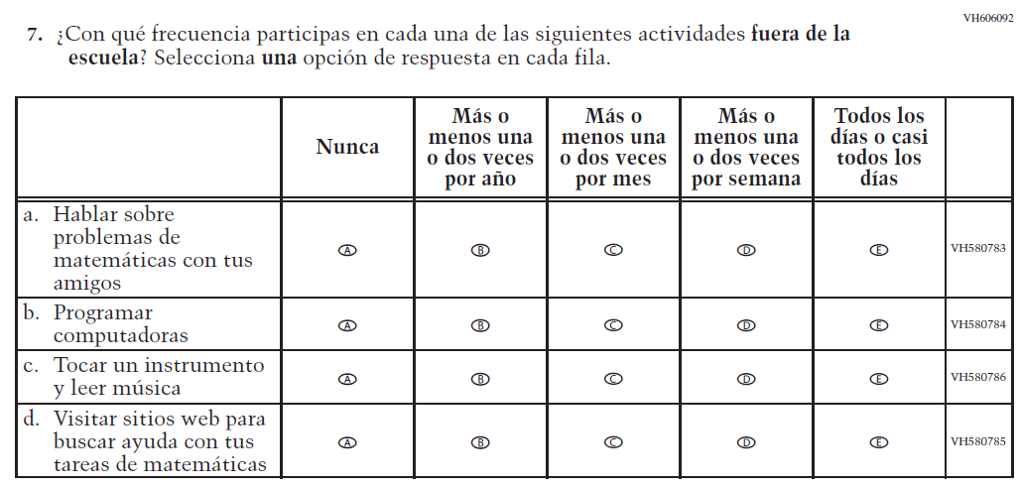  Issue: Resources for Learning and Instruction | NC | N/A

2022 Operational Grade 8 Mathematics Student – Bilingual
Previous item | 2022 item | D/A/R/NC+ | Rationale
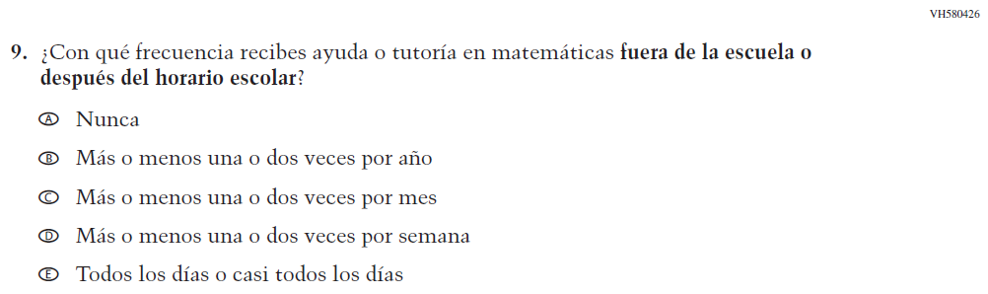  (2019 Operational Grade 8 Student Mathematics - Bilingual) | 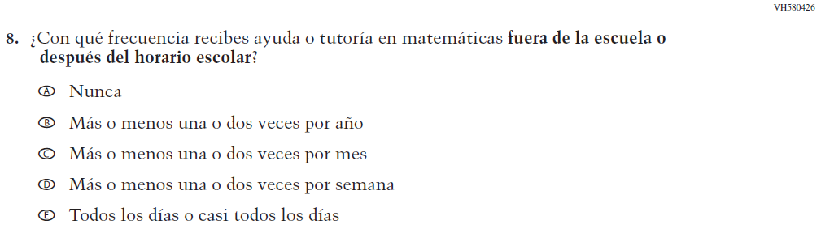  Issue: Resources for Learning and Instruction | NC | N/A
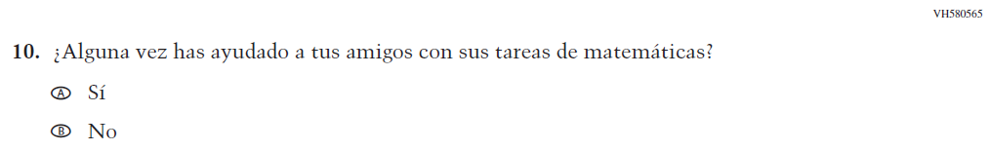  (2019 Operational Grade 8 Student Mathematics - Bilingual) | N/A | D | To keep student burden low, this item was dropped.
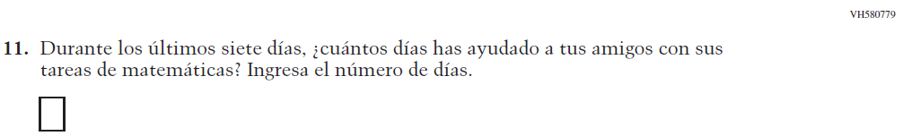  (2019 Operational Grade 8 Student Mathematics - Bilingual) | N/A | D | To keep student burden low, this item was dropped.
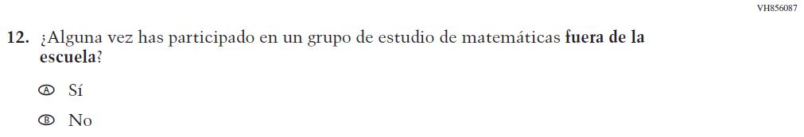  (2019 Operational Grade 8 Student Mathematics - Bilingual) | N/A | D | To keep student burden low, this item was dropped.

2022 Operational Grade 8 Mathematics Student – Bilingual
Previous item | 2022 item | D/A/R/NC+ | Rationale
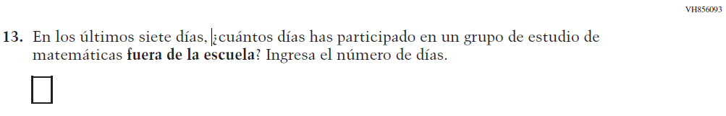  (2019 Operational Grade 8 Student Mathematics - Bilingual) | N/A | D | To keep student burden low, this item was dropped.
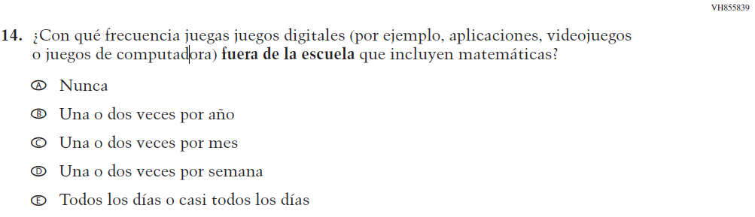  (2019 Operational Grade 8 Student Mathematics - Bilingual) | 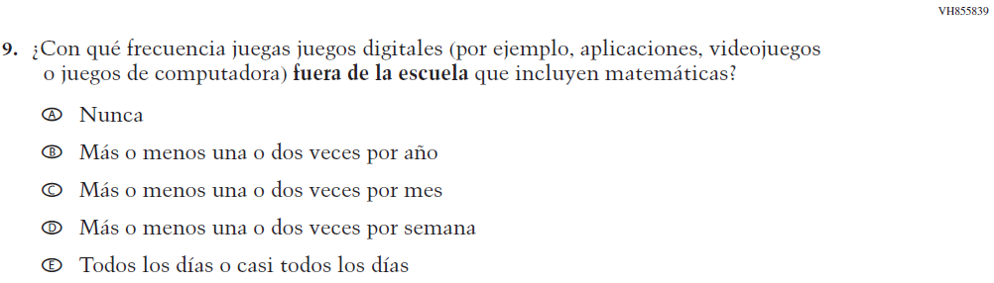  Issue: Resources for Learning and Instruction | NC | N/A

2022 Operational Grade 8 Mathematics Student – Bilingual
Previous item |  | 2022 item |  | D/A/R/NC+ |  | Rationale
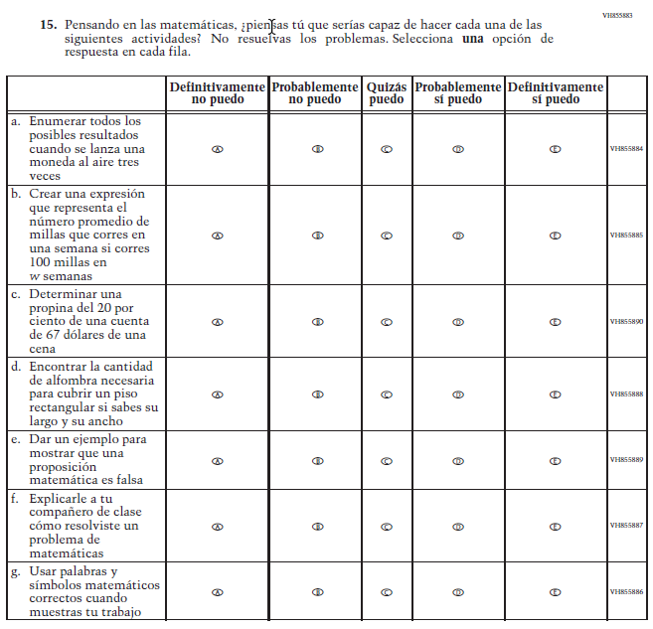  (2019 Operational Grade 8 Student Mathematics - Bilingual) |  | 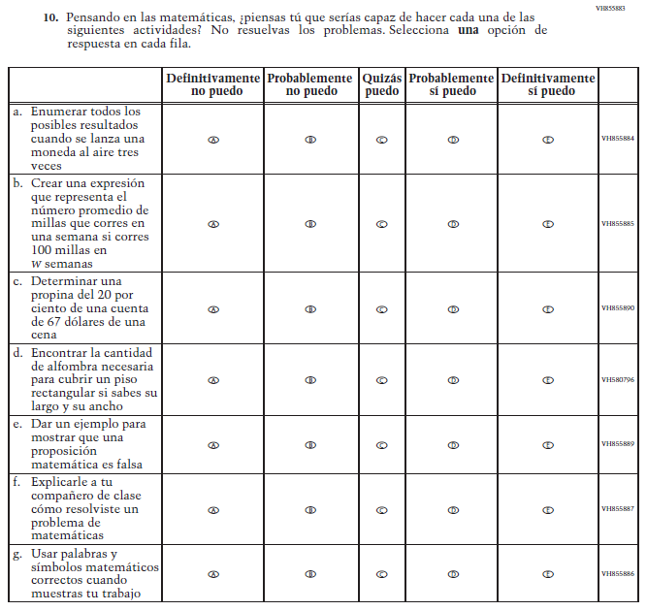  Issue: Student factors |  | NC |  | N/A
2022 Operational Grade 8 Mathematics Student – Bilingual
Previous item | 2022 item |  | D/A/R/NC+ |  | Rationale
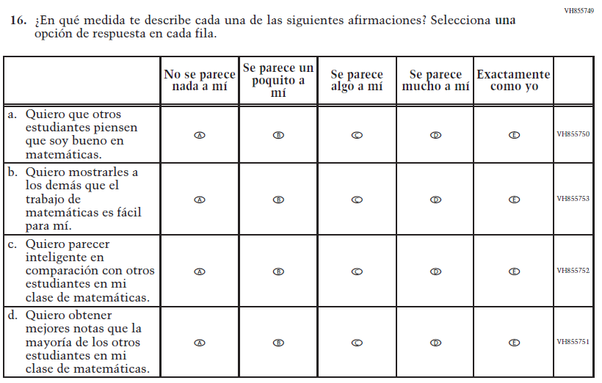  (2019 Operational Grade 8 Student Mathematics - Bilingual) | N/A |  | D |  | To keep student burden low, this item was dropped.
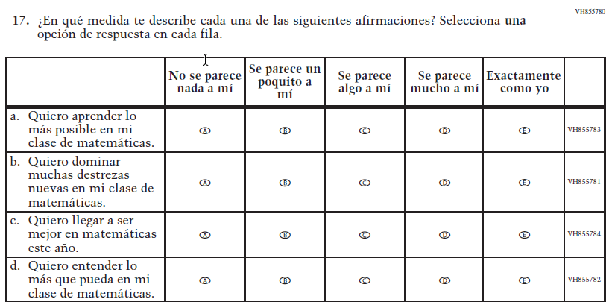  (2019 Operational Grade 8 Student Mathematics - Bilingual) | 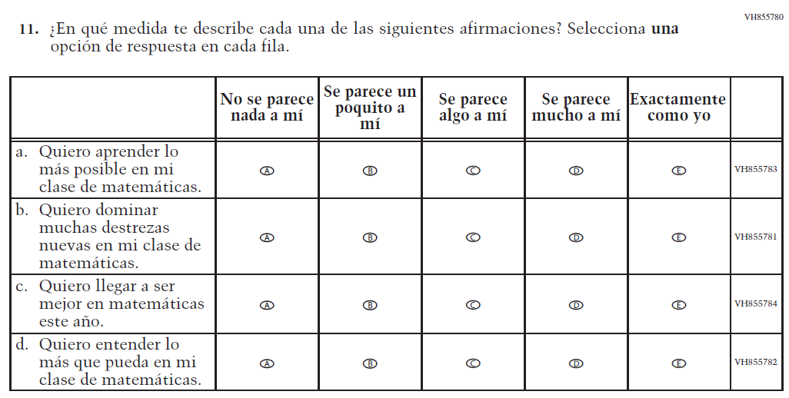  Issue: Student Factors |  | NC |  | N/A

2022 Operational Grade 8 Mathematics Student – Bilingual
Previous item | 2022 item | D/A/R/NC+ | Rationale
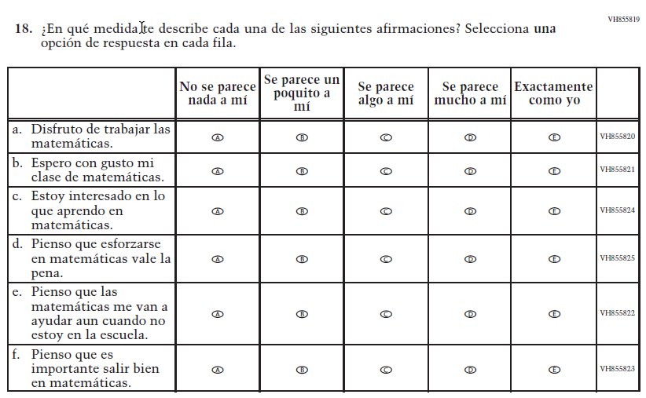  (2019 Operational Grade 8 Student Mathematics - Bilingual) | 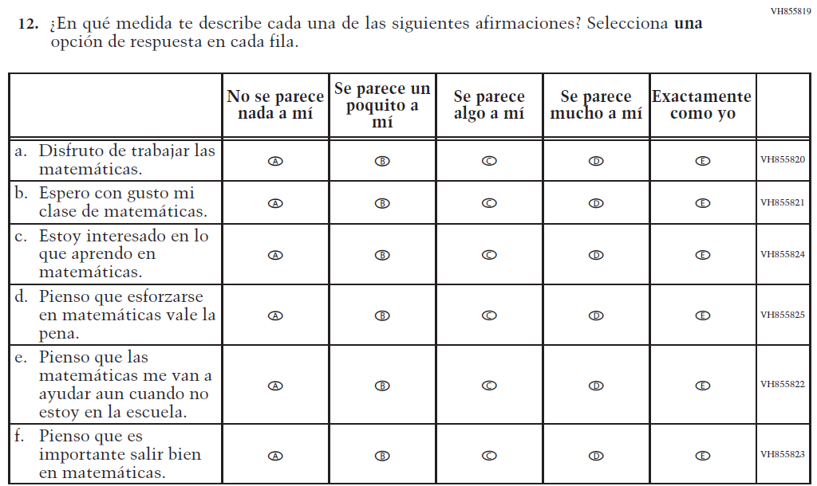  Issue: Student Factors | NC | N/A
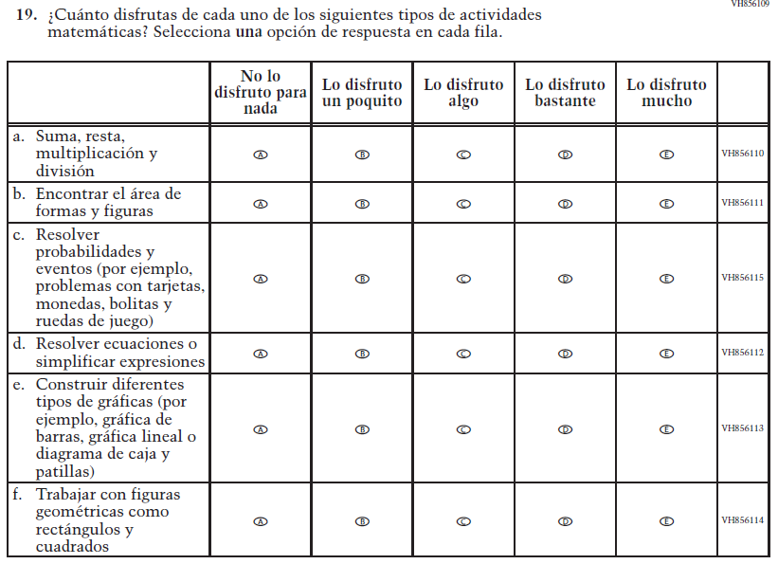  (2019 Operational Grade 8 Student Mathematics - Bilingual) | 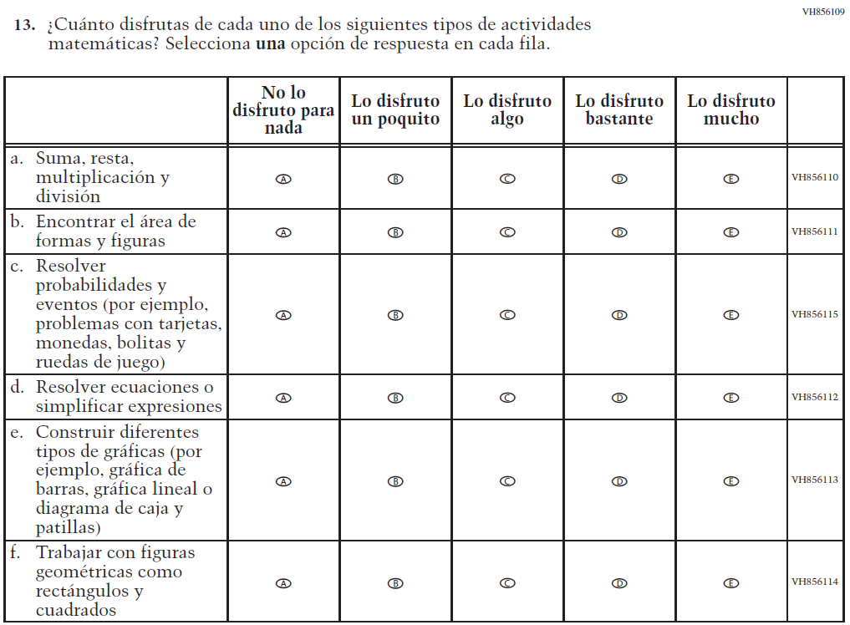  Issue: Student Factors | NC | N/A

Appendix J-1g-s-BL: Operational Grade 8 Mathematics
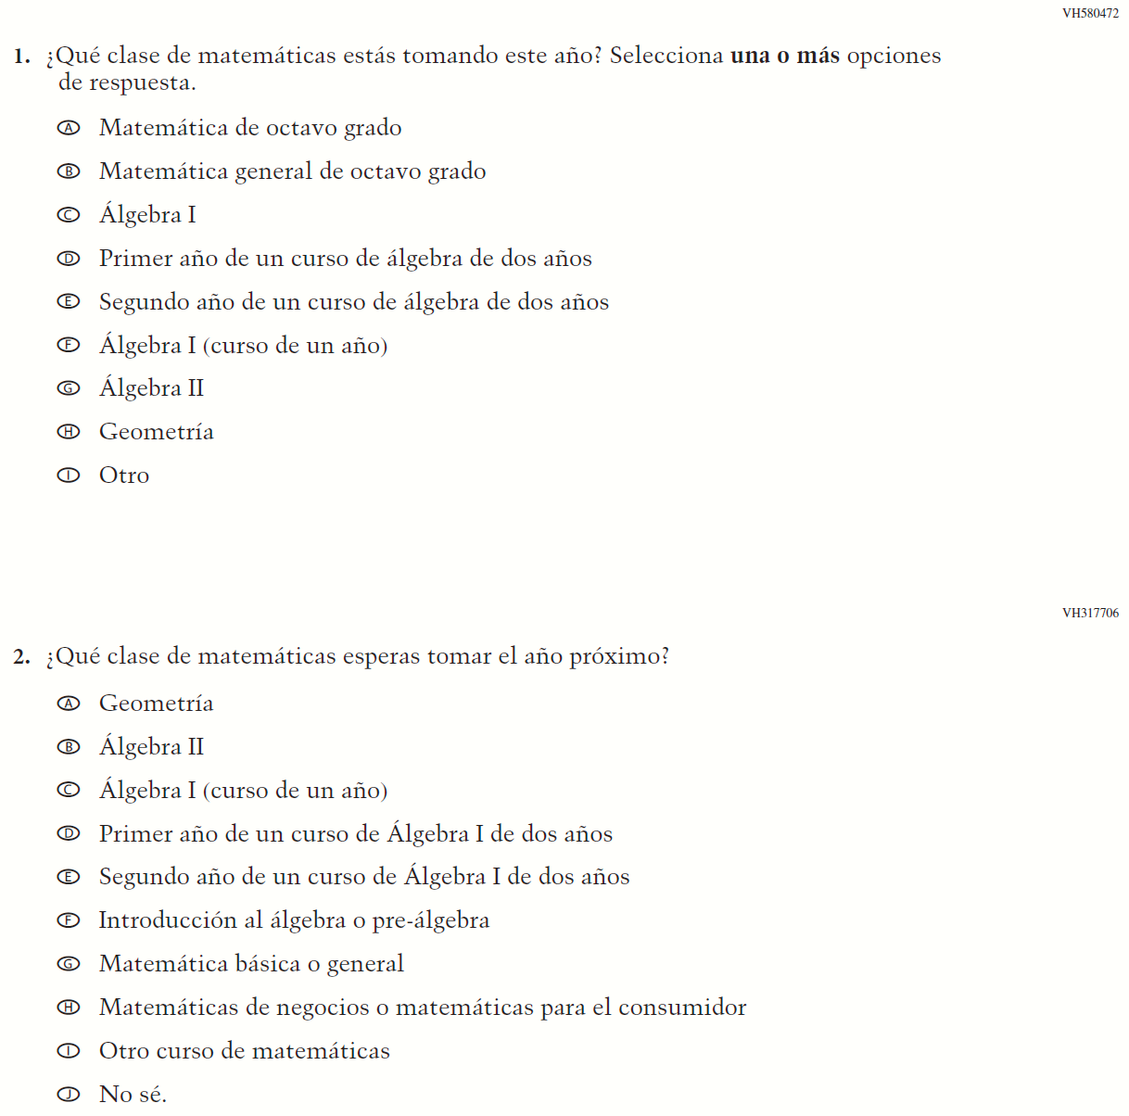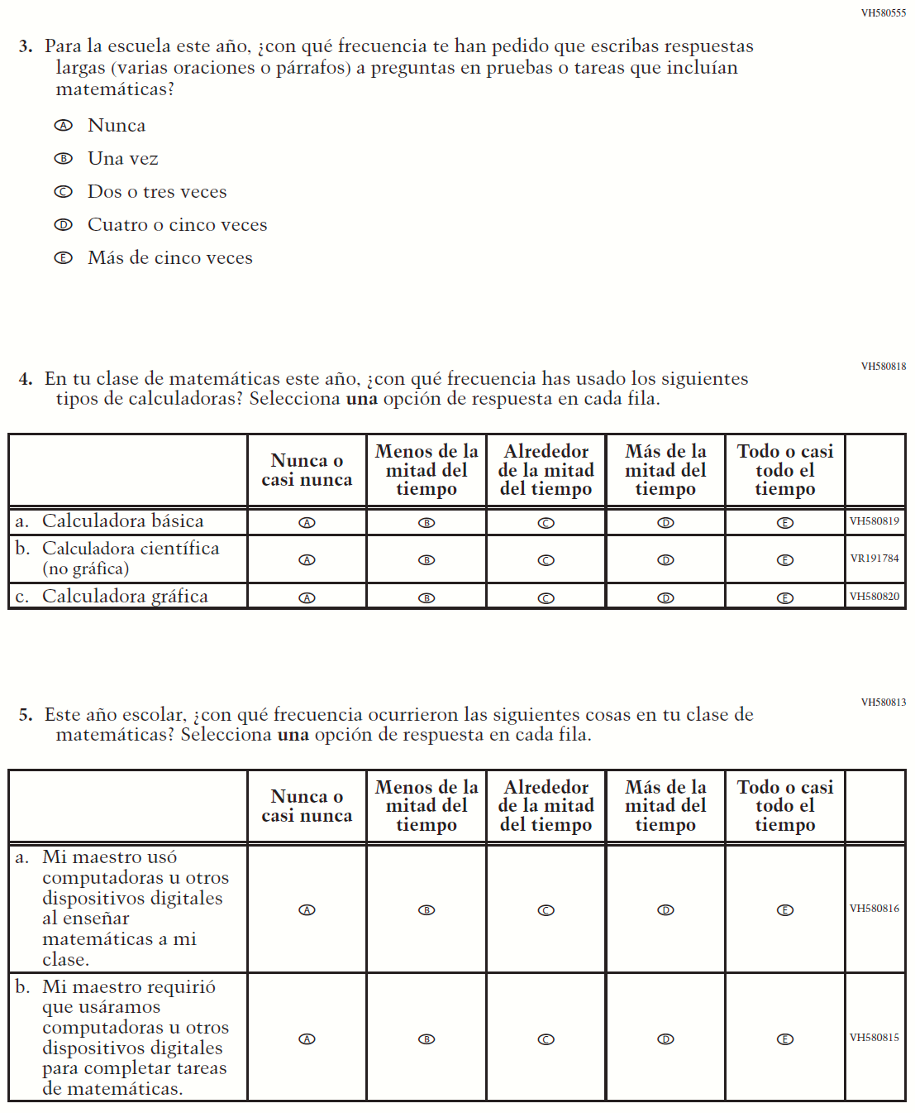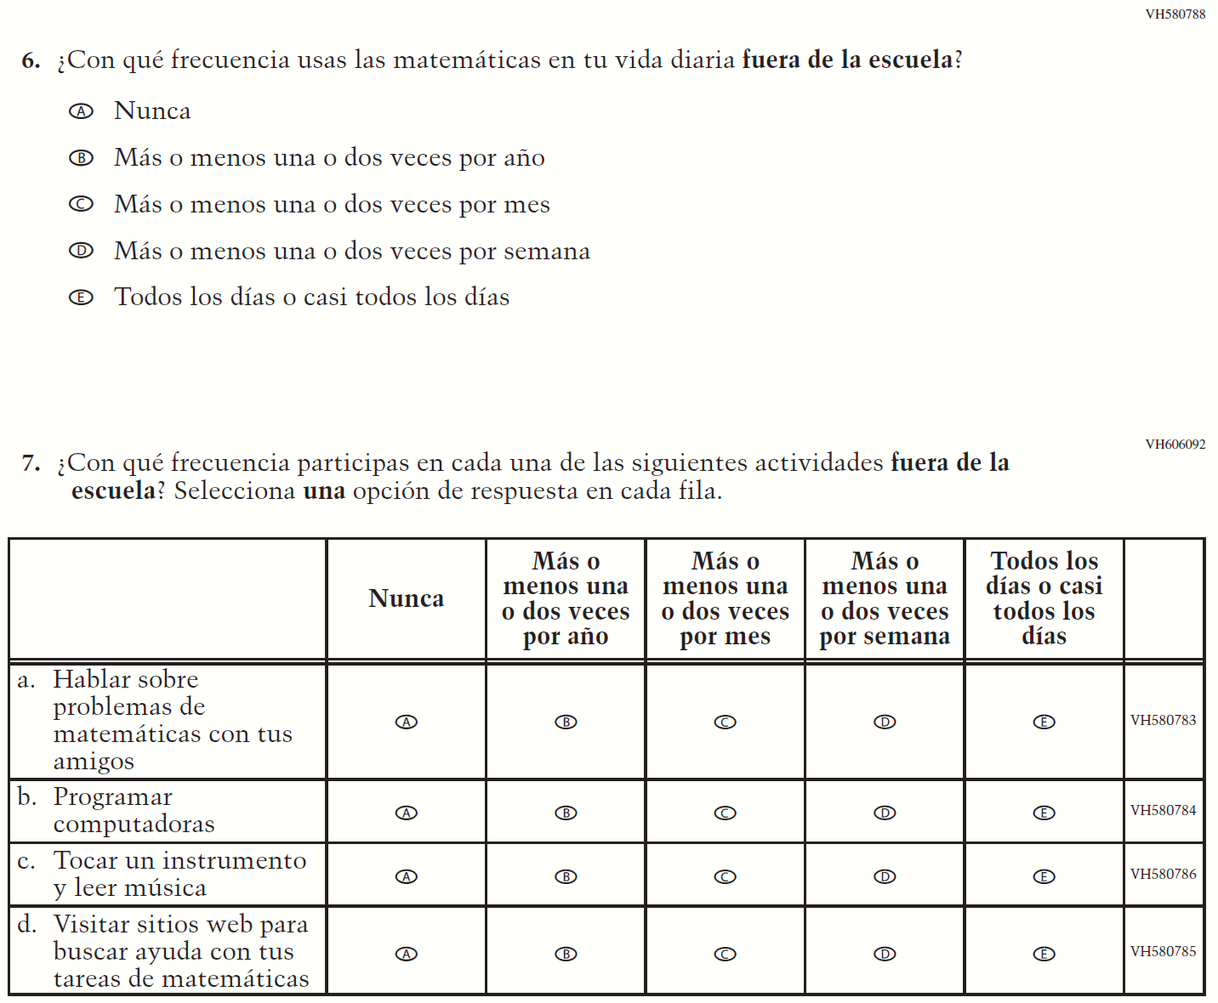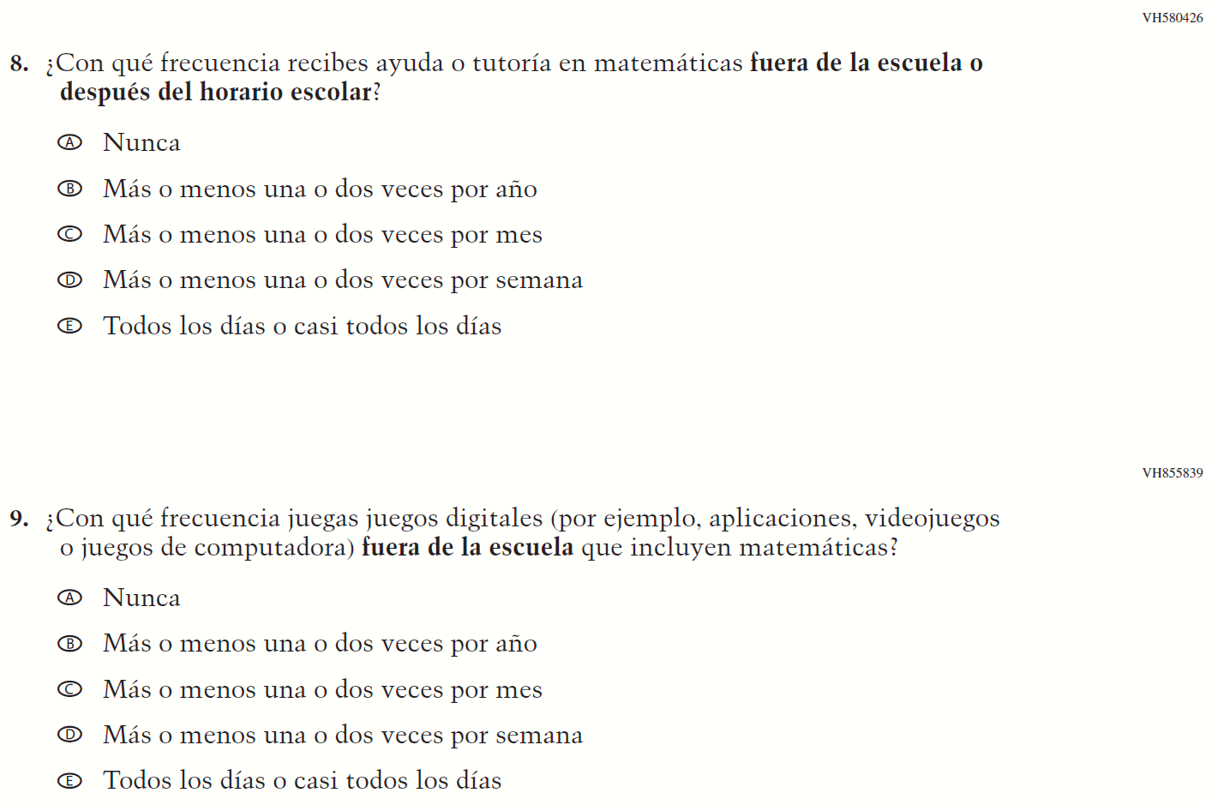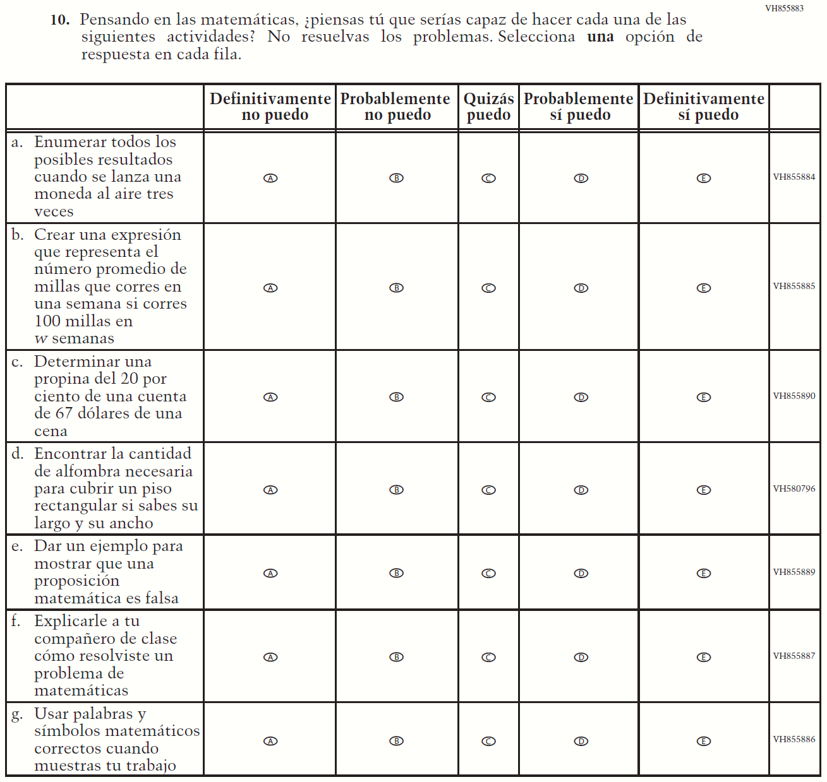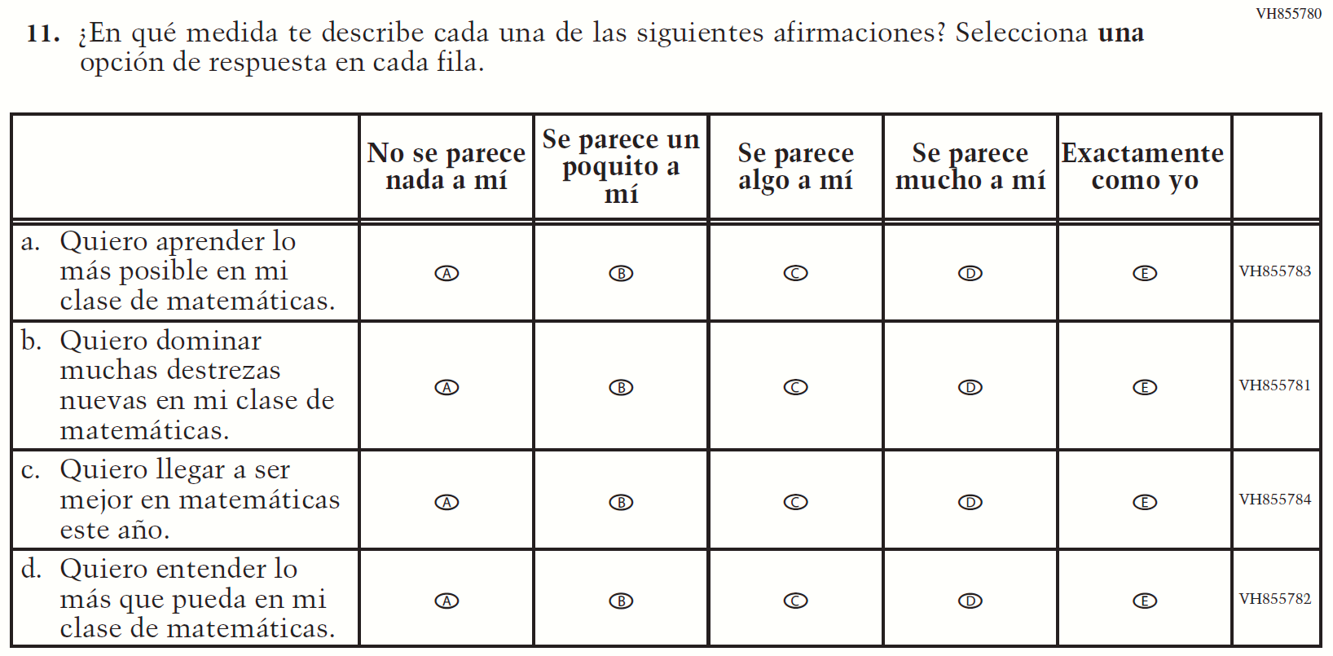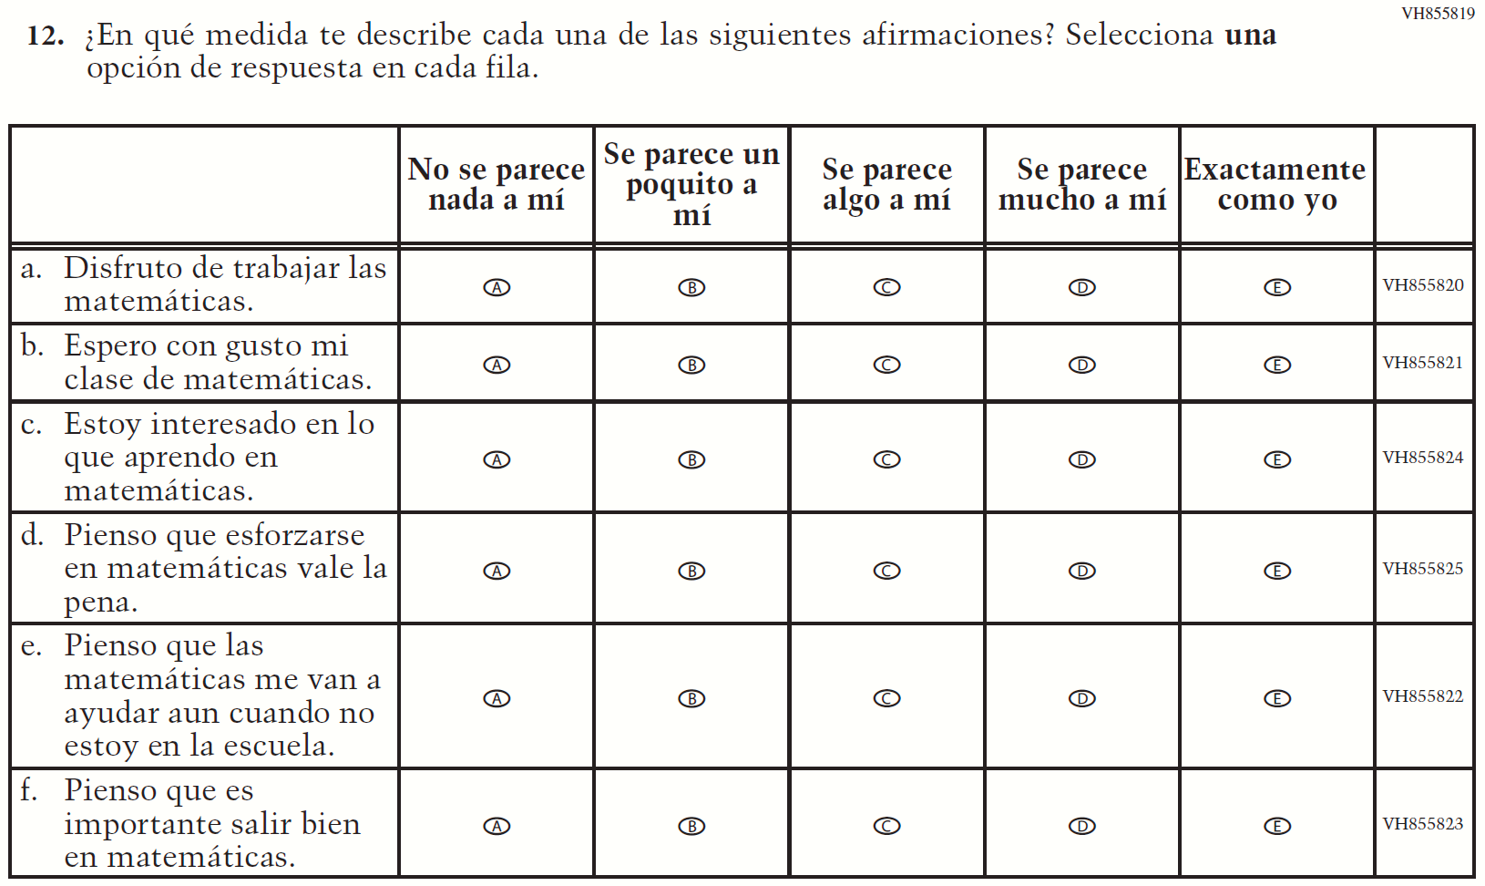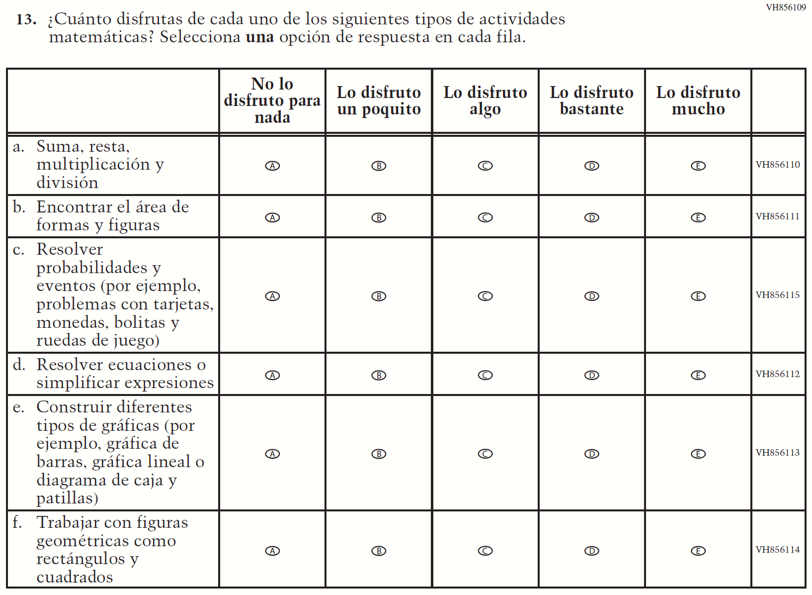

Appendix J-1h-s-PR: Summary of Changes Operational Grade 8 Mathematics
2022 Operational Grade 8 Mathematics Student – Puerto Rico

Previous item | 2022 item | D/A/ R/NC+ | Rationale
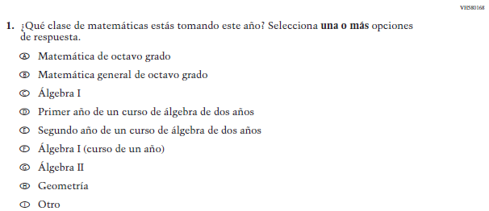  (2019 Operational Grade 8 Student Mathematics – Puerto Rico) | Issue: Organization of Instruction | NC | N/A
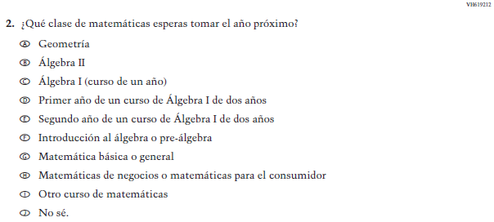  (2019 Operational Grade 8 Student Mathematics – Puerto Rico) | Issue: Organization of Instruction | NC | N/A
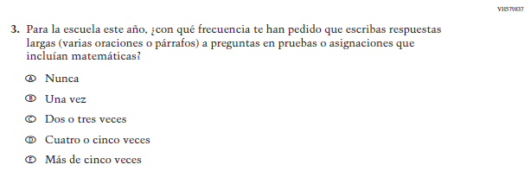  (2019 Operational Grade 8 Student Mathematics – Puerto Rico) | Issue: Organization of Instruction | NC | N/A
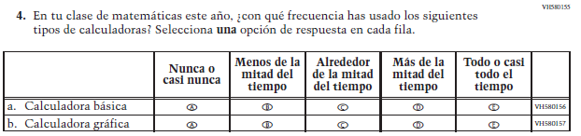  (2019 Operational Grade 8 Student Mathematics – Puerto Rico) | 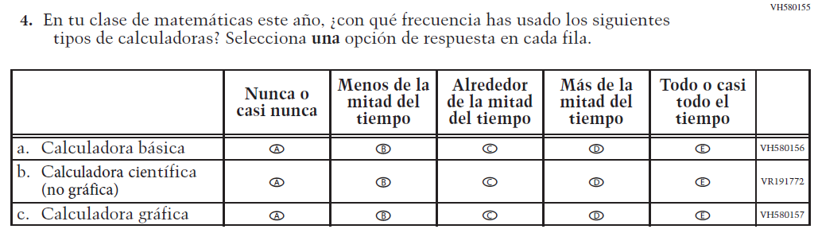  Issue: Resources for Learning and Instruction | A: sub-item “b”  NC for SL and sub-items “a” and “c” | The “Scientific (not graphing) calculator” sub-item was dropped previously due to an oversight and is being reinstated to capture calculator features in mathematics as students progress from K to 12.
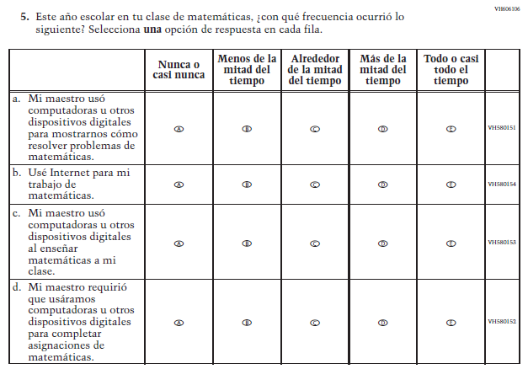  (2019 Operational Grade 8 Student Mathematics – Puerto Rico) | 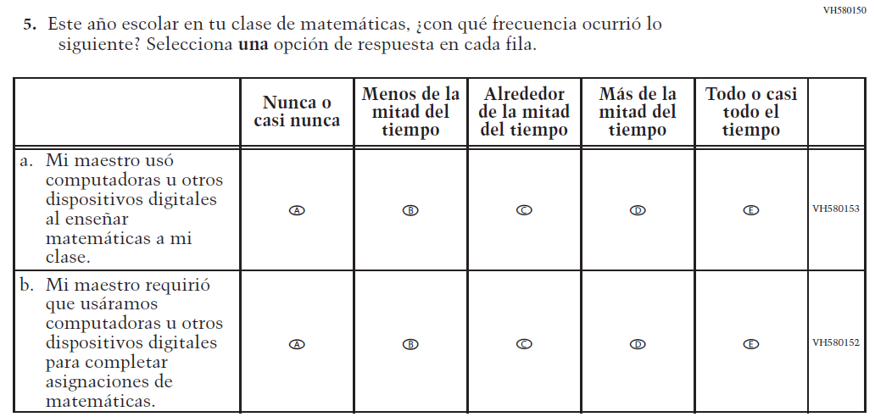  Issue: Resources for Learning and Instruction | R | To keep student burden low, sub-items a and b were dropped.
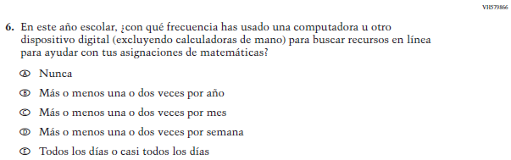  (2019 Operational Grade 8 Student Mathematics – Puerto Rico) | N/A | D | To keep student burden low, this item was dropped.
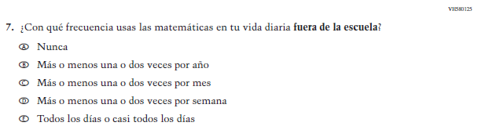  (2019 Operational Grade 8 Student Mathematics – Puerto Rico) | 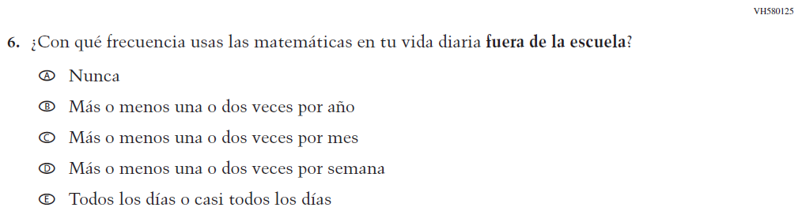  Issue: Resources for Learning and Instruction | NC
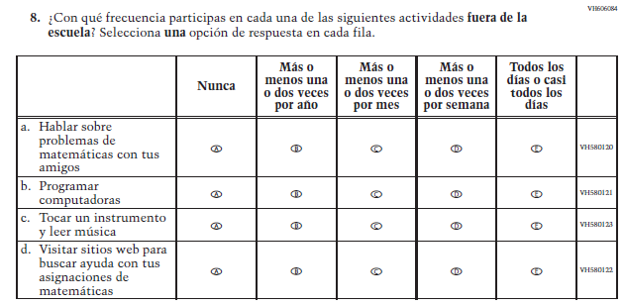  (2019 Operational Grade 8 Student Mathematics – Puerto Rico) | 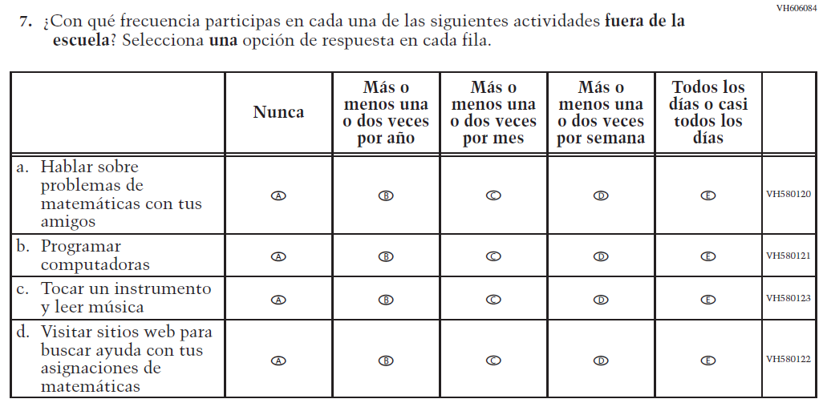  Issue: Resources for Learning and Instruction | NC | N/A
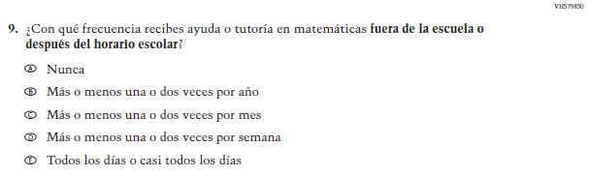  (2019 Operational Grade 8 Student Mathematics – Puerto Rico) | 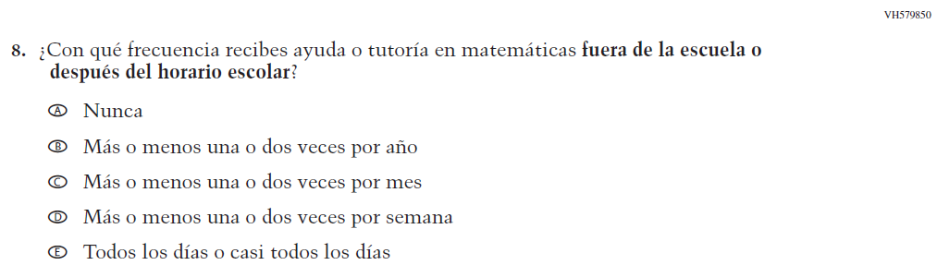  Issue: Resources for Learning and Instruction | NC | N/A

2022 Operational Grade 8 Mathematics Student – Puerto Rico

Previous item | 2022 item | D/A/ R/NC+ | Rationale
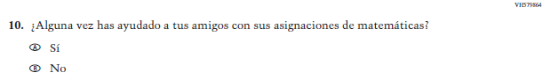  (2019 Operational Grade 8 Student Mathematics – Puerto Rico) | N/A | D | To keep student burden low, this item was dropped.
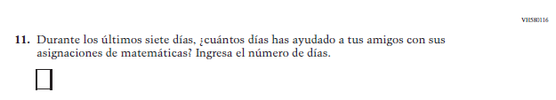  (2019 Operational Grade 8 Student Mathematics – Puerto Rico) | N/A | D | To keep student burden low, this item was dropped.
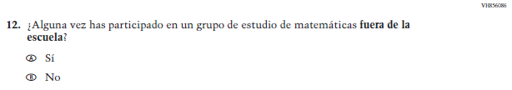(2019 Operational Grade 8 Student Mathematics – Puerto Rico) | N/A | D | To keep student burden low, this item was dropped.
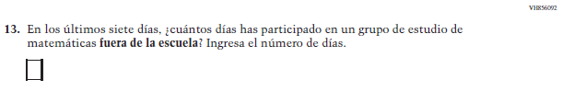  (2019 Operational Grade 8 Student Mathematics – Puerto Rico) | N/A | D | To keep student burden low, this item was dropped.

2022 Operational Grade 8 Mathematics Student – Puerto Rico

Previous item | 2022 item | D/A/ R/NC+ | Rationale
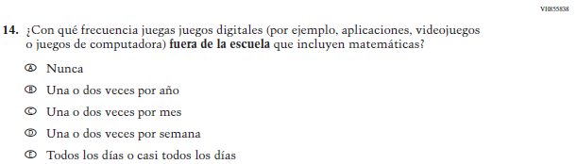  (2019 Operational Grade 8 Student Mathematics – Puerto Rico) | 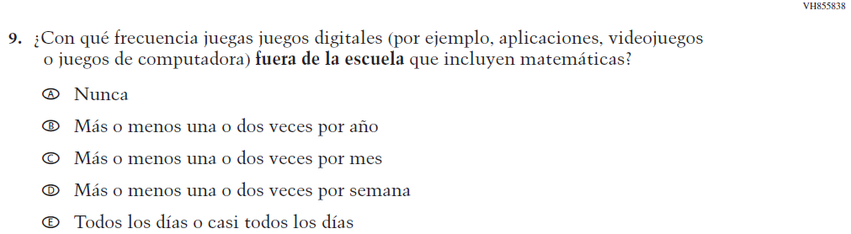  Issue: Resources for Learning and Instruction | NC | N/A
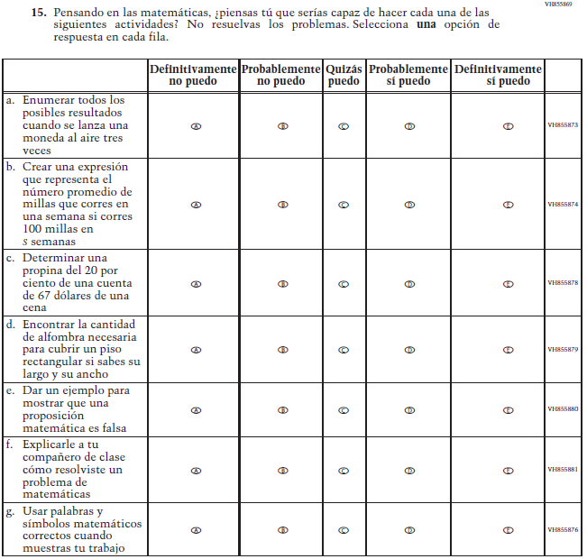  (2019 Operational Grade 8 Student Mathematics – Puerto Rico) | 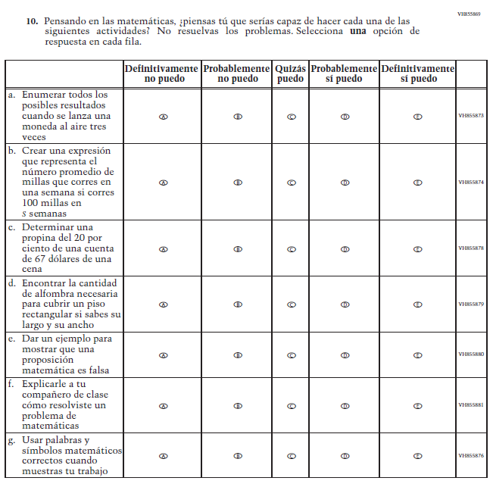  Issue: Student factors | NC | N/A

2022 Operational Grade 8 Mathematics Student – Puerto Rico

Previous item | 2022 item | D/A/ R/NC+ | Rationale
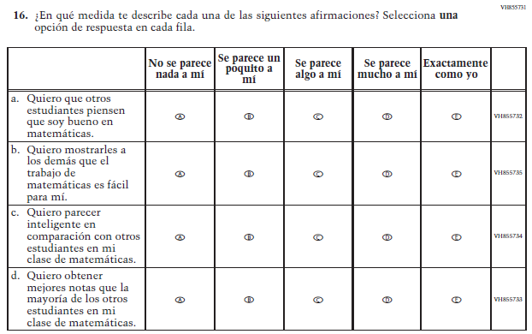  (2019 Operational Grade 8 Student Mathematics – Puerto Rico) | N/A | D | To keep student burden low, this item was dropped.
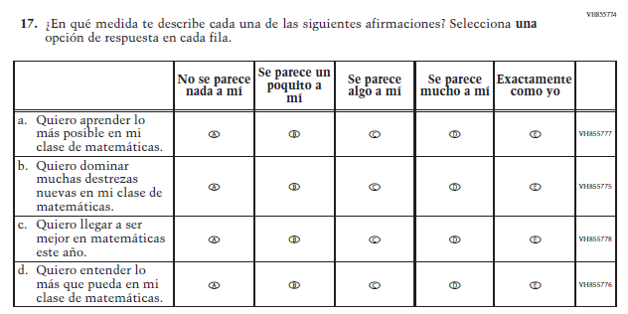  (2019 Operational Grade 8 Student Mathematics – Puerto Rico) | 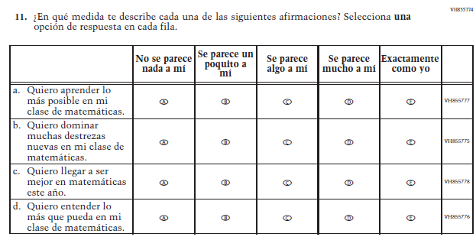  Issue: Student Factors | NC | N/A

2022 Operational Grade 8 Mathematics Student – Puerto Rico

Previous item | 2022 item | D/A/ R/NC+ | Rationale
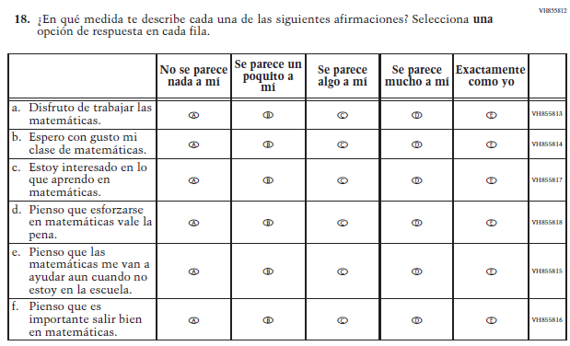  (2019 Operational Grade 8 Student Mathematics – Puerto Rico) | 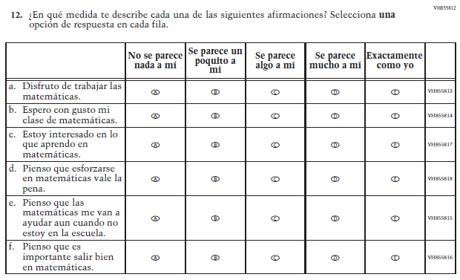  Issue: Student Factors | NC | N/A
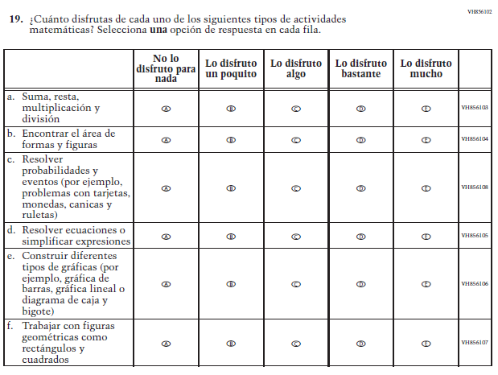  (2019 Operational Grade 8 Student Mathematics – Puerto Rico) | 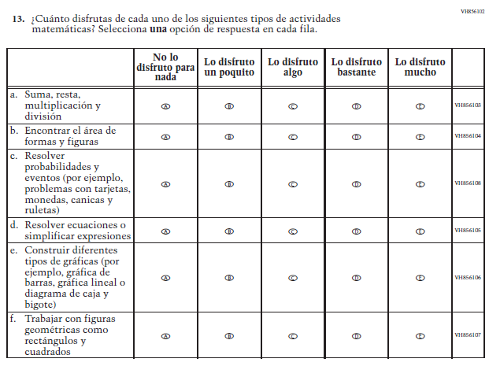  Issue: Student Factors | NC | N/A

Appendix J-1h-s-PR: Operational Grade 8 Mathematics
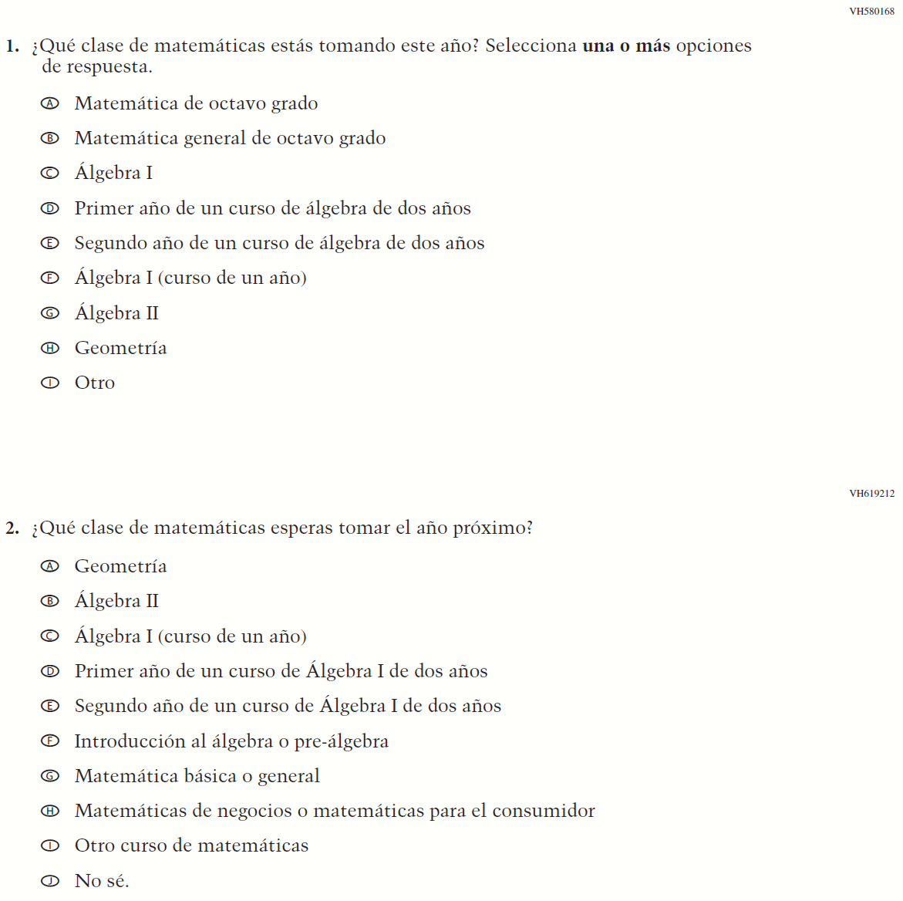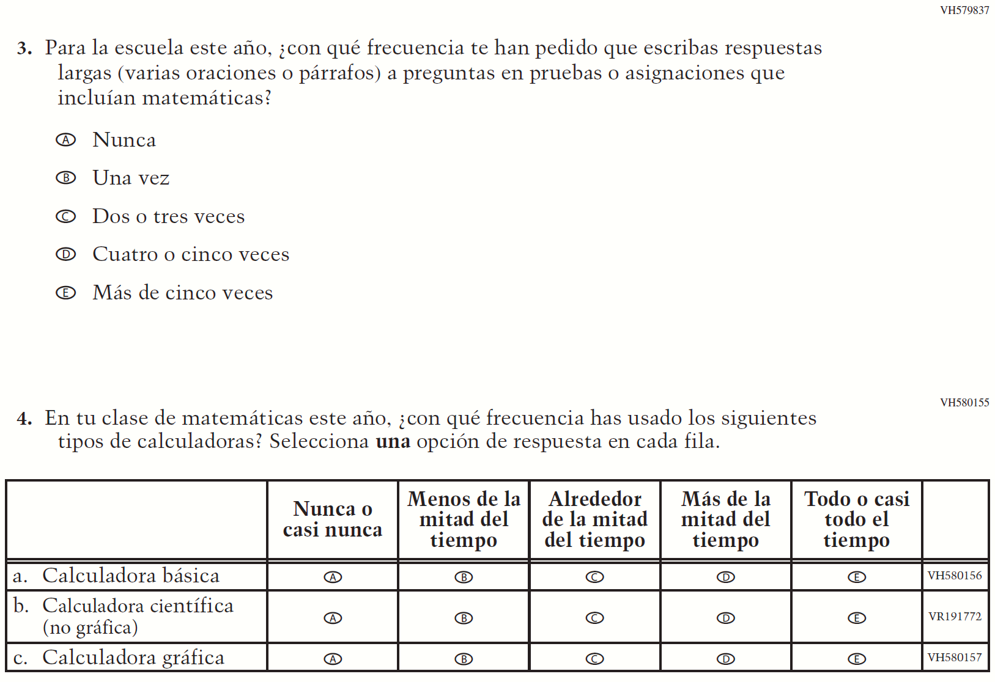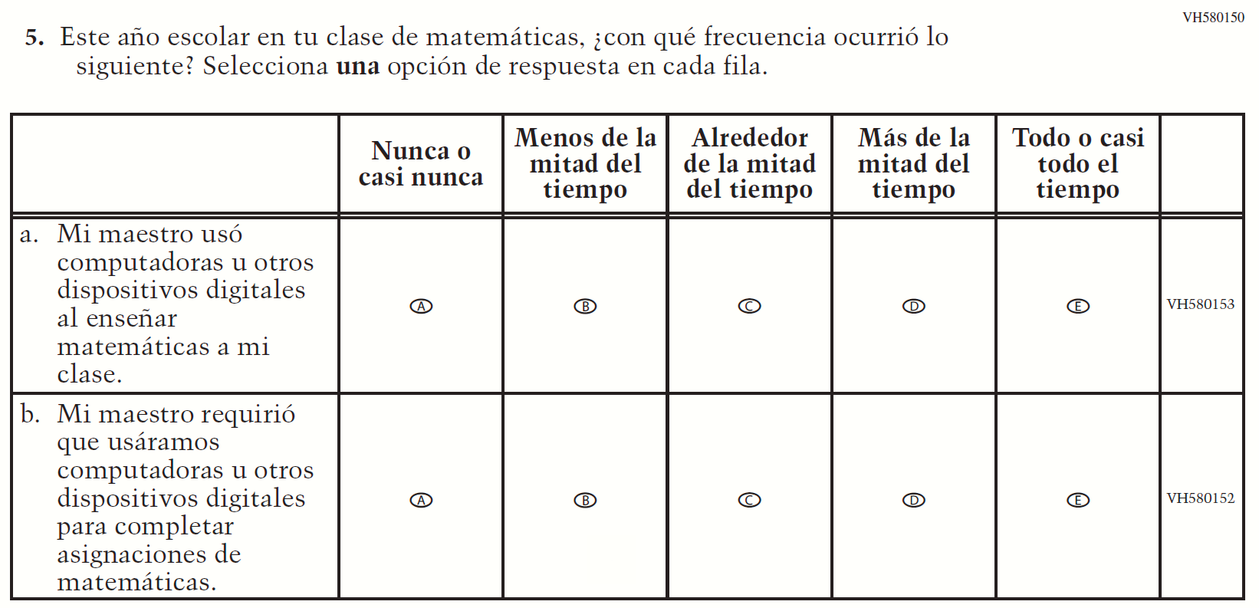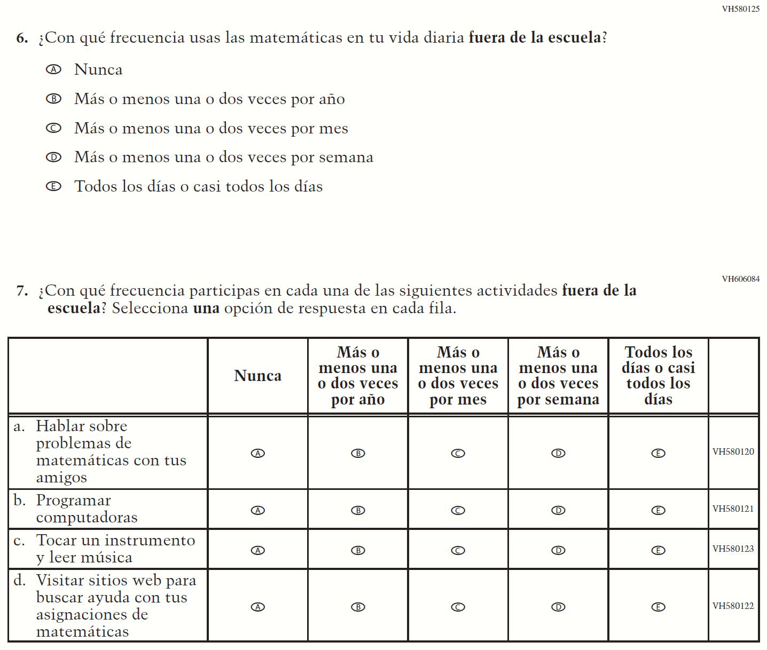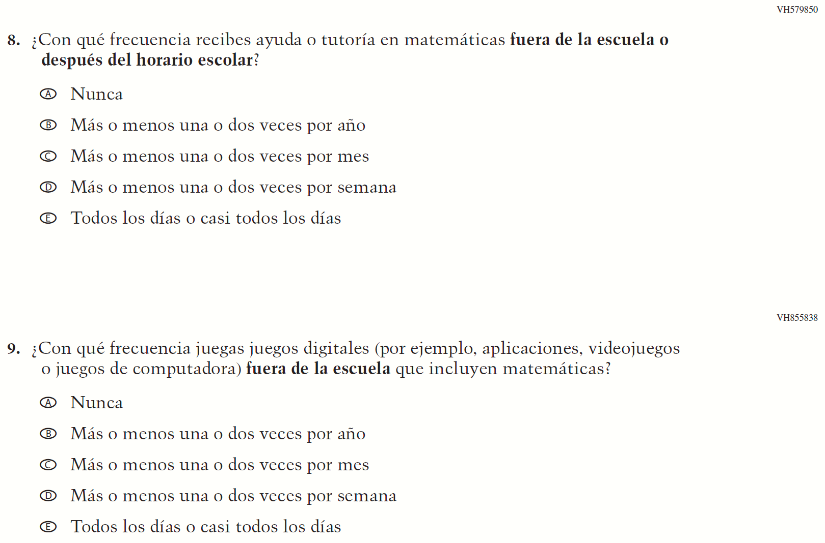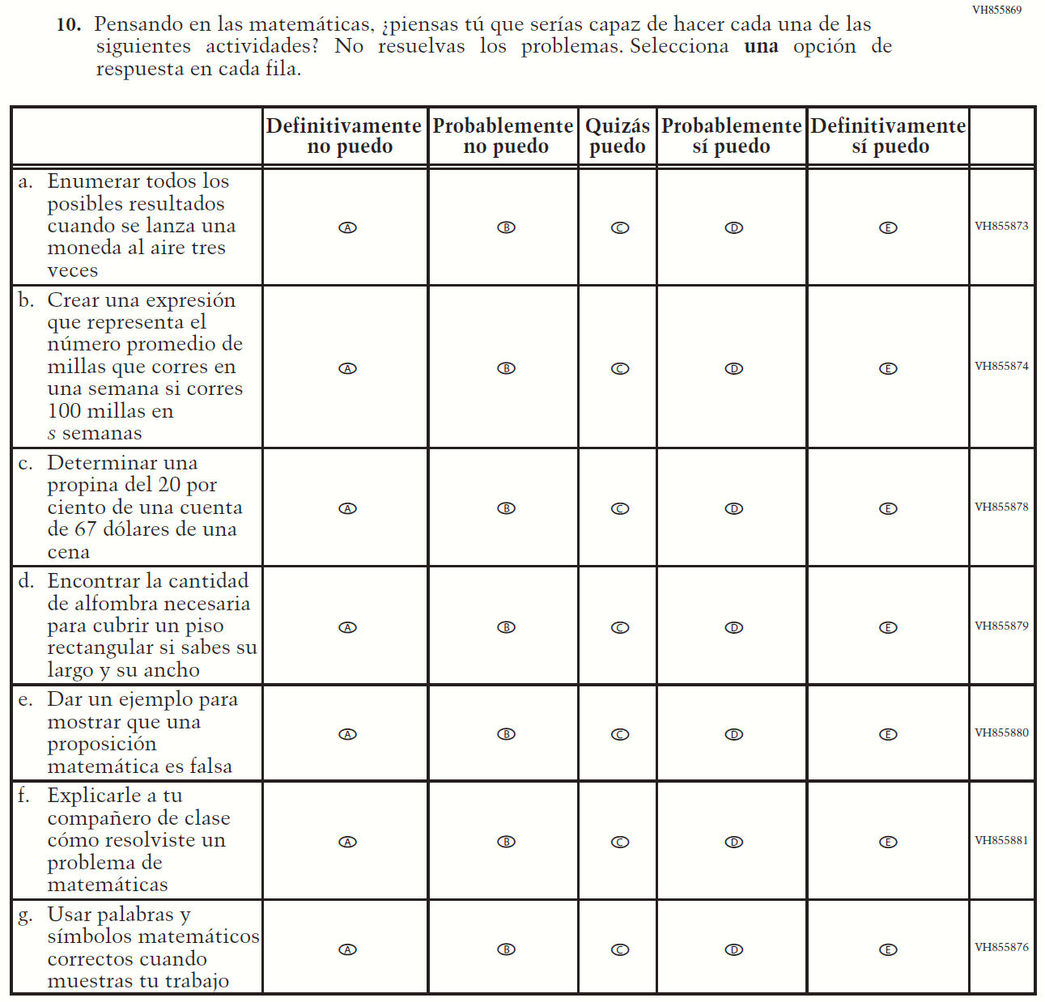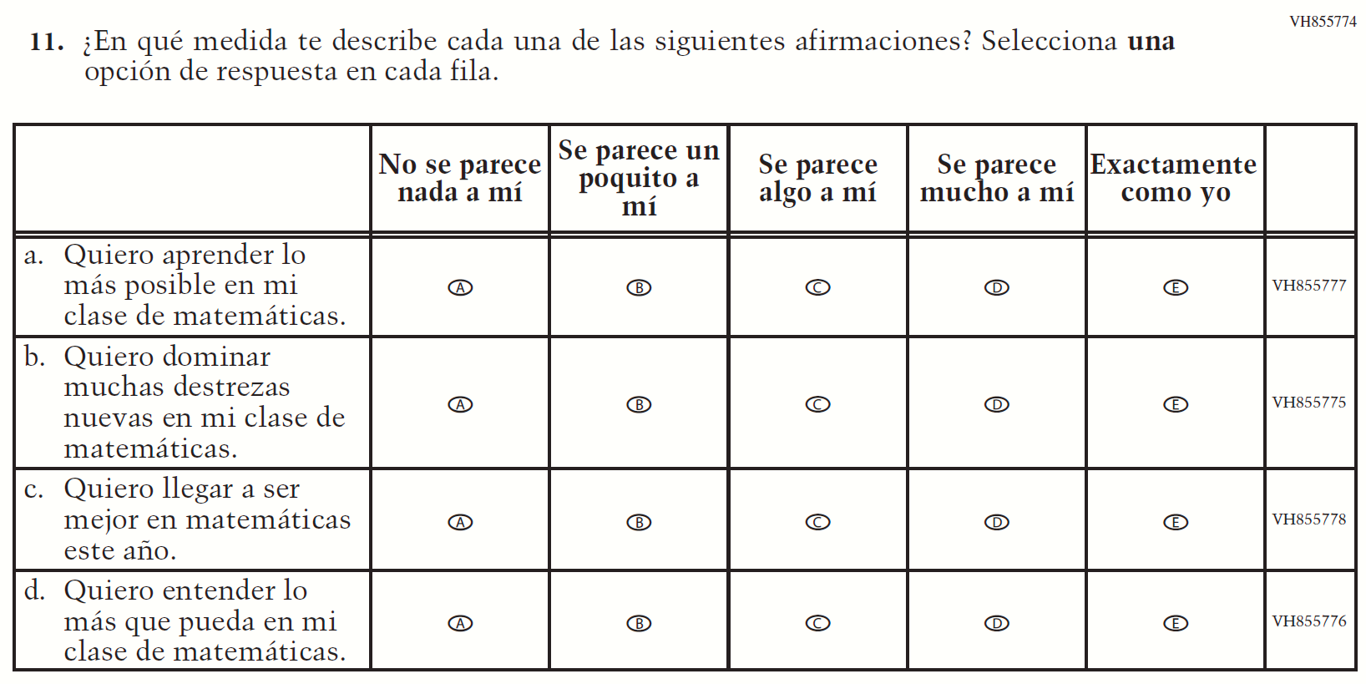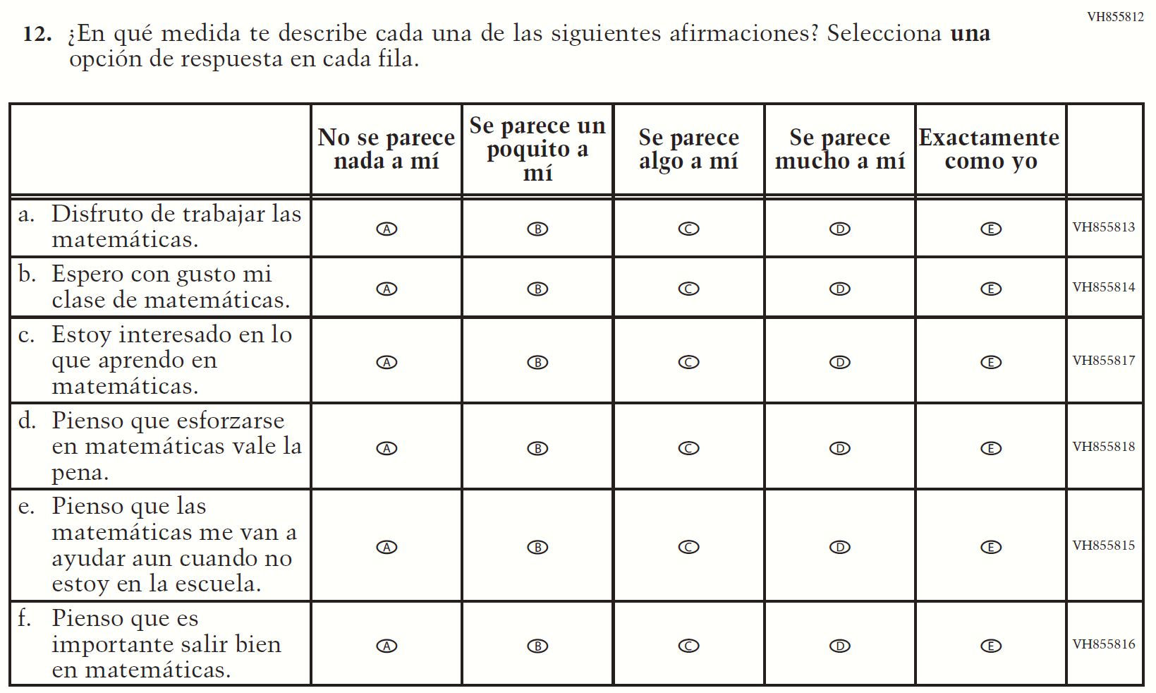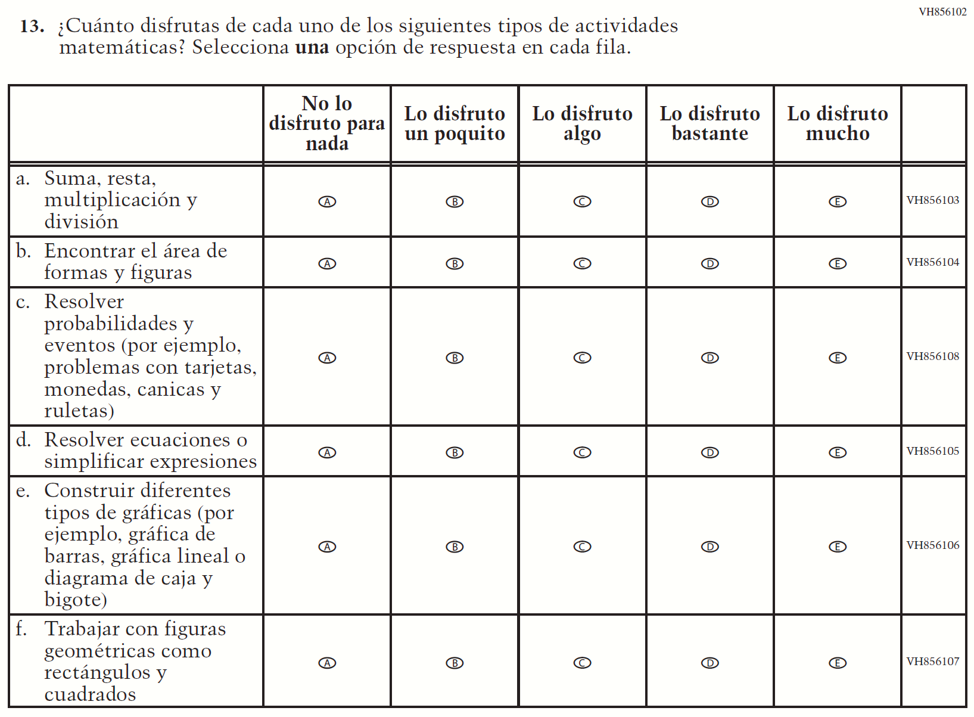

Appendix J-1i-s-BL: Summary of Changes Operational Grade 4 Reading
2022 Operational Grade 4 Reading Student – Bilingual
Previous item |  |  | 2022 item | D/A/R/NC+ | Rationale
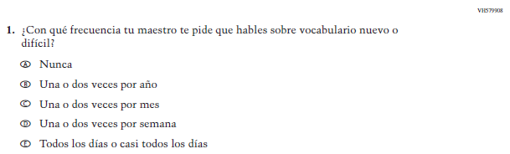  (2019 Operational Grade 4 Student Reading - Bilingual) |  |  | 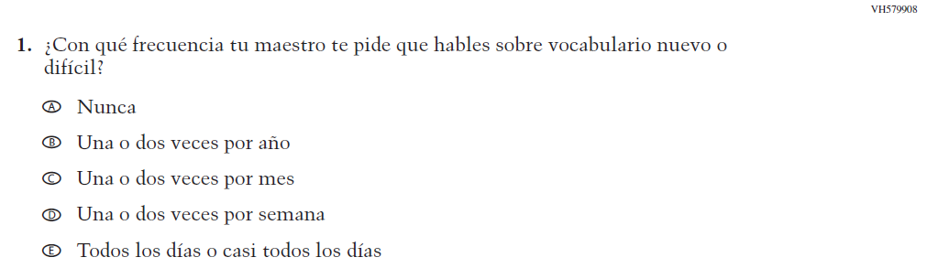  Issue: Organization of Instruction | NC | N/A
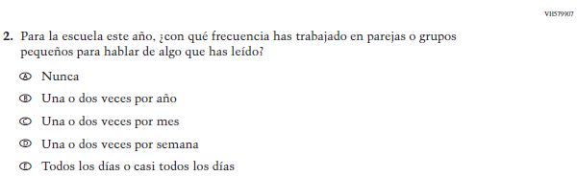  (2019 Operational Grade 4 Student Reading - Bilingual) |  |  | 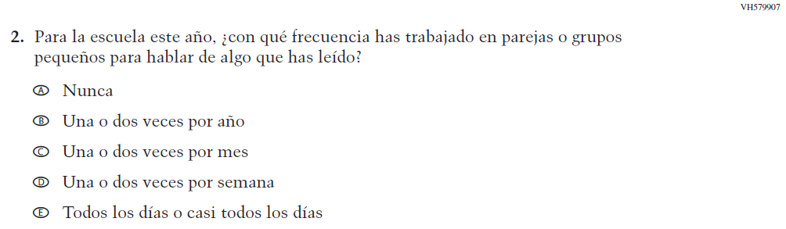  Issue: Organization of Instruction | NC | N/A
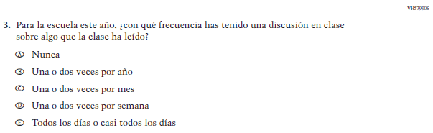  (2019 Operational Grade 4 Student Reading - Bilingual) |  |  | 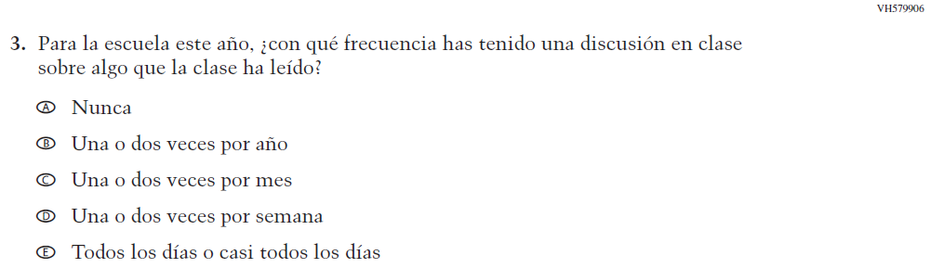  Issue: Organization of Instruction | NC | N/A
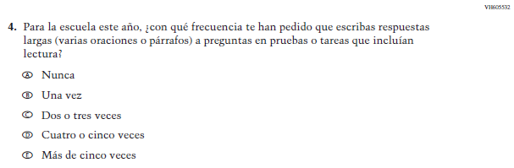  (2019 Operational Grade 4 Student Reading - Bilingual) |  |  | 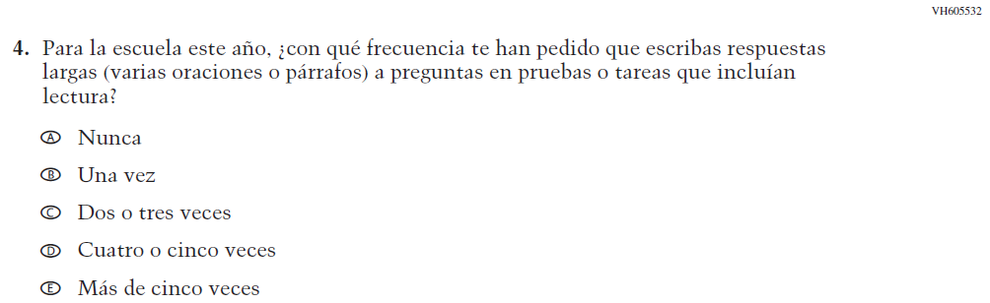  Issue: Organization of Instruction | NC | N/A
2022 Operational Grade 4 Reading Student – Bilingual
Previous item | 2022 item |  |  | D/A/R/NC+ | Rationale
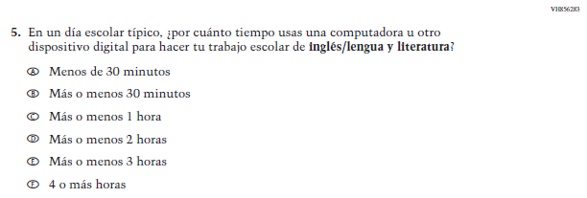  (2019 Operational Grade 4 Student Reading - Bilingual) | N/A |  |  | D | To keep student burden low, this item was dropped.
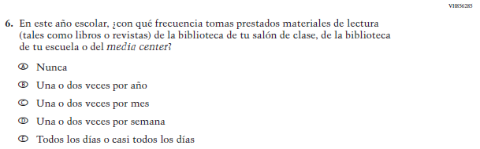  (2019 Operational Grade 4 Student Reading - Bilingual) | 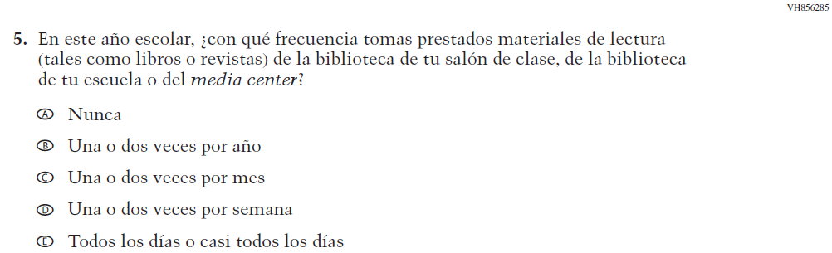  Issue: Resources for Learning and Instruction |  |  | NC | N/A
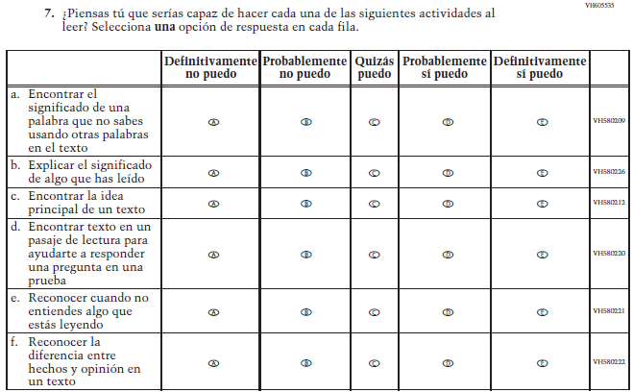  (2019 Operational Grade 4 Student Reading - Bilingual) | 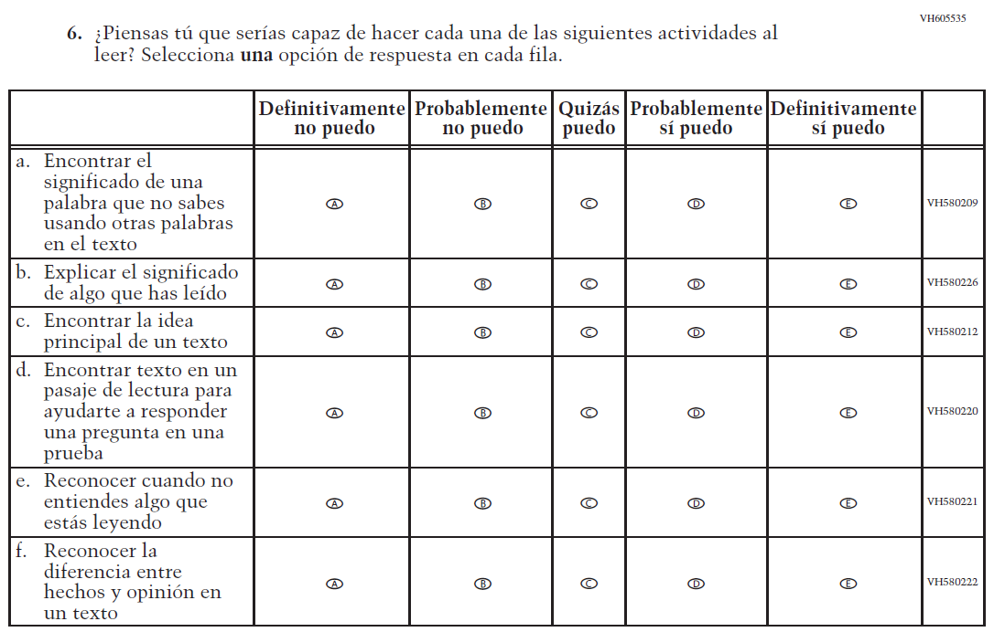  Issue: Student Factors |  |  | NC | N/A
2022 Operational Grade 4 Reading Student – Bilingual
Previous item |  | 2022 item |  | D/A/R/NC+ | Rationale
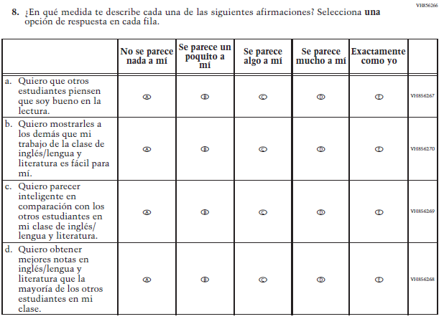  (2019 Operational Grade 4 Student Reading - Bilingual) |  | N/A |  | D | To keep student burden low, this item was dropped.
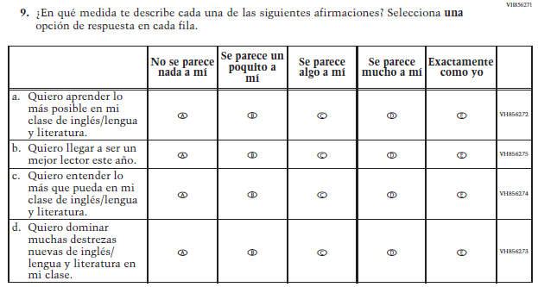  (2019 Operational Grade 4 Student Reading - Bilingual) |  | 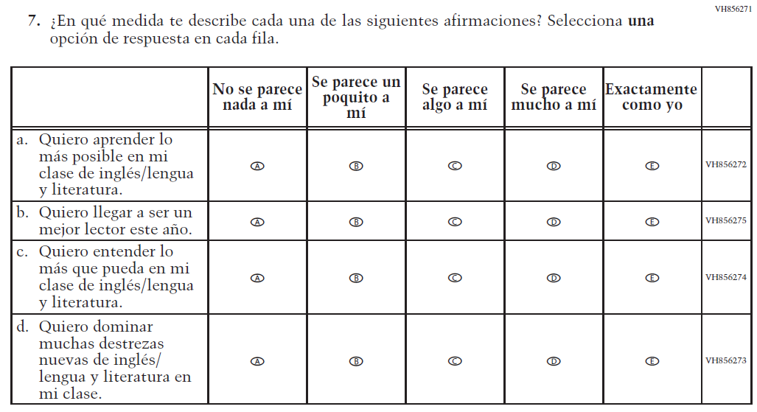  Issue: Student Factors |  | NC | N/A

2022 Operational Grade 4 Reading Student – Bilingual
Previous item | 2022 item | D/A/R/NC+ | Rationale
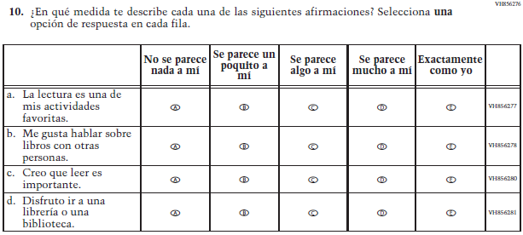  (2019 Operational Grade 4 Student Reading - Bilingual) | 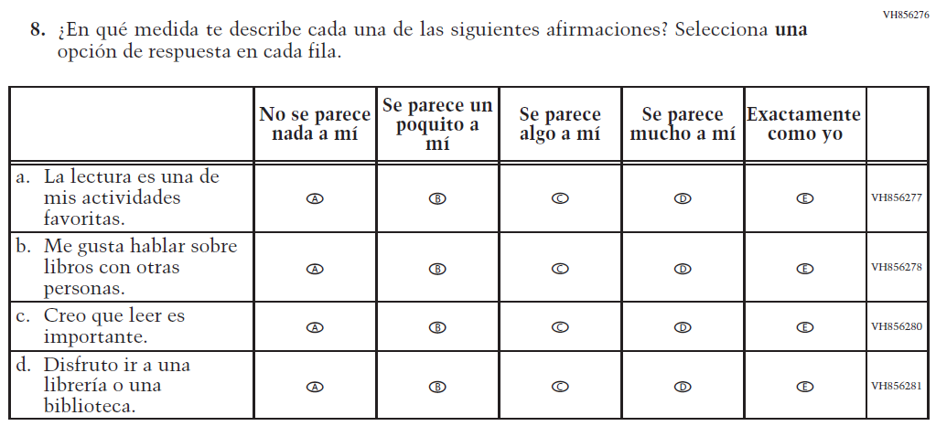  Issue: Student Factors | NC | N/A
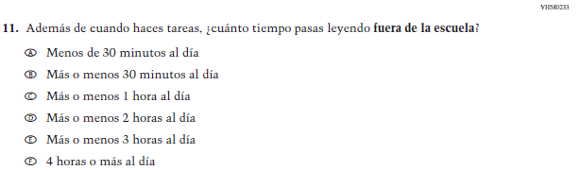  (2019 Operational Grade 4 Student Reading - Bilingual) | 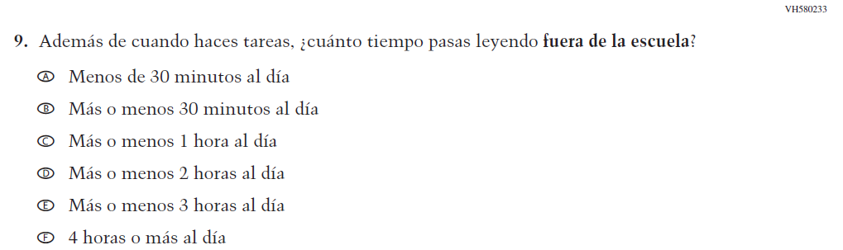  Issue: Student Factors | NC | N/A
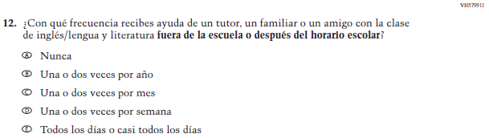  (2019 Operational Grade 4 Student Reading - Bilingual) | 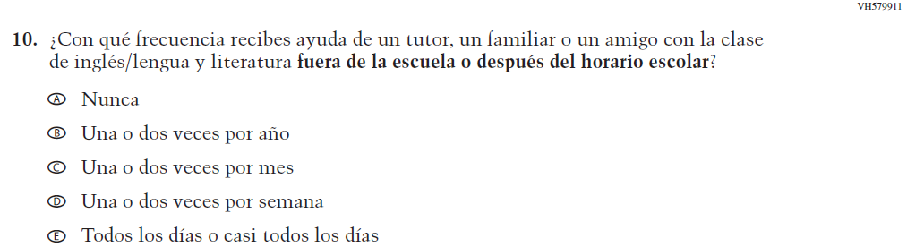  Issue: Resources for Learning and Instruction | NC | N/A

2022 Operational Grade 4 Reading Student – Bilingual
Previous item | 2022 item | D/A/R/NC+ | Rationale
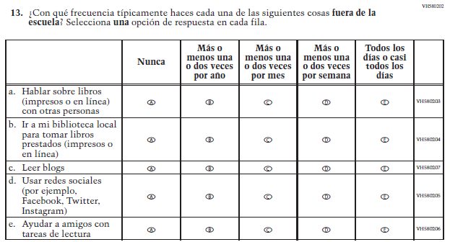  (2019 Operational Grade 4 Student Reading - Bilingual) | 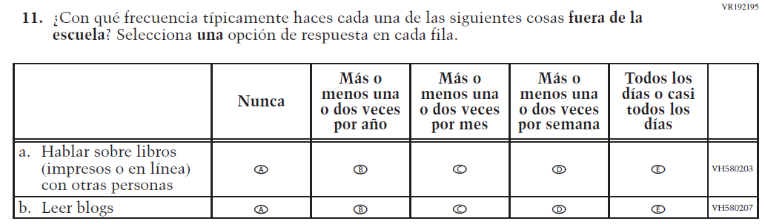  Issue: Student Factors | R | To keep student burden low, sub-items b, d, and e were dropped.

Appendix J-1i-s-BL: Operational Grade 4 Reading
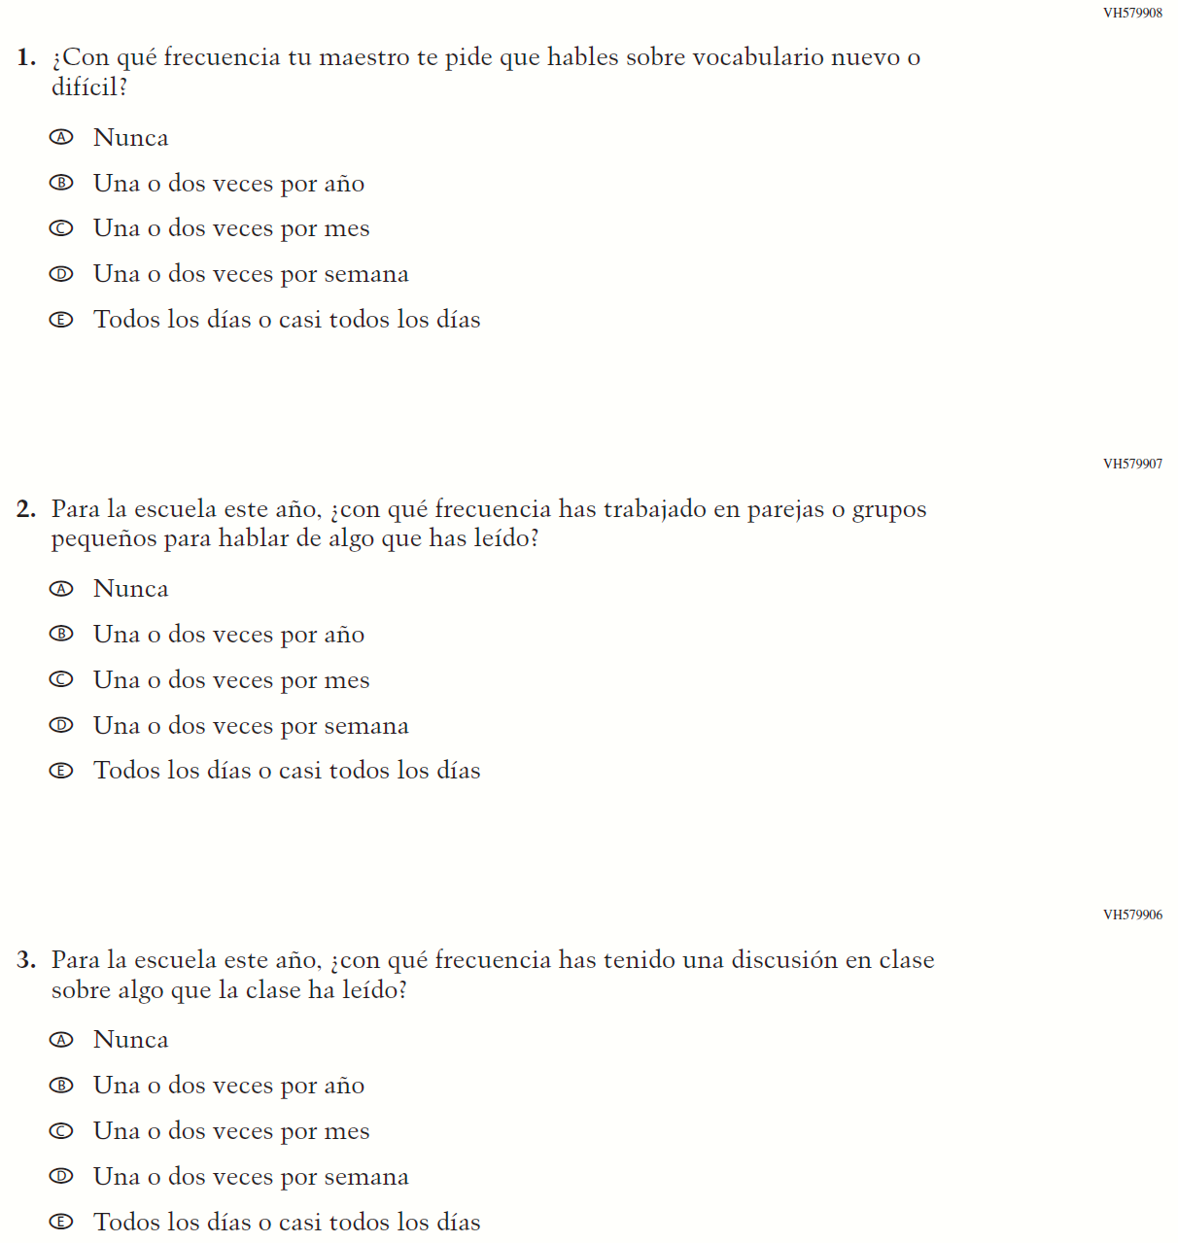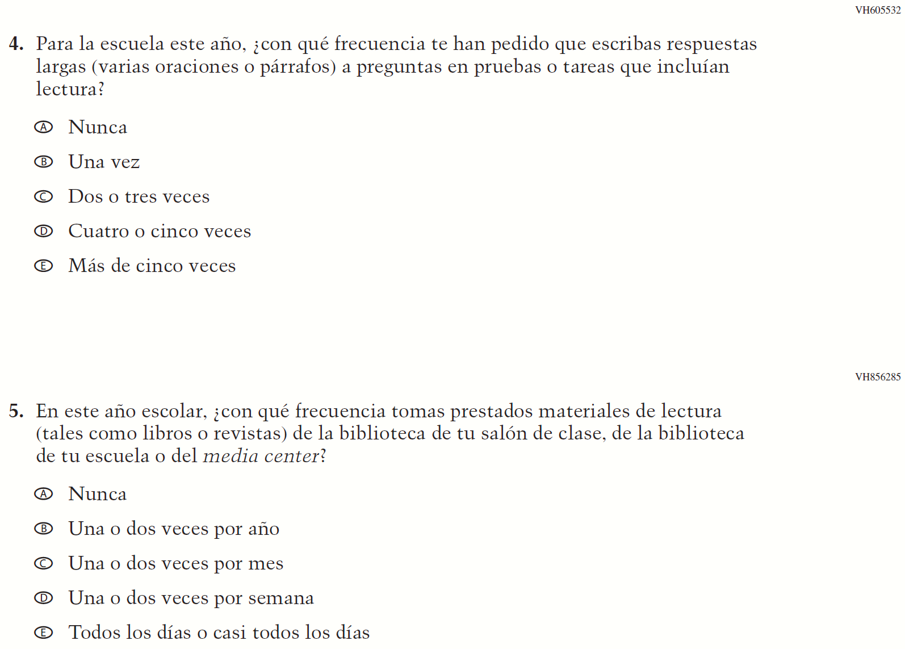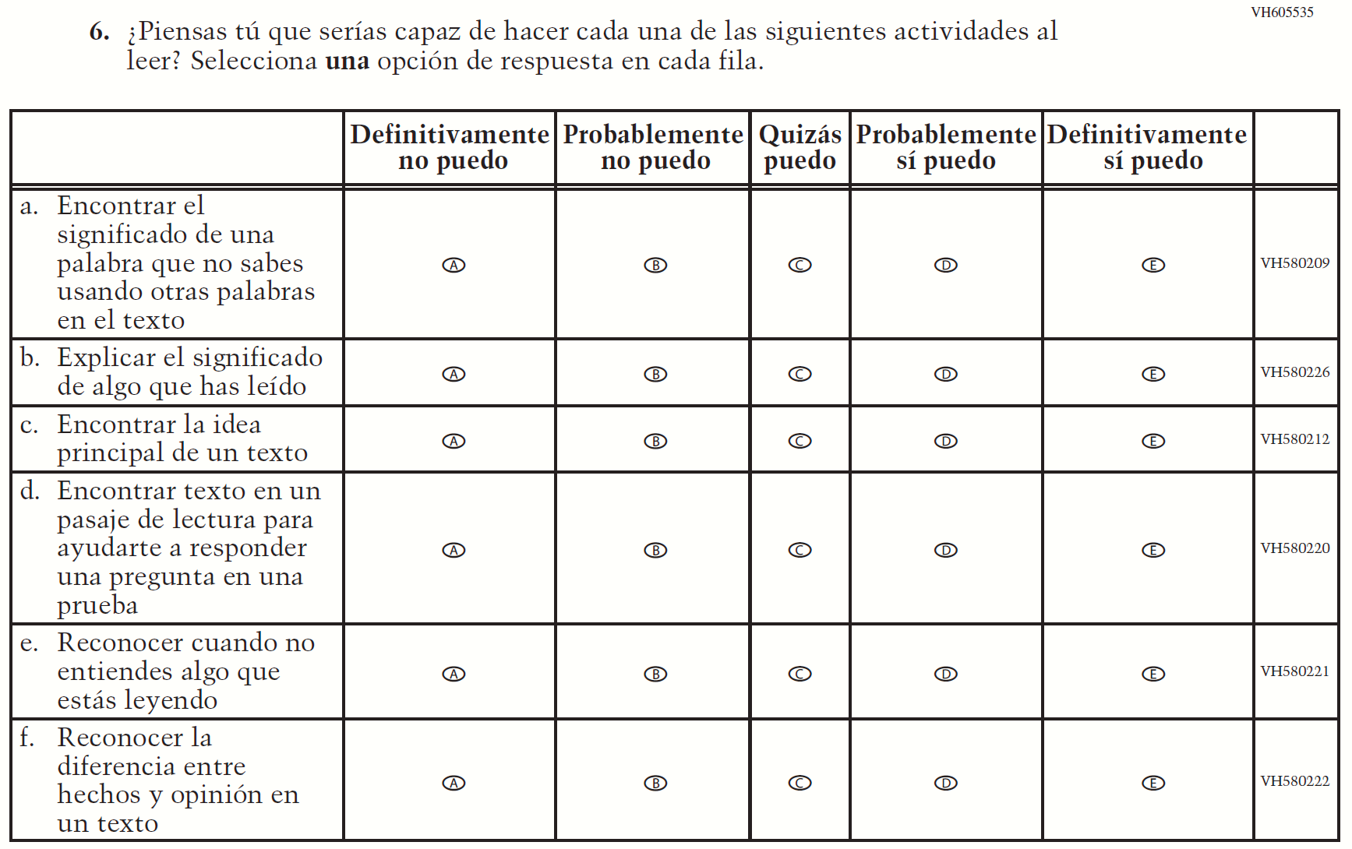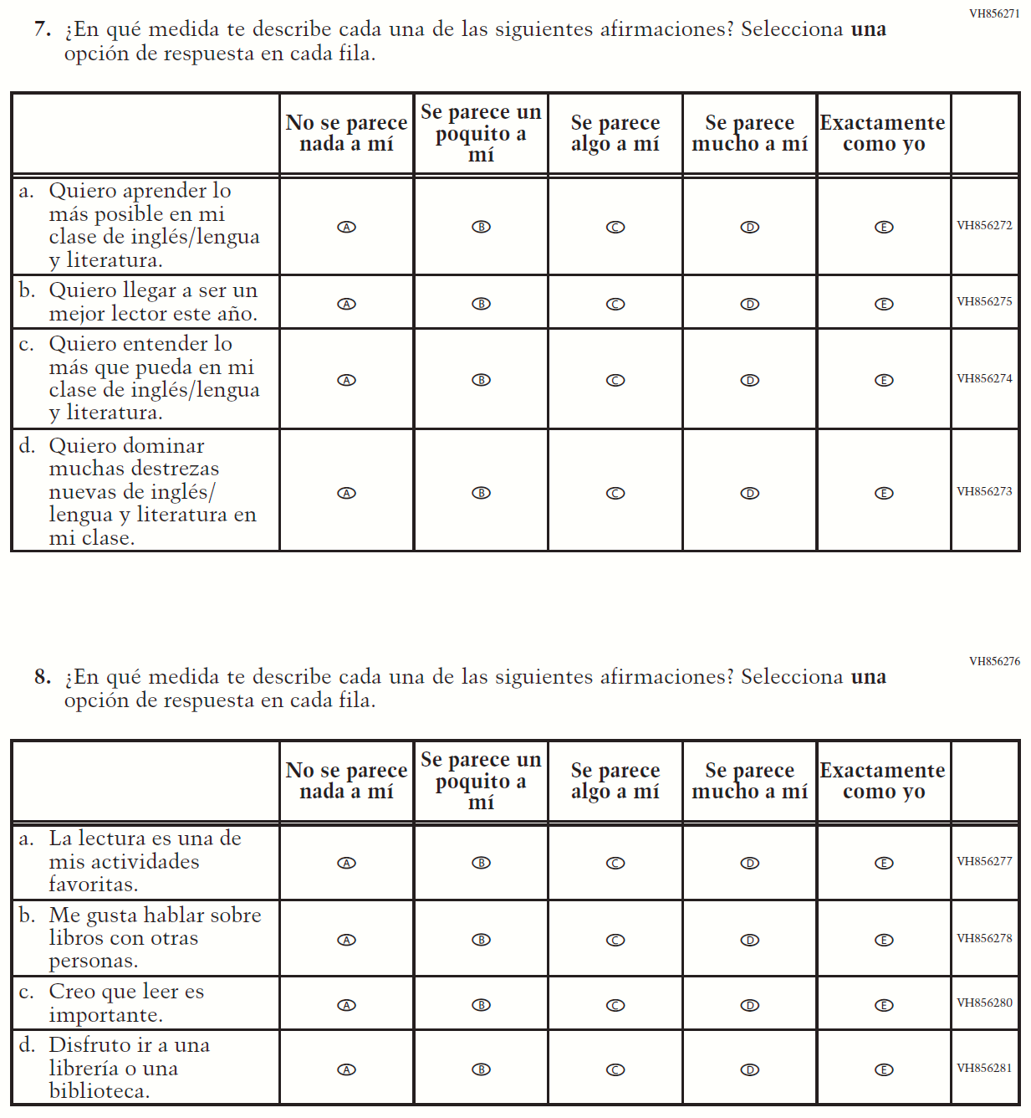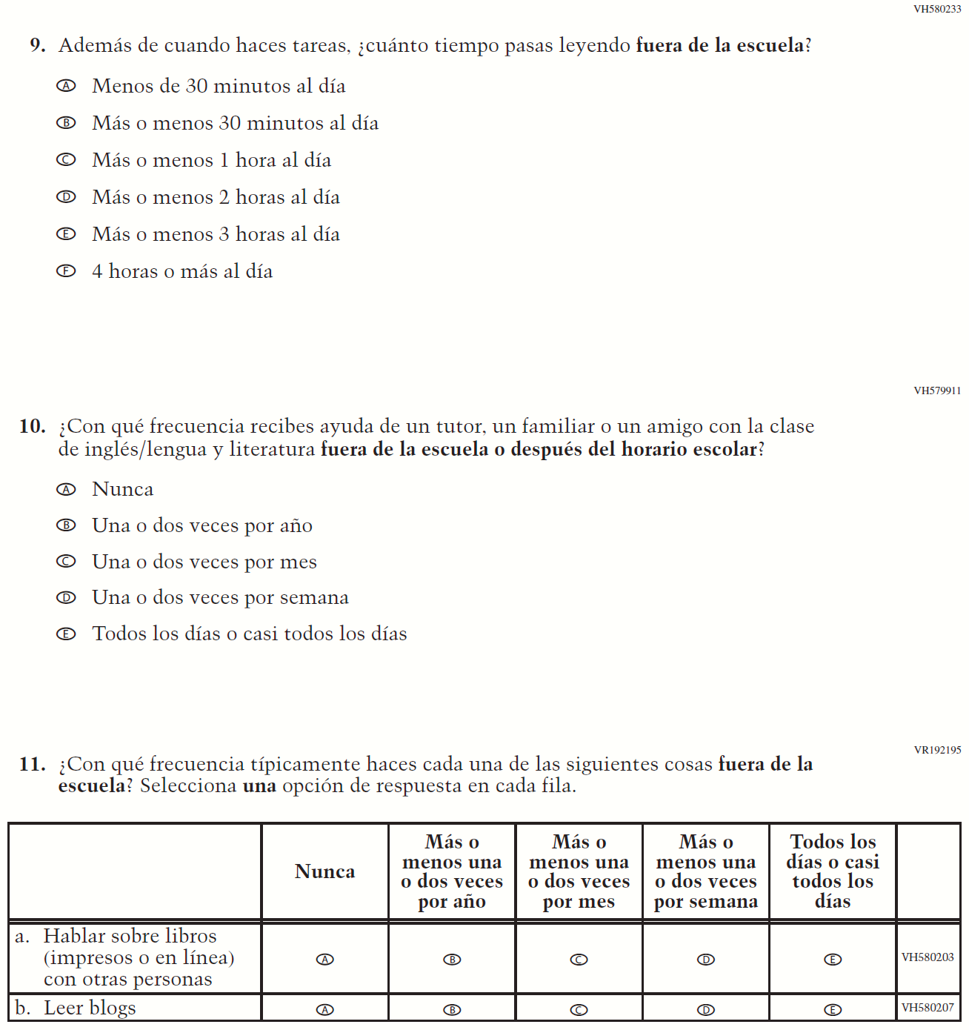

Appendix J-1j-s-BL: Summary of Changes Operational Grade 8 Reading
2022 Operational Grade 8 Reading Student – Bilingual

Previous item | 2022 item | D/A/ R/NC+ | Rationale
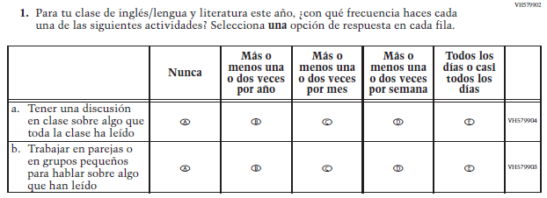  (2019 Operational Grade 8 Student Reading – Bilingual) | 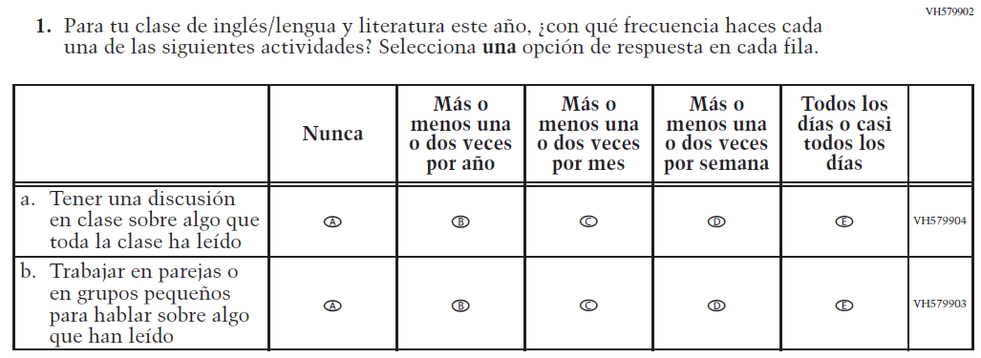  Issue: Organization of Instruction | NC | N/A
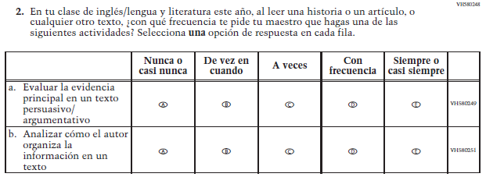  (2019 Operational Grade 8 Student Reading – Bilingual) | 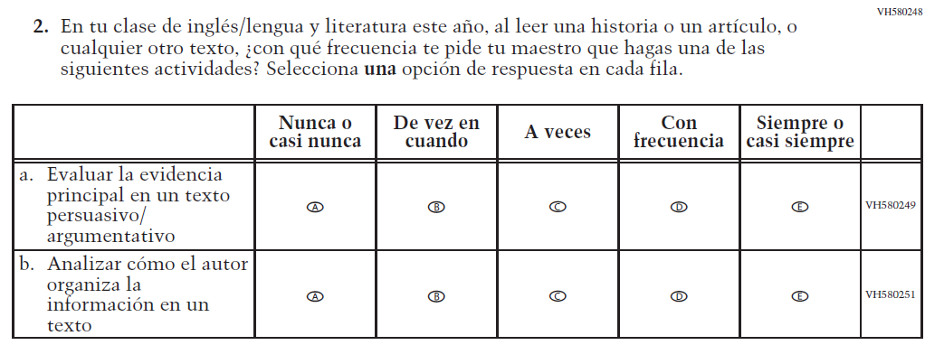  Issue: Organization of Instruction | NC | N/A
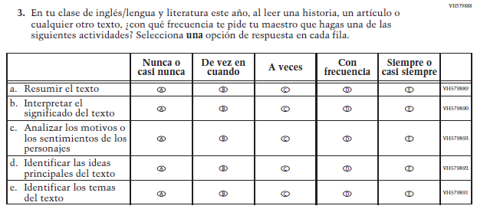  (2019 Operational Grade 8 Student Reading – Bilingual) | 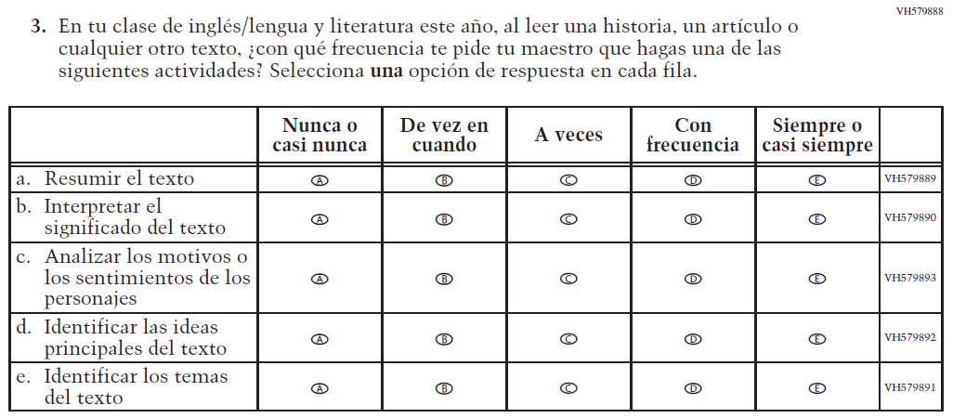  Issue: Organization of Instruction | NC | N/A
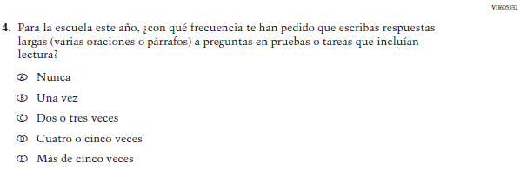  (2019 Operational Grade 8 Student Reading – Bilingual) | 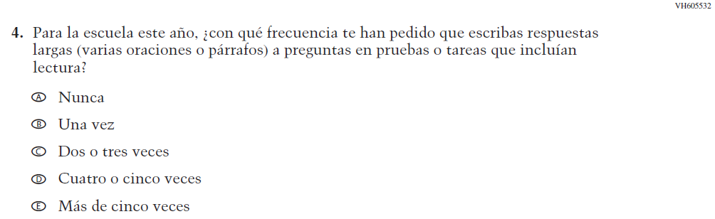  Issue: Organization of Instruction | NC | N/A
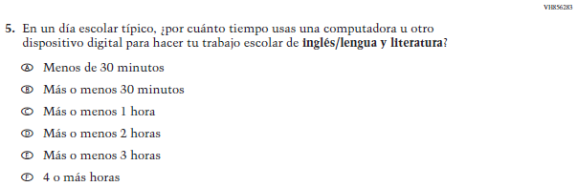  (2019 Operational Grade 8 Student Reading – Bilingual) | N/A | D | To keep student burden low, this item was dropped.
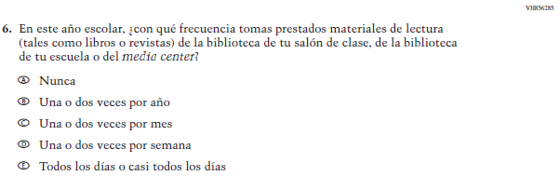  (2019 Operational Grade 8 Student Reading – Bilingual) | N/A | D | To keep student burden low, this item was dropped.

2022 Operational Grade 8 Reading Student – Bilingual

Previous item | 2022 item | D/A/ R/NC+ | Rationale
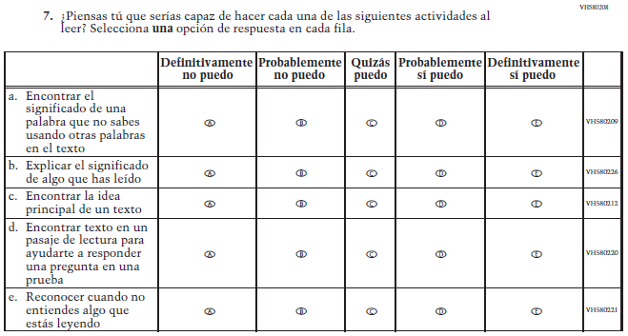  (2019 Operational Grade 8 Student Reading – Bilingual) | 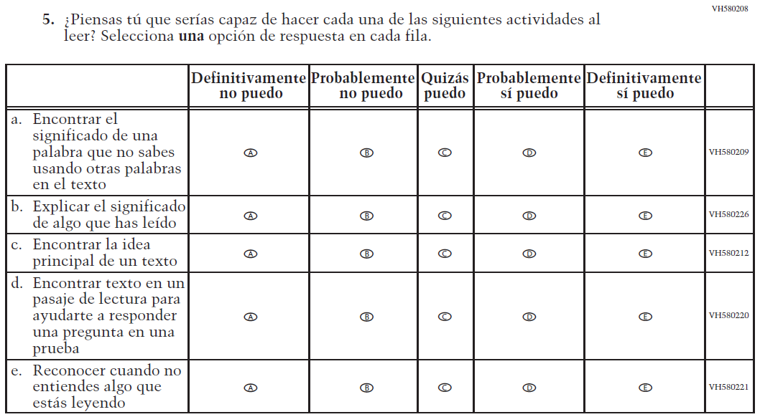  Issue: Student Factors | NC | N/A
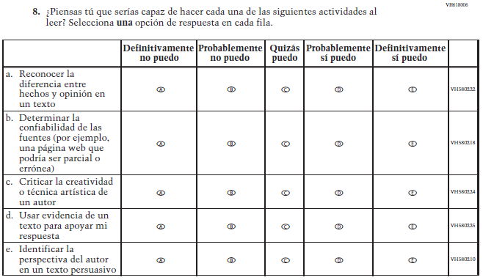  (2019 Operational Grade 8 Student Reading – Bilingual) | 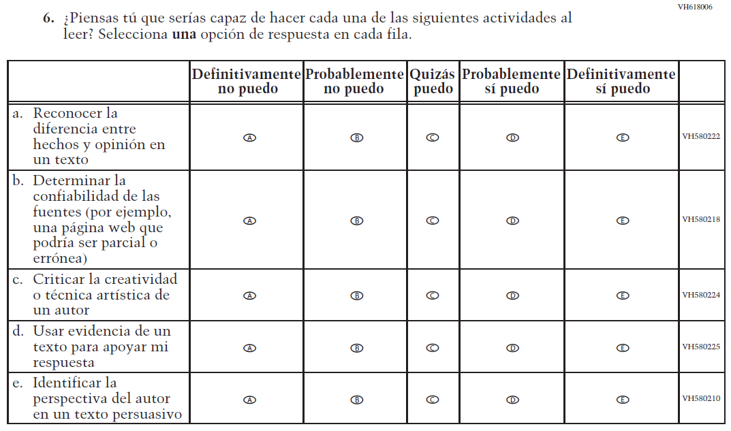  Issue: Student Factors | NC | N/A

2022 Operational Grade 8 Reading Student – Bilingual

Previous item | 2022 item | D/A/ R/NC+ | Rationale
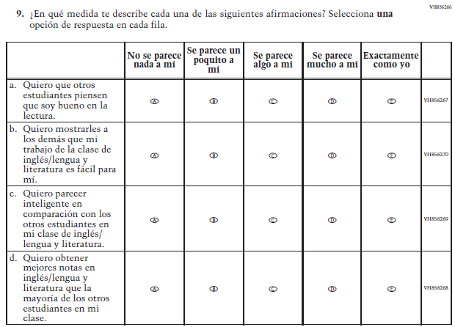  (2019 Operational Grade 8 Student Reading – Bilingual) | N/A | D | To keep student burden low, this item was dropped.
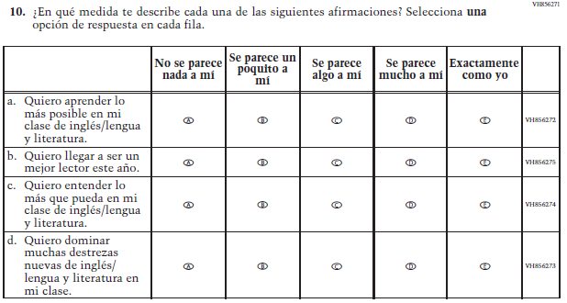  (2019 Operational Grade 8 Student Reading – Bilingual) | 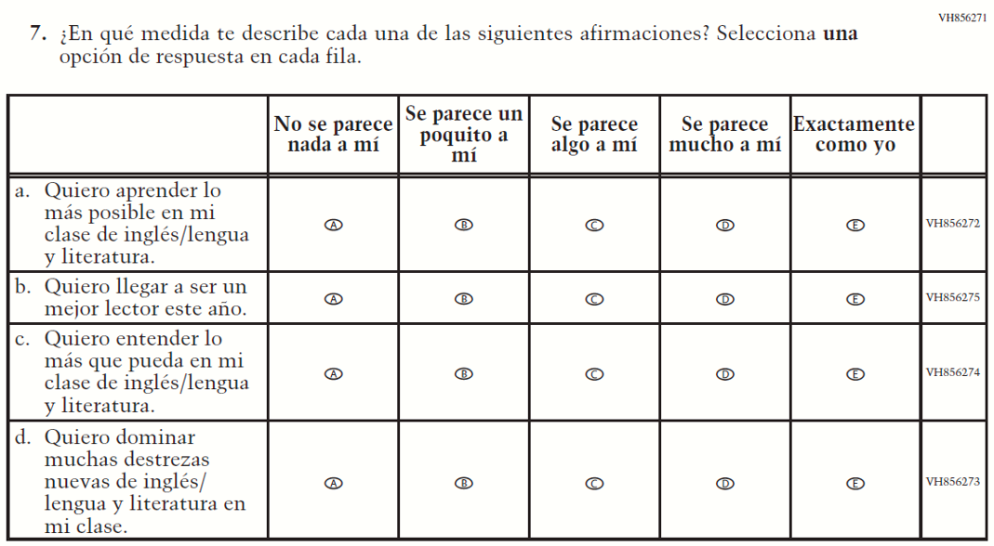  Issue: Student Factors | NC | N/A

2022 Operational Grade 8 Reading Student – Bilingual

Previous item | 2022 item | D/A/ R/NC+ | Rationale
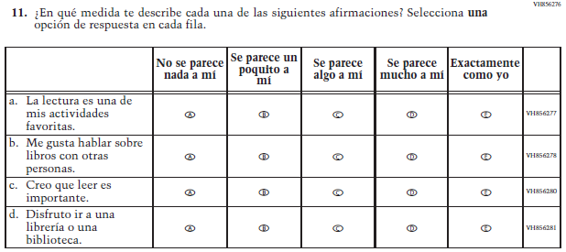  (2019 Operational Grade 8 Student Reading – Bilingual) | 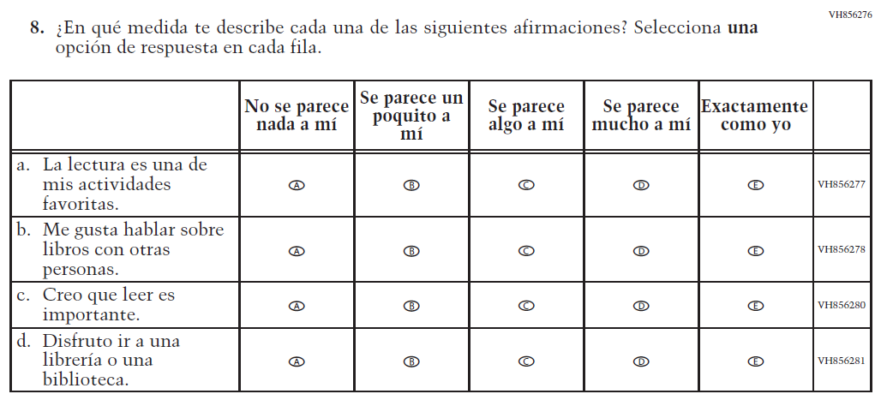  Issue: Student Factors | NC | N/A
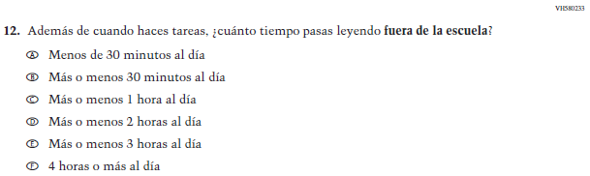  (2019 Operational Grade 8 Student Reading – Bilingual) | 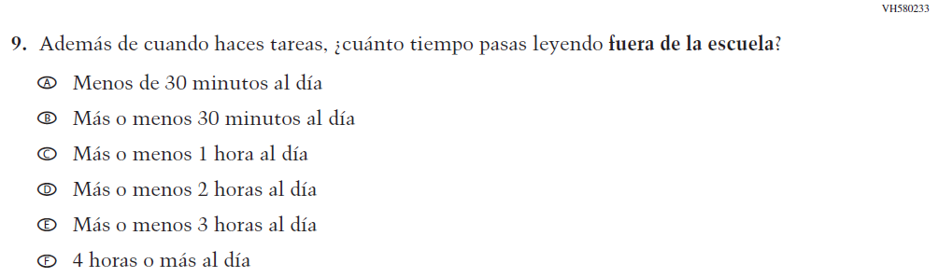  Issue: Student Factors | NC | N/A
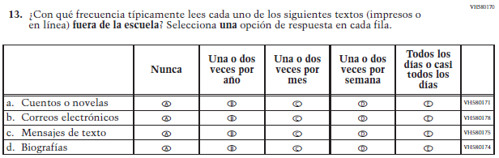  (2019 Operational Grade 8 Student Reading – Bilingual) | 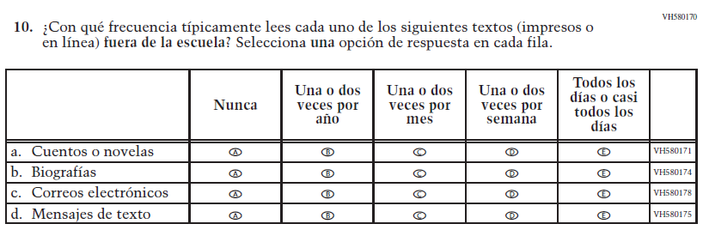  Issue: Student Factors | R | The order of sub-items b, c, and d was revised.

2022 Operational Grade 8 Reading Student – Bilingual

Previous item | 2022 item | D/A/ R/NC+ | Rationale
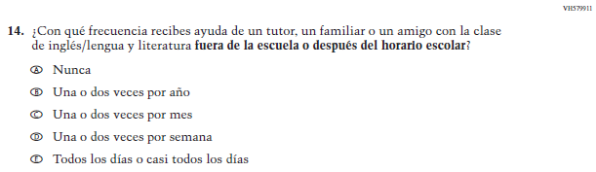  (2019 Operational Grade 8 Student Reading – Bilingual) | 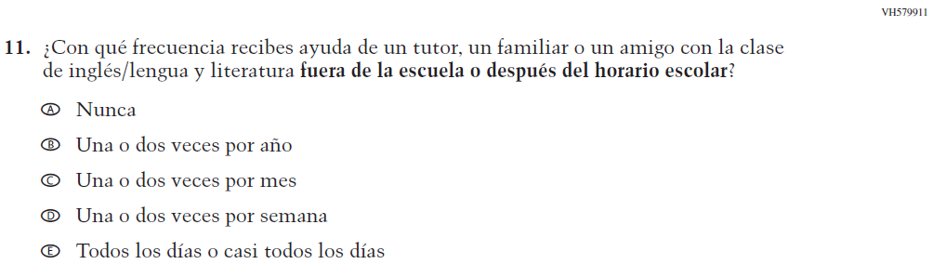  Issue: Resources for Learning and Instruction | NC | N/A
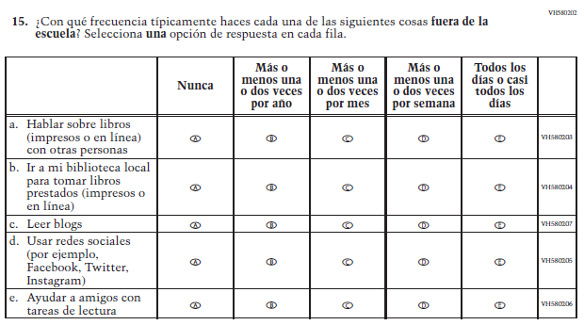  (2019 Operational Grade 8 Student Reading – Bilingual) | 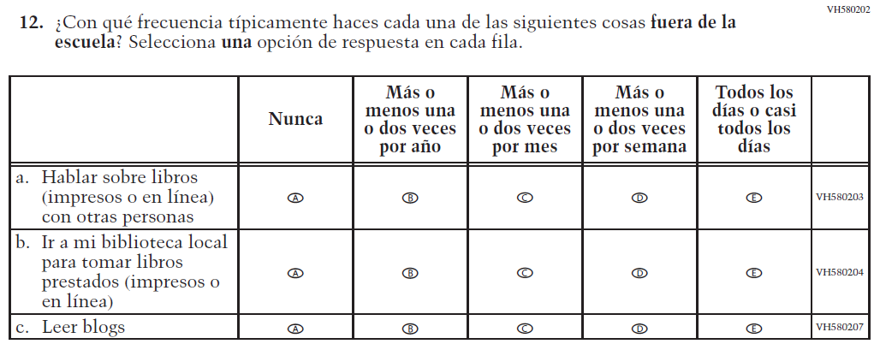  Issue: Student Factors | R | To keep student burden low, sub-items d and e were dropped.

Appendix J-1j-s-BL: Operational Grade 8 Reading
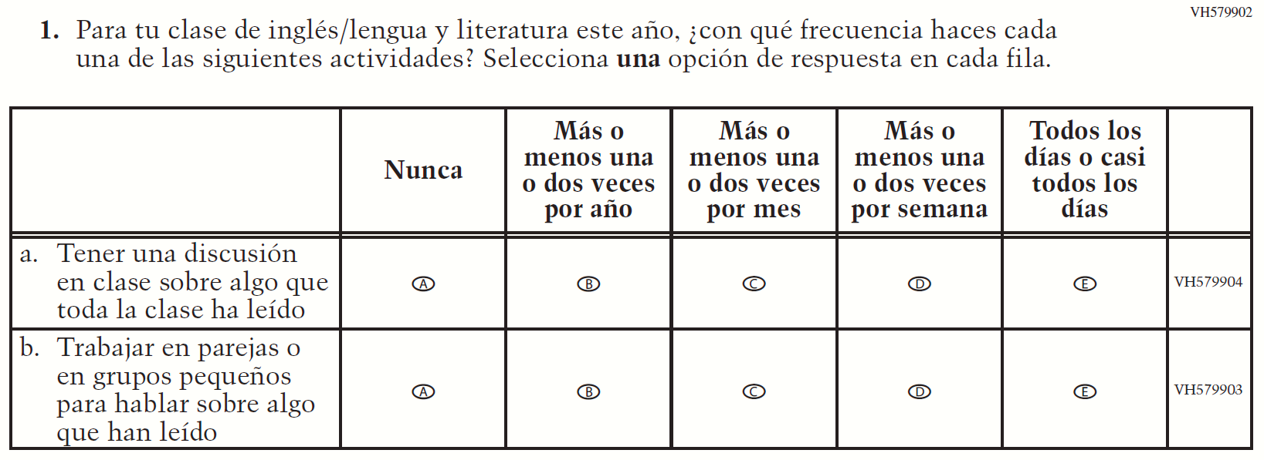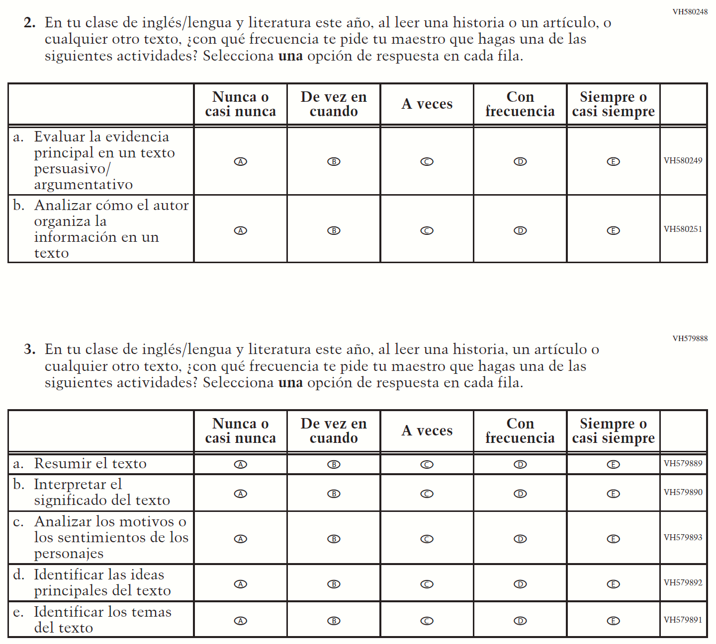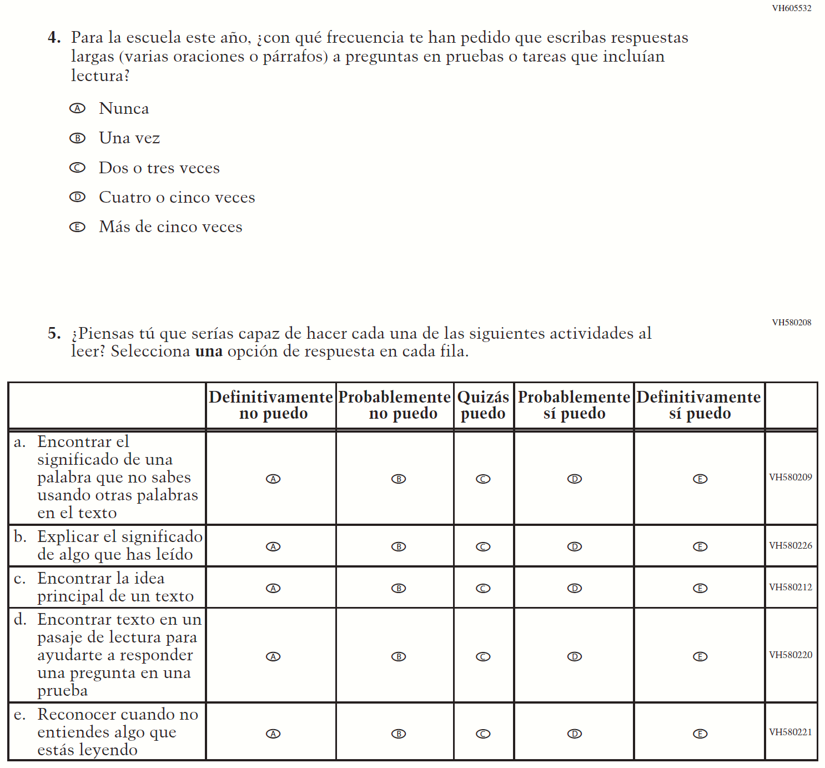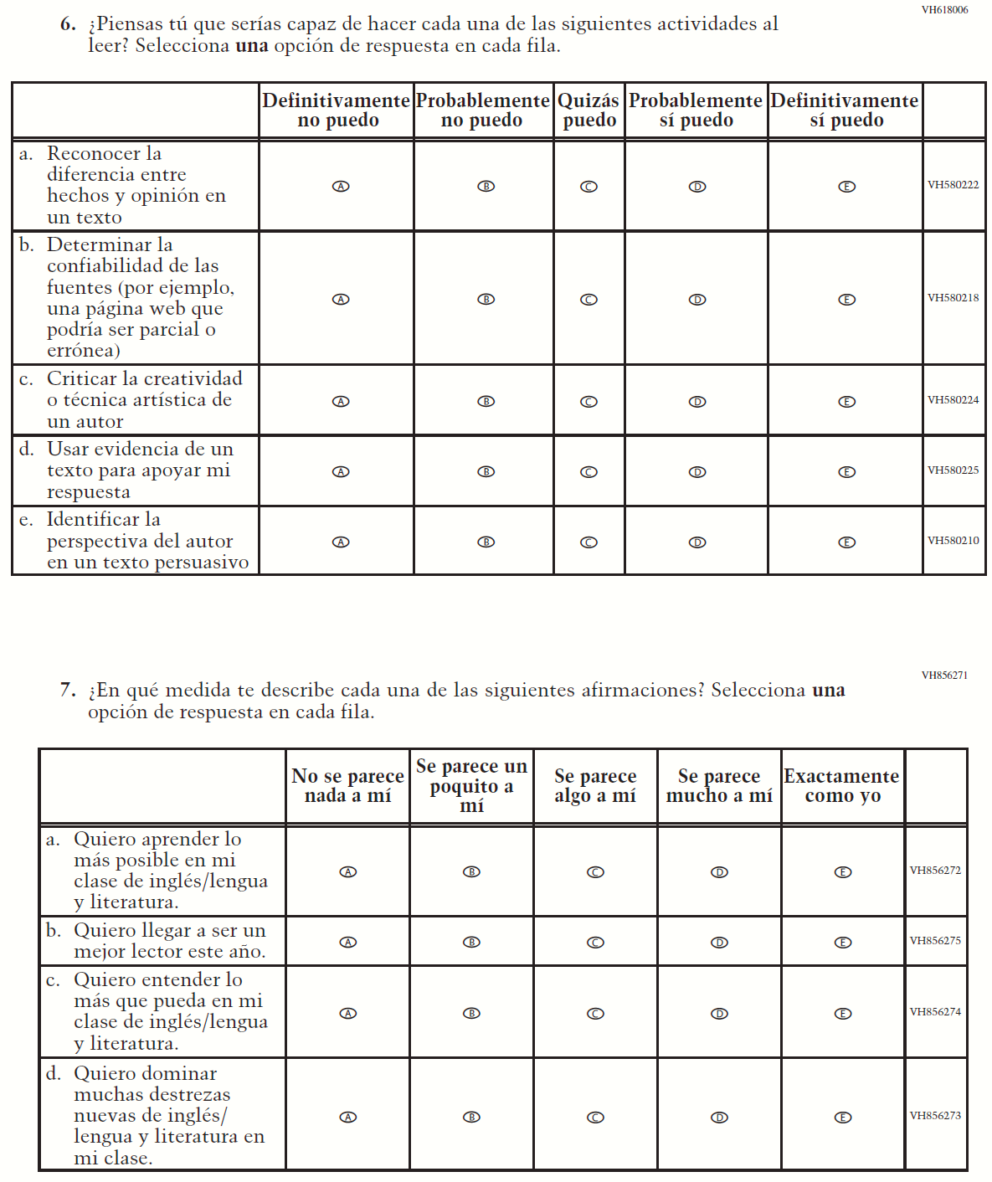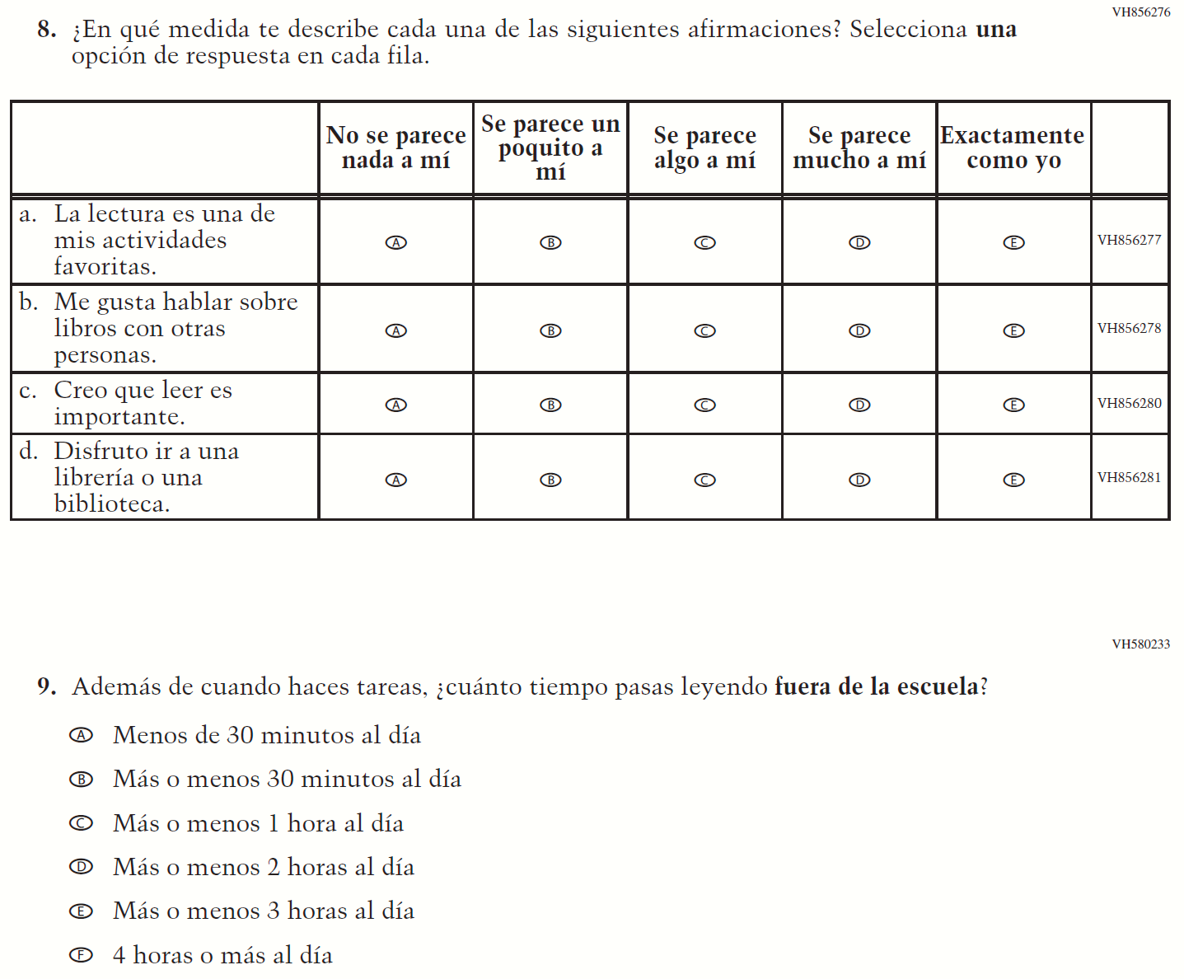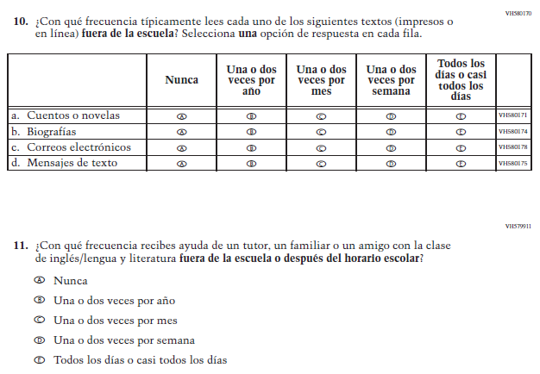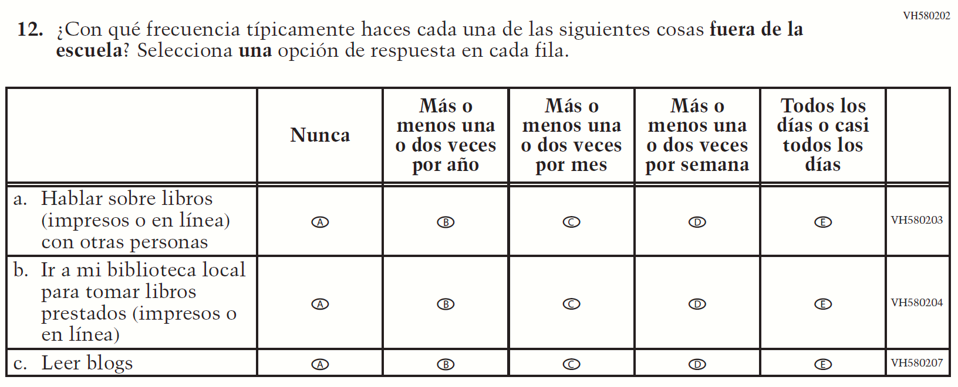

Appendix J-1k-s-BL: Operational Grade 8 Civics
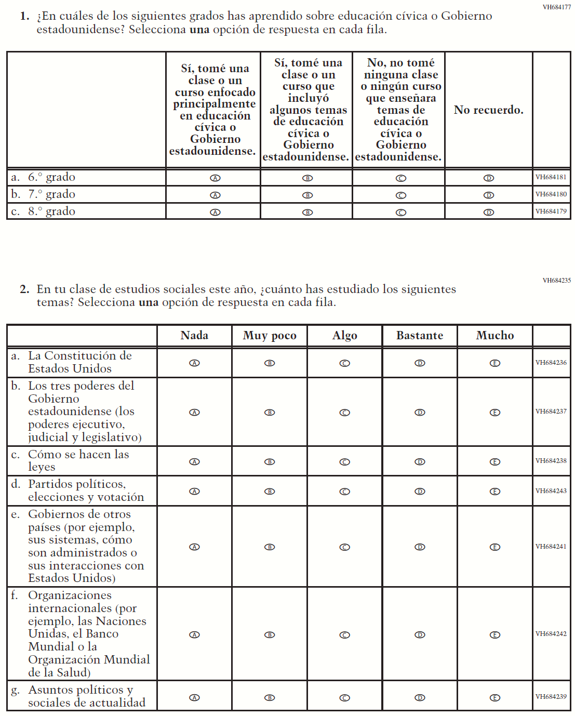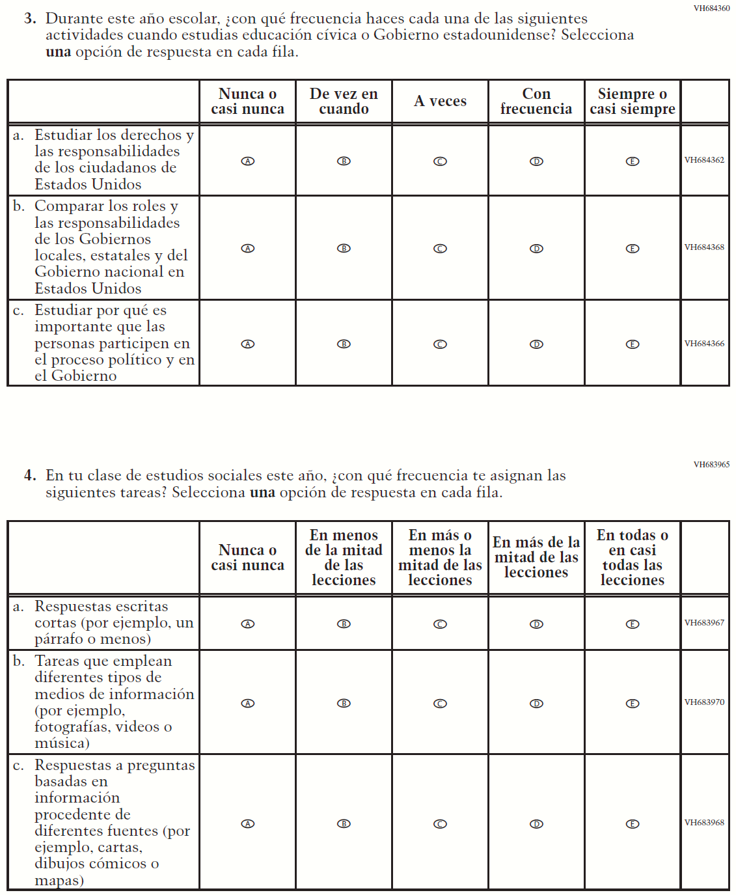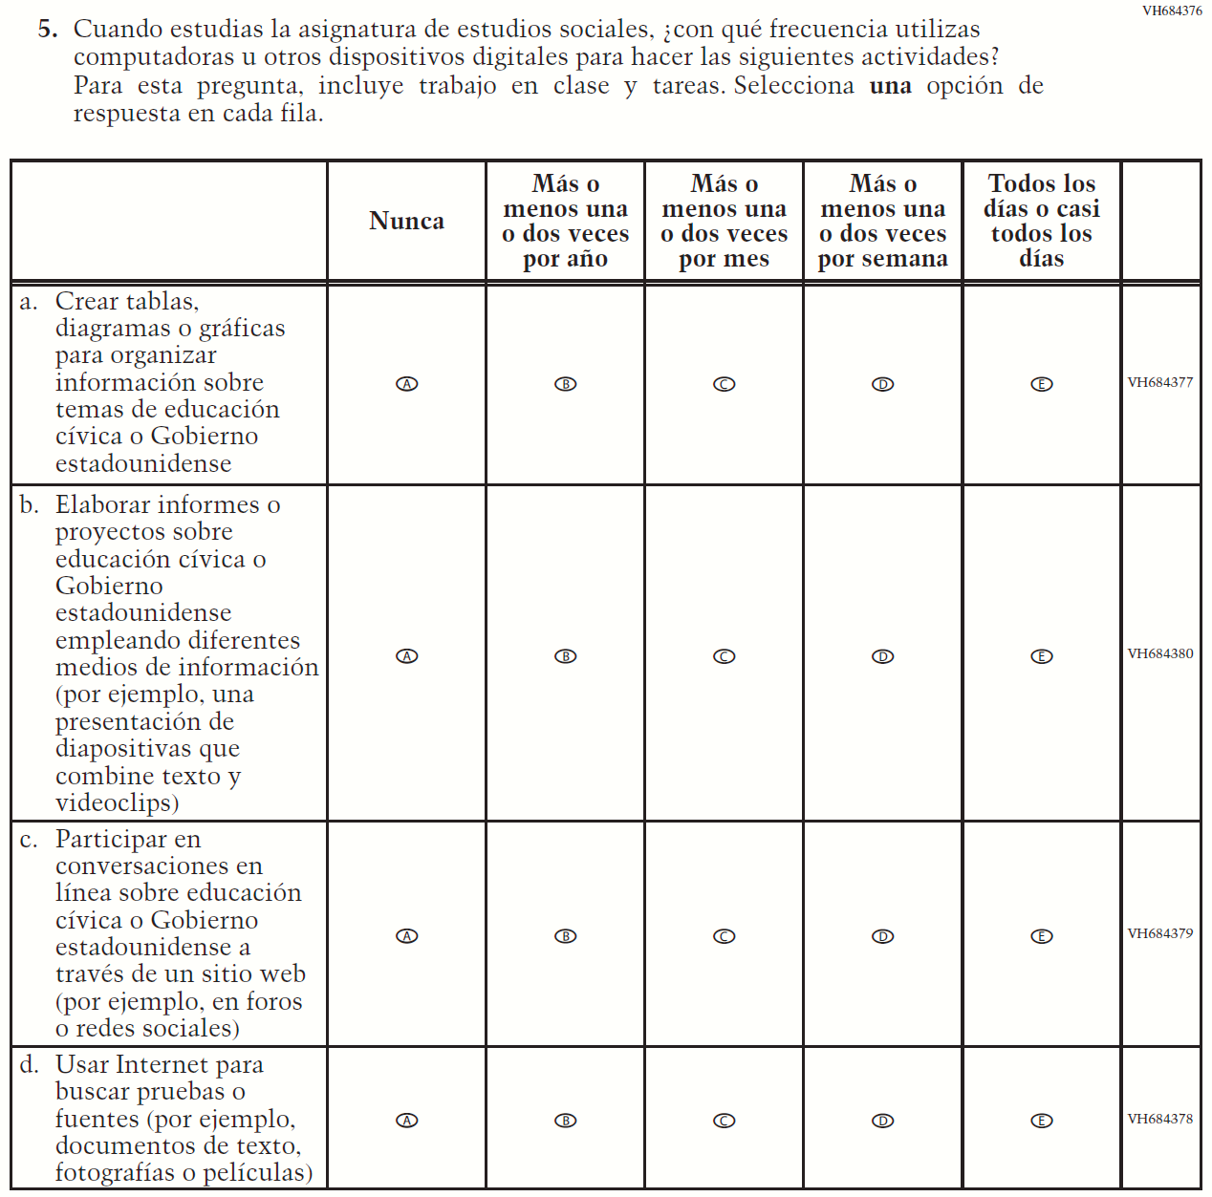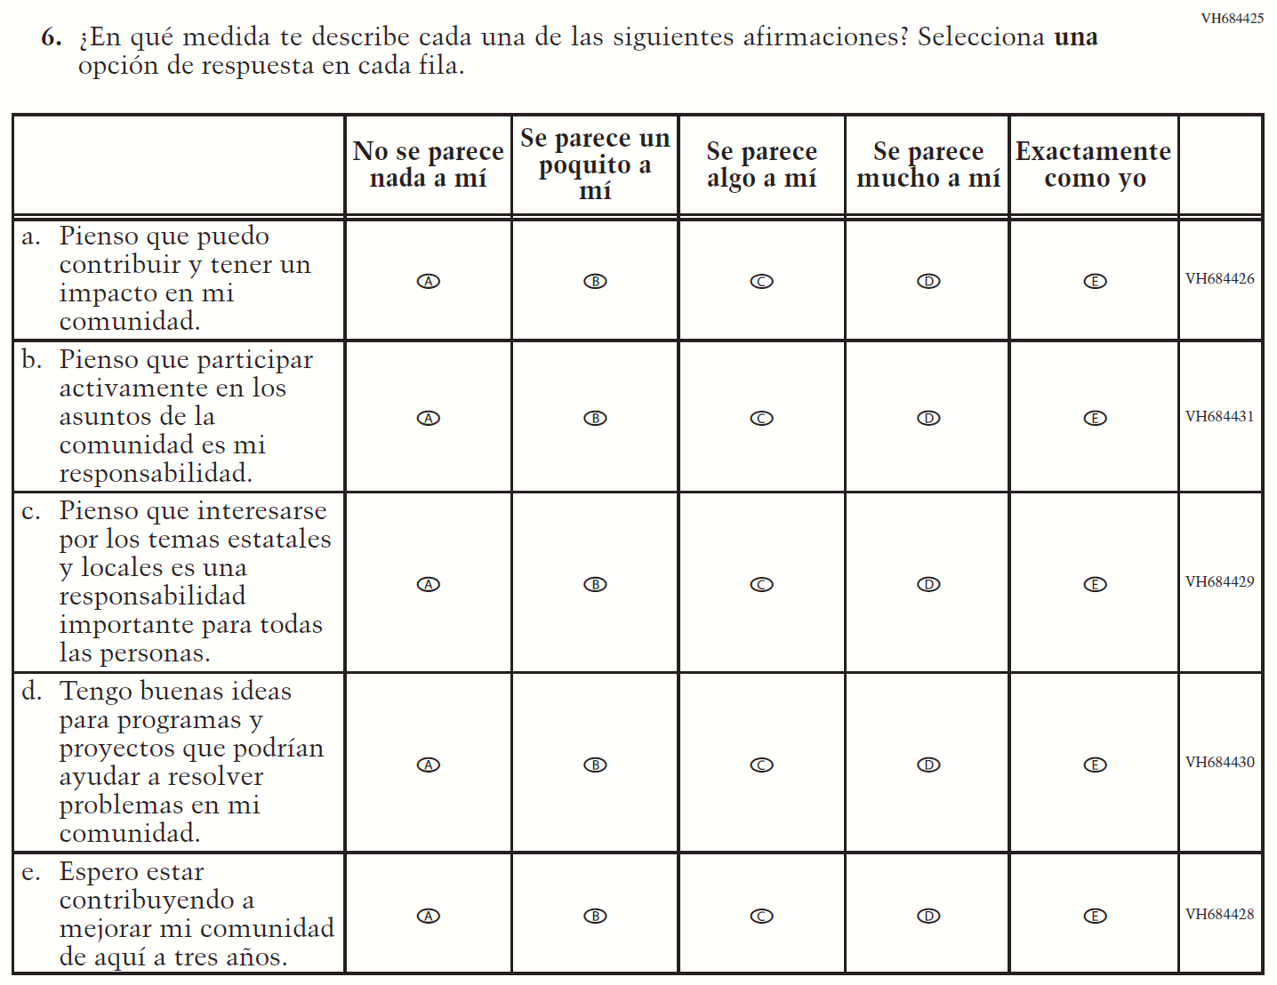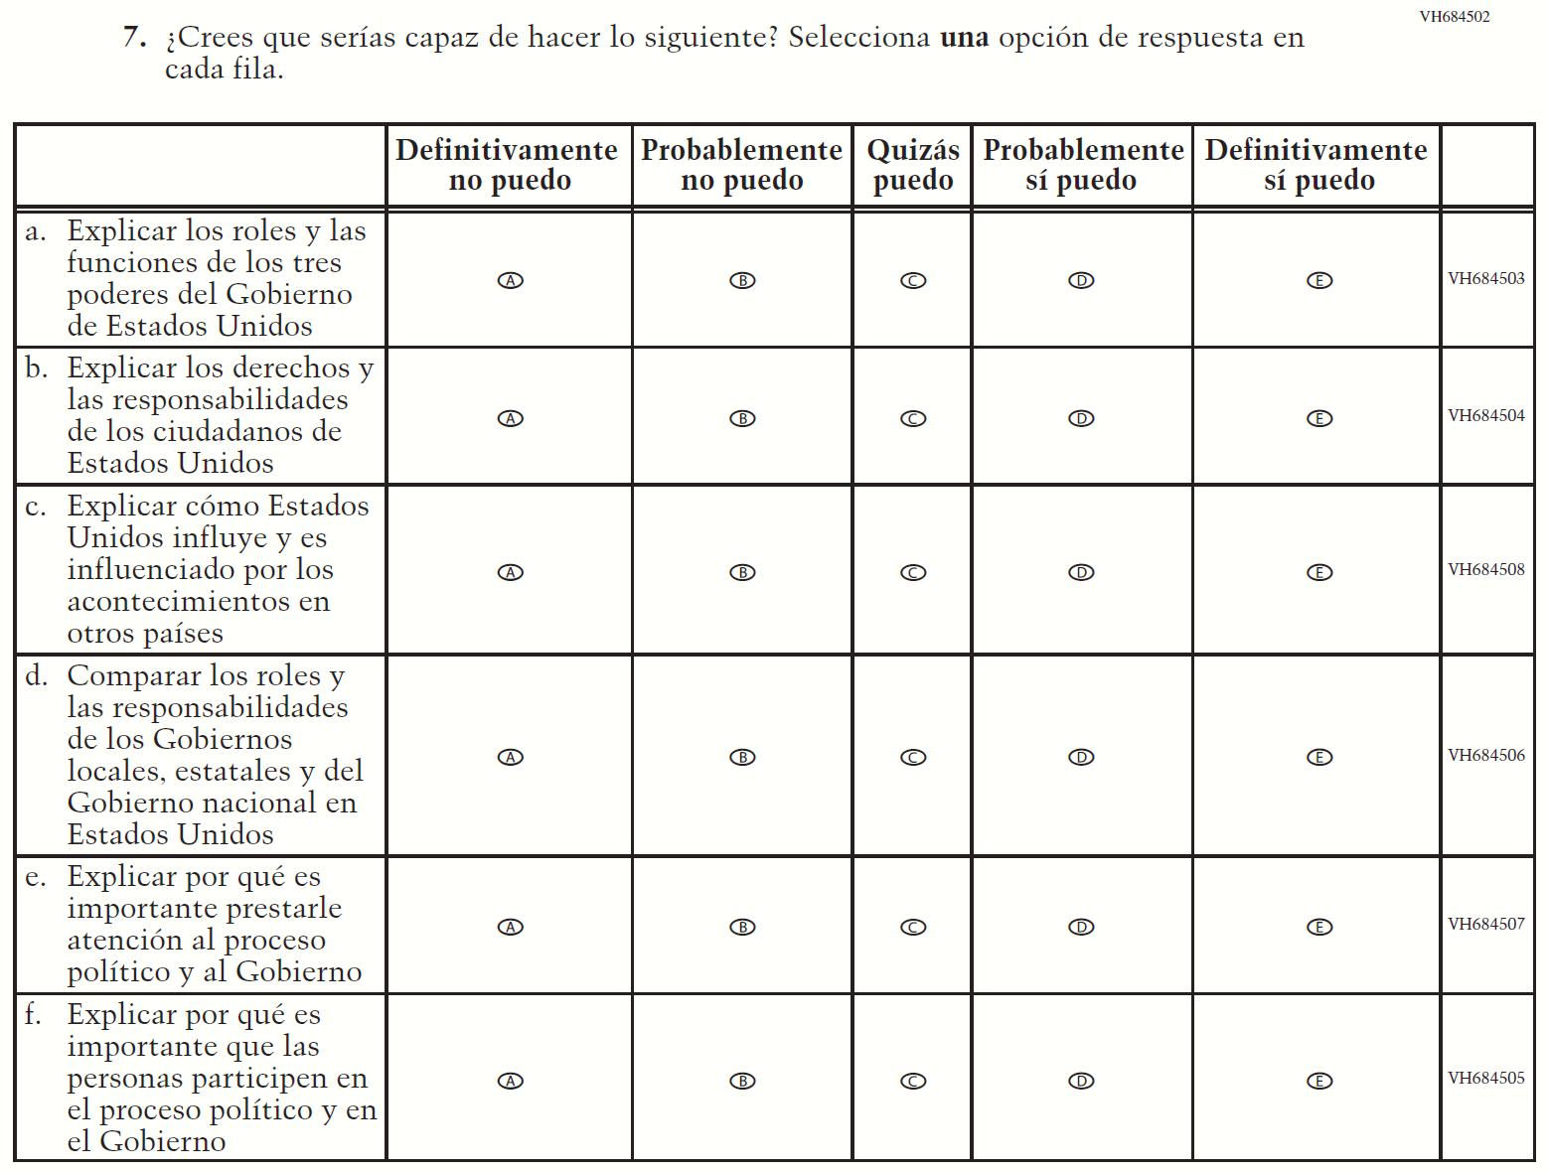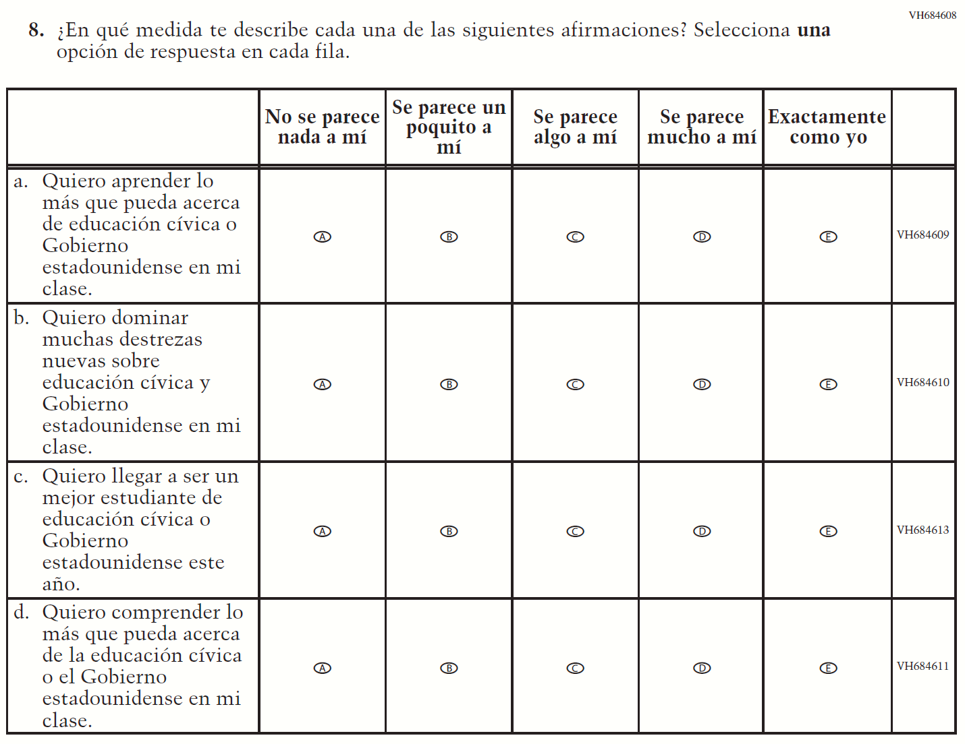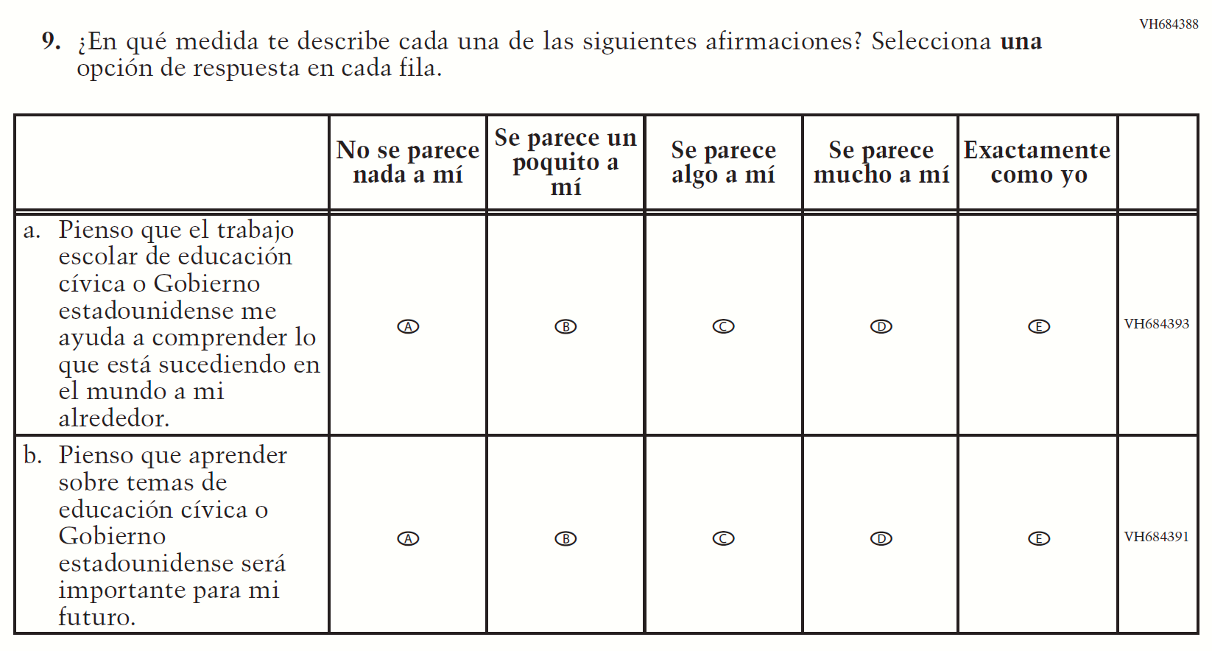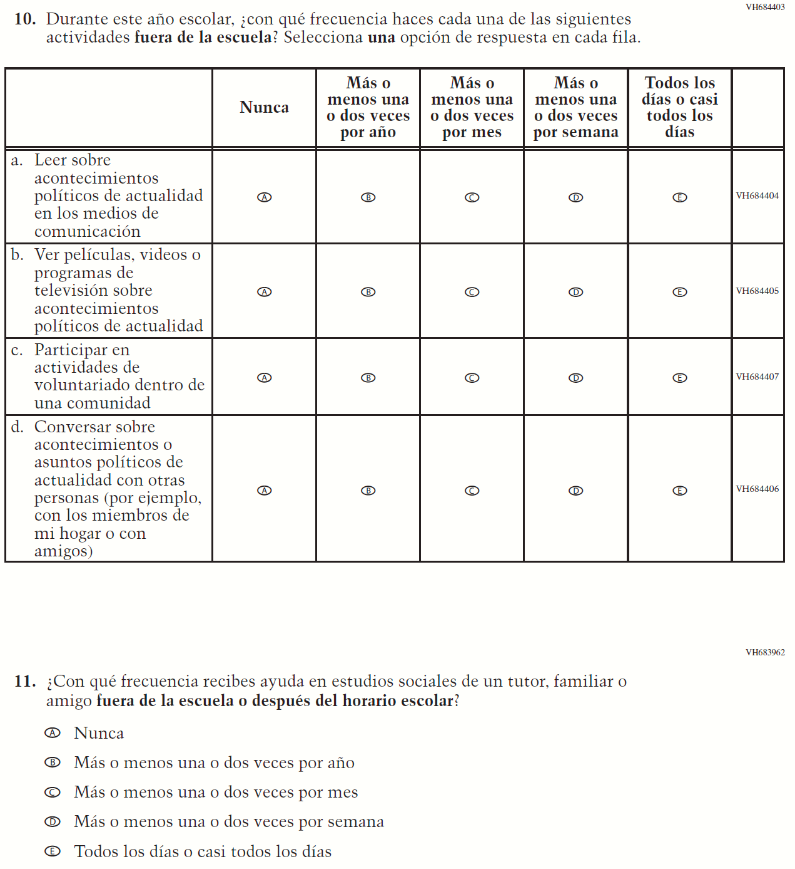

Appendix J-1l-s-BL: Operational Grade 8 US History
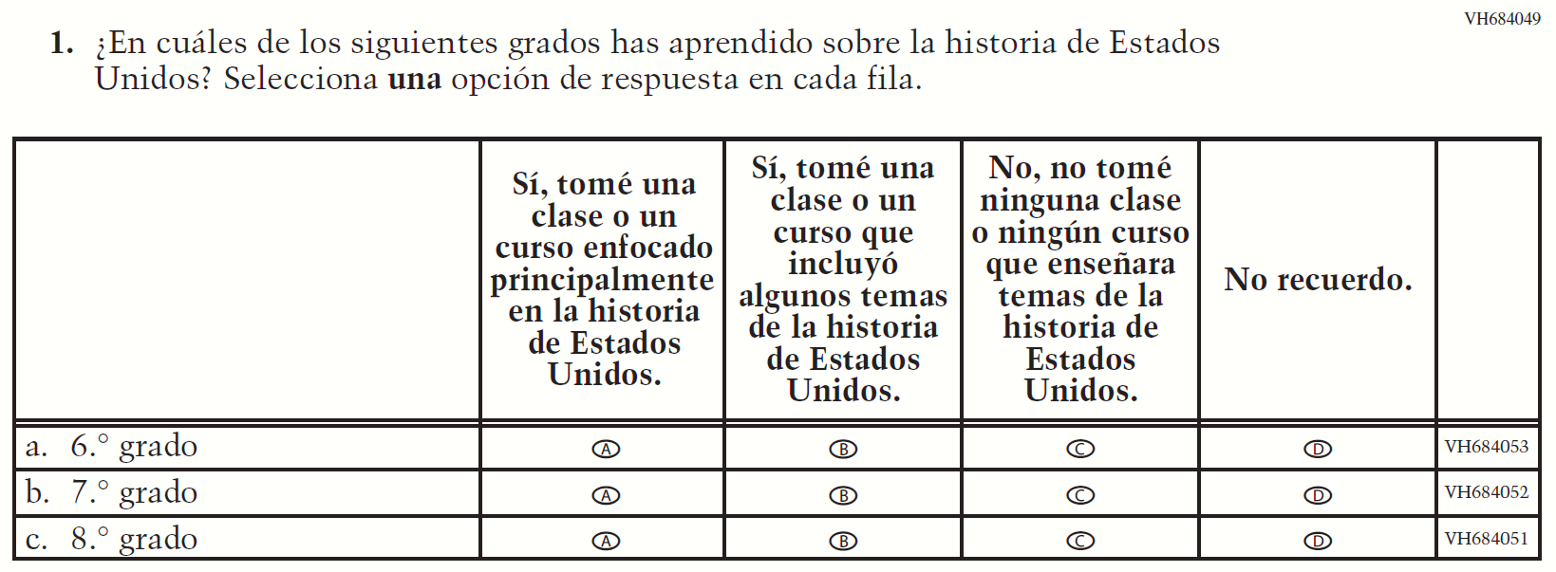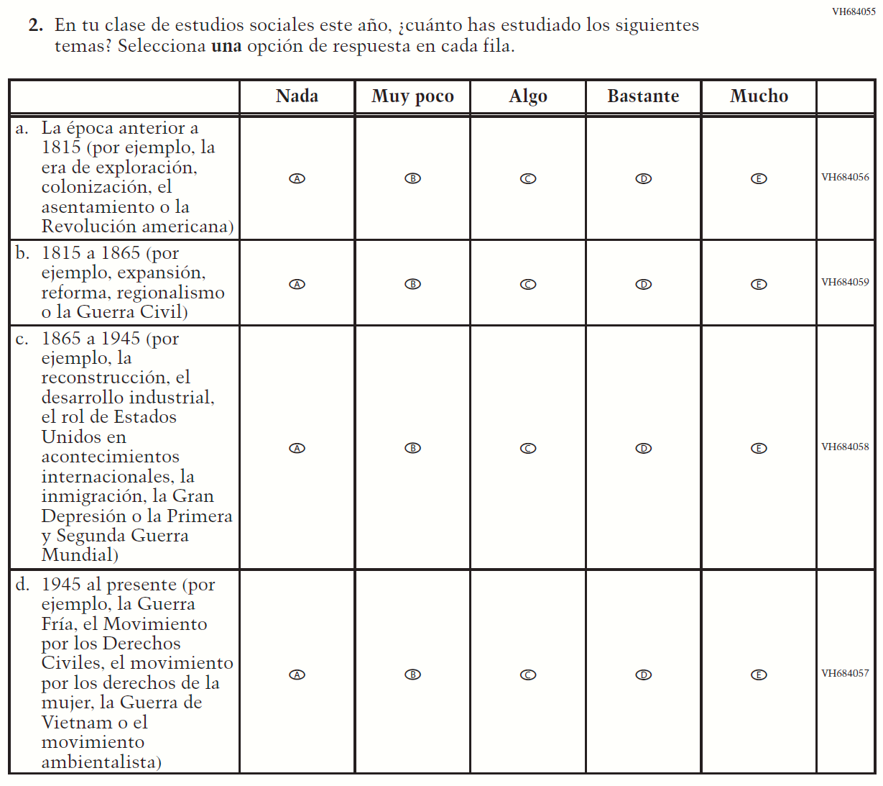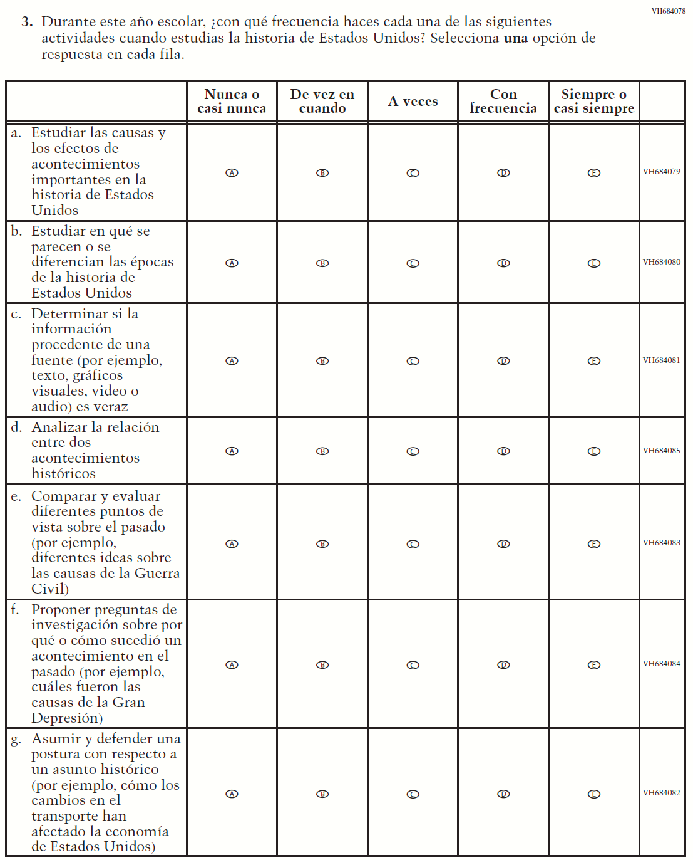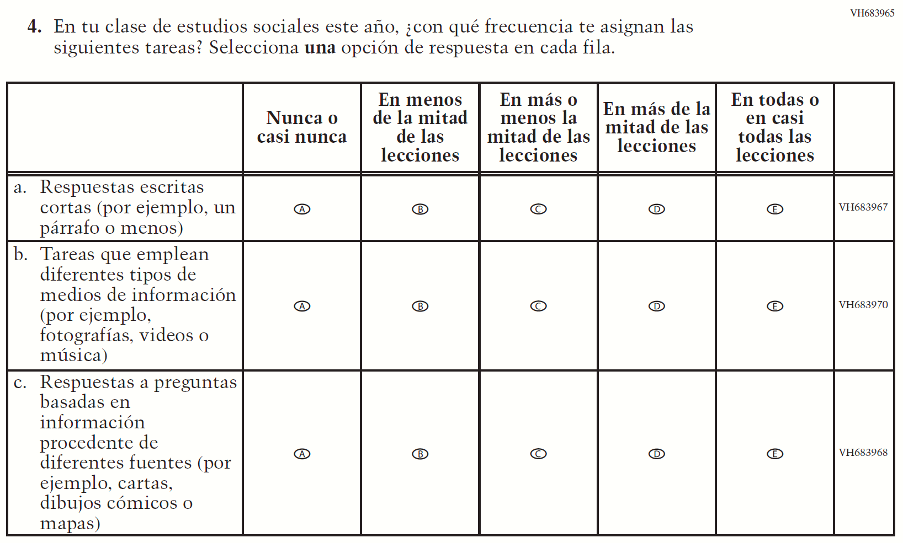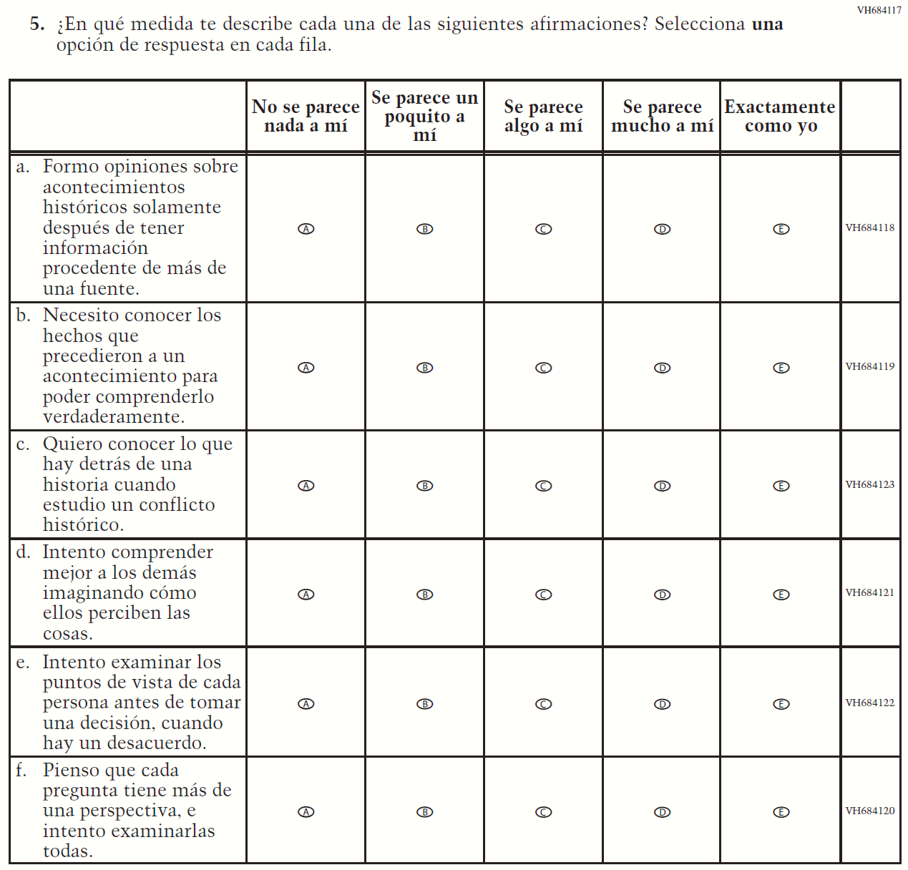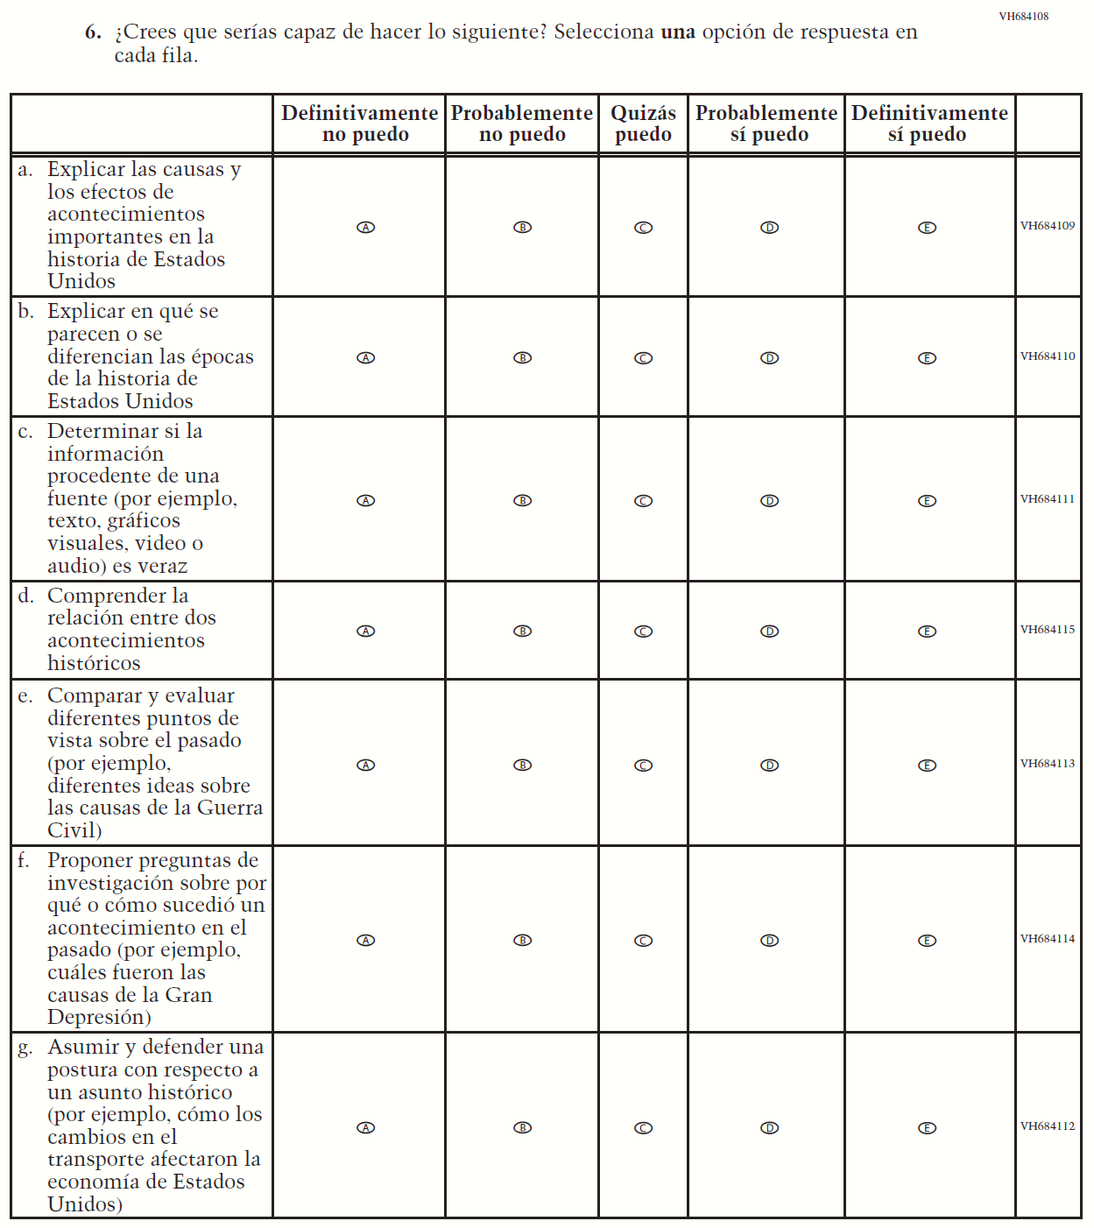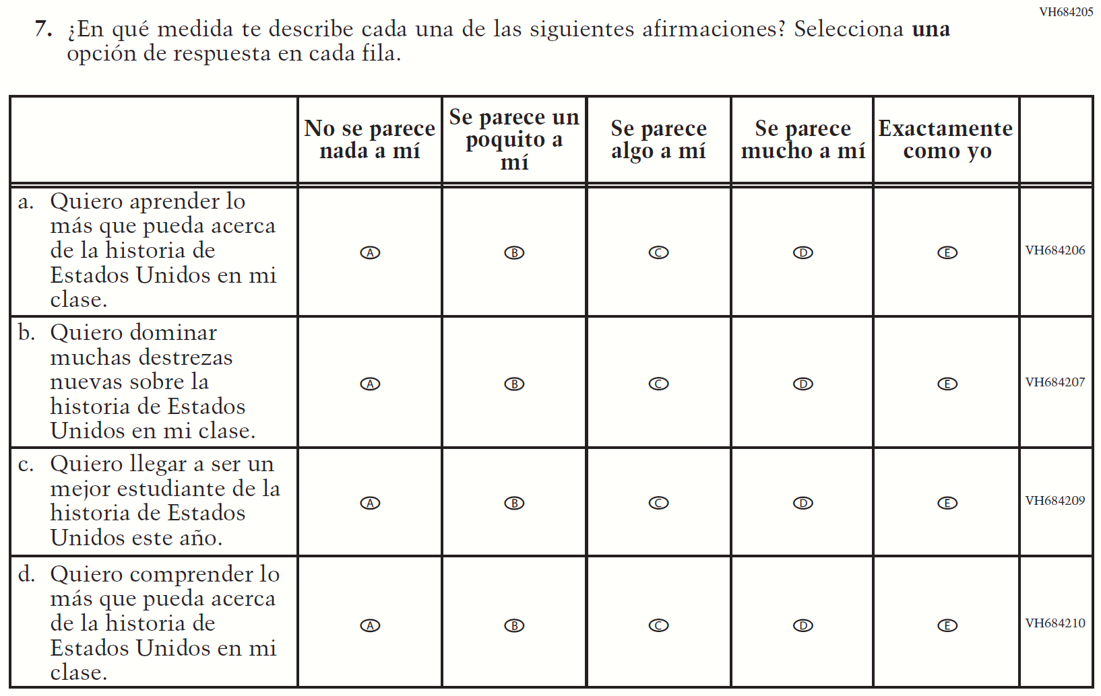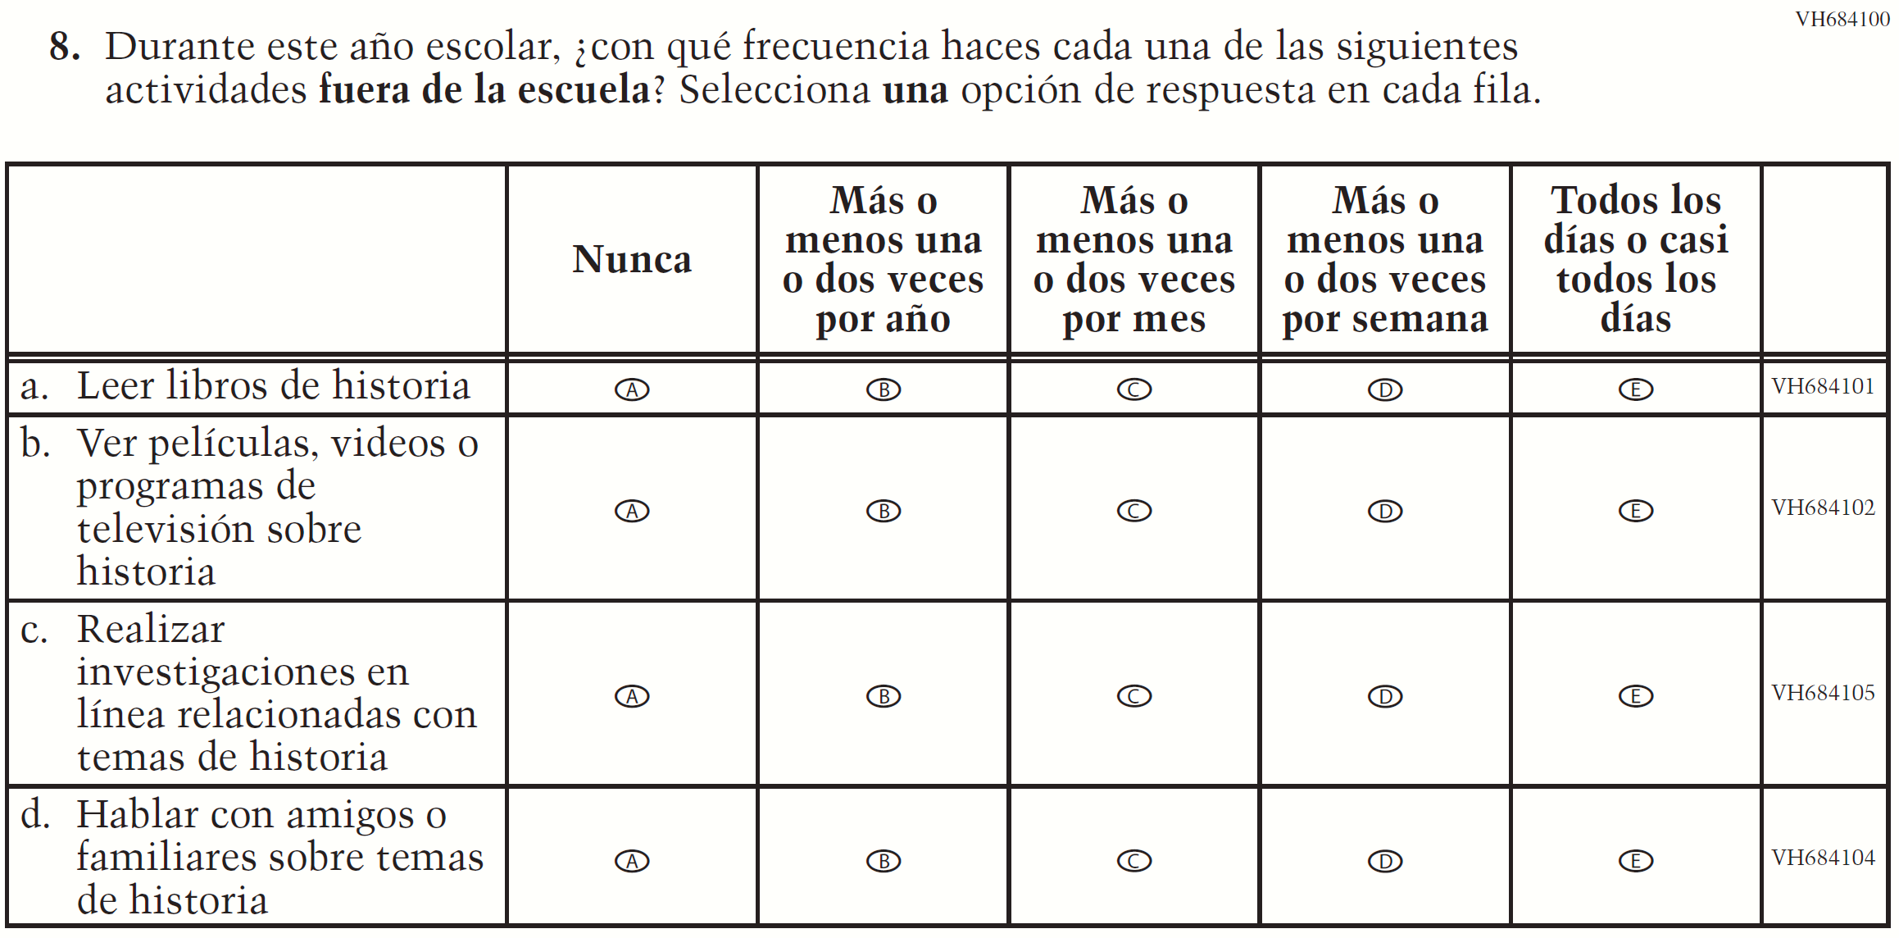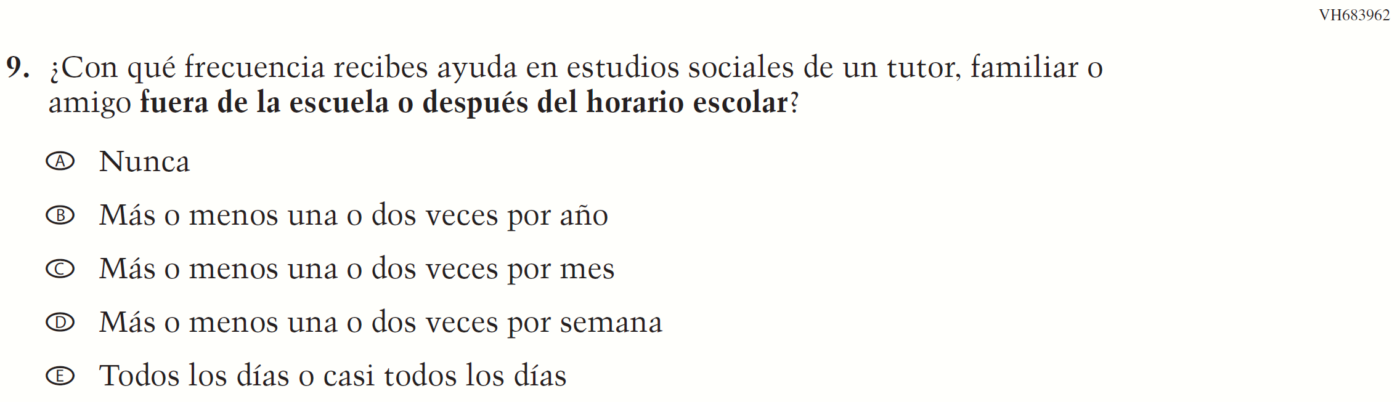

Appendix J-1m-s-BL: Summary of Operational Grade 4 Debrief
2022 Operational Grade 4 Debrief Student –Bilingual
Previous item | 2022 item | D/A/R/NC+ | Rationale
VH580900  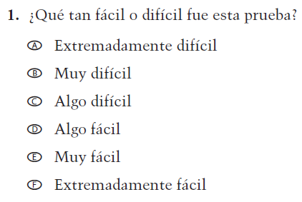  (2019 Operational Grade 4 and 8 Student Debrief- Bilingual) | N/A | D | To keep student burden low, this item was dropped.
VH580572  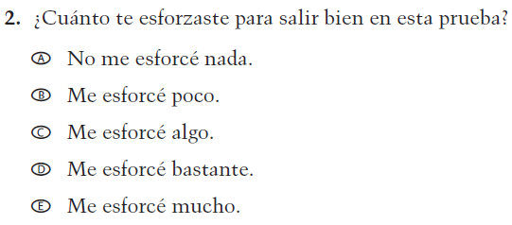  (2019 Operational Grade 4 and 8 Student Debrief- Bilingual) | VH580572  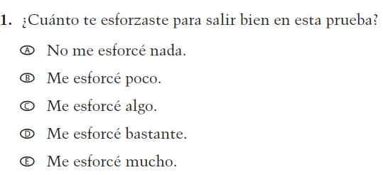  Issue: Debrief | NC | N/A

Appendix J-1m-s-BL: Operational Grade 4 Debrief
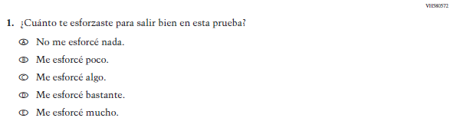

Appendix J-1n-s-PR: Summary of Operational Grade 4 Debrief
2022 Operational Grade 4 Debrief Student – Puerto Rico

Previous item | 2022 item | D/A/ R/NC+ | Rationale
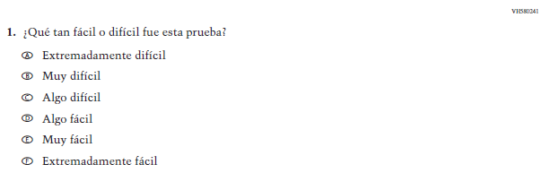  (2019 Operational Grade 4 and 8 Student Debrief – Puerto Rico) | N/A | D | To keep student burden low, this item was dropped.
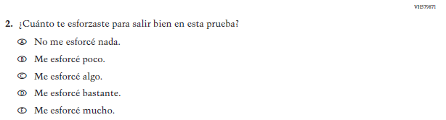  (2019 Operational Grade 4 and 8 Student Debrief – Puerto Rico) | 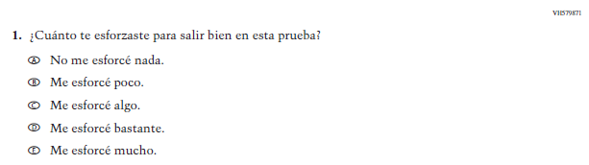  Issue: Debrief | NC | N/A

Appendix J-1n-s-PR: Operational Grade 4 Debrief
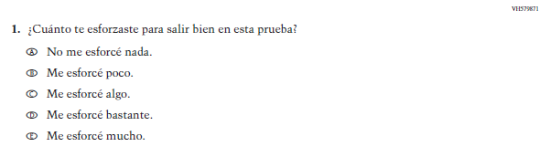

Appendix J-1o-s-BL: Summary of Operational Grade 8 Debrief
2022 Operational Grade 8 Debrief Student – Bilingual
Previous item | 2022 item | D/A/R/NC+ | Rationale
VH580900  (2019 Operational Grade 4 and 8 Student Debrief- Bilingual) | VH580900  Issue: Debrief | NC | N/A
VH580572  (2019 Operational Grade 4 and 8 Student Debrief- Bilingual) | VH580572  Issue: Debrief | NC | N/A

Appendix J-1o-s-BL: Operational Grade 8 Debrief

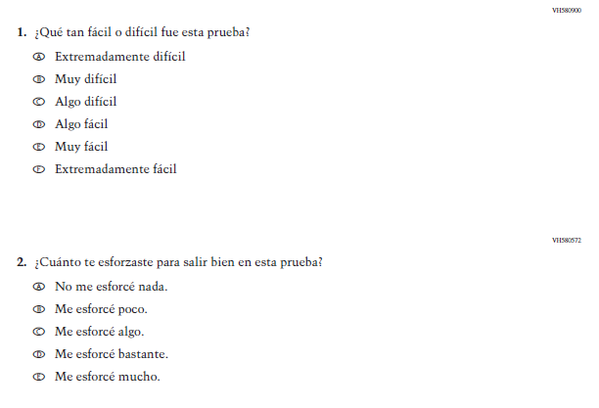

Appendix J-1p-s-PR: Summary of Operational Grade 8 Debrief
2022 Operational Grade 8 Debrief Student – Puerto Rico

Previous item | 2022 item | D/A/ R/NC+ | Rationale
(2019 Operational Grade 4 and 8 Student Debrief – Puerto Rico) | Issue: Debrief | NC | N/A
(2019 Operational Grade 4 and 8 Student Debrief – Puerto Rico) | Issue: Debrief | NC | N/A

Appendix J-1p-s-PR: Operational Grade 8 Debrief
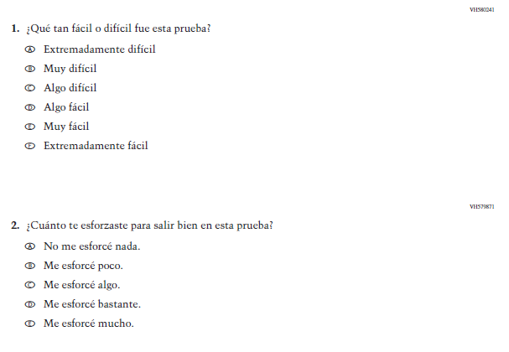

Appendix J-1q-s-BL: Operational Grade 4 COVID-19 (ELA)
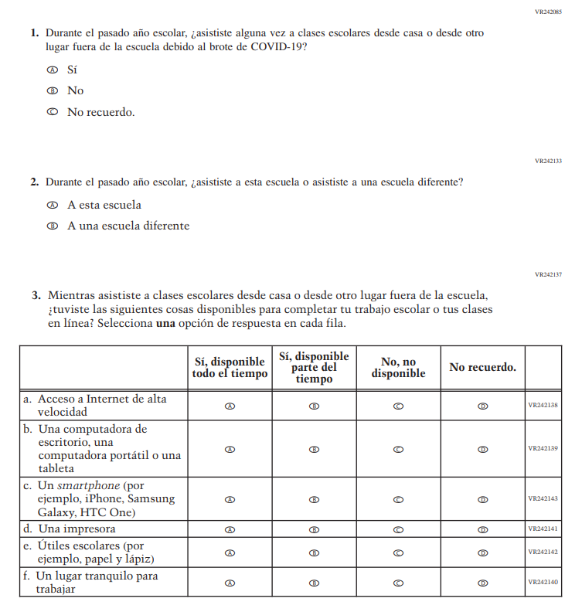

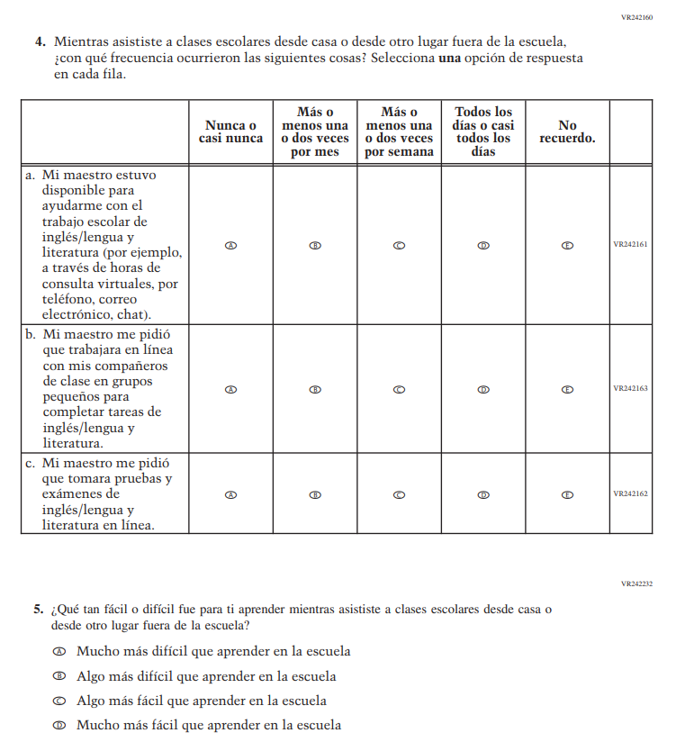

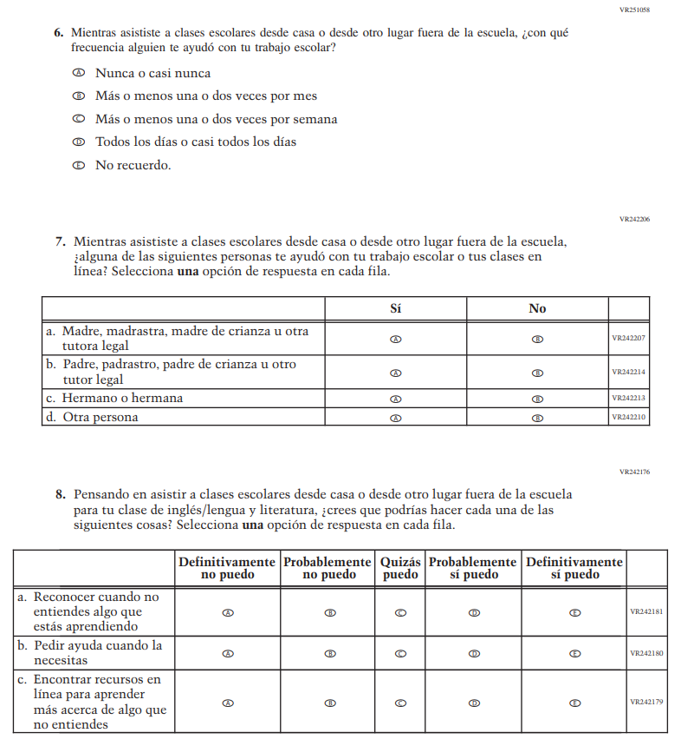

Appendix J-1r-s-BL: Operational Grade 8 COVID-19 (ELA)
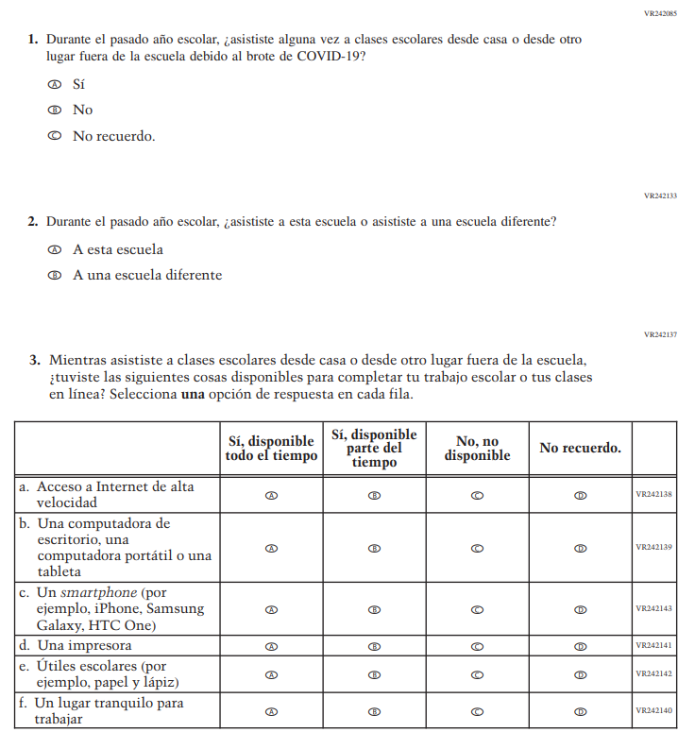

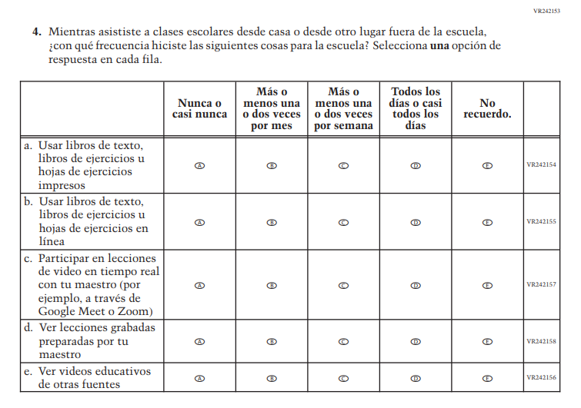

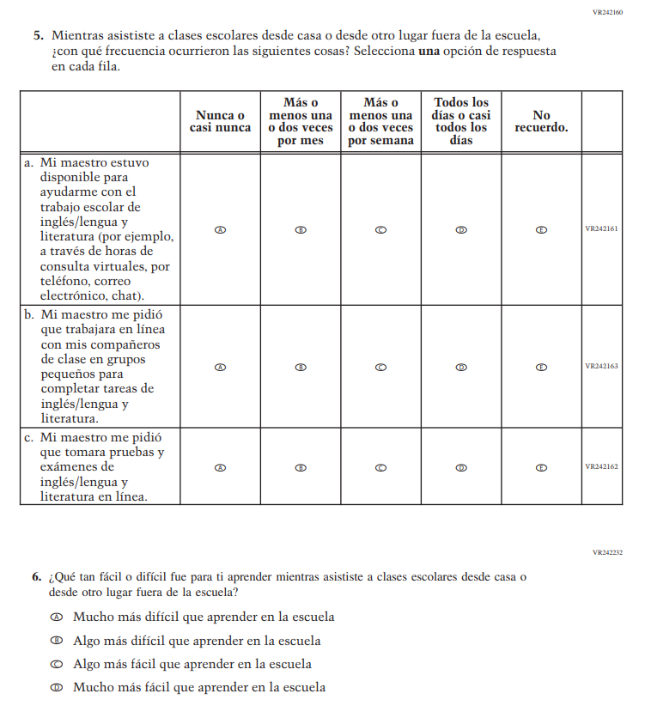

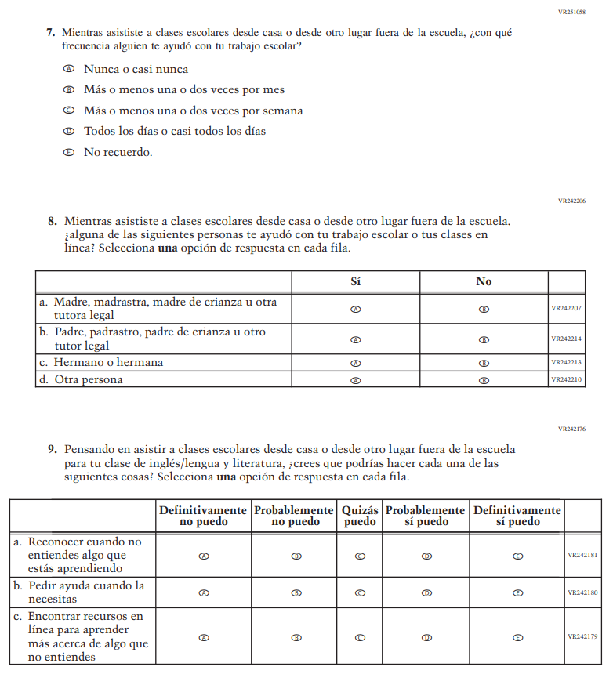

Appendix J-1s-s-BL: Operational Grade 4 COVID-19 (Math)
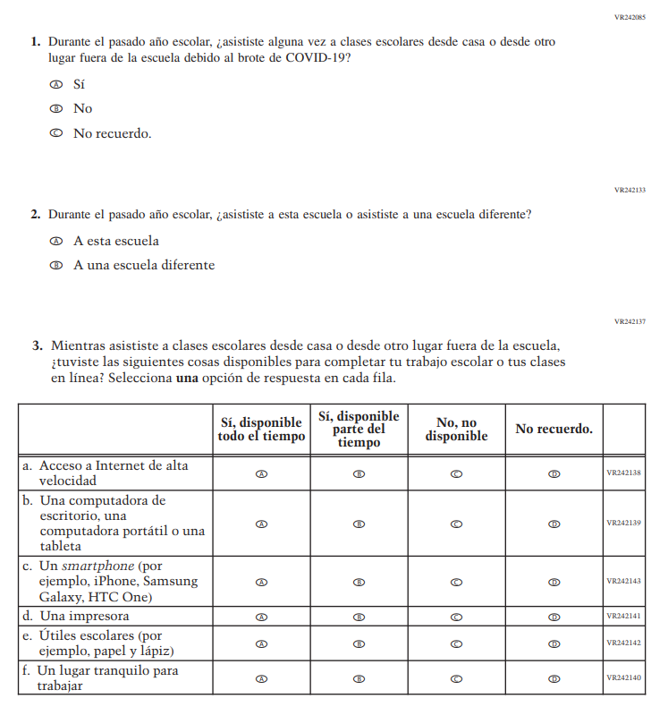

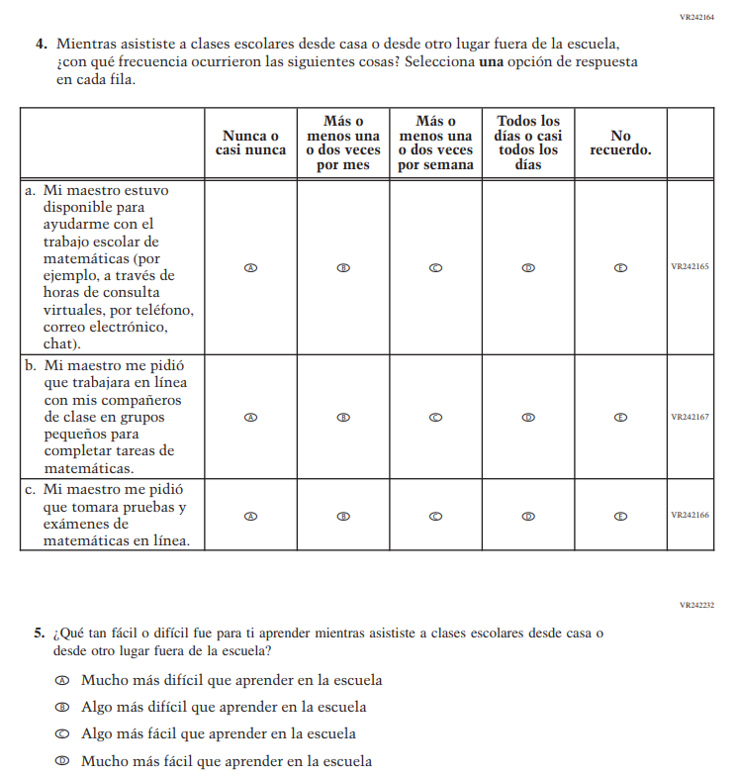

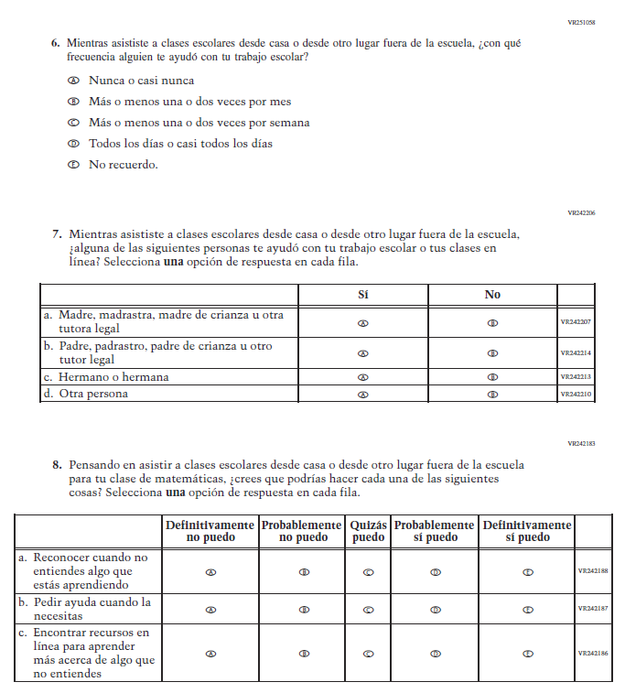

Appendix J-1t-s-PR: Operational Grade 4 COVID-19 (Math)
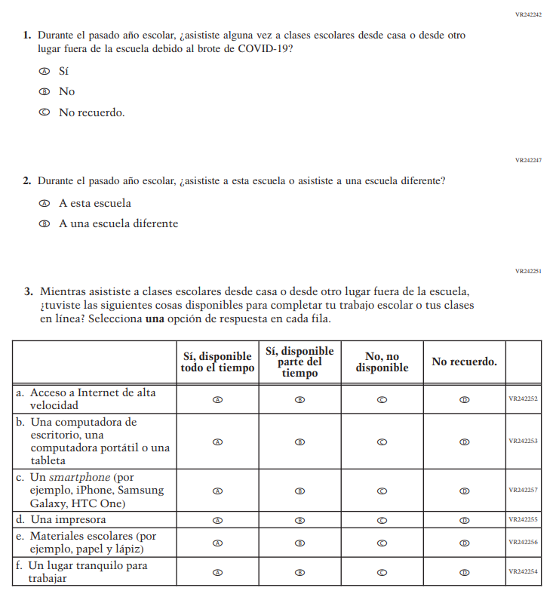

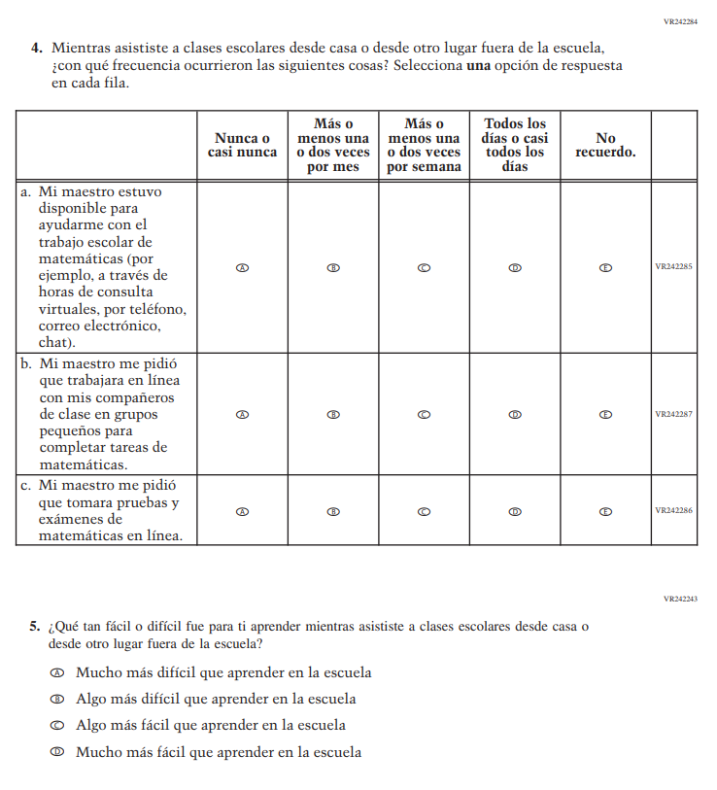

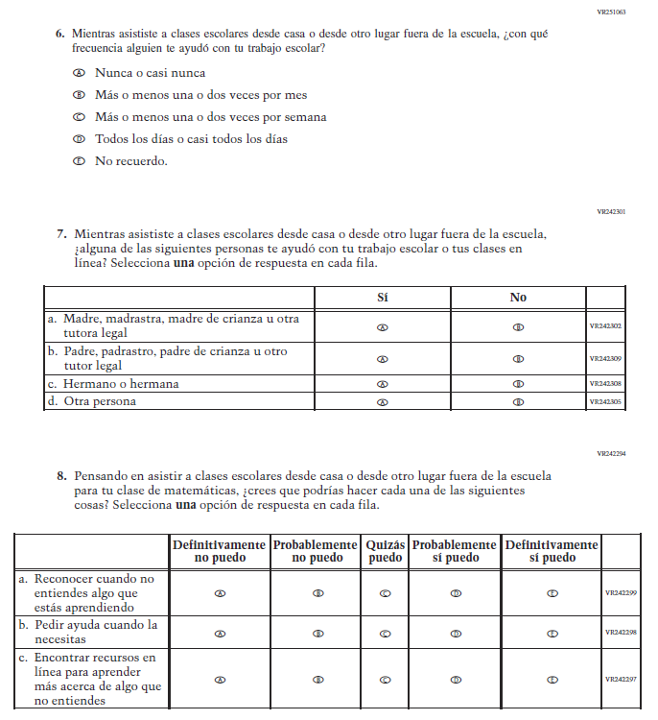

Appendix J-1u-s-BL: Operational Grade 8 COVID-19 (Math)
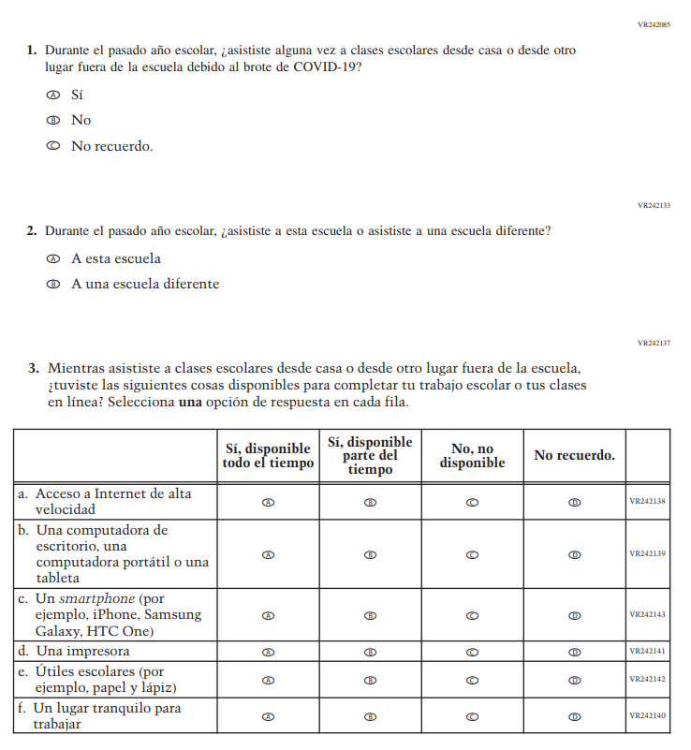

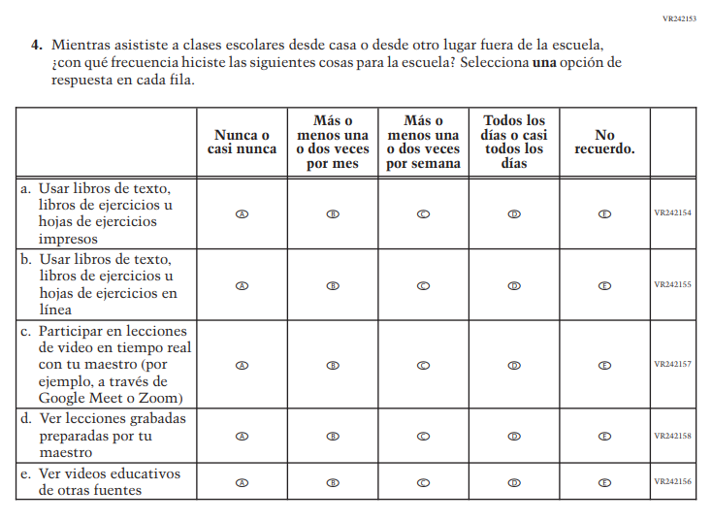

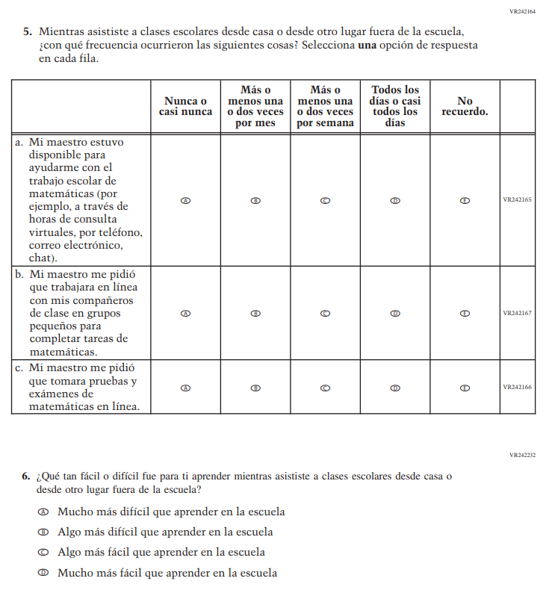

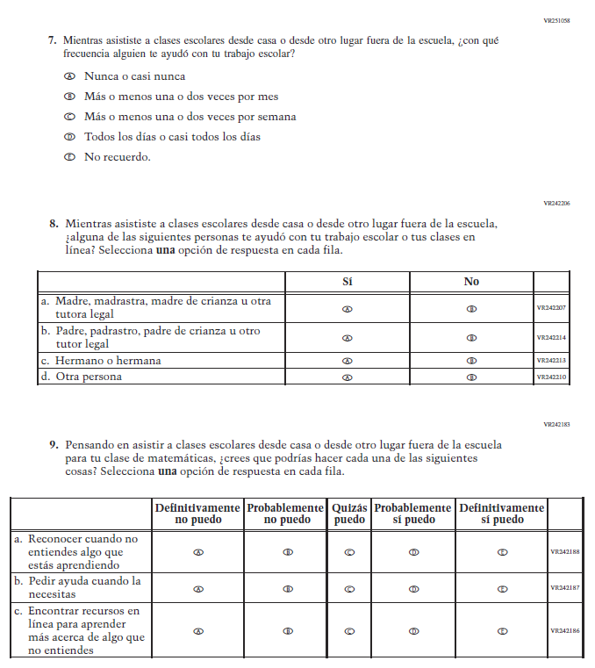

Appendix J-1v-s-PR: Operational Grade 8 COVID-19 (Math)
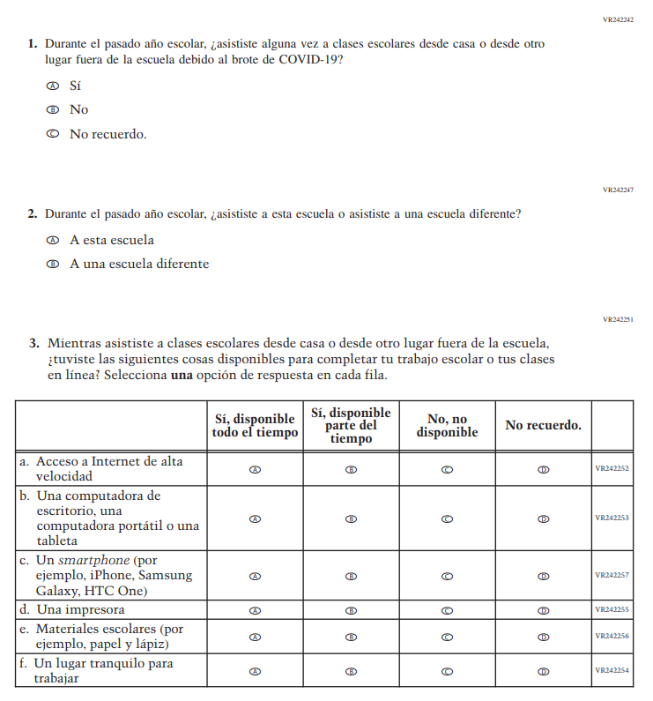

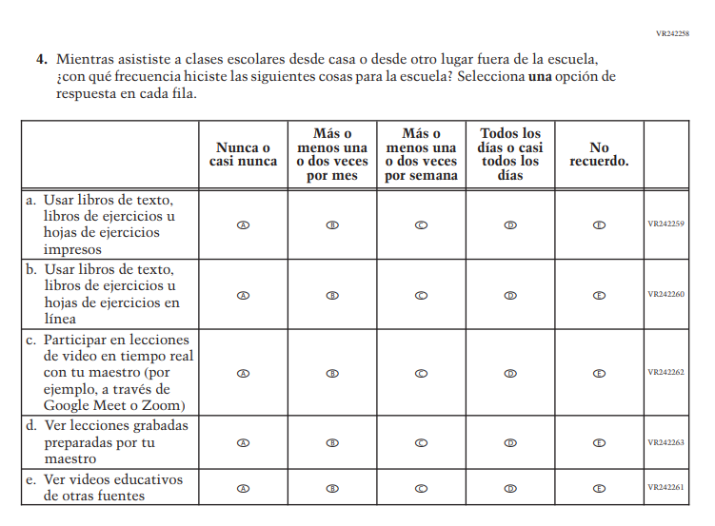

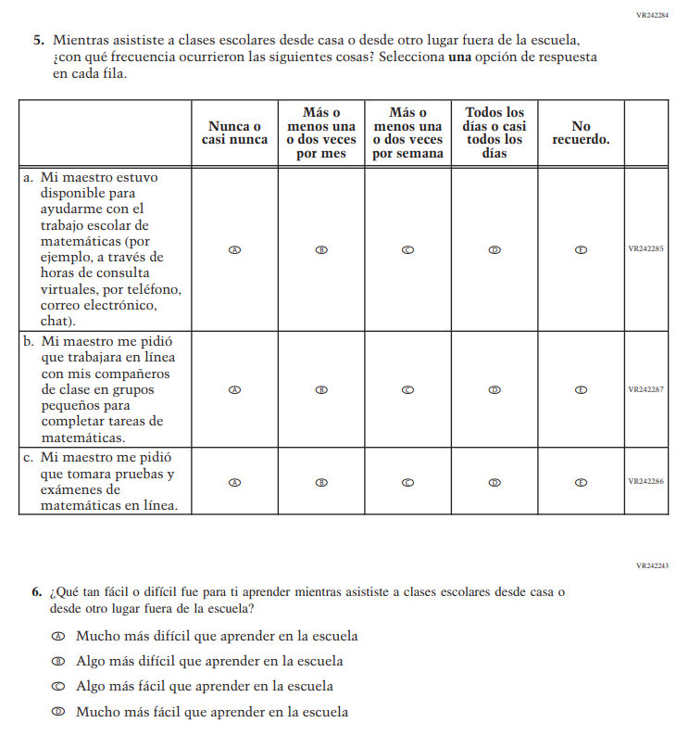

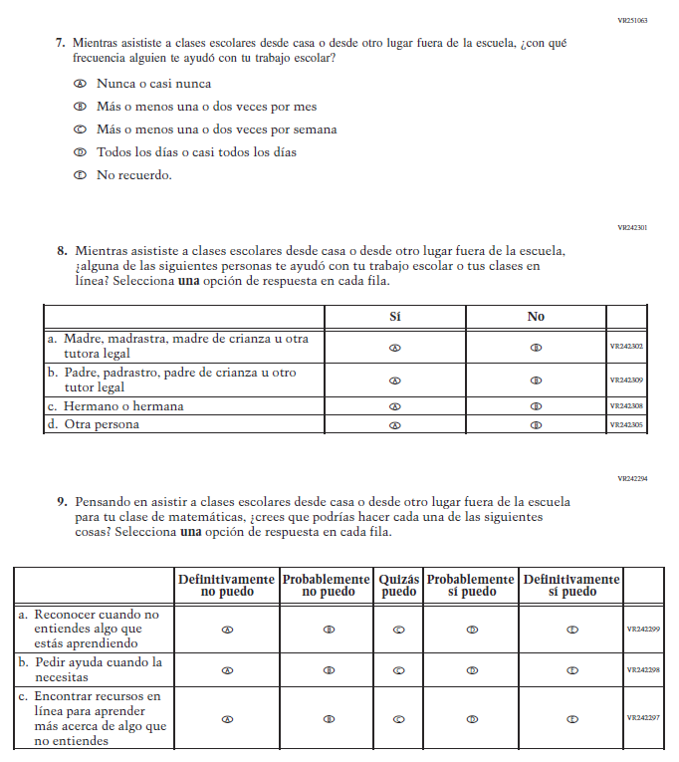

Appendix J-1w-s-BL: Operational Grade 8 COVID-19 (Civics)
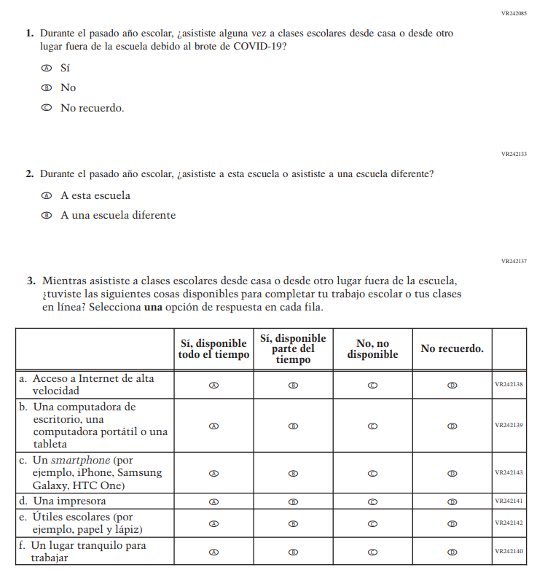

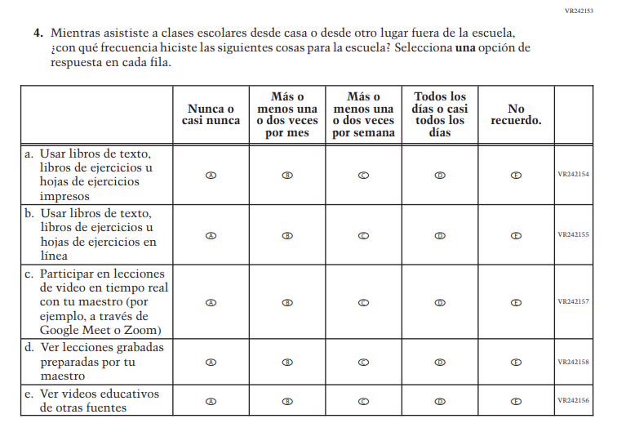

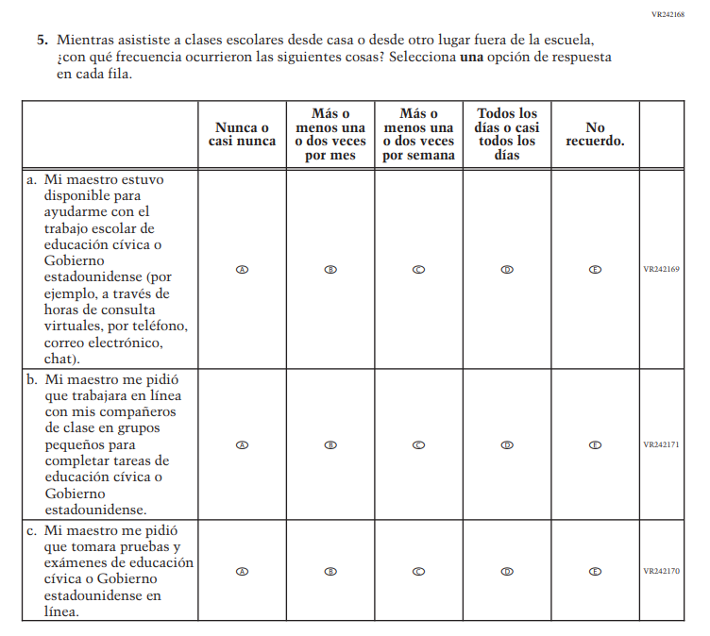

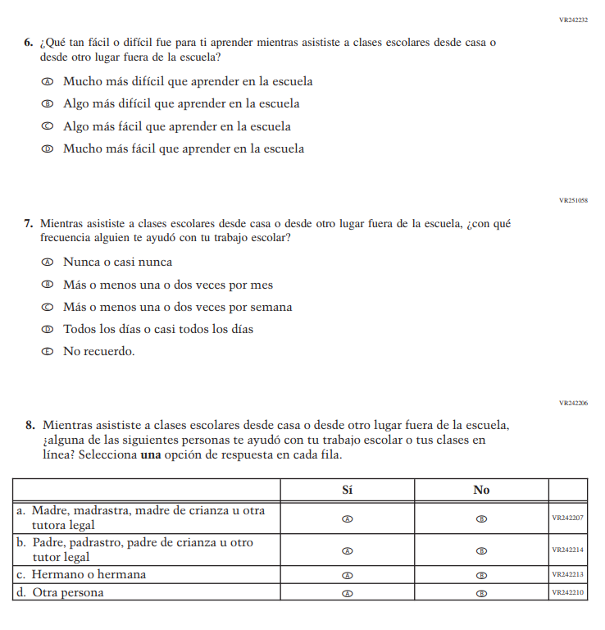
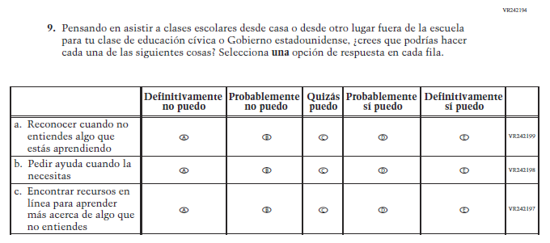

Appendix J-1x-s-BL: Operational Grade 8 COVID-19 (U.S. History)
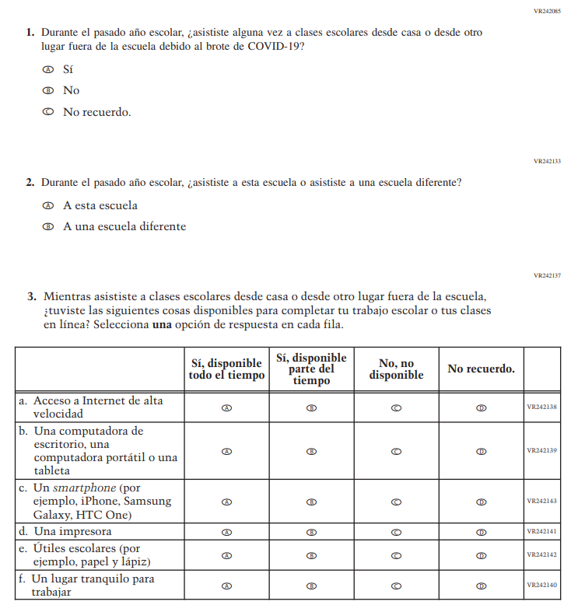

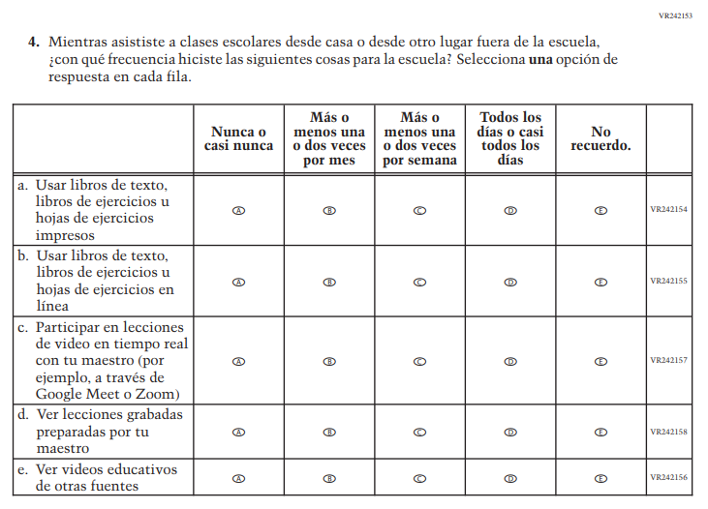

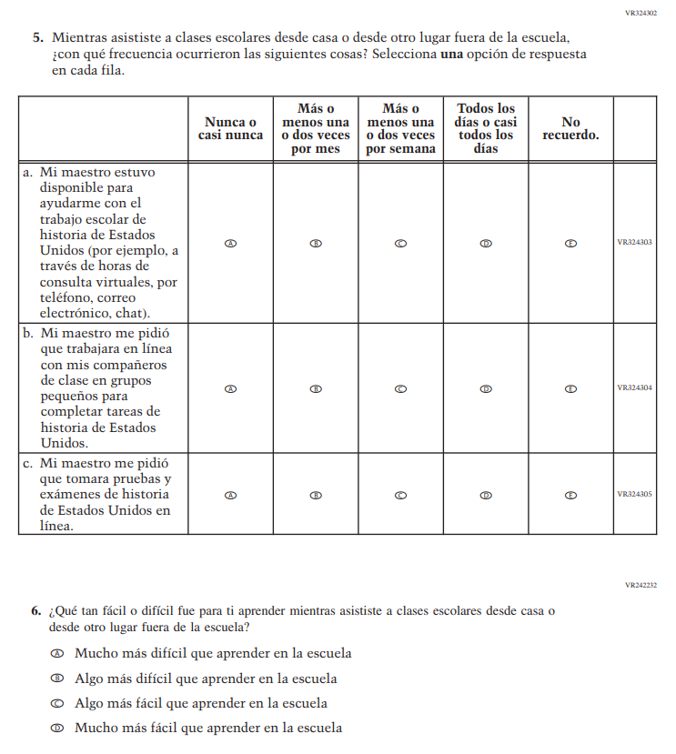

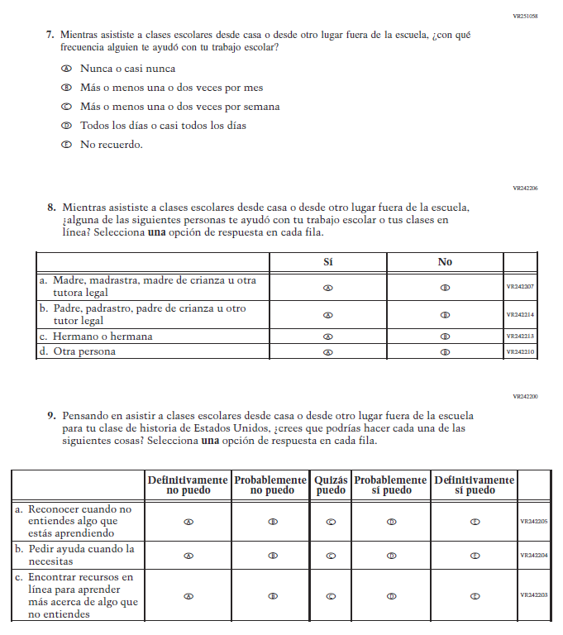

Sample Teacher Login Screen
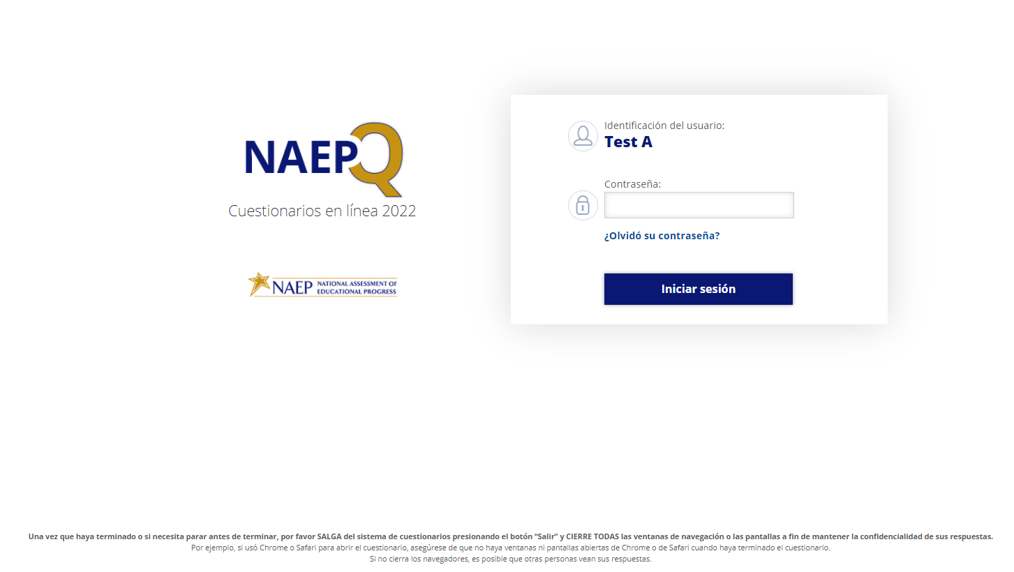

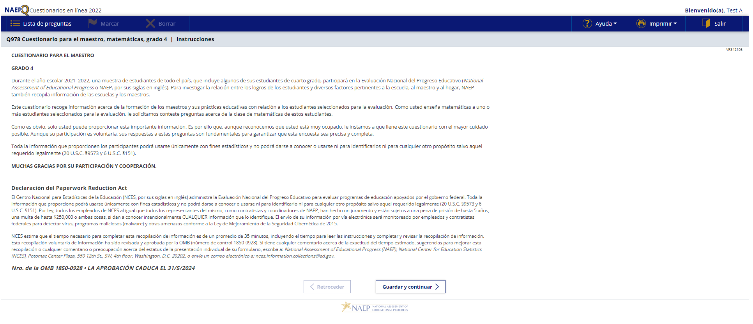

Sample Teacher Questionnaire Booklet Cover
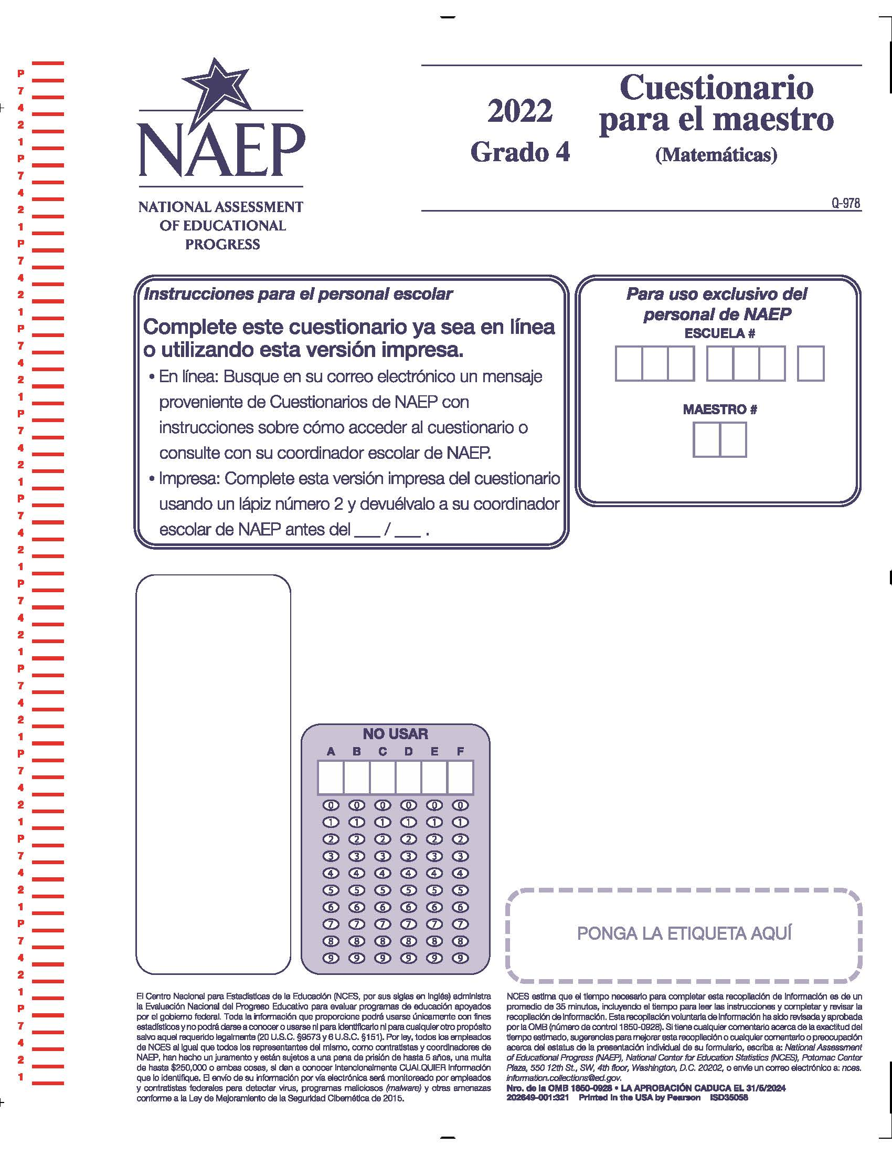

Appendix J-2-s: Spanish Translations of Teacher Questionnaires

Appendix J-2a-s-PR: Summary of Changes Operational Grade 4 CORE
2022 Operational Grade 4 Core Teacher – Puerto Rico
Previous item | 2022 item | D/A/R/NC+ | Rationale
VH835832  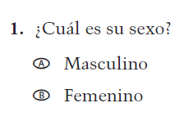  (2021 Operational Grade 4 Teacher Core – Puerto Rico) | VH835832  Issue: Gender | NC | N/A
VH319761  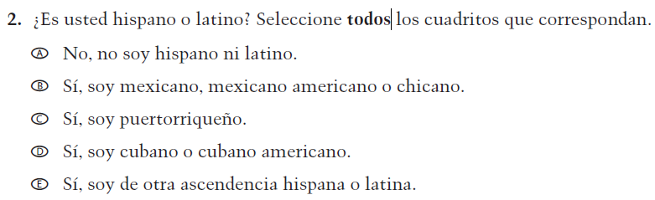  (2021 Operational Grade 4 Teacher Core – Puerto Rico) | VH319761  Issue: Race/Ethnicity | NC | N/A
VH319763  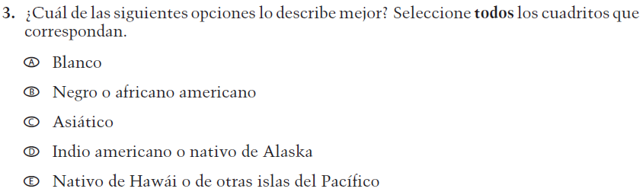  (2021 Operational Grade 4 Teacher Core – Puerto Rico) | VH319763  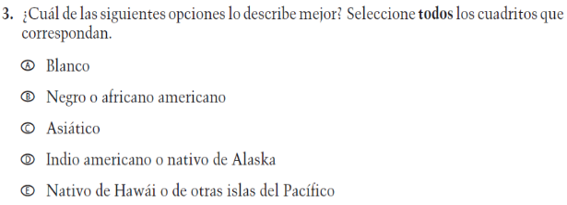  Issue: Race/Ethnicity | NC | N/A

2022 Operational Grade 4 Core Teacher – Puerto Rico
Previous item | 2022 item | D/A/R/NC+ | Rationale
VH319764  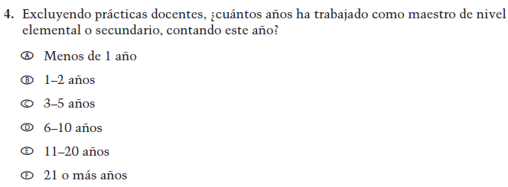  (2021 Operational Grade 4 Teacher Core – Puerto Rico) | VH319764  Issue: Teacher Preparation | NC | N/A
VH835831  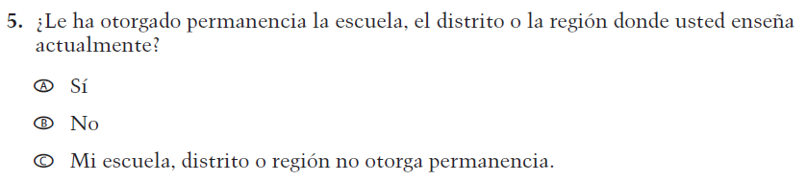  (2021 Operational Grade 4 Teacher Core – Puerto Rico) | VH835831  Issue: Teacher Preparation | NC | N/A
VH319767  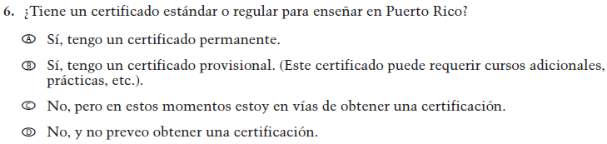  (2021 Operational Grade 4 Teacher Core – Puerto Rico) | VH319767  Issue: Teacher Preparation | NC | N/A

2022 Operational Grade 4 Core Teacher – Puerto Rico
Previous item | 2022 item | D/A/R/NC+ | Rationale
VH319769  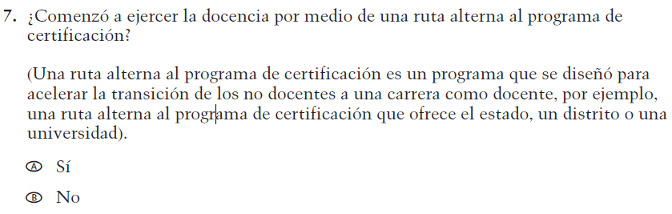  (2021 Operational Grade 4 Teacher Core – Puerto Rico) | VH319769  Issue: Teacher Preparation | NC | N/A
VH319773  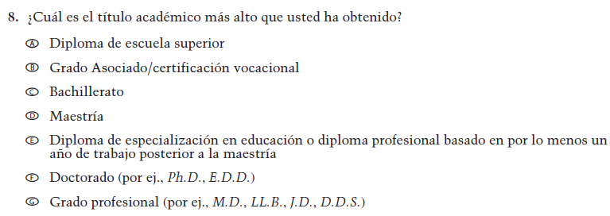  (2021 Operational Grade 4 Teacher Core – Puerto Rico) | VH319773  Issue: Teacher Preparation | NC | N/A
VH319779  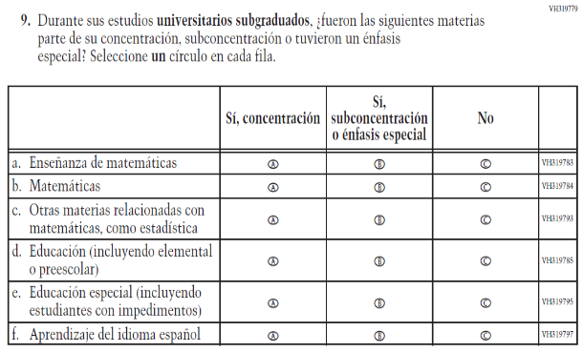  (2021 Operational Grade 4 Teacher Core – Puerto Rico) | VH319779  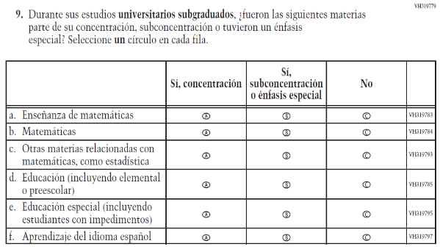  Issue: Teacher Preparation | NC | N/A

2022 Operational Grade 4 Core Teacher – Puerto Rico
Previous item | 2022 item | D/A/R/NC+ | Rationale
VH319827  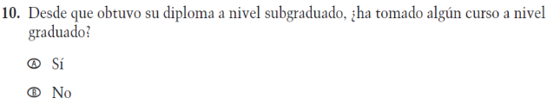  (2021 Operational Grade 4 Teacher Core – Puerto Rico) | VH319827  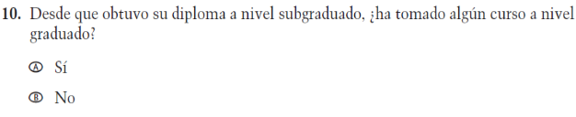  Issue: Teacher Preparation | NC | N/A
VH319832  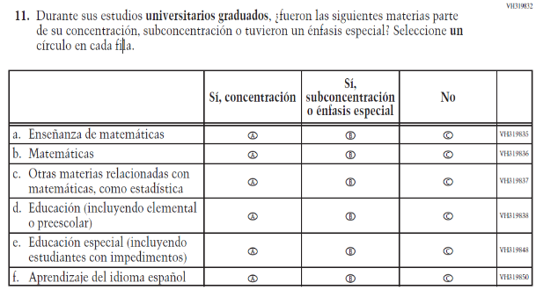  (2021 Operational Grade 4 Teacher Core – Puerto Rico) | VH319832  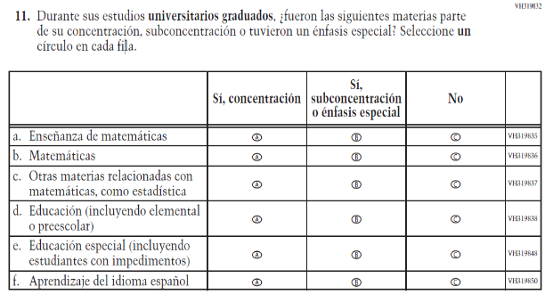  Issue: Teacher Preparation | NC | N/A
VH579698  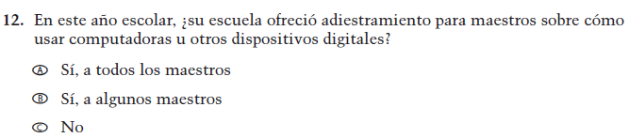  (2021 Operational Grade 4 Teacher Core – Puerto Rico) | VH579698  Issue: Technology Use | NC | N/A

2022 Operational Grade 4 Core Teacher – Puerto Rico
Previous item | 2022 item | D/A/R/NC+ | Rationale
VH579699  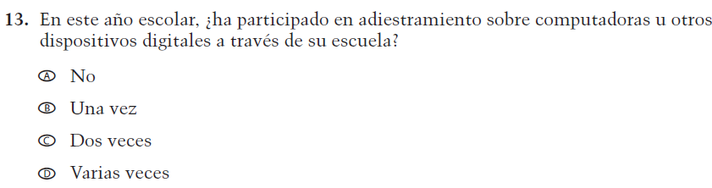  (2021 Operational Grade 4 Teacher Core – Puerto Rico) | VH579699  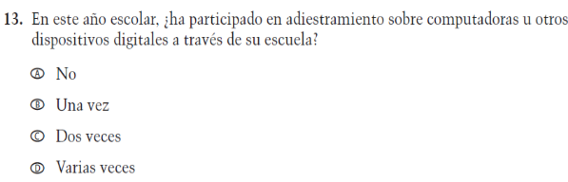  Issue: Technology Use | NC | N/A
VH320048  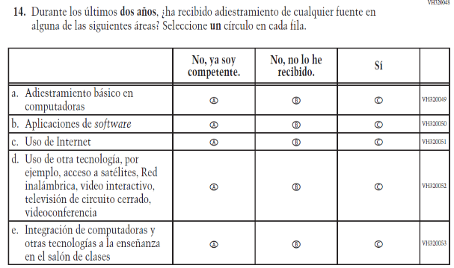  (2021 Operational Grade 4 Teacher Core – Puerto Rico) | VH320048  Issue: Technology Use | NC | N/A
VH893860  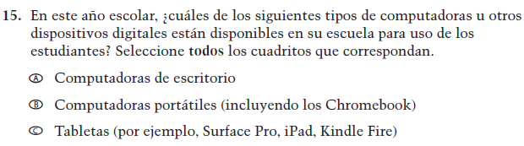  (2021 Operational Grade 4 Teacher Core – Puerto Rico) | VH893860  Issue: Technology Use | NC | N/A

2022 Operational Grade 4 Core Teacher – Puerto Rico
Previous item | 2022 item | D/A/R/NC+ | Rationale
VH579690  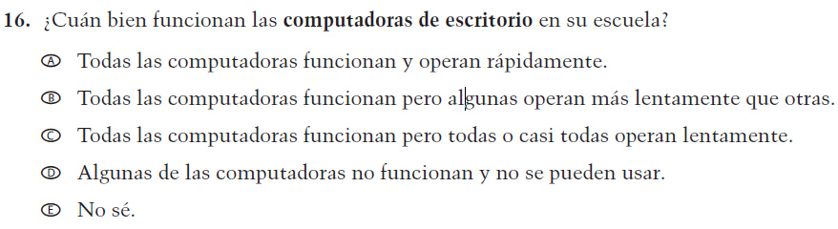  (2021 Operational Grade 4 Teacher Core – Puerto Rico) | VH579690  Issue: Technology Use | NC | N/A
VH579692  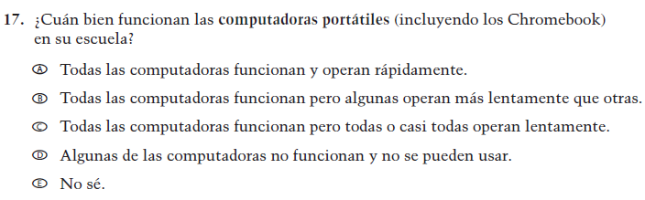  (2021 Operational Grade 4 Teacher Core – Puerto Rico) | VH579692  Issue: Technology Use | NC | N/A
VH579694  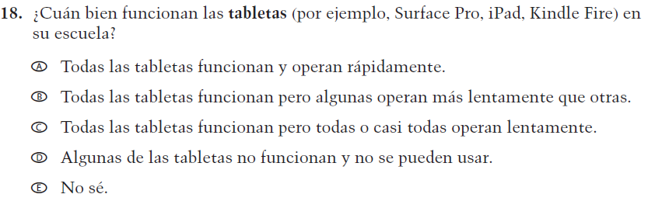  (2021 Operational Grade 4 Teacher Core – Puerto Rico) | VH579694  Issue: Technology Use | NC | N/A

2022 Operational Grade 4 Core Teacher – Puerto Rico
Previous item | 2022 item | D/A/R/NC+ | Rationale
VH579714  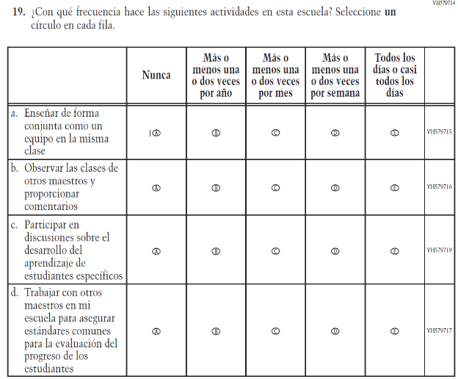  (2021 Operational Grade 4 Teacher Core – Puerto Rico) | VH579714  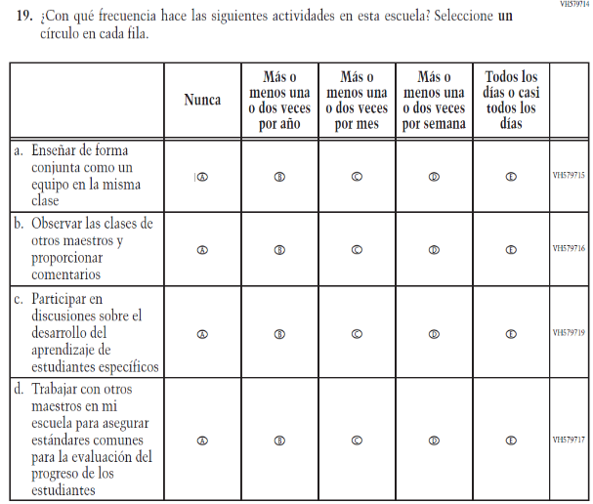  Issue: School Climate | NC | N/A
VH579777  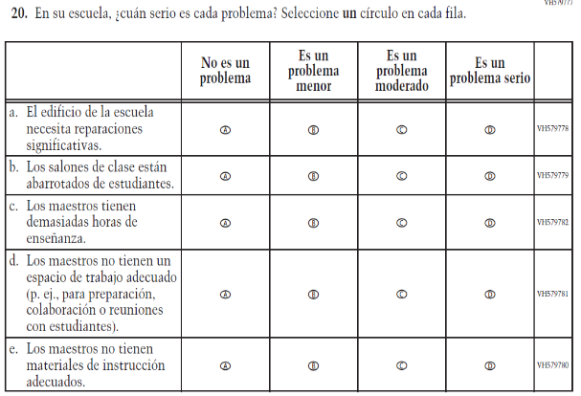  (2021 Operational Grade 4 Teacher Core – Puerto Rico) | VH579777  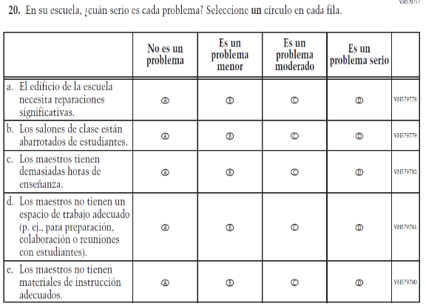  Issue: School Climate | NC | N/A

2022 Operational Grade 4 Core Teacher – Puerto Rico
Previous item | 2022 item | D/A/R/NC+ | Rationale
VH579707  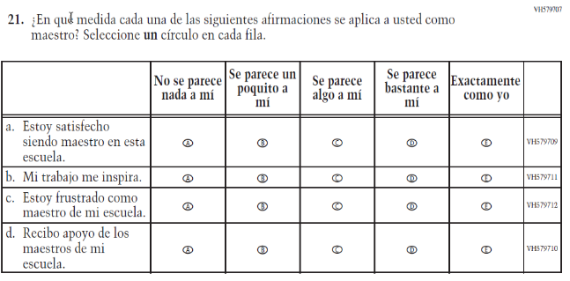  (2021 Operational Grade 4 Teacher Core – Puerto Rico) | VH579707  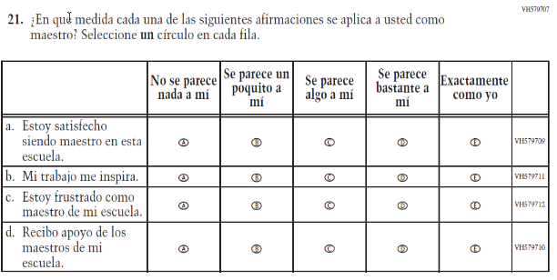  Issue: School Climate | NC | N/A
VH579703  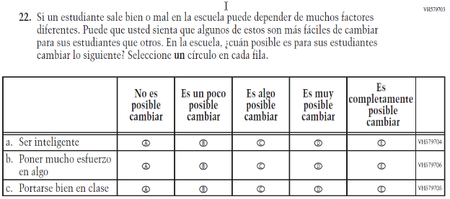  (2021 Operational Grade 4 Teacher Core – Puerto Rico) | VH579703  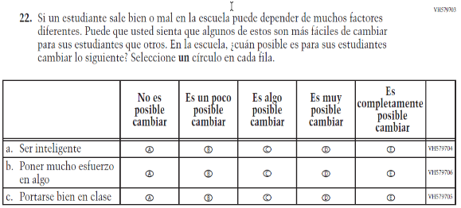  Issue: School Climate | NC | N/A

Appendix J-2a-s-PR: Operational Grade 4 CORE
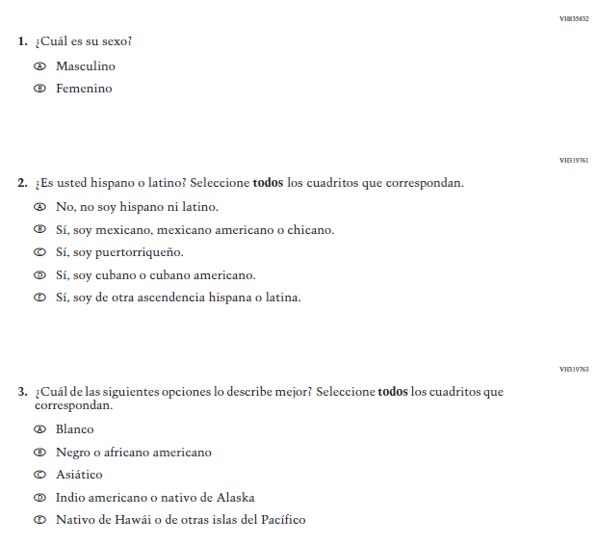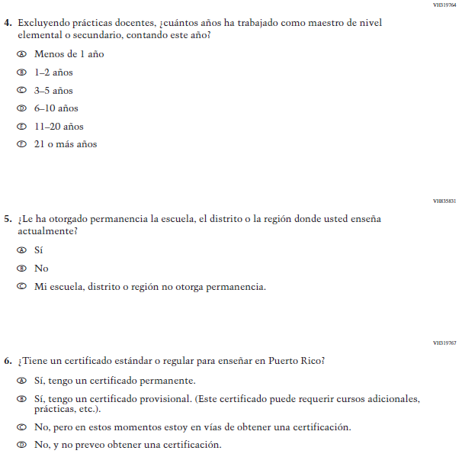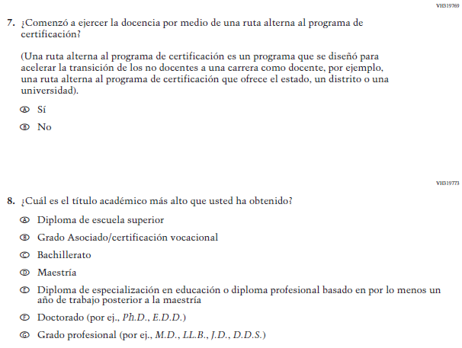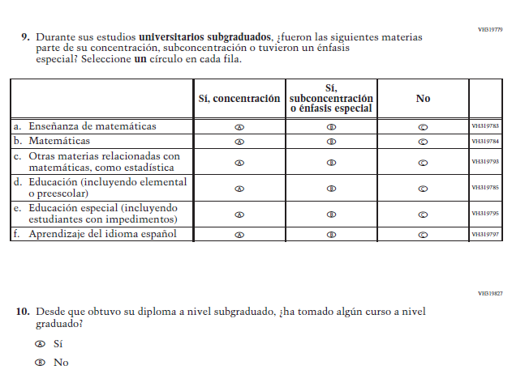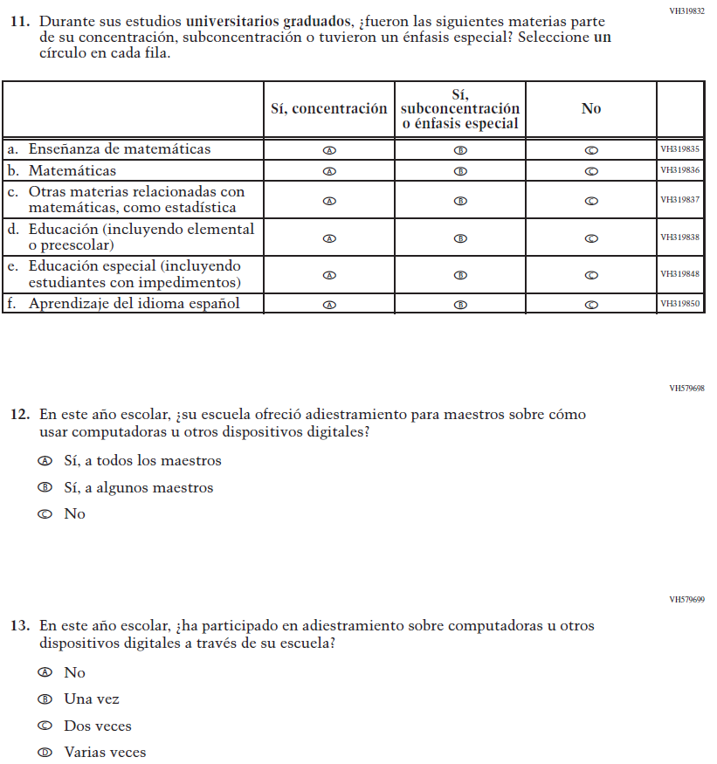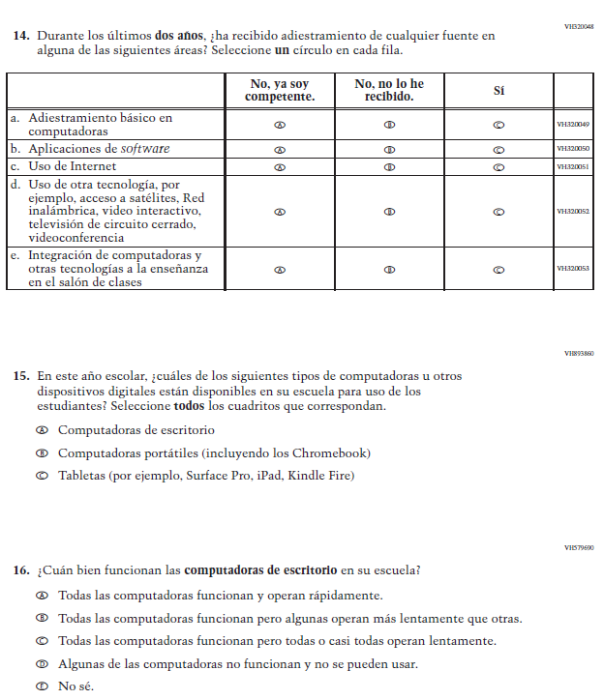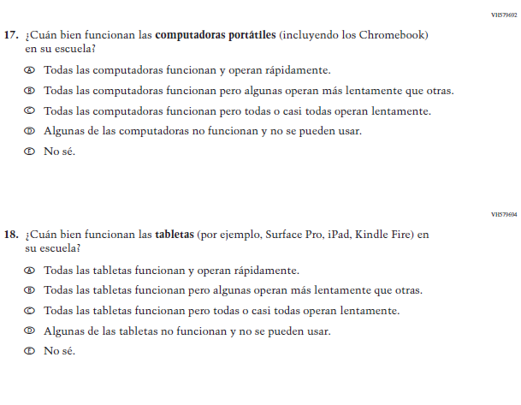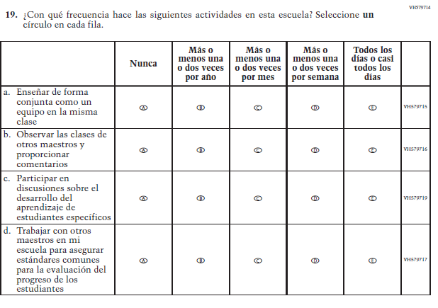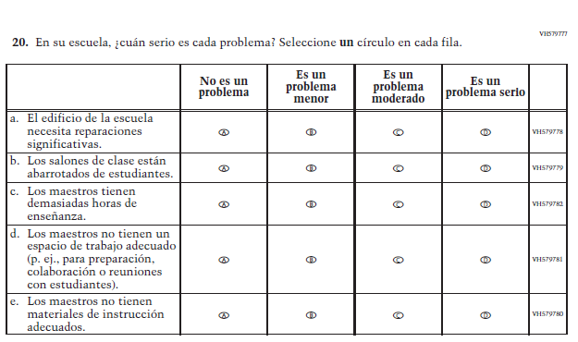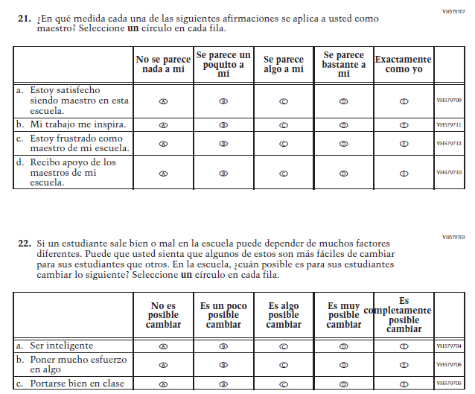

Appendix J-2b-s-PR: Summary of Changes Operational Grade 8 CORE
2022 Operational Grade 8 Core Teacher – Puerto Rico
Previous item | 2022 item | D/A/R/NC+ | Rationale
VH835832  (2021 Operational Grade 8 Teacher Core – Puerto Rico) | VH835832  Issue: Gender | NC | N/A
VH319761  (2021 Operational Grade 8 Teacher Core – Puerto Rico) | VH319761  Issue: Race/Ethnicity | NC | N/A
VH319763  (2021 Operational Grade 8 Teacher Core – Puerto Rico) | VH319763  Issue: Race/Ethnicity | NC | N/A

2022 Operational Grade 8 Core Teacher – Puerto Rico
Previous item | 2022 item | D/A/R/NC+ | Rationale
VH319764  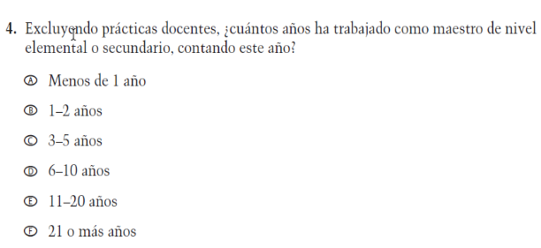  (2021 Operational Grade 8 Teacher Core – Puerto Rico) | VH319764  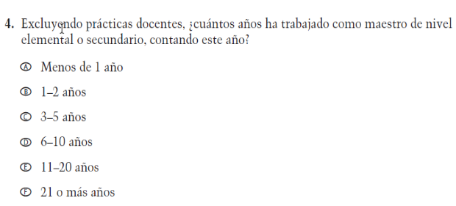  Issue: Teacher Preparation | NC | N/A
VH319892  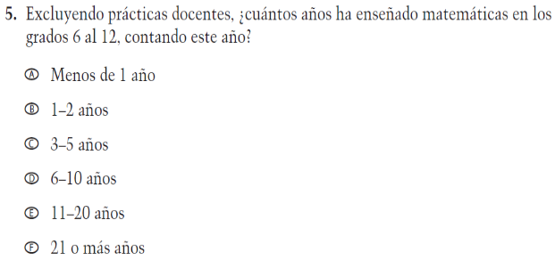  (2021 Operational Grade 8 Teacher Core – Puerto Rico) | VH319892  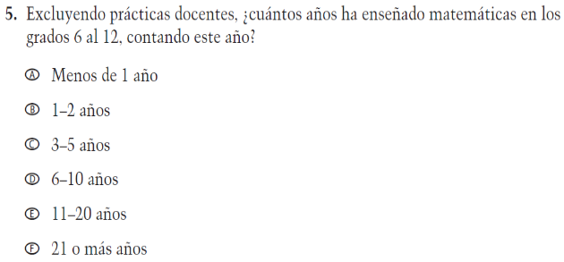  Issue: Teacher Preparation | NC | N/A
VH835831  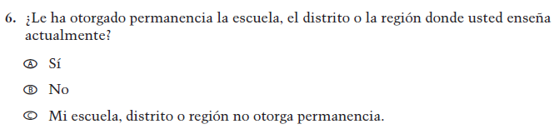  (2021 Operational Grade 8 Teacher Core – Puerto Rico) | VH835831  Issue: Teacher Preparation | NC | N/A

2022 Operational Grade 8 Core Teacher – Puerto Rico
Previous item | 2022 item | D/A/R/NC+ | Rationale
VH319767  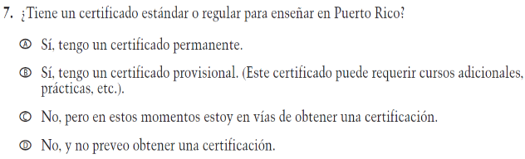  (2021 Operational Grade 8 Teacher Core – Puerto Rico) | VH319767  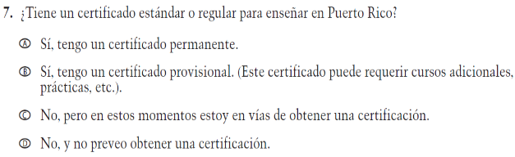  Issue: Teacher Preparation | NC | N/A
VH319769  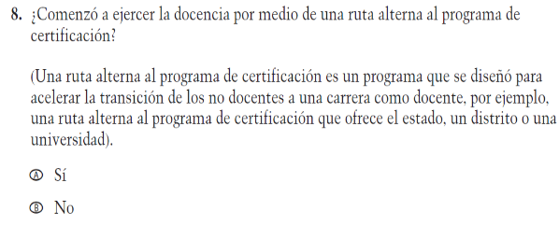  (2021 Operational Grade 8 Teacher Core – Puerto Rico) | VH319769  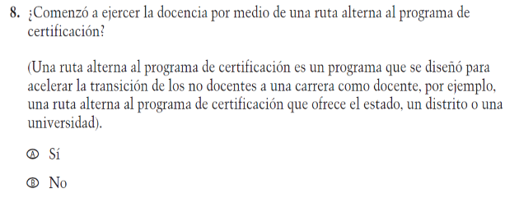  Issue: Teacher Preparation | NC | N/A
VH319773  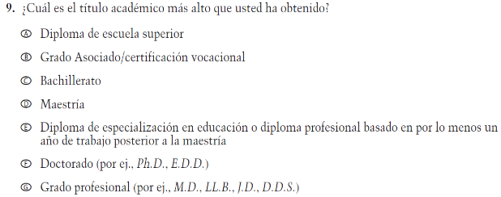  (2021 Operational Grade 8 Teacher Core – Puerto Rico) | VH319773  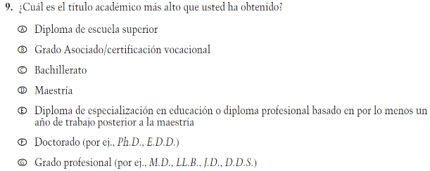  Issue: Teacher Preparation | NC | N/A

2022 Operational Grade 8 Core Teacher – Puerto Rico
Previous item | 2022 item | D/A/R/NC+ | Rationale
VH319779  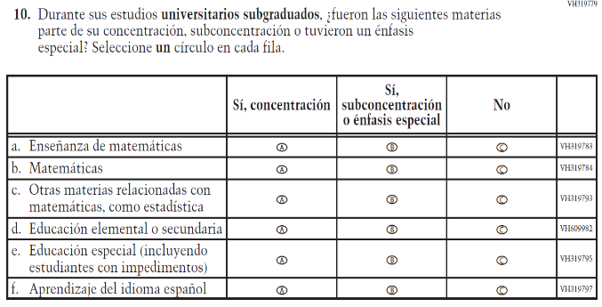  (2021 Operational Grade 8 Teacher Core – Puerto Rico) | VH319779  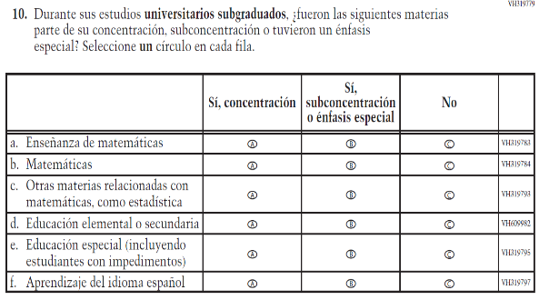  Issue: Teacher Preparation | NC | N/A
VH319827  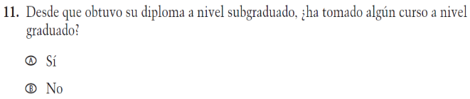  (2021 Operational Grade 8 Teacher Core – Puerto Rico) | VH319827  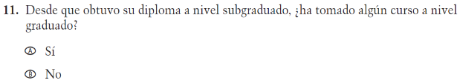  Issue: Teacher Preparation | NC | N/A
VH319832  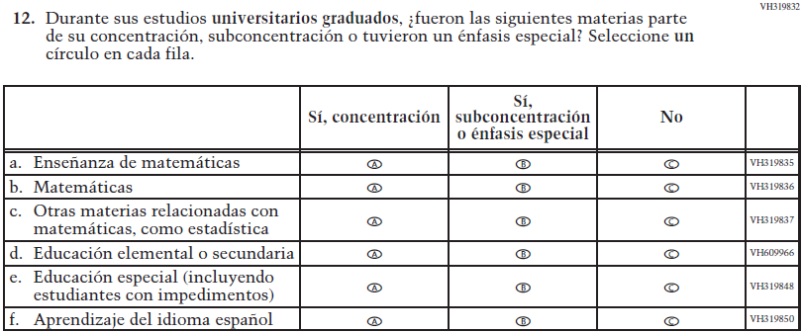  (2021 Operational Grade 8 Teacher Core – Puerto Rico) | VH319832  Issue: Teacher Preparation | NC | N/A

2022 Operational Grade 8 Core Teacher – Puerto Rico
Previous item | 2022 item | D/A/R/NC+ | Rationale
VH579698  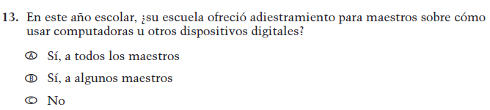  (2021 Operational Grade 8 Teacher Core – Puerto Rico) | VH579698  Issue: Technology Use | NC | N/A
VH579699  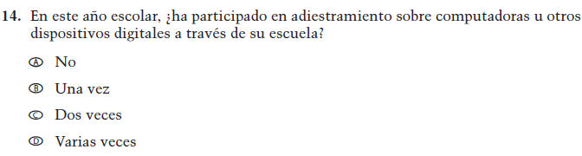  (2021 Operational Grade 8 Teacher Core – Puerto Rico) | VH579699  Issue: Technology Use | NC | N/A
VH320048  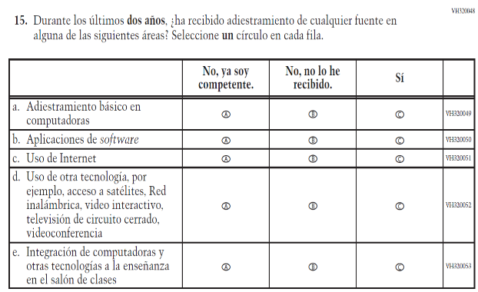  (2021 Operational Grade 8 Teacher Core – Puerto Rico) | VH320048  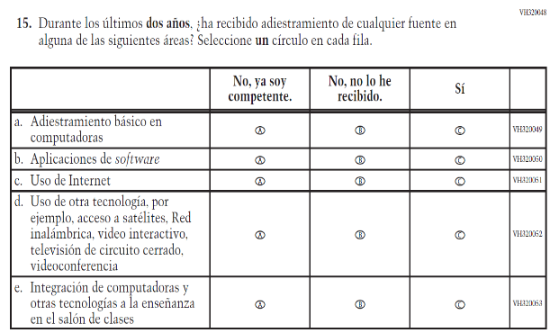  Issue: Teacher Preparation | NC | N/A

2022 Operational Grade 8 Core Teacher – Puerto Rico
Previous item | 2022 item | D/A/R/NC+ | Rationale
VH893860  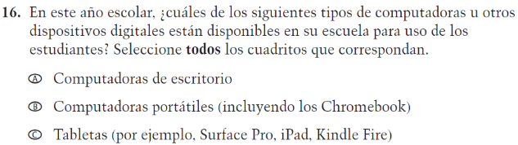  (2021 Operational Grade 8 Teacher Core – Puerto Rico) | VH893860  Issue: Technology Use | NC | N/A
VH579690  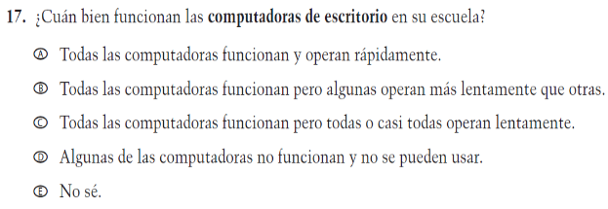  (2021 Operational Grade 8 Teacher Core – Puerto Rico) | VH579690  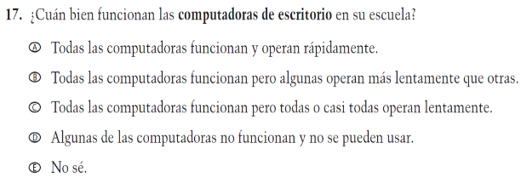  Issue: Technology Use | NC | N/A
VH579692  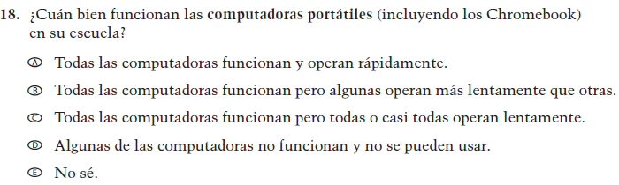  (2021 Operational Grade 8 Teacher Core – Puerto Rico) | VH579692  Issue: Technology Use | NC | N/A
VH579694  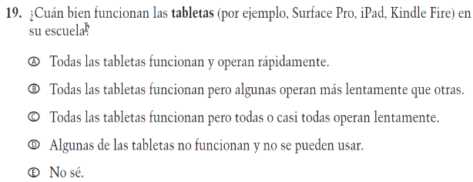  (2021 Operational Grade 8 Teacher Core – Puerto Rico) | VH579694  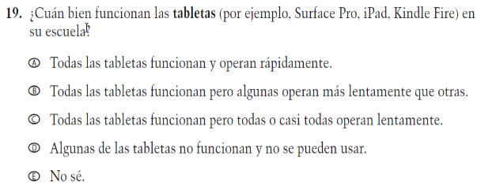  Issue: Technology Use | NC | N/A

2022 Operational Grade 8 Core Teacher – Puerto Rico
Previous item | 2022 item | D/A/R/NC+ | Rationale
VH579714  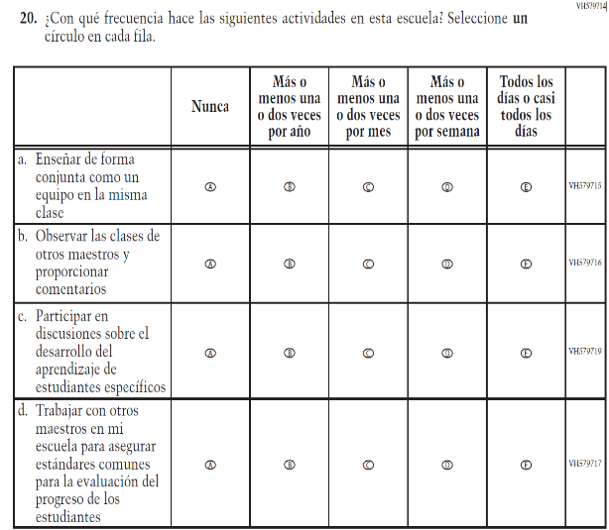  (2021 Operational Grade 8 Teacher Core – Puerto Rico) | VH579714  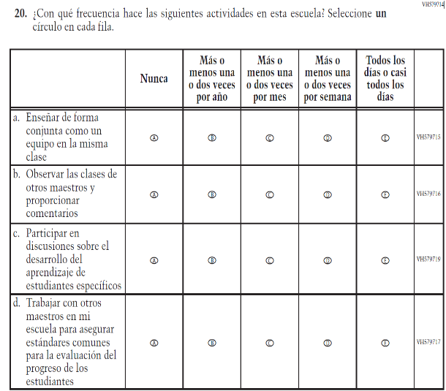  Issue: School Climate | NC | N/A
VH579777  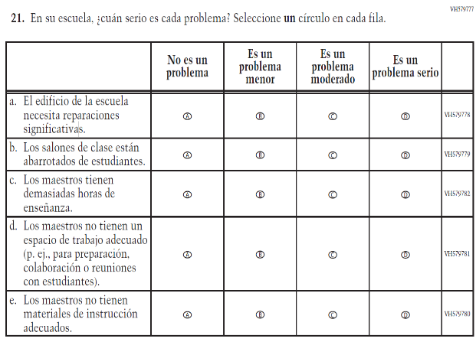  (2021 Operational Grade 8 Teacher Core – Puerto Rico) | VH579777  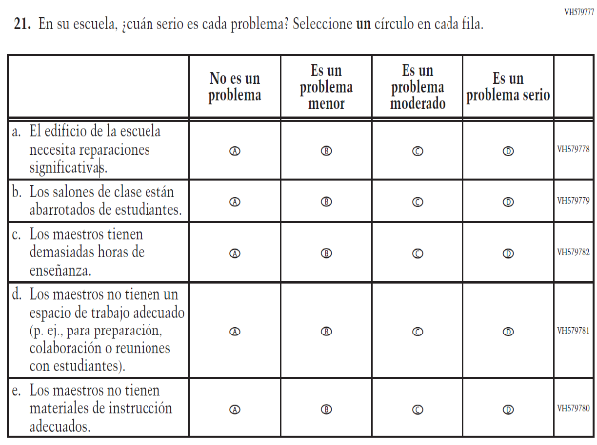  Issue: School Climate | NC | N/A

2022 Operational Grade 8 Core Teacher – Puerto Rico
Previous item | 2022 item | D/A/R/NC+ | Rationale
VH579707  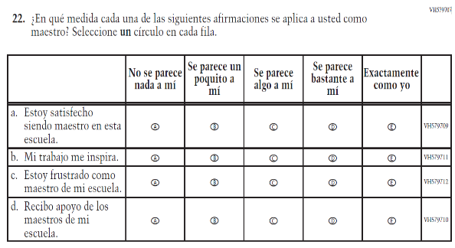  (2021 Operational Grade 8 Teacher Core – Puerto Rico) | VH579707  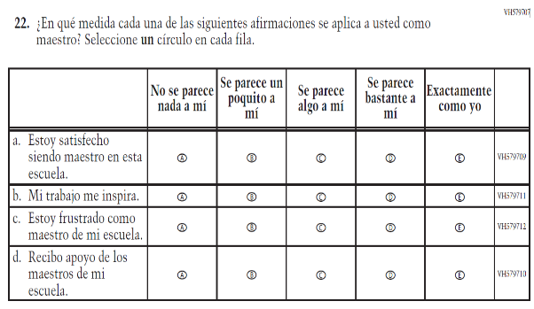  Issue: School Climate | NC | N/A
VH579703  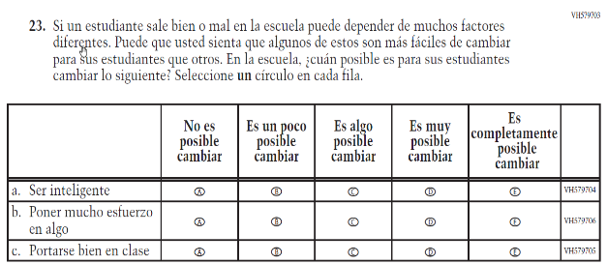  (2021 Operational Grade 8 Teacher Core – Puerto Rico) | VH579703  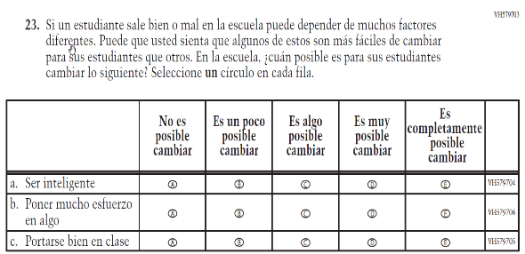  Issue: Desire for Learning | NC | N/A

Appendix J-2b-s-PR: Operational Grade 8 CORE
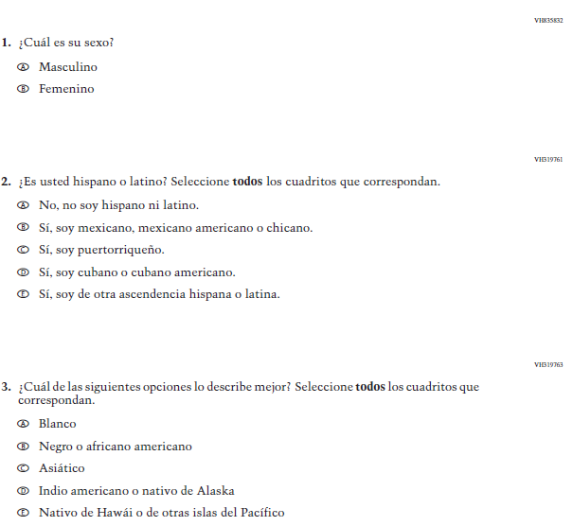
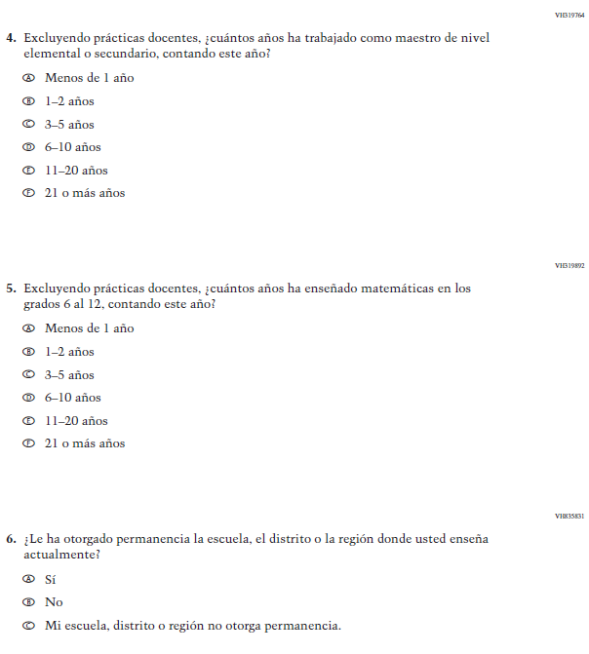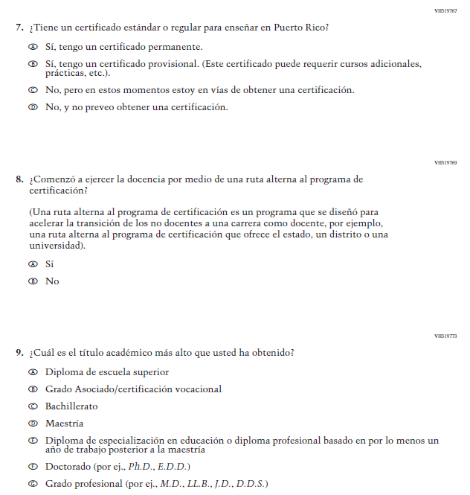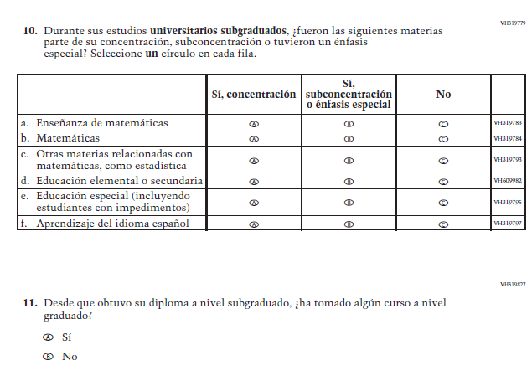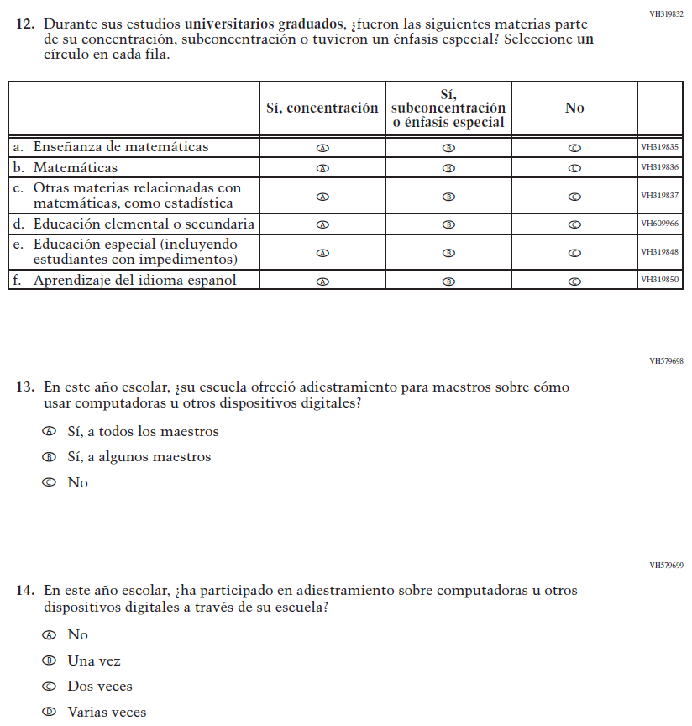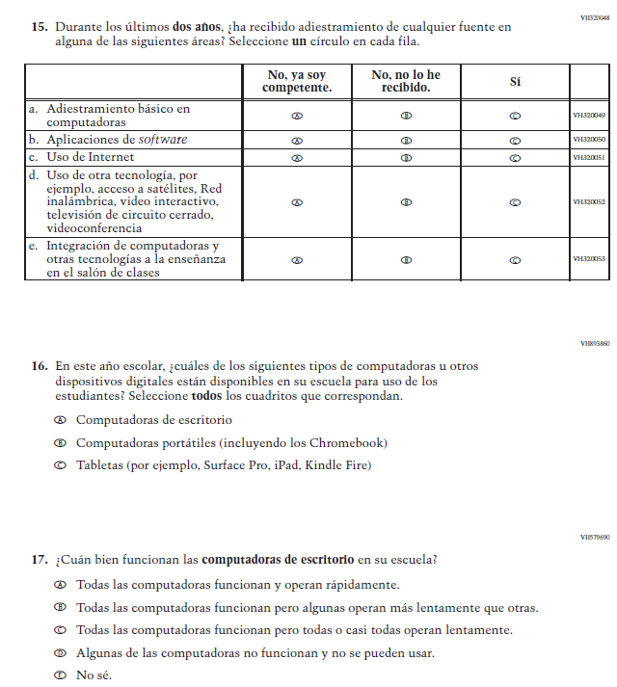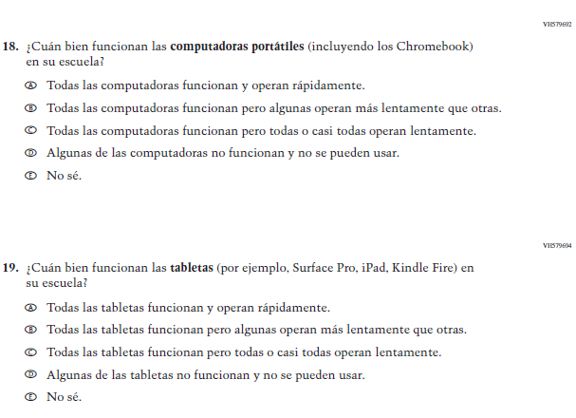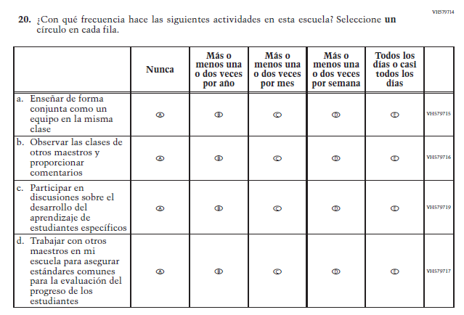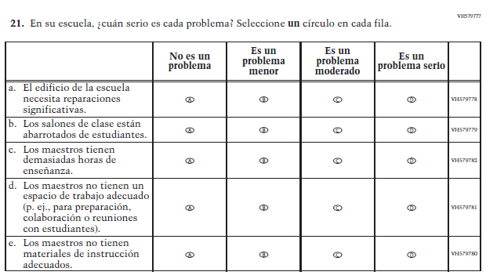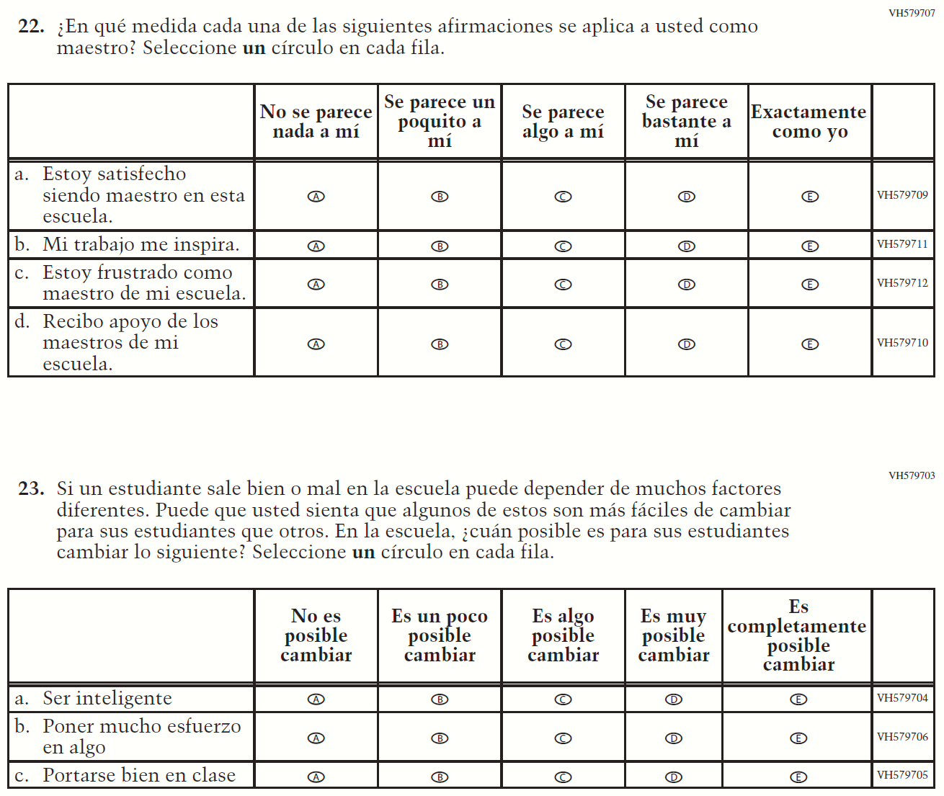

Appendix J-2c-s-PR: Summary of Changes Operational Grade 4 Mathematics
2022 Operational Grade 4 Mathematics Teacher – Puerto Rico
Previous item | 2022 item | D/A/R/NC+ | Rationale
VH320096  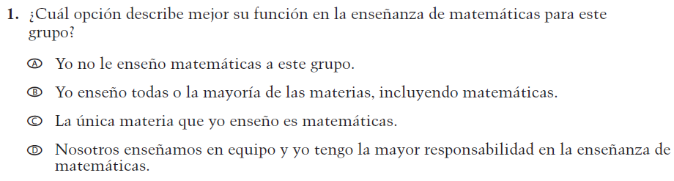  (2021 Operational Grade 4 Teacher Mathematics – Puerto Rico) | VH320096  Issue: Resources for Learning and Instruction | NC | N/A
VH579728  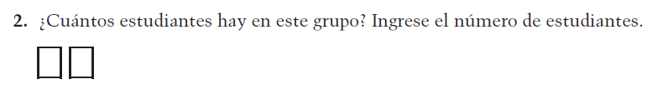  (2021 Operational Grade 4 Teacher Mathematics – Puerto Rico) | VH579728  Issue: Resources for Learning and Instruction | NC | N/A
VH857347  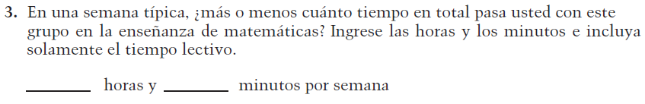  (2021 Operational Grade 4 Teacher Mathematics – Puerto Rico) | VH857347  Issue: Resources for Learning and Instruction | N/C | N/A
VH320121  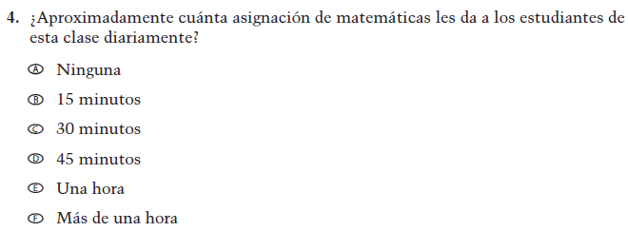  (2021 Operational Grade 4 Teacher Mathematics – Puerto Rico) | VH320121  Issue: Organization of Instruction | NC | N/A

2022 Operational Grade 4 Mathematics Teacher – Puerto Rico
Previous item | 2022 item |  | D/A/R/NC+ |  | Rationale
VH320125  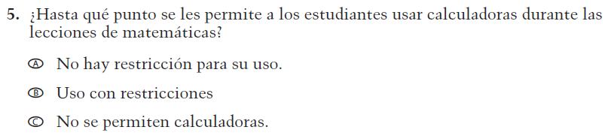  (2021 Operational Grade 4 Teacher Mathematics – Puerto Rico) | VH320125  Issue: Organization of Instruction |  | NC |  | N/A
VH320129  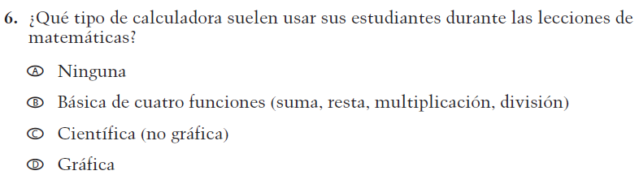  (2021 Operational Grade 4 Teacher Mathematics – Puerto Rico) | VH320129  Issue: Resources for learning and instruction |  | NC |  | N/A
VH320132  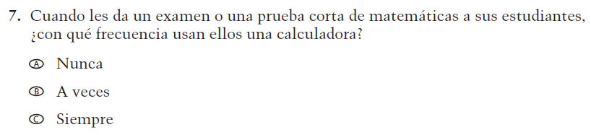  (2021 Operational Grade 4 Teacher Mathematics – Puerto Rico) | VH320132  Issue: Organization of Instruction |  | NC |  | N/A
VH579742  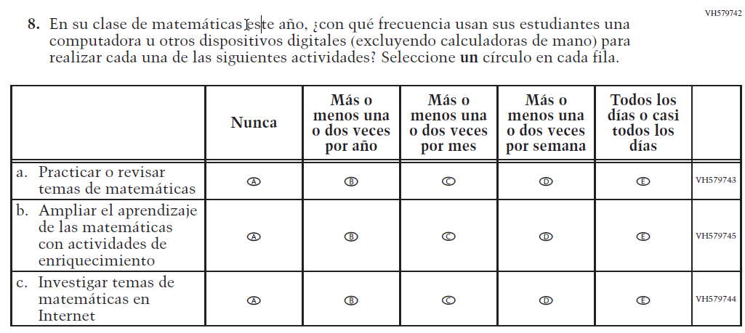  (2021 Operational Grade 4 Teacher Mathematics – Puerto Rico) | VH579742  Issue: Organization of Instruction |  | NC |  | N/A
2022 Operational Grade 4 Mathematics Teacher – Puerto Rico
Previous item |  | 2022 item |  | D/A/R/NC+ |  | Rationale
VH857351  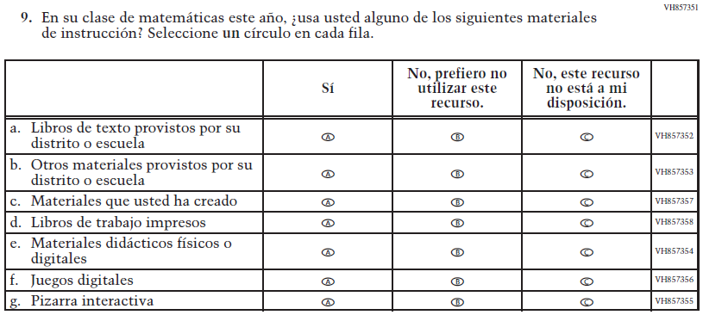  (2021 Operational Grade 4 Teacher Mathematics – Puerto Rico) |  | VH857351  Issue: Resources for Learning and Instruction |  | NC |  | N/A
VH579756  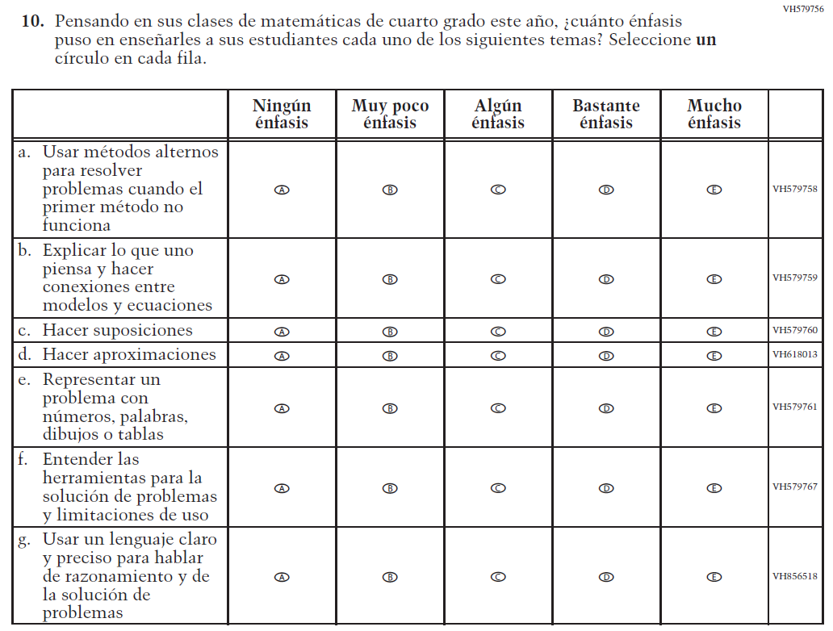  (2021 Operational Grade 4 Teacher Mathematics – Puerto Rico) |  | VH579756  Issue: Organization of Instruction |  | NC |  | N/A

2022 Operational Grade 4 Mathematics Teacher – Puerto Rico
Previous item | 2022 item | D/A/R/NC+ | Rationale
VH320151  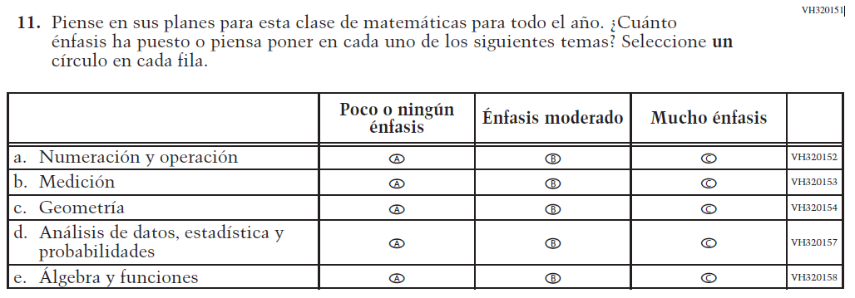  (2021 Operational Grade 4 Teacher Mathematics – Puerto Rico) | VH320151  Issue: Organization of Instruction | NC | N/A
VH320200  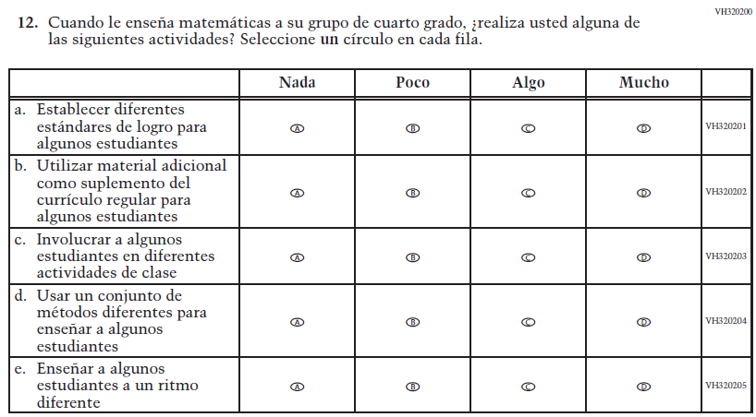  (2021 Operational Grade 4 Teacher Mathematics – Puerto Rico) | VH320200  Issue: Organization of Instruction | NC | N/A

2022 Operational Grade 4 Mathematics Teacher – Puerto Rico
Previous item |  | 2022 item |  | D/A/R/NC+ |  | Rationale
VH579746  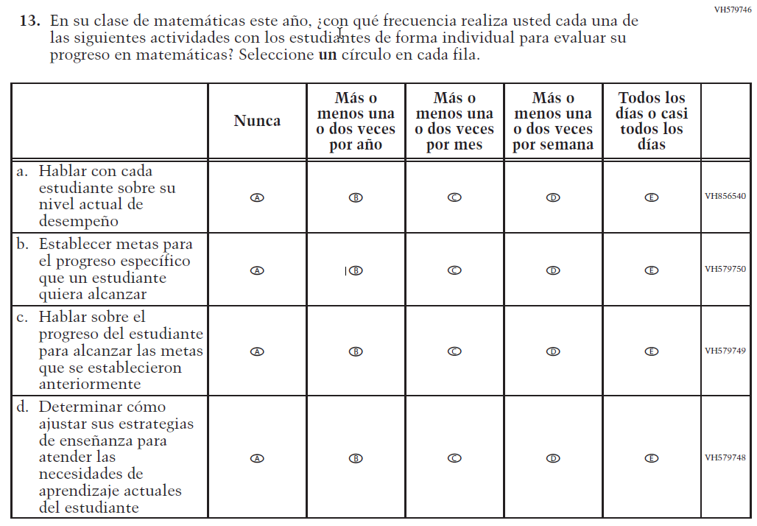  (2021 Operational Grade 4 Teacher Mathematics – Puerto Rico) |  | VH579746  Issue: Organization of Instruction |  | NC |  | N/A
VH579768  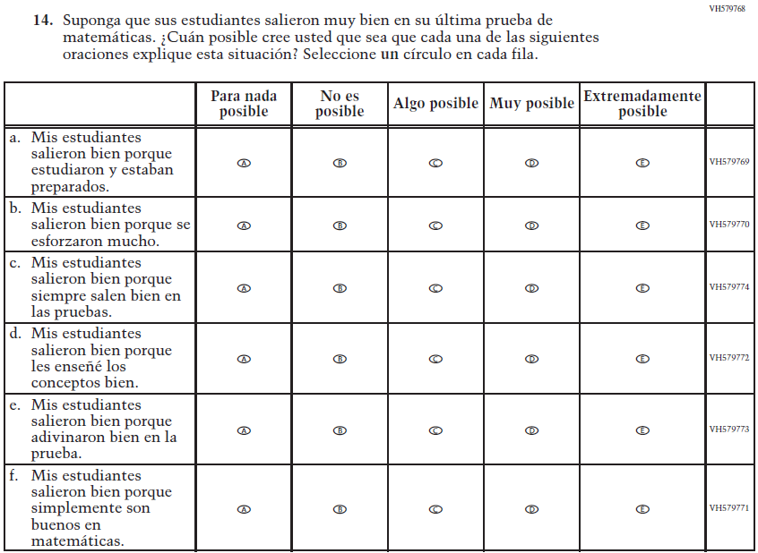  (2021 Operational Grade 4 Teacher Mathematics – Puerto Rico) |  | VH579768  Issue: Teacher Preparation |  | NC |  | N/A
2022 Operational Grade 4 Mathematics Teacher – Puerto Rico
Previous item | 2022 item |  | D/A/R/NC+ |  | Rationale
VH579775  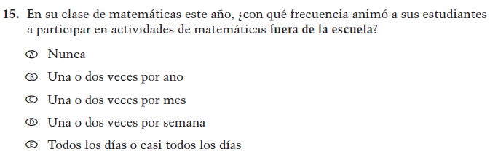  (2021 Operational Grade 4 Teacher Mathematics – Puerto Rico) | VH579775  Issue: Resources for Learning and Instruction |  | NC |  | N/A
VH579776  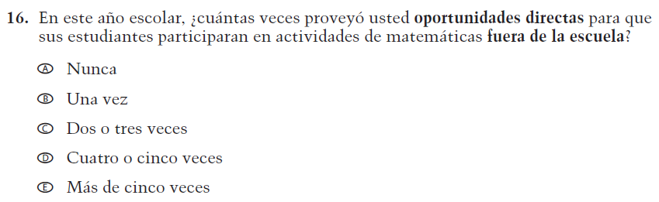  (2021 Operational Grade 4 Teacher Mathematics – Puerto Rico) | VH579776  Issue: Resources for Learning and Instruction |  | NC |  | N/A

Appendix J-2c-s-PR: Operational Grade 4 Mathematics
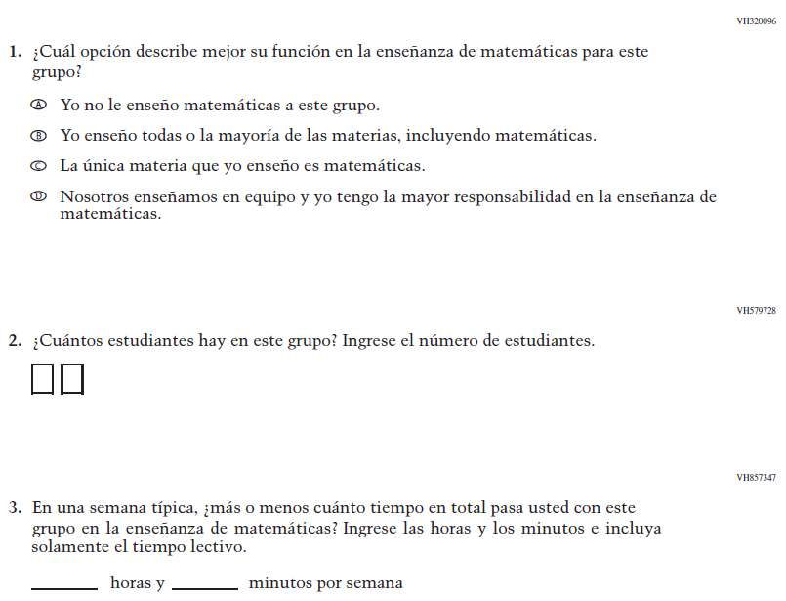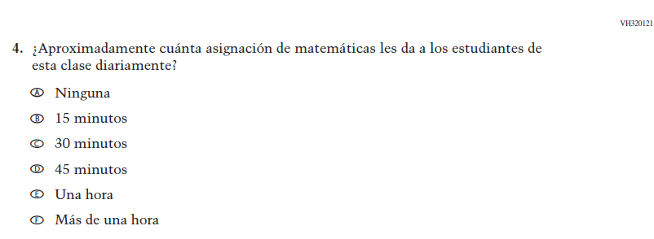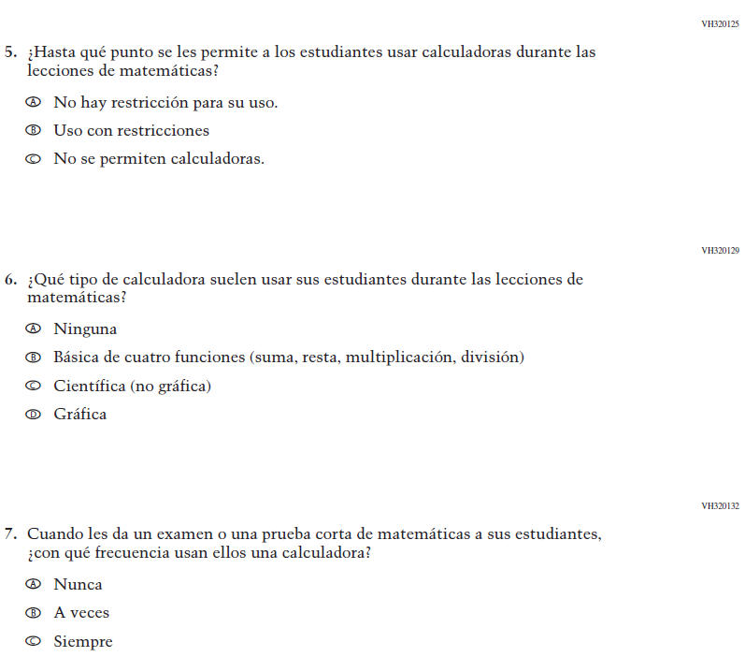
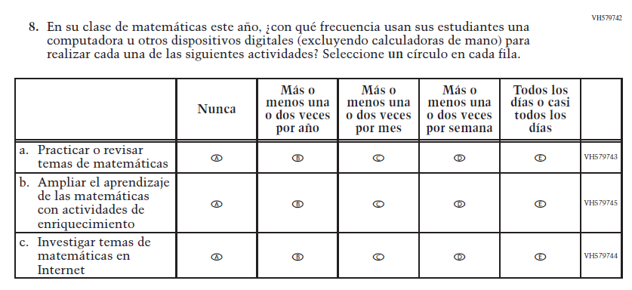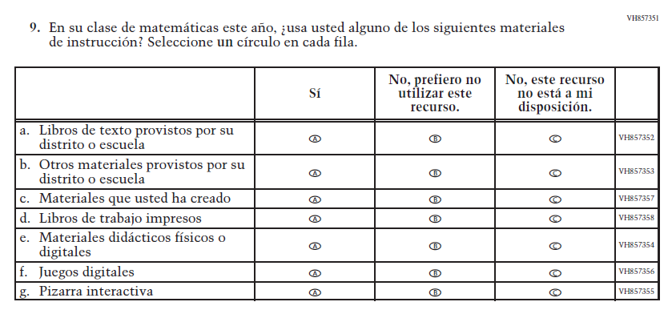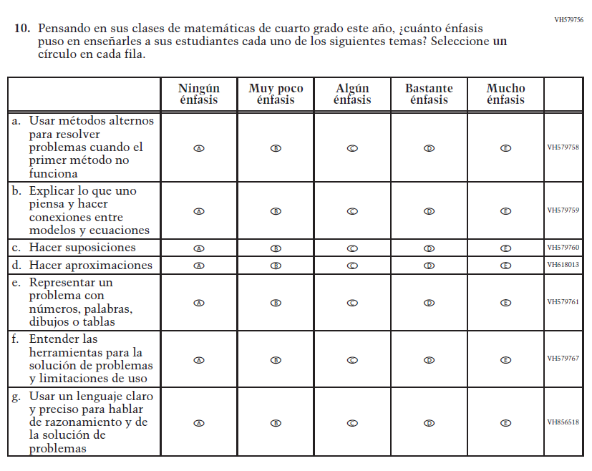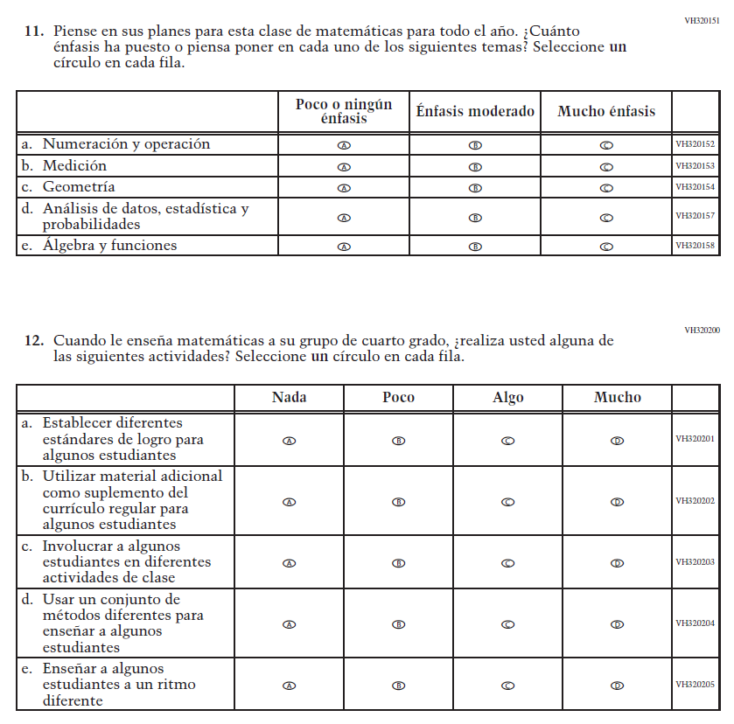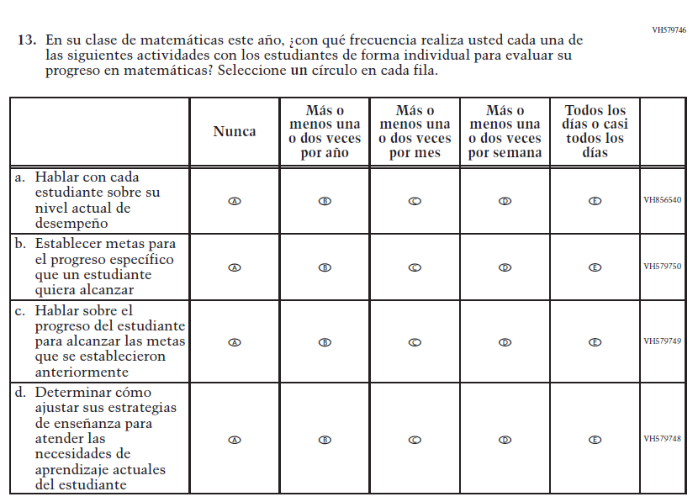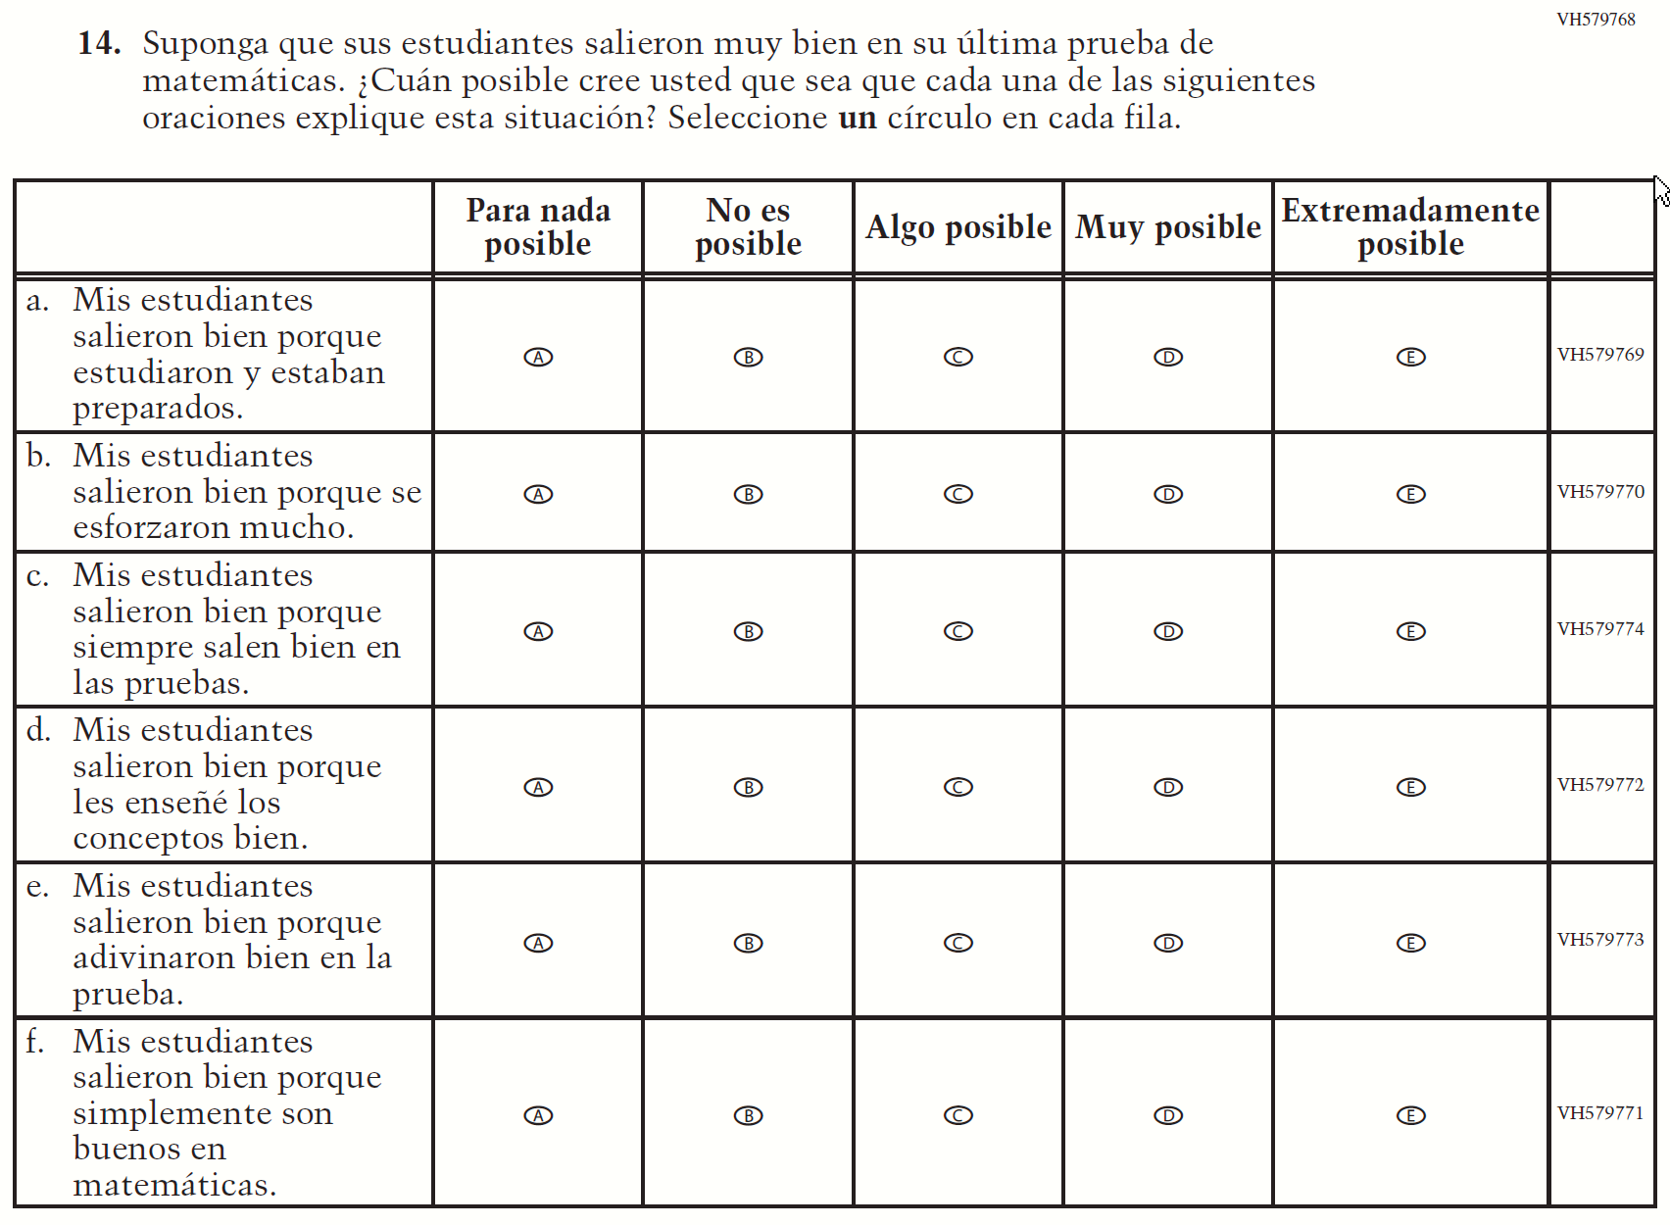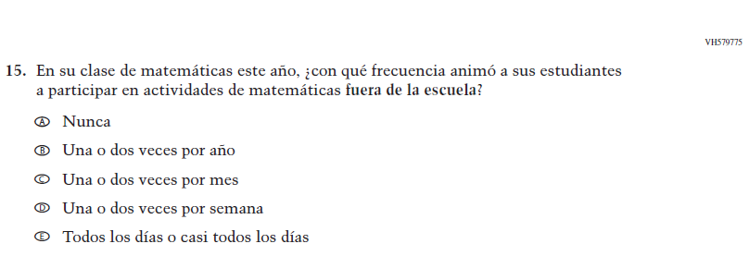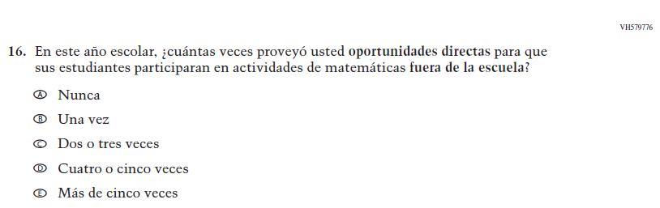

Appendix J-2d-s-PR: Summary of Changes Operational Grade 8 Mathematics
2022 Operational Grade 8 Mathematics Teacher – Puerto Rico
Previous item | 2022 item | D/A/R/NC+ | Rationale
VH320096  (2021 Operational Grade 8 Teacher Mathematics – Puerto Rico) | VH320096  Issue: Resources for Learning and Instruction | NC | N/A
VH579728  (2021 Operational Grade 8 Teacher Mathematics – Puerto Rico) | VH579728  Issue: Resources for Learning and Instruction | NC | N/A
VH857347  (2021 Operational Grade 8 Teacher Mathematics – Puerto Rico) | VH857347  Issue: Resources for Learning and Instruction | N/C | N/A
VH320121  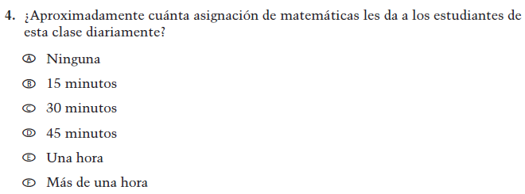  (2021 Operational Grade 8 Teacher Mathematics – Puerto Rico) | VH320121  Issue: Organization of Instruction | NC | N/A

2022 Operational Grade 8 Mathematics Teacher – Puerto Rico
Previous item | 2022 item | D/A/R/NC+ | Rationale
VH320125  (2021 Operational Grade 8 Teacher Mathematics – Puerto Rico) | VH320125  Issue: Organization of Instruction | NC | N/A
VH320129  (2021 Operational Grade 8 Teacher Mathematics – Puerto Rico) | VH320129  Issue: Resources for Learning and Instruction | NC | N/A
VH320132  (2021 Operational Grade 8 Teacher Mathematics – Puerto Rico) | VH320132  Issue: Organization of Instruction | NC | N/A
VH579742  (2021 Operational Grade 8 Teacher Mathematics – Puerto Rico) | VH579742  Issue: Organization of Instruction | NC | N/A

2022 Operational Grade 8 Mathematics Teacher – Puerto Rico
Previous item | 2022 item | D/A/R/NC+ | Rationale
VH857351  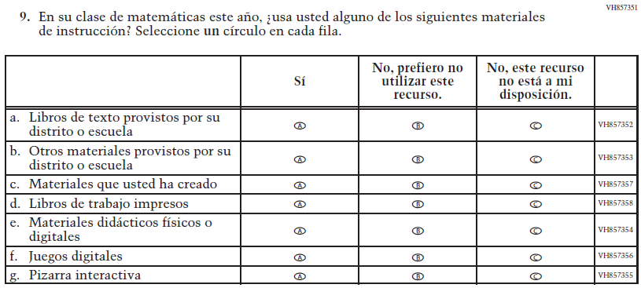  (2021 Operational Grade 8 Teacher Mathematics – Puerto Rico) | VH857351  Issue: Resources for Learning and Instruction | NC | N/A
VH579783  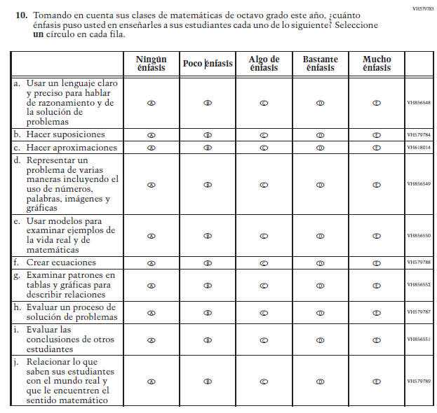  (2021 Operational Grade 8 Teacher Mathematics – Puerto Rico) | VH579783  Issue: Organization of Instruction | NC | N/A

2022 Operational Grade 8 Mathematics Teacher – Puerto Rico
Previous item | 2022 item | D/A/R/NC+ | Rationale
VH857275  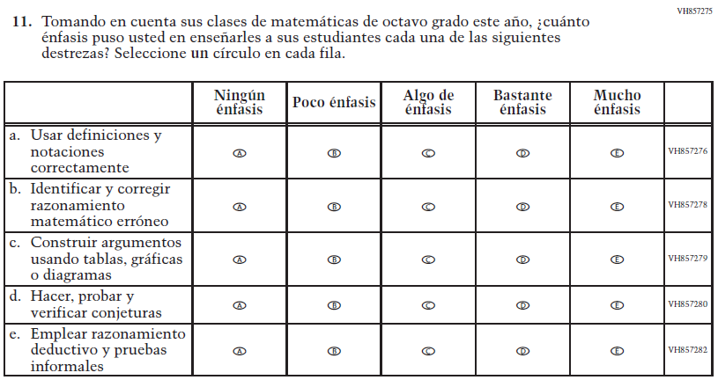  (2021 Operational Grade 8 Teacher Mathematics – Puerto Rico) | VH857275  Issue: Organization of Instruction | NC | N/A
VH320151  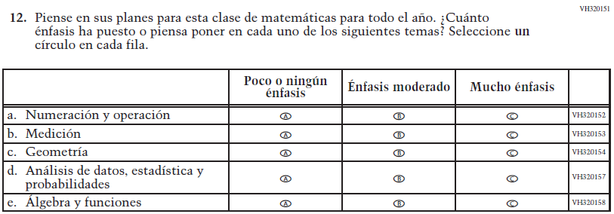  (2021 Operational Grade 8 Teacher Mathematics – Puerto Rico) | VH320151  Issue: Organization of Instruction | NC | N/A

2022 Operational Grade 8 Mathematics Teacher – Puerto Rico
Previous item | 2022 item | D/A/R/NC+ | Rationale
VH320284  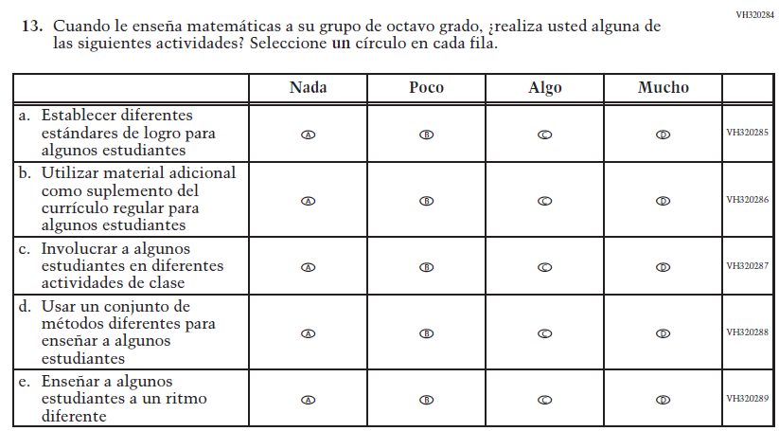  (2021 Operational Grade 8 Teacher Mathematics – Puerto Rico) | VH320284  Issue: Organization of Instruction | NC | N/A
VH579746  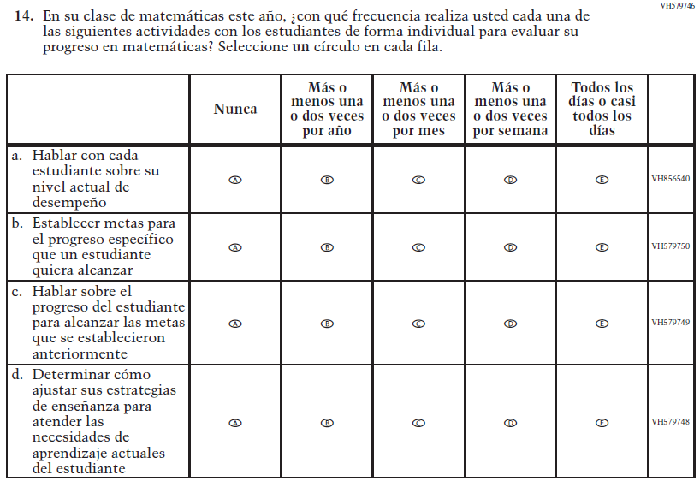  (2021 Operational Grade 8 Teacher Mathematics – Puerto Rico) | VH579746  Issue: Organization of Instruction | NC | N/A

2022 Operational Grade 8 Mathematics Teacher – Puerto Rico
Previous item | 2022 item | D/A/R/NC+ | Rationale
VH579768  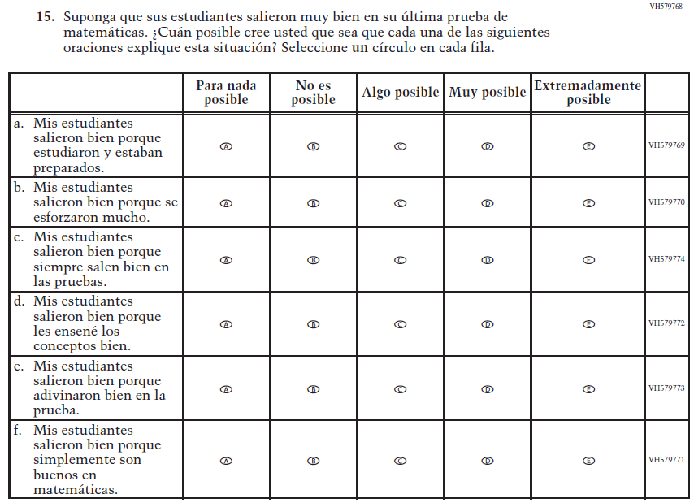  (2021 Operational Grade 8 Teacher Mathematics – Puerto Rico) | VH579768  Issue: Teacher Preparation | NC | N/A
VH579775  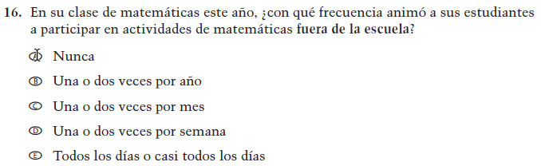  (2021 Operational Grade 8 Teacher Mathematics – Puerto Rico) | VH579775  Issue: Resources for Learning and Instruction | NC | N/A

2022 Operational Grade 8 Mathematics Teacher – Puerto Rico
Previous item | 2022 item | D/A/R/NC+ | Rationale
VH579776  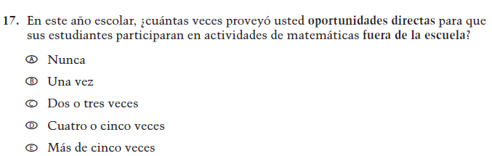  (2021 Operational Grade 8 Teacher Mathematics – Puerto Rico) | VH579776  Issue: Resources for Learning and Instruction | NC | N/A
VH857308  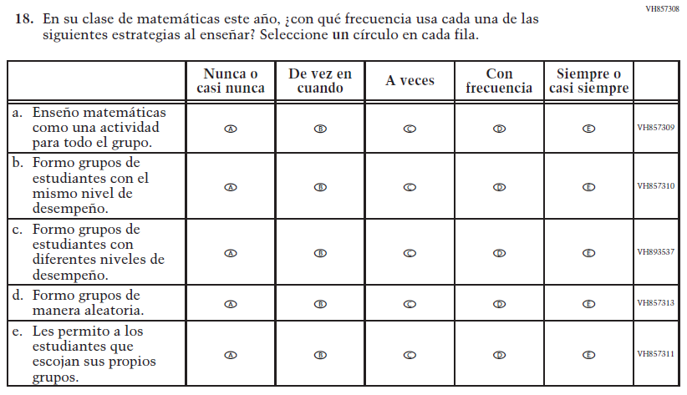  (2021 Operational Grade 8 Teacher Mathematics – Puerto Rico) | VH857308  Issue: Organization of Instruction | NC | N/A

Appendix J-2d-s-PR: Operational Grade 8 Mathematics
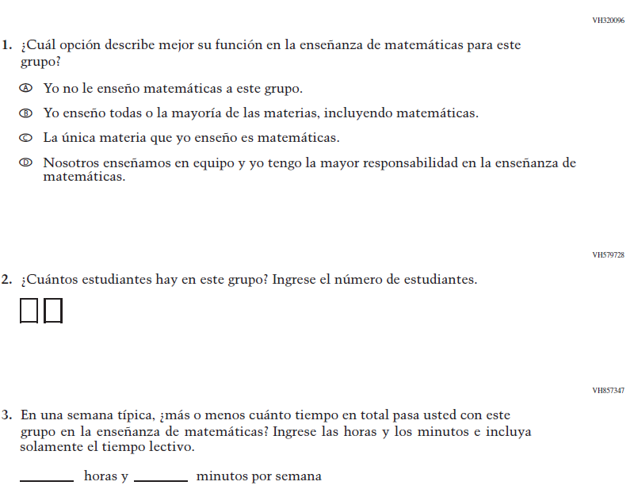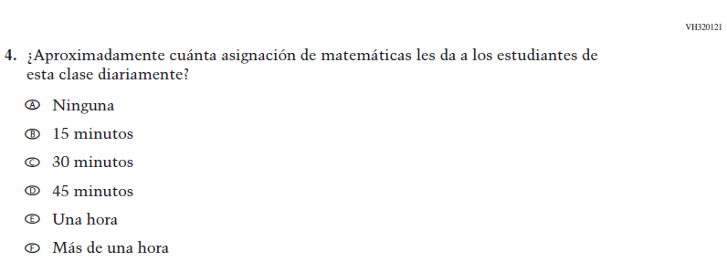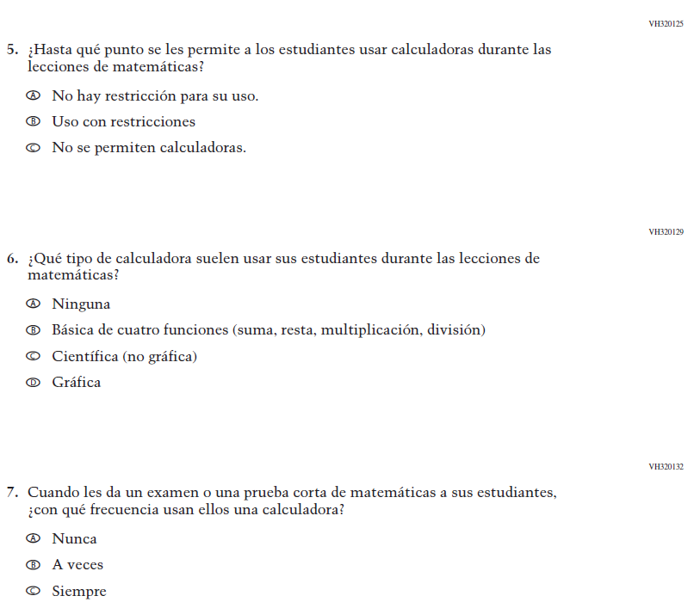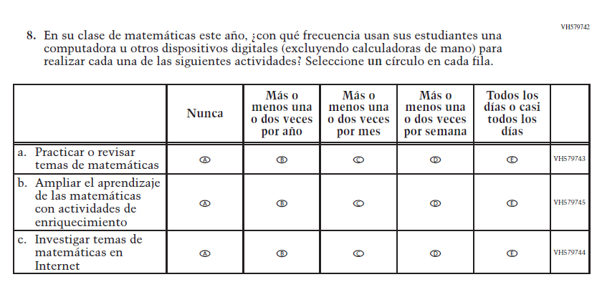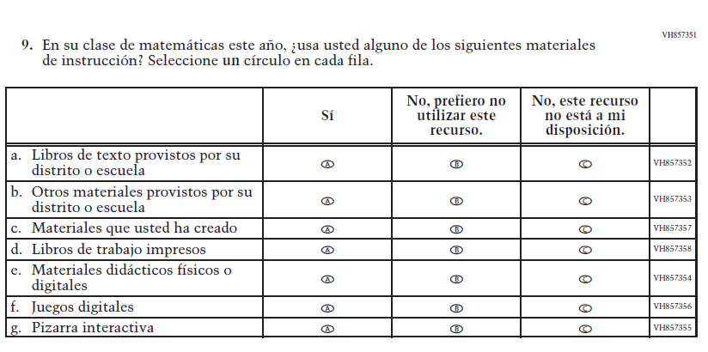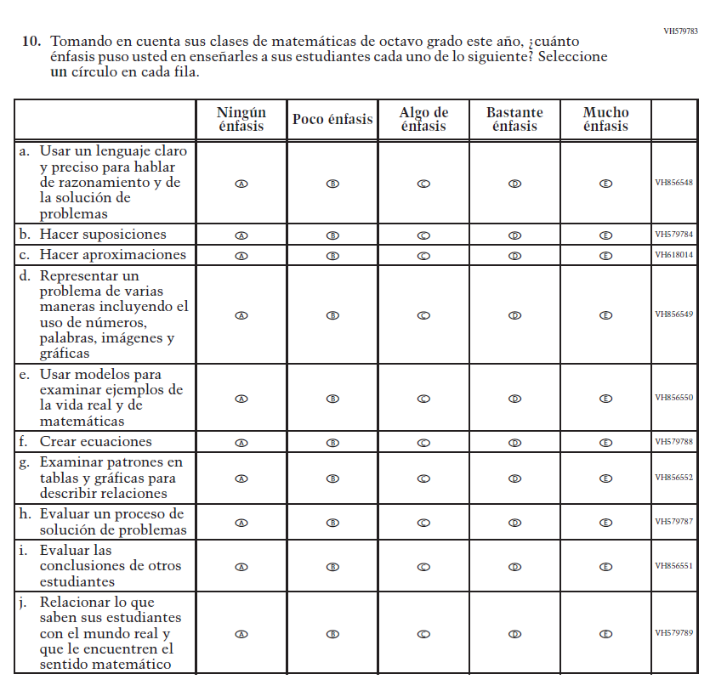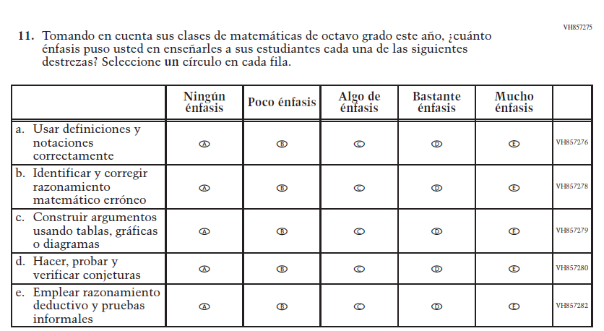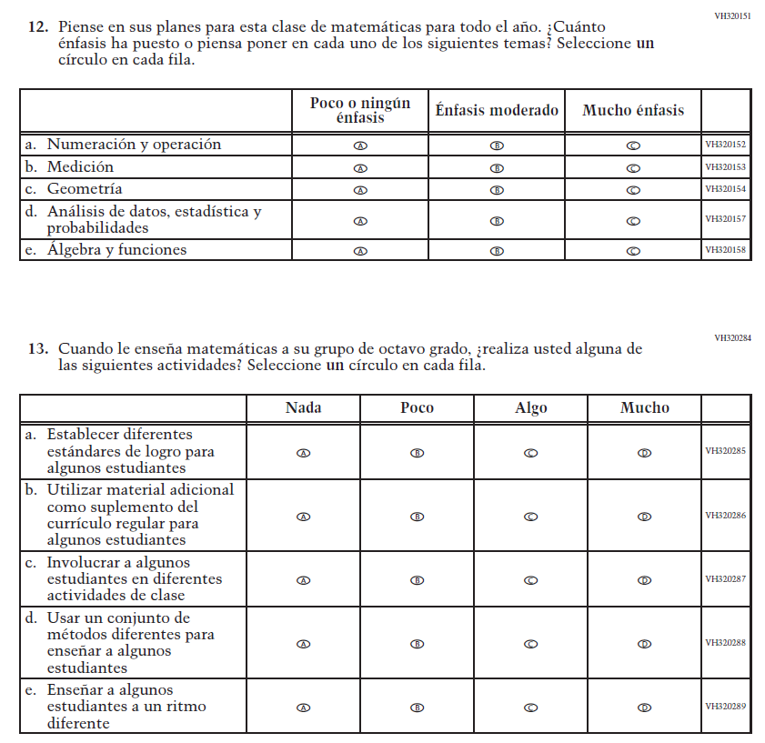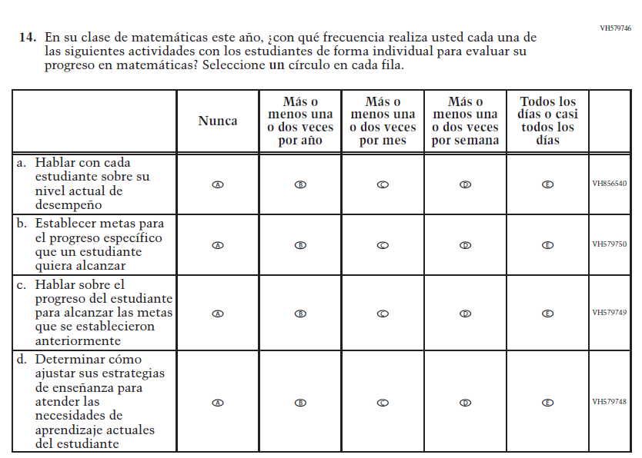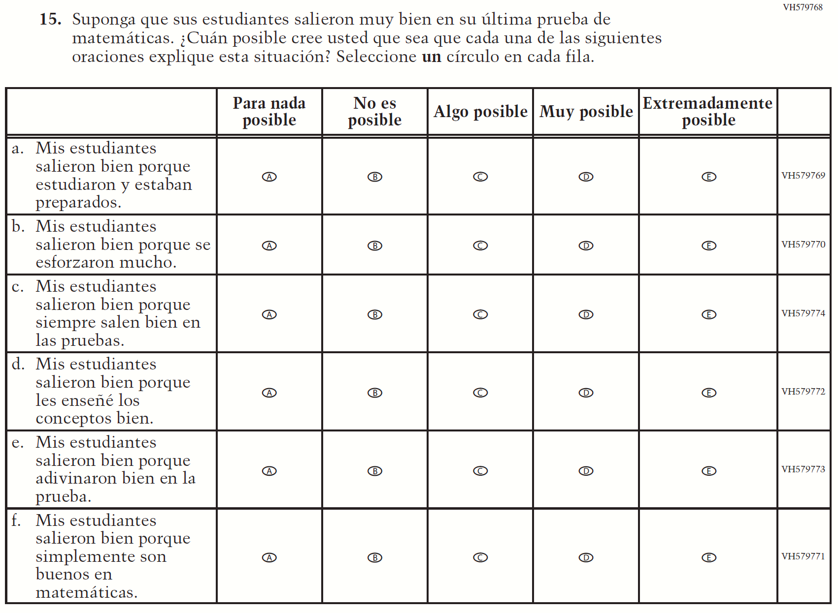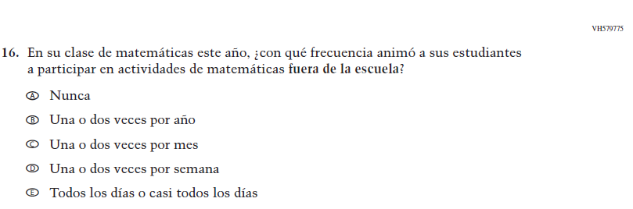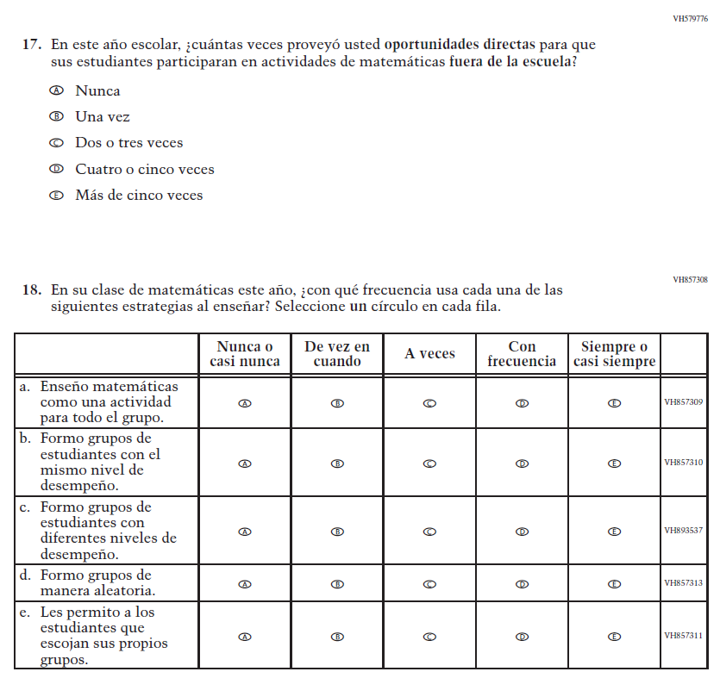

Appendix J-2e-s-PR: Summary of Operational Grade 4 COVID-19
2022 Operational Grade 4 COVID-19 Teacher – Puerto Rico
Previous item | 2022 item | D/A/R/NC+ | Rationale
VR241812  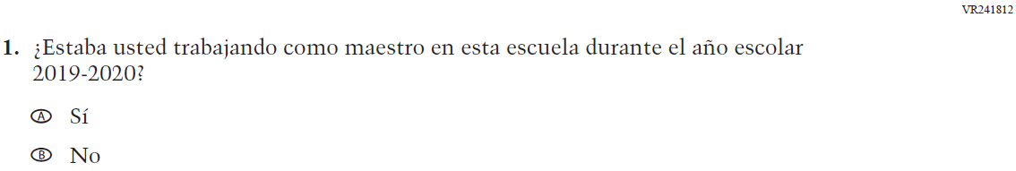  (2021 Operational Grade 4 Teacher COVID-19 – Puerto Rico) | VR241812  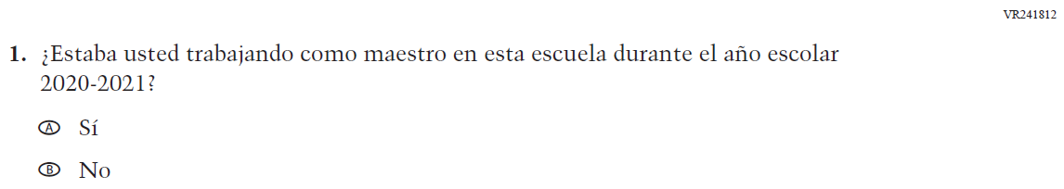  Issue: Organization of Instruction | R | This item has been updated to reference the correct academic year for the 2022 administration.
VR248919  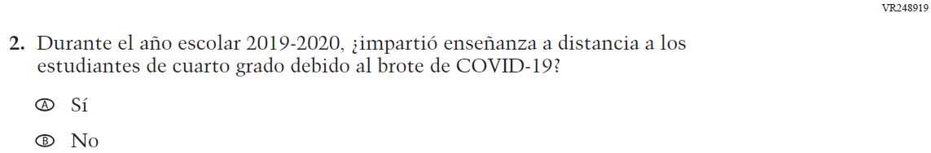  (2021 Operational Grade 4 Teacher COVID-19 – Puerto Rico) | VR248919  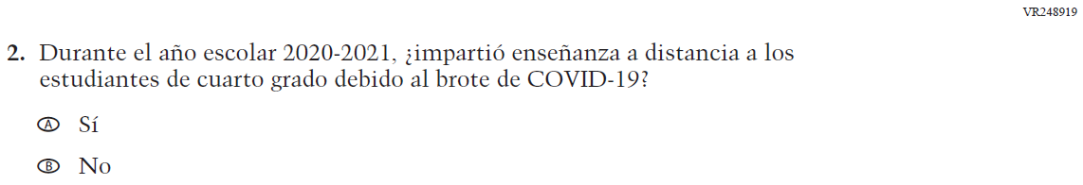  Issue: Organization of Instruction | R | This item has been updated to reference the correct academic year for the 2022 administration.

2022 Operational Grade 4 COVID-19 Teacher – Puerto Rico
Previous item | 2022 item |  |  | D/A/R/NC+ |  | Rationale
VR241799  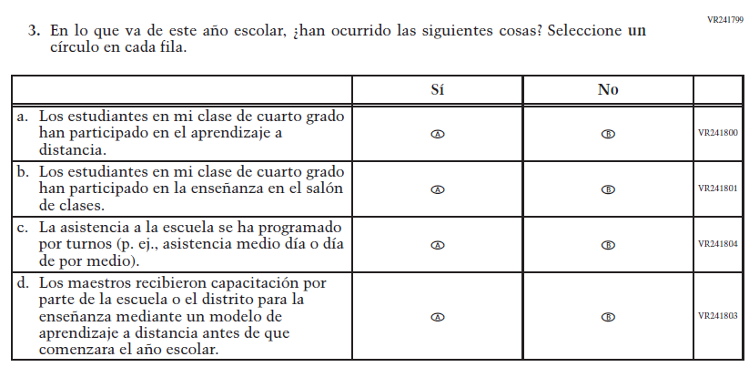  (2021 Operational Grade 4 Teacher COVID-19 – Puerto Rico) | VR241799  Issue: Organization of Instruction |  |  | NC |  | N/A
VR241763  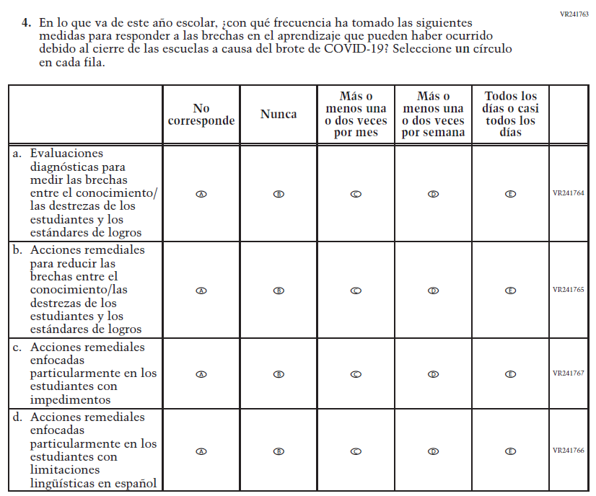  (2021 Operational Grade 4 Teacher COVID-19 – Puerto Rico) | VR241763  Issue: Organization of Instruction |  |  | NC |  | N/A
2022 Operational Grade 4 COVID-19 Teacher – Puerto Rico
Previous item |  | 2022 item | D/A/R/NC+ |  | Rationale
VR241773  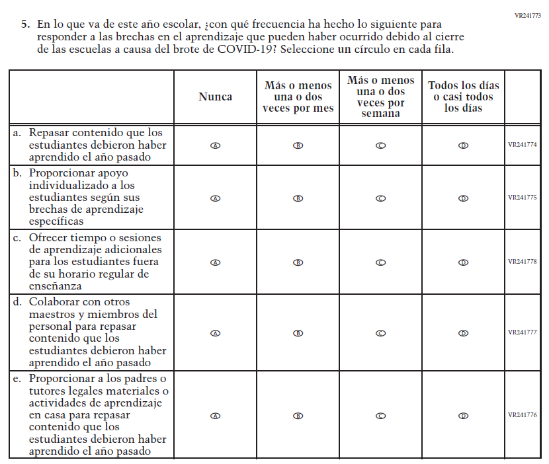  (2021 Operational Grade 4 Teacher COVID-19 – Puerto Rico) |  | VR241773  Issue: Organization of Instruction | NC |  | N/A

2022 Operational Grade 4 COVID-19 Teacher – Puerto Rico
Previous item |  | 2022 item |  | D/A/R/NC+ |  | Rationale
VR241819  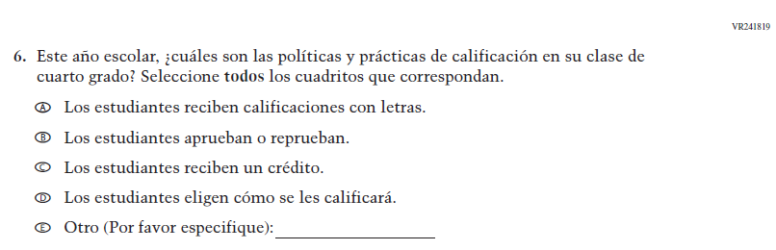  (2021 Operational Grade 4 Teacher COVID-19 – Puerto Rico) |  | VR241819  Issue: Organization of Instruction |  | NC |  | N/A
VR241781  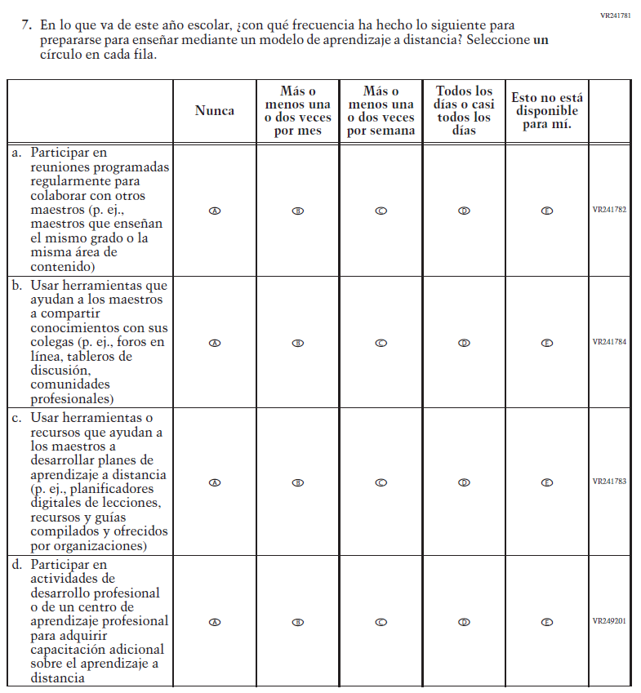  (2021 Operational Grade 4 Teacher COVID-19 – Puerto Rico) |  | VR241781  Issue: Teacher Preparation |  | NC |  | N/A
2022 Operational Grade 4 COVID-19 Teacher – Puerto Rico
Previous item | 2022 item |  | D/A/R/NC+ |  | Rationale
VR241795  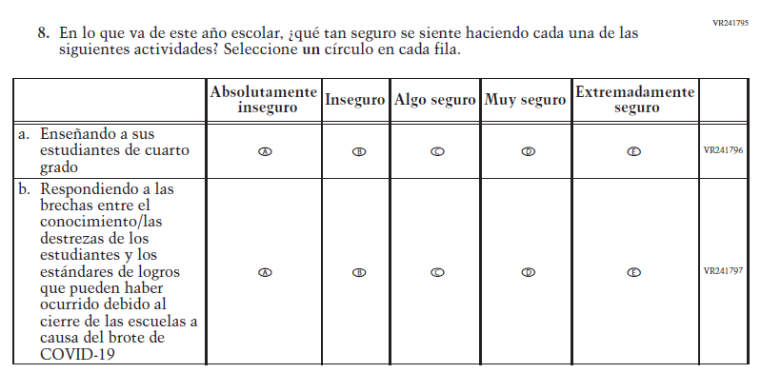  (2021 Operational Grade 4 Teacher COVID-19 – Puerto Rico) | VR241795  Issue: Self-efficacy |  | NC |  | N/A

2022 Operational Grade 4 COVID-19 Teacher – Puerto Rico
Previous item | 2022 item | D/A/R/NC+ | Rationale
VR241785  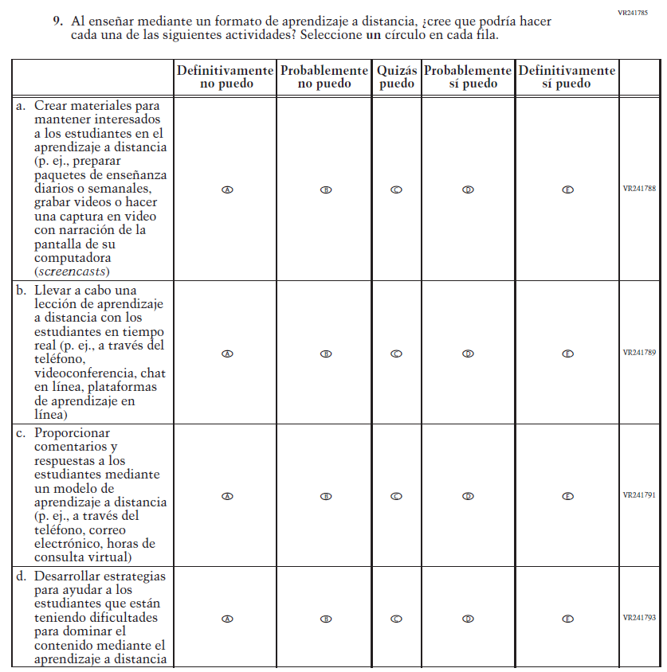  (2021 Operational Grade 4 Teacher COVID-19 – Puerto Rico) | VR241785  Issue: Self-efficacy | NC | N/A

Appendix J-2f-s-PR: Operational Grade 4 COVID-19

Appendix J-2g-s-PR: Summary of Operational Grade 8 COVID-19
2022 Operational Grade 8 COVID-19 Teacher – Puerto Rico
Previous item | 2022 item |  |  | D/A/R/NC+ |  |  | Rationale
VR241812  (2021 Operational Grade 8 Teacher COVID-19 – Puerto Rico) | VR241812  Issue: Organization of Instruction |  |  | R |  |  | This item has been updated to reference the correct academic year for the 2022 administration.
VR248921  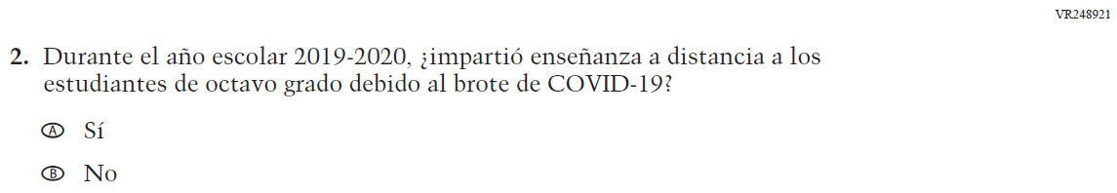  (2021 Operational Grade 8 Teacher COVID-19 – Puerto Rico) | VR248921  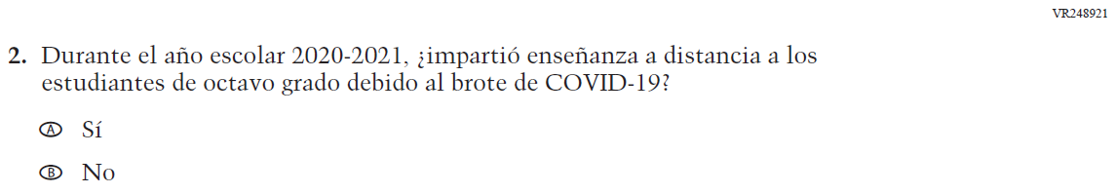  Issue: Organization of Instruction |  |  | R |  |  | This item has been updated to reference the correct academic year for the 2022 administration.
2022 Operational Grade 8 COVID-19 Teacher – Puerto Rico
Previous item |  | 2022 item |  |  |  | D/A/R/NC+ |  |  | Rationale
VR241799  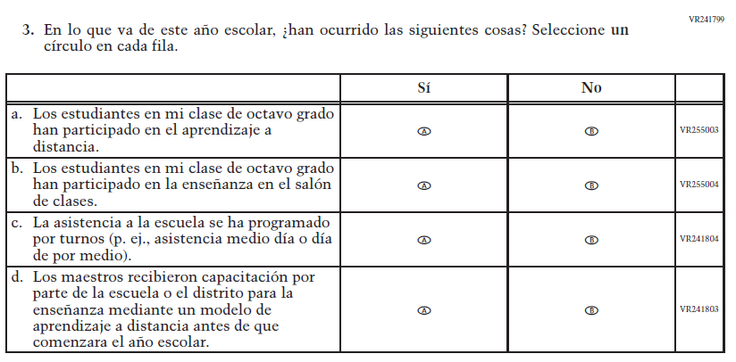  (2021 Operational Grade 8 Teacher COVID-19 – Puerto Rico) |  | VR241799  Issue: Organization of Instruction |  |  |  | NC |  |  | N/A
VR241763  (2021 Operational Grade 8 Teacher COVID-19 – Puerto Rico) |  | VR241763  Issue: Organization of Instruction |  |  |  | NC |  |  | N/A
2022 Operational Grade 8 COVID-19 Teacher – Puerto Rico
Previous item |  |  | 2022 item |  | D/A/R/NC+ |  |  | Rationale
VR241773  (2021 Operational Grade 8 Teacher COVID-19 – Puerto Rico) |  |  | VR241773  Issue: Organization of Instruction |  | NC |  |  | N/A

2022 Operational Grade 8 COVID-19 Teacher – Puerto Rico
Previous item |  | 2022 item |  | D/A/R/NC+ |  | Rationale
VR241820  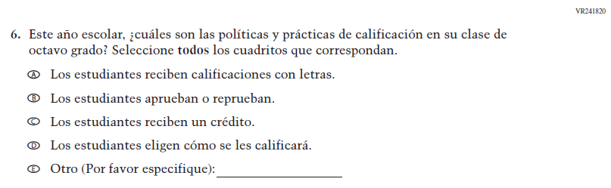  (2021 Operational Grade 8 Teacher COVID-19 – Puerto Rico) |  | VR241820  Issue: Organization of Instruction |  | NC |  | N/A
VR241781  (2021 Operational Grade 8 Teacher COVID-19 – Puerto Rico) |  | VR241781  Issue: Teacher Preparation |  | NC |  | N/A
2022 Operational Grade 8 COVID-19 Teacher – Puerto Rico
Previous item | 2022 item |  | D/A/R/NC+ |  | Rationale
VR241795  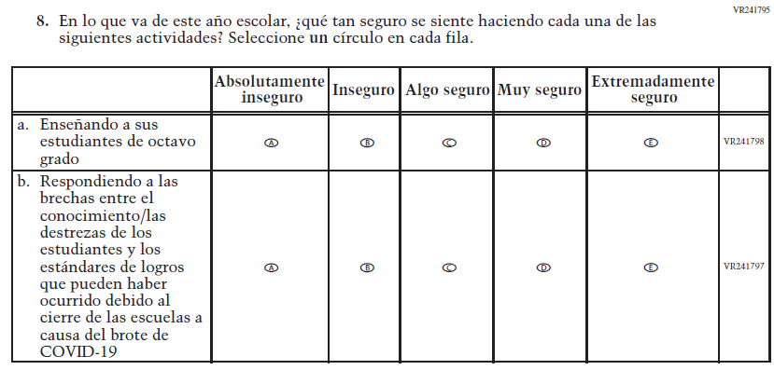  (2021 Operational Grade 8 Teacher COVID-19 – Puerto Rico) | VR241795  Issue: Self-efficacy |  | NC |  | N/A

2022 Operational Grade 8 COVID-19 Teacher – Puerto Rico
Previous item | 2022 item | D/A/R/NC+ | Rationale
VR241785  (2021 Operational Grade 8 Teacher COVID-19 – Puerto Rico) | VR241785  Issue: Self-efficacy | NC | N/A

Appendix J-2h-s-PR: Operational Grade 8 COVID-19
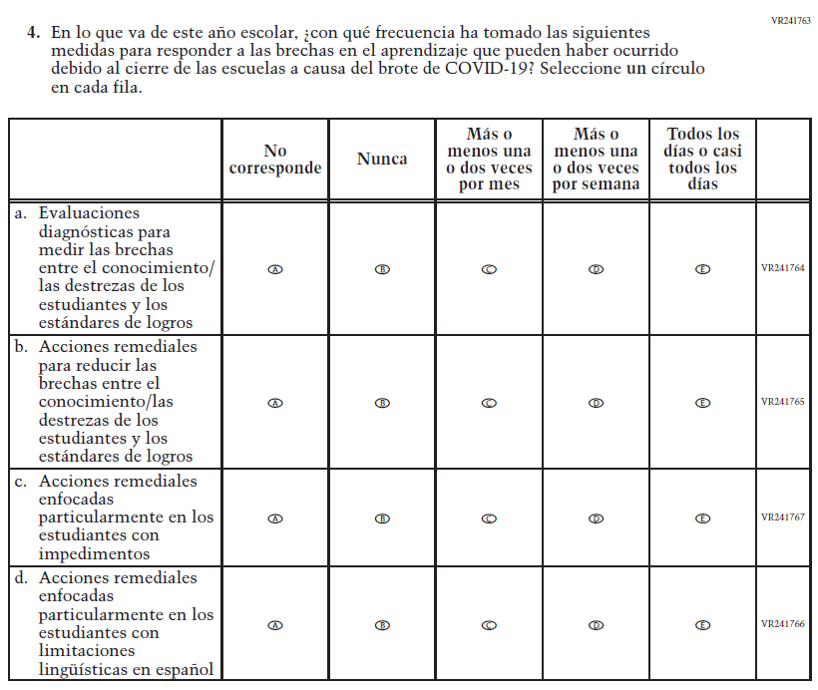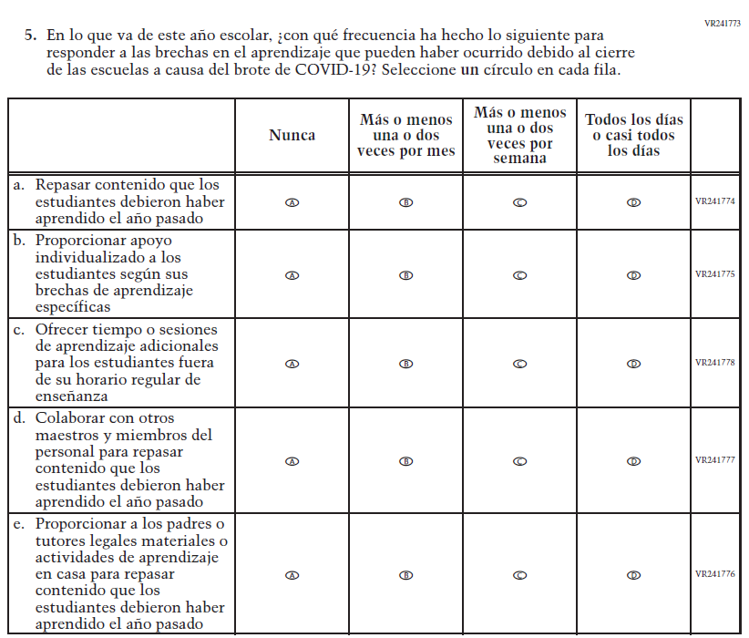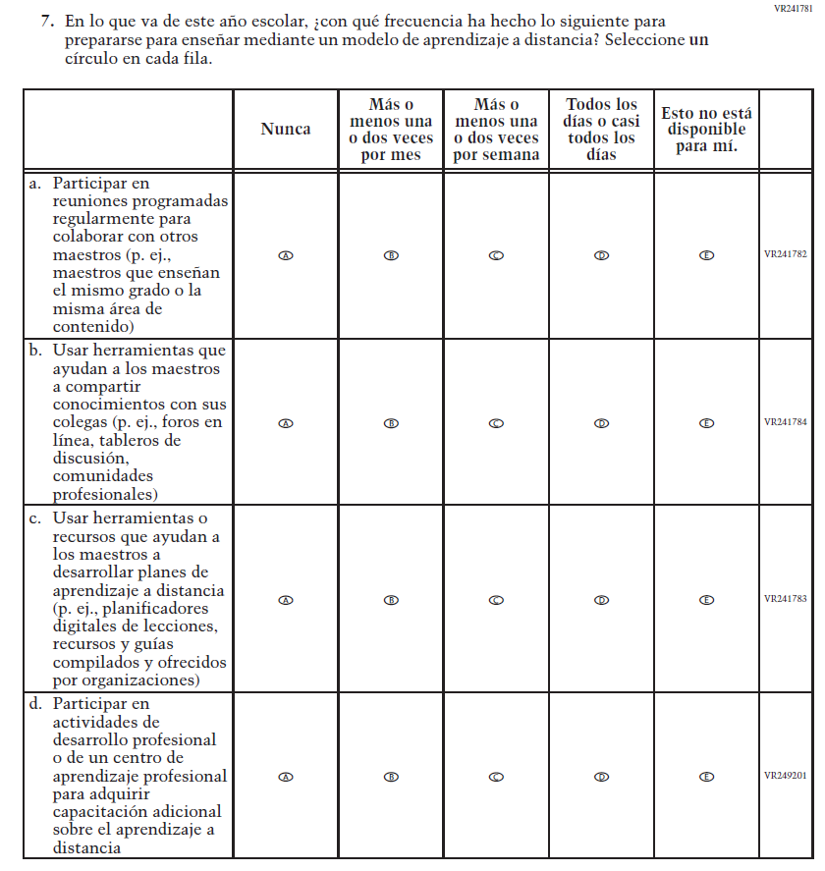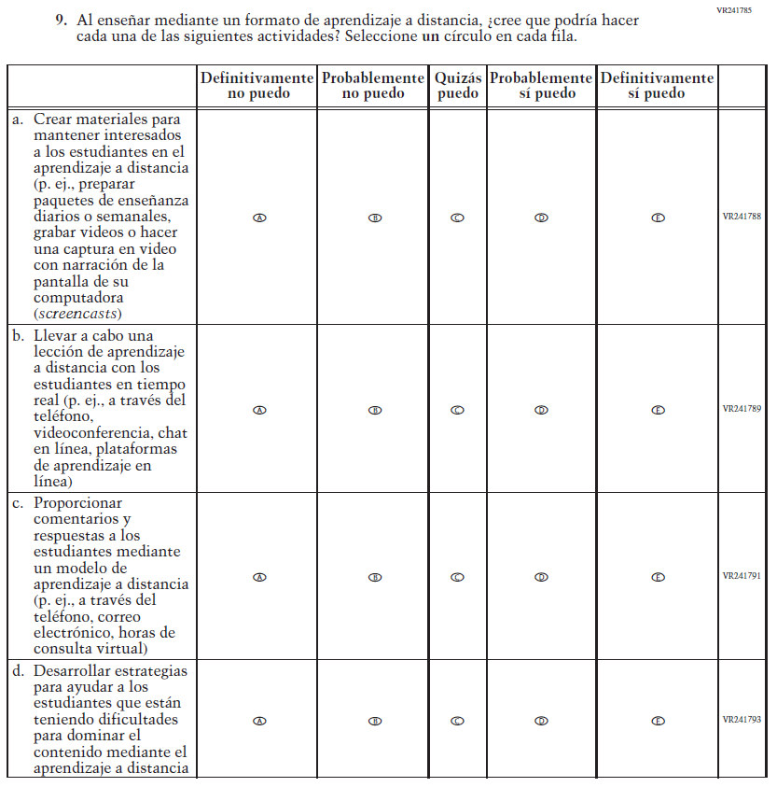

Sample School Administrator Login Screen

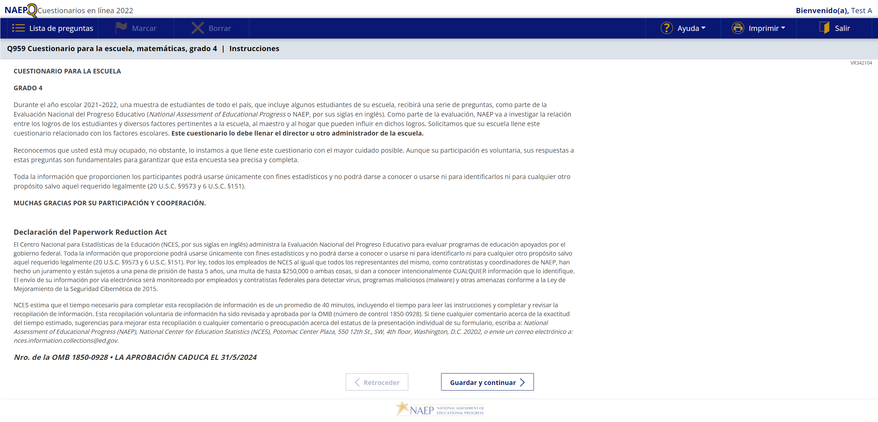

Sample School Questionnaire Booklet Covers
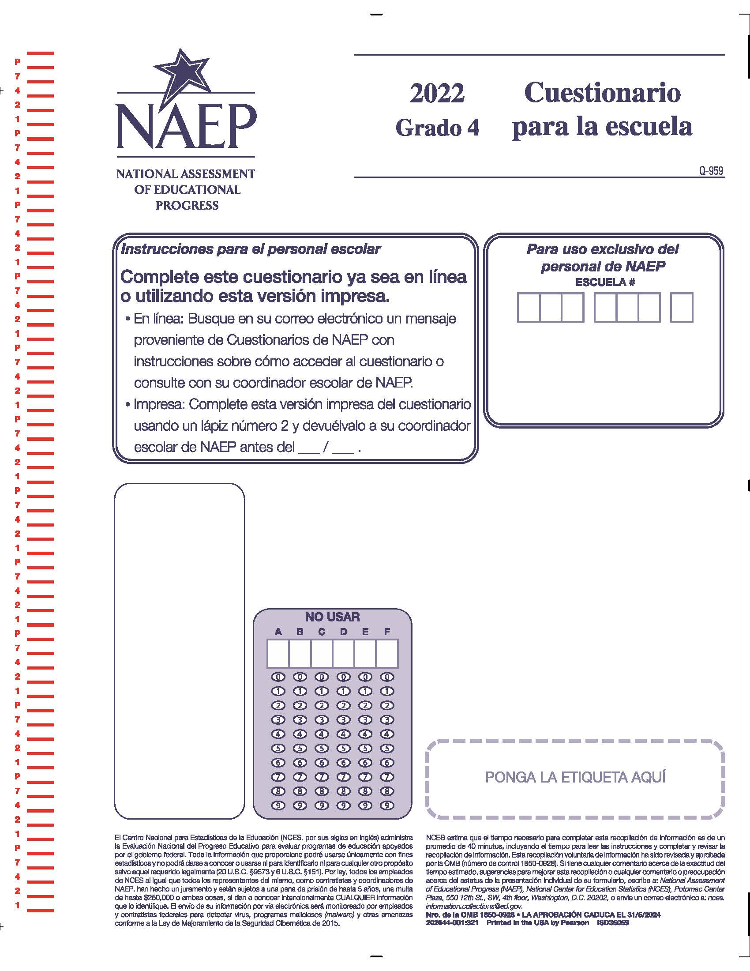

Appendix J-3-s: Spanish Translations of School Questionnaires

Appendix J-3a-s-PR: Summary of Changes Operational Grade 4 CORE
2022 Operational Grade 4 Core School – Puerto Rico
Previous item | 2022 item | D/A/R/NC+ | Rationale
VH835832  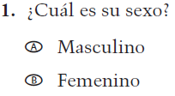  (2021 Operational Grade 4 School Core – Puerto Rico) | N/A | D | This item is recommended to be dropped due to concerns about data validity and a lack of inclusiveness in the response options.
VH318287  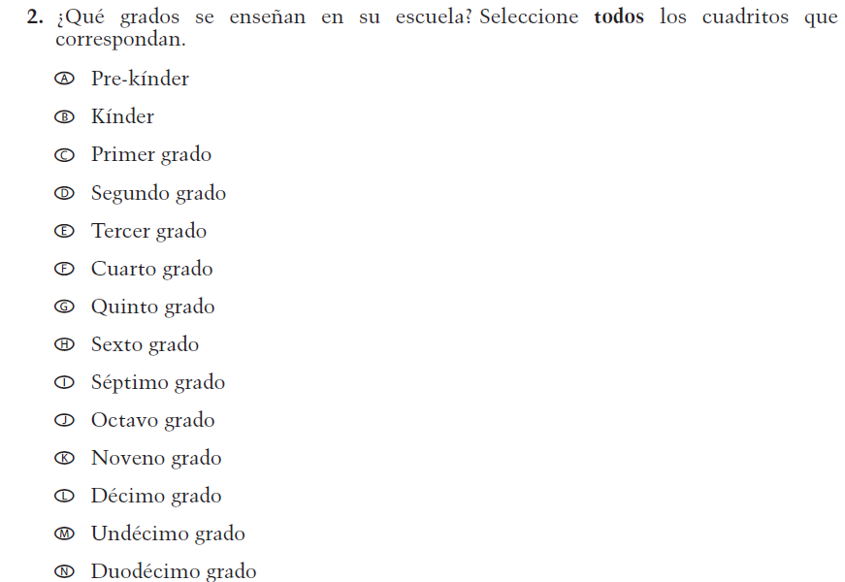  (2021 Operational Grade 4 School Core – Puerto Rico) | VH318287  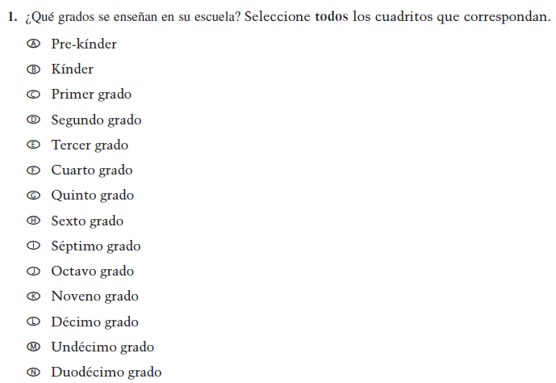  Issue: School Climate | NC | N/A

2022 Operational Grade 4 Core School – Puerto Rico
Previous item | 2022 item | D/A/R/NC+ | Rationale
VH893344  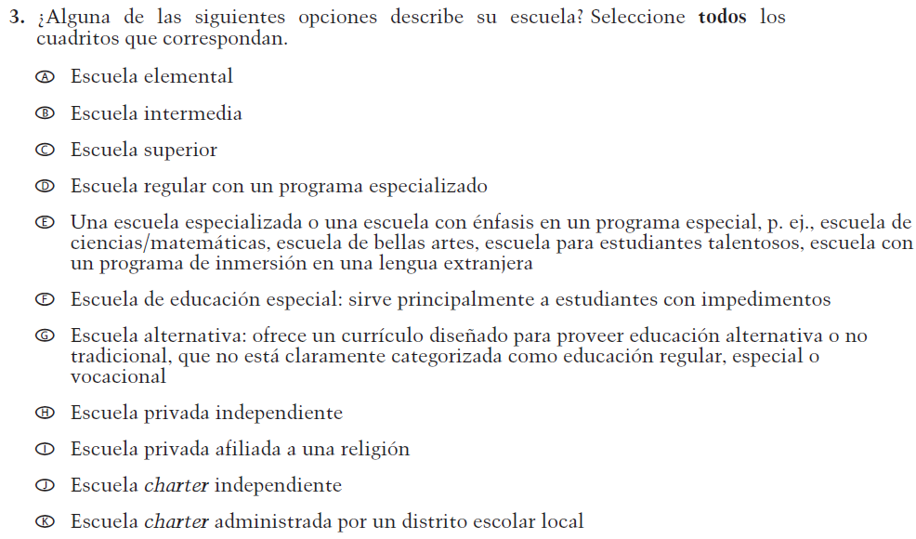  (2021 Operational Grade 4 School Core – Puerto Rico) | VH893344  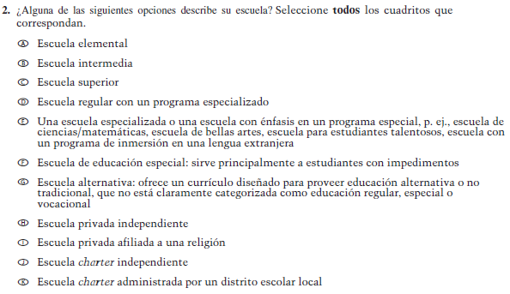  Issue: School Climate | NC | N/A
VH835855  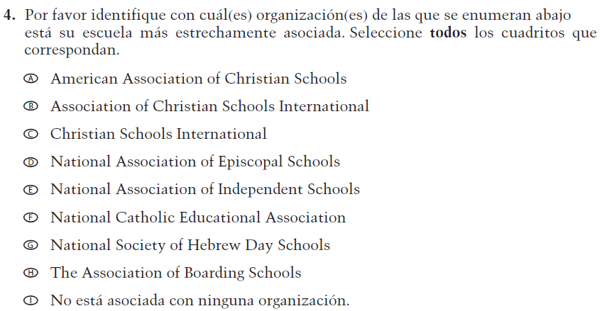  (2021 Operational Grade 4 School Core – Puerto Rico) | VH835855  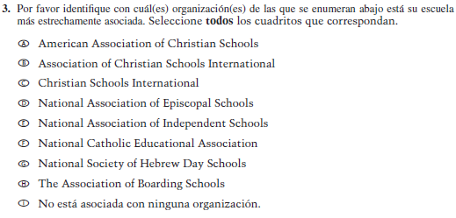  Issue: School Climate | NC | N/A

2022 Operational Grade 4 Core School – Puerto Rico
Previous item | 2022 item | D/A/R/NC+ | Rationale
VH318289  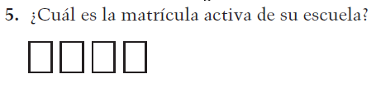  (2021 Operational Grade 4 School Core – Puerto Rico) | VH318289  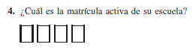  Issue: School Climate | NC | N/A
VH318292  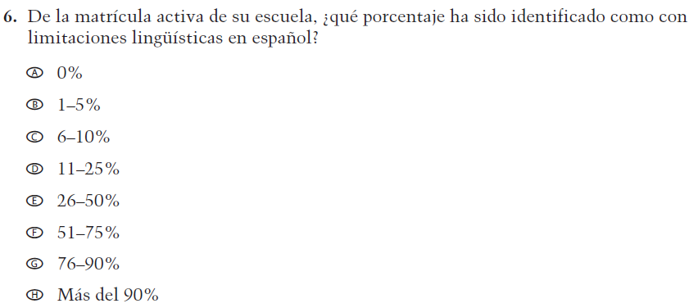  (2021 Operational Grade 4 School Core – Puerto Rico) | VH318292  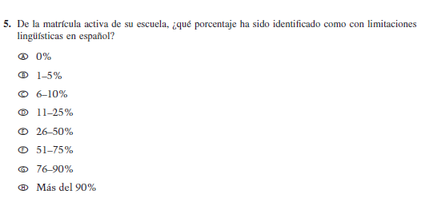  Issue: School Climate | NC | N/A
VH318291  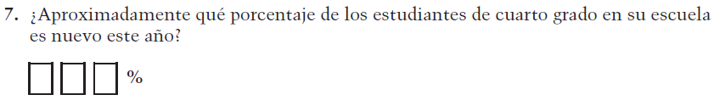  (2021 Operational Grade 4 School Core – Puerto Rico) | VH318291  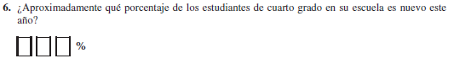  Issue: School Climate | NC | N/A

2022 Operational Grade 4 Core School – Puerto Rico
Previous item | 2022 item | D/A/R/NC+ | Rationale
VH318298  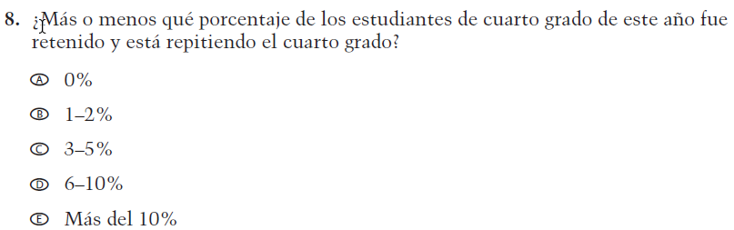  (2021 Operational Grade 4 School Core – Puerto Rico) | VH318298  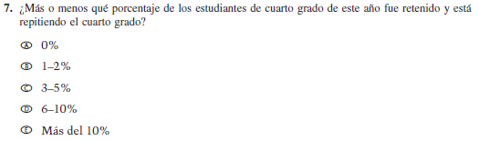  Issue: School Climate | NC | N/A
VH318293  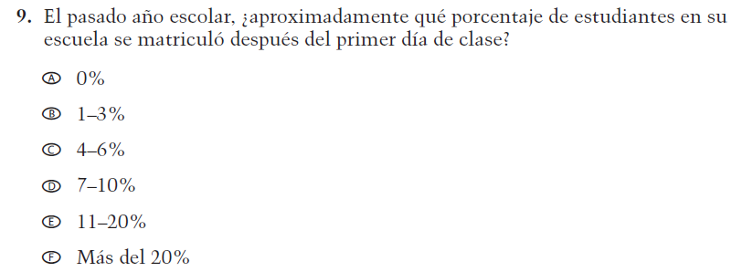  (2021 Operational Grade 4 School Core – Puerto Rico) | VH318293  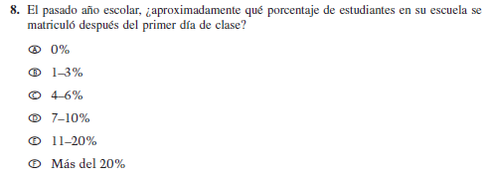  Issue: School Climate | NC | N/A
VH318294  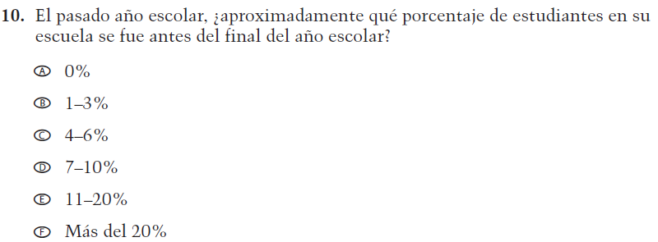  (2021 Operational Grade 4 School Core – Puerto Rico) | VH318294  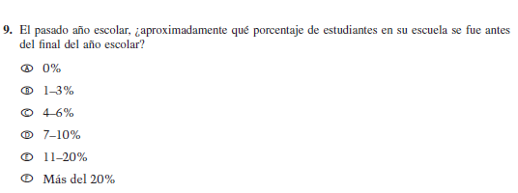  Issue: School Climate | NC | N/A

2022 Operational Grade 4 Core School – Puerto Rico
Previous item | 2022 item |  |  | D/A/R/NC+ |  | Rationale
VH318297  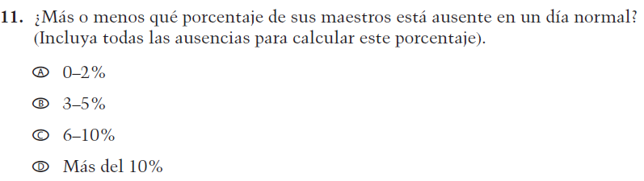  (2021 Operational Grade 4 School Core – Puerto Rico) | VH318297  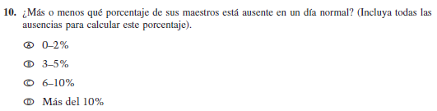  Issue: School Climate |  |  | NC |  | N/A
VH318299  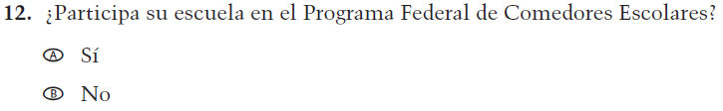  (2021 Operational Grade 4 School Core – Puerto Rico) | VH318299  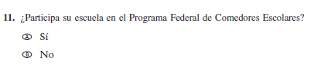  Issue: Socioeconomic Status |  |  | NC |  | N/A
VH318300  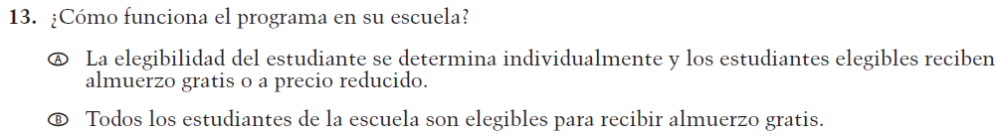  (2021 Operational Grade 4 School Core – Puerto Rico) | VH318300  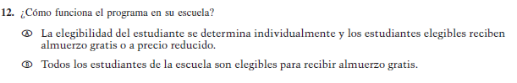  Issue: Socioeconomic Status |  |  | NC |  | N/A
VH318303  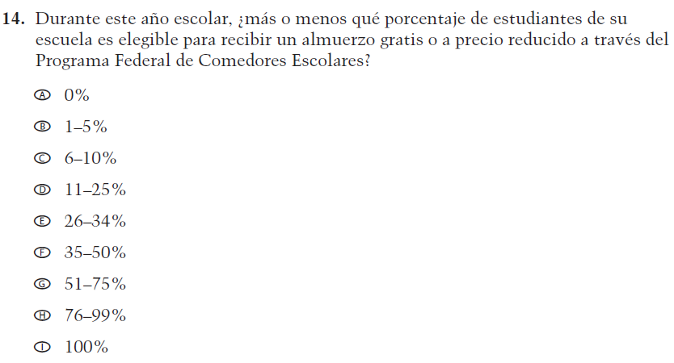  (2021 Operational Grade 4 School Core – Puerto Rico) | VH318303  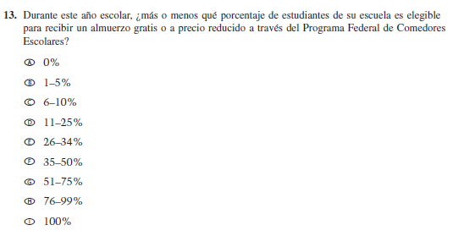  Issue: Socioeconomic Status |  |  | NC |  | N/A
2022 Operational Grade 4 Core School – Puerto Rico
Previous item | 2022 item |  |  | D/A/R/NC+ | Rationale
VH318304  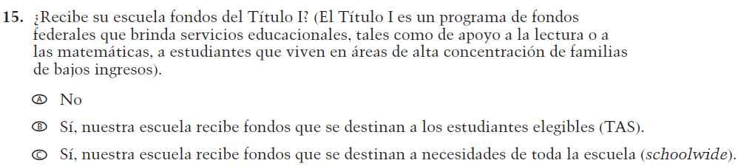  (2021 Operational Grade 4 School Core – Puerto Rico) | VH318304  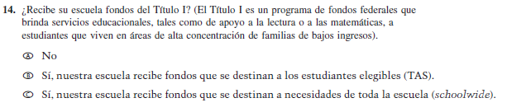  Issue: Socioeconomic Status |  |  | NC | N/A
VH318306  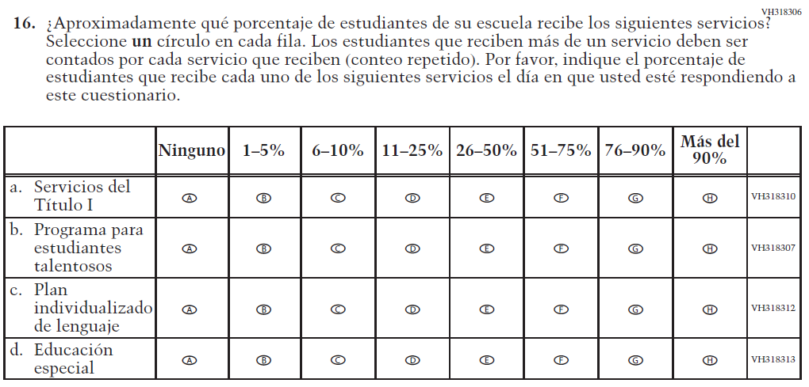  (2021 Operational Grade 4 School Core – Puerto Rico) | VH318306  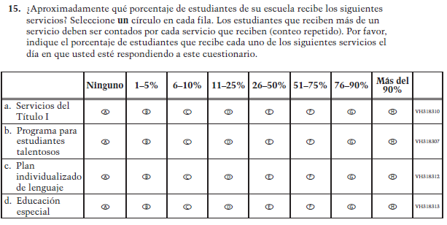  Issue: School Climate |  |  | NC | N/A
VH318316  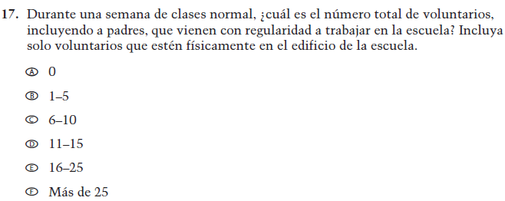  (2021 Operational Grade 4 School Core – Puerto Rico) | VH318316  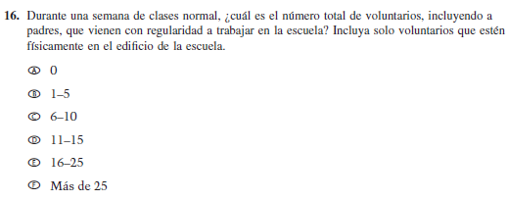  Issue: School Climate |  |  | NC | N/A
2022 Operational Grade 4 Core School – Puerto Rico
Previous item |  | 2022 item |  | D/A/R/NC+ | Rationale
VH318317  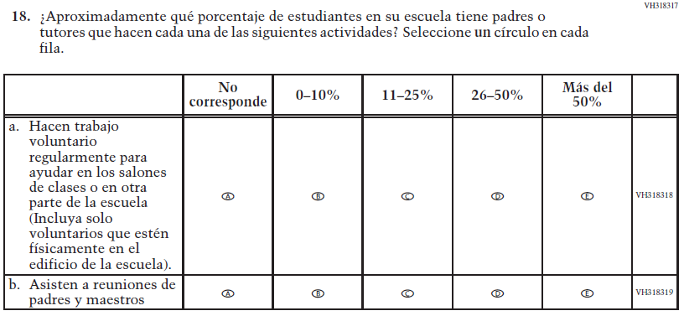  (2021 Operational Grade 4 School Core – Puerto Rico) |  | VH318317  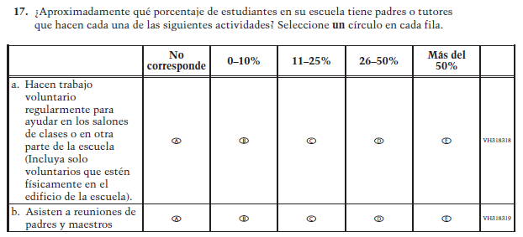  Issue: School Climate |  | NC | N/A
VH318321  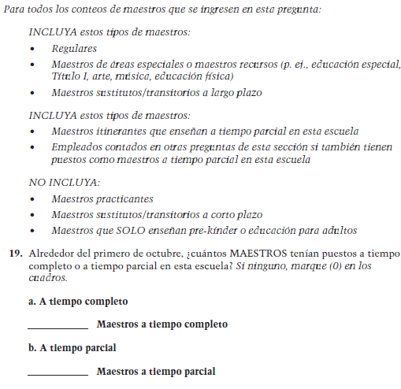  (2021 Operational Grade 4 School Core – Puerto Rico) |  | VH318321  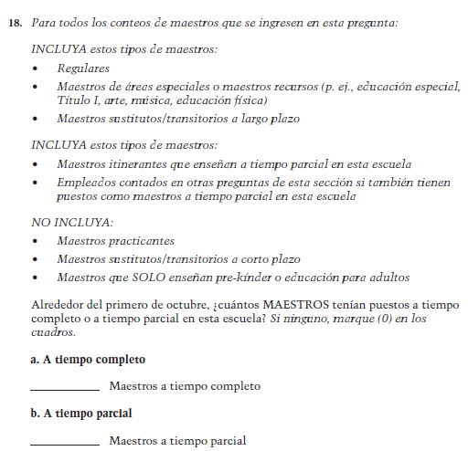  Issue: School Climate |  | NC | N/A
2022 Operational Grade 4 Core School – Puerto Rico
Previous item |  |  | 2022 item | D/A/R/NC+ | Rationale
VH835853  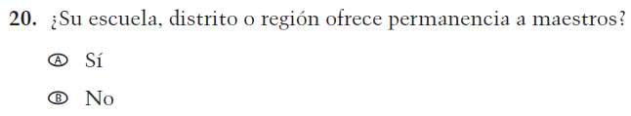  (2021 Operational Grade 4 School Core – Puerto Rico) |  |  | VH835853  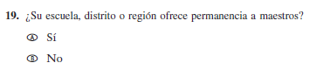  Issue: School Climate | NC | N/A
VH893347  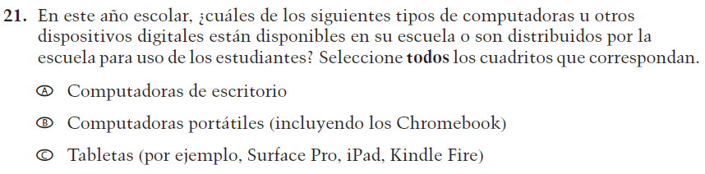  (2021 Operational Grade 4 School Core – Puerto Rico) |  |  | VH893347  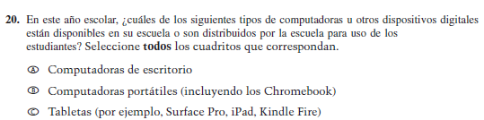  Issue: Technology Use | NC | N/A
VH579614  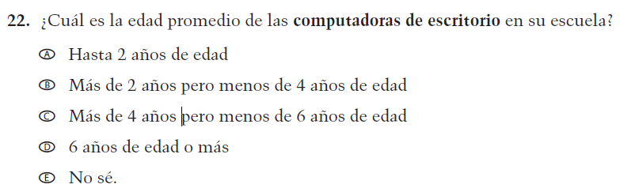  (2021 Operational Grade 4 School Core – Puerto Rico) |  |  | VH579614  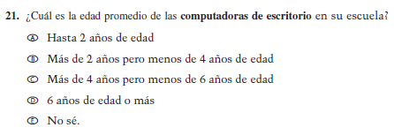  Issue: Technology Use | NC | N/A

2022 Operational Grade 4 Core School – Puerto Rico
Previous item | 2022 item |  |  | D/A/R/NC+ |  | Rationale
VH893348  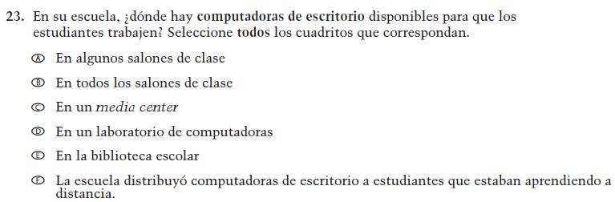  (2021 Operational Grade 4 School Core – Puerto Rico) | VH893348  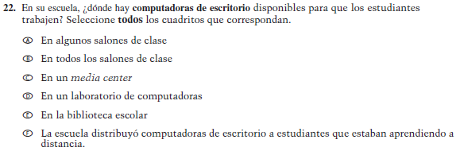  Issue: Technology Use |  |  | NC |  | N/A
VH579616  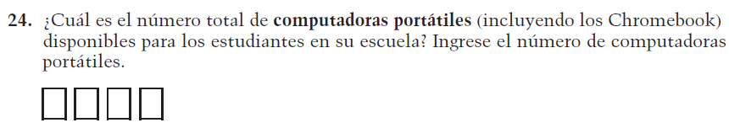  (2021 Operational Grade 4 School Core – Puerto Rico) | VH579616  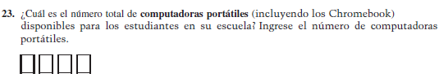  Issue: Technology Use |  |  | NC |  | N/A
VH579617  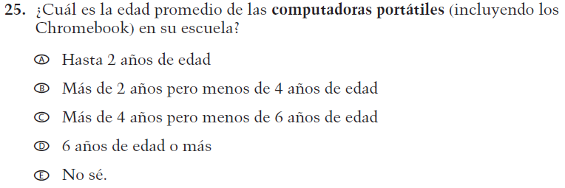  (2021 Operational Grade 4 School Core – Puerto Rico) | VH579617  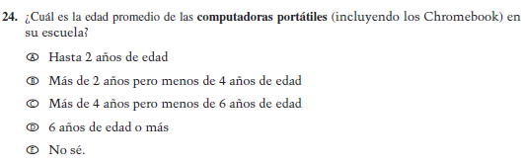  Issue: Technology Use |  |  | NC |  | N/A
2022 Operational Grade 4 Core School – Puerto Rico
Previous item |  | 2022 item | D/A/R/NC+ |  | Rationale
VH893351  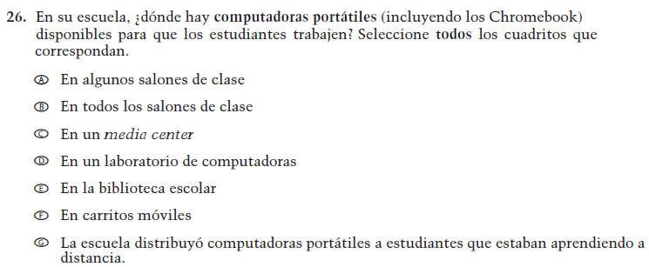  (2021 Operational Grade 4 School Core – Puerto Rico) |  | VH893351  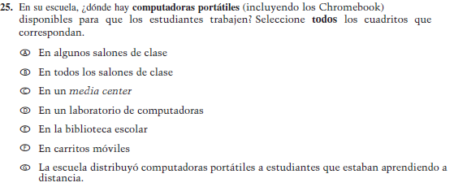  Issue: Technology Use | NC |  | N/A
VH579619  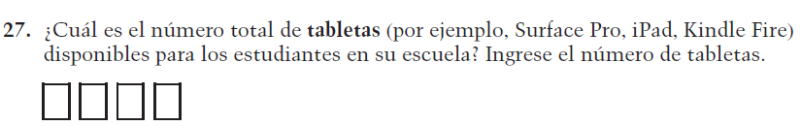  (2021 Operational Grade 4 School Core – Puerto Rico) |  | VH579619  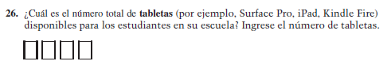  Issue: Technology Use | NC |  | N/A
VH579620  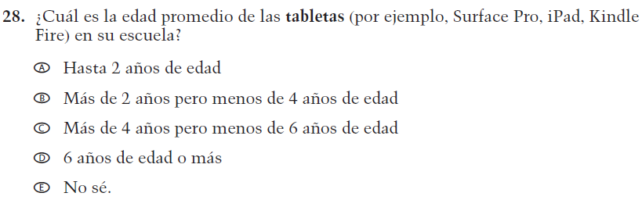  (2021 Operational Grade 4 School Core – Puerto Rico) |  | VH579620  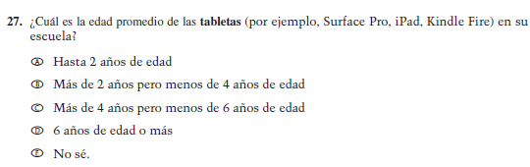  Issue: Technology Use | NC |  | N/A

2022 Operational Grade 4 Core School – Puerto Rico
Previous item | 2022 item | D/A/R/NC+ | Rationale
VH893352  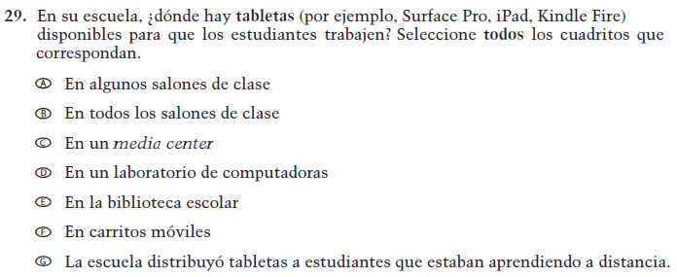  (2021 Operational Grade 4 School Core – Puerto Rico) | VH893352  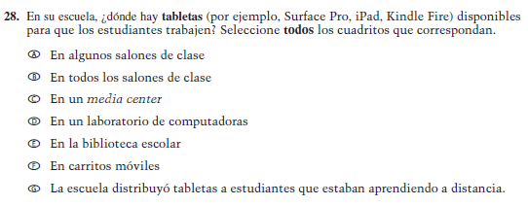  Issue: Technology Use | NC | N/A
VH579601  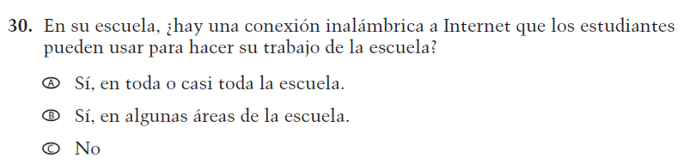  (2021 Operational Grade 4 School Core – Puerto Rico) | VH579601  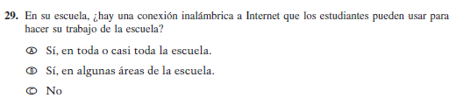  Issue: Technology Use | NC | N/A

Appendix J-3a-s-PR: Operational Grade 4 CORE
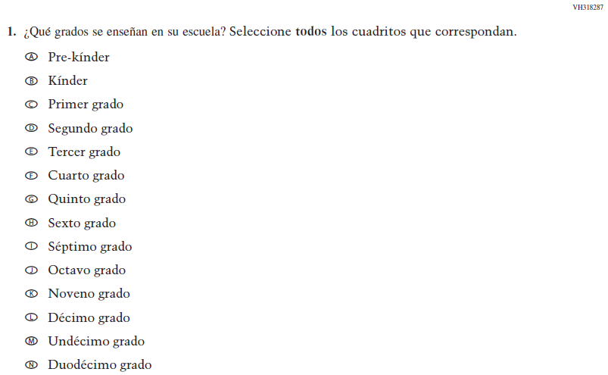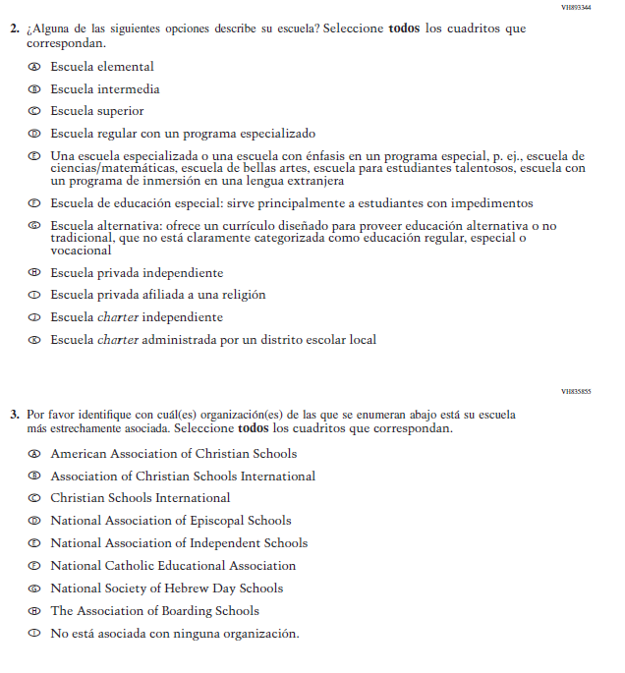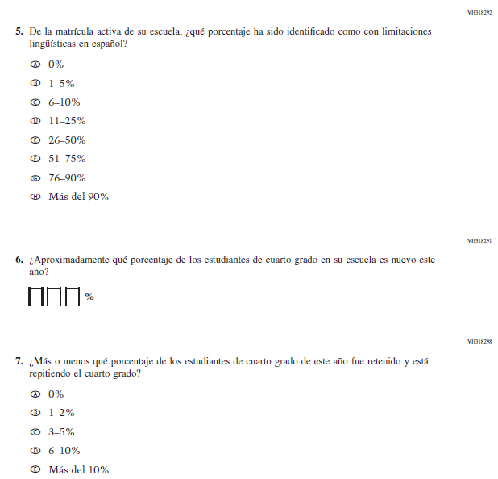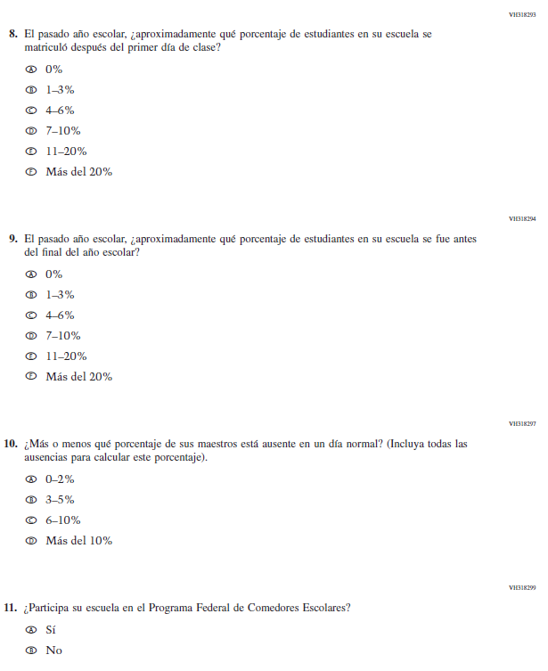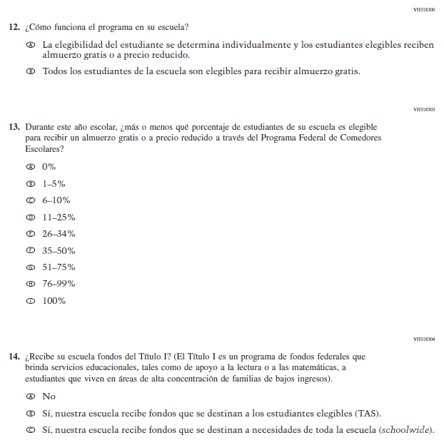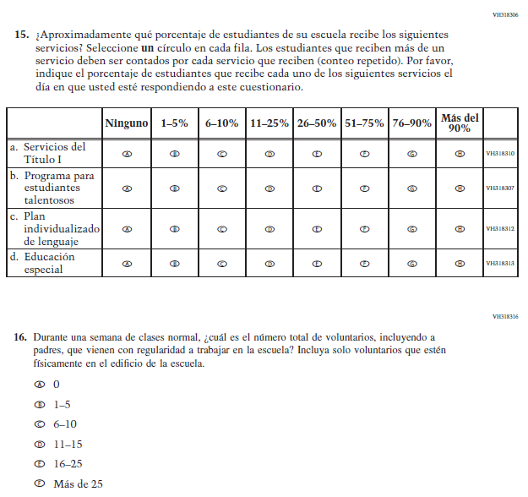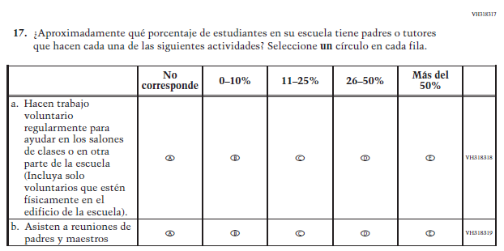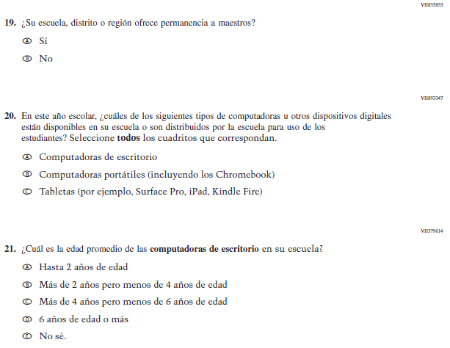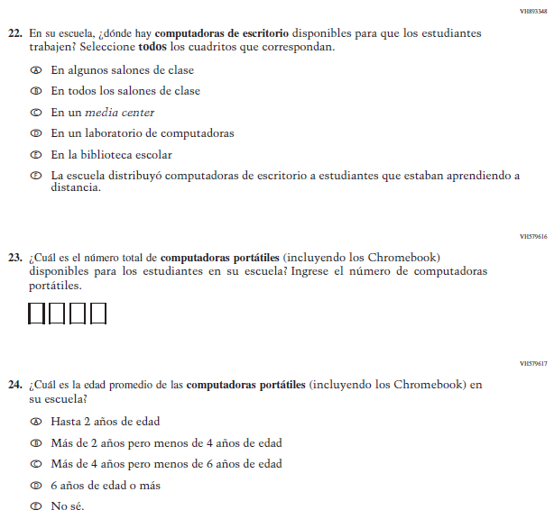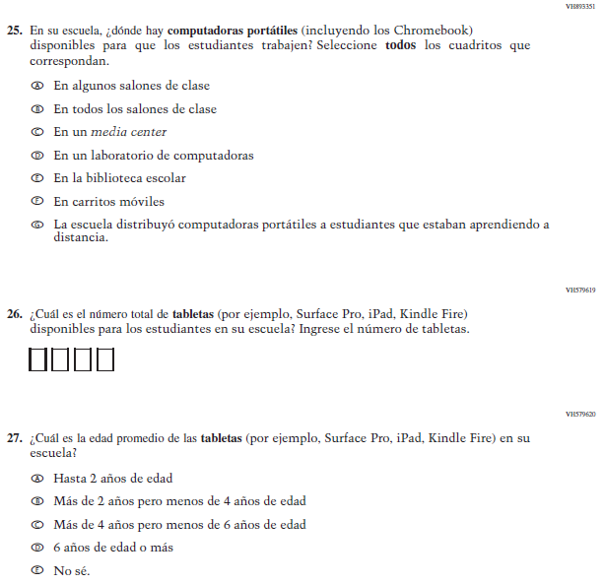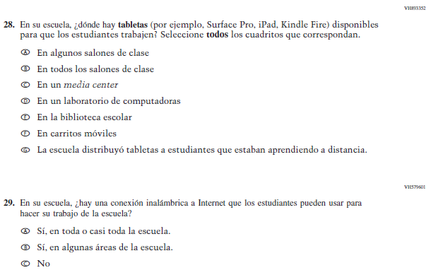

Appendix J-3b-s-PR: Summary of Changes Operational Grade 8 CORE
2022 Operational Grade 8 Core School – Puerto Rico
Previous item | 2022 item | D/A/R/NC+ | Rationale
VH835832  (2021 Operational Grade 4 School Core – Puerto Rico) | N/A | D | This item is recommended to be dropped due to concerns about data validity and a lack of inclusiveness in the response options.
VH318287  (2021 Operational Grade 4 School Core – Puerto Rico) | VH318287  Issue: School Climate | NC | N/A

2022 Operational Grade 8 Core School – Puerto Rico
Previous item | 2022 item | D/A/R/NC+ | Rationale
VH893344  (2021 Operational Grade 8 School Core – Puerto Rico) | VH893344  Issue: School Climate | NC | N/A
VH835855  (2021 Operational Grade 8 School Core – Puerto Rico) | VH835855  Issue: School Climate | NC | N/A

2022 Operational Grade 8 Core School – Puerto Rico
Previous item | 2022 item | D/A/R/NC+ | Rationale
VH318289  (2021 Operational Grade 8 School Core – Puerto Rico) | VH318289  Issue: School Climate | NC | N/A
VH318292  (2021 Operational Grade 8 School Core – Puerto Rico) | VH318292  Issue: School Climate | NC | N/A
VH318558  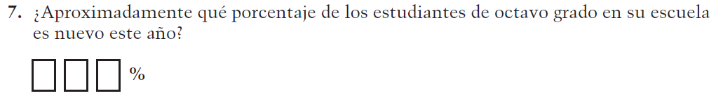  (2021 Operational Grade 8 School Core – Puerto Rico) | VH318558  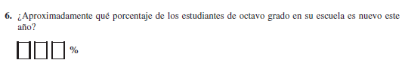  Issue: School Climate | NC | N/A

2022 Operational Grade 8 Core School – Puerto Rico
Previous item | 2022 item | D/A/R/NC+ | Rationale
VH319391  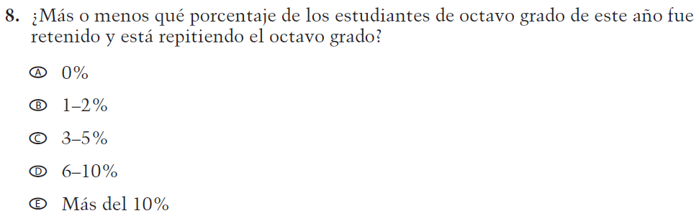  (2021 Operational Grade 8 School Core – Puerto Rico) | VH319391  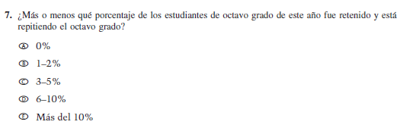  Issue: School Climate | NC | N/A
VH318293  (2021 Operational Grade 8 School Core – Puerto Rico) | VH318293  Issue: School Climate | NC | N/A
VH318294  (2021 Operational Grade 8 School Core – Puerto Rico) | VH318294  Issue: School Climate | NC | N/A

2022 Operational Grade 8 Core School – Puerto Rico
Previous item | 2022 item |  |  | D/A/R/NC+ |  | Rationale
VH318297  (2021 Operational Grade 8 School Core – Puerto Rico) | VH318297  Issue: School Climate |  |  | NC |  | N/A
VH318299  (2021 Operational Grade 8 School Core – Puerto Rico) | VH318299  Issue: Socioeconomic Status |  |  | NC |  | N/A
VH318300  (2021 Operational Grade 8 School Core – Puerto Rico) | VH318300  Issue: Socioeconomic Status |  |  | NC |  | N/A
VH318303  (2021 Operational Grade 8 School Core – Puerto Rico) | VH318303  Issue: Socioeconomic Status |  |  | NC |  | N/A
2022 Operational Grade 8 Core School – Puerto Rico
Previous item | 2022 item |  |  | D/A/R/NC+ | Rationale
VH318304  (2021 Operational Grade 8 School Core – Puerto Rico) | VH318304  Issue: Socioeconomic Status |  |  | NC | N/A
VH318306  (2021 Operational Grade 8 School Core – Puerto Rico) | VH318306  Issue: School Climate |  |  | NC | N/A
VH318316  (2021 Operational Grade 8 School Core – Puerto Rico) | VH318316  Issue: School Climate |  |  | NC | N/A
2022 Operational Grade 8 Core School – Puerto Rico
Previous item |  | 2022 item |  | D/A/R/NC+ | Rationale
VH318317  (2021 Operational Grade 8 School Core – Puerto Rico) |  | VH318317  Issue: School Climate |  | NC | N/A
VH318321  (2021 Operational Grade 8 School Core – Puerto Rico) |  | VH318321  Issue: School Climate |  | NC | N/A
2022 Operational Grade 8 Core School – Puerto Rico
Previous item |  |  | 2022 item | D/A/R/NC+ | Rationale
VH835853  (2021 Operational Grade 8 School Core – Puerto Rico) |  |  | VH835853  Issue: School Climate | NC | N/A
VH893347  (2021 Operational Grade 8 School Core – Puerto Rico) |  |  | VH893347  Issue: Technology Use | NC | N/A
VH579614  (2021 Operational Grade 8 School Core – Puerto Rico) |  |  | VH579614  Issue: Technology Use | NC | N/A

2022 Operational Grade 8 Core School – Puerto Rico
Previous item | 2022 item |  |  | D/A/R/NC+ |  | Rationale
VH893348  (2021 Operational Grade 8 School Core – Puerto Rico) | VH893348  Issue: Technology Use |  |  | NC |  | N/A
VH579616  (2021 Operational Grade 8 School Core – Puerto Rico) | VH579616  Issue: Technology Use |  |  | NC |  | N/A
VH579617  (2021 Operational Grade 8 School Core – Puerto Rico) | VH579617  Issue: Technology Use |  |  | NC |  | N/A
2022 Operational Grade 8 Core School – Puerto Rico
Previous item |  | 2022 item | D/A/R/NC+ |  | Rationale
VH893351  (2021 Operational Grade 8 School Core – Puerto Rico) |  | VH893351  Issue: Technology Use | NC |  | N/A
VH579619  (2021 Operational Grade 8 School Core – Puerto Rico) |  | VH579619  Issue: Technology Use | NC |  | N/A
VH579620  (2021 Operational Grade 8 School Core – Puerto Rico) |  | VH579620  Issue: Technology Use | NC |  | N/A

2022 Operational Grade 8 Core School – Puerto Rico
Previous item | 2022 item | D/A/R/NC+ | Rationale
VH893352  (2021 Operational Grade 8 School Core – Puerto Rico) | VH893352  Issue: Technology Use | NC | N/A
VH579601  (2021 Operational Grade 8 School Core – Puerto Rico) | VH579601  Issue: Technology Use | NC | N/A

Appendix J-3b-s-PR: Operational Grade 8 CORE

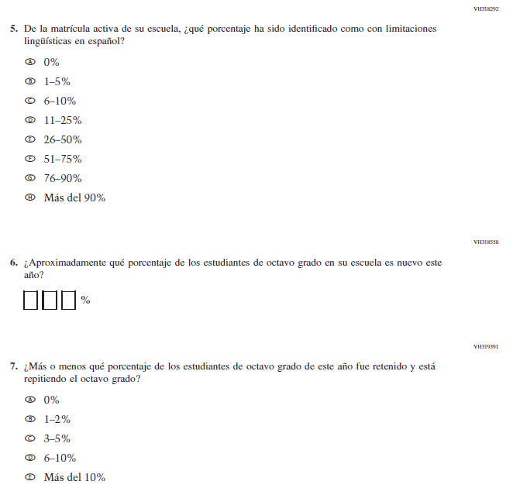

Appendix J-3c-s-PR: Summary of Changes Operational Grade 4 Mathematics
2022 Operational Grade 4 Mathematics School – Puerto Rico
Previous item | 2022 item | D/A/R/NC+ | Rationale
VH579623  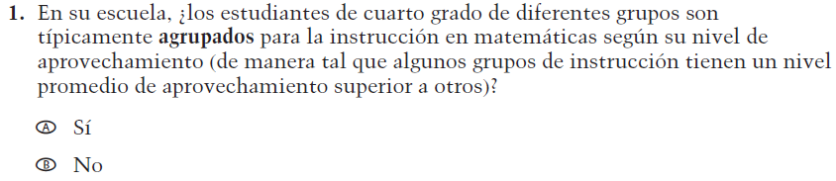  (2021 Operational Grade 4 School Mathematics – Puerto Rico) | VH579623  Issue: Resources for Learning and Instruction | NC | N/A
VH857365  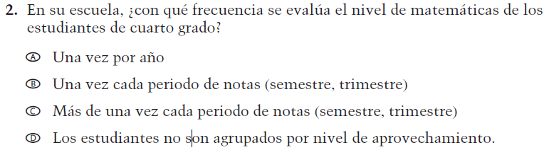  (2021 Operational Grade 4 School Mathematics – Puerto Rico) | VH857365  Issue: Organization of Instruction | NC | N/A
VH579648  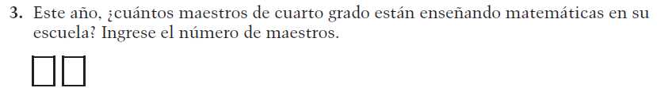  (2021 Operational Grade 4 School Mathematics – Puerto Rico) | VH579648  Issue: Resources for Learning and Instruction | N/C | N/A
VH318441  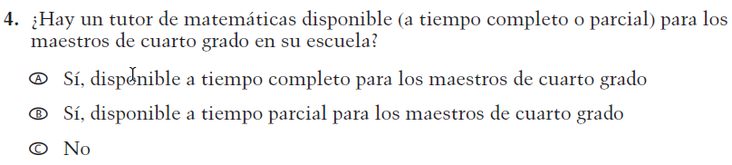  (2021 Operational Grade 4 School Mathematics – Puerto Rico) | VH318441  Issue: Resources for Learning and Instruction | NC | N/A

2022 Operational Grade 4 Mathematics School – Puerto Rico
Previous item | 2022 item | D/A/R/NC+ | Rationale
VH318442  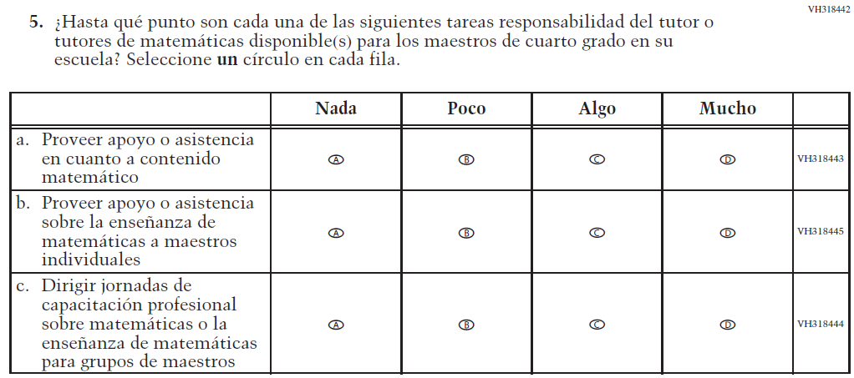  (2021 Operational Grade 4 School Mathematics – Puerto Rico) | VH318442  Issue: Resources for Learning and Instruction | NC | N/A
VH318425  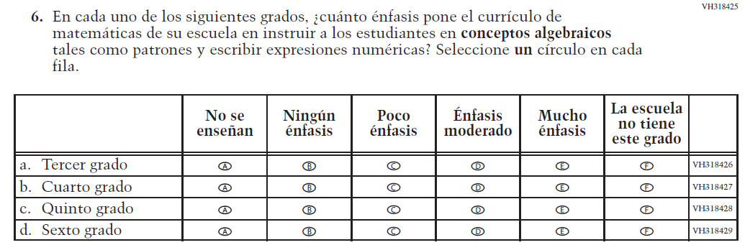  (2021 Operational Grade 4 School Mathematics – Puerto Rico) | VH318425  Issue: Organization of Instruction | NC | N/A
VH318448  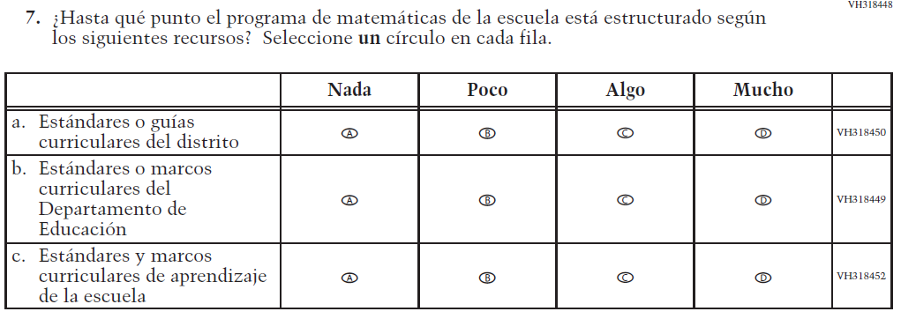  (2021 Operational Grade 4 School Mathematics – Puerto Rico) | VH318448  Issue: Organization of Instruction | NC | N/A

2022 Operational Grade 4 Mathematics School – Puerto Rico
Previous item | 2022 item | D/A/R/NC+ | Rationale
VH318473  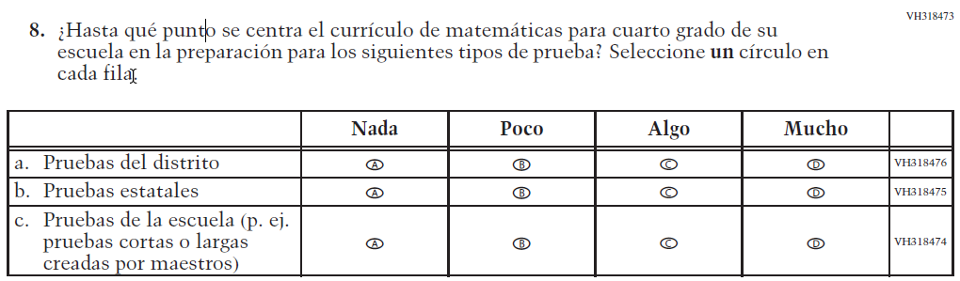  (2021 Operational Grade 4 School Mathematics – Puerto Rico) | VH318473  Issue: Organization of Instruction | NC | N/A
VH579650  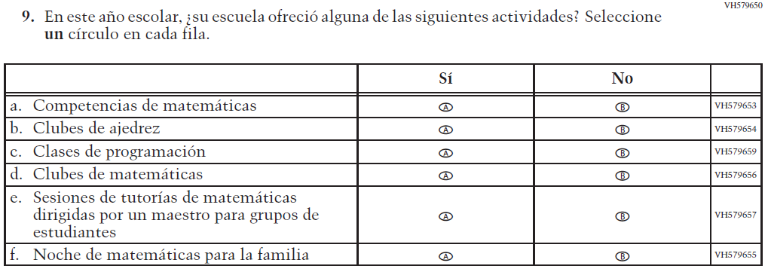  (2021 Operational Grade 4 School Mathematics – Puerto Rico) | VH579650  Issue: Resources for Learning and Instruction | NC | N/A

Appendix J-3c-s-PR: Operational Grade 4 Mathematics
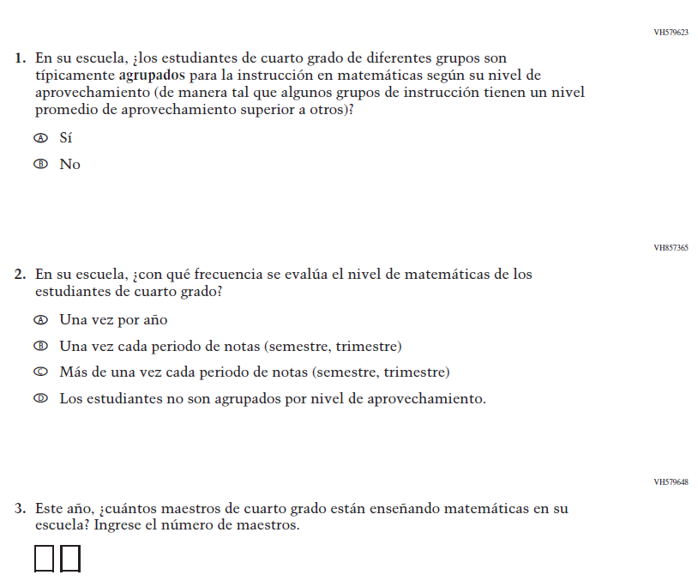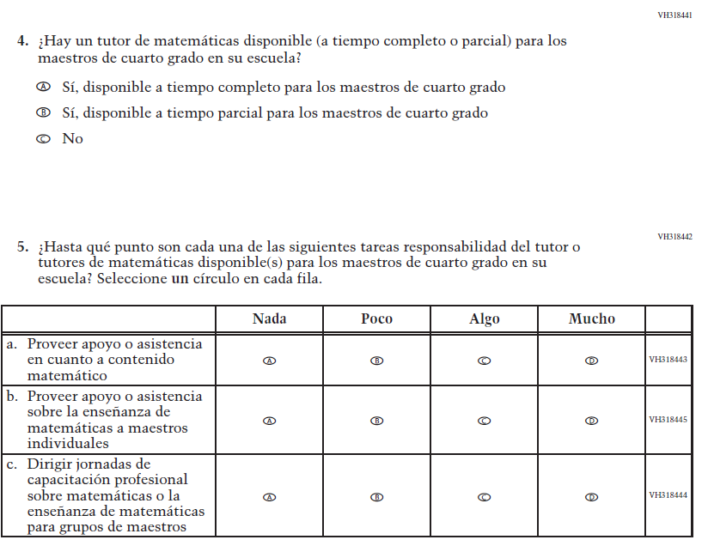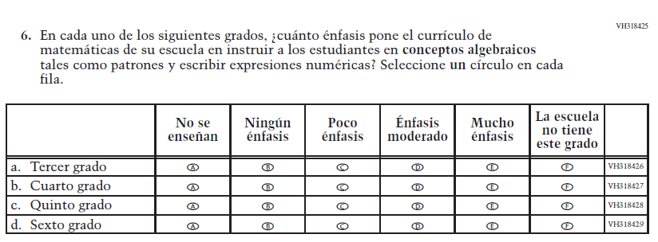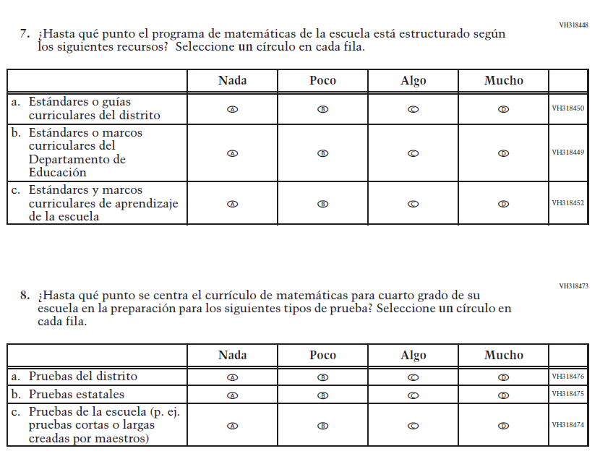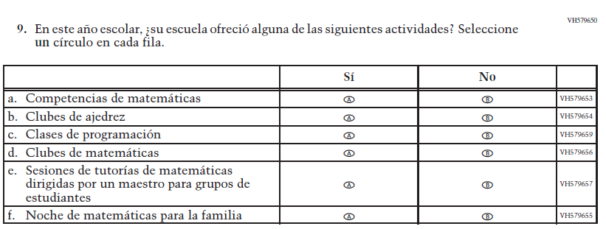

Appendix J-3d-s-PR: Summary of Changes Operational Grade 8 Mathematics
2022 Operational Grade 8 Mathematics School – Puerto Rico
Previous item | 2022 item | D/A/R/NC+ | Rationale
VH610664  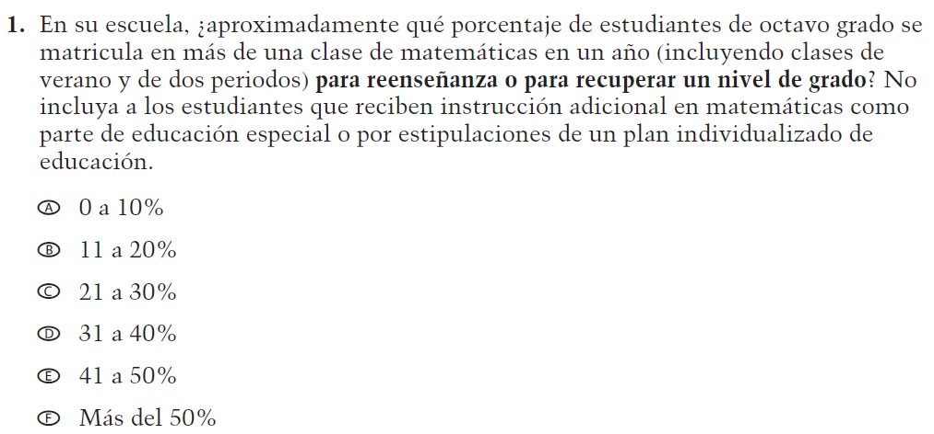  (2021 Operational Grade 8 School Mathematics – Puerto Rico) | VH610664  Issue: Organization of Instruction | NC | N/A
VH610661  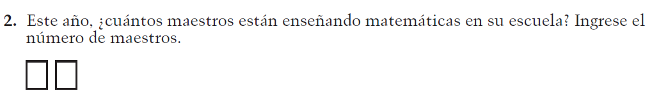  (2021 Operational Grade 8 School Mathematics – Puerto Rico) | VH610661  Issue: Resources for Learning and Instruction | NC | N/A
VH857377  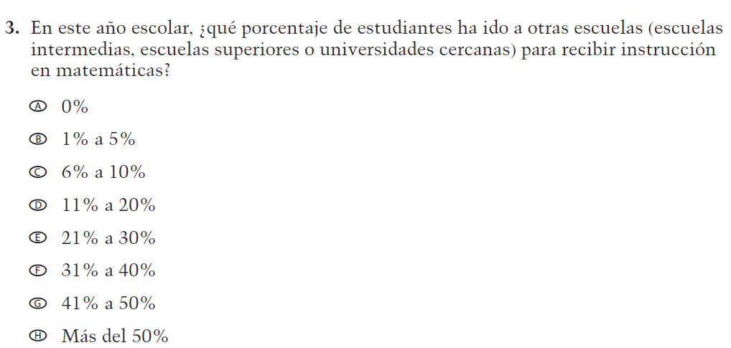  (2021 Operational Grade 8 School Mathematics – Puerto Rico) | VH857377  Issue: Resources for Learning and Instruction | N/C | N/A

2022 Operational Grade 8 Mathematics School – Puerto Rico
Previous item |  | 2022 item |  | D/A/R/NC+ |  | Rationale
VH579683  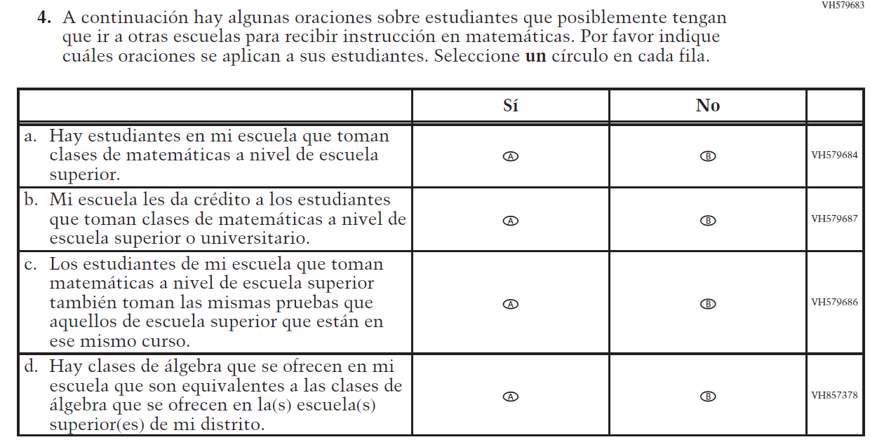  (2021 Operational Grade 8 School Mathematics – Puerto Rico) |  | VH579683  Issue: Resources for Learning and Instruction |  | NC |  | N/A
VH318639  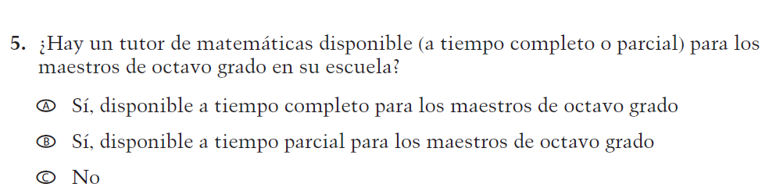  (2021 Operational Grade 8 School Mathematics – Puerto Rico) |  | VH318639  Issue: Resources for Learning and Instruction |  | NC |  | N/A
VH318640  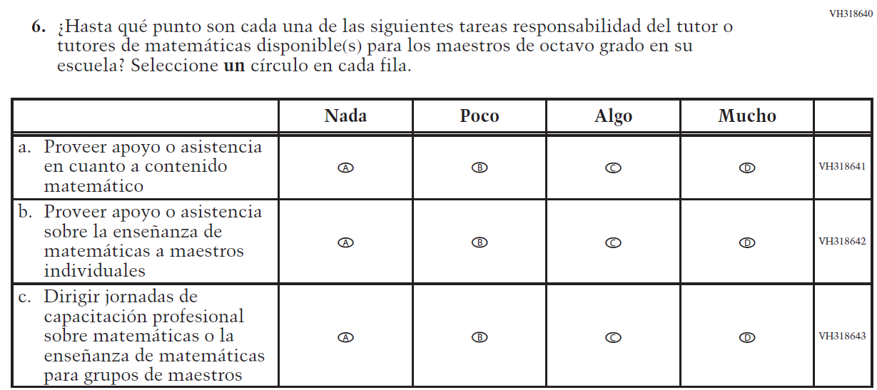  (2021 Operational Grade 8 School Mathematics – Puerto Rico) |  | VH318640  Issue: Resources for Learning and Instruction |  | NC |  | N/A
2022 Operational Grade 8 Mathematics School – Puerto Rico
Previous item | 2022 item |  | D/A/R/NC+ |  | Rationale
VH318448  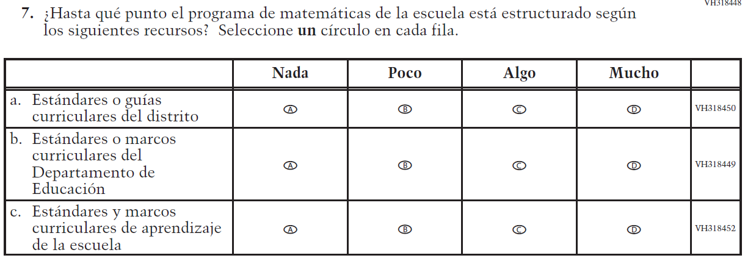  (2021 Operational Grade 8 School Mathematics – Puerto Rico) | VH318448  Issue: Organization of Instruction |  | NC |  | N/A
VH318653  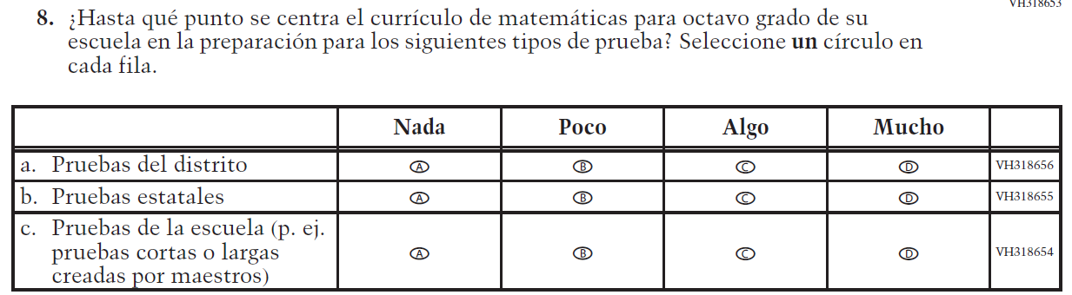  (2021 Operational Grade 8 School Mathematics – Puerto Rico) | VH318653  Issue: Organization of Instruction |  | NC |  | N/A
VH579650  (2021 Operational Grade 8 School Mathematics – Puerto Rico) | VH579650  Issue: Resources for Learning and Instruction |  | NC |  | N/A

Appendix J-3d-s-PR: Operational Grade 8 Mathematics
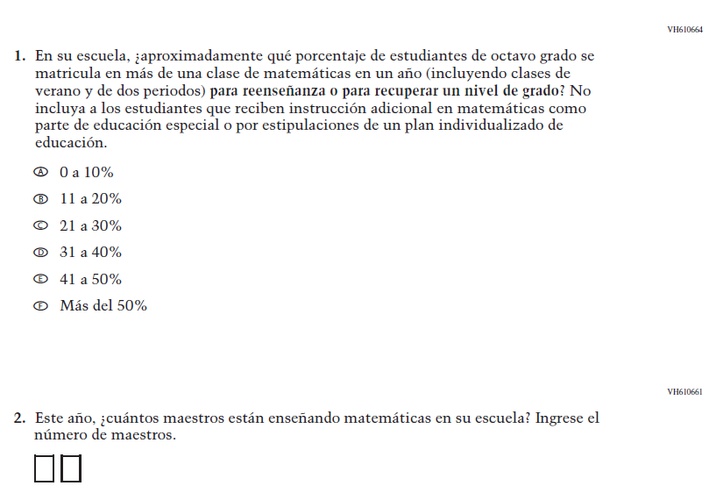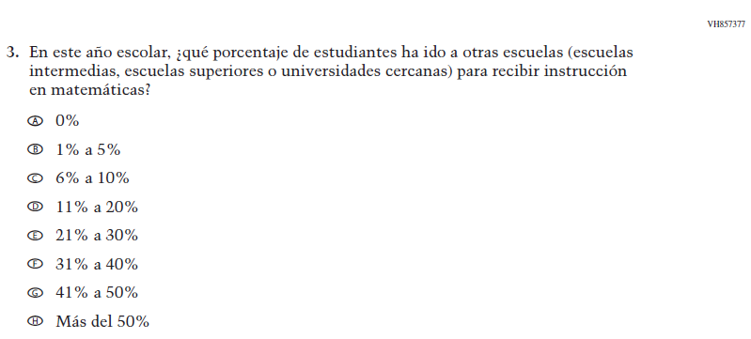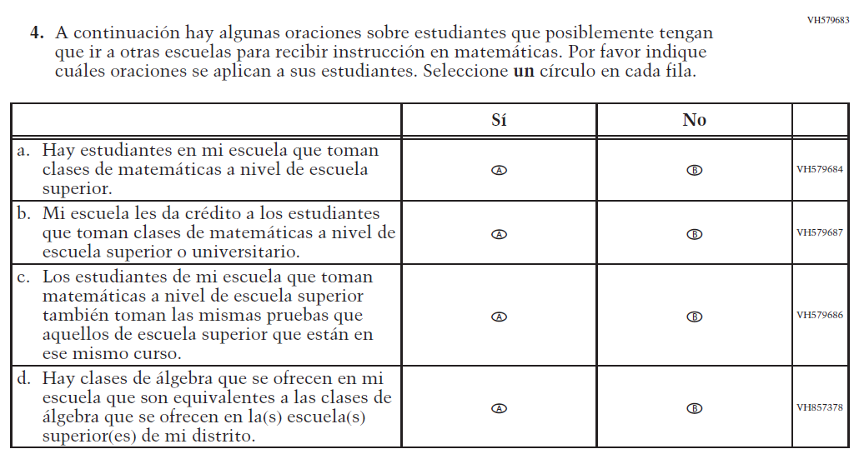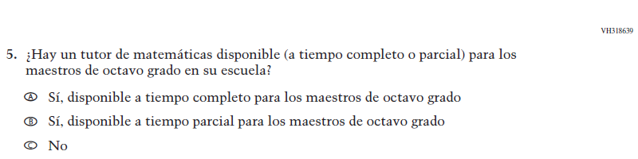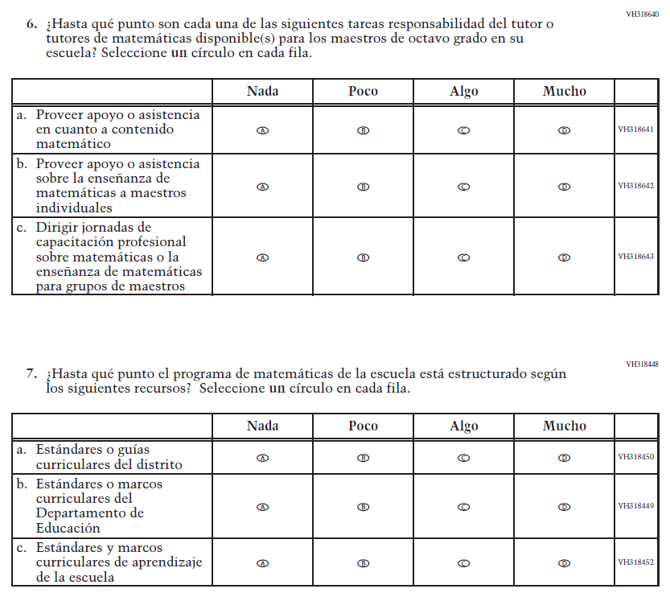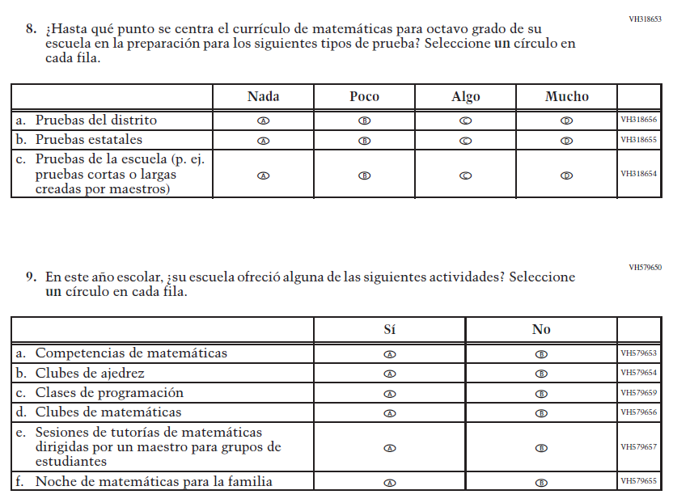

Appendix J-3e-s-PR: Summary of Operational Grade 4 COVID-19
2022 Operational Grade 4 COVID-19 School Items – Puerto Rico
Previous item | 2022 item | D/A/R/NC+ | Rationale
VR267207  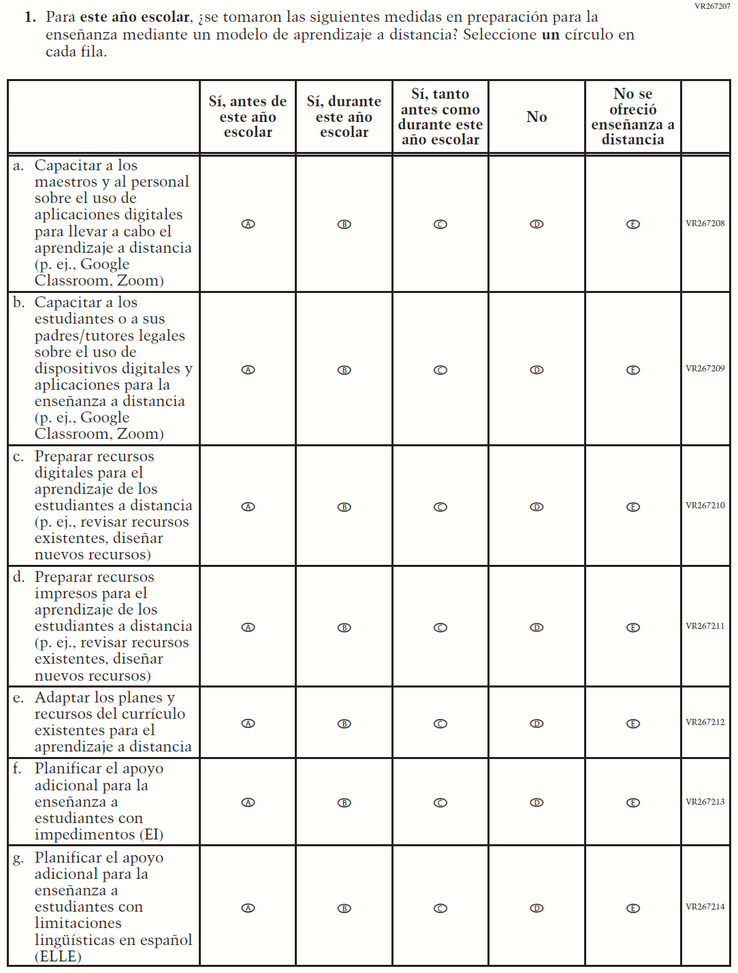  (2021 Operational Grade 4 School COVID-19 – Puerto Rico) | VR267207  Issue: Resources for Learning and Instruction | NC | N/A

2022 Operational Grade 4 COVID-19 School Items – Puerto Rico
Previous item | 2022 item | D/A/R/NC+ | Rationale
VR268834  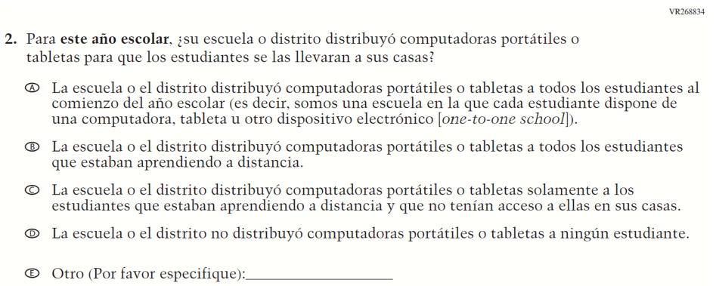  (2021 Operational Grade 4 School COVID-19 – Puerto Rico) | VR268834  Issue: Technology Use and Access | NC | N/A
VR268836  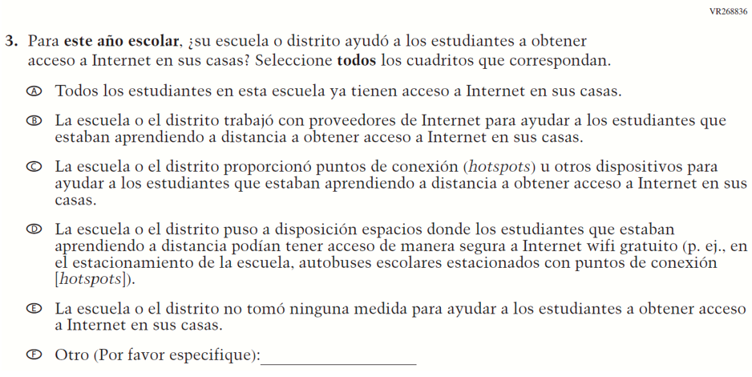  (2021 Operational Grade 4 School COVID-19 – Puerto Rico) | VR268836  Issue: Technology Use and Access | NC | N/A

2022 Operational Grade 4 COVID-19 School Items – Puerto Rico
Previous item | 2022 item | D/A/R/NC+ | Rationale
VR267226  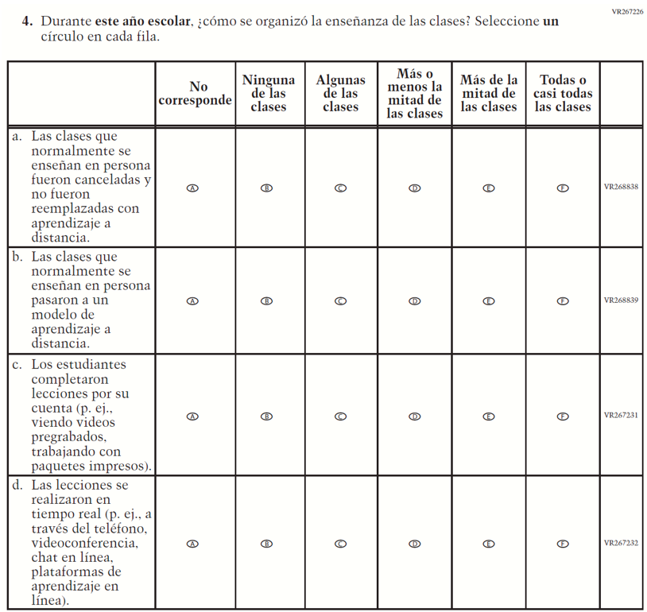  (2021 Operational Grade 4 School COVID-19 – Puerto Rico) | VR267226  Issue: Organization of Instruction | NC | N/A

2022 Operational Grade 4 COVID-19 School Items – Puerto Rico
Previous item | 2022 item | D/A/R/NC+ | Rationale
VR267234  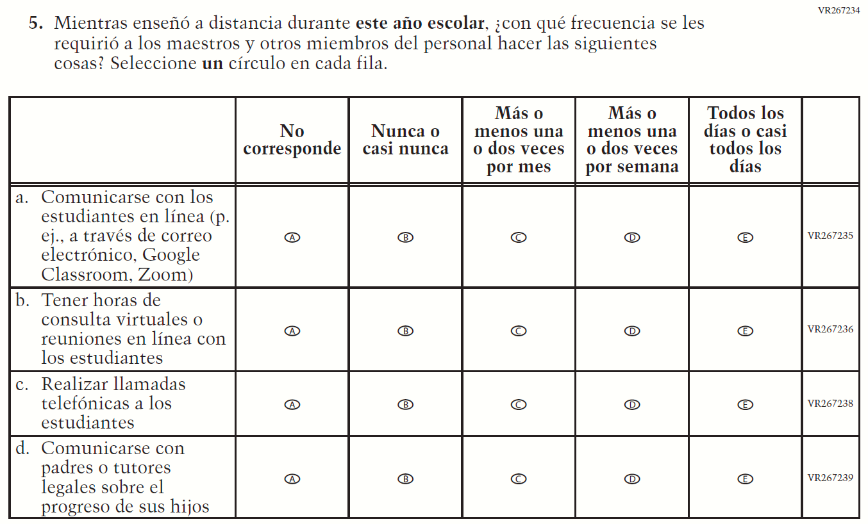  (2021 Operational Grade 4 School COVID-19 – Puerto Rico) | VR267234  Issue: Resources for Learning and Instruction | NC | N/A
VR242117  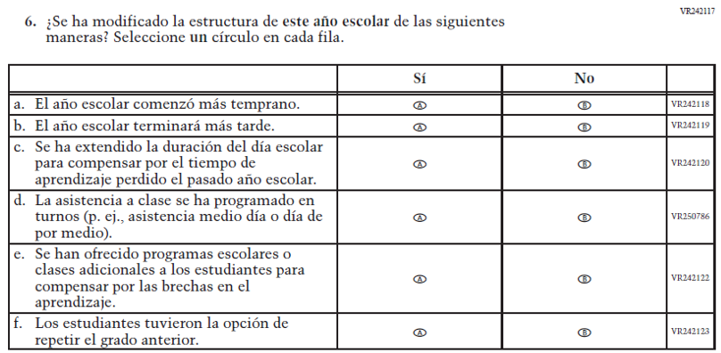  (2021 Operational Grade 4 School COVID-19 – Puerto Rico) | VR242117  Issue: Organization of Instruction | NC | N/A

2022 Operational Grade 4 COVID-19 School Items – Puerto Rico
Previous item |  | 2022 item |  | D/A/R/NC+ |  | Rationale
VR242051  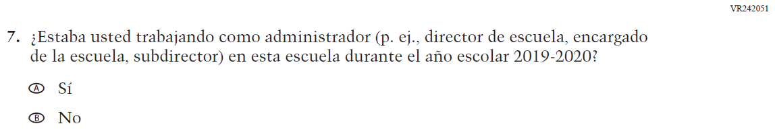  (2021 Operational Grade 4 School COVID-19 – Puerto Rico) |  | VR242051  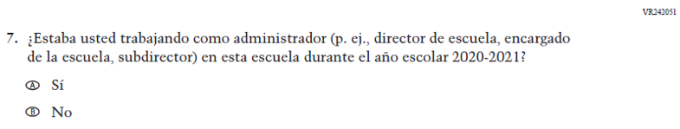  Issue: Organization of Instruction |  | R |  | This item has been updated to reference the correct academic year for the 2022 administration.
VR242090  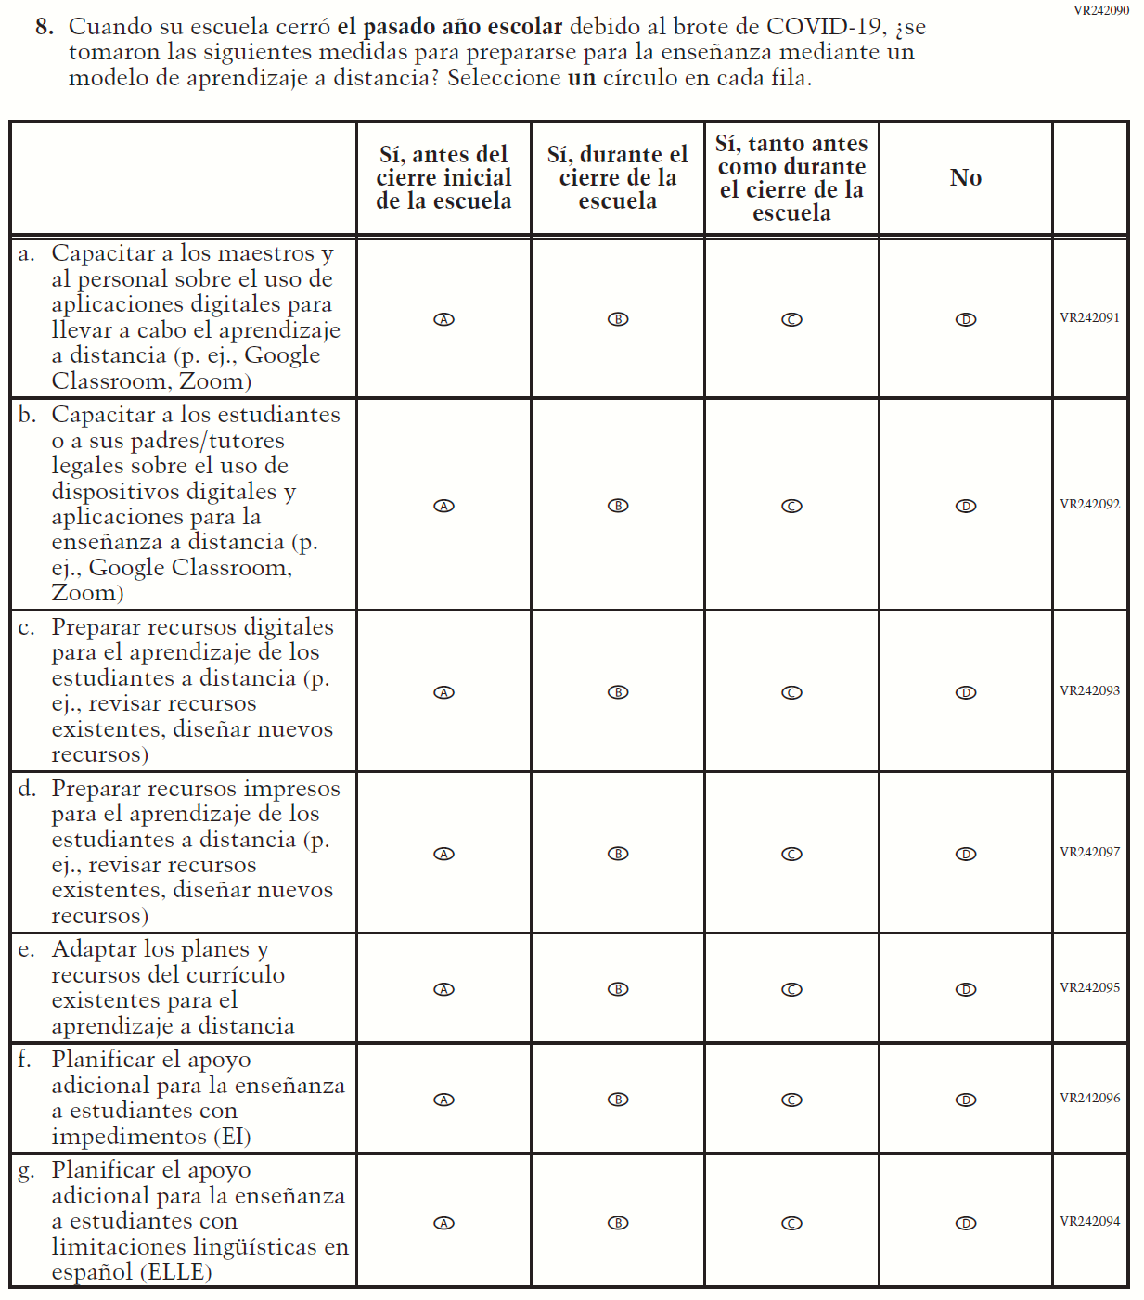  (2021 Operational Grade 4 School COVID-19 – Puerto Rico) |  | VR385749  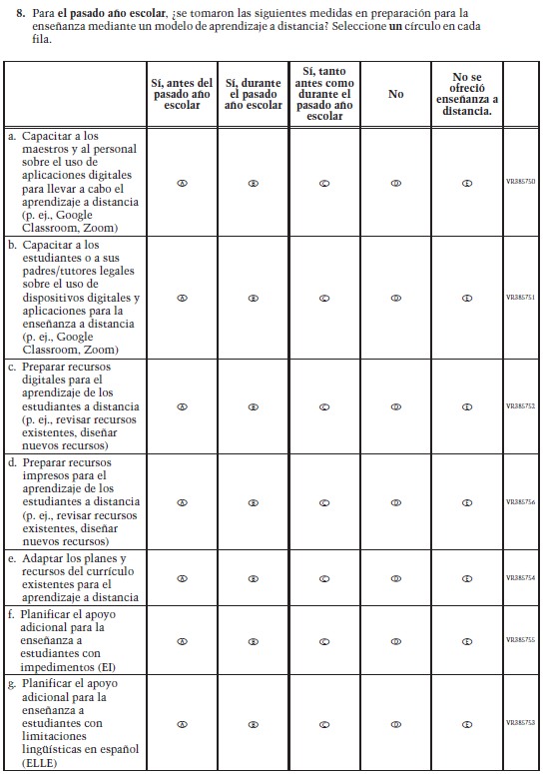  Issue: Resources for Learning and Instruction |  | R |  | The stem of this item was revised from "when your school was closed last school year" to "for last school year" to remove references to school closures. The last response option (i.e. “Distance learning was not offered.”) was also added.
2022 Operational Grade 4 COVID-19 School Items – Puerto Rico
Previous item | 2022 item |  | D/A/R/NC+ |  | Rationale
VR242112  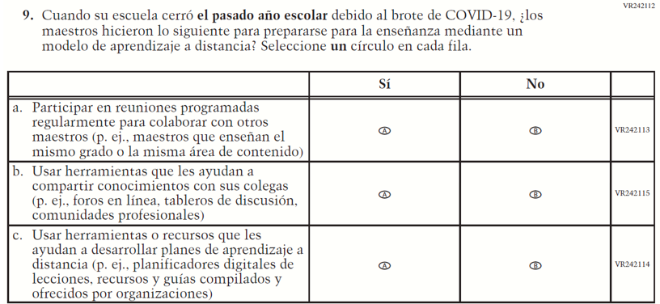  (2021 Operational Grade 4 School COVID-19 – Puerto Rico) | N/A |  | D |  | This item was dropped.
VR242068  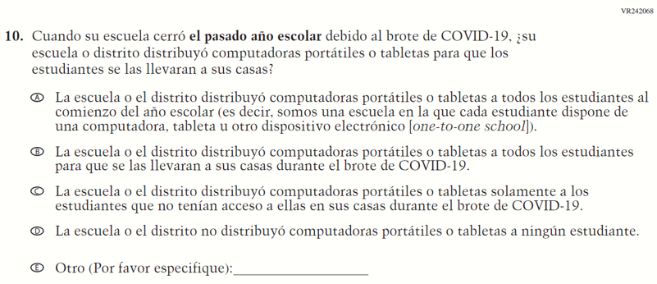  (2021 Operational Grade 4 School COVID-19 – Puerto Rico) | VR385757  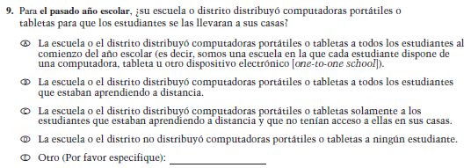  Issue: Technology Use and Access |  | R |  | The stem of this item was revised from "when your school was closed last school year" to "for last school year" to remove references to school closures.

2022 Operational Grade 4 COVID-19 School Items – Puerto Rico
Previous item | 2022 item | D/A/R/NC+ | Rationale
VR242086  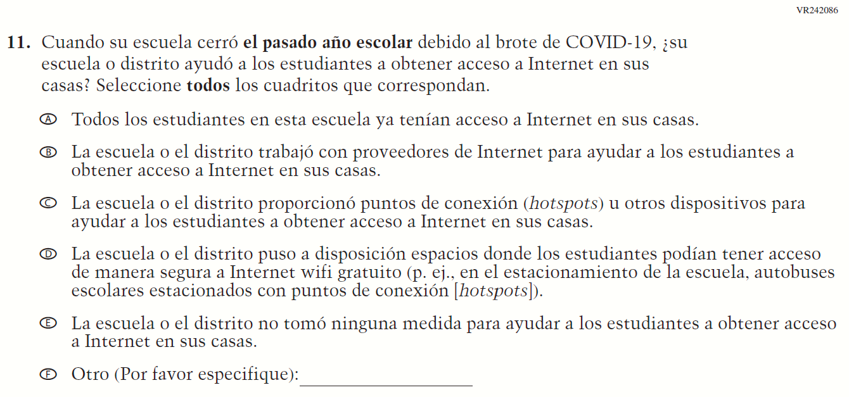  (2021 Operational Grade 4 School COVID-19 – Puerto Rico) | VR385758  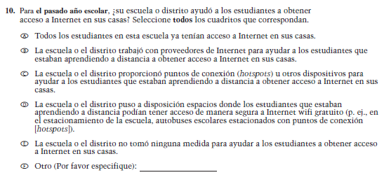  Issue: Technology Use and Access | R | The stem of this item was revised from "when your school was closed last school year" to "for last school year" to remove references to school closures.

2022 Operational Grade 4 COVID-19 School Items – Puerto Rico
Previous item | 2022 item | D/A/R/NC+ | Rationale
VR242126  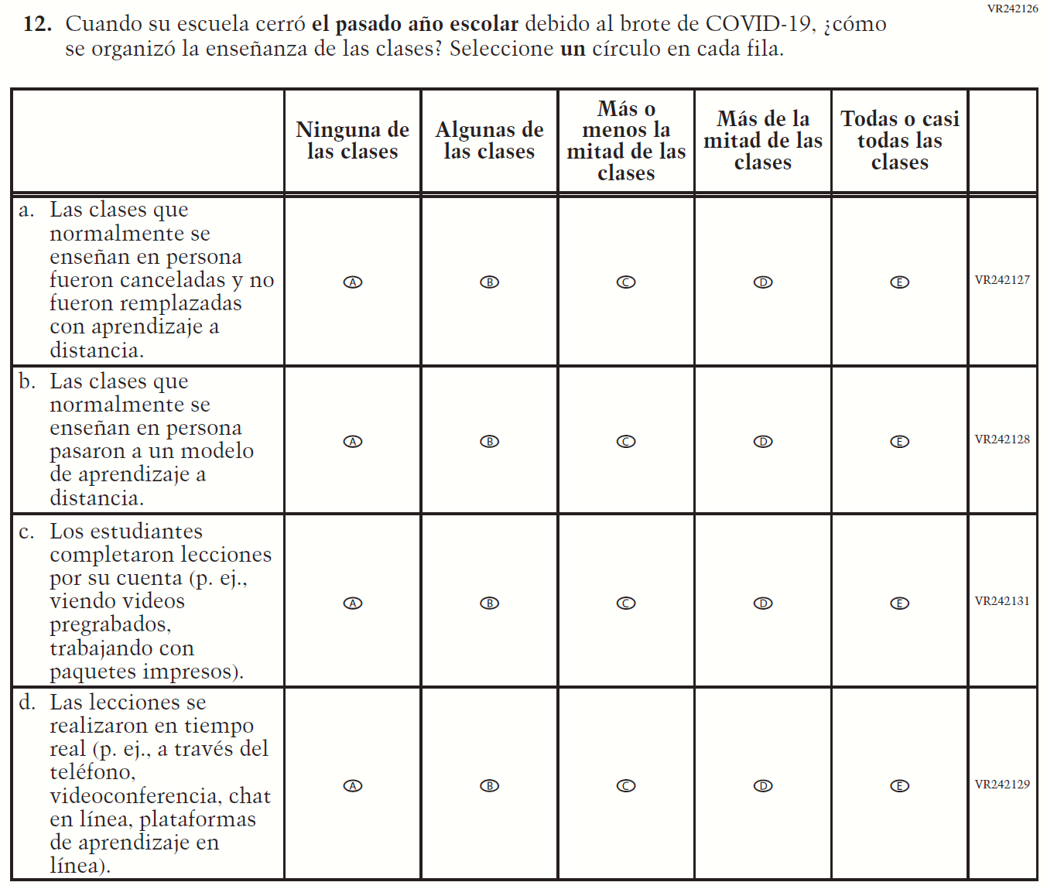  (2021 Operational Grade 4 School COVID-19 – Puerto Rico) | VR385760  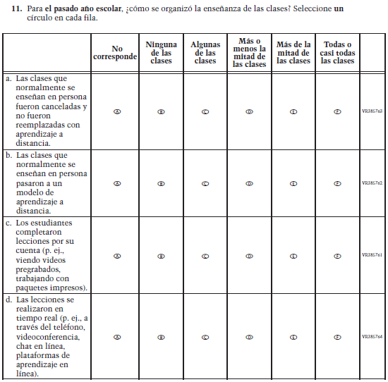  Issue: Organization of Instruction | R | The stem of this item was revised from "when your school was closed last school year" to "for last school year" to remove references to school closures.  The first response option (i.e. “Not applicable”) was added.

2022 Operational Grade 4 COVID-19 School Items – Puerto Rico
Previous item | 2022 item | D/A/R/NC+ | Rationale
VR242105  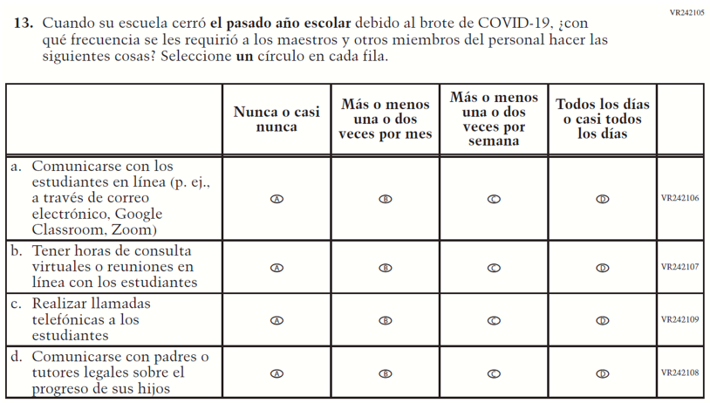  (2021 Operational Grade 4 School COVID-19 – Puerto Rico) | VR385765  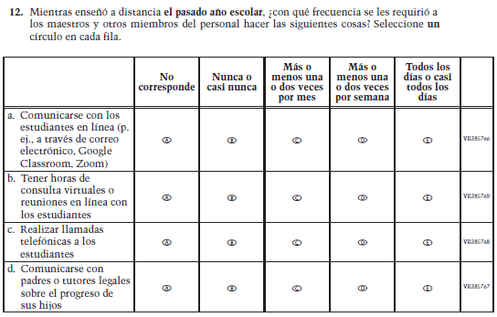  Issue: Resources for Learning and Instruction | R | The stem of this item was revised from "when your school was closed last school year" to "for last school year" to remove references to school closures. The first response option (i.e. “Not applicable”) was added.

2022 Operational Grade 4 COVID-19 School Items – Puerto Rico
Previous item | 2022 item | D/A/R/NC+ | Rationale
N/A | VR385770  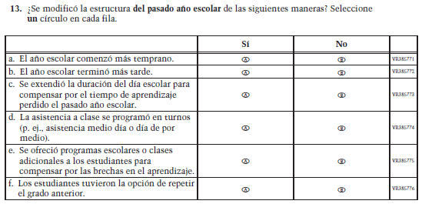  Issue: Organization of Instruction | A | This item is based on Question 6 above and was added to understand school structures in distance learning format. The stem is revised from “has the structure of this school year been modified” to “was the structure of last school year modified”.
VR242088  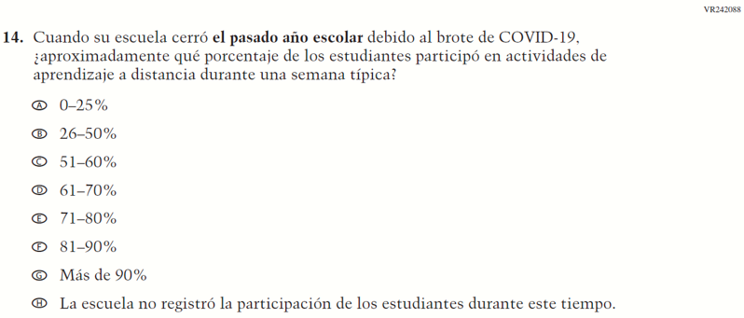  (2021 Operational Grade 4 School COVID-19 – Puerto Rico) | N/A | D | This item was dropped.

Appendix J-3f-s-PR: Operational Grade 4 COVID-19
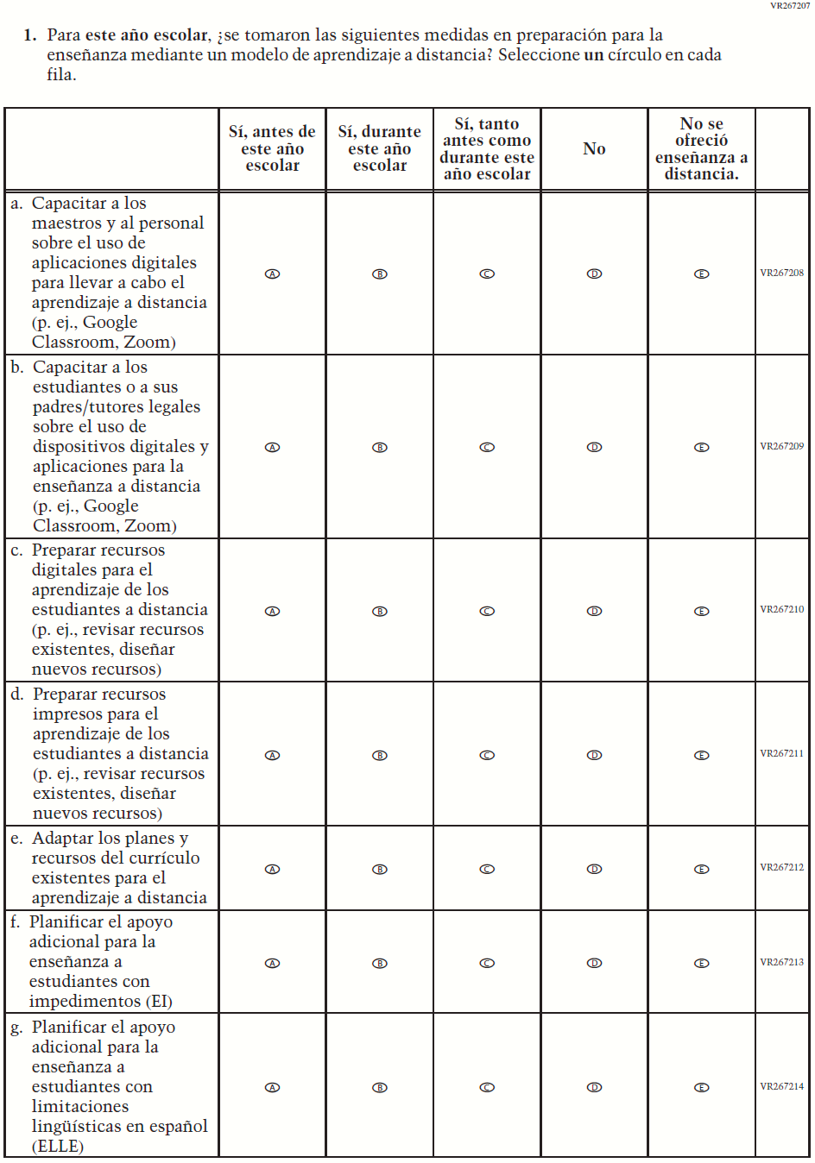
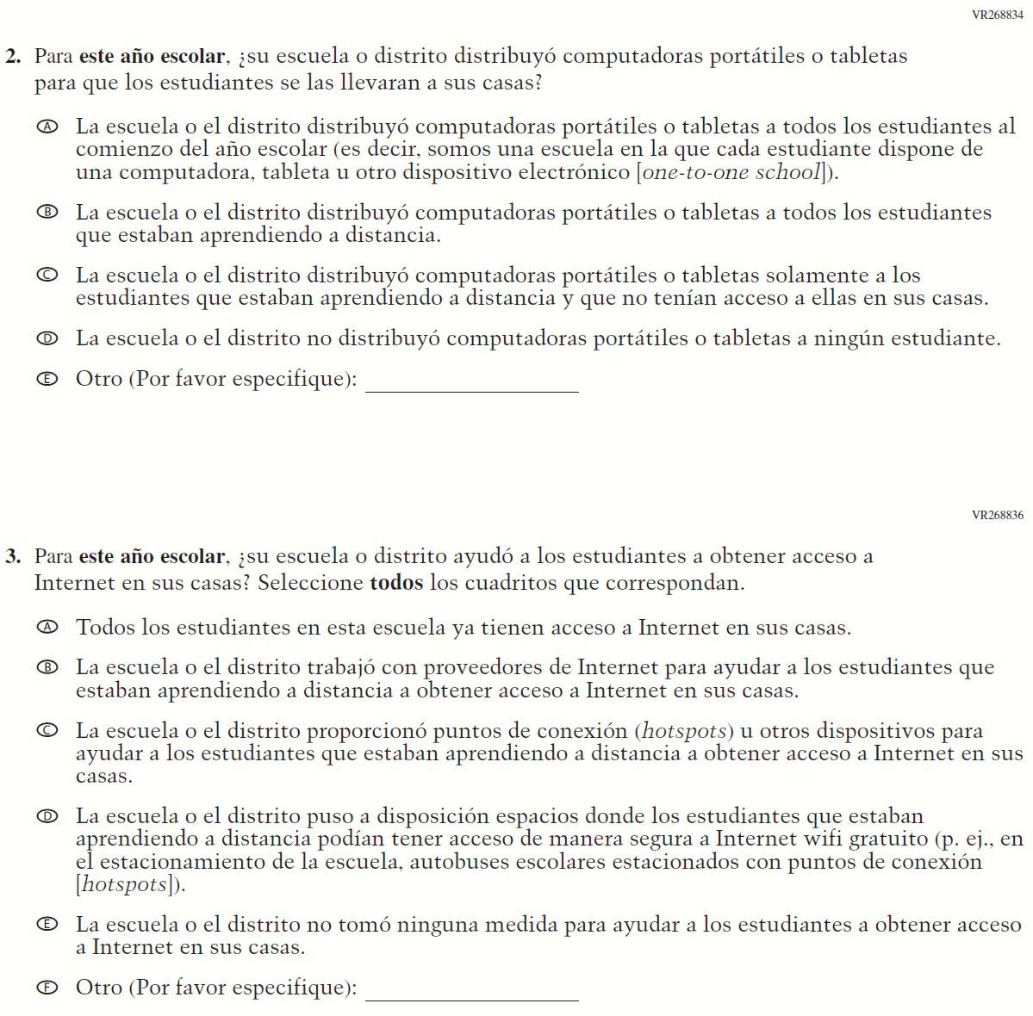

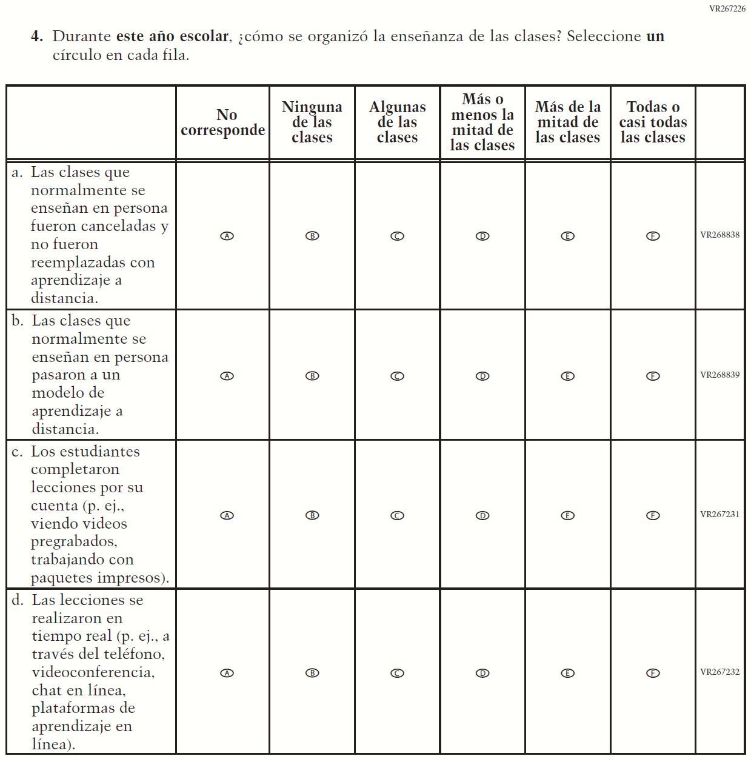

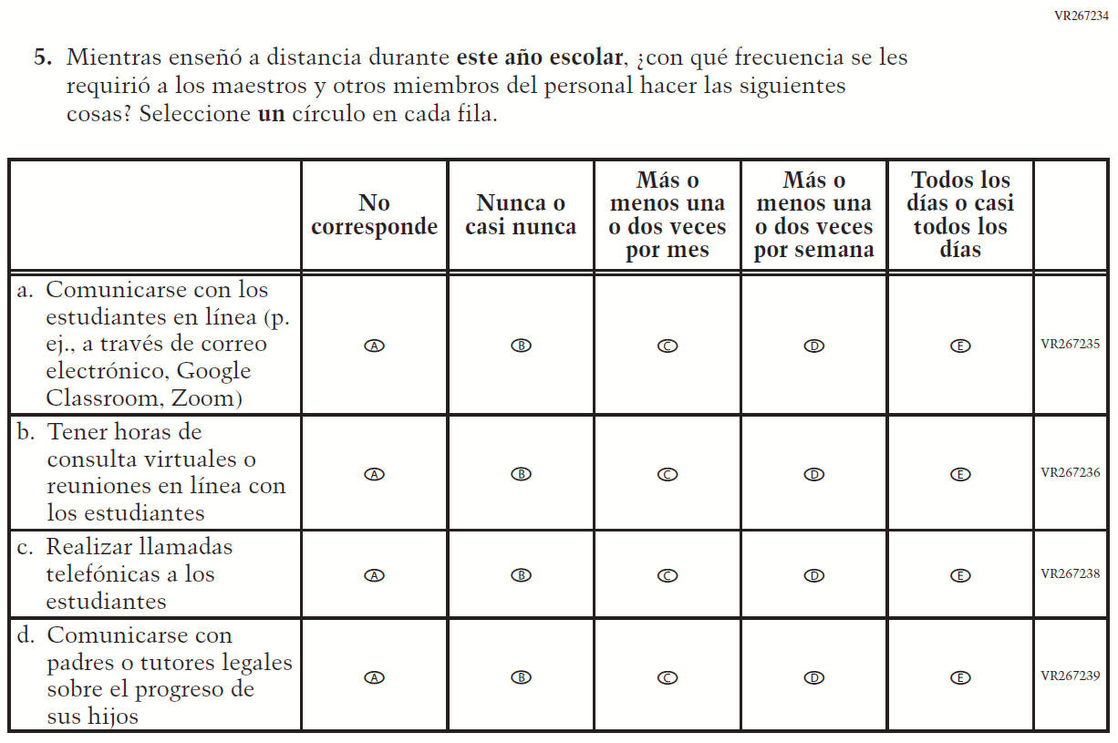

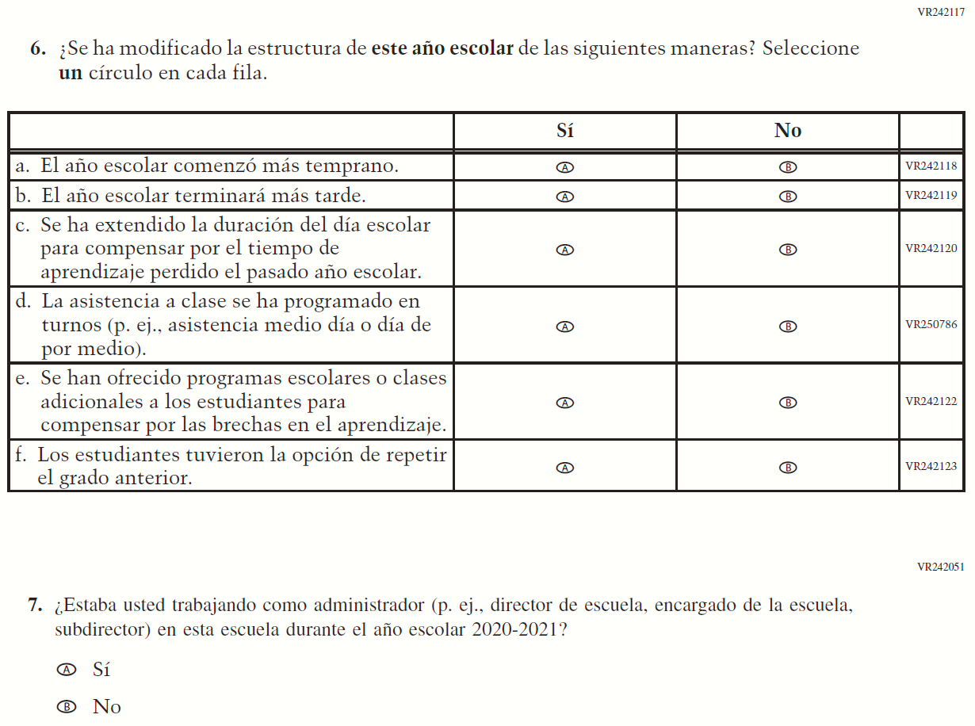

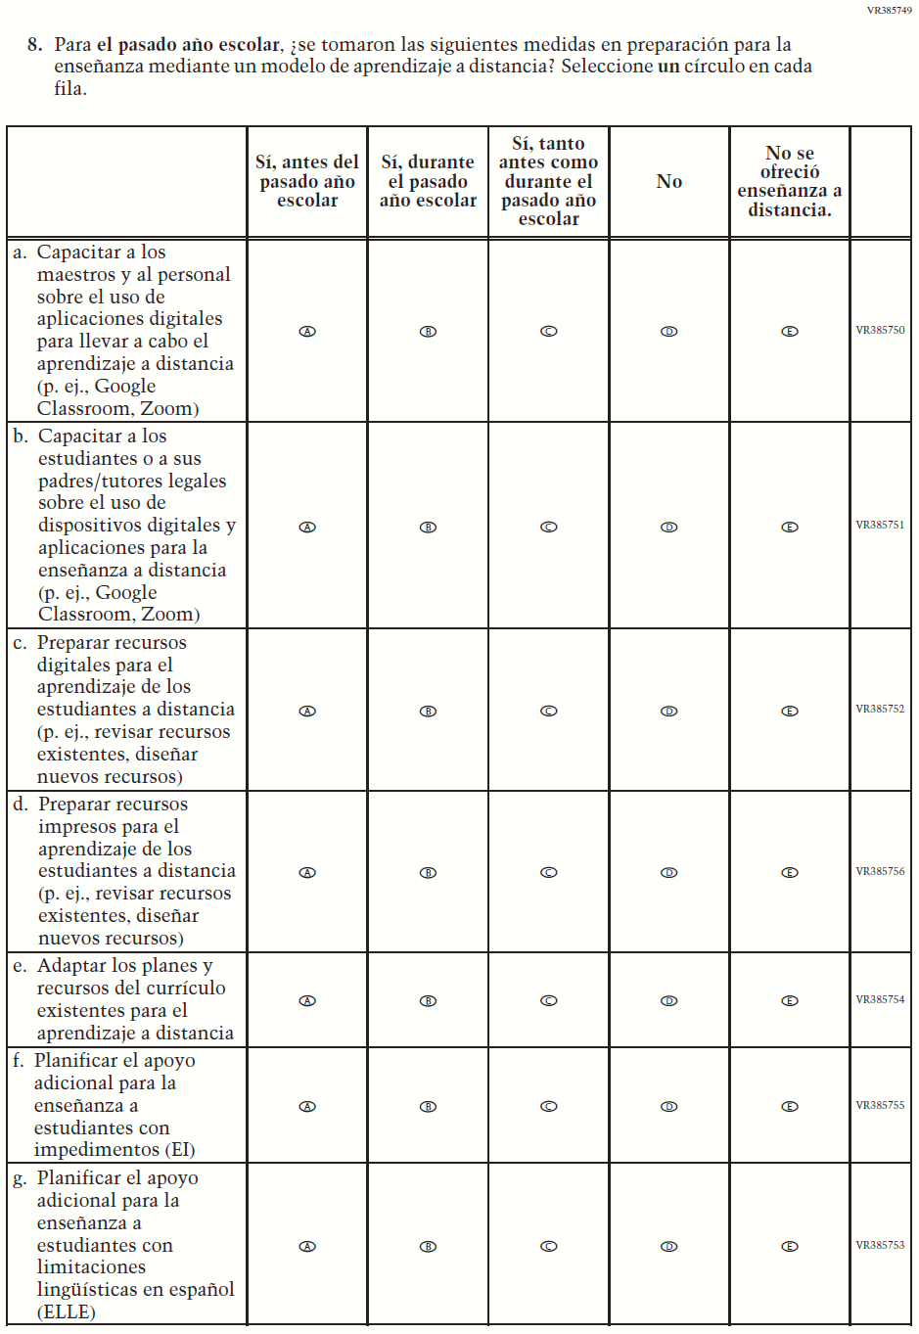
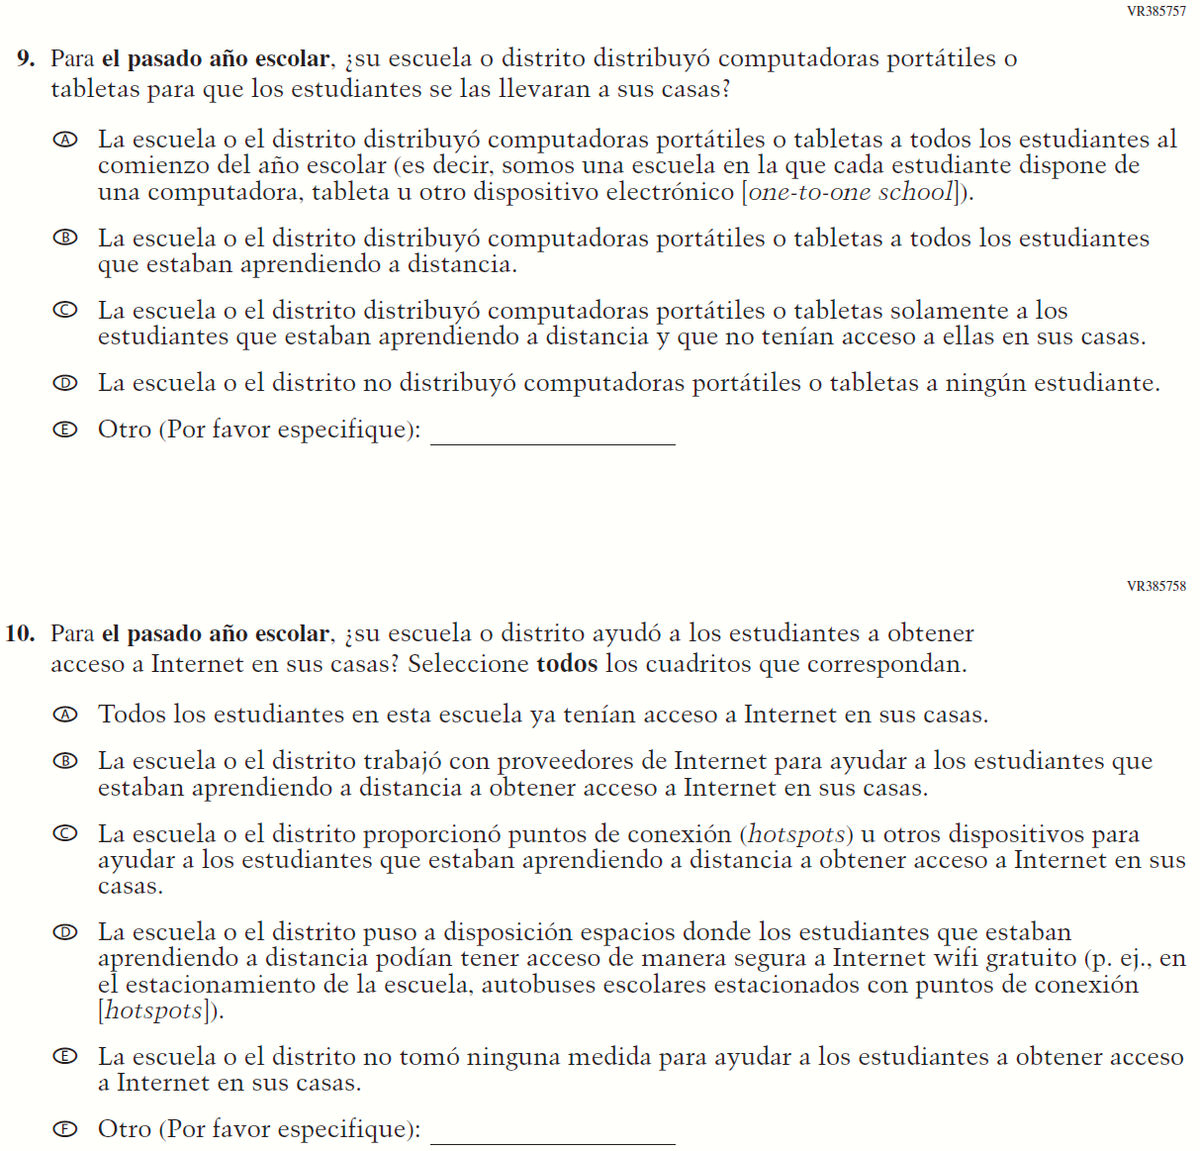

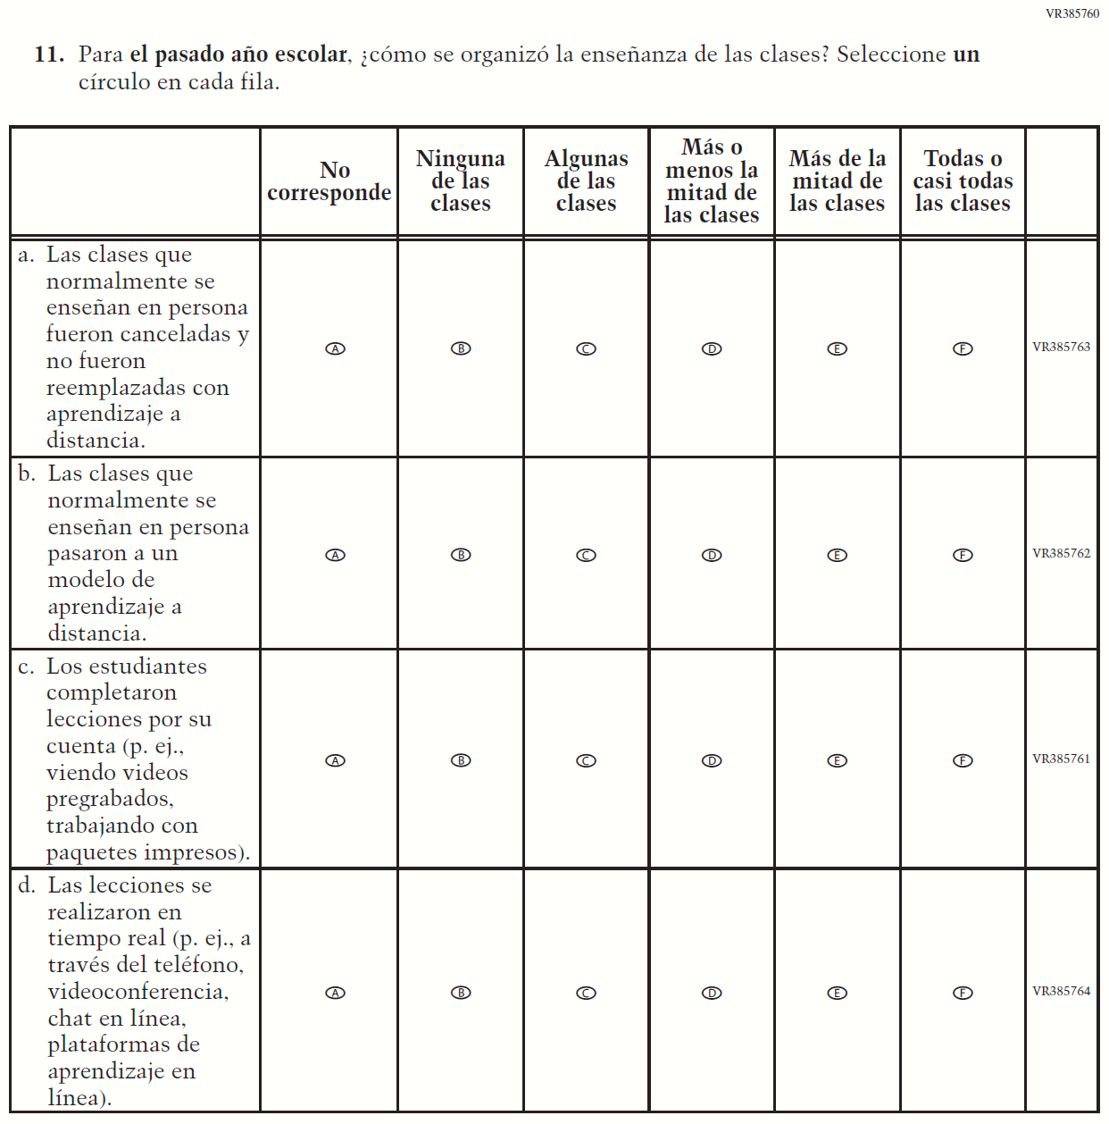

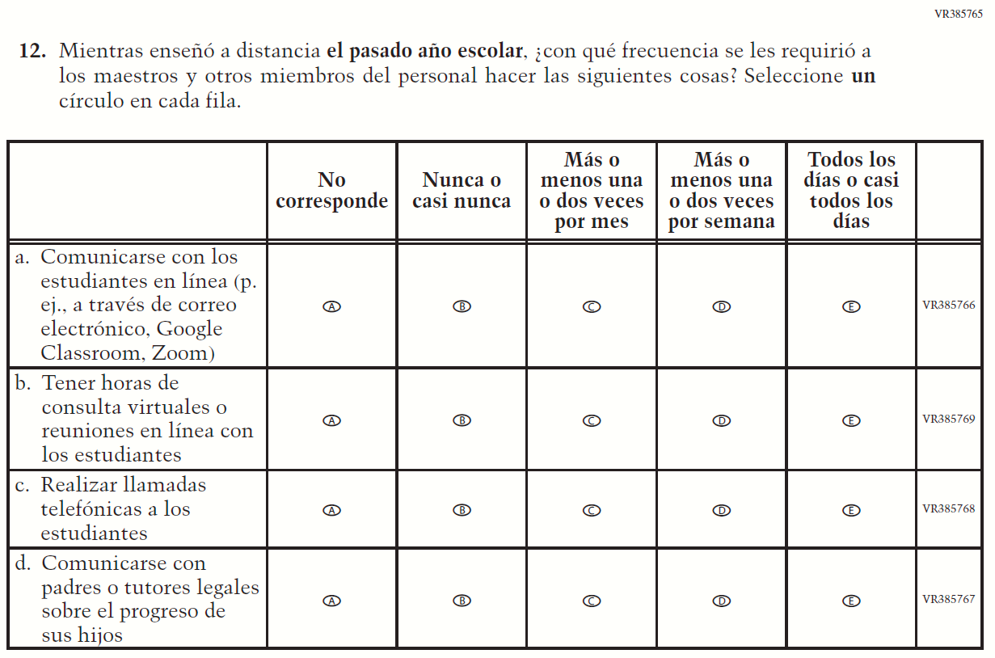

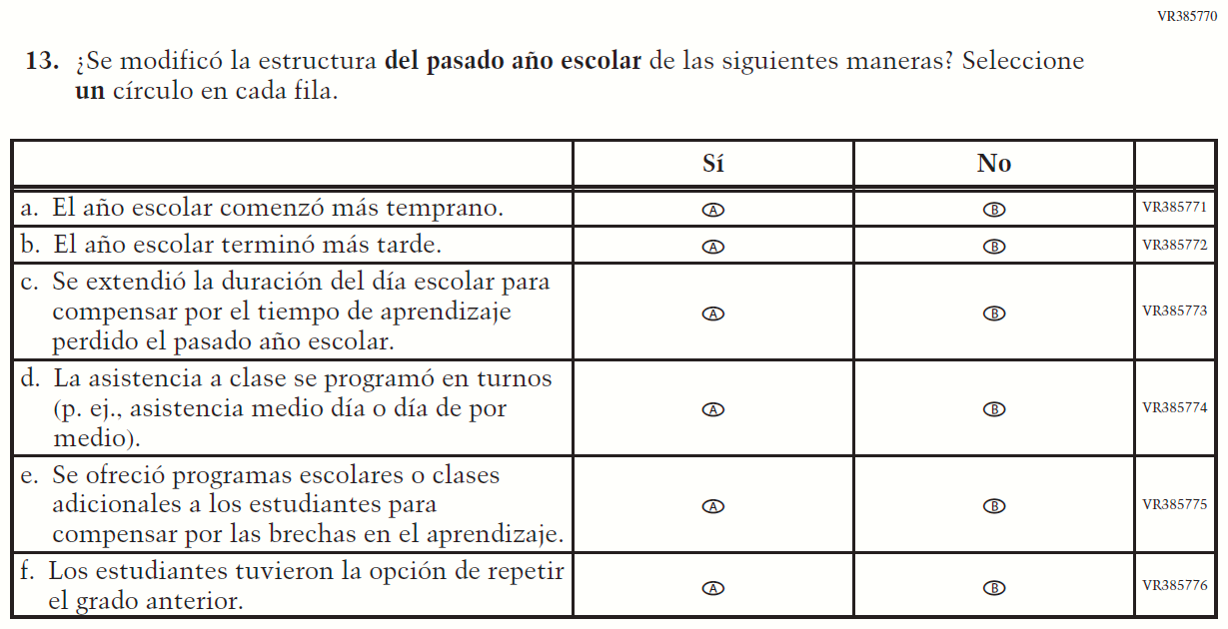

Appendix J-3g-s-PR: Summary of Operational Grade 8 COVID-19
2022 Operational Grade 8 COVID-19 School Items – Puerto Rico
Previous item | 2022 item | D/A/R/NC+ | Rationale
VR267207  (2021 Operational Grade 8 School COVID-19 – Puerto Rico) | VR267207  Issue: Resources for Learning and Instruction | NC | N/A

2022 Operational Grade 8 COVID-19 School Items – Puerto Rico
Previous item | 2022 item | D/A/R/NC+ | Rationale
VR268834  (2021 Operational Grade 8 School COVID-19 – Puerto Rico) | VR268834  Issue: Technology Use and Access | NC | N/A
VR268836  (2021 Operational Grade 8 School COVID-19 – Puerto Rico) | VR268836  Issue: Technology Use and Access | NC | N/A

2022 Operational Grade 8 COVID-19 School Items – Puerto Rico
Previous item | 2022 item | D/A/R/NC+ | Rationale
VR267226  (2021 Operational Grade 8 School COVID-19 – Puerto Rico) | VR267226  Issue: Organization of Instruction | NC | N/A

2022 Operational Grade 8 COVID-19 School Items – Puerto Rico
Previous item | 2022 item | D/A/R/NC+ | Rationale
VR267234  (2021 Operational Grade 8 School COVID-19 – Puerto Rico) | VR267234  Issue: Resources for Learning and Instruction | NC | N/A
VR242117  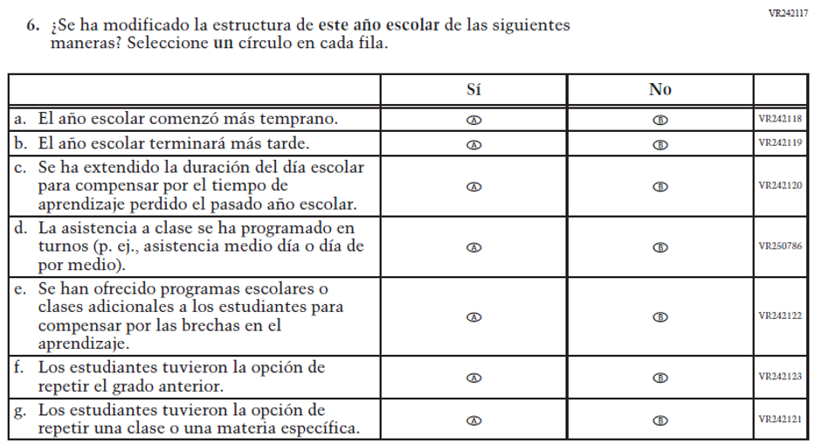  (2021 Operational Grade 8 School COVID-19 – Puerto Rico) | VR242117  Issue: Organization of Instruction | NC | N/A

2022 Operational Grade 8 COVID-19 School Items – Puerto Rico
Previous item |  | 2022 item | D/A/R/NC+ |  | Rationale
VR242051  (2021 Operational Grade 8 School COVID-19 – Puerto Rico) |  | VR242051  Issue: Organization of Instruction | R |  | This item has been updated to reference the correct academic year for the 2022 administration.
VR242090  (2021 Operational Grade 8 School COVID-19 – Puerto Rico) |  | VR385749  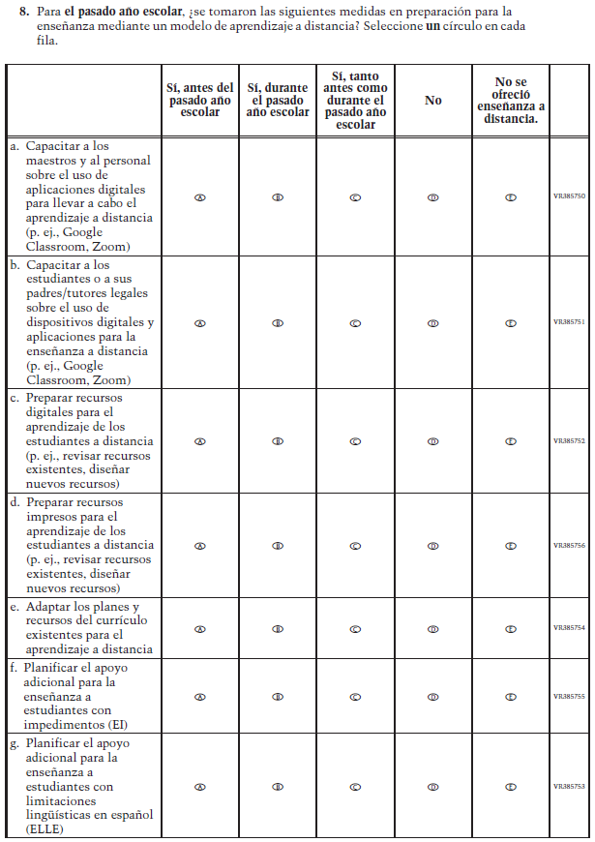  Issue: Resources for Learning and Instruction | R |  | The stem of this item was revised from "when your school was closed last school year" to "for last school year" to remove references to school closures. The last response option (i.e. “Distance learning was not offered.”) was also added.
2022 Operational Grade 8 COVID-19 School Items – Puerto Rico
Previous item | 2022 item |  |  | D/A/R/NC+ |  | Rationale
VR242112  (2021 Operational Grade 8 School COVID-19 – Puerto Rico) | N/A |  |  | D |  | This item was dropped.
VR242068  (2021 Operational Grade 8 School COVID-19 – Puerto Rico) | VR385757  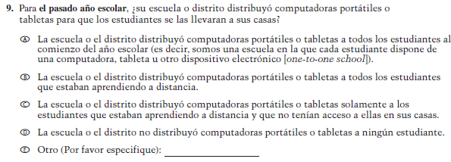  Issue: Technology Use and Access |  |  | R |  | The stem of this item was revised from "when your school was closed last school year" to "for last school year" to remove references to school closures.

2022 Operational Grade 8 COVID-19 School Items – Puerto Rico
Previous item | 2022 item | D/A/R/NC+ | Rationale
VR242086  (2021 Operational Grade 8 School COVID-19 – Puerto Rico) | VR385758  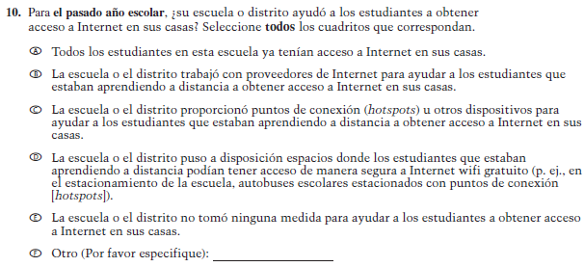  Issue: Technology Use and Access | R | The stem of this item was revised from "when your school was closed last school year" to "for last school year" to remove references to school closures.

2022 Operational Grade 8 COVID-19 School Items – Puerto Rico
Previous item | 2022 item | D/A/R/NC+ | Rationale
VR242126  (2021 Operational Grade 8 School COVID-19 – Puerto Rico) | VR385760  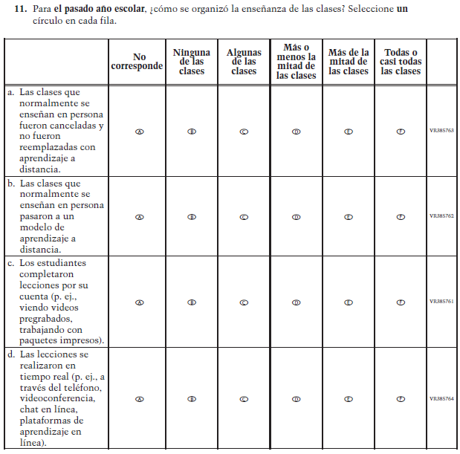  Issue: Organization of Instruction | R | The stem of this item was revised from "when your school was closed last school year" to "for last school year" to remove references to school closures. The first response option (i.e. “Not applicable”) was added.

2022 Operational Grade 8 COVID-19 School Items – Puerto Rico
Previous item | 2022 item | D/A/R/NC+ | Rationale
VR242105  (2021 Operational Grade 8 School COVID-19 – Puerto Rico) | VR385765  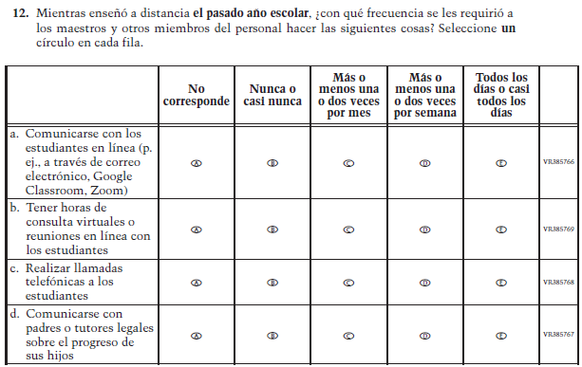  Issue: Resources for Learning and Instruction | R | The stem of this item was revised from "when your school was closed last school year" to "for last school year" to remove references to school closures. The first response option (i.e. “Not applicable”) was added.

2022 Operational Grade 8 COVID-19 School Items – Puerto Rico
Previous item | 2022 item | D/A/R/NC+ | Rationale
N/A | VR385770  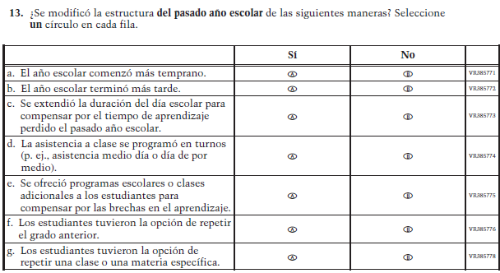  Issue: Organization of Instruction | A | This item is based on Question 6 above and was added to understand school structures in distance learning format. The stem is revised from “has the structure of this school year been modified” to “was the structure of last school year modified”.
VR242088  (2021 Operational Grade 8 School COVID-19 – Puerto Rico) | N/A | D | This item was dropped.

Appendix J-3h-s-PR: Operational Grade 8 COVID-19
