National Center for Education Statistics
National Assessment of Educational Progress

National Assessment of Education Progress (NAEP)
Long-Term Trend (LTT) 2022
Materials Update #2

Appendix D3

Long Term Trend (LTT) 2022 Communications and Recruitment Materials Update #2

OMB# 1850-0928 v.25

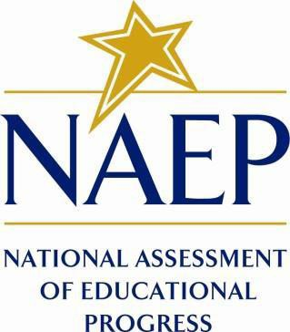

September 2021

Two new Spanish language appendices included in this amendment are marked as “NEW”.
Table of Contents
Appendix D3-1: NAEP 2022 Notification Letters from NAEP State Coordinator to School Principal, LTT (Approved v.23) 3
Appendix D3-2: Assessment Details Letter National State Coordinator to School Coordinator, LTT (Approved v.23) 6
Appendix D3-3: NAEP 2022 Parent Letter, LTT, Public Schools (Approved v.23) 9
Appendix D3-4: NAEP 2022 Parent Letter, LTT, Private Schools (Approved v.23) 11
Appendix D3-5: NAEP 2022 School Coordinator Responsibilities, A Guide to MyNAEP, LTT, Public Schools (Approved v.23) 14
Appendix D3-6: NAEP 2022 School Coordinator Responsibilities, A Guide to MyNAEP, LTT, Private schools (Approved v.23) 19
Appendix D3-7: NAEP 2022 In Your School, LTT, Public Schools (Approved v.23) 24
Appendix D3-8: NAEP 2022 In Your School, LTT, Private Schools (Approved v.23) 29
Appendix D3-9: NAEP 2022 Spanish Parent Letter, LTT, Public Schools (NEW) 33
Appendix D3-10: NAEP 2022 Spanish Parent Letter, LTT, Private Schools (NEW) 36

Appendix D3-1: NAEP 2022 Notification Letters from NAEP State Coordinator to School Principal, LTT (Approved v.23)

NAEP 2022 Notification Letter From
NAEP STATE/TUDA COORDINATOR TO SCHOOL PRINCIPAL:
Initial Notification and Assessment Details Combined Letter for Long-Term Trend
Red text should be customized before mail merge; highlighted text represents mail merge fields

Dear Principal,
I am pleased to inform you that school name has been selected to represent schools across the nation by participating in the 2022 administration of the National Assessment of Educational Progress (NAEP). NAEP is the largest nationally representative and continuing assessment of what students in the United States know and can do in various subjects. It is administered by the National Center for Education Statistics (NCES), within the U.S. Department of Education.
Students will participate in long-term trend mathematics and reading assessments. Each student will be assessed in one subject only. The data collected from long-term trend can be linked to NAEP assessments conducted since the early 1970s to measure progress over time. National-level results will be released as The Nation’s Report Card. In addition to subject-area questions, students will complete NAEP survey questions that provide valuable information about participating students’ educational experiences and opportunities to learn both in and outside of the classroom.
[Age]-year-old students from your school are scheduled to take the assessment on assessment date. If you have questions or a conflict with the scheduled assessment date, please contact me by date. Otherwise, please place this date on your 2021–2022 school calendar. As the COVID-19 pandemic continues to evolve, NAEP will continue to adapt to new processes and procedures. For more information about updated NAEP administration plans, please visit our web page at https://nces.ed.gov/nationsreportcard/about/covid19.aspx and see the enclosed document, NAEP COVID-19 Protocols.
NAEP representatives will provide significant support to your school by administering the assessment and bringing all necessary materials. NAEP representatives’ top priority is to protect the health and safety of students and school staff. Outlined below is a broad overview of the assessment:

- Assessment date: Assessment date
- Subjects: Mathematics and reading
- Students to be assessed: [Age]-year-olds
- Assessment duration: Approximately 90 minutes (including transition time, instructions,
and completion of survey questions)
- Assessment administrator: NAEP representatives

To prepare for the assessment, please review the enclosed School Coordinator Responsibilities: A Guide to MyNAEP and designate a NAEP school coordinator to serve as the liaison for all NAEP activities in your school. Give the enclosed folder to your designated NAEP school coordinator. The school coordinator should

- know how to collect student information, such as birth dates, demographic information, and if any students have withdrawn;
- be comfortable using a computer, since all assessment preparation activities will be completed online; and
- be familiar with how students participate in statewide assessments.
A NAEP representative responsible for administering the assessment will contact your school coordinator in month. During the assessment, we would appreciate the presence of a school staff member as an observer in each session. A staff member’s presence can have a positive impact on students’ motivation and performance.
I look forward to collaborating with you and your school coordinator to ensure the successful administration of NAEP 2022. More information about NAEP can be found in the enclosures and at https://nces.ed.gov/nationsreportcard/participating/schools.aspx.

If you would like to access the MyNAEP site (www.mynaep.com), please register with this ID number: MyNAEP Registration ID. MyNAEP is a protected site, so you will create your own password. Should you have questions, please contact me at telephone number or email address.

Sincerely,

NAEP State Coordinator
Enclosures: NAEP in Your School
NAEP COVID-19 Protocols
NAEP folder for your NAEP school coordinator, including the following:
Letter to your school coordinator
School Coordinator Responsibilities: A Guide to MyNAEP
MyNAEP Registration Instructions
Student List Submission Instructions
Parent/Guardian Notification Letter

CC: District Test Director
National Center for Education Statistics (NCES) is authorized to conduct NAEP by the National Assessment of Educational Progress Authorization Act (20 U.S.C. §9622) and to collect students’ education records from education agencies or institutions for the purposes of evaluating federally supported education programs under the Family Educational Rights and Privacy Act (FERPA, 34 CFR §§ 99.31(a)(3)(iii) and 99.35). All of the information provided by participants may be used only for statistical purposes and may not be disclosed, or used, in identifiable form for any other purpose except as required by law (20 U.S.C. §9573 and 6 U.S.C. §151). By law, every NCES employee as well as every NCES agent, such as contractors and NAEP coordinators, has taken an oath and is subject to a jail term of up to 5 years, a fine of $250,000, or both if he or she willfully discloses ANY identifiable information about participants. Electronic submission of participant’s information will be monitored for viruses, malware, and other threats by Federal employees and contractors in accordance with the Cybersecurity Enhancement Act of 2015. The collected information will be combined across respondents to produce statistical reports.

Appendix D3-2: Assessment Details Letter National State Coordinator to School Coordinator, LTT (Approved v.23)

Early Fall NAEP 2022 Assessment Details Letter for Long-Term Trend
NAEP STATE COORDINATOR TO SCHOOL COORDINATOR
Red text should be customized before mail merge, highlighted text represents mail merge fields

Dear School Coordinator:
Welcome to the 2022 National Assessment of Educational Progress (NAEP). I look forward to working with you to coordinate NAEP at school name. A sample of [Age]-year-old students will take mathematics and reading assessments on assessment date. Each student will be assessed in one subject only.
As the school coordinator, you will have a number of responsibilities critical to making NAEP a success. The MyNAEP website is designed to assist you with these responsibilities. The timeline below indicates when you will need to complete specific MyNAEP sections.
- August–September: Register at www.mynaep.com with the following registration ID: MyNAEP Registration ID. Answer the questions in the Provide School Information section by date. For instructions, see the enclosed School Coordinator Responsibilities: A Guide to MyNAEP.
- The following red text should only be included for schools that are submitting their own student lists. [Dates]: Prepare a list of all [age]-year-old students and submit the list electronically in the Submit Student List section by date. Please see the enclosed Student List Submission Instructions.
- [Dates]: An assigned NAEP representative who is responsible for administering the assessment will contact you. At that time, you will log onto the MyNAEP site with the representative and discuss how to complete the Prepare for Assessment section. Major tasks are highlighted below.
  - Provide information about students with disabilities and English learners (SD/EL) so that assessment administrators can plan appropriate testing accommodations. You can request MyNAEP access for your school’s SD/EL specialists on the Complete SD/EL Student Information page so that they can assist with this task.
  - Notify parents/guardians that their children have been selected for the assessment. A sample parent/guardian notification letter is enclosed and will be available on the MyNAEP website for you to customize and print on your school letterhead.
  - Schedule assessment sessions and reserve space at your school.
  - Participate in a preassessment review call with your assigned NAEP representative. During this call, you will review and confirm information entered into MyNAEP and other assessment details. Be sure to complete all Prepare for Assessment activities before the scheduled call.
  - One week before the assessment: Visit the Support Assessment Activities section to print student appointment cards and notify teachers in advance so they know when to release students.

  - After the assessment: Safeguard all confidential hardcopy materials until the end of the school year.
During the assessment, we would appreciate the presence of a school staff member as an observer in each session. A staff member’s presence can have a positive impact on students’ motivation and performance.
More information about your responsibilities is provided in the enclosed School Coordinator Responsibilities: A Guide to MyNAEP. Additional information about NAEP can be found at http://nces.ed.gov/nationsreportcard.
Thank you in advance for your cooperation and effort in helping to coordinate this important assessment. If you have any questions, please feel free to contact me at telephone number or email address.

Sincerely,

NAEP State Coordinator

Enclosures: NAEP folder, including the following:
School Coordinator Responsibilities: A Guide to MyNAEP
Student List Submission Instructions
Parent/Guardian Notification Letter
MyNAEP Registration Instructions

National Center for Education Statistics (NCES) is authorized to conduct NAEP by the National Assessment of Educational Progress Authorization Act (20 U.S.C. §9622) and to collect students’ education records from education agencies or institutions for the purposes of evaluating federally supported education programs under the Family Educational Rights and Privacy Act (FERPA, 34 CFR §§ 99.31(a)(3)(iii) and 99.35). All of the information provided by participants may be used only for statistical purposes and may not be disclosed, or used, in identifiable form for any other purpose except as required by law (20 U.S.C. §9573 and 6 U.S.C. §151). By law, every NCES employee as well as every NCES agent, such as contractors and NAEP coordinators, has taken an oath and is subject to a jail term of up to 5 years, a fine of $250,000, or both if he or she willfully discloses ANY identifiable information about participants. Electronic submission of participant’s information will be monitored for viruses, malware, and other threats by Federal employees and contractors in accordance with the Cybersecurity Enhancement Act of 2015. The collected information will be combined across respondents to produce statistical reports.

Appendix D3-3: NAEP 2022 Parent Letter, LTT, Public Schools (Approved v.23)

NAEP 2022 LONG-TERM TREND PARENT/GUARDIAN NOTIFICATION LETTER
(School Letterhead)
(Insert Date Here)
Dear Parent or Guardian:

(School name) will participate in the National Assessment of Educational Progress (NAEP) on (date). NAEP is the largest nationally representative and continuing assessment of what students know and can do in various subjects. NAEP is different from our state assessments because it is a common measure of achievement across the country. The assessment is administered by the National Center for Education Statistics, within the U.S. Department of Education. The results are released as The Nation’s Report Card, which provides information about student achievement to educators, parents, policymakers, and the public.

Your child (will/may) take a mathematics or reading assessment. In addition to subject-area questions, students voluntarily complete NAEP survey questions. These questions provide valuable information about participating students’ educational experiences and opportunities to learn both in and outside of the classroom. More information about NAEP survey questions is available at https://nces.ed.gov/nationsreportcard/parents under the section “What Questions Are on the Test?”

The assessment takes about 90 minutes for most students, which includes transition time, directions, and completion of survey questions.

The information collected is used for statistical purposes only.
- Your child’s grades will not be affected.
- Students may be excused for any reason, are not required to complete the assessment, and may skip any question.
- While the assessment is voluntary, NAEP depends on student participation to help policymakers improve education. However, if you do not want your child to participate, please notify me in writing by (date).

There is no need to study in preparation for NAEP, but please encourage your child to do their best. Contact (name) at (telephone number) or at (email address) if you have any questions.

We are excited that our school is participating in NAEP. We know that (school name)’s students will show what our nation’s students know and can do.

Sincerely,

(School Principal’s Name)

National Center for Education Statistics (NCES) is authorized to conduct NAEP by the National Assessment of Educational Progress Authorization Act (20 U.S.C. §9622) and to collect students’ education records from education agencies or institutions for the purposes of evaluating federally supported education programs under the Family Educational Rights and Privacy Act (FERPA, 34 CFR §§ 99.31(a)(3)(iii) and 99.35). All of the information provided by participants may be used only for statistical purposes and may not be disclosed, or used, in identifiable form for any other purpose except as required by law (20 U.S.C. §9573 and 6 U.S.C. §151). By law, every NCES employee as well as every NCES agent, such as contractors and NAEP coordinators, has taken an oath and is subject to a jail term of up to 5 years, a fine of $250,000, or both if he or she willfully discloses ANY identifiable information about participants. Electronic submission of participant’s information will be monitored for viruses, malware, and other threats by Federal employees and contractors in accordance with the Cybersecurity Enhancement Act of 2015. The collected information will be combined across respondents to produce statistical reports.

Appendix D3-4: NAEP 2022 Parent Letter, LTT, Private Schools (Approved v.23)

NAEP 2022 PARENT/GUARDIAN NOTIFICATION LETTER PRIVATE SCHOOL
Long-Term Trend Age [age]
(School Letterhead)
(Insert Date Here)

Dear Parent or Guardian:

We are pleased to notify you that (school name) has been selected to represent private schools across the nation by participating in the National Assessment of Educational Progress (NAEP) on (date). NAEP is the largest nationally representative and continuing assessment of what students in public and private schools know and can do in various subjects, and is different from state and school assessments because it provides a common measure of student achievement across the country. It is administered by the National Center for Education Statistics, within the U.S. Department of Education. The results are released as The Nation’s Report Card, which provides information about student achievement to educators, parents, policymakers, and the public.

Your child (will/may) take a mathematics or reading assessment. In addition to subject-area questions, students voluntarily complete NAEP survey questionnaires. The questionnaires provide valuable information about participating students’ educational experiences and opportunities to learn both in and out of the classroom. More information is available at https://nces.ed.gov/nationsreportcard/parents under the section “What Questions Are on the Test?”

The assessment takes approximately 90 minutes for most students, including transition time, directions, and completion of the survey questions.

The information collected is used for statistical purposes only.
- Your child’s grades will not be affected.
- Students may be excused for any reason, are not required to complete the assessment, and may skip any question.
- While the assessment is voluntary, NAEP depends on student participation to help policymakers improve education. However, if you do not want your child to participate, please notify me in writing by (date).

There is no need to study in preparation for NAEP, but please encourage your child to do their best. Contact (name) at (telephone number) or at (email address) if you have any questions. To learn more about private school participation in NAEP, visit https://nces.ed.gov/nationsreportcard/participating/private_nonpublic.aspx.

We are excited that our school is participating in NAEP. We know that (school name)’s students will show what our nation’s students in private schools know and can do.

Sincerely,

School Principal

National Center for Education Statistics (NCES) is authorized to conduct NAEP by the National Assessment of Educational Progress Authorization Act (20 U.S.C. §9622) and to collect students’ education records from education agencies or institutions for the purposes of evaluating federally supported education programs under the Family Educational Rights and Privacy Act (FERPA, 34 CFR §§ 99.31(a)(3)(iii) and 99.35). All of the information provided by participants may be used only for statistical purposes and may not be disclosed, or used, in identifiable form for any other purpose except as required by law (20 U.S.C. §9573 and 6 U.S.C. §151). By law, every NCES employee as well as every NCES agent, such as contractors and NAEP coordinators, has taken an oath and is subject to a jail term of up to 5 years, a fine of $250,000, or both if he or she willfully discloses ANY identifiable information about participants. Electronic submission of participant’s information will be monitored for viruses, malware, and other threats by Federal employees and contractors in accordance with the Cybersecurity Enhancement Act of 2015. The collected information will be combined across respondents to produce statistical reports.

Appendix D3-5: NAEP 2022 School Coordinator Responsibilities, A Guide to MyNAEP, LTT, Public Schools (Approved v.23)

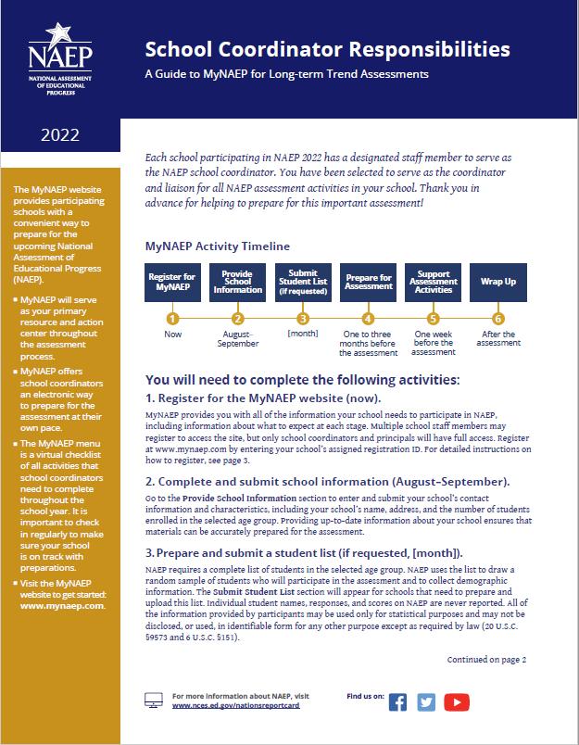

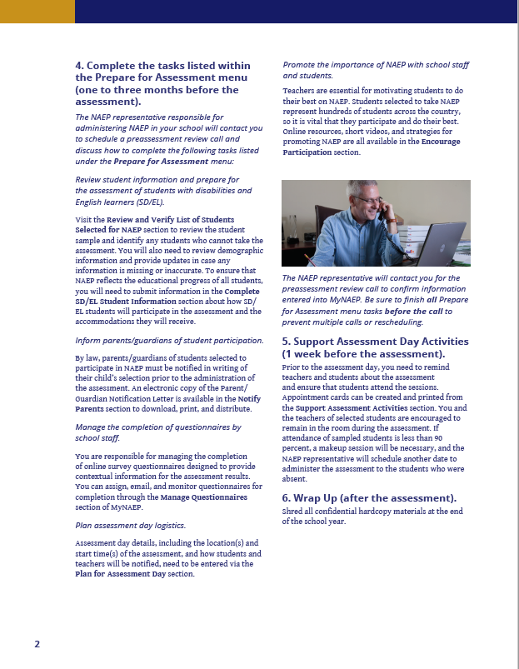
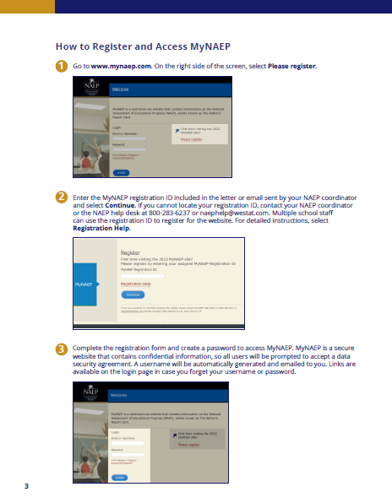
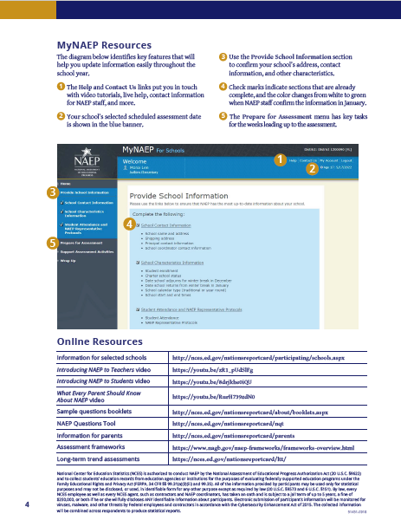

Appendix D3-6: NAEP 2022 School Coordinator Responsibilities, A Guide to MyNAEP, LTT, Private schools (Approved v.23)

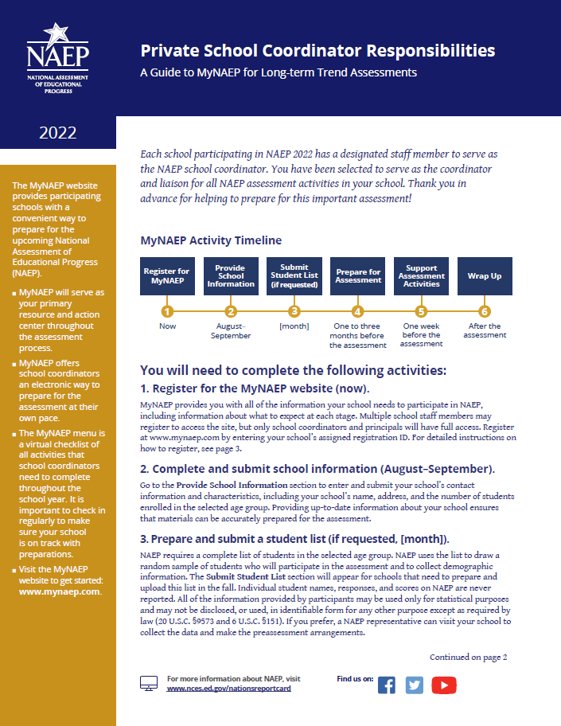

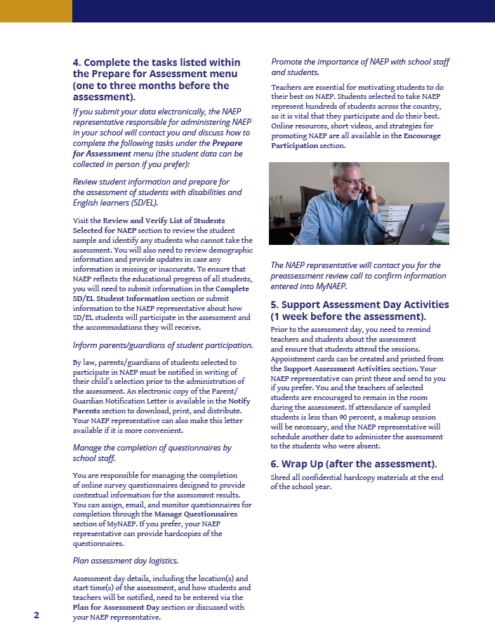

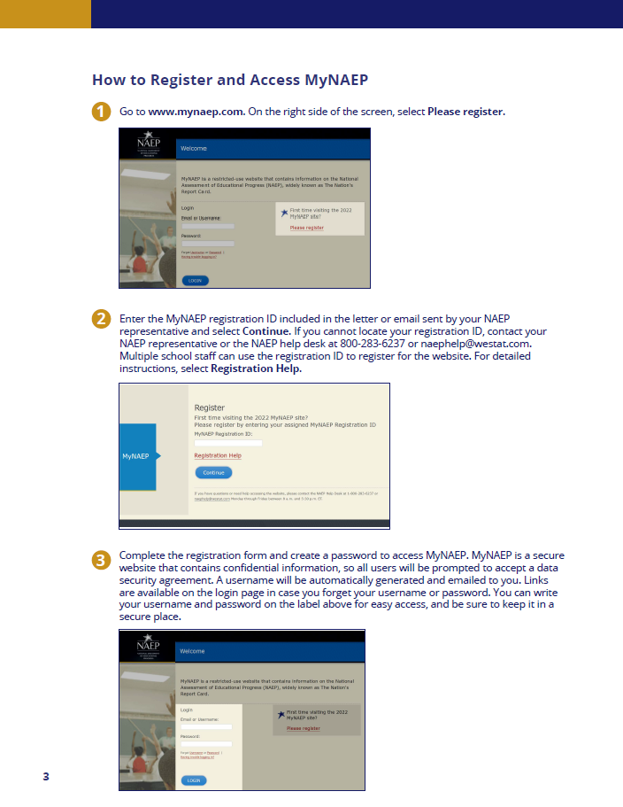

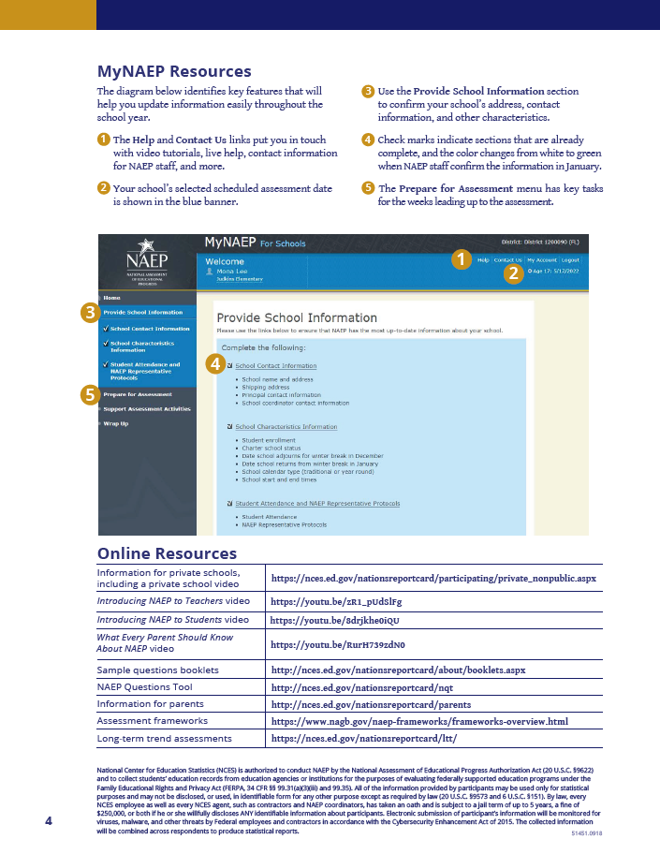

Appendix D3-7: NAEP 2022 In Your School, LTT, Public Schools (Approved v.23)

NAEP 2022 in Your School – [Age 9 OR Age 17] Long-Term Trend Mathematics and Reading

“NAEP is the only assessment providing half a century of performance data to measure what students know and can do. The state and national trends inform local, state, and national program and policy discussions that improve teaching and learning.”
– David Atherton, EdD, Principal, Clear Creek Middle School, Gresham, OR

What is NAEP?
The National Assessment of Educational Progress (NAEP) is an integral measure of academic progress across the nation and over time. It is the largest nationally representative and continuing assessment of what our nation’s students know and can do in various subjects such as civics, mathematics, reading, and U.S. history. The program also provides valuable insights into students’ educational experiences and opportunities to learn in and outside of the classroom.

NAEP is a congressionally mandated program administered by the National Center for Education Statistics (NCES), within the U.S. Department of Education and the Institute of Education Sciences.

How are NAEP results reported?
The results of NAEP are released as The Nation’s Report Card. Depending on the assessment, NAEP results are available for the nation, states, and select urban districts that participate in the Trial Urban District Assessment (TUDA). Results are also available for different student groups, based on factors such as race/ethnicity, gender, school location, and more. NAEP is not designed to collect or report results for individual students, classrooms, or schools.

Why should my school participate in NAEP?
Your school’s participation will help ensure that you and your fellow educators—as well as policymakers and elected officials—have reliable data to better understand and improve student learning.

Your school and students represent schools and students across the country. When students participate and give their best effort, NAEP results provide the most accurate and representative measure possible of student achievement and experience.

What NAEP assessments will be administered in 2022?
The NAEP long-term trend assessment will be administered via paper and pencil to [9-year-olds OR 17-year-olds] in your school between [date] and [date]. NAEP long-term trend assessments measure student performance in mathematics and reading, and allow the performance of today’s students to be compared with students since the early 1970s. Students will also be asked to complete survey questionnaires to provide a better understanding of factors that may be related to students’ learning. There will be no teacher questionnaire, but a school questionnaire will be administered.

Results will be released for the nation.

What will my students do?
Participating [9-year-olds OR 17-year-olds] will complete subject-area questions in mathematics or reading. Each student will be assessed in one subject only. Students will also complete survey questionnaires that provide valuable information about their educational experiences and opportunities to learn both in and outside of the classroom, as well as how they have accessed learning during the COVID-19 pandemic.

It takes approximately 90 minutes for students to complete the paper-based assessment, including transition time, directions, and completion of survey questionnaires. A broad range of accommodations are provided for students with disabilities and English learners.

Do teachers need to prepare students for the assessment?
Teachers do not need to prepare their students to take the assessment but should encourage them to do their best.

How can my teachers and I use NAEP data to help our students?
The NAEP Data Explorer (https://www.nationsreportcard.gov/ndecore) is a powerful tool that allows you to examine the relationships between student performance and factors such as instructional practices, school resources, and more.

Questions from previous NAEP assessments can also be used as a helpful educational resource in the classroom. Teachers can use the NAEP Questions Tool (http://nces.ed.gov/nationsreportcard/nqt) to see how their students’ performance compares to peers in your state and across the nation. Released NAEP questions come with a scoring guide, sample student responses, and performance data.

Who will administer NAEP in my school? What does my school need to provide on the day of the assessment?
NAEP representatives will administer the NAEP assessment and provide significant support to your school on assessment day. They will wear necessary personal protective equipment (PPE) and follow all school-specific health protocols. NAEP representatives will also bring all necessary materials and equipment. Schools will only need to provide space for students to take the assessment.

More information about roles and responsibilities for coordinating and administering NAEP in your school are on the last page of this fact sheet.

How was my school selected for NAEP?
Your school was selected as part of a carefully designed sampling process that ensures NAEP-selected schools and students are representative of their district, state, and the nation.

How is NAEP different from our state assessment?
NAEP serves a different role than state assessments. While states have their own unique assessments to measure student achievement against specific content standards, NAEP is designed to provide a common measure of student performance and progress across the country.

How long has NAEP been around?
NAEP was first administered in 1969 to measure student achievement nationally. In 1990, NAEP was administered at the state level for the first time. The NAEP TUDA program, which measures student achievement in some of the nation’s large urban districts, began in 2002. The program has come to be recognized as the gold standard of large-scale assessments due to its high technical quality and rigorous design and methodology.

How often is NAEP administered?
Students in grades 4 and 8 are scheduled to be assessed at the state and national levels in mathematics and reading every 2 years. Under the Elementary and Secondary Education Act, districts and states that receive Title I funds are required to participate in these biennial assessments. Other subjects are assessed periodically. Long-term trend assessments for 9-, 13-, and 17-year-olds are also assessed periodically.

Where can I find more information?
Learn more about the NAEP program at nces.ed.gov/nationsreportcard, and explore the latest NAEP results at nationsreportcard.gov.

Visit https://nces.ed.gov/nationsreportcard/about/covid19.aspx for more information about NAEP COVID-19 protocols.

You can also find NAEP on: <Facebook logo> <Twitter logo> <YouTube logo>

Roles and Responsibilities for Coordinating and Administering NAEP
Your NAEP State Coordinator, NAEP representatives, and school staff will work together to coordinate and administer the assessment. You will need to assign a staff member from your school to serve as the school coordinator and work closely with NAEP representatives to organize assessment activities. This person will be the primary contact for the assessment and should be familiar with how students participate in statewide assessments and how to use a computer to collect and enter student information online.

The school coordinator will be responsible for
- confirming the scheduled assessment date with the NAEP State Coordinator;
- registering for the MyNAEP website and providing information about the school;
- if requested, overseeing the submission of an electronic list of [9-year-olds OR 17-year-olds];
- using the MyNAEP website to prepare for the assessment;
- notifying parents of the assessment (more information will be provided on how to complete this task);
- communicating with NAEP representatives and participating in a preassessment review call to finalize assessment preparations;
- reserving space for the assessment, including room(s) and desks or tables; and
- collaborating with school staff to ensure a high rate of student participation.

Additional information about the school coordinator’s responsibilities will be sent prior to NAEP representatives contacting you.

The NAEP State Coordinator works at your state department of education and will be responsible for
- working with schools to confirm the assessment date;
- communicating with principals about the importance of NAEP and student participation;
- providing schools with instructions for preparing a list of students and information about notifying parents of participating students;
- providing guidance for including students with disabilities and English learners; and
- responding to questions from the school community throughout the assessment period.

NAEP representatives, employed by a U.S. Department of Education contractor to work directly with schools, will be responsible for
- selecting a random sample of [9-year-olds OR 17-year-olds] from the school list;
- verifying information that the school coordinator has provided via the MyNAEP website, the online hub for completing school preparation activities throughout the NAEP assessment process;
- working with the school coordinator to finalize assessment logistics;
- bringing all assessment materials to the school on the scheduled day; and
- administering the assessment.

Each principal will be responsible for
- assigning a school staff member to serve as the school coordinator;
- including the NAEP assessment date on the school calendar;
- empowering the designated school coordinator to work with NAEP representatives to prepare for the assessment; and
- informing school staff and students about NAEP and why student participation is critically important.

National Center for Education Statistics (NCES) is authorized to conduct NAEP by the National Assessment of Educational Progress Authorization Act (20 U.S.C. §9622) and to collect students’ education records from education agencies or institutions for the purposes of evaluating federally supported education programs under the Family Educational Rights and Privacy Act (FERPA, 34 CFR §§ 99.31(a)(3)(iii) and 99.35). All of the information provided by participants may be used only for statistical purposes and may not be disclosed, or used, in identifiable form for any other purpose except as required by law (20 U.S.C. §9573 and 6 U.S.C. §151). By law, every NCES employee as well as every NCES agent, such as contractors and NAEP coordinators, has taken an oath and is subject to a jail term of up to 5 years, a fine of $250,000, or both if he or she willfully discloses ANY identifiable information about participants. Electronic submission of participant’s information will be monitored for viruses, malware, and other threats by Federal employees and contractors in accordance with the Cybersecurity Enhancement Act of 2015. The collected information will be combined across respondents to produce statistical reports.

This publication was prepared for the National Assessment of Educational Progress by Hager Sharp under contract GS-23F-0024M to the National Center for Education Statistics, U.S. Department of Education.

Appendix D3-8: NAEP 2022 In Your School, LTT, Private Schools (Approved v.23)

NAEP in Your Private School 2022
Age [age] Long-Term Trend Mathematics and Reading

Page 1 Sidebar:
What is NAEP?
The National Assessment of Educational Progress (NAEP) is an essential measurement of student achievement in the United States.
- First administered in 1969, NAEP is the largest continuing and nationally representative assessment of what our nation’s public and private school students know and can do in various subjects.
- The schools and students participating in NAEP make an important contribution by representing other schools and students across the country.
- NAEP is a common measure of academic progress across the nation and over time. The results are released as The Nation’s Report Card.
Page 1 Text:
Why participate in NAEP?
Participation in NAEP gives private schools a voice in the national conversation about education. Your school has been selected to represent other private schools across the nation, and it is vital that all selected students participate to accurately capture our students’ progress.
Schools, students, and teachers who participate in NAEP enable The Nation’s Report Card to provide more inclusive representation of what our nation’s students know and can do in key subject areas. NAEP has consistently demonstrated over time and across subjects that students in private schools on average outperform students in public schools.
NAEP long-term trend assessments measure student performance in mathematics and reading, and allow the performance of today’s students to be compared with students since the early 1970s.

How will NAEP 2022 be administered in your school?
From [date] to [date], NAEP will be administered in public and private schools across the country. NAEP representatives will administer the NAEP assessment [to selected [age]-year-old students] and provide significant support to your school on assessment day. They will wear necessary personal protective equipment (PPE) and follow all school-specific health protocols. NAEP representatives will also bring all necessary materials. Schools will only need to provide space for students to take the assessment.

Visit https://nces.ed.gov/nationsreportcard/about/covid19.aspx for more information about NAEP COVID-19 protocols.
[The following three questions and answers each appear inside their own word-bubble graphic]

What subjects will students be assessed in?
One subject per student
Math or reading

How will the assessment be conducted?
Administered by NAEP personnel (in PPE)
As paper-and-pencil assessment

How long will the assessment take?
About 90 minutes including
Transition, directions, and questionnaires

Students will also complete survey questionnaires that provide valuable information about their educational experiences and opportunities to learn both in and outside the classroom, as well as how they have accessed learning during the COVID-19 pandemic. In addition to the student questionnaire, the school principal will also be asked to complete a questionnaire. This questionnaire covers topics such as teacher training and school policies to provide valuable information for education stakeholders who need to gain a better picture of student performance.

[Large quote at top of page 2]
“The Council for American Private Education (CAPE) strongly encourages private schools to participate in NAEP, an essential measure of student achievement in the United States.”

Michael Schuttloffel
Executive Director, CAPE

Page 2 Text:
What are the responsibilities of the principal and school coordinator?
The principal is responsible for
- Including the NAEP assessment date on the school calendar;
- Designating a school coordinator to work with NAEP representatives and to prepare for the assessment;
- Informing school staff about NAEP and why participation is critically important; and
- Completing the school questionnaire.
The school coordinator is responsible for
- Confirming that the suggested assessment date works with the school calendar;
- Securing space for the assessment to take place;
- Providing a list of eligible students from which a random sample will be selected for participation in the assessment (student and school names will not be included in any reports)*;
- Informing parents about the assessment;
- Completing preassessment activities with guidance and support from NAEP representatives; and
- Ensuring that students attend the session on the assessment date.
NAEP representatives will take care of everything else related to preparing for and conducting the assessment.
For more information about NAEP visit:
- Program overview http://nces.ed.gov/nationsreportcard
- Private school participation https://nces.ed.gov/nationsreportcard/participating/private_nonpublic.aspx

NAEP – Giving Private Schools a Voice in the National Conversation

Find us on:
[Facebook, Twitter, and YouTube logos]
(Located across from “Find us on:” section or as footer on Page 1):
* National Center for Education Statistics (NCES) is authorized to conduct NAEP by the National Assessment of Educational Progress Authorization Act (20 U.S.C. §9622) and to collect students’ education records from education agencies or institutions for the purposes of evaluating federally supported education programs under the Family Educational Rights and Privacy Act (FERPA, 34 CFR §§ 99.31(a)(3)(iii) and 99.35). All of the information provided by participants may be used only for statistical purposes and may not be disclosed, or used, in identifiable form for any other purpose except as required by law (20 U.S.C. §9573 and 6 U.S.C. §151). By law, every NCES employee as well as every NCES agent, such as contractors and NAEP coordinators, has taken an oath and is subject to a jail term of up to 5 years, a fine of $250,000, or both if he or she willfully discloses ANY identifiable information about participants. Electronic submission of participant’s information will be monitored for viruses, malware, and other threats by Federal employees and contractors in accordance with the Cybersecurity Enhancement Act of 2015. The collected information will be combined across respondents to produce statistical reports.

Appendix D3-9: NAEP 2022 Spanish Parent Letter, LTT, Public Schools (NEW)

CARTA DE NOTIFICACIÓN A LOS PADRES O TUTORES SOBRE NAEP DE 2022 TENDENCIA A LARGO PLAZO
(Membrete de la escuela)
(Coloque la fecha aquí)
Estimado(a) padre, madre o tutor:

(Nombre de la escuela) participará en la Evaluación Nacional del Progreso Educativo (NAEP, por sus siglas en inglés) el (fecha). NAEP es la evaluación continua y nacionalmente representativa más grande acerca de lo que los estudiantes saben y pueden hacer en diferentes materias. NAEP es diferente de nuestras evaluaciones estatales ya que ofrece una medida común de los logros en todo el país. NAEP es administrada por el Centro Nacional de Estadísticas de la Educación (NCES, por sus siglas en inglés), parte del Departamento de Educación de Estados Unidos. Los resultados se publican en un informe llamado La Libreta de Calificaciones de la Nación, el cual les proporciona información a los educadores, padres, legisladores y al público acerca de los logros de los estudiantes.

Su hijo(a) (tomará/posiblemente tome) una evaluación de matemáticas o lectura. Además de las preguntas sobre la materia, los estudiantes contestan preguntas de contexto de NAEP de manera voluntaria. Las preguntas proporcionan información valiosa acerca de las experiencias y oportunidades de aprendizaje dentro y fuera del salón de clases de los estudiantes participantes. Puede encontrar más información acerca de las preguntas de NAEP en https://nces.ed.gov/nationsreportcard/parents/spanish.aspx en la sección “¿Qué se le preguntará a su hijo(a)?”

La evaluación toma unos 90 minutos para la mayoría de los estudiantes, incluyendo el tiempo de transición, instrucciones y el contestar las preguntas de contexto.

La información recolectada se utiliza únicamente con fines estadísticos.
- Las calificaciones de su hijo(a) no se verán afectadas.
- Los estudiantes pueden ser excusados por cualquier motivo, no están obligados a completar la evaluación y pueden dejar de responder cualquier pregunta.
- Aunque la evaluación es voluntaria, NAEP depende de la participación de los estudiantes para ayudarles a los legisladores a mejorar la educación. No obstante, si no desea que su hijo(a) participe, por favor, notifíqueme por escrito antes de (fecha).

No es necesario estudiar en preparación para NAEP, pero anime a su hijo(a) a que haga su mejor esfuerzo. Si tiene alguna pregunta, comuníquese con (nombre) llamando al (número de teléfono) o por correo electrónico escribiendo a (correo electrónico).

Nos entusiasma que nuestra escuela participe en NAEP. Sabemos que los estudiantes de (nombre de la escuela) mostrarán lo que los estudiantes de nuestro país saben y pueden hacer.

Atentamente,

(Nombre del director(a) de la escuela)

El Centro Nacional para Estadísticas de la Educación (NCES, por sus siglas en inglés) está autorizado por la Ley de Autorización para la Evaluación Nacional del Progreso Educativo (20 U.S.C.§9622) para administrar NAEP y para recopilar los expedientes educativos de los estudiantes, de agencias o instituciones educativas con el propósito de evaluar programas de educación apoyados por el gobierno federal conforme a la Ley de Derechos Educativos y Privacidad Familiar (FERPA, por sus siglas en inglés; 34 CFR §§ 99.31(a)(3)(iii) y 99.35). Toda la información que proporcionen los participantes podrá usarse únicamente con fines estadísticos y no podrá darse a conocer o usarse ni para identificarlos ni para cualquier otro propósito salvo aquel requerido legalmente (20 U.S.C. §9573 y 6 U.S.C. §151). Por ley, todos los empleados de NCES al igual que todos los representantes del mismo, como contratistas y coordinadores de NAEP, han hecho un juramento y están sujetos a una pena de prisión de hasta 5 años, una multa de hasta $250,000 o ambas cosas, si dan a conocer intencionalmente CUALQUIER información que identifique a los participantes. El envío de la información del participante por vía electrónica será monitoreado por empleados y contratistas federales para detectar virus, programas maliciosos (malware) y otras amenazas conforme a la Ley de Mejoramiento de la Seguridad Cibernética de 2015. La información recolectada de todos los participantes se combinará para elaborar informes estadísticos.

Appendix D3-10: NAEP 2022 Spanish Parent Letter, LTT, Private Schools (NEW)

CARTA DE NOTIFICACIÓN A LOS PADRES O TUTORES SOBRE NAEP DE 2022 ESCUELAS PRIVADAS
Tendencia a Largo Plazo
(Membrete de la escuela)
(Coloque la fecha aquí)
Estimado(a) padre, madre o tutor:

Nos complace notificarle que (nombre de la escuela) ha sido seleccionada para representar a las escuelas privadas de todo el país al participar en la Evaluación Nacional del Progreso Educativo (NAEP, por sus siglas en inglés) el (fecha). NAEP es la evaluación continua y nacionalmente representativa más grande acerca de lo que los estudiantes en las escuelas privadas saben y pueden hacer en diferentes materias y es diferente de las evaluaciones estatales y escolares ya que ofrece una medida común de los logros de los estudiantes en todo el país. NAEP es administrada por el Centro Nacional de Estadísticas de la Educación (NCES, por sus siglas en inglés), parte del Departamento de Educación de Estados Unidos. Los resultados se publican en un informe llamado La Libreta de Calificaciones de la Nación, el cual les proporciona información a los educadores, padres, legisladores y al público acerca de los logros de los estudiantes.

Su hijo(a) (tomará/posiblemente tome) una evaluación de matemáticas o lectura. Además de las preguntas sobre la materia, los estudiantes contestan cuestionarios de contexto de NAEP de manera voluntaria. Los cuestionarios proporcionan información valiosa acerca de las experiencias y oportunidades de aprendizaje dentro y fuera del salón de clases de los estudiantes participantes. Puede encontrar más información acerca de las preguntas de NAEP en https://nces.ed.gov/nationsreportcard/parents/spanish.aspx en la sección “¿Qué se le preguntará a su hijo(a)?”

La evaluación toma aproximadamente 90 minutos para la mayoría de los estudiantes, incluyendo el tiempo de transición, instrucciones y el contestar las preguntas de contexto.

La información recolectada se utiliza únicamente con fines estadísticos.
- Las calificaciones de su hijo(a) no se verán afectadas.
- Los estudiantes pueden ser excusados por cualquier motivo, no están obligados a completar la evaluación y pueden dejar de responder cualquier pregunta.
- Aunque la evaluación es voluntaria, NAEP depende de la participación de los estudiantes para ayudarles a los legisladores a mejorar la educación. No obstante, si no desea que su hijo(a) participe, por favor, notifíqueme por escrito antes de (fecha).

No es necesario estudiar en preparación para NAEP, pero anime a su hijo(a) a que haga su mejor esfuerzo. Si tiene alguna pregunta, comuníquese con (nombre) llamando al (número de teléfono) o por correo electrónico escribiendo a (correo electrónico). Para saber más sobre la participación de las escuelas privadas en la NAEP, visite https://nces.ed.gov/nationsreportcard/participating/private_nonpublic.aspx (en inglés).

Nos entusiasma que nuestra escuela participe en NAEP. Sabemos que los estudiantes de (nombre de la escuela) mostrarán lo que los estudiantes en las escuelas privadas de nuestro país saben y pueden hacer.

Atentamente,

Director(a) de la escuela

El Centro Nacional para Estadísticas de la Educación (NCES, por sus siglas en inglés) está autorizado por la Ley de Autorización para la Evaluación Nacional del Progreso Educativo (20 U.S.C.§9622) para administrar NAEP y para recopilar los expedientes educativos de los estudiantes, de agencias o instituciones educativas con el propósito de evaluar programas de educación apoyados por el gobierno federal conforme a la Ley de Derechos Educativos y Privacidad Familiar (FERPA, por sus siglas en inglés; 34 CFR §§ 99.31(a)(3)(iii) y 99.35). Toda la información que proporcionen los participantes podrá usarse únicamente con fines estadísticos y no podrá darse a conocer o usarse ni para identificarlos ni para cualquier otro propósito salvo aquel requerido legalmente (20 U.S.C. §9573 y 6 U.S.C. §151). Por ley, todos los empleados de NCES al igual que todos los representantes del mismo, como contratistas y coordinadores de NAEP, han hecho un juramento y están sujetos a una pena de prisión de hasta 5 años, una multa de hasta $250,000 o ambas cosas, si dan a conocer intencionalmente CUALQUIER información que identifique a los participantes. El envío de la información del participante por vía electrónica será monitoreado por empleados y contratistas federales para detectar virus, programas maliciosos (malware) y otras amenazas conforme a la Ley de Mejoramiento de la Seguridad Cibernética de 2015. La información recolectada de todos los participantes se combinará para elaborar informes estadísticos.

