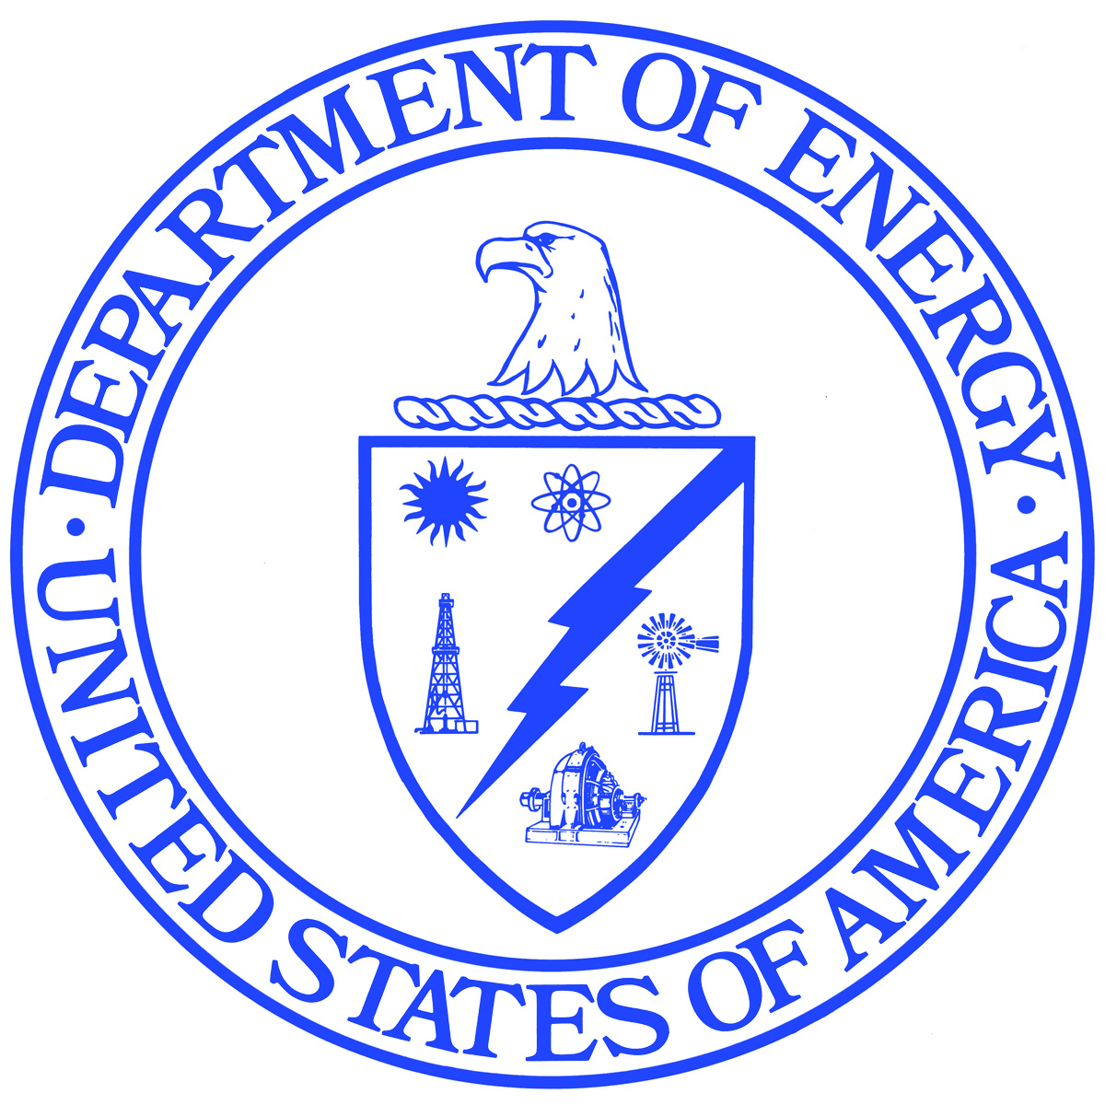
Department of Energy
Washington, DC 20585

September 23, 2021

<INSERT PREFIX AND FULL NAME>
<INSERT COMPANY>
<INSERT DEPARTMENT>
<INSERT ADDRESS>
<INSERT CITY>, <INSERT STATE> <INSERT ZIP>

Subject: Form NWPA-830G Standard Remittance Advice for Payment of Fees

Dear Ms. <INSERT LAST NAME>,

The U.S. Department of Energy (DOE) is conducting its quarterly data collection using Form NWPA-830G Appendix G - Standard Remittance Advice for Payment of Fees, including Annex A to Appendix G, in accordance with Article VIII (B.1) and Appendix G of Article XXII (C) of the Standard Contract for Disposal of Spent Nuclear Fuel and/or High-Level Radioactive Waste. This form collects information on net electricity generation and estimation of the spent nuclear fuel disposal fees that would otherwise accrue from this generation.

Appendix G collects information on net electric power generation and serves as the basis for DOE to determine the payment of fees into the Nuclear Waste Fund. The data are used by DOE’s Office of the Chief Financial Officer, Energy Finance and Accounting Service Center to verify the amounts of these payments. Appendix G data provides an audit trail of all payments made by purchasers into the Nuclear Waste Fund. Annex A to Appendix G collects data on the amount of net electricity generated and sold upon which the fees are based. DOE’s Office of Standard Contract Management, Energy Information Administration (EIA), and DOE’s Office of Nuclear Energy use data from the Annex A to Appendix G form. DOE’s Office of Standard Contract Management use fee payment data in a number of internal reports, including Fee Adequacy reports and Total System Life Cycle Cost reports. EIA uses net electricity generation data reported on Annex A to Appendix G to verify consistency with data reported on other surveys and as a source of energy loss and pumped storage data that may not be available on other surveys. The requirement to check for data consistency across sources for net electricity generation is discussed in the Final Rule on the Standard Contract for Disposal of Spent Nuclear Fuel and/or High-Level Radioactive Waste, 56 Fed. Reg. 67648 (December 31, 1991). Adjustment factor data are used to determine energy losses and the distribution of electricity sales between sales for resale and sales to ultimate consumers. The data in these collections will not be published.

In accordance with the terms of the Standard Contract, companies are allowed to mark any data reported under the contract as “proprietary data” (See 10 C.F.R. 961.11, Article XXI – Rights in Technical Data). Although a large part of the information furnished is publicly available, this information is not typically published by DOE. If a request for the information is received, to the extent that information is not in the public domain or has been marked as “proprietary data,” the procedures listed below will be followed.
The information reported on Form NWPA-830G will be protected and not disclosed to the public to the extent that it satisfies the criteria for exemption under the Freedom of Information Act (FOIA), 5 U.S.C. §552, DOE regulations implementing the FOIA, 10 C.F.R. §1004.11, and the Trade Secrets Act, 18 U.S.C. §1905.

The Federal Energy Administration Act requires EIA to provide company-specific data to other federal agencies when requested for official use. The information reported on this form may also be made available, upon request, to another DOE component, to any committee of Congress, the Government Accountability Office, or other federal agencies authorized by law to receive such information. A court of competent jurisdiction may obtain this information in response to an order. The information may be used for any non-statistical purposes such as administrative, regulatory, law enforcement, or adjudicatory purposes.
EIA has agreed to provide company-specific information to DOE’s Office of Standard Contract Management. The data are used for administrative, regulatory, and adjudicatory purposes only. The agreement requires that the information is protected and not disclosed to the public as set forth above. (See 10 C.F.R. 961.11, Article VIII-Fees And Terms of Payment, (E)(3)

The Purchaser shall furnish DOE with such records, reports, and data as may be necessary for the detenninatlon of quantities delivered hereunder and for final settlement of amounts due under this contract and shall retain and make available to DOE and its authorized representative(s) for examination at all reasonable times such records, reports, and data for a period or three (3) years from the completion of delivery of all material under the Standard Contract.

Response to this survey is mandatory. DOE estimates that the average reporting burden for this survey is 5 hours. DOE requests Contract Holders to continue to submit the quarterly Remittance Advice (RA) forms (NWPA-830G) with all generation and ownership information, including calculation of the Total Energy Adjustment Factor (TEAF). Form NWPA-830G Appendix G-Standard Remittance Advice for Payment of Fees, including Annex A to Appendix G, may also be viewed and downloaded here: http://www.eia.gov/survey/#nwpa-830g. In mid-2013, DOE replaced the Remittance Advice Reporting System with an online fillable PDF version of the Remittance Advice forms. It is recommended that you use the current PDF forms as they have been updated with the latest information and have been granted OMB approval. While respondents may continue to use the RAPS software, they are responsible for ensuring that all data and calculations are correct. Completed Remittance Advice forms must be printed out, signed, and returned to DOE in accordance with the provisions of the Standard Contract.

Purchasers shall forward completed RAs to either:

a. U.S. Department of Energy
Office of Finance and Accounting, CF-11
19901 Germantown Road
Germantown. MD 20874-1290

b. Electronic copy with signature to (investment@hq.doe.gov)

Request for further information, additional forms, and instructions may be directed in writing to the address (or email) above or by telephone to 301-903-9720.

If you have any questions on this matter, please contact me at (202) 586-7826.

Sincerely,

__________________________________
Constance A. Barton
Director, Contracting Officer
Office of Standard Contract Management
Office of General Counsel

