United States Environmental Protection Agency
Office of Pollution
Prevention and Toxics
Washington, DC 20460
August 2021

TOXICS RELEASE INVENTORY
Guidance for Reporting Parent Company Information to TRI

Section 313 of the Emergency Planning and Community Right-to-Know Act of 1986 (EPCRA) requires certain facilities manufacturing, processing, or otherwise using listed toxic chemicals to report the annual quantity of such chemicals entering each environmental medium. Such facilities must also report pollution prevention and recycling data for such chemicals, pursuant to section 6607 of the Pollution Prevention Act, 42 U.S.C. 13106. EPCRA section 313 is also known as the Toxics Release Inventory (TRI).

CONTENTS
SECTION 1.0 INTRODUCTION 1
Section 1.1 Background on Proposed Rule 1
Section 1.2 Purpose of Supporting Document 2
SECTION 2.0 PROPOSED RULE: TRI PARENT COMPANY DEFINITION (Proposed CFR Text) 2
SECTION 3.0 REPORTING EXAMPLES 4
Section 3.1 Ownership by a Single, Standalone Entity 5
Section 3.2 Ownership by a Single, Subsidiary Entity 7
Section 3.3 Direct Ownership by Multiple Entities 7
SECTION 4.0 REFERENCES 10

LIST OF EXAMPLES

Example 1: Single Company Owning Single Facility 5
Example 2: Single Company Owning Multiple Facilities 5
Example 3: Ownership by a Single Foreign Company 5
Example 4: Ownership by a Federal Government Agency or Department 6
Example 5: Government-Owned, Contractor-Operated; Contractor Reporting 6
Example 6: Government-Owned, Contractor-Operated; Federal Agency Reporting 6
Example 7: Ownership by a State, Local, or Tribal Agency 7
Example 8: Ownership by U.S. Division of U.S. Corporation 7
Example 9: Ownership by U.S. Subsidiary of Foreign Corporation 7
Example 10: Multi-company Ownership by U.S. Companies 8
Example 11: Multi-company Ownership Including Foreign Entities 8
Example 12: Multi-company Ownership Including Foreign Entities 9
Example 13: Multi-company Ownership Including Foreign Entities 9
Example 14: U.S. 50-50 Joint Venture Ownership 10
Example 15: Foreign 50-50 Joint Venture Ownership 10

INTRODUCTION

Background on Proposed Rule
EPA is proposing to codify a definition of parent company and further clarify reporting requirements for providing facility parent company information to the Toxics Release Inventory (TRI). TRI currently requires facilities to report their highest level United States-based parent company information annually in Part I, Section 5 of the annual reporting forms. However, no regulatory definition related to this important data field currently exists in 40 CFR part 372. Facilities currently rely on the following guidance in the TRI Reporting Forms and Instructions (US EPA, 2017) when determining the appropriate parent company to report:
“Your parent company is the highest level company, located in the United States, and that directly owns at least 50 percent of the voting stock of [the facility’s] company…. [A] facility that is a 50:50 joint venture is its own parent company. When a facility is owned by more than one company and none of the facility owners directly owns at least 50 percent of its voting stock, the facility should provide the name of the parent company of either the facility operator or the owner with the largest ownership interest in the facility.”
Each year, EPA standardizes parent company names submitted to TRI. This process involves aligning submissions to a set of business rules (e.g., “Corporation” is changed to “Corp”) to provide consistency in the TRI database. EPA also researches submitted names to ensure proper reporting by using online sources and other public datasets. After identifying suggested changes to the submitted parent company name, EPA contacts these facilities to confirm the appropriate name, per formatting guidelines and instructions. Each year through this process, EPA standardizes many of the forms received.
Through the parent company name standardization and subsequent correspondence with facilities, EPA has identified several causes for misreporting of parent company information to TRI including:
- Facilities with several levels of ownership misinterpret the use of the word “directly” in the parent company reporting guidance to mean the company that directly owns the facility, which may be the subsidiary of a higher level company based in the United States.
- Facilities whose highest-level parent company is based outside of the United States report a foreign company as the highest level company, often while not knowing the highest level U.S.-based parent company.
- Facilities incorrectly report that no parent company exists.
In addition, there are several company ownership scenarios where current guidance does not explicitly address how to report the parent company:
- Facilities with multiple owners and no owner with at least 50 percent of voting stock
- Companies that own multiple facilities but have no higher level parent company
- Facilities that are publicly-owned (e.g. federal facilities, municipal power plants)
The proposed rule would further define and clarify reporting requirements for facility parent company information. Under the proposed rule, the parent company definition would provide reporting clarity to facilities by identifying the appropriate parent company to report for a variety of facility ownership scenarios, and codifying this definition and instructions. The proposed rulemaking specifically would include:
- Clarifying reporting requirements for the highest level U.S.-based parent company in the existing Part I, Section 5.1 and its Dun & Bradstreet Number in Part I, Section 5.2 by providing a regulatory definition, and
- Soliciting public feedback on whether and how to incorporate foreign parent company data, including by adding new data elements similar to Part I, Sections 5.1 and 5.2 for reporting the name of a foreign company and its Dun & Bradstreet number.

Purpose of Supporting Document
The purpose of this document is to assist facilities in understanding the proposed reporting requirements for facility parent company information. The objectives of this document are to:
- Provide explanation and assistance on EPCRA section 313 reporting requirements for parent company information
- Promote consistency in the reporting of parent company information
- Reduce the level of effort expended by those facilities that prepare TRI reports
Below, this document provides the proposed definition of parent company (Section 2.0) and provides several examples of how to report parent company information under various ownership scenarios (Section 3.0).

PROPOSED RULE: TRI PARENT COMPANY DEFINITION (Proposed CFR Text)
This section provides the proposed definition of parent company. For the full regulatory text of the proposed rule, please see the Notice of Proposed Rulemaking in Docket EPA-HQ-OPPT-2018-0155.
Proposed Regulatory Text, 40 CFR 372:
§ 372.3 Definitions.
* * * * *
Parent company means the highest-level company(s) of the facility’s ownership hierarchy as of December 31 of the year for which data are being reported according to the following instructions. The U.S. parent company is located within the United States while the foreign parent company is located outside the United States:
(1) If the facility is entirely owned by a single U.S. company that is not owned by another company, that single company is the U.S. parent company.
(2) If the facility is entirely owned by a single U.S. company that is, itself, owned by another U.S.-based company (e.g., it is a division or subsidiary of a higher-level company), the highest-level company in the ownership hierarchy is the U.S. parent company. If there is a higher-level parent company that is outside of the United States, the highest-level foreign company in the ownership hierarchy is the foreign parent company.
(3) If the facility is owned by more than one company (e.g., company A owns 40 percent, company B owns 35 percent, and company C owns 25 percent), the highest-level U.S. company with the largest ownership interest in the facility is the U.S. parent company. If there is a higher-level foreign company in the ownership hierarchy, that company is the foreign parent company.
(4) If the facility is owned by a 50:50 joint venture or a cooperative, the joint venture or cooperative is its own parent company.
(5) If the facility is entirely owned by a foreign company (i.e., without a U.S.-based subsidiary within the facility’s ownership hierarchy), the highest-level foreign parent company is the facility’s foreign parent company.
(6) If the facility is federally owned, the highest-level federal agency or department operating the facility is the U.S. parent company.
(7) If the facility is owned by a non-federal public entity (e.g., a State, municipal, or tribal government), that entity is the U.S. parent company.
* * * * *
§ 372.85 Toxic chemical release reporting form and instructions.
* * * * *
(b) Form elements. Information elements reportable on EPA Form R and Form R Schedule 1 include the following:
* * * * *
(8) Legal name of the facility’s U.S.-based parent company and its Dun and Bradstreet identification number.
(i) Legal name of the facility’s highest-level foreign parent company and its Dun and Bradstreet identification number, when applicable.
(ii) The facility must report using the standardized conventions for the naming of a parent company as provided in the toxic chemical release inventory reporting instructions identified in paragraph (a) of this section.
* * * * *
§ 372.95 Alternate threshold certification and instructions.
* * * * *
(b) Alternate threshold certification statement elements. The following information must be reported on an alternate threshold certification statement pursuant to §372.27(b):
* * * * *
(12) Legal name of the facility’s U.S.-based parent company and its Dun and Bradstreet identification number.
(i) Legal name of the facility’s highest-level foreign parent company and its Dun and Bradstreet identification number, when applicable.
(ii) The facility must report using the standardized conventions for the naming of a parent company as provided in the toxic chemical release inventory reporting instructions identified in paragraph (a) of this section.

REPORTING EXAMPLES
In order to demonstrate how facilities would report parent companies under the proposed rule, several example ownership scenarios are described below and accompanied by a description of the appropriate reporting of U.S. parent company and foreign parent company for each scenario. These examples are not intended to be a comprehensive description of all possible ownership scenarios, but rather provide some assistance to help facilities in their determination of the appropriate parent company(s) to report.
Table 3–1: Summary of Ownership Scenarios
Ownership Scenario | US Parent | Foreign Parent | Corresponding Sub-part in Proposed Parent Company Definition  (40 CFR 372.3) | Relevant Example(s)
US Parent Whole Ownership | X |  | 1, 2 | 1, 2, 8
Foreign Parent, No US Ownership |  | X | 5 | 3, 15
US Federal Ownership | F |  | 6 | 4
US Federal Government Owned, Contractor Operated (GOCO) | X |  | 1, 2 | 5, 6
US State Local Tribe Owned | SLT |  | 7 | 7
US Parent, Foreign Ultimate Ownership | X | X | 2 | 9
US Parents, Split Ownership | XX |  | 3 | 10
US and Foreign Parents, Split Ownership | XX | XX | 3 | 11, 12, 13
50/50 US Parent Joint Venture | X |  | 4 | 14
50/50 Foreign Parent Joint Venture |  | X | 4 | 15
Note: X = single company/corporation; XX = multiple companies/corporations; F = federal government agency; SLT = other public legal entity (e.g., state, local, or tribe)

In the sections below, examples are provided for facility ownership by single standalone entities (Section 3.1); by single entities that are themselves owned by other entities (Section 3.2); and by multiple entities (Section 3.3). For each example, a scenario is described, the corresponding sub-part in the proposed parent company definition is indicated, and the reported data are provided for the following three reporting form data elements:
- Part I, Section 4.1: Facility or Establishment Name (Facility)
- Part I, Section 5.1: Name of U.S. Parent Company (U.S. Parent)
- Part I, Section 5.3: Name of Foreign Parent Company (Foreign Parent)
In cases where there is no actual U.S. or foreign parent, the respondent will indicate not applicable (NA). In addition to the U.S. or foreign parent names, the facility must also report the corresponding Dun and Bradstreet number if applicable (not shown in the examples). Federally owned facilities and government owned, contractor operated (GOCO) facilities will also need to indicate their status through Part I, Section 4.2c (A Federal Facility) or Part I, Section 4.2d (GOCO).

Ownership by a Single, Standalone Entity
This section describes how to report parent company information for facilities that are owned by a single entity that is not owned by another entity. This includes scenarios in which the facility’s single owner is a U.S. company (Example 1 and Example 2), a foreign company (Example 3), a federal government agency (Example 4, Example 5, and Example 6), or a state, local, or tribal entity (Example 7).
All facilities are expected to report on ownership. Nearly all facilities will report a U.S. parent unless a facility has entirely foreign ownership (e.g., Example 3).

Example 1: Single Company Owning Single Facility
A facility is 100% owned directly by a U.S.-based company (Company X), which is not a subsidiary of any other entity.
Corresponding Subpart in Proposed Parent Company Definition: 1
Demonstration of appropriate reporting:
- Facility: Facility Name
- U.S. Parent: Company X
- Foreign Parent: NA

Example 2: Single Company Owning Multiple Facilities
Several facilities (Facility A, Facility B, and Facility C) are 100% owned directly by a large U.S.-based company (Company X), which is not a subsidiary of any other entity.
Corresponding Subpart in Proposed Parent Company Definition: 1
Demonstration of appropriate reporting:
- Facility: Facility A Name  - U.S. Parent: Company X  - Foreign Parent: NA | - Facility: Facility B Name  - U.S. Parent: Company X  - Foreign Parent: NA | - Facility: Facility C Name  - U.S. Parent: Company X  - Foreign Parent: NA

Example 3: Ownership by a Single Foreign Company
A facility is directly owned by a foreign company (Company X), without any of the foreign company’s U.S.-based subsidiaries within the ownership hierarchy of the facility. The foreign company is neither owned by nor a subsidiary of another entity.
Corresponding Subpart in Proposed Parent Company Definition: 5
Demonstration of appropriate reporting:
- Facility: Facility Name
- U.S. Parent: NA
- Foreign Parent: Company X
Example 4: Ownership by a Federal Government Agency or Department
A facility is owned and directly operated by a federal government agency/department.
Corresponding Subpart in Proposed Parent Company Definition: 6; also see Appendix A of TRI Reporting Forms and Instructions. Per Appendix A, federal facilities should report their facility name as the federal agency or department acronym and the facility name, prefaced by “US”. Federal facilities should report their parent company name by reporting their complete Department or Agency name, prefaced by “US”. The facility would also indicate “Federal Facility” in Part I, Section 4.2.
Demonstration of appropriate reporting:
- Facility: US Federal Agency/Department Acronym Facility Name
- U.S. Parent: US Agency or Department Name
- Foreign Parent: NA
- Part I, Section 4.2c: A Federal Facility
Example 5: Government-Owned, Contractor-Operated; Contractor Reporting
A facility is owned by a federal government agency.
A contractor (Company X) operates at this government facility and is required to file TRI reports independently of the federal facility. This contractor operating at the government facility is not a subsidiary of any other entity. Note that the federal facility, pursuant to executive order, will also need to file TRI reports. See Example 6 for how to populate the facility and parent company names for the federal entity’s TRI reporting.
Corresponding Subpart in Proposed Parent Company Definition: 1; also see Appendix A of TRI Reporting Forms and Instructions. Per Appendix A, federal contractors at government owned, contractor operated (GOCO) facilities should report the contractor name (not a federal department or agency name) as the parent company. The facility name should first list the agency name, followed by the specific plant or site name.
Demonstration of appropriate reporting:
- Facility: US Federal Agency/Department Acronym Facility Name
- U.S. Parent: Company X
- Foreign Parent: NA
- Part I, Section 4.2d: Government Owned, Contractor Operated (GOCO)
Example 6: Government-Owned, Contractor-Operated; Federal Agency Reporting
A facility is owned by a federal government agency and is submitting TRI reports. Note that there may be contractors at this facility that are required to file TRI reports independently of the federal facility. See Example 5 for how to populate the facility and parent company names for the contractor’s TRI reporting.
Corresponding Subpart in Proposed Parent Company Definition: 1; also see Appendix A of TRI Reporting Forms and Instructions. Per Appendix A, federal contractors at government owned, contractor operated (GOCO) facilities should report the contractor name (not a federal department or agency name) as the parent company. The facility name should first list the agency name, followed by the specific plant or site name.
Demonstration of appropriate reporting:
- Facility: US Federal Agency/Department Acronym Facility Name
- U.S. Parent: Company X
- Foreign Parent: NA
- Part I, Section 4.2c: A Federal Facility
Example 7: Ownership by a State, Local, or Tribal Agency
A facility is owned and operated by a State, Local, or Tribal agency.
Corresponding Subpart in Proposed Parent Company Definition: 7
Demonstration of appropriate reporting:
- Facility Name: Facility Name
- U.S. Parent: State, Local, or Tribal Agency
- Foreign Parent: NA

Ownership by a Single, Subsidiary Entity
This section describes how to report parent company information for facilities that are owned by a single entity, which are in turn owned by another entity, and may have more complicated ownership structures. Below, examples are provided, including scenarios in which the single owner is a U.S. company owned by another U.S. corporation (Example 8), or the single owner is a U.S. company owned by a foreign corporation (Example 9).
Example 8: Ownership by U.S. Division of U.S. Corporation
A facility is 100% owned directly by a company (Company X) within the U.S., which is a division of a larger U.S. company (Company Y).
Corresponding Subpart in Proposed Parent Company Definition: 2
Demonstration of appropriate reporting:
- Facility: Facility Name
- U.S. Parent: Company Y
- Foreign Parent: NA

Example 9: Ownership by U.S. Subsidiary of Foreign Corporation
A facility is 100% owned directly by a company (Company X) within the U.S., which is a division of a larger U.S. company (Company Y). This larger U.S.-based company is a subsidiary of a large foreign corporation (Corporation Z).
Corresponding Subpart in Proposed Parent Company Definition: 2
Demonstration of appropriate reporting:
- Facility: Facility Name
- U.S. Parent: Company Y
- Foreign Parent: Corporation Z

Direct Ownership by Multiple Entities
This section describes how to report parent company information for facilities that are directly owned by multiple entities, which in turn can have multilevel ownership structures including both U.S. and foreign entities. Schematic illustrations of multilevel ownership structures are also included.
Example 10: Multi-company Ownership by U.S. Companies
A facility is partially owned by three U.S.-based companies: Company A owns 40%, Company B owns 35%, and Company C owns 25%. Company A is a subsidiary of a large U.S.-based corporation, Corporation D. None of the companies are owned by a foreign company.  Corresponding Subpart in Proposed Parent Company Definition: 3  Demonstration of appropriate reporting:  - Facility: Facility Name  - U.S. Parent: Corporation D  - Foreign Parent: NA | 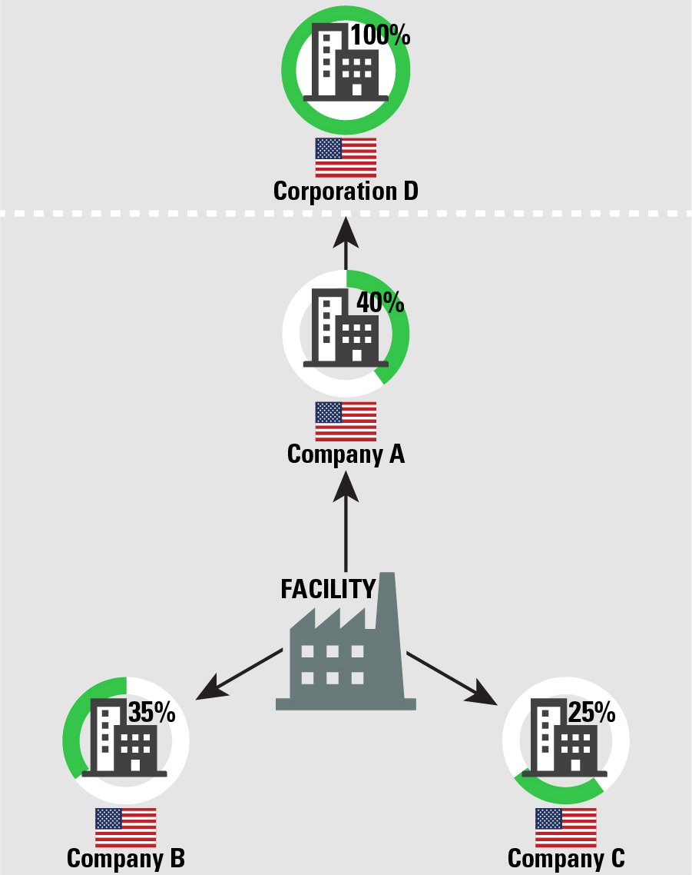

Example 11: Multi-company Ownership Including Foreign Entities
A facility is partially owned by two companies: Company A owns 60%, and Company B owns 40%. Both Company A and Company B are based in the U.S. Company B is a 100% subsidiary of a foreign company, Corporation D.  Corresponding Subpart in Proposed Parent Company Definition: 3  Demonstration of appropriate reporting:  - Facility: Facility Name  - U.S. Parent: Company A  - Foreign Parent: Corporation D | 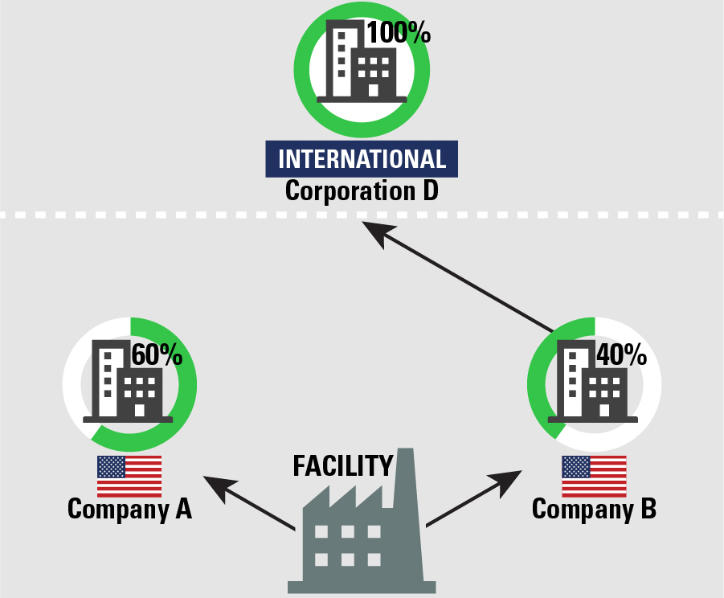

Example 12: Multi-company Ownership Including Foreign Entities
A facility is partially owned by three companies: Company A owns 40%, Company B owns 35%, and Company C owns 25%. Company A is a foreign corporation, and Companies B and C are based in the U.S. Company B is a 100% subsidiary of a foreign company, Corporation D. Companies A and C are not owned by any other entity.  Corresponding Subpart in Proposed Parent Company Definition: 3  Demonstration of appropriate reporting:  - Facility: Facility Name  - U.S. Parent: Company B  - Foreign Parent: Company A  Note that Company A holds the largest percentage share of ownership in the facility itself and is a foreign company, thus it should be reported as the foreign parent. Company B has the largest percentage of U.S.-based ownership, and thus should be reported as the U.S. parent. | 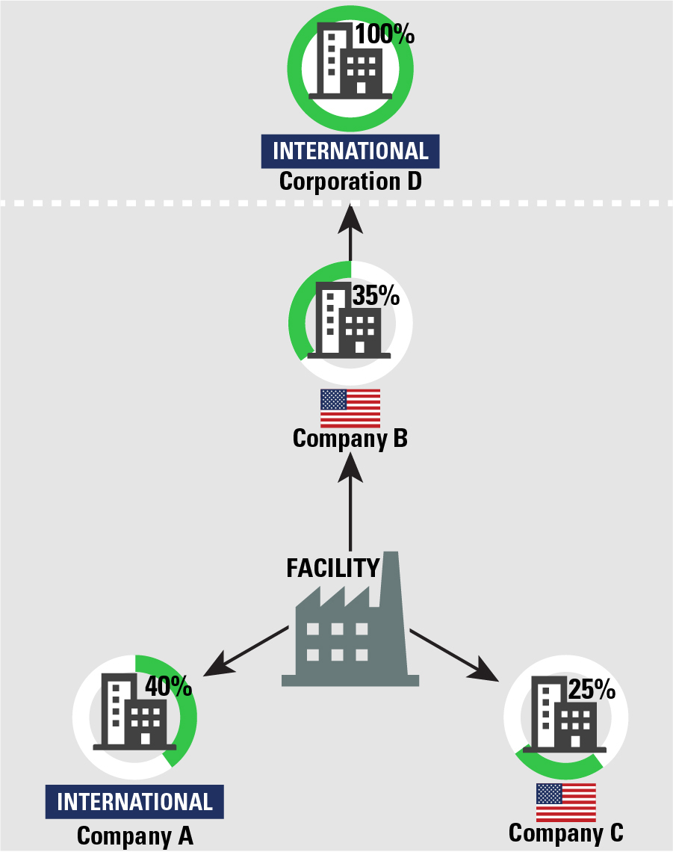

Example 13: Multi-company Ownership Including Foreign Entities
A facility is partially owned by three companies: Company A owns 40%, Company B owns 35%, and Company C owns 25%. Company A is a U.S.-based company, which is a 100% subsidiary of a foreign company, Corporation D. Companies B and C are both foreign companies, neither of which are owned by any other entity.  Corresponding Subpart in Proposed Parent Company Definition: 3  Demonstration of appropriate reporting:  - Facility: Facility Name  - U.S. Parent: Company A  - Foreign Parent: Corporation D  Note that Corporation D, through its ownership of Company A, holds the largest percentage share of foreign ownership in the facility. Corporation D should be reported as the foreign parent. | 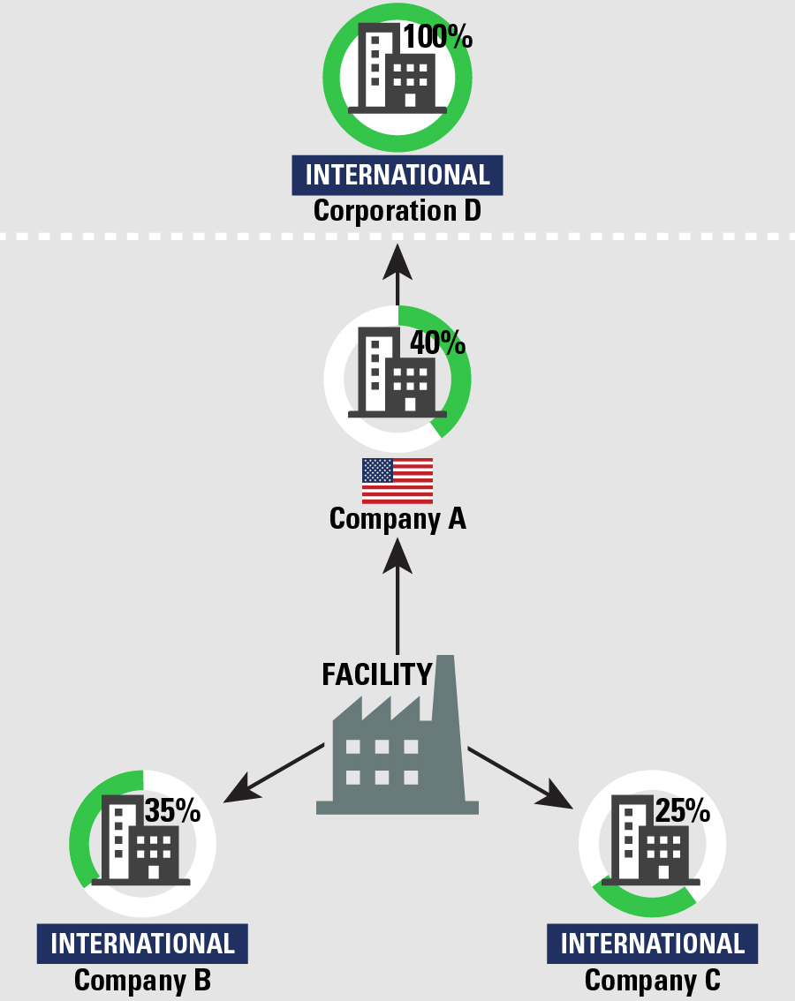

Example 14: U.S. 50-50 Joint Venture Ownership
A facility is owned by a joint venture between two companies, Company A and Company B, both of which own exactly half of the facility. This joint venture is based in the U.S.
Corresponding Subpart in Proposed Parent Company Definition: 4
Demonstration of appropriate reporting:
- Facility: Facility Name
- U.S. Parent: Name of joint venture
- Foreign Parent: NA

Example 15: Foreign 50-50 Joint Venture Ownership
A facility is owned by a joint venture between two companies from different countries, Company A and Company B, both of which own exactly half of the facility. The resulting joint venture is considered to be based outside the U.S.
Corresponding Subpart in Proposed Parent Company Definition: 4
Demonstration of appropriate reporting:
- Facility: Facility Name
- U.S. Parent Company: NA
- Foreign Parent Company: Name of foreign-based joint venture

REFERENCES
US EPA (2020). Toxic Chemical Release Inventory Reporting Forms and Instructions: Revised 2020 Version. Available: www.epa.gov/tri/rfi [Accessed July 2021].

