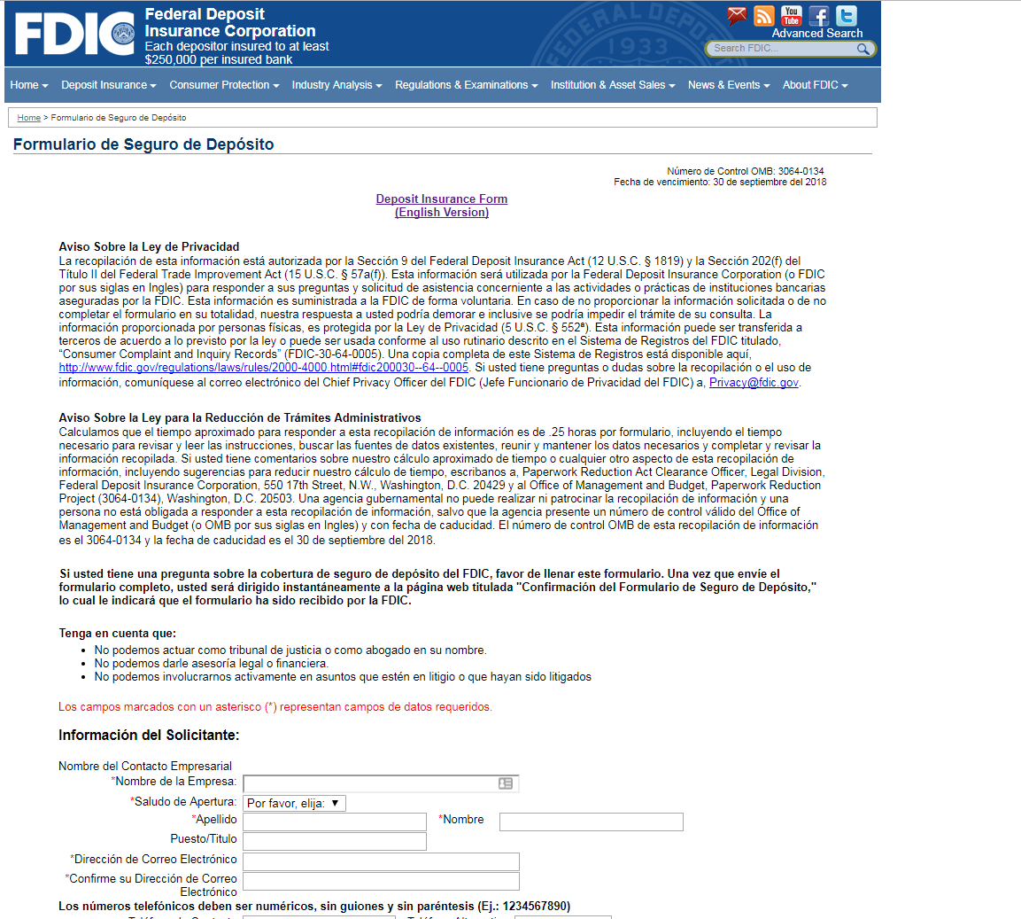
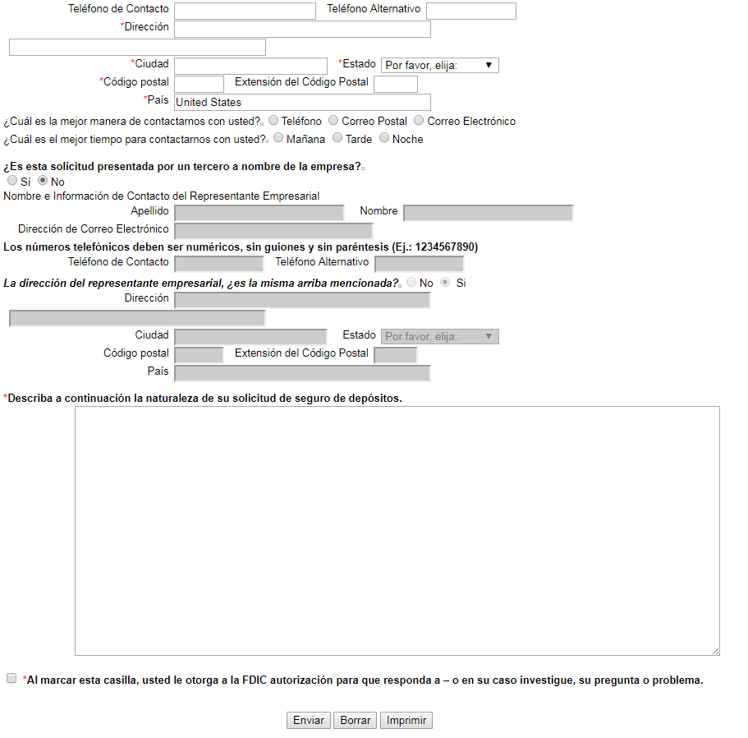
FDIC 6422/15 (8-18) consumeralerts@fdic.gov

