National Science Foundation Research Traineeship (NRT) Program

Coordinator Instrument
Version: Draft
Prepared by CBS and NSF

Table of Contents
1 Table of Contents 2
2 Conventions in this document 3
3 Coordinator Instrument 6
3.1 Name and Contact Information 6

Conventions in this document
The conventions described below are an attempt to render dynamic UI elements and interactive content and behaviors in this static word document.
○ | Radio Button (select one in the group)
□ | Checkbox (select any in the group)
 | Textbox (enter text)
Option 1  Option 2  Option 3 | Dropdown box (Select one)
Searchable list of things | A search box that will narrow the results as the user types, e.g., states and countries
Date Picker | When the user selects the control a date picker will appear. They can also enter the date via the keyboard.
Single Add | As the user types a list of matching values will appear in a dropdown list. The user can click on an entry in the list, and it will be added to the textbox in a pill format. If the string of characters is new the user can hit tab/enter and the new value will also turn into a pill.
Multi Add | Same as Single Add but the user will then be able to enter further values. This is an example:  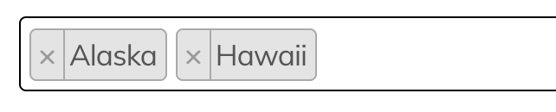
[Button] | A button that performs an action. Added for context around managing lists and final submit
<Information> | Text in angle brackets is inserted by the system and is read-only.
[Read only] | These data are read-only and can only be changed by contacting support.
[Read only after first year] | The data are read-only after the first year. After the first year these data can only be changed by contacting support
[Preloaded] | These data are pre-loaded at the beginning of the reporting period.
[Copied] | These data are copied from the previous year when preparing for a new reporting period.
[Change management] | These data are subject to other rules when they change.
{Skip Ref A-Z} | Indicates that a response to this question affects other questions after it.
{Skip when A-Z} | Indicates that the question should be skipped if the skip reference meets a certain criteria
This is instructional text | Instructions to the respondents

Coordinator Instrument

Name and Contact Information

First Name
Required
Limit 50 characters
[Copied]
[Read only]
[Change management]

Middle Initial or Name
[Copied]
[Read only]
[Change management]

Last Name
Required
Limit 50 characters
[Copied]
[Read only]
[Change management]

Email Address
Required
Limit 200 characters
[Copied]
[Read only]
[Change management]

Phone (xxx-xxx-xxxx)
Required
Limit 10 characters
[Copied]

Extension
Limit 5 characters
[Copied]

