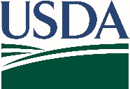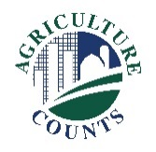

**United States Department of Agriculture**

April 4, 2022

**What should I do next?**

Complete your survey in one of the following ways:

**Online** at [agcounts.usda.gov](http://www.agcounts.usda.gov). ***Online reporting is fast and secure.*** All you need is the survey code on the enclosed form to begin.

By **mail or fax**. Complete the survey and mail it back in the return envelope provided or fax it to 855-415-3687.

**Why am I getting this letter?**

You have been selected to participate in the Conservation Practice Adoption and Motivations(CPAM) survey. This survey is a joint project between USDA’s National Agriculture Statistics Service (NASS) and National Resource Conservation Service (NRCS) aimed at better understanding conservation practice adoption and the role of technical and financial assistance. Please complete the questionnaire at your earliest convenience.

**If we do not receive your completed survey, we may contact you to arrange a telephone interview.**

**How does the survey data affect me?**

Your response is critical to ensure that the data collected accurately represent the conservation practices and programs used by farmers and ranchers across the United States. These data will be used to guide the implementation of NRCS programs in the future.

The information you provide will be used for statistical purposes only. In accordance with federal law, your responses will be kept confidential.

Thank you for participating and for your support of U.S. agriculture. If you have any questions, please contact us at

888-424-7828.

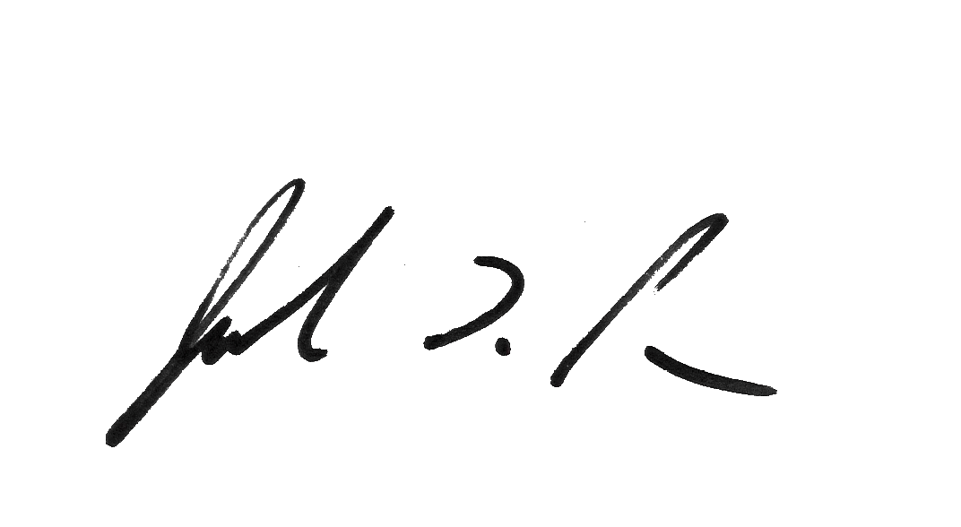

Sincerely,

Joseph L. Parsons

Chair, Agricultural Statistics Board

Enclosure