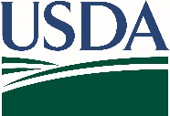
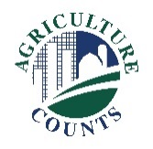
United States Department of Agriculture
National Agricultural Statistics Service

May 2, 2022
What should I do next?
Complete your survey in one of the following ways:
Online at agcounts.usda.gov. Online reporting is fast and secure. All you need is the unique survey code on the enclosed form to begin.

By mail or fax. Complete the questionnaire and mail it back in the pre-paid envelope provided or fax it to 855-415-3687.

Why am I getting this letter?

You should have recently received the Conservation Practice Adoption Motivations survey. If you have completed the survey, thank you. If not, there is still time. This survey is a joint project between USDA’s National Agriculture Statistics Service (NASS) and National Resource Conservation Service (NRCS) aimed at better understanding conservation practice adoption and the role of technical and financial assistance.

If we do not receive your completed survey, we may contact you to arrange a telephone interview.

How do the survey data affect me?

Your response is critical to ensure that the data collected accurately represent the conservation practices and programs used by farmers and ranchers across the United States. These data will be used to guide the implementation of NRCS programs in the future.

The information you provide will be used for statistical purposes only. In accordance with federal law, your responses will be kept confidential and will not be disclosed in identifiable form. We will publish the survey findings in February 2022.

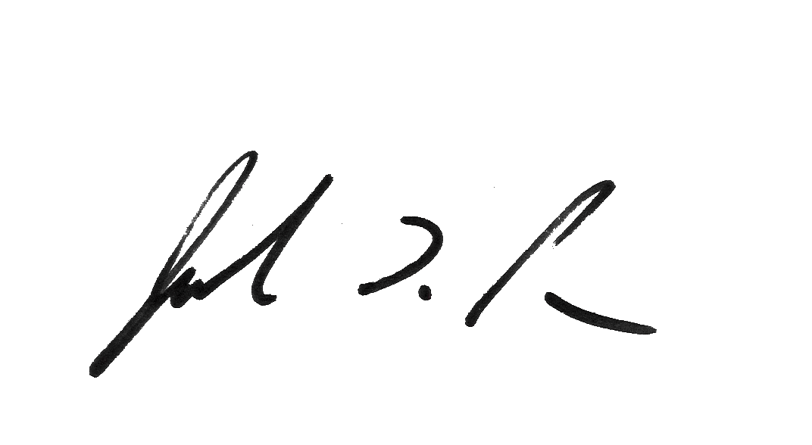
Thank you for participating and for your support of our programs and U.S. agriculture. If you have any questions, please feel free to contact us at (888) 424-7828.
Sincerely,

Joseph L. Parsons
Chair, Agricultural Statistics Board

Enclosure

