Commodity Flow Survey Respondent Login/Welcome Screen
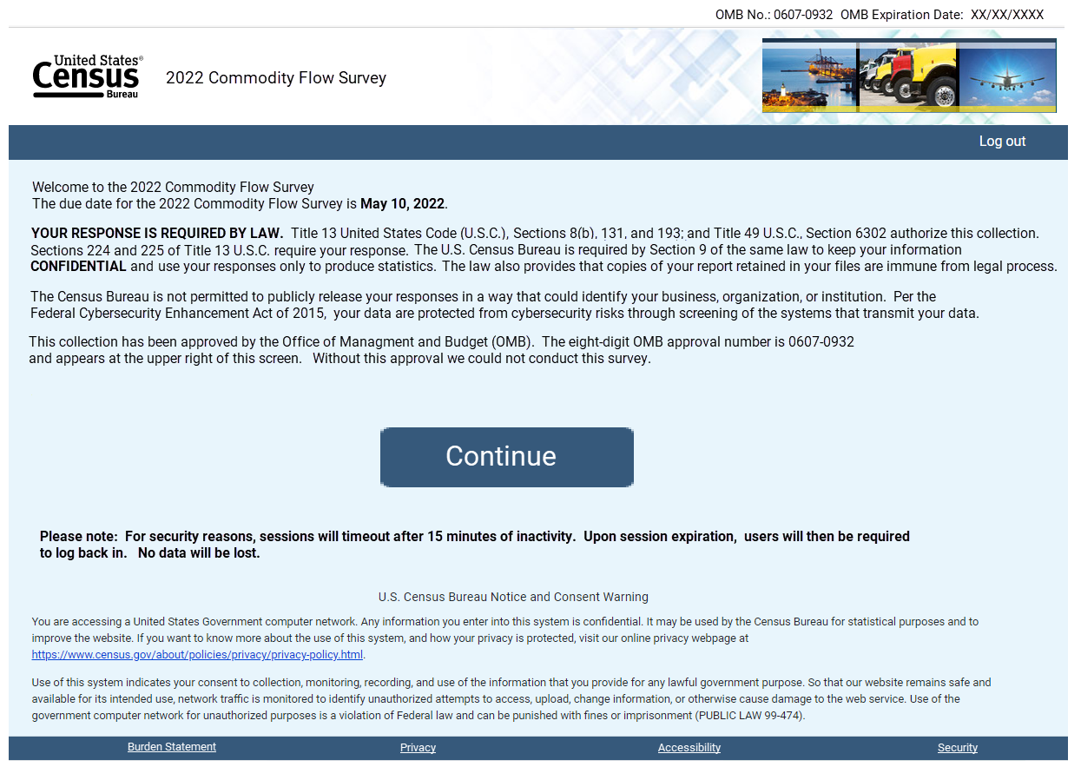

Burden Statement
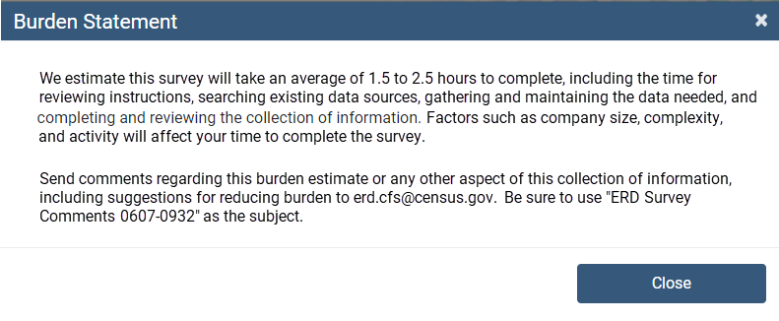

If Individual Location Reporter – Main Menu
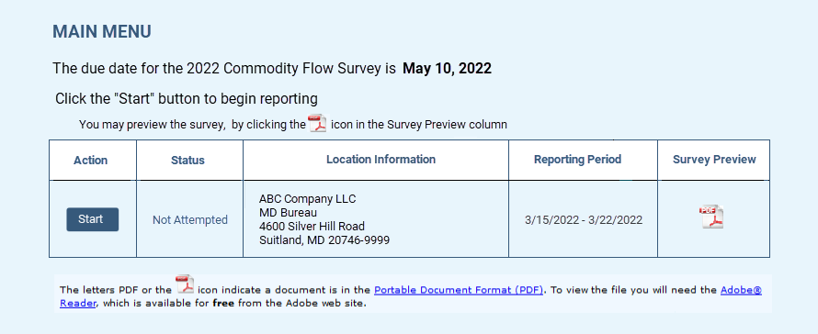

If Company Consolidated Reporter – Reporting Method Option
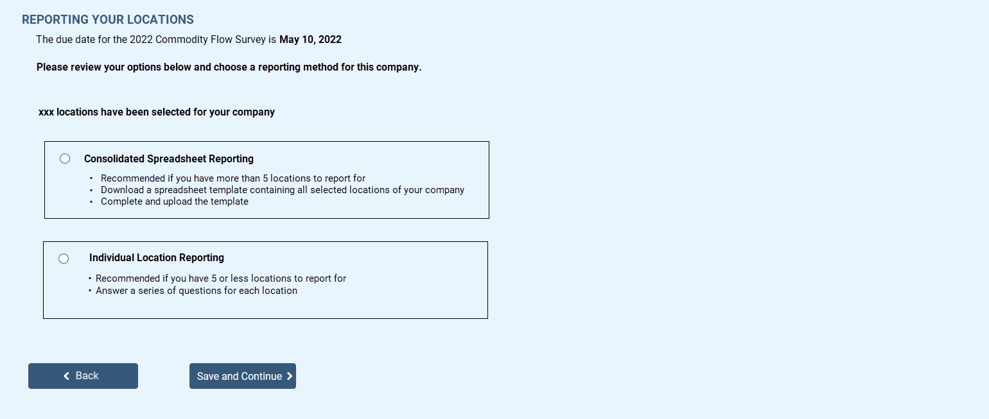

Consolidated Spreadsheet Reporting Option – Main Menu
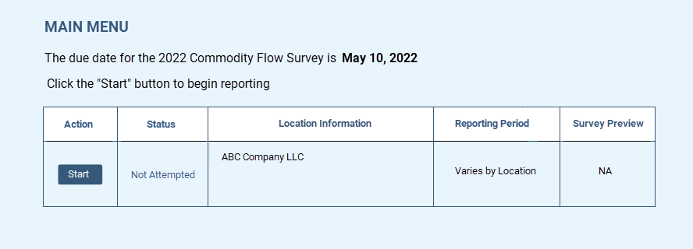
Company Reporting Individual Locations Option – Main Menu
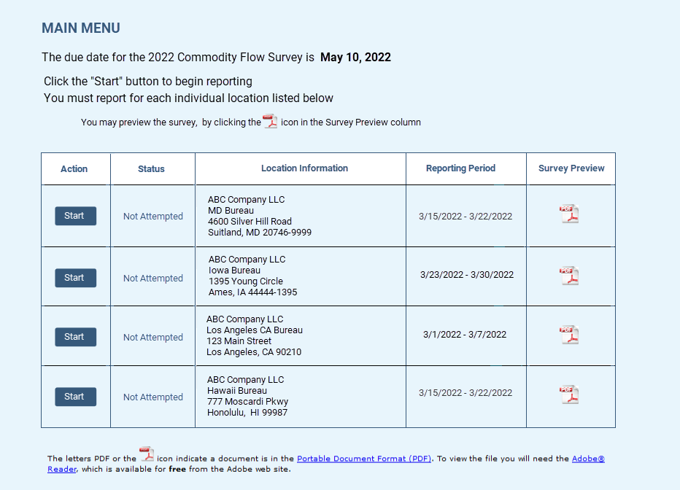

Item A – Company Information – All reporters
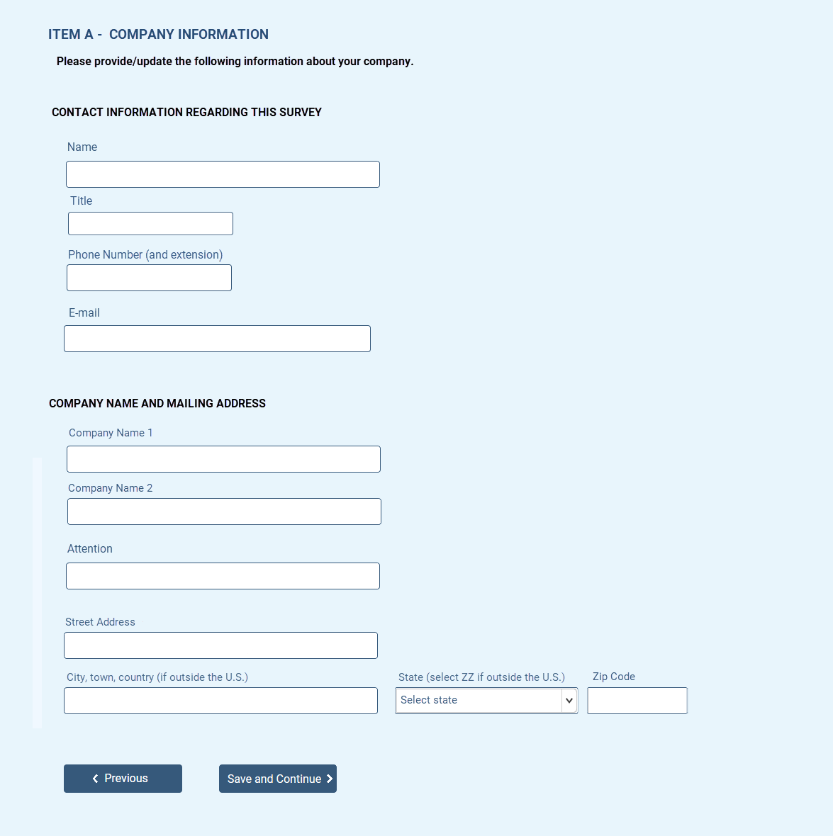

Individual Location Reporter – Item A – Shipping Location Information
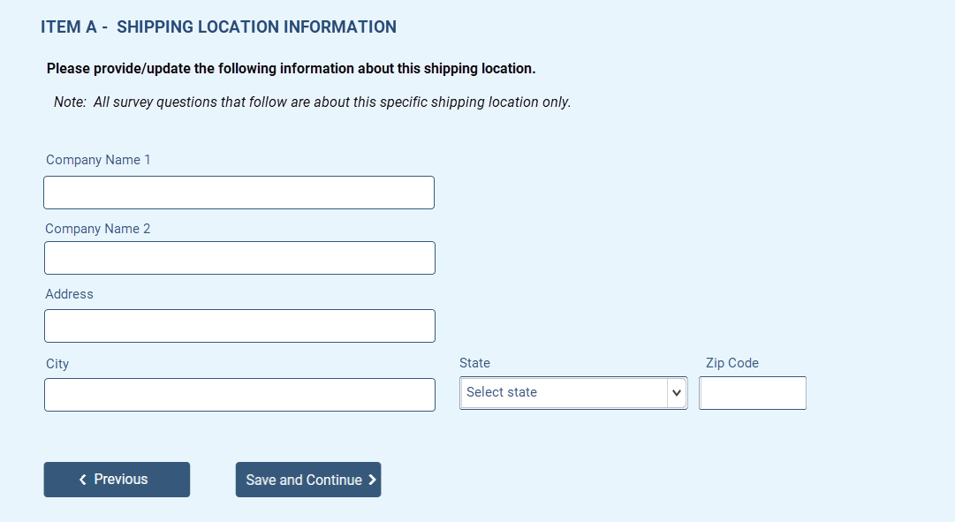

Individual Location Reporter – Item B – 2021 Total Annual Value of Shipments
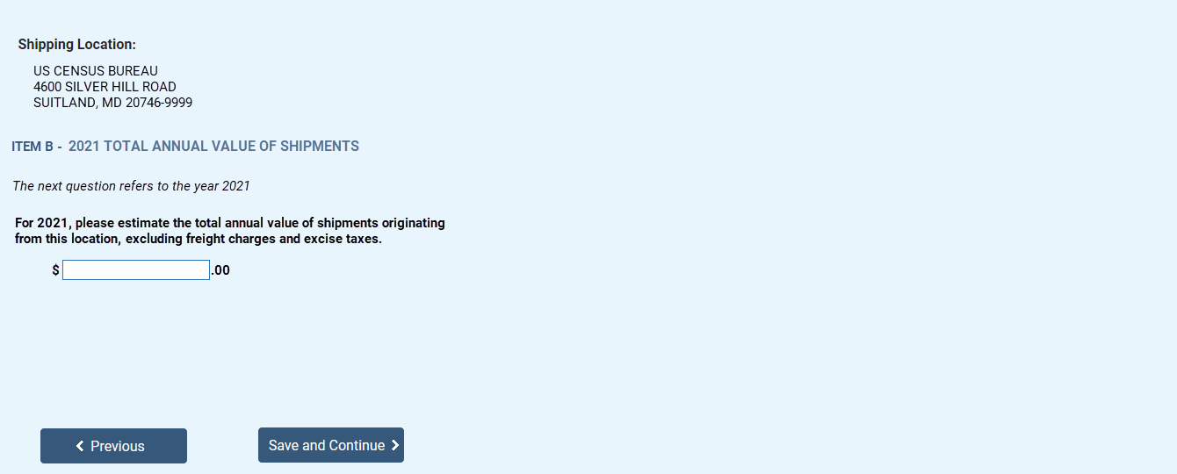

Individual Location Reporter – Item C – Operating Status
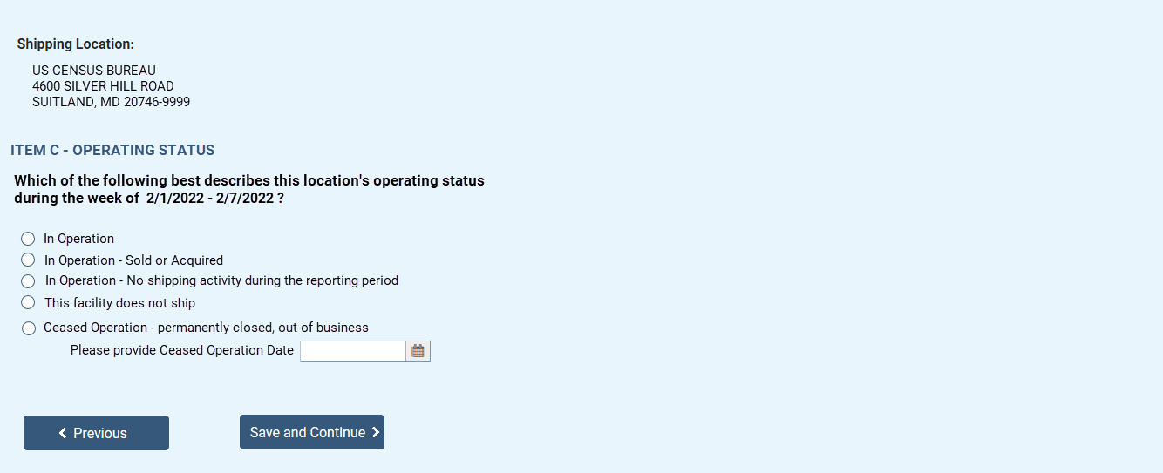

Individual Location Reporter – Item D1 – Shipments from Originating Shipping Location
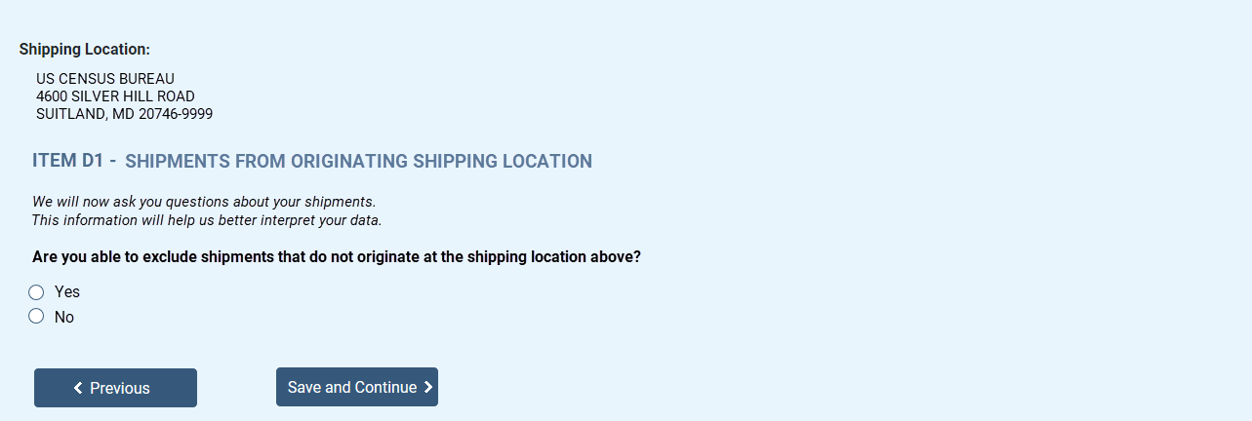
Individual Location Reporter – Item D2 – Total Number and Value of Outbound Shipments
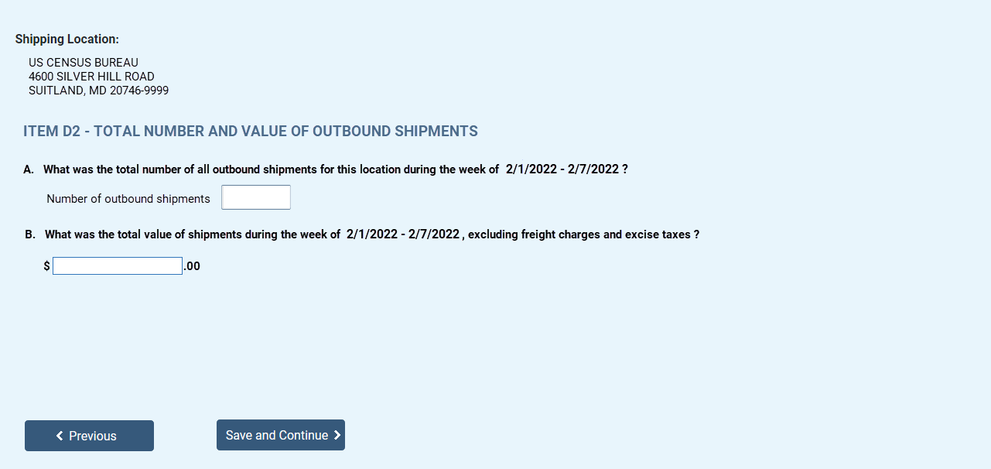

Individual Location Reporter – Item E – Hazardous Materials Supplemental (Item H) Screener Question
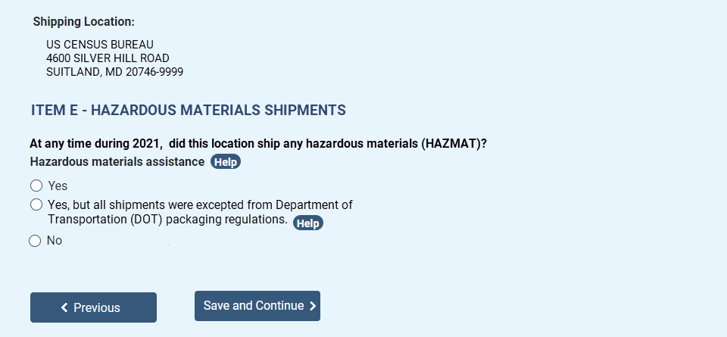

Consolidated Spreadsheet Reporters Only - Verify Shipping Locations Dashboard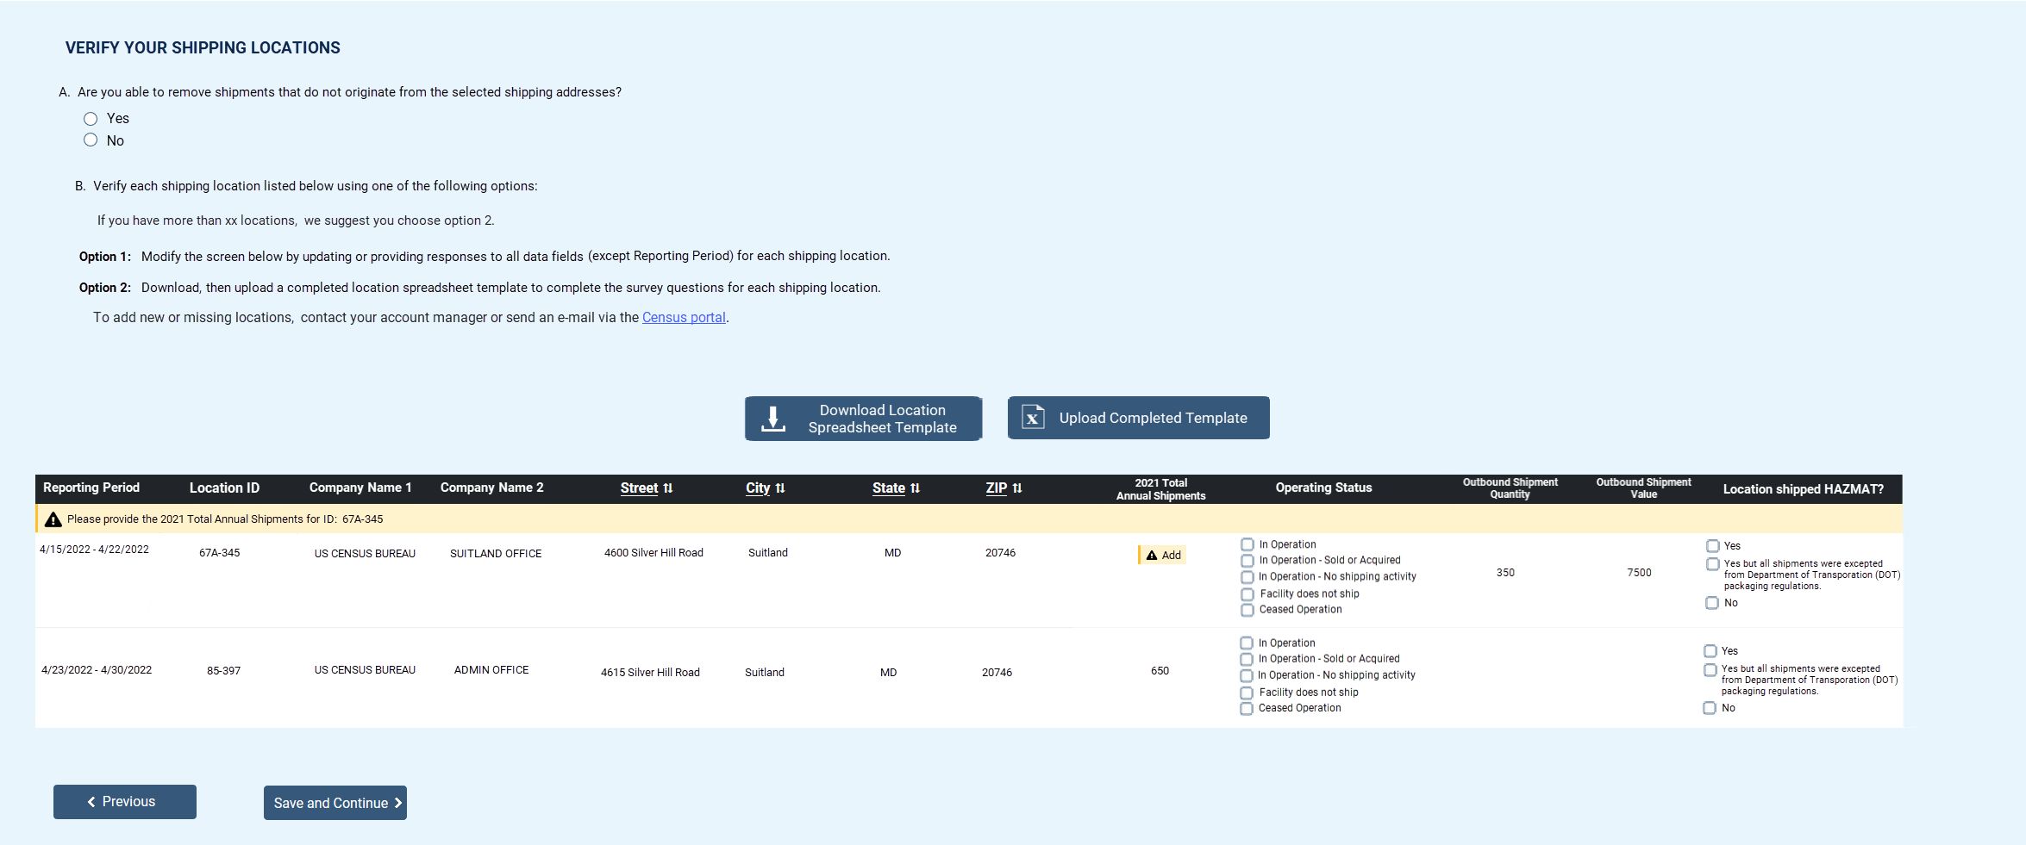

Individual Location Reporting Only – Item F1 – Shipment Reporting Options
If TOTAL_SHIPMENT_QUANTITY < = 40 (reported in Item D2.A)
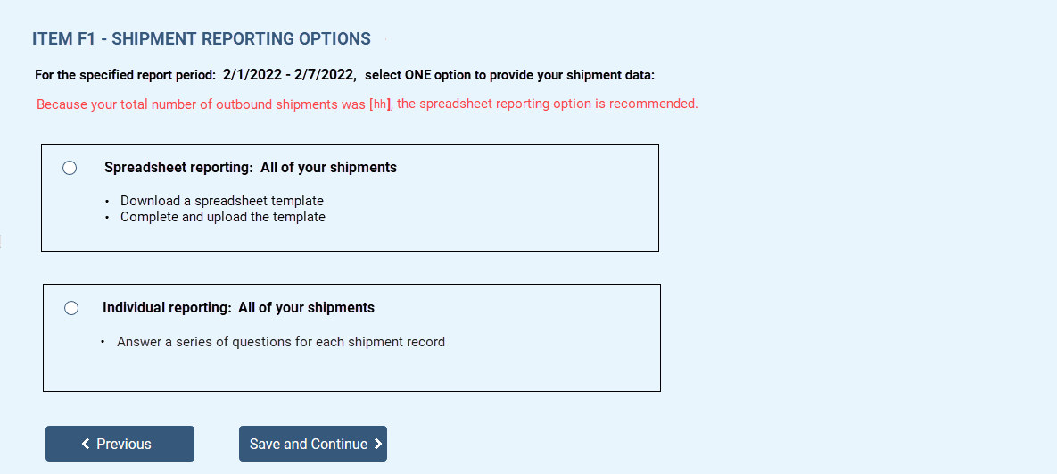
If TOTAL_SHIPMENT_QUANTITY > 40 (reported in Item D2.A)
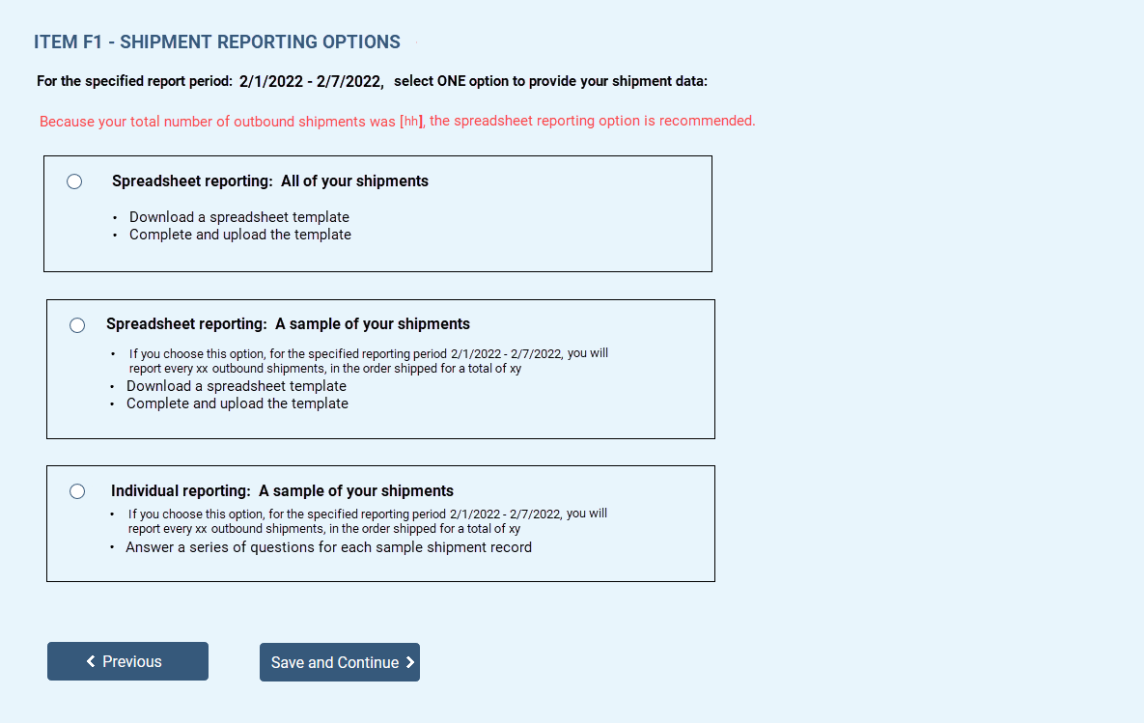

Individual Location Reporting – Item F – Shipment Characteristics Summary Dashboard
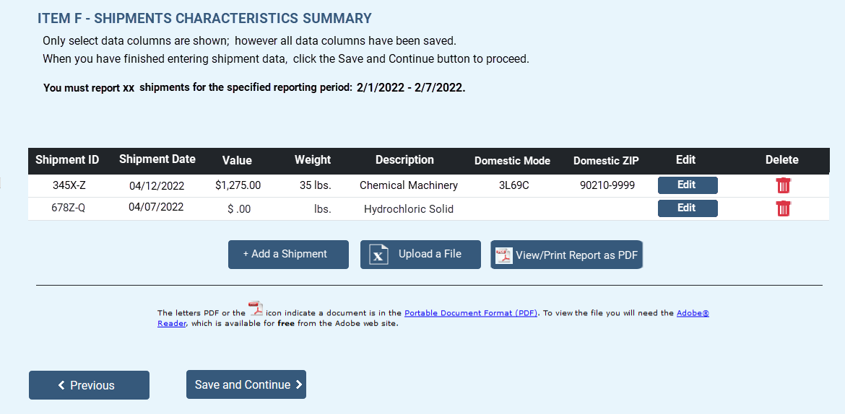

Individual Location Reporting – Item F3 – Shipment Characteristics (displays on the dashboard, previous screen, with each additional shipment)
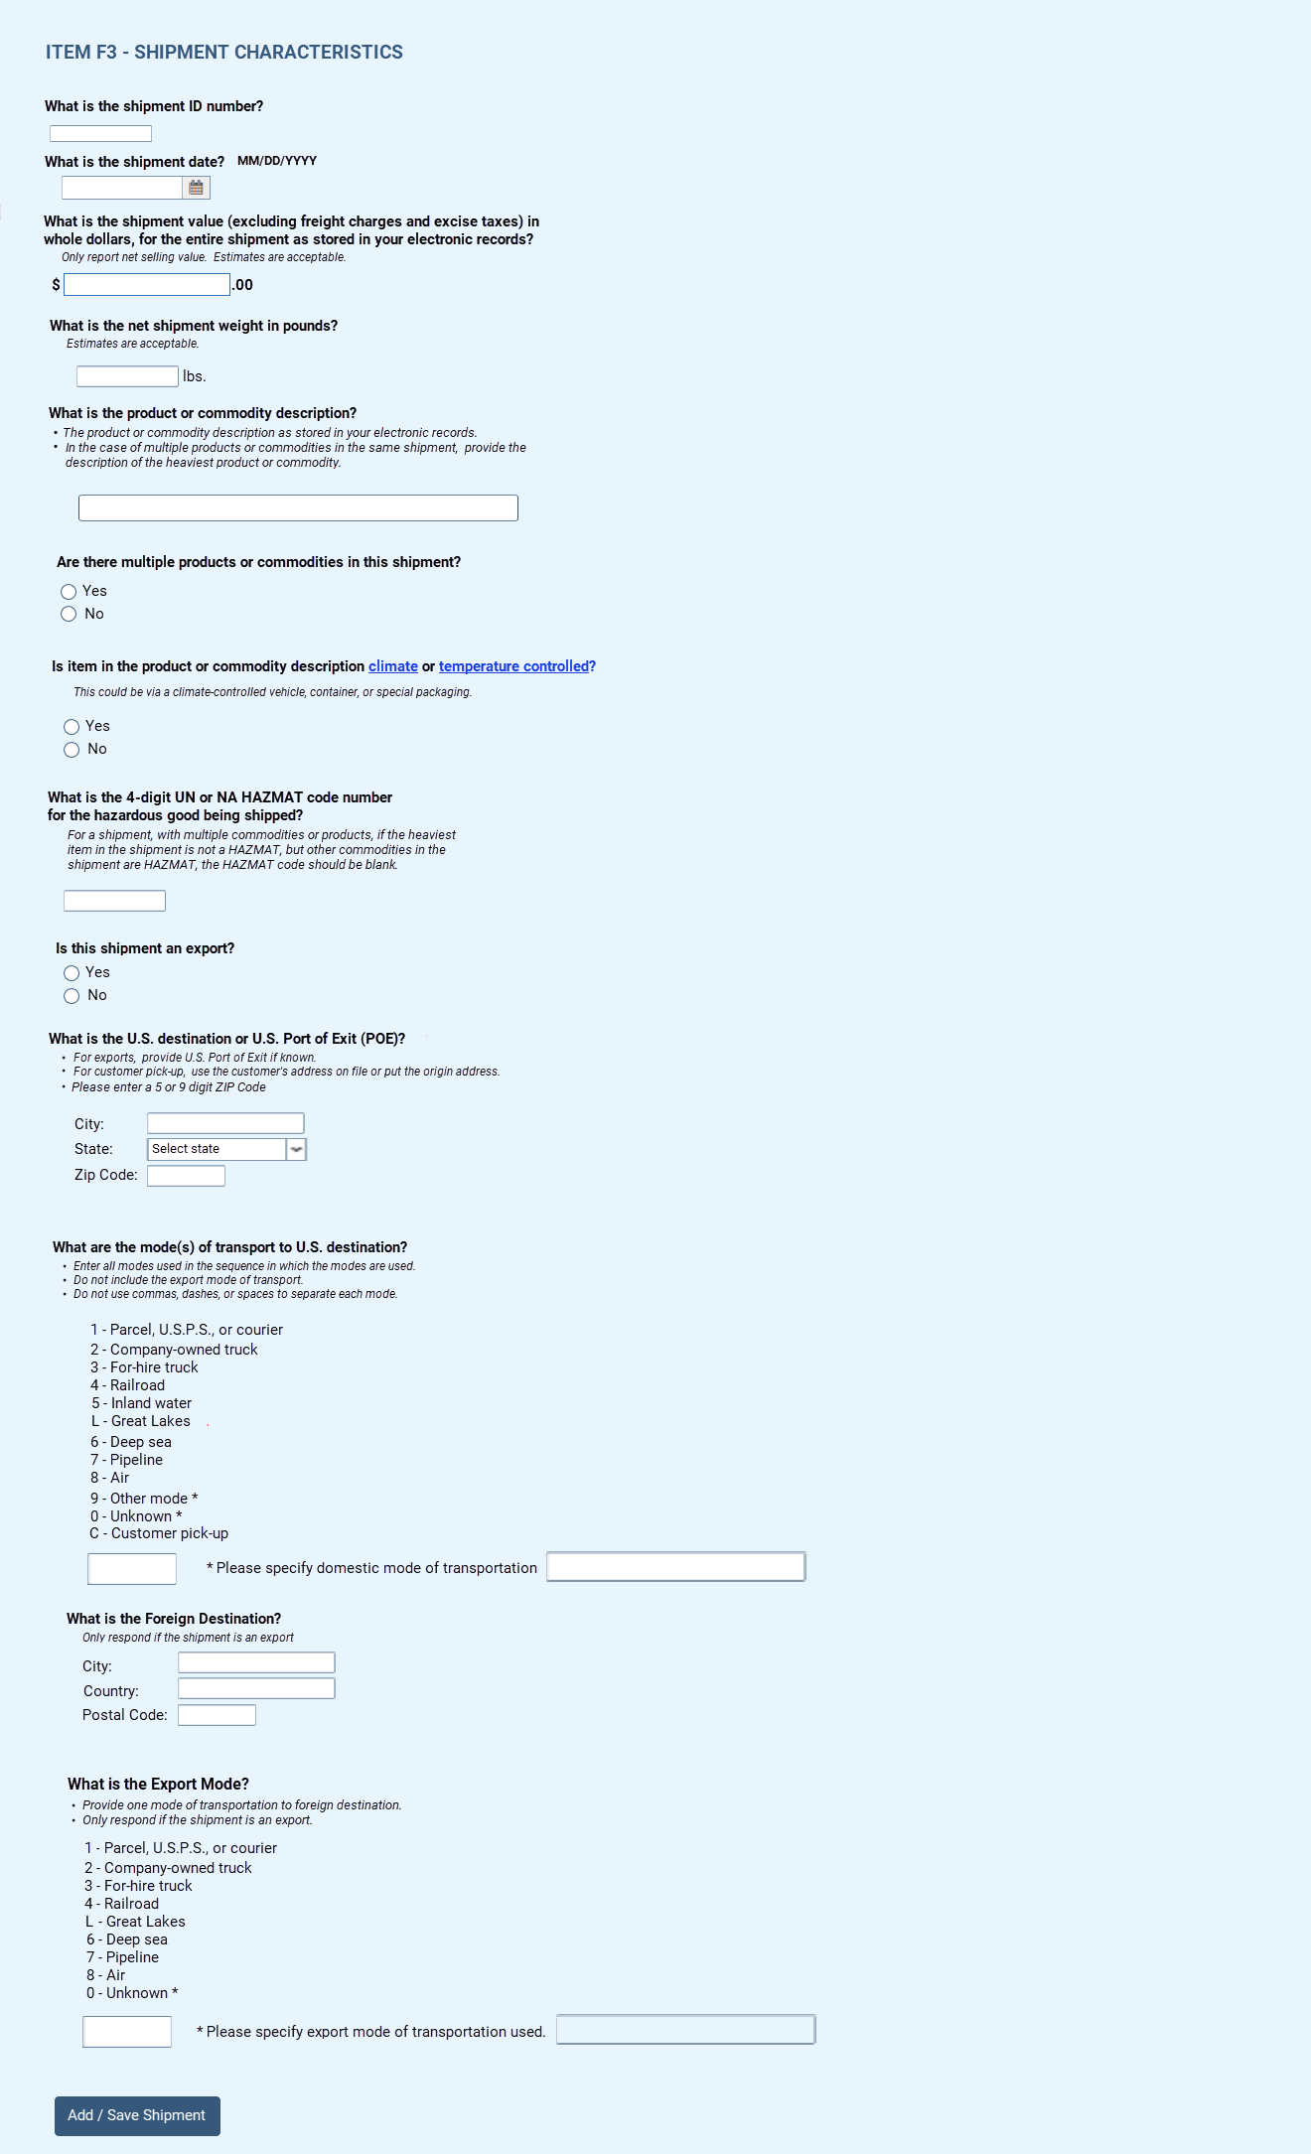

Consolidated and/or Individual Location Spreadsheet Reporting only
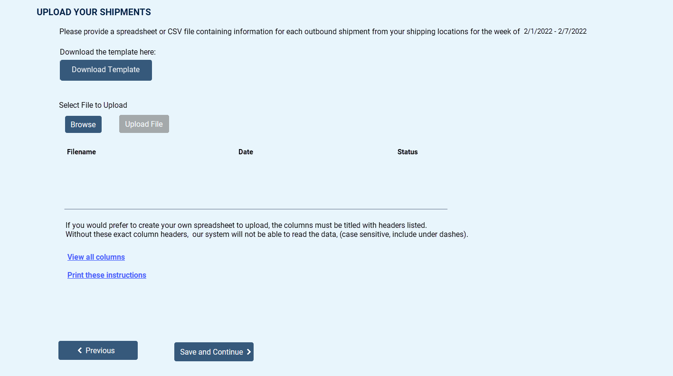

Item G1 – Shipment Validation Screen for Consolidated and/or Individual Location Spreadsheet Reporting only
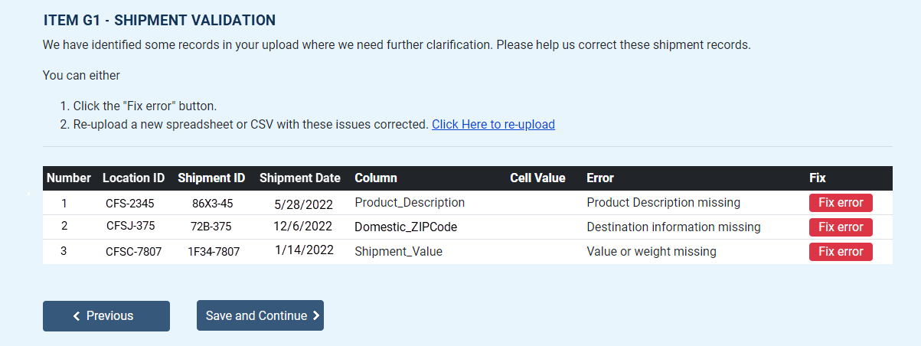
Item G2 – Shipment Product Code Validation
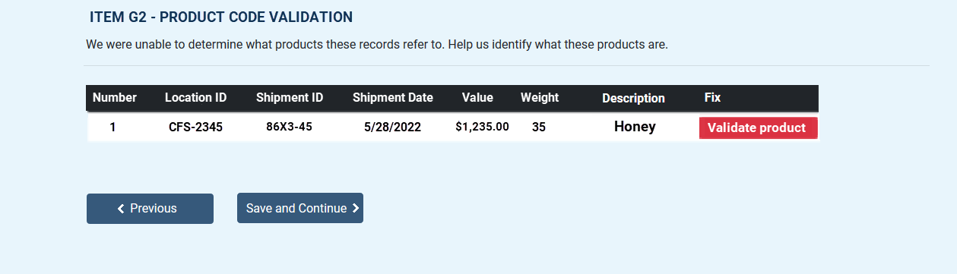

Consolidated Reporting only – Survey Reporting Follow Up Screen for the Hazardous Materials Supplemental Questions
(if reported Item E = yes)
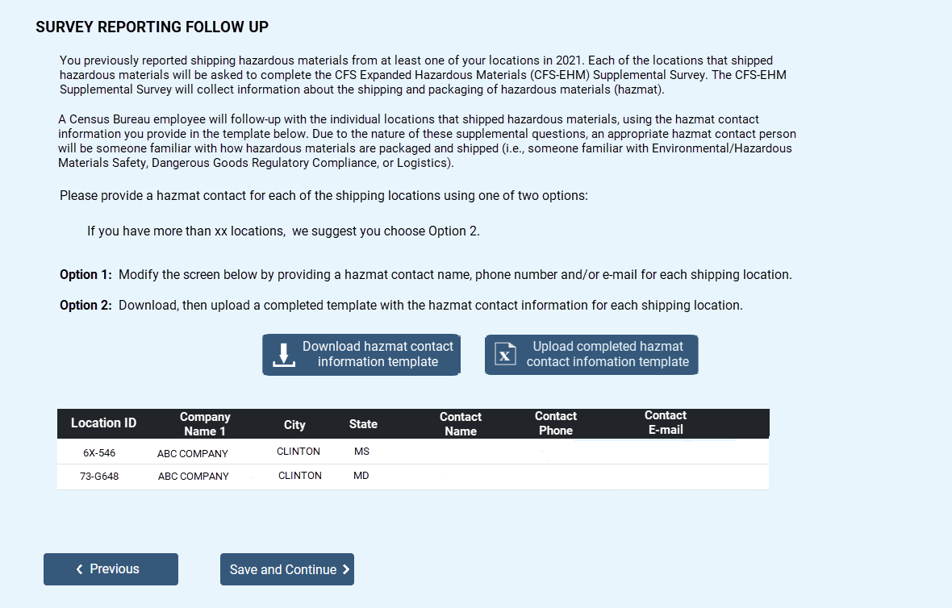

Individual Location Reporting only
Item H1 – Hazardous Materials Supplemental Questions
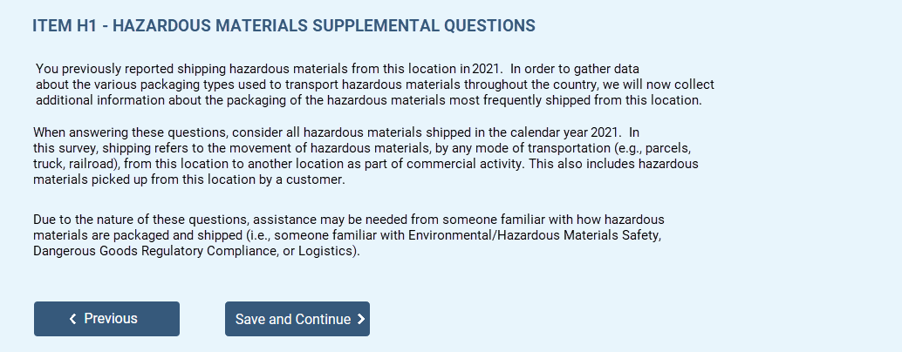

Item H2 – Hazardous Materials Shipments: Listing
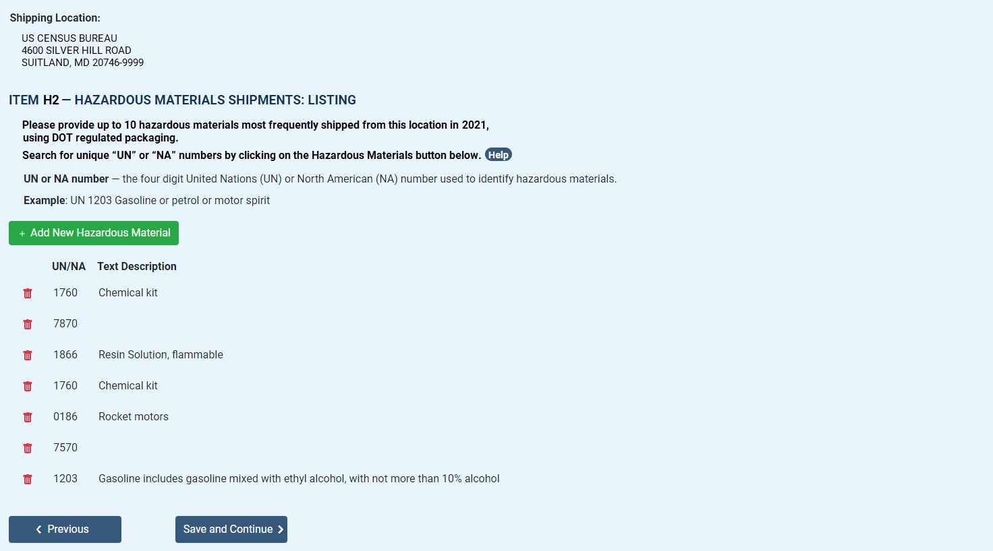

Item H3 – UN/NAs Frequently Shipped
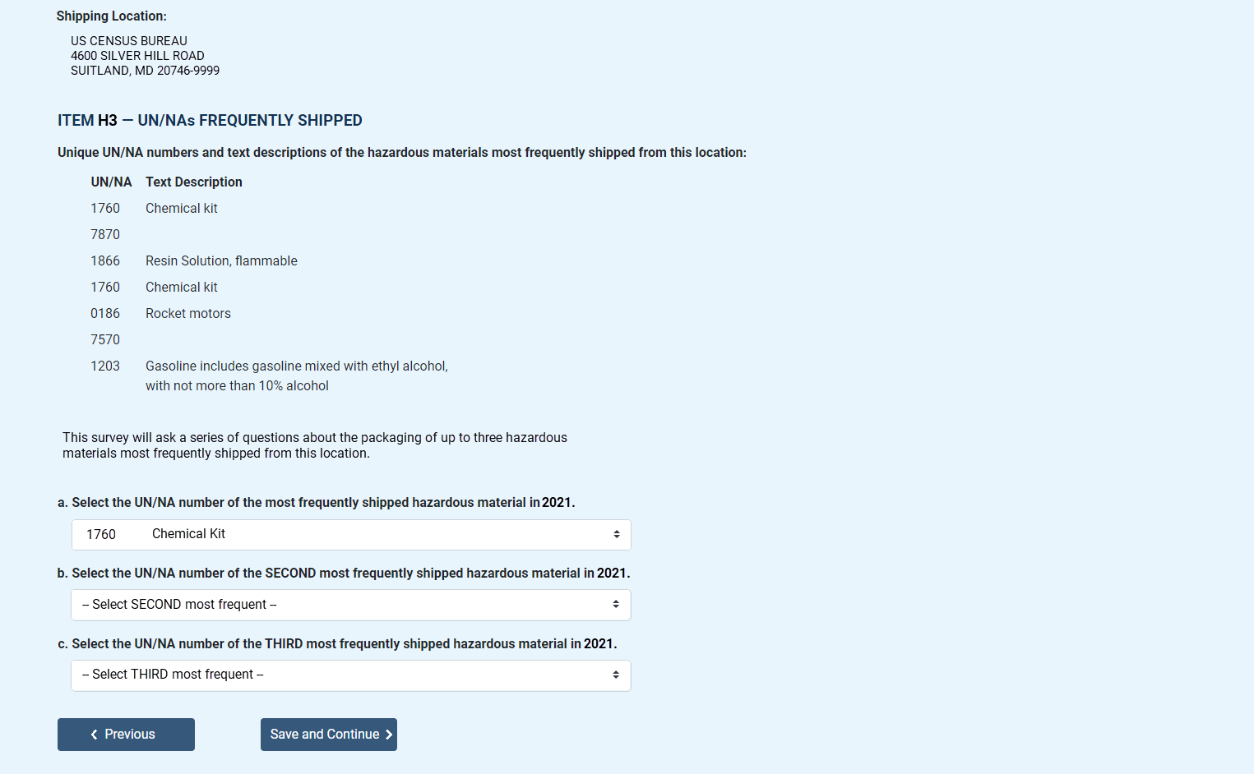
Item H4 – Total Unique UN/NA Numbers
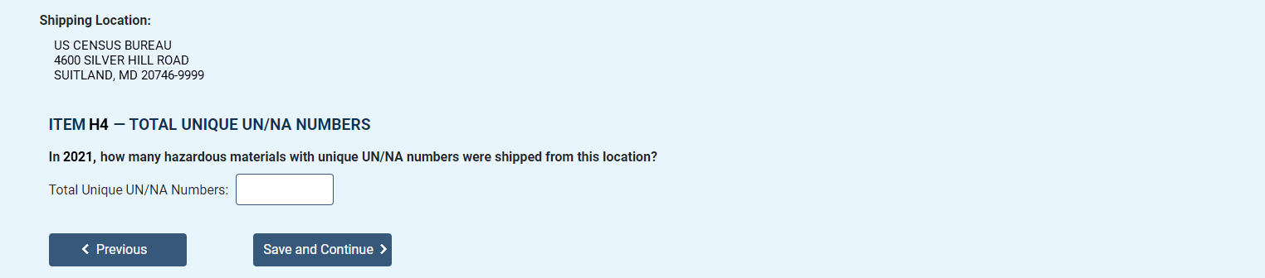
Item H5 – UN/NA Outer Packaging
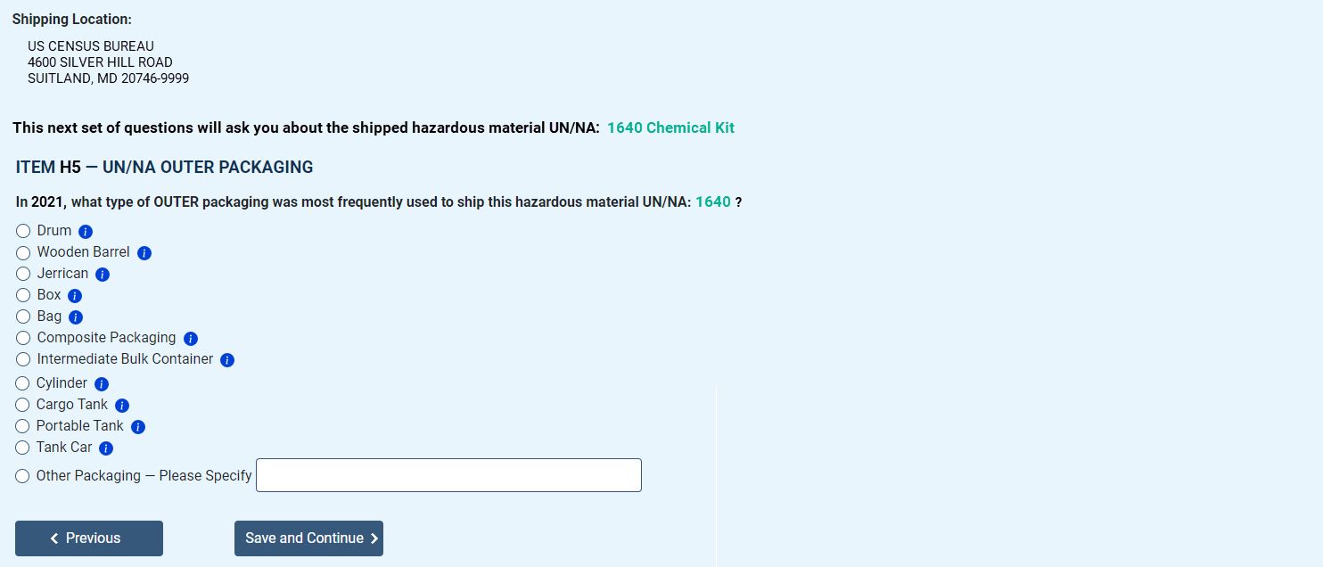

Item H6 – Hazardous Materials Shipments: Performance Oriented Packaging
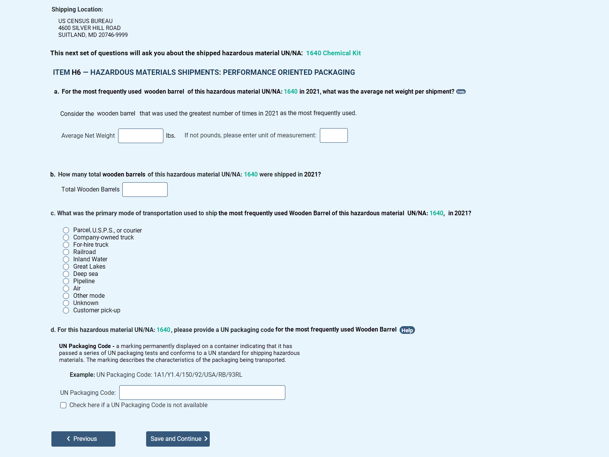

Item H6 – Hazardous Materials Shipments: Specification Packaging
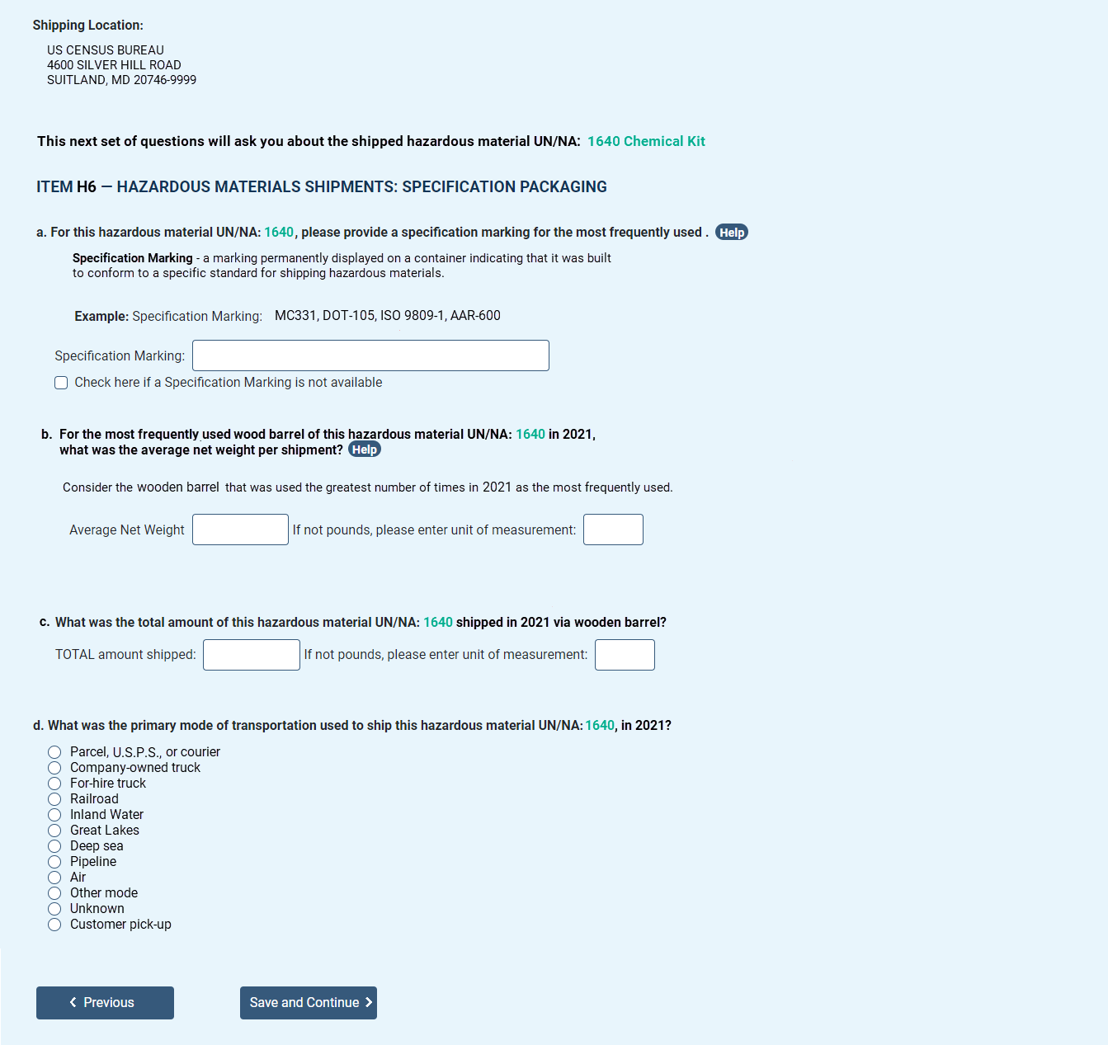

Item H7 – Hazardous Materials Shipments: Packaging Type and Material
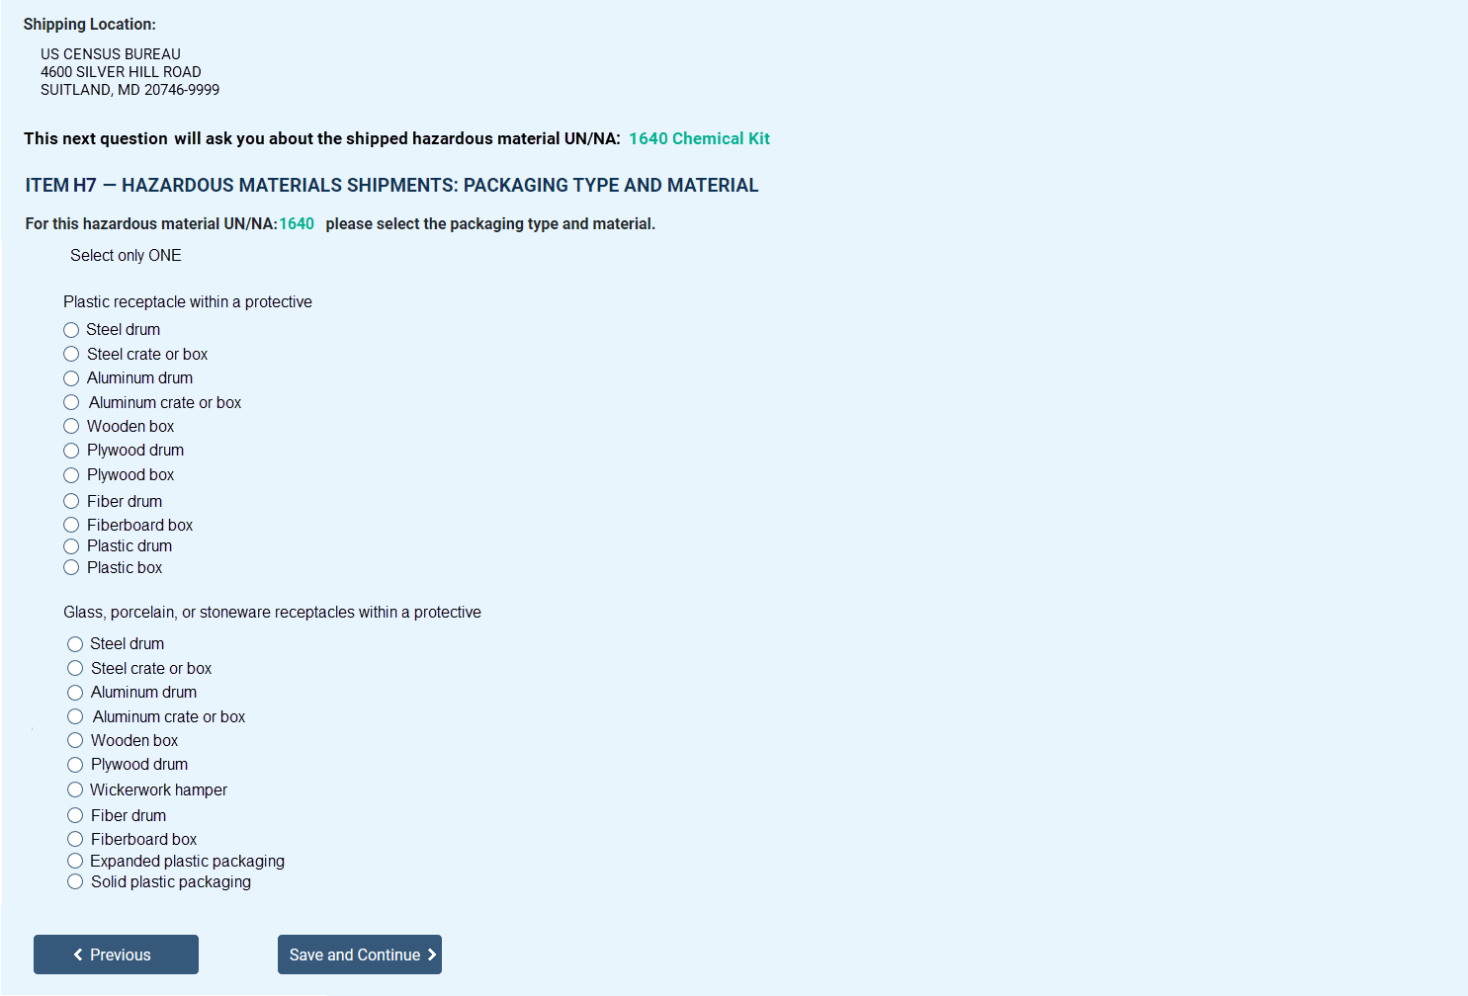

Item I – Time to Complete Survey
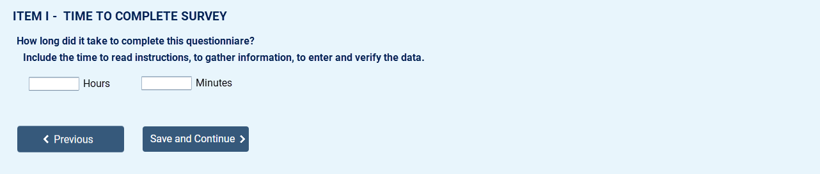

Item J - Remarks

Submission Confirmation Screen
