ITEM E: HAZMAT_SHIPMENTS & ITEM H2: HAZMAT_DESCRIPTIONS
Hazardous material (hazmat) – a substance or material that the Secretary of Transportation has determined is capable of posing an unreasonable risk to health, safety, and property when transported in commerce, and has designated as hazardous under section 5103 of Federal hazardous materials transportation law (49 U.S.C. 5103).

For additional information about classifying hazardous materials, please refer to the Department of Transportation’s Check the Box website: CheckTheBox.dot.gov. This website provides guidance on the classification and shipping of hazmat.

Common hazardous materials from CheckTheBox.dot.gov.
- Aerosol spray receptacles (e.g., household cleaners, disinfectants, hairspray, spray paint)  - Airbags and airbag inflators  - Alcohols (e.g., rubbing alcohol, high-proof spirits)  - Ammunition and gun powders  - Bleaches  - Camping equipment (e.g., camping stove, kerosene lanterns)  - Car batteries  - Carbon dioxide canisters and cylinders  - Consumer electronics with lithium batteries (e.g., cell phones, laptops) | - Dry ice  - Essential oils (flammable)  - Fertilizer compounds and ammonium nitrate fertilizers  - Fire extinguishers  - Fireworks – consumer and novelty  - Fragrances (e.g., perfumes and colognes)  - Fuels (e.g., gasoline, diesel fuel, propane, kerosene)  - Fuel-powered equipment (containing fuel)  - Hand sanitizer  - Inks (flammable)  - Insecticides and pest control products  - Lighters and matches | - Lithium batteries, including portable chargers and power banks  - Mercury and articles that contain mercury  - Nail polish and nail polish remover  - Oxygen tanks (medical and recreational)  - Paints  - Paint thinners and removers  - Refrigerant gases (e.g., liquid nitrogen or carbon dioxide)  - Scuba tanks  - Smoke detectors  - Swimming pool chemicals  - Wood treatment products (e.g., sealants, stains, varnishes)
This is not a comprehensive list of hazardous materials. Locate the Safety Data Sheet (SDS) prepared by the manufacturer to determine whether a consumer product is hazmat. Contact the Hazardous Materials Information Center by telephone at 1-800-467-4922 or by e-mail at infocntr@dot.gov for additional compliance assistance.
Ship - In this survey, shipping hazardous materials refers to the movement of a hazardous material from the location address specified to another location.

Shipments to Include:
- Any hazardous material picked up by the customer (“customer pick-up”)
- Only those hazardous material shipments that were sent from the shipping location listed
- Hazardous material shipments made from the shipping location listed on behalf of another establishment (Drop-Shipments)
- Hazardous material shipments of all sizes, by any mode of transportation (e.g., parcels, truck, railroad)
- Any shipment of hazardous materials from this shipping location to another location of the company that are intended for sale (e.g., hazardous material moved from this location to a company warehouse)

Shipments to Exclude:
- Drop-shipments, made from another location other than the shipping location listed
- Hazardous waste, unless this location is in the business of selling these materials
- Items moved from this location to another location of the company if not intended for commercial activity

ITEM E: HAZMAT_SHIPMENTS (precode 2)

This option may apply to you if you ship hazardous materials that are excepted from the packaging requirements in the Hazardous Materials Regulations (HMR). Your exception may be due to the hazard class, or because you are shipping in limited or small quantities. Waivers of specific requirements of the HMR may also be authorized by Special Permits or Approvals issued in writing from the US Department of Transportation.
This survey is specifically concerned with packaging referred to as UN Standard Packaging or Specification Packaging. This type of packaging will bear markings that indicate that the packaging has successfully passed required performance tests or has been built to a specific standard (e.g. UN, DOT, AAR). If you fall into the excepted category some of the questions in this survey may not apply.
For more information regarding the authorized packagings for hazardous material shipments, you may refer to the Hazardous Materials Table in Title 49 of the Code of Federal Regulations (see Electronic Code of Federal Regulations (eCFR) 49 CFR § 172.101).
ITEM H5: OUTER_PACKAGING

Packaging - a receptacle and any other components or materials necessary for the receptacle to perform its containment function. In the case of combination packaging, or packaging consisting of one or more inner packagings secured in a non-bulk outer packaging, report the outer packaging type only.

Packaging Type | Examples
Drum - a flat-ended or convex-ended cylindrical packaging made of metal, fiberboard, plastic, plywood, or other suitable materials. This definition also includes packagings of other shapes made of metal or plastic (e.g., round taper-necked packagings or pail-shaped packagings) but does not include cylinders, jerricans, wooden barrels or bulk packagings. | 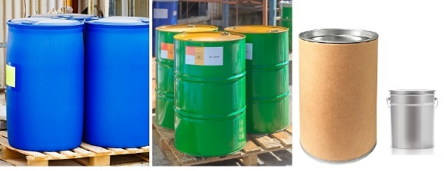
Wooden Barrel - a packaging made of natural wood, of round cross-section, having convex walls, consisting of staves and heads and fitted with hoops. | 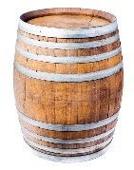
Jerrican - a metal or plastic packaging of rectangular or polygonal cross-section. | 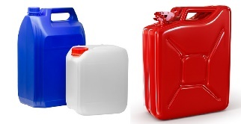
Box - a packaging with complete rectangular or polygonal faces, made of metal, wood, plywood, reconstituted wood, fiberboard, plastic, or other suitable material. | 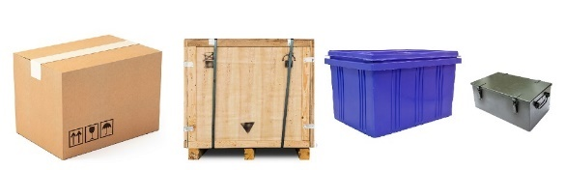
Bag - a flexible packaging made of paper, plastic film, textiles, woven material or other similar materials. | 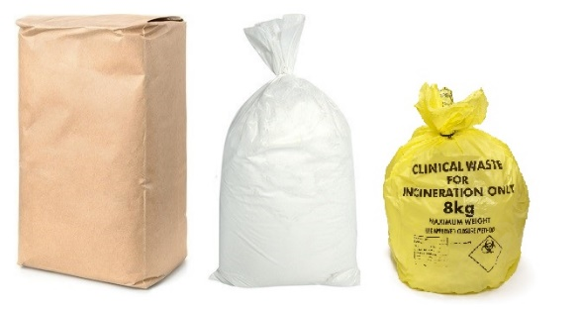
Composite Packaging - a packaging consisting of an outer packaging and an inner receptacle, so constructed that the inner receptacle and the outer packaging form an integral packaging. Once assembled it remains thereafter an integrated single unit; it is filled, stored, shipped and emptied as such. | 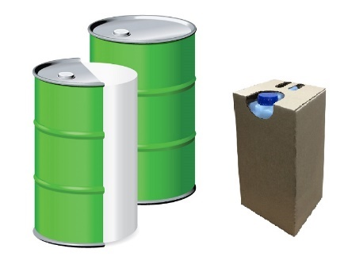
Intermediate Bulk Container – (also known as an IBC tote or IBC tank) is a rigid or flexible portable packaging, other than a cylinder or portable tank, which is designed for mechanical handling. | 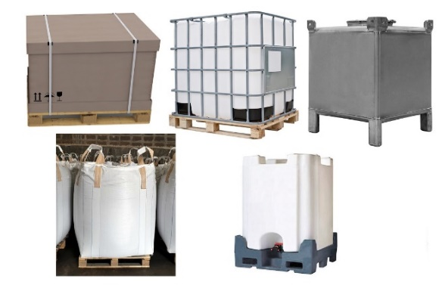
Cylinder - a pressure vessel designed for pressures higher than 40 psia and having a circular cross-section. It does not include a portable tank, multi-unit tank car tank, cargo tank, or tank car. | 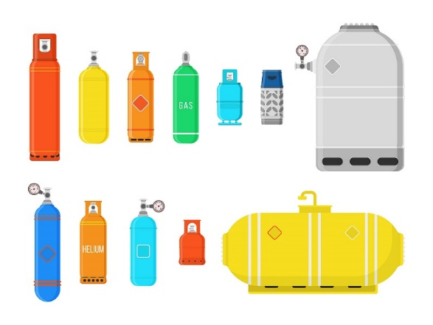
Cargo tank - a bulk packaging that:  (1) Is a tank intended primarily for the carriage of liquids or gases and includes appurtenances, reinforcements, fittings, and closures;  (2) Is permanently attached to or forms a part of a motor vehicle, or is not permanently attached to a motor vehicle but which, by reason of its size, construction or attachment to a motor vehicle is loaded or unloaded without being removed from the motor vehicle; and  (3) Is not fabricated under a specification for cylinders, intermediate bulk containers, multi-unit tank car tanks, portable tanks, or tank cars. | 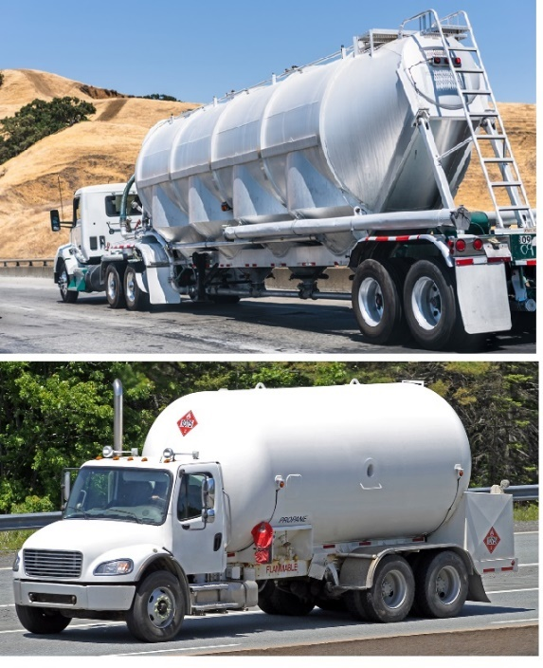
Portable tank - a bulk packaging (except a cylinder having a water capacity of 1000 pounds or less) designed primarily to be loaded onto, or on, or temporarily attached to a transport vehicle or ship and equipped with skids, mountings, or accessories to facilitate handling of the tank by mechanical means. It does not include a cargo tank, tank car, multi-unit tank car tank, or trailer carrying 3AX, 3AAX, or 3T cylinders. | 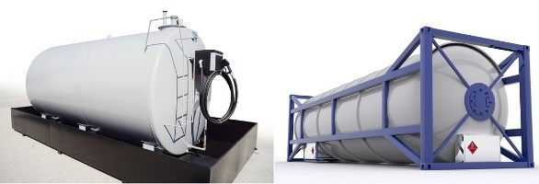
Tank Car - a railcar that has a tank for its body for transporting liquids, solids, and liquefied gases, consisting of a shell and heads together with connections welded directly to it. | 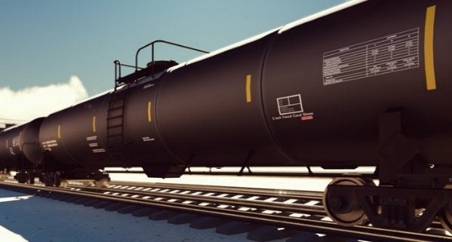

ITEM H6A: POP_PACKAGING

Consider the packaging used the greatest number of times as the one most frequently used, this may or may not be the packaging containing the highest quantity of the hazardous material. For example, if you shipped a 55 gallon drum of a hazardous material 10 times and a 110 gallon drum 8 times, the 55 gallon drum is the most frequently used drum. We are interested the weight of the hazardous material contained within the 55 gallon drum.

ITEM H6D: POP_PACKAGING
UN Packaging Code – a marking permanently displayed on a container indicating that it has passed a series of UN packaging tests and conforms to a UN standard for shipping hazardous materials. The marking describes the characteristics of the packaging being transported.
Sample UN Packaging Code Markings
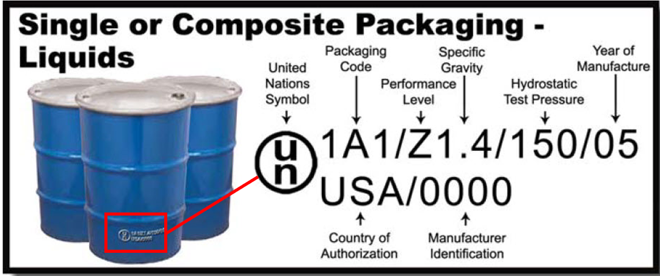
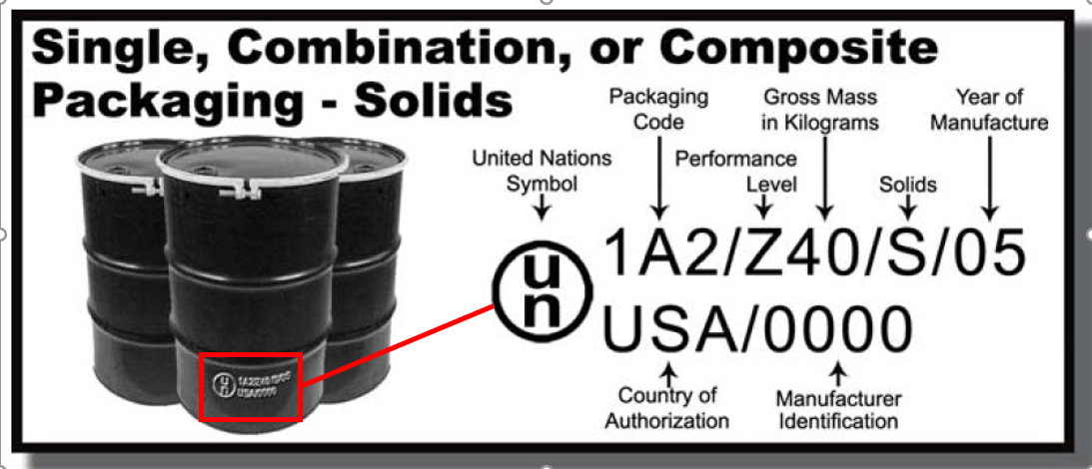
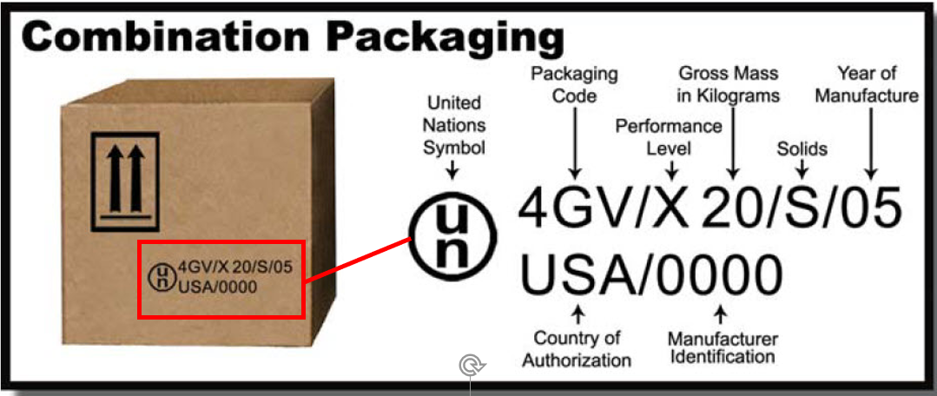
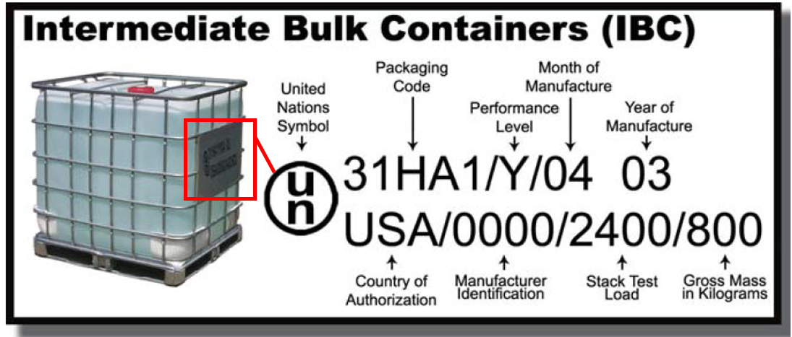

Click below, for additional information on Performance Packaging Codes:

Performance Packaging Codes.pdf

This guide provides information associated with performance packaging as identified in 49 CFR, Part 178. It provides sample markings, codes, tests, approximate conversion factors, and definition of packing group associated with packaging used for hazardous materials shipments.

ITEM H6A: SPEC_PACKAGING
Specification Marking - a marking permanently displayed on a container indicating that it was built to conform to a specific standard for shipping hazardous materials.
Sample Specification Markings
Cylinder - Specification numbers are marked on the container. Examples: DOT 3AA, ISO 9809-1
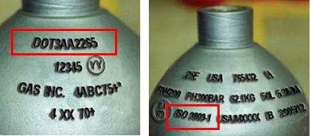
Cargo Tank –Specification numbers are marked on a metal plate permanently attached to the left side of the tank (plates will be found on the right side for tanks built before July 1, 1985).
Examples: DOT 406, MC 331, TC 312
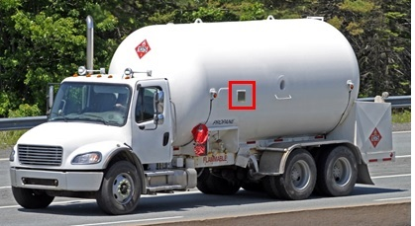

Portable Tank – Specification numbers are marked either on the portable tank itself or on a metal plate firmly secured to the portable tank. Examples: AAR 600, DOT 51, IM 101, T11
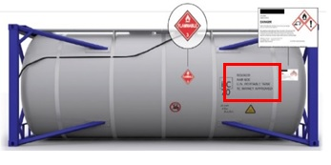
Tank Car – Specification numbers are stenciled directly on the heads and sides of the tank. Examples: DOT 111, TC 117, AAR 204
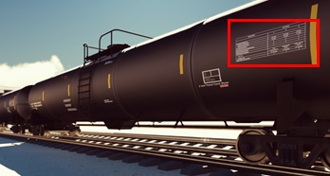

ITEM H6B: SPEC_PACKAGING

Consider the packaging used the greatest number of times as the one most frequently used, this may or may not be the packaging containing the highest quantity of the hazardous material. For example, if you shipped a hazardous material in a 2,800 gallon cargo tank 10 times and a 7,500 gallon cargo tank 8 times, the 2,800 gallon cargo tank is the most frequently used cargo tank. We are interested in the weight of the hazardous material contained within the 2,800 gallon cargo tank.

