TAPS Parent Survey

https://atest-cawi.norc.org/SE/?st=tT6ZyQXGSUPJJlEXsokurzrRHCUan5QFbLiKcBk24ME%3d&tui=auto&nocookie=1

[DISPLAY – WINTRO_1]
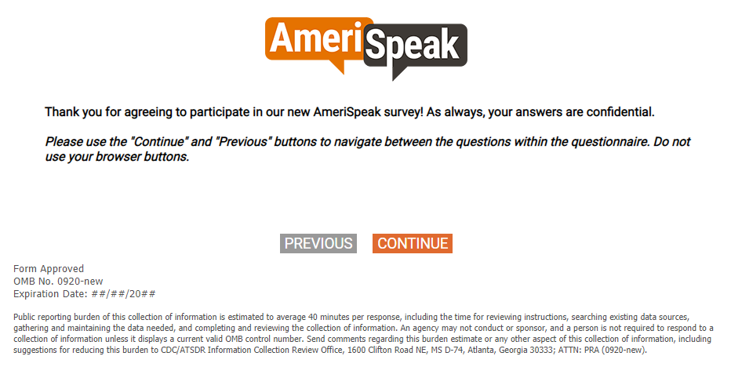
[DISPLAY]
INTRO_PAR.
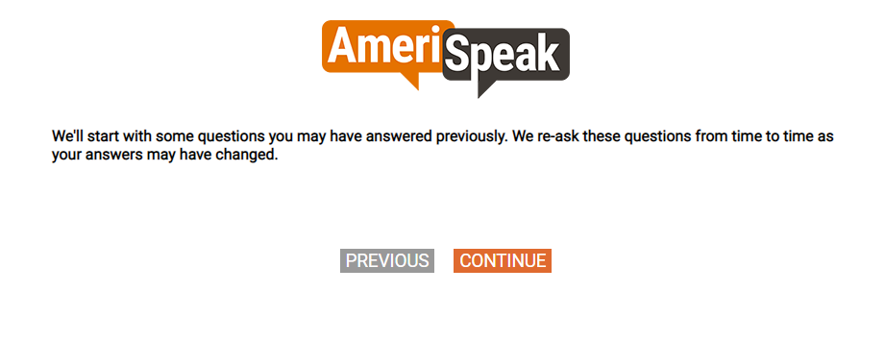
[MP] [DOUBLE PROMPT]
S1.
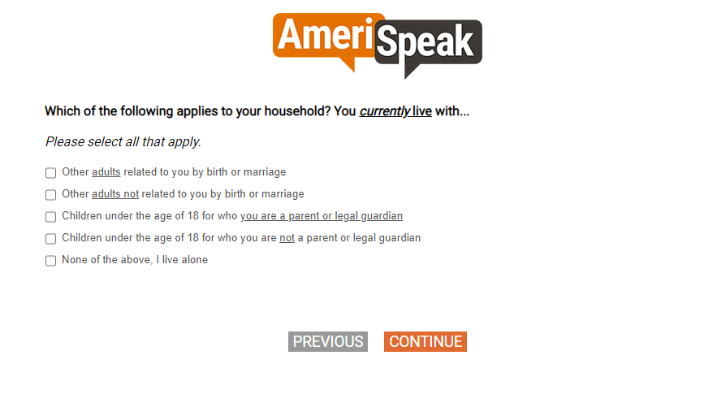
[SHOW IF S1=3]
[NUMBOX]
S2.
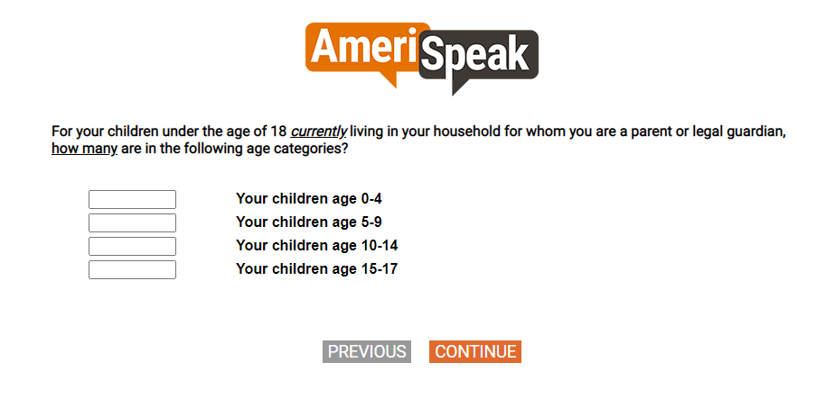

[TEXTBOX]
S3.
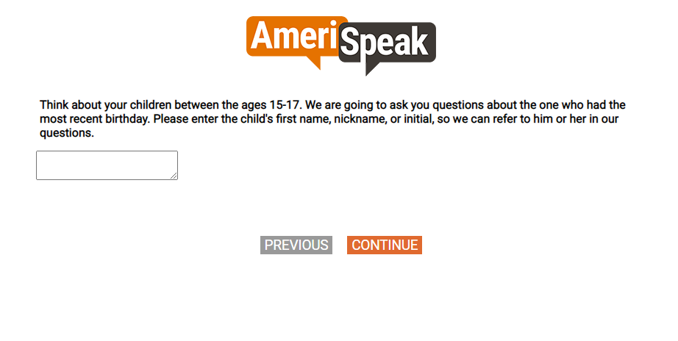

[SHOW IF S2D=1-12]
[SP, DOUBLE PROMPT]
CONSENT.
[SHOW IF TERMINATED]
TERMSORRY.
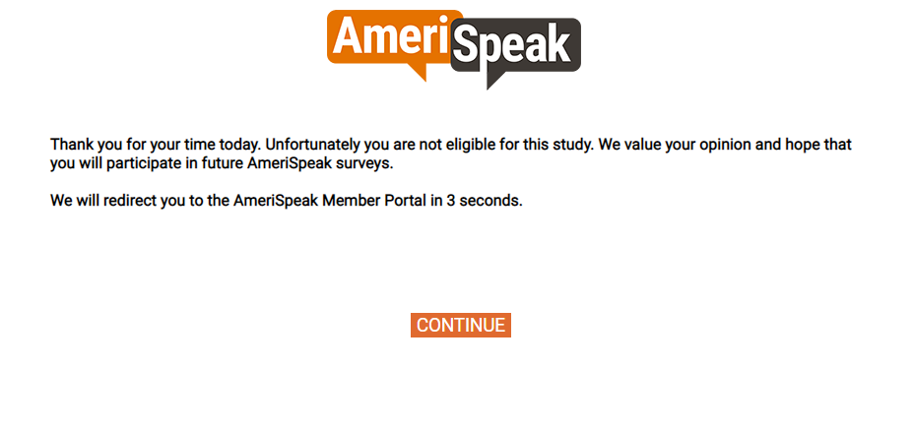

[DOUBLE PROMPT]
[NUMBOX]
QTAGE.
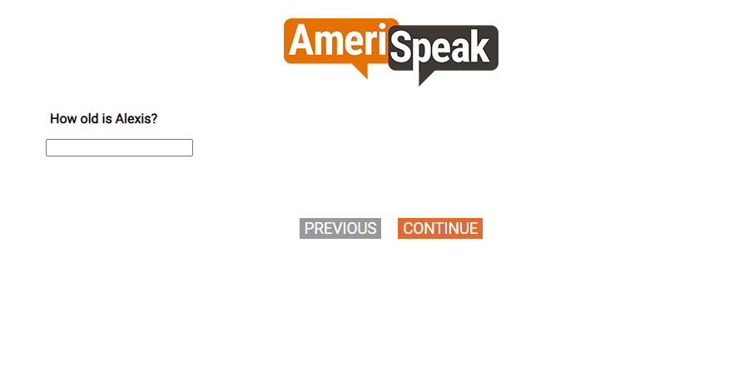

[DOUBLE PROMPT]
[SP]
QTGEN1.
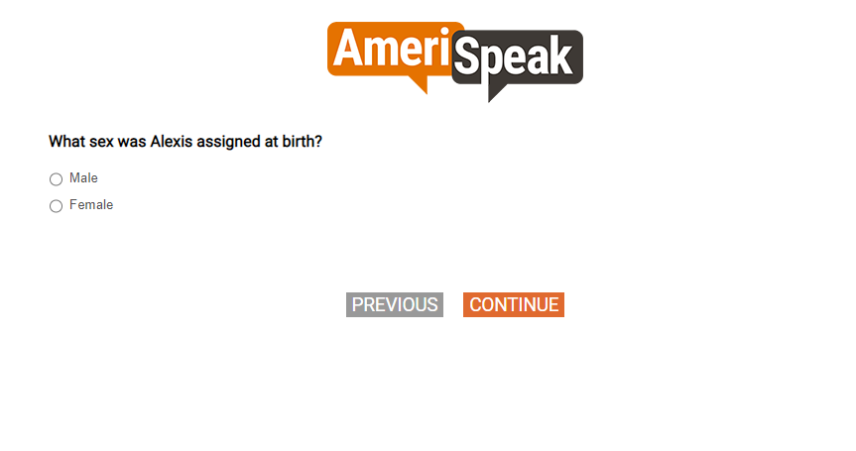

[SP]
QTGEN2.
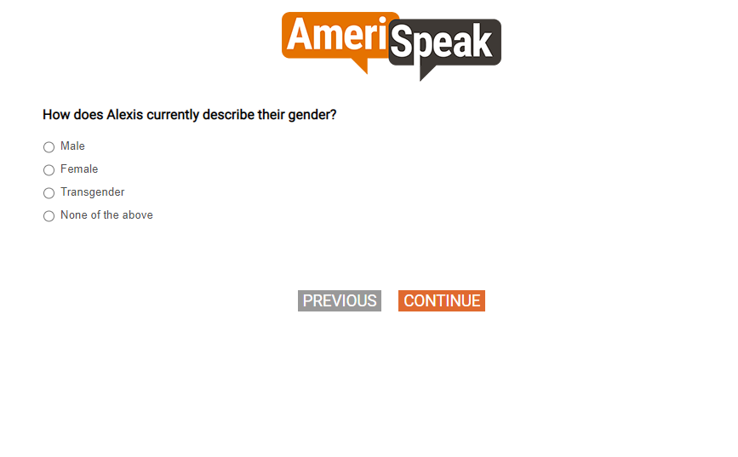

[MP]
QTRACE
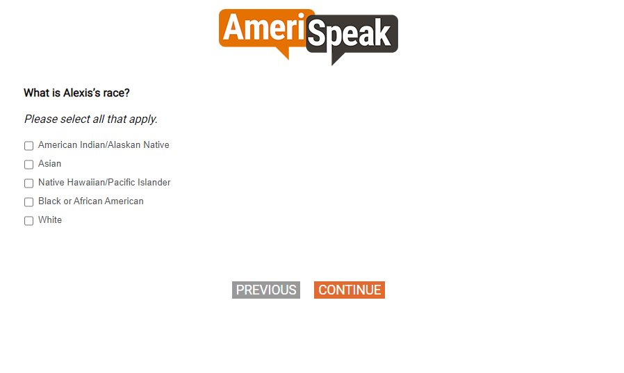

[SP]
QTETH
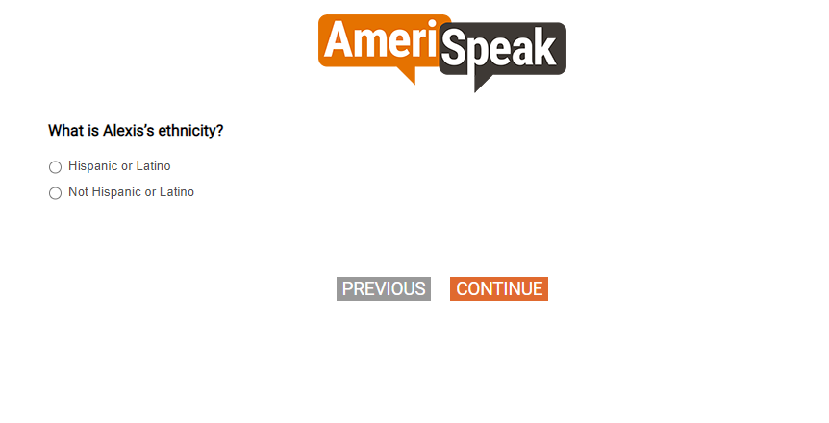

Section A. Family Protective Factors

[SP]
Q1_A
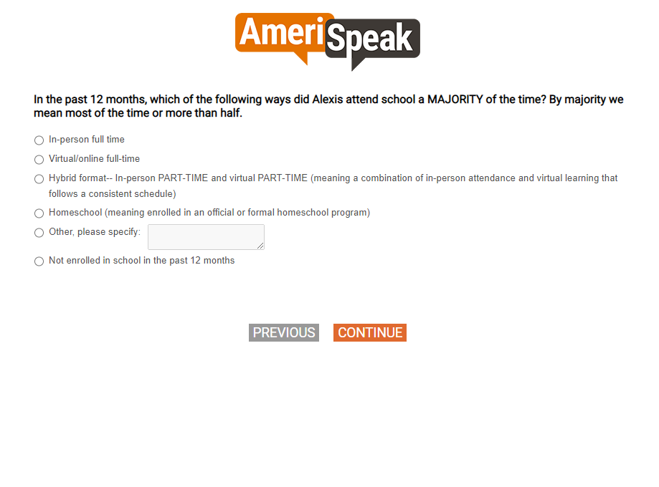

[SHOW IF Q1A=1-5]
[SP]
Q1.
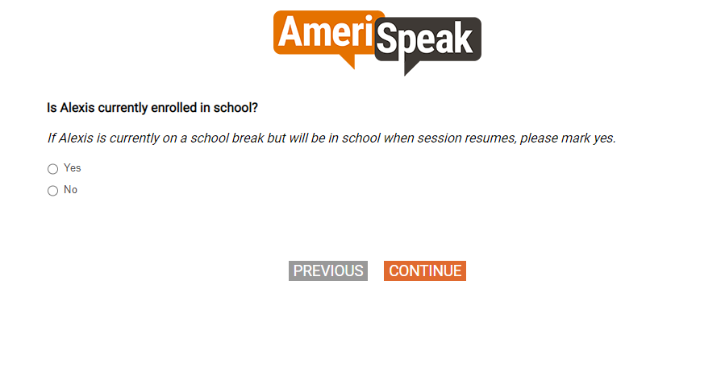

[SHOW IF Q1=1]
[SP]
Q1_B
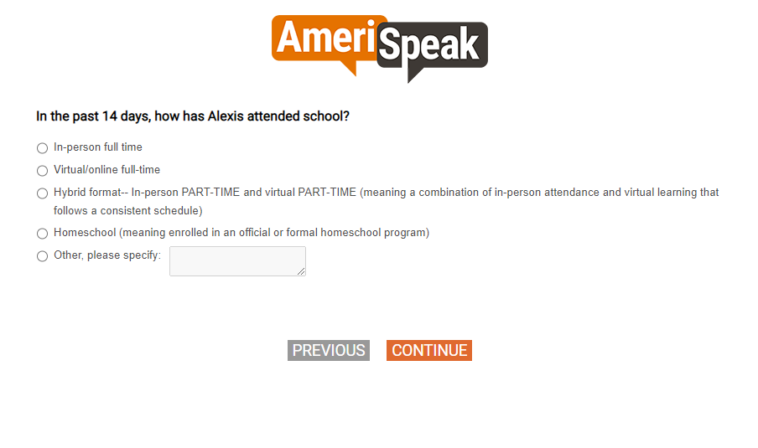

[GRID, SP]
Q2.
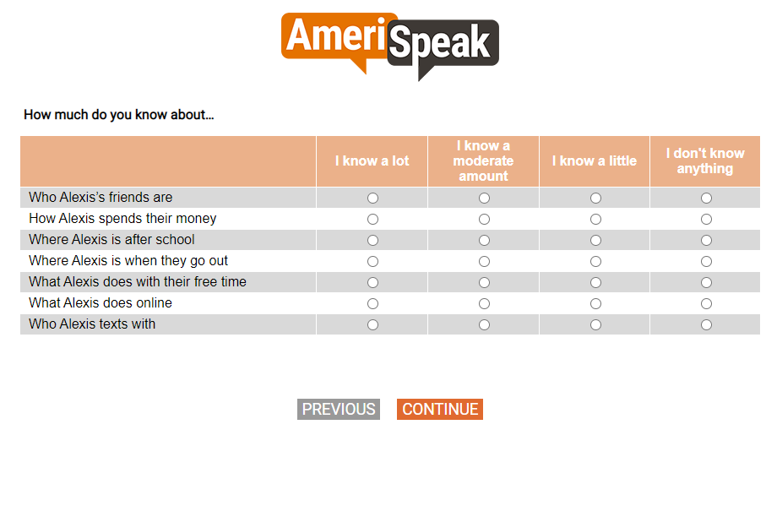

[GRID, SP]
Q5.
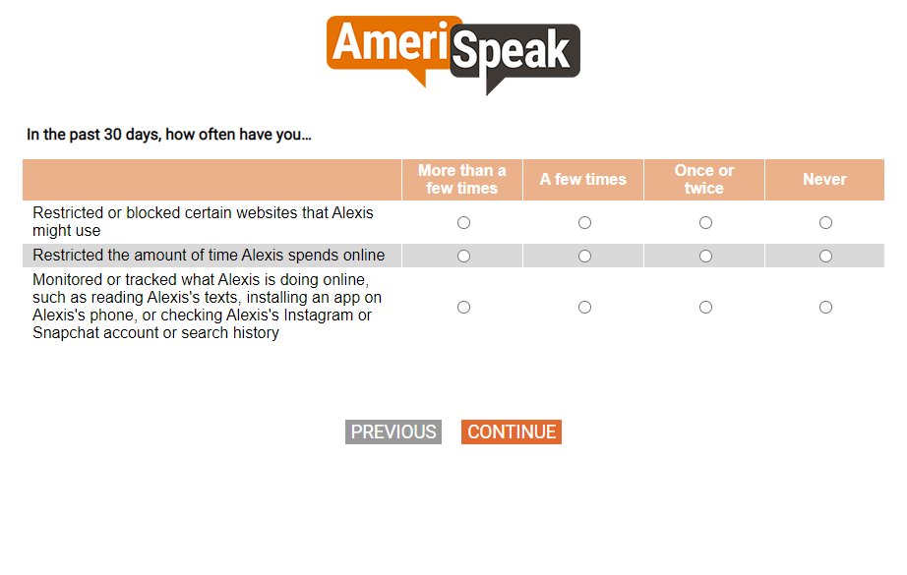

[SP]
Q5d.
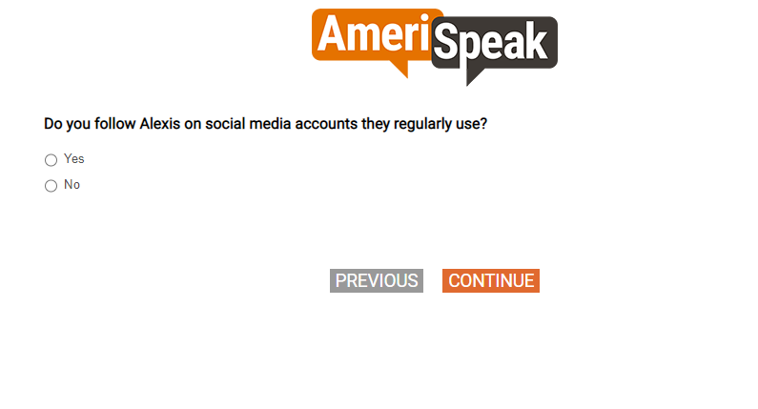

[SP]
[CAWI: IF S3=77,98,99, PIPE-IN "my child" INSTEAD OF "your child"
CATI: IF S3=77,98,99, PIPE-IN "your child"]
Q4.
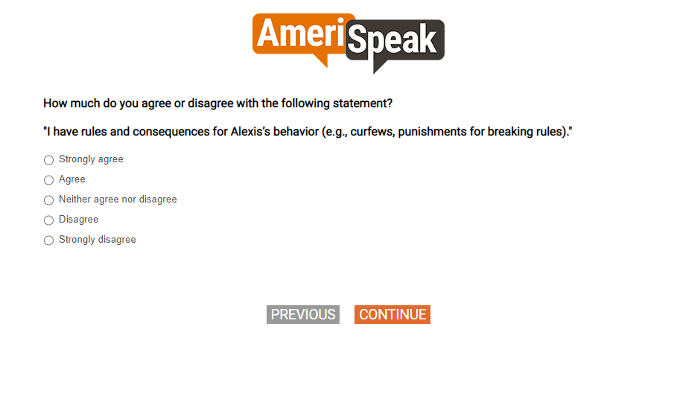

[GRID, SP; 4, 5, 4, 4]
Q6.
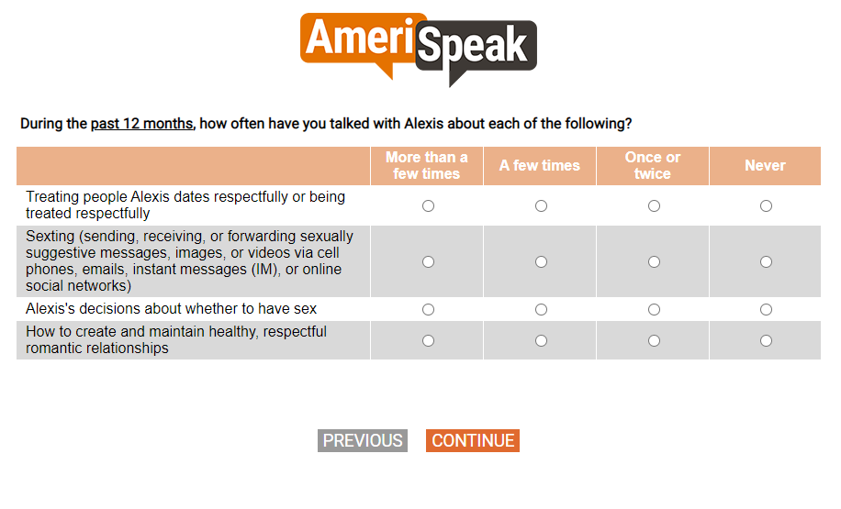
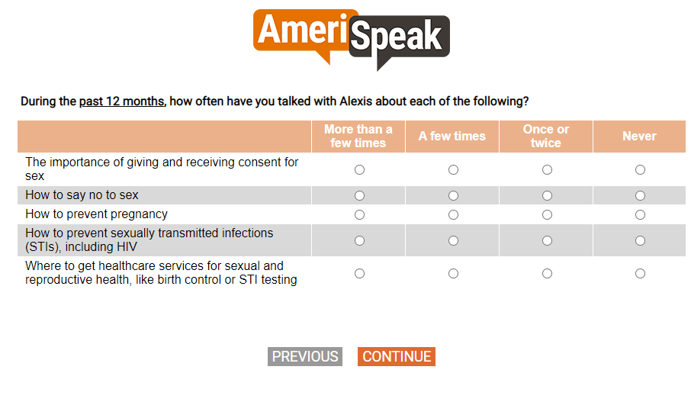
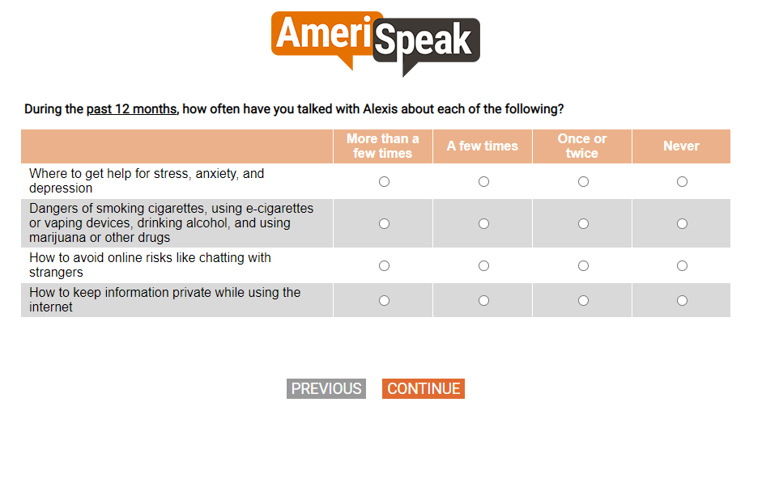
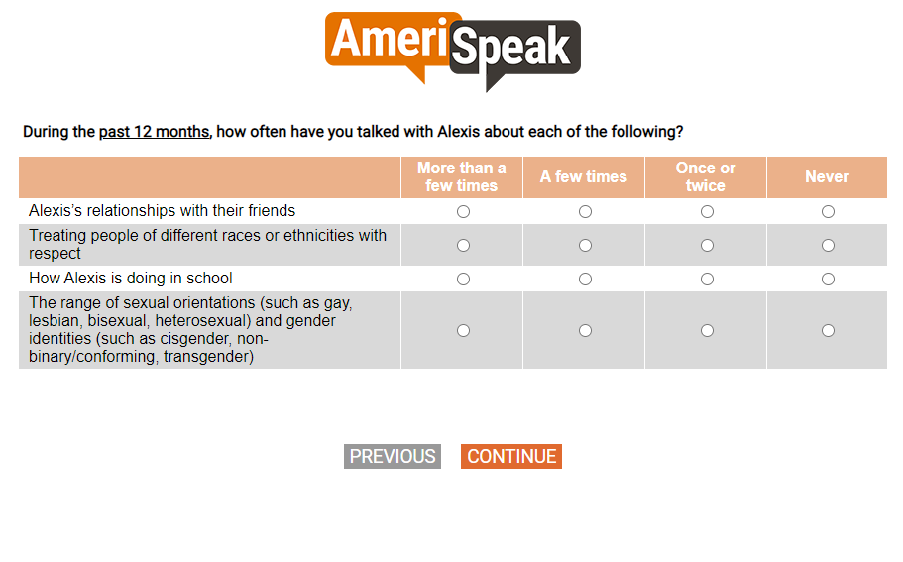

[GRID, SP]
Q7.
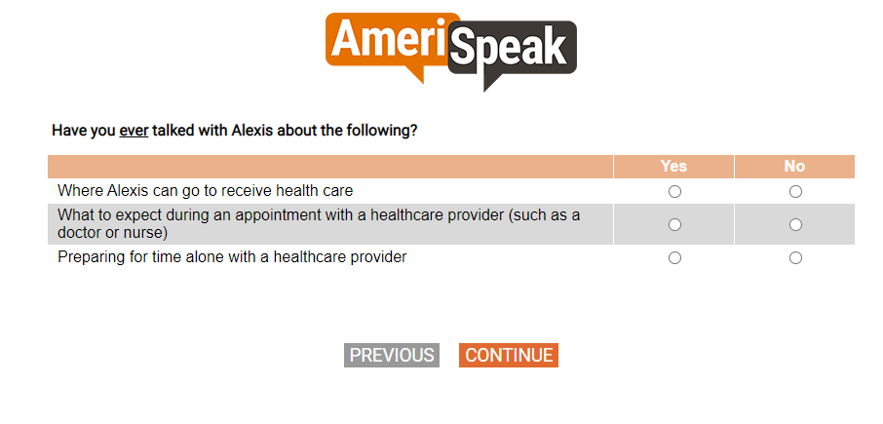

[GRID, SP]
[CAWI: IF S3=77,98,99, PIPE-IN "my child" INSTEAD OF "your child"
CATI: IF S3=77,98,99, PIPE-IN "your child"]
Q8.
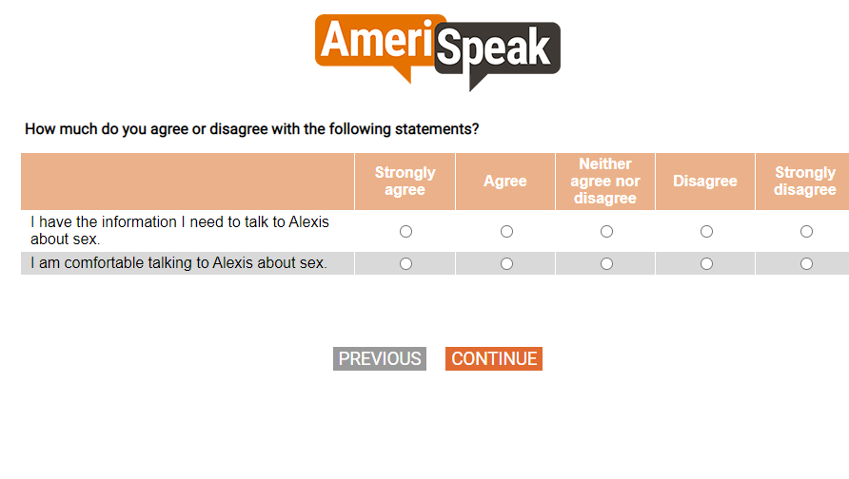

[GRID, SP]
[CAWI: IF S3=77,98,99, PIPE-IN "my child" INSTEAD OF "your child"
CATI: IF S3=77,98,99, PIPE-IN "your child"]
Q9.
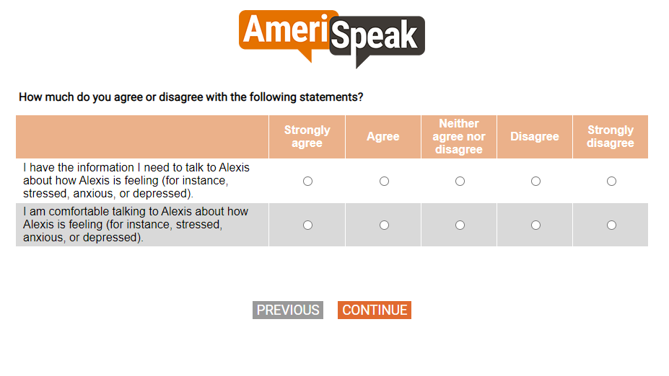

[SP]
[CAWI: IF S3=77,98,99, PIPE-IN "my child" INSTEAD OF "your child"
CATI: IF S3=77,98,99, PIPE-IN "your child"]
Q3.
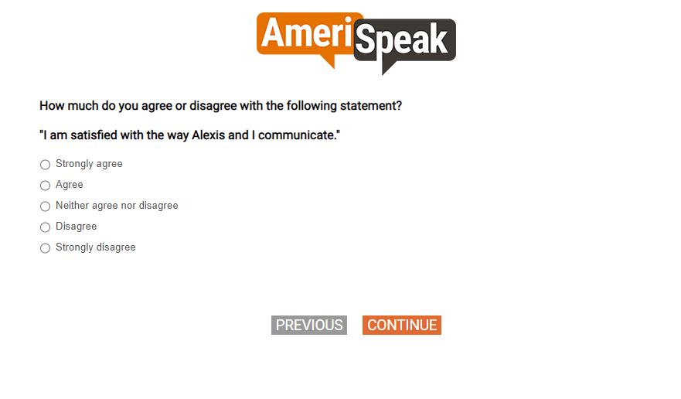

Section D. Health Education

[DISPLAY – SECTD_INTRO]
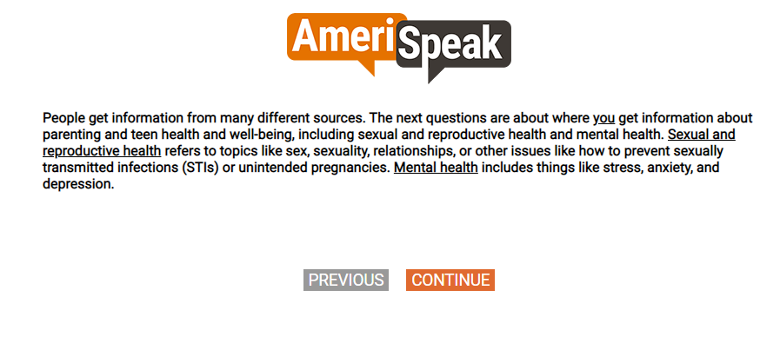

[GRID, SP]
Q19.
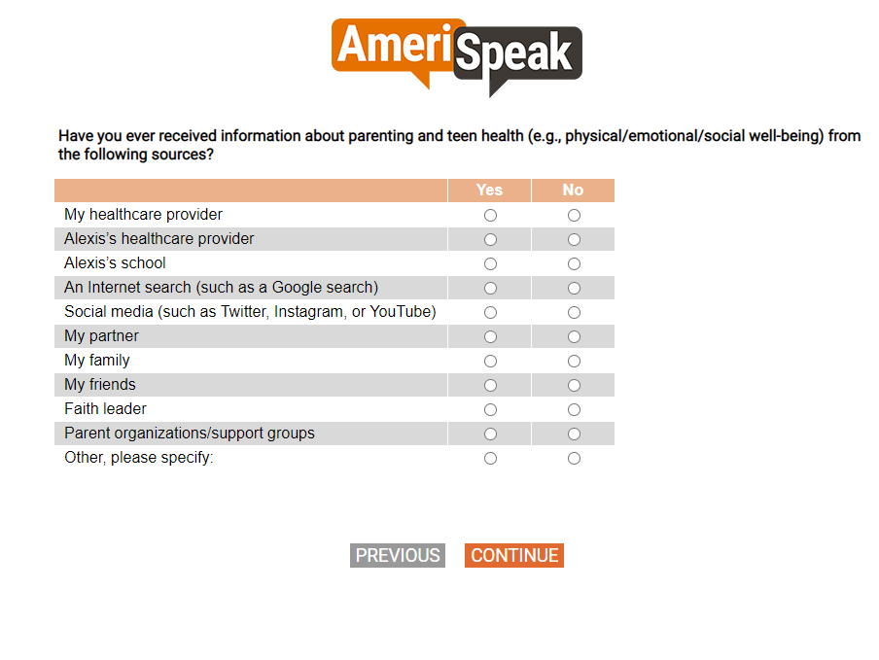

[DISPLAY – SECTD_1]
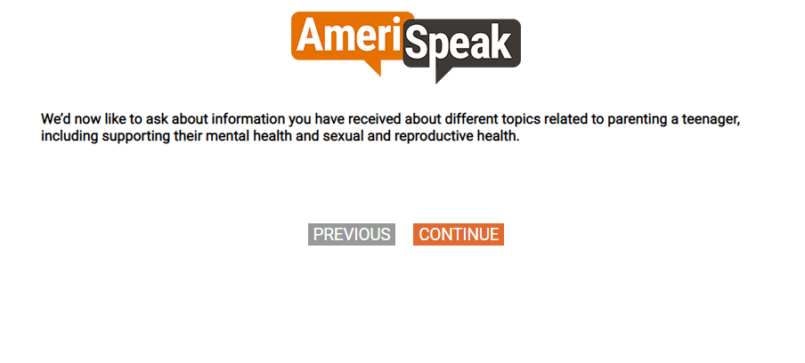

[LOOP THROUGH Q20A thru Q20k, SHOW Q20 FOR EVERY Q19=1]
[GRID, SP]
Q20.

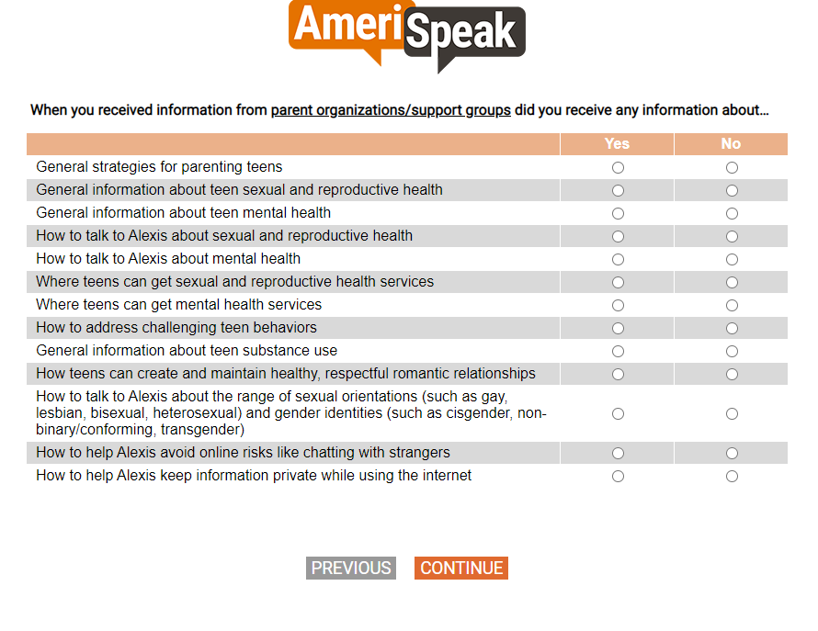

[SHOW IF DOV_MENTHEALTH=1]
[GRID, SP; show numeric labels]
Q21.
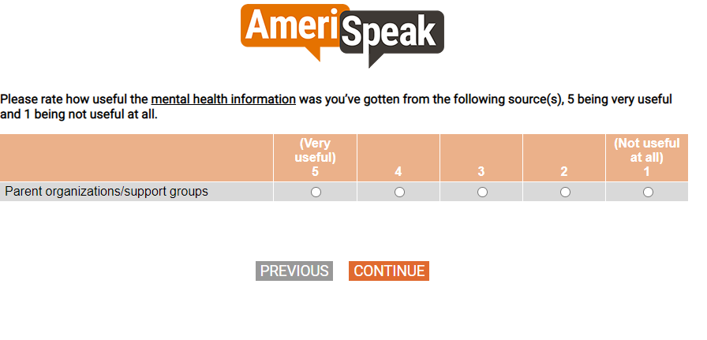

[GRID, SP; 4, 4, 4]
Q22.
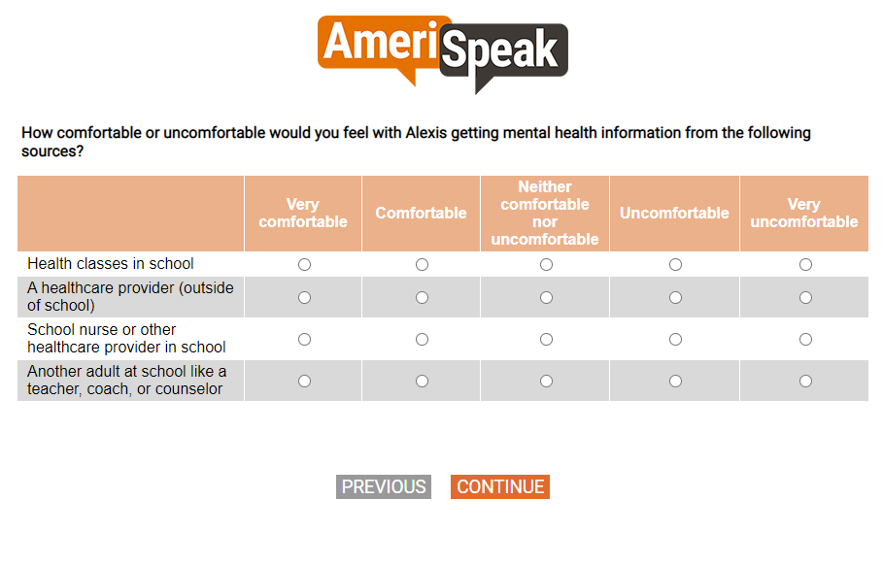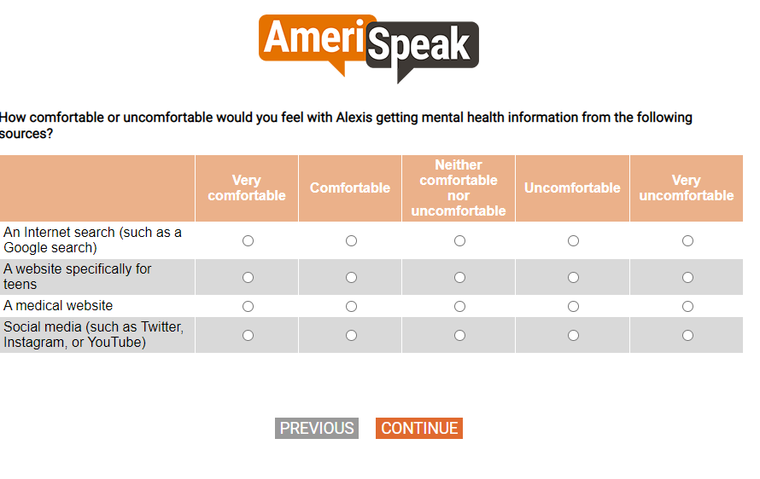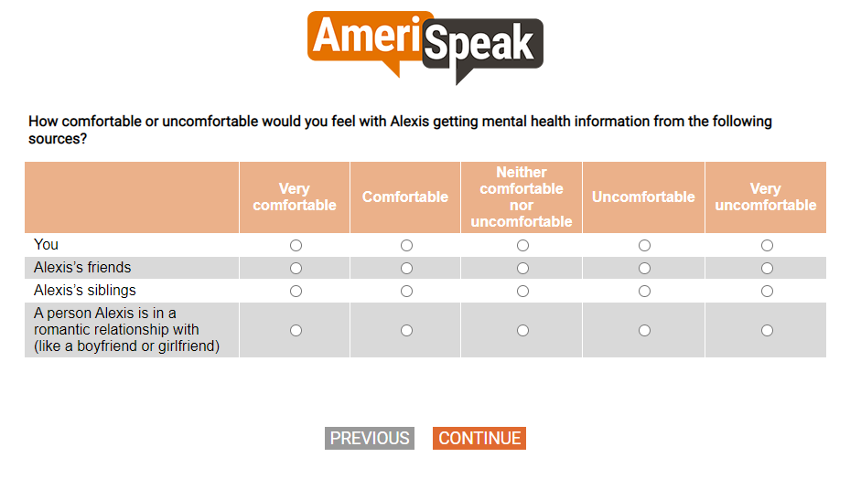

[SHOW IF DOV_SEXHEALTH=1]
[GRID, SP]
Q23.
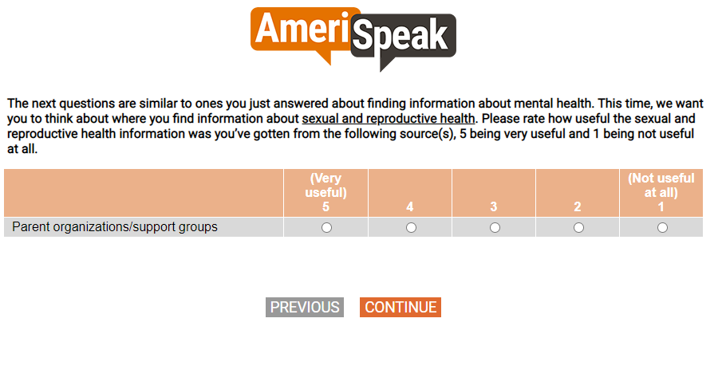

[GRID, SP; 4, 4, 4]
Q24.
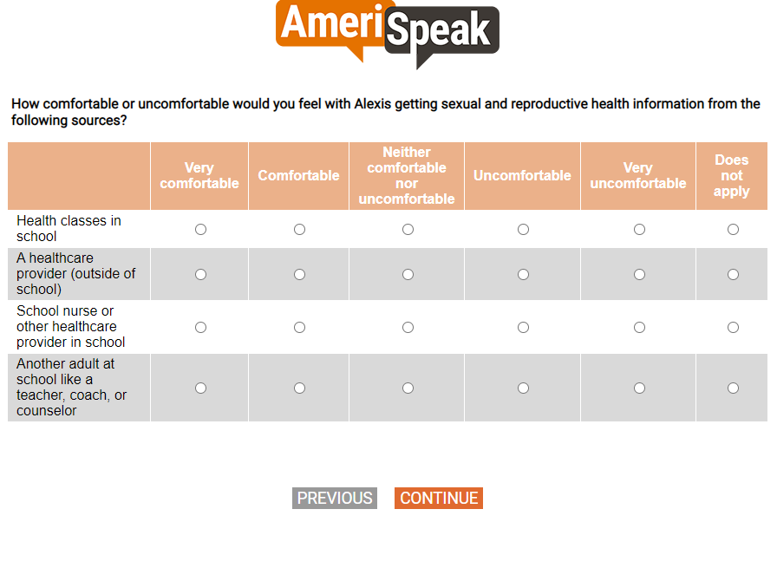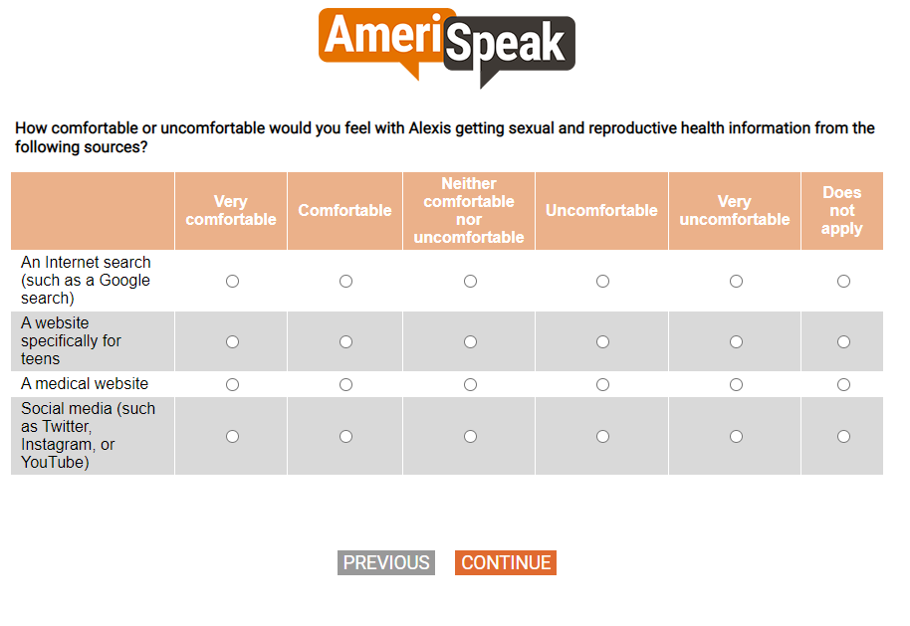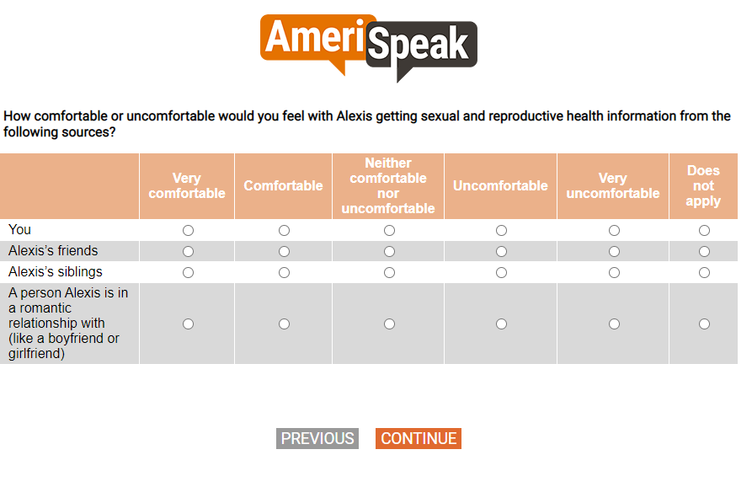

[GRID, SP; 3, 4, 3, 2, 2]
Q26.
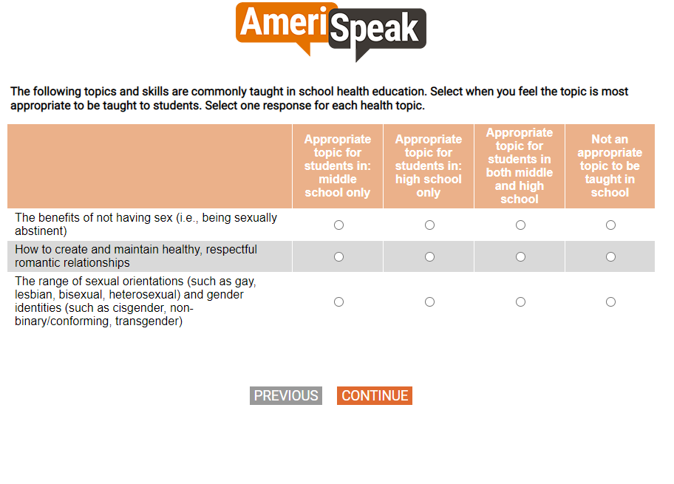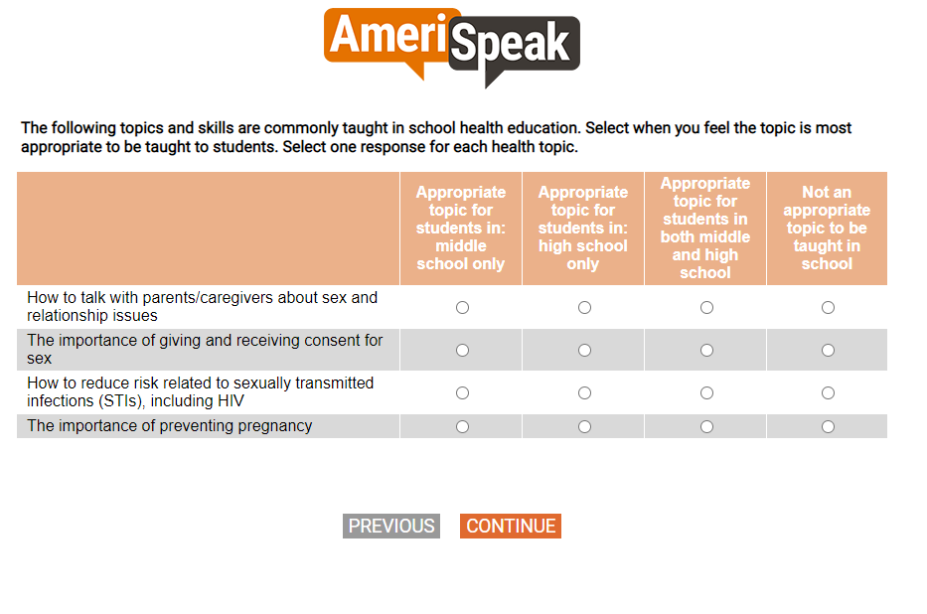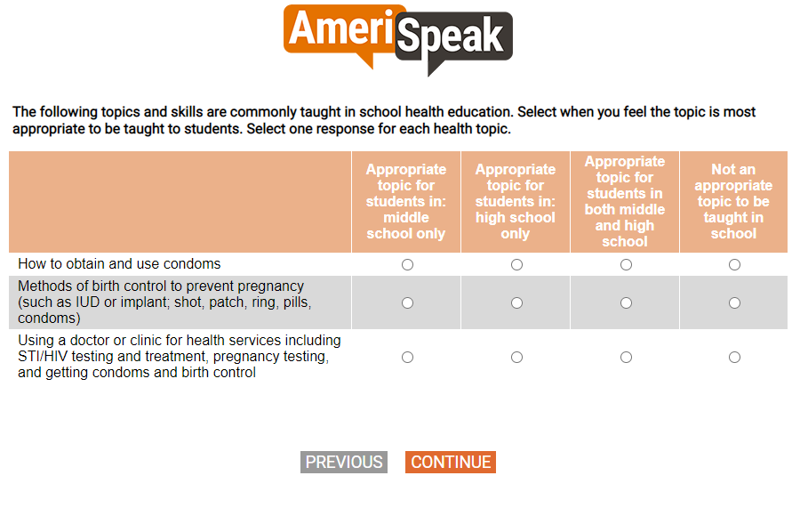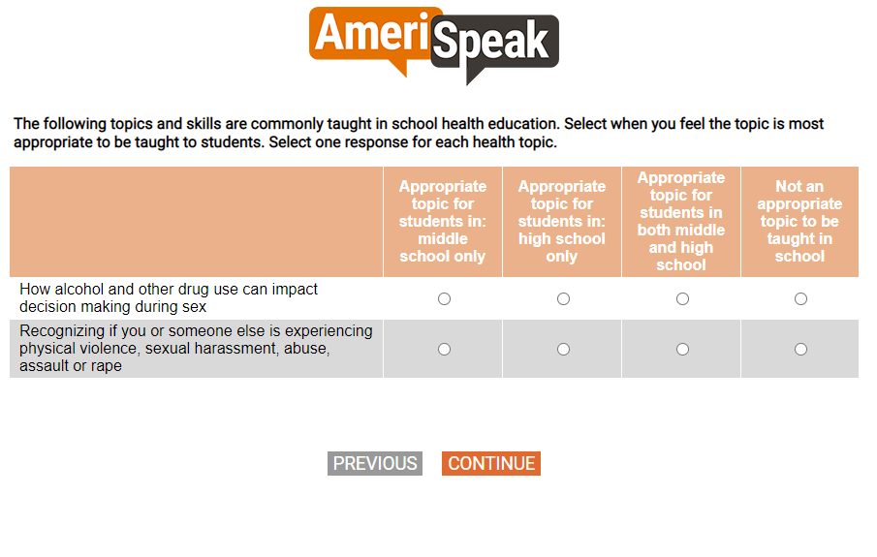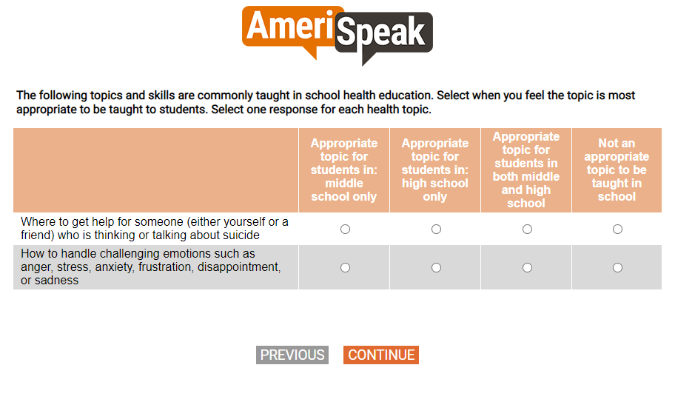

[GRID, SP; 3, 3, 3]
[SHOW IF Q1=1]
[CAWI:
IF S3=77,98,99 and DOV_CHILDNAME does NOT start the grid item label, PIPE-IN "my child" INSTEAD OF "your child";
IF S3=77,98,99 and DOV_CHILDNAME starts the grid item label, PIPE-IN "My child" INSTEAD OF "your child"
CATI:
IF S3=77,98,99 and DOV_CHILDNAME does NOT start the grid item label, PIPE-IN "your child"
IF S3=77,98,99 and DOV_CHILDNAME starts the grid item label, PIPE-IN "Your child"]
Q27.
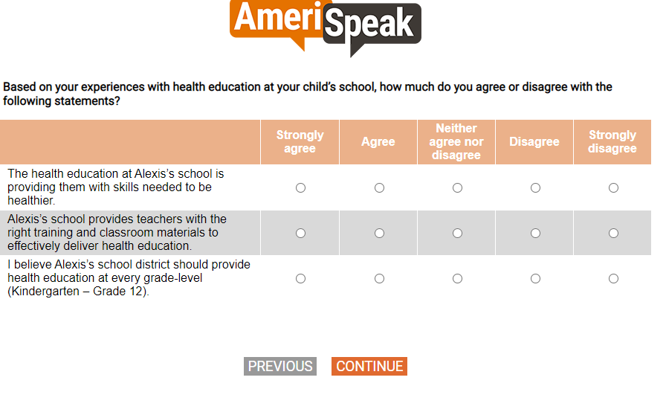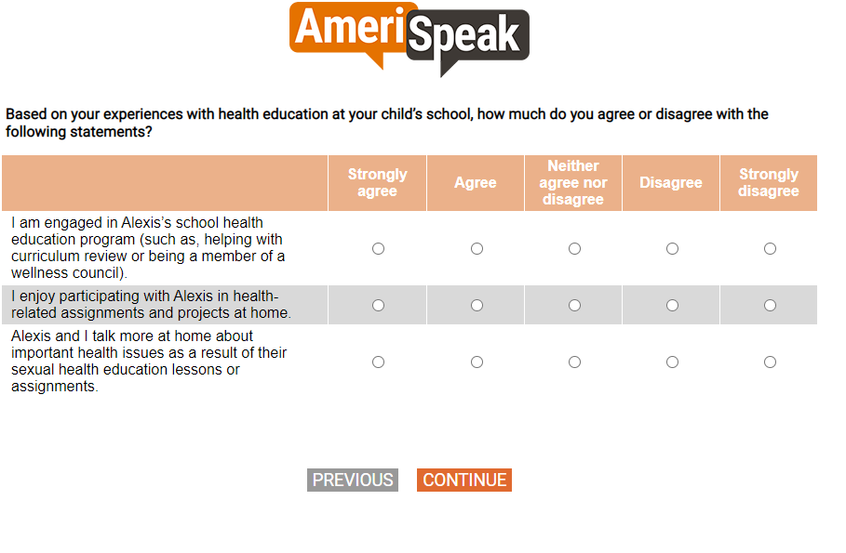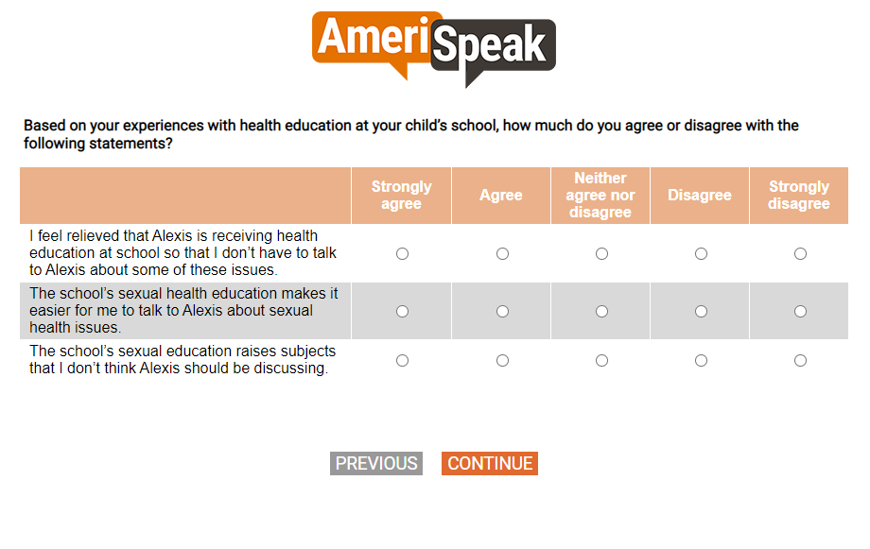

Section B. Mental Health

[DISPLAY – SECTB_INTRO]
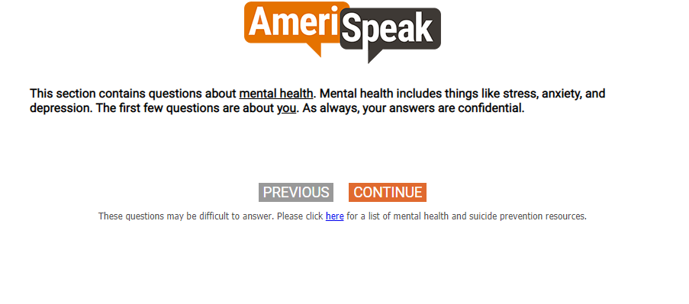

[SP]
Q11.
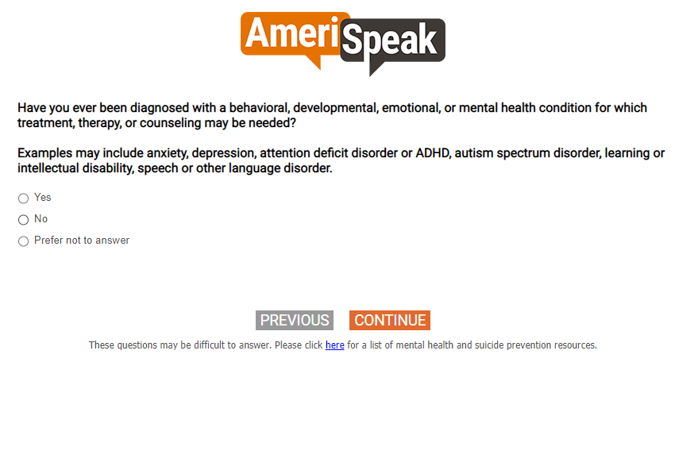

[SHOW IF Q11=1]
[SP]
Q12.
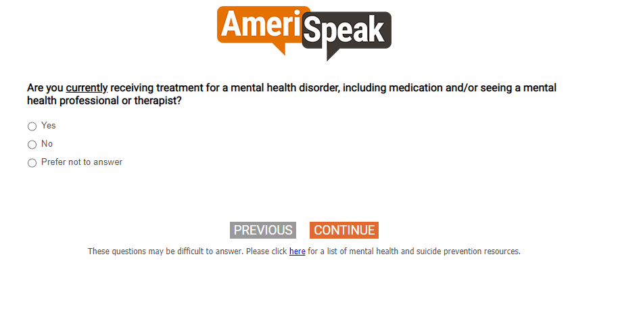

[SP]
Q13.
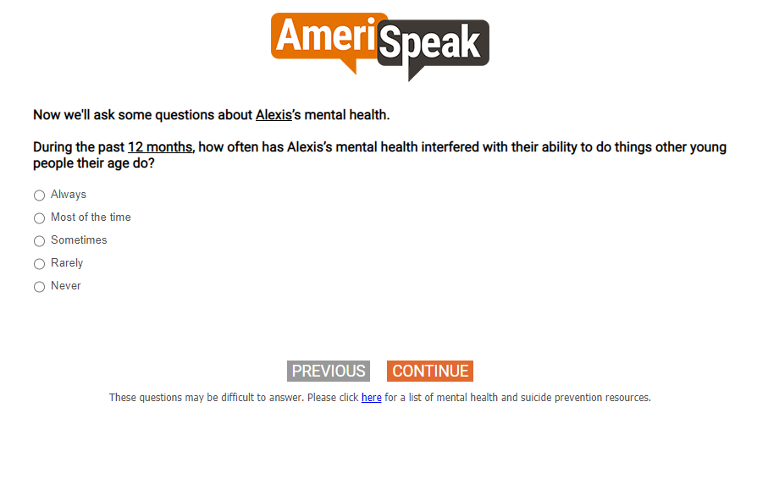

[GRID, SP; 5, 4]
Q14.
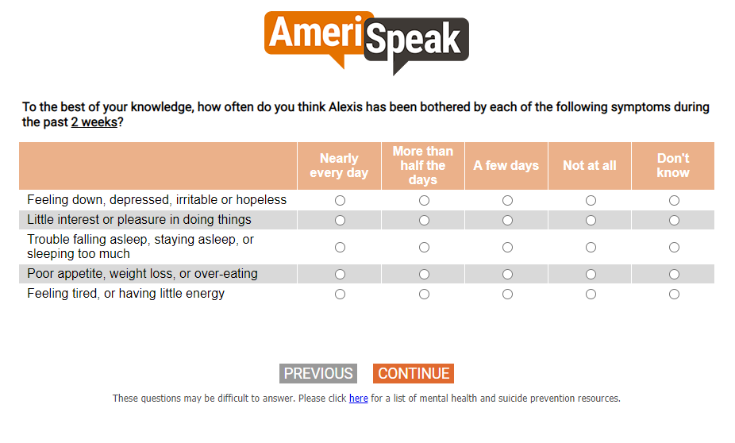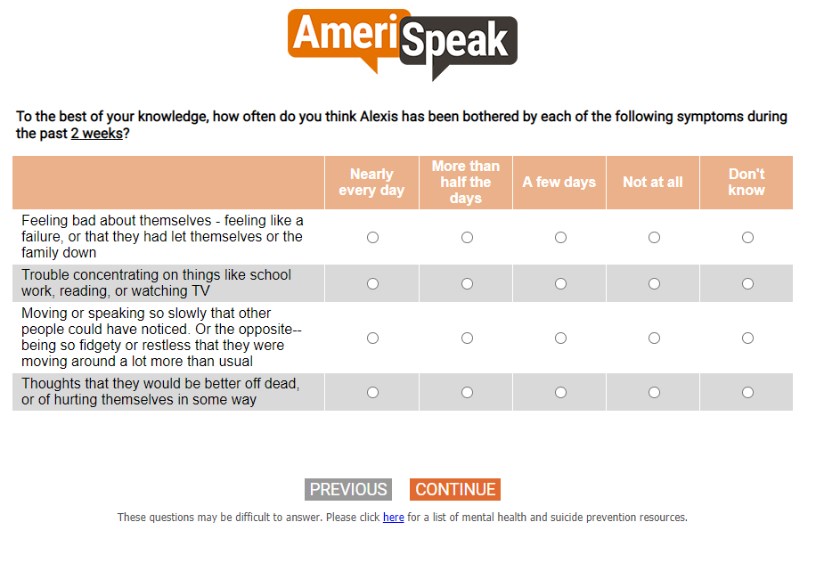

[DISPLAY – SECTB_1]
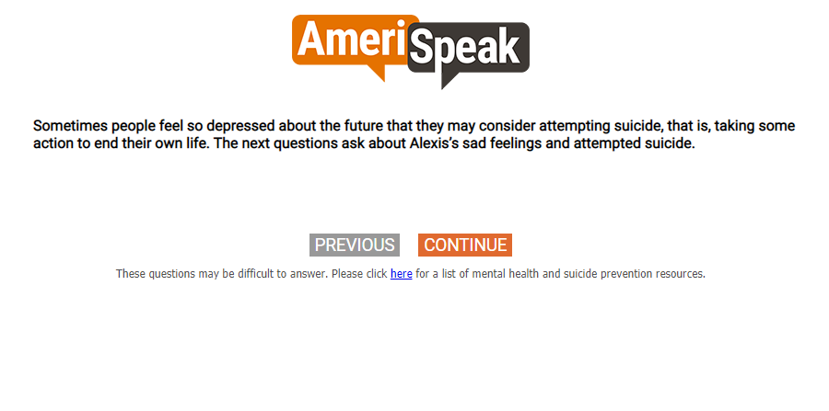

[SP]
Q15.
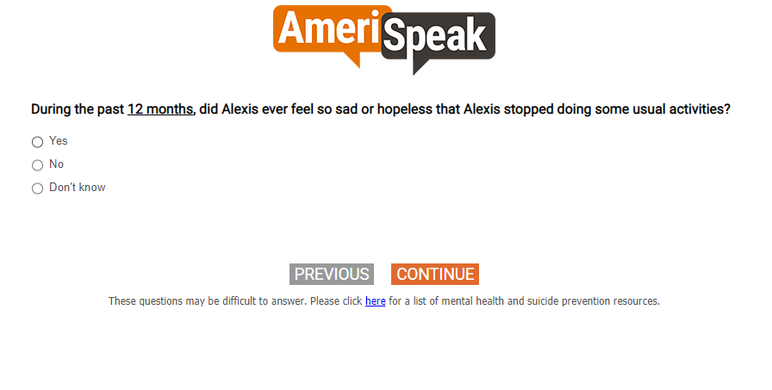

[SP]
Q16.
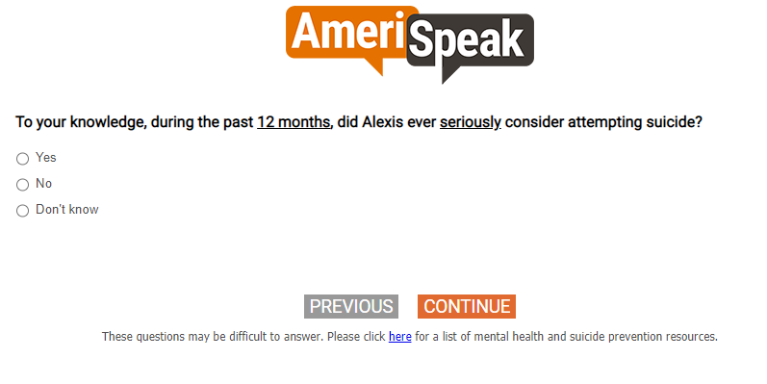

Section C. Adverse Childhood Events

[GRID, SP; 4, 3, 4, 4, 4] [do not show numeric labels]
[IF DOV_CHILDNAME starts the grid item label and S3=77,98,99, PIPE-IN "Your child" INSTEAD OF "your child"]
Q18.
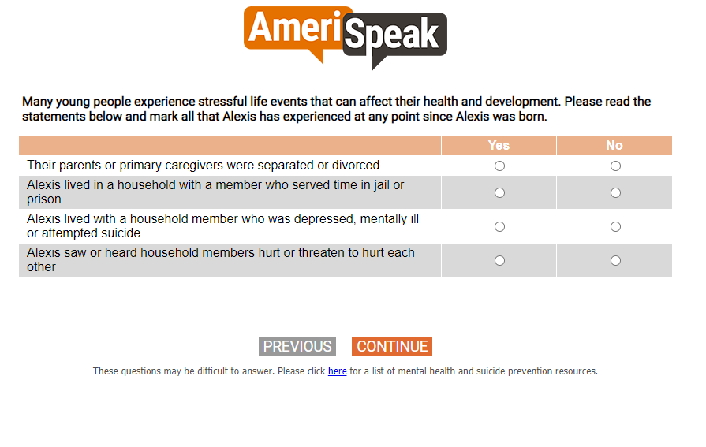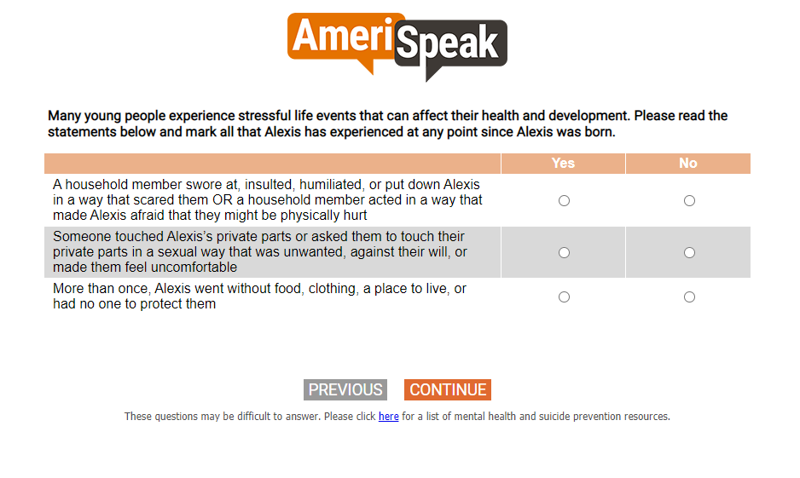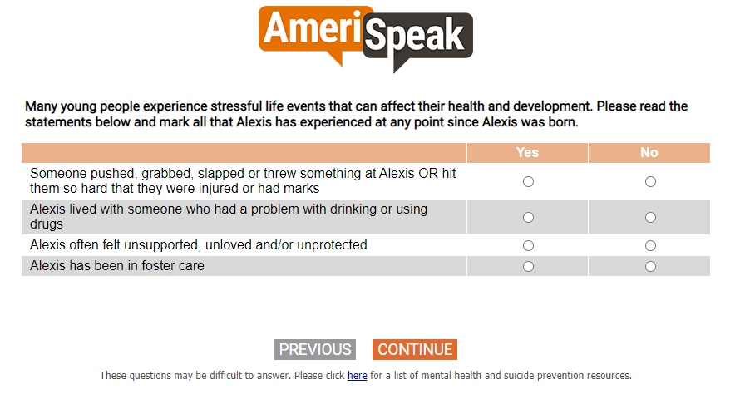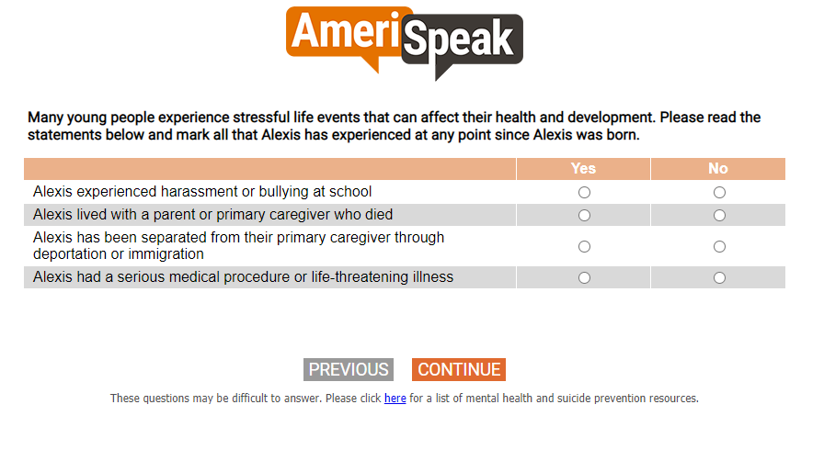

Section E. Health Services

[GRID, SP]
[CAWI: IF S3=77,98,99, PIPE-IN "my child" INSTEAD OF "your child"
CATI: IF S3=77,98,99, PIPE-IN "your child"]
Q28.
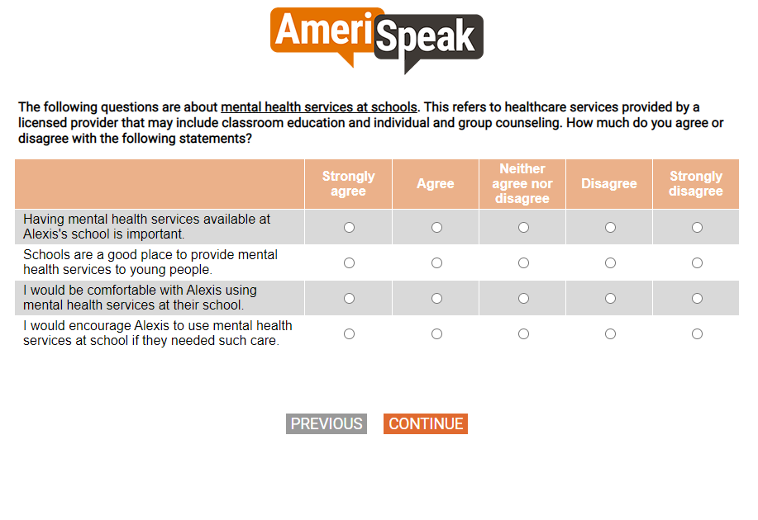

[GRID, SP]
[CAWI: IF S3=77,98,99, PIPE-IN "my child" INSTEAD OF "your child"
CATI: IF S3=77,98,99, PIPE-IN "your child"]
Q29.
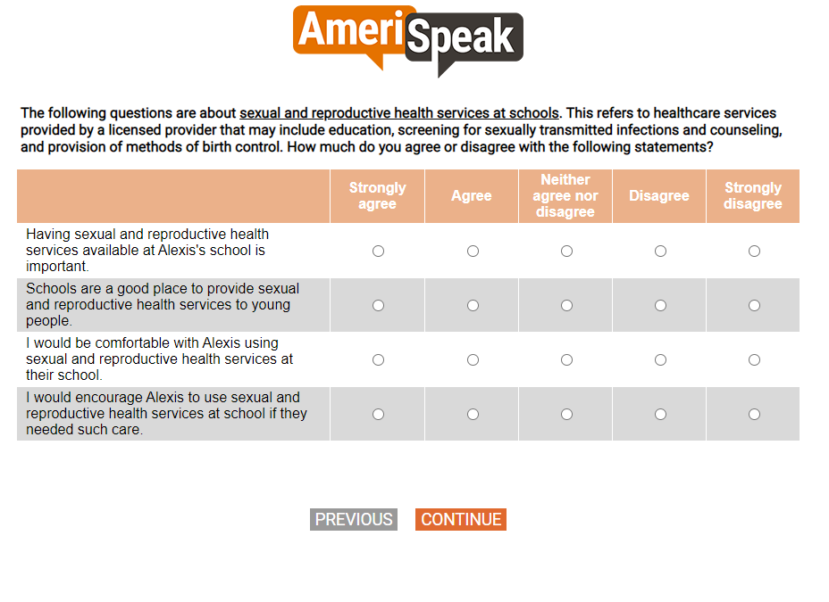

[DISPLAY – SECTE_1]

[SP]
Q30.
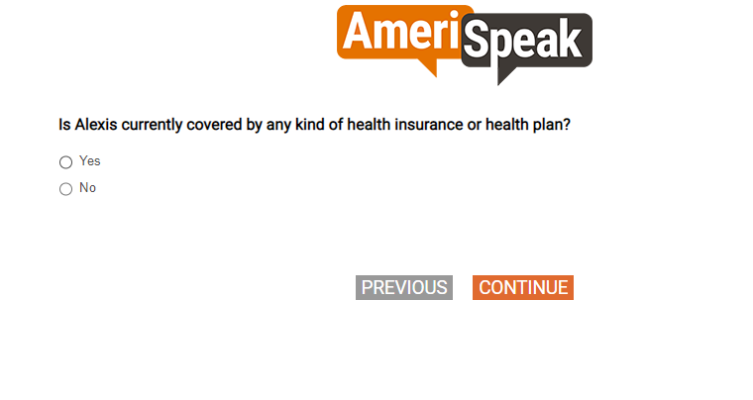

[SHOW IF Q30=1]
[SP]
Q30A.
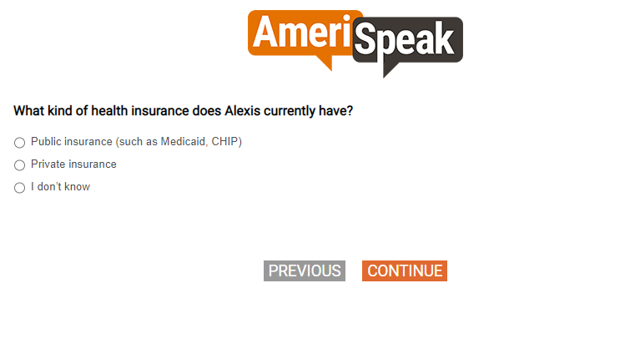

[SP]
Q31.
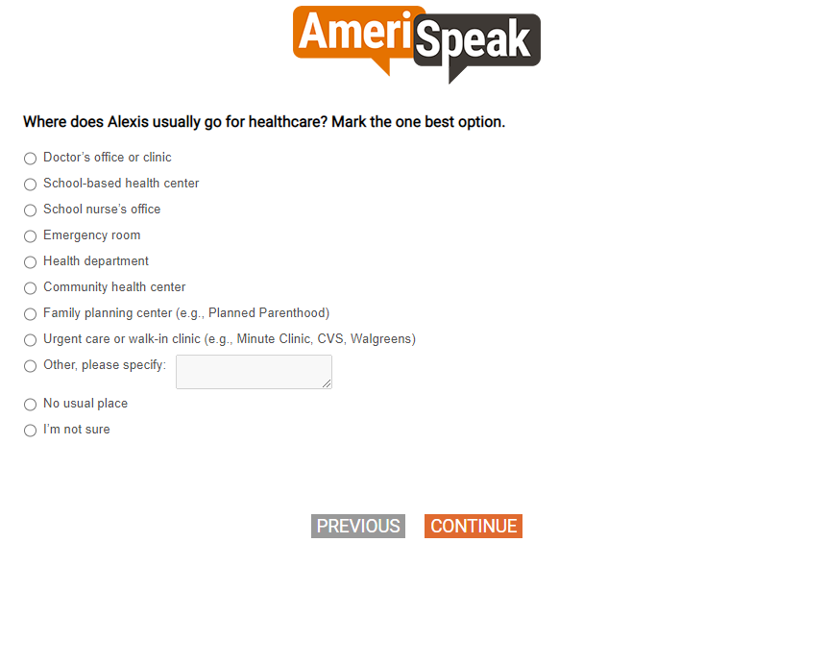

[SP]
Q32.
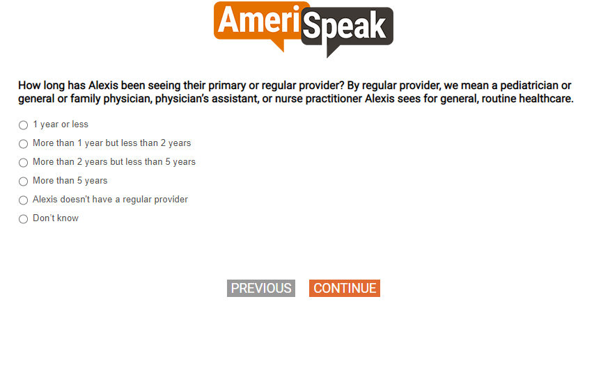

[SP]
Q33.
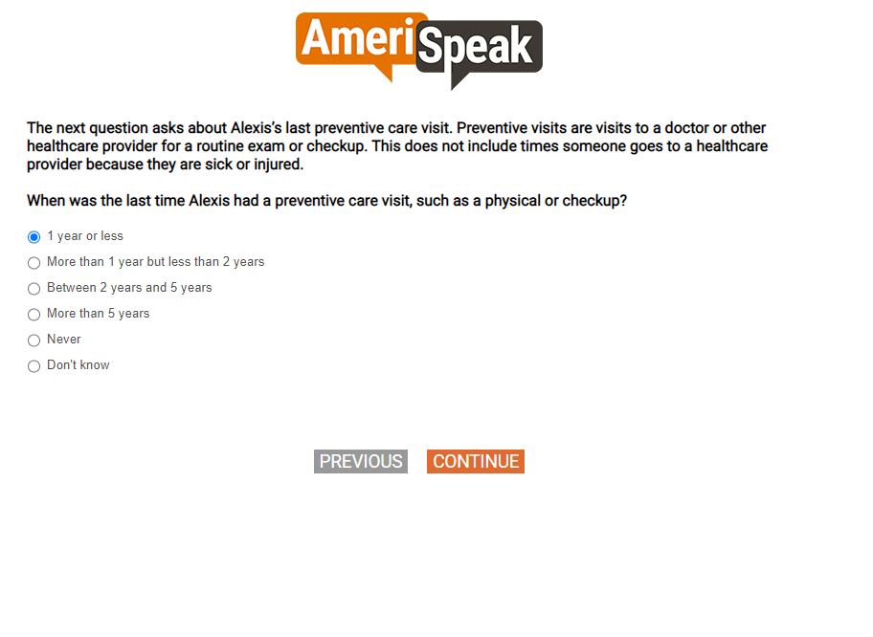

[SHOW IF Q33=1,2,3,4]
[GRID, SP; 4, 4, 4, 4]
Q34.
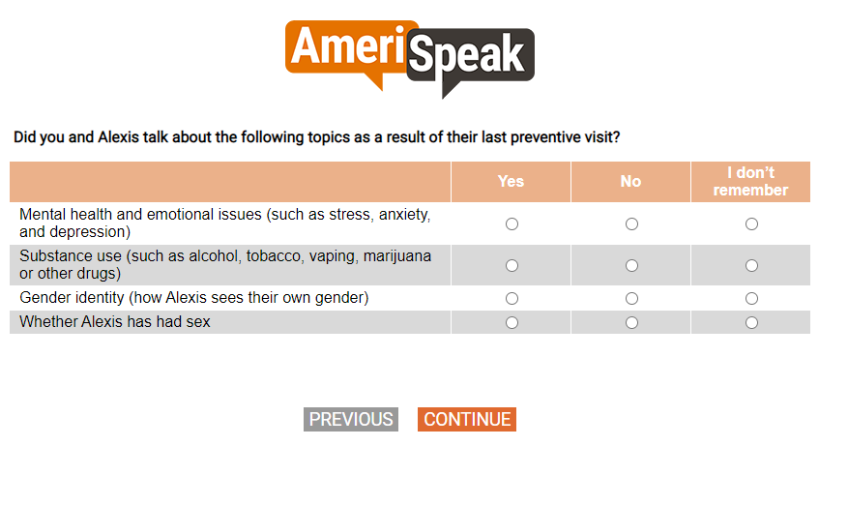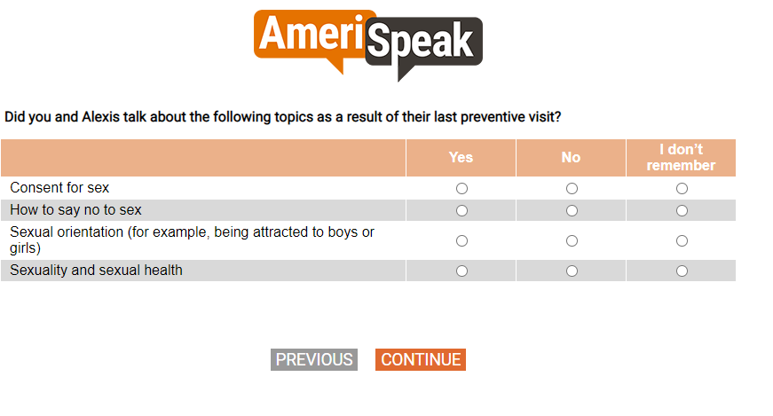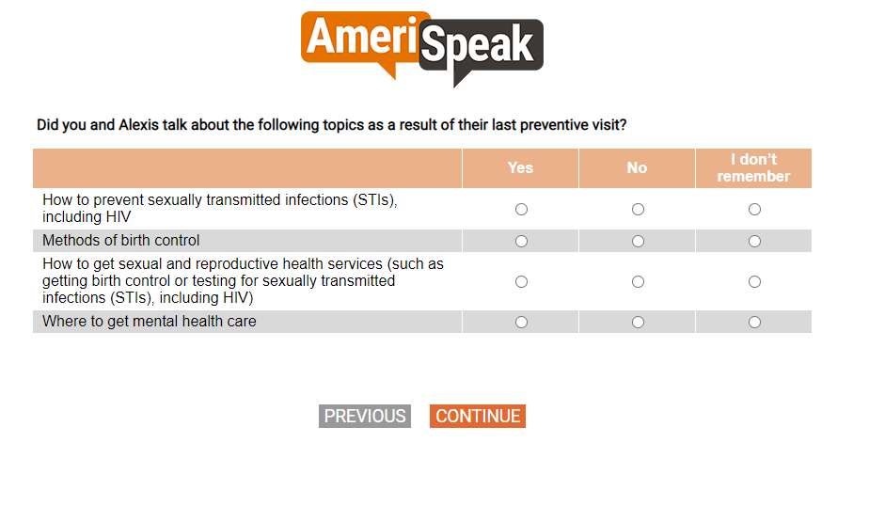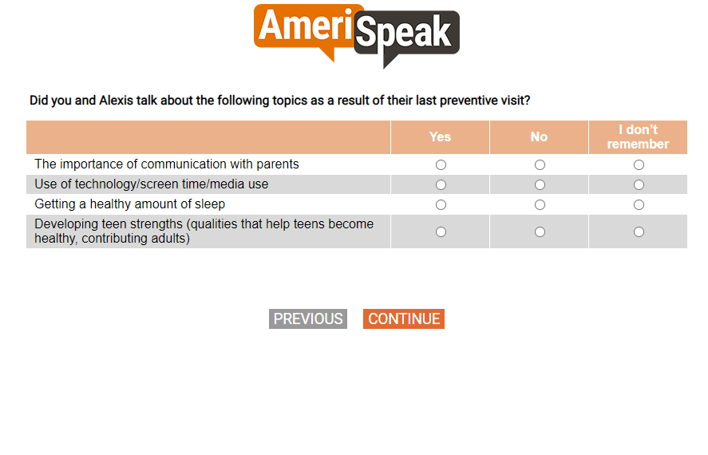

[GRID, SP; 4, 4, 4, 4]
Q35.
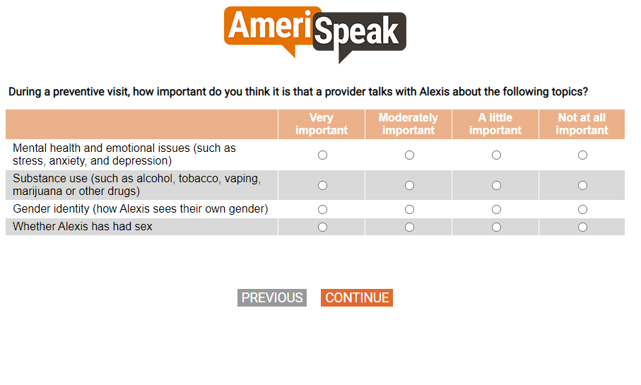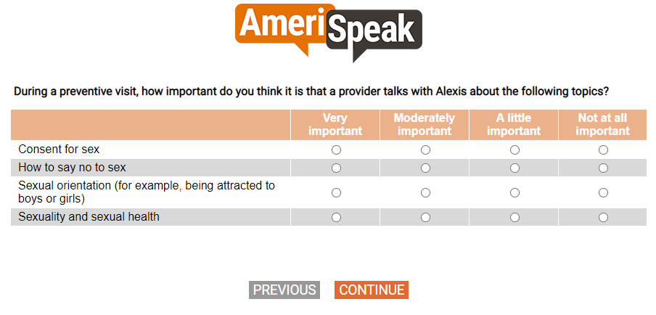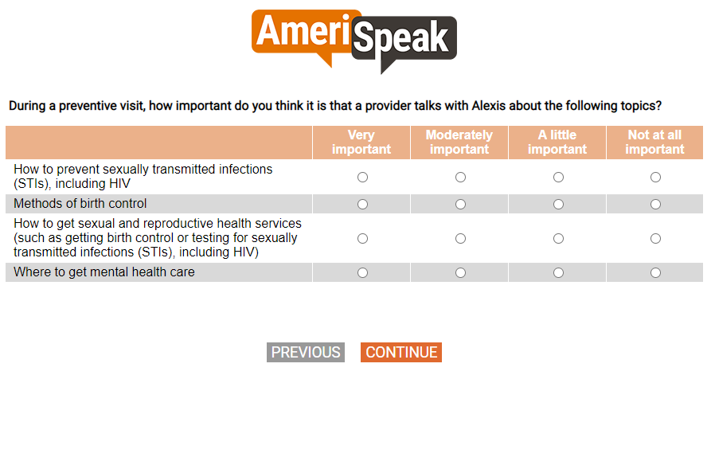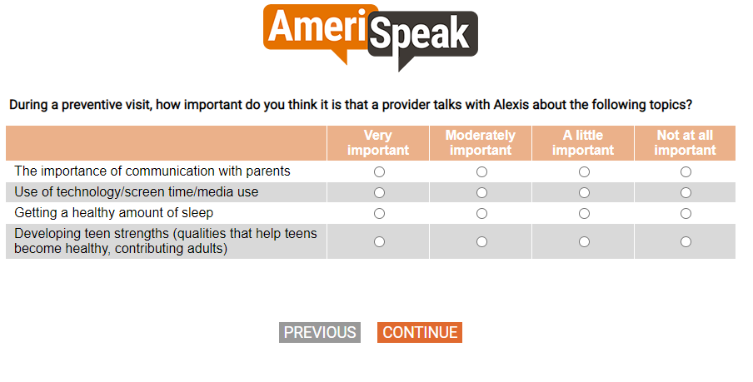

[GRID, SP; 4, 4, 4,4]
Q36.
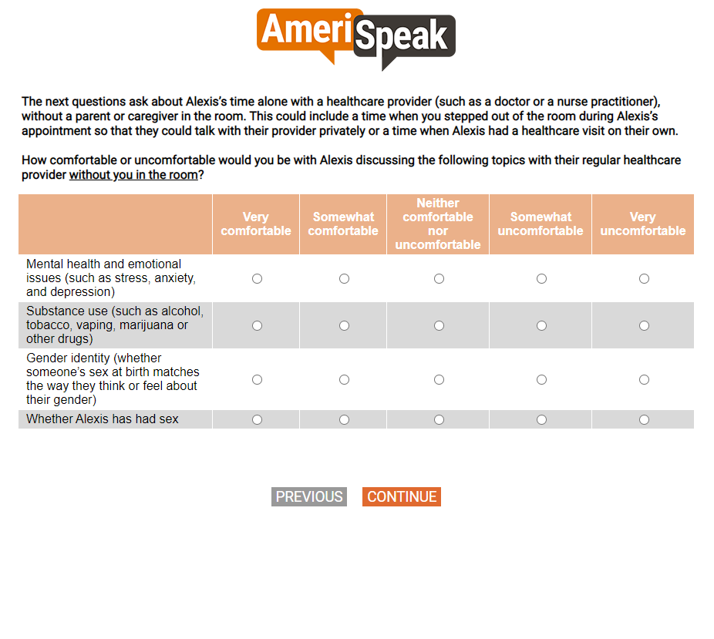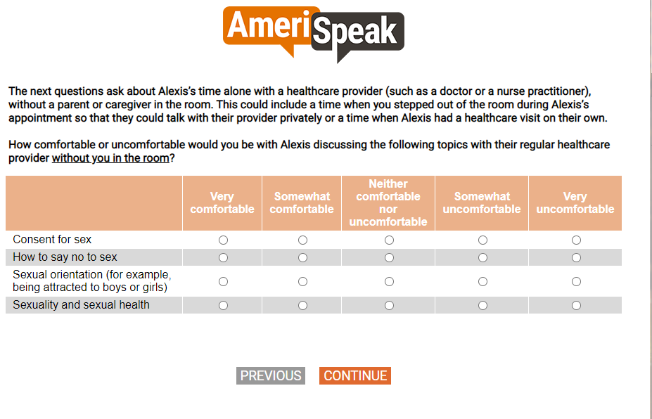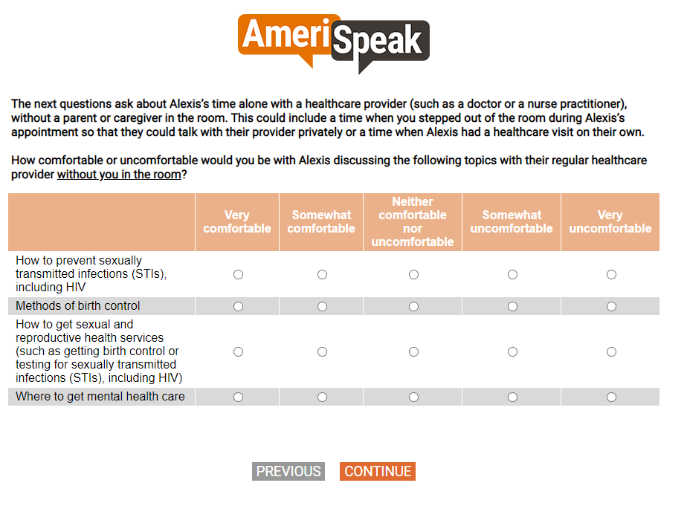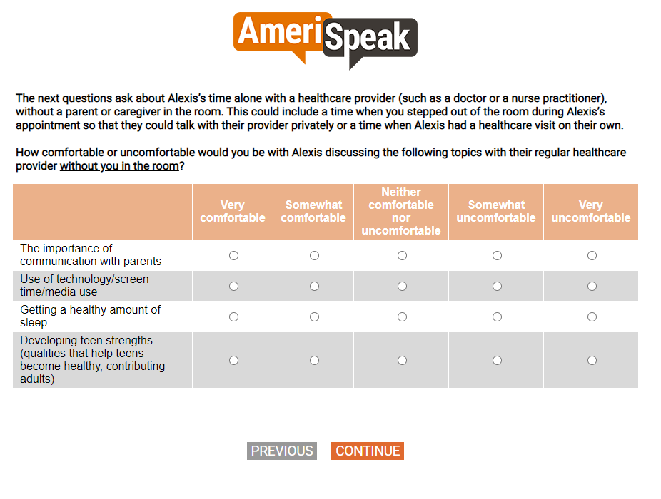

[SP]
Q37.
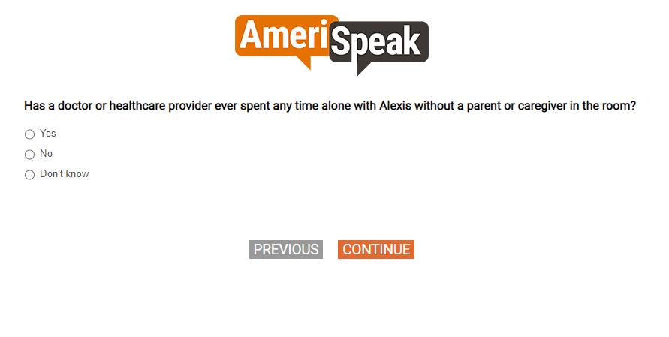

[SHOW IF Q37=1 and (Q33=1-4)]
[SP]
Q37A.
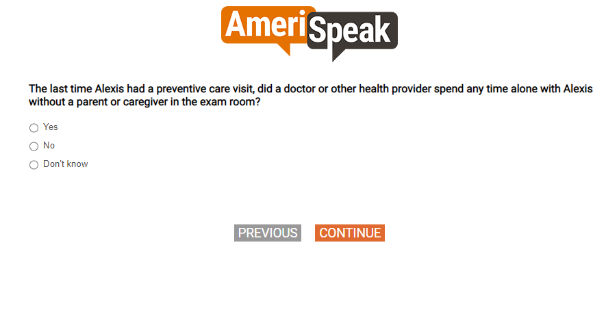

[SHOW IF Q37=1 or Q37A=1]
[SP]
Q37B.
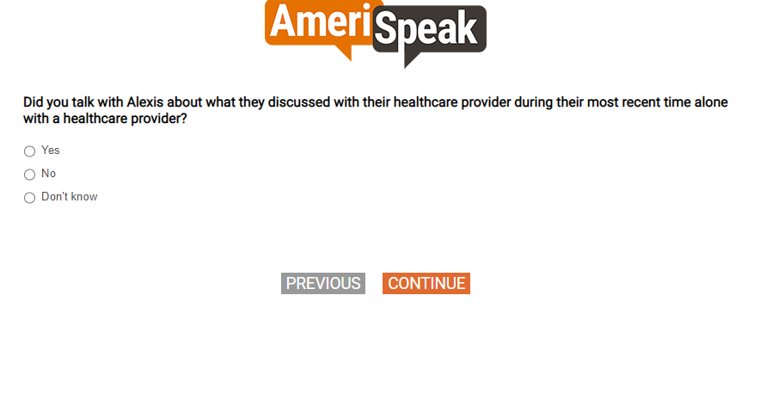

[NUMBOX 0-18]
Q40.
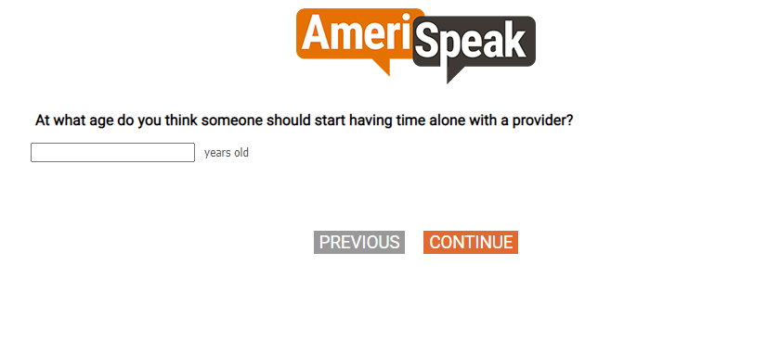

[SHOW IF Q37=2, 77, 98, 99]
[SP]
Q38.
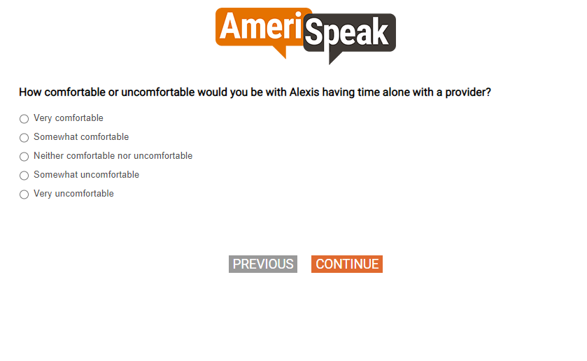

[SHOW IF Q38=4, 5]
[MP]
Q39.
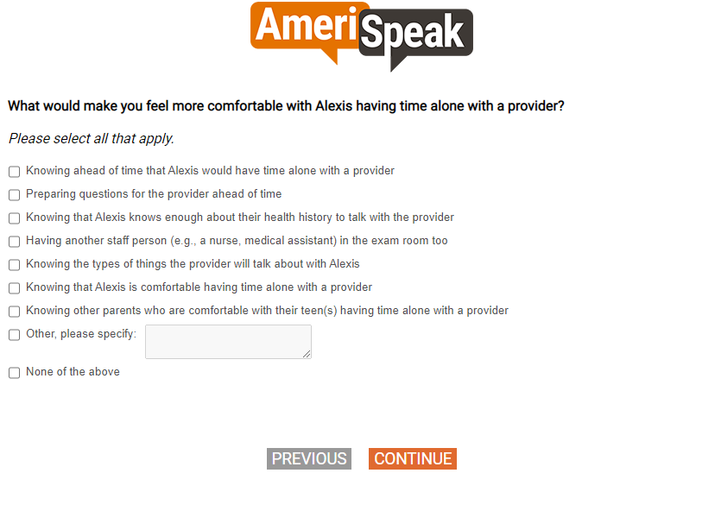

[GRID, SP; 3, 3]
[CAWI:
IF S3=77,98,99 and DOV_CHILDNAME does NOT start the grid item label, PIPE-IN "my child" INSTEAD OF "your child";
IF S3=77,98,99 and DOV_CHILDNAME starts the grid item label, PIPE-IN "My child" INSTEAD OF "your child"
CATI:
IF S3=77,98,99 and DOV_CHILDNAME does NOT start the grid item label, PIPE-IN "your child"
IF S3=77,98,99 and DOV_CHILDNAME starts the grid item label, PIPE-IN "Your child"]
Q41.
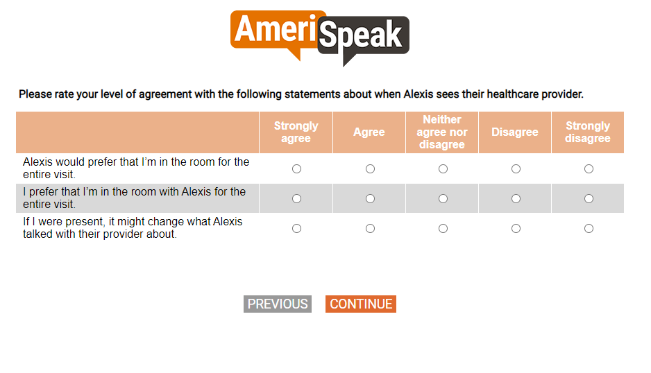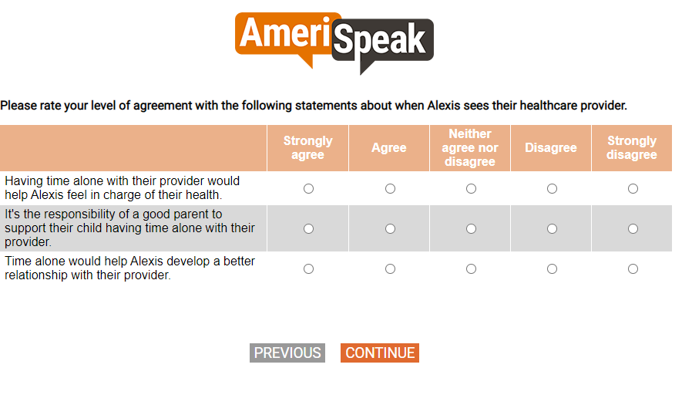

[GRID; SP]
Q43.
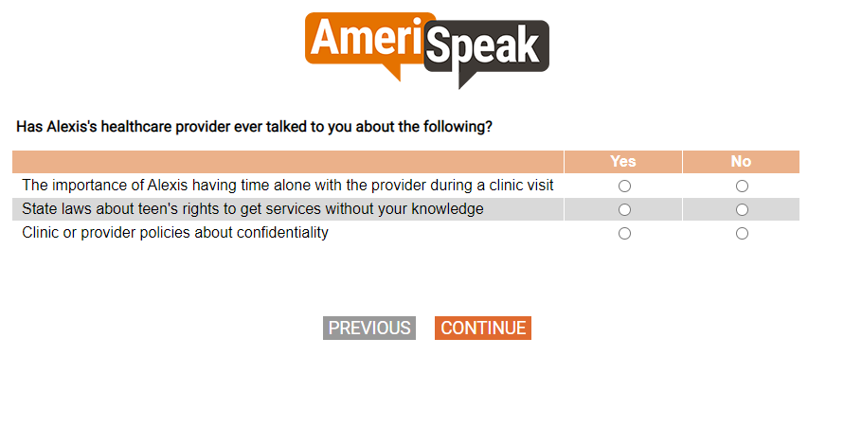

[GRID, SP]
[CAWI: IF S3=77,98,99, PIPE-IN "my child" INSTEAD OF "your child"
CATI: IF S3=77,98,99, PIPE-IN "your child"]
Q44.
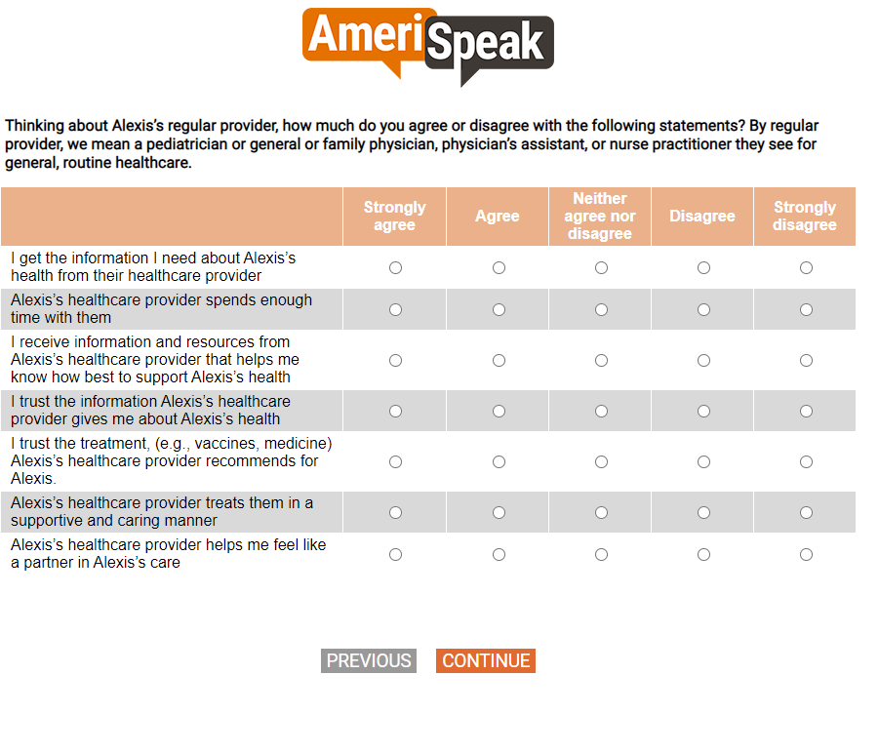

[GRID, SP; 3, 4]
Q45.
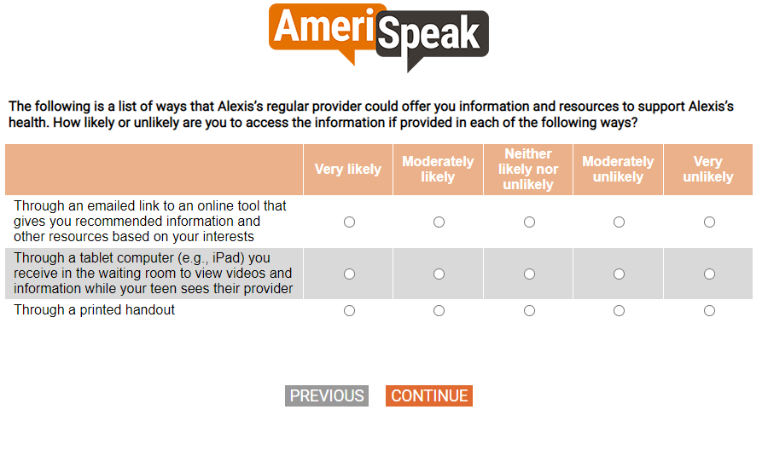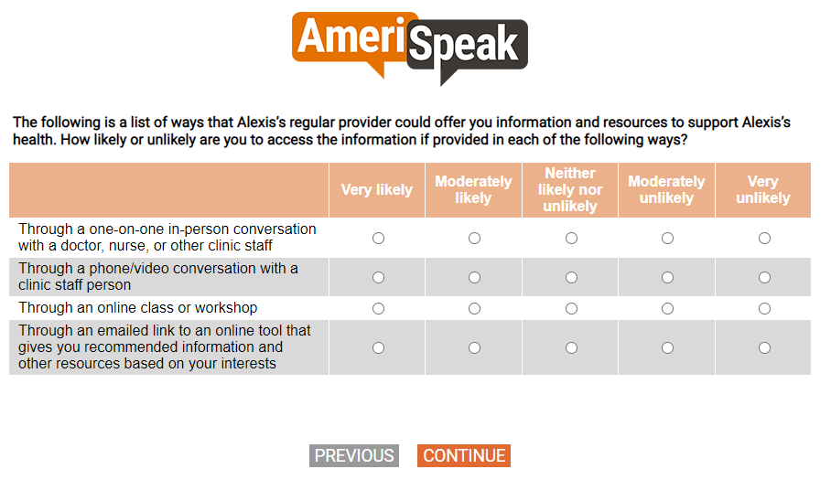

[SP]
Q46.
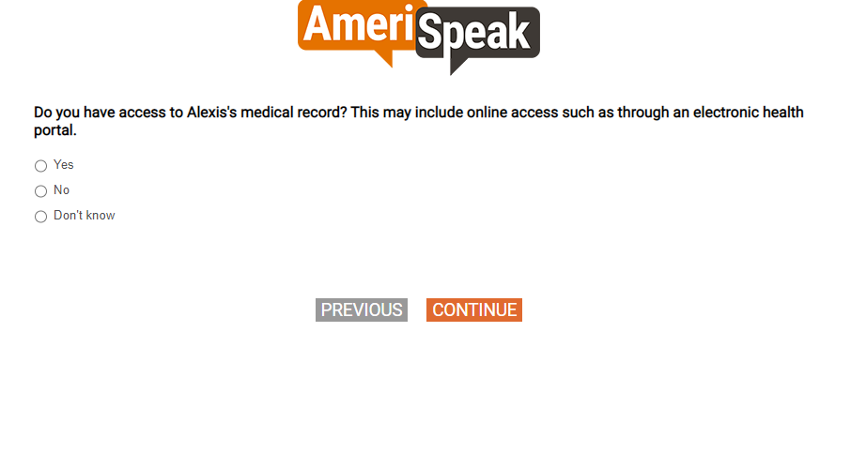

[SP]
Q46A.
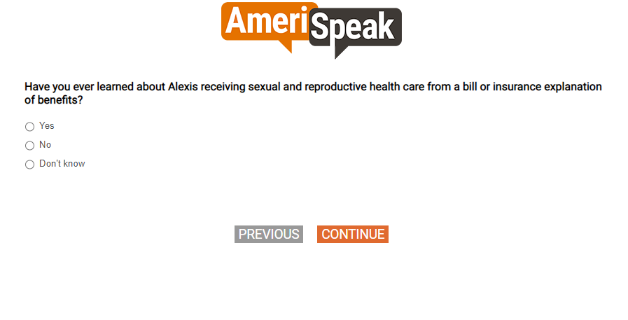

[SP]
Q47.

[SHOW IF Q47=1,2, 77, 98, 99]
[SP]
Q48.
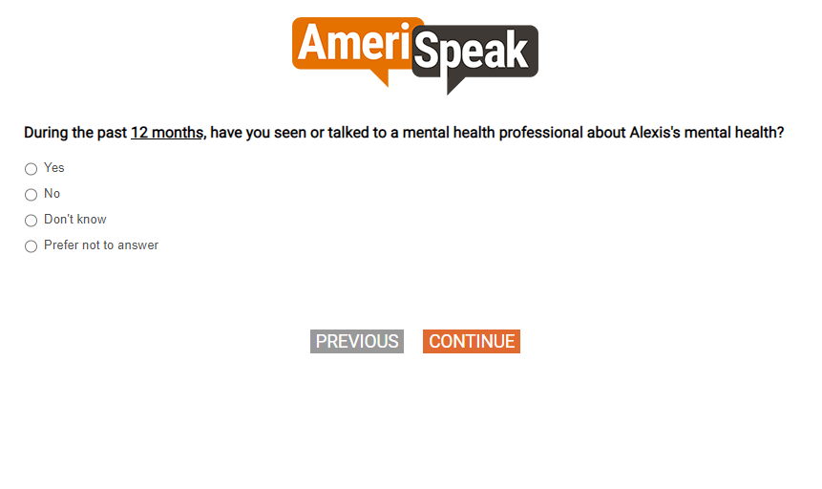

[SP]
Q49.
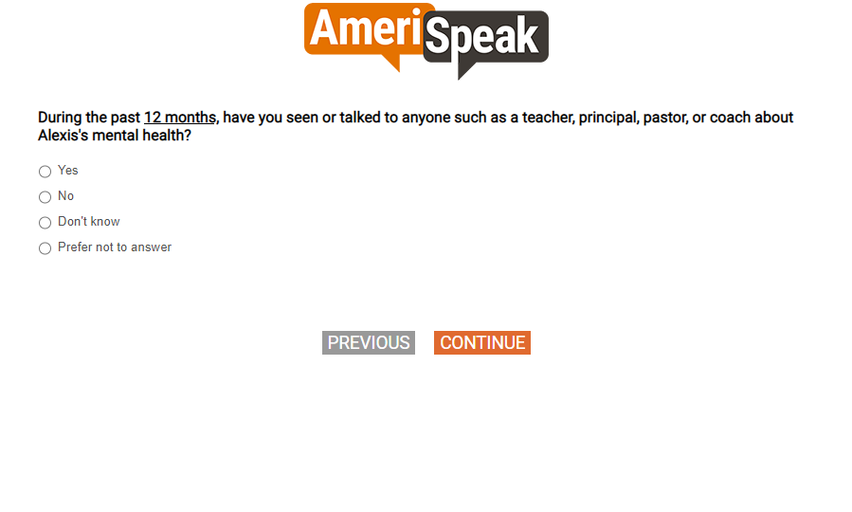

[SHOW IF Q47=1,2]
[SP]
Q50.
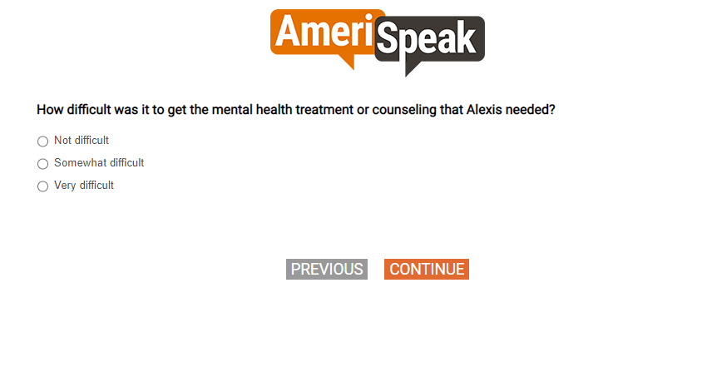

Section F. Sexual Health

[SP]
Q52.
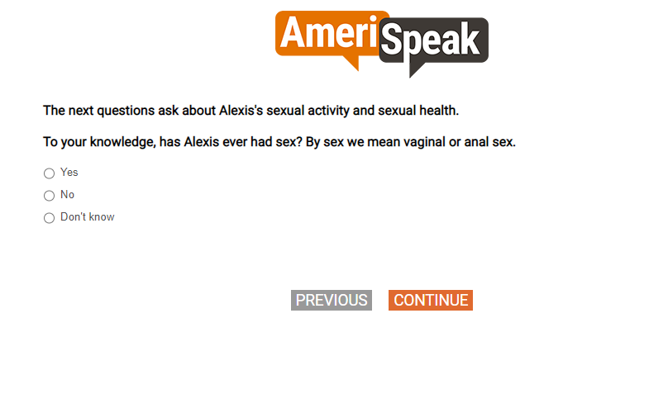

[SHOW IF Q52=1]
[NUMBOX]
[if QTAGE=77,98,99: NUMBOX range 0-17]
Q53.
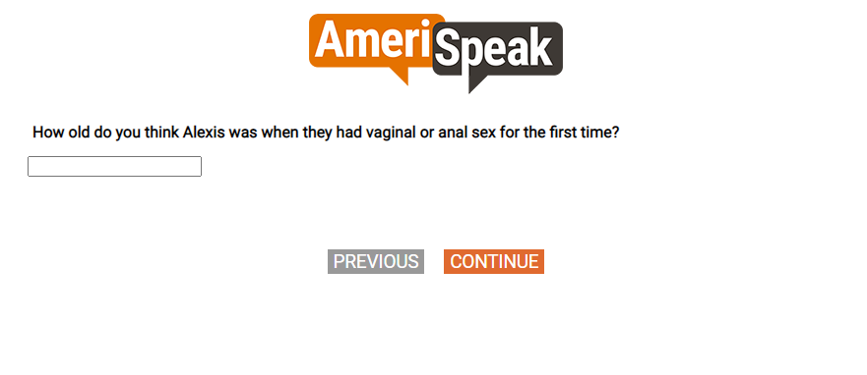

[SHOW IF Q52=1]
[MP]
Q53A.
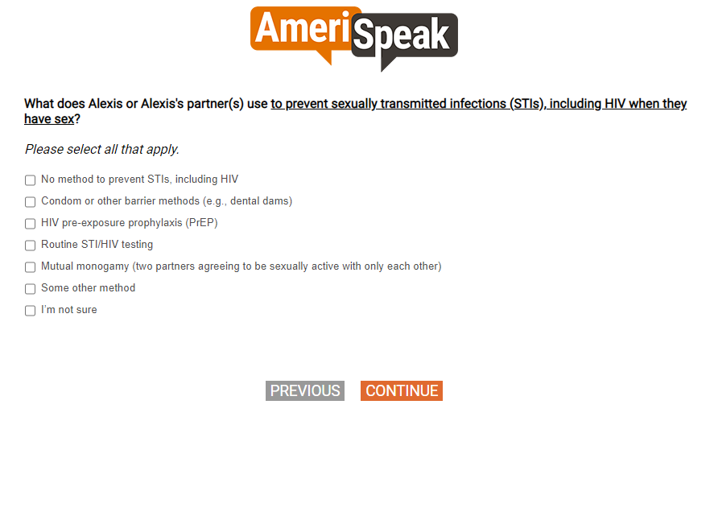

[SHOW IF Q52=1]
[SP]
Q54.
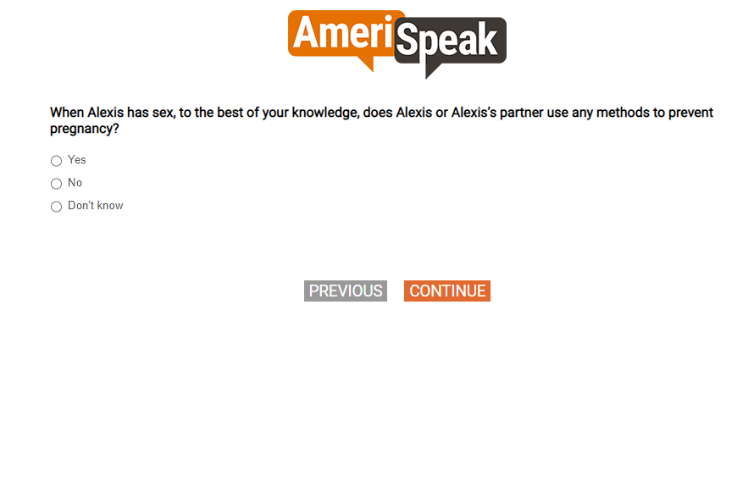

[SHOW IF Q54=1]
[MP]
Q55.
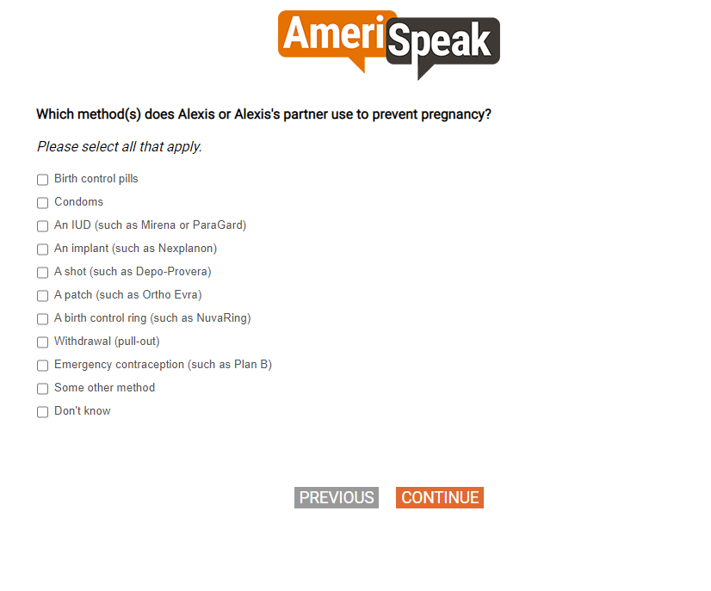

[SP]
Q57.
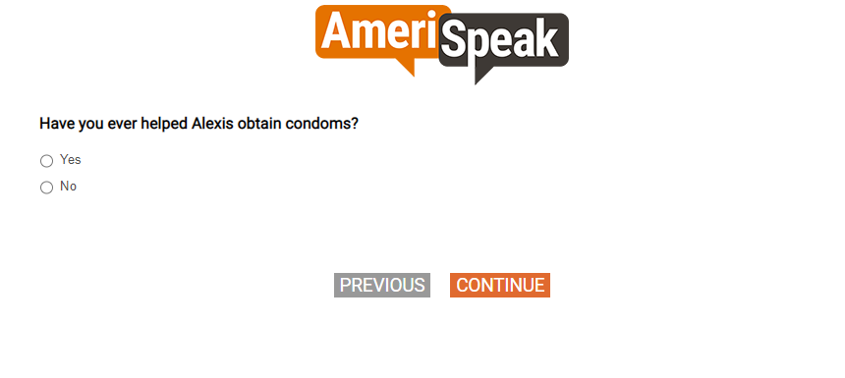

[SHOW IF QTGEN1=2]
[SP]
Q56.
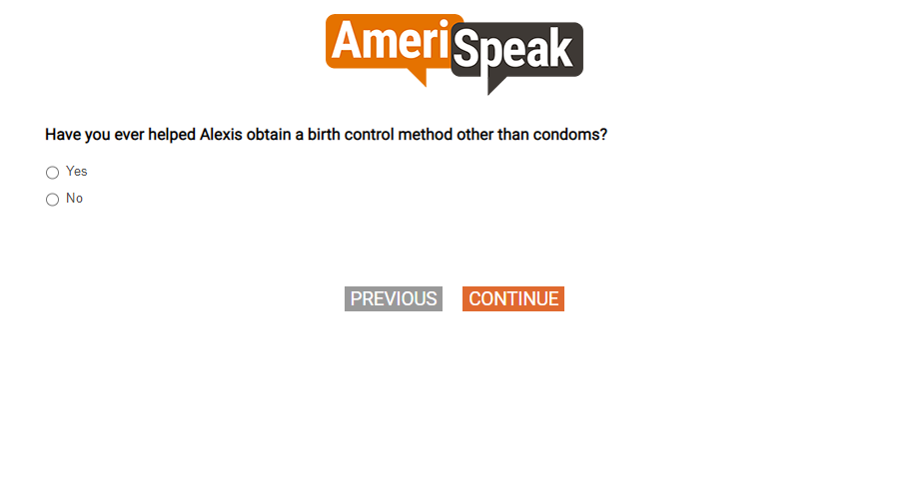

[SP]
Q58.
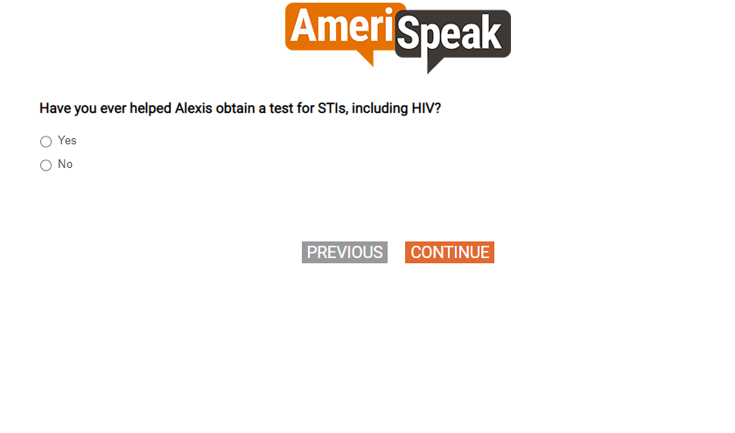

[SHOW IF QTGEN1=2]
[GRID,SP]
[CAWI: IF S3=77,98,99, PIPE-IN "my child" INSTEAD OF "your child"
CATI: IF S3=77,98,99, PIPE-IN "your child"]
Q60.
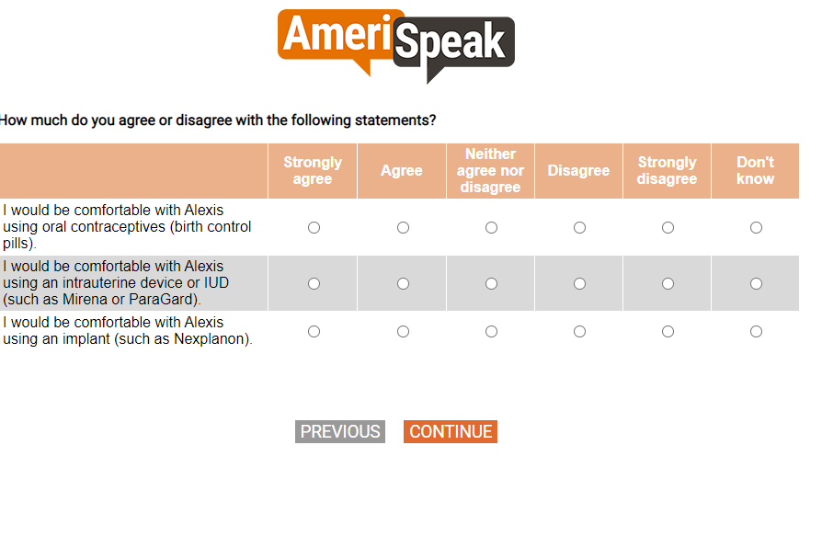

[GRID, SP]
Q59.
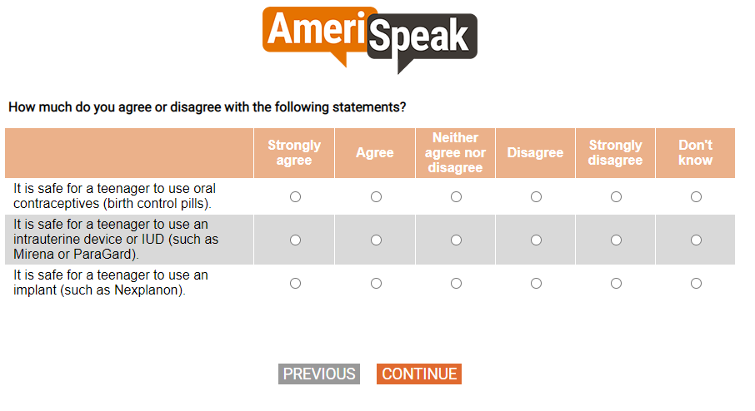
[MP]
Q60_B.
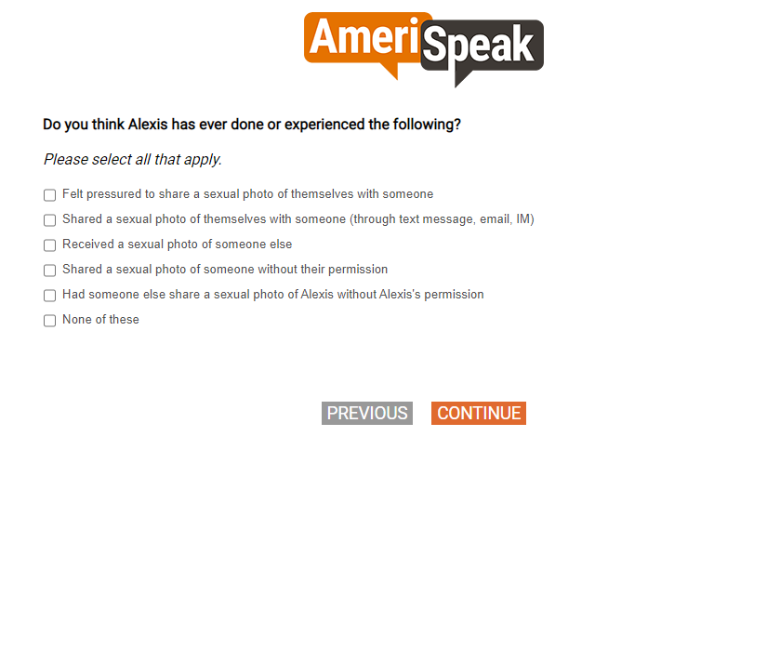

Section G. Substance Use

[GRID, SP]
Q61.
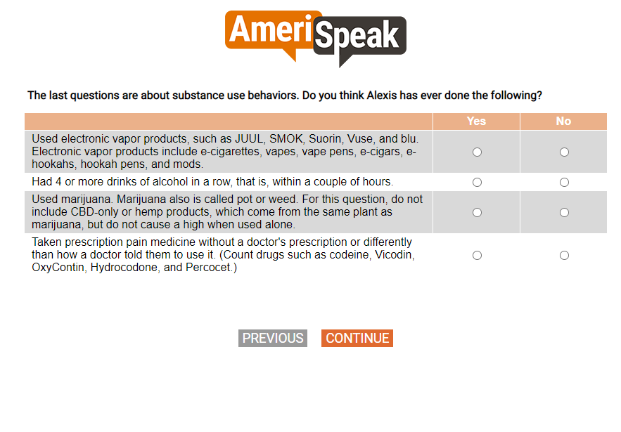

SCRIPTING NOTES: PUT QFINAL1, QFINAL2, QFINAL3 in the same screen.
[SINGLE CHOICE]
QFINAL1.
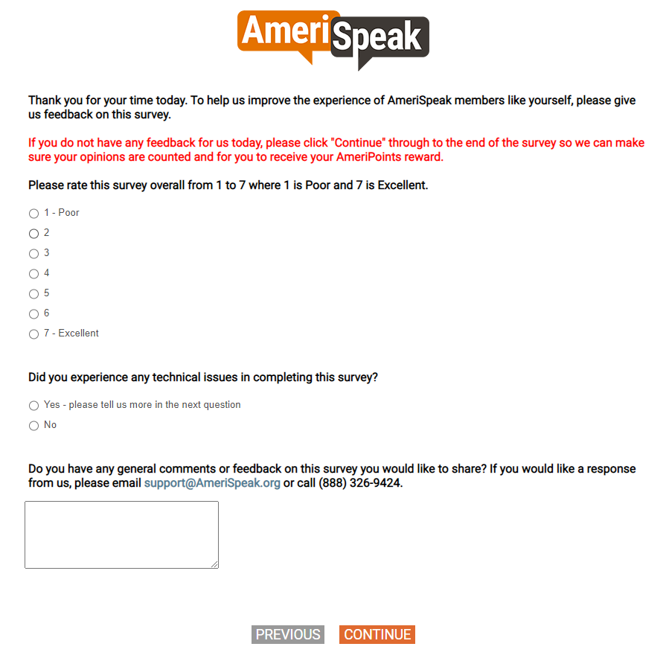
[DISPLAY]
END.
