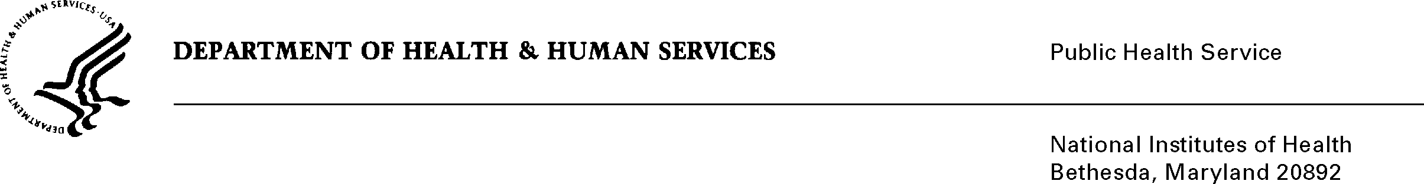

DATE: September 29, 2021

TO: Office of Management and Budget (OMB)
Matt Eliseo, Desk Officer

FROM: Mikia P. Currie
Chief, Project Clearance Branch

SUBJECT: Non-material/Non-substantive change request for: NIH COVID-Vaccination Attestation Intake Form, OMB 0925-0771, Expiration 3/31/2022

This is a request for OMB to approve a modification of a name change to the NIH COVID-Vaccination Attestation Intake Form in addition to other minor changes. Initially, this request was submitted to comply with the vaccination attestation requirements for the Federal Safer Workforce Taskforce. While the OMB approval was processing, the White House issued two Executive Orders that changed requirements in terms of the information collected and how they were to be collected.

Executive Order 14043 Requiring Coronavirus Disease 2019 Vaccination for Federal Employees requires that each agency implement a program to require COVID-19 vaccination for all Federal employees. Executive Order 14042 Ensuring Adequate COVID Safety Protocols for Federal Contractors requires that parties that contract with the Federal Government comply with guidance published by the Safer Federal Workforce Taskforce. Additionally, the NIH now has a mandatory vaccination requirement that affects several thousand staff working in our healthcare areas. This includes staff that are not federal employees or contractors. Our Division, through the Occupational Medical Service, has been providing contractors, tenants, fellows and other staff access to testing and vaccines during this pandemic. The information to be collected is needed to ensure we have the vaccination details for our staff (e.g., those providing essential services to the NIH via use agreements, visiting scientists, fellows and contractors, food service providers and our three separate childcare providers) to comply with Executive Order 14042, Executive Order 14043, and U.S. Department of Health and Human Services’ (HHS) policy to mandate COVID-19 vaccinations for healthcare support and patient facing health care staff.

 | Previous Version | Proposed Version
Name | NIH COVID-Vaccination Attestation Intake Form | NIH Vaccination Status Form
Form elements | Based on attestation process | Add: location of vaccination, Lot number (if known), upload feature for vaccine documentation  Remove: Attestation button, uploads for medical/ religious exemptions, decline to respond

The information being collected will be added to the staff members OMS file. It is being collected to ensure compliance with our vaccination policies, and to provide the highest levels of safety to our workforce and patient populations. The timeframe and the burden on respondents due to this change is unchanged.

Your full consideration is appreciated.

