SUPPORTING STATEMENT FOR THE
STATE OPIOID RESPONSE (SOR) AND TRIBAL OPIOID RESPONSE (TOR) PROGRAM DATA COLLECTION AND PERFORMANCE MEASUREMENT

JUSTIFICATION

A1. Circumstances of Information Collection

The Substance Abuse and Mental Health Services Administration (SAMHSA), Center for Substance Abuse Treatment (CSAT) is requesting approval from the Office of Management and Budget (OMB) for revisions to the previously approved program instrument and data collection activities associated with the State Opioid Response (SOR) and Tribal Opioid Response (TOR) grant programs (OMB No. 0930–0384). SAMHSA is requesting approval to modify its existing CSAT SOR/TOR Program Instrument by (1) collapsing the original three questions into two questions for clarity, and (2) adding ten questions in order to collect information on Congressionally mandated and programmatic activities and comply with reporting requirements. The SOR/TOR programs were first authorized under Title II Division H of the Consolidated Appropriations Act, 2018, Public Law 115-141.

This information is collected using a grantee-level (state/territory or tribal entity) tool that provides CSAT with prevention information about all SOR/TOR grantees, including data on:

- Reported overdose reversals;
- The purchase and distribution of naloxone;
- Training on the administration of naloxone;
- Implementation of prevention and education activities;
- Outreach activities for underserved communities; and
- The purchase and distribution of fentanyl test strips.

This program level information is collected quarterly. In order to be fully accountable for the spending of federal funds, SAMHSA/CSAT requires all SOR/TOR grantees to collect and report data to ensure that program goals and objectives are met. Data collected as part of this package are used as a tool to monitor performance through the grant period. All data under this request will be collected electronically in SAMHSA’s Performance and Accountability Reporting System (SPARS).

Approval of this information collection will allow SAMHSA to continue to meet the Government Performance and Results Modernization Act (GPRA) of 2010 reporting requirements that quantify the effects and accomplishments of its discretionary grant programs, which are consistent with OMB guidance.

In order to carry out section 1105(a) (29) of the GPRA, SAMHSA is required to prepare a performance plan for its major program activities.

SAMHSA’s legislative mandate includes increasing access to high quality prevention services and to improve outcomes. Its mission is to reduce the impact of substance use and mental illness on our communities.
A2. Purposes and Use of Information

SAMHSA uses this information to report on the performance and outcomes of its SOR/TOR programs. The information is used by individuals at different levels: the Assistant Secretary and SAMHSA staff, the Center administrators, Government Project Officers (GPOs), and grantees:

Assistant Secretary Level – The information is used to inform the administration of the performance of the SOR/TOR programs.

Center Level – In addition to providing information about the performance of the SOR/TOR programs, the information is used to monitor and manage individual grant projects within each program. The information is used by GPOs to identify program strengths and weaknesses, to provide an informed basis for providing technical assistance and other support to grantees, to inform funding decisions, and to identify potential issues for additional evaluation

Grantee Level – In addition to monitoring performance and outcomes, the grantee staff uses the information to improve the quality of prevention services provided to clients within their projects.

SAMHSA and CSAT will use the data to better assess grantee accountability and performance on the required education and prevention activities for the SOR/TOR programs. SAMHSA will also use the data collected through the revised tool to implement recommendations resulting from the GAO study, “Drug Misuse: Agencies Have Not Fully Identified How Grants That Can Support Drug Prevention Education Programs Contribute to National Goals (GAO-21-96).” Finally, the revisions will assist SAMHSA in providing comprehensive data on the full range of required activities to inform Congressionally mandated reports for the SOR program.

Proposed Changes to Data Collection Tool

SAMHSA is proposing to revise the SOR/TOR Program Instrument data collection instrument (OMB No. 0930-0384), to collect information on Congressionally mandated and programmatic activities and comply with reporting requirements.

SAMHSA originally developed the SOR/TOR Program Instrument to collect minimum data on naloxone purchase and distribution, but the SOR/TOR programs are unique in that they have prevention requirements. SOR/TOR grantees are required to engage in the following prevention activities: (1) Implement prevention and education services including training of peers and first responders on recognition of opioid overdose and appropriate use of the opioid overdose antidote naloxone; (2) Develop evidence-based community prevention efforts, including strategic messaging on the consequences of opioid misuse; and (3) Purchase and distribute naloxone and train on its use. The revised tool will allow SAMHSA to collect data on the required education and prevention activities, and better assess grantee performance on these activities.

Based on a recent United States Government Accountability Office (GAO) Report to Congress GAO 21-96, ‘Drug Misuse: Agencies Have Not Fully Identified How Grants That Can Support Drug Prevention Education Programs Contribute to National Goals,’ GAO found that SAMHSA’s performance measures for the SOR program partially reflect its core program activities, and that although SAMHSA reported three performance measures for the SOR program, all three measures focused on treatment or recovery services only. GAO recommended, and SAMHSA agreed to, the following: “The Secretary of Health and Human Services should determine how the State Opioid Response program contributes to the prevention goals of the National Drug Control Strategy and develop performance measures that relate to achieving those goals including the prevention education goal.” Collection of the data in the revised tool will enable SAMHSA to implement the recommendations of the GAO.

Finally, SAMHSA and CSAT will use the program data for Congressionally mandated SOR reports. The information collected through the revised tool will provide comprehensive data on the full range of required activities to inform Congressionally mandated reports for the SOR program.

Summary of Proposed Changes:

The original SOR/TOR program instrument had three questions. SAMHSA is proposing to (1) collapse the three questions into two questions for clarity and (2) add ten questions, in order to collect information on Congressionally mandated and programmatic activities and comply with reporting requirements. The revised question will provide CSAT with clarification on the purchase and distribution of naloxone kits. The ten additional questions will: enhance SAMHSA’s ability to assess grantee accountability and performance on the required education and prevention activities for the SOR/TOR programs; enable SAMHSA to implement GAO recommendations to determine how the SOR program contributes to the prevention goals of the National Drug Control Strategy and develop performance measures that relate to achieving those goals, including the prevention education goal; and provide comprehensive data on the full range of required activities, to inform Congressionally mandated reports for the SOR program.

As a result of the ten additional questions, SOR/TOR grantees will submit data on the following outcome measures:

- Reported overdose reversals;
- Purchase and distribution of fentanyl test strips;
- Training of first responders and key community sectors on recognizing an opioid overdose and the appropriate use of naloxone overdose reversal kits;
- Educating individuals, including school-aged children, on the consequences of opioid and/or stimulant misuse, using strategic messaging and prevention activities;
- Training individuals to provide school-based prevention and education activities to school-aged children; and
- Providing targeted prevention outreach activities to underserved and/or diverse populations.

All SOR/TOR data collection activities are intended to promote the use of consistent measures among SOR/TOR grantees. These measures are a result of extensive examination and recommendations, using consistent criteria, by panels of staff who have knowledge of and experience with the SOR/TOR programs. Wherever feasible, the measures are consistent with or build upon previous data development efforts within CSAT. These data collection activities are organized to reflect and support required SOR/TOR prevention and education services.

A3. Use of Improved Information Technology

Grantees collect program-level information using a variety of methods, including paper-and-pencil and electronic methods. This project will not interfere with ongoing program collection operations that facilitate information collection at each site.

A web-based data collection and entry system, SAMHSA’s Performance Accountability and Reporting System (SPARS), has been developed, and is currently used and available to all programs for data submission. This web-based system allows for easy data entry, submission, and reporting to all those who have access to the system. Levels of access have been defined for users based on their authority and responsibilities regarding the data and reports. Access to the data and reports is limited to those individuals with a username and password. A screenshot of the data entry screen on SPARS is below:

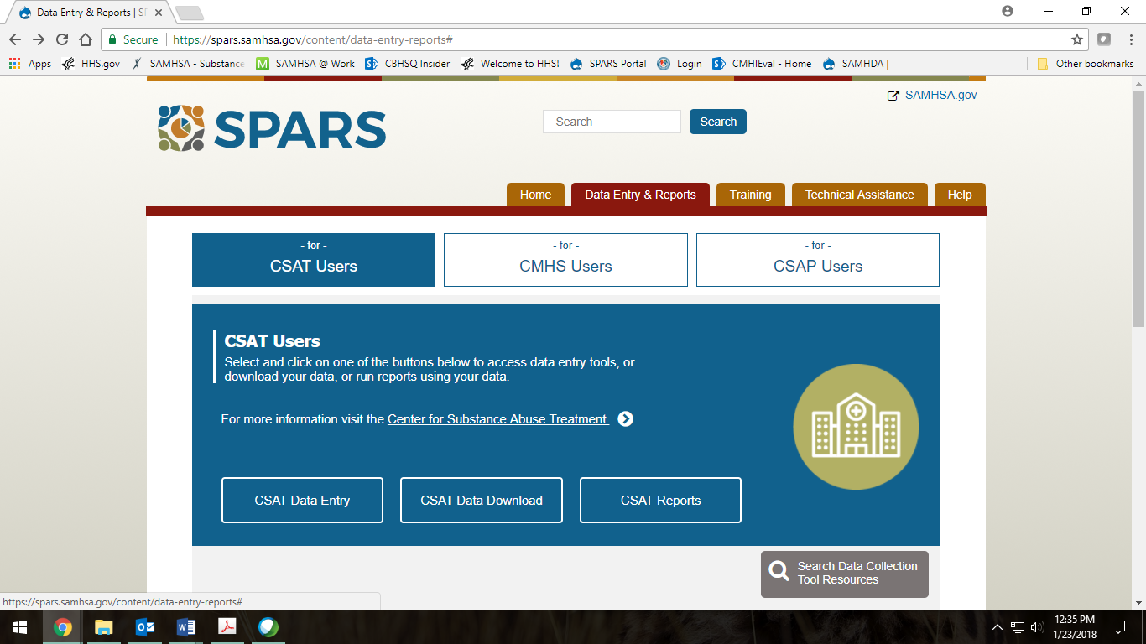

Electronic submission of the data promotes enhanced data quality. With built-in data quality checks and easy access to data outputs and reports, users of the data can feel confident about the quality of the output. The electronic submission also promotes immediate access to the dataset. Once data are entered in the web-based system, they are available for access, review, and reporting by all those with access to the system, both Center and grantee staff.

A4. Efforts to Identify Duplication

The items collected are necessary in order to assess grantee performance. SAMHSA is promoting the use of consistent performance and outcomes measures across SOR and TOR programs; this effort will result in less overlap and duplication and will substantially reduce the burden on grantees that results from data demands associated with individual programs.

A program-level review of current measures and methods of data collection was conducted with the goal of creating questions for more precise monitoring of grantee performance. Each proposed question was reviewed and approved by CSAT senior leadership as meeting the performance monitoring and management needs of the SOR/TOR program.

A5. Involvement of Small Entities

Individual grantees vary from tribal entities to tribes and states. Every effort has been made to minimize the number of data items collected from grantees, requiring responses to only the items necessary to accomplish the objectives described in the GPRA reporting requirements. Therefore, there is no significant impact to small entities.

A6. Consequences if Information Collected Less Frequently

SOR/TOR grant programs report program level data to SAMHSA quarterly. These points in time are part of regular program monitoring. If these data are collected less frequently, changes in program services will be difficult to measure.

These data will be reported by SAMHSA in Congressionally mandated SOR reports.

A7. Consistency with the Guidelines in 5 CFR1320.5(d)(2)
This information collection fully complies with 5 CFR 1320.5(d) (2).

A8. Consultation Outside the Agency

The notice required by 5 CFR 1320.8(d) was published in the Federal Register on August 2, 2021 (86 FR 41495). No comments were received in response to this notice.

A9. Payment to Respondents

The respondents do not receive payments.

A10. Assurance of Confidentiality

The information from Grantees and all other potential respondents will be kept private through all steps in the data collection and reporting processes. However, SAMHSA cannot ensure complete confidentiality of the program level data. Only aggregated data will be reported. SAMHSA has statutory authority to collect data under the GPRA (Public Law 1103(a), Title 31), and is subject to the Privacy Act for the protection of data. Federally assisted substance abuse treatment providers are subject to the federal regulations for alcohol and substance abuse patient records (42 CFR Part 2) (OMB No. 0930-0092), which govern the protection of patient identifying data. In some cases, these same providers meet the definition of a Health Insurance Portability and Accountability Act covered entity and are additionally subject to the Privacy Rule (45 CFR Parts 160 and 164) for the protection of individually identifiable data.

A11. Questions of a Sensitive Nature

SAMHSA’s mission is to improve the quality and availability of prevention, early intervention, treatment, and rehabilitation services for substance use and mental illnesses, including co-occurring disorders, in order to improve health and reduce illness, death, disability, and cost to society. The data submitted by each grantee primarily include aggregate data on reported overdose reversals; the purchase and distribution of naloxone; training on naloxone administration; implementation of prevention and education activities; outreach activities for underserved communities; and the purchase and distribution of fentanyl test strips.

A12. Estimates of Annualized Hour Burden

The estimated time to complete the instruments is given in Table 1. These estimates are based on current funding and planned funding and the number of consumers served in recent years. The amount of time required to complete the new questions is based on an informal pilot and prior SAMHSA/CSAT experience in collecting similar data.

Table 1: Estimates of Annualized Hour Burden for SOR/TOR Grantees

SAMHSA Data Collection | Number of Respondents | Responses per Respondent | Total Number of Responses | Burden Hours per Response | Total Burden Hours | Hourly Wage | Total Wage Cost
Grantee-Level Instrument | 159 | 4 | 636 | .30 | 190.80 | $24.78 | $4,728.02
CSAT Total | 159 | 4 | 636 | .30 | 191 | $24.78 | $4,728.02
^{[2]} The hourly wage estimate is $24.78 based on the Occupational Employment and Wages, Mean Hourly Wage Rate for 21-1018 Substance Abuse, Behavioral Disorder, and Mental Health Counselors= $24.78 /hr. as of May 2020 (https://www.bls.gov/oes/current/oes211018.htm Accessed on May 4, 2021.)
The estimates in this table reflect the maximum annual burden for currently funded SOR/TOR programs. The number of clients served in future years is estimated to be the same, assuming unchanged funding of the SOR/TOR program, resulting in the same annual burden estimate for those years.

A13. Estimates of Annualized Cost Burden to Respondents

There are no capital or startup costs, nor are there any operation and maintenance costs.

A14. Estimates of Annualized Cost to the Government

The principal additional cost to the government for this project is a contract to collect data from the various programs and conduct analyses for routine reports. The reports will examine baseline characteristics and changes between baseline and discharge, and each of the follow-up periods. It will be the responsibility of the contractor to work with the GPO when preparing reports that combine client services data with the project annual reports.

The cost of one full-time equivalent staff (25% for one GS-14 Step 5, $34,716.50 and 75% for one GS-12 Step 5, $74,120.25) responsible for the CSAT data collection effort is approximately $217,673.50 over 2 years.

The annualized cost to the government is $108,837.

A15. Changes in Burden
Currently, there are 244 burden hours in the OMB-approved inventory. SAMHSA is not requesting additional hours at this time. A decrease in respondents created a decrease in total burden hours. There remains a 53.20 hour decrease in burden, despite addition of new items to the instrument.

A16. Time Schedule, Publication and Analysis Plans
Data for the SOR/TOR programs are needed by SAMHSA to prepare Congressionally mandated reports. The SOR/TOR program data are readily available through the web-based system. Data are provided quarterly to SAMHSA, in order to assure timely analysis, to submit the required Congressional reports. The data might also be used for specific comparisons relative to the Office of National Drug Control Policy’s National Drug Control Strategic Goals, especially for the prevention education goal.

There will also be program-specific analyses of these data, because each program has unique programmatic and performance goals. The data items collected will be analyzed and presented in GPRA reports using basic descriptive statistics. Key outcomes that will be calculated and aggregated at the program level include: reported overdose reversals; the purchase and distribution of naloxone; training on the administration of naloxone; implementation of prevention and education activities; outreach activities for underserved communities; and the purchase and distribution of fentanyl test strips. If deemed necessary for CSAT specific issues, the data will be examined at the individual activity level.

A17. Display of Expiration Date

The expiration date for OMB approval will be displayed on all data collection instruments.

A18. Exceptions to Certification Statement

This collection of information involves no exceptions to the Certification for Paperwork Reduction Act Submissions. The certifications are included in this submission.

United States Government Accountability Office. (2020, November). Drug Misuse Agencies Have Not Fully Identified How Grants That Can Support Drug Prevention Education Programs Contribute to National Goals. https://www.gao.gov/assets/gao-21-96.pdf

