Expiration Date: XX/XXXX

MLMS Assister Training Certificate Mock-Up

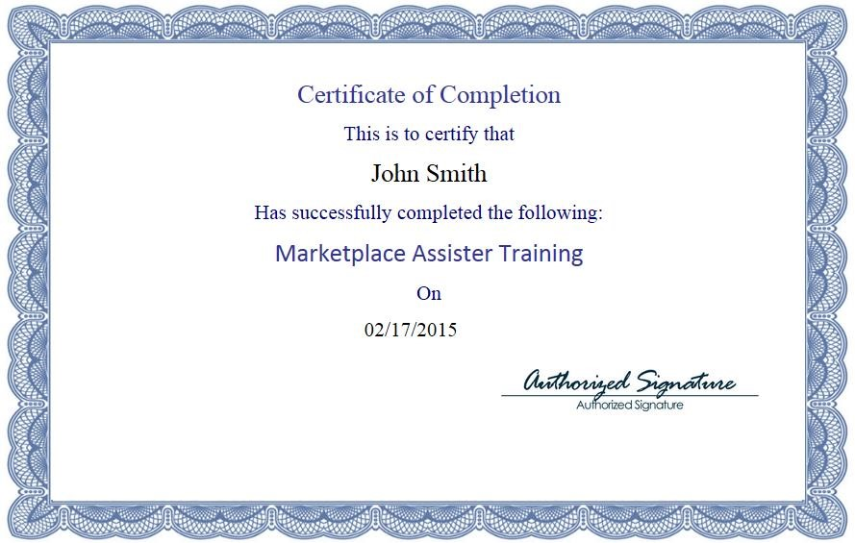

Graphic 1- Example Certificate for Assisters
Written description of Mock-up Certification example for the MLMS Assister Training.
Certificate says:
Certificate of Completion
This is to certify that
John Smith
Has successfully completed the following:
Marketplace Assister Training
On
02/17/2015
Authorized Signature

