Person Statement (DPST) screen in the SSI Claims Systems (MSSICS)
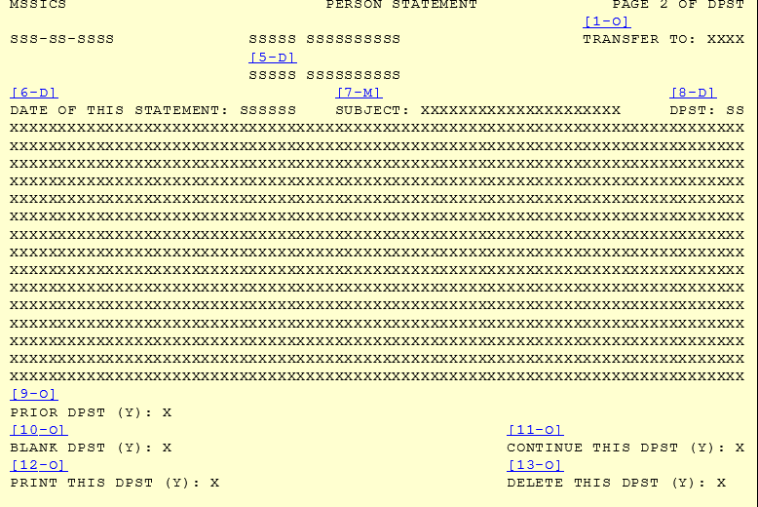
Technicians use the Person Statement (DPST) screen in the SSI Claims Systems as the SSA-795 to collect the information via telephone or in-person interviews and then prints the form for the individual to sign. Once the form is printed and signed, the technician uploads the copy to the claimant’s Electronic File.

Consolidated Claims Experience (CCE) Web-based electronic version of the SSA-795
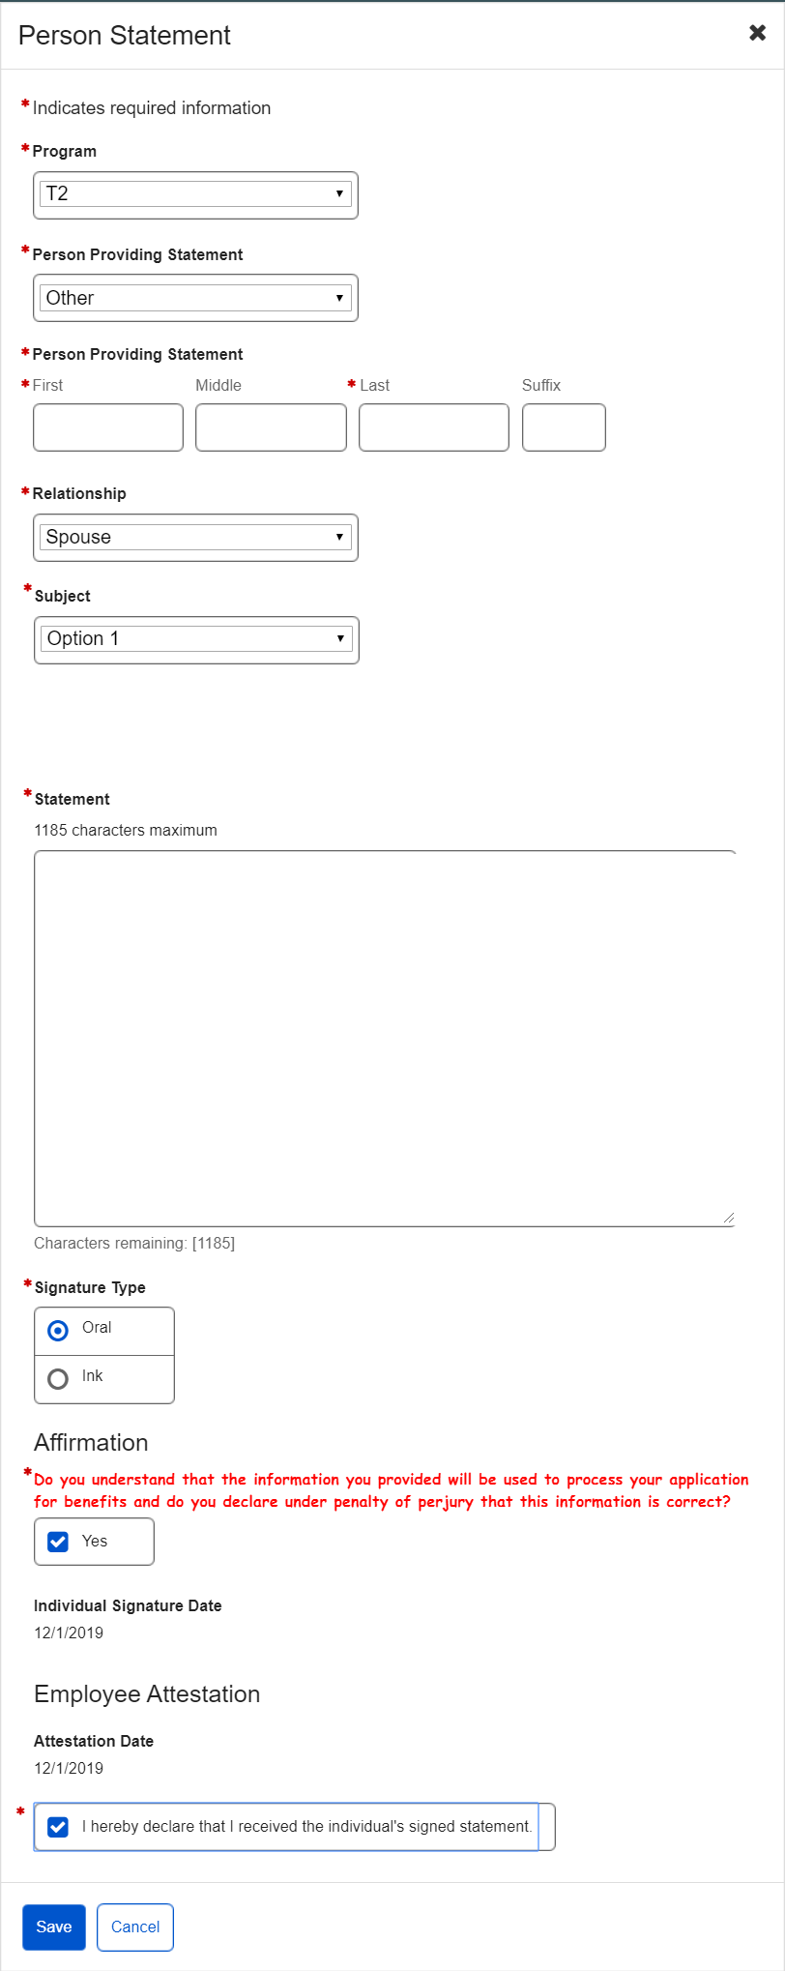
CCE will eventually replace other claims screens or other forms. Therefore, the electronic SSA-795 provides an option to select other Social Security programs i.e. T2 besides SSI i.e. T16.
The new web-based CCE platform will house an electronic version of the SSA-795, which allows the SSA technician to record the individual’s statement and obtain a signature using either the attestation procedure or wet signature. Once filled out, the system will save the electronic version as part of the claim.

