Consolidated Claims Experience (CCE) Web-based electronic version of the SSA-795
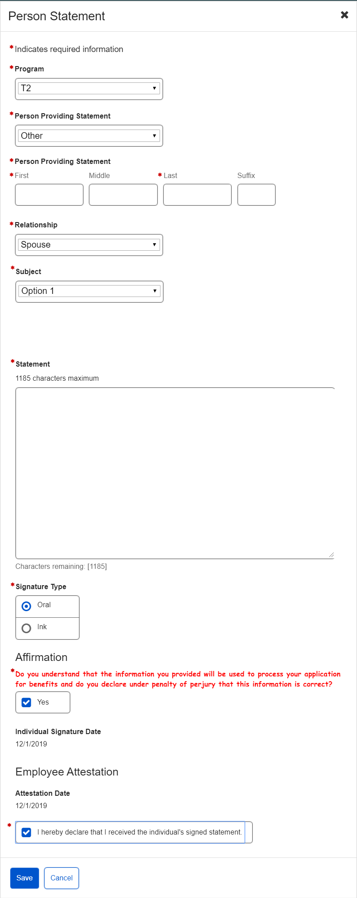
CCE will eventually replace other claims screens or other forms. Therefore, the electronic SSA-795 provides an option to select other Social Security programs i.e. T2 besides SSI i.e. T16.
The new web-based CCE platform will house an electronic version of the SSA-795, which allows the SSA technician to record the individual’s statement and obtain a signature using either the attestation procedure or wet signature. Once filled out, the system will save the electronic version as part of the claim.

