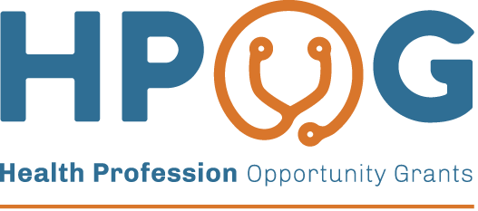
Newsletter for HPOG 2.0 Study Participants
Hello again from the Health Profession Opportunity Grants (HPOG 2.0) Evaluation team!
In 2015, the Administration for Children and Families (ACF), part of the US Department of Health and Human Services, awarded a second round of HPOG grants (HPOG 2.0) to 32 local organizations. ACF hired Abt Associates to conduct a study of this second round of HPOG programs. This study will help ACF learn more about how training opportunities help people find better jobs in healthcare. The HPOG study is well underway. The staff at ACF and the study team are grateful for your participation and cooperation in our study. We want to update you on activities we have completed over the past 5 years and share a look into what is coming up!

Accomplishments over the past five years:
- Over 9,200 study participants completed the 15-month survey by late 2019. In 2021, the HPOG evaluation team published a report on the results.
- The study team completed the 36-month survey data collection in 2021 with over [xx] study participants. The evaluation team published the report in [TO BE FILLED IN PRIOR TO MAILING].

Looking Ahead!
- The next phase of the study is to conduct another survey to study long-term outcomes for HPOG 2.0 study participants. This long-term follow-up survey will help ACF learn more about how employment and training programs help participants about 5 ½ years after they enrolled in the study.
- The survey data collection is scheduled to begin in May 2023.
- You and your unique experiences since enrolling in the study are very important to ACF. Your participation is voluntary. Any information you give us will be kept private

We need your help! We would love to be able to talk to you again because we are interested in the experiences of everyone who applied to the HPOG program, even if you were not selected to participate in the program. To help us contact you in 2023 when the next survey will begin, please review the enclosed form to check your address, telephone number, and email. If your information is correct, please mark the box next to “No Changes.” The enclosed letter includes instructions on how to make any corrections.

Once we receive your updated contact information, we will send you a gift card valued at $5, by email. If you have any questions or do not have an email address, please feel free to contact us at 1-XXX-XXX-XXXX. Thank you in advance for your cooperation.
Si le gustaría recibir esta información en español, favor de llamar a Abt Associates al 1-xxx-xxx-xxxx.

Sincerely yours,

Brenda Rodríguez, Senior Survey Project Director Gretchen Locke, Study Project Director
Abt Associates Abt Associates

Curious to learn more about what we have learned so far? Visit the Career Pathways Website:
https://career-pathways.org/acf-sponsored-studies/hpog-2/hpog-2-ne/

Paperwork Reduction Act (PRA) Statement: Your participation in the described information collection is voluntary. An agency may not conduct or sponsor, and a person is not required to respond to, a collection of information unless it displays a currently valid OMB control number. The OMB control number for this collection is 0970-0462 and it expires xx/xx/xxxx. If you have comments regarding this collection of information, including suggestions for reducing this burden, please send them to Gretchen Locke Abt Associates 10 Fawcett St Suite 5 Cambridge, MA 02138; Attn: OMB-PRA (0970-0462).

