IDCF/E-Update

This application accessed through the IDCF Gatekeeper application that requires an account number and password to authenticate. This allows previously entered data to be displayed to the respondent when they enter the NCS E-Update application.

Welcome Page:
Government CIPSEA and OMB Statements
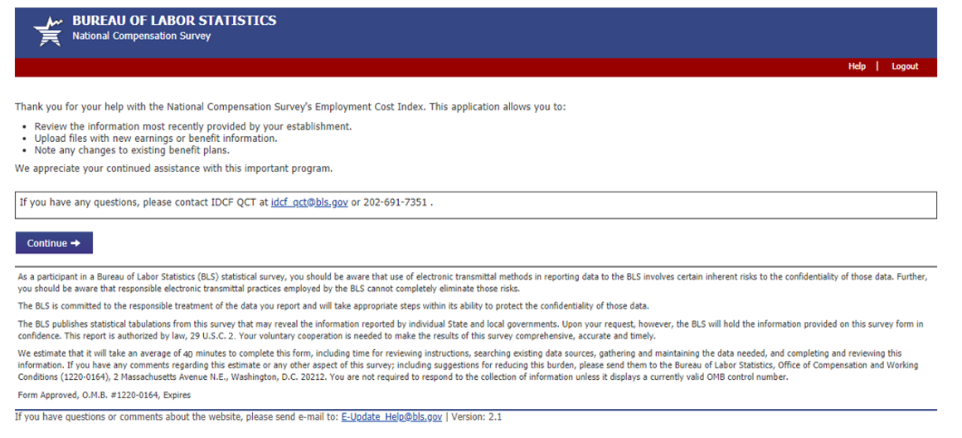
CIPSEA and OMB Statement
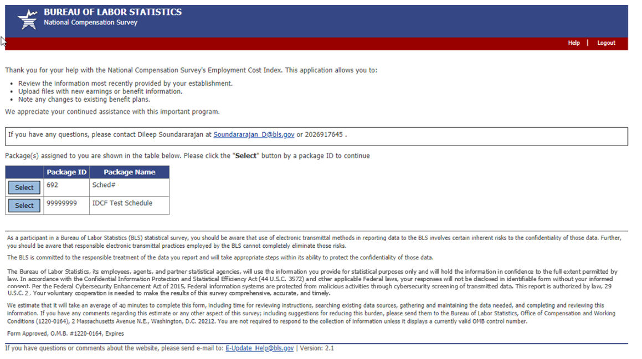
Data Entry Page:
Benefits
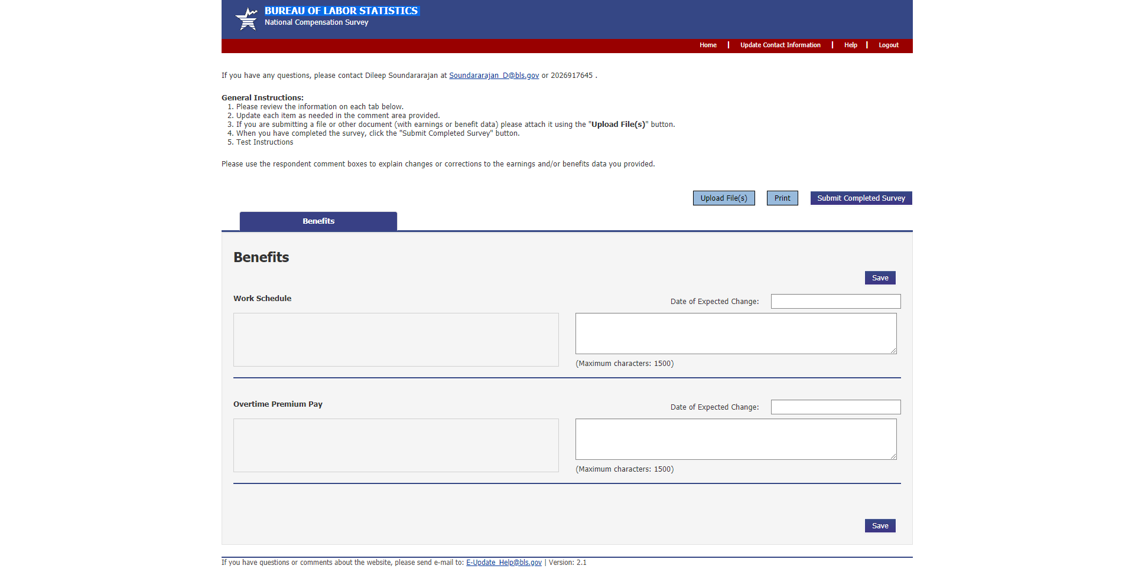
Earnings
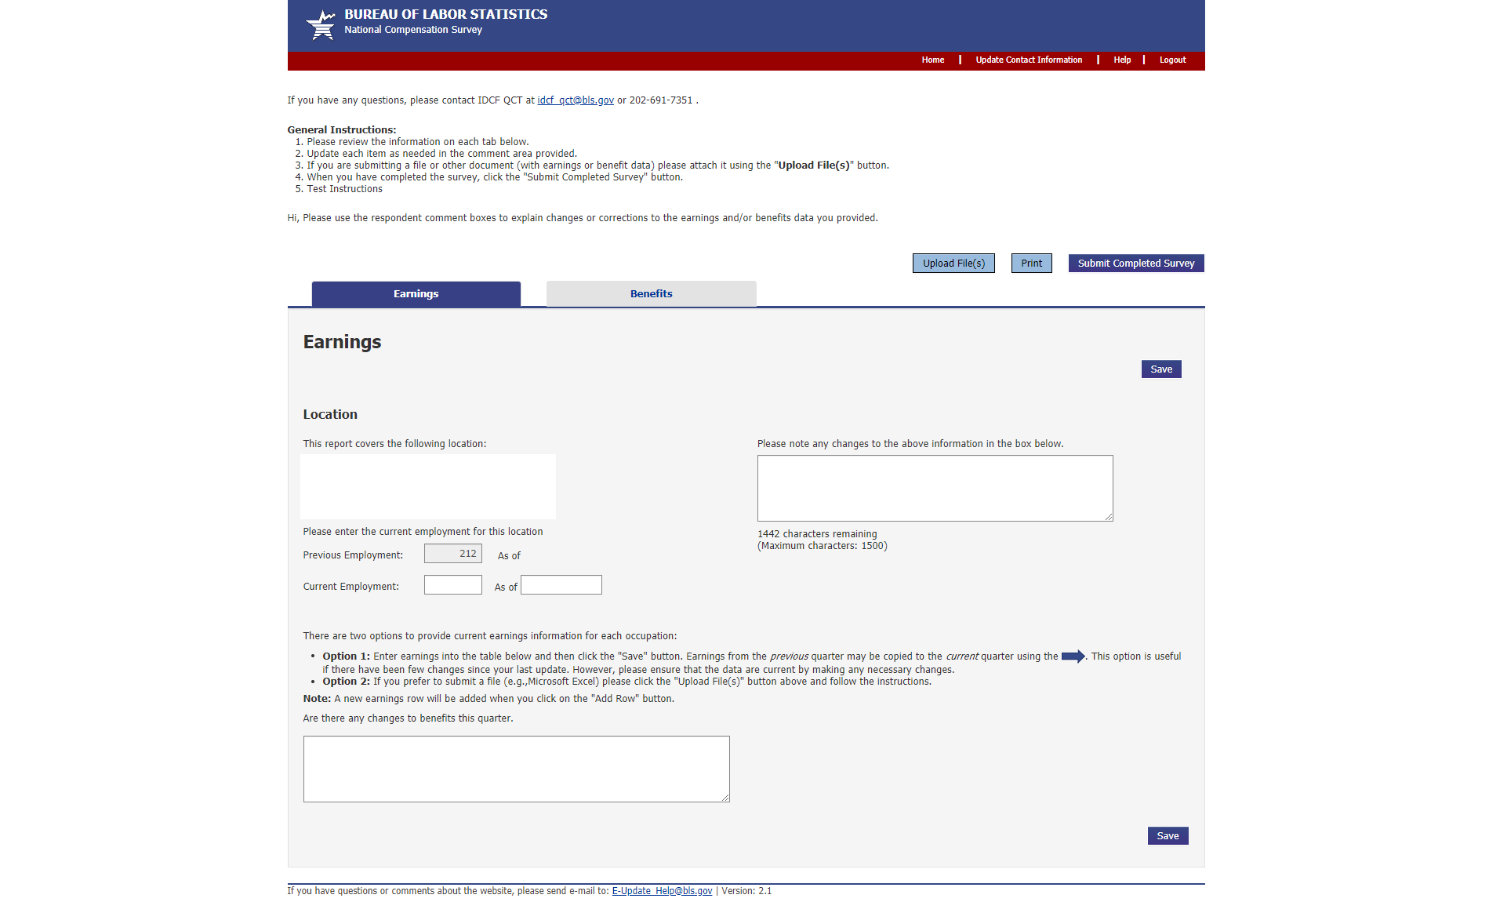

Upload File(s):
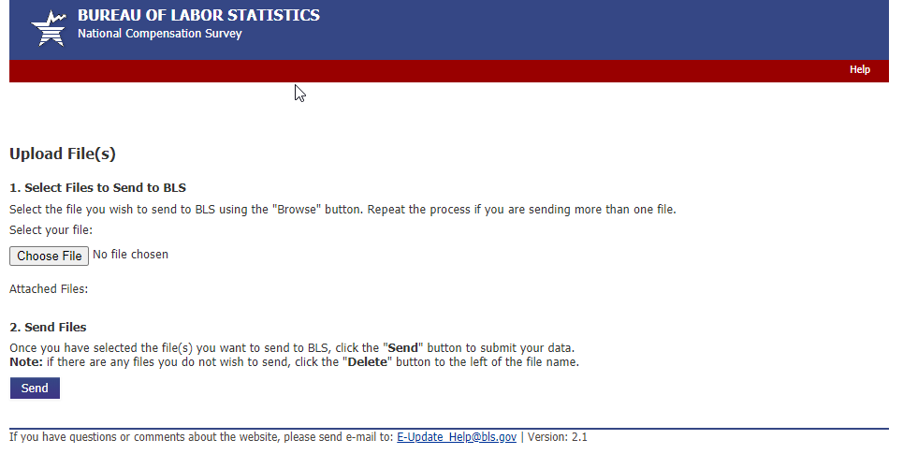
Update Contact Information:
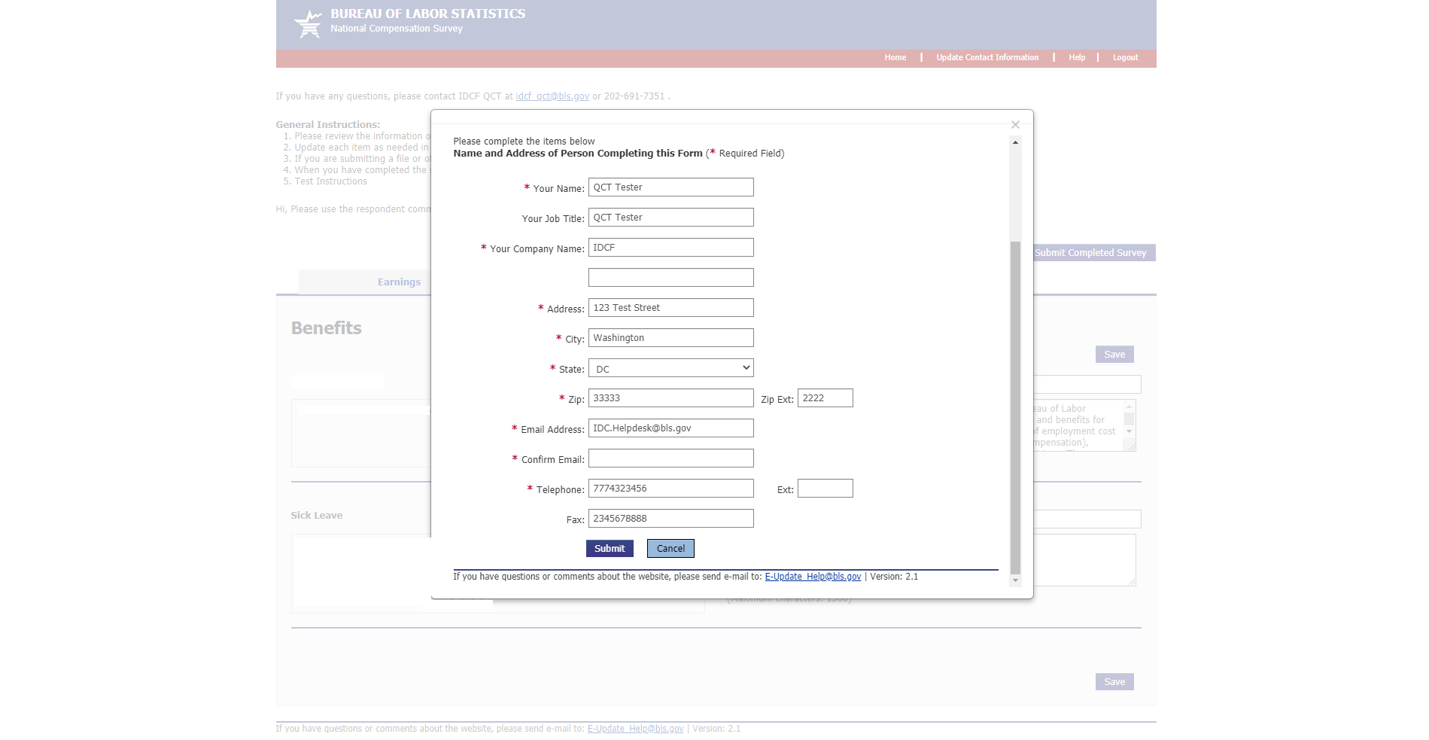

Confirmation/Thank You Page:
