Request for Nonsubstantive Change
ICR 0579-0327

November 29, 2021

APHIS conducted a review of VS Form 1-64 and requests approval for the following nonsubstantive changes.

A. Added a “Clear Form” button top right of first page.

B. On page 1, under PURPOSE OF APPLICATION, change descriptive text under options from
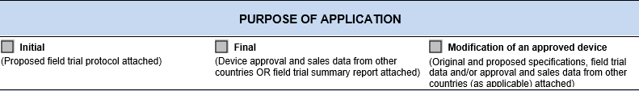

To

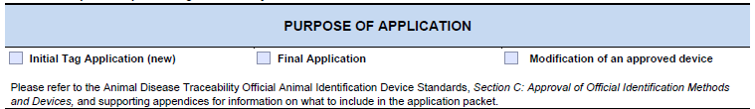

C. On page 2, section Device Information, change Device Format from

Eartag Injectable Transponder Other

to

Eartag Type (with dropdown) Injectable Transponder Other

D. On page 2, section SPECIES, change option selections from

Alpaca/Llama, Cattle/Bison, Deer/Elk, Horses, Sheep/Goats, Swine

to

Cattle/Bison, Deer/Elk, Horses, Sheep/Goats, Swine

These changes make the form efficient and does not affect response time or burden.

