ATTACHMENT 6a: NBCCEDP Clinic-Level Data Instrument (Screenshots)

Welcome Screen

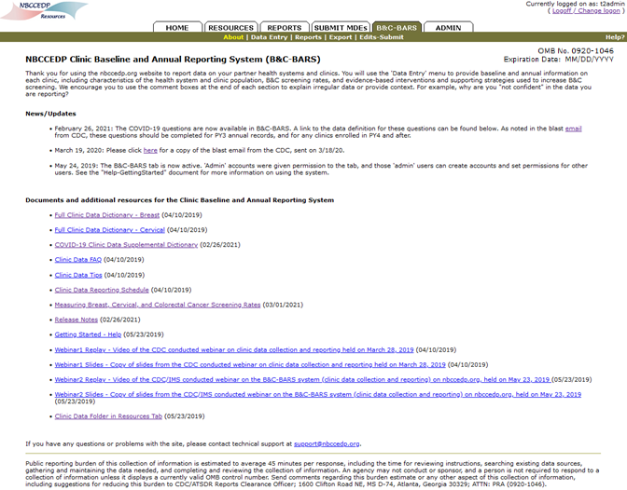
Menu Bar and Navigation

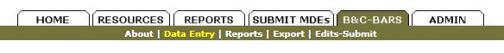
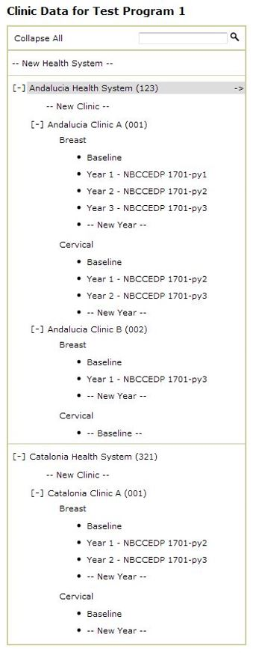
Health System Data
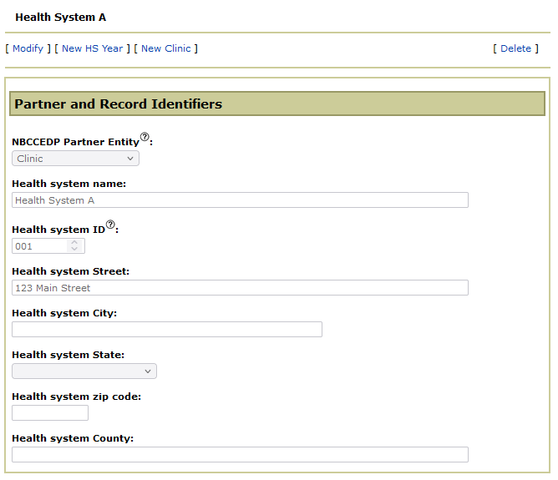

Health System Data – Baseline
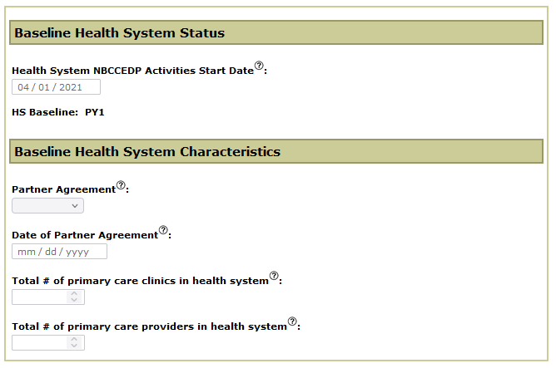

Health System Data – Annual
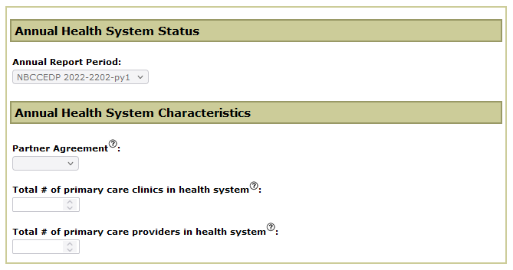

Clinic Data - Characteristics
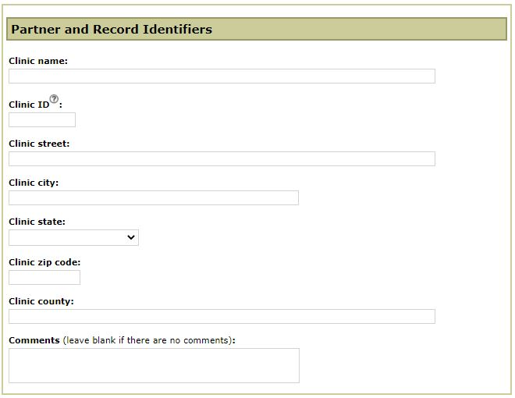

Clinic Data – Baseline Breast
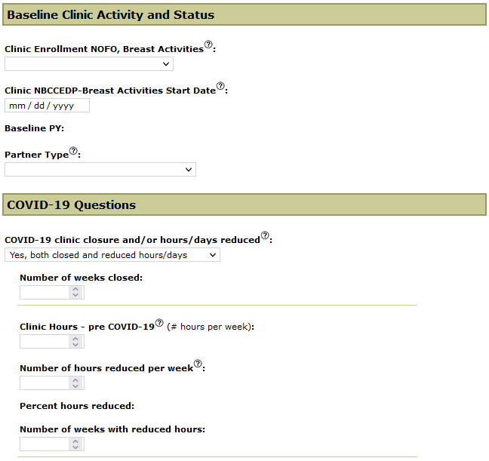
Clinic Data – Baseline Breast (continued)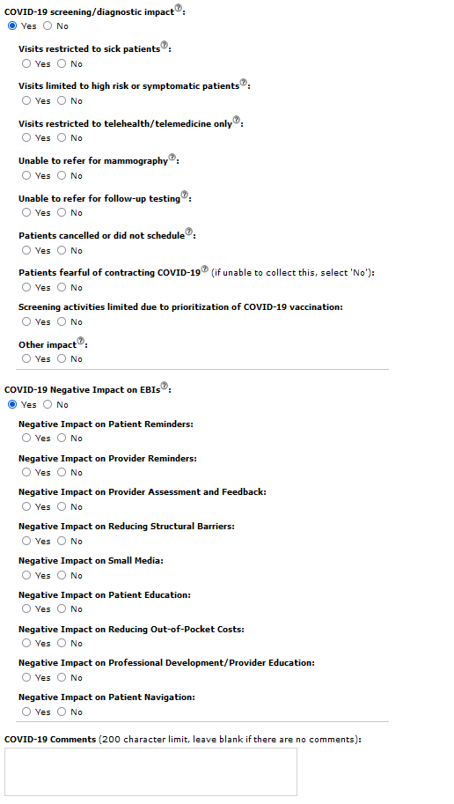
Clinic Data – Baseline Breast (continued)
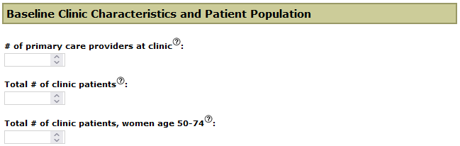
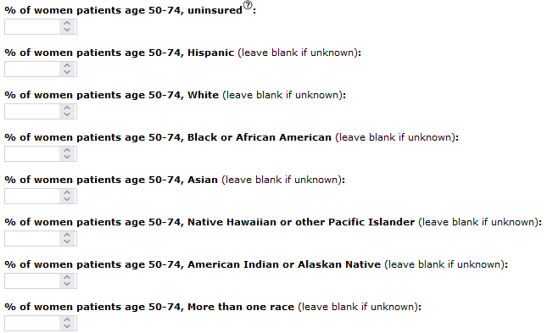
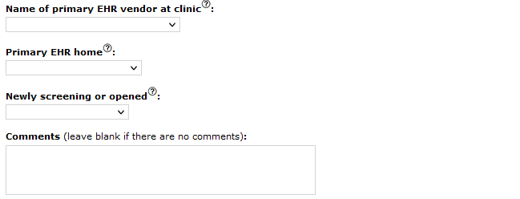
Clinic Data – Baseline Breast (continued)
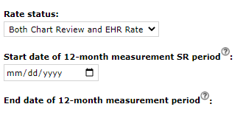
** End date above is auto calculated based on start date.
** If rate status is ‘not available’, collect the following field:
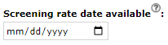
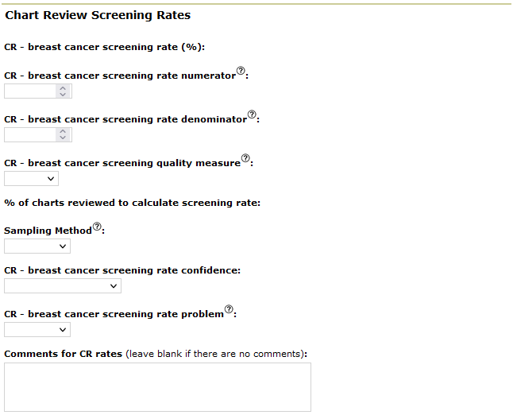

Clinic Data – Baseline Breast (continued)
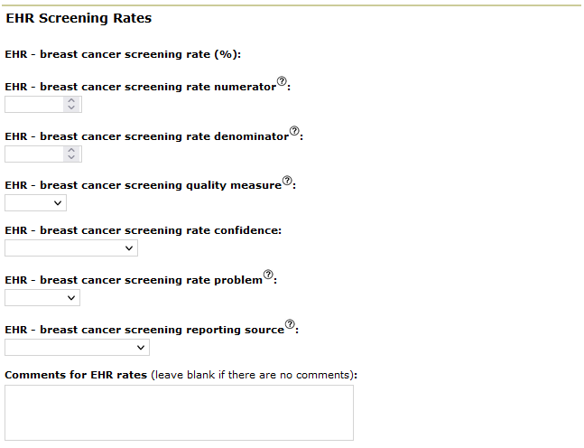
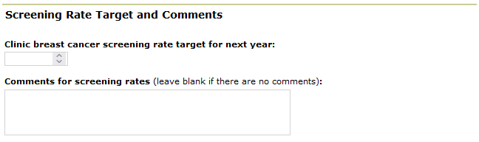
Clinic Data – Baseline Breast (continued)
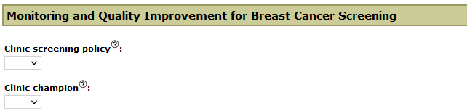
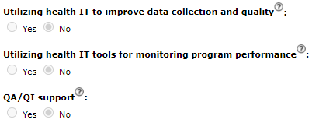
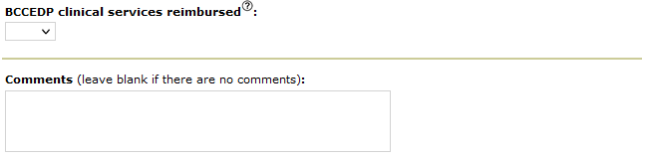

Clinic Data – Baseline Breast (continued)
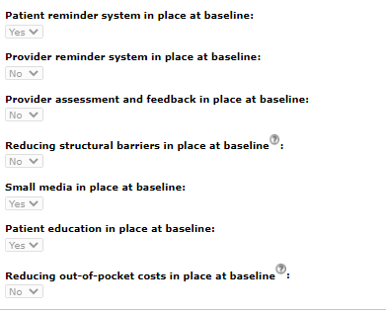
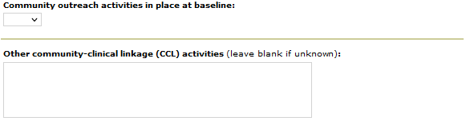
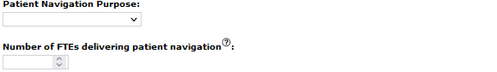
Clinic Data – Baseline Breast (continued)

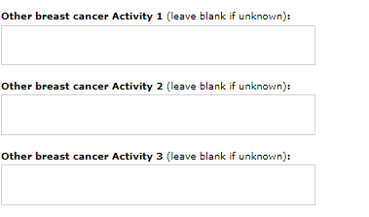

Clinic Data – Annual Breast
** Collect the following if status is ‘terminated’ or ‘suspended’:
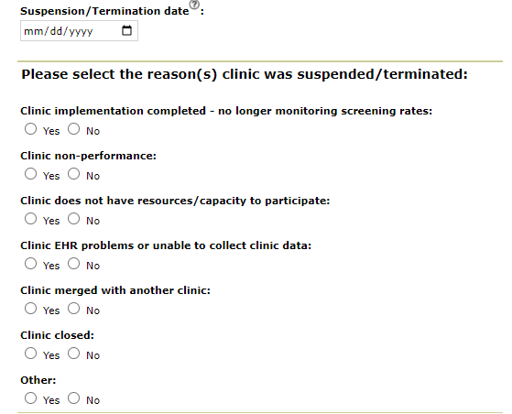

Clinic Data – Annual Breast (continued)
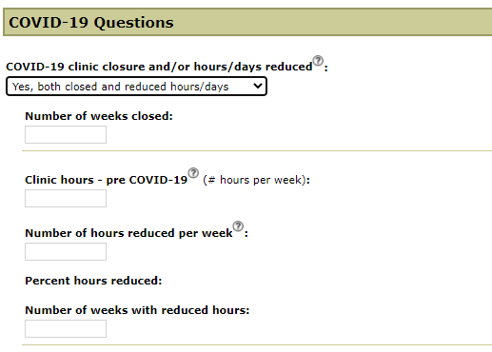

Clinic Data – Annual Breast (continued)
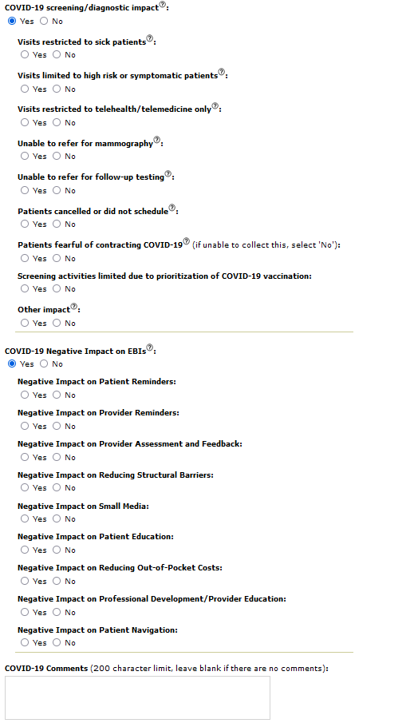
Clinic Data – Annual Breast (continued)
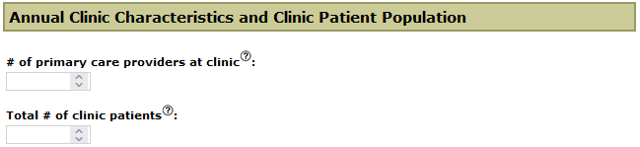
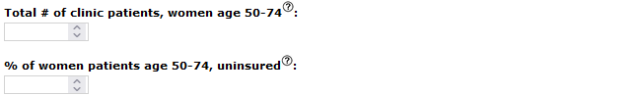
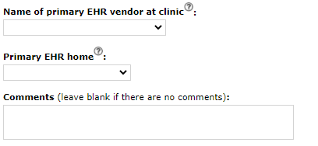

Clinic Data – Annual Breast (continued)
** End date above is auto calculated based on start date.
** If rate status is ‘not available’, collect the following field:

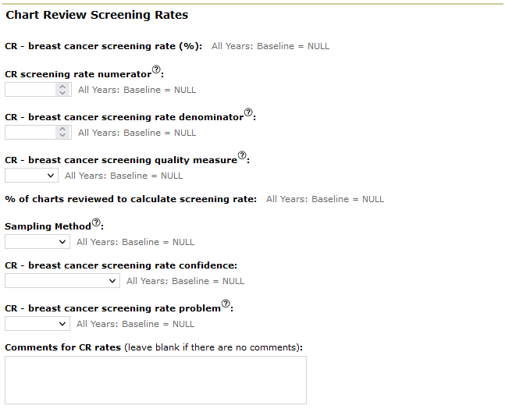
Clinic Data – Annual Breast (continued)
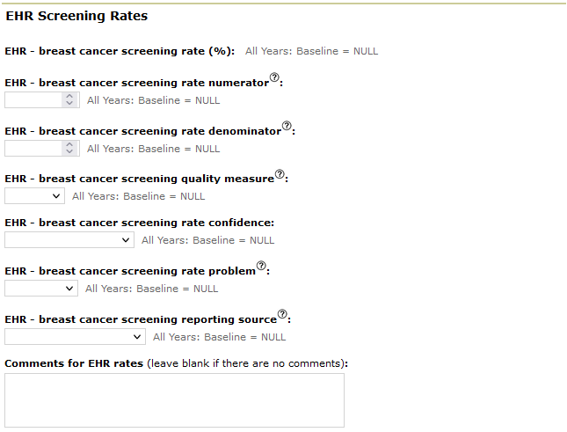
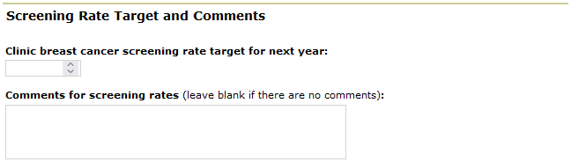

Clinic Data – Annual Breast (continued)
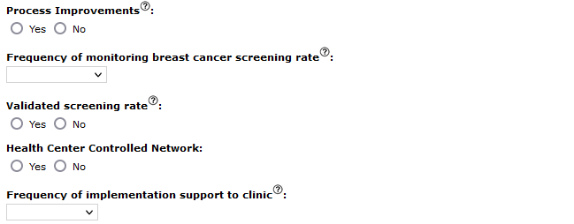
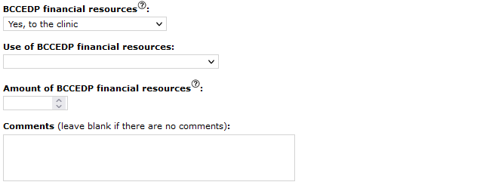
Clinic Data – Annual Breast (continued)
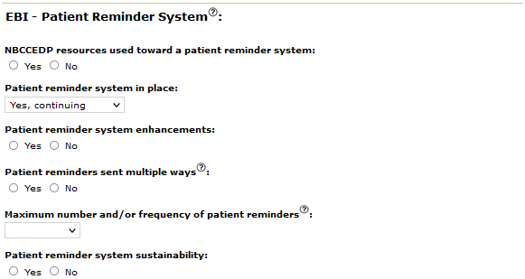
** If not in place at PY end, ask the following question:
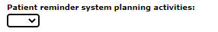
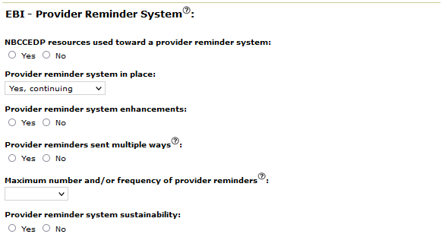
** If not in place at PY end, ask the following question:
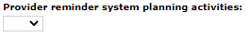

Clinic Data – Annual Breast (continued)
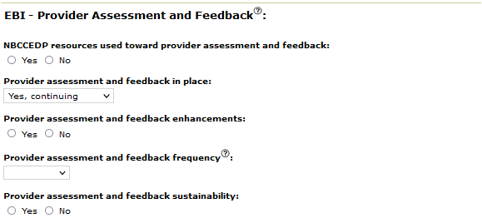
** If not in place at PY end, ask the following question:
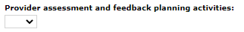

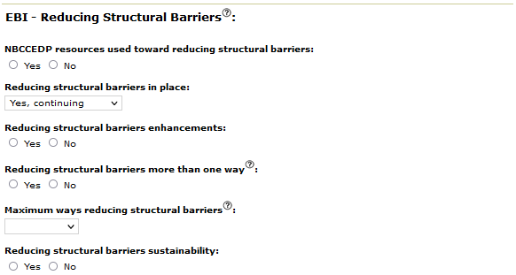
** If not in place at PY end, ask the following question:
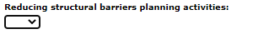

Clinic Data – Annual Breast (continued)
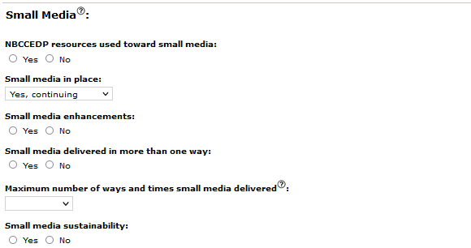
** If not in place at PY end, ask the following question:

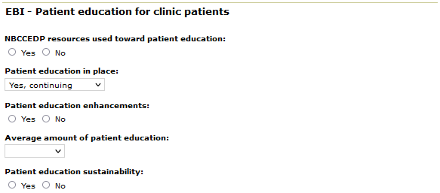
** If not in place at PY end, ask the following question:
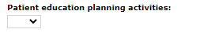

Clinic Data – Annual Breast (continued)
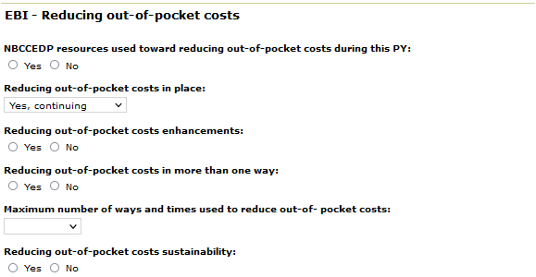
** If not in place at PY end, ask the following question:
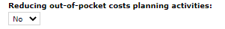

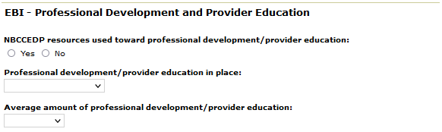

Clinic Data – Annual Breast (continued)
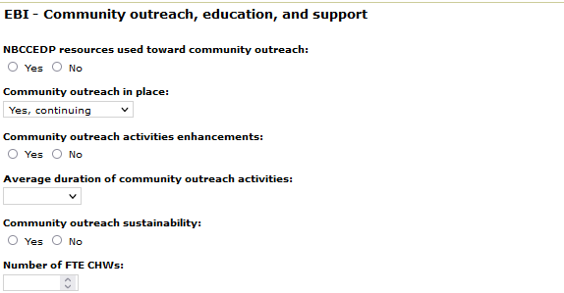
** If not in place at PY end, ask the following question:
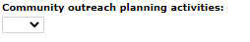

Clinic Data – Annual Breast (continued)
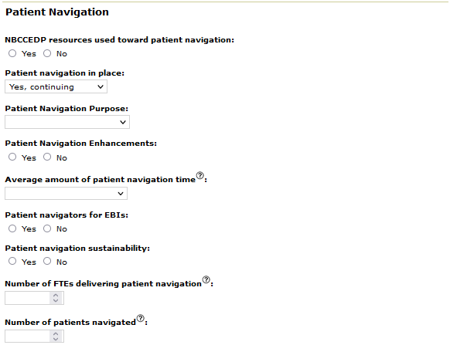
** If not in place at PY end, ask the following question:
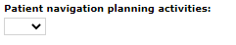

Clinic Data – Annual Breast (continued)
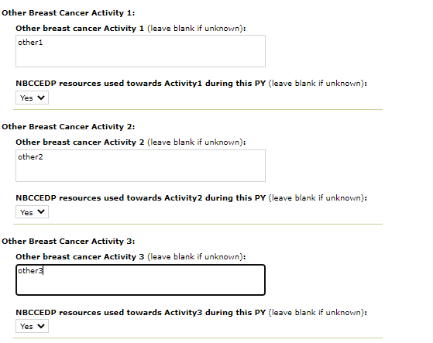

Clinic Data – Baseline Cervical
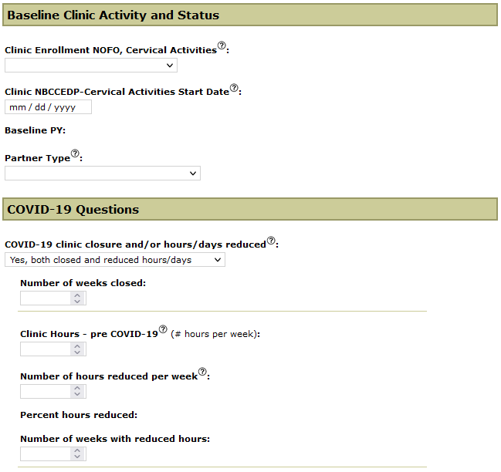
Clinic Data – Baseline Cervical (continued)
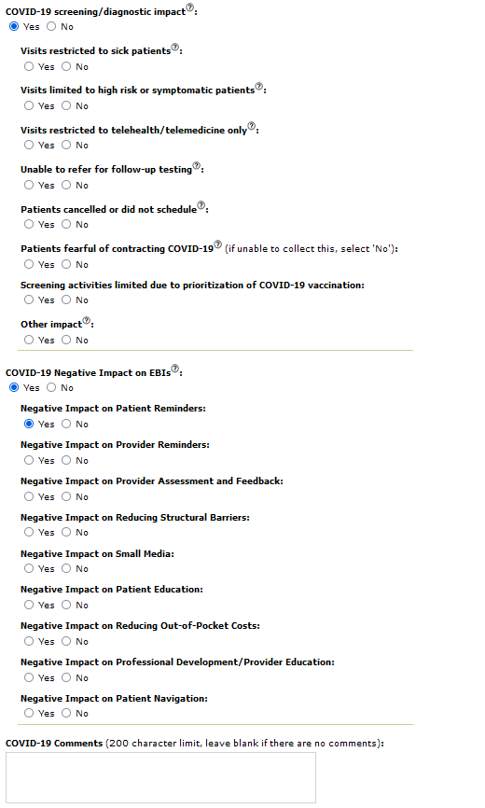

Clinic Data – Baseline Cervical (continued)
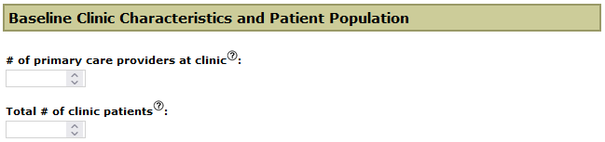
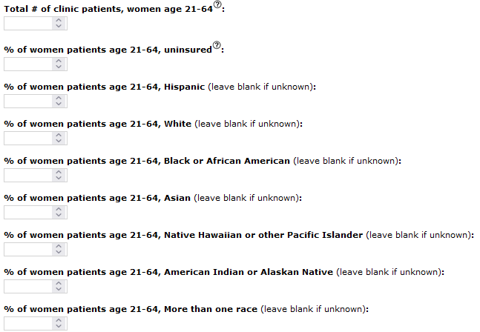
Clinic Data – Baseline Cervical (continued)
** End date above is auto calculated based on start date.
** If rate status is ‘not available’, collect the following field:
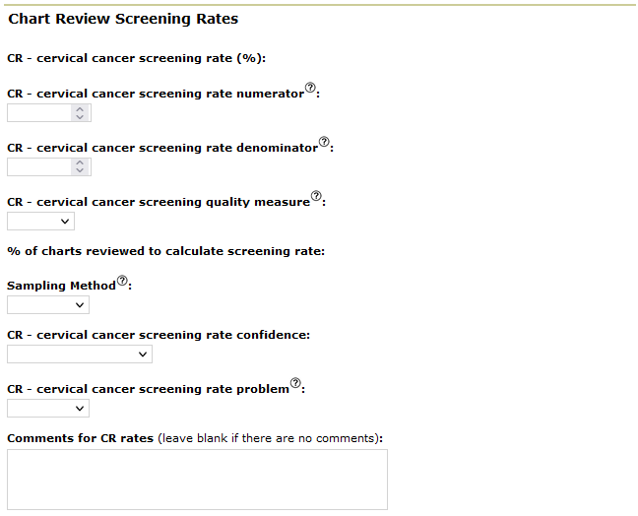

Clinic Data – Baseline Cervical (continued)
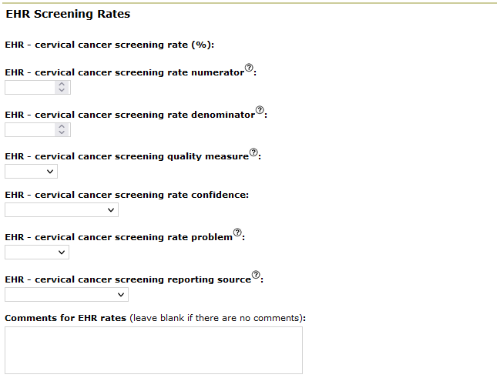
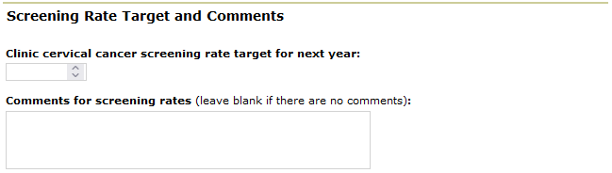
Clinic Data – Baseline Cervical (continued)
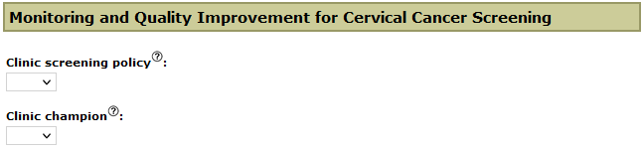

Clinic Data – Baseline Cervical (continued)
Clinic Data – Baseline Cervical (continued)

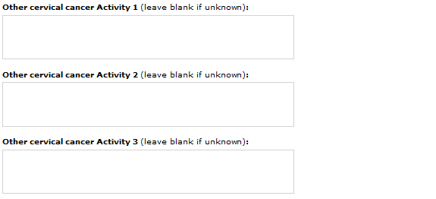

Clinic Data – Annual Cervical
** Collect the following if status is ‘terminated’ or ‘suspended’:

Clinic Data – Annual Cervical (continued)

Clinic Data – Annual Cervical (continued)
Clinic Data – Annual Cervical (continued)
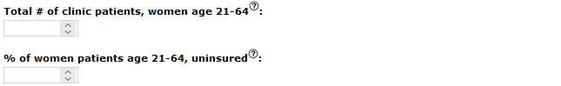

Clinic Data – Annual Cervical (continued)
** End date above is auto calculated based on start date.
** If rate status is ‘not available’, collect the following field:

Clinic Data – Annual Cervical (continued)
Clinic Data – Annual Cervical (continued)
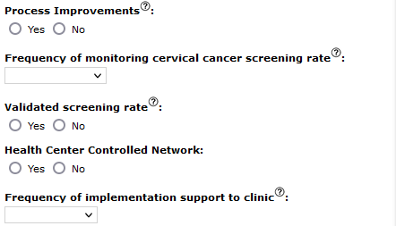
Clinic Data – Annual Cervical (continued)

If not in place at PY end, ask the following question:
If not in place at PY end, ask the following question:

Clinic Data – Annual Cervical (continued)

If not in place at PY end, ask the following question:

If not in place at PY end, ask the following question:

Clinic Data – Annual Cervical (continued)

If not in place at PY end, ask the following question:

If not in place at PY end, ask the following question:

Clinic Data – Annual Cervical (continued)

If not in place at PY end, ask the following question:

Clinic Data – Annual Cervical (continued)

If not in place at PY end, ask the following question:

Clinic Data – Annual Cervical (continued)

If not in place at PY end, ask the following question:

Clinic Data – Annual Cervical (continued)

