ATTACHMENT 7a: NBCCEDP Quarterly Program Update (Screenshots)

Landing/About Page

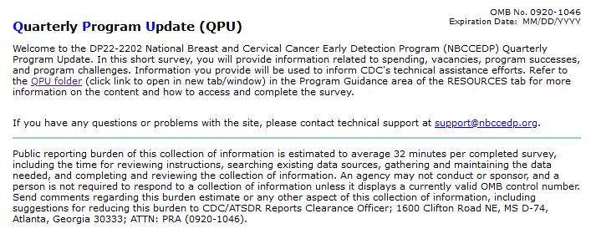
Section 1. Respondent Information and Section 2. Award Spending

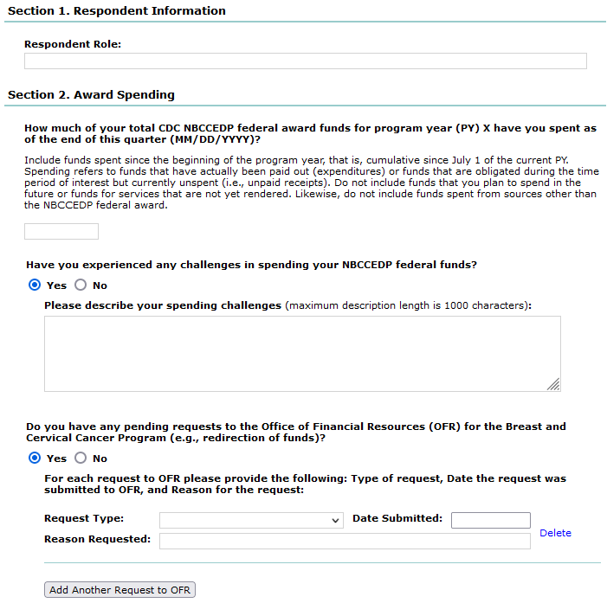

Section 3. Service Delivery

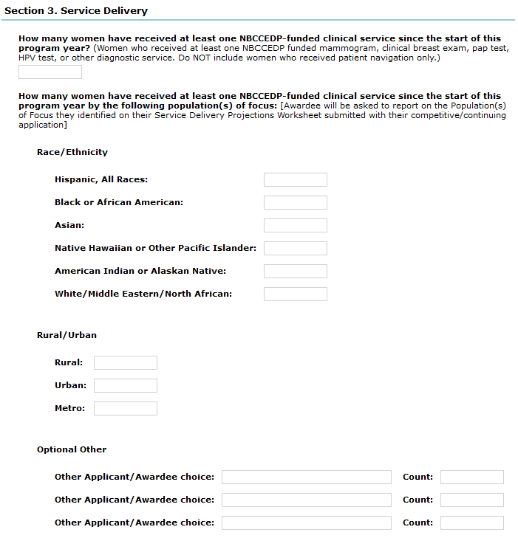

Section 3. Service Delivery (continued)

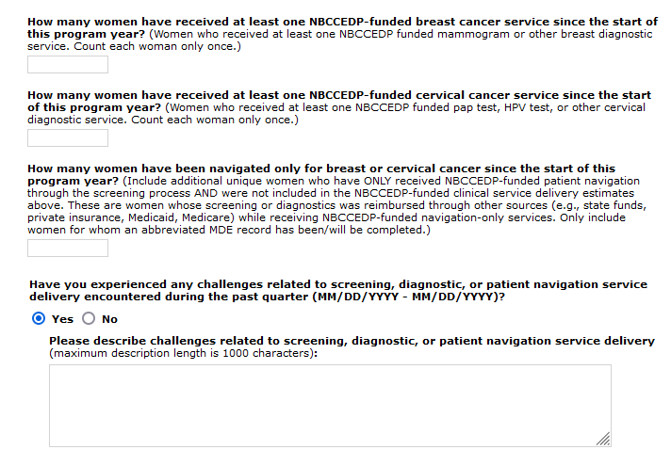

Section 4. Vacancies & Section 5. Accomplishments and Challenges

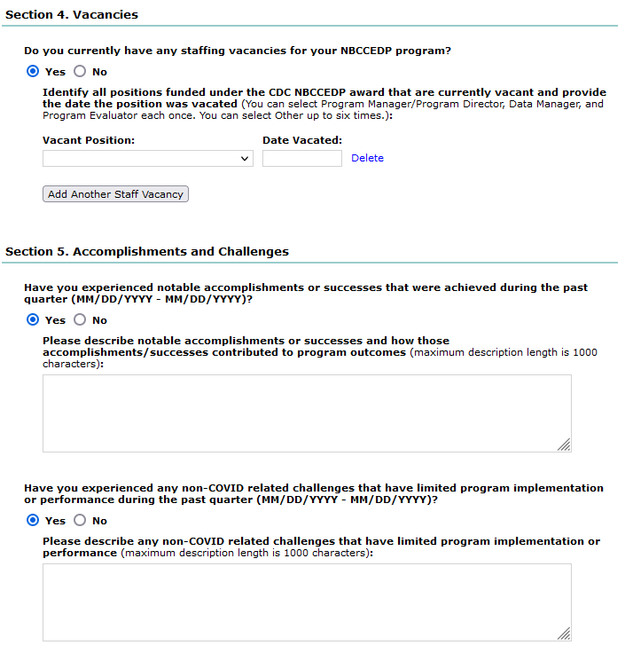

Section 6. Technical Assistance Needs & Section 7. COVID-19

