ATTACHMENT 8a: NBCCEDP Service Delivery Projections (Screenshots)

Landing/About Page
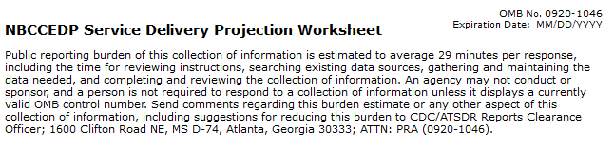
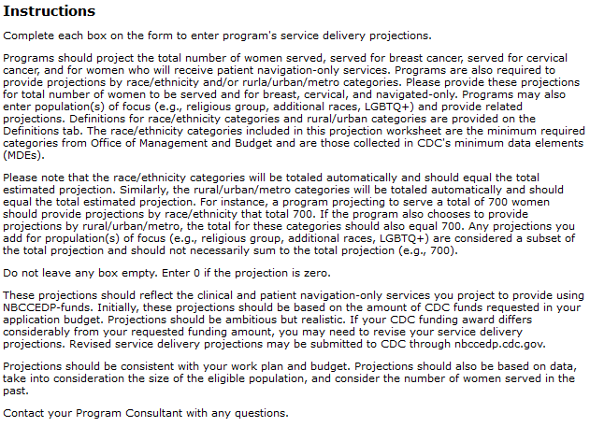

NBCCEDP-funded Clinical Services

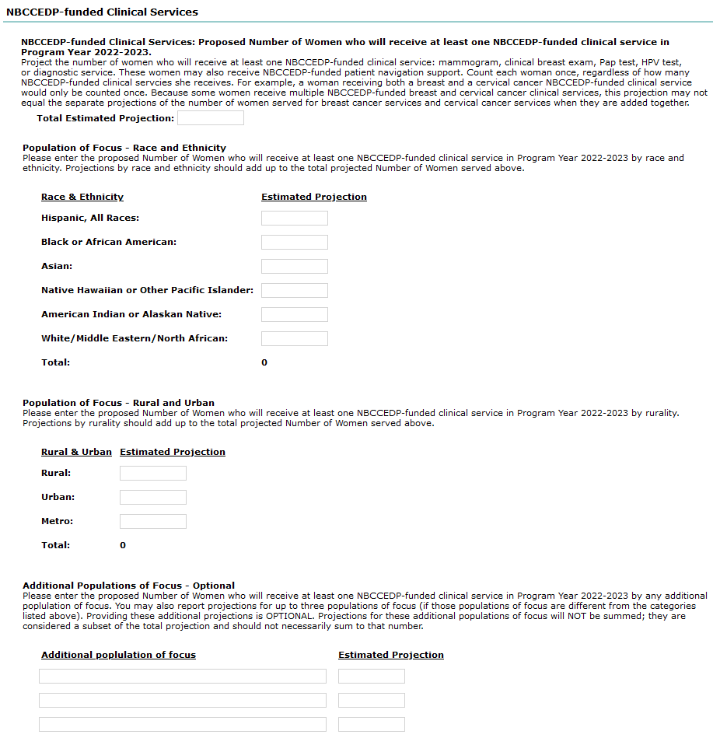

NBCCEDP-funded Breast Cancer Services

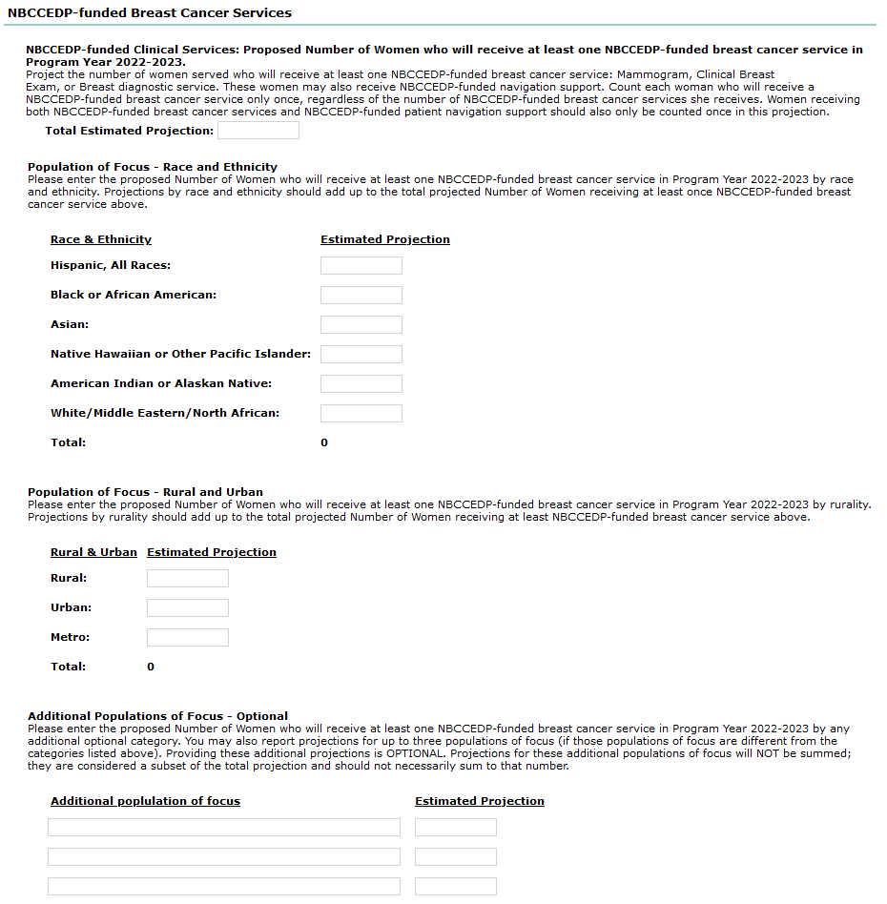

NBCCEDP-funded Cervical Cancer Services

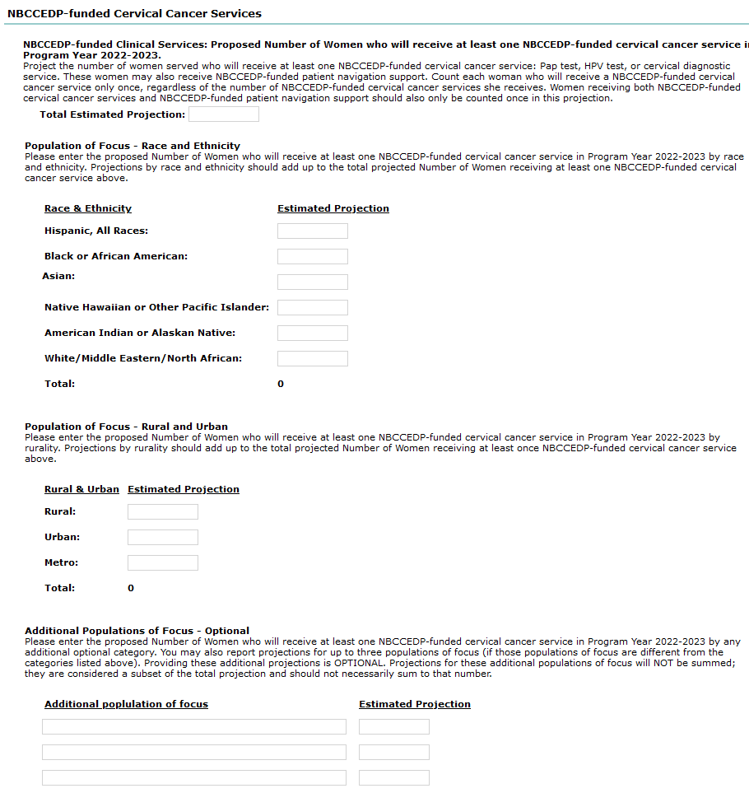

NBCCEDP-funded Patient Navigation Only Support

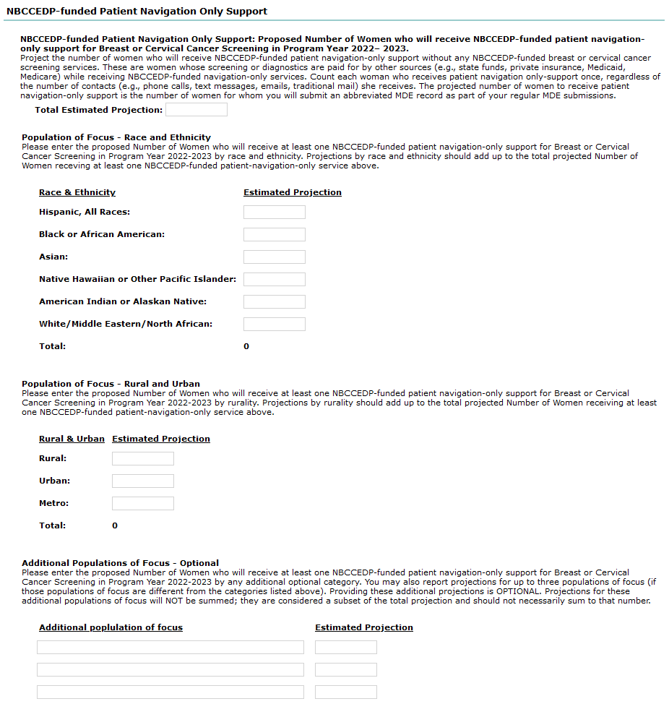

Definitions

