Attachment 5
Information Collection Instrument,
Training and Continuing Education Online New Participant Registration

TCEO New Participant Registration | 2018

Table of Contents
Introduction 2
Figure 1. Create Account Screen 3
Figure 1 – Create Account Screen (Top of Page 1) 4
Table 1 – Create Account Data Elements 4
Figure 2. My Profile 5
Figure 2a – My Profile Screen (Middle of Page 1) 6
Figure 2b – My Profile Screen (Bottom of Page 1) 7
Table 2 – My Profile Screen Data Elements 8
Table 4 – Select CE Data Elements 12

Introduction

The purpose of this document is to list all data elements collected online from the learners that wish to obtain continuing education credit through the Centers for Disease Control and Prevention’s (CDC) Training and Continuing Education Online System (TCEO).

TCEO has a robust, flexible framework, and is successfully tailored for the various healthcare professions requiring continuing education for certification and licensure. This collection of data elements, derived from the Create Account and My Profile screens, makes up the TCEO New Participant Registration form.

Figure 1. Create Account Screen
To create an account in the Training and Continuing Education Online System (TCEO) participants are required to complete the data fields shown in the Create Account screen (Figure 1). The data element options to create an account are shown in Table 1.

Figure 1 – Create Account Screen (Top of Page 1)
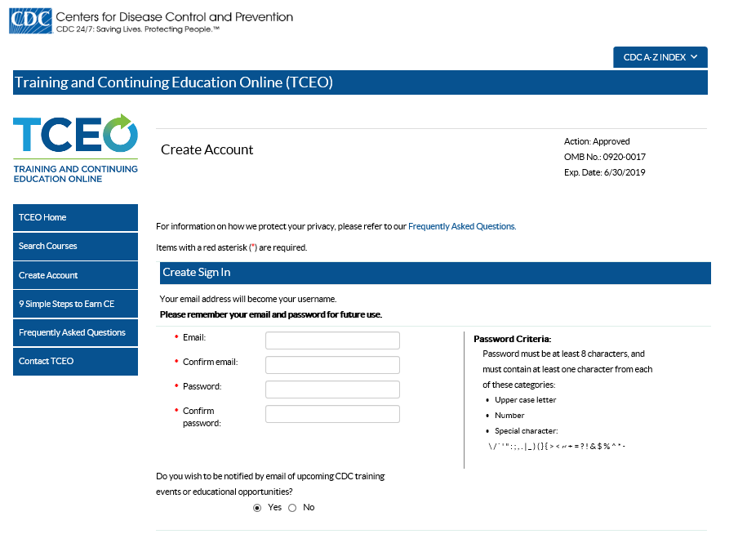
Exp. date changed from xx/xx/2016

Table 1 – Create Account Data Elements
Column Label | Display property | Figure
Email: |  | 1
Confirm email: |  | 1
Password: |  | 1
Confirm password: |  | 1
Do you wish to be notified by email of upcoming CDC training events or educational opportunities? | Y/N | 1

Figure 2. My Profile
To complete creating an account in the Training and Continuing Education Online System (TCEO), participants are required to complete the data fields shown in the My Profile screen (Figure 2). The data element options to create an account are shown in Table 2.

Figure 2a – My Profile Screen (Middle of Page 1)
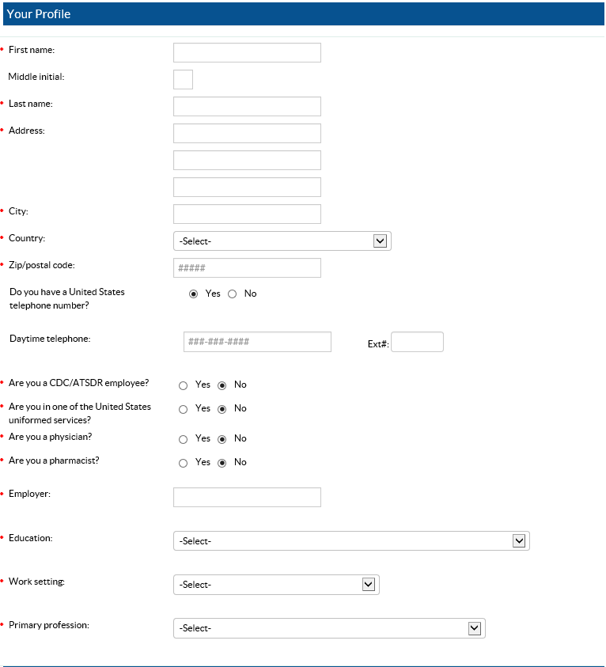
“State/Territory” appears if “United States (and Territories)” is selected as country

Figure 2b – My Profile Screen (Bottom of Page 1)

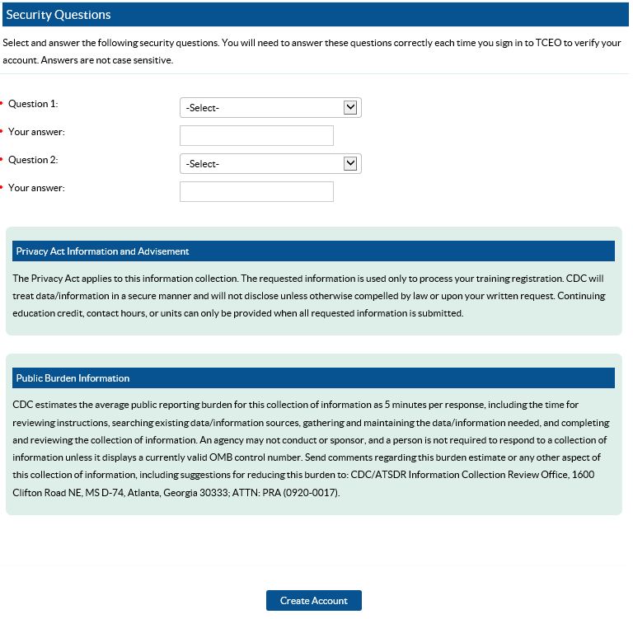

New

Table 2 – My Profile Screen Data Elements
Removed “Academic”
New
New
New
New
New
New
Column Label  New | Display property | Figure
First name: |  | 2a & 2b
Middle initial: |  | 2a & 2b
Last name: |  | 2a & 2b
Address: |  | 2a & 2b
City: |  | 2a & 2b
Country: |  | 2a & 2b
Specify: If US selected as country, then dropdown selection appears: “State/Territory” |  | 2a & 2b
Zip/postal code: |  | 2a & 2b
Do you have a United States telephone number? | Y/N | 2a & 2b
Daytime telephone: |  | 2a & 2b
Ext # |  | 2a & 2b
Are you a CDC/ATSDR employee? | Y/N | 2a & 2b
Are you in the United States Uniformed Services? | Y/N | 2a & 2b
If so, what branch? |  | 2a & 2b
Subspecialty: | US Army | 2a & 2b
Subspecialty: | US Air Force | 2a & 2b
Subspecialty: | US Marines | 2a & 2b
Subspecialty: | US Navy | 2a & 2b
Subspecialty: | US Coast Guard | 2a & 2b
Subspecialty: | NOAH Commissioned Corps | 2a & 2b
Subspecialty: | USPHS Commissioned Corps | 2a & 2b
Are you a Physician? | Y/N | 2a & 2b
Are you a Pharmacist? | Y/N | 2a & 2b
Employer: |  | 2a & 2b
Education: | Select: | 2a & 2b
Specify: | Eighth grade or less | 2a & 2b
Specify: | Some high school | 2a & 2b
Specify: | High school graduate | 2a & 2b
Specify: | Some college | 2a & 2b
Specify: | Completed college (e.g., BA or BS) | 2a & 2b
Specify: | Some graduate or professional school (requiring work beyond college graduation | 2a & 2b
Specify: | Masters (e.g., MA, MPH, or MS) | 2a & 2b
Specify: | JD | 2a & 2b
Specify: | PhD, EdD, DrPH, PharmD, ScD, or equivalent | 2a & 2b
Specify: | MD, DO, or equivalent | 2a & 2b
Specify: | MD/PhD, MD/JD, or equivalent dual advanced degrees | 2a & 2b
Specify: | Other education | 2a & 2b
Work setting: | Select: | 2a & 2b
Specify: | Educational Institution | 2a & 2b
Subspecialty: | K-12 | 2a & 2b
Subspecialty: | Pre-K/Childcare | 2a & 2b
Subspecialty: | University/Higher/Institution | 2a & 2b
Specify: | Healthcare | 2a & 2b
Subspecialty: | Behavioral/Mental Health Facility | 2a & 2b
Subspecialty: | Clinical or Commercial Laboratory | 2a & 2b
Subspecialty: | Diagnostic Imaging Center | 2a & 2b
Subspecialty: | Home Care | 2a & 2b
Subspecialty: | Hospice | 2a & 2b  New
Subspecialty: | Hospital | 2a & 2b
Subspecialty: | Nursing Home or Long Term Home Facility | 2a & 2b
Subspecialty: | Outpatient Care Center | 2a & 2b
Subspecialty: | Private Office or Clinic | 2a & 2b
Subspecialty: | Rural/Community Health Center (or other Federally Qualified Health Center) | 2a & 2b
Subspecialty: | School Health Clinic | 2a & 2b
Subspecialty: | Other | 2a & 2b
Specify: | Indian Health Service | 2a & 2b
Specify: | Non-profit Organization | 2a & 2b
Specify: | Private Industry (except healthcare) | 2a & 2b
Specify: | Public Health Agency | 2a & 2b
Public health work setting: | Federal Public Health | 2a & 2b
Public health work setting: | Local Public Health | 2a & 2b  New
Public health work setting: | Public Health Clinic | 2a & 2b
Public health work setting: | Regional/Area Public Health | 2a & 2b
Public health work setting: | State/Territory Public Health | 2a & 2b
Specify: | Tribal Health Sites | 2a & 2b
Specify: | Other Governmental Agency (except military) | 2a & 2b
Specify: | Other Work Setting | 2a & 2b
Primary profession: | Select: | 2a & 2b
Specify: | Administrative Support Staff | 2a & 2b
Specify: | Administrator/Director/Manager | 2a & 2b
Specify: | Allied Health Professional | 2a & 2b
Subspecialty: | Dietician | 2a & 2b
Subspecialty: | Medical Assistant | 2a & 2b
Subspecialty: | Medical Imaging Professional | 2a & 2b
Subspecialty: | Optician | 2a & 2b
Subspecialty: | Rehabilitation Professional | 2a & 2b
Subspecialty: | Respiratory Therapy Professional | 2a & 2b
Subspecialty: | Speech, Language, Audiology Professional | 2a & 2b
Specify: | Animal Handler | 2a & 2b
Specify: | Biostatistician | 2a & 2b
Specify: | Childcare Provider | 2a & 2b
Specify: | Computer/Information Systems Specialists | 2a & 2b
Specify: | Dental Professional | 2a & 2b  New
Subspecialty: | Dental Assistant | 2a & 2b
Subspecialty: | Dental Hygienist or Technical Assistant | 2a & 2b
Subspecialty: | Dentist | 2a & 2b
Subspecialty: | Other Dental Professional | 2a & 2b
Specify: | Emergency Responder | 2a & 2b
Subspecialty: | Emergency Medical Services Personnel | 2a & 2b
Subspecialty: | Emergency Preparedness/Management Personnel | 2a & 2b
Subspecialty: | Fire and Rescue Personnel | 2a & 2b
Subspecialty: | Other Emergency Responder | 2a & 2b
Specify: | Environmental Health Professional | 2a & 2b
Subspecialty: | Engineer/Engineering Technician | 2a & 2b
Subspecialty: | Environmental Health Specialist/Sanitarian | 2a & 2b
Subspecialty: | Food Safety Professional | 2a & 2b
Subspecialty: | Hazardous Substance Professional | 2a & 2b
Subspecialty: | Industrial Hygienist | 2a & 2b
Subspecialty: | Radon Specialist | 2a & 2b
Subspecialty: | Toxicologist | 2a & 2b
Subspecialty: | Other Environmental Health | 2a & 2b
Specify: | Epidemiologist/Infection Control/Communicable Disease Professional | 2a & 2b
Specify: | Facility Manager/Engineer | 2a & 2b
Specify: | Food Service/Housekeeping | 2a & 2b
Specify: | Governmental Official | 2a & 2b
Subspecialty: | Board of Health Member | 2a & 2b
Subspecialty: | Other Elected Appointed Official (except Public Health) | 2a & 2b
Specify: | Health Educator | 2a & 2b
Specify: | Laboratory Professional/Technician | 2a & 2b
Specify: | Law Enforcement | 2a & 2b
Specify: | Legal Professional | 2a & 2b
Specify: | Liberian/Information Specialist | 2a & 2b
Specify: | Licensure/Inspection/Regulatory Specialist | 2a & 2b
Specify: | Medical Examiner/Coroner | 2a & 2b
Specify: | Mental and Behavioral Health Professional | 2a & 2b  Everything  on this page is new
Subspecialty: | Marriage and Family Therapist | 2a & 2b
Subspecialty: | Mental Health Counselor | 2a & 2b
Subspecialty: | Other Mental or Behavioral Health | 2a & 2b
Subspecialty: | Psychologist | 2a & 2b
Subspecialty: | Social Worker | 2a & 2b
Subspecialty: | Substance Abuse Counselor | 2a & 2b
Specify: | Nursing Professional | 2a & 2b
Subspecialty: | Advanced Practiced Nurse | 2a & 2b
Specify: | Clinical Nurse Specialist | 2a & 2b
Specify: | General | 2a & 2b
Specify: | Nurse Anesthetist | 2a & 2b
Specify: | Nurse Practitioner | 2a & 2b
Specify: | Nurse Midwife | 2a & 2b
Subspecialty: | Licensed Practical Nurse (LPN)/ Licensed Vocational Nurse (APRN) | 2a & 2b
Subspecialty: | Registered Nurse | 2a & 2b
Specify: | Administrator | 2a & 2b
Specify: | Clinical Nurse | 2a & 2b
Specify: | General | 2a & 2b
Specify: | Infection Prevention | 2a & 2b
Specify: | Mental and Behavioral Health Nurse | 2a & 2b
Specify: | Nurse Educator | 2a & 2b
Specify: | Public Health Nurse | 2a & 2b
Specify: | Occupational Health and Safety Personnel | 2a & 2b
Specify: | Outreach/Field Worker | 2a & 2b
Specify: | Pharmacy Professional | 2a & 2b
Subspecialty: | Pharmacist | 2a & 2b
Subspecialty: | Pharmacy Technician/Aid | 2a & 2b
Specify: | Physician | 2a & 2b
Subspecialty: | Allergy/Immunology | 2a & 2b
Subspecialty: | Anesthesiology | 2a & 2b
Subspecialty: | Colon and Rectal Surgery | 2a & 2b
Subspecialty: | Dermatology | 2a & 2b
Subspecialty: | Emergency Medicine | 2a & 2b
Subspecialty: | Family Practice | 2a & 2b
Subspecialty: | Internal Medicine | 2a & 2b
Subspecialty: | Medical Genetics | 2a & 2b
Subspecialty: | Neurological Surgery | 2a & 2b
Subspecialty: | Neurology | 2a & 2b
Subspecialty: | Nuclear Medicine | 2a & 2b
Subspecialty: | Obstetrics and Gynecology | 2a & 2b
Subspecialty: | Ophthalmology | 2a & 2b
Subspecialty: | Orthopedic Surgery | 2a & 2b
Subspecialty: | Otolaryngology | 2a & 2b
Subspecialty: | Pathology-Anatomic and Clinical | 2a & 2b
Subspecialty: | Pediatrics | 2a & 2b
Subspecialty: | Physical Medicine and Rehabilitation | 2a & 2b
Subspecialty: | Plastic Surgery | 2a & 2b
Subspecialty: | Preventive Medicine | 2a & 2b
Subspecialty: | Psychiatry | 2a & 2b
Subspecialty: | Radiation Oncology | 2a & 2b
Subspecialty: | Radiology-Diagnostic | 2a & 2b
Subspecialty: | Surgery-General | 2a & 2b
Subspecialty: | Thoracic Surgery | 2a & 2b
Subspecialty: | Urology | 2a & 2b
Subspecialty: | Other | 2a & 2b
Specify: | Policy Planner | 2a & 2b
Specify: | Program Specialist | 2a & 2b
Specify: | Public Health Official | 2a & 2b
Specify: | Public Relations/Media/Communications Specialists | 2a & 2b
Specify: | Researcher/Analyst | 2a & 2b
Specify: | Student | 2a & 2b
Specify: | Teacher/Faculty | 2a & 2b
Specify: | Veterinarian | 2a & 2b
Specify: | Volunteer | 2a & 2b
Specify: | Other Medical Professional | 2a & 2b
Specify: | Other Profession | 2a & 2b
Subspecialty: | Chiropractor | 2a & 2b
Subspecialty: | Optometrist | 2a & 2b
Subspecialty: | Physician Assistant | 2a & 2b
Subspecialty: | Podiatrist | 2a & 2b
Subspecialty: | Other | 2a & 2b
Specify: | Other Profession | 2a & 2b
Security Question 1: |  | 2a & 2b
Your answer: |  | 2a & 2b
Security Question 2: |  | 2a & 2b
Your answer: |  | 2a & 2b
New

Table 4 – Select CE Data Elements
Column Label | Display property | Figure
Select CE Type: |  | 4
You must specify other profession. You must select a profession. You must select a specialty. |  | 4
MY CE INFORMATION: |  | 4
Specify: | CME (Physician) Information | 4
Specify: | CME Type: (Dropdown: MBBS, DO, MD, Certificate of Participation) | 4
Specify: | Physician MOC Information | 4
Specify: | - MOC ID: | 4
Specify: | - Birth Month: | 4
Specify: | - Birth Day: | 4
Specify: | CHES (Certified Health Education Specialists) Information | 4
Specify: | - CHES Number: | 4
Specify: | CPE (Pharmacists) Information | 4
Specify: | - CPE ID: | 4
Specify: | - Birth Month: | 4
Specify: | - Birth Day: | 4
Specify: | AAVSB (Veterinarians) Information | 4
Specify: | - License Number (up to 2): | 4
Specify: | - State (up to 2) | 4

