Public reporting burden for this collection of information is estimated to average 60 minutes per response, including the time for reviewing instructions, searching existing data sources, gathering and maintaining the data needed, and completing and reviewing the collection of information. An Agency may not conduct or sponsor, and a person is not required to respond to, a collection of information unless it displays a current valid OMB control number. Send comments regarding this burden estimate or any other aspect of this collection of information, including suggestions for reducing this burden, to NIH, Project clearance Branch, 6705 Rockledge Drive, MSC 7974, Bethesda, MD 20892-7974, ATTN: PRA (XXXX-XXXX). Do not return the completed form to this address.

Federal COVID Response Audience Feedback Discussion – For use with group or individual conversations
Month 01, 2021 at 00:00 p.m. Eastern Time

A 60-minute listening session with

Black /African American OR Bilingual Hispanic/Latino OR Any Additional Race/Ethnicity Individuals Affected by COVID-19

HIGH-LEVEL SESSION OVERVIEW
Background (<5 minutes)
Participant Introductions (5 minutes)
Feedback Context Questions (15 minutes):
COVID-19 Treatment and Clinical Trial Awareness [MONTH ONE ONLY]
COVID-19 Treatment News Discussion [SUBSEQUENT MONTHS]
Ad/Message Options (30-35 minutes)
Preferred Communication Channels (5-10 minutes)
General Sources for Health Information [MONTH ONE ONLY]
Preferred Communication Channel for Ad/Message Options Discussed [SUBSEQUENT MONTHS]

MODERATOR’S GUIDE

Please note: Participants have been asked to dial-in 5 to 10 minutes prior to the start of the discussion. During this time, the moderator will ensure that each participant can see the shared screen, consents to audio recording the conversation, and knows how to mute his or her phone when not speaking.
Before we begin, can you/anyone NOT see the shared screen? If you cannot, please let me know now.

A few items to review before joining today’s call:
- Our discussion will be audio-recorded so that I can refer to the recording as needed for my report writing, and my colleague is also on the line to take notes. In addition, other project staff are on the line listening to today’s discussion. Does anyone object to this discussion being audio recorded? [Moderator to dismiss anyone who objects to the audio recording. Notetaker to press “record.”]
- We will use first names only during today’s discussion, and I will report all findings from our conversation in summary form, never connecting an individual comment with an individual name.
- We will use the findings from today’s discussion only to inform the development of a public health awareness and outreach effort.
- Please mute your speakers when you are not speaking to minimize background noise.
- There are no right or wrong answers to any of the questions I will be asking. Please be honest.
- [For group discussions: It is valuable for me to hear all points of view, so please talk respectfully, one at a time and let other participants finish what they’re saying before speaking.]
- [For group discussions: Please state your first name before you make a statement.]
- [For bilingual discussions: Finally, we will be conversing mainly in English today; however, at some points during our conversation, I will be asking you for feedback on Spanish-language information.]
Do you/does anyone have any questions at this time?

BACKGROUND [Not to exceed 5 minutes]

[MONTH ONE ONLY: Good evening/afternoon. Thank you for taking time to participate in this discussion. My name is [MODERATOR NAME], and I am going to facilitate our conversation. I am a trained moderator who works for IQ Solutions, a company contracted by the U.S. Federal COVID Response Team. The Federal COVID Response Team is a cross-agency partnership that includes the U.S. Department of Health and Human Services (HHS), including the Centers for Disease Control and Prevention (CDC), the U.S. Food and Drug Administration (FDA), the National Institutes of Health (NIH), the Biomedical Advanced Research and Development Authority (BARDA), and the U.S. Department of Defense (DOD).

The National Institutes of Health has set up a partnership among government, industry, and university researchers to identify drugs and other treatments that are most promising. These are called ACTIV trials-- Accelerating COVID-19 Therapeutic Interventions and Vaccines (ACTIV).

The main purpose of our discussion today is talk about treatments for COVID-19 (including trials for new treatments), where you go to learn new COVID-19 information, and get your reactions to a few message and ad options for the Federal COVID Response Team initiative.]

[SUBSEQUENT MONTHS: Good evening/afternoon. Thank you for taking time to participate in this discussion. My name is [MODERATOR NAME], and I am going to facilitate our conversation. I am a trained moderator who works for IQ Solutions, a company contracted by the U.S. Federal COVID Response Team.

The main purpose of our discussion is to explore what is new with COVID-19 since we last met, and get your reactions to a few new message and ad options for the Federal COVID Response Team initiative.]

INDIVIDUAL DISCUSSION: PARTICIPANT INTRODUCTIONS [Not to exceed 5 minutes]

Please introduce yourself briefly by letting us know the name that you would like me to use during this discussion—remember, no last names.

GROUP DISCUSSION: PARTICIPANT INTRODUCTIONS [Not to exceed 5 minutes]

All of you who are participating are individuals OR Blacks/African Americans OR Bilingual Hispanics/Latinos who have been in some capacity affected by COVID-19.

I am now going to go around the “virtual” table and call your first name.

[SUBSEQUENT MONTHS ONLY] Some of you joined us in a past session, and I’d like to welcome you back and thank you for your continued participation.

Please introduce yourself to the group briefly by letting us know:

- The name that you would like me to use during this discussion—remember, no last names

- Your city and state

The facilitator will walk through each question below, probing for responses as needed and reorganizing the order of questions as necessary according to the organic flow of the conversation. The notetaker will display each poll question at the appropriate times.

[FEEDBACK CONTEXT QUESTIONS FOR MONTH 1 ACTIVITY ONLY] COVID-19 TREATMENT AND CLINICAL TRIAL AWARENESS [Not to exceed 15 minutes.]

The facilitator will probe elements of the below questions based on participants’ awareness and experience.

Let’s begin with a few broad questions:

- What do you think some effective treatments are for COVID-19?

- Tell me about your personal experience[s] with COVID-19 treatment. If needed: have you or a close family member/friend been treated for COVID-19?

- [How many of you are]/[Are you] familiar with what a “clinical trial” is? Ask a participant to define a clinical trial. Follow up with definition:

Clinical trials are research studies in which volunteers receive new drugs or other treatments so that scientists can evaluate how well the treatments work. They are the primary way that researchers find out if a new treatment, like a new drug, diet, or medical device is safe and effective in people. In addition to taking the drugs or treatments being tested, participants may help measure results by reporting on how they feel and by allowing providers to conduct follow-up exams that might include blood tests or other testing.

- [How many of you have]/[Have you] ever participated in a clinical trial?

- [How many of you are]/[Are you] aware that there are clinical trials for COVID-19 treatments?

[FEEDBACK CONTEXT QUESTIONS FOR SUBSEQUENT MONTHS] [Not to exceed 15 minutes.]

The facilitator will probe for elements of the broad context questions below, based on important current events and what participants have shared in past feedback team activities.

Let’s begin with a few broad questions:

- Since we last met, what has changed in your area in terms of the COVID-19 pandemic and the pandemic response? If this is your first time joining the group, please share what has changed over the last few months.

[Probe for changes about: case numbers, restrictions/re-openings, mask mandates, vaccination rates, etc. Also probe for participants’ feelings about these changes.]

- Since we last met (or in the last few months, if this your first time joining), what is something new you have learned about preventing or treating COVID-19?

[Probe about prevention, treatment, major current event, something else. Also probe for the source of the information, whether others have heard the same.]

[MESSAGE OR AD CONCEPT QUESTIONS TO REMAIN THE SAME ACROSS MONTHS; HOWEVER NEW AD MESSAGES/CONCEPTS WILL BE PRESENTED TO PARTICIPANTS BASED ON EACH UNIQUE TOPIC]

MESSAGE OR AD CONCEPT OPTIONS [Not to exceed 35 minutes]
[MONTH ONE ONLY: As mentioned earlier in our discussion, the U.S. Federal COVID Response Team is developing an initiative to build awareness about clinical trials for the treatment of COVID-19.
As part of this effort, and why we are here today, we want to get your reactions to a few messages and/or ad options for this initiative. As you might know, an ad is a memorable phrase or motto that usually appears alongside a logo or image. A logo is a symbol or design that can represent a brand or idea. The messages or ads I will show you today are not final products. We are looking to get your reactions to the basic overall designs and messages.]

[SUBSEQUENT MONTHS: We are going to now look at a set of new message and/or ad options the FCR team has developed.]

Let’s begin with the [messages, ad options], which you will see one by one on the shared screen. After we show each option, two poll questions will appear as “pop-ups” on your computer screen. When a poll appears, please take a few seconds to “click” your answer. Please be honest in your responses.

Notetaker to advance the slides and display relevant polls after each logo.

Let’s get started.
The first set of ads or messages were created for [description of specific audience]. Please put yourself in the shoes of this audience when looking at each ad and answering the poll questions. Moderator to confirm participants understand this approach.

AD or MESSAGE Option 1
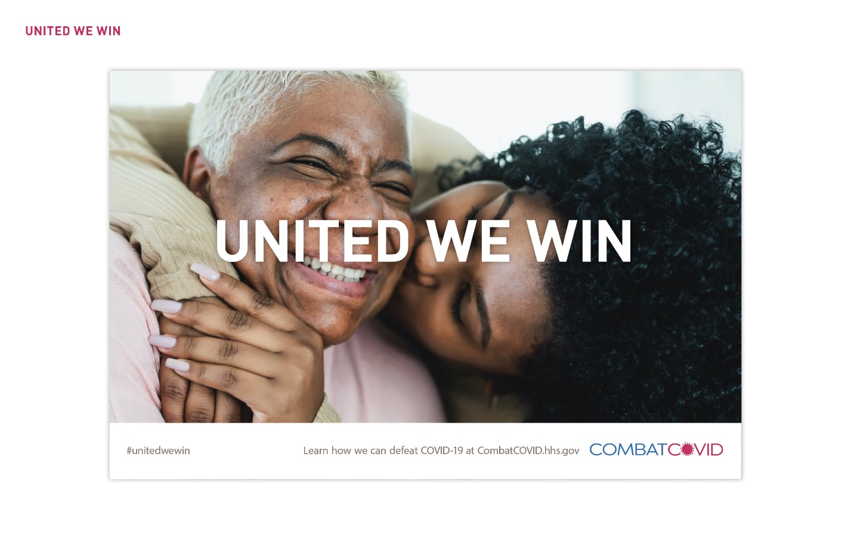

POLL 1
  - How understandable is this ad/message? Scale 1–5, “Not at all understandable to very understandable.
  - How interested would you be in learning more after seeing this ad/message? Scale 1–5, “Very interested to not at all interested.”

BILINGUAL TEAM ONLY:

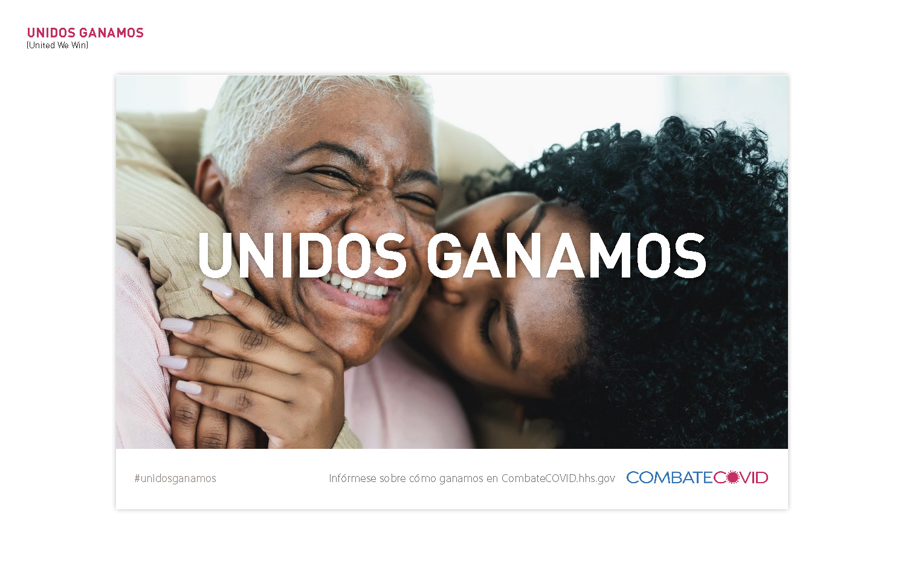

- POLL: How understandable is the Spanish version of this ad/message? Scale 1–5, “Not at all understandable to Very understandable.” SHOW RESULTS AND BRIEFLY DISCUSS REACTIONS TO THE HEADLINE TRANSLATION.

I am now going to show you 3 other headline options for this ad. Imagine that these headlines would take the place of the current headline you see on the screen.

AD or MESSAGE Option 2
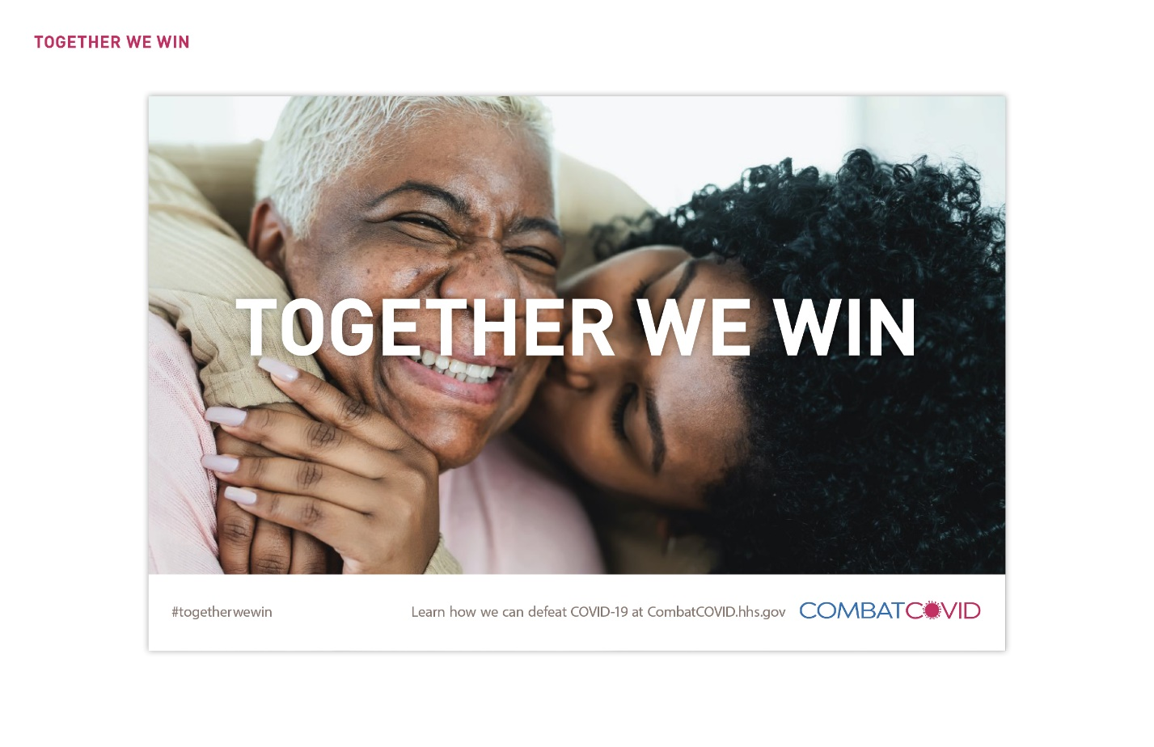
POLL 2
- How understandable is this ad/message? Scale 1–5, “Not at all understandable to very understandable.
- How interested would you be in learning more after seeing this ad/message? Scale 1–5, “Very interested to not at all interested.”

BILINGUAL TEAM ONLY:

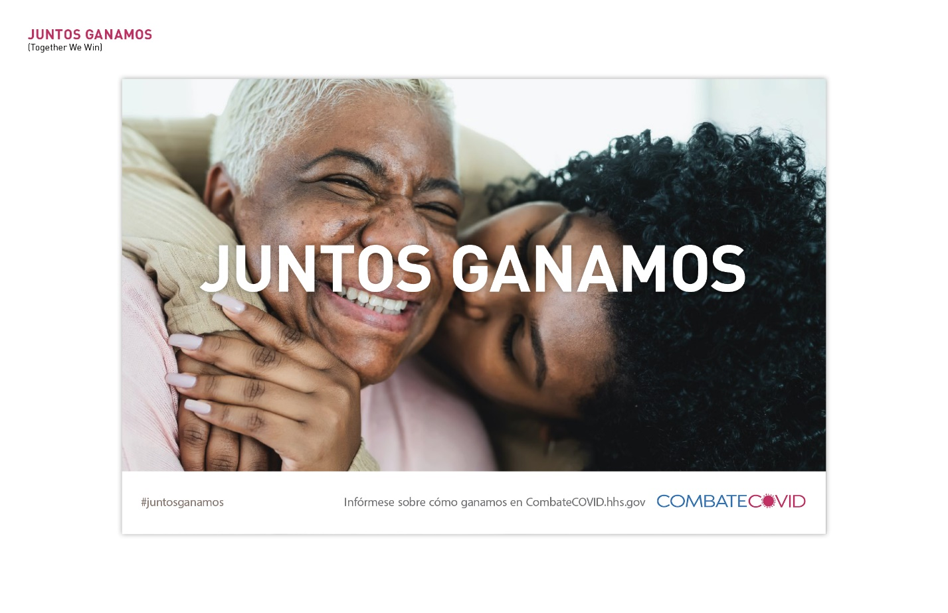

- POLL: How understandable is the Spanish version of this ad/message? Scale 1–5, “Not at all understandable to Very understandable.” SHOW RESULTS AND BRIEFLY DISCUSS REACTIONS TO THE HEADLINE TRANSLATION.

AD or MESSAGE Option 3
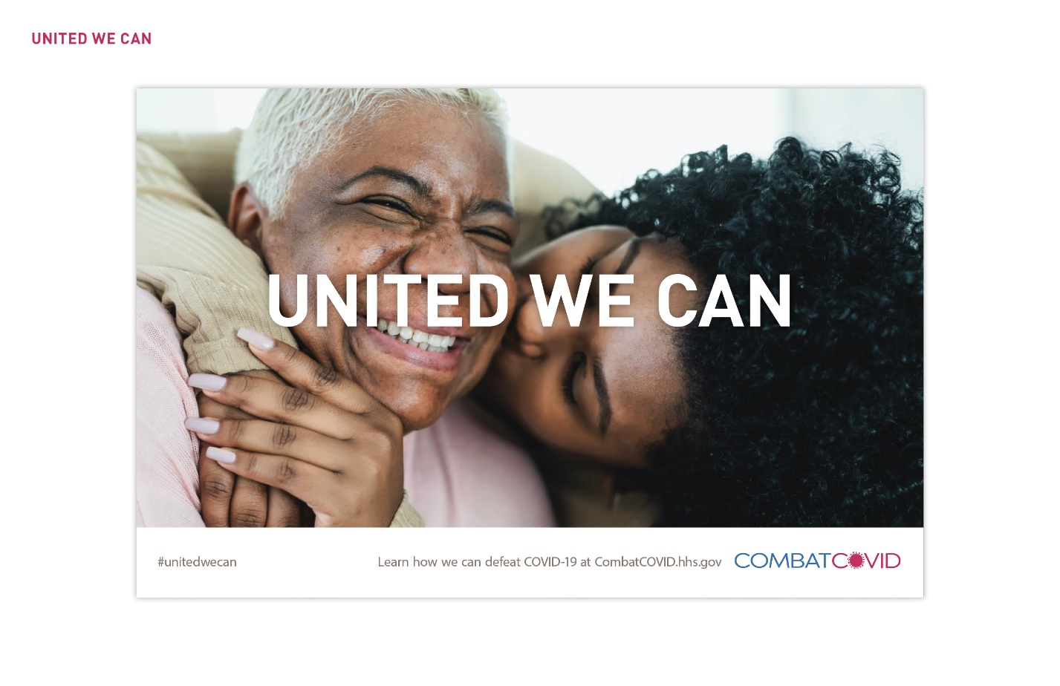
POLL 3
- How understandable is this ad/message? Scale 1–5, “Not at all understandable to very understandable.
- How interested would you be in learning more after seeing this ad/message? Scale 1–5, “Very interested to not at all interested.”

BILINGUAL TEAM ONLY:

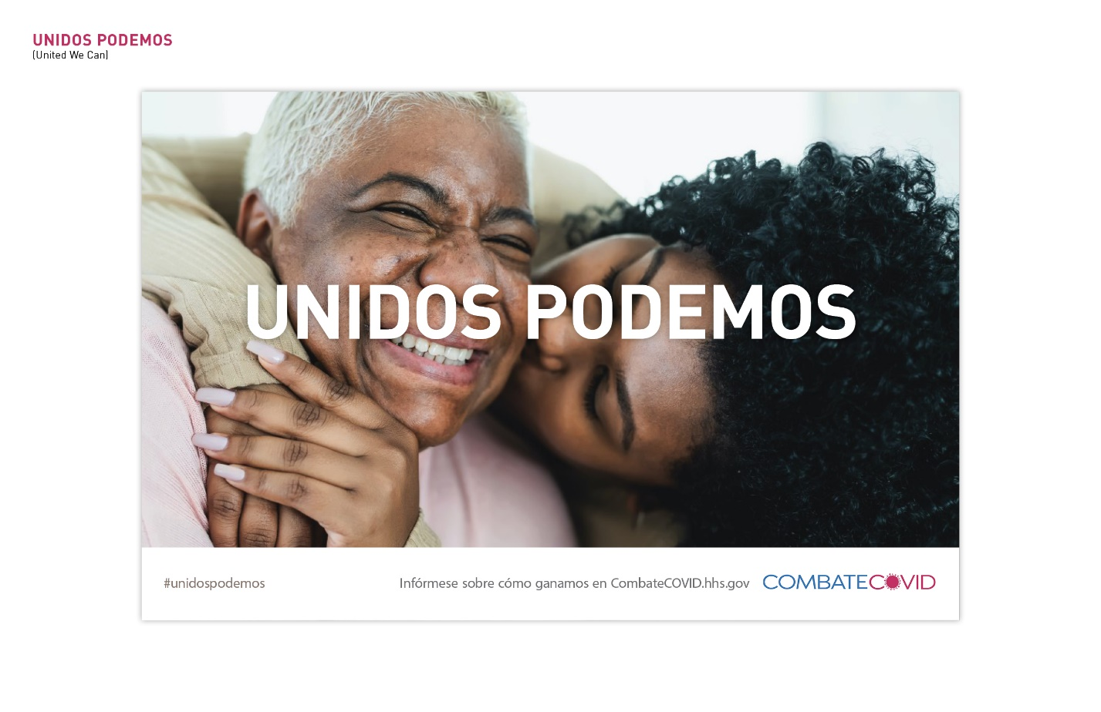

- POLL: How understandable is the Spanish version of this ad/message? Scale 1–5, “Not at all understandable to Very understandable.” SHOW RESULTS AND BRIEFLY DISCUSS REACTIONS TO THE HEADLINE TRANSLATION.

AD or MESSAGE Option 4
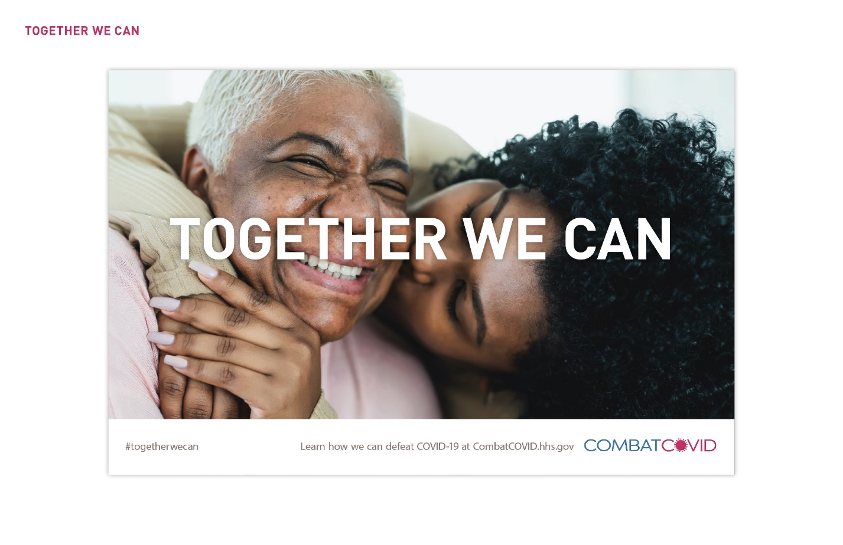
POLL 4
- How understandable is this ad/message? Scale 1–5, “Not at all understandable to very understandable.
- How interested would you be in learning more after seeing this ad/message? Scale 1–5, “Very interested to not at all interested.”

BILINGUAL TEAM ONLY:

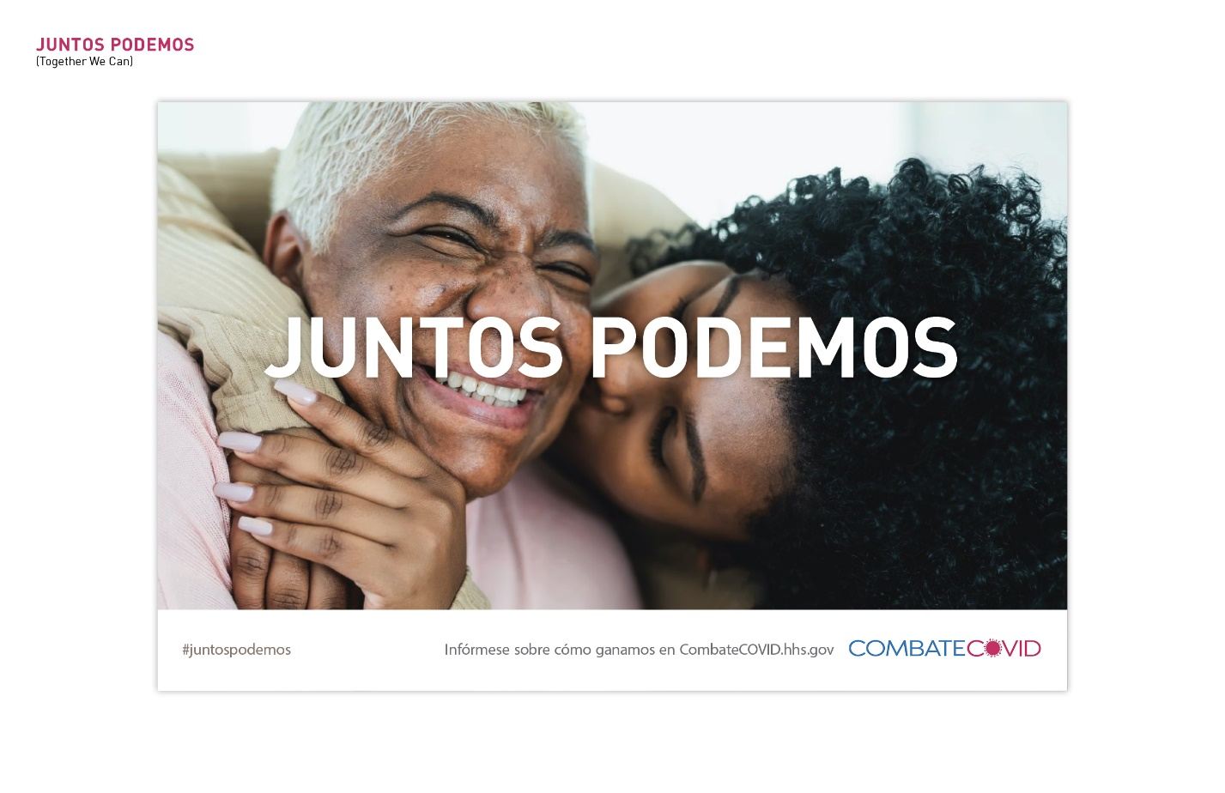

- POLL: How understandable is the Spanish version of this ad/message? Scale 1–5, “Not at all understandable to Very understandable.” SHOW RESULTS AND BRIEFLY DISCUSS REACTIONS TO THE HEADLINE TRANSLATION.

SHOW ALL ADS OR MESSAGES ON ONE SLIDE AND BRIEFLY DISCUSS.
- Which ad/message is your favorite? Least favorite?
- What do you like/dislike about these ads/messages?
- What about these ads/messages was unclear? Alternative: What did you not understand?
- What, if anything, would you change about these ads/messages? Alternate: How would you make these ads/messages better? In English or in Spanish? Probe for changes to messages, as well as images, colors, overall design, etc.

PREFERRED COMMUNICATION CHANNELS [Not to exceed 10 minutes or remainder of discussion time, whichever is sooner]
Moderator will probe these topics as needed, based on what has been already been covered in the preceding discussion and/or in past sessions.
A few more questions and then we will conclude today’s discussion.

[QUESTIONS 1—7 FOR MONTH ONE ONLY, QUESTIONS 8—10 FOR SUBSEQUENT MONTHS/FEEDBACK TEAM SESSIONS]

[MONTH ONE ONLY – Sources of COVID-19 health information.]

What information about effective treatments for COVID-19 is still needed?

Who would you trust most to give you information about effective treatments for COVID-19? (e.g., government agency, online health website, your doctor, a doctor [more generally], pharmacist, community leader, friend or family member?)

Who would you trust most to give you information about treatment clinical trials for COVID-19? (e.g., government agency, online health website, your doctor, a doctor [more generally], pharmacist, community leader, friend or family member?)

- What would motivate you to participate in or encourage a friend or family member to participate in a COVID-19 treatment clinical trial?

[If participant(s) took part in a clinical trial since last discussion, probe what motived them to join the trial.]

- Where would you expect to see or learn about the campaign you heard about today?

[If participant(s) is/are familiar with the campaign already, probe for where they saw it.]

- What would be the most effective way to reach you with this campaign (e.g., on television, radio, podcasts, social media, a website)?

[Probe for specific channels/platforms: Facebook, Twitter, YouTube, podcasts, local television or radio station]

- What else would you want to know about clinical trials for COVID-19 treatments?

  - How or where would you like to learn about it?

[Probe about format:
- Webpage, brochure; blog; doctor’s office; email announcements; Facebook page; magazine articles; newspaper articles; radio stories; television
- From whom would you want to receive information about this campaign?]

[SUBSEQUENT MONTHS] Thinking about the ad/message concepts we just discussed…

- Where would you expect to see ads/messages like these?

  - What places would NOT be appropriate for ads/messages like these?

[Probe for location, medium, specific channels.]

- Of all the places you would want to see ads/messages like these, which would have the biggest impact on getting someone to take action?

- What additional information is still needed, based on what’s going on with COVID-19 now?

  - How or where would you like to learn about it?

Are there any additional comments or final thoughts you’d like to mention before we conclude?

Thank you so much for your valuable input. Your feedback will help us ensure this campaign reaches its audience effectively.

