Public reporting burden for this collection of information is estimated to average 60 minutes per response, including the time for reviewing instructions, searching existing data sources, gathering, and maintaining the data needed, and completing and reviewing the collection of information. An Agency may not conduct or sponsor, and a person is not required to respond to, a collection of information unless it displays a current valid OMB control number. Send comments regarding this burden estimate or any other aspect of this collection of information, including suggestions for reducing this burden, to NIH, Project clearance Branch, 6705 Rockledge Drive, MSC 7974, Bethesda, MD 20892-7974, ATTN: PRA (0925-0769). Do not return the completed form to this address.

Federal COVID Response Audience Feedback Discussion – For use with group or individual conversations
Month 01, 2021 at 00:00 p.m. Eastern Time

A 60-minute listening session with

COVID-19 Healthcare Providers

SESSION OVERVIEW
Background (<5 minutes)
Participant Introductions (5 minutes)
Feedback Context Questions (15 minutes)
COVID-19 Treatment and Clinical Trial Awareness [MONTH ONE ONLY]
COVID-19 Treatment News Discussion [SUBSEQUENT MONTHS]
Ad/Message Options (30-35 minutes)
Preferred Communication Channels (5-10 minutes)
General Sources for Health Information [MONTH ONE ONLY]
Preferred Communication Channel for Ad/Message Options Discussed [SUBSEQUENT MONTHS]

MODERATOR’S GUIDE

Please note: Participants have been asked to dial-in 5 to 10 minutes prior to the start of the discussion. During this time, the moderator will ensure that each participant can see the shared screen, consents to audio recording the conversation, and knows how to mute his or her phone when not speaking.

Before we begin, can you/anyone NOT see the shared screen? If you cannot, please let me know now.

A few items to review before joining today’s call:
- Our discussion will be audio-recorded so that I can refer to the recording as needed for my report writing, and my colleague is also on the line to take notes. In addition, other project staff are on the line listening to today’s discussion. Does anyone object to this discussion being audio recorded? [Moderator to dismiss anyone who objects to the audio recording. Notetaker to press “record.”]
- We will use first names only during today’s discussion, and I will report all findings from our conversation in summary form, never connecting an individual comment with an individual name.
- We will use the findings from today’s discussion only to inform the development of a public health awareness and outreach effort.
- Please mute your speakers when you are not speaking to minimize background noise.
- There are no right or wrong answers to any of the questions I will be asking. Please be honest.
- It is valuable for me to hear all points of view, so please talk respectfully, one at a time and let other participants finish what they’re saying before speaking.
- Please state your first name before you make a statement.

Do you/does anyone have any questions at this time?

BACKGROUND [<5 minutes]

[MONTH 1 ONLY: Good morning/afternoon/evening. Thank you for taking time to participate in this discussion. My name is [MODERATOR NAME], and I am going to facilitate our conversation. I am a trained moderator who works for IQ Solutions, a company contracted by the U.S. Federal COVID Response Team. The Federal COVID Response Team is a cross-agency partnership that includes the U.S. Department of Health and Human Services (HHS), including the Centers for Disease Control and Prevention (CDC), the U.S. Food and Drug Administration (FDA), the National Institutes of Health (NIH), the Biomedical Advanced Research and Development Authority (BARDA), and the U.S. Department of Defense (DOD).

The main purpose of our discussion today is talk about treatments for COVID-19 (including trials for new treatments), where you go to learn new COVID-19 information, and get your reactions to a few message and ad options for the Federal COVID Response Team initiative.]

[SUBSEQUENT MONTHS: Good evening/afternoon. Thank you for taking time to participate in this discussion. My name is [MODERATOR NAME], and I am going to facilitate our conversation. I am a trained moderator who works for IQ Solutions, a company contracted by the U.S. Federal COVID Response Team.

The main purpose of our discussion is to explore what is new with COVID-19 since we last met, and get your reactions to a few new message and ad options for the Federal COVID Response Team initiative.]

Consent to Audio-Record
- We would like to audio-record this conversation so that when it comes time to write the summary report, we will have your actual words to ensure accuracy, if needed. However, you will not be identified in the report.
- Do I have your permission to audio-record this discussion? [Dismiss participant if they do not verbally consent.]

INDIVIDUAL DISCUSSION INTRODUCTION [Not to exceed 5 minutes]

Please introduce yourself briefly by letting us know:
- The name that you would like me to use during this discussion—remember, no last names
- Your professional title and specialty
- Your city and state
- Your general patient population demographics

GROUP DISCUSSION PARTICIPANT INTRODUCTIONS [Not to exceed 5 minutes]

I am aware that you are all healthcare providers who treat or work with COVID-19 positive patients. Please introduce yourself briefly by letting me know:
- The name that you would like me to use during this discussion—remember, no last names
- Your professional title and specialty
- Your city and state
- Your general patient population demographics

The facilitator will walk through each question below, probing for responses as needed and reorganizing the order of questions as necessary according to the organic flow of the conversation.

[FEEDBACK CONTEXT QUESTIONS FOR MONTH 1 ACTIVITY ONLY] COVID-19 TREATMENT AND CLINICAL TRIAL AWARENESS [Not to exceed 15 minutes]

The facilitator will probe elements of the below questions based on participants’ awareness and experience.

Let’s begin with a few broad questions:
- What effective therapeutics and treatments are you aware of for COVID-19?

- Tell me about your experiences treating COVID-19 positive patients. Probe for whether they have prescribed COVID-19 treatments to these patients and willingness among patients to accept treatments.

Example probes:
- Have you prescribed COVID-19 treatments to any of your patients?
- What specific treatments? How effective were those treatments?
- What kind of patient? At what stage of disease? What’s the “typical patient profile” that you see who has COVID-19?
- How willing have these patients been to accept your COVID-19 treatment recommendations? Why?
Let’s briefly discuss clinical trials:
- Have you ever recommended your patients enroll in a clinical trial for any health condition?

Example probes:

How did you learn about that trial? (e.g. research manager, a colleague, information in electronic medical record, trial representative who contacted you)

What piece of information or factor would you say ultimately made a patient accept/agree to enroll in a clinical trial?

What would you say to another provider who had never recommended clinical trials to their patients?

- Have you recommended your COVID-19 patients enroll in a clinical trial for COVID-19 therapeutic/treatment? Tell me about your patients’ willingness to participate and whether they enrolled.

What would motivate you to encourage a patient or their family member to participate in a COVID-19 treatment clinical trial? What would discourage you from sharing information about a clinical trial?

The most recent time you looked for information about COVID-19 [clinical trials], where did you go first? [Listen for online search, a hospital or health system [e.g., Johns Hopkins], medical websites, medical journals, colleagues, continuing education activities]

Example probes:

Did you look or go anywhere else that time? Where else did you look or go?

Why did you look there for information?

What keywords did you use (e.g., specific symptoms)?

What else would you want to know about clinical trials for treating patients with COVID-19 or anything else related to this topic?

[FEEDBACK CONTEXT QUESTIONS FOR SUBSEQUENT MONTHS] [Not to exceed 15 minutes.]

The facilitator will probe for elements of the broad context questions below, based on important current events and what participants have shared in past feedback team activities.

- Since we last met, what has changed with respect to the COVID-19 pandemic and the pandemic response? If this is your first time joining, please share what has changed over the last few months.

[Probe for changes about: case numbers, restrictions/re-openings, mask mandates, vaccination rates, etc. Also probe for participants’ feelings about these changes.]

- What differences are you seeing in your COVID-19 patients, since we last met (or in the last few months)?

[Probe for changes in number of patients, severity of illness, different demographics of patients (age, sex), comorbidities, vaccination status, etc.]

- Since we last met (or in the last few months), what has changed in the way you manage your COVID-19 patients?

[Probe for new therapeutics, new treatment courses, where they learned about the new approach, whether others have heard the same/have made the same changes.]

[MESSAGE OR AD CONCEPT QUESTIONS TO REMAIN THE SAME ACROSS MONTHS; HOWEVER NEW AD MESSAGES/CONCEPTS WILL BE PRESENTED TO PARTICIPANTS BASED ON EACH UNIQUE TOPIC]

AD OR MESSAGE OPTIONS [Not to exceed 35 minutes]
[MONTH ONE ONLY: As mentioned earlier in our discussion, the U.S. Federal COVID Response Team is developing an initiative to build awareness about clinical trials for the treatment of COVID-19.
As part of this effort, and why we are here today, we want to get your reactions to a few message and/or ad options for this initiative. As you might know, an ad is a memorable phrase or motto that usually appears alongside a logo or image. A logo is a symbol or design that can represent a brand or idea. The messages and/or ads I will show you today are not final products. We are looking to get your reactions to the basic overall designs and messages.]

[SUBSEQUENT MONTHS: We are going to now look at a set of new message and/or ad options the FCR team has developed.]

Let’s begin with the [messages, ad options], which you will see one by one on the shared screen. After we show each option, two poll questions will appear as “pop-ups” on your computer screen. When a poll appears, please take a few seconds to “click” your answer. Please be honest in your responses.

Notetaker to advance the slides and display relevant polls after each logo.

Let’s get started by looking at a few [messages, ad options] intended for healthcare providers.

AD or MESSAGE Option 1
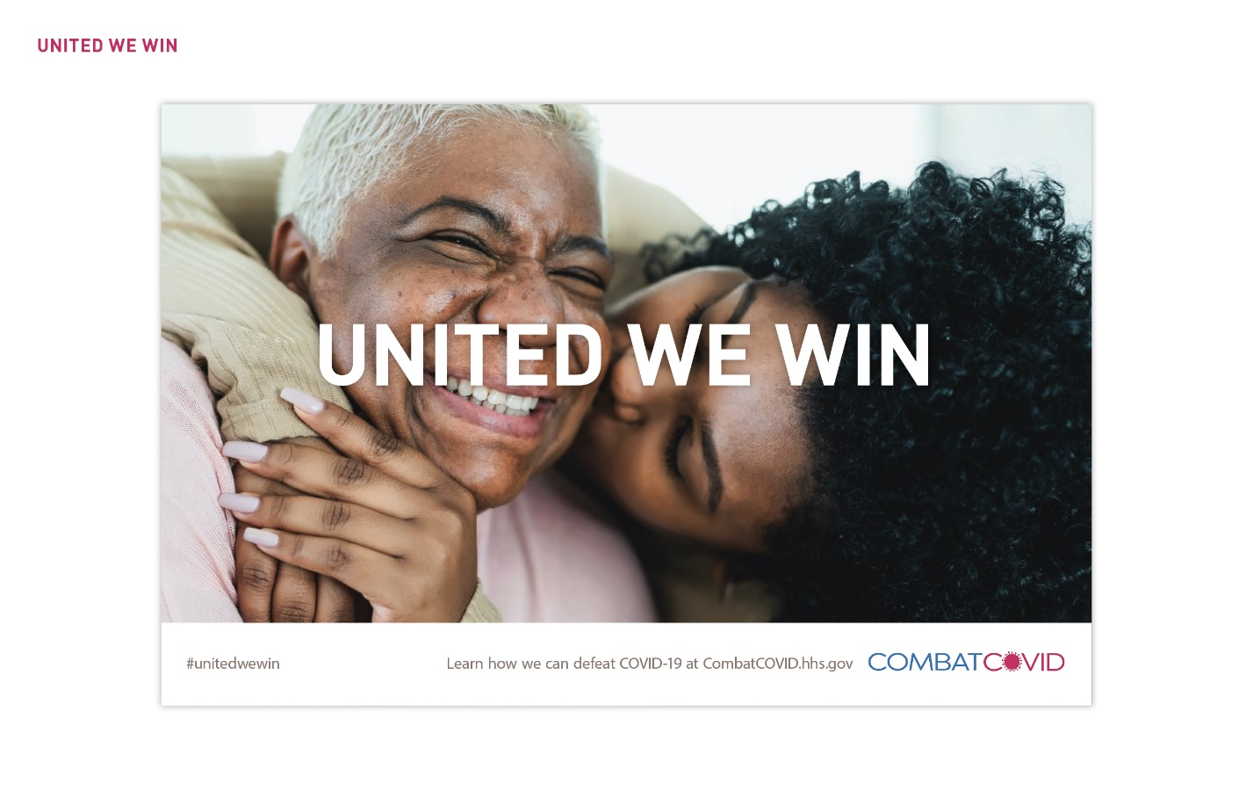
POLL 1:
- How understandable is this ad? Scale 1–5, “Not at all understandable to very understandable.” SHARE AND DISCUSS RESULTS.
- How interested would you be in learning more after seeing this ad? Scale 1–5, “Not at all interested to very interested.” SHARE AND DISCUSS RESULTS.

I am now going to show you 3 other headline options for this ad. Imagine that these headlines would take the place of the current headline you see on the screen.

AD or MESSAGE Option 2
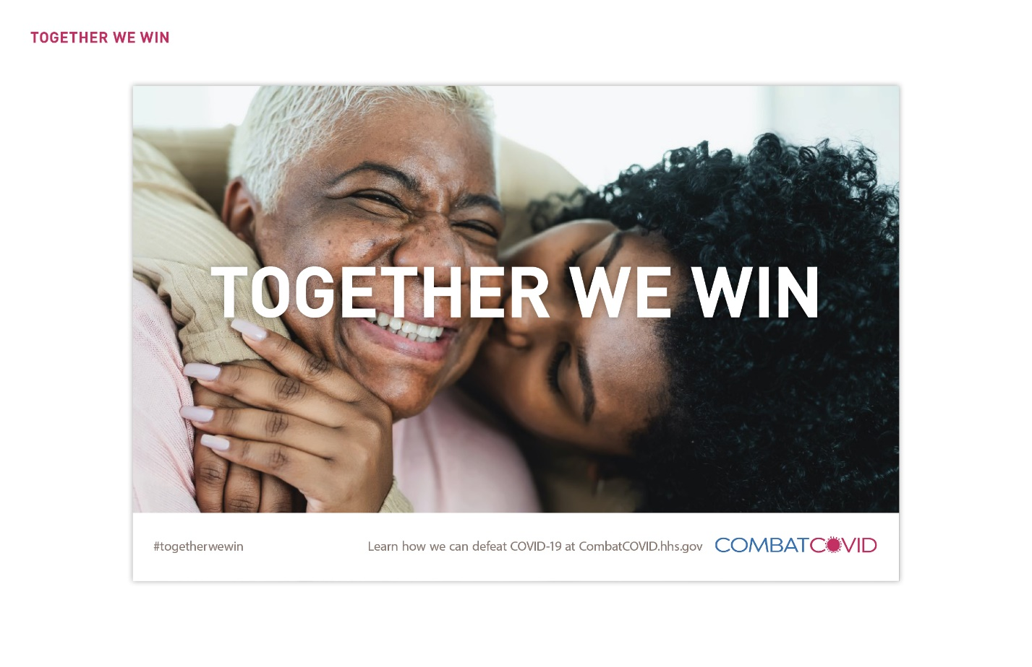
POLL 2
- How understandable is this ad/message? Scale 1–5, “Not at all understandable to very understandable.
- How interested would you be in learning more after seeing this ad/message? Scale 1–5, “Very interested to not at all interested.”

AD or MESSAGE Option 3
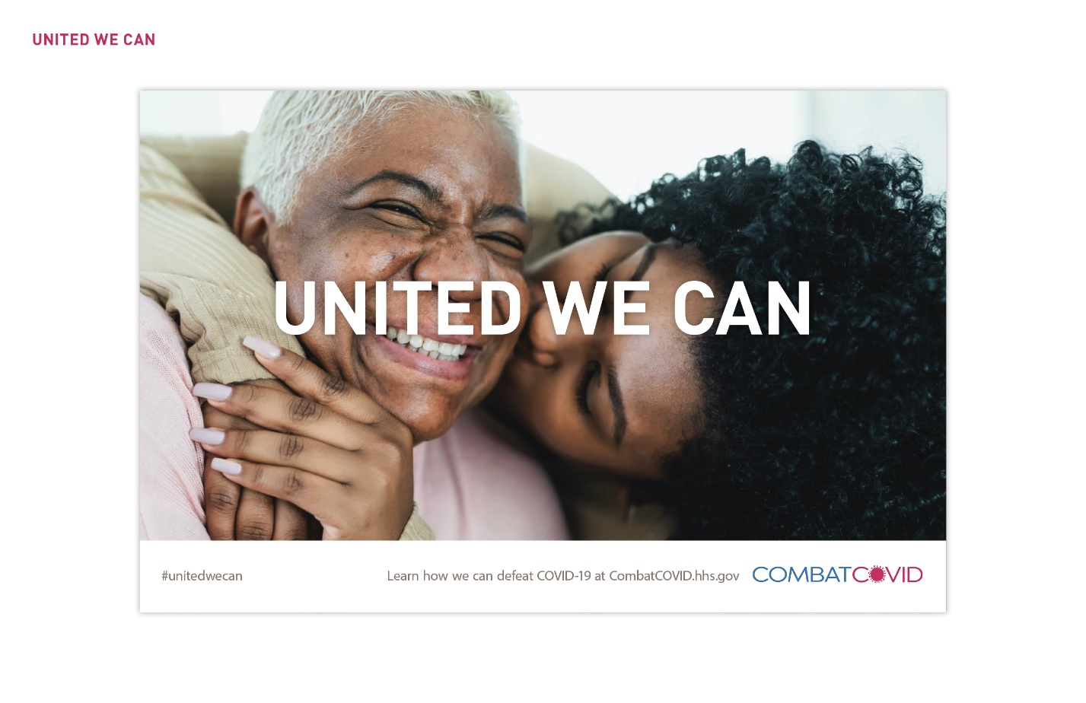
POLL 3
- How understandable is this ad/message? Scale 1–5, “Not at all understandable to very understandable.
- How interested would you be in learning more after seeing this ad/message? Scale 1–5, “Very interested to not at all interested.”

AD or MESSAGE Option 4
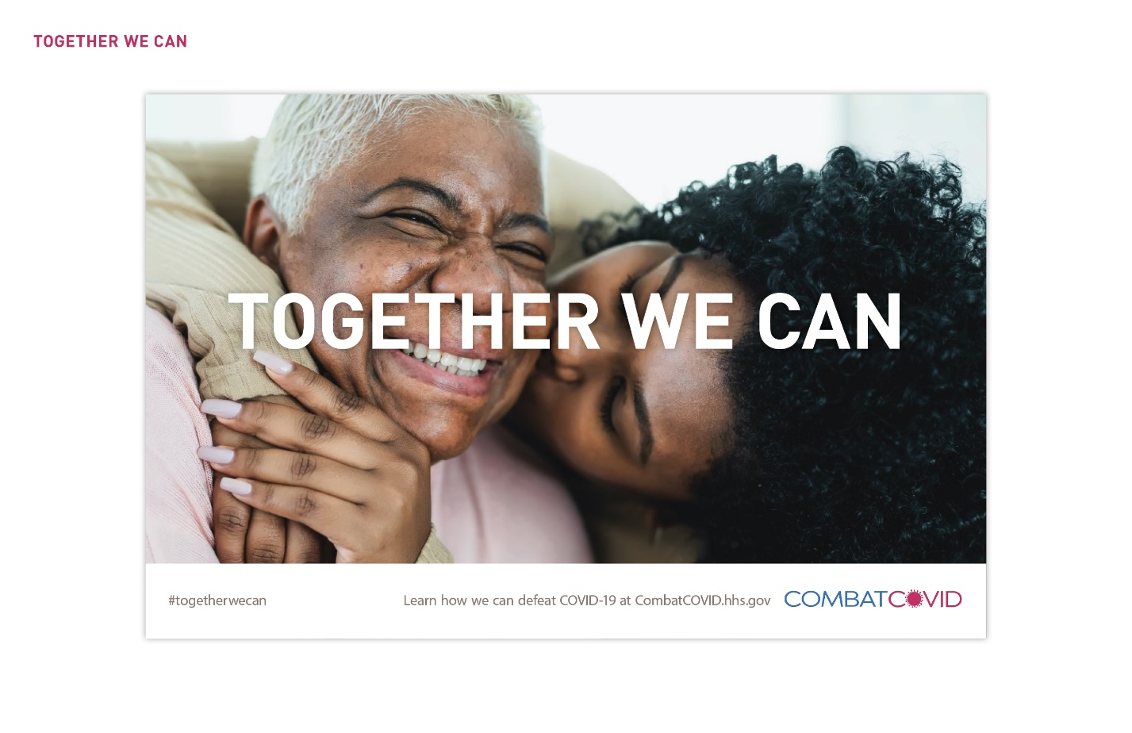
POLL 4
- How understandable is this ad/message? Scale 1–5, “Not at all understandable to very understandable.
- How interested would you be in learning more after seeing this ad/message? Scale 1–5, “Very interested to not at all interested.”

SHOW ALL ADS OR MESSAGES ON ONE SLIDE.
- Which ad/message is your favorite? Least favorite?
- What do you like/dislike about these ads/messages?
- What about these ads/messages was unclear? Alternative: What did you not understand?
- What, if anything, would you change about these ads/messages? Alternate: How would you make these ads/messages better? Probe for changes to messages, as well as images, colors, overall design, etc.

PREFERRED COMMUNICATION CHANNELS [Not to exceed 10 minutes or remainder of discussion time, whichever is sooner]

A few more questions and then we will conclude today’s discussion.
[QUESTIONS 1—5 FOR MONTH ONE ONLY, QUESTIONS 6—X FOR SUBSEQUENT MONTHS/FEEDBACK TEAM SESSIONS]

[MONTH 1 ONLY – Sources of COVID-19 health information.]

Who would you trust most to give you or your patients information about effective treatments for COVID-19?

Who would you trust most to give you or your patients information about available opportunities for therapeutic and treatment clinical trials for COVID-19?

What information would be most helpful to you in having conversations with your patients about treatments for COVID-19, including active clinical trials?

- Where would you expect to see or learn about the campaign you heard about today?

- What would be the most effective way to reach providers like you with information related to this campaign? (E.g., via membership organizations, on television, radio, podcasts, social media, a website.)

Probe for specifics (which organization, which podcast, which social media accounts, etc.)
- What additional information would be useful when having conversations with your patients about COVID-19 prevention or treatment?

[SUBSEQUENT MONTHS] Thinking about the ad/message concepts we just discussed…

- Where would you expect to see ads/messages like these?

  - What places would NOT be appropriate for ads/messages like these?

[Probe for location, medium, specific channels.]

- Of all the places you would want to see ads/messages like these, which would have the biggest impact on getting someone to take action?

- What additional information is still needed, based on what’s going on with COVID-19 now?

- For providers or for patients?
- How or where would you like to learn about it?

Are there any additional comments or final thoughts you’d like to mention before we conclude?

Thank you so much for your valuable input. Your feedback will help us ensure this campaign reaches its audience effectively.

