Welcome Screen - ALL RESPONDENTS
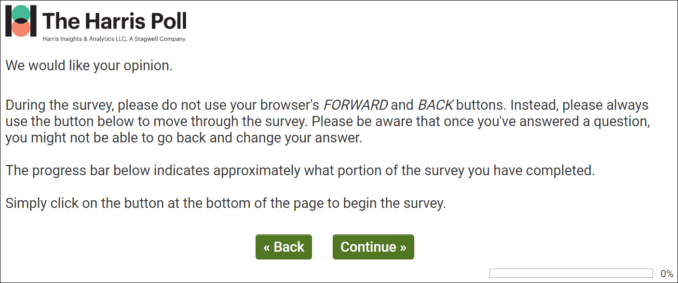

dmConsent – ALL RESPONDENTS
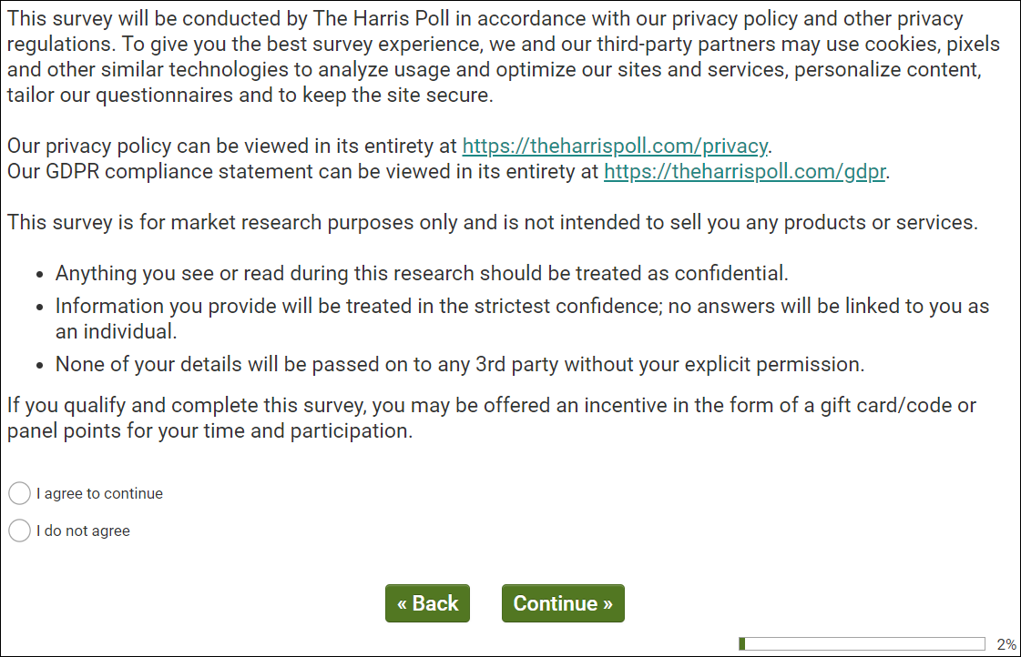
Public reporting burden for this collection of information is estimated to average 15 minutes per response,
including the time for reviewing instructions, searching existing data sources, gathering and maintaining the
data needed, and completing and reviewing the collection of information. An Agency may not conduct or
sponsor, and a person is not required to respond to, a collection of information unless it displays a current
valid OMB control number. Send comments regarding this burden estimate or any other aspect of this
collection of information, including suggestions for reducing this burden, to NIH, Project clearance
Branch, 6705 Rockledge Drive, MSC 7974, Bethesda, MD 20892-7974, ATTN: PRA (XXXX-XXXX). Do
not return the completed form to this address.

[IF dmConsent/1 PROCEED TO dmCntry.]
[IF dmConsent/2 NO TERMINATE IMMEDIATELY.]
AVTestPlayer , audioTest , videoTest – ALL RESPONDENTS
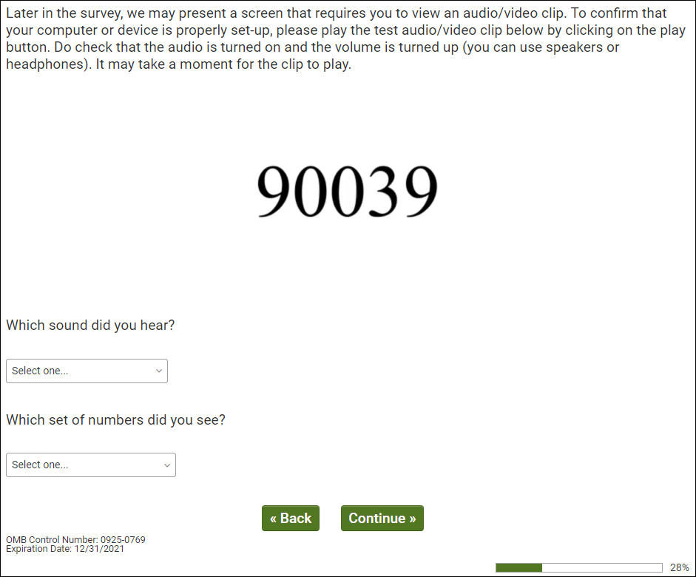

dmCntry – ALL RESPONDENTS
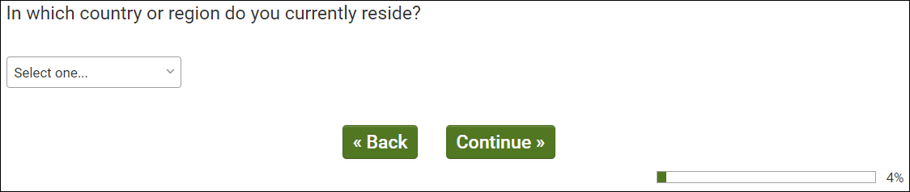
OMB Control Number: 0925-0769
Expiration Date: 12/31/2021
[IF dmCntry/244 UNITED STATES OF AMERICA PROCEED TO dmGen & dmAge.]
[IF hCntry DOES NOT EQUAL dmCntry TERMINATE IMMEDIATELY.]
dmGen & dmSex & dmAge – ALL RESPONDENTS
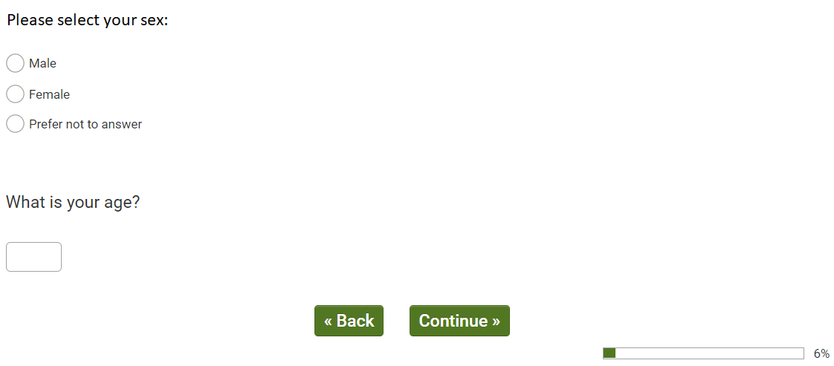
OMB Control Number: 0925-0769
Expiration Date: 12/31/2021
[IF dmAge/18+ PROCEED TO dmHispUS.]

[IF NOT 18+ TERMINATE IMMEDIATELY.]

dmHispUS – ALL US RESPONDENTS
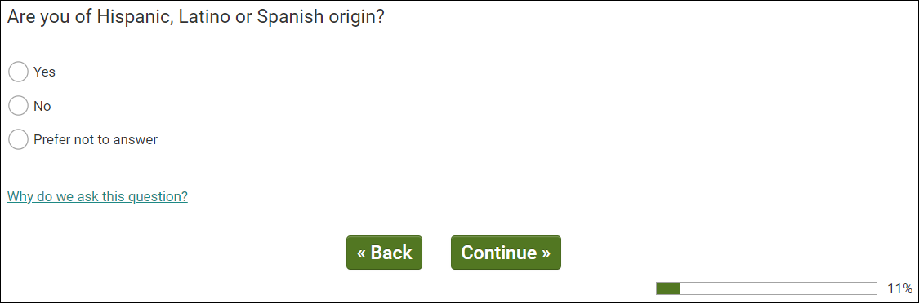
OMB Control Number: 0925-0769
Expiration Date: 12/31/2021
[PROCEED TO dmRaceMUS.]

dmRaceMUS – ALL US RESPONDENTS
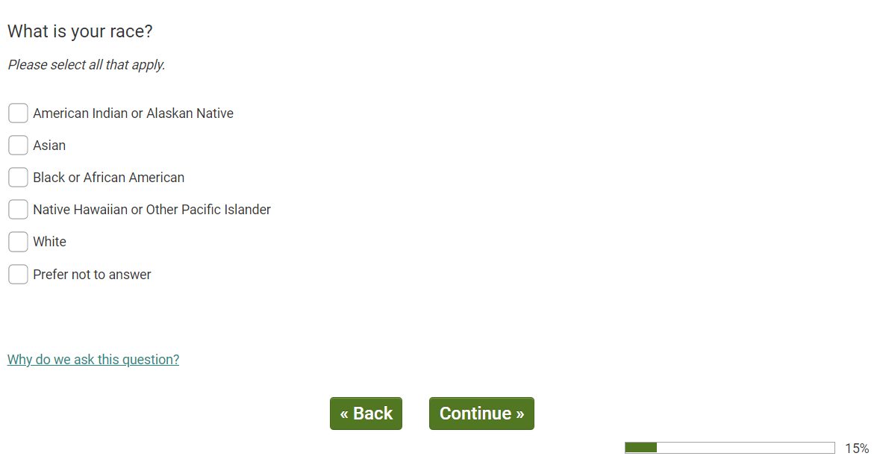
OMB Control Number: 0925-0769
Expiration Date: 12/31/2021

[PROCEED TO Q5.]

Q5 – ALL US RESPONDENTS
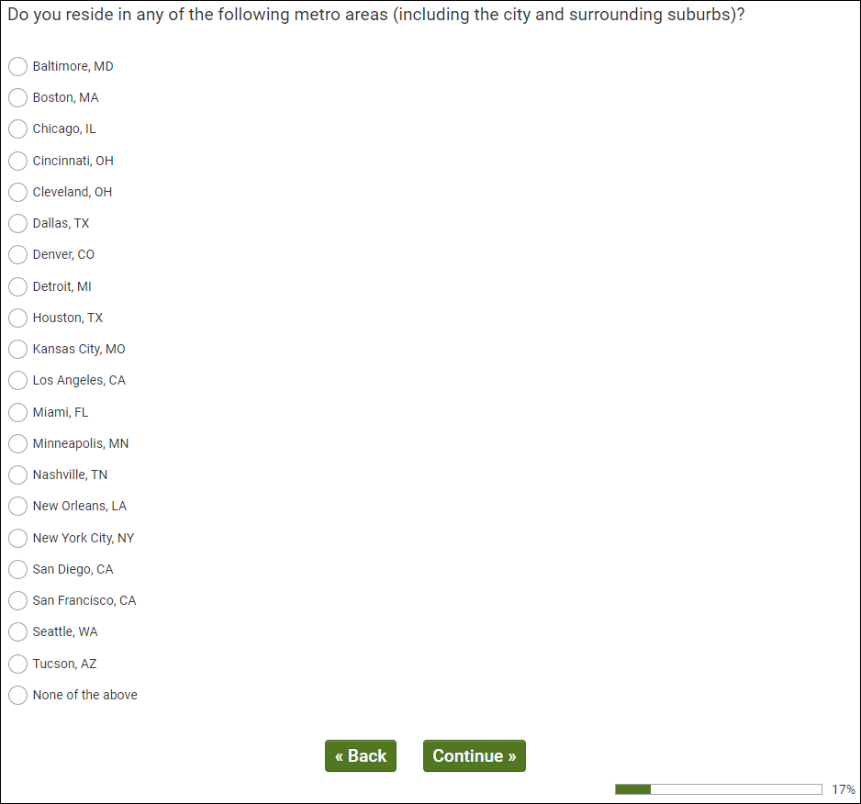
OMB Control Number: 0925-0769
Expiration Date: 12/31/2021

[IF Q5/1-20, PROCEED TO dmEmploy.]
[MUST RESIDE IN TARGET DMA 1-20. TERMINATE IF Q5/96 – None of the above.]

dmEmploy – ALL US RESPONDENTS
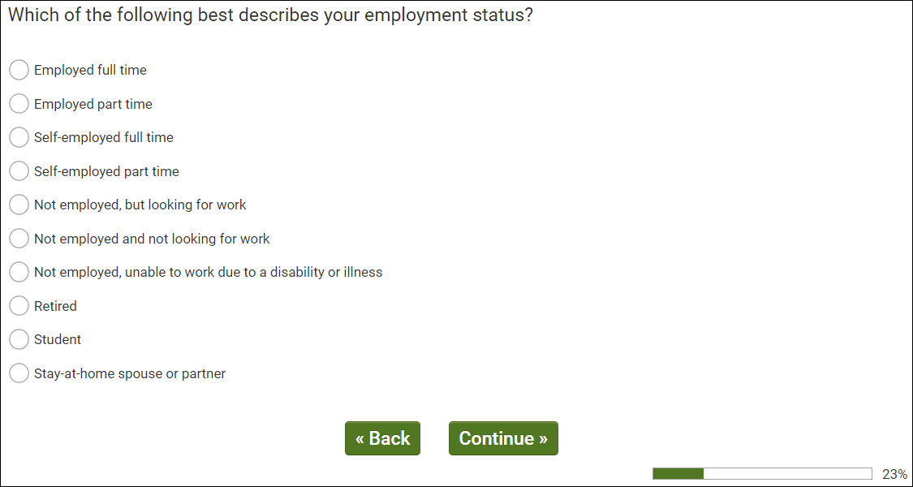
OMB Control Number: 0925-0769
Expiration Date: 12/31/2021

[IF dmEmploy/1,2,3,4 PROCEED TO Q10.]
[IF dmEmploy/5-10 PROCEED TO Q100]

Q10 - EMPLOYED (netEmploy/1)
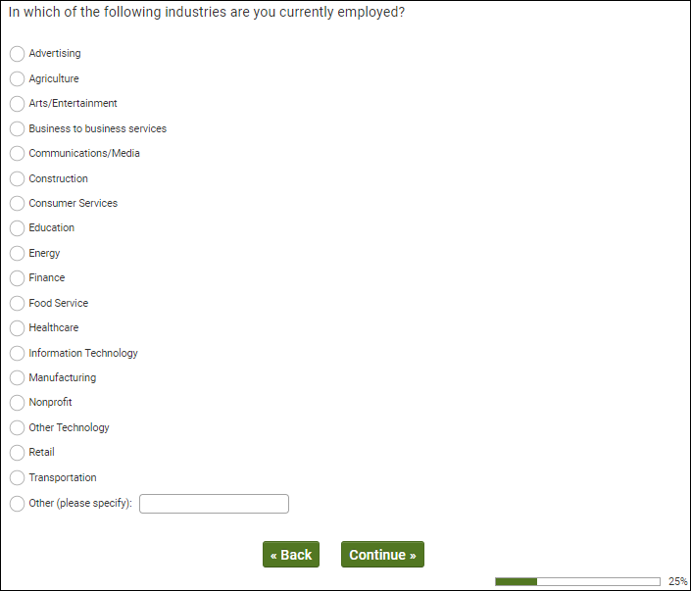
OMB Control Number: 0925-0769
Expiration Date: 12/31/2021

[IF Q10/12 HEALTHCARE PROCEED TO Q20.]
[IF Q10/1-11,13-20 PROCEED TO Q100.]

Q20 - EMPLOYED IN HEALTHCARE (Q10/12) AND HCP SAMPLE SOURCE (Q1/2)
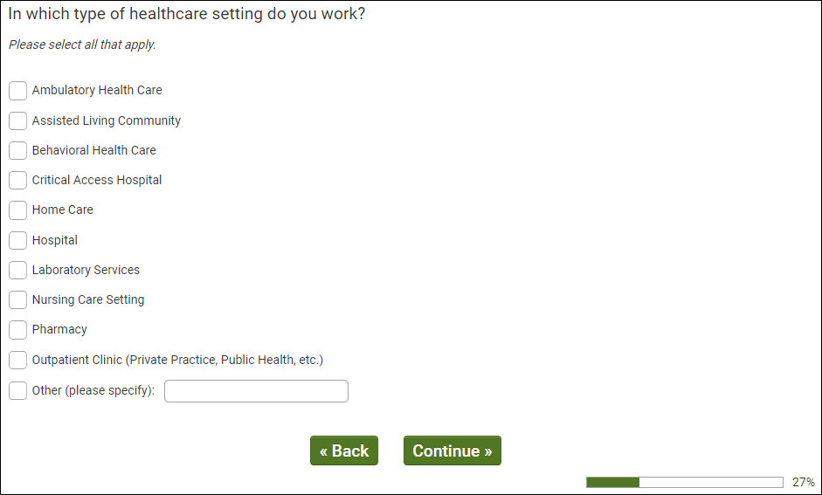
OMB Control Number: 0925-0769
Expiration Date: 12/31/2021

[IF HCP SAMPLE SOURCE Q1/2, MUST SELECT 1, 2, 4, 5, 6, 8, 9, 10 TO QUALIFY. PROCEED TO Q3. TERMINATE OTHERS]

Q30 - HCP SAMPLE (Q1/2) AND WORK IN QUALIFYING SETTING (Q20/1,2,4,5,6 OR 8)
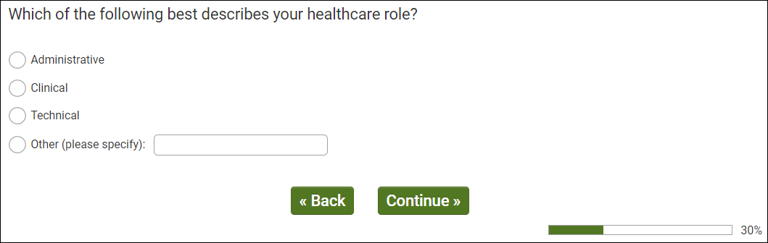
OMB Control Number: 0925-0769
Expiration Date: 12/31/2021

[IF HCP SAMPLE SOURCE (Q1/2) MUST SELECT 2/CLINICAL TO QUALIFY. PROCEED TO Q40. TERMINATE OTHERS]

Q40 - HCP SAMPLE (Q1/2) AND CLINICAL HEALTHCARE WORKER (Q30/2)
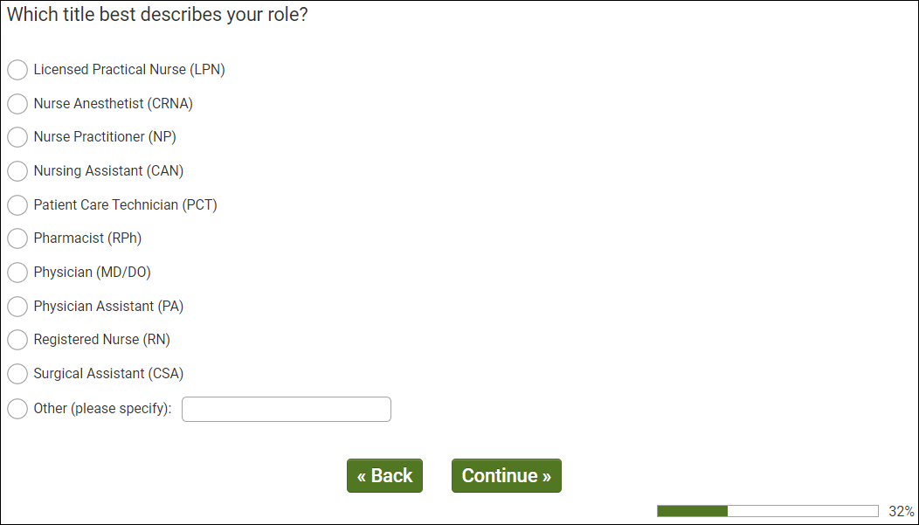
OMB Control Number: 0925-0769
Expiration Date: 12/31/2021

[IF HCP SAMPLE SOURCE (Q1/2) MUST SELECT 1, 2, 3, 6, 7, 8 OR 9 TO QUALIFY. PROCEED TO Q50. TERMINATE OTHERS]

Q50 - HCP SAMPLE (Q1/2) AND TARGET ROLE (Q40/3,6-7)
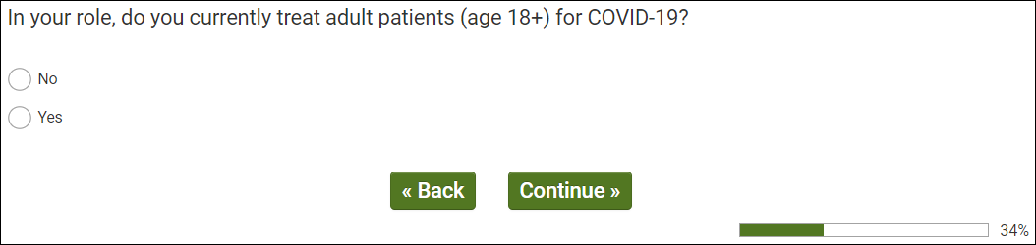
OMB Control Number: 0925-0769
Expiration Date: 12/31/2021

[IF HCP SAMPLE SOURCE (Q1/2) MUST SELECT 2/YES TO QUALIFY. PROCEED TO Q60 TERMINATE OTHERS]

Q60 - HCP SAMPLE (Q1/2) AND TREAT COVID PATIENTS (Q50/2)
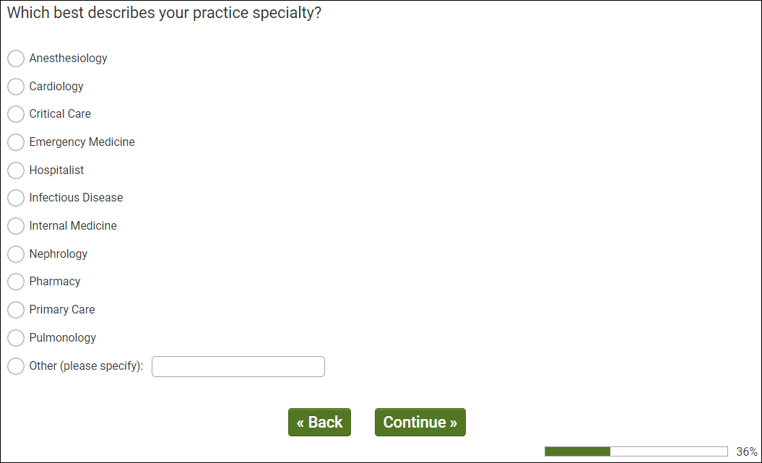
OMB Control Number: 0925-0769
Expiration Date: 12/31/2021

QUALIFICATIONS

Consumers (Q1/1)
- Live in target DMA (Q5/1-20)
- Representative sample 18+

Healthcare Providers (Q1/2)
- Live in target DMA (Q100/1-20)
- Qualifying Setting (Q20/1, 2, 4, 5, 6, 8, 9, 10)
- In Clinical Role (Q30/2)
- Qualifying Specific Role (Q40/1,2,3,6,7,8,9)
- Treat patients with COVID-19 (Q50/2)

Q100 – QUALIFIED CONSUMER RESPONDENTS
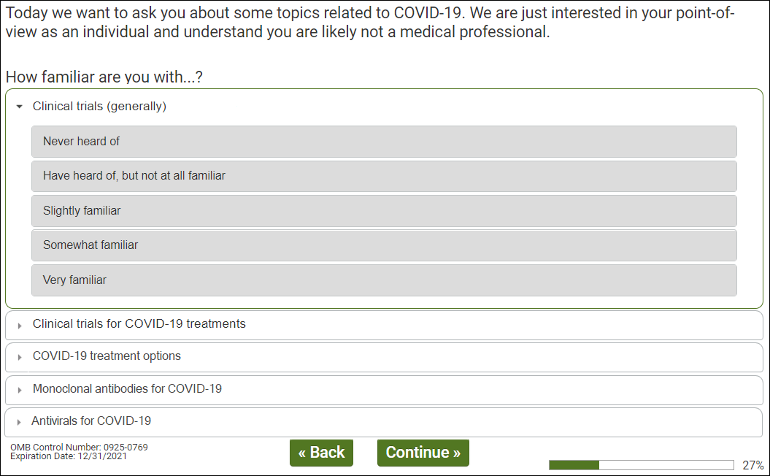
OMB Control Number: 0925-0769
Expiration Date: 12/31/2021

[IF QUALIFIED HCP (Q99/2) AND FAMILIAR (Q100 RATING 3-5) WITH TREATMENT TRIALS (Q100 CARD/2) PROCEED TO Q102.]
[IF QUALIFIED CONSUMER (Q99/1) AND FAMILIAR (Q100 RATING 3-5) WITH TREATMENT TRIALS (Q100 CARD/2) PROCEED TO Q110.]
Q102 – HCP ONLY
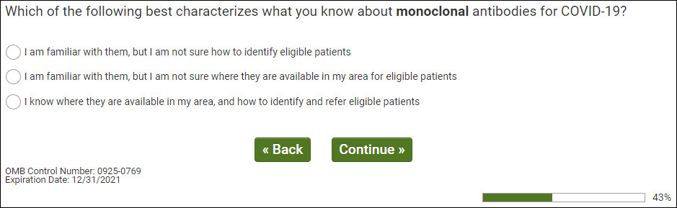

Q103 – HCP ONLY
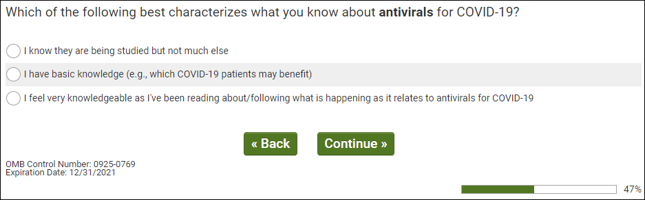

Q105 - QUALIFIED HCP (Q99/2) AND FAMILIAR (Q100 RATING 3-5) WITH TREATMENT TRIALS (Q100 CARD/2)
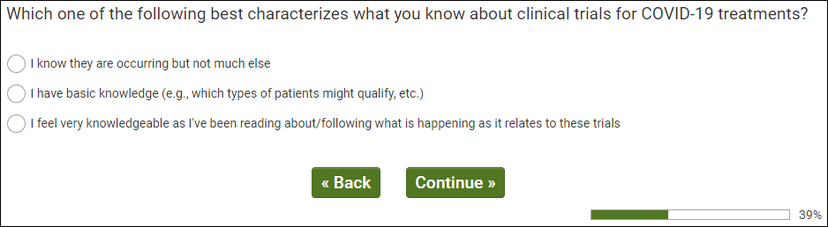
OMB Control Number: 0925-0769
Expiration Date: 12/31/2021

[ALL PROCEED TO Q110.]

Q110 - QUALIFIED RESPONDENTS
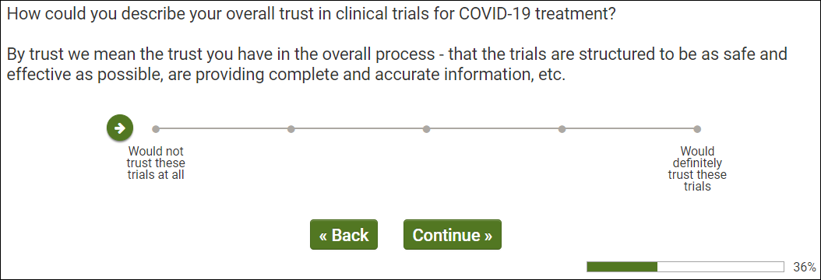
OMB Control Number: 0925-0769
Expiration Date: 12/31/2021

[ALL PROCEED TO Q112.]

Q112– ALL QUALIFIED RESPONDENTS
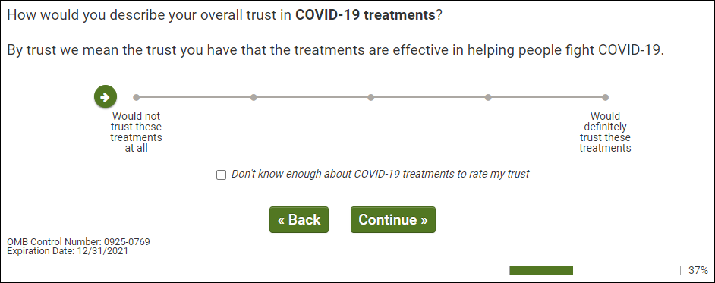
[ALL PROCEED TO Q113.]
Q113 – ALL QUALIFIED RESPONDENTS
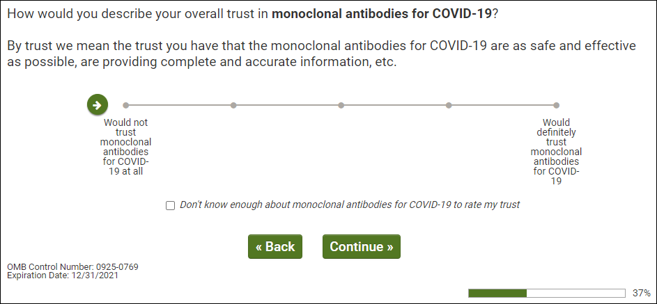
[ALL PROCEED TO Q114.]

Q114 – ALL QUALIFIED RESPONDENTS
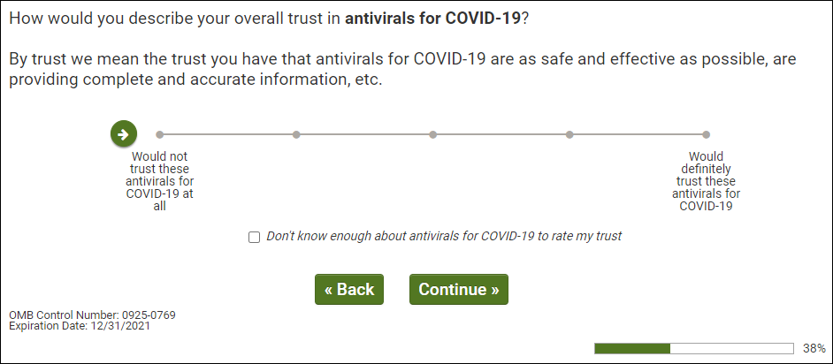
[QUALIFIED CONSUMERS (Q99/1) TO Q119.]
[QUALIFIED HCPS (Q99/2) PROCEED TO Q130.]

Q119 - QUALIFIED RESPONDENTS
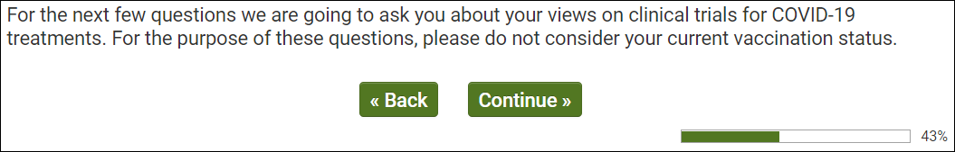
OMB Control Number: 0925-0769
Expiration Date: 12/31/2021

[ALL PROCEED TO Q120.]

Q120 - QUALIFIED CONSUMER RESPONDENTS
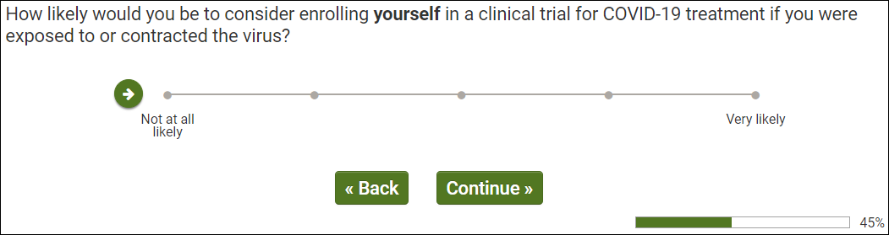
OMB Control Number: 0925-0769
Expiration Date: 12/31/2021

[ALL PROCEED TO Q123.]

Q123 – QUALIFIED CONSUMER RESPONDENTS
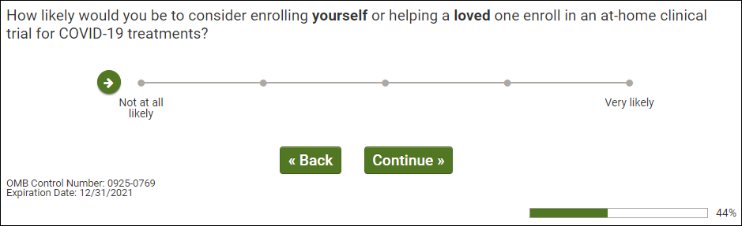
[ALL PROCEED TO Q125.]
Q125 - QUALIFIED CONSUMER RESPONDENTS
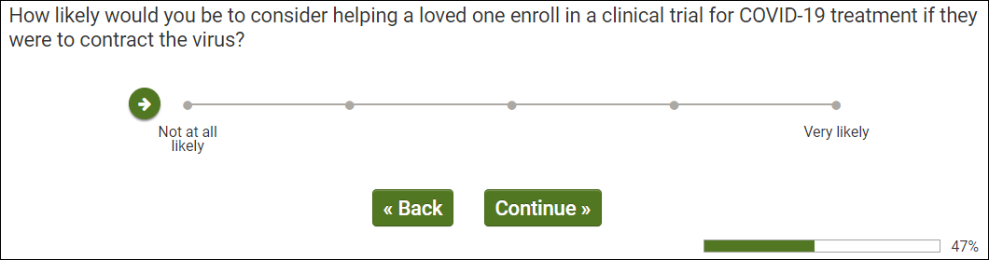
OMB Control Number: 0925-0769
Expiration Date: 12/31/2021

[ALL PROCEED TO Q128.]

Q128 – QUALIFIED CONSUMER RESPONDENTS
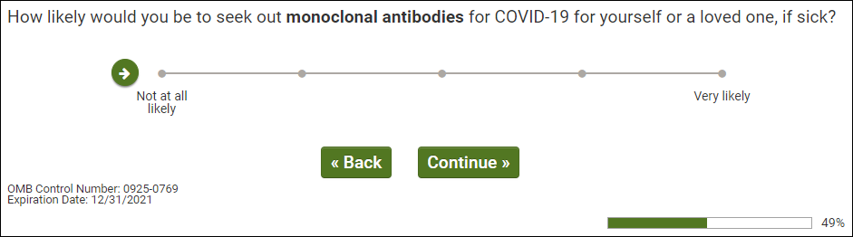
[QUALIFIED CONSUMERS (Q99/1) PROCEED TO Q200.]

Q130 - QUALIFIED HCP (Q99/2)
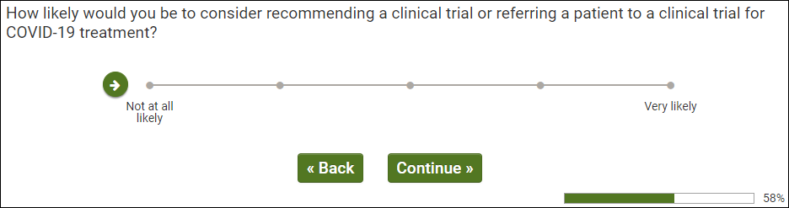
OMB Control Number: 0925-0769
Expiration Date: 12/31/2021

[QUALIFIED HCPS (Q99/2) PROCEED TO Q135.]
Q135 - QUALIFIED HCP (Q99/2)
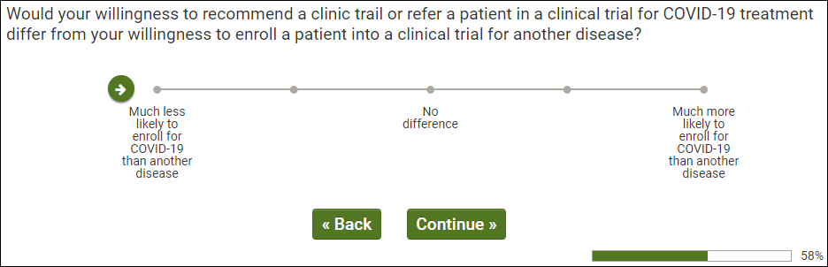
OMB Control Number: 0925-0769
Expiration Date: 12/31/2021

[ALL PROCEED TO Q200.]
Q200 - ALL RESPONDENTS
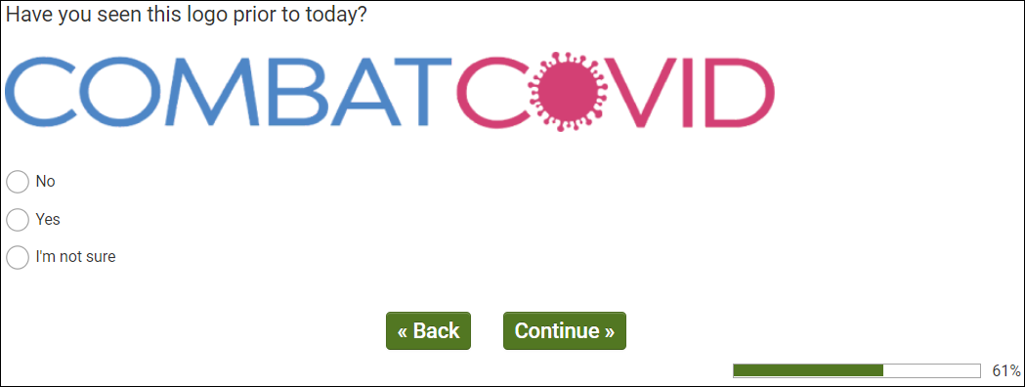
OMB Control Number: 0925-0769
Expiration Date: 12/31/2021

[QUALIFIED CONSUMERS (Q99/1) TO Q200a, CONSUMER ONLY.]
[QUALIFIED HCPS (Q99/2) PROCEED TO Q200a, HCPs ONLY.]

Q200a, CONSUMERS ONLY 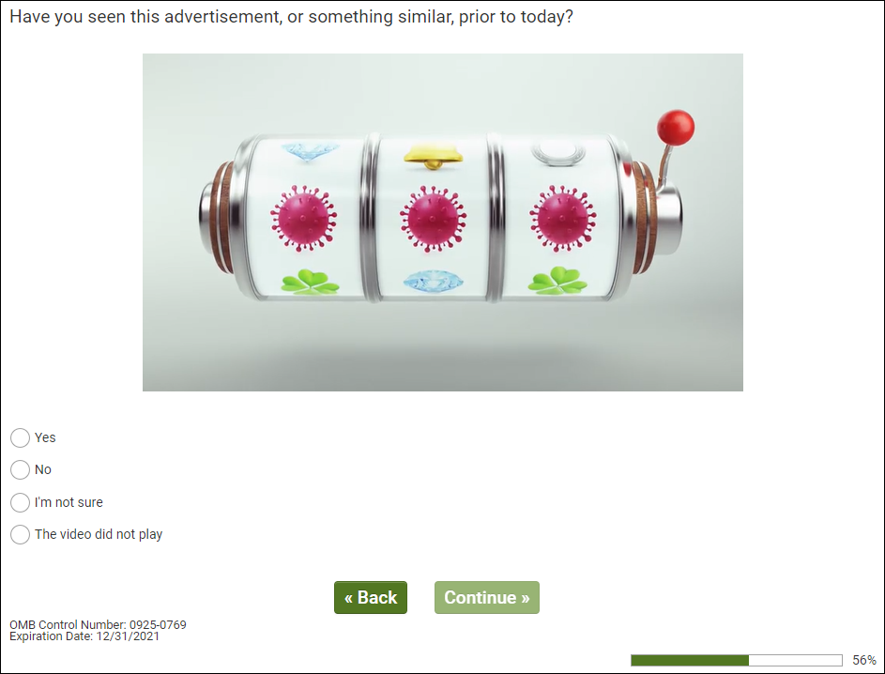
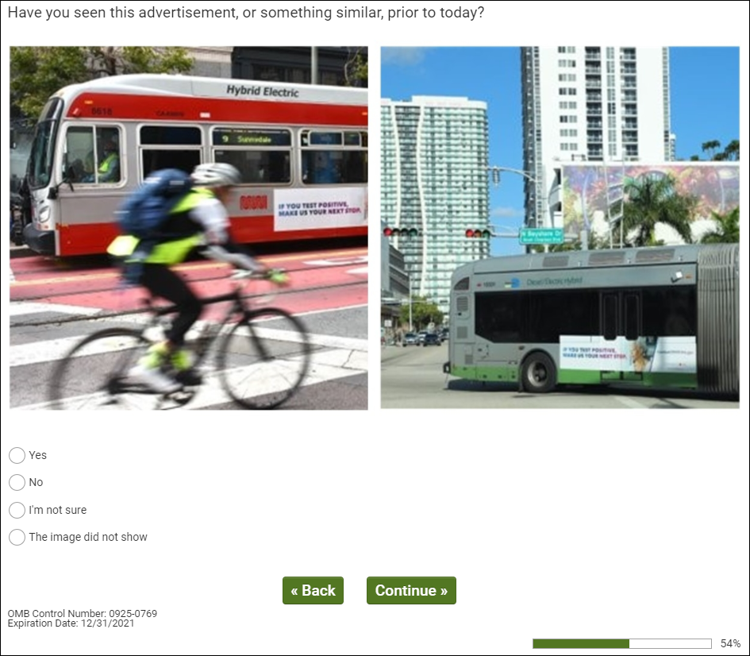
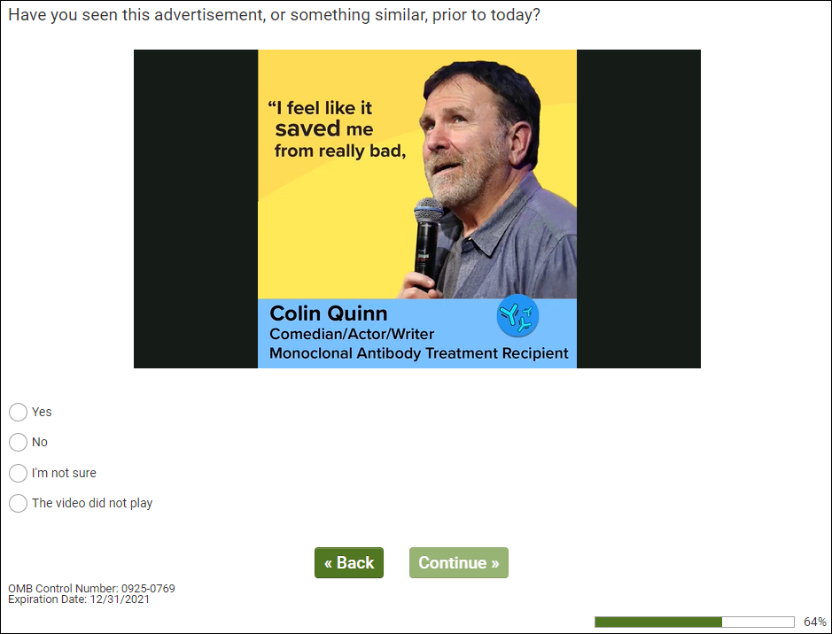
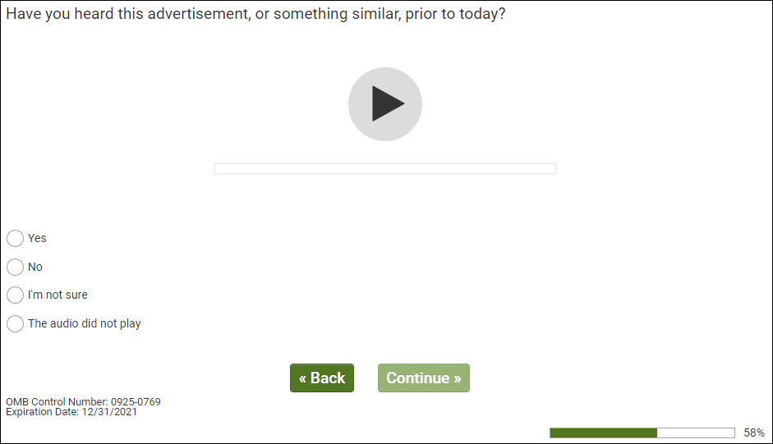
Q200a – HCPs ONLY 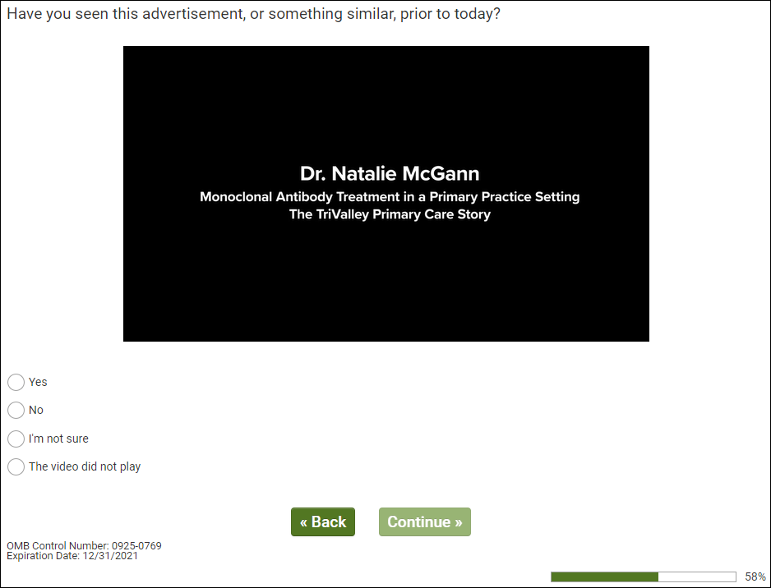
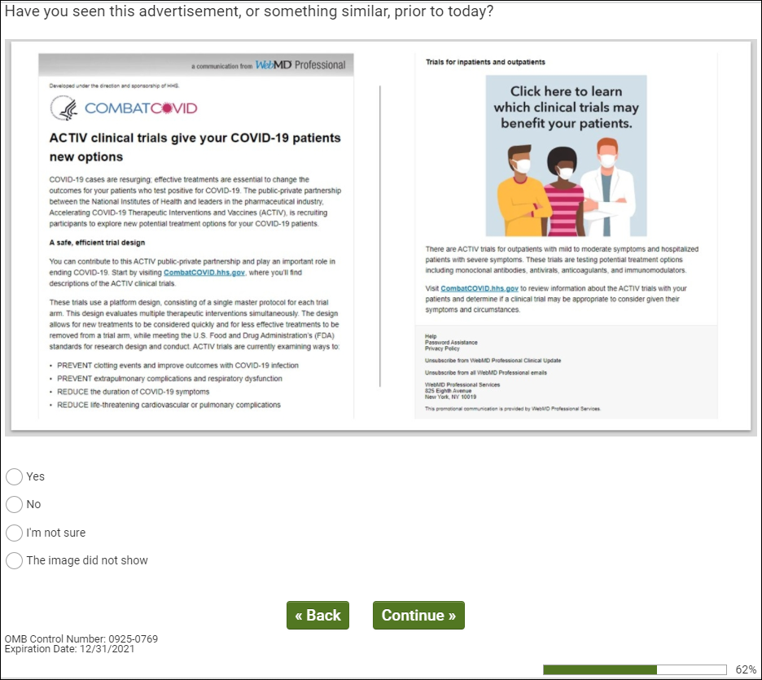
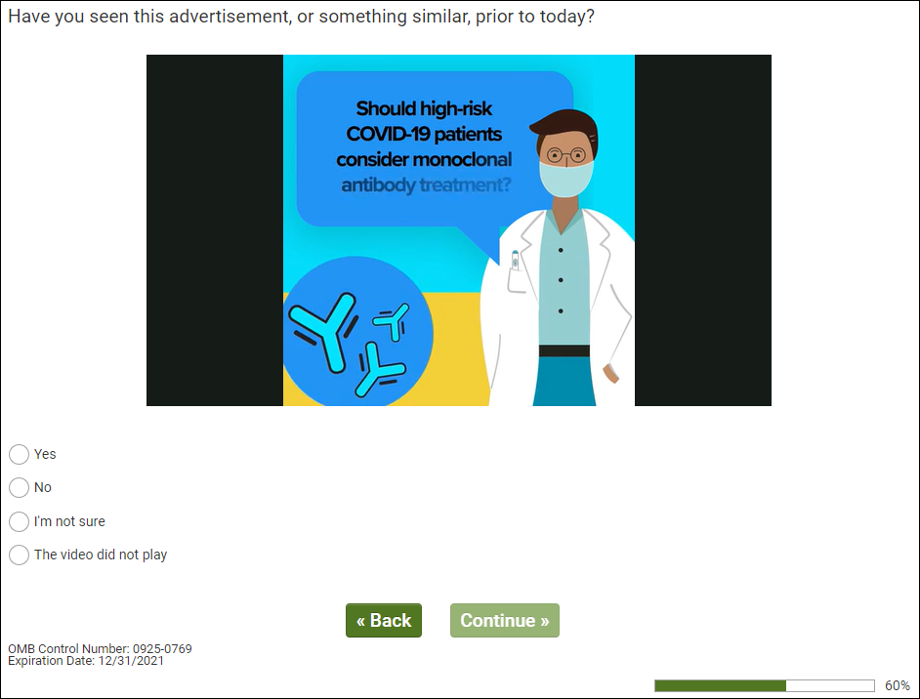
[ALL PROCEED TO Q201.]

Q201 - ALL RESPONDENTS
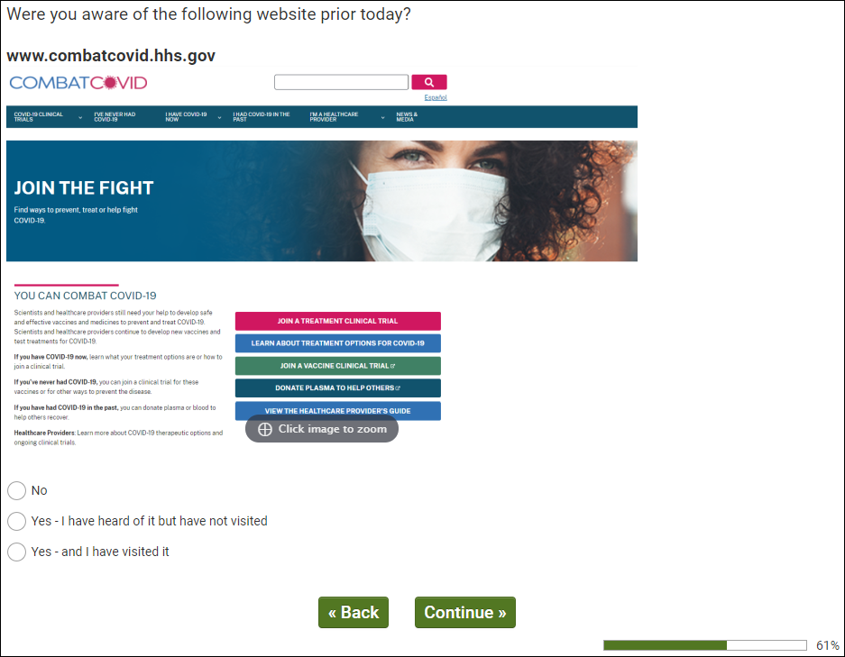
OMB Control Number: 0925-0769
Expiration Date: 12/31/2021

[IF Q201/1 PROCEED TO Q300.]
[IF Q201/2,3 PROCEED TO Q202.]

Q202 - AWARE OF WEBSITE (Q201/2,3)
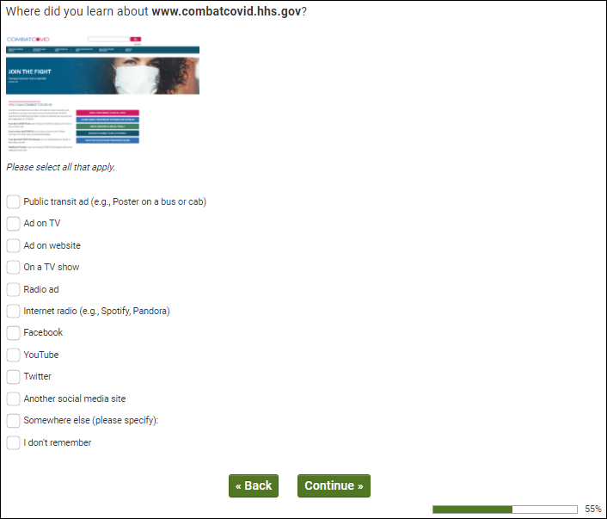
OMB Control Number: 0925-0769
Expiration Date: 12/31/2021

[PROCEED TO Q210.]

Q210 - HAVE VISITED SITE (Q201/3)
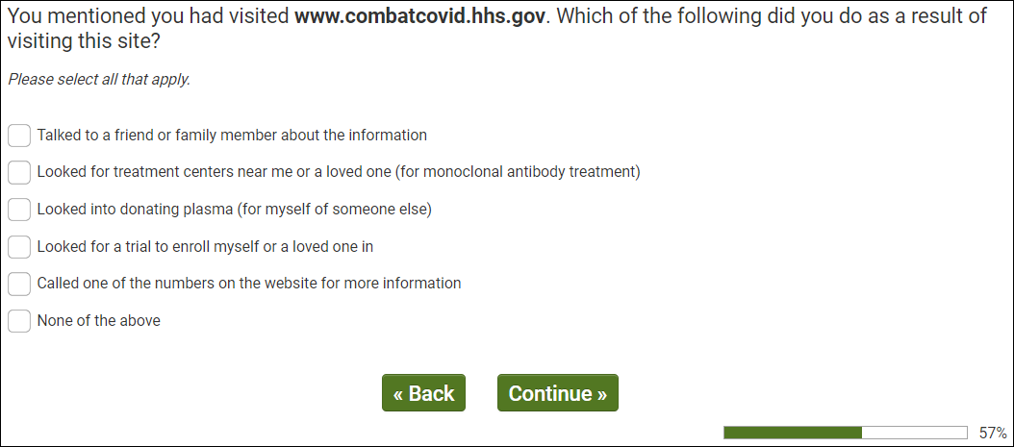
OMB Control Number: 0925-0769
Expiration Date: 12/31/2021

[PROCEED TO Q220.]

Q220 - EXPOSED TO CAMPAIGN (Q200/2 OR Q201/2,3 OR Q203/2,3 OR Q204/2)
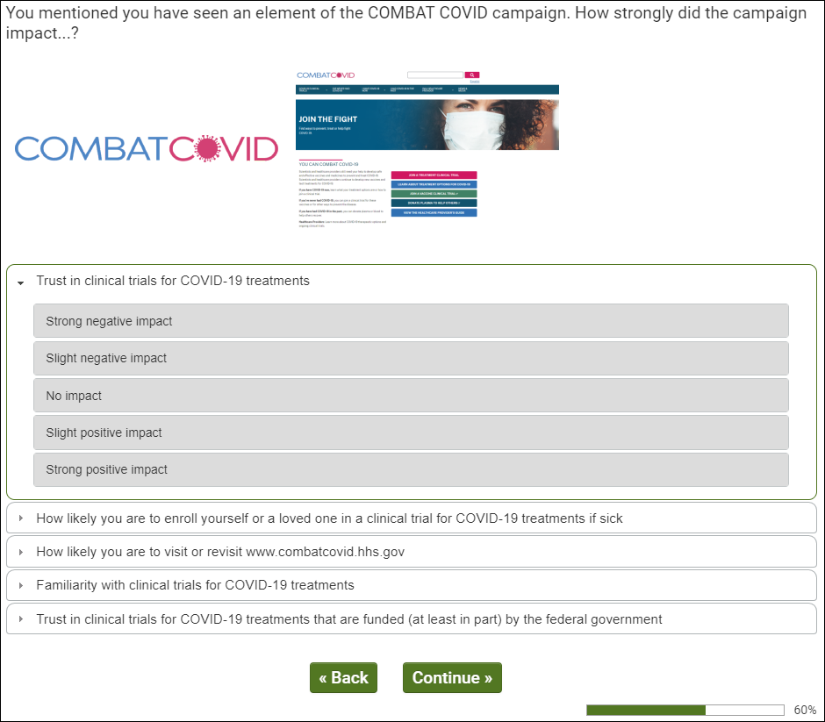
OMB Control Number: 0925-0769
Expiration Date: 12/31/2021

[IF CONSUMER (Q99/1) PROCEED TO Q300.]
[IF HCP (Q99/2) PRCOEED TO Q405.]

Q300 – CONSUMER SAMPLE (Q99/1)
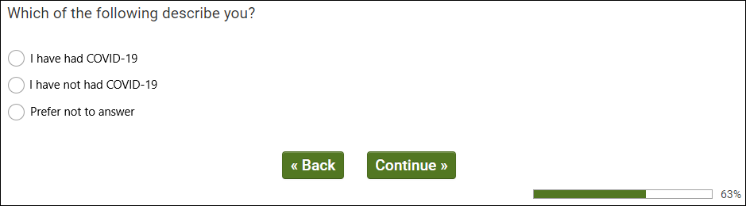
OMB Control Number: 0925-0769
Expiration Date: 12/31/2021

[IF Q300/1, PROCEED TO Q302.]
[IF Q300/2 OR Q300/3, PROCEED TO Q315.]
Q302 – CONSUMERS ONLY
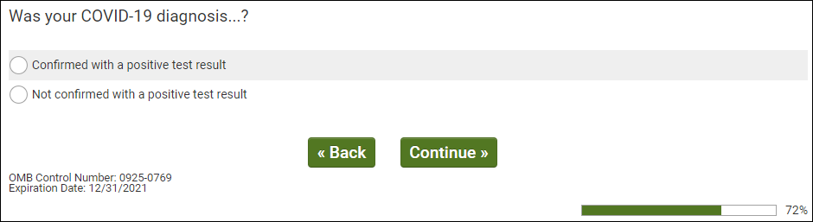
[ALL PROCEED TO Q303.]
Q303 – CONSUMERS ONLY
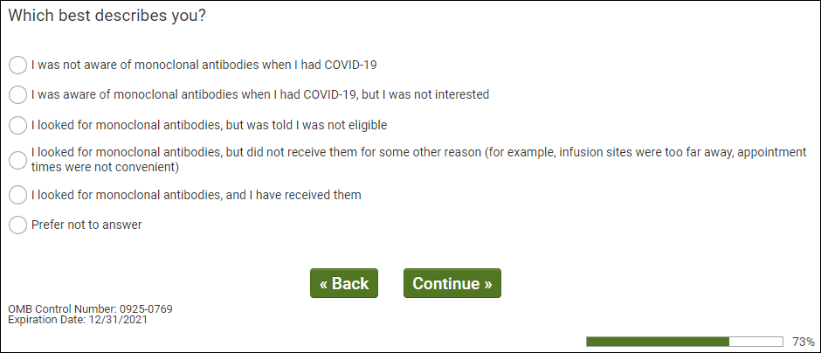
[ALL PROCEED TO Q315.]
Q315 – CONSUMER SAMPLE (Q99/1)
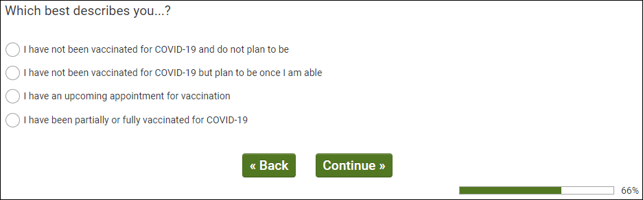
OMB Control Number: 0925-0769
Expiration Date: 12/31/2021

[ALL PROCEED TO Q322.]
Q322 – CONSUMER SAMPLE (Q99/1)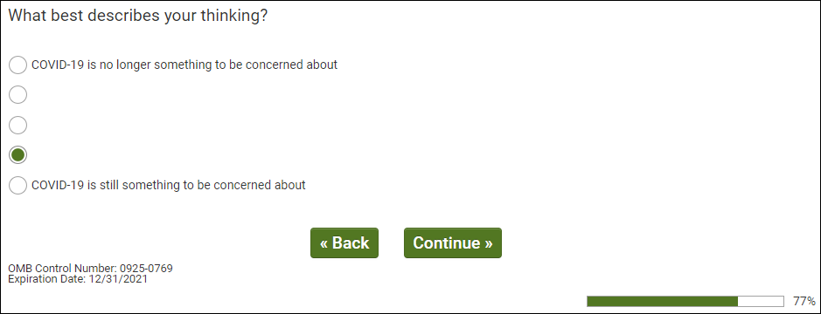
[ALL PRCOEED TO Q335.]

Q335 – CONSUMER SAMPLE (Q99/1)
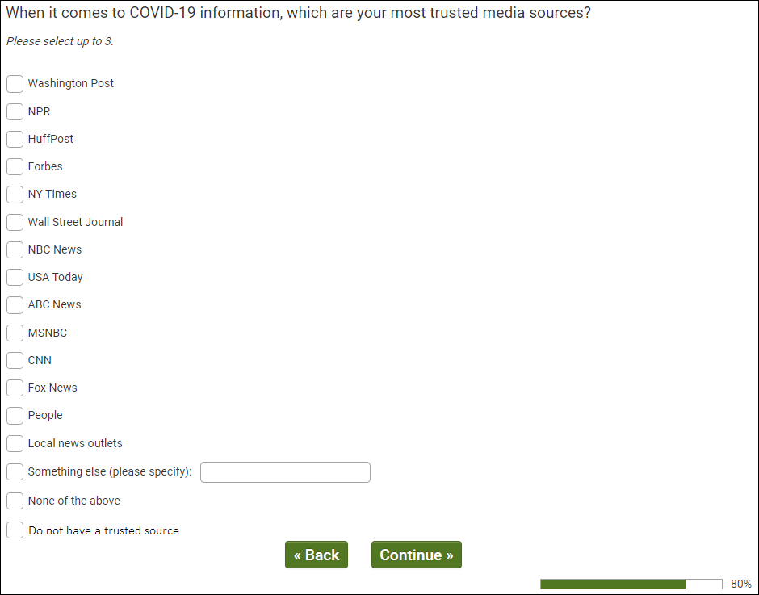
OMB Control Number: 0925-0769
Expiration Date: 12/31/2021

[ALL PROCEED TO Q340.]

Q340 – CONSUMER SAMPLE (Q99/1)
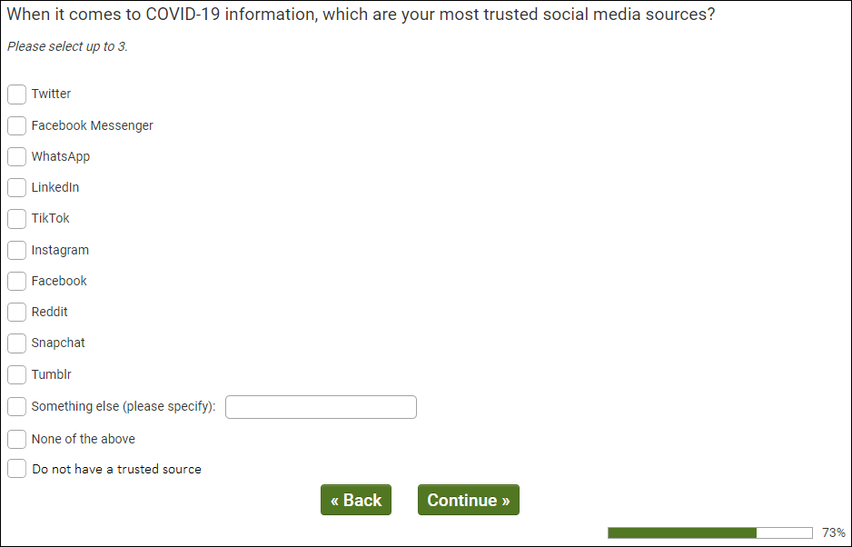
OMB Control Number: 0925-0769
Expiration Date: 12/31/2021

[ALL PROCEED TO dmStateUS.]

Q405 – HCP SAMPLE (Q99/2)
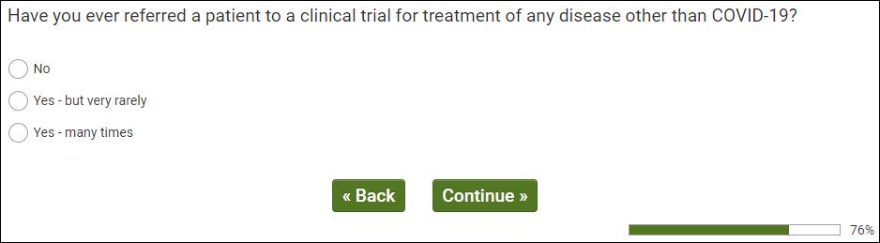
OMB Control Number: 0925-0769
Expiration Date: 12/31/2021

[ALL PROCEED TO Q407.]

Q407 – HCP SAMPLE (Q99/2)
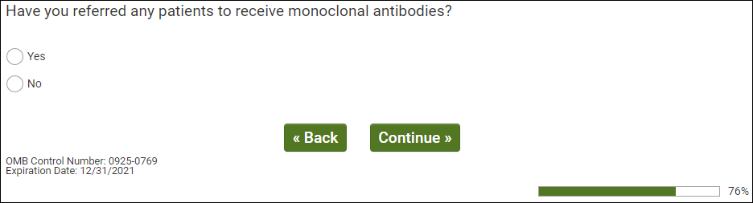
[ALL PROCEED TO Q407.]
Q408 - HCP SAMPLE (Q99/2)
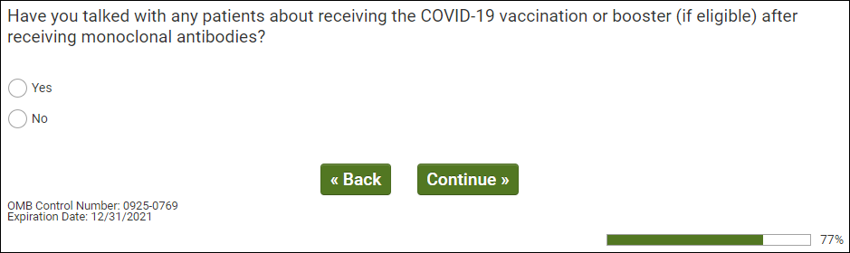
[ALL PROCEED TO Q410.]
Q410 – HCP SAMPLE (Q99/2)
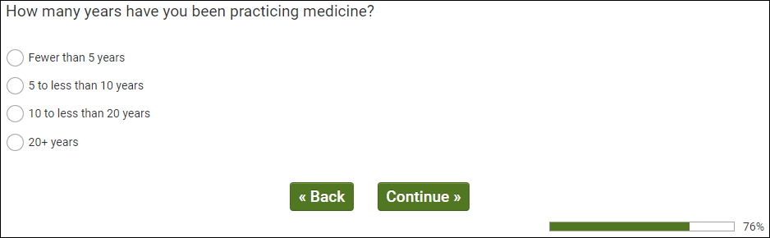
OMB Control Number: 0925-0769
Expiration Date: 12/31/2021

[ALL PROCEED TO Q415.]

Q415 – HCP SAMPLE (Q99/2)
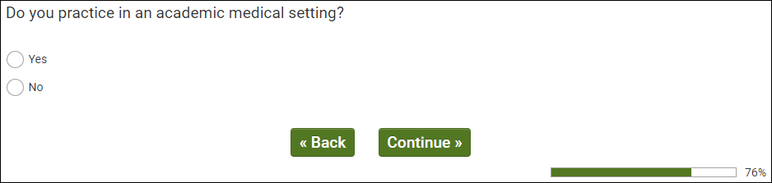
OMB Control Number: 0925-0769
Expiration Date: 12/31/2021

[ALL PROCEED TO Q420.]
Q420 – HCP SAMPLE (Q99/2)
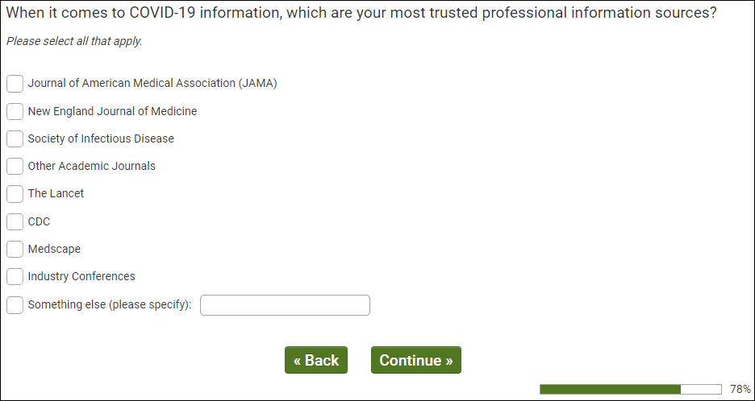
OMB Control Number: 0925-0769
Expiration Date: 12/31/2021

OMB Control Number: XXXX-XXXX
Expiration Date: XX/XX/XXXX
[ALL PROCEED TO dmStateUS.]

Real Answer Check – QUALITY CHECK
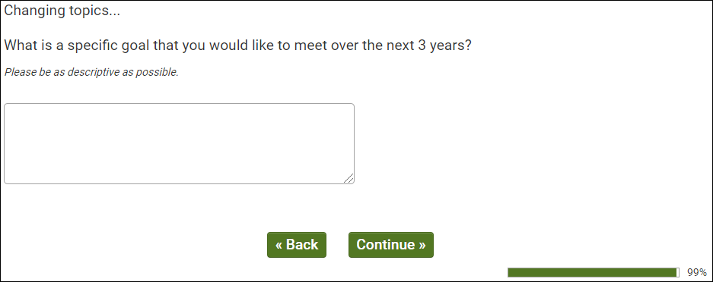
OMB Control Number: 0925-0769
Expiration Date: 12/31/2021

[REAL ANSWER CHECK INSERTED ACCORDING TO QUALITY CHECK LOGIC.]
ISQ Check – QUALITY CHECK
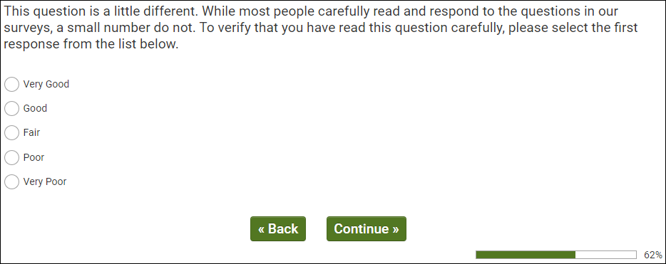
OMB Control Number: 0925-0769
Expiration Date: 12/31/2021

[ISQ CHECK INSERTED ACCORDING TO QUALITY CHECK LOGIC.]
dmStateUS – ALL RESPONDENTS
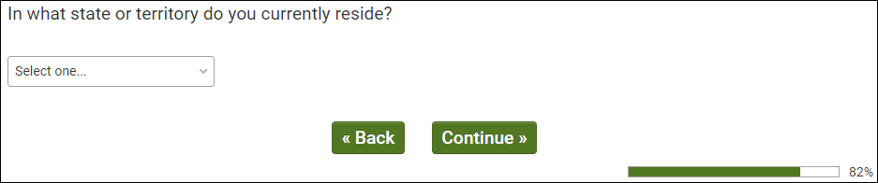
OMB Control Number: 0925-0769
Expiration Date: 12/31/2021

[PROCEED TO dmZipUS.]

dmZipUS – ALL RESPONDENTS
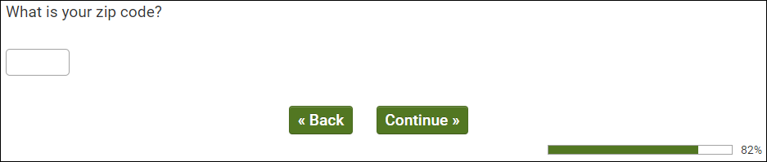
OMB Control Number: 0925-0769
Expiration Date: 12/31/2021

[PROCEED TO dmEduUS.]
dmEduUS – ALL RESPONDENTS
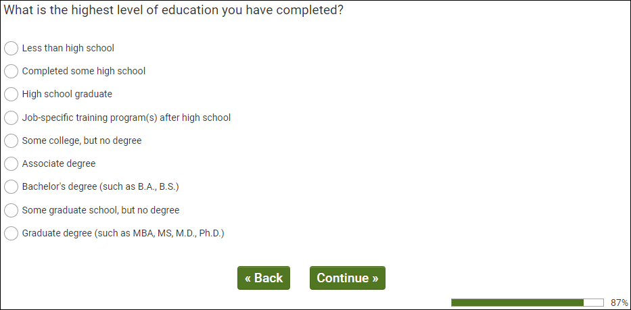
OMB Control Number: 0925-0769
Expiration Date: 12/31/2021

[PROCEED TO dmMarStat.]
dmMarStat – ALL RESPONDENTS
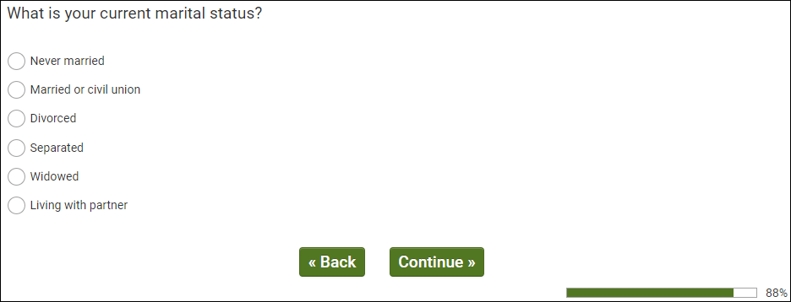
OMB Control Number: 0925-0769
Expiration Date: 12/31/2021

[PROCEED TO dmAdultHh.]
dmAdultHh – ALL RESPONDENTS
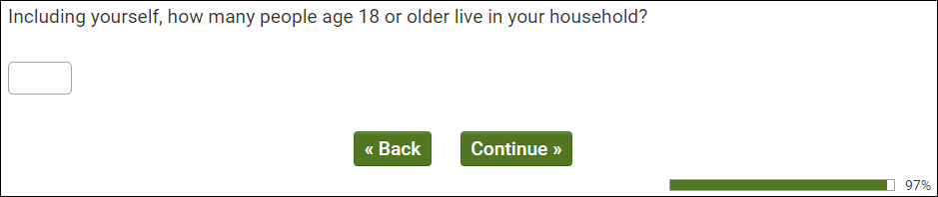
OMB Control Number: 0925-0769
Expiration Date: 12/31/2021

[PROCEED TO dmChildHh.]
dmChildHh – ALL RESPONDENTS
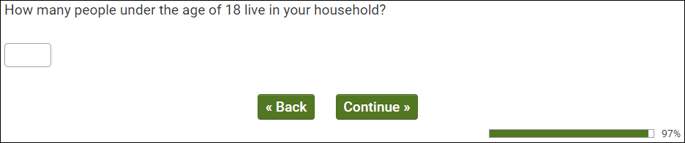
OMB Control Number: 0925-0769
Expiration Date: 12/31/2021

[PROCEED TO dmHhIncUS.]

dmHhIncUS – ALL RESPONDENTS
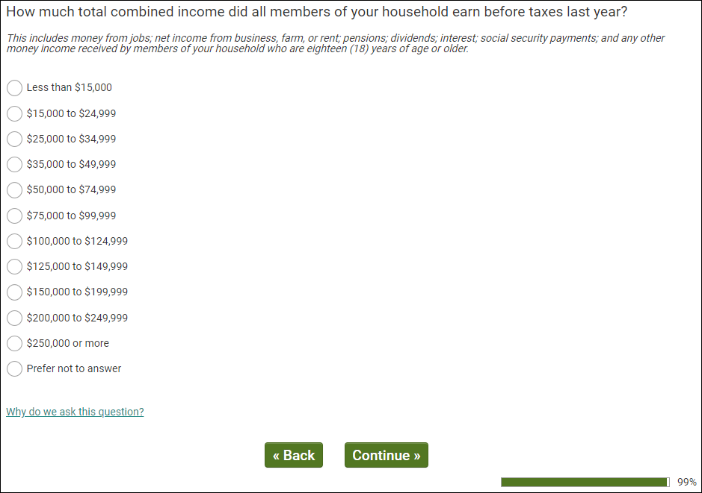
OMB Control Number: 0925-0769
Expiration Date: 12/31/2021

[PROCEED TO THANK YOU AND TERMINATE.]

