**EQRS Global App Log In Page:**

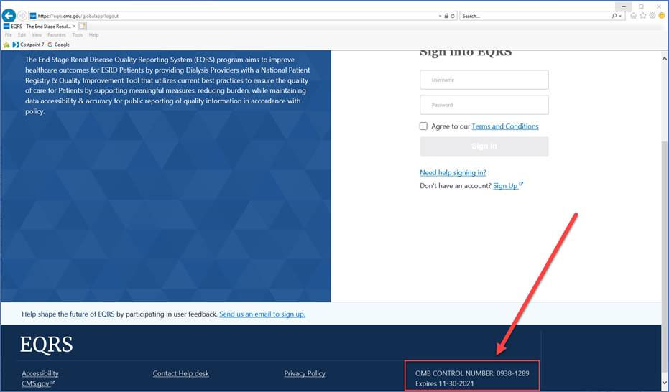

***Dashboard Page:***

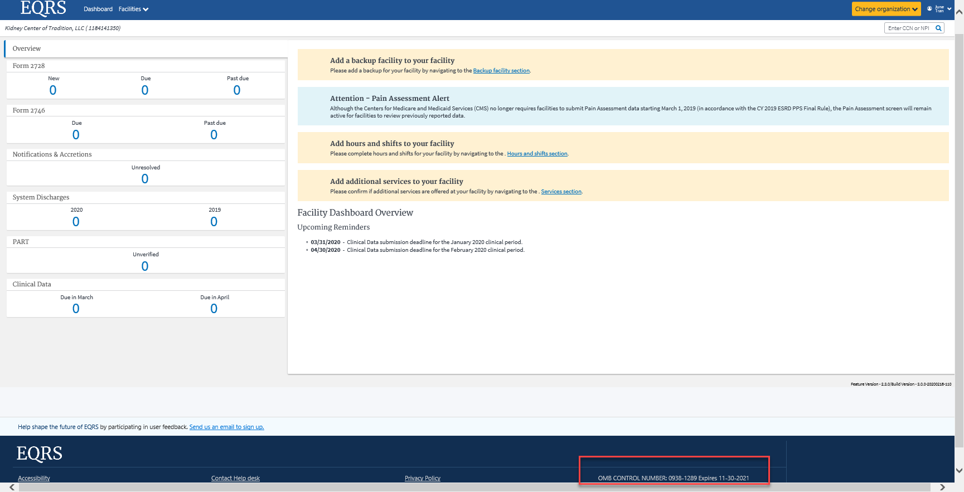

**Facility: Add a Facility Page:**

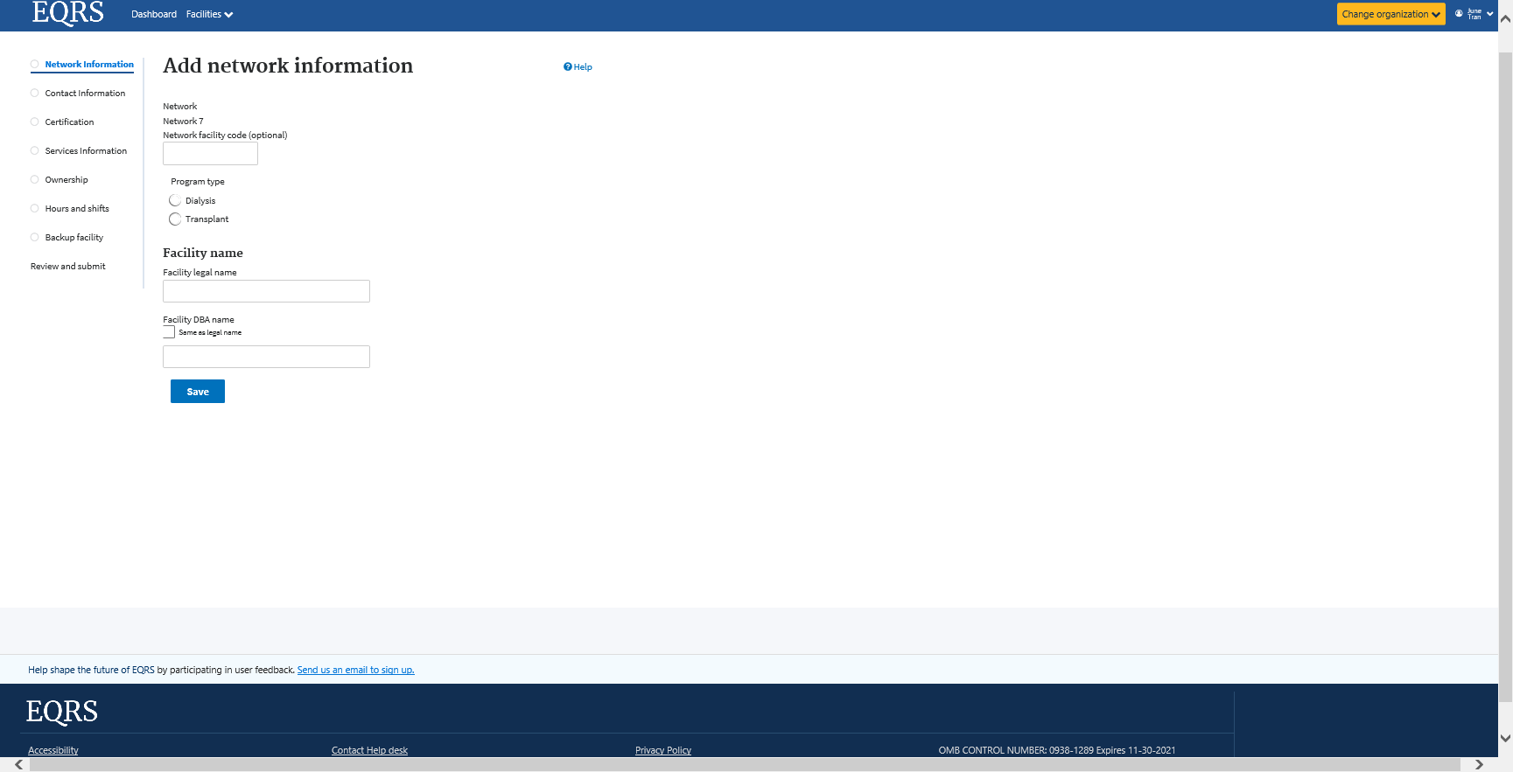

**Facility: Search for a Facility Page:**

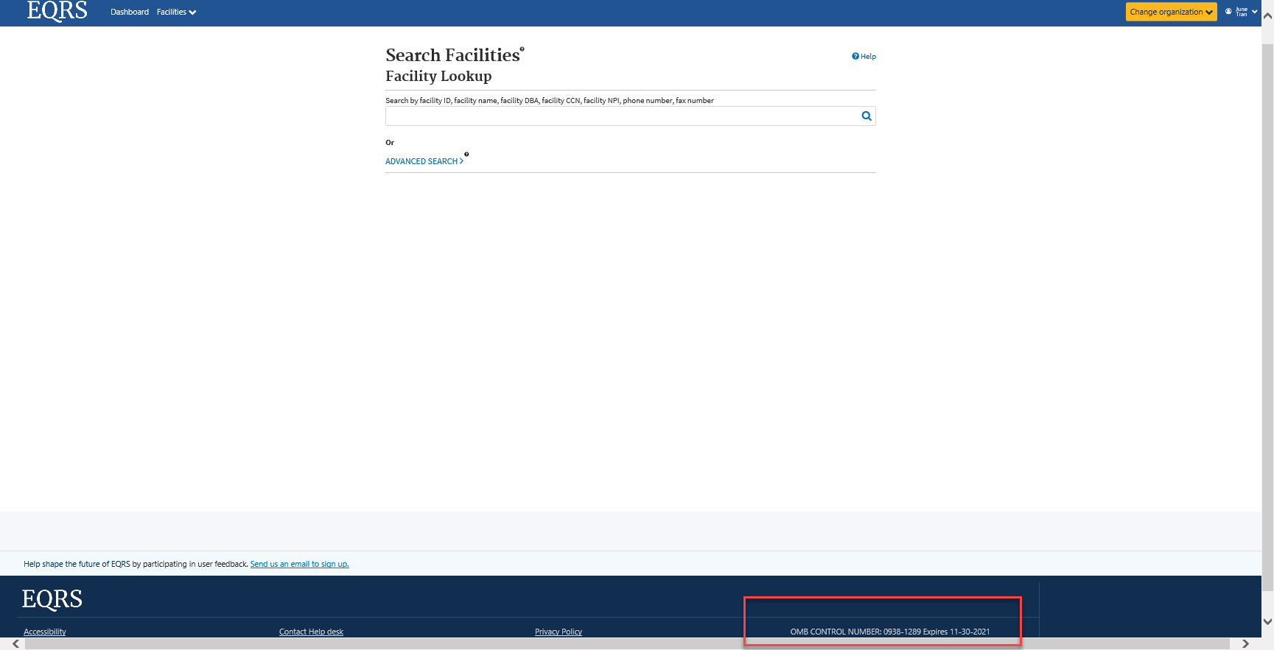

**Facility: Personnel Page:**

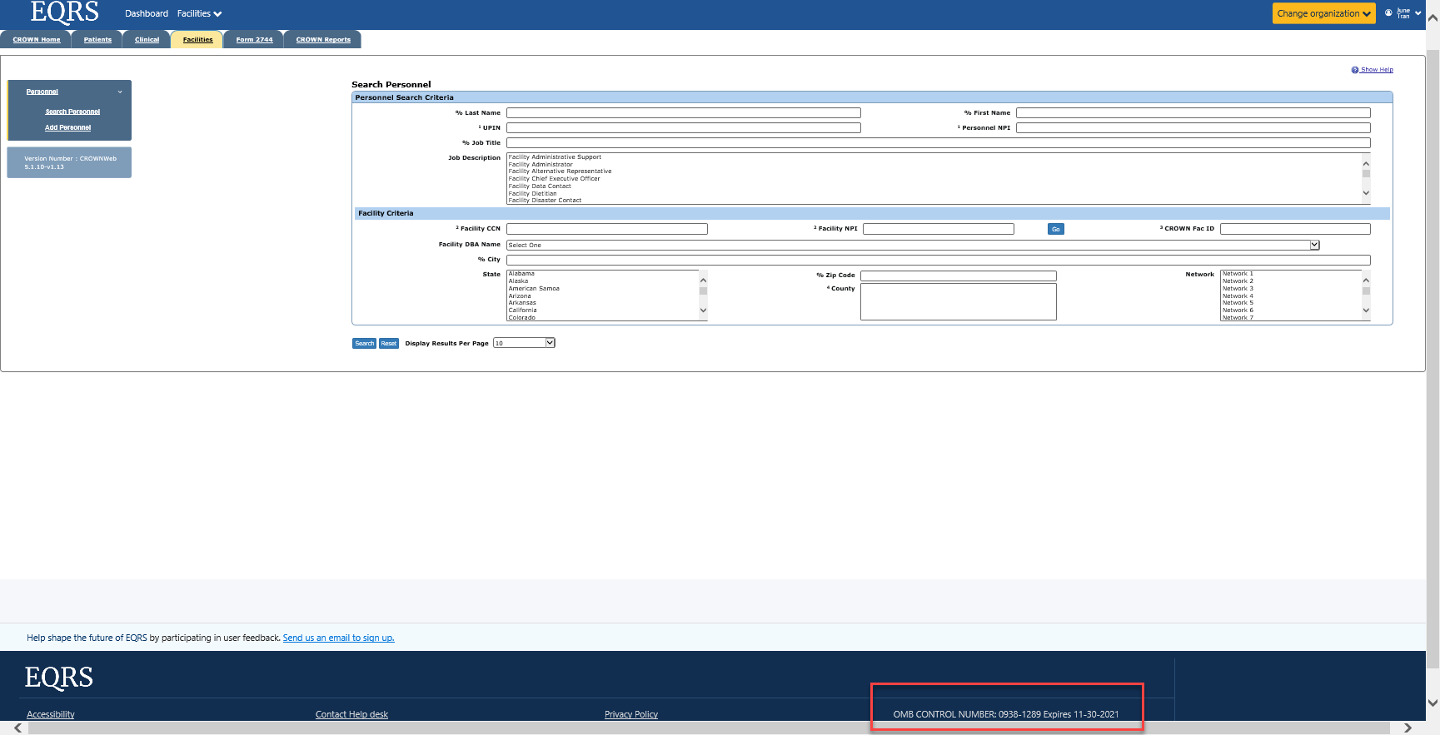

**CROWNWeb Home Module:**

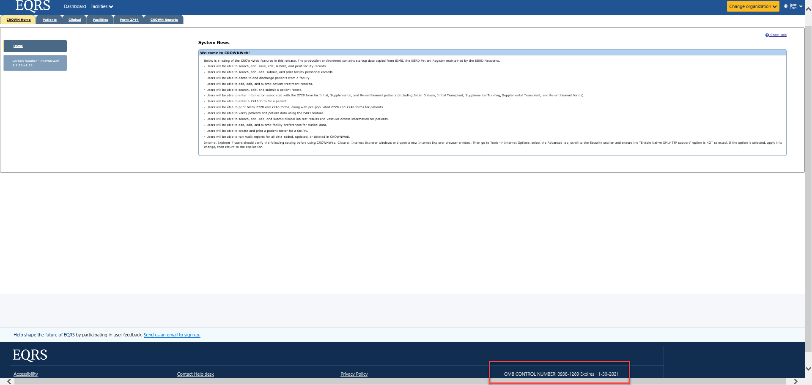

**CROWNWeb Patient Module:**

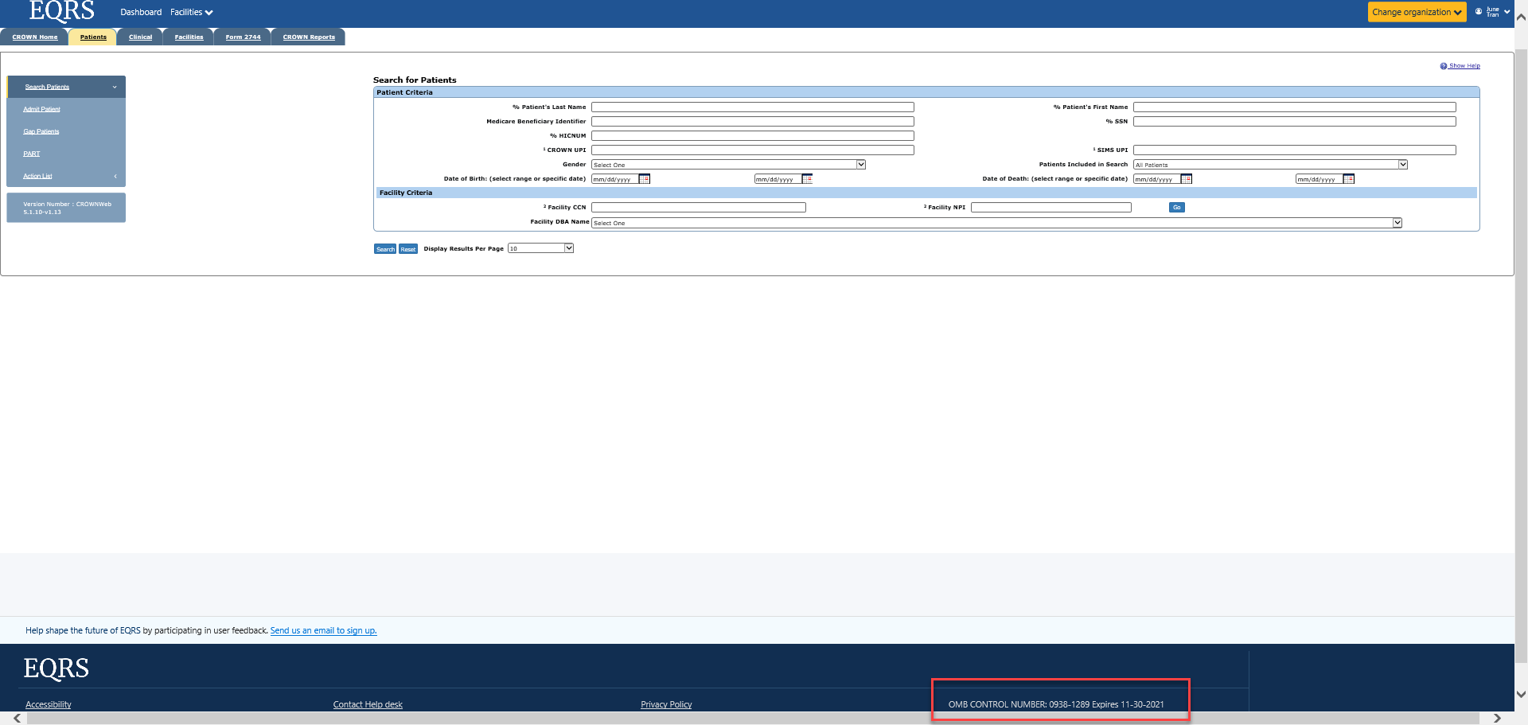

**CROWNWeb Clinical Module:**

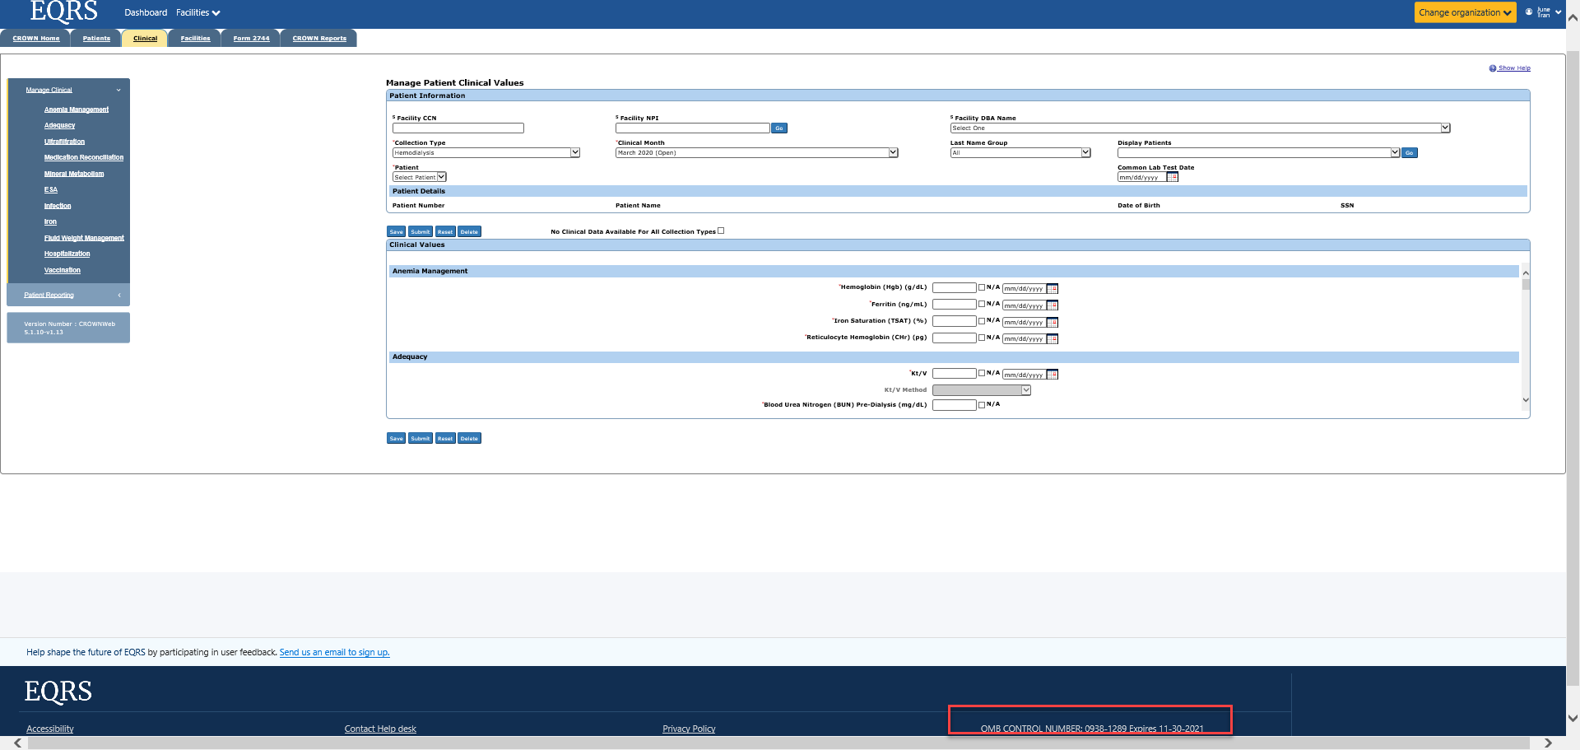

**CROWNWeb Form 2744 Module:**

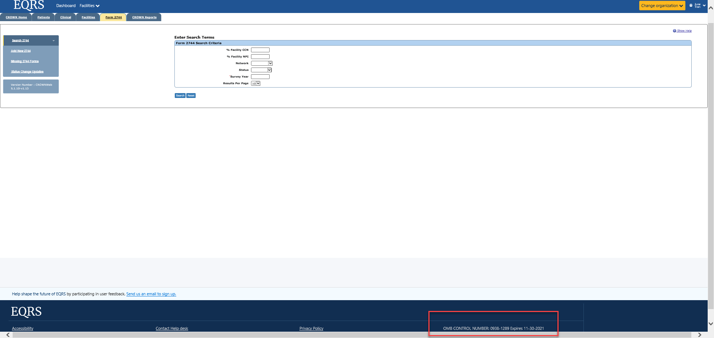

**CROWNWeb Reports Module:**

