Attachment G: COVID-19 Monthly Outcome Survey – Communications

Ipsos Survey Recruitment Email (English/Spanish)
Default Email Invitation and Reminder Text
Client Overview
Created January 2020

Introduction

This document contains the default text used in email invitations and reminders for KnowledgePanel members.

This text can be customized and modified as needed to fit the needs of the study.
Default English Email Invitation
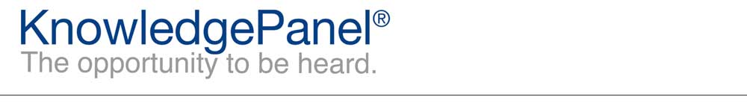

Dear %%firstname%%,
Thanks for being an integral part of KnowledgePanel! Your latest survey can be accessed by clicking the following link:
%%LINK%%
Depending on your email reader, you may need to copy and paste the link into your web browser.
Our Panel Member Support Center is available if you have questions or comments. You can contact us at our toll-free 1-800-782-6899 number, or simply reply to this email. In order to better serve you, please be sure to include reference %%ANO%% in the subject of your message. We are always happy to hear from you!
Thanks,
The KnowledgePanel Team

Participating in KnowledgePanel® gives you the unique opportunity to make your opinions heard among business and policy decision makers. You can express those opinions fully confident that KnowledgePanel is committed to safeguarding your privacy. We will never transfer your personally identifiable information (name, address, phone number) to users of our research without your consent, nor will we ever try to sell you anything.
If you have any questions about our Privacy Policy or practices, you can email us at privacy@knowledgepanel.com.
If you believe you have received this email in error or prefer to opt out from receiving our emails, send a message to KnowledgePanel support at support@knowledgepanel.com or call us toll free at 1-800-782-6899.
© 2020 Ipsos | Panel Relations
1 Upper Pond Rd #D-2, Parsippany, NJ 07054

Default Spanish Email Invitation
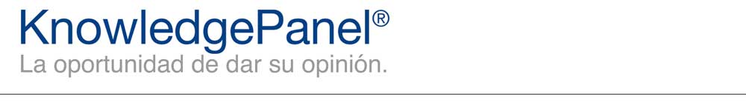

Estimado(a) %%firstname%%,
¡Gracias por ser parte del KnowledgePanel! Usted puede acceder a su encuesta más reciente haciendo clic en el enlace a continuación:
%%LINK%%
Dependiendo de su lector de correo electrónico, pueda ser que usted necesite copiar y pegar el enlace en su navegador de internet.
Nuestro Centro de Asistencia Técnica para Afiliados al Panel está disponible en caso de que usted tenga alguna pregunta o comentario. Nos puede contactar gratis llamándonos al 1-800-782-6899, o simplemente respondiendo a este mensaje de correo electrónico. Para poder servirle mejor, por favor asegúrese de incluir el número de referencia %%ANO%% en el asunto de su mensaje. ¡Nosotros siempre estamos encantados en saber de usted!
Gracias,
El equipo de KnowledgePanel

El participar en KnowledgePanel® le da la oportunidad única de hacer que las personas encargadas de tomar decisiones en empresas y políticas, escuchen sus opiniones. Usted puede expresar sus opiniones con la plena seguridad que KnowledgePanel se compromete a proteger su privacidad. Nosotros nunca compartiremos su información personal identificable (nombre, dirección, número telefónico) con ningún usuario de nuestros estudios, sin su consentimiento y tampoco nunca trataremos de venderle nada.
Si usted tiene alguna pregunta acerca de nuestra política de privacidad o nuestras prácticas, usted puede enviarnos un correo electrónico a privacy@knowledgepanel.com.
Si usted cree que ha recibido este correo electrónico por error o prefiere optar por no recibir nuestros correos electrónicos, envié un mensaje al equipo de Asistencia de KnowledgePanel a ayudatecnica@knowledgepanel.com o llámenos gratis al 1-800-782-6899.
© 2020 Ipsos | Panel Relations
1 Upper Pond Rd #D-2, Parsippany, NJ 07054

Default English Email Reminder
Dear %%firstname%%,
We recently sent you a survey. We'd appreciate you taking it at your earliest convenience by using the link below. If you have already completed the survey, thank you and please disregard this email.
%%LINK%%
Depending on your email reader, you may need to copy and paste the link into your web browser.
Thanks,
The KnowledgePanel Team

Participating in KnowledgePanel® gives you the unique opportunity to make your opinions heard among business and policy decision makers. You can express those opinions fully confident that KnowledgePanel is committed to safeguarding your privacy. We will never transfer your personally identifiable information (name, address, phone number) to users of our research without your consent, nor will we ever try to sell you anything.
If you have any questions about our Privacy Policy or practices, you can email us at privacy@knowledgepanel.com.
If you believe you have received this email in error or prefer to opt out from receiving our emails, send a message to KnowledgePanel support at support@knowledgepanel.com or call us toll free at 1-800-782-6899.
© 2020 Ipsos | Panel Relations
1 Upper Pond Rd #D-2, Parsippany, NJ 07054

Default Spanish Email Reminder
Estimado(a) %%firstname%%,
Recientemente le enviamos una encuesta. Nosotros le agradeceríamos que la contestara tan pronto como le sea posible, utilizando el enlace de abajo. Si usted ya ha completado la encuesta, gracias y por favor ignore este correo electrónico.
%%LINK%%
Dependiendo de su lector de correo electrónico, pueda ser que usted necesite copiar y pegar el enlace en su navegador de internet.
Gracias,
El equipo de KnowledgePanel

El participar en KnowledgePanel® le da la oportunidad única de hacer que las personas encargadas de tomar decisiones en empresas y políticas, escuchen sus opiniones. Usted puede expresar sus opiniones con la plena seguridad que KnowledgePanel se compromete a proteger su privacidad. Nosotros nunca compartiremos su información personal identificable (nombre, dirección, número telefónico) con ningún usuario de nuestros estudios, sin su consentimiento y tampoco nunca trataremos de venderle nada.
Si usted tiene alguna pregunta acerca de nuestra política de privacidad o nuestras prácticas, usted puede enviarnos un correo electrónico a privacy@knowledgepanel.com.
Si usted cree que ha recibido este correo electrónico por error o prefiere optar por no recibir nuestros correos electrónicos, envié un mensaje al equipo de Asistencia de KnowledgePanel a ayudatecnica@knowledgepanel.com o llámenos gratis al 1-800-782-6899.
© 2020 Ipsos | Panel Relations
1 Upper Pond Rd #D-2, Parsippany, NJ 07054

