**`Date**: November 5, 2021

**MEMORANDUM**

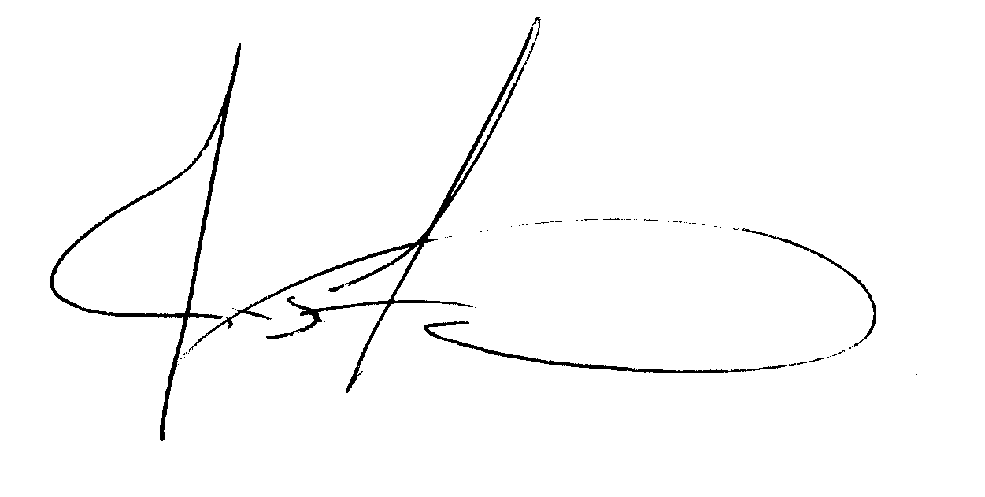**From**: James S. Fredrick, Deputy Assistant Secretary of Labor

for Occupational Safety and Health Administration

**To**: Stephanie Block, Associate Administrator Office of Information and Regulatory Affairs

**Subject**: Request for Emergency Review and Clearance of Information Collections in OSHA’s Emergency Temporary Standard for COVID-19 Vaccinations, Testing, and Face Coverings (29 CFR 1910.501)

**______________________________________________________________________________**

Pursuant to Office of Management and Budget (OMB) procedures established at 5 C.F.R. Part 1320, Controlling Paperwork Burdens on the Public, OSHA is requesting emergency clearance for the proposed information collections under the OSHA Emergency Temporary Standard (ETS) for COVID-19 Vaccinations, Testing, and Face Coverings (29 CFR 1910.501, Subpart U)**.**  The Emergency Clearance Request will be processed in accordance with 5 C.F.R. § 320.13.

The Occupational Safety and Health Act of 1970 (OSH Act) requires OSHA to issue an ETS if the agency determines that “employees are exposed to grave danger from exposure to substances or agents determined to be toxic or physically harmful or from new hazards,” and an ETS is “necessary to protect employees from such danger.” 29 U.S.C. § 655(c). OSHA may issue the ETS without regard to the notice-and-comment requirements of the Administrative Procedures Act and any such ETS shall be effective “[u]pon publication” in the Federal Register. See id.

On September 9, 2021, President Biden issued a plan under Executive Order 13999, to help lead the nation out of the COVID-19 pandemic in which directed OSHA to develop a new ETS to protect employers with 100 or more employees. OSHA is issuing an ETS for vaccinations, testing, and face covering pursuant to the President’s Order that will include collections of information subject to OMB review under the Paperwork Reduction Act (PRA), 44 U.S.C. § 3501 et seq. The agency has determined that this collection of information must be collected prior to the time periods established under 5 C.F.R. Part 1320 and that this collection of information is essential to OSHA’s mission of protecting the health and safety of workers affected by the COVID-19 pandemic.

Given the urgent need to promulgate a standard to address the current crisis as quickly as possible, OSHA cannot reasonably comply with the PRA’s normal clearance procedures prior to publishing the ETS. To do so would delay the issuance of this emergency standard, resulting in serious public harm.

Pursuant to 5 C.F.R. § 1320.13, OSHA requests a 180-day emergency clearance of the information collection requirements in the ETS for vaccination and testing. OSHA requests that OMB approve the information collection by November 5, 2021 and waive publication of the 60-day and 30-day Federal Register notices, as permitted under 5 C.F.R. § 1320.13.

If you have any questions, please contact Maureen Ruskin at Ruskin.Maureen@dol.gov or by phone at 202-693-1950.