U.S. Bureau of Labor Statistics
International Price Program
Import/Export Price Survey website

Server Maintenance message
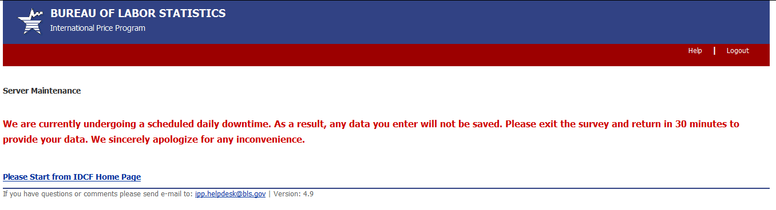

Downtime message
