U.S. Bureau of Labor Statistics
IDCF Web Lite 1.0

Login page
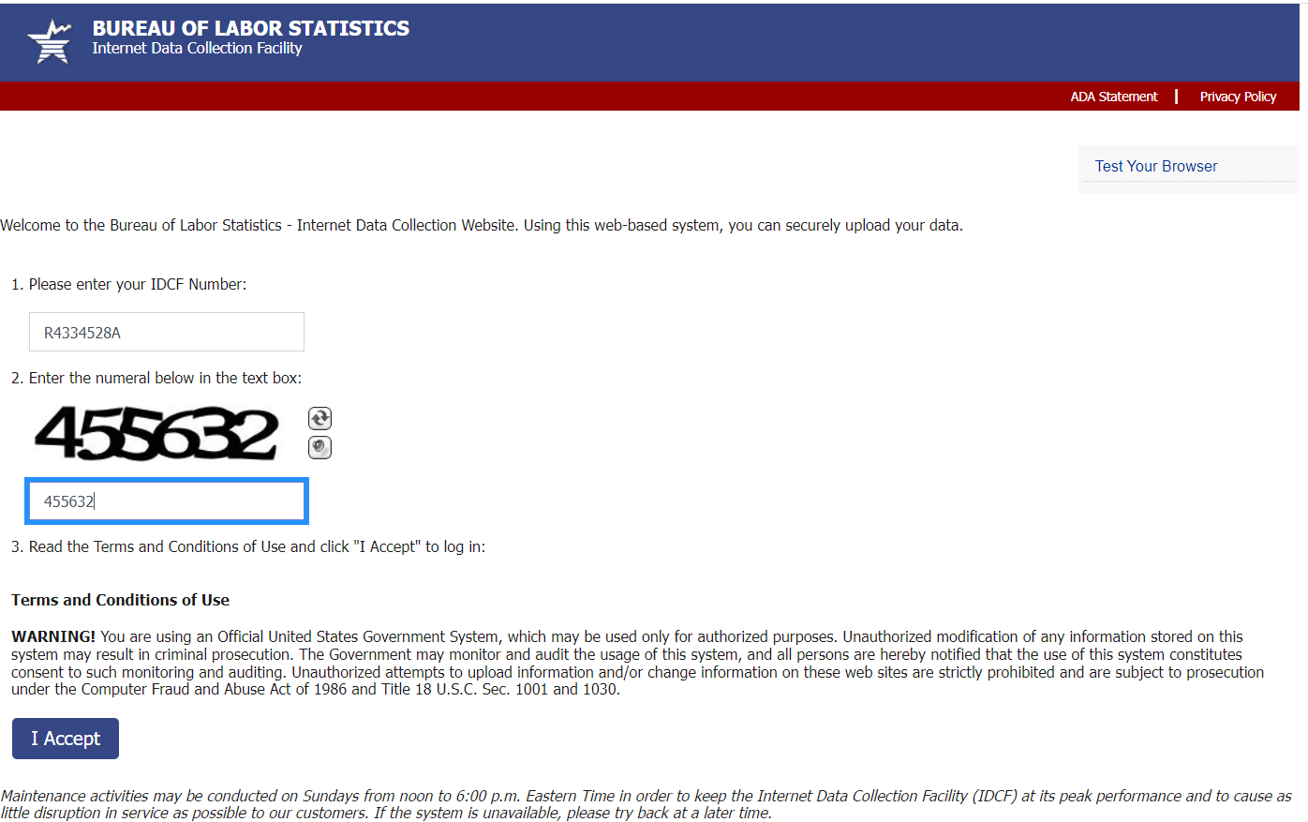

Welcome Screen
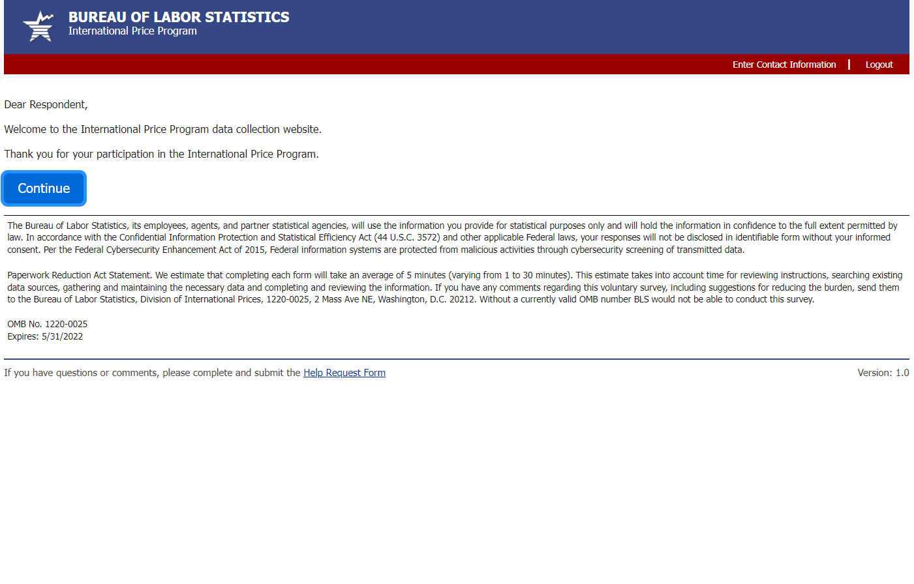

File upload screen
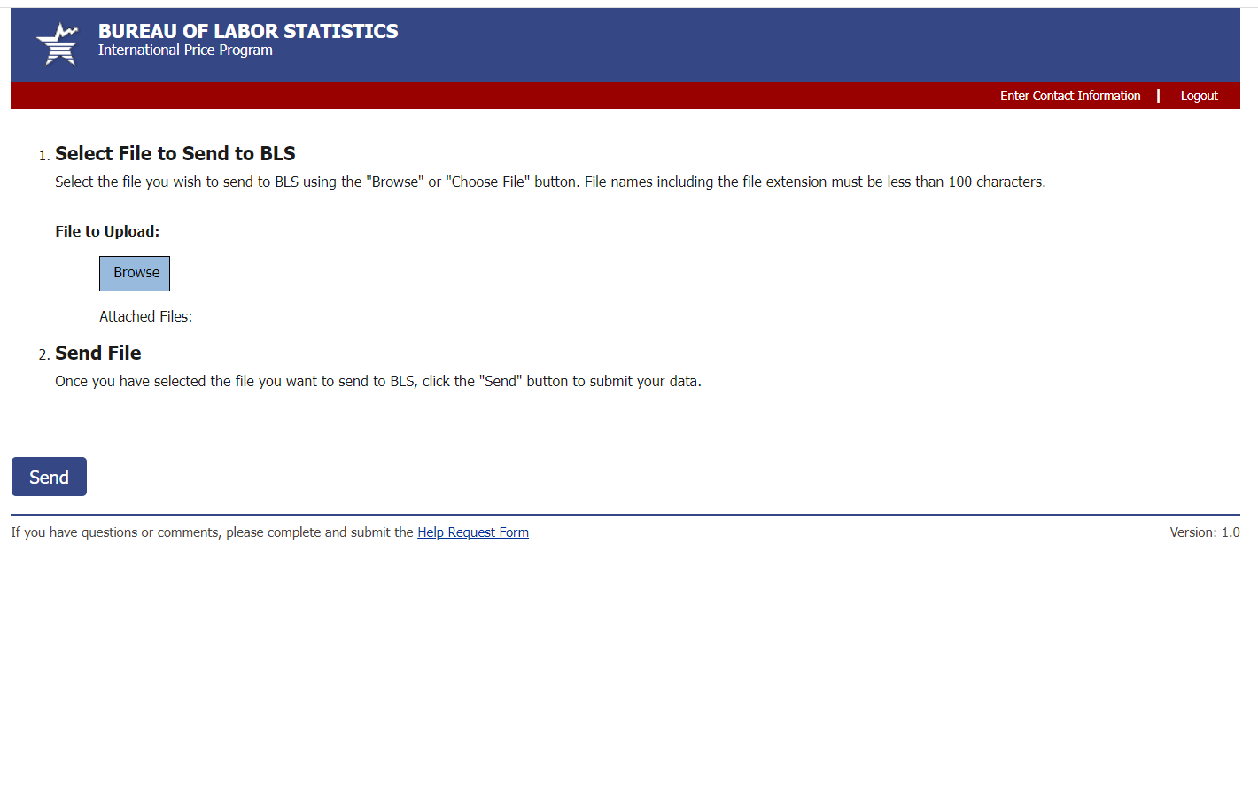
Select the file to upload
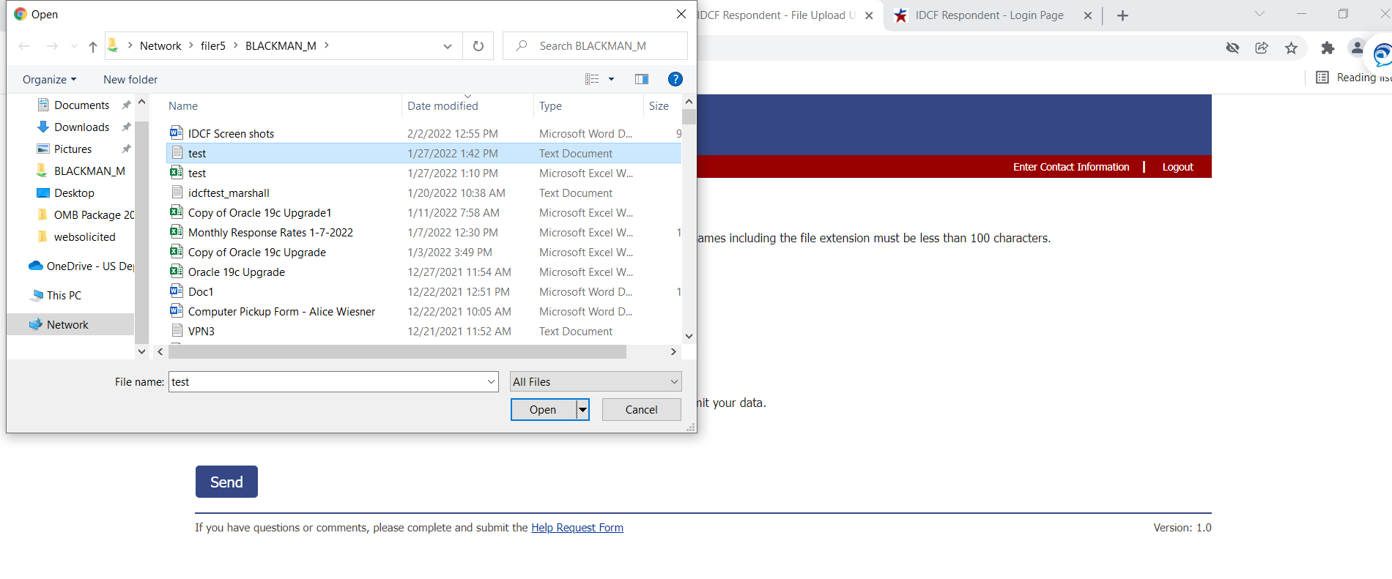

Attach the file
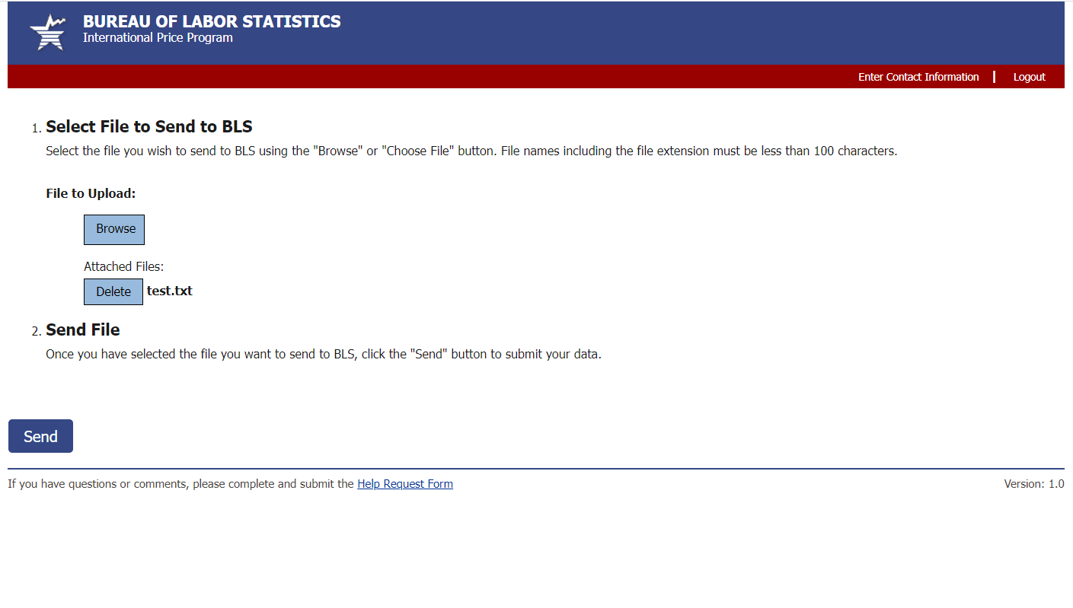
Send the file to the share

Thank you Screen
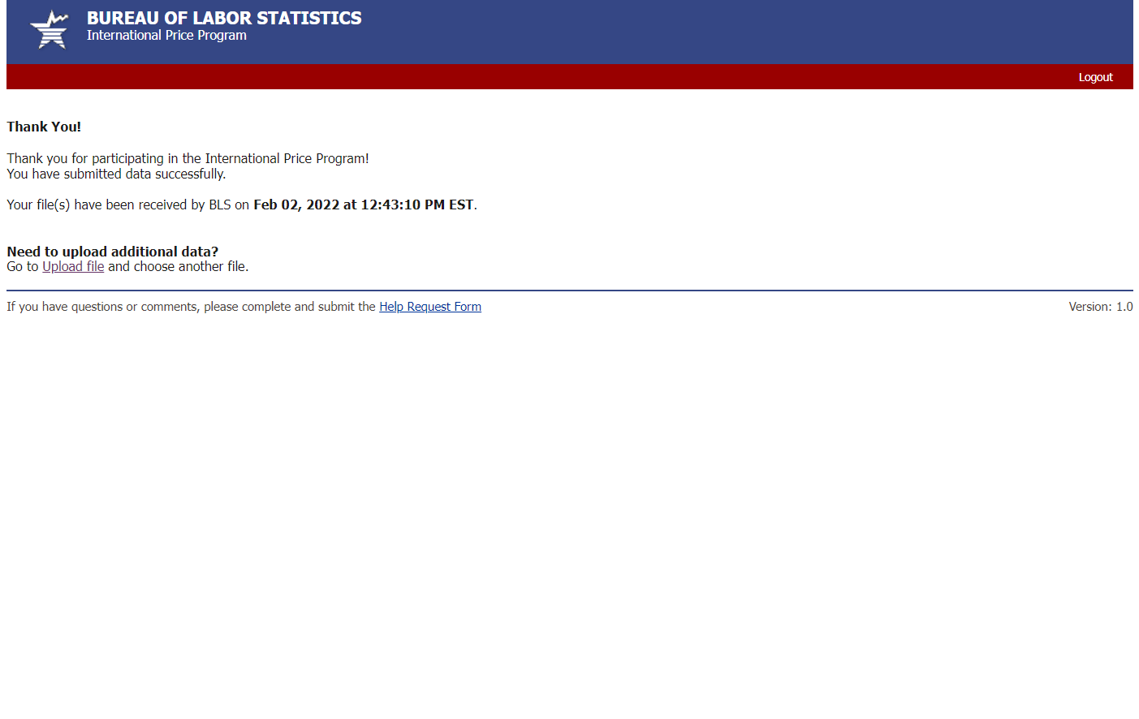

Dear NAME,

Thank you for agreeing to provide price information for the U.S. Import and Export Price Indexes, one of the nation’s principal federal economic indicators. To upload your Import and/or Export Price electronic file through the U.S. Bureau of Labor Statistics’ secure internet data collection facility (IDCF), follow the steps below.

To upload your file, go to: IDCF Web Lite 1.0 Production Link

Enter your IDCF Number: R1234567

Respond to security prompt (Captcha)

If you have any questions, please reply to this email.
Importance of Your Participation:
"As a Bureau of Labor Statistics survey participant, you help enhance our understanding of the increasingly complex U.S. economy. The more we understand, the better we are able to fulfill our mission and promote the prosperity of American workers, consumers, and businesses. When you agree to participate in a Bureau of Labor Statistics survey, you help provide the vital statistics we use to analyze our economy and keep it strong. For that, I thank you."
-Jerome Powell, Chairman, Federal Reserve Board of Governors

Thank you for your participation.
Analyst Signature

