OMB No. 1513–0040, Application for Operating Permit under 26 U.S.C. 5171(d), is included within the Distilled Spirits Plant Application portion of TTB’s “Permits Online” system (PONL) at https://www.ttbonline.gov/permitsonline/. This PONL application is equivalent to form TTB F 5110.25. Screen shots for the Distilled Spirits Plant Operating Permit Application follow:
PONL Log-in Screen:

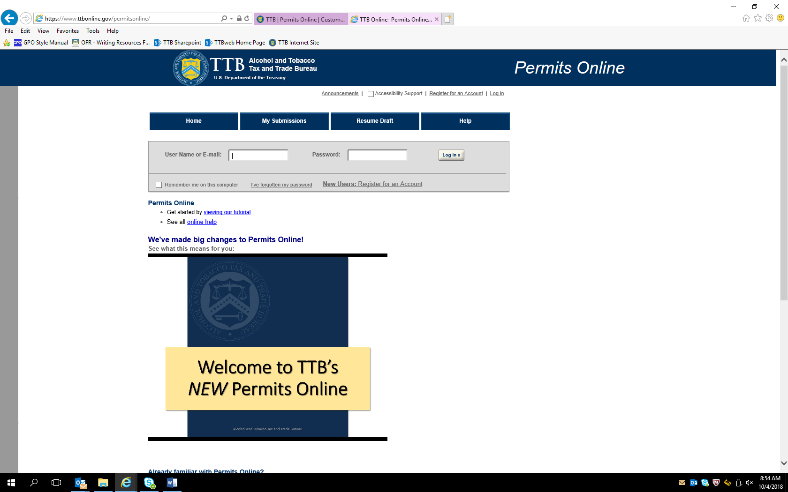

PONL Log-in Screen (continued):

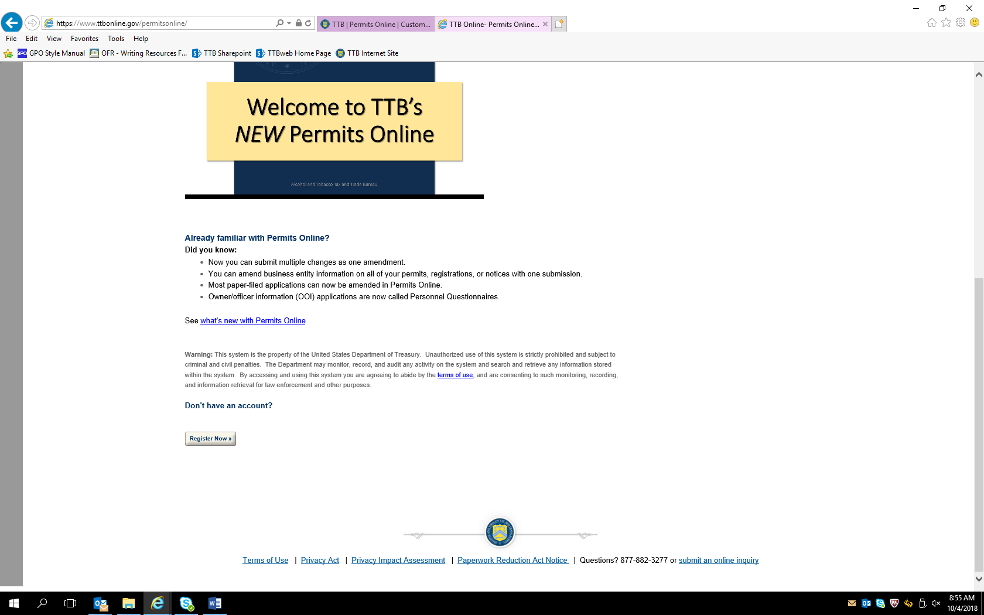

Screen shown after successful log-in:

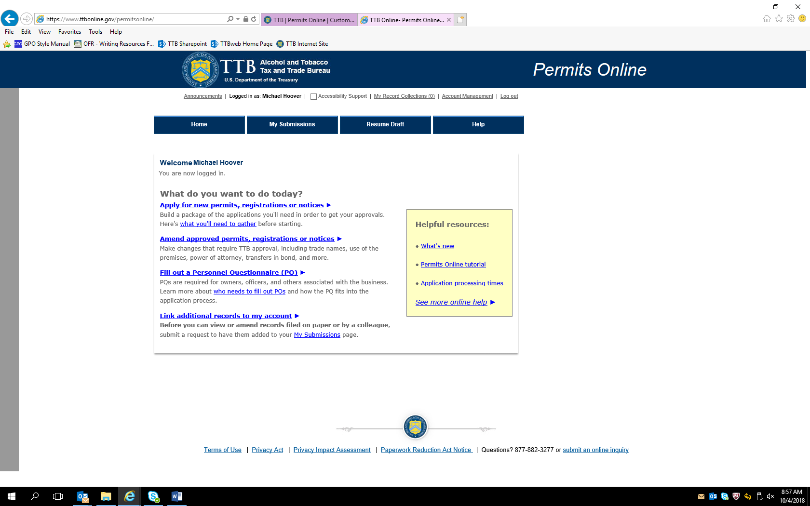

After clicking appropriate “What do you want to do today?” link, the Penalty of Perjury screen appears:

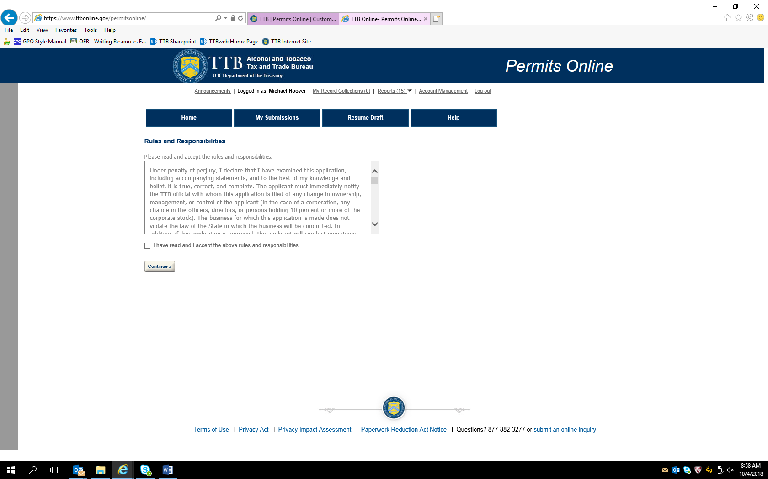

After accepting perjury statement, the New Applications wizard screen appears. The Application Contact information auto fills from PONL registration information:

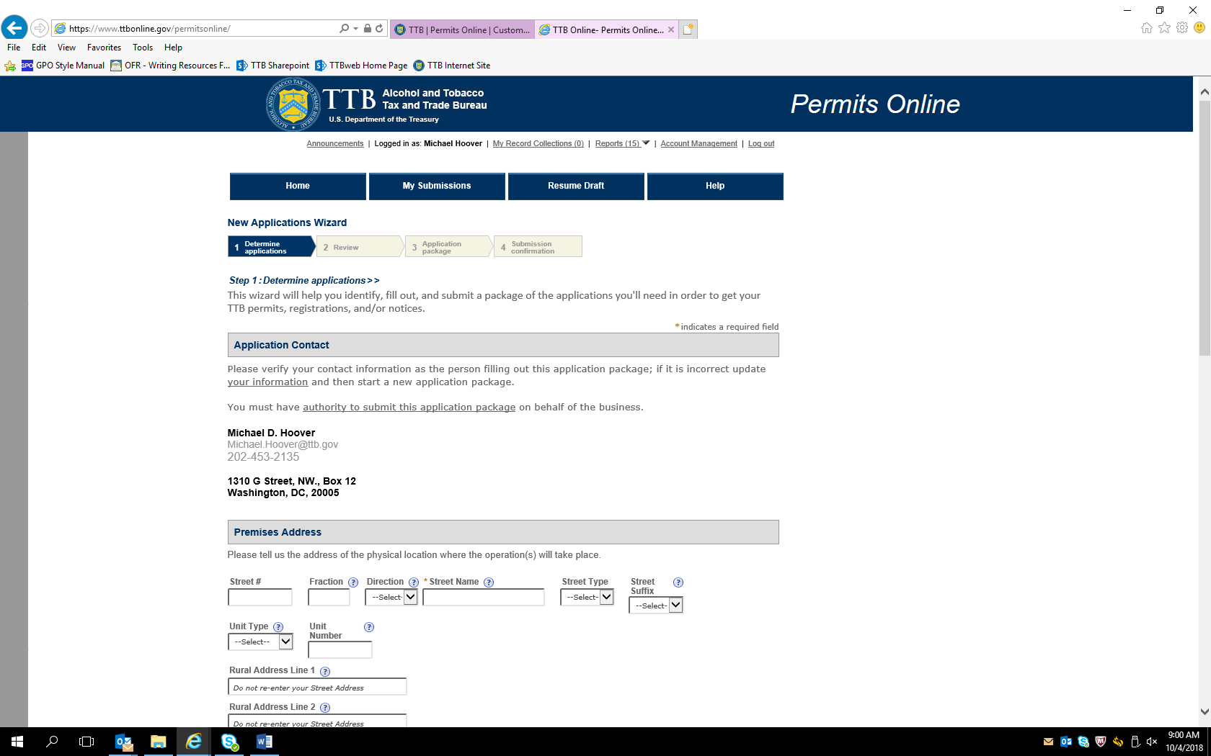

New Application Wizard screen continued:

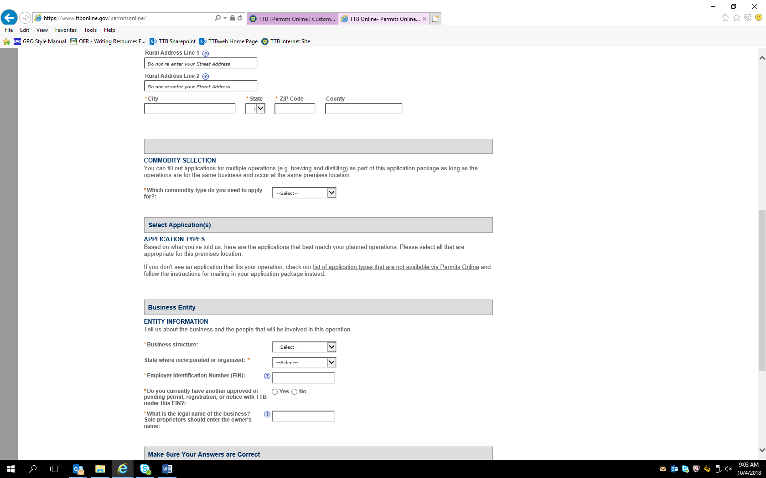

New Application Wizard screen continued:

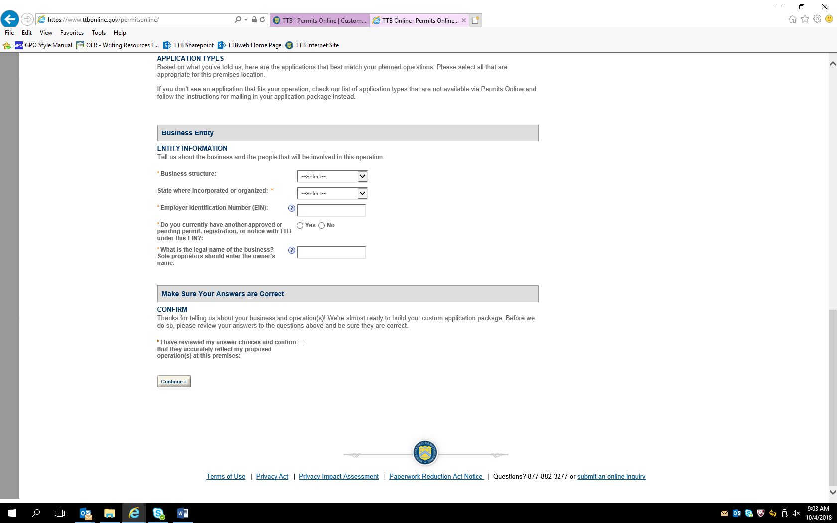

Selecting “Alcohol” and “Spirits (distillery / industrial use)” in the Commodity Selection section, then “Distilled Spirits Plant” in the “Application Types” section results in these addition data fields appearing (similar data fields appear for other types of alcohol commodity selections):

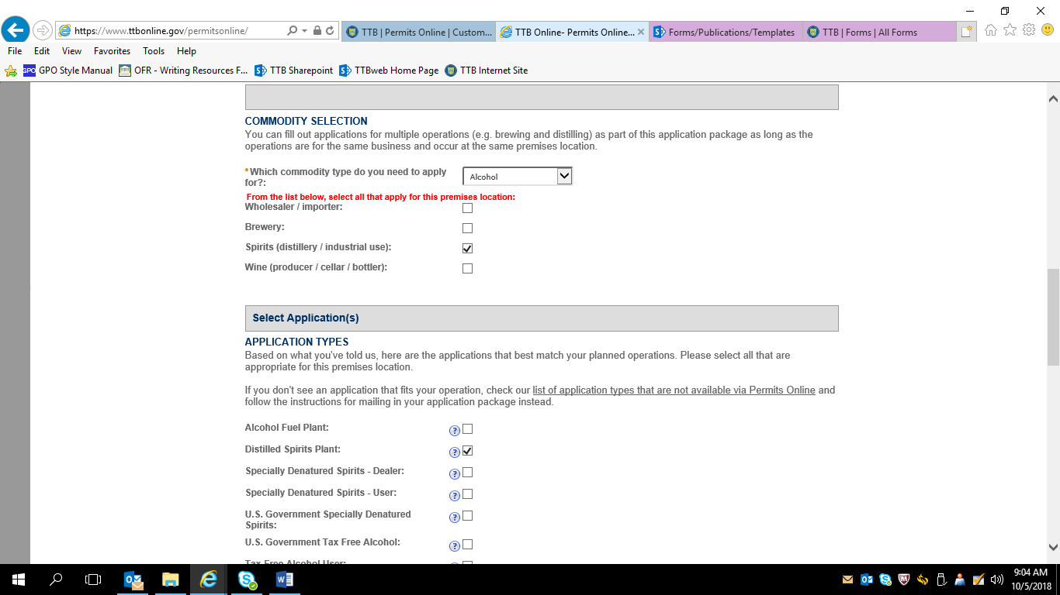

Selecting “Corporation” in the Business Entity section, leads to this screen, including a confirmation statement:

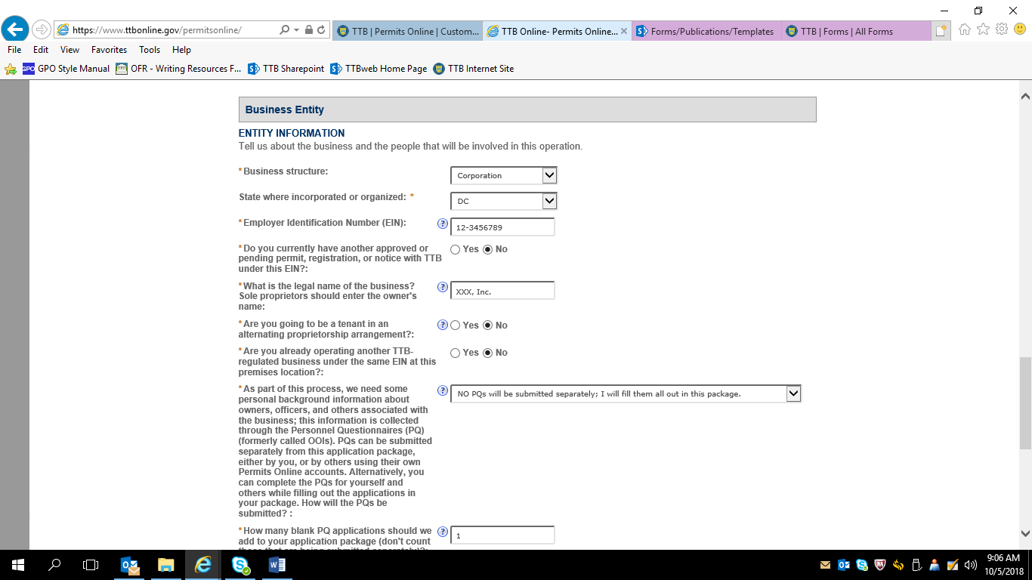

After confirmation is made, the next screen allows the applicant to review the information submitted to this point in the PONL application:

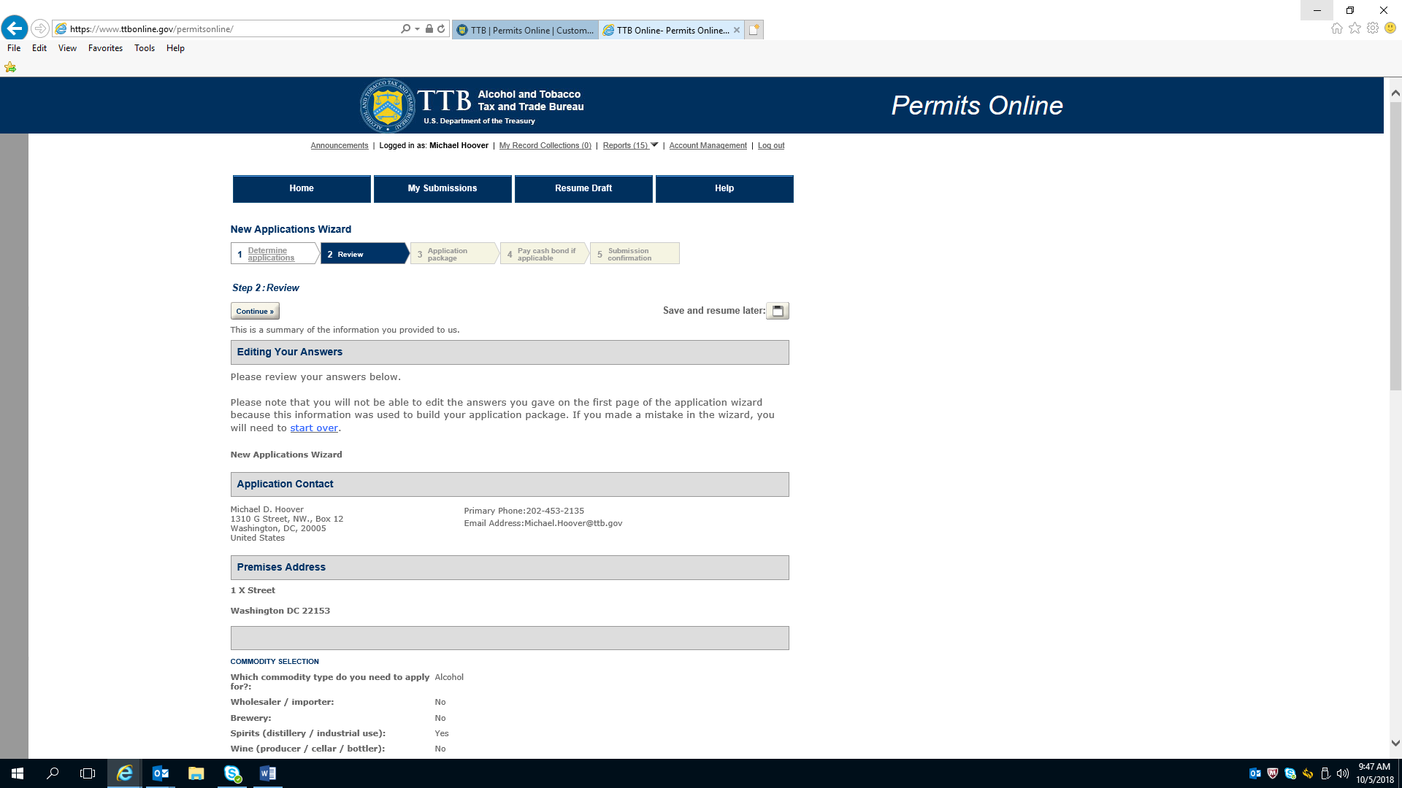

New Application Wizard—Review of Information (continued)

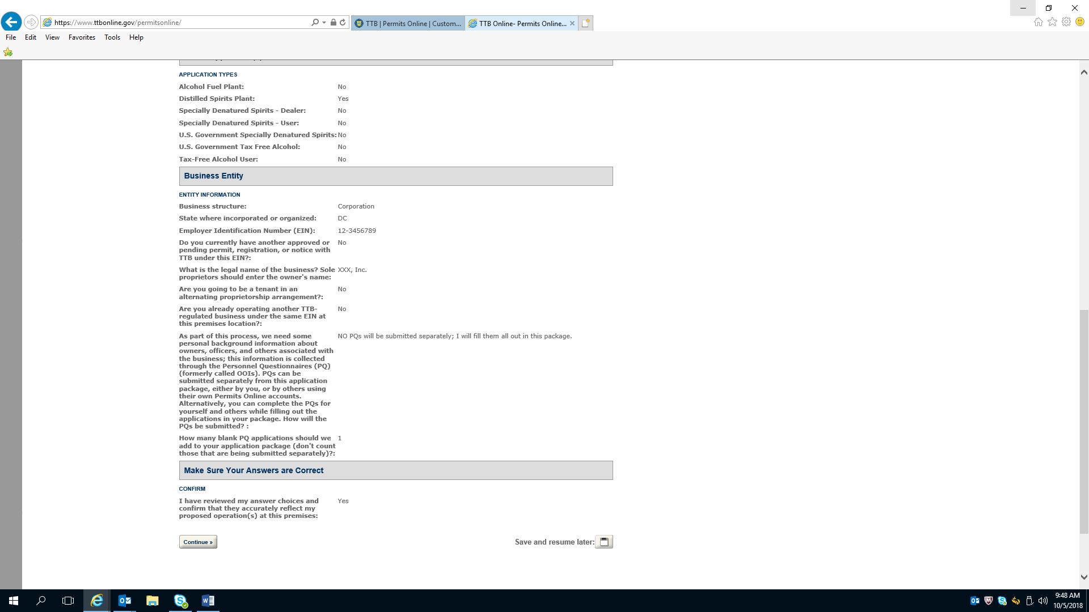

Application for a Distilled Spirits Plant—Initial Page

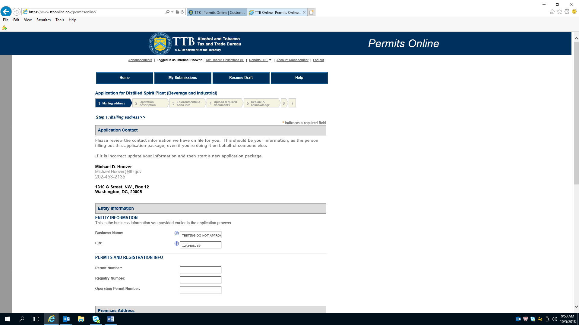

Application for a Distilled Spirits Plant—Initial Page (continued)

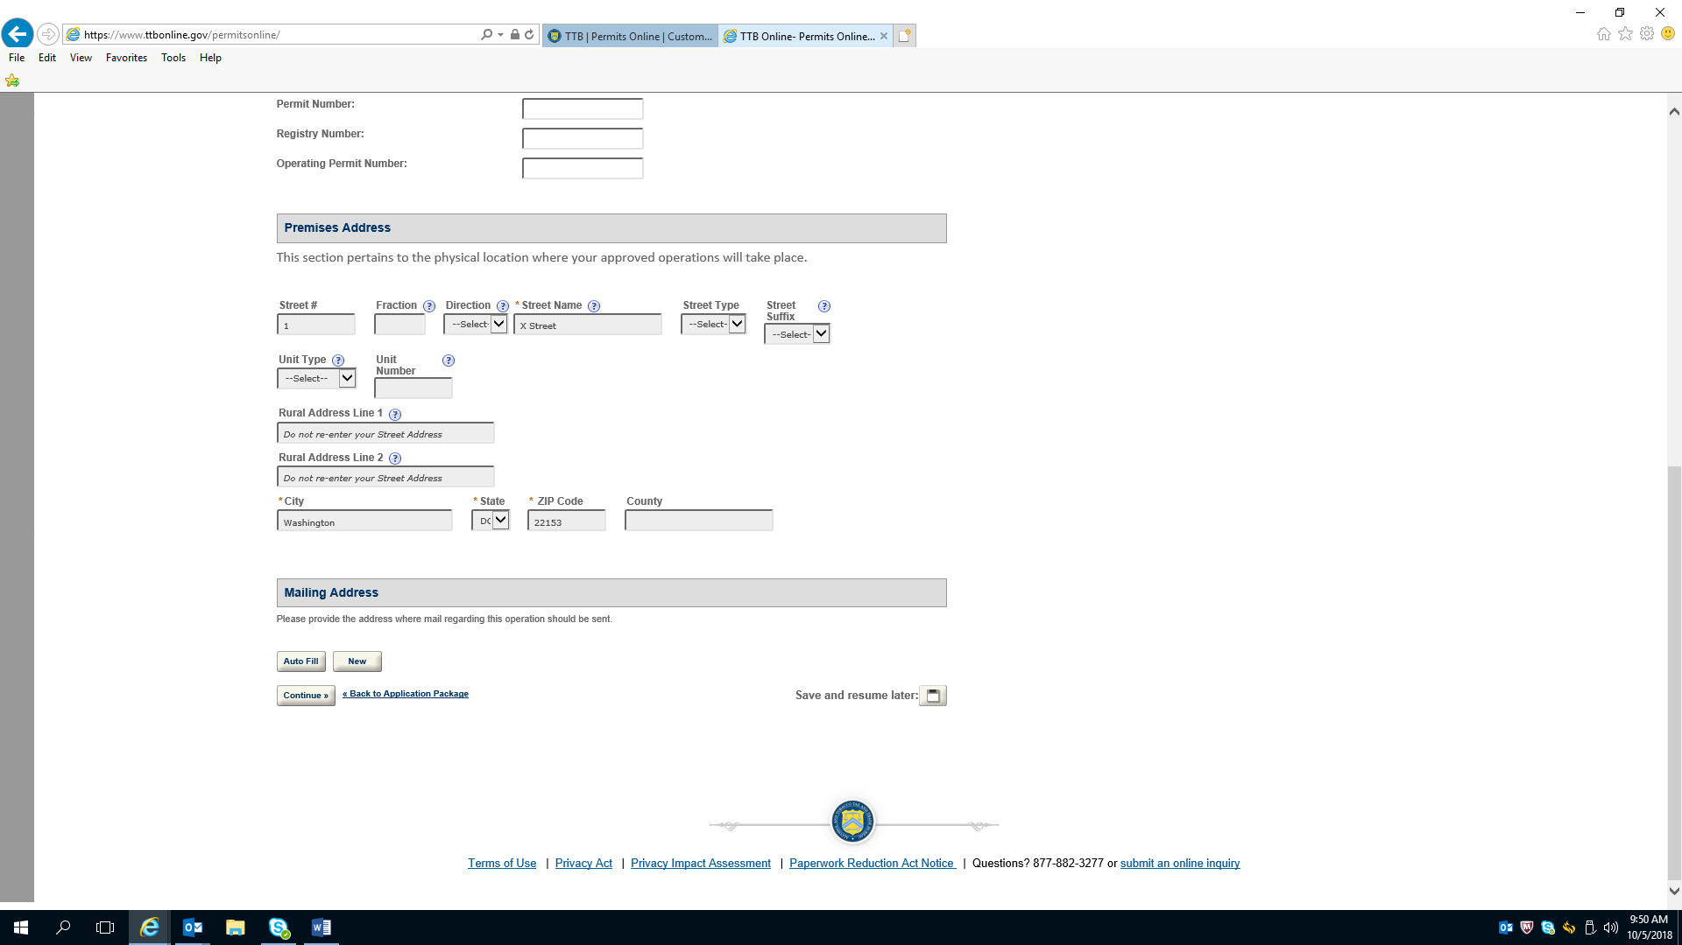

Application for a Distilled Spirits Plant—Operations Description

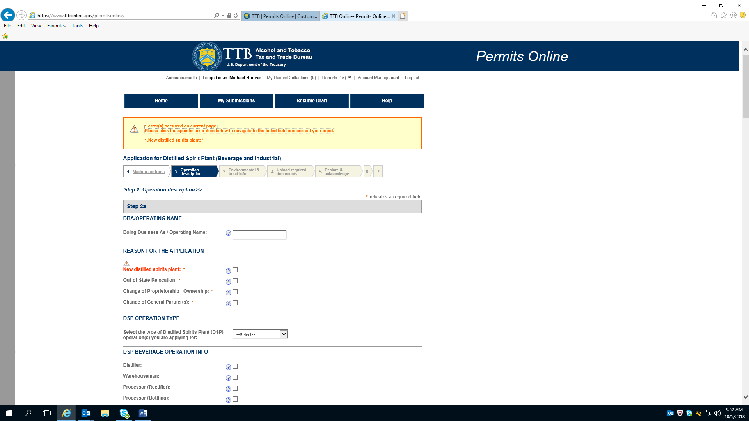

Application for a Distilled Spirits Plant—Operations Description (continued)

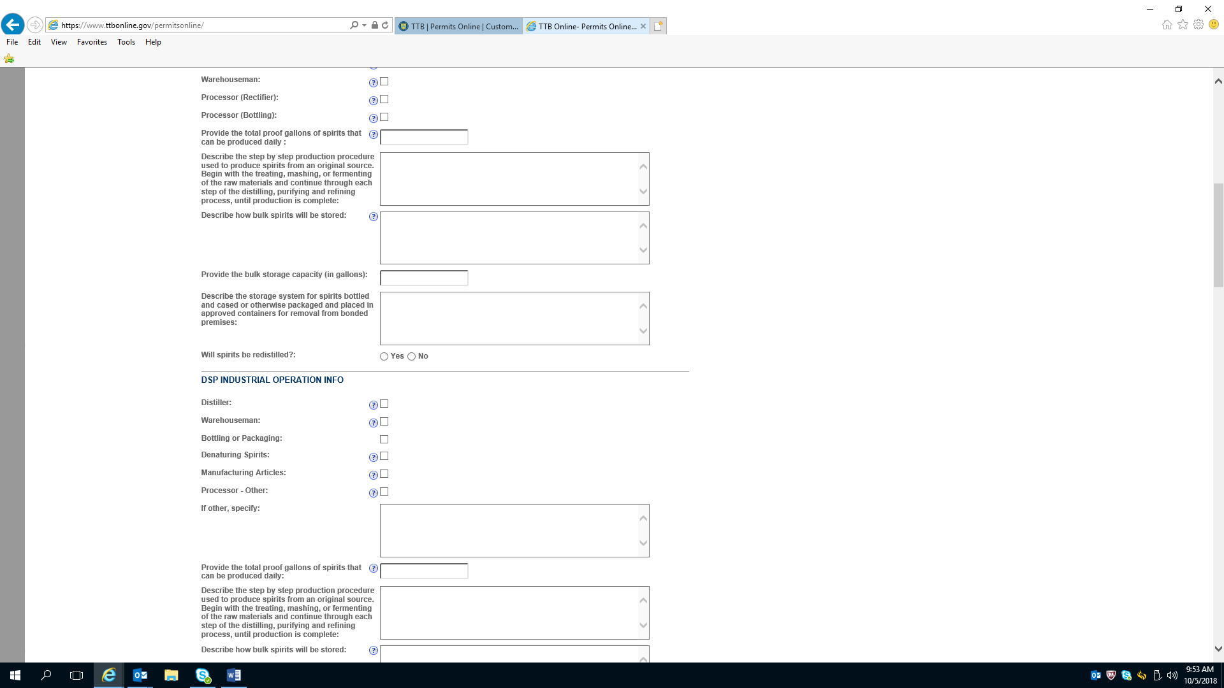

Application for a Distilled Spirits Plant—Operations Description (continued)

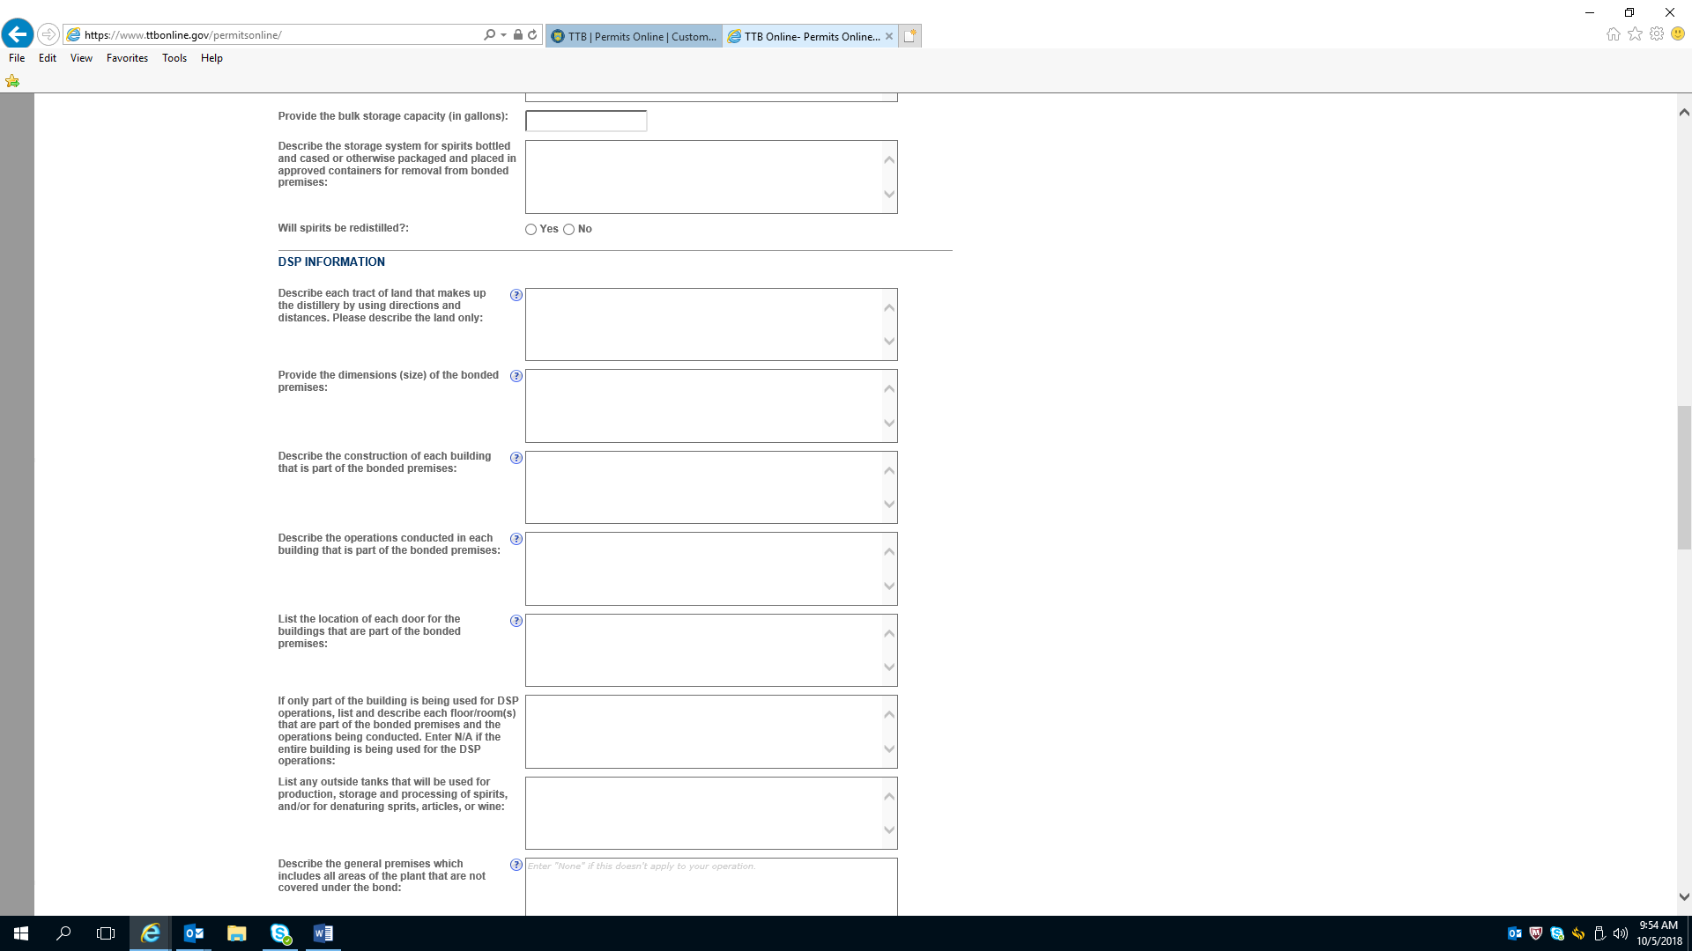

Application for a Distilled Spirits Plant—Operations Description (continued)

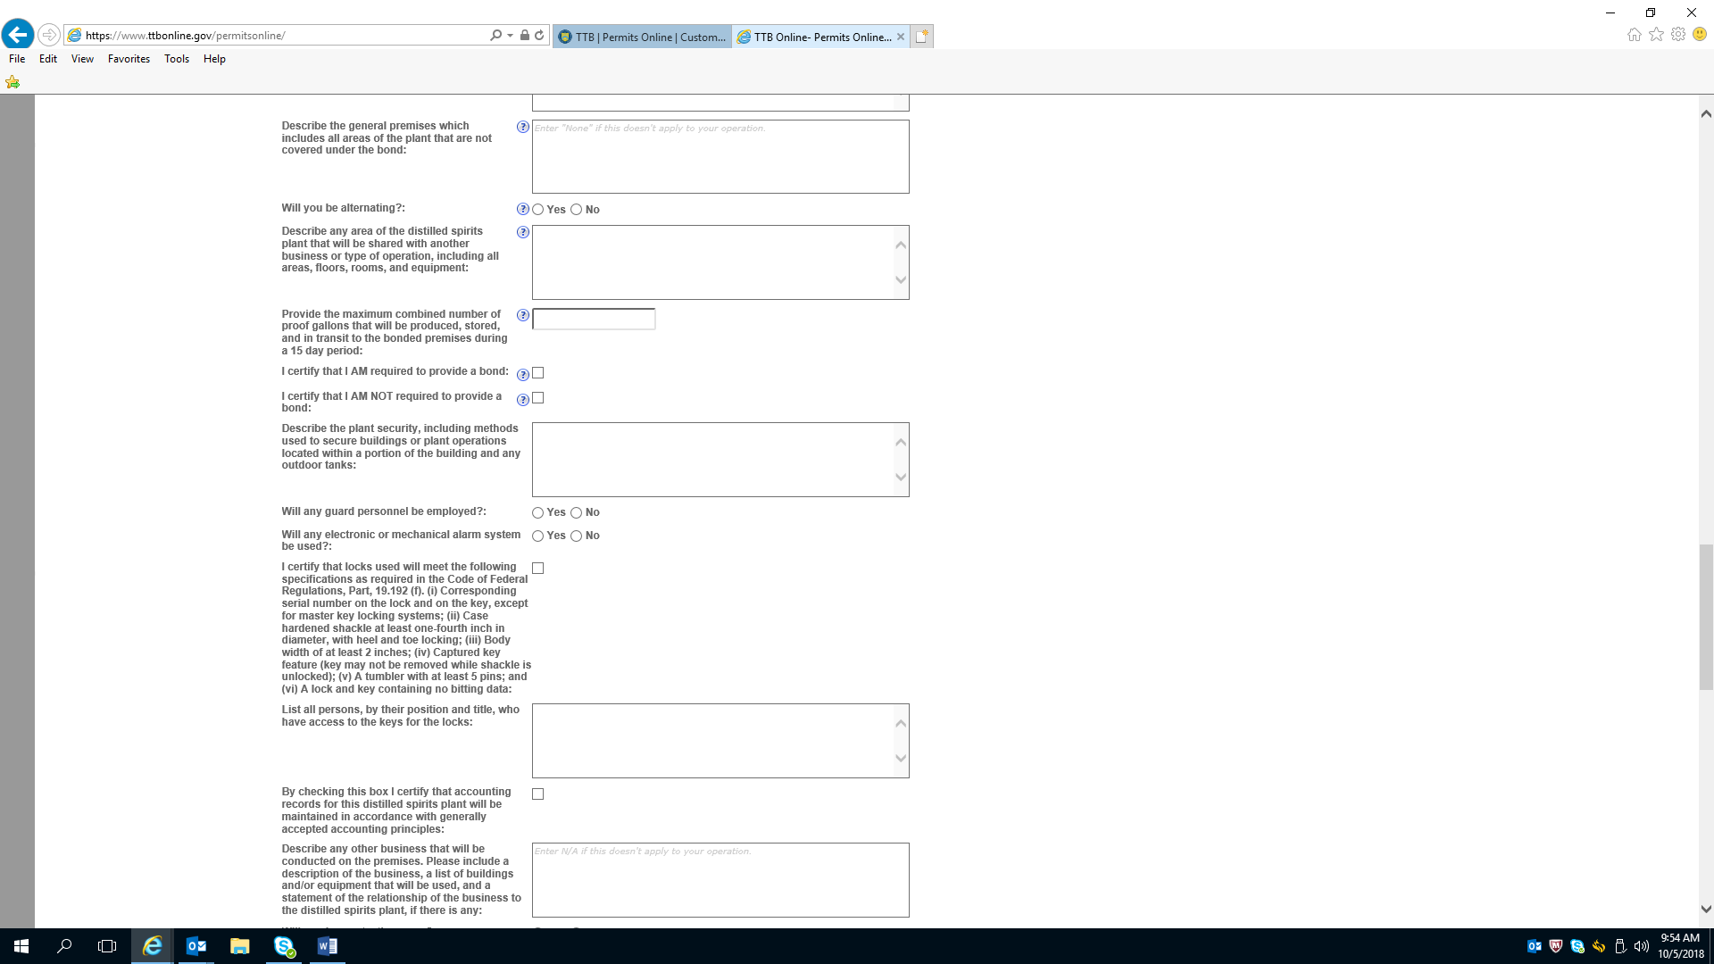

Application for a Distilled Spirits Plant—Operations Description (continued)

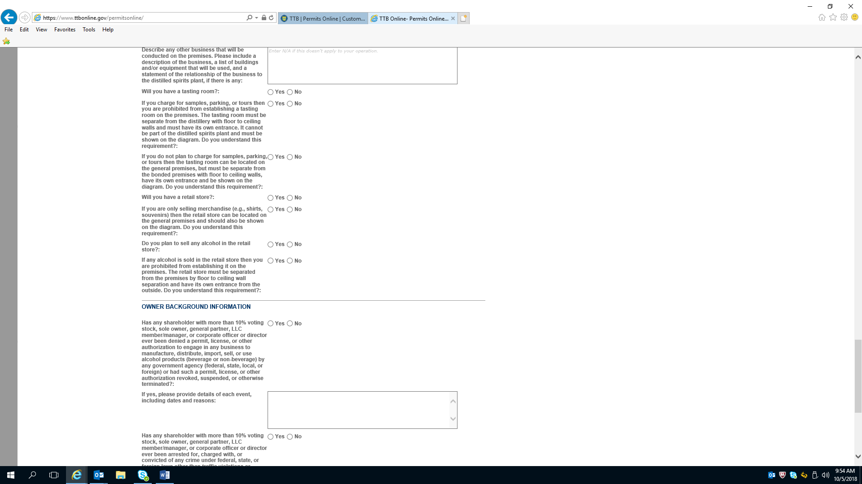

Application for a Distilled Spirits Plant—Operations Description (continued)

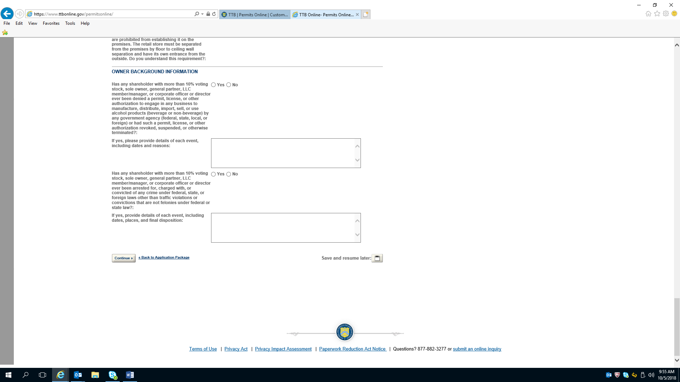

Application for a Distilled Spirits Plant—Environmental and Bond Information

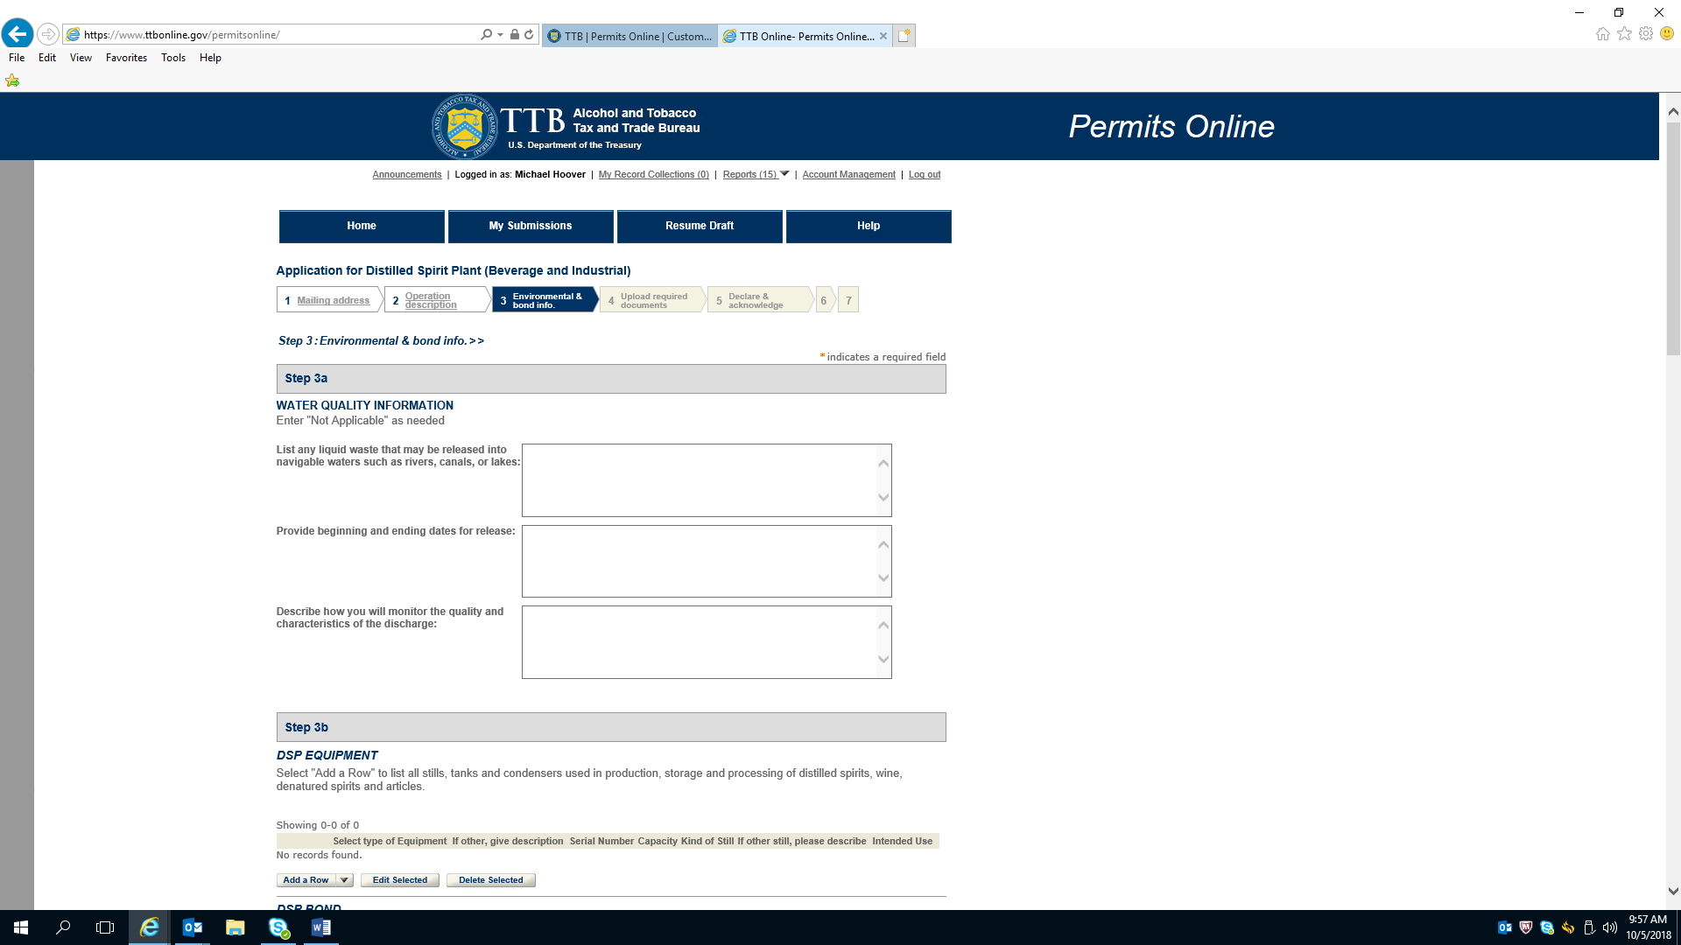

Application for a Distilled Spirits Plant—Environmental and Bond Information (continued) — Adding DSP Equipment:

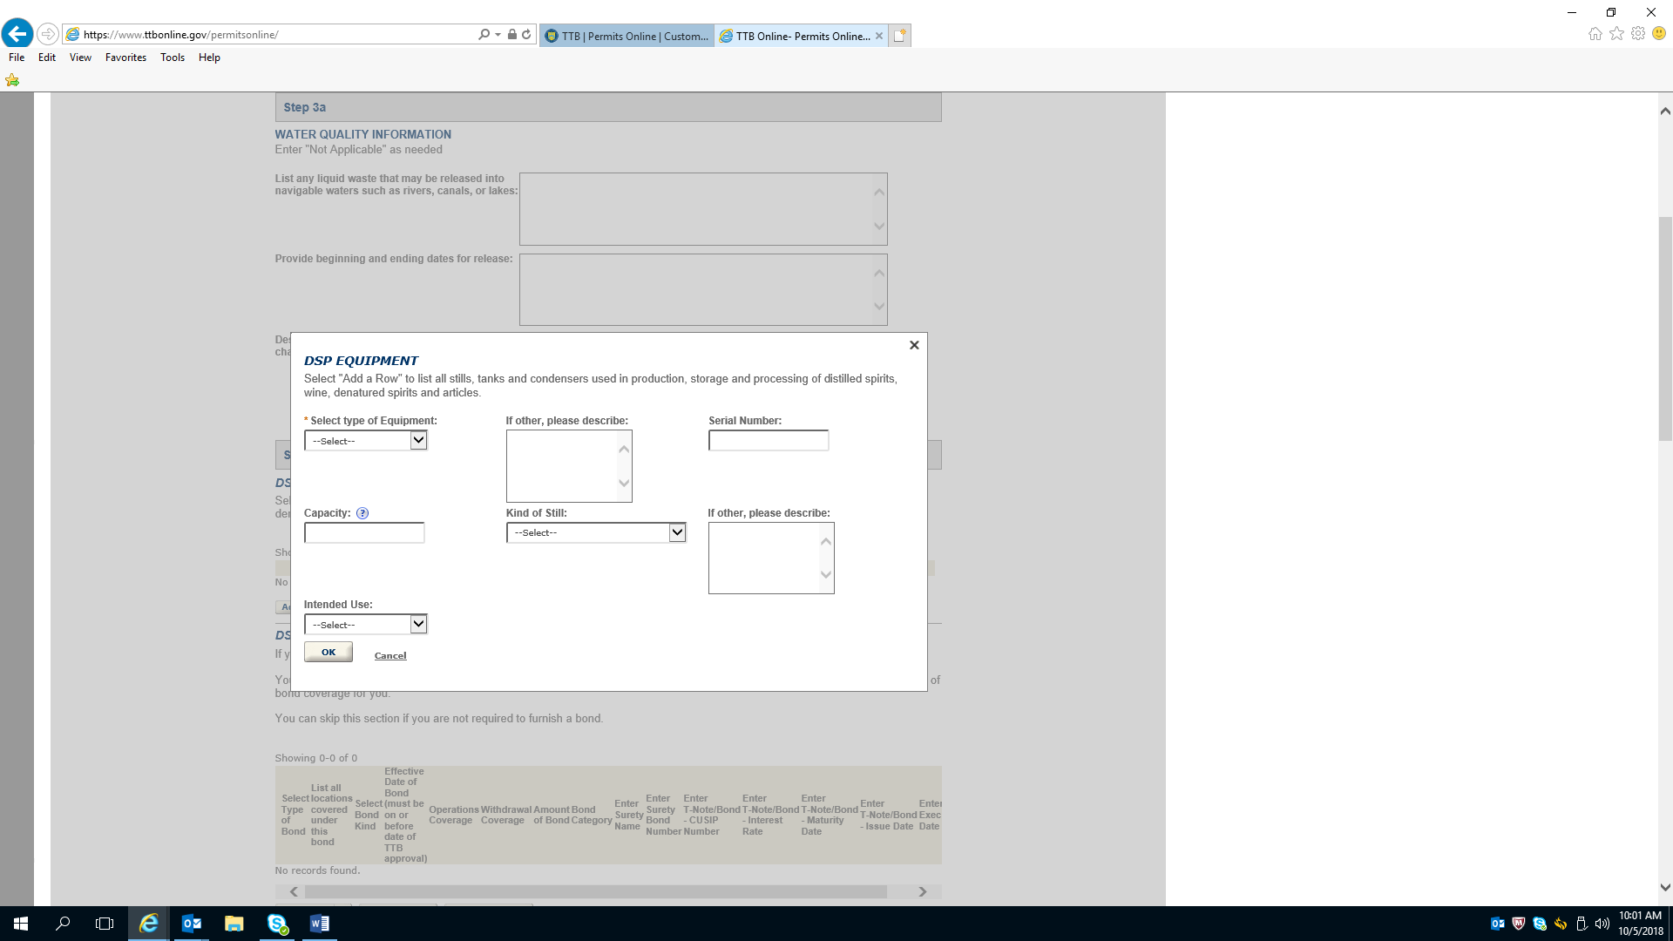

Application for a Distilled Spirits Plant—Environmental and Bond Information (continued)

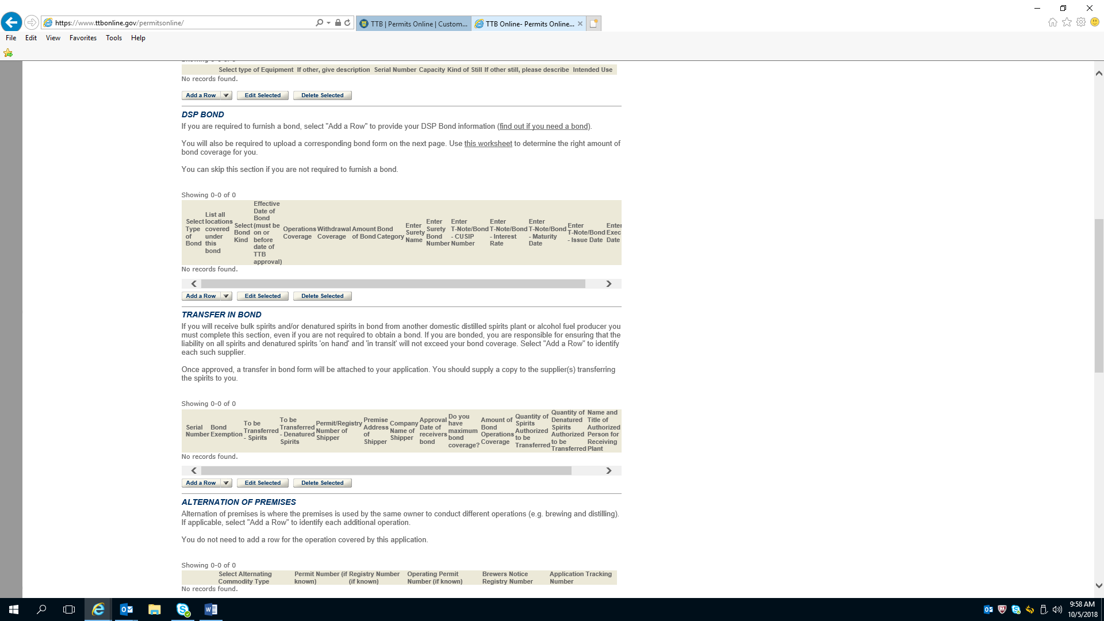

Application for a Distilled Spirits Plant—Environmental and Bond Information (continued) — Adding a DSP Bond

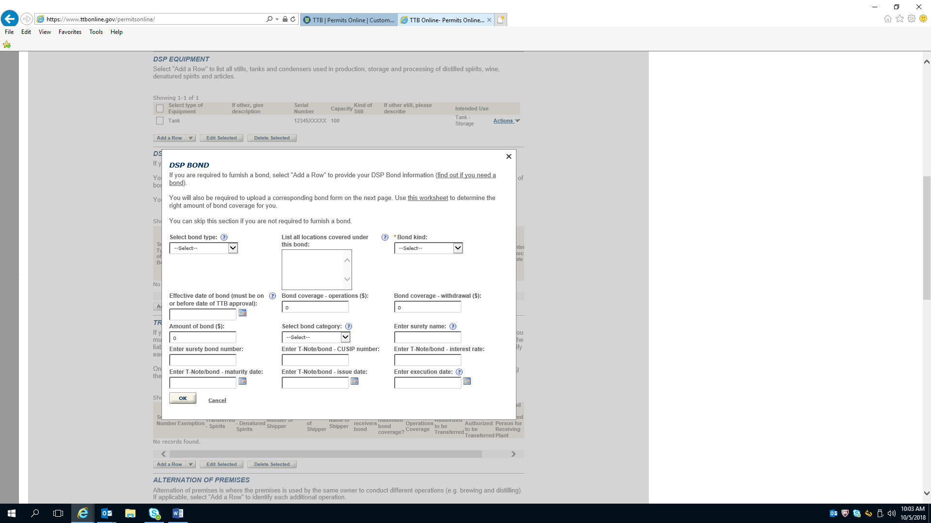

Application for a Distilled Spirits Plant—Environmental and Bond Information (continued)

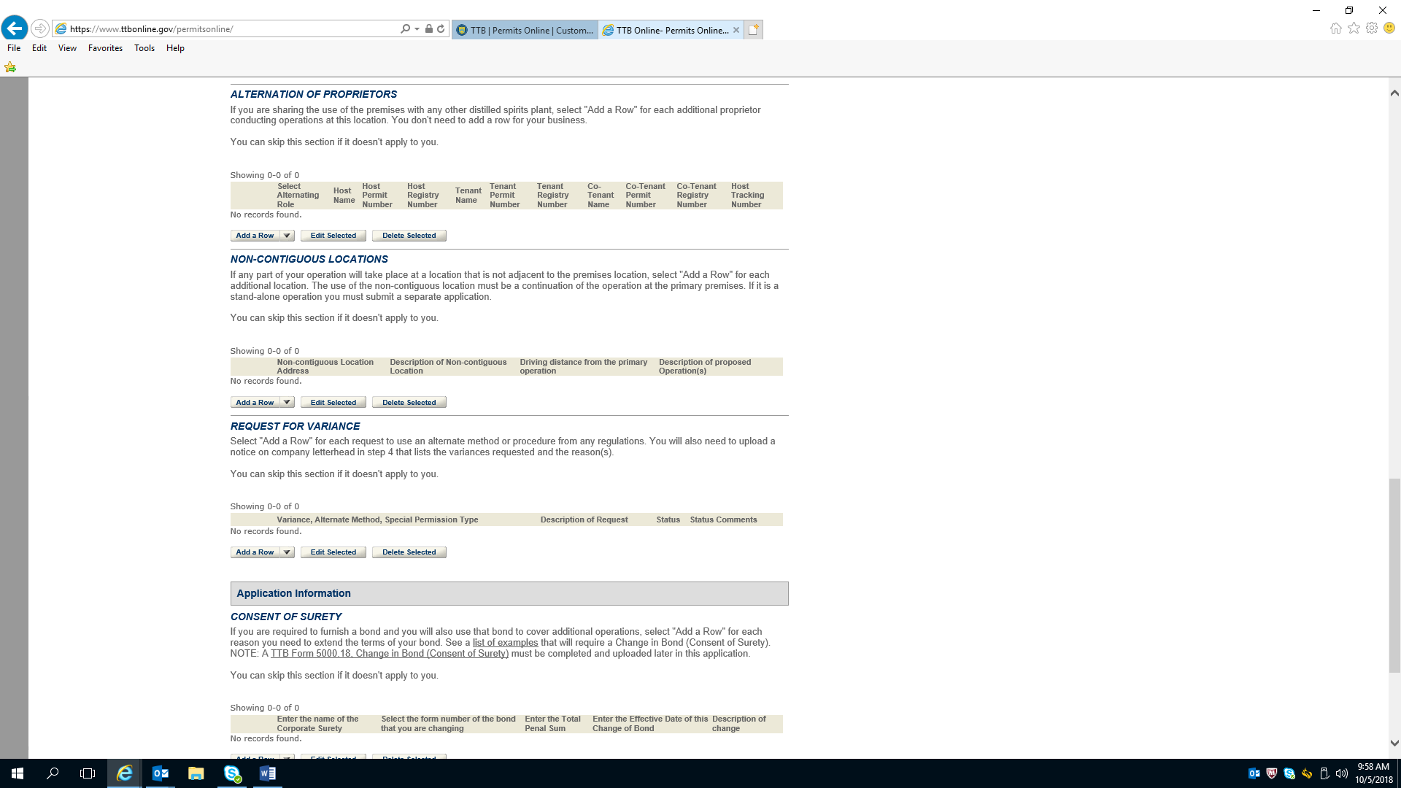

Application for a Distilled Spirits Plant—Environmental and Bond Information (continued)

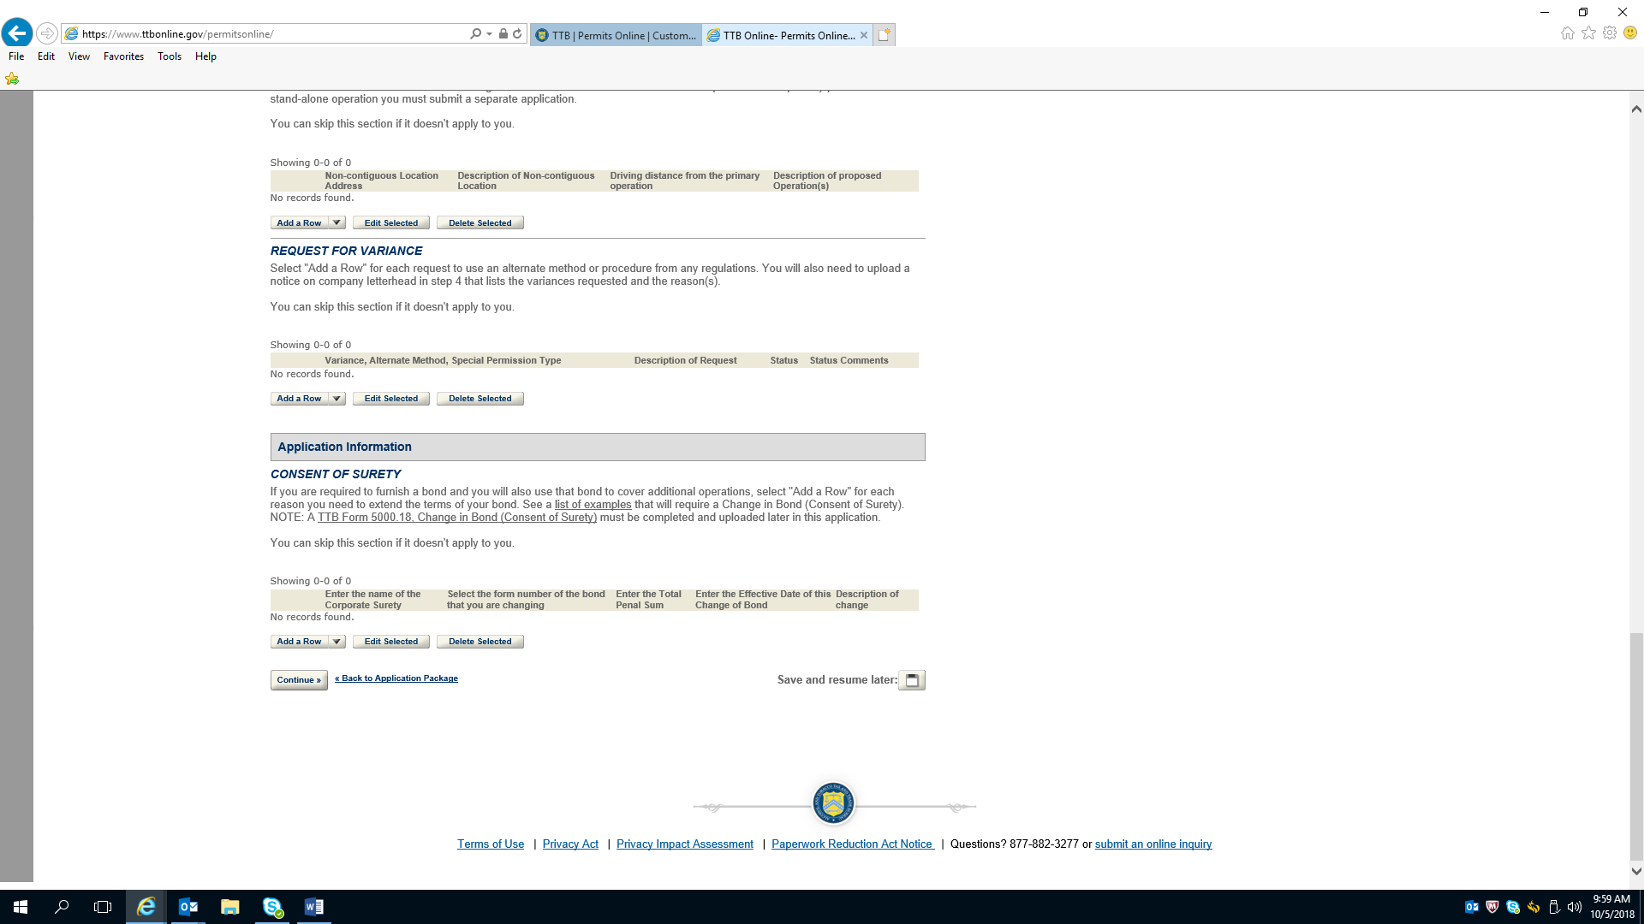

Application for Distilled Spirit Plant –Required Document Checklist

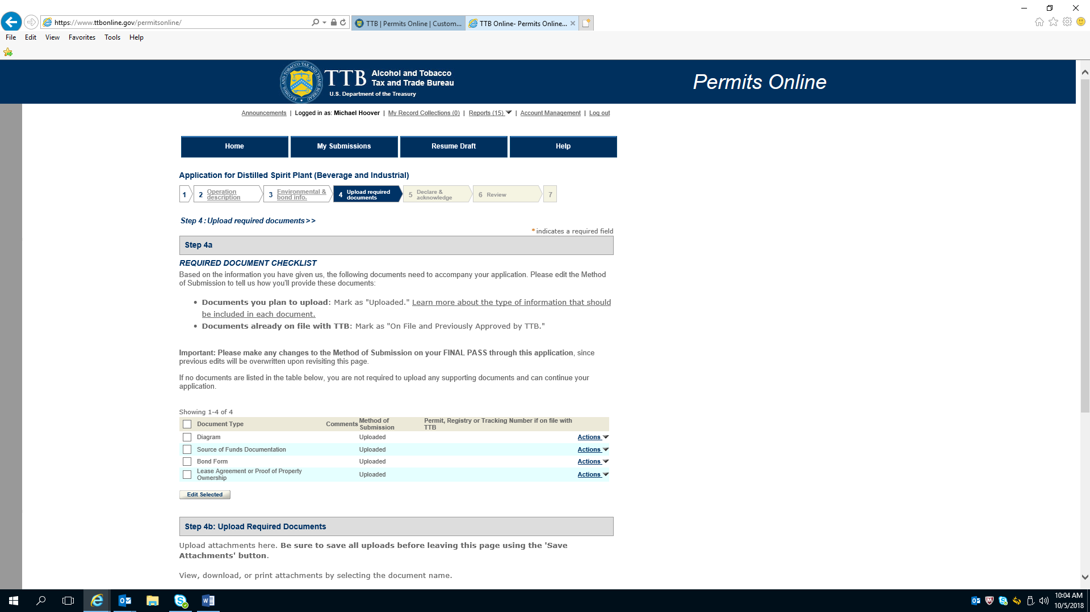

Application for Distilled Spirit Plant –Required Document Checklist (Continued)

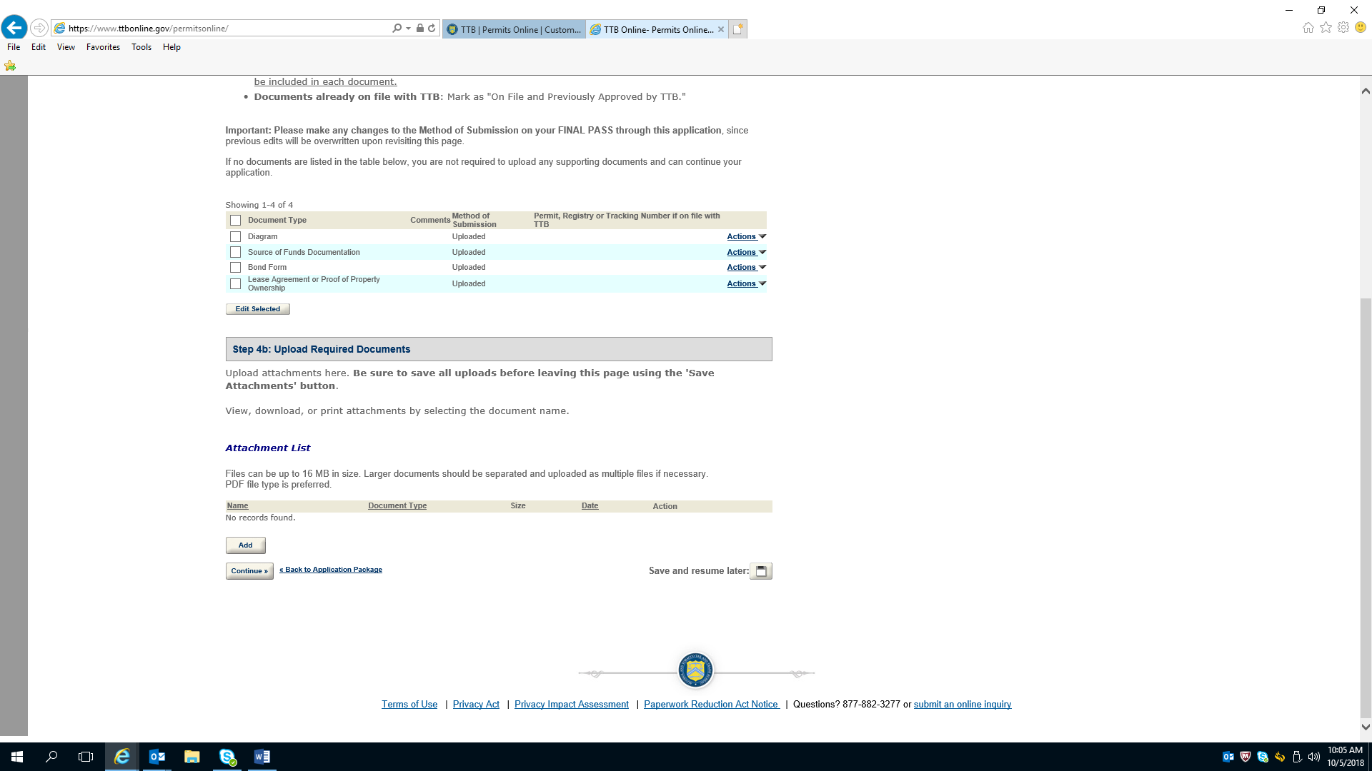

Application for Distilled Spirit Plant---Declare and Acknowledge

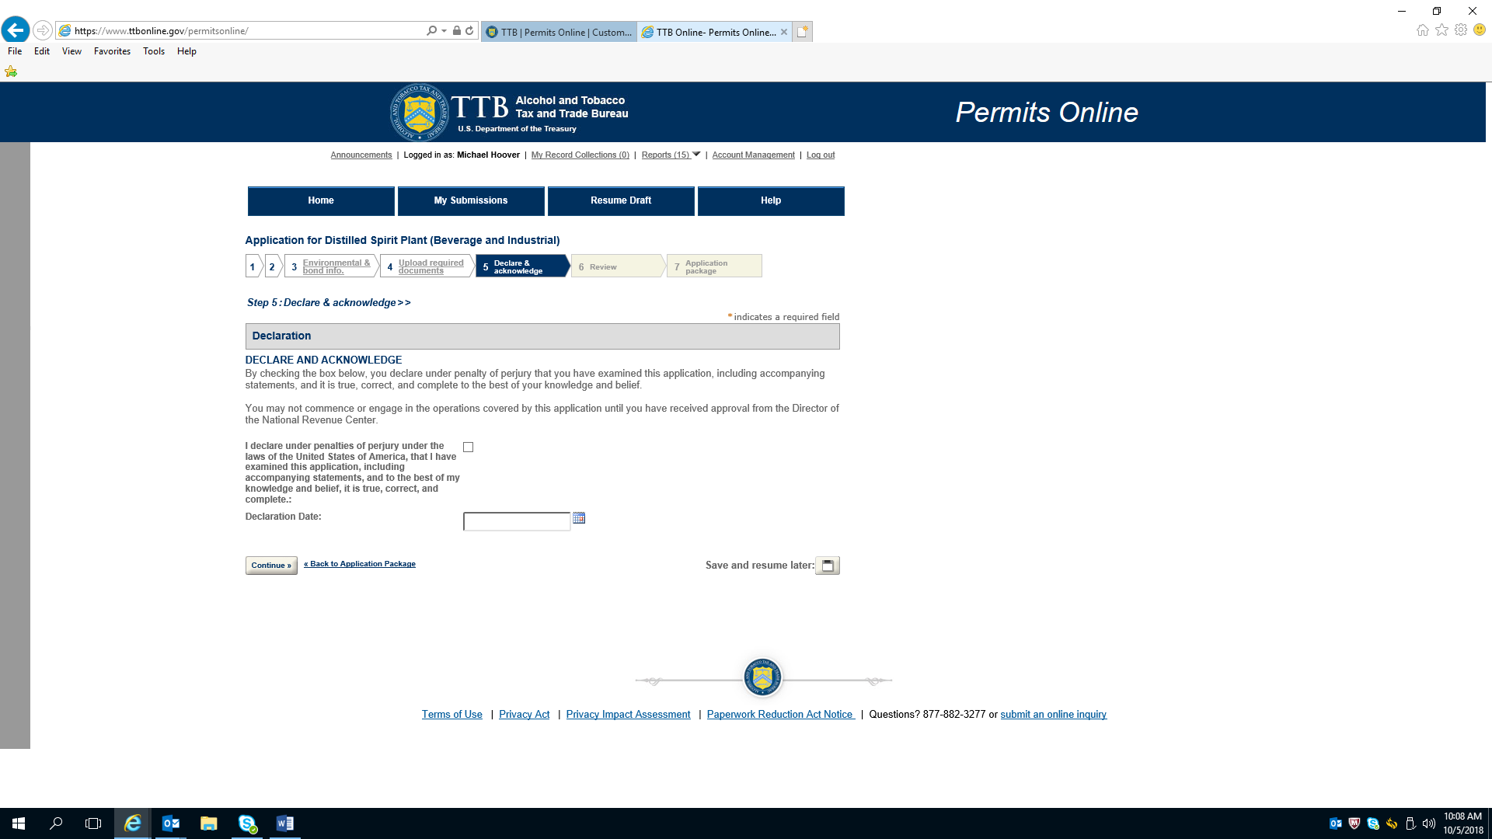

Application for Distilled Spirit Plant---Review

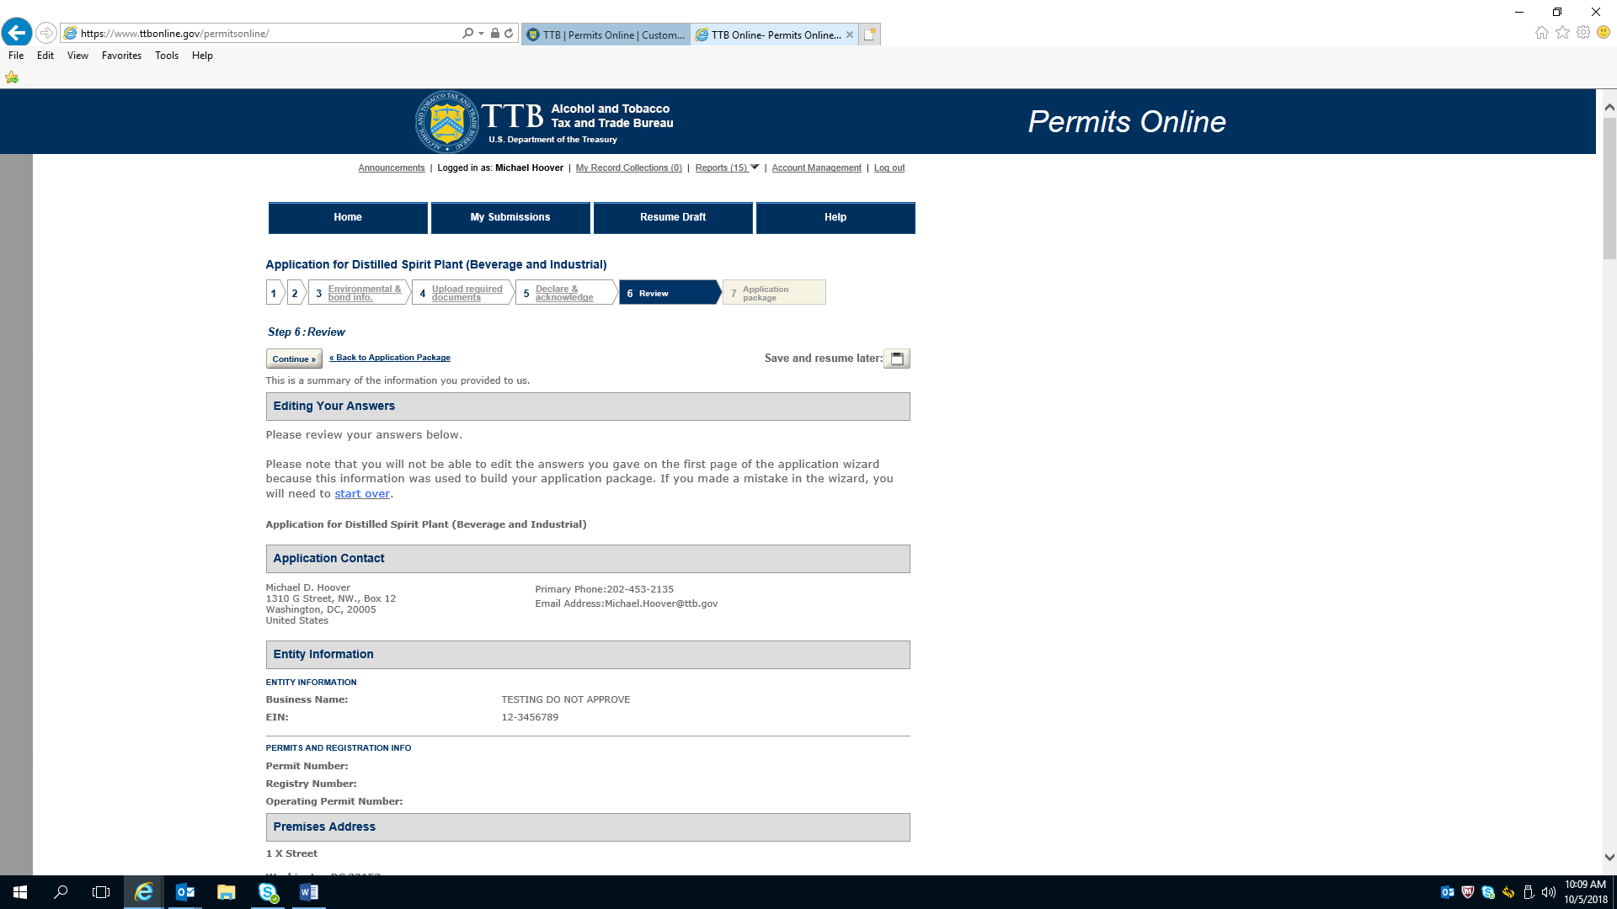

Application for Distilled Spirit Plant---Review (Continued)

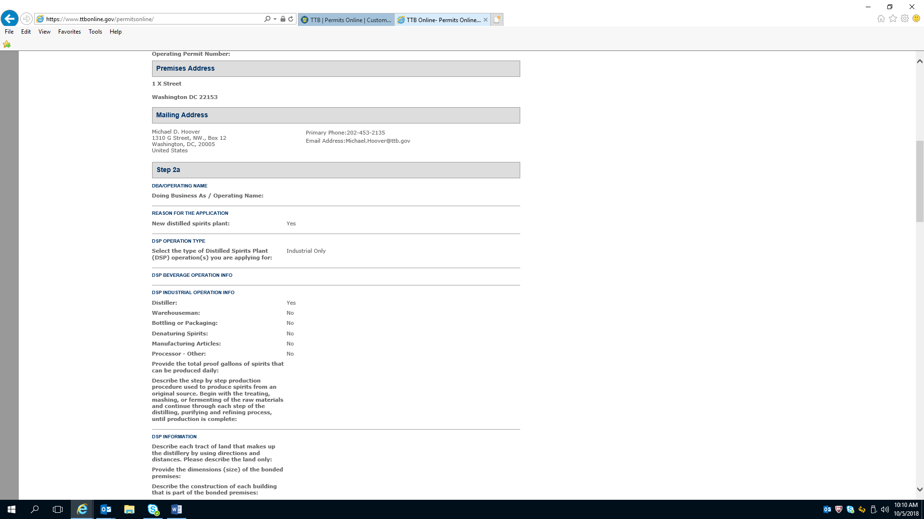

Application for Distilled Spirit Plant---Review (Continued)

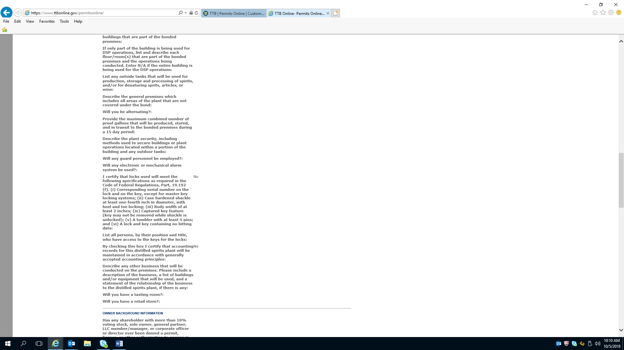

Application for Distilled Spirit Plant---Review (Continued)

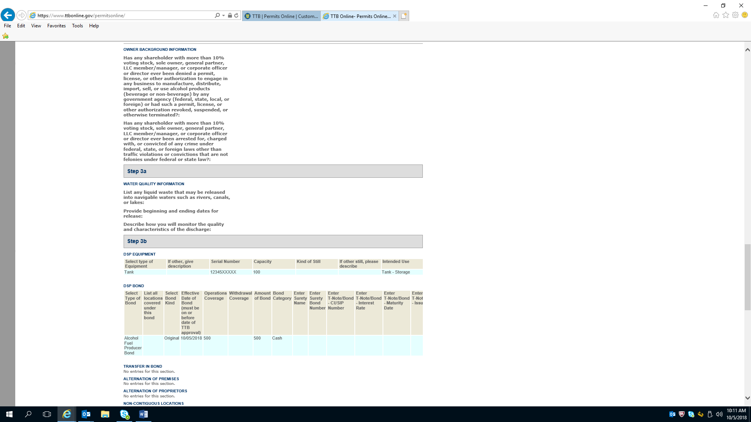

Application for Distilled Spirit Plant---Review (Continued)

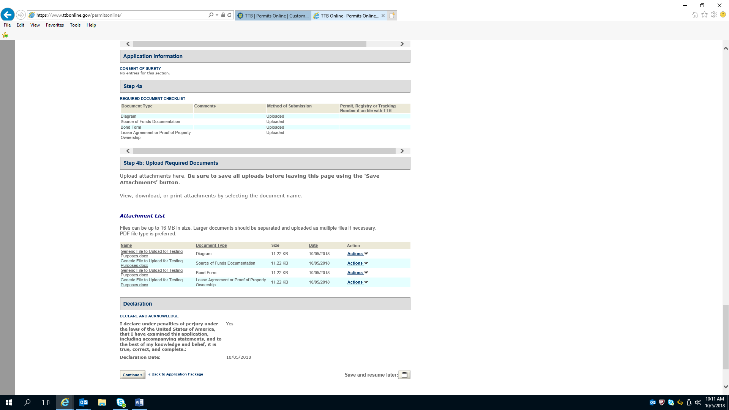

Privacy Act

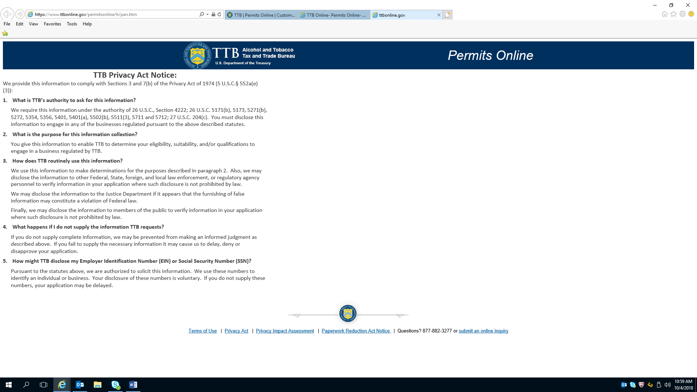

Privacy Impact Assessment

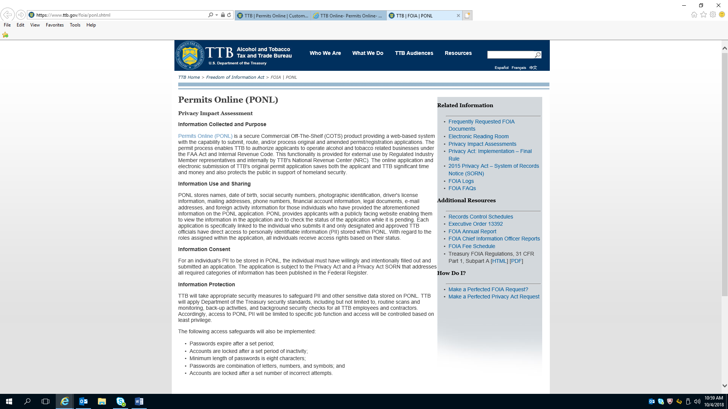

Privacy Impact Assessment (continued)

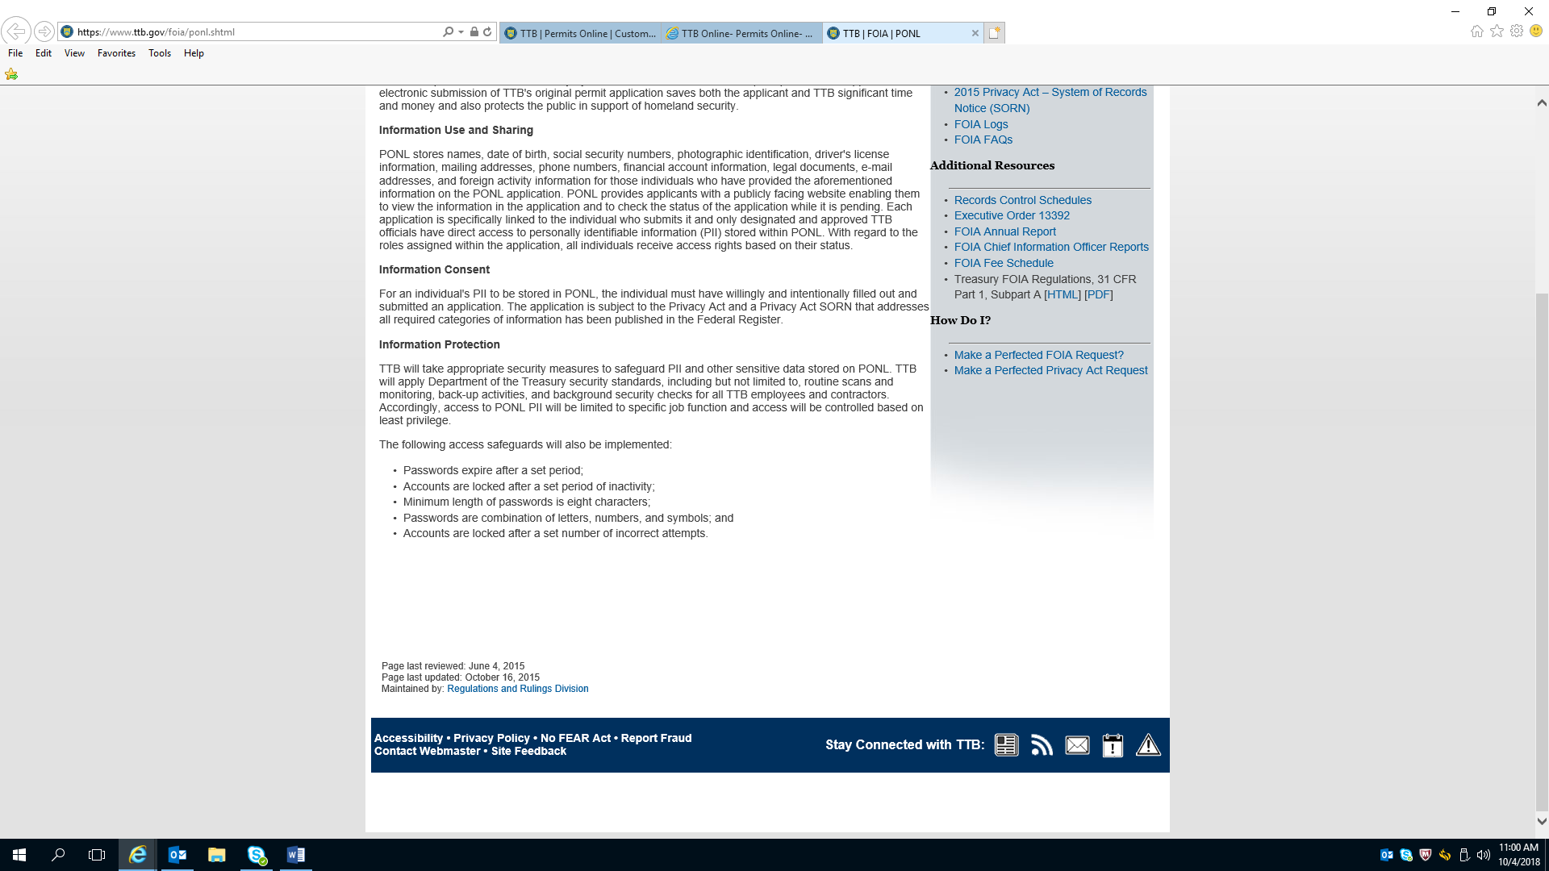

PRA Notice

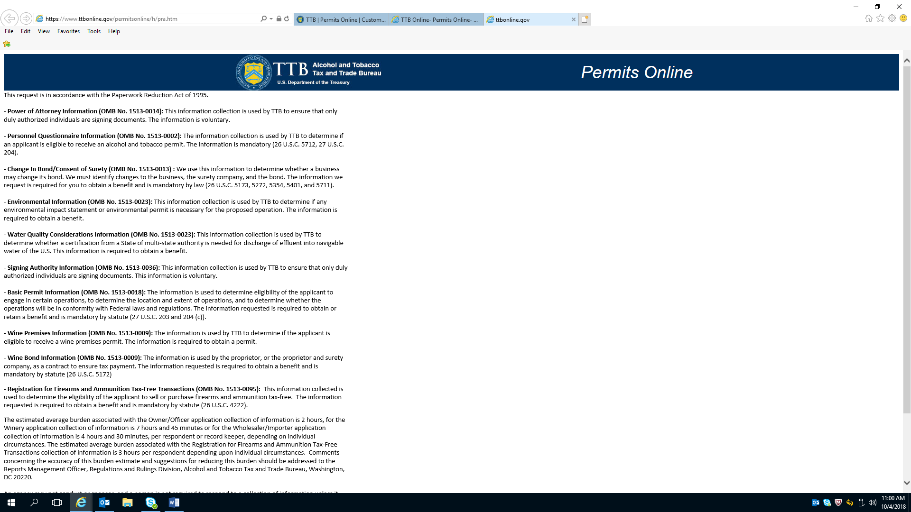

PRA Notice (Continued)

