Permits Online (PONL), New Alcohol Wholesaler or Importer Application — for OMB Control No. 1513–0018, Application for Basic Permit under the Federal Alcohol Administration Act).

This PONL application is equivalent to TTB F 5100.24, Application for Basic Permit under the Federal Alcohol Administration Act, for new alcohol beverage (distilled spirits, wine, malt beverages) Wholesaler or Importer permit applications made on that form.

PONL Log-in Screen:

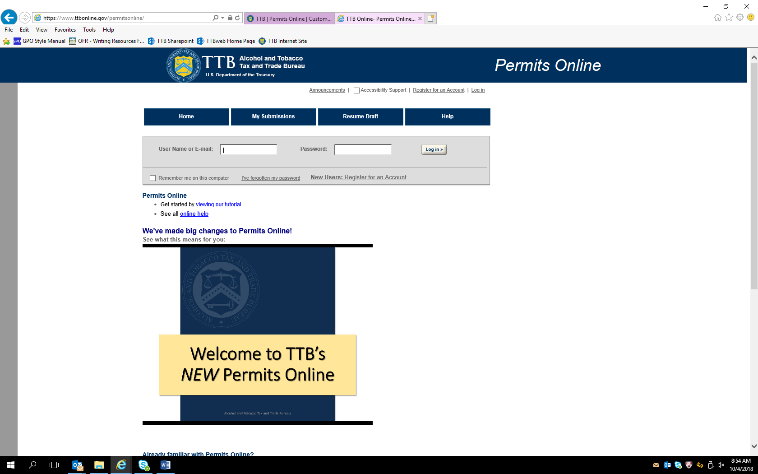

PONL Log-in Screen (continued):

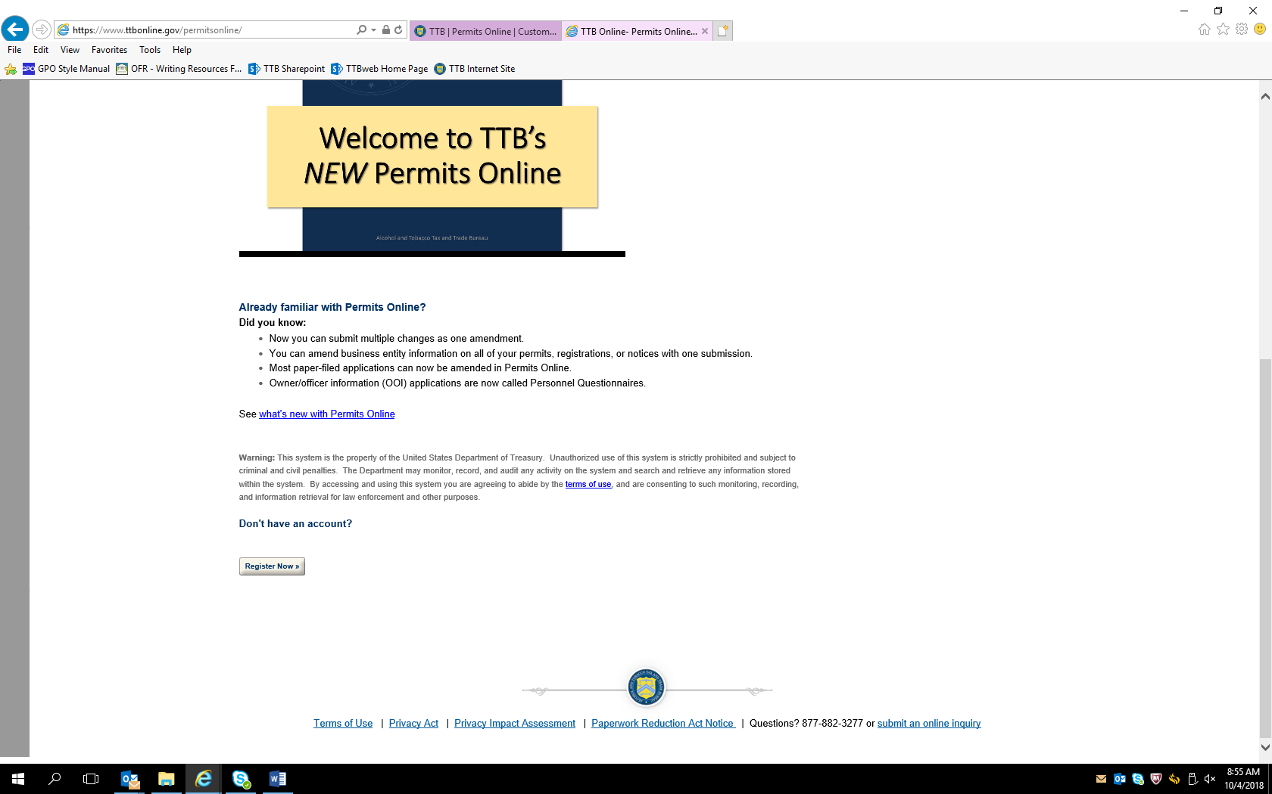

Screen shown after successful log-in:

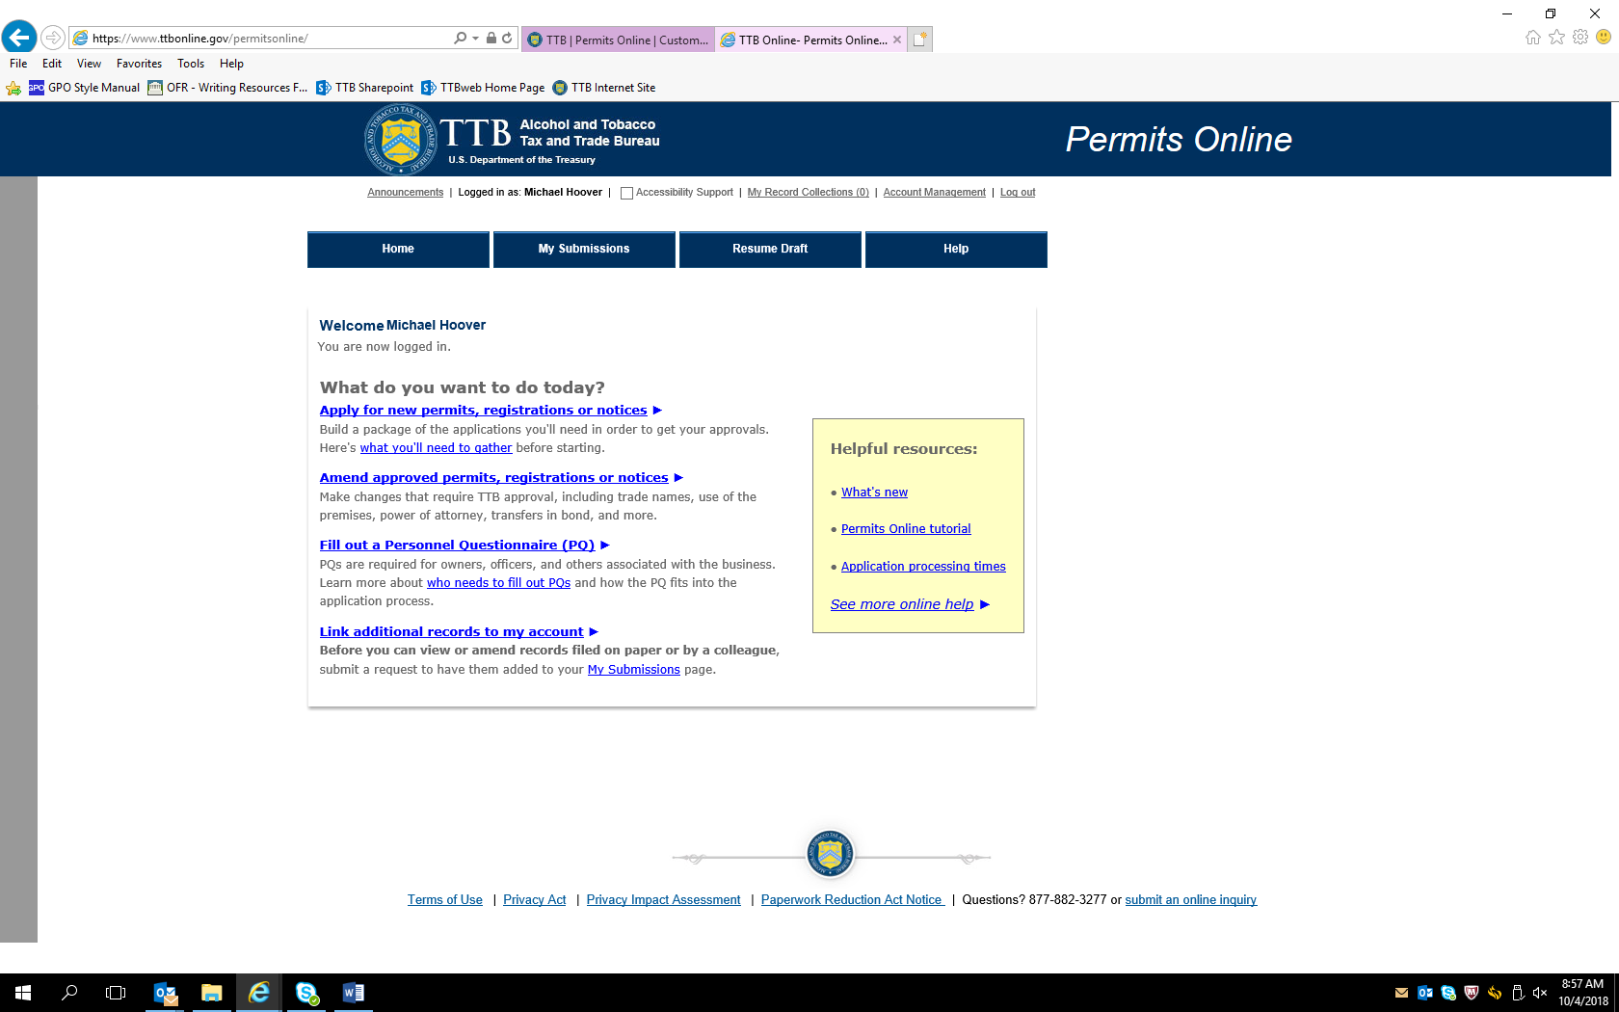

After clicking appropriate “What do you want to do today?” link, the Penalty of Perjury screen appears:

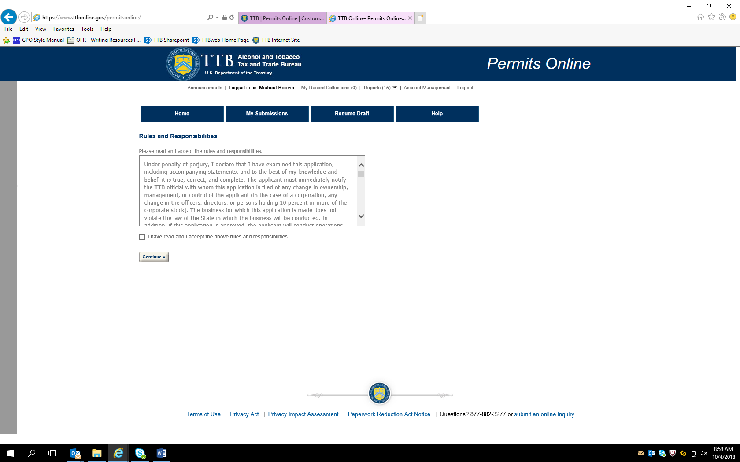

After accepting perjury statement, the New Applications wizard screen appears. The Application Contact information auto fills from PONL registration information:

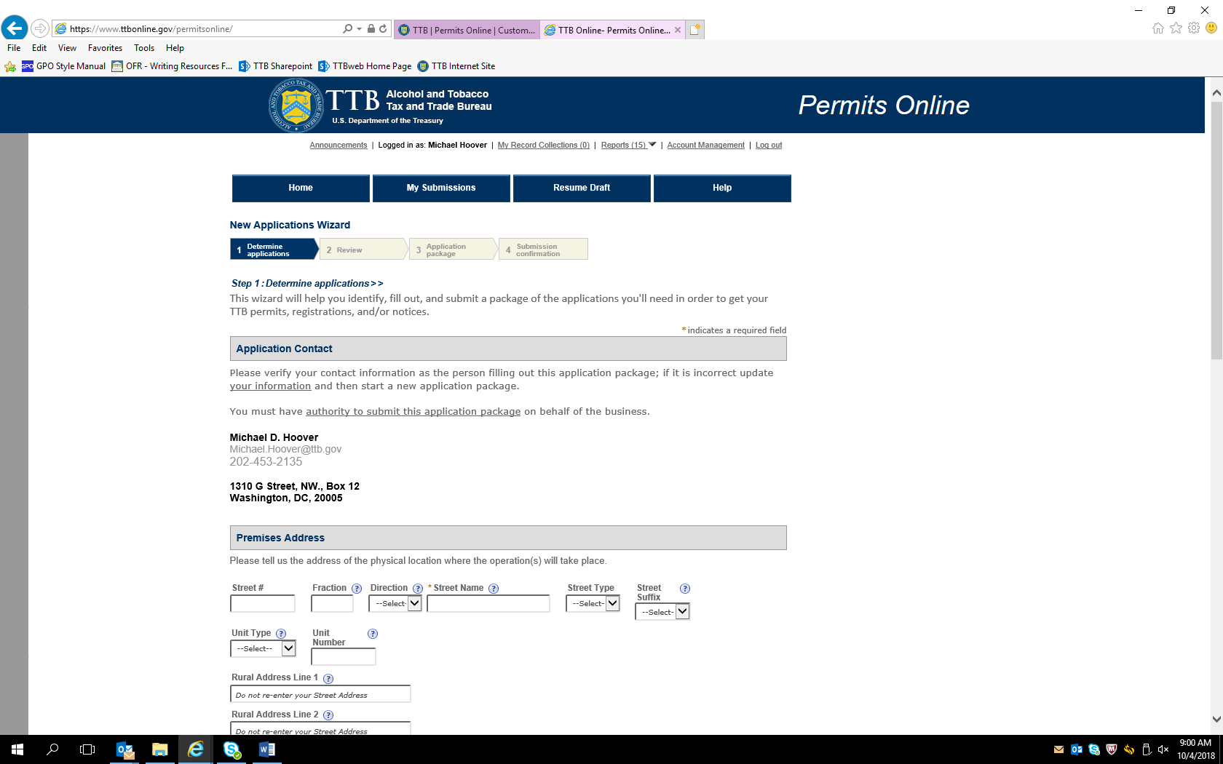

New Application Wizard screen continued – Alcohol Wholesaler selected, with business organized as an LLC (selecting “Alcohol Importer” does not change the data collected):

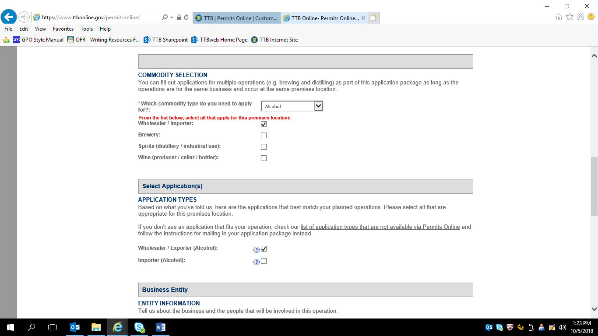

New Application Wizard screen continued:

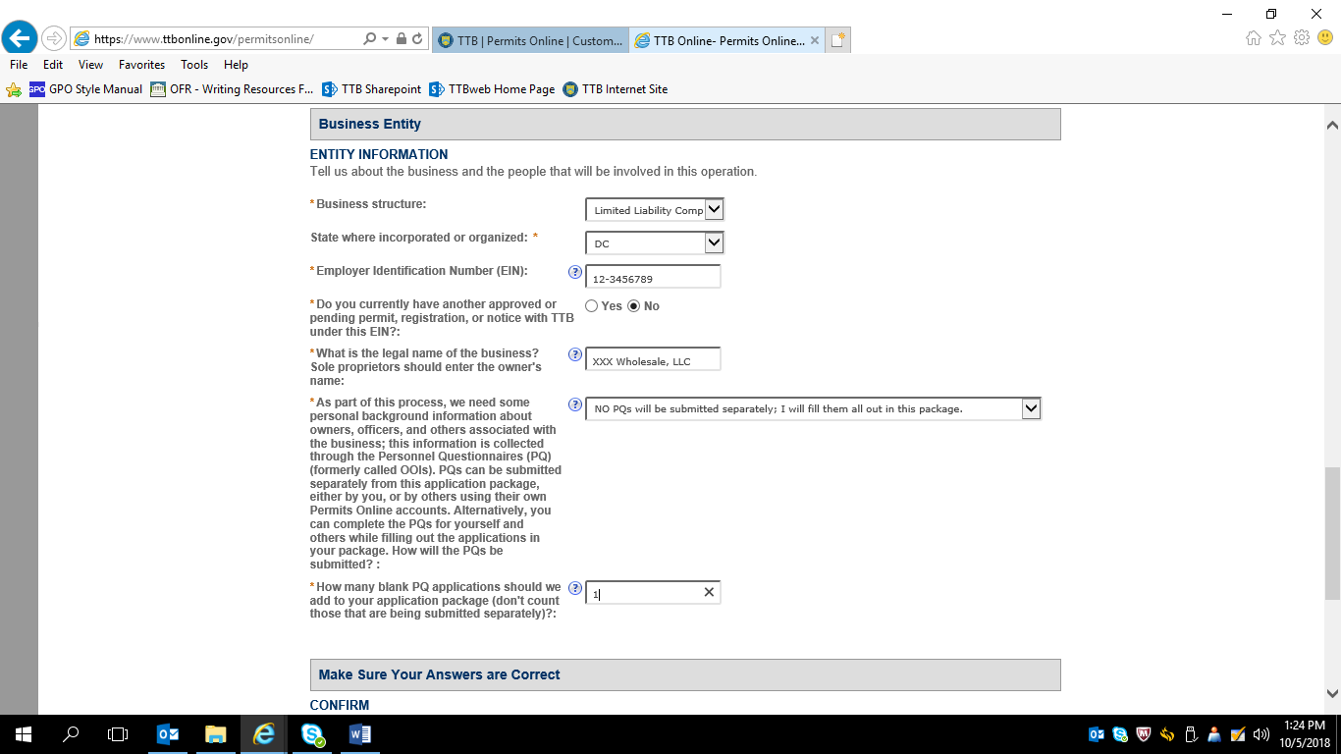

After confirming the information, the respondent is presented with review screens:
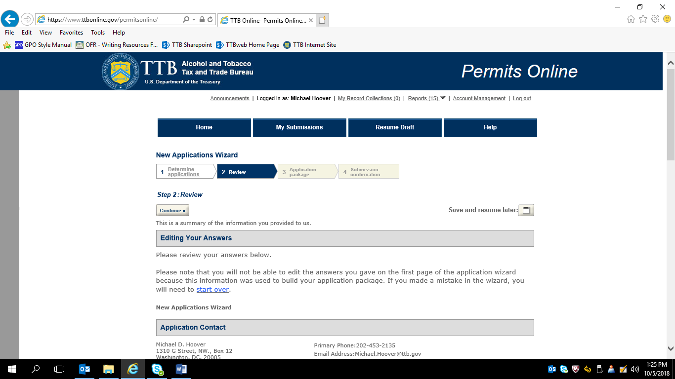

Review screen continued:

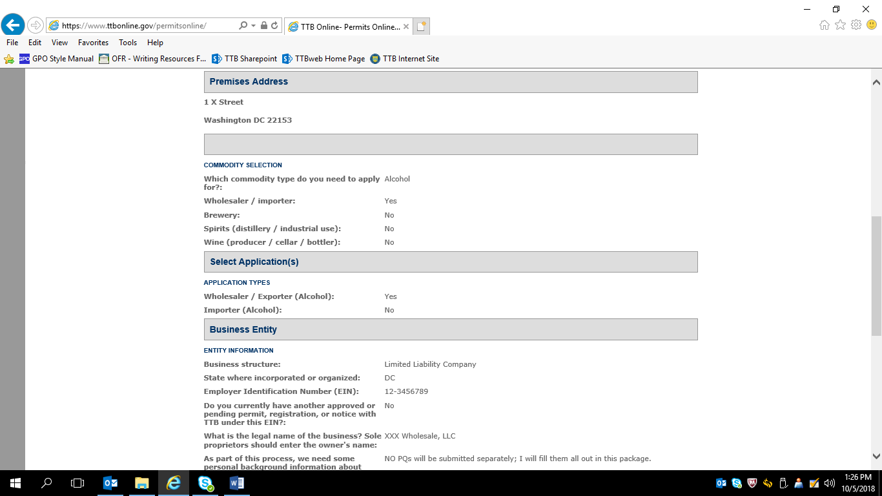

Review screens continued:

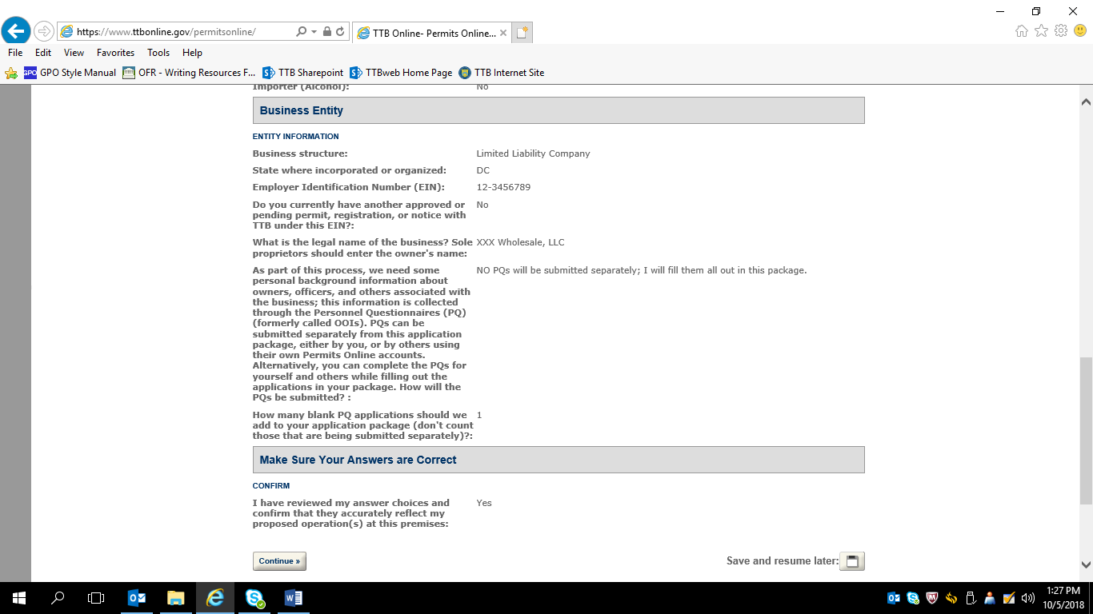

This screen shows the applications the respondent has to complete (Personnel Questionnaire approved under 1513–0002 and Application for Original Entity approved under several OMB control numbers, and these screens are not shown).

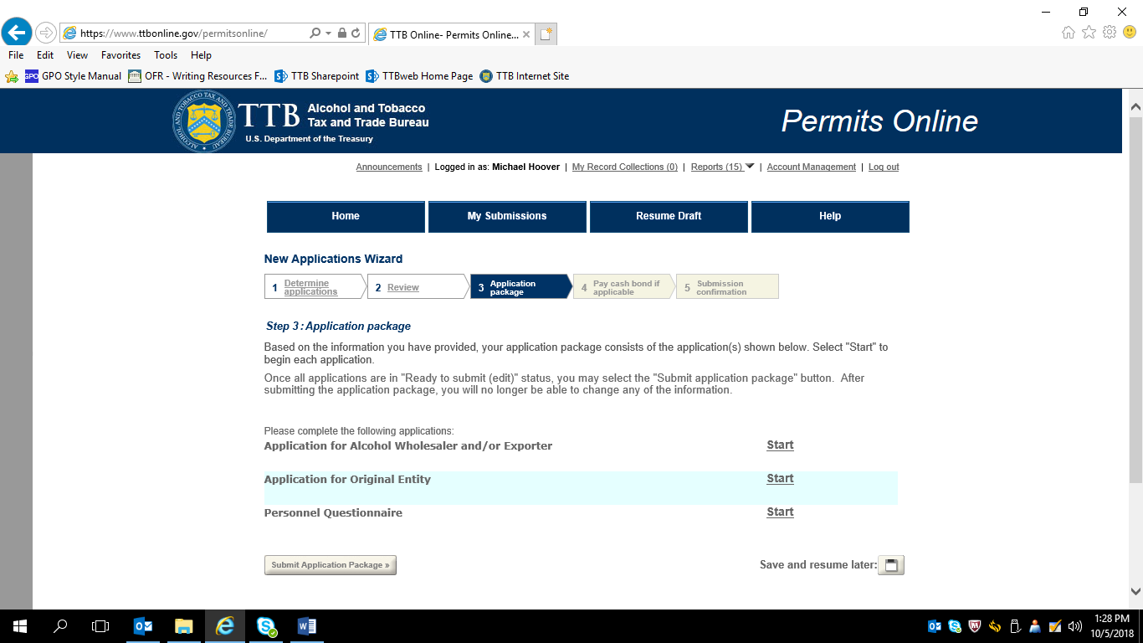

Clicking on “Alcohol Wholesaler and/or Export leads to this screen:

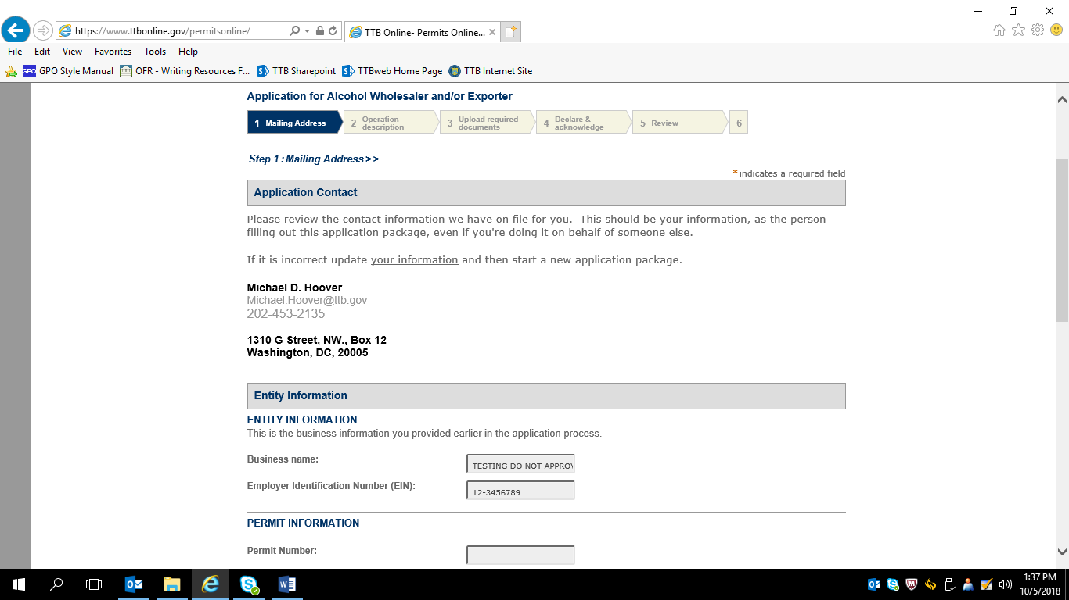

Screen continued:

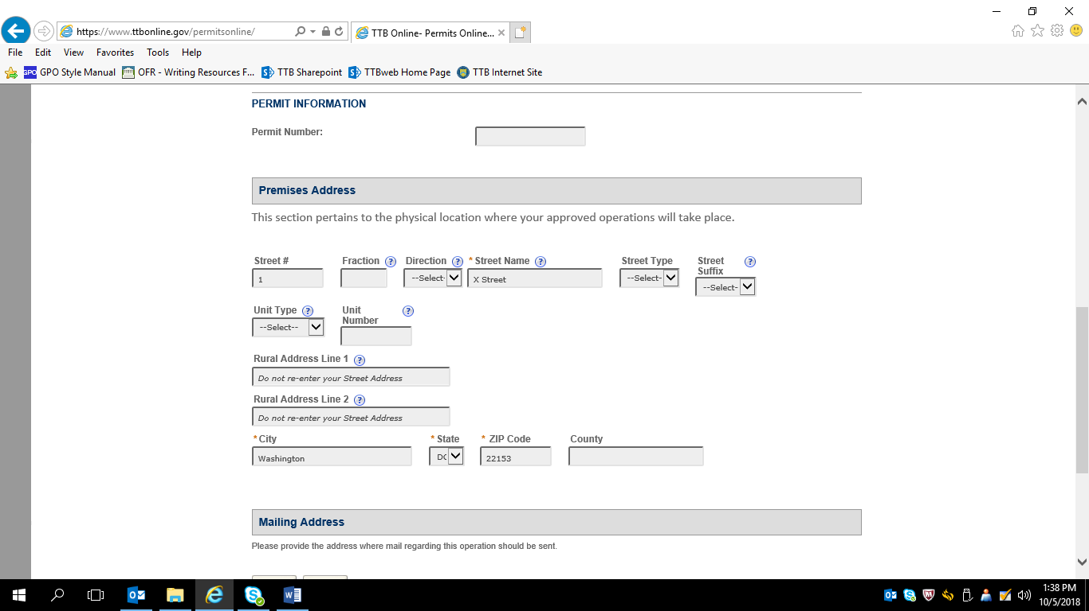

Screen continued:

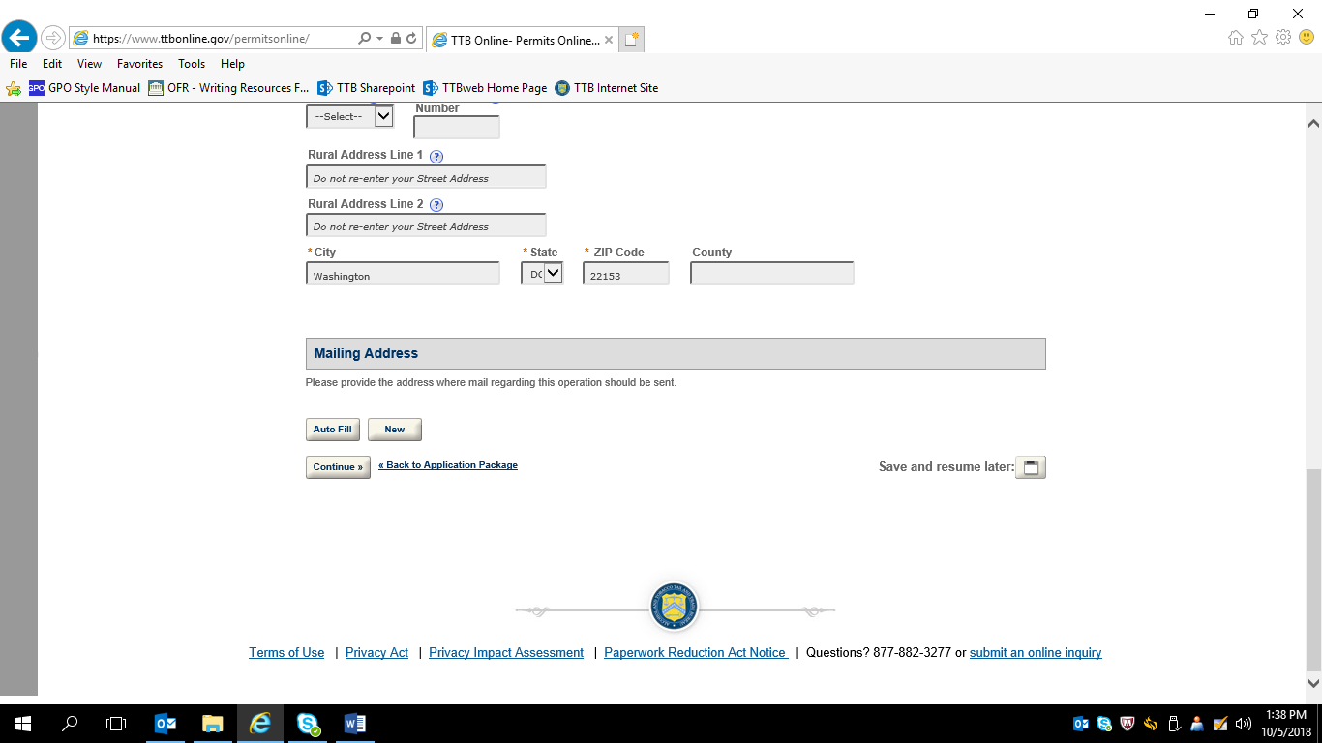

Business Name and other business information:

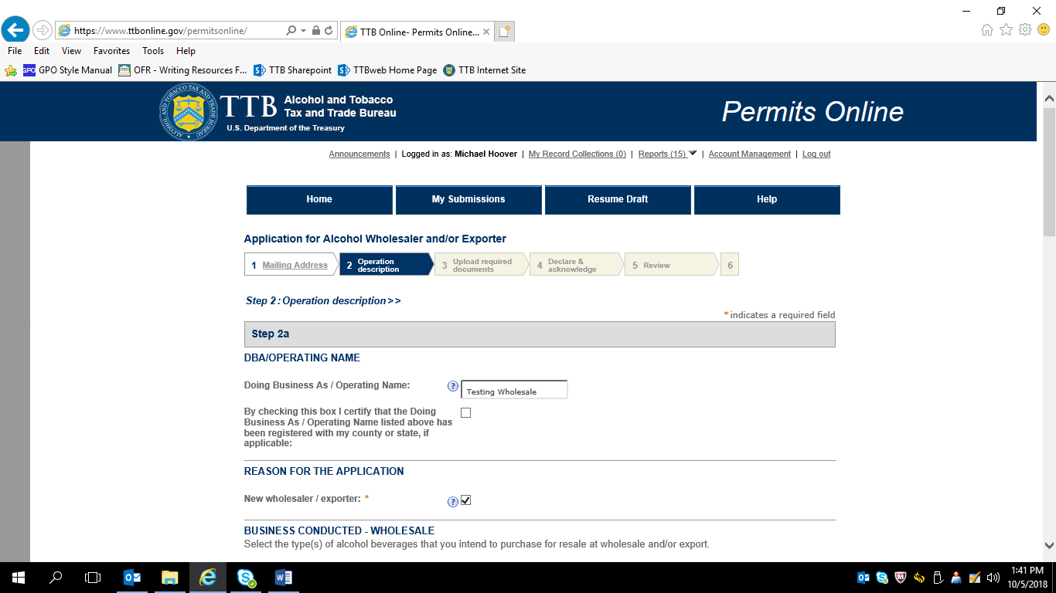

Screen continued:

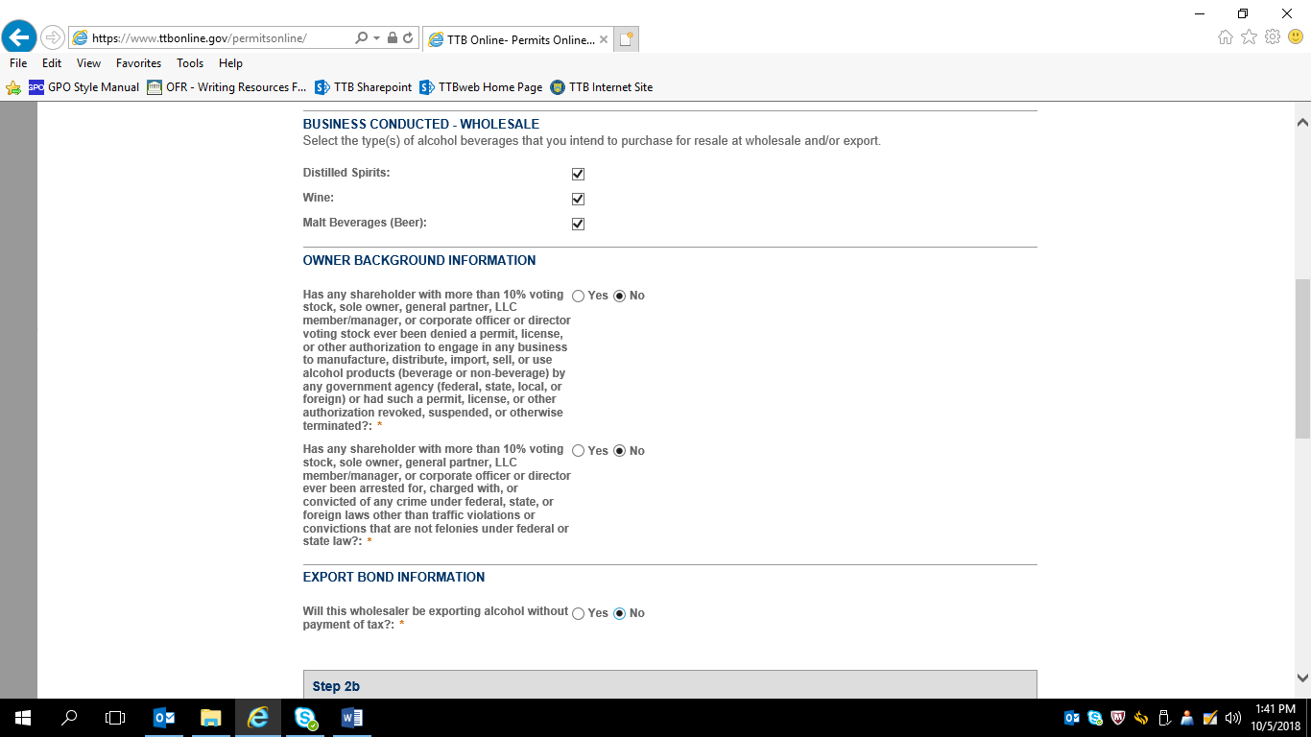

(Bond information approved under 1513–0135 and other control numbers and PONL bond information not shown here).

Supporting document upload screen:

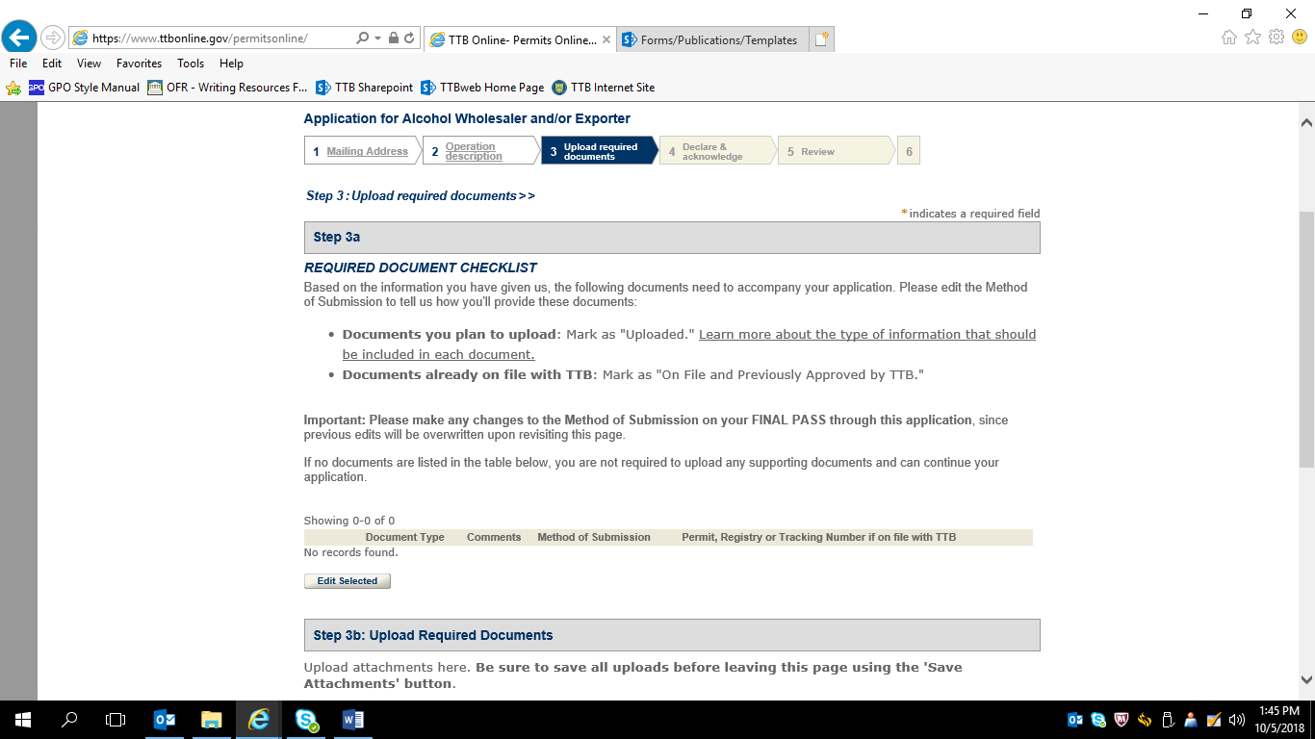

Declare and Acknowledge screen:

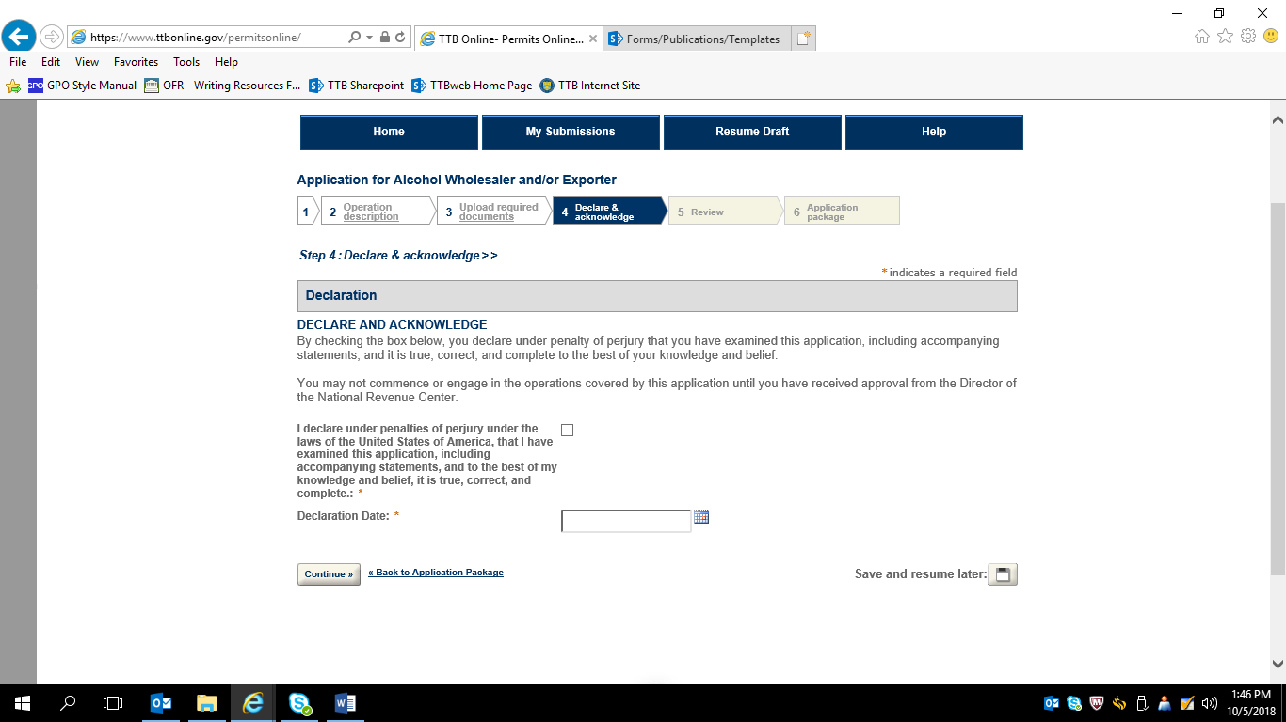

PONL user notification screens:

Terms of Use
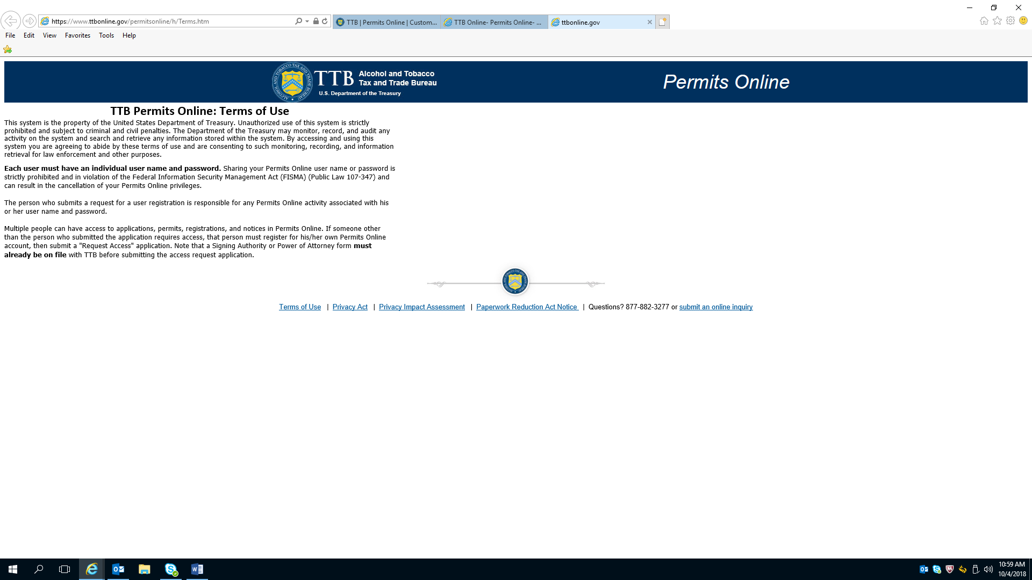

Privacy Act

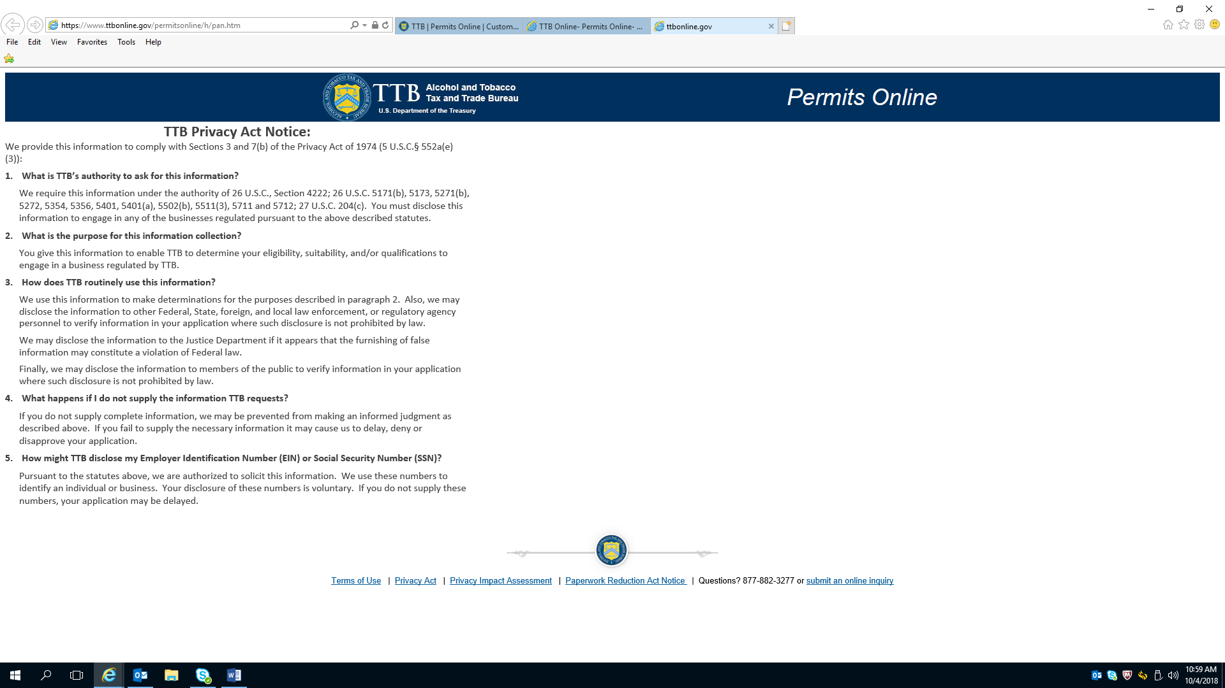

Privacy Impact Assessment

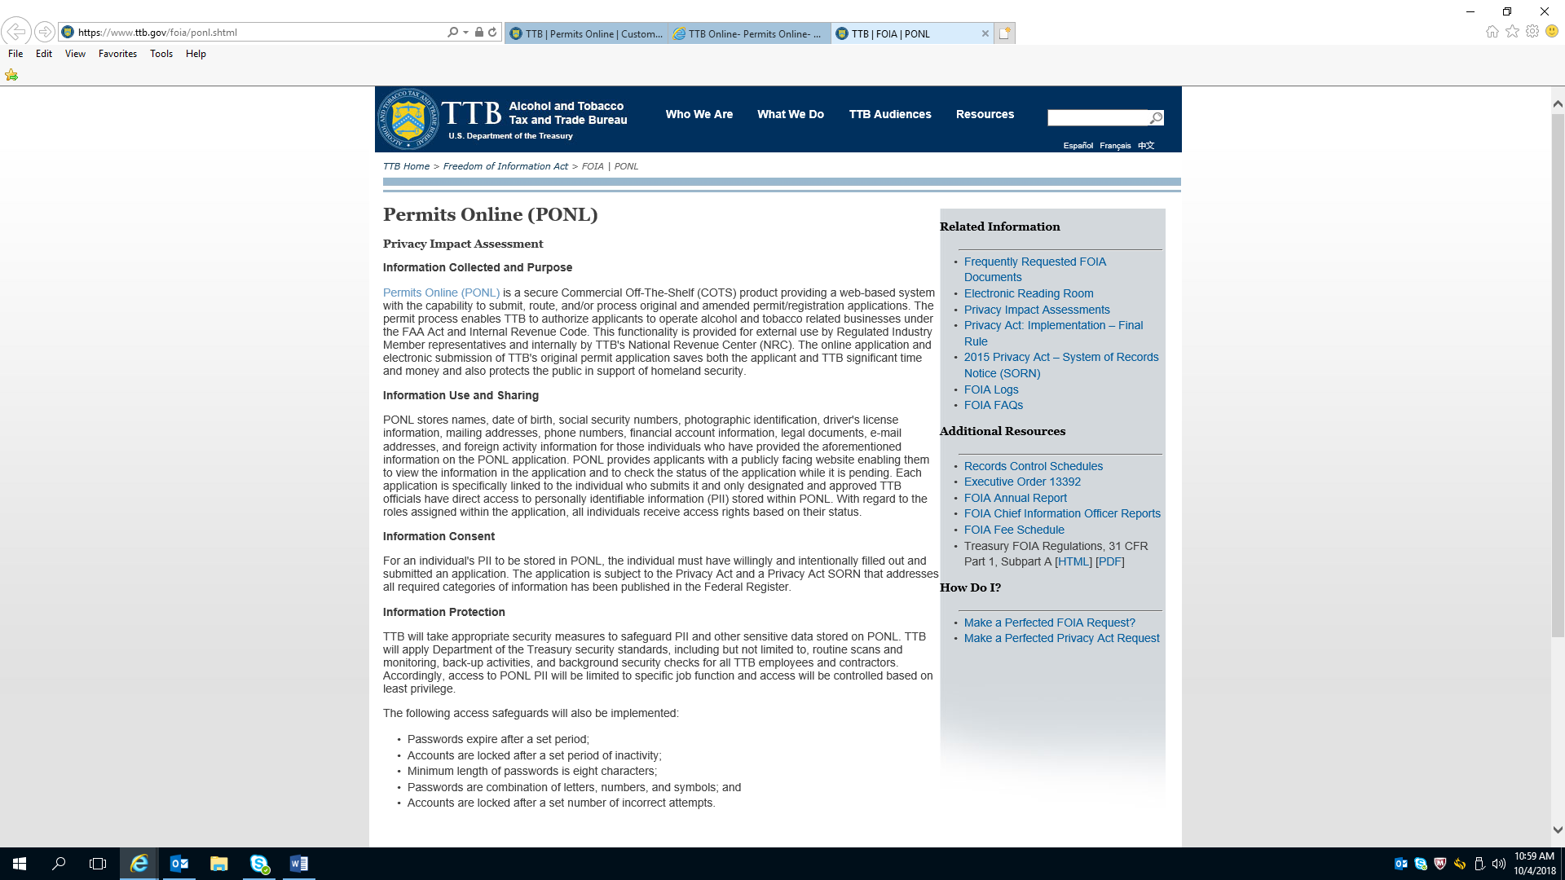

Privacy Impact Assessment (continued)

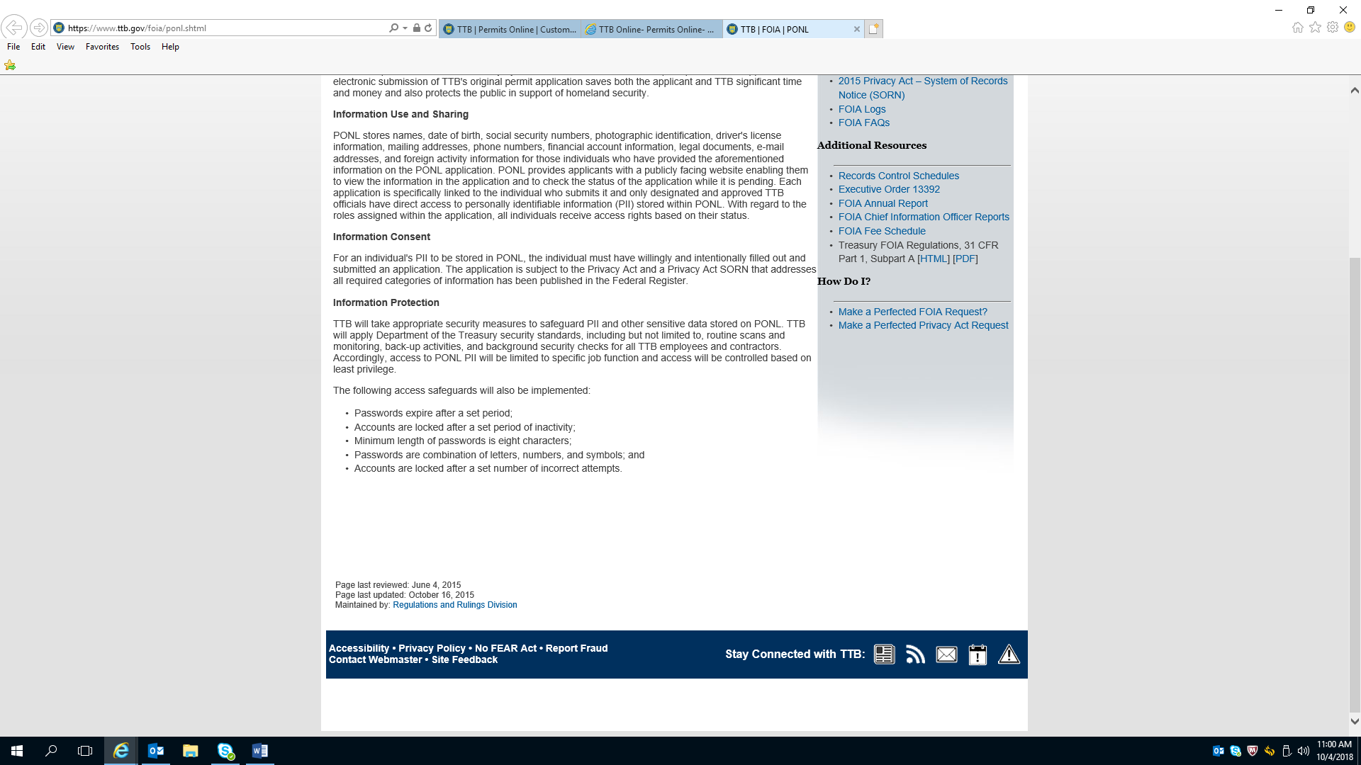

Paperwork Reduction Act Notice:

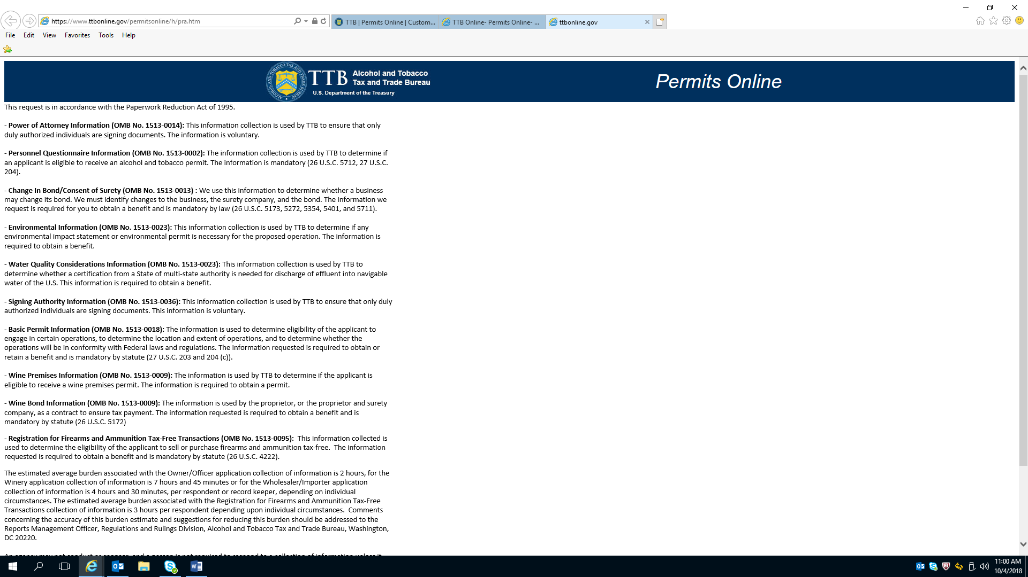

PRA Notice (Continued)

