Mockup of Vaccine Documentation collection from selectees/new hires in USA Staffing. Task instructions and privacy act statement are illustrative and may be revised as needed.
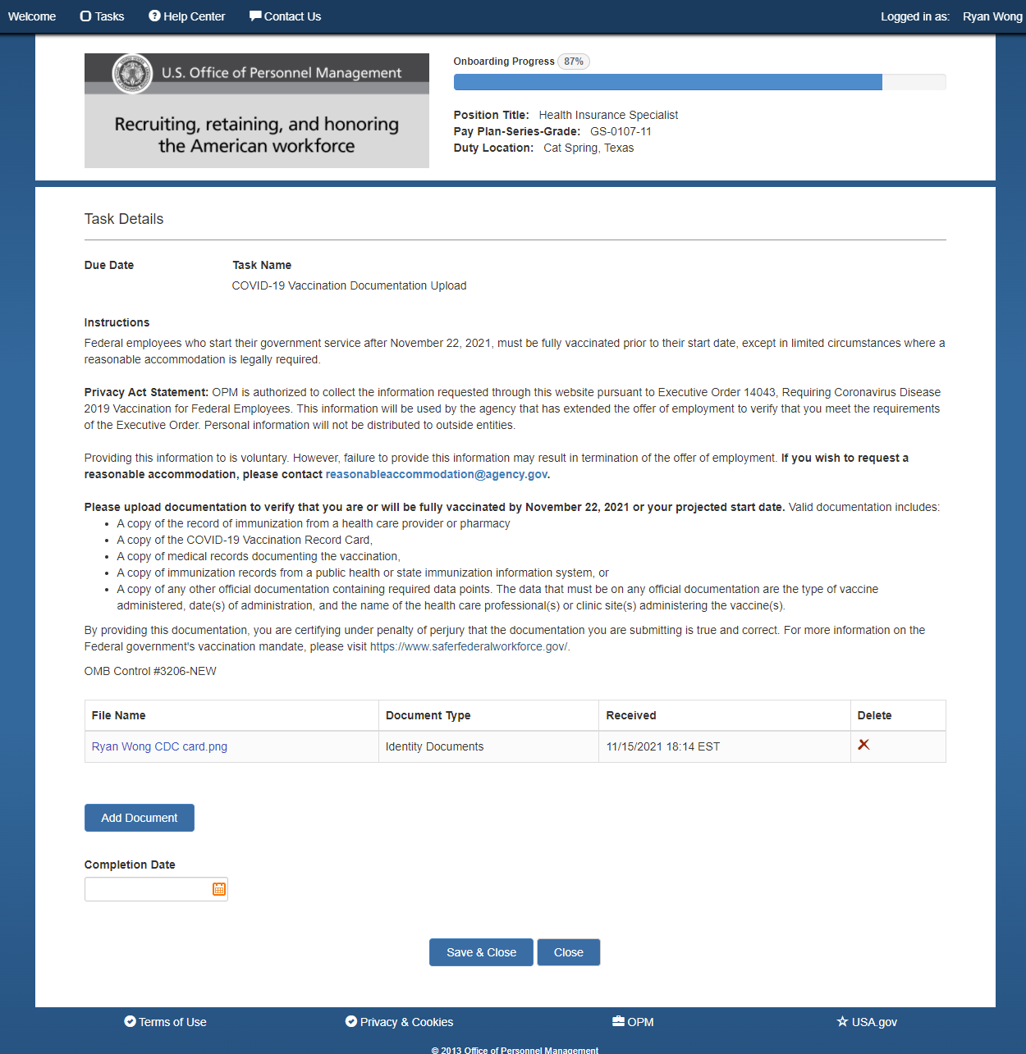

Appendix B: Current Public Facing Questionnaire Interface in USA Staffing Onboarding
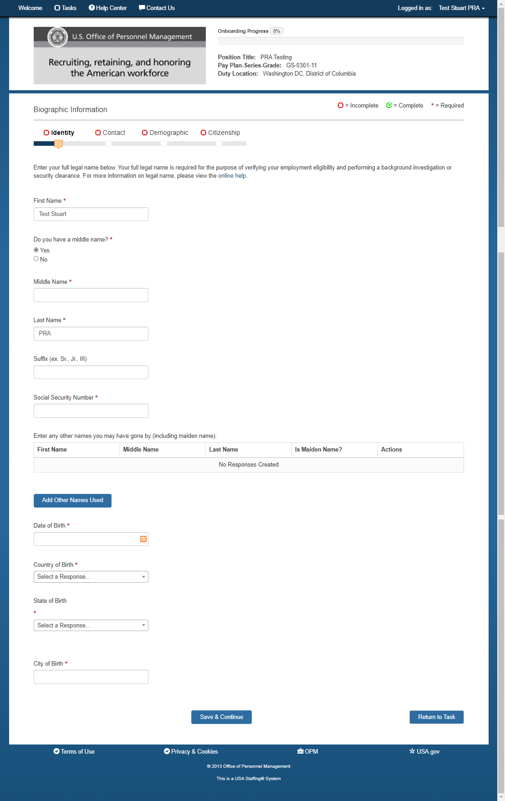
Biographic/Identity
Biographic/Contact Info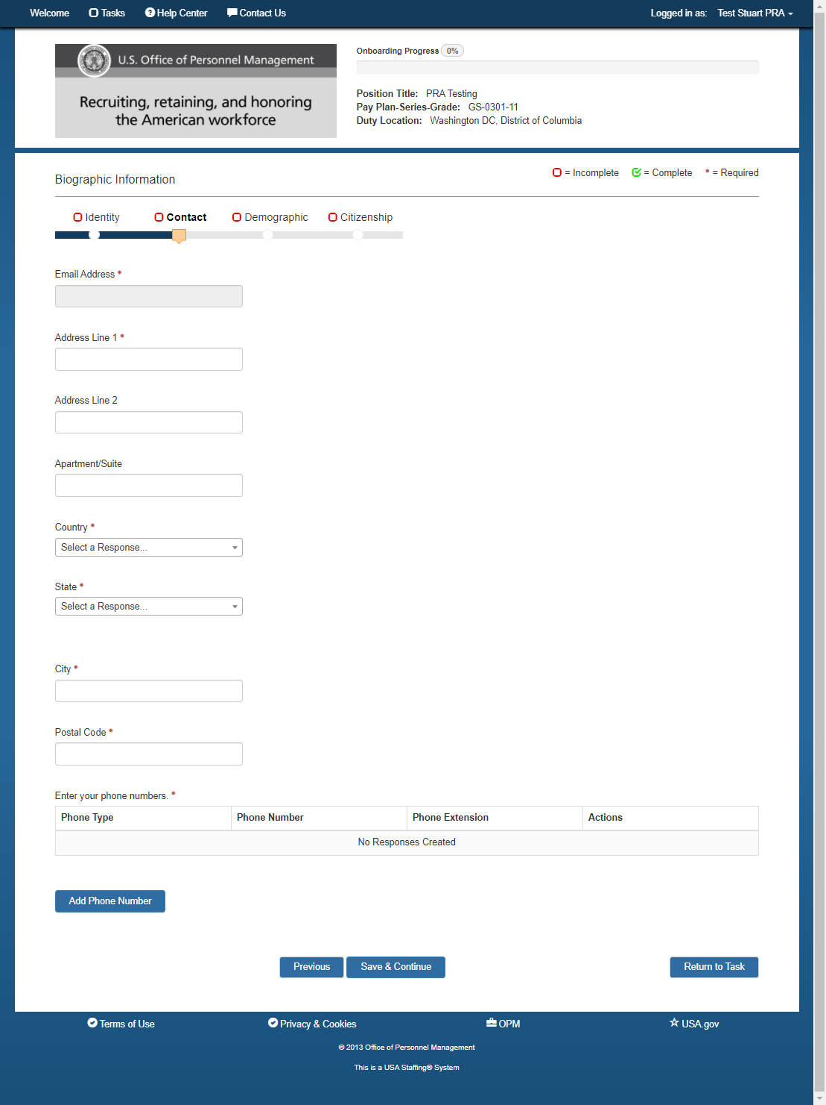
Biographic/Demographic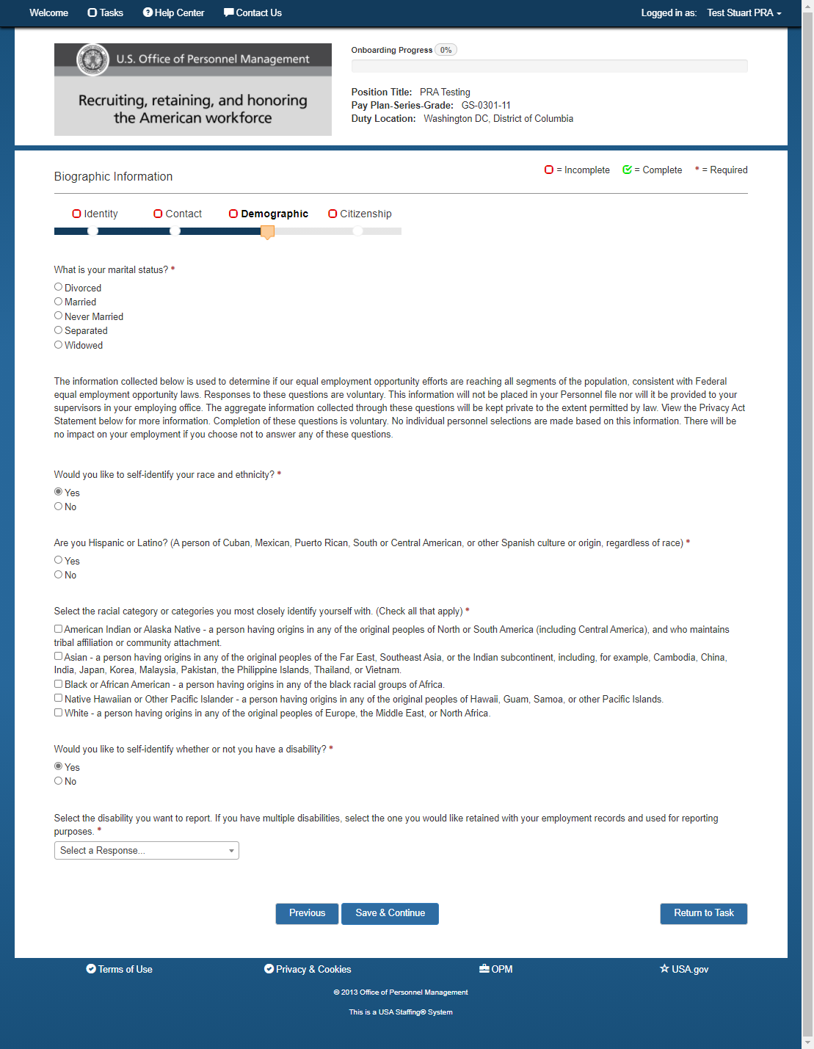
Biographic/Citizenship (Yes to US Citizenship)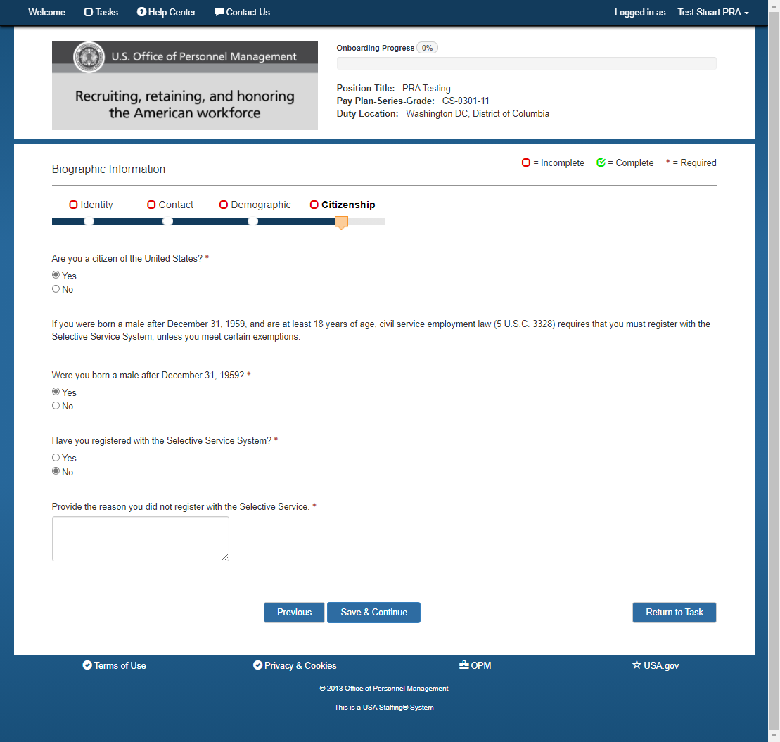

Biographic/Citizenship (No to US Citizenship)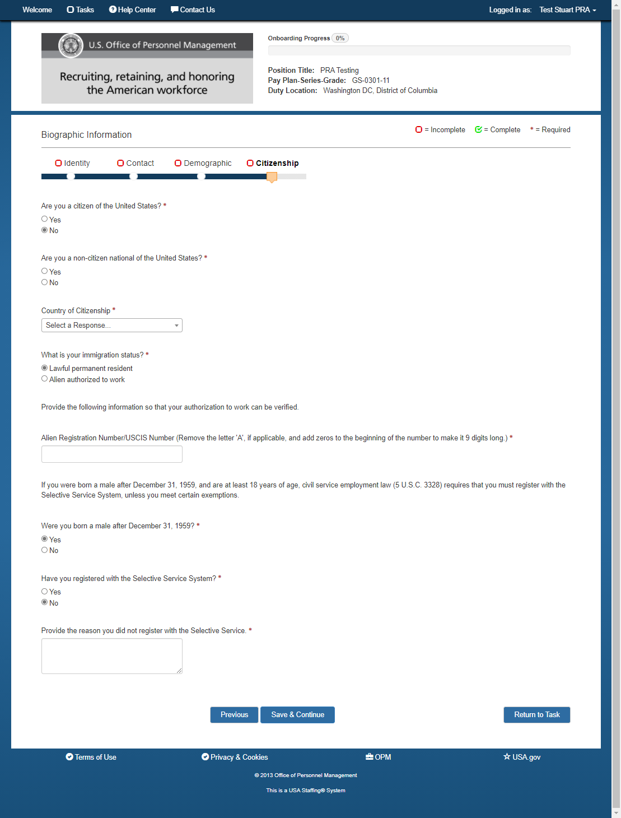

Biographic/Citizenship

(Alien Authorized to Work)
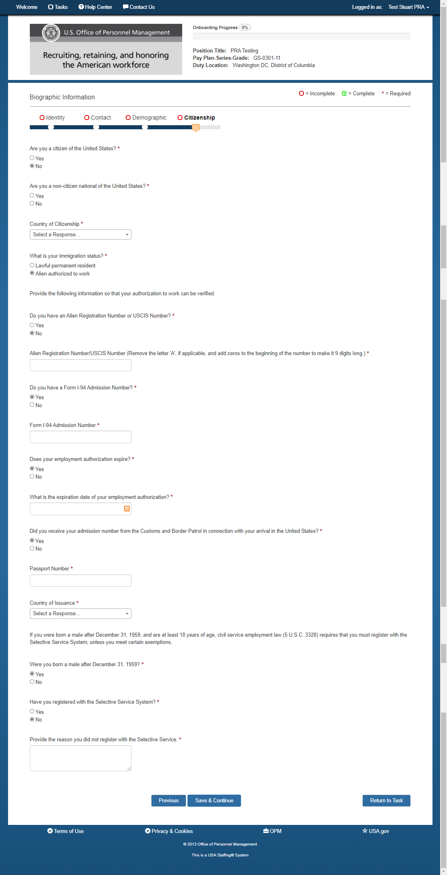

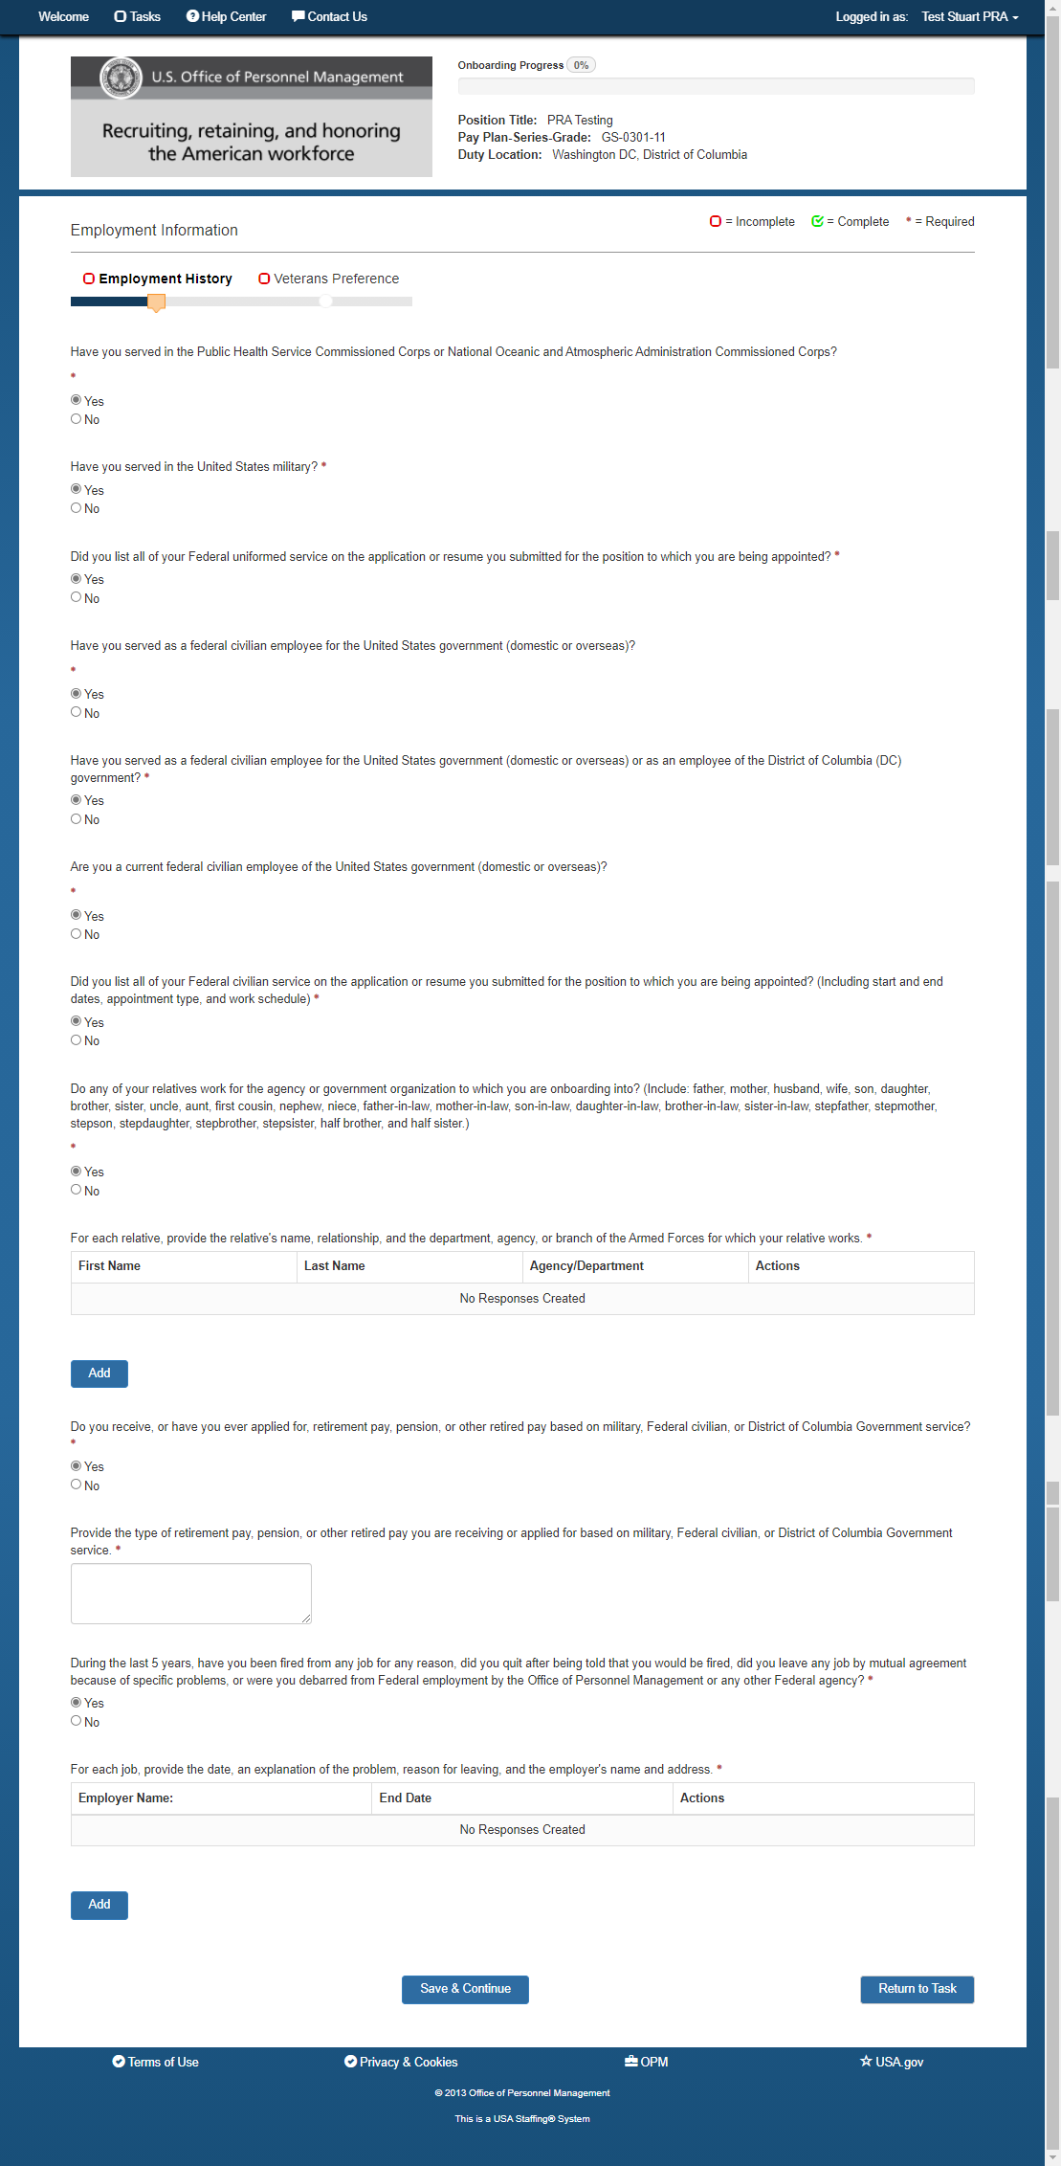
Employment/Employment History

Employment/Uniformed Service 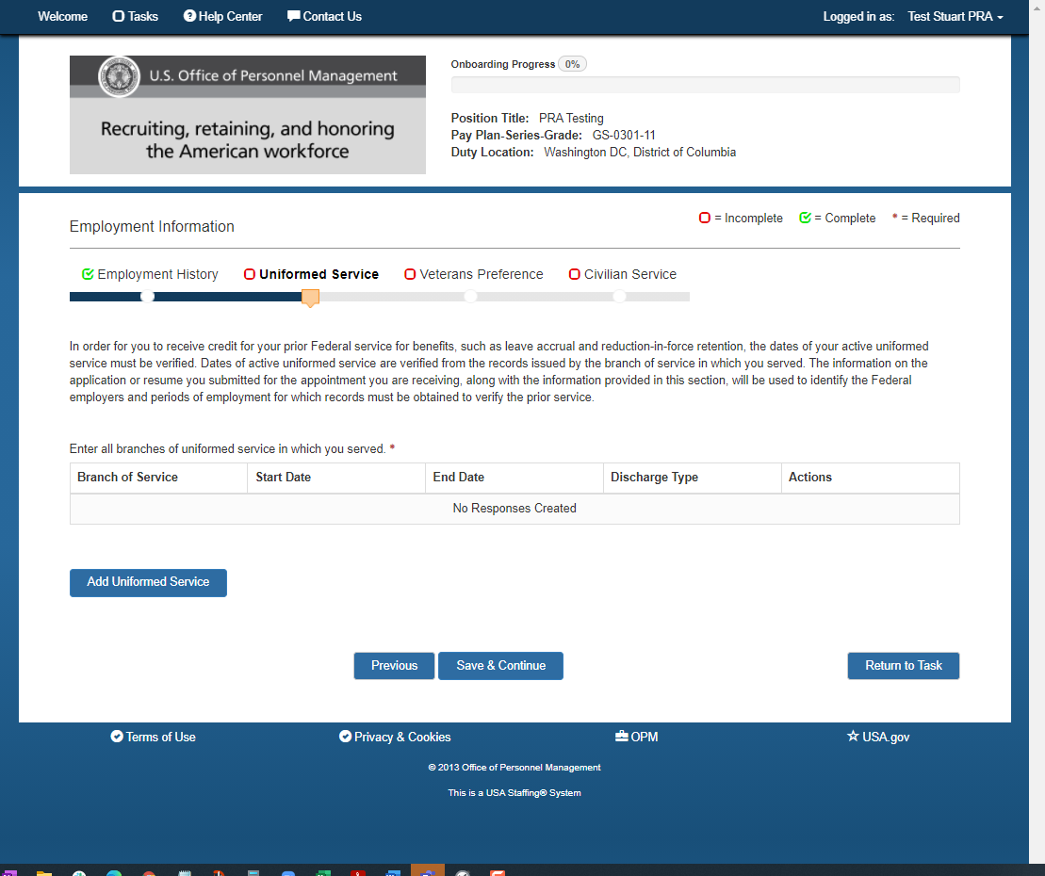

Employment/Veterans Preference (all possible questions displayed)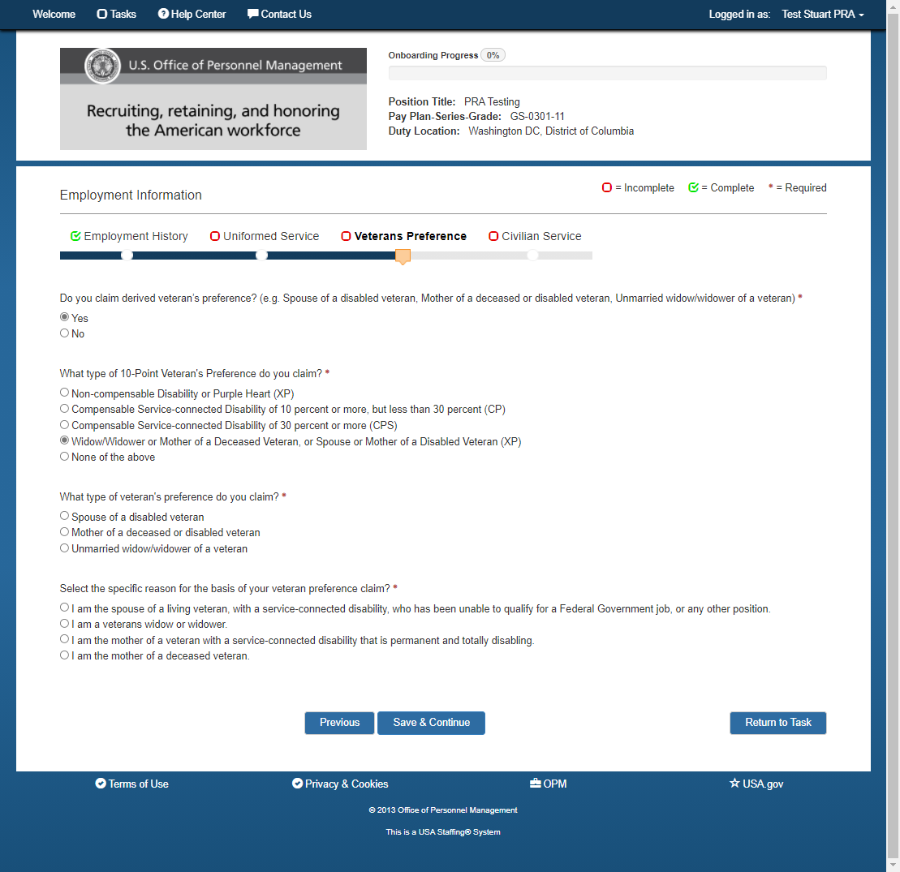

Employment/Civilian Service (All possible questions)
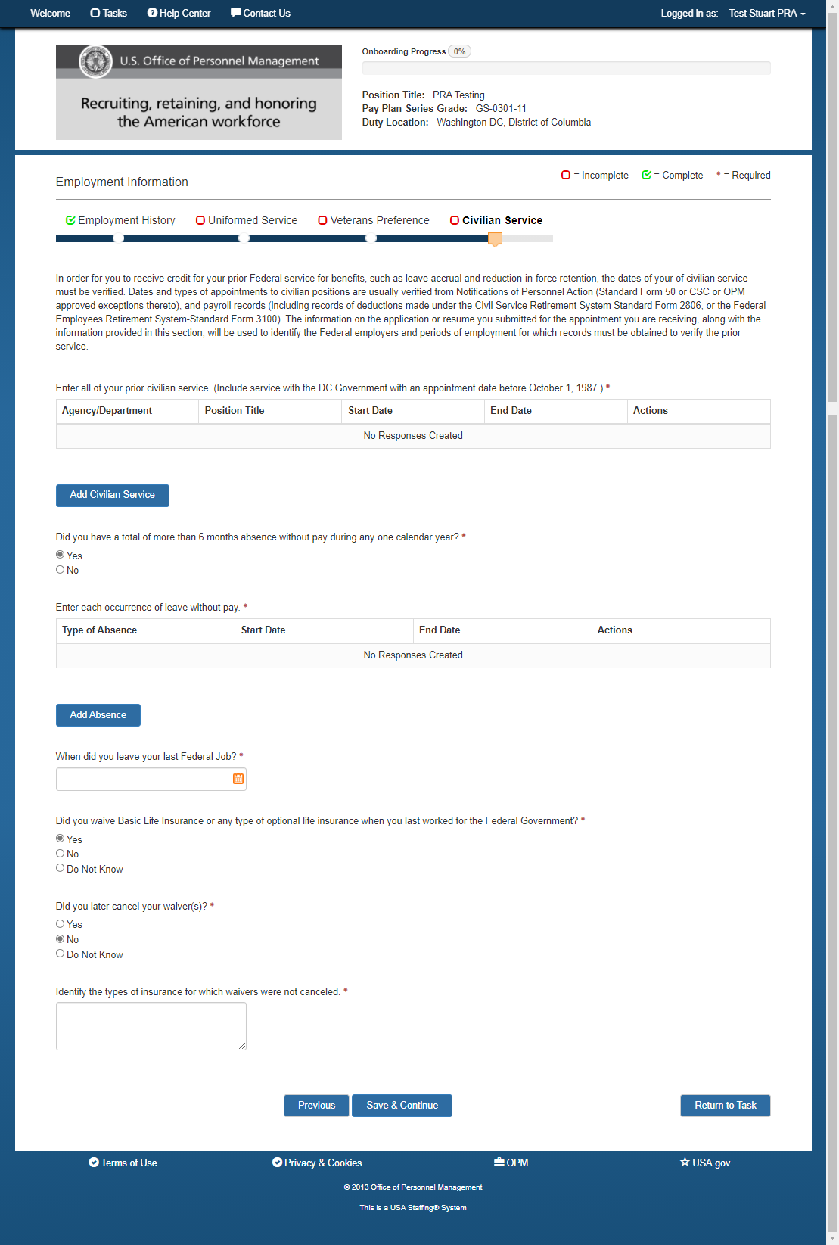

Benefits/Beneficiaries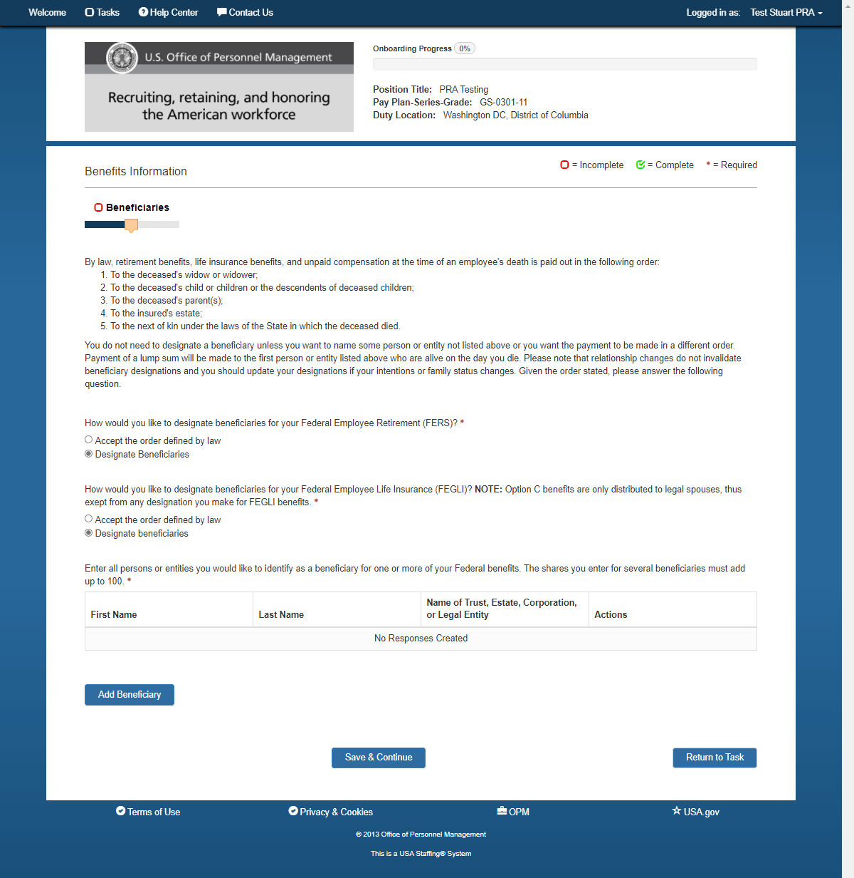

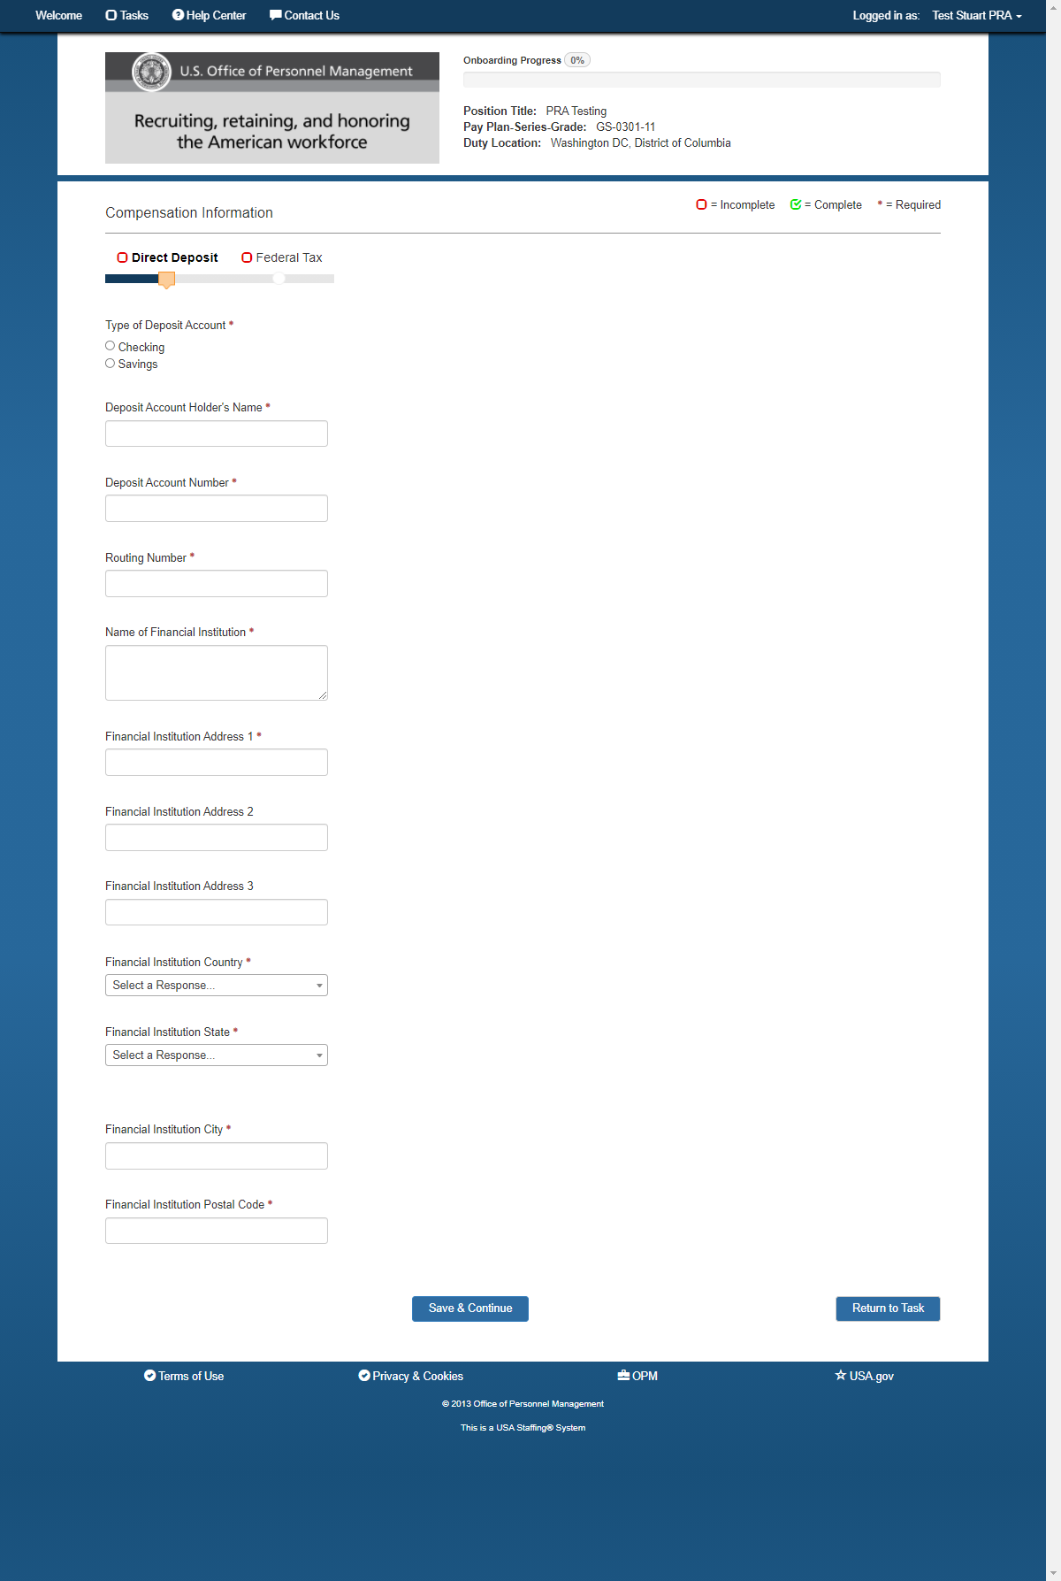
Compensation/Direct Deposit

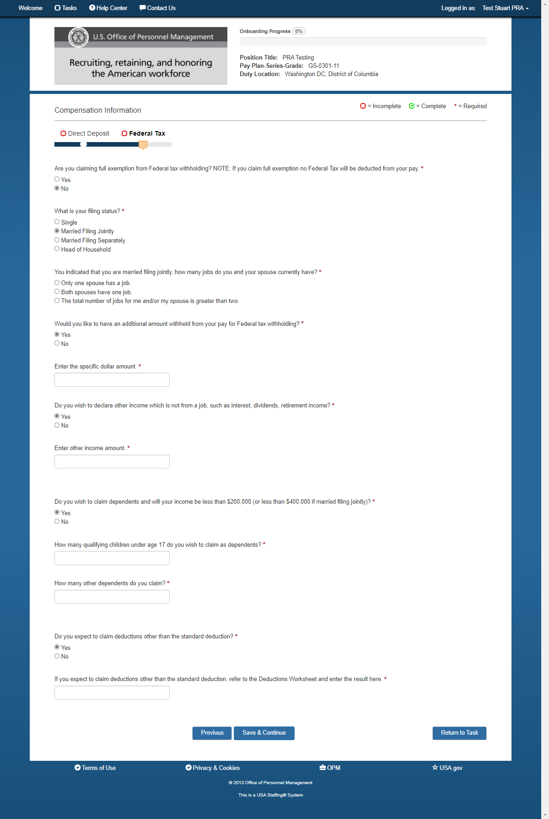
Compensation-Federal Tax (Married Filing Jointly Questions)

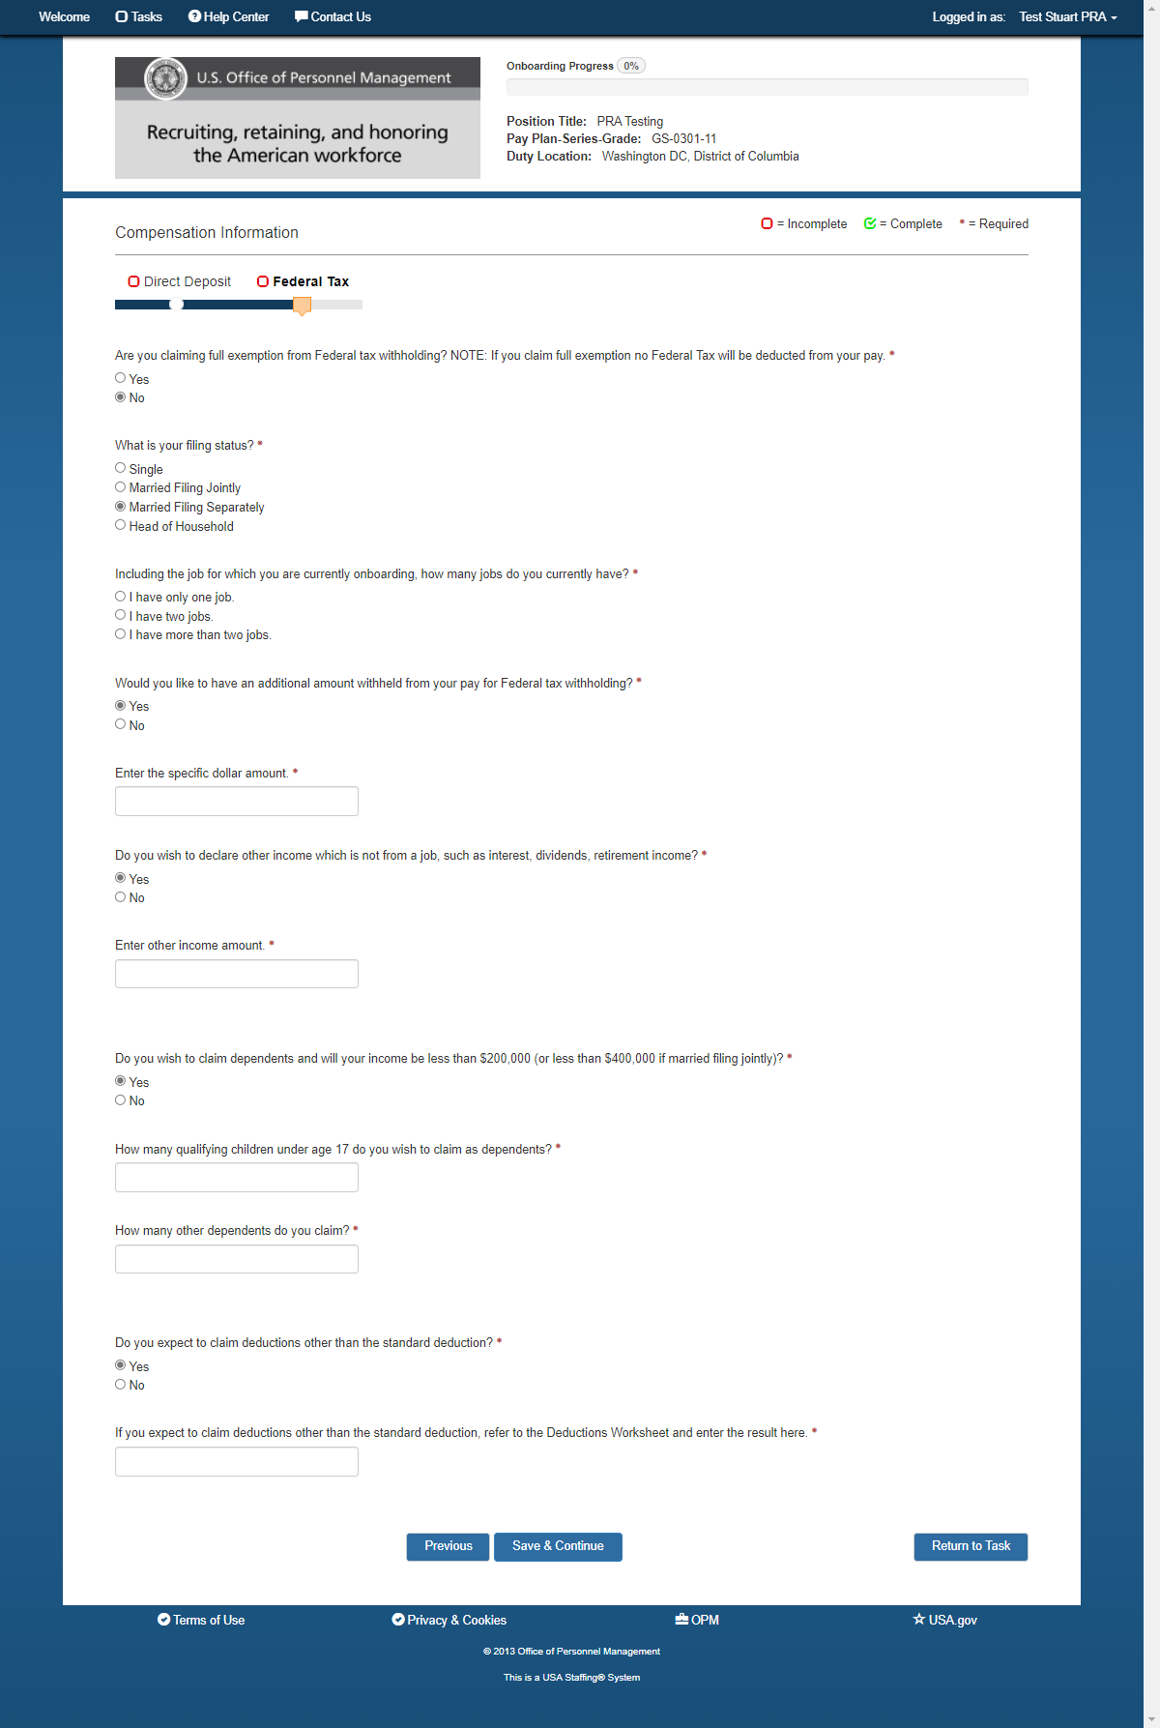
Compensation-Federal Tax (Married Filing Separately/Head of Household

