Supporting Statement for Paperwork Reduction Act Submissions

Title: USA Staffing Onboarding

OMB Control Number: 3206-NEW

A. Justification

1. Explain the circumstances that make the collection of information necessary. Identify any legal or administrative requirements that necessitate the collection. Attach a copy of the appropriate section of each statute and regulation mandating or authorizing the collection of information.

USA Staffing is OPM’s talent acquisition solution for Federal agencies to onboard candidates for Federal positions. Federal agencies purchase the services of USA Staffing through an Interagency Agreement (IAA) under the provisions of the Revolving Fund, 5 U.S.C. §1304 (e) (1), which permits OPM to perform human resources management services for Federal agencies on a cost-recovery basis.

USA Staffing’s public facing web page for onboarding individuals selected for Federal employment but who have not yet entered on duty, is accessed by authenticating at onboard.usataffing.gov using USAJOBS.gov accounts and provides a single interface to submit data and forms required during the Federal onboarding process. USA Staffing captures the essential information Federal agencies require to onboard applicants for Federal jobs under the authority of sections 1104, 1302, 3301 - 3320, 3361, 3393, and 3394 of Title 5 United States Code. This onboarding process also includes the collection of proof of vaccination against COVID 19, pursuant to Executive Order 14043, Requiring Coronavirus Disease 2019 Vaccination for Federal Employees, and guidance from the Safer Federal Workforce Taskforce. Individuals who begin their Federal employment after November 22, 2021, are required to provide documentation to prove they are vaccinated prior to their enter on duty date. OPM’s USA Staffing proposes to provide a streamlined mechanism for agencies who use USA Staffing to onboard new employees to collect this information in a secure, efficient, and standard manner. Accordingly, emergency clearance of this information collection is necessary to enable agencies to comply with the EO and the Taskforce guidance.

2. Indicate how, by whom, and for what purpose the information is to be used. Except for a new collection, indicate the actual use the agency has made of the information received from the current collection.
Individuals enter their information electronically in the USA Staffing system. The system is used to capture the essential information Federal agencies require to onboard selectees, which will include confirmation of their COVID 19 vaccination.
3. Describe whether, and to what extent, the collection of information involves the use of automated, electronic, mechanical, or other technological collection techniques or other forms of information technology, e.g., permitting electronic submission of responses, and the basis for the decision for adopting this means of collection. Also describe any consideration of using information technology to reduce burden.

The collection of information is handled predominantly online via the USA Staffing interface, where selectees answer questions to complete assigned forms, sign forms electronically, and upload supporting documents necessary to enter on duty with the Federal government.

The removal of paper processes has improved the quality, speed, and security of onboarding new employees and substantially increased the quality of engagement between Human Resources (HR) and the incoming employee. Agency HR representatives identify the required forms and documentation that must be provided in accordance with each agency’s business and legal requirements. USA Staffing facilitates the process in a single online, secure, and configurable tool that is accessible by all participants in the onboarding process. The information collected through USA Staffing is only accessible by personnel the agency deems necessary to the onboarding process.

Appendix A provides a “mock-up” of the document upload task and instructions that would be assigned to new hires to collect their vaccination documentation. Uploading a document into USA Staffing is equivalent in process and time to attaching a document to an email.

4. Describe efforts to identify duplication. Show specifically why any similar information already available cannot be used or modified for use for the purposes described in Item 2 above.

USA Staffing removes duplication via a questionnaire system which collects personal information only once and populates that information across all forms that require it. It ensures forms are filled out completely and accurately before submission, thus streamlining the redundant effort often required during an in-person, paper-based onboarding process.

5. If the collection of information impacts small businesses or other small entities (Item 5 of OMB Form 83-I), describe any methods used to minimize.

N/A

6. Describe the consequence to Federal program or policy activities if the collection of information is not conducted, or is conducted less frequently, as well as any technical or legal obstacles to reducing burden.

If the information is not collected, agencies will not be able to onboard selectees for Federal employment in an electronic process. The online onboarding module in USA Staffing is designed to capture the essential information that Federal agencies require to onboard selectees to Federal jobs and reuse data to complete additionally needed forms. In addition, failure to collect vaccination information in the onboarding process will result in an inability of agencies to meet the requirements of EO 14043 and the Safer Federal Workforce Taskforce.

7. Explain any special circumstances that would cause an information collection to be conducted in a manner:
- requiring respondents to report information to the agency more often than quarterly.
- requiring respondents to prepare a written response to a collection of information in fewer than 30 days after receipt of it;
- requiring respondents to submit more than an original and two copies of any document;
- requiring respondents to retain records, other than health, medical, government contract, grant-in-aid, or tax records, for more than three years;
- in connection with a statistical survey, that is not designed to produce valid and reliable results that can be generalized to the universe of study;
- requiring the use of statistical data classification that has not been reviewed and approved by OMB;
- that includes a pledge of confidentiality that is not supported by authority established in statute or regulation, that is not supported by disclosure and data security policies that are consistent with the pledge, or which unnecessarily impedes sharing of data with other agencies for compatible confidential use; or
- requiring respondents to submit proprietary trade secrets, or other confidential information unless the agency can demonstrate that it has instituted procedures to protect the information’s confidentiality to the extent permitted by law.

Individuals may be required to respond to the collection of information fewer than 30 days after receipt in order to onboard at the agency that selected them for employment. There are no other special circumstances involved with the collection of this information.

8. Federal Register Notice: Provide a copy and identify the date and page number of publication in the Federal Register of the agency’s notice soliciting comments on the information collection prior to submission to OMB.

OPM has requested and has been granted a waiver from the requirement to publish a notice in the Federal Register in connection with a request for emergency clearance of this information collection request.

9. Explain any decision to provide any payment or gift to respondents, other than remuneration of contractors or grantees.

No gifts or payments of any kind have been provided to any individuals who are connected to this collection.

10. Describe any assurance of confidentiality provided to respondents and the basis for the assurance in statute, regulation, or agency policy.

This information collection is governed by the Privacy Act of 1974 and included in the OPM/GOVT-5 system of records.

11. Provide additional justification for any questions of a sensitive nature, such as sexual behavior and attitudes, religious beliefs, and other matters that are commonly considered private. This justification should include the reasons why the agency considers the questions necessary, the specific uses to be made of the information, the explanation to be given to persons from whom the information is requested, and any steps to be taken to obtain their consent.

This information collection does not include questions of a sensitive nature, such as sexual behavior and attitudes, religious beliefs, and other matters that are commonly considered private. This information collection does include a request for information documenting that an individual has received the COVID-19 vaccination. To the extent this information is deemed sensitive by respondents, it is necessary to promote the safety of Federal buildings, and the Federal workforce, and others on site at agency facilities consistent with Executive Order and government-wide guidance.

12. Provide estimates of the hour burden of the collection of information. The statement should:

a. Indicate the number of respondents, frequency of response, annual hour burden, and an explanation of how the burden was estimated. Unless directed to do so, agencies should not conduct special surveys to obtain information on which to base hour burden estimates. Consultation with a sample (fewer than 10) of potential respondents is desired. If the hour burden on respondents is expected to vary widely because of differences in activity, size, or complexity, show the range of estimated hour burden, and explain the reasons for the variance. Generally, estimates should not include burden hours for customary and usual business practices.
b. If this request for approval covers more than one form, provide separate hour burden estimates for each form and aggregate the hour burdens in Item 13 of OMB Form 83-I.
c. Provide estimates of annualized cost to respondents for the hour burdens for collections of information, identifying and using appropriate wage rate categories. The cost of contracting out or paying outside parties for information collection activities should not be included here. Instead, this cost should be included in Item 14.

Due to the fact that USA Staffing Onboarding is used to collect new hire information per the specific requirements of each customer agency to enable for a more efficient onboarding experience, completion time varies based on the requirements identified by each individual agency, position selected for and selectee’s employment history. The average completion time for the onboarding questionnaire, review of responses for accuracy and completeness, and submission to human resources is estimated at 25minutes per individual, yielding an estimated annual burden of 237,030 hours.

Type of Respondent | Collection Name | No. of Respondents | No. of Responses per Respondent | Avg. Burden per Response (in hours) | Total Annual Burden (in hours)
Selectees for Federal Employment (aka New Hires) | USA Staffing Onboarding | 568,874 | 1 | .42 | 238,927

Appendix B provides screen captures of a typical new hire’s experience competing a representative onboarding questionnaire.

13. Provide an estimate of the total annual cost burden to respondents or recordkeepers resulting from the collection of information. (Do not include the cost of any hour burden shown in Items 12 and 14.)

The cost estimate should be split into two components: (1) a total capital and start-up cost component (annualized over its expected useful life); and (b) a total operation and maintenance and purchase of services component. The estimates should take into account costs associated with generating, maintaining, and disclosing or providing the information. Include descriptions of methods used to estimate major cost factors including system and technology acquisition, expected useful life of capital equipment, the discount rate(s), and the time period over which costs will be incurred. Capital and start-up costs include, among other items, preparations for collecting information such as purchasing computers and software; monitoring, sampling, drilling and testing equipment; and record storage facilities.

If cost estimates are expected to vary widely, agencies should present ranges of cost burdens and explain the reasons for the variance. The cost of purchasing or contracting out information collection services should be a part of this cost burden estimate. In developing cost burden estimates, agencies may consult with a sample of respondents (fewer than 10), utilize the 60-day pre-OMB submission public comment process and use existing economic or regulatory impact analysis associated with the rulemaking containing the information collection as appropriate.

Generally, estimates should not include purchases of equipment or services, or portions thereof, made: (1) prior to October 1, 1995, (2) to achieve regulatory compliance with requirements not associated with the information collection, (3) for reasons other than to provide information to keep records for the government, or (4) as part of customary and usual business or private practices.

Type of Respondent | Form Name | No. of Respondents | Total No. of  Responses | Avg. Burden per Response (in hours) | Hourly Wage Rate | Total  Respondent Costs
Selectees for Federal Employment (aka New Hires) | USA Staffing Onboarding | 568,874 | 1 | .42 | $27.07 | $6,467,756

14. Provide estimates of annualized cost to the Federal Government. Also, provide a description of the method used to estimate cost, which should include quantification of hours, operational expenses (such as equipment, overhead, printing and support staff), and any other expense that would have been incurred without this collection of information. You may also aggregate cost estimates for Items 12, 13, and 14 in a single table.

The annualized cost to the Federal government of USA Staffing Onboarding is estimated at $2,750,000, which is $4.83 per new hire. This cost includes overhead, direct labor, forms design, development, and agency/new hire support.

15. Explain the reasons for any program changes or adjustments reported in Items 13 or 14 of the OMB Form 83-I. Changes in hour burden, i.e., program changes or adjustments made to annual reporting
and recordkeeping hour and cost burden. A program change is the result of deliberate Federal government action. All new collections and any subsequent revisions of existing collections (e.g., the addition or deletion of questions) are recorded as program changes. An adjustment is a change that is not the result of a deliberate Federal government action. These changes that result from new estimates or actions not controllable by the Federal government are recorded as adjustments.

Not applicable.

16. For collections of information whose results will be published, outline plans for tabulation and publication. Address any complex analytical techniques that will be used. Provide the time schedule for the entire project, including beginning and ending dates of the collection of information, completion of report, publication dates, and other actions.

No information collected from the form will be published.

17. If seeking approval to not display the expiration date for OMB approval of the information collection, explain reasons that display would be inappropriate.

Not applicable. Display of OMB Control Number and expiration date is acceptable.

18. Explain each exception to the certification statement identified in Item 19 “Certification for Paperwork Reduction Act Submissions,” of OMB Form 83-I.

No exceptions are requested for this collection.

Appendices

Appendix A: Mockup of Vaccine Documentation collection from selectees/new hires in USA Staffing. Task instructions and privacy act statement are illustrative and may be revised as needed.
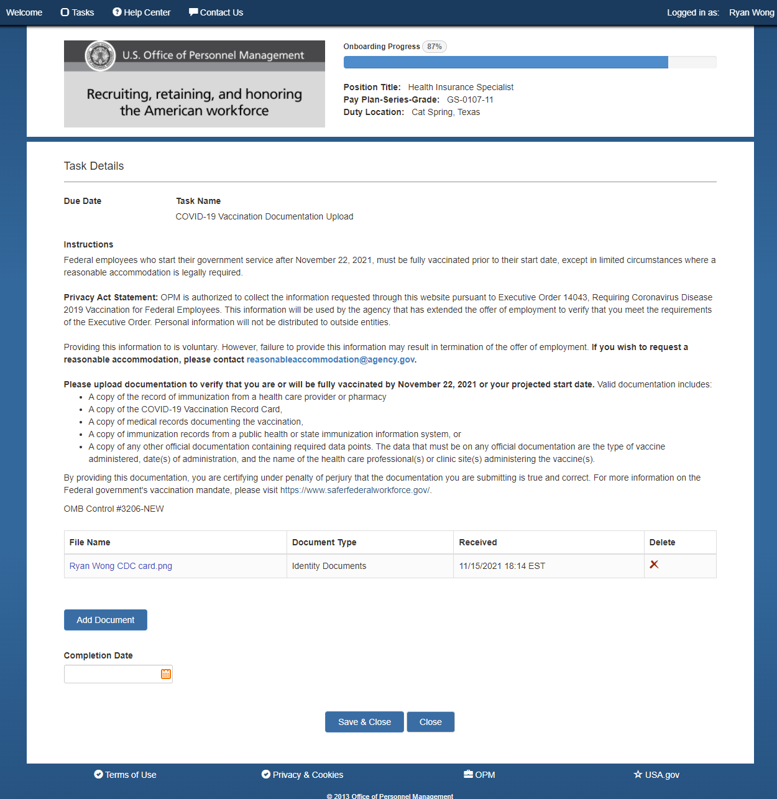

Appendix B: Current Public Facing Questionnaire Interface in USA Staffing Onboarding
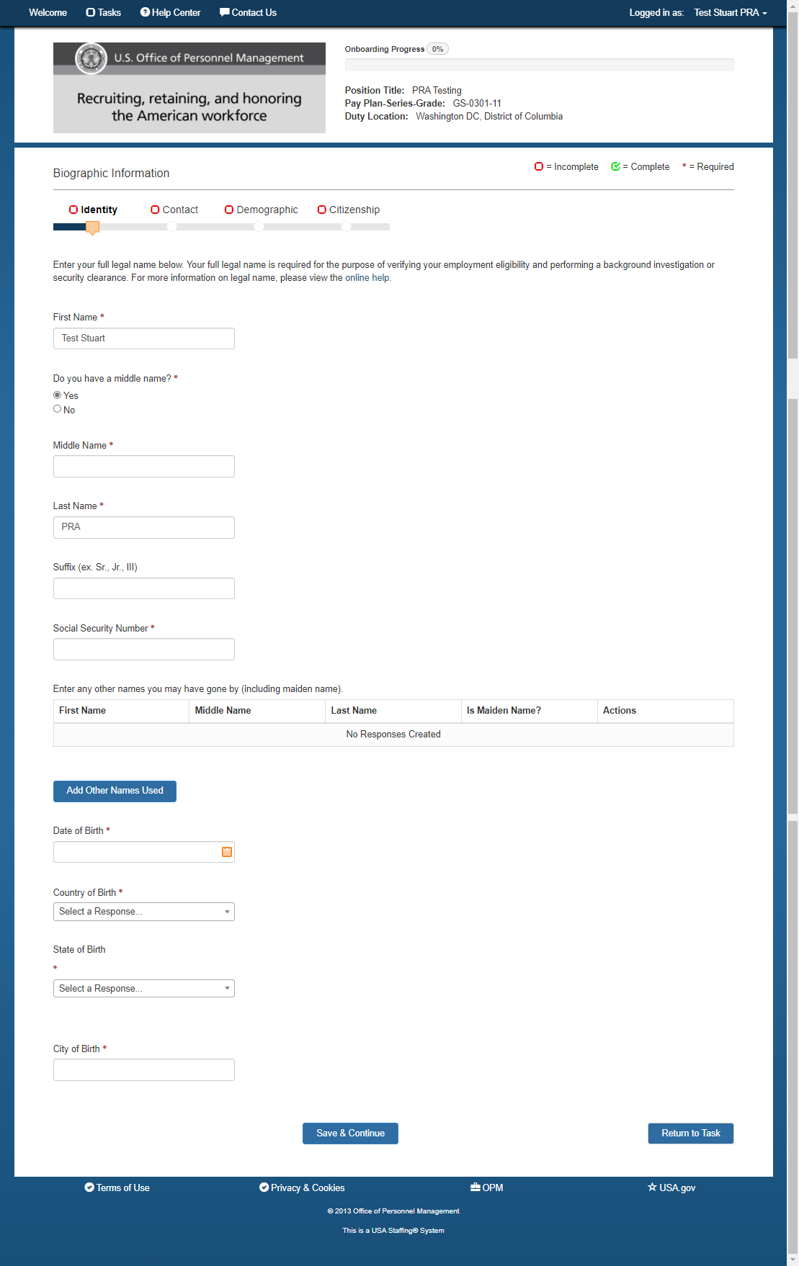
Biographic/Identity
Biographic/Contact Info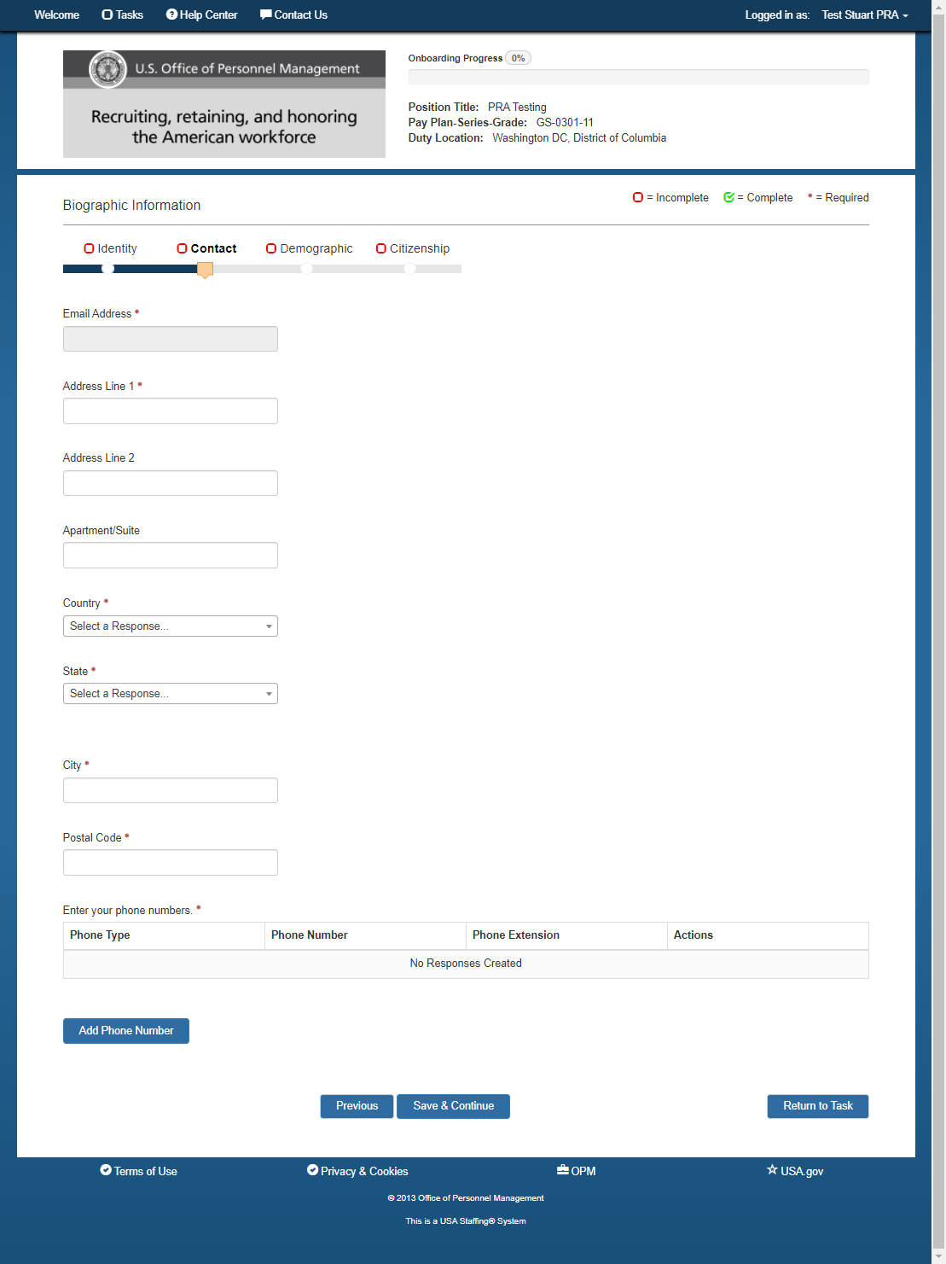
Biographic/Demographic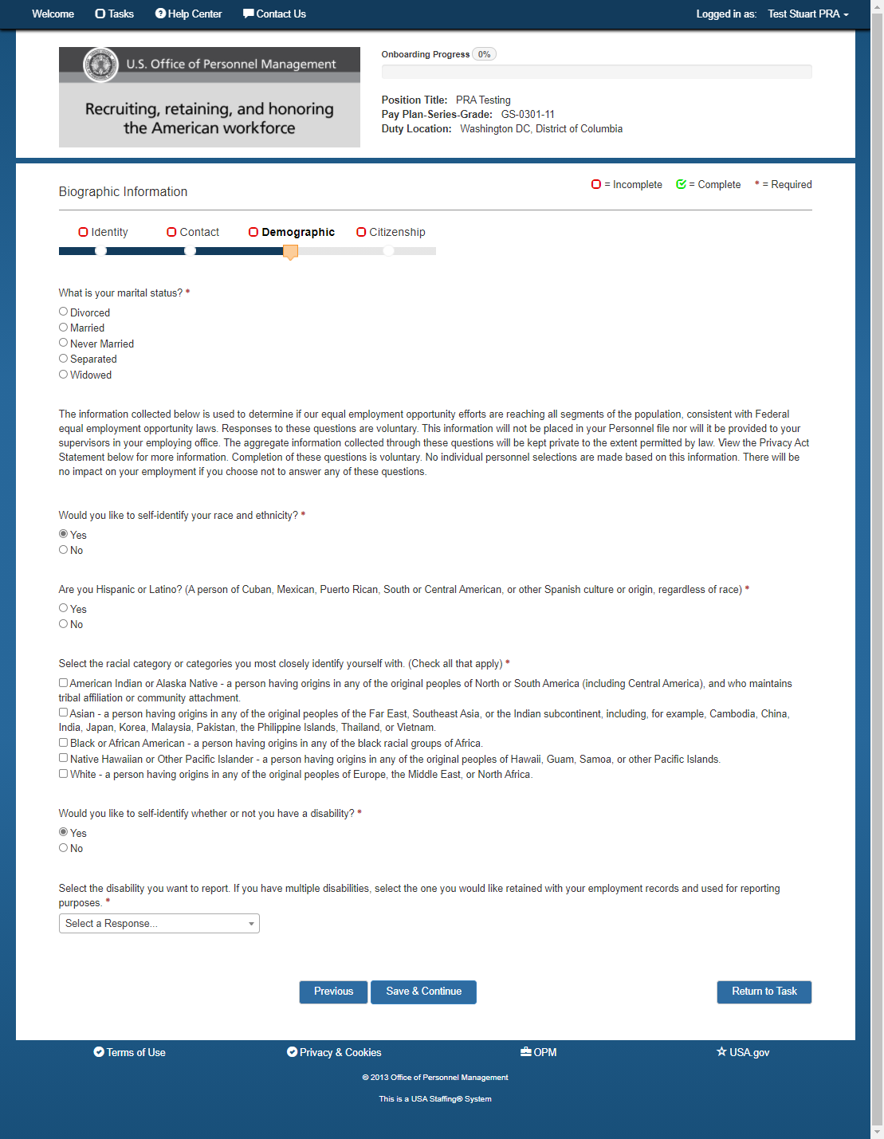
Biographic/Citizenship (Yes to US Citizenship)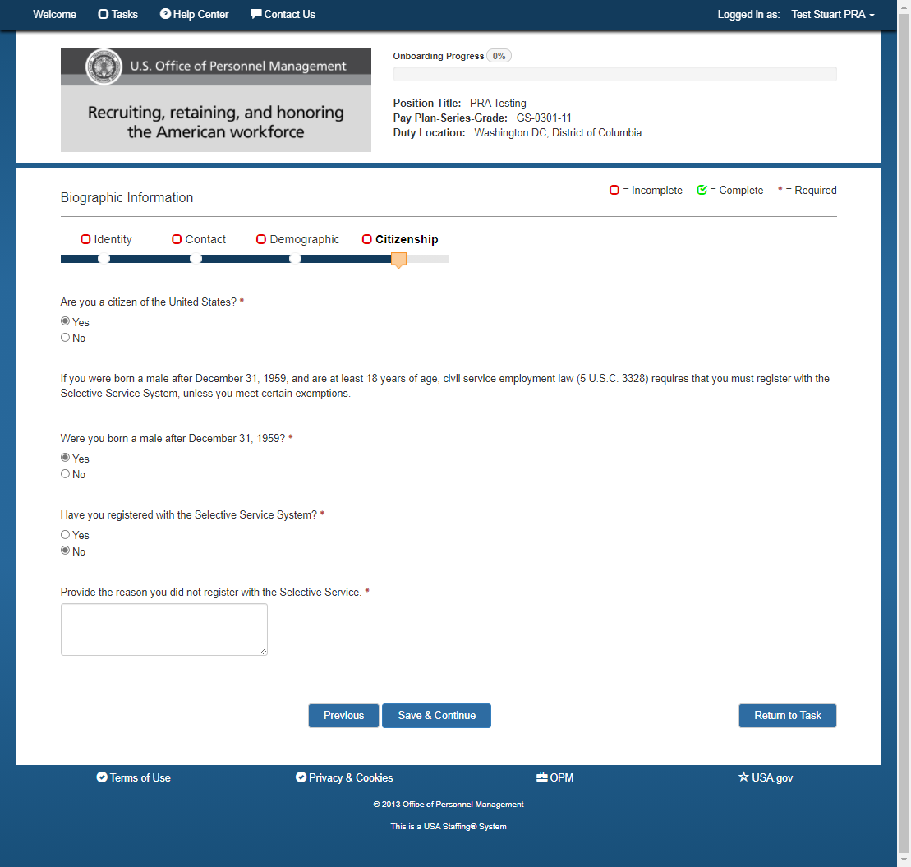

Biographic/Citizenship (No to US Citizenship)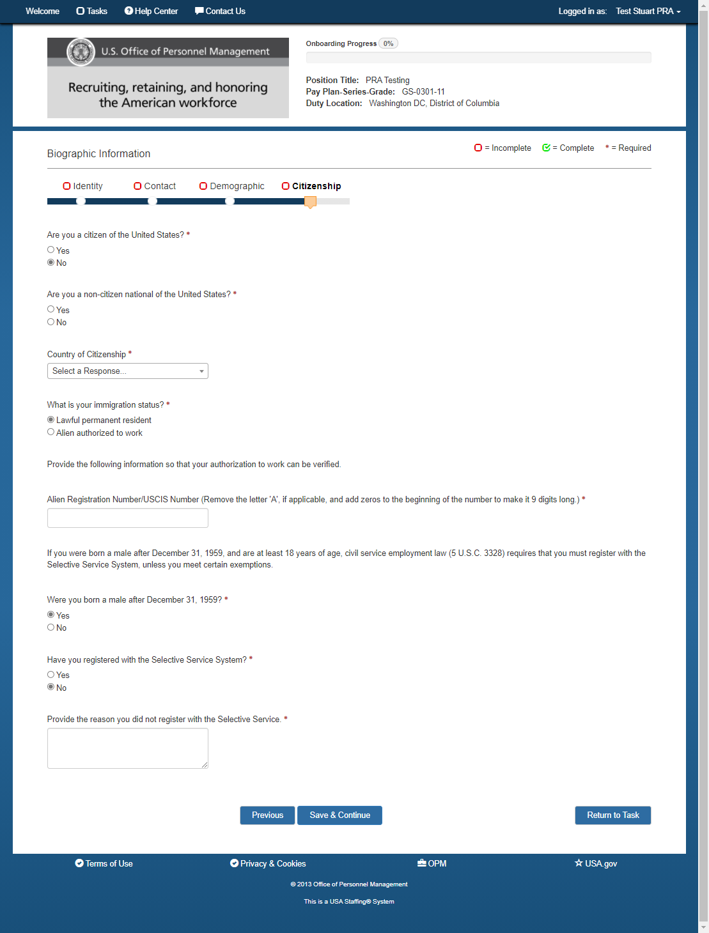

Biographic/Citizenship

(Alien Authorized to Work)
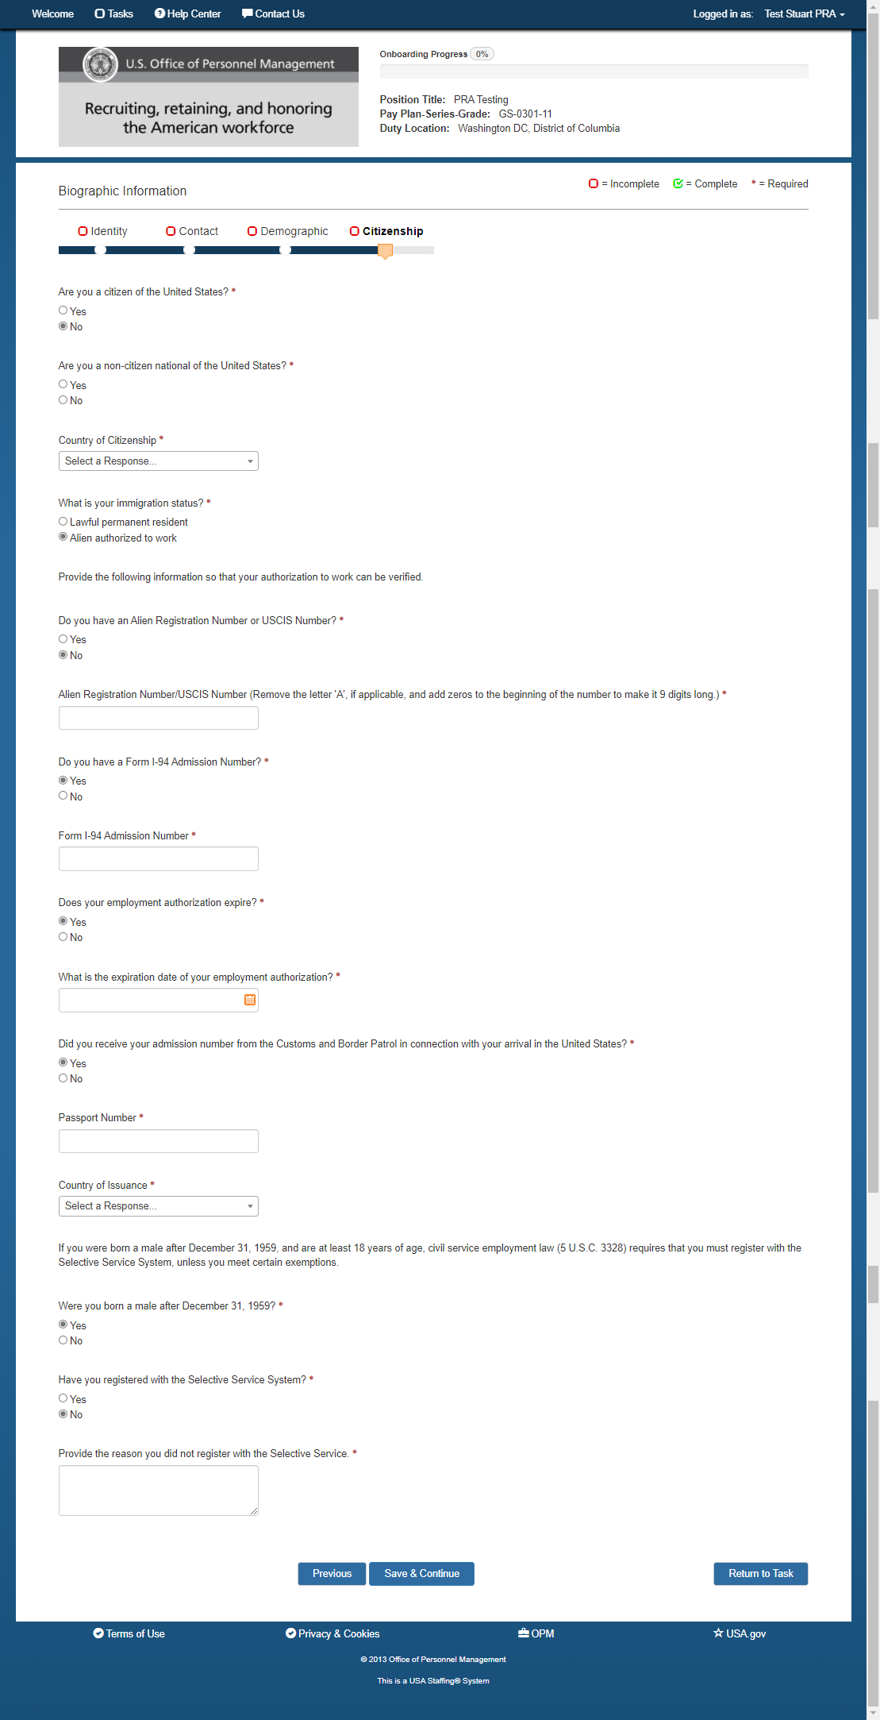

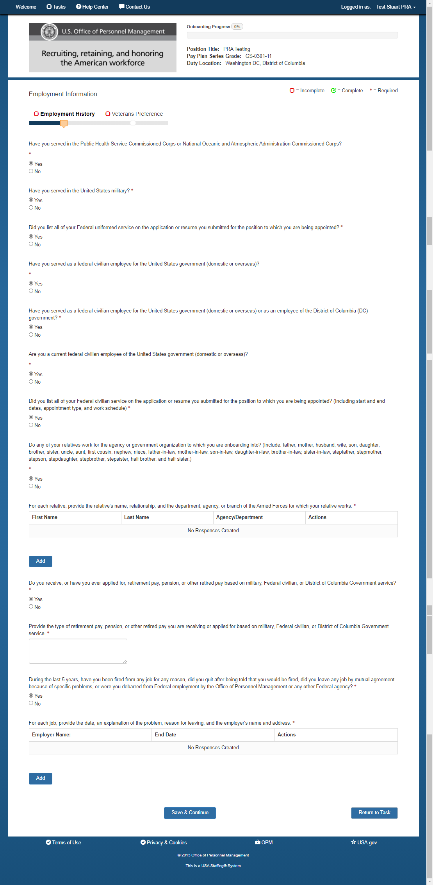
Employment/Employment History

Employment/Uniformed Service 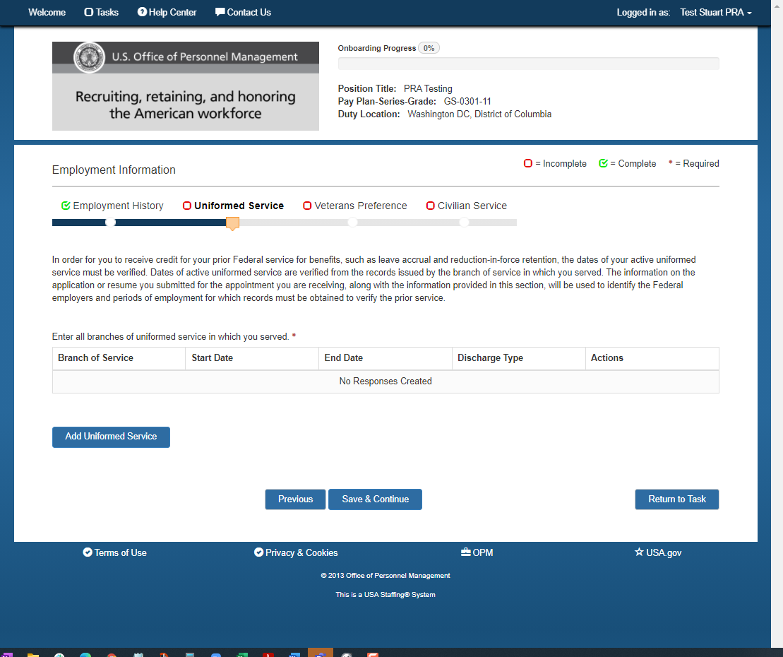

Employment/Veterans Preference (all possible questions displayed)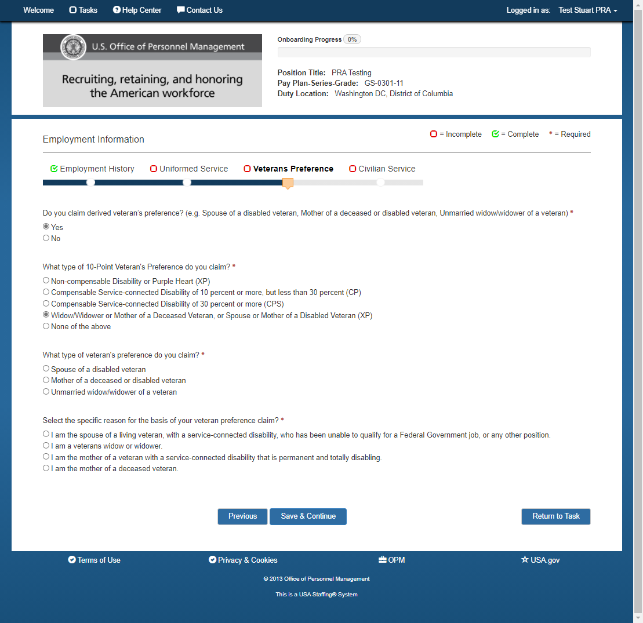

Employment/Civilian Service (All possible questions)
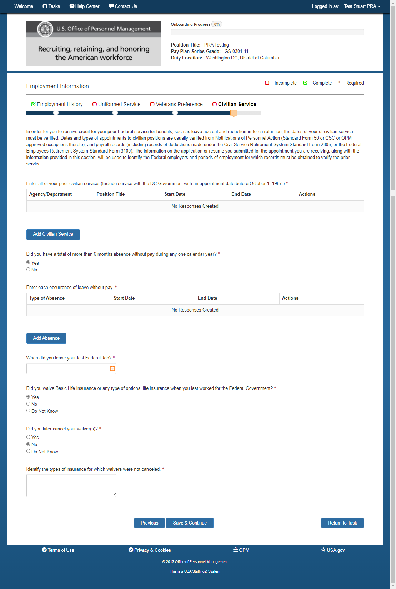

Benefits/Beneficiaries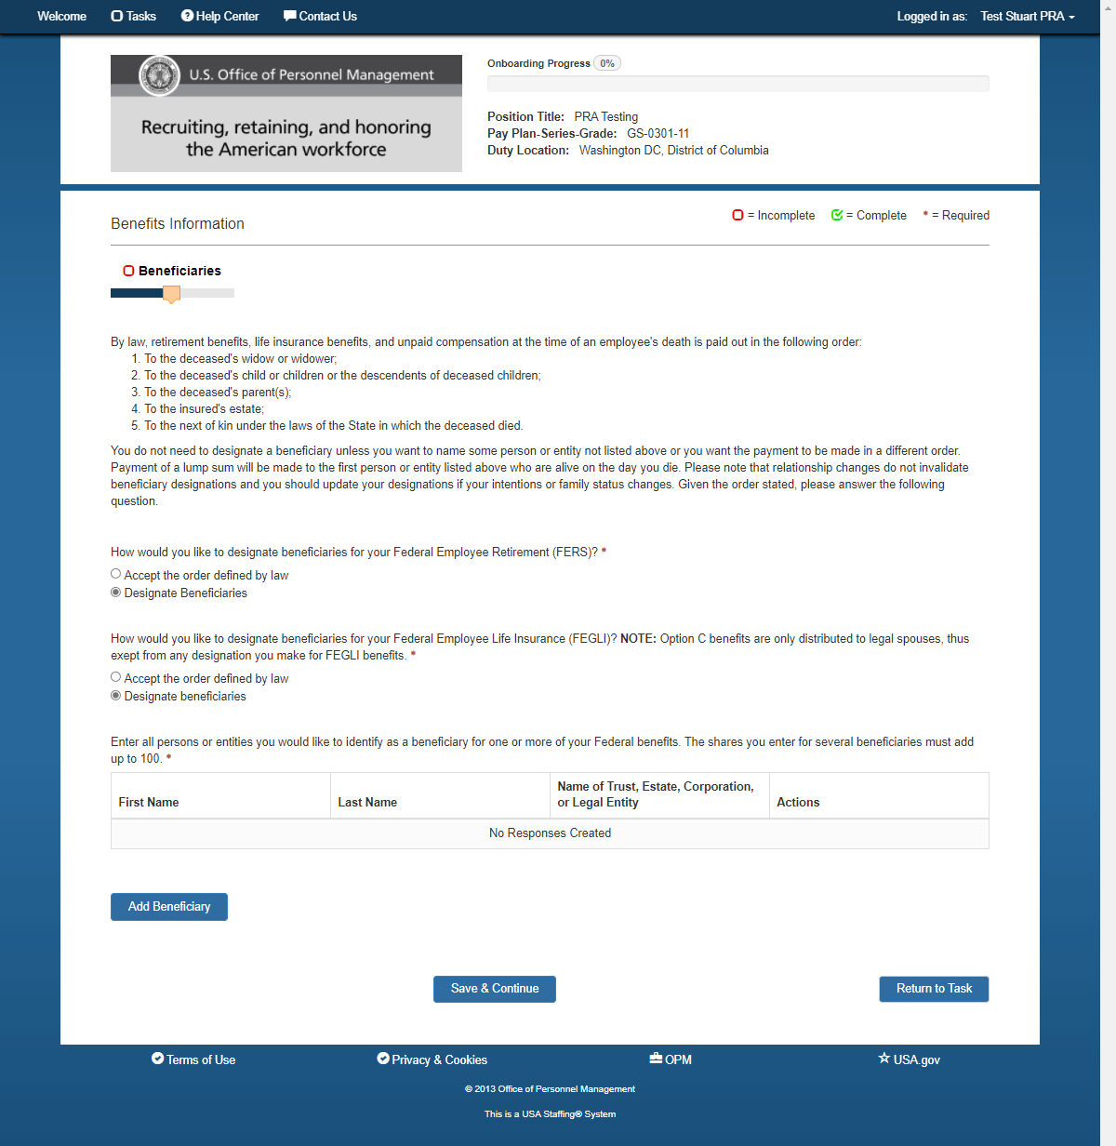

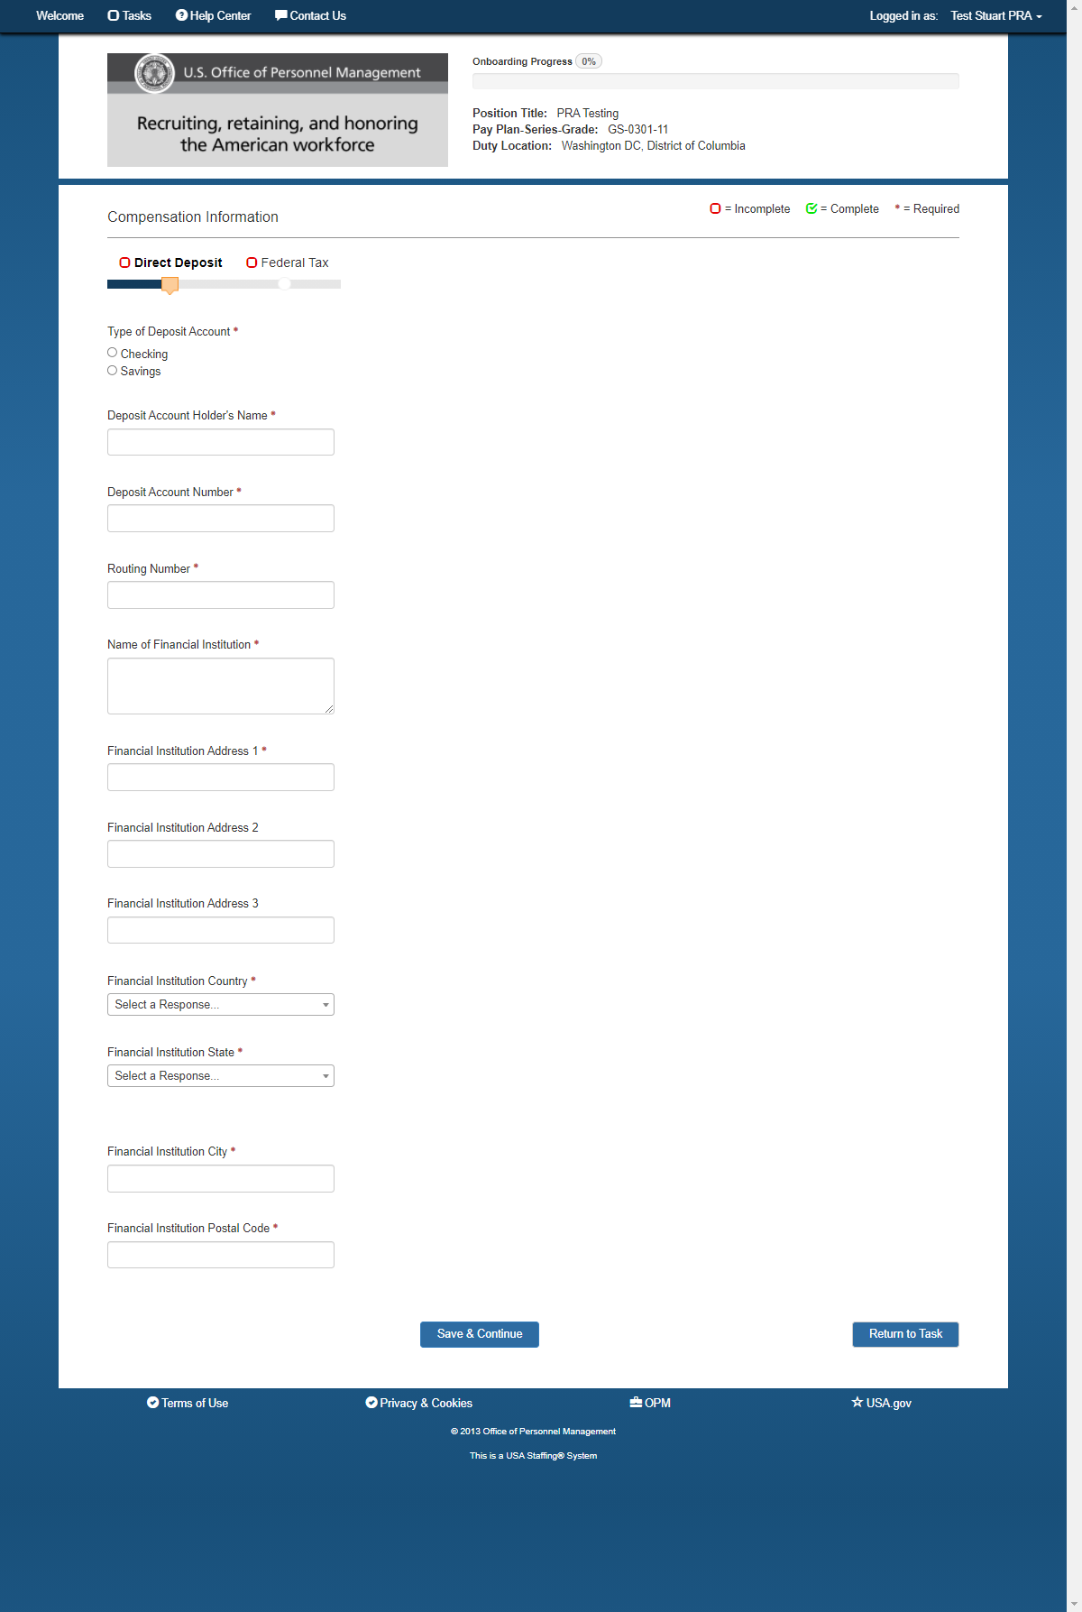
Compensation/Direct Deposit

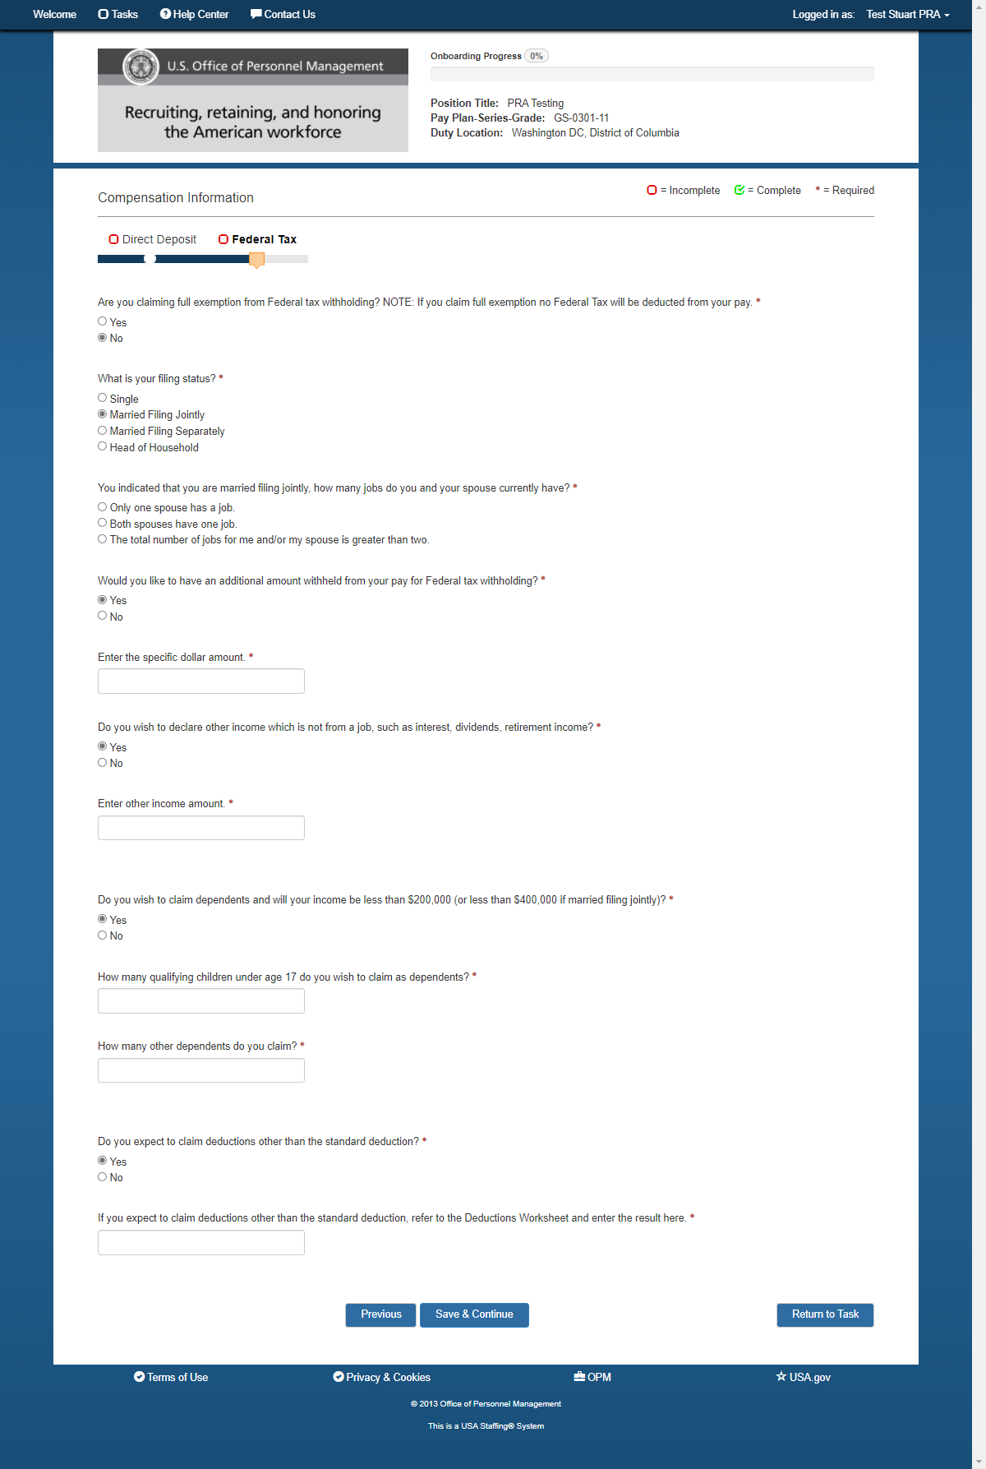
Compensation-Federal Tax (Married Filing Jointly Questions)

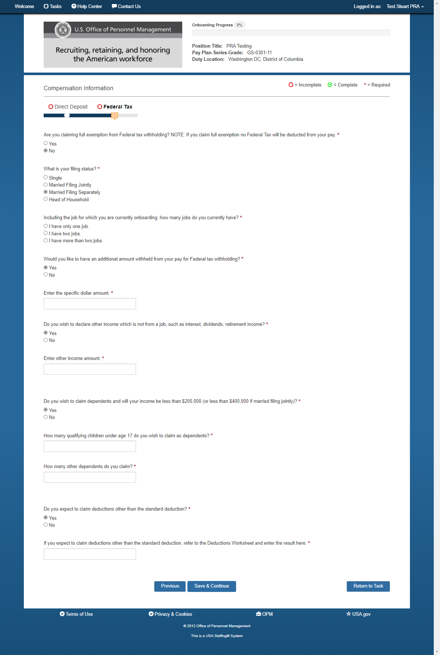
Compensation-Federal Tax (Married Filing Separately/Head of Household questions)

