Screen 1

RRB Employer Reporting System (ERSNet) Login Screen

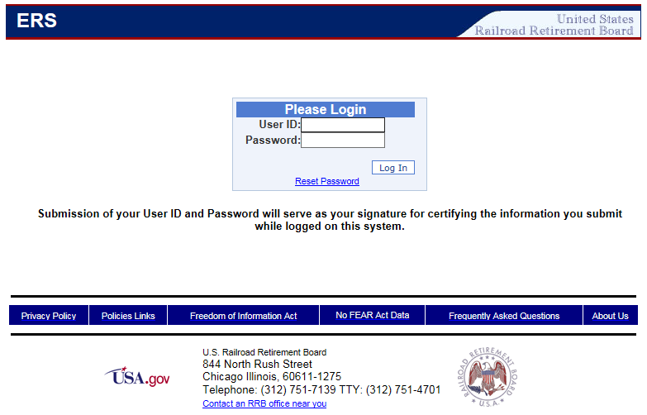

Screen 2

ERSNet Main Menu Screen (Forms)

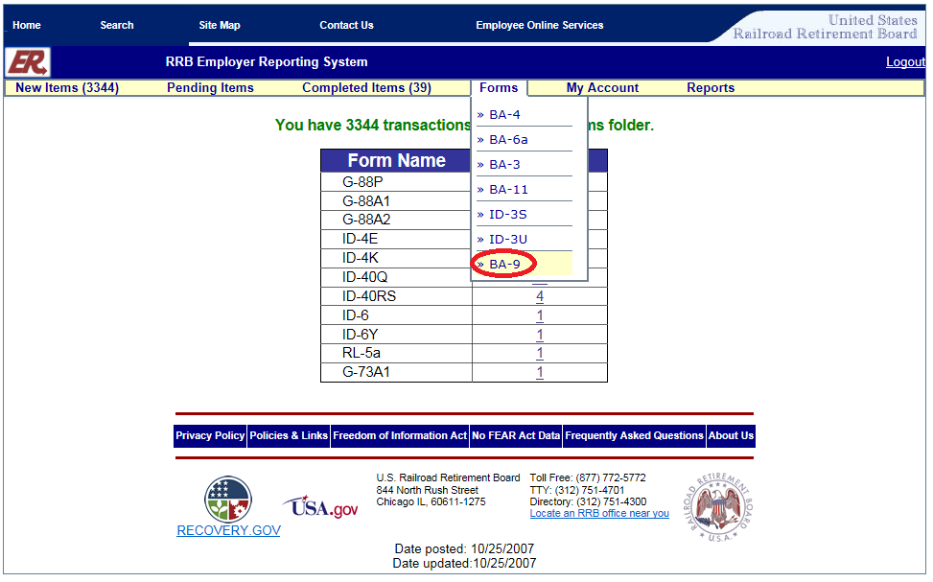

Screen 3

Form BA-9 (Selection Screen)

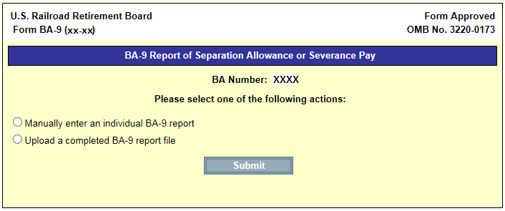

Screen 4

Form BA-9 (Initial Manual Entry Screen)

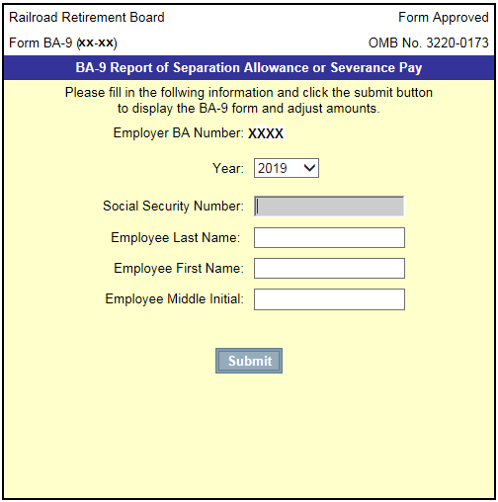

Screen 5

Form BA-9

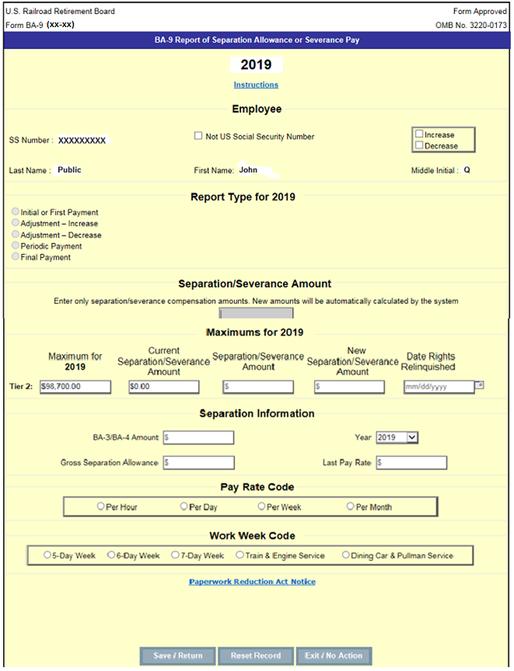

Screen 6

Instructions

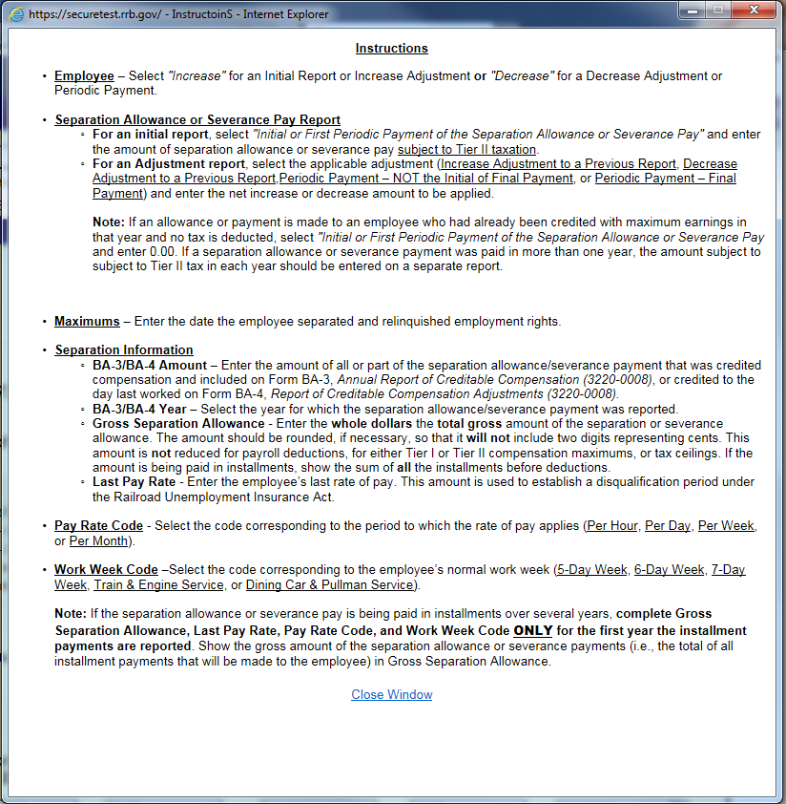

Screen 7

Paperwork Reduction Act Notice

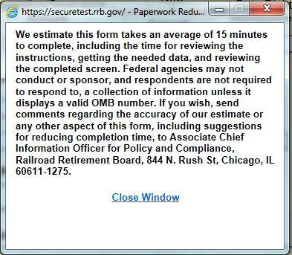

Screen 8

Form BA-9 (Initial Manual Entry Screen – Pending Items)

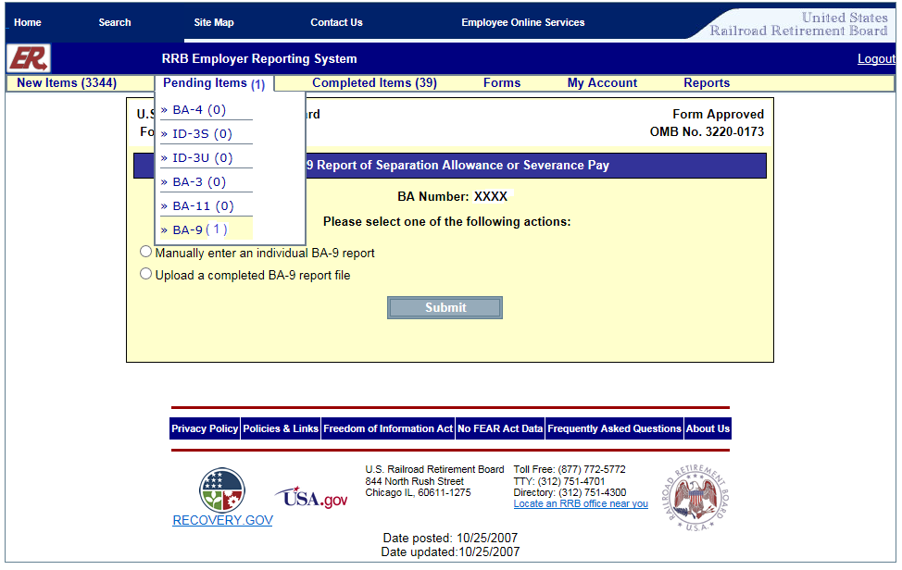

Screen 9

Form BA-9 (Pending Items Screen)

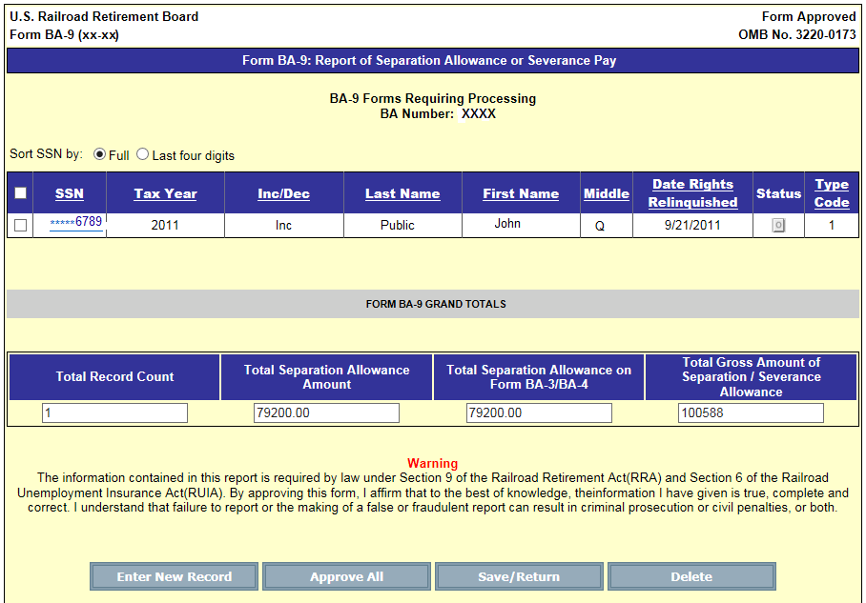

Screen 10

Form BA-9 (Employer Upload Screen)

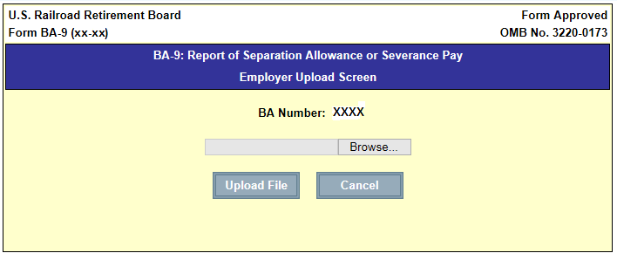

Screen 11

Form BA-9 (Upload Grand Totals Screen)

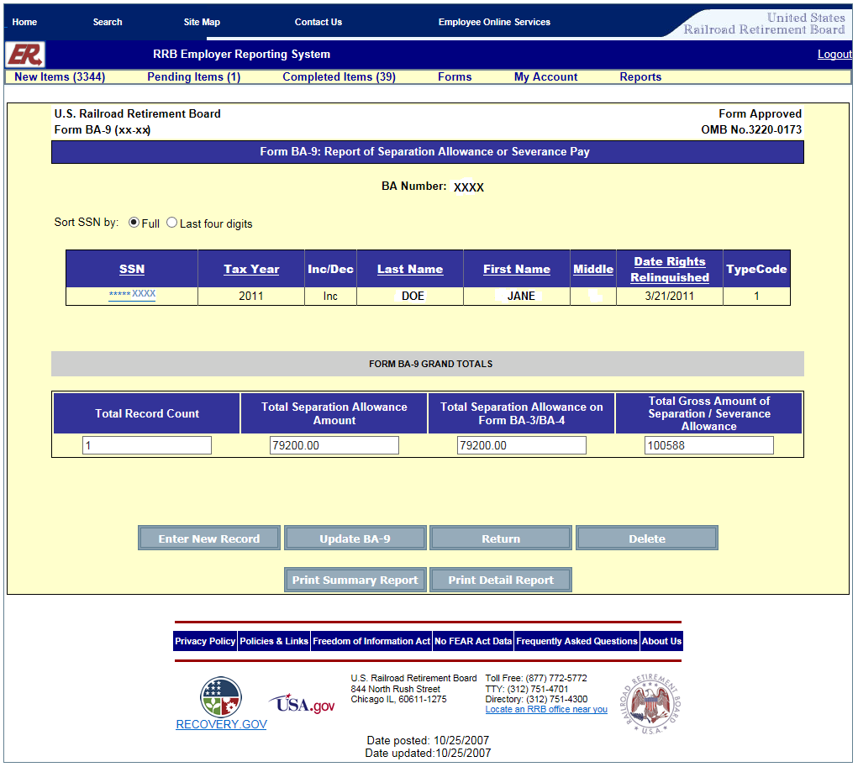

Screen 12

Message after selecting Update BA-9 Button

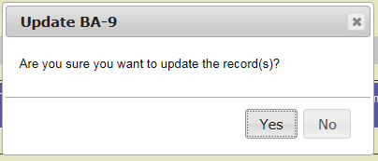

Screen 13

Form BA-9 (Pending Items Screen after Upload)

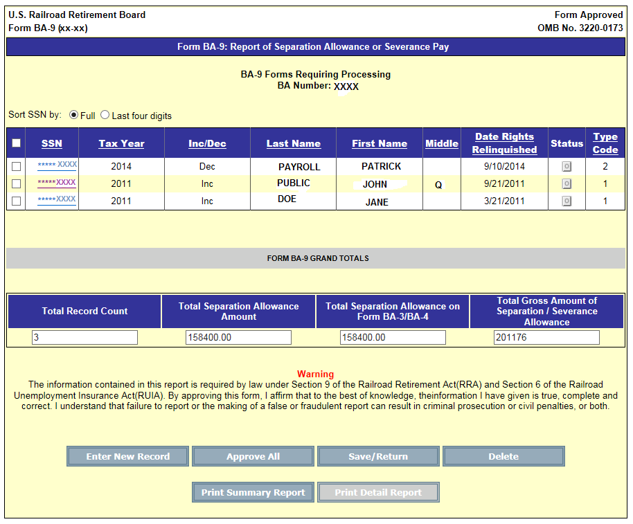

Screen 14

Message after selecting Approve All Button

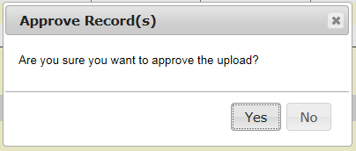

Screen 15

Approve Record Confirmation Message

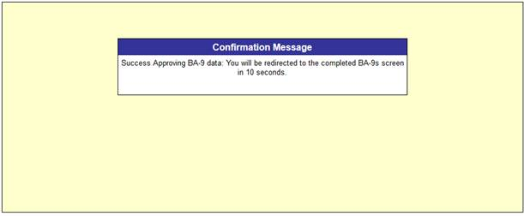

Screen 16

Form BA-9

Individual Pending Record Screen

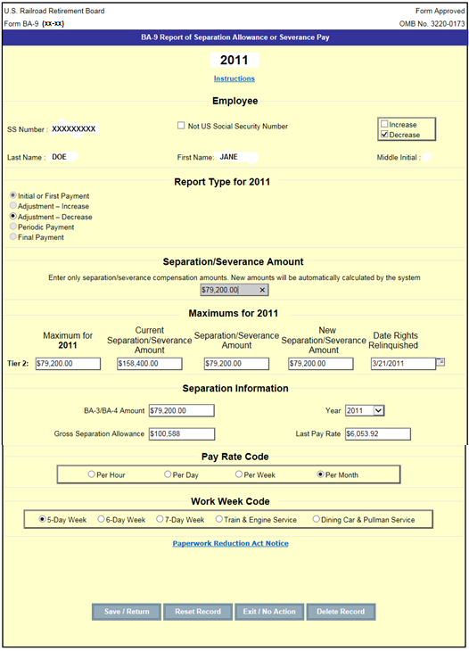

Screen 17a

Completed Items Screen

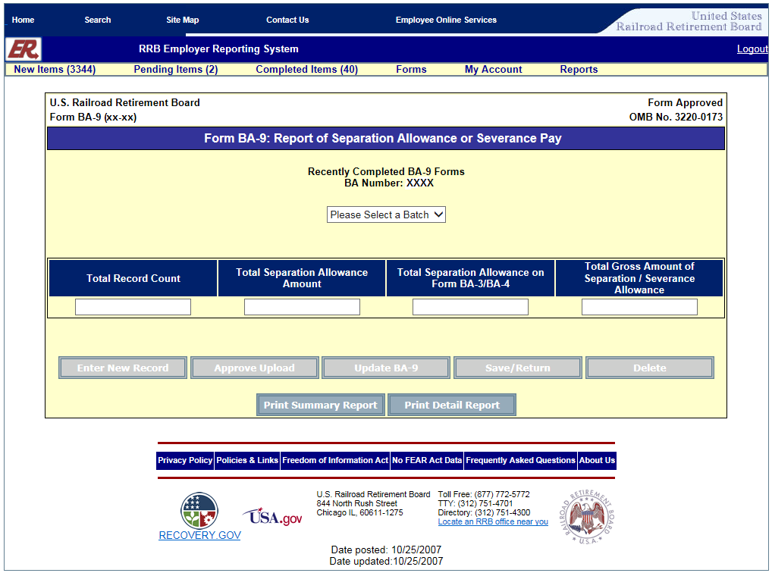

Screen 17b

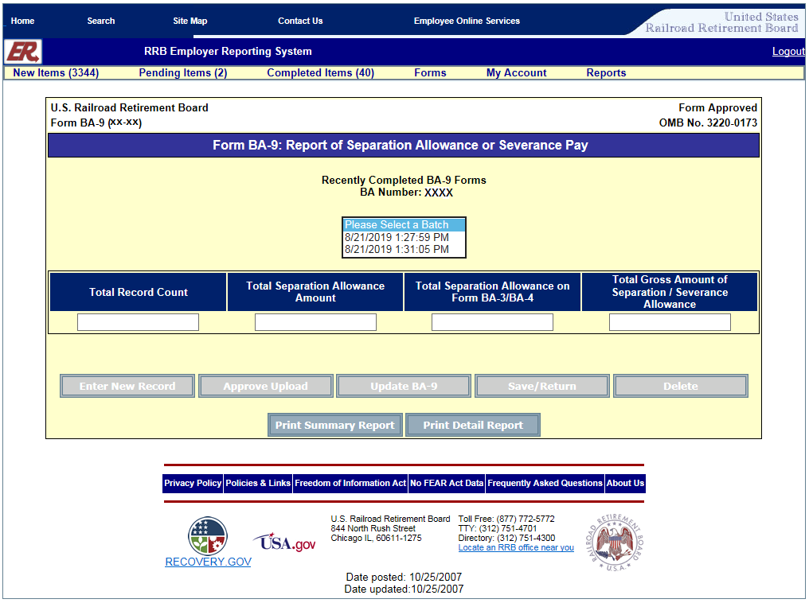

Screen 17c

