U.S. Small Business Administration
Washington, D.C. 20416
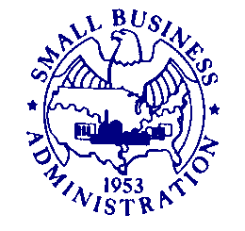

DATE: November 19, 2021
TO: Susan Minson
SBA Desk Officer
Office of Information and Regulatory Affairs
Office of Management and Budget

FROM: Rosemarie Drake
Chief, 7(a) Loan Division
SUBJECT: Non-Substantive Change Request Regarding SBA Form 413, Personal Financial Statement (OMB Control #3245-0188)
Expiration Date: 5/31/2024
The Small Business Administration (SBA) has created a Spanish version of the currently approved SBA Form 413, Personal Financial Statement. As required by OMB’s Paperwork Reduction Act guidance, SBA is submitting this non-substantive change for approval. The Spanish version of the form is a direct translation of the OMB approved English version, with no substantive changes to its content. This change also has no impact on the burden hours currently reported for the information collection.
For SBA’s financial assistance programs, SBA, its participating lenders, CDCs, and Sureties use the information collected by SBA Form 413 as part of the analysis to determine repayment ability and creditworthiness of applicants and their owners for an SBA loan guaranty or a disaster loan, or with respect to the SBG program to assist in recovery in the event that the contractor defaults on the contract.
The information is also collected from applicants and participants in SBA's 8(a)/BD and Women-Owned Small Business (WOSB) Program certification process to determine whether they meet the economic disadvantage requirements of the programs.

If you have any questions concerning this request, please contact SBA’s PRA Liaison, Curtis Rich at curtis.rich@sba.gov.

