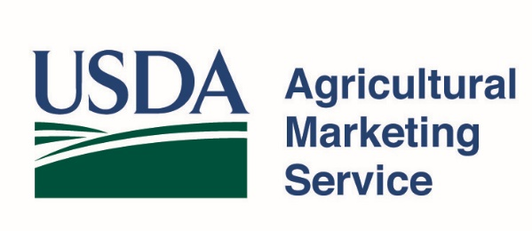 | Grant Program  Accounting System & Financial Capability Questionnaire

Purpose
Recipients of Federal funds must maintain adequate accounting systems that meet the criteria outlined in 2 CFR §200’s Standards for Financial and Program Management. The responses to this questionnaire are used to assist in the Agricultural Marketing Service’s (AMS) evaluation of your accounting system to ensure the adequate, appropriate, and transparent use of Federal funds. Failure to comply with the criteria outlined in the regulations above may preclude your organization from receiving an award. This form applies to AMS’ competitive grant programs.

Organization Information
Organization Name: Enter the Legal Name of the Organization
Employer Identification Number: Enter Organization’s EIN
Authorized Organization Representative (AOR): Enter the Name of Individual Authorized to Sign this Document
Year the Organization was established: Enter Calendar Year
Number of Employees: Enter Number of Employees

Grant Staff Information
Provide the name of the project staff and number of years that they have been employed by the applicant organization.
Staff Member | Name | Number of Years
AOR
Project Director
Financial Point of Contact

Financial Managment System and Internal Controls

Requirement |  | Yes | No
Is there a dedicated accountant or finance manager responsible for monitoring organizational funds? |  | ☐ | ☐
Does your organization have written accounting policies and procedures that meet the requirements associated with 2 CFR §200.302?  If yes, provide a copy of or a hyperlink to your organization’s written accounting policies and procedures (e.g., payment procedures and budgeting process). |  | ☐ | ☐
Hyperlink (if available):
Does your organization have a written account of its internal controls as required by 2 CFR §200.303?  If yes, provide a copy of or a hyperlink to your organization’s written internal controls for Federal awards (e.g., segregation of duties). |  | ☐ | ☐
Hyperlink (if available):

Audit Financial and Reports

Requirement |  | Yes | No
Does your organization issue annual financial reports and/or plans? |  | ☐ | ☐
Has your organization been audited within the last 5 fiscal years?  If yes, provide a copy of or a hyperlink to the audit report. |  | ☐ | ☐
Hyperlink (if available):

Additional Information

Additional financial information including expanding on responses in previous sections

Applicant Certification
I certify that the above information is complete and correct to the best of my knowledge.
AOR Signature and Date
Phone:
Email:

According to the Paperwork Reduction Act of 1995, an agency may not conduct or sponsor, and a person is not required to respond to a collection of information unless it displays a valid OMB control number. The valid OMB control number for this information collection is 0581-NEW. The time required to complete this information collection is estimated to average 19.98 minutes per response, including the time for reviewing instructions, searching existing data sources, gathering and maintaining the data needed, and completing and reviewing the collection of information.

USDA is an equal opportunity provider, employer, and lender.

