File Name: PIFSC IC_American Samoa Pelagic Longline Fishery Cost-Earnings Survey 02.15..2022

AMERICAN SAMOA LONGLINE ECONOMIC DATA COLLECTION

FOR 202X OPERATIONS

Date of interview: ___________________

Interviewer: ___________________

Vessel Name: ______________________(Please provide all vessel specific information for this vessel.)

Vessel permit number: ______________

Interviewee’s name:________________________ Contact (phone): _______________

Interviewee’s position: (Please select one) Vessel/business owner Owner operator
Hired captain Vessel manager Other (Please specify)____________________________

I. About the owner OR owner operator

- How many fishing vessels did you (or the company you work for) own in 202X? _______ vessel(s)
How many vessels fished in Am. Samoa Longline Fishery? _______
How many vessels fished in other fisheries? _______

- When did you (or your company) start longline fishing in Am. Samoa? _________year

- In 202X, did your household (or the fishing company you work for) have other income sources besides the fishing business in Am. Samoa?
No
Yes. Income from longline fishing was _______% of the total household (or the fishing company you work for) income

- Did the vessel owner live in Am. Samoa in 202X? Yes No

- How long have you (or the fishing company you work for) owned this vessel? _____ years

- Was this vessel operated by a hired captain or by its owner in 202X?
by hired captain
by owner

- If it was operated by a hired a captain, how did you find the captain for this vessel– write down the details _____________________

II. About this Vessel

- When was this vessel built? ___________ year

- When was this vessel purchased?___________ year

- What was the purchase price? $______________;

10a. Did the purchase price include a permit? Yes No.

10b. If NO, did you purchase it, lease it OR receive it from the initial allocation?

- What was the start-up costs (the cost of getting it ready for fishing the first time after it was purchase)? $______________

- When was the last appraisal performed __________ (year) and what was the appraised value? $______

12a. When was the last major upgrade (not including the start-up costs) that would have changed the vessel’s market value ______ (year) and what was the cost of the upgrade?
$ _________

- How much do you think your vessel (include all gears and equipment and permit) could be sold for? $_____________

13a. How much do you think your permit could be sold for? $_________

- What is the vessel length? _____________ ft

- What is the vessel width/beam? _____________ ft

- What is its fuel capacity? ____________ gallons

- What is its fish holding capacity?___________ pounds

III. About Vessel Operation and Fish Sold in 202X

- How many fishing trips did this vessels make in 202X __________________ trips

- In what areas did this vessel operate/fish in 202X? (Check all that apply)
American Samoa EEZ
Other EEZ _________ (i.e. Cook Islands)
High Seas
Other (Please specify)

- How did you usually sell/distribute fish landed by this vessel and what was the % distribution to each?
Gave away to friend or family ________ %
Sold to the Cannery _________ %
Sold to a restaurant _________%
Other distributors or brokers (list the name(s) _______

IV. About Labor Costs in 202X

- How many crew did the vessel usually have (NOT including the captain)? ___

- How many foreign crew did that include (NOT including the captain)? ___

- On average, how long had the crew been working with this vessel/company?
_________ years

- What is the longest time a current crew had been working with this vessel/company? _________ years

In the following questions, the term ‘share’ (%) is interpreted as the part of the gross or net revenue from a fishing trip that was paid to the captain or crew. This is in contrast to a ‘flat rate’, which was paid per fishing trip or month regardless of the revenues from a fishing trip or month. Trip revenue is defined as fish sales revenue. Net revenue is defined as trip revenue minus any trip costs that were deducted before calculating what the captain or crew were paid.

- How was the captain paid?
By shares ______ % of GROSS revenue
______ % of NET revenue
Flat rate $______ per trip or per month or per year
Flat rate $______ AND bonus $_______ per trip per month or per year
If a bonus was paid, please describe how it was determined or explain the bonus schedule. ______________________________________________________________________________________________________________________________________________________
- If shares were based on net revenue, which of the following trip expenses did you subtract to calculate net revenue? (Check all that apply)
Fuel
Bait
Provision
Fishing gear
Freon
Engine oil
Communications
Agent fee, insurance, parts for repairs
Any others (Please specify)______

- Did all the crew get paid by the same method? Yes No

If YES
By shares ______ % of GROSS revenue
______ % of NET revenue
Flat rate average per crew $_______ per trip per month or per year
Flat rate average per crew $ ____ AND average bonus per crew $_______ per trip per month or per year
If bonuses were paid, please describe how they were determined or explain the bonus schedule. ______________________________________________________________________________________________________________________________________________________
If NO, please provide the following information for each crewmember.

Position | Foreigner  (Y/N) | Shares  % | Share of Trip  or  Net Revenue | Flat Rate  (Per Trip,  Month or Year) | Bonuses  (Per Trip  Month or year | Initial Payment  (when hired) | What Year  (for initial payment)
Owner/Operator |  | _________% | Trip  Ne
Hired Captain |  | _________% | Trip  Net | $____________  Per trip  Per month  Per year | $___________  Per trip  Per month  Per year
Crewmember 1 | Yes  No | _________% | Trip  Net | $____________  Per trip  Per month  Per year | $___________  Per trip  Per month  Per year | $_______
Crewmember 2 | Yes  No | _________% | Trip  Net | $____________  Per trip  Per month  Per year | $___________  Per trip  Per month  Per year | $_______
Crewmember 3 | Yes  No | _________% | Trip  Net | $____________  Per trip  Per month  Per year | $___________  Per trip  Per month  Per year | $_______
Crewmember 4 | Yes  No | _________% | Trip  Net | $____________  Per trip  Per month  Per year | $___________  Per trip  Per month  Per year | $_______
Crewmember 5 | Yes  No | _________% | Trip  Net | $____________  Per trip  Per month  Per year | $___________  Per trip  Per month  Per year | $_______
Crewmember 6 | Yes  No | _________% | Trip  Net | $____________  Per trip  Per month  Per year | $___________  Per trip  Per month  Per year | $_______

- As an owner of a fishing vessel, did you hire an agent to take care of the fishing business in 202X?
Yes
No
If YES, what was the agent’s fee? $ ____per trip, OR $ ____per month, OR $ ____ per year
If NO, what types of works did the owner usually do? (Check all that apply)
Book keeping
Buying parts
Look for crew and captain
Getting the boats ready to depart (such as getting supplies, parts, call PIRO)
Others __________ ?

V. About Trip Costs in 202X

- Did trip cost vary trip by trip?
If YES, was the main reason the variation in trip length? Yes No
What were the others reasons? (Please specify)__________________

- Please provide the following information for the last trip landed in 202X
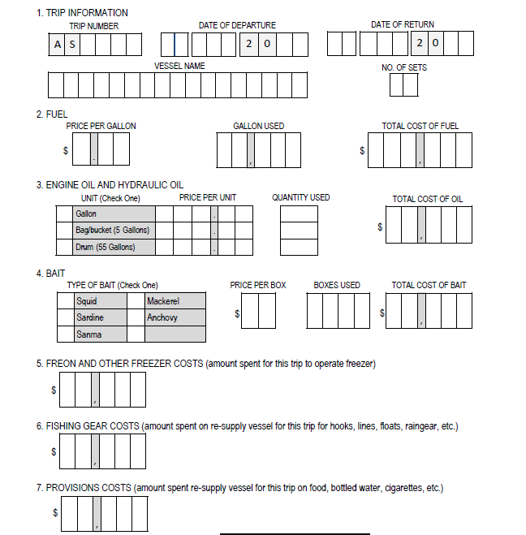
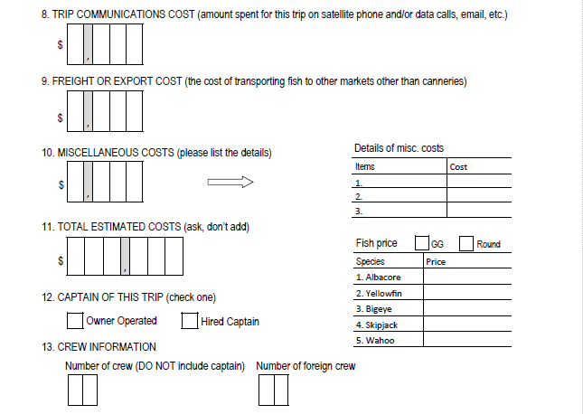

- Please provide the following information for one trip in or near June 202X
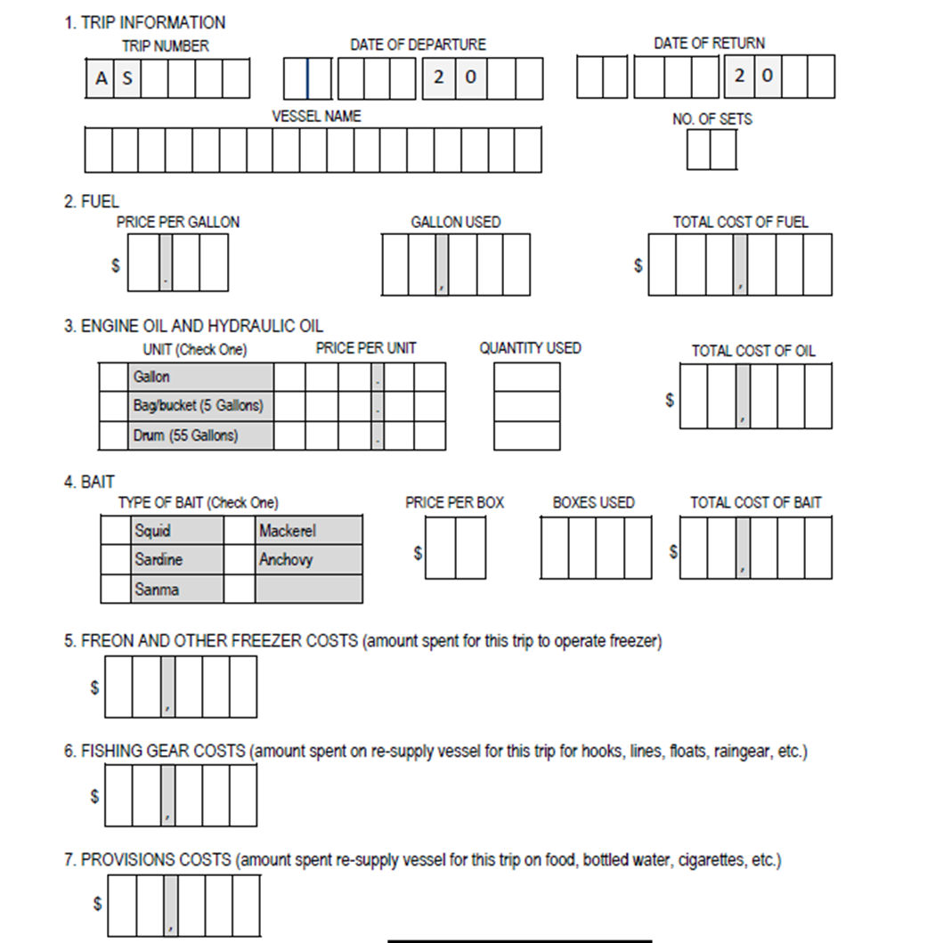
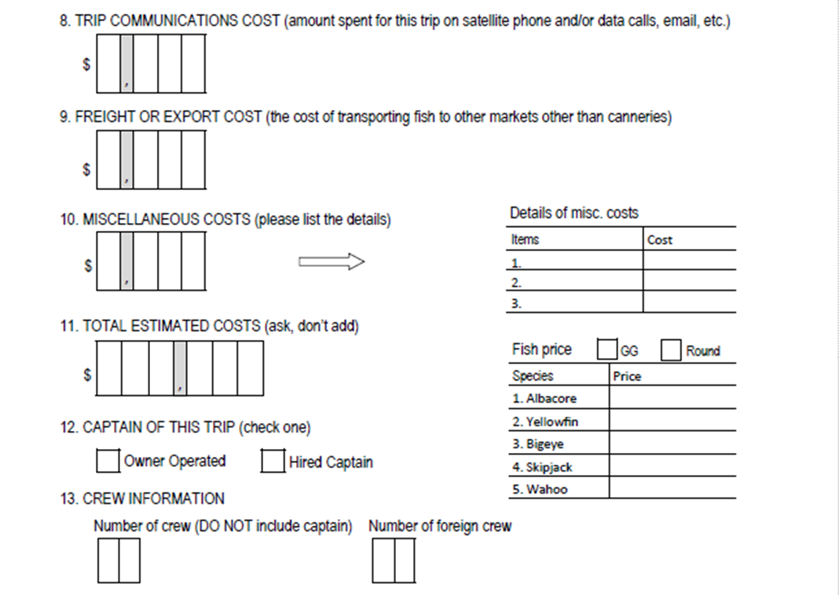

VI. About Fixed Costs

- Total mooring fees (port fees for all the trips before departures) in 202X? $ ___________

- Did you hire someone to do 202X bookkeeping?
Yes. Paid someone $ ___________ per month OR $ ____ per year
No. Owner or a family member did it (no fee was charged).
No. It was done by the agent, and agent fee was $ ____per trip, OR $ ____per month, OR $ ____ per year
No. Shared with other family business, share was $ ____per month OR $ ____ per year

- What were your insurance costs for this vessel (or for the all ______ of your fishing vessels) in 202X? $ ________________
This included (Check all that apply)
Vessel only
Liability only (“P” and “I”)
Vessel and liability
Pollution
Health (Please specify who is covered) __________________

- Did you have loan payments for this vessel in 202X? Yes No

If YES, how much were your payments in 202X?
$ ____ per month OR $ ____ per year

- When did you last dry dock your vessel? ______________ year

- When do you plan the next dry dock? ______________year

- How much did it cost in total for the last dry dock $ ____________ …

Please list the major repairs and upgrades in the last dry dock and the associated costs (if the data are available)
cost $________________ for ___________________________________________

cost $________________ for ___________________________________________

cost $________________ for ___________________________________________

cost $________________ for ___________________________________________

- Have you overhauled this vessel’s engine? Yes No

If YES,
1) when did you last overhaul your engine? ______________ year

2) How much did it cost $ ____________________

3) How often do you overhaul your engine? Every _______ years

- Did you have any routine repairs and maintenance on a trip or annual base? Yes No
If YES, were they included in the trip costs above? Yes No
If NO, how much did the routine repairs and maintenance cost in 202X? $_______________

- Beside the routine repairs, dry dock and overhaul costs list above, did you have any major repairs, upgrades and maintenance work done in 202X for this vessel?
Yes No

If YES, what was the cost? $________________

Please list the major repairs, upgrades and maintenance and the associated costs (if the data are available)
cost $________________ for ___________________________________________

cost $________________ for ___________________________________________

cost $________________ for ___________________________________________

cost $________________ for ___________________________________________

- Did I miss any items on other fixed costs? Yes No

If YES, how much were the other fixed costs? $_________
What were the other fixed costs for? (Please give details) _____________________?

- Did you substantially change your fishing activities in 202X? ◻ No ◻ Yes

If YES, please answer the following questions.
43a: How did you change your fishing activities in 202X? ________________________
43b: What were the main reasons you made those changes?_______________________

43c: By what percentage did each of the following increase or decrease for your vessel(s) in 202X due to those changes? (Please enter “0” if there was no change)

Landings decreased by ______% OR increased by______%
Fishing revenues decreased by ______% OR increased by______%
Total operating costs decreased by ______% OR increased by______%
Crew size decreased by ______% OR increased by______%
- What are the three biggest constrains or challenges that impact the economic performance of your fishing business
- __________________________
- __________________________
- __________________________

45. Open Ended Questions: Is there anything else you would like to say? (present challenges, COVID-19 pandemic, comments on fishing management)
______________________________________________________________________
______________________________________________________________________
______________________________________________________________________

We appreciate the confidential nature of the data being collected by this survey. NOAA’s Pacific Islands Fisheries Science Center (PIFSC) will handle individual survey data as confidential business information and a form of protected personal information and will maintain the confidentiality of the information consistent with legal authorities available to it, including but not limited to the Privacy Act (5 U.S.C. Section 552a) and the Trade Secrets Act (18 U.S.C. Section 1905). The PIFSC will protect individual survey data from public disclosure to the extent permitted by law and it has instituted procedures to provide that protection.

Paperwork Reduction Act Statement. The PIFSC is collecting this economic information to improve its ability to conduct the analyses required by the Magnuson-Stevens Fishery Conservation and Management Act (MSA) and other applicable law. The PIFSC and the Western Pacific Fishery Management Council will use this information to monitor, explain and predict changes in the economic performance and impacts of the American Samoan longline fishery. Among other things, this will enable fisheries managers and the public to more fully consider the economic effects of proposed and existing regulations for this important fishery.

A Federal agency may not conduct or sponsor, and a person is not required to respond to, nor shall a person be subject to a penalty for failure to comply with an information collection subject to the requirements of the Paperwork Reduction Act of 1995 unless the information collection has a currently valid OMB Control Number. The approved OMB Control Number for this information collection is 0648-0773 and its expiration data is XX/XX/20XX. Without this approval, we could not conduct this information collection. Public reporting for this information collection is estimated to be approximately 60 minutes per response, including the time for reviewing instructions, searching existing data sources, gathering and maintaining the data needed, and completing and reviewing the information collection. All responses to this information collection are voluntary. Send comments regarding this burden estimate or any other aspect of this information collection, including suggestions for reducing this burden to the NOAA Fisheries at: 1845 Wasp Blvd., Building 176, Honolulu, HI 96818, Attn: Minling Pan, and Minling.Pan@noaa.gov if desired.

