File Name: NEFSC IC_Greater Atlantic Region Commercial Fishing Cost Survey — Trawl 021722
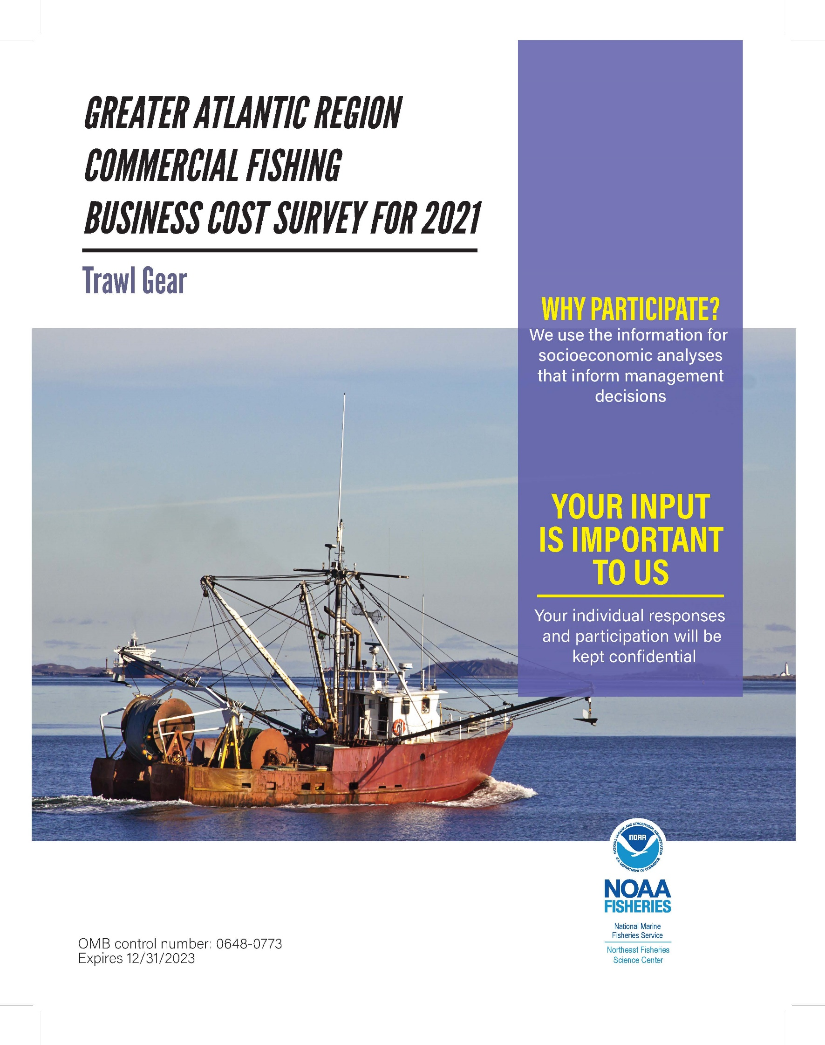

Individual participation and responses will be kept confidential.
Throughout the survey we will refer to a “selected vessel”, that you own.
Please respond to these questions thinking only about this vessel:
[Vessel Name]
Coast Guard Documentation or State Registration Number: [12345678]

General Information

In what year did you become the owner of the selected vessel? Please see the top of this page for the name of the “selected vessel”.

YYYY

- How many commercial fishing/shellfishing trips did the selected vessel take in 20XX? Please write the number of trips in the box below.

Commercial trips
- This vessel was inactive for all of 20XX.
- This vessel did not take any commercial fishing/shellfishing trips in 20XX, but did take recreational or other types of trips.
New/Replacement, Repair/Maintenance, Upgrade and Other Costs for the Selected Vessel

New, Repair, Maintenance, & Upgrade Cost Category | Total 20XX Cost  for the Selected Vessel | OR | Check Box if NO Cost in 20XX
Propulsion Engine such as engine, drive train, exhaust/cooling systems and cost of oil/oil changes | $ .00 |  | - No cost
Deck Equipment / Other Machinery such as winches, haulers, generators, hydraulics, compressors, reels, pumps | $ .00 |  | - No cost
Haul-out Costs such as haul-out costs for regular repair and maintenance, emergency haul-out, long term storage, zincs, bottom paint, acid wash and gel coating |  |  | - No cost
Hull such as frame, deck, wheelhouse, keel, steering, rigging, fish holds, fuel tanks |  |  | - No cost
Fishing Gear such as codends, nets/panels, doors, cables, weight, chain rope |  |  | - No cost
Wheelhouse Electronics such as AIS, radar, GPS, depth finder, door/codend sensors, new/updated VMS system (not VMS fees), sounder, radio, depth/temp/net sensors, monitors (Do not include electronic monitoring [EM] costs in this section) |  |  | - No cost
Processing / Refrigeration such as refrigerated sea water systems, packaging equipment, ice maker (Do not include the cost of ice itself, shore-side freezer rental, or ANY costs captured in docking fees (Question 4)) |  |  | - No cost
Safety Equipment such as EPIRB, raft repacking, fire extinguisher maintenance, flares, survival suits |  |  | - No cost
- Record your total new/replacement, repair/maintenance, and upgrade costs incurred in 20XX for the selected vessel. In this section, please include the associated labor costs (paid out to vendors).

Record the amount spent in 20XX for the selected vessel for each of the categories below.

Category | Total 20XX Cost for the Selected Vessel | OR | Check Box if NO Cost in 20XX
Mooring/Docking Fees including upkeep expenses you paid in 20XX |  |  | - No cost
State and Federal Permits and/or License Renewal Fees not including costs pertaining to purchasing permits or licenses |  |  | - No cost
Vessel or Permit Payments/Financing including the amount you paid on down payments or loans on vessel/permit purchases, made in 20XX, including tax |  |  | - No cost
Annual Vessel Insurance Premium for 20XX annual premium paid for hull and Protection & Indemnity (P & I) insurance in 20XX | Number of  months insured:  Number of months  vessel was laid–up/  out of water in 20XX: |  | - No cost

Trip Expenses for the Selected Vessel

Note: If this vessel did not take any commercial trips in 20XX, check here and SKIP to Question 12.

Please provide your total trip costs by category OR the average cost per trip (best estimate) if that amount is easier to provide, for the selected vessel incurred in 20XX.

Do not include costs if they were captured in mooring/docking fees (Question 4).
Trip Cost Category | Total 20XX Cost for the Selected Vessel | OR | 20XX Avg. Cost  per Trip | OR | Check Box if NO Cost in 20XX
Fuel |  |  |  |  | - No cost
Food for captain and crew |  |  |  |  | - No cost
Ice including purchases or cost of making ice |  |  |  |  | - No cost
Catch Handling costs for auction, lumping, grading, shipping/trucking, and unloading. Please only include costs directly incurred by the vessel. Do not include costs that were captured in ex-vessel price. |  |  |  |  | - No cost
At-sea Processing, At-sea Boxing/ Packaging |  |  |  |  | - No cost

- Please choose the option that best describes how trip expenses were paid for on most commercial trips in 20XX:
Please do not include the cost of leasing in/buying quota or Days at Sea (DAS). A full list of trip expenses to consider can be found on the survey instruction sheet.
- 100% of trip expenses were paid by the boat/owner (including cases of no crew or hired captain in 20XX)
- 100% of trip expenses were paid by crew
- Trip expenses were shared: Boat/owner paid % of trip expenses.
- Other (please describe):

- Trip expenses in 20XX were paid….
- Off the top (including cases of no crew or hired captain in 20XX)
- After shares were split

- Other (please describe):

Crew Payment System for the Selected Vessel

Note: if this vessel did not have crew AND did not have a hired captain onboard for any commercial trips in 20XX please check here and SKIP to Question 12.

Who was the captain of this vessel for the majority of commercial trips taken in 20XX?
- Majority hired captain
- Majority owner‐operated
- Commercial trips were evenly split between hired captain and owner‐operated
- The selected vessel did not take any commercial trips in 20XX (SKIP to Question 12)

- Which crew payment method was used on the majority of commercial trips on the selected vessel in 20XX?
- a flat rate system ($/hour, $/day , $/week etc.)
- a share system
- a combination of a flat rate system AND a share system

- Other (please describe):

- What were the total payments (excluding bonuses) made to crew and hired captains in 20XX?
Please check No Cost where applicable.
- Crew: or No Cost
- Hired Captain: or No Cost

- If you (the vessel owner) provided any benefits to the crew and/or hired captains that worked on the selected vessel in 20XX, what was the total cost for these benefits in 20XX? Please include holiday bonuses and profit sharing (see the instruction sheet for a full list of benefits).
or I did not provide benefits to crew or a hired captain in 20XX.

Overhead Costs

- Please record all overhead costs associated with this vessel only that were incurred in 20XX.
If you own multiple vessels and you are not able to provide overhead costs associated with the selected vessel, please report the total overhead costs for your fishing business in the “Total Cost for All OWNED Vessels” column.
Category and Examples | Total 20XX Cost for the Selected Vessel | OR | Total Cost for All OWNED Vessels | OR | Check box if NO cost in 20XX
Business Vehicle Costs including mileage/fuel, insurance, maintenance and financing apportioned to fishing business-related purposes only |  |  |  |  | - No cost
Business Travel Costs including lodging and travel expenses for business-related activities, excluding business vehicle costs and trucking/shipping costs |  |  |  |  | - No cost
Association Fees Paid including co-operative, fishing organization, sector fees, and union dues |  |  |  |  | - No cost
Legal Expenses Paid including settlement and legal fees |  |  |  |  | - No cost
Additional Labor Payments including payments to accountants, office administrative assistants, book keepers, and night watchmen |  |  |  |  | - No cost
Advertising Costs |  |  |  |  | - No cost
Communications Costs including cell/ landline phones, office radio, VMS operational fees (not including the cost of new/upgraded VMS systems) etc. |  |  |  |  | - No cost
Office/Workshop/Storage Expenses including office /workshop supplies, office utilities (electric, heat, internet etc.), rental of office/shed/freezer space, excluding communication costs |  |  |  |  | - No cost

For how many permitted vessels were you listed as an owner of in 20XX (not including skiffs)?

Owner of vessels

How many of the vessels in Question 13 took at least one commercial fishing/shellfishing trip in 20XX?

vessels

The Value of the Selected Vessel

As of December 31, 20XX what was the estimated market value of this vessel? Please include all equipment and fishing gear. Please do not include fishing permits or fishing history in this value.
- I don't know
- I prefer not to answer

As of December 31, 20XX what was the estimated market value of the fishing permits and fishing history associated with the selected vessel?
- I don't know
- I prefer not to answer

Quota Costs and Revenues for the Selected Vessel

NOTE: If you DID NOT lease IN or lease OUT quota and had no Research Set-Aside (RSA) costs in 20XX

please check here and SKIP to Question 20. Please do not include permanent quota transfers in this section.

Record the total cost from leasing IN quota or DAS in 20XX from permits associated with the selected vessel.

If non-monetary payments were used to obtain quota or DAS, please estimate the value of those non-monetary payments. Include the cost of purchasing Research Set-Aside quota or DAS.
- No cost in 20XX from leasing IN quota or DAS from permits associated with the selected vessel (If no costs, please SKIP to Question 19).
If quota leasing costs cannot be attributed solely to the selected vessel, because costs were associated with multiple vessels, list the total quota cost below and the number of vessels the cost pertained to:
total quota costs across number of vessels

- If you incurred a cost in Question 17, how were these costs paid in 20XX?
- 100% of quota leasing costs were paid by the boat/owner (including cases of no crew or hired captain in 20XX)
- 100% of quota leasing costs were paid by crew
- Quota leasing costs were shared: Boat/owner paid % of quota leasing costs
- Other (Please describe):

Record your gross revenues earned from leasing OUT quota or DAS in 20XX from permits associated with the selected vessel.

- No revenue received in 20XX from leasing OUT quota or DAS from permits associated with the selected vessel.

- Record total quota monitoring costs (for example, costs from observer or dockside monitoring/electronic monitoring equipment/servicing /video review) incurred in 20XX for the selected vessel. Please only include costs that you were not directly compensated or reimbursed for.
- No quota monitoring costs incurred by the selected vessel in 20XX (including if all quota monitoring costs were reimbursed).

Completeness of Cost Information

- Did you have any other costs in 20XX for the selected vessel that we have not asked about in this survey? If so, list them below. Please do not report your personal costs (see instruction sheet for examples of personal costs).
Additional cost in 20XX | Description of other costs incurred in 20XX for this vessel

Please indicate if the costs provided in this survey were directly from your records or from your best estimates.

- Cost information provided is from my records.
- Cost information provided reflects my best estimates.
- Cost information provided reflects both information from my records and some best estimates.

Survey Follow-up Questions

May we contact you if we have follow up questions to clarify the information you have provided us with in this survey?

Yes

No

If you responded “YES” to Question 23, please provide your contact information and preferred method for contacting you:

Name:
Telephone:
E-Mail:
Preferred Method of Contact | - Telephone  - E-Mail

Thank you for your time!
Please use the space below or on the back of this survey to write comments or suggestions.

Paperwork Reduction Act Statement: The Northeast Fisheries Science Center (NEFSC) is collecting this economic information to improve its ability to conduct analyses required by the Magnuson-Stevens Fishery Conservation and Management Act (MSA) and other applicable law. The NEFSC, the New England Fishery Management Council, and the Mid-Atlantic Fishery Management Council will use this information to monitor, explain and predict changes in the economic performance and impacts of regional fisheries. Among other things, this will enable fisheries managers and the public to more fully consider the economic effects of proposed and existing regulations for regional fisheries. A Federal agency may not conduct or sponsor, and a person is not required to respond to, nor shall a person be subject to a penalty for failure to comply with an information collection subject to the requirements of the Paperwork Reduction Act of 1995 unless the information collection has a currently valid OMB Control Number. The approved OMB Control Number for this information collection is 0648-0773 and its expiration data is 12/31/2023. Without this approval, we could not conduct this information collection. Public reporting for this information collection is estimated to be approximately one hour per response, including the time for reviewing instructions, searching existing data sources, gathering and maintaining the data needed, and completing and reviewing the information collection. All responses to this information collection are voluntary. Send comments regarding this burden estimate or any other suggestions for reducing this burden to Gregory Ardini, NMFS NEFSC, 166 Water Street MB19, Woods Hole, MA 02543, Gregory.Ardini@noaa.gov.
Confidentiality Statement: We appreciate the confidential nature of the data being collected by this survey. The NEFSC will handle individual survey data as confidential business information and a form of protected personal information and will maintain the confidentiality of the information consistent with legal authorities available to it, including but not limited to the Privacy Act (5 U.S.C. Section 552a) and the Trade Secrets Act (18 U.S.C. Section 1905). The NEFSC will protect individual survey data from public disclosure to the extent permitted by law and it has instituted procedures to provide that protection. Survey cover photo retrieved from Shutterstock© .

