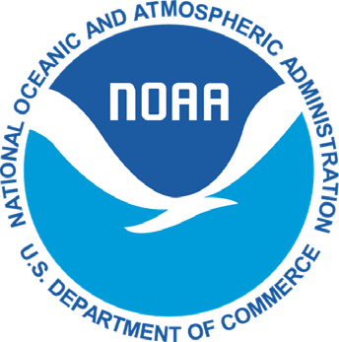
UNITED STATES DEPARTMENT OF COMMERCE OMB CONTROL NO. 0648-0204
National Oceanic and Atmospheric Administration Expiration Date: 1/31/2020

NATIONAL MARINE FISHERIES SERVICE
West Coast Region

501 West Ocean Boulevard, Suite 4200 Long Beach, California 90802-4213 wcr-permits@noaa.gov

COASTAL PELAGICS FISHING LIMITED ENTRY PERMIT
PERMIT RENEWAL FORM

Mail to: Permits Office, 501 W Ocean Blvd., Suite 4200, Long Beach, CA 90802

- APPLICANT INFORMATION
Name of current permit owner  PERMIT_HOLDER |  | Permit Number  Permit_number
Address  ADDRESS |  | Phone Number  PHONE_NUMBER
Signature | Print name |  | Date

- VESSEL INFORMATION (If no vessel is assigned write NO VESSEL)
Vessel Name  VESSEL_NAME |  |  |  | Permit Fixed Gross Tonnage  Fixed_Gt
U.S. Coast Guard Documentation number or State registration number  Uscg_Doc_Or_State_Reg_Num |  | Home Port  HOME_PORT |  | International Radio Call Sign (IRCS)  IRCS
Overall Length (ft.)  LENGTH | Breadth (ft.)  BREADTH |  | Depth (ft.)  DEPTH | Vessel Calculated Gross Tonnage*  Gross_Tons

*Gross tonnage (GT) means gross tonnage as determined by the formula in 46 CFR 69.209(a) for a vessel not designed for sailing (.67 x length x breadth x depth/100). A vessel’s length, breadth, and depth are those specified on the vessel’s certificate of documentation issued by the U.S. Coast Guard or state.

The purpose of this information collection is to limit the number of vessels fishing for coastal pelagic species according to the provisions of the Fishery Management Plan for Coastal Pelagic Species, which was approved by the Secretary of Commerce and implemented by federal regulations on December 15, 1999 (64 FR 69888). The information on this form is mandatory for owners of vessels who wish to participate in the limited entry fishery, and is required by 50 CFR 660.512. Notwithstanding any other provision of the law, no person is required to respond to, nor shall any person be subject to a penalty for failure to comply with, a collection of information subject to the requirements of the Paperwork Reduction Act, unless that collection of information displays a currently valid OMB Control Number.

Paperwork Reduction Act - Public reporting burden for this collection is estimated to average 10 minutes per response, including the time for reviewing instructions, searching existing data sources, gathering and maintaining the data needed, and completing and reviewing the collection of information. Send comments regarding this burden estimate or any other aspect of this collection of information, including suggestions for reducing this burden to West Coast Region, NMFS, 501 West Ocean Blvd., Suite 4200, Long Beach, California 90802-4213.

