**Attachment A**

Authorization for Research Data Center Proposal

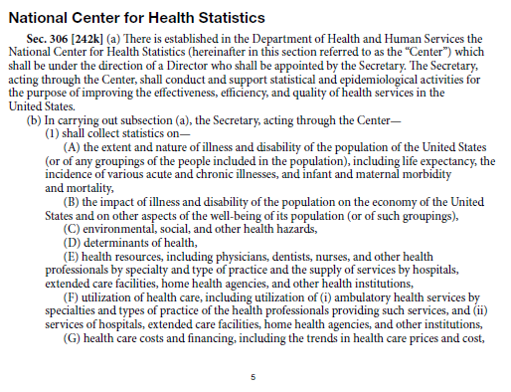

* Section 306(b)(4) of the Public Health Service Act [42 U.S.C. 242k(b)(4)] –

“(b) Duties

In carrying out subsection (a), the Secretary, acting through the Center,

. . .

(4) may collect, furnish, tabulate, and analyze statistics, and prepare studies, on matters referred to in paragraph (1) upon request of public and nonprofit private entities under arrangements under which the entities will pay the cost of the service provided.”

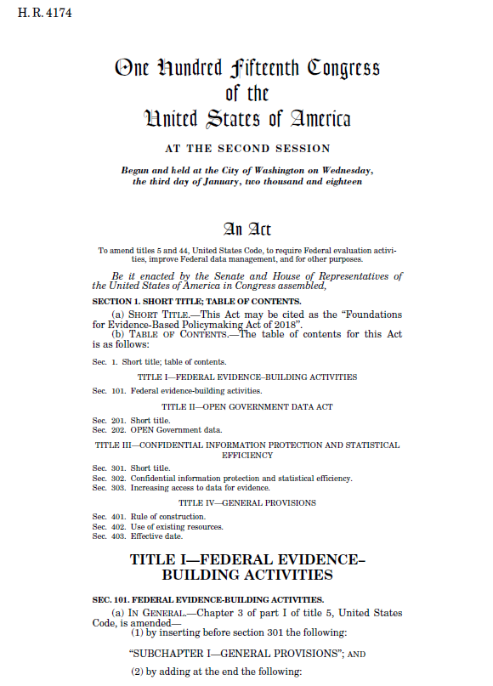

* Title III - Confidential Information Protection and Statistical Efficiency (see 44 U.S.C. 3583).

“(a) STANDARD APPLICATION PROCESS -The Director shall establish a process through which agencies, the Congressional Budget Office, State, local, and Tribal governments, researchers, and other individuals, as appropriate, may apply to access the data assets accessed or acquired under this subchapter by a statistical agency or unit for purposes of developing evidence.

(1) Sufficient detail to ensure that each statistical agency or unit establishes an identical process.

(2) A common application form.

(3) Criteria for statistical agencies and units to determine whether to grant an applicant access to a data asset.

(4) Timeframes for prompt determinations by each statistical agency or unit.

(5) An appeals process for adverse decisions and noncompliance with the process established under this subsection.

(6) Standards for transparency, including requirements to make the following information publicly available:

(A) Each application received.

(B) The status of each application.

(C) The determination made for each application.

(D) Any other information, as appropriate, to ensure full transparency of the process established under this subsection.

(b) CONSULTATION.—In establishing the process required under subsection (a), the Director shall consult with stakeholders, including the public, agencies, State and local governments, and representatives of non-governmental researchers.

(c) IMPLEMENTATION.—The head of each statistical agency or unit shall implement the process established under subsection (a).”