Appendix C4: Social Media Recruitment Content

Social Media Recruitment Content
EI Social Media
Newton and Jasper County Lead Testing

Social Media  Platform | Topic | Message – Action | Visual | Notes
Twitter | Lead testing | Soil in Newton & Jasper counties has high lead levels from historic mining, milling, & smelting. Even low levels of lead can harm health. Have kids under 6 & pregnant women come out for #LeadTesting on TBD at TBD. Receive $20 gift card. Learn more: Https://www.atsdr.cdc.gov/TBDXZY |  | Add specific EI website to the listing. Image courtesy of EPA R7- Newton County Mine Tailings. add date/time of events(s) when available. Consider branding #ATSDRLeadTesting or #Newton LeadTesting or #JasperLeadTesting
Twitter | Ways to protect yourself | Free lead testing. Protect your family from high lead levels in soil from historic mining, milling, and smelting in Newton & Jasper counties. Consider #LeadTesting for kids under 6 on TBD at TBD. Receive $20 gift card. Learn more Https://www.atsdr.cdc.gov/TBDXZY | 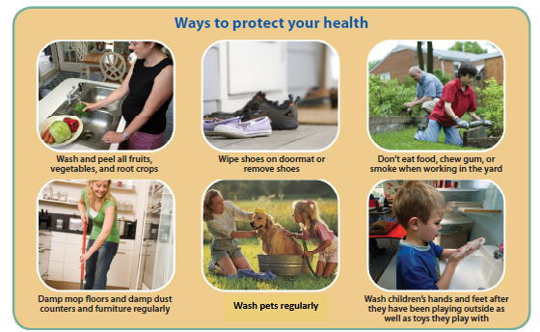 | Add specific EI website to the listing. Add date and time of event(s) when available
Twitter | Children exposures | Kids under 6 can have lowered IQ and behavioral issues from lead exposures. Soil in Newton & Jasper counties has high lead levels from historic mining, milling, & smelting. Even low levels of lead can harm health. Come get your child #LeadTested at TBD on TBD and receive a $20 gift card. Learn more Https://www.atsdr.cdc.gov/TBDXZY |  | Add specific EI website to the listing. Add date and time of event(s) when available… consider removing there is no safe level of lead if going over space limits. Photo courtesy of ATSDR Cory Kokko.
Facebook and Instagram | Testing health effects | ATSDR will be conducting a free lead testing event in Newton and Jasper counties due to high lead levels in soil from historic mining, milling, & smelting. Kids under 6 can have lowered IQs and behavioral issues from lead exposures, Babies can have low birth weights and slow growth. Even low levels of lead can harm health. Have your blood, household, water, and yard tested.  Eligible participants:  - Children under 6  - Pregnant women  - Women of childbearing age.  Participants will receive $20 gift card.  To learn more, go to: Https://www.atsdr.cdc.gov/TBDXZY  Event information:  Newton County, PLACE TBD, DATE TBD  Jasper County, PLACE TBD, DATE TBD |  | Add specific EI website to the listing. Add date and time of event(s) when available. Photo courtesy of ATSDR Cory Kokko.
Facebook and Instagram | Protect yourself | Protect yourself and your family against the health effects from high lead levels in soil from historic mining, milling, and smelting in Newton and Jasper counties. Even low levels of lead can harm health. Please have all children under 6 and women that are pregnant or of childbearing age come for free lead testing of blood, households, water, and yards. Receive a $20 gift card. Learn more Https://www.atsdr.cdc.gov/TBDXZY |  | Add specific EI website to the listing. Add date and time of event(s) when available.
Facebook and Instagram | Historic soil, testing | Historic mining, smelting and milling have caused high lead levels in soil throughout Newton and Jasper counties in Missouri. The health effects of lead exposures- even at low levels- include reduced IQs and behavioral problems in children under 6 and low birth weight and slow growth in babies born to women that were exposed to lead.  Join ATSDR for a free lead testing event where blood, households, water, and yards will all be tested to determine whether there are levels of lead in your body, or sources of lead where you and your family live and play. Receive a $20 gift card per participant.  To learn more, go to: Https://www.atsdr.cdc.gov/TBDXZY  Event information:  Newton County, PLACE TBD, DATE TBD  Jasper County, PLACE TBD, DATE TBD | Lead waste removals in Newton and Jasper counties | Add specific EI website to the listing. Image courtesy of EPA R7- Newton County Mine Tailings and Jasper County Oronogo-Duenweg site. Add date/time of events(s) when available.

