OHO COVID-19 Screening Survey (OCSS) Screenshots

External Survey

First Screen with Privacy Statement and PRA Statement Collapsed:

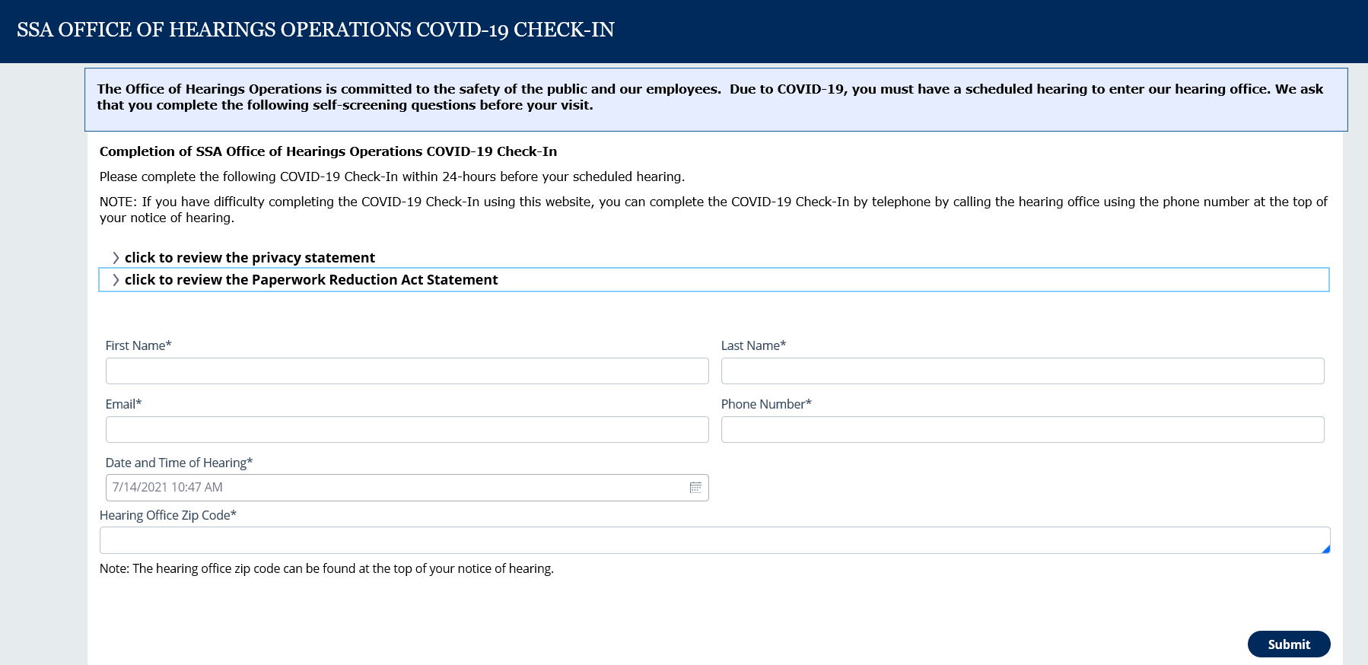

First Screen with Privacy Statement expanded:

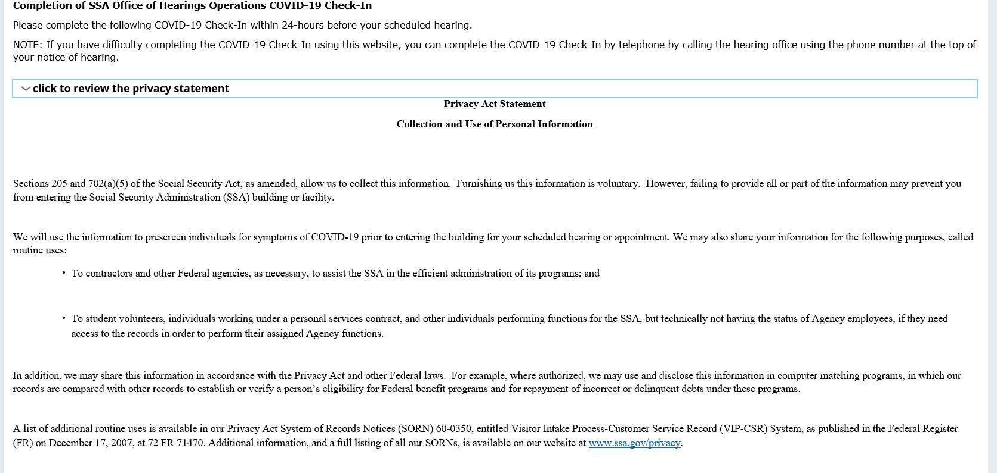

First Screen with the PRA Statement Expanded:

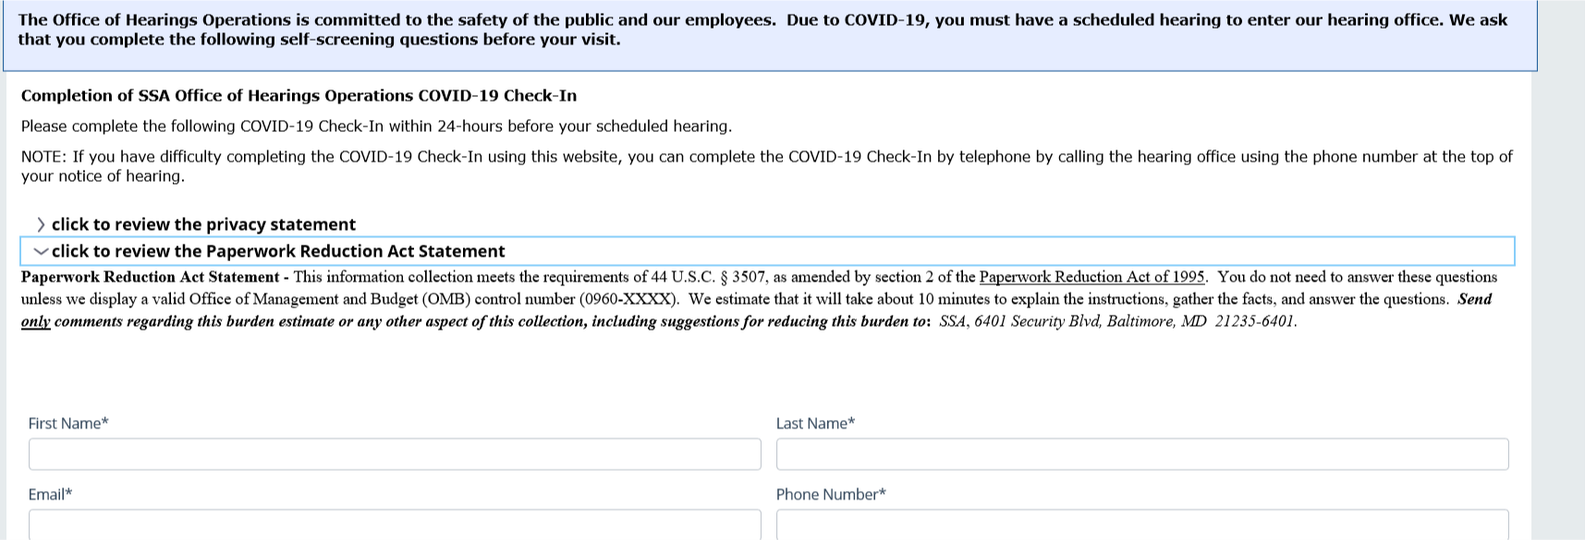

First Screen with Errors: 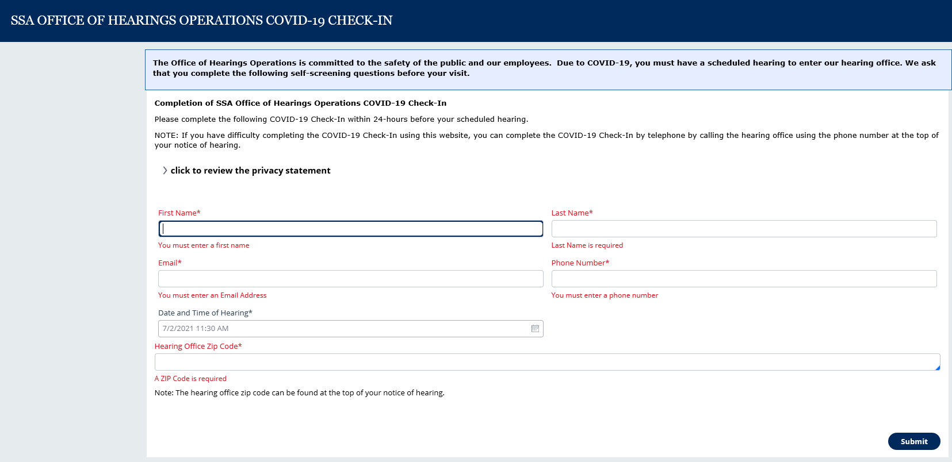

Second Screen – Survey Questions:

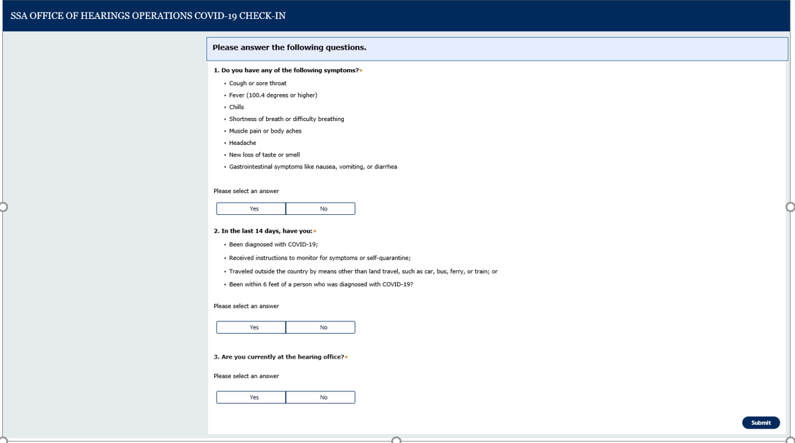

Cleared for Hearing Screen:

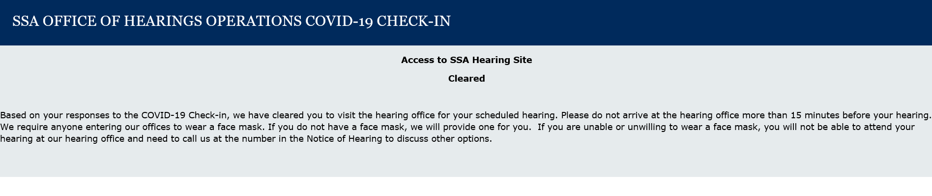

Cleared for Hearing Email: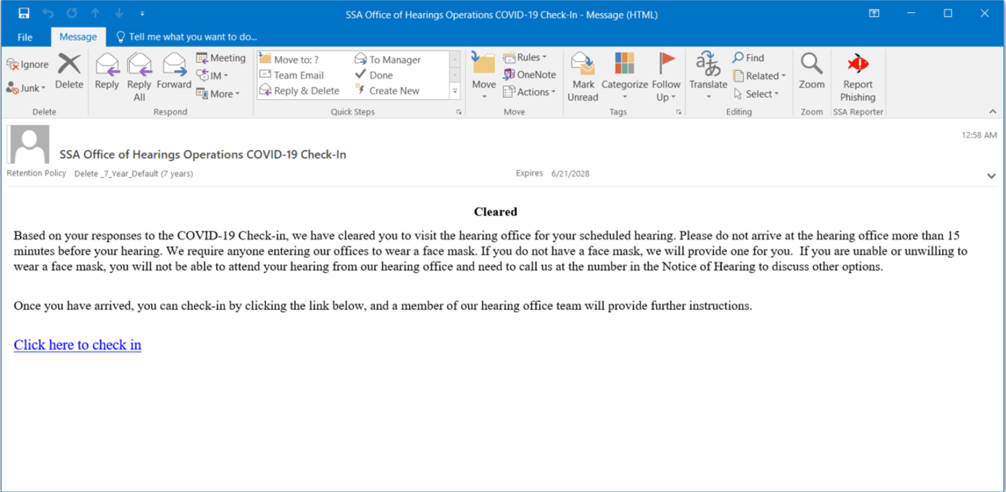

Check In Confirmation:

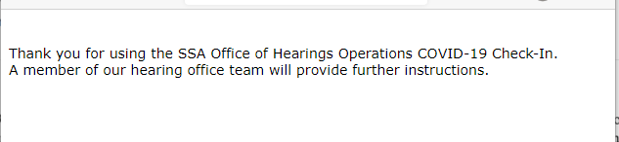

Not Cleared for Hearing Screen:

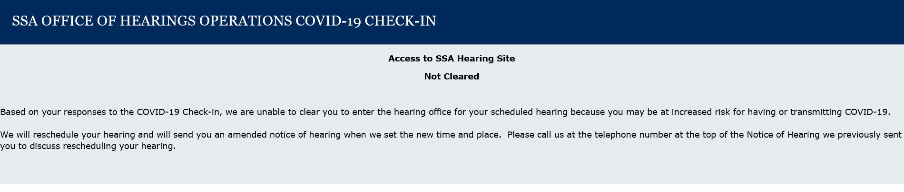

OHO Case Manager Dashboard (Internal users):

