Addendum to the Supporting Statement for Integrated Registration Services (IRES) System
20 CFR 401.45
OMB No. 0960-0626

Minor Revisions to the Collection Instrument

SSA is making the following revisions:

- Change #1: We are making changes to the password set for the Business Services Online (BSO) accounts. Users will no longer be able to select a password commonly used, or on list, the user will be required to select a unique password.

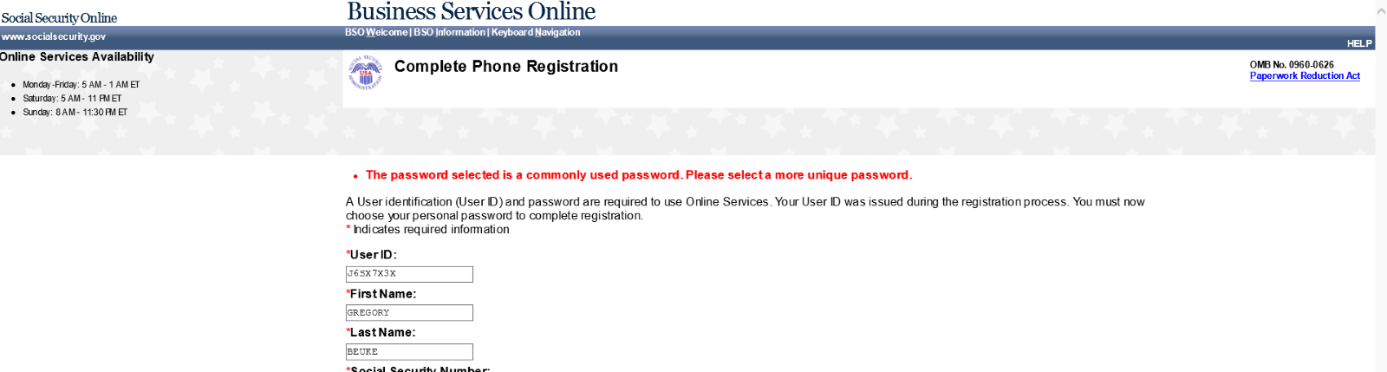
Known Bad Password Error – Complete Phone Registration Screen

Known Bad Password Error – Create Your Password Screen
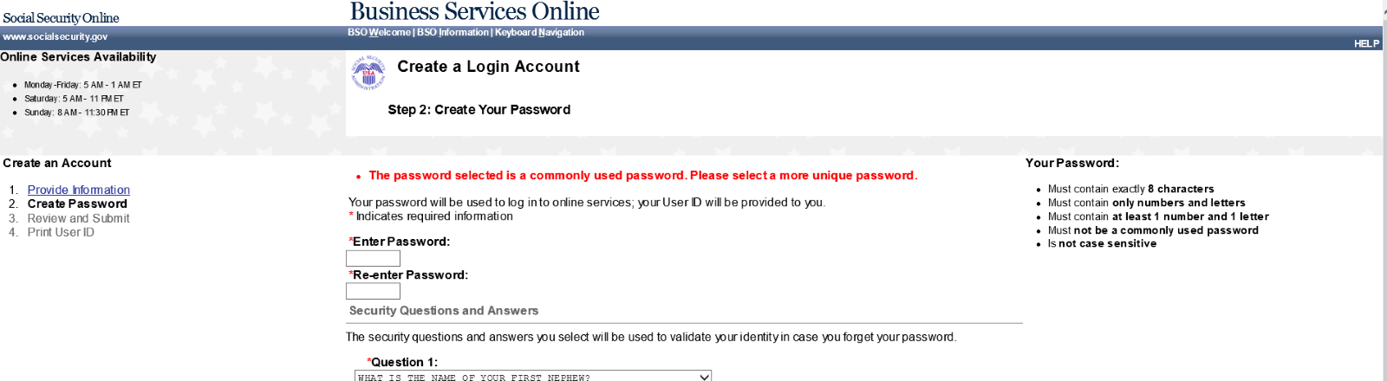

Known Bad Password Error – Change Password Screen

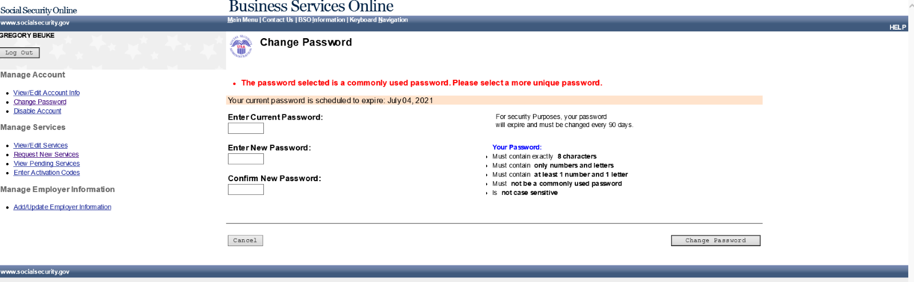

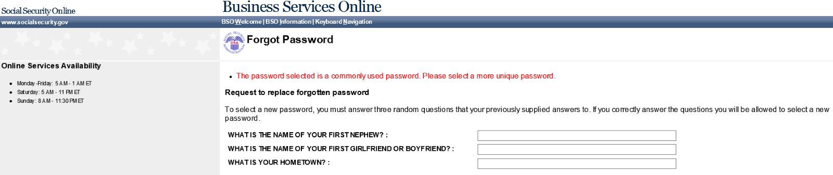

.

Justification #1: We are making these changes to enhance security measures.

- Change #2: We are revising the Privacy Act Statement on this form.

Justification #2: SSA’s Office of the General Counsel is conducting a systematic review of SSA’s Privacy Act Statements on agency forms. As a result, SSA is updating the Privacy Act Statement on the form.

