Attachment B: COVID-19 Attitudes and Beliefs Survey – NORC Consent Form

ONLINE CONSENT SCREEN TO JOIN THE AMERISPEAK PANEL

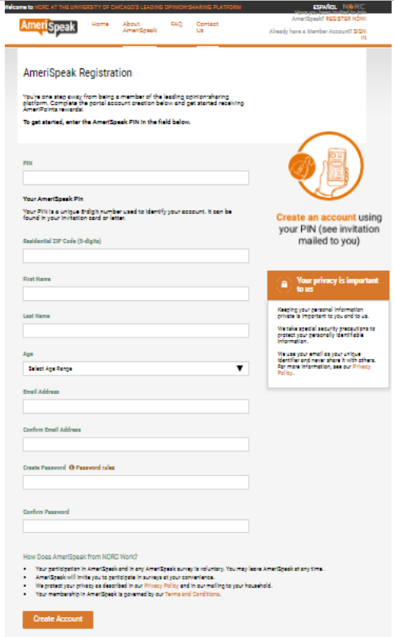

TELEPHONE CONSENT LANGUAGE TO JOIN THE AMERISPEAK PANEL
Thank you! Your participation in AmeriSpeak is voluntary. You may choose not to answer any questions you don’t wish to answer. You may withdraw your participation in AmeriSpeak at any time. We take all possible steps to protect your privacy, and we will use your answers only for statistical research. NORC will not share information that would disclose your identity with any clients unless you give us permission to do so.

In appreciation for your participation, you will receive <> AmeriPoints worth $[INCENTDLR] for completing your first survey. You will receive between 2,000-5,000 AmeriPoints, which can be redeemed for rewards worth between $2 and $5 for additional surveys you complete.
If this is agreeable to you, I’d like to continue now unless you have any further questions.

01. Yes, agreed – [CONTINUE TO RECRUIT]
02. No, does not agree – [TERMINATE CALL AND DISPLAY: Unfortunately, we won’t be able to enroll you right now as we need your consent to complete your registration. PAUSE. Thank you for talking to us. If you have any questions, you can contact AmeriSpeak at 800-860-1178.]

