OMB control number 1652-0029
Exp. 09/30/2022
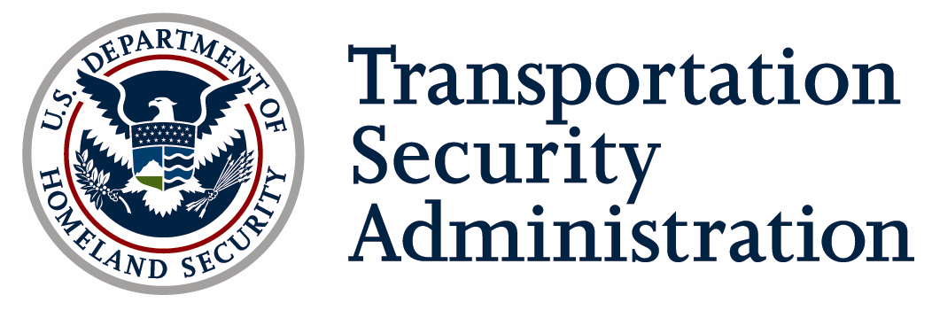
MD-3 PIN Application
Applicant Phone

Applicant E-mail INSTRUCTIONS: Complete all applicable fields. In Section 1, check the Maryland Three (MD-3) airport where you are based. If you own an aircraft, complete all of Section 3. If you do not own an aircraft, leave make/model and FAA Registration No. fields blank in Section 3. Take this form to the FAA Flight Standard District Office (FSDO) for an official to sign and to also to your selected airport for the Airport Security Coordinator to sign. Submit completed application via fax to (571) 227-2948.

Section 1: MD-3 Airports Access
Check One: | College Park | Hyde Field |  | Potomac Air Field |  | Transient
Section 2: Applicant Information
Name: |  |  |  | Date of Birth: |  | SSN Last 4 digits:
Home Address: |  |  | City: |  |  | State: | Zip:
Section 3: Airman/Aircraft Information
Airman Certificate No.: |  |  |  | ATP Commercial Private Student
Aircraft Make/Model (e.g., enter “C-172” if a Cessna 172): |  |  |  |  | FAA Registration No.:
Section 3: Approvals
FAA FSDO OFFICIAL
I have inspected the applicant’s airman certificate, flight medical certificate, and all other appropriate information.
Print Name Signature Date Phone Number
FAA Inspector No. on 110A:
DCA SECURITY COORDINATOR
The applicant has been fingerprinted and completed the appropriate paperwork for a background check. Reference code SON = 644F / SOI = TD30.
Print Name Signature Date Phone Number
I have completed the TSA-approved security training module under the supervision of the airport security coordinator. I will comply with the procedures outlined in the security training. I have been provided an opportunity to ask questions of the airport manager or been directed by the airport manager to appropriate Federal Aviation Administration (FAA), Transportation Security Administration (TSA), or United States Secret Service (USSS) officials to resolve any questions. I have been apprised of my security responsibilities, as outlined in the airport security procedures, and am aware of my reporting and security responsibilities.
I have completed the items required above and understand that I may be subject to questioning by FAA, TSA, or USSS officials as part of airport inspections or surveillance activities. I further understand that failure to comply with the airport security procedures may result in suspension of my privileges to operate an aircraft to or from the airport(s) indicated above.
Applicant Signature Required: |  |  |  |  |  | Date:
AIRPORT SECURITY COORDINATOR or ALTERNATE
I have reviewed and photocopied the applicant’s airman certificate and a government-issued identification with photograph. I have included a copy of these documents in the Airport Security Plan. The applicant viewed the Airport/Pilot Security Briefing tape developed by the FAA, TSA, and the USSS regarding pilot and airport security procedures at the airport indicated above.
Print Name Signature Date Phone Number

PRIVACY ACT STATEMENT: Authority: 49 U.S.C. § 114 authorizes collection of this information. Principal Purpose(s): TSA will use the information to process your application to fly to, from, or through the airspace of the College Park, Hyde Field, and Potomac airports located in Maryland. Routine Use(s): TSA may share this information with FAA when relevant to the issuance of security clearance, license or other credential. For further information, please consult DHS/TSA 002 Transportation Security Threat Assessment System. Disclosure: Voluntary; Failure to provide the requested information may result in a denial of your request to take off, land, or fly through the airspace of the Maryland 3 airports.
PAPERWORK REDUCTION ACT BURDEN STATEMENT: This is a mandatory collection of information if you wish to fly to, from, or through the airspace of the College Park, Hyde Field, and Potomac airports located in Maryland. The total average burden per response associated with this collection is estimated to be approximately 6 hours. Send comments regarding this burden estimate or any other aspect of this collection to: TSA-11, Attention: PRA 1652-0029, 6595 Springfield Center Drive, Springfield, VA 20598 -6011. An agency may not conduct or sponsor, and a person is not required to respond to, a collection of information unless it displays a valid OMB control number. The control number assigned to this collection is OMB 1652-0029, which expires 9/30/2022.

TSA Form 418, 10/09 [File: 2000.2] OMB Control No. 1652-0029; Expiration Date: 09/30/2022.

