NCCDB Complaint Entry Home Page

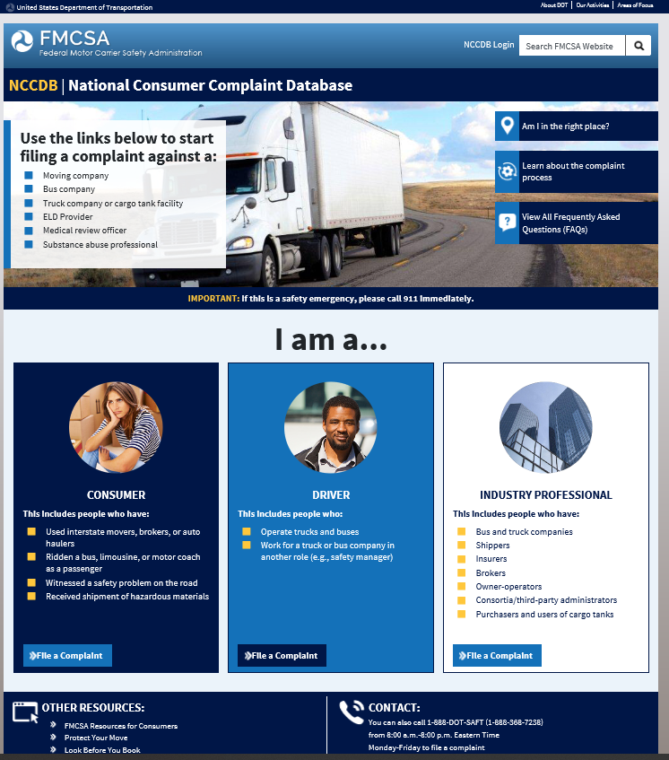

Consumer Moving Complaint Type

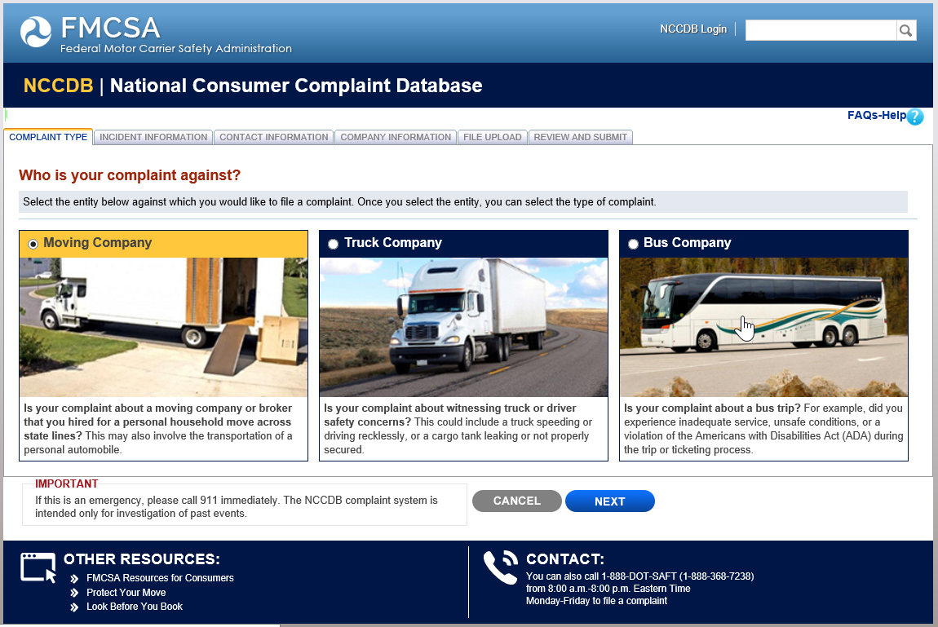

Consumer Moving Complaint Incident Information

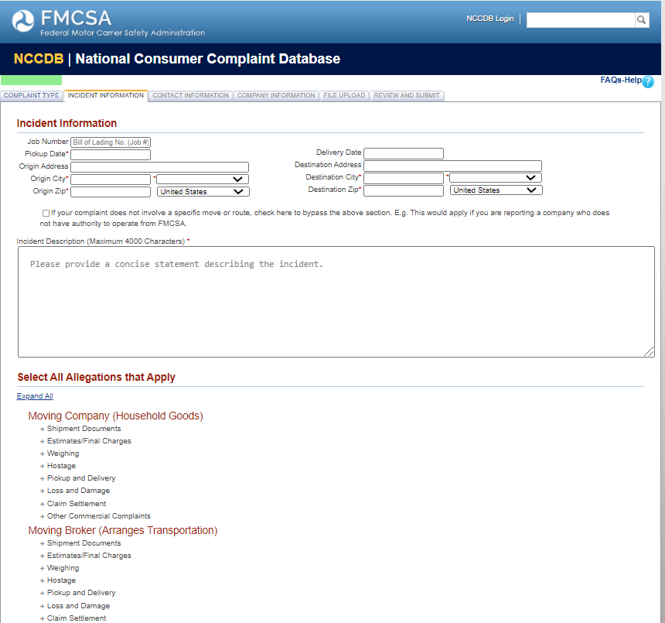

Consumer Moving Complaint Incident Information

Continued

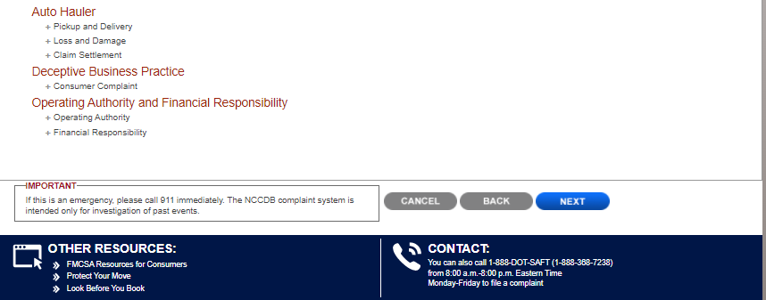

Consumer Moving Complaint Incident Information

Continued
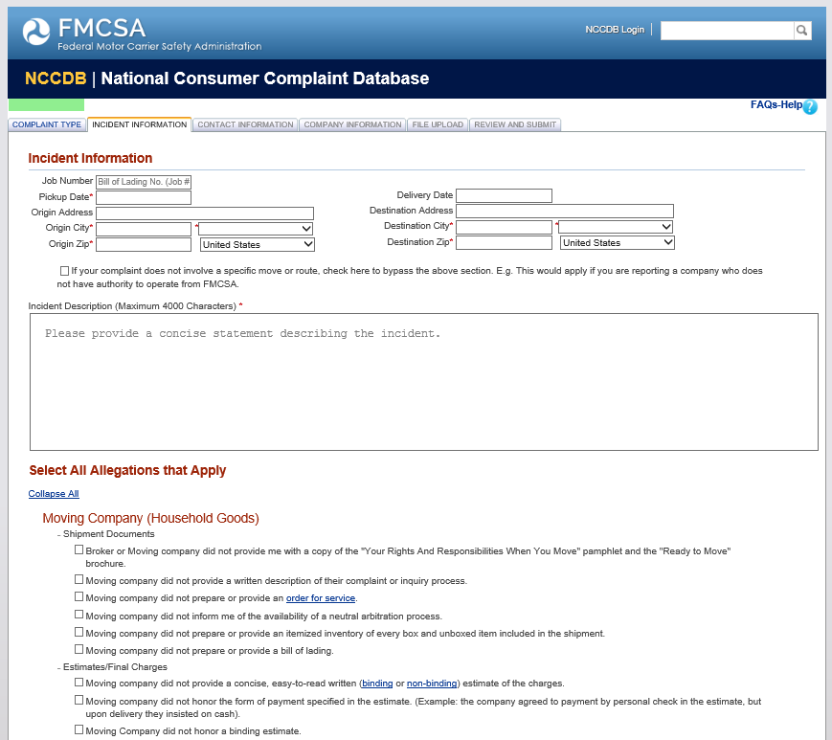

Consumer Moving Complaint Incident Information

Continued
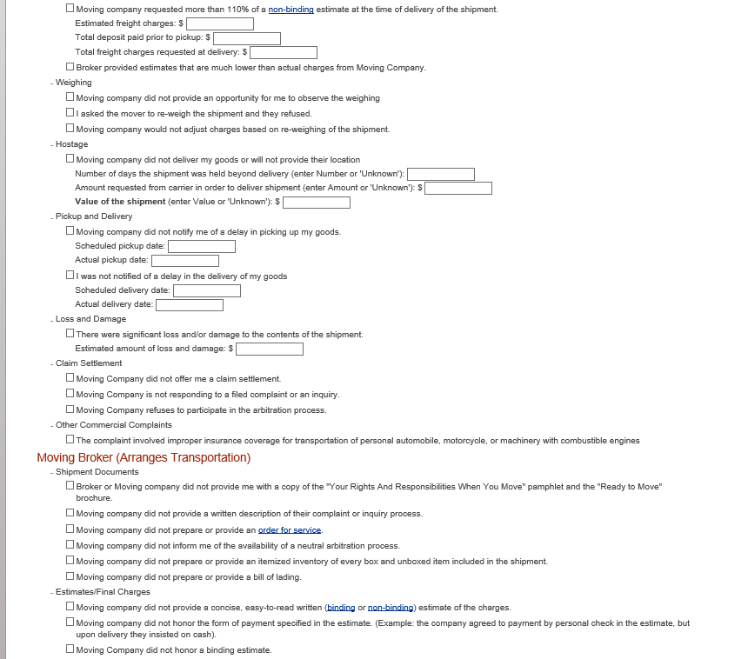

Consumer Moving Complaint Incident Information

Continued

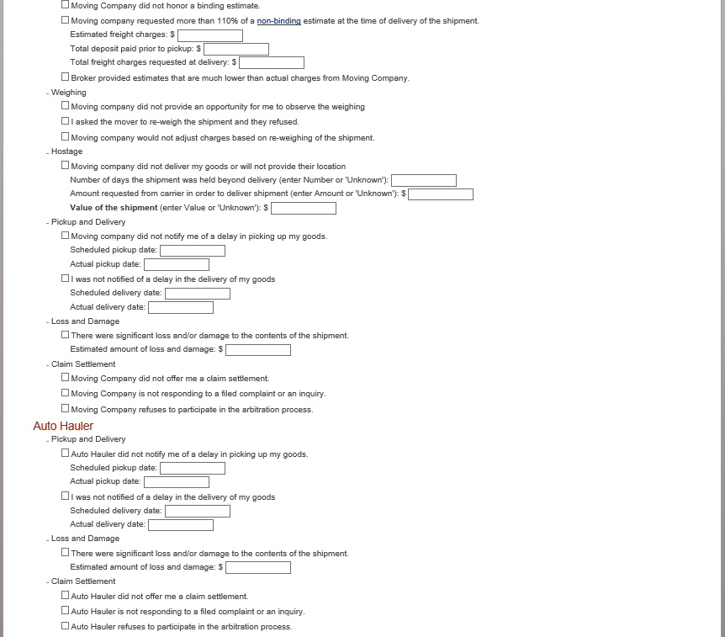

Consumer Moving Complaint Incident Information

Continued

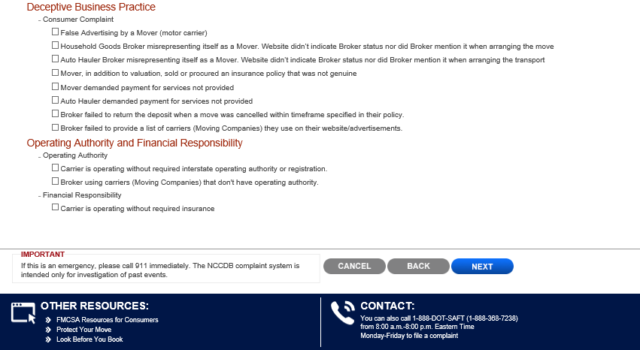

Consumer Moving Complaint Contact Information

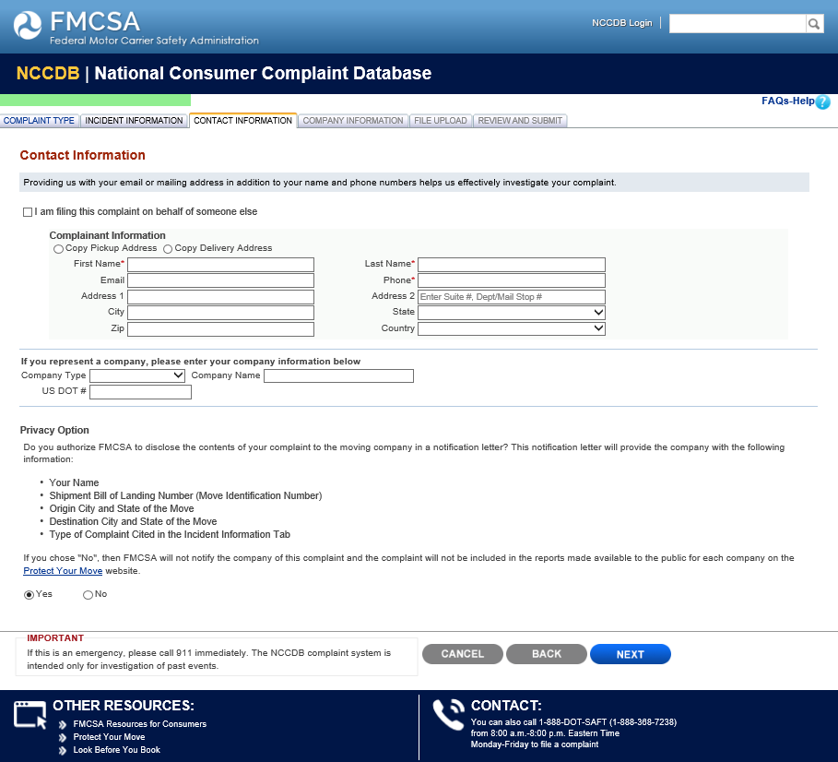

Consumer Moving Complaint Company Information

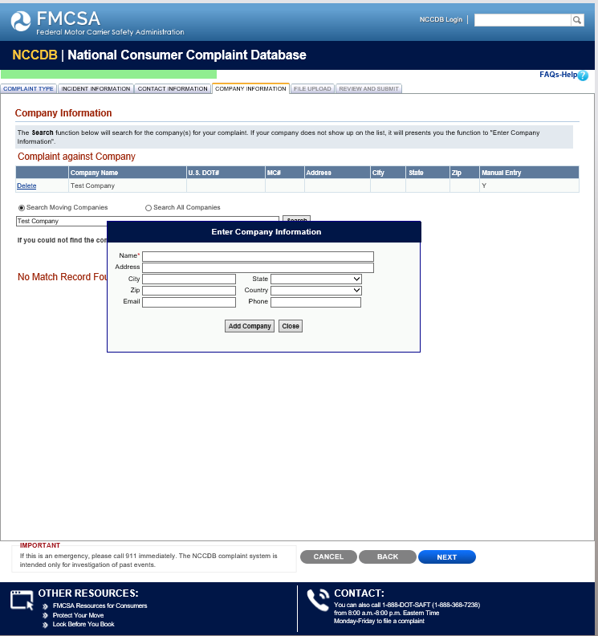

Consumer Moving Complaint File Upload

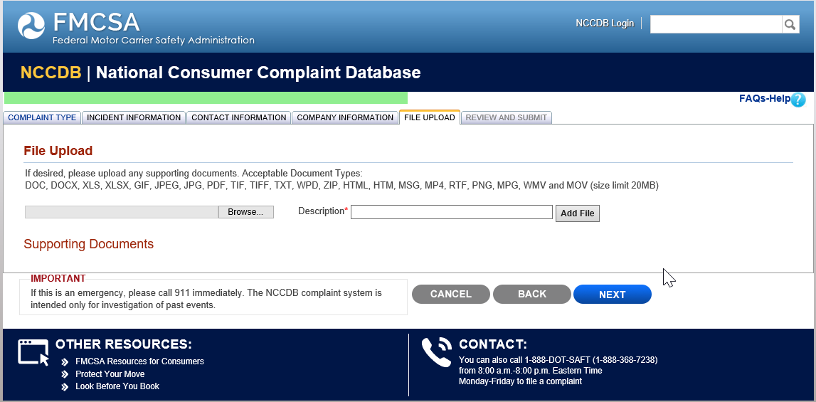

Consumer Moving Complaints Review and Submit

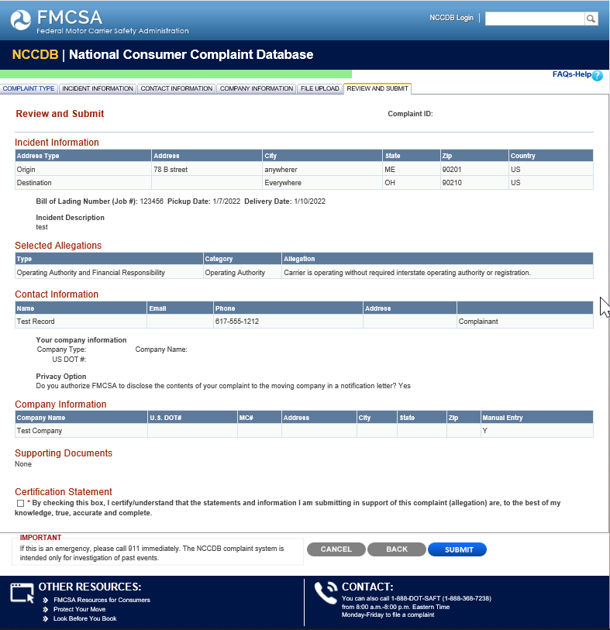

Consumer Truck Complaint Type

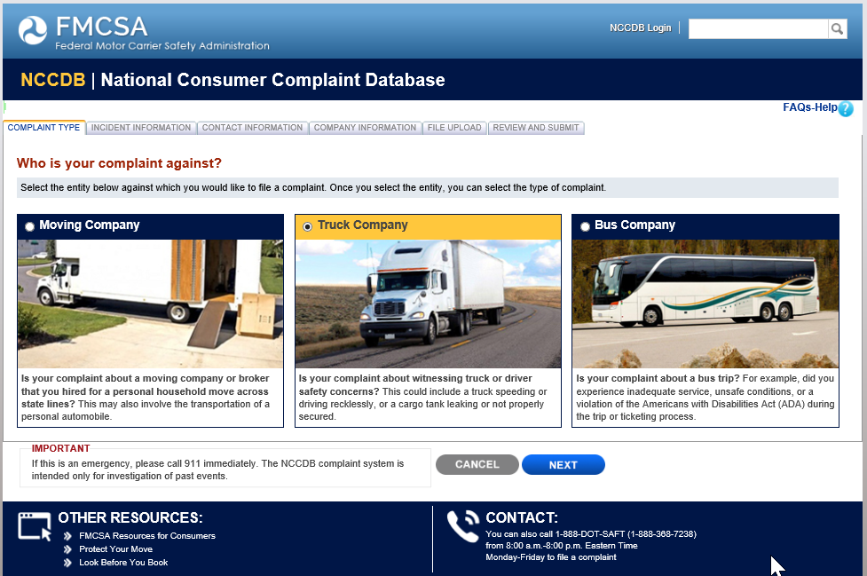

Consumer Truck Complaint Incident Information

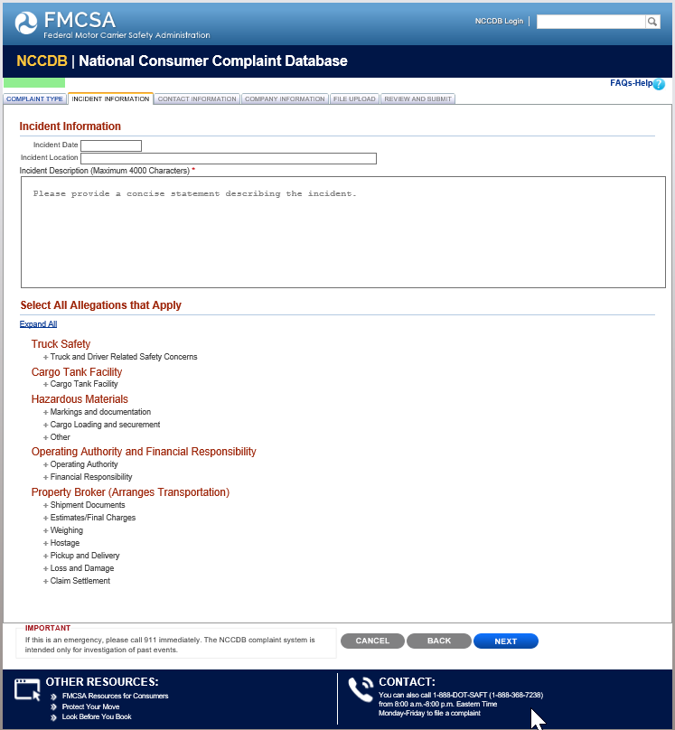

Consumer Truck Complaint Incident Information

Continued

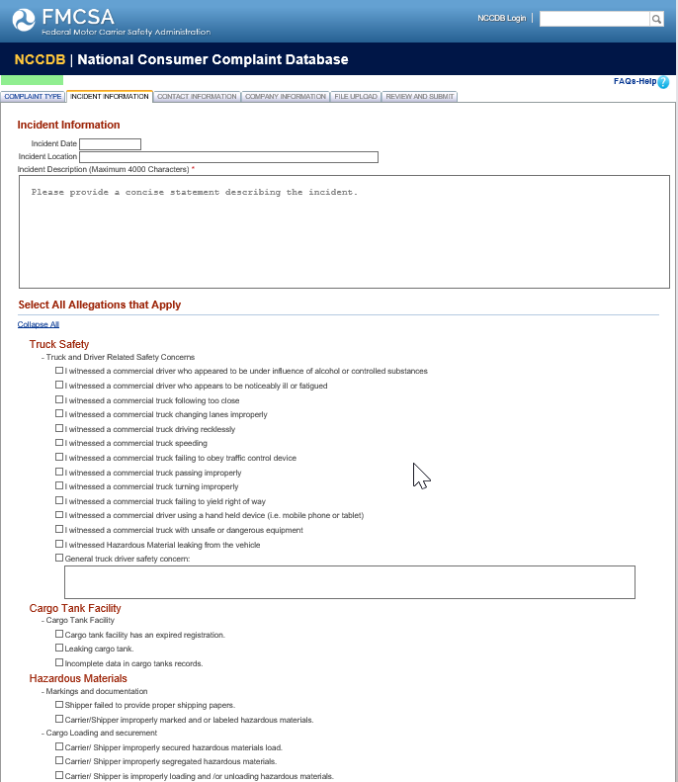

Consumer Truck Complaint Incident Information

Continued

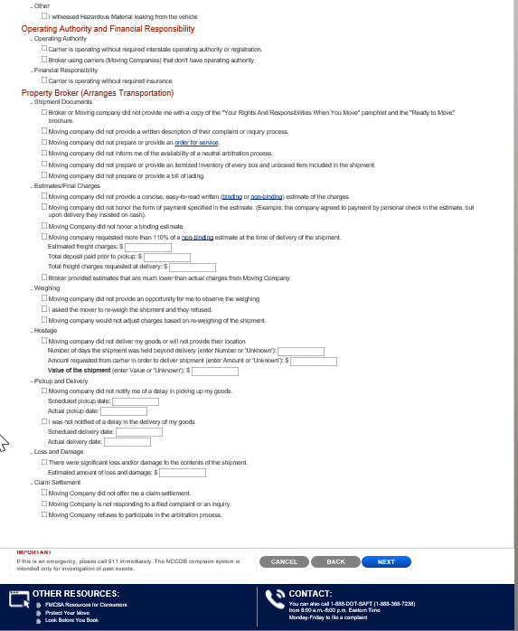

Consumer Truck Complaint Contact Information

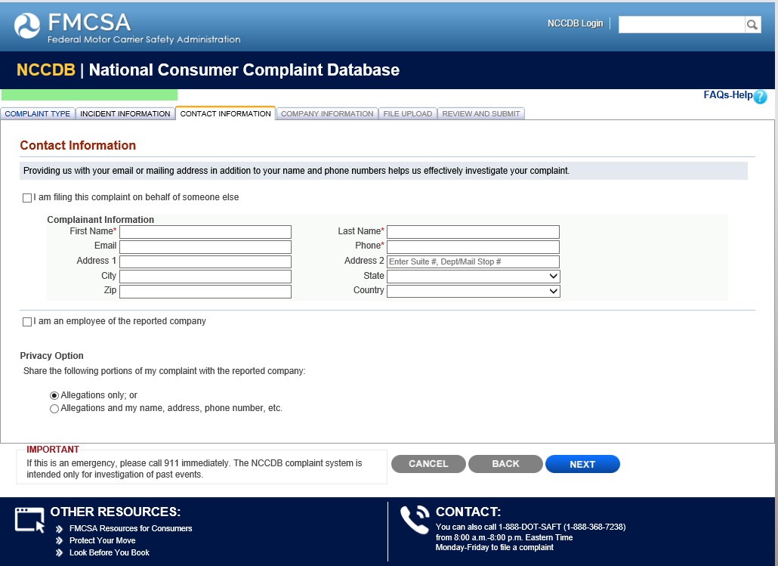

Consumer Truck Complaint Company Information

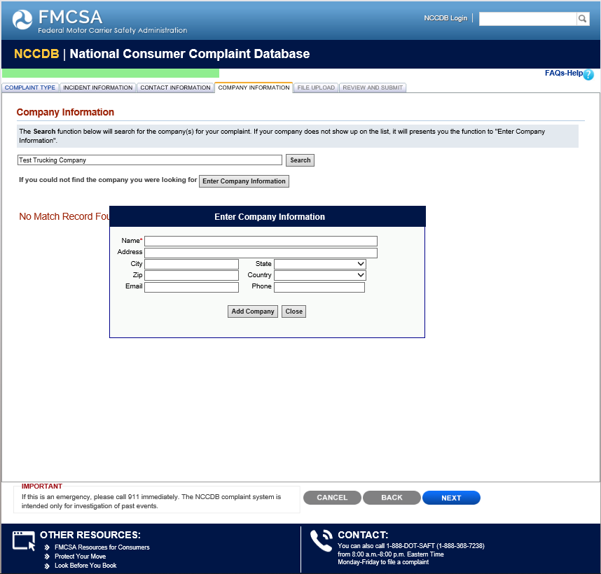

Consumer Truck Complaint File Upload

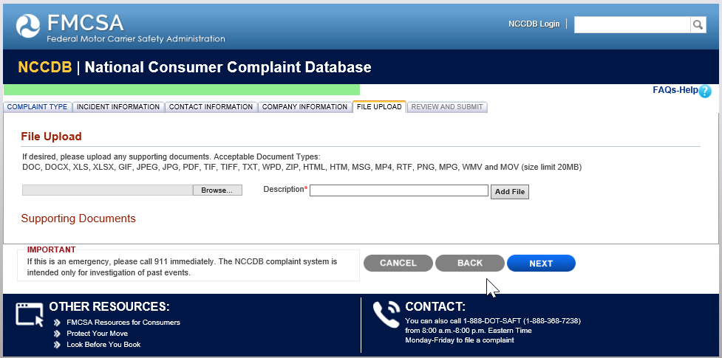

Consumer Truck Complaint Review and Submit

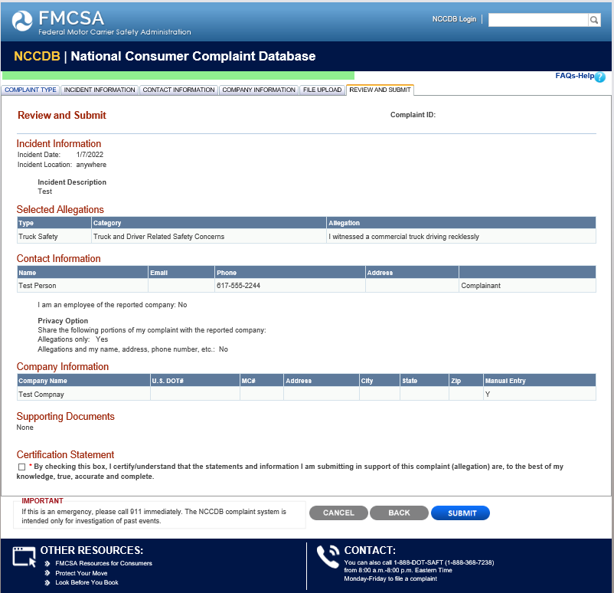

Consumer Bus Complaint Type

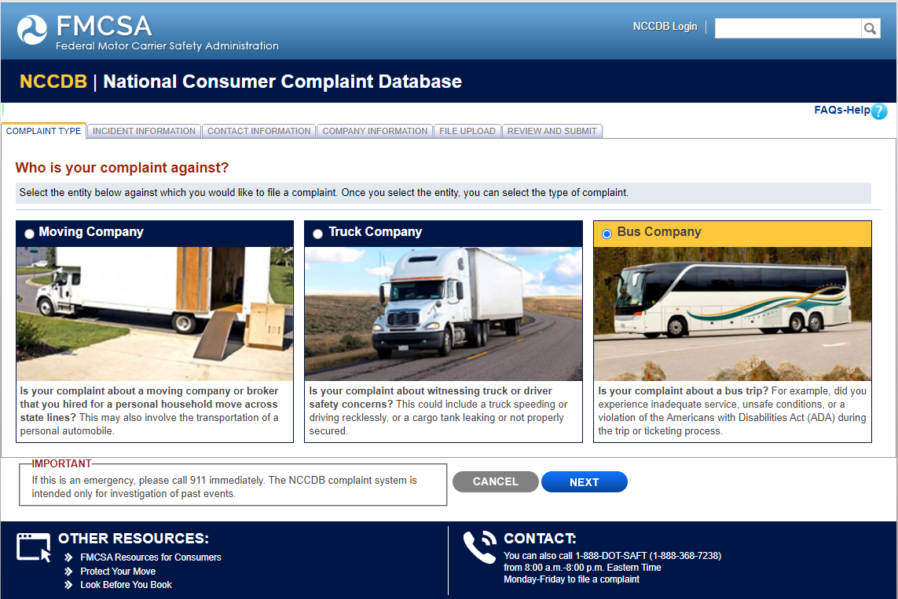

Consumer Bus Complaint Incident Information

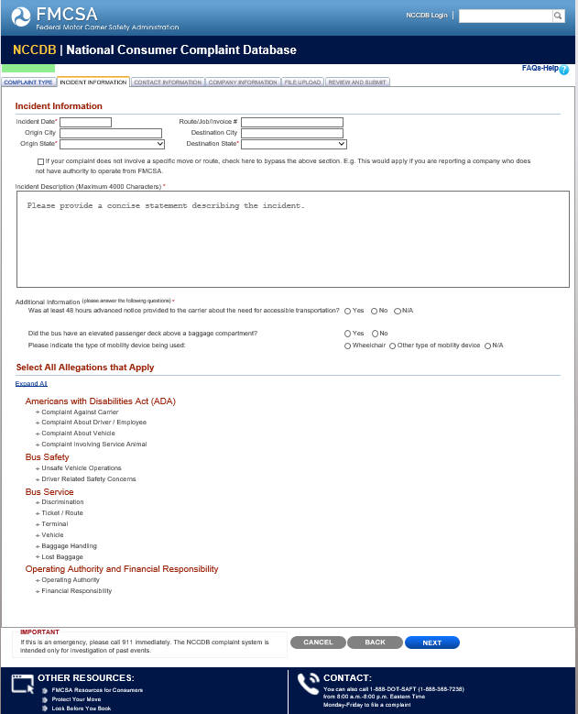

Consumer Bus Complaint Incident Information

Continued
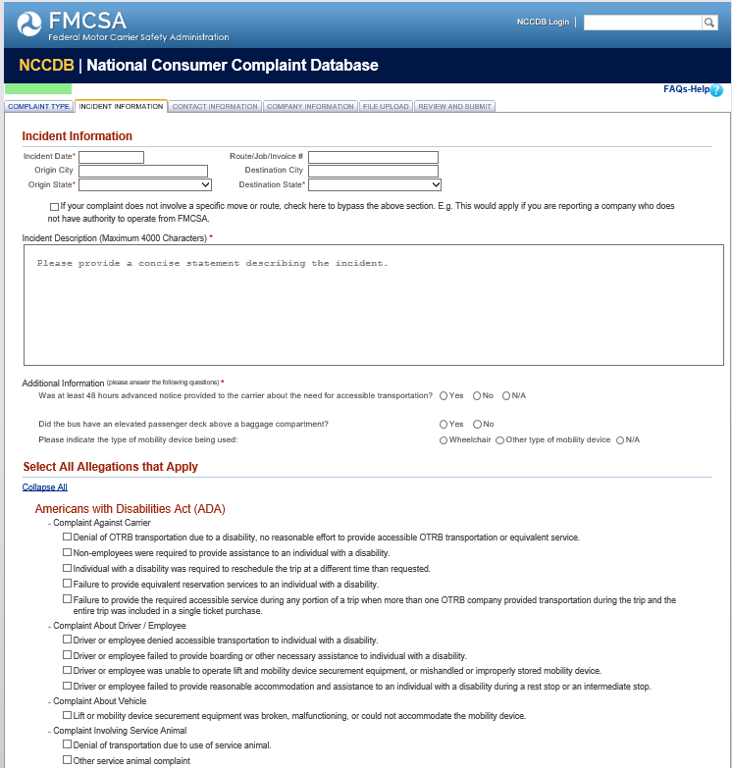

Consumer Bus Complaint Incident Information

Continued
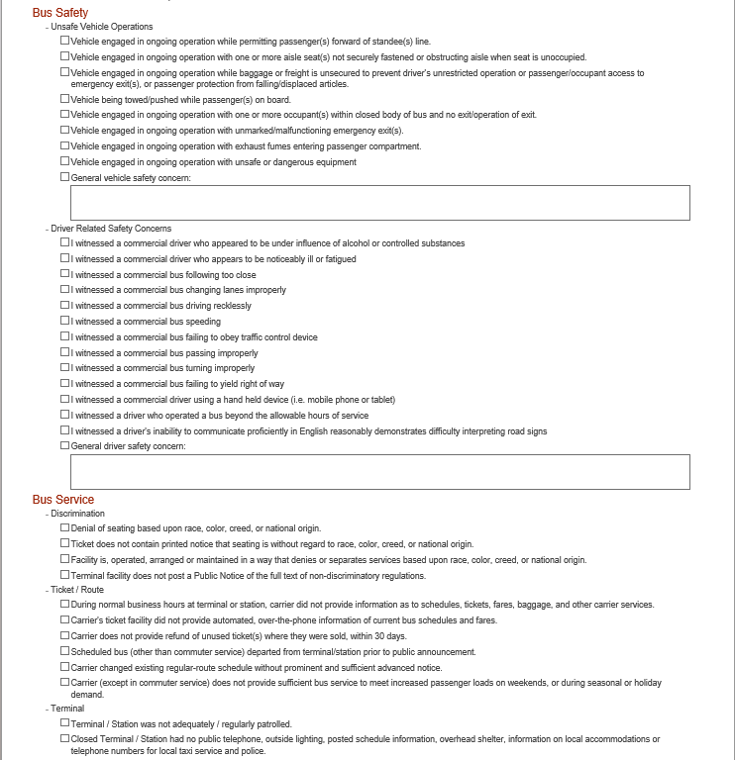

Consumer Bus Complaint Incident Information

Continued
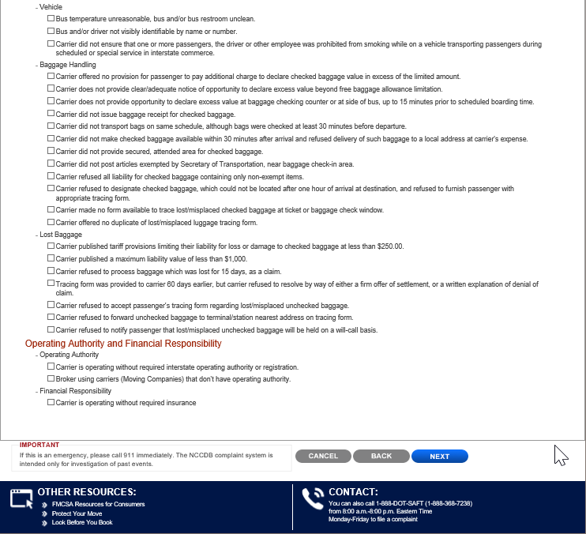

Consumer Bus Complaint Contact Information

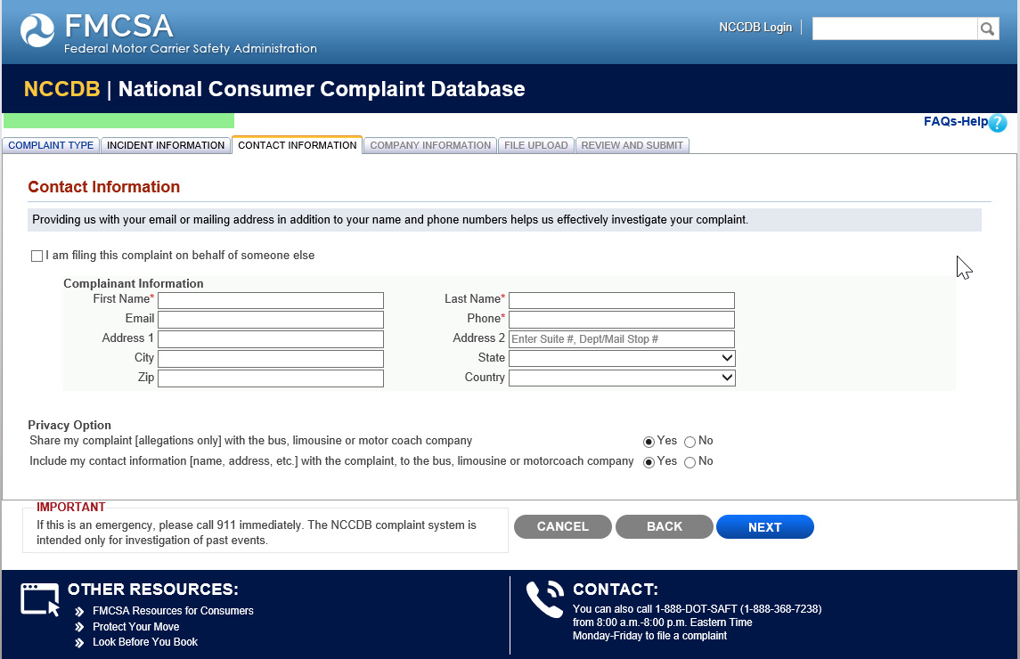

Consumer Bus Complaint Company Information

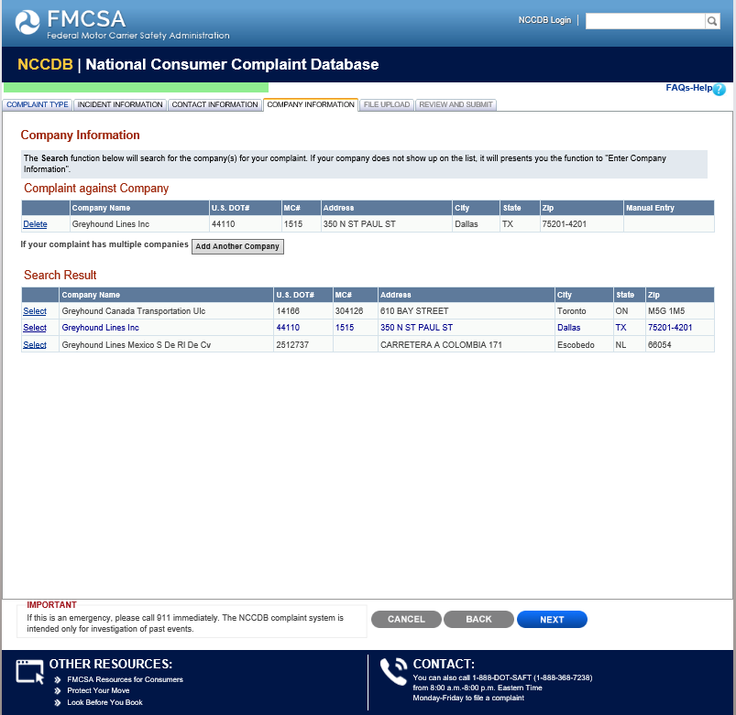

Consumer Bus Complaint File Upload

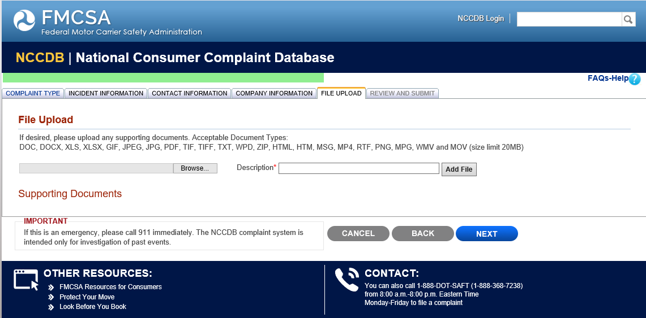

Consumer Bus Complaint Review and Submit

