NCCDB Complaint Entry Home Page

Industry Moving Complaint Type

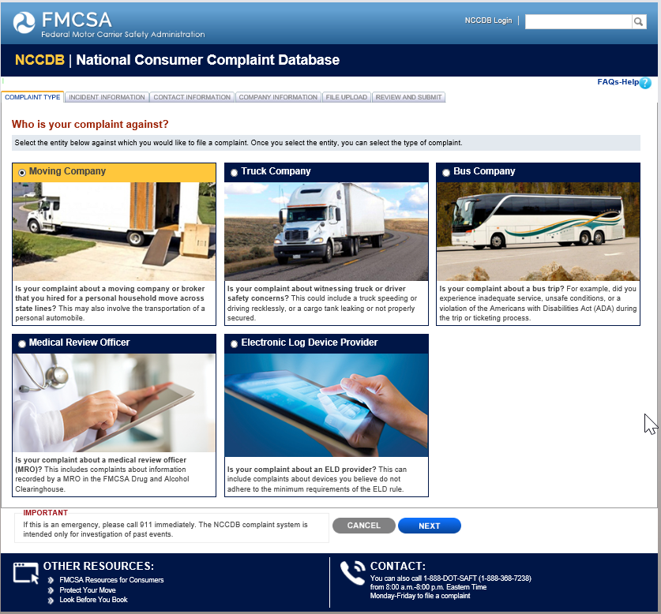

Industry Moving Complaint Incident Information

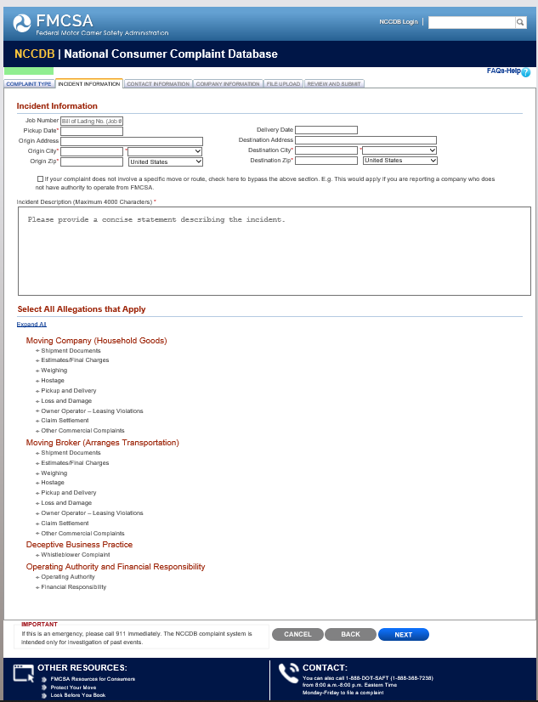

Industry Moving Complaint Incident Information

Continued
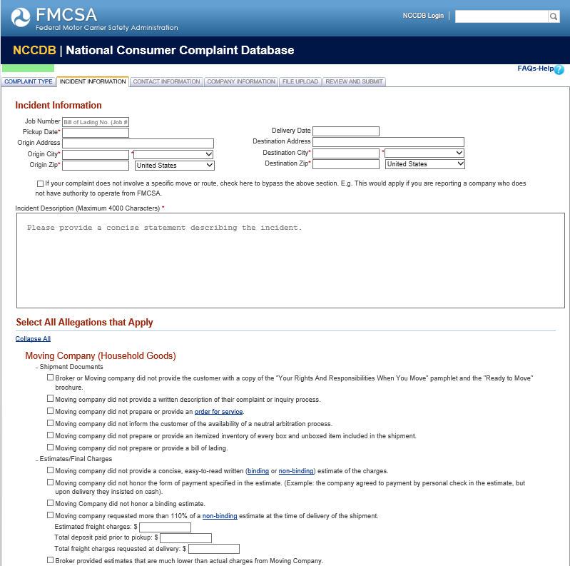

Industry Moving Complaint Incident Information

Continued
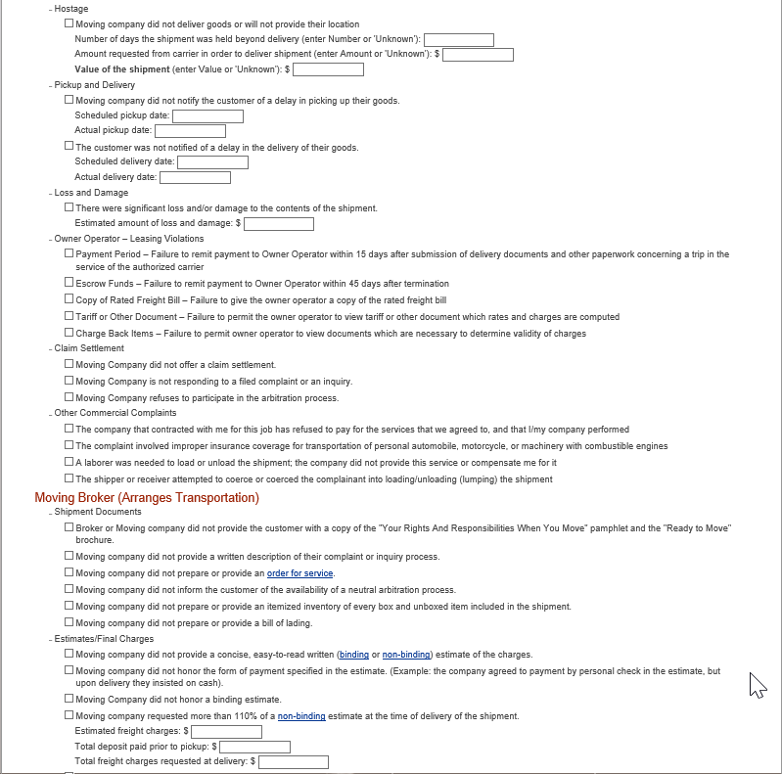

Industry Moving Complaint Incident Information

Continued

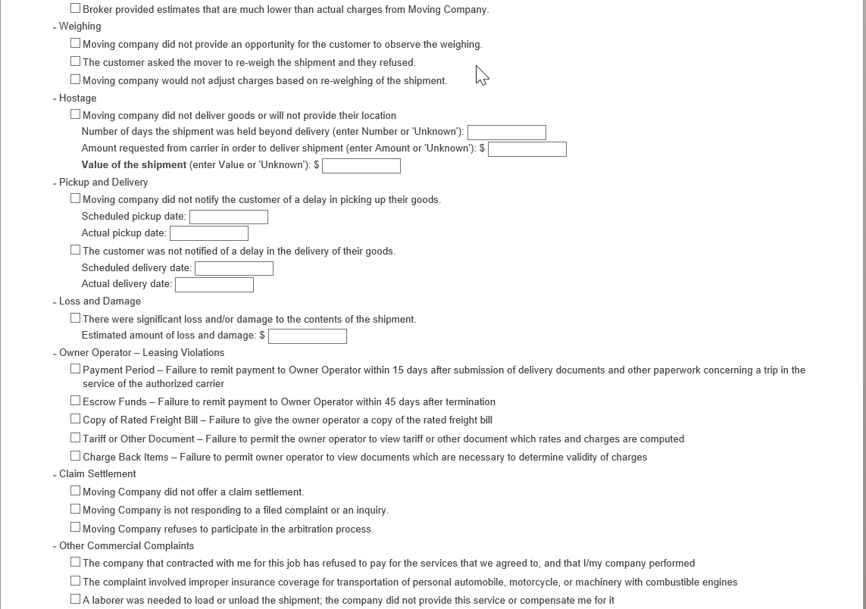

Industry Moving Complaint Incident Information

Continued

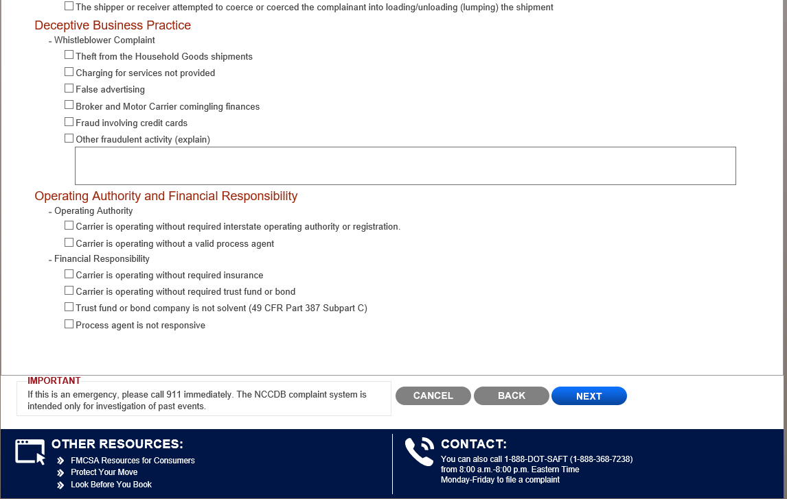

Industry Moving Complaint Contact Information

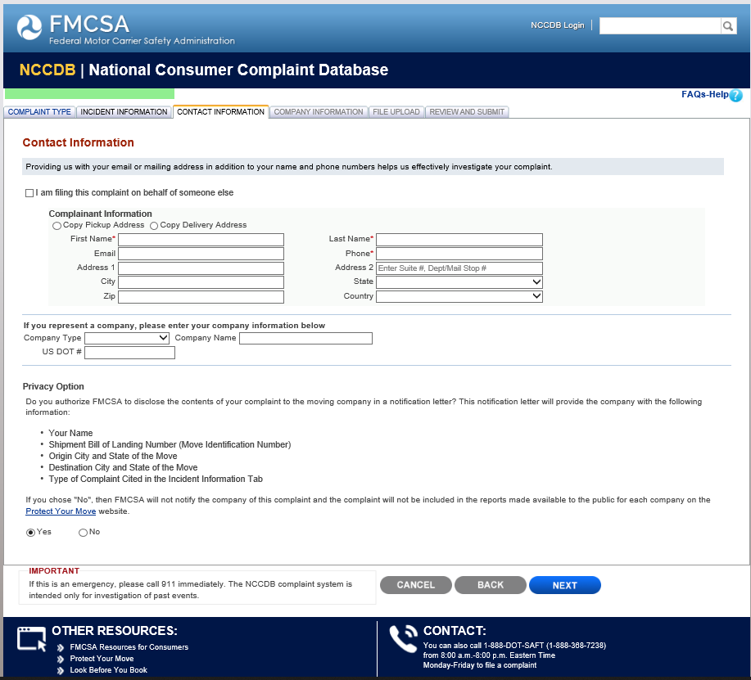

Industry Moving Complaint Company Information

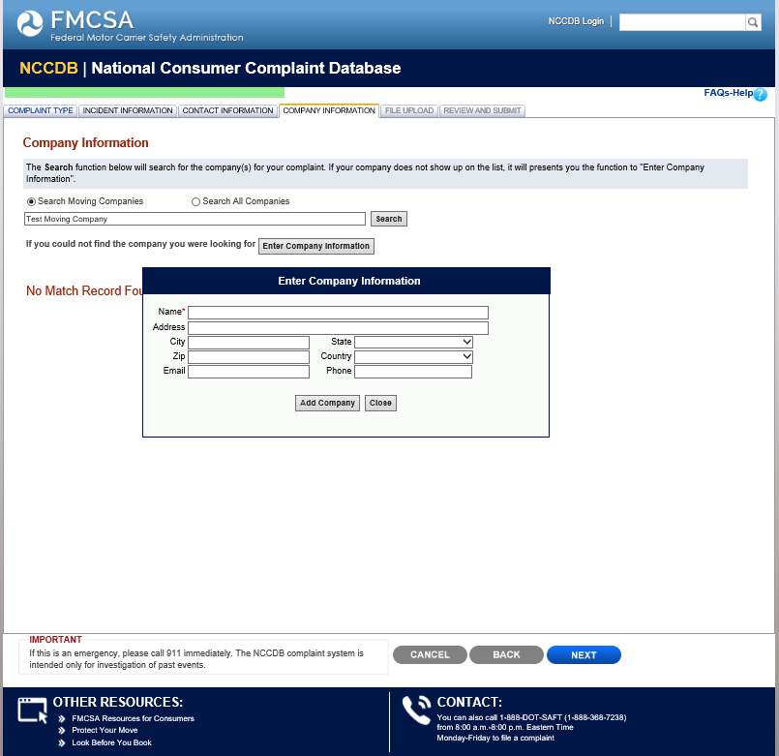

Industry Moving Complaint File Upload

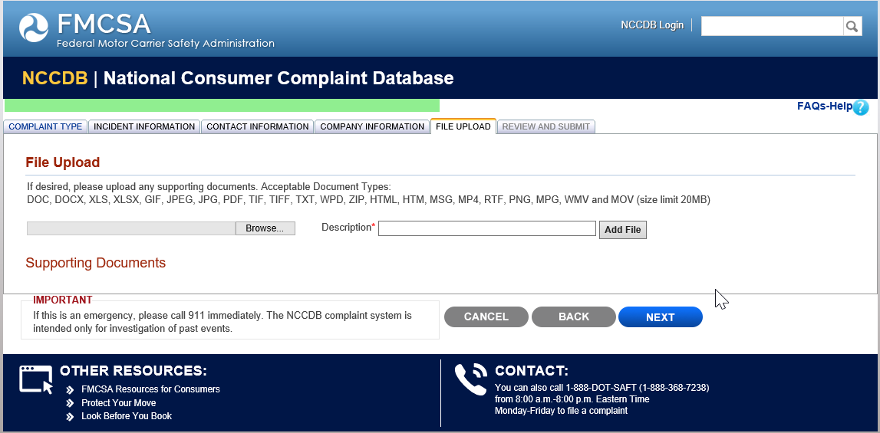

Industry Moving Complaint Review and Submit

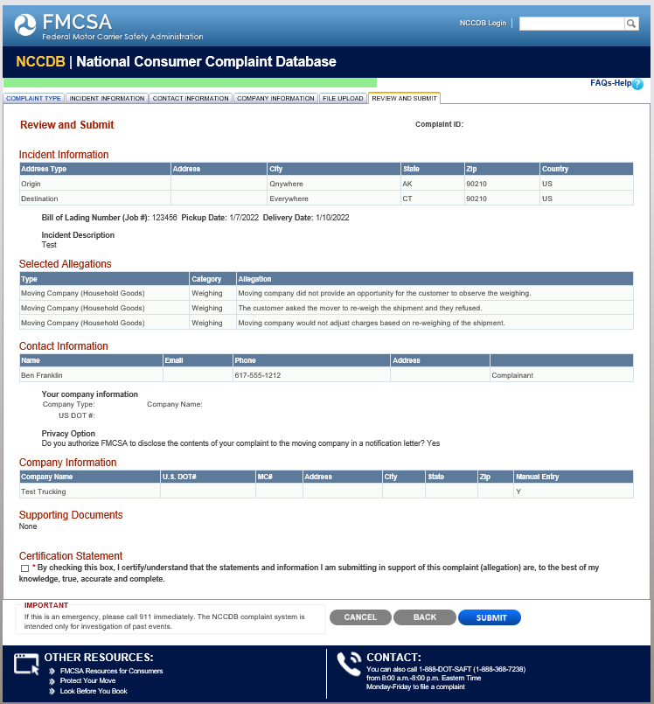

Industry Truck Complaint Type

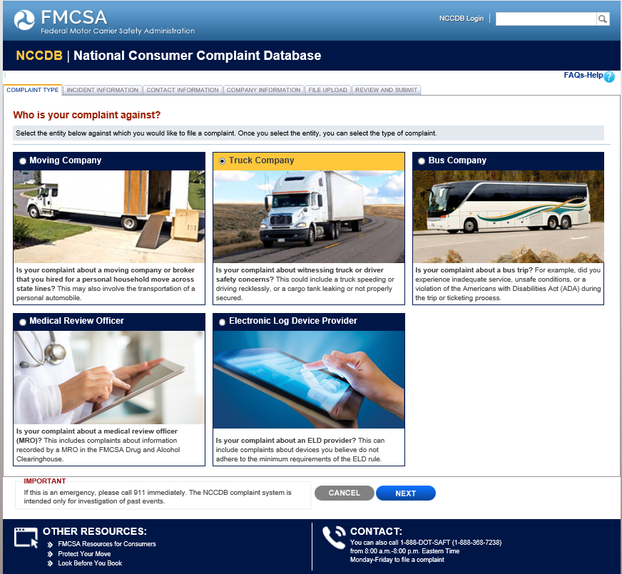

Industry Truck Complaint Incident Information

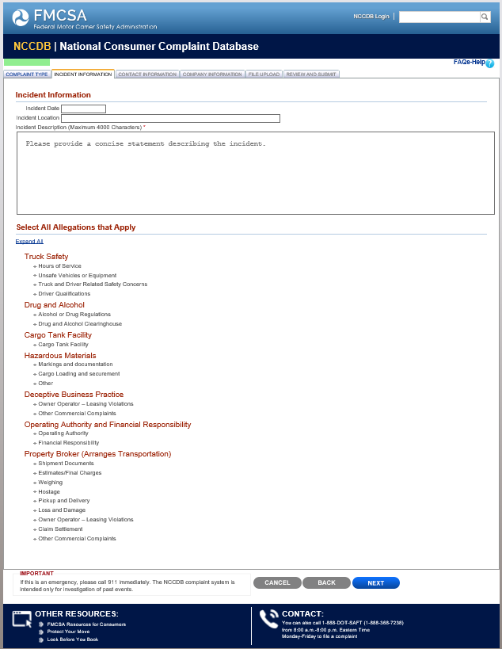

Industry Truck Complaint Incident Information

Continued

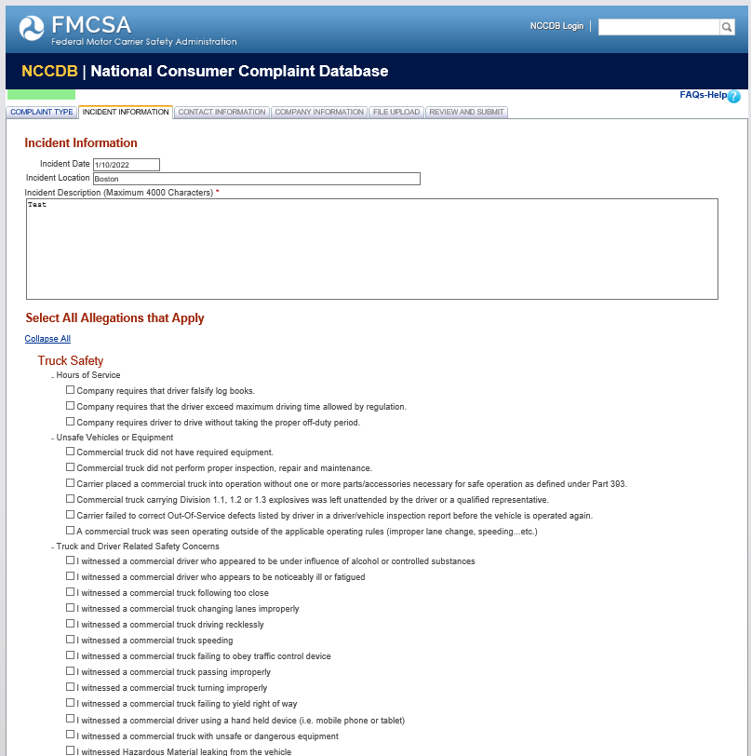

Industry Truck Complaint Incident Information

Continued

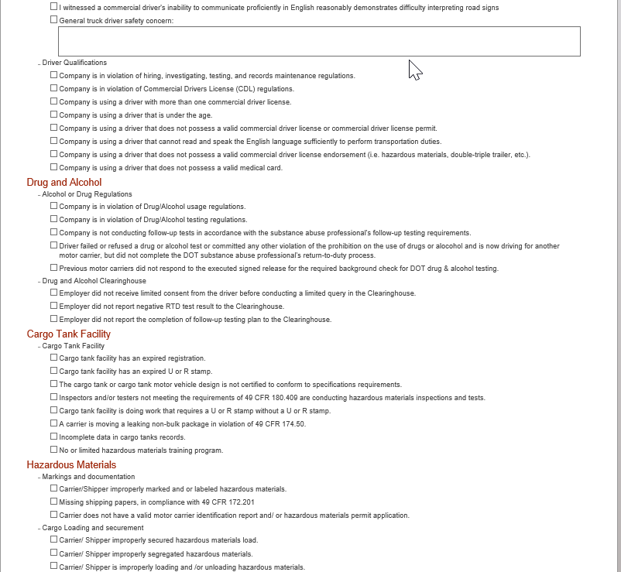

Industry Truck Complaint Incident Information

Continued

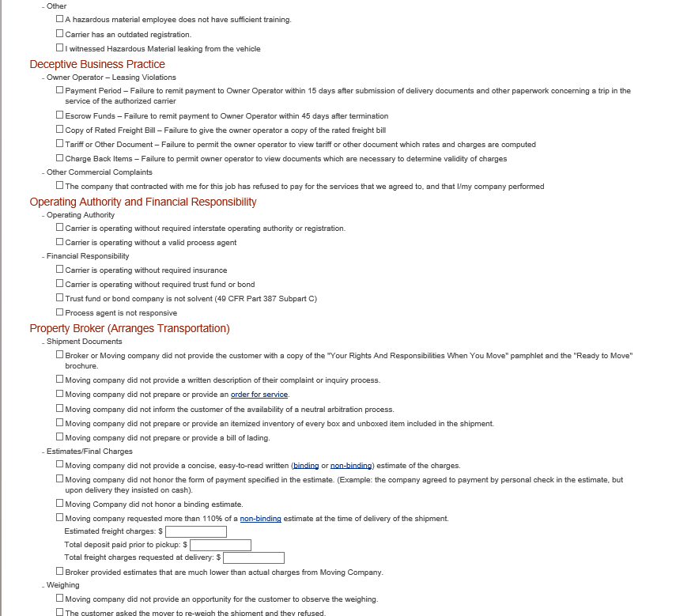

Incident Truck Complaint Incident Information

Continued

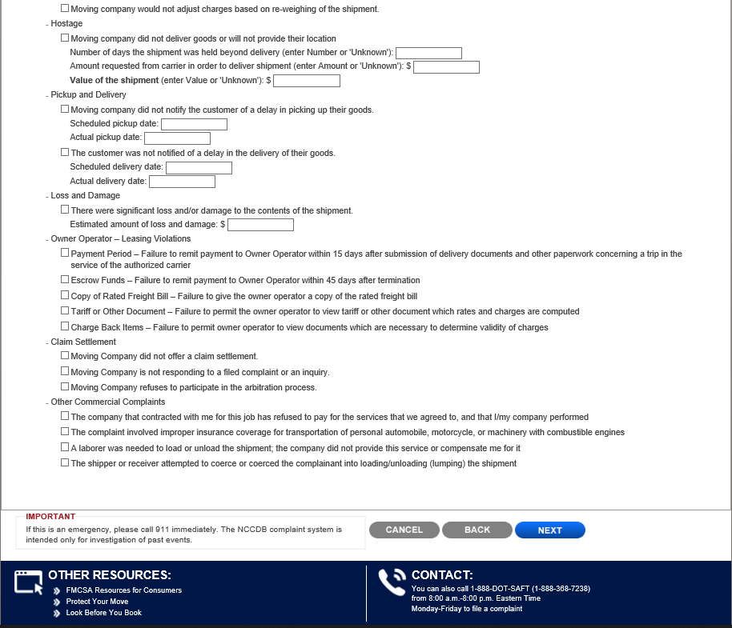

Industry Truck Complaint Contact Information

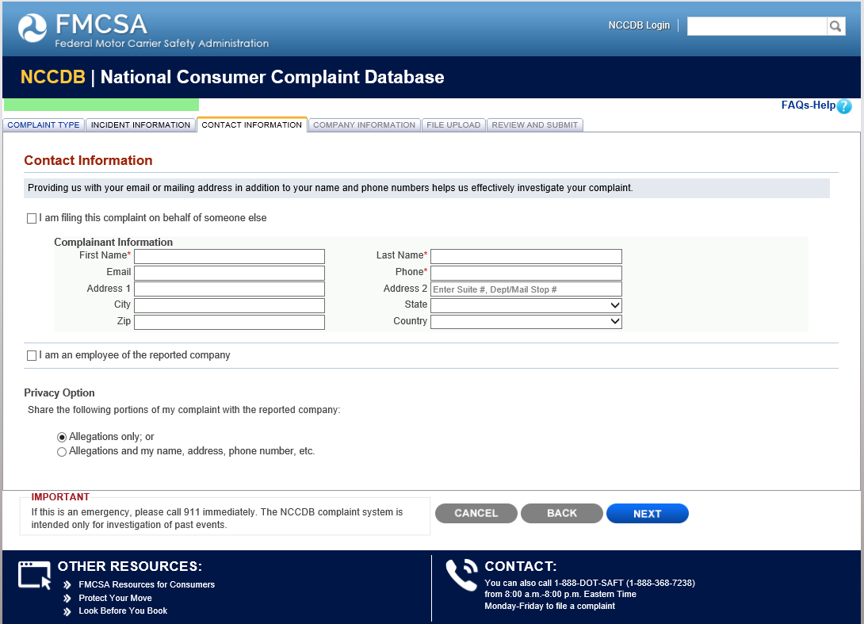

Industry Truck Complaint Company Information

Industry Truck Complaint File Upload

Industry Truck Complaint Review and Submit

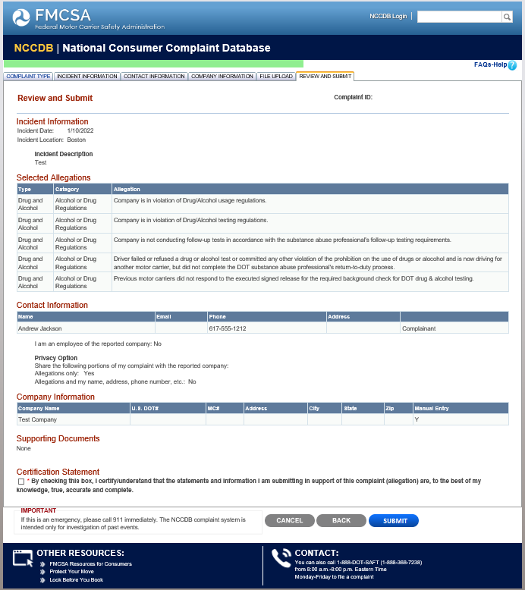

Industry Bus Complaint Type

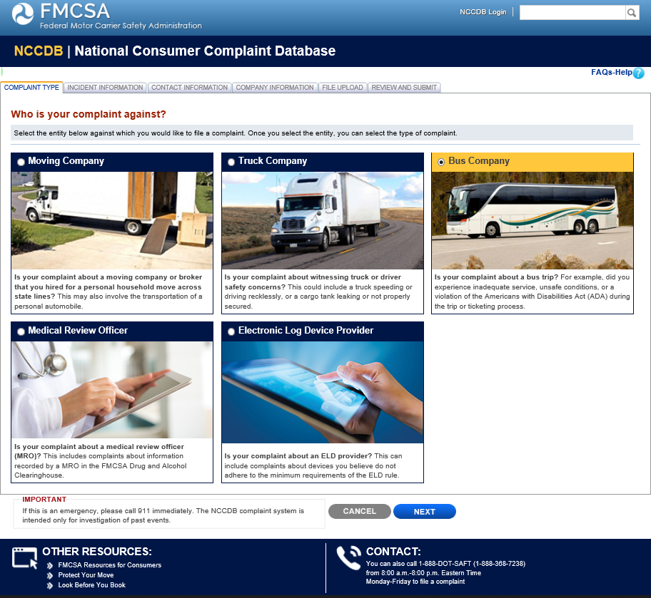

Industry Bus Complaint Incident Information

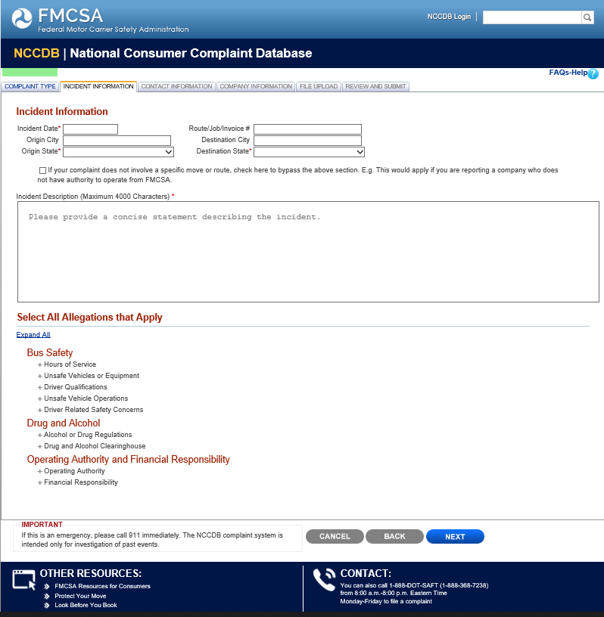

Industry Bus Complaint Incident Information

Continued
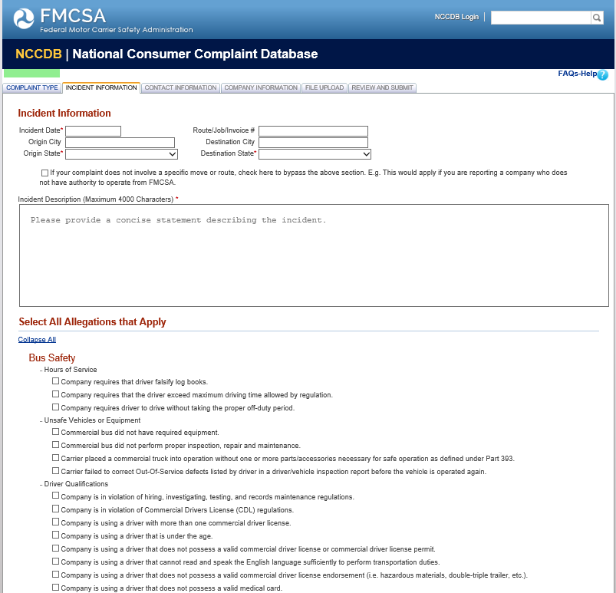

Industry Bus Complaint Incident Information

Continued
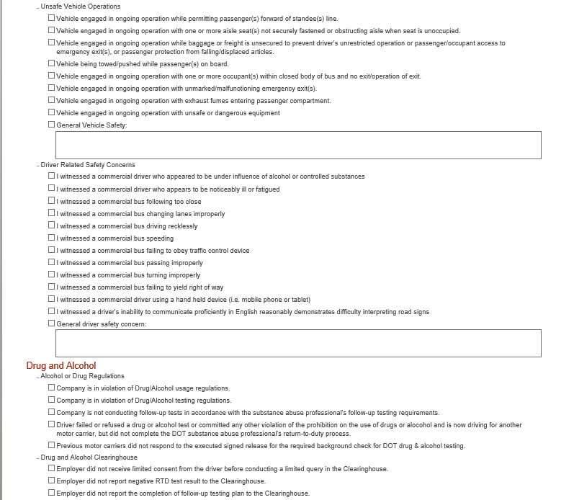

Industry Bus Complaint Incident Information

Continued

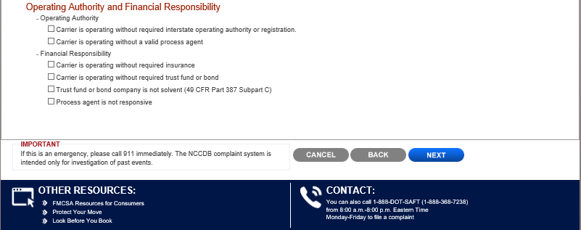

Industry Bus Complaint Contact Information

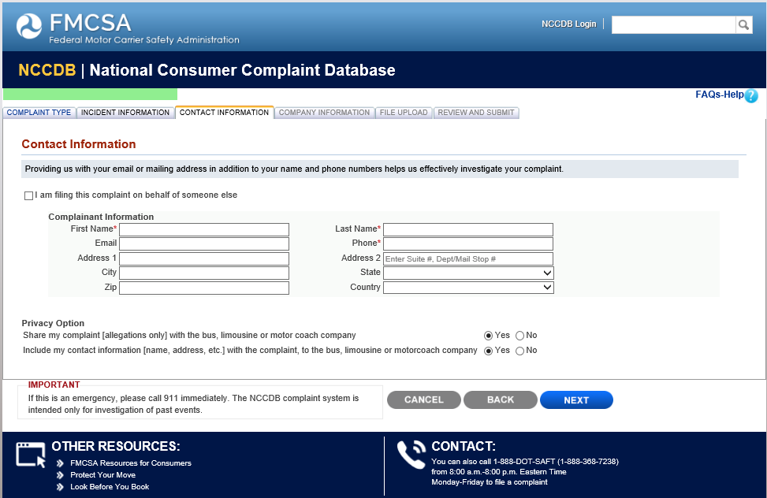

Industry Bus Complaint Company Information

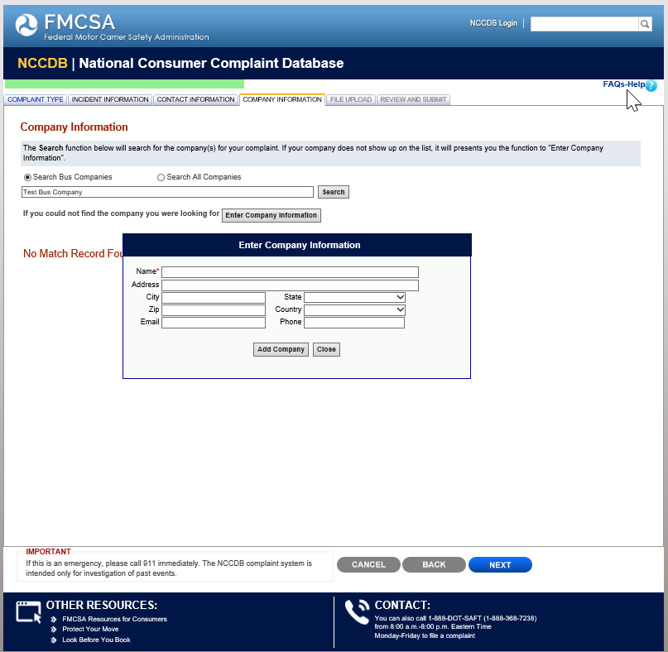

Industry Bus Complaint File Upload

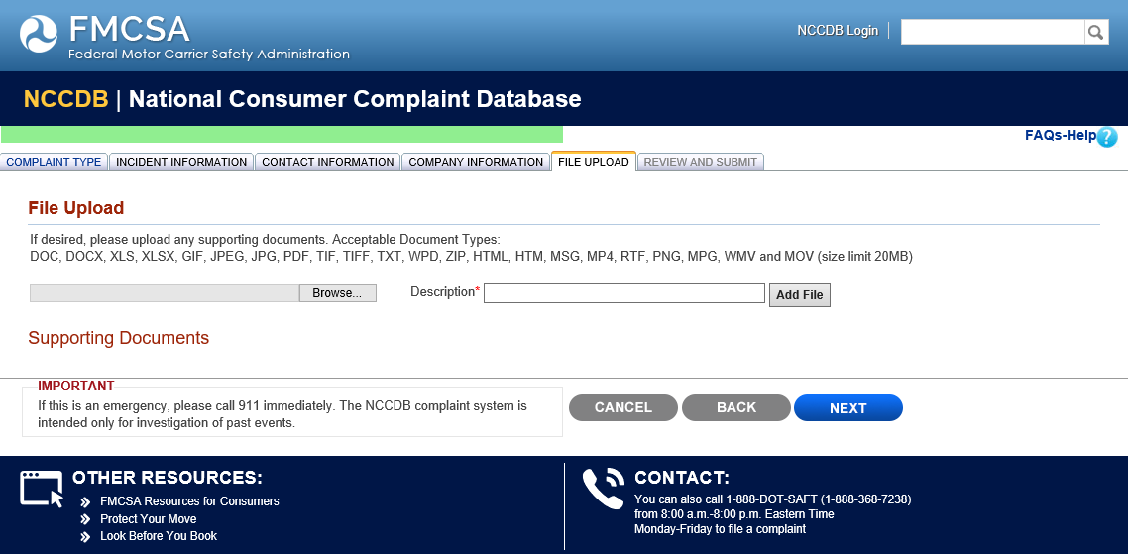

Industry Bus Complaint Review and Submit

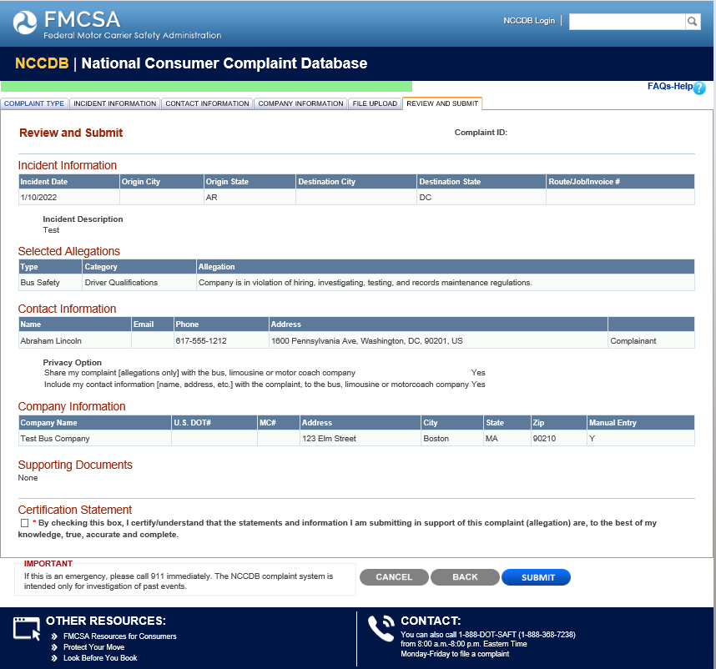

Industry Medical Review Officer (MRO) Complaint Type

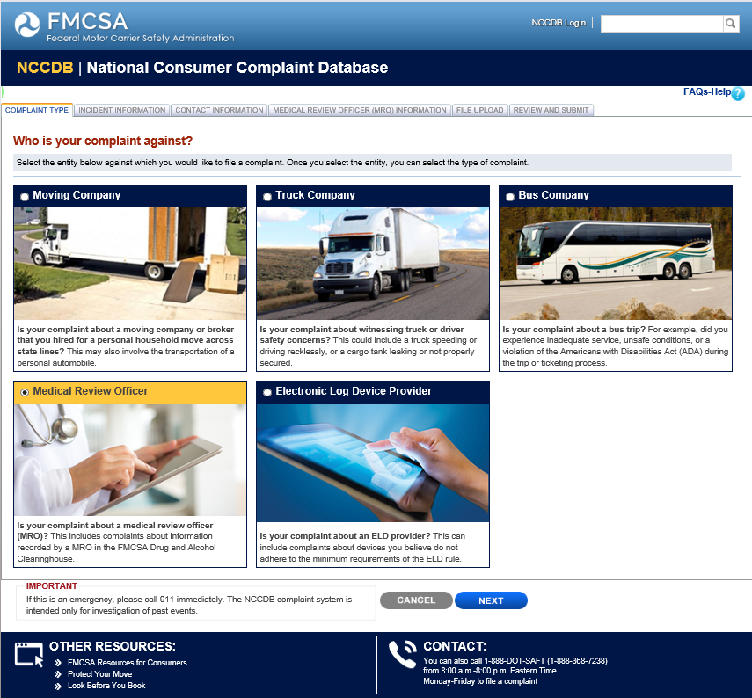

Industry MRO Complaint Incident Information

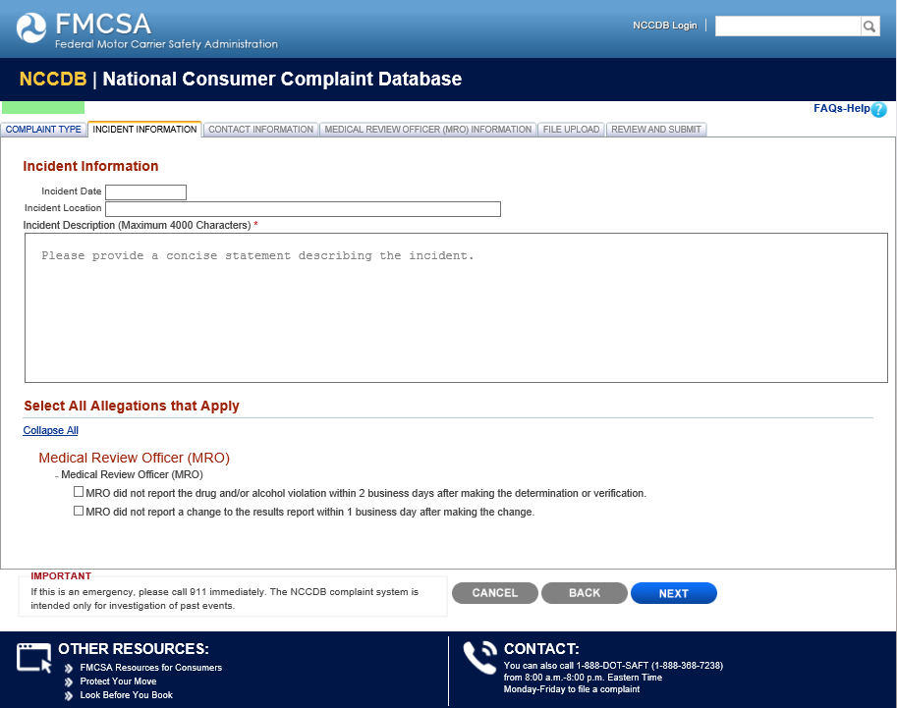

Industry MRO Complaint Contact Information

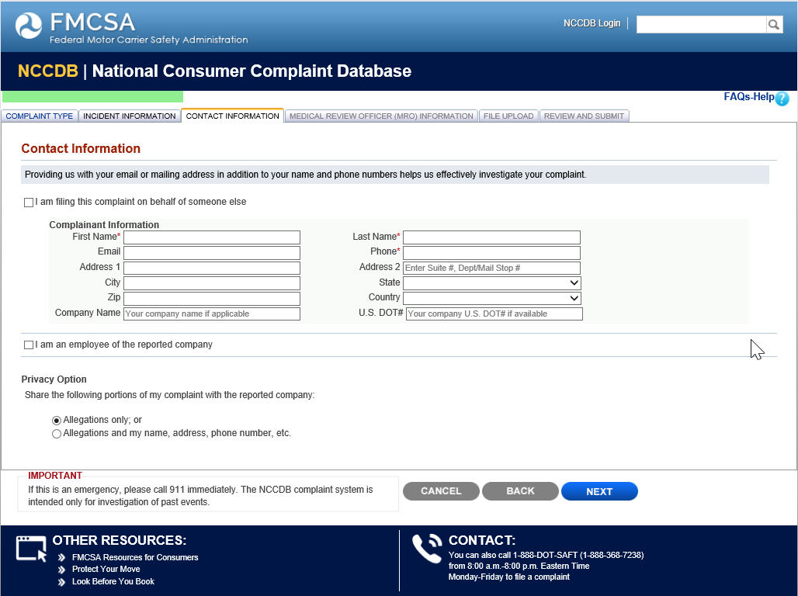

Industry MRO Complaint Company Information

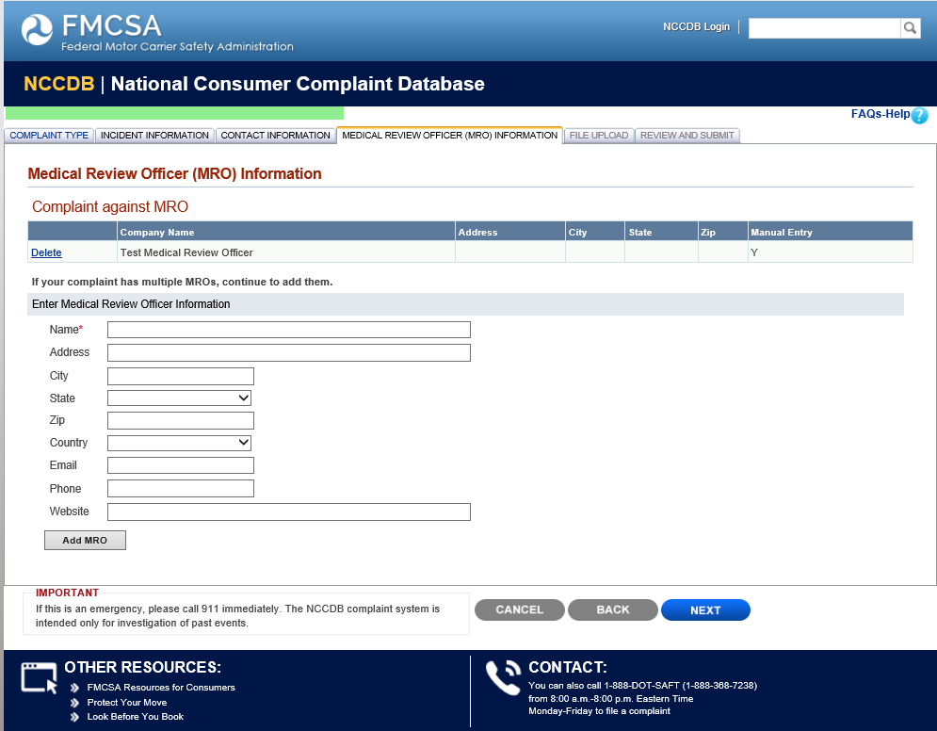

Industry MRO Complaint File Upload

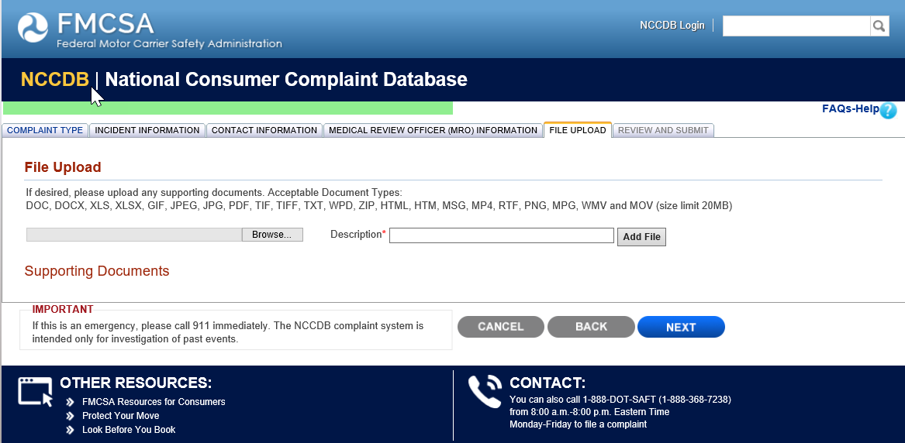

Industry MRO Complaint Review and Submit

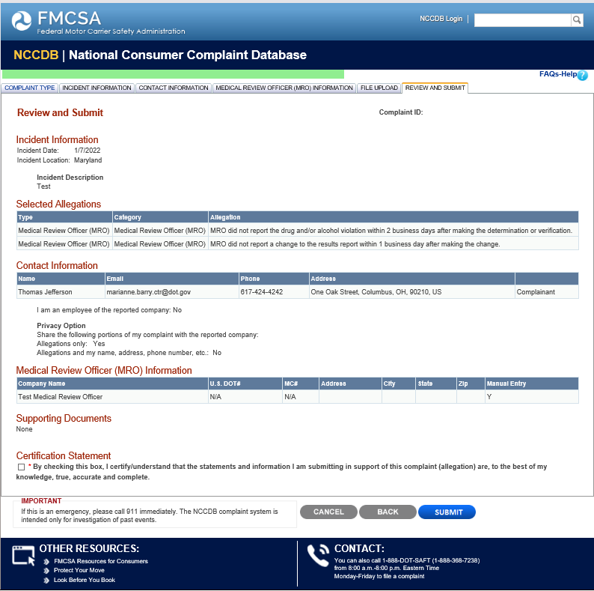

Industry Electronic Log Device (ELD) Provider Complaint Type

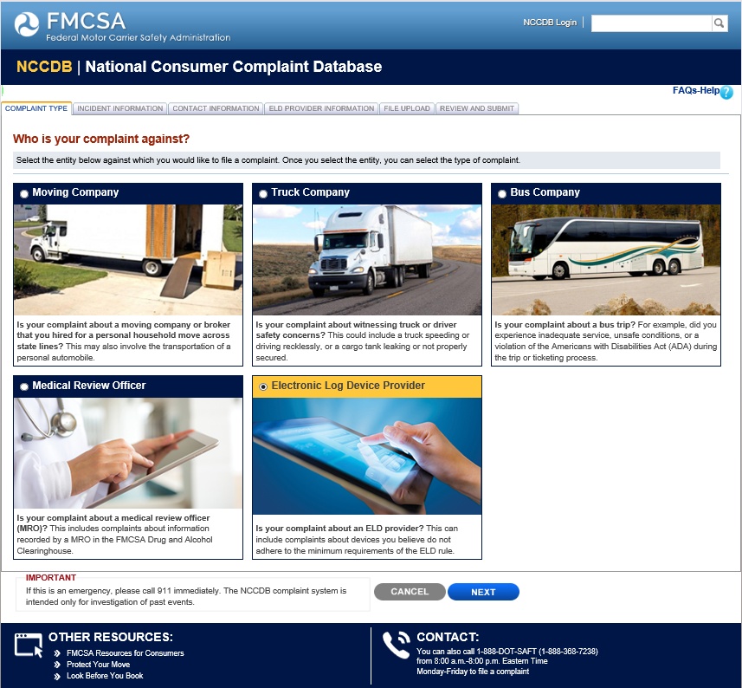

Industry Electronic Log Device (ELD) Provider Incident Information

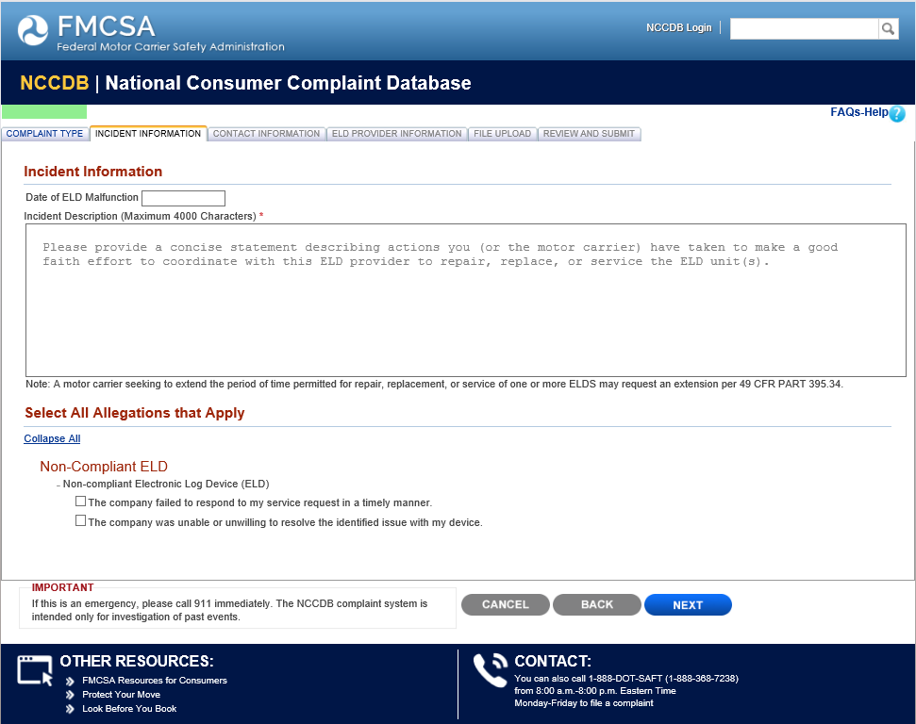

Industry Electronic Log Device (ELD) Provider Contact Information

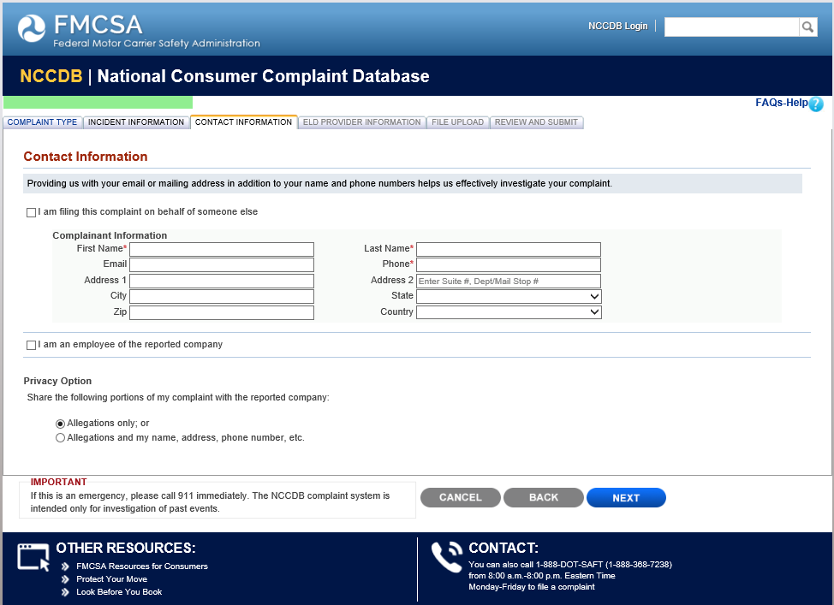

Industry Electronic Log Device (ELD) Provider Information

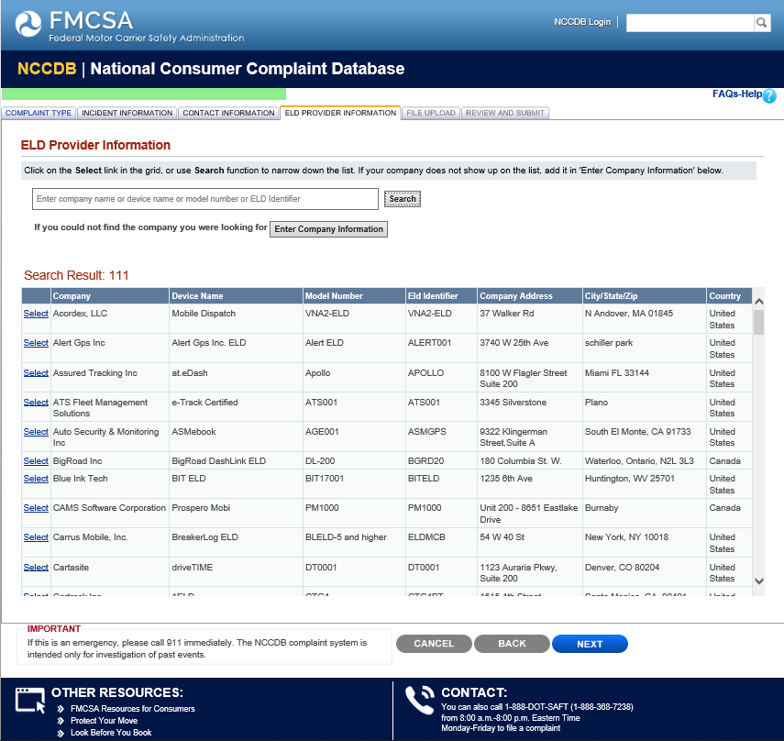

Industry Electronic Log Device (ELD) Provider File Upload

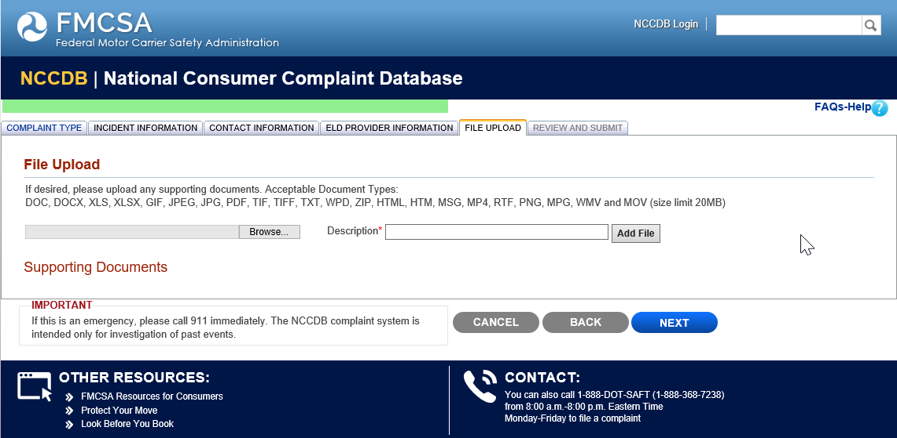

Industry Electronic Log Device (ELD) Provider Review and Submit

