NCCDB Complaint Entry Home Page

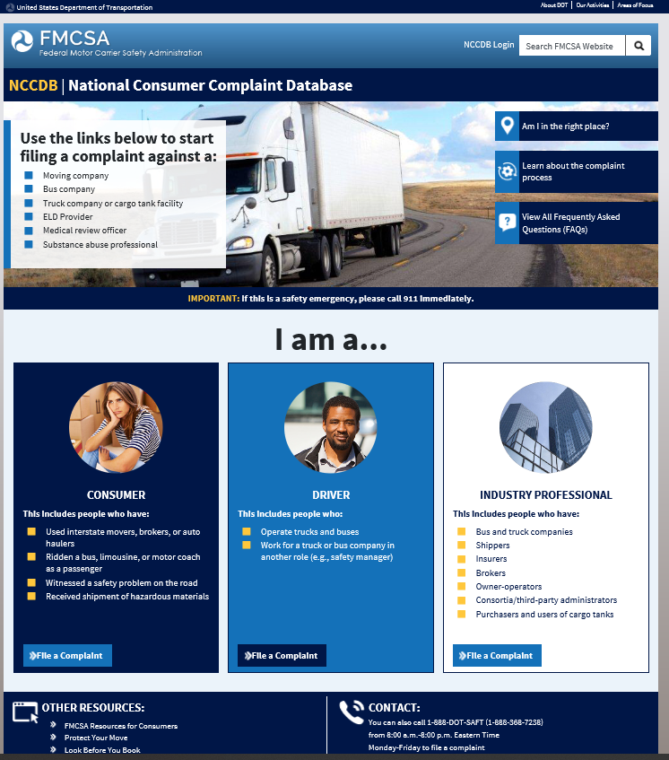

Driver Moving Complaint Type

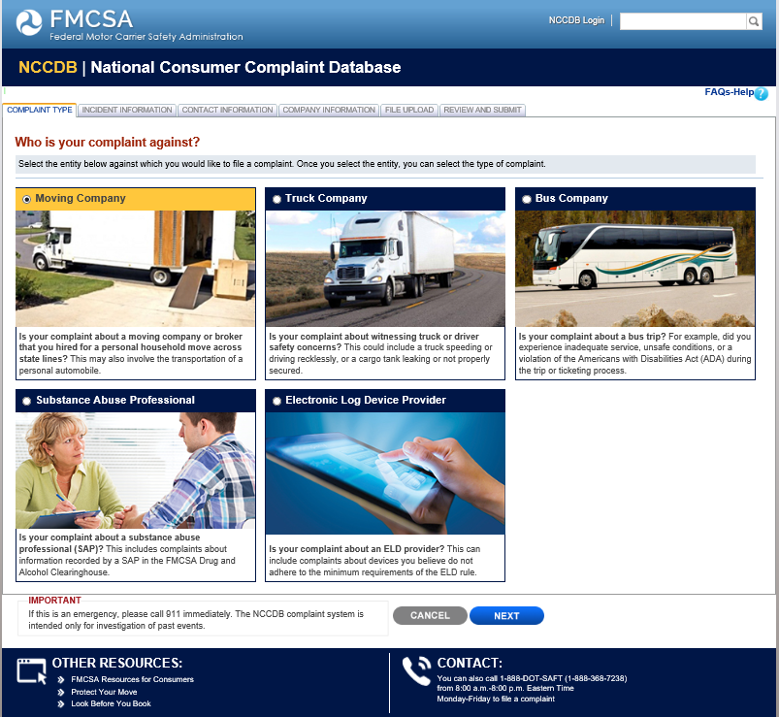

Driver Moving Complaint Incident Information

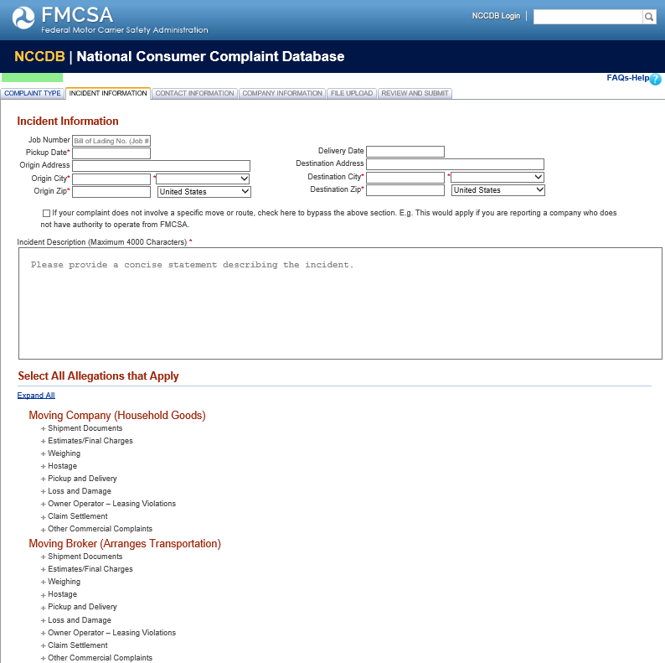

Driver Moving Complaint Incident Information

Continued
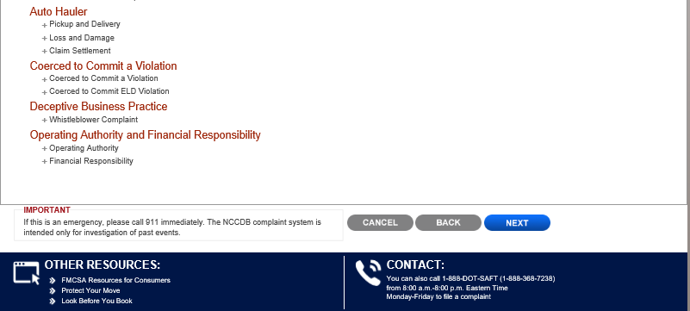

Driver Moving Complaint Incident Information

Continued
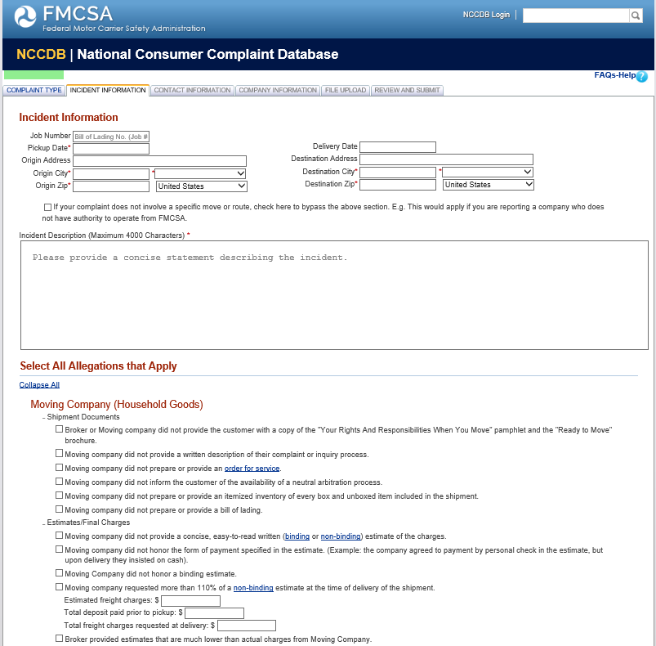

Driver Moving Complaint Incident Information

Continued
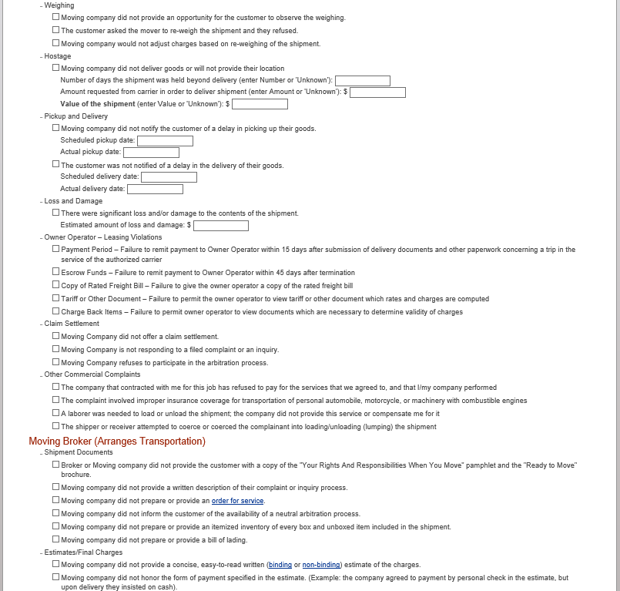

Driver Moving Complaint Incident Information

Continued
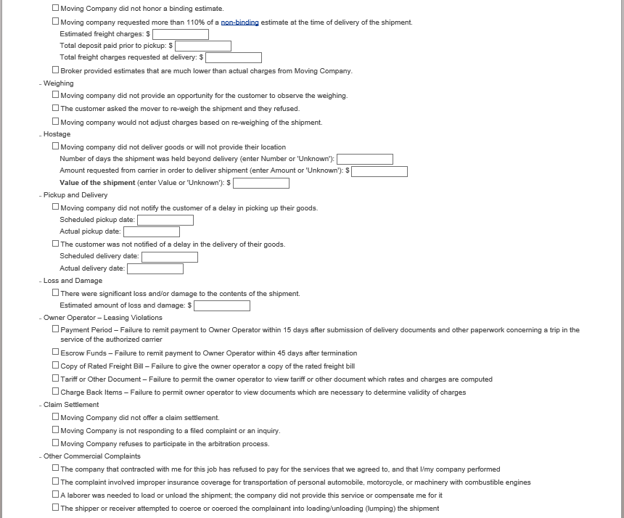

Driver Moving Complaint Incident Information

Continued

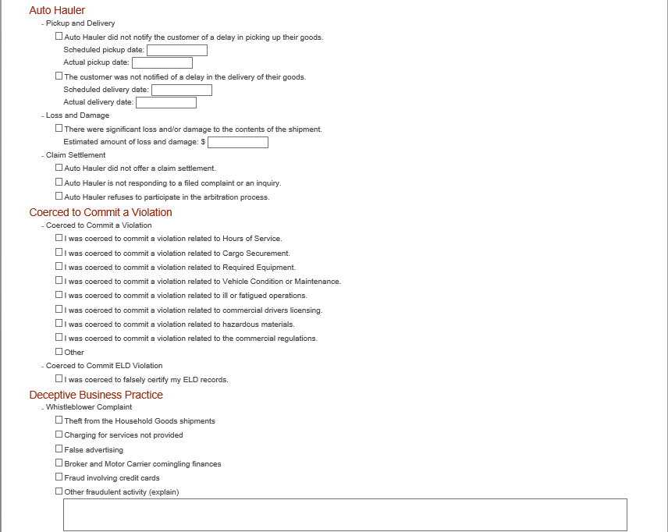

Driver Moving Complaint Incident Information

Continued

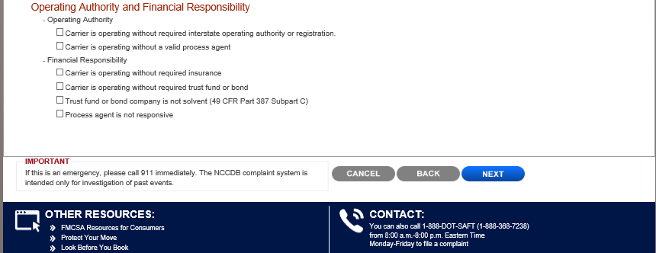

Driver Moving Complaint Contact Information

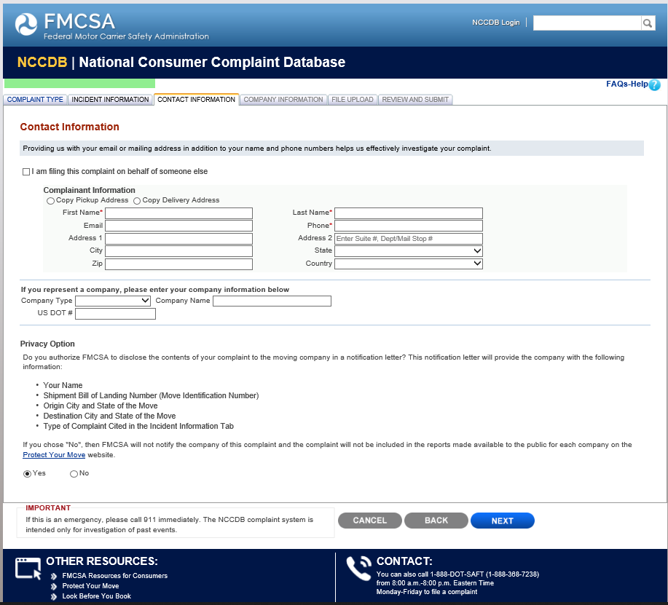

Driver Moving Complaint Company Information

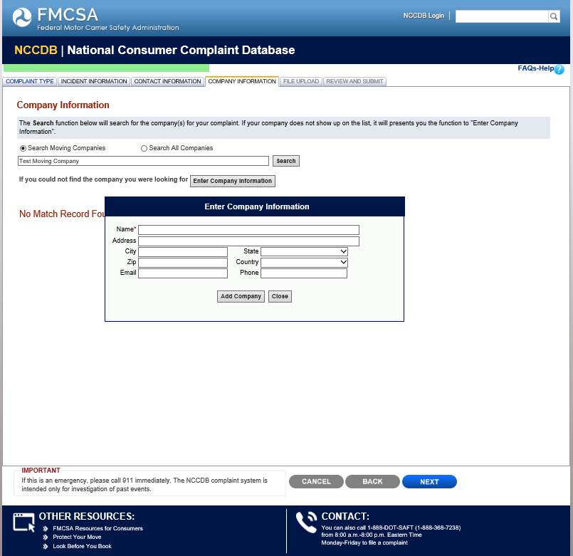

Driver Moving Complaint File Upload

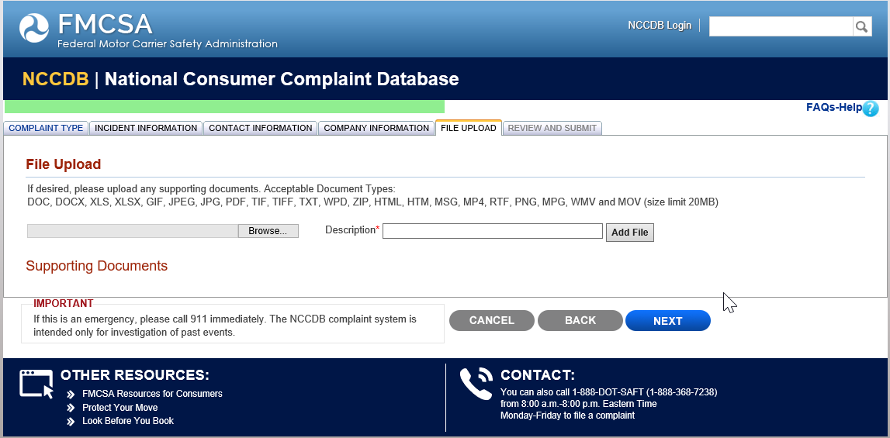

Driver Moving Complaint Review and Submit

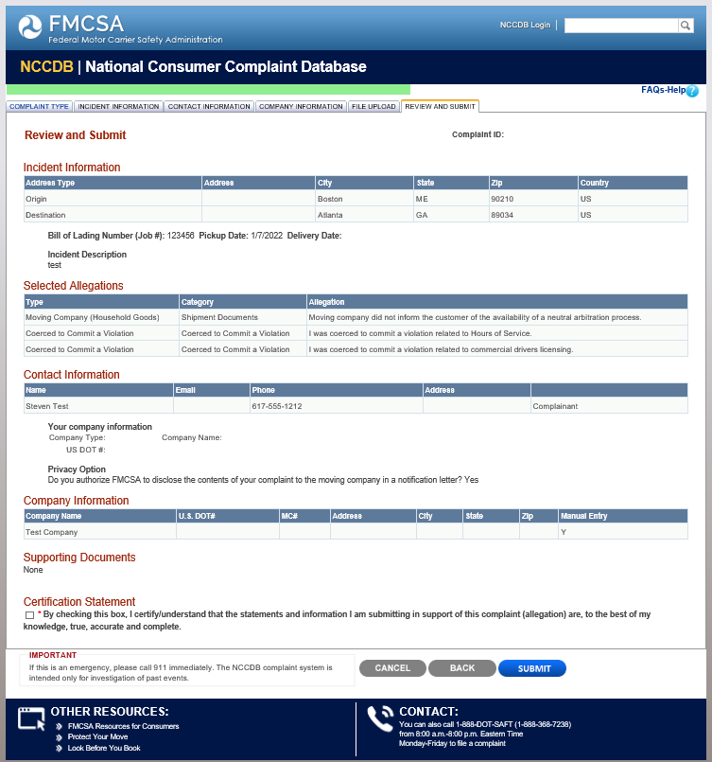

Driver Truck Complaint Type

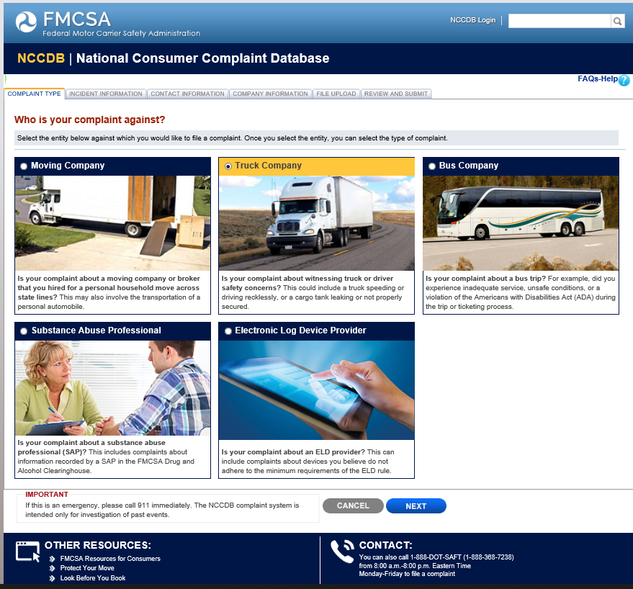

Driver Truck Complaint Incident Information

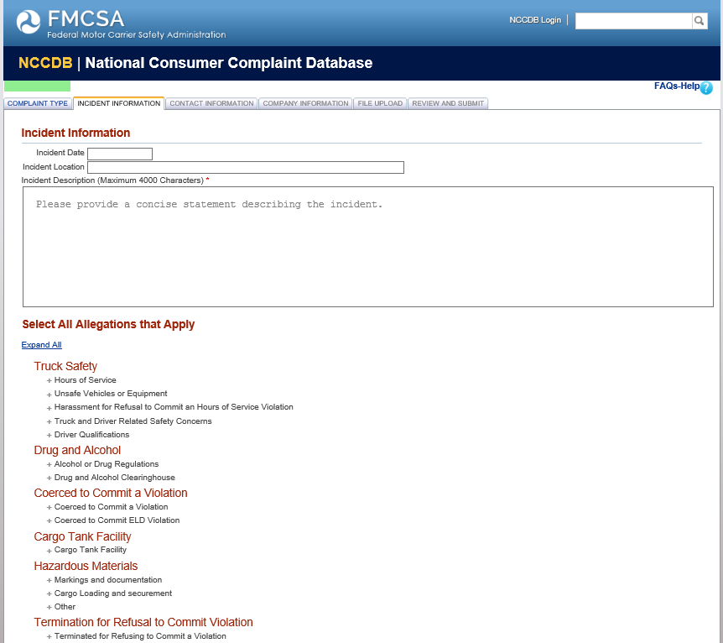

Driver Truck Complaint Incident Information

Continued

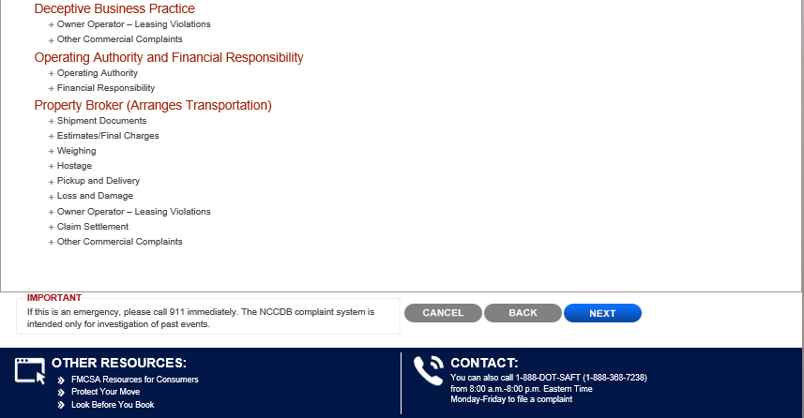

Driver Truck Complaint Incident Information

Continued
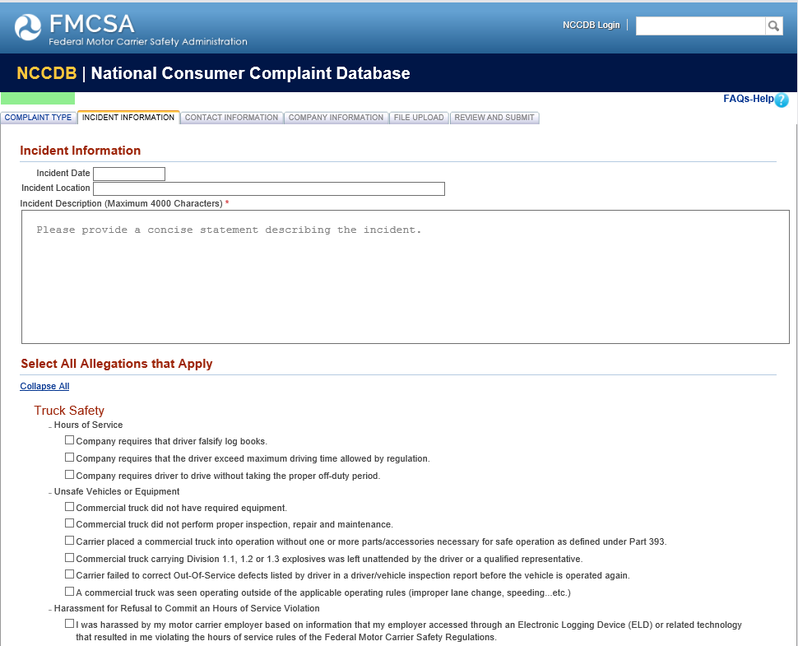

Driver Truck Complaint Incident Information

Continued
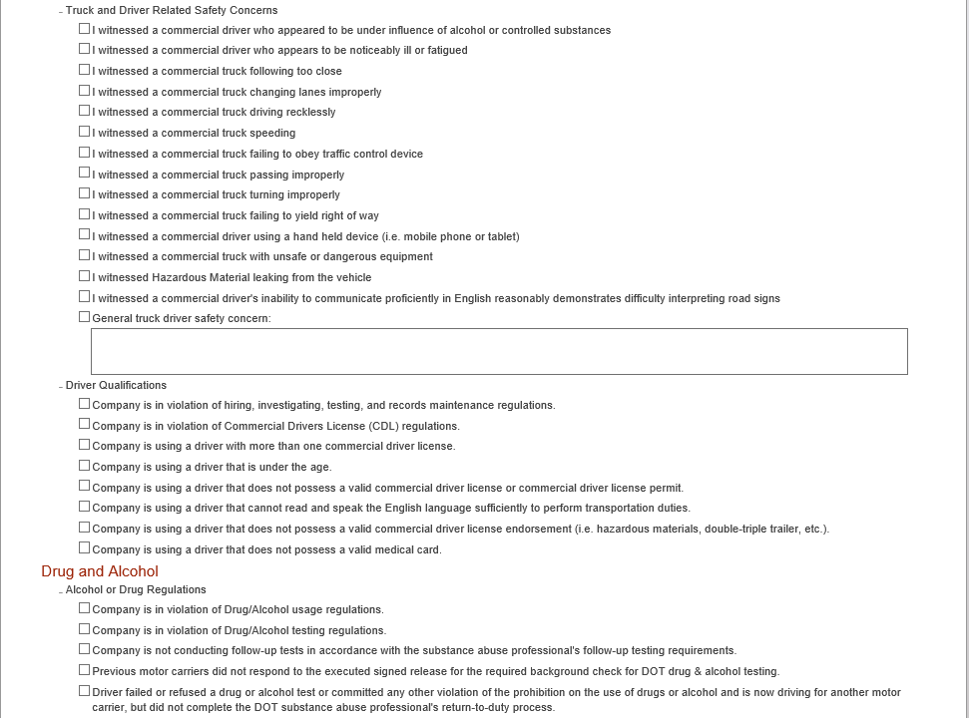

Driver Truck Complaint Incident Information

Continued
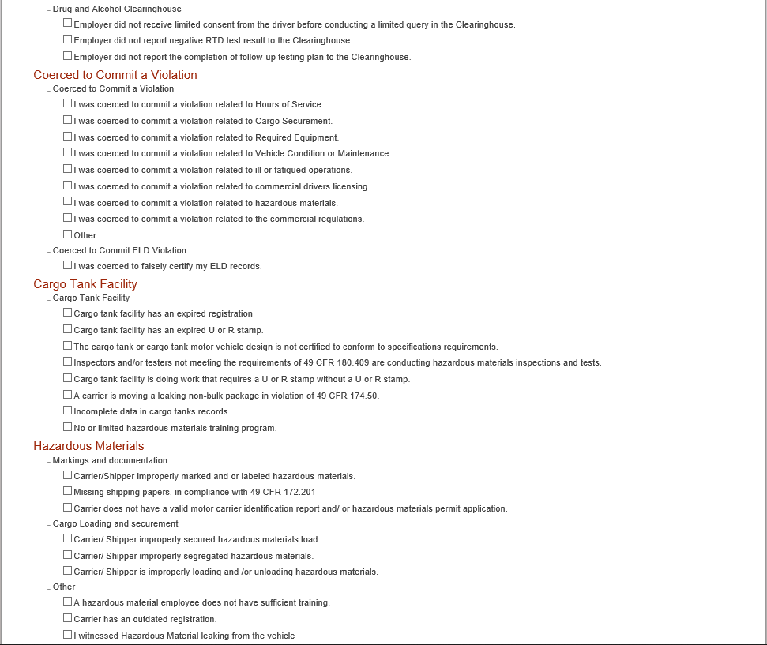

Driver Truck Complaint Incident Information

Continued

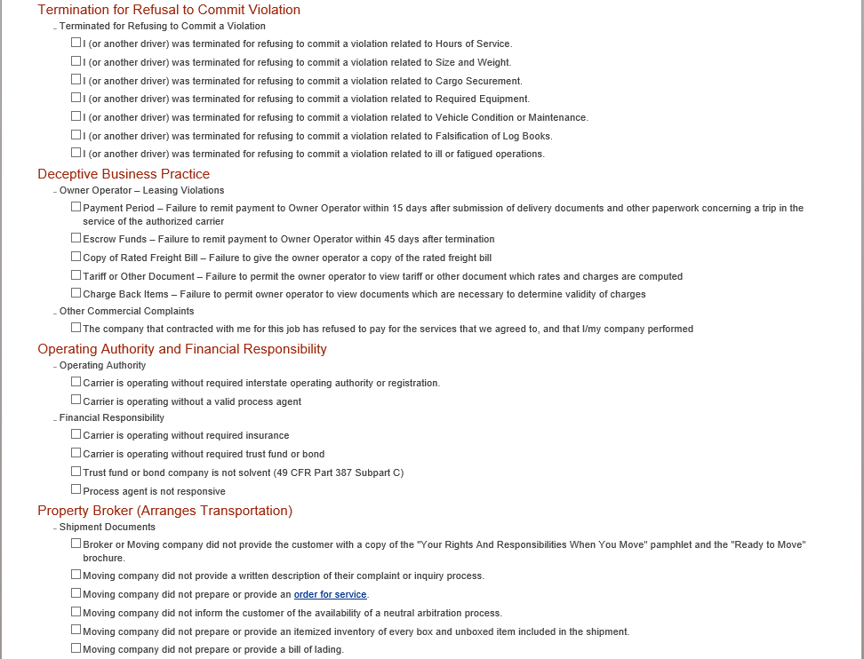

Driver Truck Complaint Incident Information

Continued

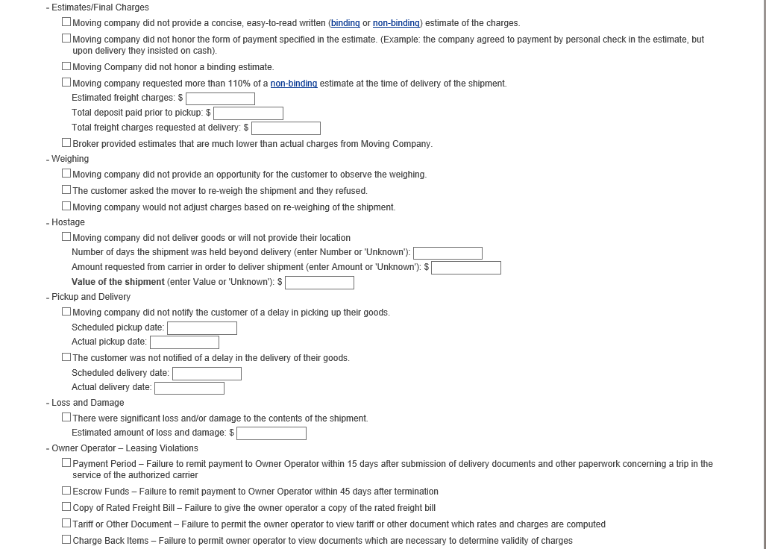

Driver Truck Complaint Incident Information

Continued
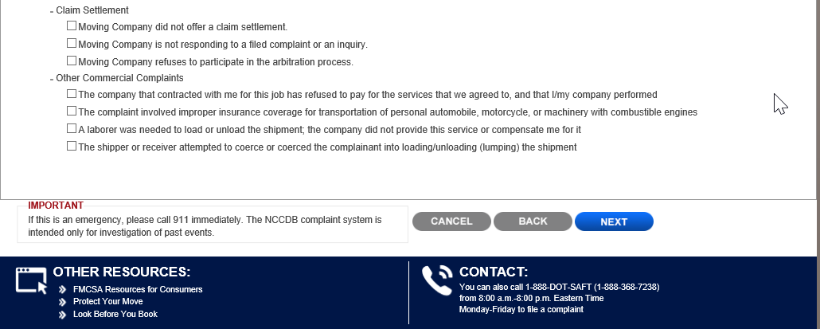

Driver Truck Complaint Contact Information

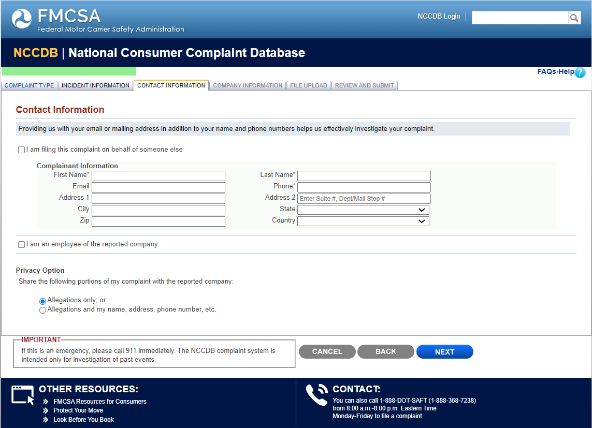

Driver Truck Complaint Company Information

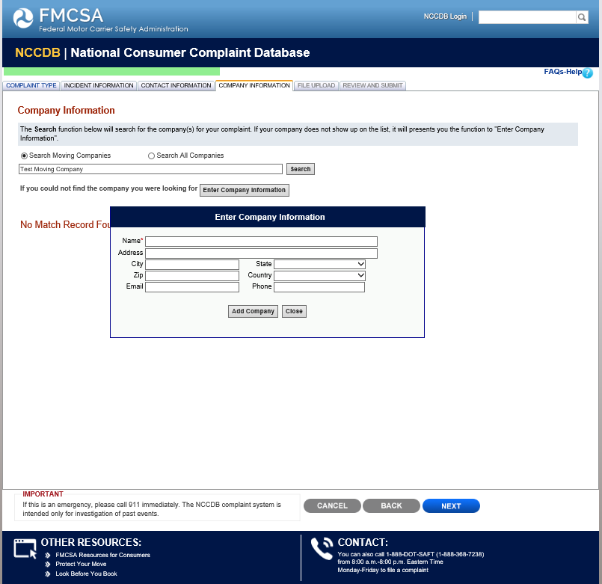

Driver Truck Complaint File Upload

Driver Truck Complaint Review and Submit

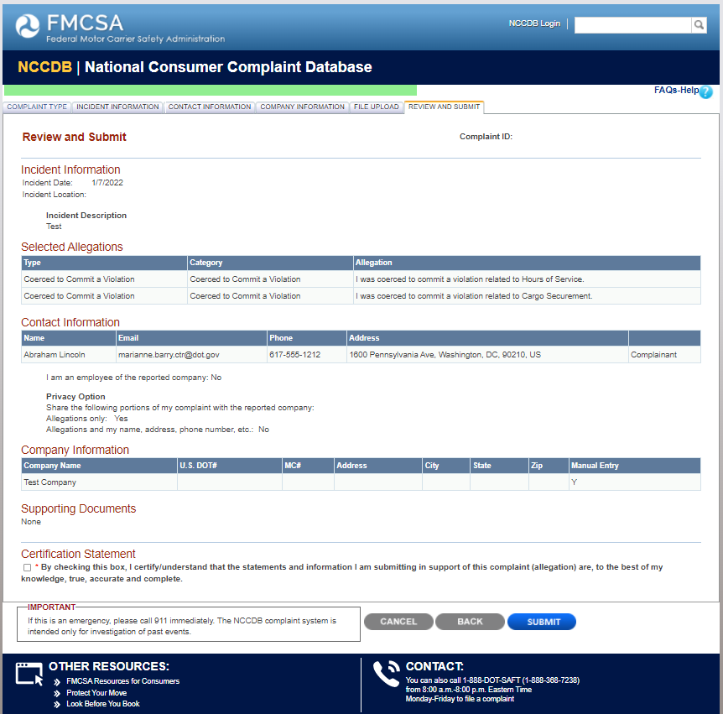

Driver Bus Complaint Type

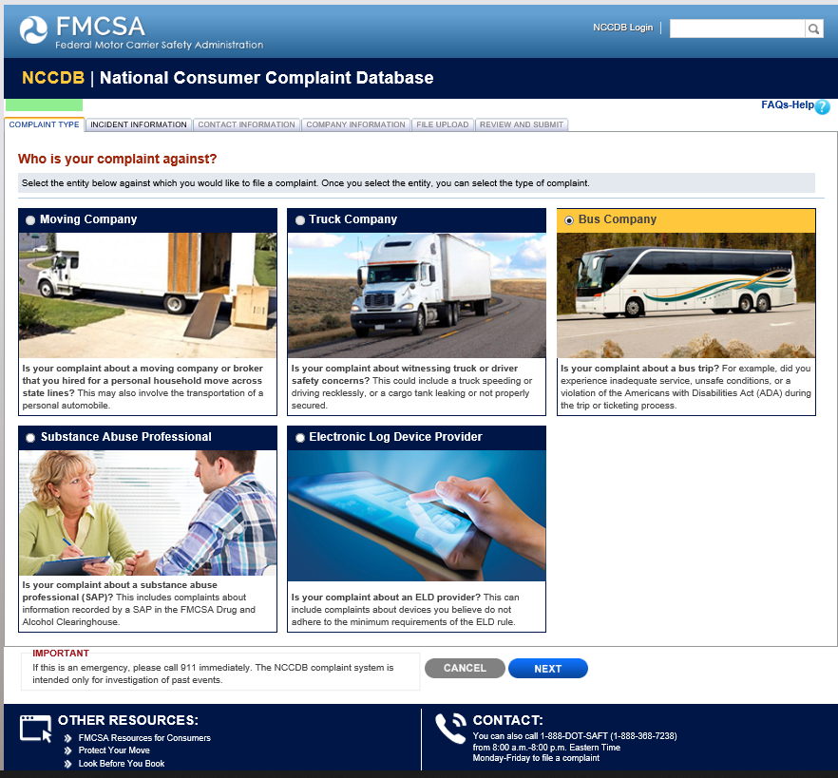

Driver Bus Complaint Incident Information

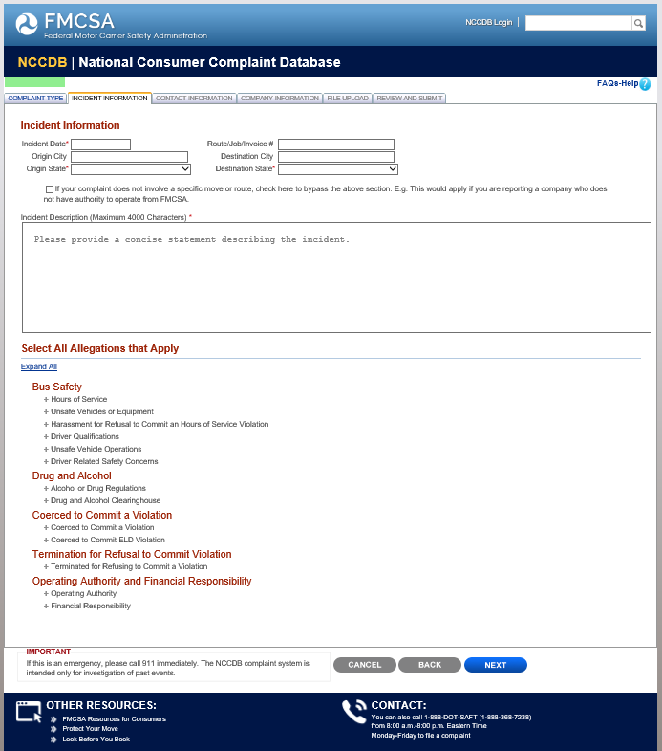

Driver Bus Complaint Incident Information

Continued
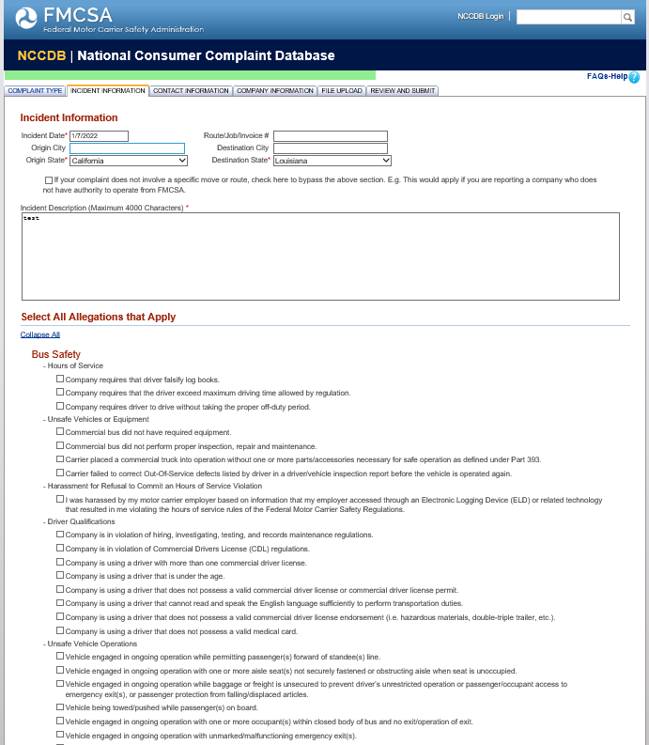

Driver Bus Complaint Incident Information

Continued
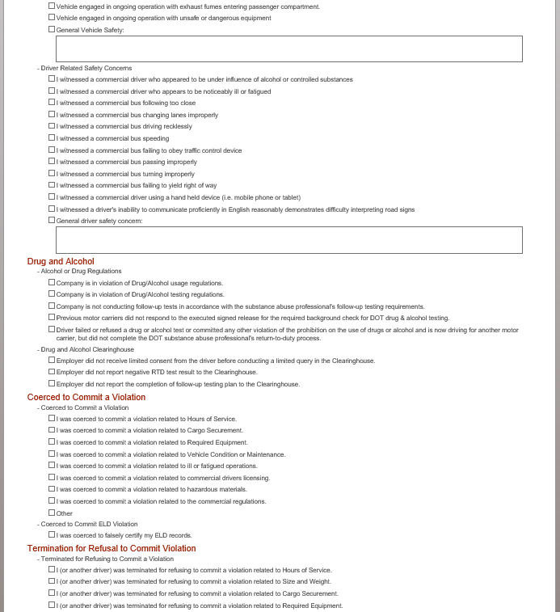

Driver Bus Complaint Incident Information

Continued

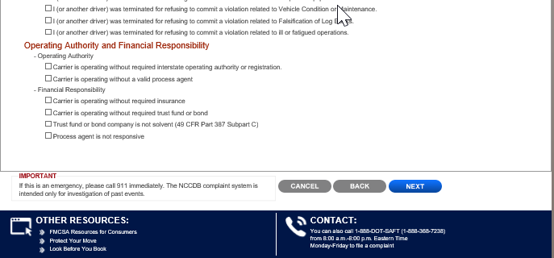

Driver Bus Complaint Contact Information

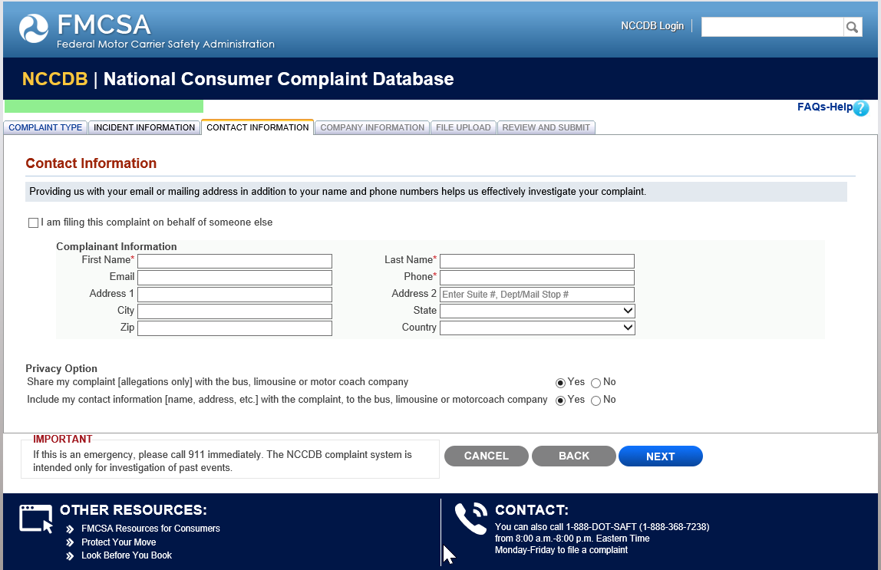

Driver Bus Complaint Company Information

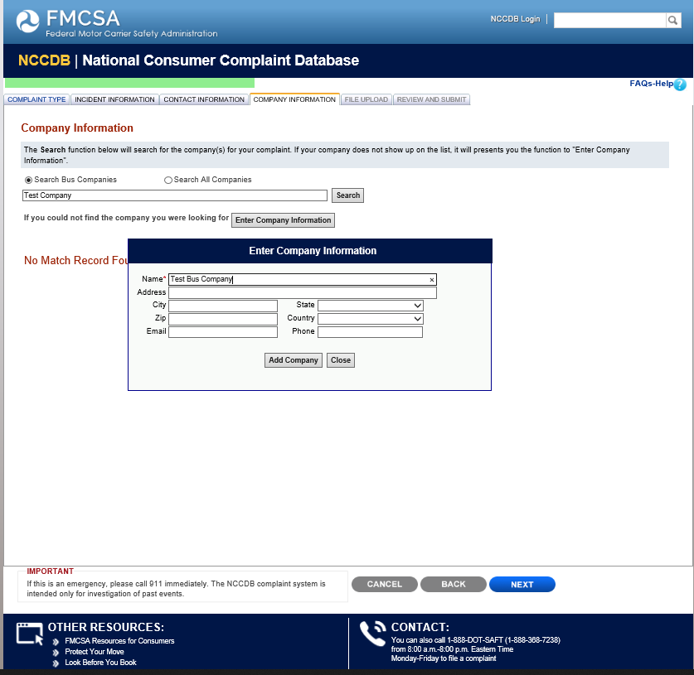

Driver Bus Complaint File Upload

Driver Bus Complaint Review and Submit

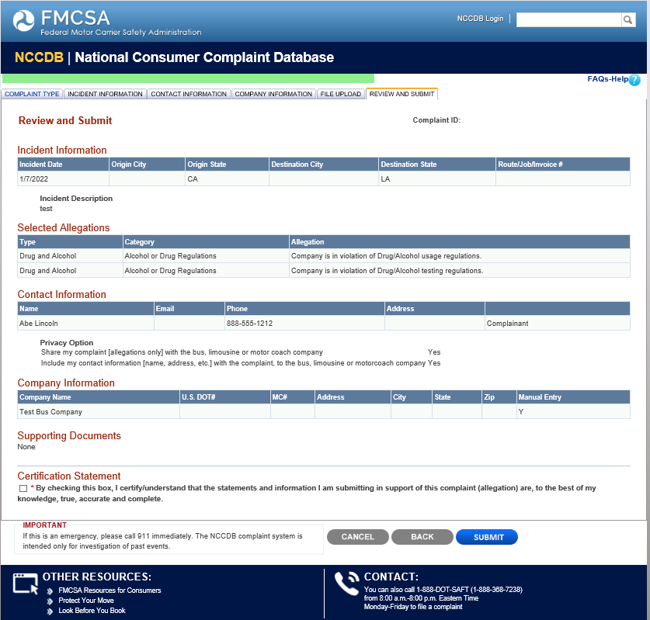

Driver Substance Abuse Professional (SAP) Complaint Type

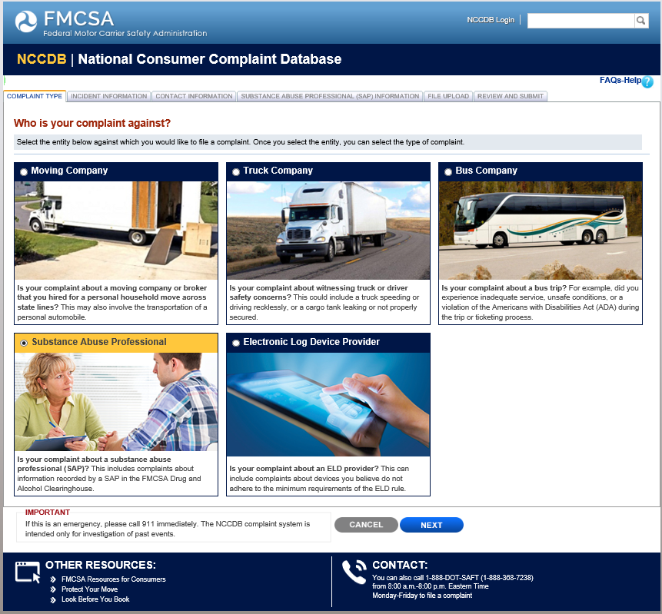

Driver SAP Complaint Incident Information

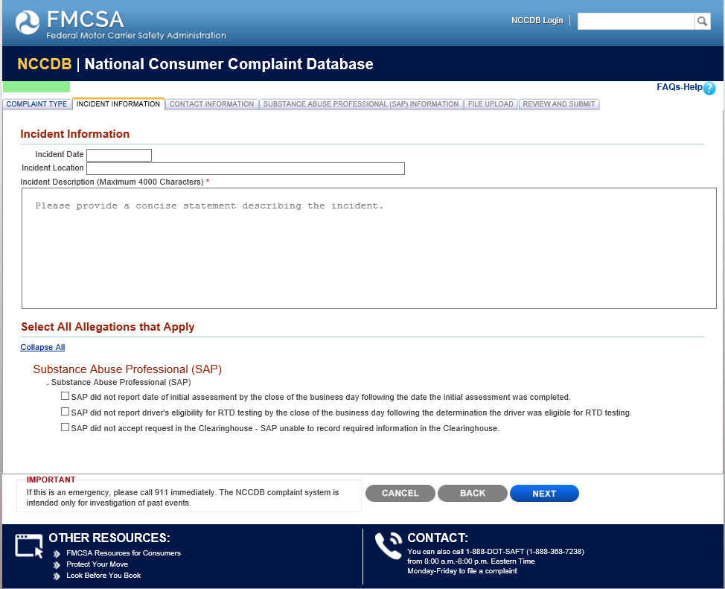

Driver SAP Complaint Contact Information

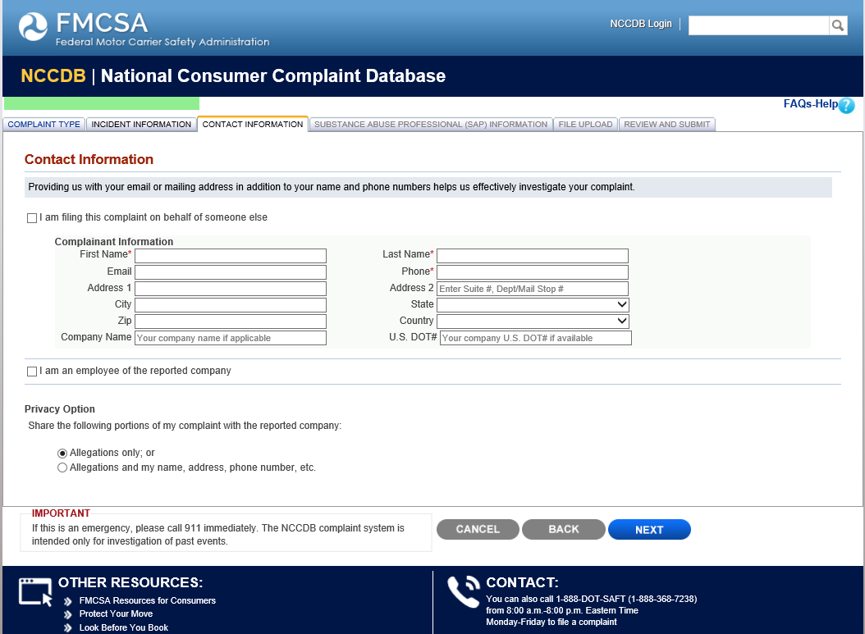

Driver SAP Complaint SAP Information

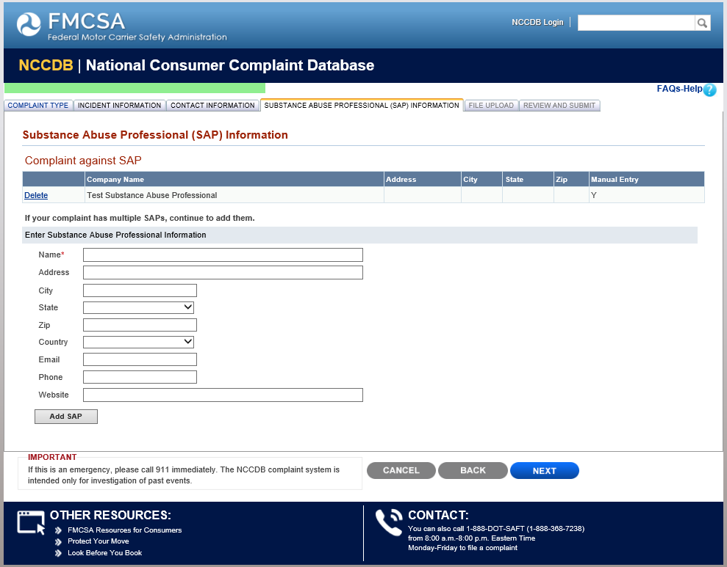

Driver SAP Complaint File Upload

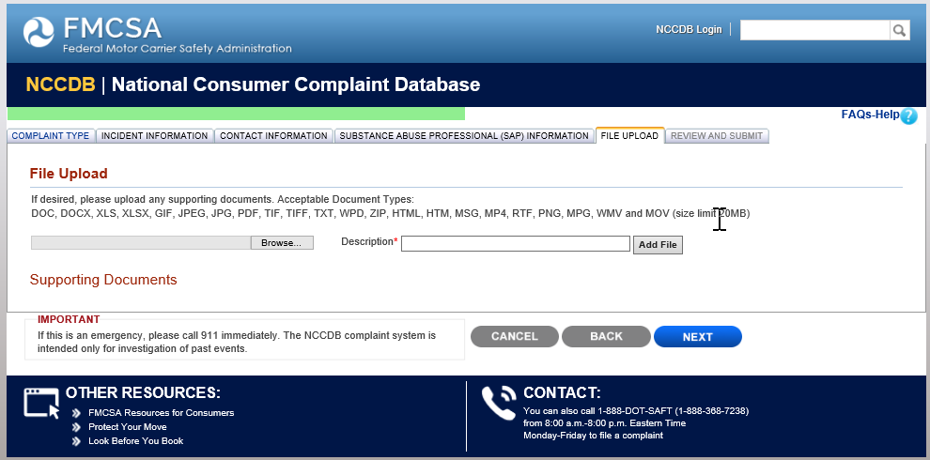

Driver SAP Complaint Review and Submit

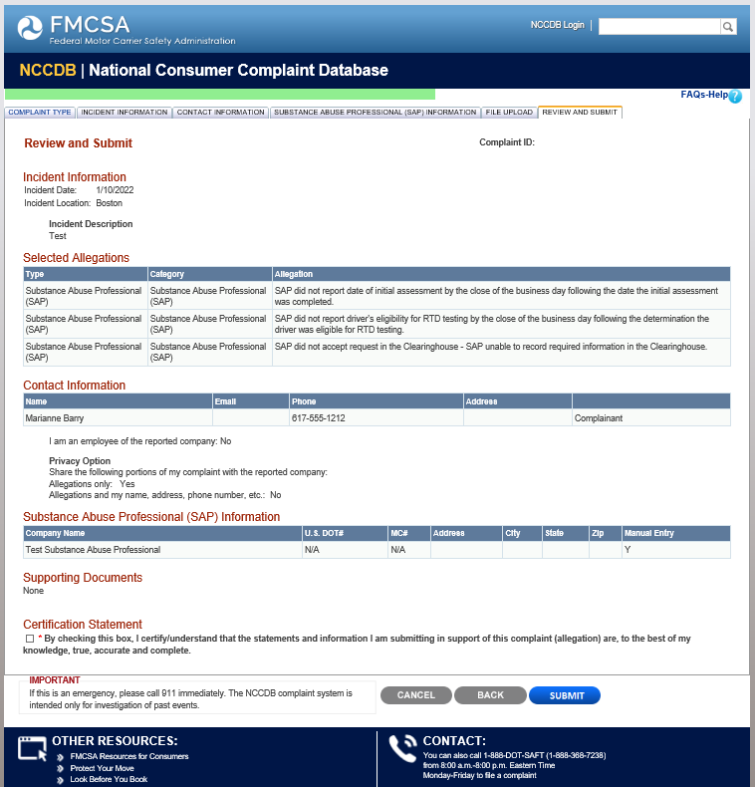

Driver Electronic Log Device (ELD) Provider Complaint Type

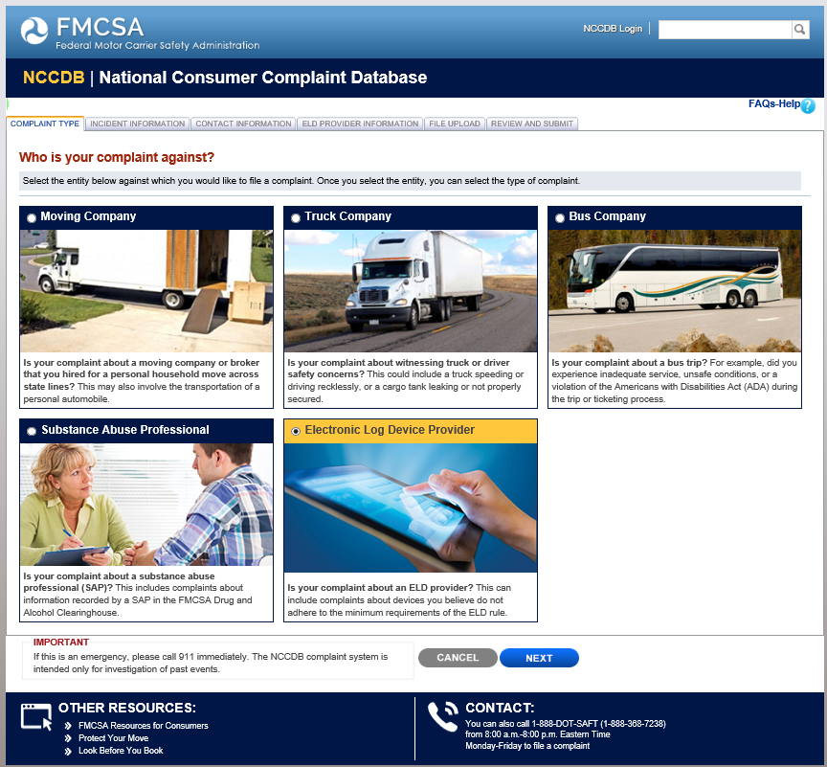

Driver (ELD) Provider Complaint Information

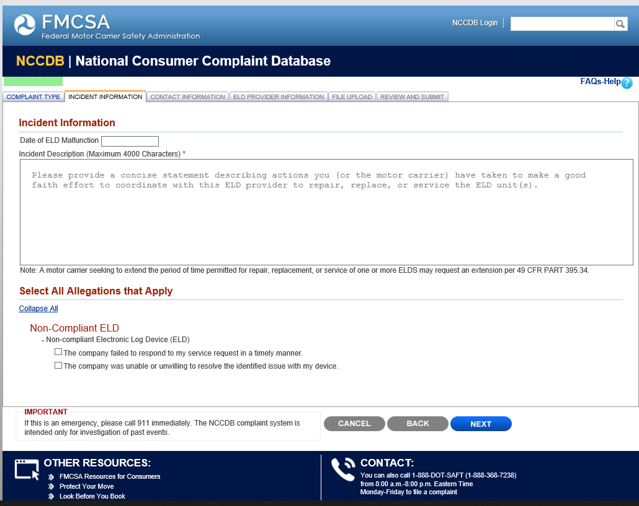

Driver (ELD) Provider Contact Information

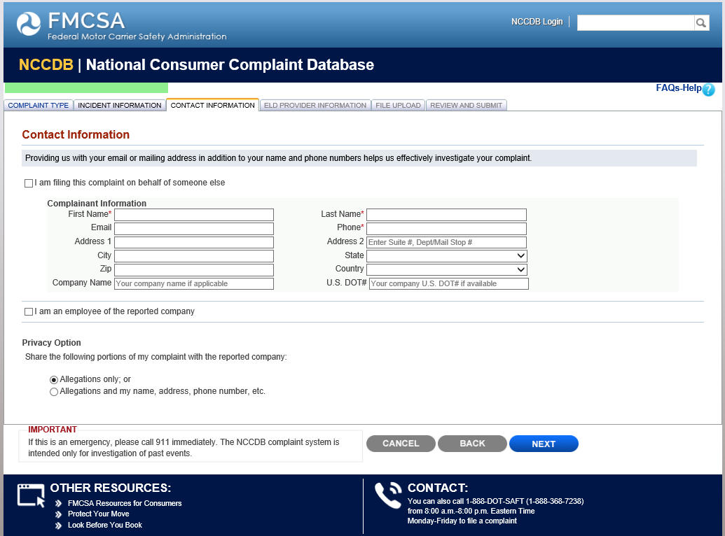

Driver ELD Provider Complaint ELD Provider Information

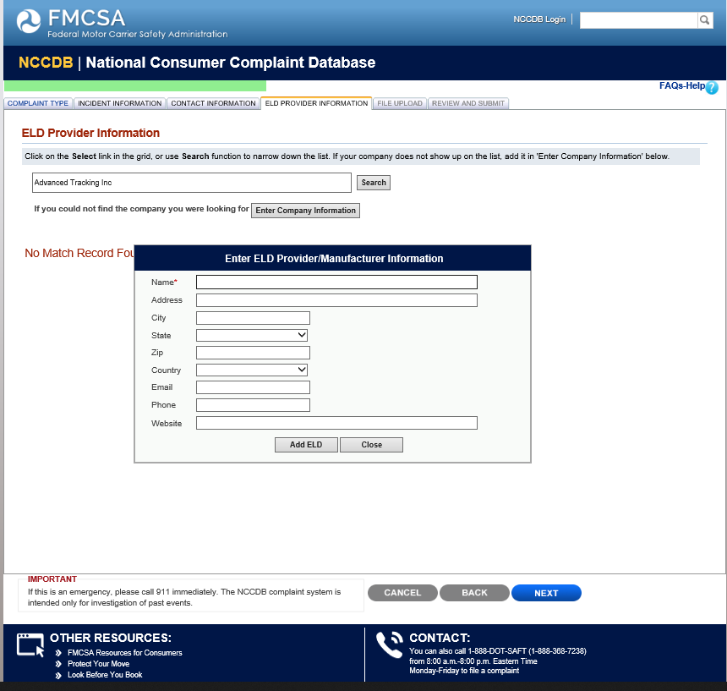

Driver ELD Provider Complaint File Upload

Driver ELD Provider Complaint Review and Submit

